Degradation mechanisms of SiC/BN/SiC after low temperature humidity exposure
Oriol Gavalda Diaz^{a*}, Katharina Marquardtª, Stephen Harris^{b}, Louise Gale^{b}, Luc Vandeperreª, Eduardo Saizª, Finn Giulianiª
ª Department of Materials, - Centre of Advanced Structural Ceramics, Imperial College London, London, SW7 2AZ, UK
^{b} Rolls Royce plc, Derby, DE24 8BJ, UK
Abstract
The environmental degradation of SiC/BN/SiC CMCs under low temperature water exposure is still an unexplored field. This work shows how the effect of low temperature humid environments can be detrimental for turbostratic BN interphases, leading to a drop in mechanical properties. Furthermore, initial low-temperature humid environments can induce a faster degradation during subsequent thermal exposure. In order to understand how low temperature water exposure affects the CMC and how these changes affect the material response to subsequent exposures, intermediate temperature (800ºC) exposures have been studied before and after the low temperature humidity tests. The main challenge of this work consists of understanding how different constituents of the CMC structure (e.g. fibres and interphases) are degrading and consequently affecting the overall bulk mechanical performance and failure modes of the material. For this, linking the change in morphology and chemistry of the interphases with the micromechanical properties each constituent has been crucial.

Keywords: Ceramic Matrix Composites, Transmission Electron Microscopy, Micromechanics, Degradation, Interphases
- Introduction
Ceramic Matrix Composites (CMCs) have been considered for structural applications at high temperature during the last 40-50 years [1]. However, their manufacturing and the fundamental understanding of their failure modes were not mature enough for them to be employed in critical situations. To understand failure, several authors have looked at the roles of the matrix-fibre interface, matrix cracking and inelastic strain development [2]–[4]. This work has provided much needed guidelines for structural design. Together with progress in fabrication it has triggered the development of a new generation of CMCs that is making inroads in high-value industries such as aerospace, nuclear and sport engineering (i.e. brakes in racing cars). An example can be found in the use of SiC/SiC parts in turbines for aero-engines [5], [6].
The fibre-matrix interface must ensure load transmission to the fibres while promoting crack deflection which results in a tougher material. Interfaces are usually engineered through thin layer deposition of interphases. The most common interphases are based on pyrolytic carbon (PyC) [7] or boron nitride (BN) [8], [9]. For aerospace applications, BN is the best choice due to its ability to form liquid oxide (B₂O₃) instead of volatile species (CO or CO₂) under high temperature in oxygen-containing environments. This oxide can then flow to promote some degree of self-healing [10], [11]. Several authors have studied the thermomechanical degradation of SiC/BN/SiC CMCs at intermediate (700-900ºC) and at high (900-1300ºC) temperatures in different atmospheres such as oxygen [12], [13], water vapour [14], [15] or combustion environments [16], [17]. One of the main conclusions is that humidity coming from the combustion products and/or compressed ambient moisture in aero-engines, promotes the degradation of BN interphases within SiC-based composites. Furthermore, the microstructure of BN has an impact on moisture sensitivity: higher crystallinity in the BN promotes resistance but requires a higher deposition temperature during fabrication [18] which might induce thermal or chemical damage in the fibre or the formation of an oxygen rich layer at the fibre surface [10]. In addition, an increase in temperature usually accelerates the kinetics of deposition, reducing the overall uniformity of the coating [19]. Consequently, current manufacturing routes aim to decrease deposition temperatures in order to reduce the possible degradation of the fibres and improve material homogeneity. However, lower processing temperature results in amorphous or turbostratic BN coatings which can be more sensitive to humidity. Previous literature reported the degradation mechanism of BN interphases at high (900-1300ºC) and intermediate (700-900ºC) temperature water exposures, showing the formation of borosilicate glasses due to the oxidation of BN and SiC. These glasses form a protective layer that limits the volatilization of other boron compounds [20]. However, low temperature humidity exposures (i.e. between 25-300ºC) also occur during the life time of an aero-engine and may pose a bigger problem. While BN can still hydrolyse; borosilicate species do not form, and the nature of the oxidative products might not provide protection. Moreover, similar effects have been shown to happen at room temperature when using BN interphases with some degree of crystallinity in SiC/SiC CMCs [21].
The main challenge is to understand how degradation affects the internal structure of the CMC and how these changes at the nano to micro-scale affect the macroscopic mechanical properties. For this, the combination of high-resolution characterisation and micromechanical testing is required. Micromechanical tests such as fibre push-out [9], [22], micropillar compression [23] or microcantilever beam fracture [24] have been used to quantify the properties of the fibre-matrix interface. The push-out test has been chosen in this work to measure the Interfacial Shear Strength (ISS) and fibre friction during sliding. The information can be related to the fibre pull-out mechanism observed during CMC failure. In addition, push-out enables testing of a relatively large number of fibres. In regard to the fibre properties, the main mechanical characterisation tool has been nanoindentation [24] and tension tests of single fibres or bundles of fibres [25], [26]. However, tensile strengths cannot be extracted via nanoindentation and conventional tensile tests require a relatively large length of fibres/bundles (e.g. centimetre scale) and are not amenable to quantifying fibres which have been exposed inside the composite. For instance, Hay et al. [27], [28] studied the degradation of Hi-Nicalon Type S fibres over a wide range of temperatures in moist/dry air, correlating the degradation of the fibre to the superficial silica formation and the associated loss of cross-sectional area. However, by using this methodology, fibres are degraded outside the CMC, and thus the real degradation conditions (e.g. partial pressure of oxidants) or even the presence of other relevant reaction products (e.g. boric acid) might not be fully captured. To address these problems, a technique based on three-point bending of single fibres at a microscale, previously validated with individual Al₂O₃ platelets [29], Si particles [30] and SiC nanowires [31] has been used. This methodology induces the maximum tensile stress at the fibres surface, making it a suitable technique to characterise the small surface damage that could be induced at the interfacial region.
In this study we aim at understanding how exposure to humidity at low temperature might degrade the fibre-matrix interface in CMCs and how this affects the overall mechanical performance. We have focused on the effect of intermediate/low temperature cycles that mimic to some extent what the composite will see in service (intermediate/high temperature during operation and low temperature when idle sometimes in very high humidity environments). To reach this aim, our study combines high resolution microstructural and chemical characterisation with micromechanical testing of the individual components of the CMC.
- Experimental methodology
  - Material
The SiC/BN/SiC used in this study was preformed from commercially available Hi-Nicalon SiC fibre (NGS Advanced Fibres Co, Japan) 2-dimensional 5HS fabric. These preforms were subsequently coated via Chemical Vapor Infiltration (CVI) with boron nitride and partially densified with CVI SiC. The final matrix was obtained via the SiC slurry infiltration of SiC particles and melt infiltration with silicon. More studies and information on the same SiC/BN/SiC can be found in [32], [33]. The samples used for the mechanical testing were cut into dogbone specimens and exposed to different degradation environments as described below.
  - Degradation environments
As the main objective of this work is to understand how humidity exposure at low temperatures influences the microstructure and affects subsequent degradation steps simulating an aero-engine environment. The following degradation steps have been used in this study:
- “Heating”: the first step consisted in exposing to 800ºC in air (31% relative humidity at 23°C) for 500 hours. Heating and cooling were performed at a rate of 10 ºC min⁻¹.
- “Water exposure”: the second step consisted of 500 hours at 65ºC in a moist environment with 95% relative humidity (corresponding to partial pressure of water of 0.23 atm).
- “Reheating”: the third step consisted of reheating the water exposed samples for 15 min at 800ºC in air (31% relative humidity at 23°C). Heating and cooling were again performed at a rate of 10ºC min⁻¹.
  - Mechanical Testing
To quantify the change in bulk mechanical properties standard 152.4 mm (6 inches) long dogbone specimens were machined from 4.5 mm thick plates and were tested in monotonic tension to failure per ASTM C1275. Samples were face-loaded using mechanical wedge grips and loaded in displacement control at a rate of 2.54 mm/min. Strain was measured using an Epsilon Technology Corp. (Jackson, WY) 3648 high temperature extensometer. At least 3 samples were tested for each condition, showing similar trends on the failure.
  - Microstructural characterisation
To ensure comparable levels of degradation, all the samples were extracted from a similar distance from the cut edges (about 2 mm).
The microstructure of the samples was first characterised with a dual-beam field emission gun (FEG) scanning electron microscope (SEM) and focussed ion beam (FIB) workstation (Auriga, Zeiss, Germany) on samples polished using alcohol-based diamond suspensions (from 9 to 0.25 µm) to avoid preparation-related moisture damage. To study the morphology and element distribution found around the interphases, electron transparent samples for TEM were prepared using a FIB lift-out technique (Helios NanoLab SEM, FEI, US). These samples where characterised using STEM-EDS with a TEM/STEM at 200 kV (JEM-2100F, JEOL, Japan) equipped with an EDS detector (X-Max detector STEM-EDS, Oxford Instruments, UK). More detailed data on the change in chemical structure and bonding energies was obtained using scanning transmission electron microscopy at 300 kV in combination with electron energy loss spectroscopy (STEM-EELS) using a monochromated TEM STEM (Titan 80/300, FEI, US) equipped with an EELS detector (Tridiem GIF, Gatan, US). The EELS information was acquired at a camera length of 77 mm, condenser aperture of 70 and spot size of 9.
X-ray Photoelectron Spectroscopy (XPS) was used to characterize the surface chemistry of the exposed fibres after degradation by employing a X-ray photoelectron spectrometer (K-Alpha+, Thermo Fisher Scientific, US) equipped with an MXR3 Al Ka monochromatic X-ray source (hv = 1486.6ev). The fractured samples with exposed fibres were mounted onto an XPS sample holder using a small rectangular piece of conductive tape. All the high-resolution core level spectra (B 1s, Si 2p, N 1s, C 1s, and O 1s) were obtained using 20 eV pass energy and 0.1 eV step size.
  - In-situ micromechanical testing
Two different micromechanical tests have been carried out within a scanning electron microscope (SEM) in this work: fibre push-out and 3-point bending of single fibres on a FEG-SEM (Quanta, FEI, US) equipped with an in-situ Alemnis nanoindenter (Alemnis, Switzerland). The Alemnis is actuated by a piezoelectric transducer and, hence, operates in true displacement control.
The push out tests were performed on 140-180 µm thick samples (taken from the edge and the centre of the specimens) polished with a disk grinder by using alcohol-based polishing diamond suspensions from 9 to 0.25 µm. The samples were placed on top of a standard TEM copper grid such that the fibres which were not overlapping with the grid bars could be pushed out. The test was performed with a 3.5 µm flat punch indenter in displacement control mode at 0.1 µm/sec. The indenter punch left minimal indentation imprint on the fibre and did not touch the matrix even for large displacements after interface failure occurred. The test was stopped before the sides of the indenter flat punch touched the matrix. A minimum of 15 push out tests were carried out after each degradation step.
In-situ 3-point bending experiments of Hi-Nicalon fibres were performed on 4 to 5 fibres after each degradation step. For the as-received fibres, non-embedded and non-coated Hi Nicalon fibres were used. For the water exposed samples, fibres from the fractured surface of previously exposed and tested samples were used. Finally, for the reheated fibres, the already fractured samples from the previous step were exposed to the reheat step. All the fibres were cut via FIB with the Helios NanoLab SEM. The fibres were then attached to an Omniprobe needle by depositing a small amount of Pt and individually placed on top of a 200x50x30 µm milled trench in a silicon wafer. The bending tests were performed in displacement control mode at 0.05 µm s⁻¹ using a 10 µm wedge tip and applying the load at the centre of the trench.
- Results
Macroscopic testing was done to obtain information about the evolution of the CMC mechanical properties after each degradation step (Figure 1). A decrease in ultimate tensile strength and work of fracture happens after the water exposure followed by a more pronounced embrittlement after the reheat.
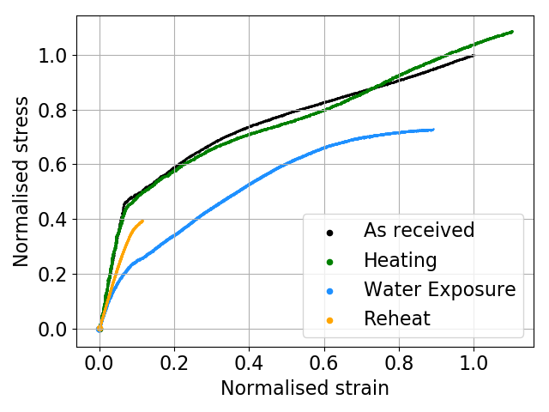
Figure 1 Representative normalised stress-strain curve for the as-received material, after heating at intermediate temperatures (heated) after low temperature water exposure and after reheating at intermediate temperature.
The corresponding fracture surfaces from the water exposed and reheat samples were analysed via SEM (Figure 2) to further elucidate the cause of the observed variations. In general, the amount of fibre pull-out in a fracture surface provides an indication of how well the fibre-matrix interphase is deflecting cracks and also gives a qualitative view of the interfacial shear strength with lower interfacial shear strengths resulting in longer fibre pull-out [34]. The results show a considerably higher pull out length for the water exposed sample compared to the reheat one. These results are consistent with the mechanical data and suggest that the water is in some way degrading the fibre-matrix interphase, which then affects the samples after reheating.
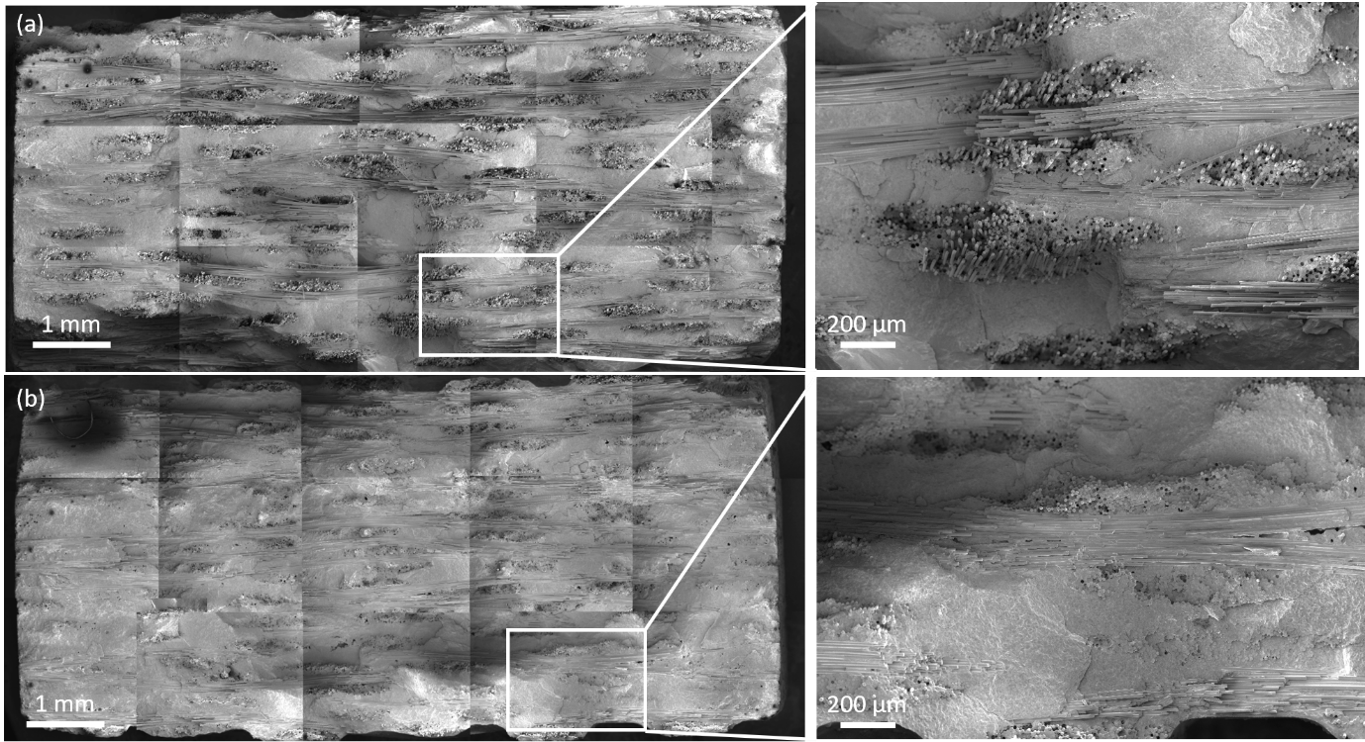
Figure 2 Macro image of the fracture surfaces for a) Water Exposure and b) Reheat samples.
Three main conclusions can be extracted from the macroscopic tests are:
- The turbostratic BN interphase used in this work promotes graceful failure resulting in an enhanced work of fracture when compared to catastrophic failures.
- The mechanical properties (e.g. tensile strength and work of fracture) of the SiC/BN/SiC CMCs are significantly affected by the low temperature water exposure. The material undergoes a reduction of the elastic limit and ultimate tensile strength.
- A subsequent short exposure at intermediate temperatures (15 min at 800ºC) further affects the mechanical properties. It induces embrittlement with a massive reduction of the work of fracture and ultimate tensile strength.
Low temperature water exposures can degrade BN interphases [21] and might have a significant impact on further temperature exposures which a priori were less concerning.
  - Microstructure and chemistry evolution of the BN interphase
The as-received BN interphases were analysed via TEM (Figure 3). From the HR-TEM image and its respective FFT in Figure 3b it can be concluded that there is some degree of crystallinity in the interphase, however the crystallites are smaller than 5 nm. Moreover, looking at the EELS spectra (Figure 3c) it can be seen that the B-K and N-K edges match the edges found in the literature [35] for a hexagonal BN (h-BN) polytype indicating its sp² bonding nature. Hence, from the diffraction and EELS information it can be concluded that the BN interphase has a turbostratic nature. Carbon has also been found at the interphase (Figure 3c). This could be due to contamination during sample preparation – i.e. some hydrocarbons in the TEM could decompose at the surface of the sample – or during processing due to diffusion of free carbon from the fibre surface during deposition or to the presence of some carbon contaminants in the BN precursors.
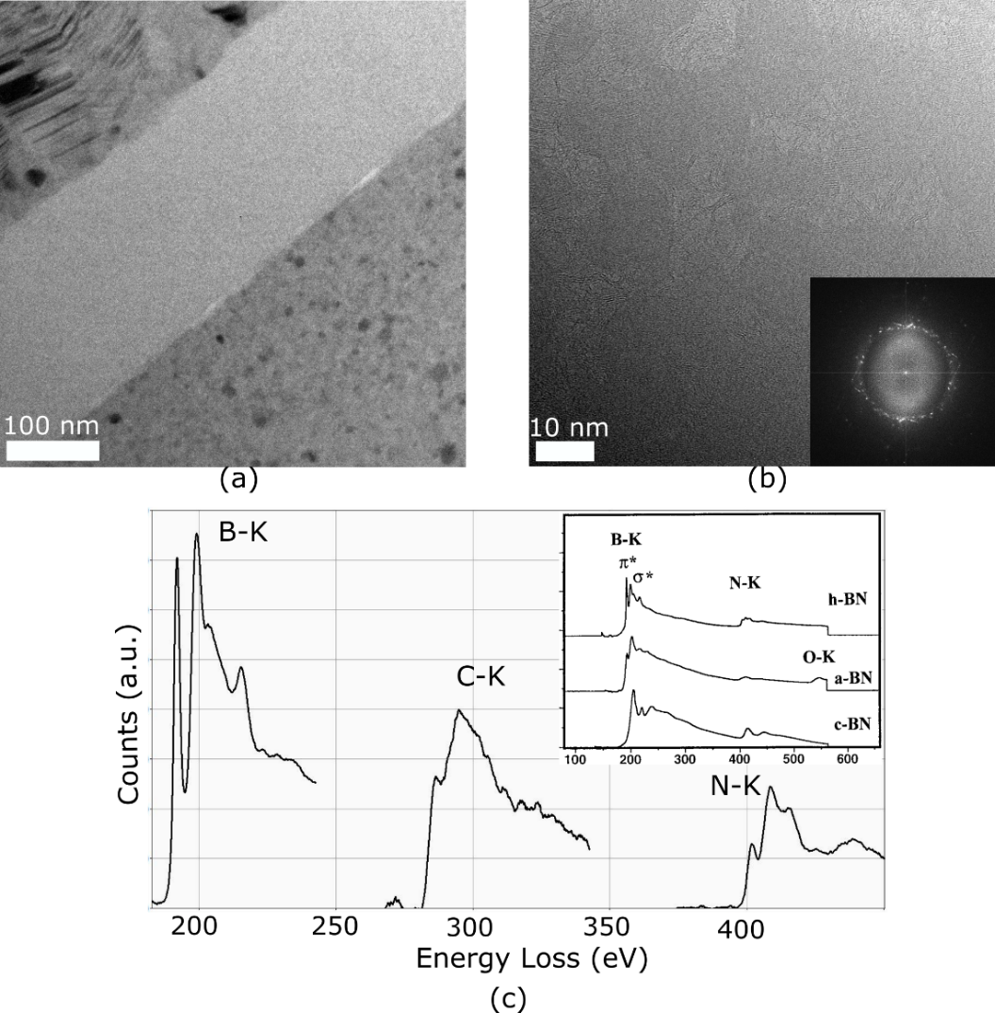
Figure 3 Microstructural characterisation of the “as-received” interphase showing (a) TEM overview of the interphase, (b) HR TEM image and respective FFT of the interphase and (c) EELS spectra of the interphase together with some reference spectra of the different types of BN polymorphs extracted from [35].
The microstructure of the BN interphase did not change after the first heating step, showing a similar morphology to the one observed for the as received state (Figure 4(a-b)). The STEM-EDS maps in Figure 4c show some oxygen content in the BN interphase. However, similar levels oxygen are also found in the as-received BN interphases and therefore they are not clear evidence of oxidation during the testing. These observations are consistent with the retention of the mechanical properties after 500 h at 800°C and the slow degradation kinetics at this temperature [36].
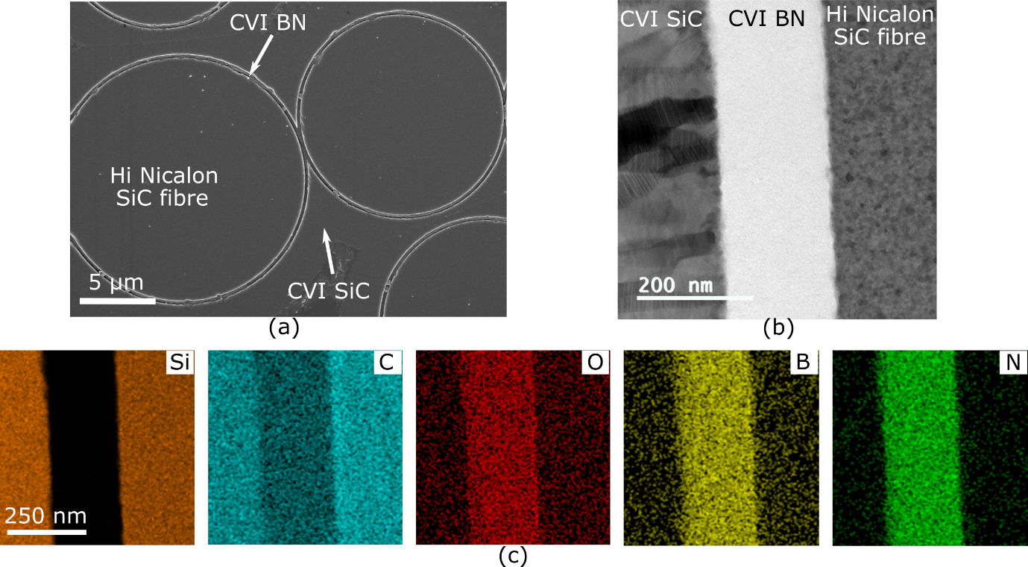
Figure 4 Characterisation of the effect of intermediate temperature on the degradation of BN interphases (a) SEM image of the overview, (b) Bright Field (BF) STEM image of the “as-heated” of the BN interphase and (c) EDS mapping of the STEM image.
In contrast, low temperature water exposure has a significant effect on the BN layer: large sections of the BN coating are removed leaving a gap between the fibre and matrix (Figure 5a). The STEM-EDS study (Figure 5(b-c)) shows the microstructural changes in the remaining interphase. Smaller regions containing B and N can be identified with EDS showing a considerable change in interphase thickness and morphology. This microstructural change is accompanied by a chemical alteration, where Si and B and N are colocalized (see arrow in Figure 5b, c).
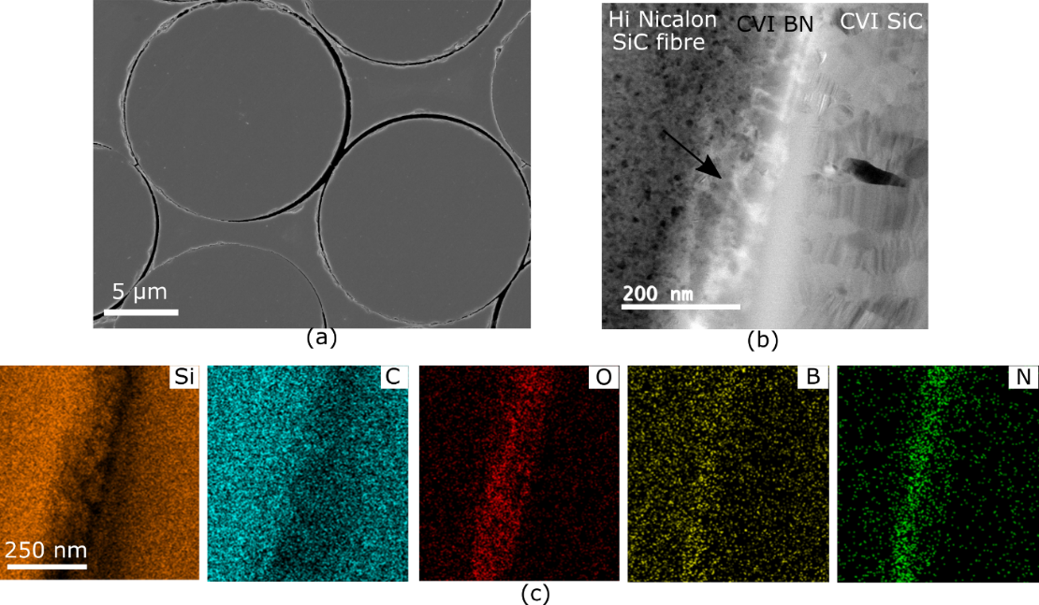
Figure 5 Characterisation of the effect of low temperature water exposure in the degradation of BN interphases (a) SEM image of the overview showing how the interphase is partially leached out, (b) and (c) BF STEM and EDS analysis of the remaining interphase.
Looking at the chemistry of the remaining material found at the interphase, Figure 6a, the presence of a B-edge in the EELS results confirms the STEM-EDS results showing that some B-related species do remain at the interface. Furthermore, if the B-K edge is compared with the one measured before water exposure (i.e. after heating), it can be observed that the energy loss near edge structure (ELNES) has the same signature, concluding that some non-degraded BN is still left at the interface after low temperature water degradation. However, some of the interfacial regions are empty suggesting that much of the BN coating has been removed from the composite. Large values of tensile residual stresses in the interface could also exacerbate the removal of the interphases, however, previous studies on the same material indicate that the residual stresses are very small [32], [37], concluding that a chemical removal is likely the dominant factor.
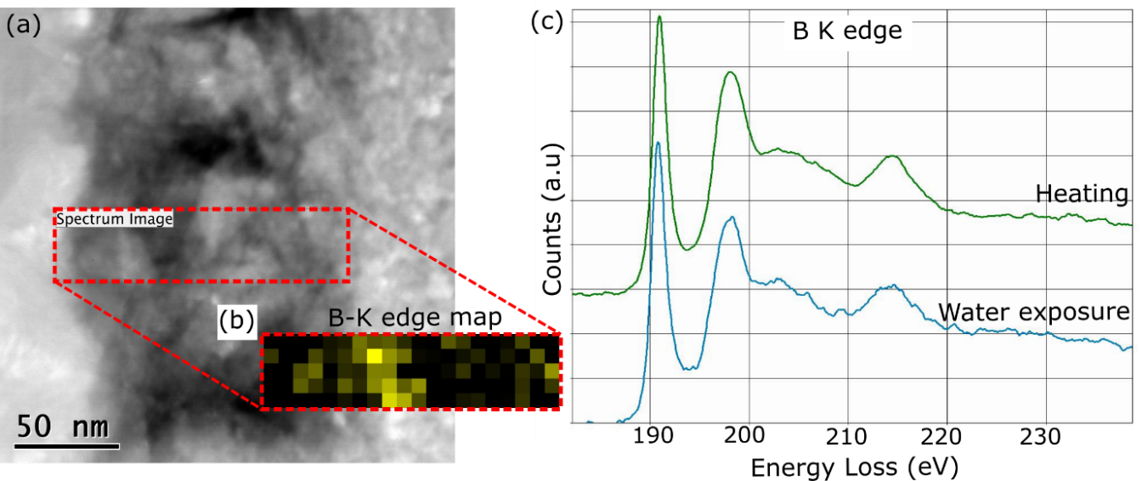
Figure 6 (a) High-Angle Annular Dark Field (HADDF) STEM image, (b) EELS mapping of the B-K edge of the water exposed interphases and (c) energy loss near edge structure comparison of the B-K edge before and after the water exposure.
The reheating experiment after water exposure is conducted at 800°C, the same temperature used in the initial heating, but for a much shorter duration. The aim is to ascertain the degradation effect of intermediate temperatures after the interphase has been partially removed in the humid environment. The interfaces remain partially empty and there is further degradation with the formation of additional products which provide insight into the active degradation mechanisms (Figure 7).
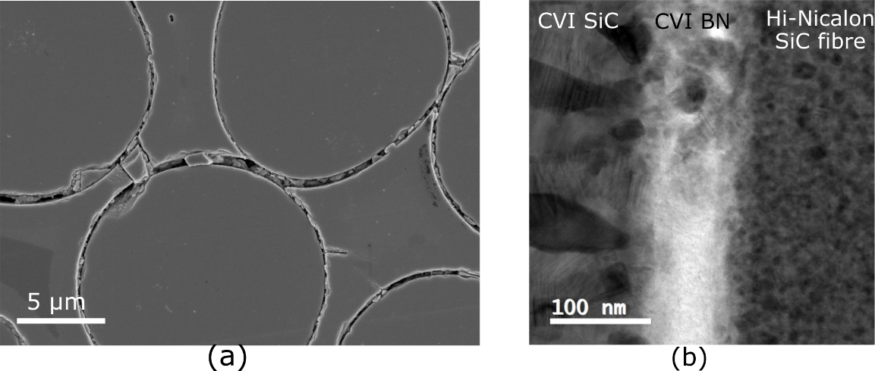
Figure 7 (a) SE SEM and (b) BF STEM images after the reheat effect showing the alterations happening in the previously empty interfaces.
The EDS map in Figure 8(a-b) shows the presence of silicon in both interfaces, before and after the reheating step. Nevertheless, the EELS spectra in Figure 8c shows that its bonding changes during reheat from preferential Si-C bonding to Si-O bonding. Hence, the removal of the BN coating during low temperature water exposure creates a pathway for easy access of oxygen to the interior of the CMC and even after a very short time at intermediate temperatures the exposed regions of the fibres start to oxidise. Even if at 800ºC the oxidation kinetics of SiC are relative slow [38], the residual BN at the interfaces can accelerate the degradation SiC, via the formation of boria which alters the SiO₂ structure by forming Si-O-B bonds and results in liquid phase with relatively low viscosity that allows faster oxygen diffusion [39].
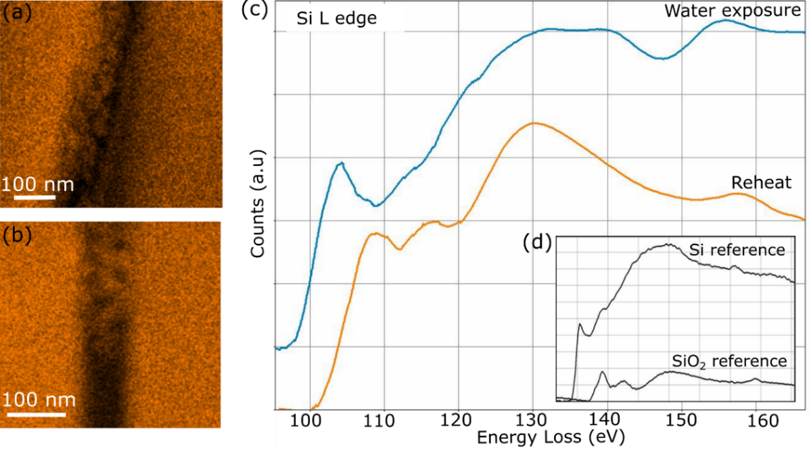
Figure 8 (a) and (b) Si Ka EDS mapping before and after the reheat effect and (c) EELS Si-K edge also before and after the reheat step.
Similar conclusions can be drawn from the XPS results of the fibres in Figure 9, where the Si 2p spectra shows a formation of SiO₂ in the fibre surface after reheat. At the same time, the clear peak shift to a higher oxidation state after the reheat shows how the BN, which was left at the interface after the water exposure, is also oxidised during reheating.
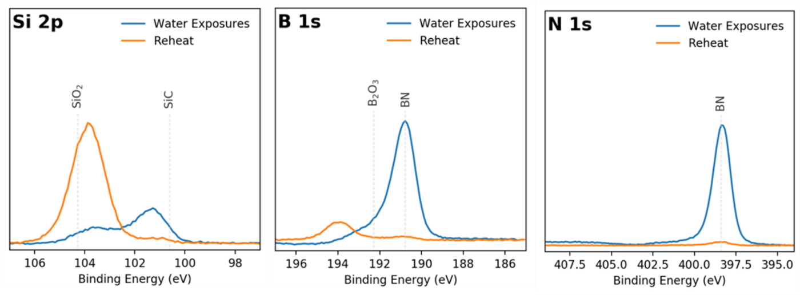
Figure 9 XPS analysis of the fibres after the water exposures and after the reheat showing a change in chemistry in the BN and SiC content. The binding energies references have been extracted from the NIST XPS database [40] and are used as an indication.

  - Interfacial mechanical properties
With the aim of understanding how the change in microstructure and chemistry experienced at the interphases has an impact on the mechanical properties of the CMC, in-situ push out tests in the SEM have been performed in as-received and degraded samples. The average interfacial shear stress applied to the interphase during push out is calculated as [41]:
 | $$τ=\frac{F}{2πrt}$$ | (1)
where F is the force applied by the indenter, r the fibre radius and t the thickness of the sample.
Figure 10 shows an example of the stress-displacement curve measured during the push-out test of as received samples. Between point 1 and 2 the sample is being accommodated in the cooper grid (first slope) and starts being fully loaded (second slope). In this region the interface starts to slightly debond. After reaching the critical interfacial shear strength (ISS) in point 2, the interface suffers a brittle failure which results in a load drop. The (unstable) plateau region (from point 3 onwards) that follows can be correlated to the friction of the fibre being pushed out.
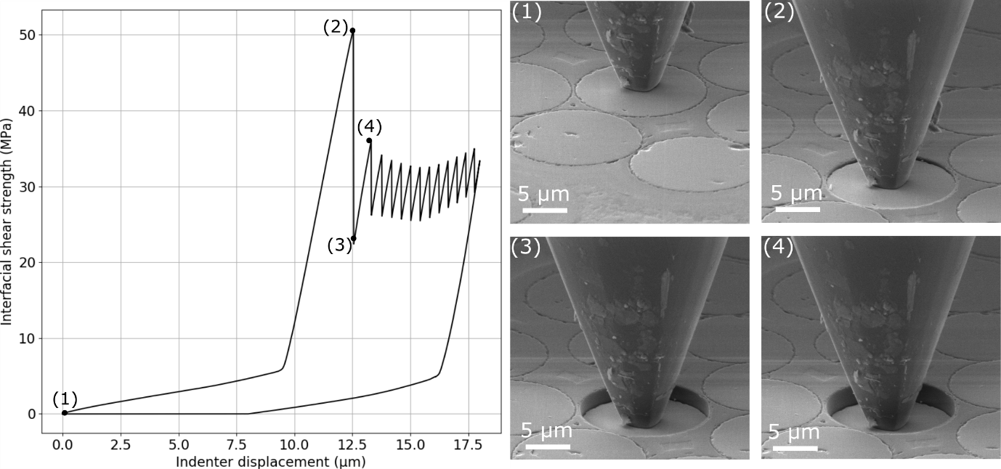
Figure 10 (a) Interfacial Shear Stress vs indenter displacement obtained for the push-out test with four different SEM frames correlated to the stress-displacement signal. (Video will be added in the online version).
An overview of the ISS and friction values obtained for at least 15 tests for the different degradation steps is shown in Figure 11. The ISS and friction values remain unchanged after the first heating step which agrees well with the characterisation above, where no evident change in morphology or chemistry was observed. After the low temperature water exposure, the ISS and friction values drastically decrease (approximately by a factor of 10). This is consistent with the removal of BN from the interface observed after degradation. After the last reheating step, the ISS and friction values are comparable to those measured after water exposure. This implies that no major change in the interfacial properties occur during reheat. Our measurements of the ISS fall within the rather wide range observed in the literature: for (Hi)-Nicalon/BN/SiC reported ISS values fluctuate between 5-140 MPa, depending on the composition of the interphase and the methodology used (i.e. push out or microcomposites hysteresis test) [9], [42]. In particular the values recorded for push-out tests only vary between 40 and 140 MPa. More in detail, it has been considered that in SiC/SiC weak interphases will display ISS of around 10-20 MPa while strong interphases 100-300 MPa [9]. Hence, our material seems to be in an intermediate situation but slightly closer to the values of weak fibre-matrix bonding. The wide scatter observed on the results for the as-received and as-heated samples is due to the variability of the interphase itself. A clear influence exists on the ISS values depending on for example were the push out is performed within the tow [43]. On the other hand, after the water exposure the interphase loses almost all the strength and the scatter is massively reduced.
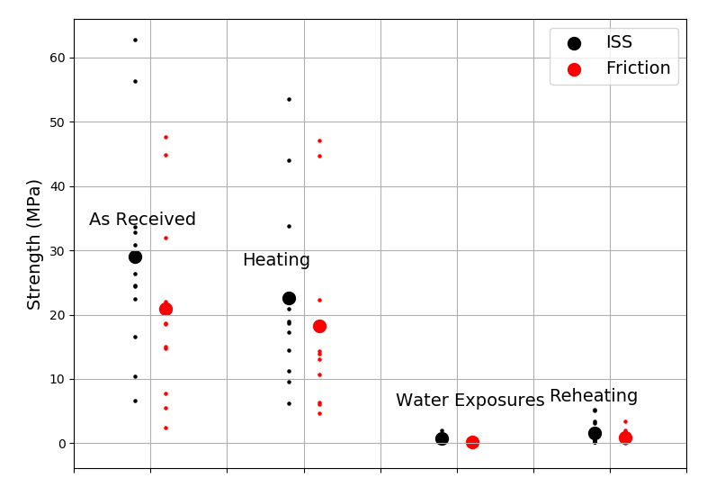
Figure 11 Comparison of the Interfacial Shear Strength (ISS) and friction results found for the different steps of degradation: As received, Heating, Water Exposures and Reheating. The small dots represent individual tests and the large ones the average.
One of the advantages of using an SEM in-situ setup with a true displacement control nanoindenter is that a better understanding of brittle failure can be obtained. There is a clear change in the nature of the friction before and after water exposure. Before water exposure (Figure 12a), the friction displays the type of stick-slip like behaviour that has already been reported [44], [45] which could be linked to the fracture morphology and irregularities of the interface resulting in an abrupt increase. This effect might only be appreciated when the tip is actuated by a true displacement control indenter, otherwise, the time needed for loop closure is faster than the actuator. On the other hand, after water exposure (Figure 12b), the friction plateau is flat, the process is based on stable push-out dominated by the dynamic coefficient of friction.
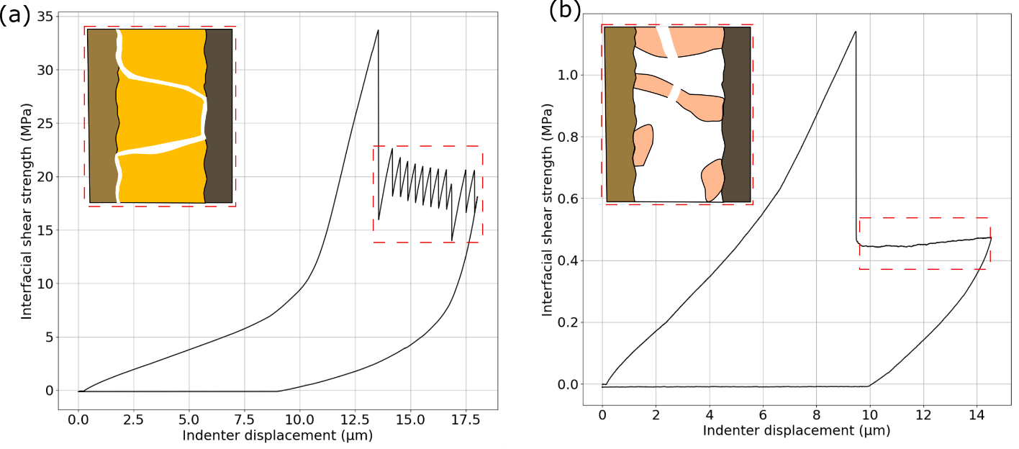
Figure 12 Comparison between the different friction mechanisms found depending on the degradation state of the interface (a) as-received and (b) after water exposure.

  - Fibre strength
The 3-point bending setup of individual fibres was used to assess the effect of surface degradation (e.g. as a result of oxidation and/or degradation) on the tensile strength. Figure 13 shows the alignment of the fibres on the trench together with a typical load-displacement curve obtained during the test.
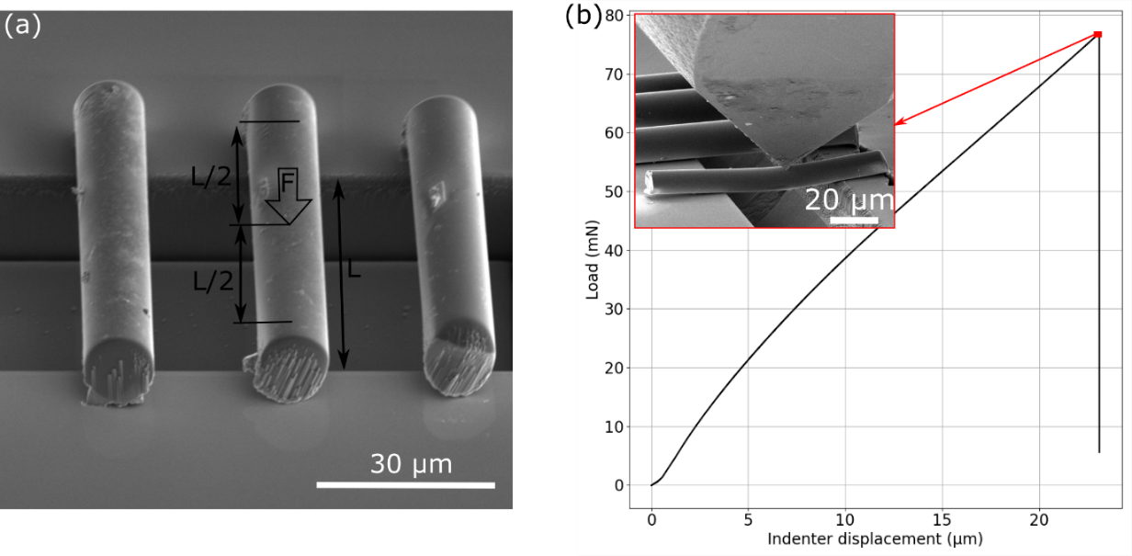
Figure 13 a) SEM image of the fibres aligned over the trench and (b) load-displacement curve with a SEM frame of the maximum bending load. (Video will be added in the online version).
From the peak load values obtained during the test, the tensile strength (σ^{UTS}) was calculated based on the position of the wedge (L/2) and the fibre radius, r, which was measured for each fibre tested and by assuming a circular long beam:
 | $$σ^{UTS}=\frac{F_{max}L}{πr^{3}}$$ | (2)
with F_{max} being the peak load of the force-displacement curve.
Figure 14 shows a comparison of the fibre strengths after each degradation step when breaking 4-5 fibres for each condition. The strengths of the as-received and water exposed fibres are relative similar, with average values around 10 GPa. Even for this limited number of samples, the results suggest that after reheating, the average values decrease to approximately 7 GPa, which implies a ≈ 30% reduction in the average tensile strength with no overlap in the scatter with the as received fibres or after water exposure.
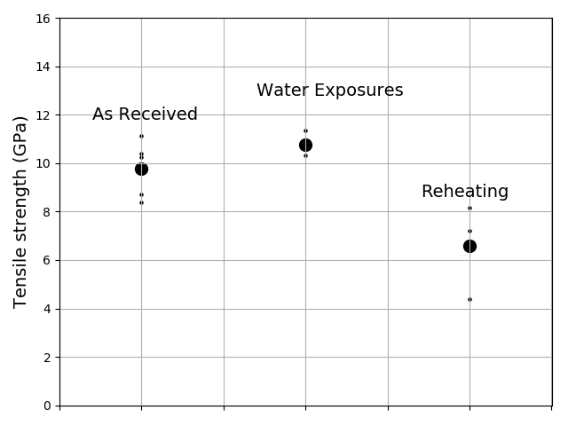
Figure 14 Tensile strength measured in the 3-point bending of as-received, water exposed and reheated samples. The small dots represent individual tests and the big ones the average.
A simplified calculation based on linear elastic fracture mechanics can be used to estimate the change in defect size (δ) induced during reheating:
 | $$K_{ic}=σ{(πδ)}^{1/2}$$ | (3)
 | $$K_{ic}^{wat exp}= K_{ic}^{reheat}→\frac{δ_{reheat}}{δ_{wat exp}}={\left(\frac{σ_{wat exp}^{UTS}}{σ_{reheat}^{UTS}}\right)}^{2}≈2$$ | (4)

where K_{ic} and σ^{UTS} are the fracture toughness and the tensile strength of the fibres. It can then be concluded that, when sampling small superficial defects in the fibres, the reheating effect is inducing an increase of defect size of the order of two.
Tensile strengths of ≈ 3 GPa have been previously reported in the literature for Hi-Nicalon fibres [46]–[48]. These strengths are two to four times smaller than the ones measured here. This is mainly due to the different sample sizes: 25 mm gauge length tensile tests were used in the literature compared to the 3-point bending test on 50 µm long fibres used in this work. This has a clear impact on the volume of interaction and the number of defects that are sampled under tension. It can be expected that our tests on small samples than literature tests, will give higher strengths. Similar observations have been reported in the literature for other ceramics where 5-10x greater values of tensile strength were found when comparing micro to macroscopic tests [29].
- Discussion
The first question to be answered in deriving the reaction mechanism between moisture and the BN coating is to determine whether the reaction is trigged by water vapour or occurs in contact with liquid water. This is determined by the following equilibrium:
 | $${H_{2}O}_{(l)}↔{H_{2}O}_{(g)}$$ | (5)
Writing the equilibrium constant for this reaction yields:
 | $$K_{1}= p_{H_{2}O}$$ | (6)
Using the reaction function of FactSage [49], K₁ was tabulated as a function of temperature between 25 and 125°C to yield the equilibrium vapour pressure of water, i.e. the vapour pressure of water where both water vapour and liquid water co-exist, see curve ❶ in Figure 15. In our system, a region around the p_{sat} and 65°C is faced by the material, as highlighted with a blue rectangle in Figure 15.
Nevertheless, where water vapour is exposed to capillaries, it is well known that the saturation pressure where condensation happens, p_{z}, is reduced according to the Kelvin equation [50]. From the Kelvin equation the difference between p_{z} and p_{sat} is limited unless the gap is well below 100 nm (see Appendix 1). As the thickness of the BN interphases can vary from 50 to 200 nm, water might be condensing producing liquid water at the interphase.
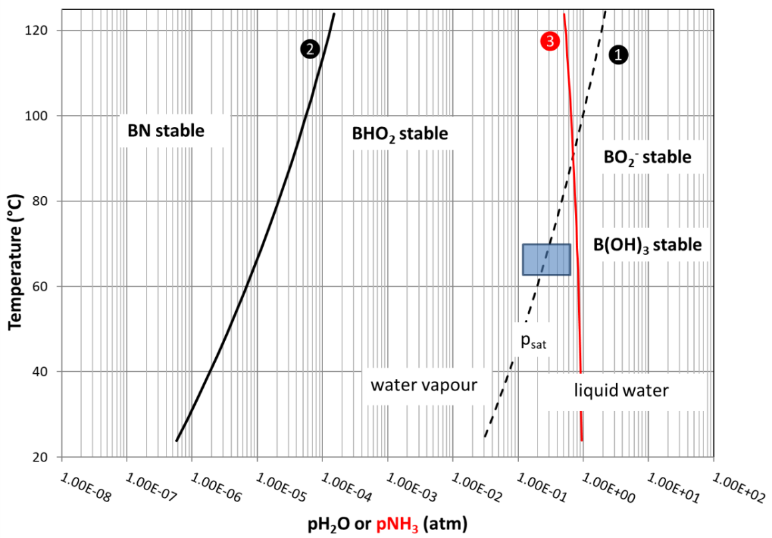
Figure 15 Relationship between the equilibrium partial pressure of water (atm) governing condensation (line ❶) and oxidation of BN (line ❷) and temperature and the equilibrium partial pressure of ammonia for the oxidation of BN (line ❸). The labels indicating the stability of phases are for the partial pressure of water.
Hence two cases are plausible depending on whether the moisture attack is dominated by a low (p_{H20} < p_{z}) or a high (p_{H20} > p_{z}) water vapour pressure scenario:
- Low water vapour pressure (p_{H20} < p_{z}):
Using the equilibrium tool of FactSage it was found that for low vapour pressures of water, the reaction at 1 atmosphere and 65 °C is:
 | $$BN\left(s\right)+2H_{2}O\left(g\right)=BHO_{2}\left(s\right)+NH_{3}(g)$$ | (7)
The function defining the necessary partial pressure of water (curve ❷ in Figure 15) can be calculated (see Appendix 2) showing that in principle all boron nitride in contact with water vapour near room temperature should become oxoborinic acid (BHO₂) as the partial pressure needed to stabilize boron nitride is extremely low (<2 × 10⁻⁶ atm at 65°C). Moreover, the partial pressure of pure ammonia has to be close to 1 atm at 65°C for the reaction not to occur (curve ❸ in Figure 15).
Since a solid oxide (BHO₂) forms with larger molar volume (17.6 cm³mol⁻¹) than the solid BN that it replaces (11.8 cm³mol⁻¹), in principle the reaction should lead to oxidation protection via a protective coating through which the transport of the reactants is controlled by a slow diffusion rate. A schematic of this mechanism has been shown in Figure 16a.
- High water vapour pressure (p_{H20} > p_{z}):
To investigate this regime, the equilibrium module of FactSage was used and 1 mole BN was exposed to an increasing amount of water (0.1-400 mole H₂O). It takes a little over 2 moles of water, for BN to remain at equilibrium, but under these circumstances the reaction is:
 | $$BN\left(s\right)+2H_{2}O\left(l\right)=BHO_{2}\left(s\right)+NH_{3}(aq)$$ | (8)
The oxoborinic acid still remains as a solid. The ammonia partially reacts to give:
 | $$NH_{3}\left(aq\right)+H^{+}\left(aq\right)= {NH}_{4}^{+}(aq)$$ | (9)
which raises the pH to 9.45. Moreover, water (p=0.16 atm) and ammonia (p=0.7 atm) are also present in the form of a vapour. As the amount of water is increased, some of the oxoborinic acid dissolves in the increasing water that remains:
 | $${BHO}_{2}\left(s\right)= {BO}_{2}^{-}\left(aq\right)+H^{+}(aq)$$ | (10)
and some of the dissolved oxoborinic acid reacts further to yield boric acid:
 | $${BO}_{2}^{-}\left(aq\right)+H^{+}\left(aq\right)+H_{2}O= B{(OH)}_{3}$$ | (11)
Given that in the small space becoming available by dissolution of the BN coating, the amount of water in direct contact with the boron nitride coating will be limited, the reaction mechanism is expected to consist of oxidation of boron nitride into oxoborinic acid. As the ions diffuse through the liquid towards the water/air interface at the surface of the composite, the concentration at the interface is decreased and oxoborinic acid can dissolve again. Hence the rate of reaction at that interface could be controlled by the rate of diffusion/convection of the BO₂⁻ and B(OH)₃ in the water. The oxidation of the boron nitride interphase, however, is likely to continue as the solubility limit of NH₃ is not reached and even gaseous NH₃ could form. The kinetics in this case could either be controlled by diffusion or convection of BO₂⁻ and B(OH)₃ away from the interface through the water to dissolve the oxide layer, or the diffusion of N, H and O through the oxide to grow the oxide layer. A schematic of this mechanism has been shown in Figure 16b.
Since the gas phase in equilibrium with water does not contain boron species in a sufficient quantity to remove the boron via evaporation, while the ammonia reaching the surface of the composite can boil off, the water near the air/water interface at the edge of the composite can be expected to have a reduced pH compared to near the interface where BN is being eroded. This reduces the solubility of the oxoborinic acid, which will therefore deposit as a solid outside and near the outside of the composite if it does not drip out of the composite with water droplets in which it is contained. This reprecipitation could locally induce a strong bond, promoting an embrittlement in the bulk failure but more studies on this effect are needed.
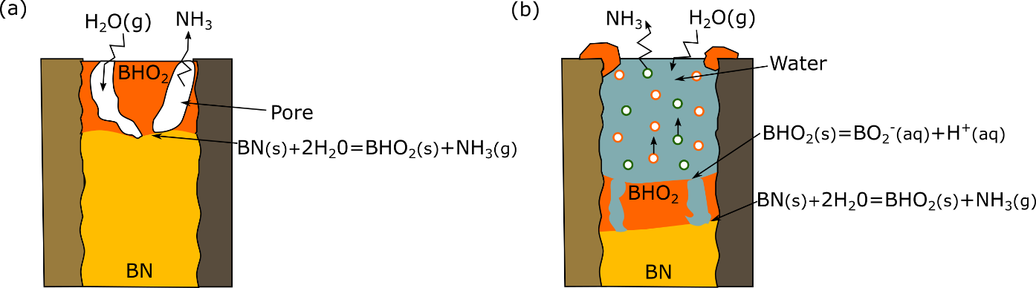
Figure 16 Proposed mechanism of BN attack by moisture inside SiC/SiC for (a) low (p_{H2O}<p_{z}) and (b) high (p_{H2O}>p_{z}) water vapour pressures in the environment.
The experimental observations of substantial BN removal are more consistent with the mechanism involving liquid water (and not just water vapour), which also explains the decrease in ISS and friction properties of the BN interphase affecting the bulk properties. The metastable nature of the acids formed at the interface and the high content of water makes the characterisation process almost impossible as under vacuum, these species will evaporate/precipitate and only the remaining BN will be observed in the electron microscopy analysis. Further study considering the thermodynamics of this process could be explored by using atmospheric in-situ TEM exposures techniques as recently done for grain boundary characterisation in metallic systems [51].
In regards to fibre degradation, even if a large number of fibres were not tested due to the complexity of the setup, the results from fibre bending suggest a decrease in tensile strength after the reheat. The bending tests shows a small increase in defect size. These results may indicate that the observed decrease in strength could be related to the formation of a thin layer on the fibre surface. However, larger defects regions might be also forming in localised areas (e.g. where some boron species were left) inducing a larger defect size and therefore driving the failure of the fibre to a lower strength. Probably, these defects will not be sampled in our tests. Unfortunately extracting long lengths of fibre from the composite for larger scale tests without damage is not possible.

- Conclusions
The effect of low (65ºC) temperature water exposure on a SiC/BN/SiC CMC has been studied by combining high resolution microstructural characterization together with micromechanical testing. The results show how the BN interphase degrades in this relatively mild environment with a decrease in interfacial shear strength and friction of around 90%. The result is a significant decrease in macroscopic mechanical properties. In addition, low temperature humid degradation of the interphase opens a free path for oxygen or other agents towards the core of the material. As a result, subsequent intermediate temperature exposures (e.g. reheats in air) can trigger fibre degradation and significant drop in the mechanical response of the CMC. In-situ bending of single fibres shows a strength decrease of ~30% due to oxidation and/or surface defect growth. This work demonstrates how high-resolution characterization (STEM-EDS/EELS) and micromechanics can be combined to provide insight into the failure mechanisms of fibre-reinforced ceramics subject to complex environmental demands.
References
[1] R. . Naslain, “Ceramic Matrix Composites,” Philos. Trans. R. Soc. A, no. 351, pp. 485–496, 1995.
[2] D. B. Marshall, B. N. Cox, and A. G. Evans, “The mechanics of matrix cracking in brittle-matrix,” Acta Metall., vol. 33, no. Il, pp. 2013–2021, 1985.
[3] A. G. Evans, “The mechanical properties of reinforced ceramic, metal and intermetallic matrix composites,” Mater. Sci. Eng. A, vol. 143, no. 1–2, pp. 63–76, 1991.
[4] A. G. Evans, “Ceramics and ceramic composites as high-temperature structural materials: challenges and opportunities,” Philosiphical Trans. R. Soc. A, vol. 351, pp. 511–527, 1995.
[5] G. Gardiner, “Aeroengine Composites, Part 1: The CMC invasion,” Composites World, Jul-2015.
[6] J. Steibel, “Ceramic matrix composites taking flight at GE Aviation,” Am. Ceram. Soc. Bull., vol. 98, no. 3, pp. 30–33, 2019.
[7] N. Carrère, E. Martin, and J. Lamon, “Influence of the interphase and associated interfaces on the deflection of matrix cracks in ceramic matrix composites,” Compos. Part A Appl. Sci. Manuf., vol. 31, no. 11, pp. 1179–1190, 2000.
[8] J. J. Brennan, “Interfacial characterization of a slurry-cast melt-infiltrated SiC/SiC ceramic-matrix composite,” Acta Mater., vol. 48, no. 18–19, pp. 4619–4628, 2000.
[9] F. Rebillat, J. Lamon, and A. Guette, “Concept of a strong interface applied to SiC/SiC composites with a BN interphase,” Acta Mater., vol. 48, no. 18–19, pp. 4609–4618, 2000.
[10] R. Naslain et al., “Boron Nitride Interphase in Ceramic-Matrix Composites,” J. Am. Ceram. Soc., vol. 88, no. i, pp. 2482–2488, 1991.
[11] G. N. Morscher, “Tensile Stress Rupture of SiCf/SiCm Minicomposites with Carbon and Boron Nitride Interphases at Elevated Temperatures in Air,” J. Am. Ceram. Soc., vol. 42, pp. 2029–2042, 1997.
[12] K. L. More, K. S. Ailey, R. A. Lowden, and H. T. Lin, “Evaluating the effect of oxygen content in BN interfacial coatings on the stability of SiC/BN/SiC composites,” Compos. Part A Appl. Sci. Manuf., vol. 30, no. 4, pp. 463–470, 1999.
[13] G. N. Morscher, J. Hurst, and D. Brewer, “Intermediate-Temperature Stress Rupture of a Woven Hi-Nicalon, BN-Interphase, SiC-Matrix Composite in Air,” J. Am. Ceram. Soc., vol. 49, 2000.
[14] S. Mall and K. J. Larochelle, “Fatigue and stress-rupture behaviors of SiC / SiC composite under humid environment at elevated temperature,” Compos. Sci. Technol., vol. 66, pp. 2925–2934, 2006.
[15] K. More and P. Tortorelli, “High‐Temperature Stability of SiC‐Based Composites in High‐Water‐Vapor‐Pressure Environments,” J. Am. Ceram. Soc., vol. 81, pp. 1272–1281, 2003.
[16] E. J. Opila, R. C. Robinson, and M. J. Verrilli, “Borosilicate Glass-Induced Fiber Degradation of SiC/BN/SiC Composites Exposed in Combustion Environments,” Int. J. Appl. Ceram. Technol., vol. 13, no. 3, pp. 434–442, 2016.
[17] D. J. Bertrand, V. Sabelkin, L. Zawada, and S. Mall, “Fatigue behavior of sylramic-iBN/BN/CVI SiC ceramic matrix composite in combustion environment,” J. Mater. Sci., vol. 50, no. 22, pp. 7437–7447, 2015.
[18] N. S. Jacobson, D. S. Fox, and E. J. Opilab, “High temperature oxidation of ceramic composites,” Pure Appl. Chem, vol. 70, no. 2, pp. 493–500, 1998.
[19] T. Matsuda, N. Uno, H. Nakae, and T. Hirai, “Synthesis and structure of chemically vapour-deposited boron nitride,” J. Mater. Sci., vol. 21, no. 2, pp. 649–658, 1986.
[20] N. S. Jacobson, G. N. Morscher, D. R. Bryant, and R. E. Tressler, “High-Temperature Oxidation of Boron Nitride : II , Boron Nitride Layers in Composites,” J. Am. Ceram. Soc., vol. 82, 1998.
[21] J. Dai, Y. Wang, Z. Xu, and L. He, “Degradation of boron nitride interfacial coatings fabricated by chemical vapor infiltration on SiC fibers under ambient air/room temperature conditions,” Ceram. Int., vol. 45, no. 6, pp. 6937–6943, 2019.
[22] C. H. Hsueh, F. Rebillat, J. Lamon, and E. Lara-Curzio, “Analyses on fiber push-out tests performed on Nicalon/SiC composites with tailored interfaces,” Compos. Eng., vol. 5, no. 10, pp. 1387–1401, 1995.
[23] J. Kabel et al., “Ceramic composites : A review of toughening mechanisms and demonstration of micropillar compression for interface property extraction,” J. Mater. Res, vol. 33, no. 4, 2018.
[24] Y. Zayachuk, P. Karamched, C. Deck, P. Hosemann, and D. E. J. Armstrong, “Linking microstructure and local mechanical properties in SiC-SiC fiber composite using micromechanical testing,” Acta Mater., vol. 168, pp. 178–189, 2019.
[25] E. B. Callaway and F. W. Zok, “Strengths of ceramic fiber bundles: Theory and practice,” J. Am. Ceram. Soc., vol. 100, no. 11, pp. 5306–5317, 2017.
[26] E. B. Callaway and F. W. Zok, “Weibull parameters obtained from dependence of fiber strength on fiber length and area,” J. Am. Ceram. Soc., vol. 101, no. 10, pp. 4719–4731, 2018.
[27] R. S. Hay and R. J. Chater, “Oxidation kinetics strength of Hi-NicalonTM-S SiC fiber after oxidation in dry and wet air,” J. Am. Ceram. Soc., vol. 100, no. 9, pp. 4110–4130, 2017.
[28] R. S. Hay and P. Mogilevsky, “Model for SiC fiber strength after oxidation in dry and wet air,” J. Am. Ceram. Soc., vol. 102, no. 1, pp. 397–415, 2019.
[29] E. Feilden et al., “Micromechanical strength of individual Al2O3 platelets,” Scr. Mater., vol. 131, pp. 55–58, 2017.
[30] M. G. Mueller, M. Fornabaio, G. Žagar, and A. Mortensen, “Microscopic strength of silicon particles in an aluminium-silicon alloy,” Acta Mater., vol. 105, pp. 165–175, 2016.
[31] C. Ferraro et al., “Light and Strong SiC Networks,” Adv. Funct. Mater., vol. 26, no. 10, pp. 1636–1645, 2016.
[32] O. Gavalda Diaz, D. A. Axinte, P. Butler-Smith, and D. Novovic, “On understanding the microstructure of SiC/SiC Ceramic Matrix Composites (CMCs) after a material removal process,” Mater. Sci. Eng. A, vol. 743, no. September 2018, pp. 1–11, 2019.
[33] M. W. Knauf, “Effects of Heat - treatment on the Microstructure and,” PhD Purdue University, 2017.
[34] J. Lamon, “Interfaces and interfacial mechanics: influence on the mechanical behavior of ceramic matrix composites (CMC),” J. Phys. III, vol. 3, no. 7 pt 3, pp. 1607–1616, 1993.
[35] J. Y. Huang, H. Yasuda, and H. Mori, “HRTEM and EELS studies on the amorphization of hexagonal boron nitride induced by ball milling,” J. Am. Ceram. Soc., vol. 83, no. 2, pp. 403–409, 2000.
[36] M. E. Wilson, “Oxidation of SiC/BN/SiC Ceramic Matrix Composites and their constituents,” University of Virginia, 2018.
[37] M. W. Knauf, “Effects of heat treatment in SiC/SiC Ceramic Matrix Composites,” Purdue University, 2017.
[38] M. Wilson and E. Opila, “A Review of SiC Fiber Oxidation with a New Study of Hi-Nicalon SiC Fiber Oxidation,” Adv. Eng. Mater., vol. 18, no. 10, pp. 1698–1709, 2016.
[39] B. Mcfarland and E. J. Opila, “Silicon carbide fiber oxidation behavior in the presence of boron nitride,” J. Am. Ceram. Soc., no. May, pp. 1–18, 2018.
[40] “Nist.” [Online]. Available: https://srdata.nist.gov/xps/main_search_menu.aspx. [Accessed: 12-May-2019].
[41] F. Rebillat, J. Lamon, R. Naslain, E. Lara-curzio, M. K. Ferber, and T. M. Besmann, “Interfacial Bond Strength in SiC / C / SiC Composite Materials , As Studied by Single-Fiber Push-Out Tests,” J. Am. Ceram. Soc., vol. 78, 1998.
[42] J. Lamon, “Influence of interfaces and interphases on the mechanical behavior of fiber-reinforced ceramic matrix composites,” in Ceramic matrix composites : materials, modeling and technology, N. P. Bansal and J. Lamon, Eds. New Jersey: John Wiley & Sons, Inc., 2015, pp. 40–64.
[43] A. Hussey, R. De Meyere, C. Deck, D. E. J. Armstrong, and Y. Zayachuk, “Statistically sound application of fiber push-out method for the study of locally non-uniform interfacial properties of SiC-SiC fiber composites,” J. Eur. Ceram. Soc., vol. 40, no. 4, pp. 1052–1056, 2020.
[44] A. D. Berman, W. A. Ducker, and J. N. Israelachvili, “Origin and Characterization of Different Stick−Slip Friction Mechanisms †,” Langmuir, vol. 12, no. 19, pp. 4559–4563, 1996.
[45] P. D. Jero, R. J. Kerans, and T. A. Parthasarathy, “Effect of Interfacial Roughness on the Frictional Stress Measured Using Pushout Tests,” J. Am. Ceram. Soc., vol. 74, no. 11, pp. 2793–2801, 1991.
[46] T. Ishikawa, “Recent developments of the SiC fiber Nicalon and its composites, including properties of the SiC fiber Hi Nicalon for ultra-high temperature,” Compos. Sci. Technol., vol. 51, pp. 135–144, 1994.
[47] S. M. Dong et al., “Characterization of nearly stoichiometric SiC ceramic fibres,” J. Mater. Sci., vol. 36, no. 10, pp. 2371–2381, 2001.
[48] A. R. Bunsell and A. Piant, “A review of the development of three generations of small diameter silicon carbide fibres,” J. Mater. Sci., vol. 41, no. 3, pp. 823–839, 2006.
[49] C. W. Bale, “FactSage Thermochemical software and databases,” Calphad J., vol. 62, pp. 189–228, 2002.
[50] L. Fisher, R. Gamble, and J. Middlehurst, “The Kelvin equation and capillary condensation,” Nature, vol. 290, no. April, pp. 575–576, 1981.
[51] M. G. Burke, G. Bertali, E. Prestat, F. Scenini, and S. J. Haigh, “The application of in situ analytical transmission electron microscopy to the study of preferential intergranular oxidation in Alloy 600,” Ultramicroscopy, vol. 176, no. September 2016, pp. 46–51, 2017.

