Supplement Information

- Measurements of the optical properties
The optical observations were performed by means of Oxford Cryosystems Metripol Birefringence Imaging System (known in the litertuare as Metripol setup). This system consists of a polarising microscope equipped with a polariser capable of rotating to fixed angles α from a reference position, a circularly polarising analyser and a CCD camera. The sample is held in Linkam THMS600E temperature microscope stage, which maintains a constant temperature to within 0.1 K.
The principle of the measuring technique is that the light first passes through the polariser. Next, the polarised wave passes through an anisotropic crystal of thickness h. Birefringence results from anisotropy within the sample, leading to a variation of the refractive index n. An indicatrix represents this variation with three principal refractive indices n1, n2 and n3. For any given incident light direction, the perpendicular cross-section of the indicatrix will generally have the form of an ellipse. The difference in the lengths of the ellipse axes is equal to Δn = n1 - n2. Together with the inclination ϕ of the indicatrix, it produces the optical retardation (phase shift) δ within the sample that appears for the particular direction of light. This retardation can be measured by registering the light intensity I by a CCD camera:
$$I= \frac{I_{0}}{2} [1+sin(2ϕ-2α)sinδ],$$

where I0 is the intensity of unpolarised light passing through the sample, α is the angular position of the analyser as it rotates, and ϕ is the angle of the principal axis of the indicatrix (optical orientation)
for a predetermined position. The ϕ is defined as the angle measured anticlockwise from the horizontal direction of the microscope stage to the slow (longer) axis of the indicatrix. The difference in refractive indexes introduces phase shift δ =(2π/λ)*Δn*h to the light rays on passing through a sample of thickness h. By measuring several images with varying positions α of the polariser, it is possible to refine the quantities I0,|sinδ|and ϕ at each pixel position within the image, and false-colour images (maps) can be constructed of these quantities. In this way, the spatial variation of the optical retardation and indicatrix orientation can be seen simultaneously. Moreover, the setup enables calculating ϕ within the range of each degree in the range from 0º to 180º. This option was used to find the population of indicatrix orientations representing complex domains structure in the investigated PZT single crystal.
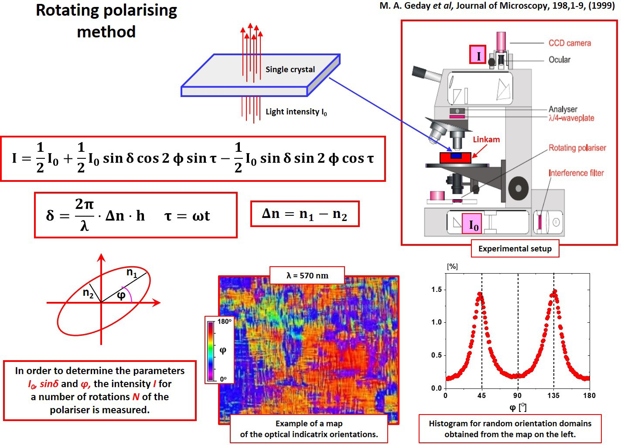

- Piezoelectric resonances before and after AC field action
The modulus |Y| of the complex admittance as a function of frequency at 300K for a PbZr_{0.54}Ti_{0.46}O₃ single crystal, before (red points) and after (black points) measurements in the AC field is shown in the Figure below. The inset shows the dependence of the phase angle θ as a function of frequency. A small shift observed in the resonant frequencies, relative to those in Figure 5 in the main text, was because of the hard-to-avoid thermostat capacitance, in which simultaneous measurement of the d₃₃ and d₃₁ was performed.
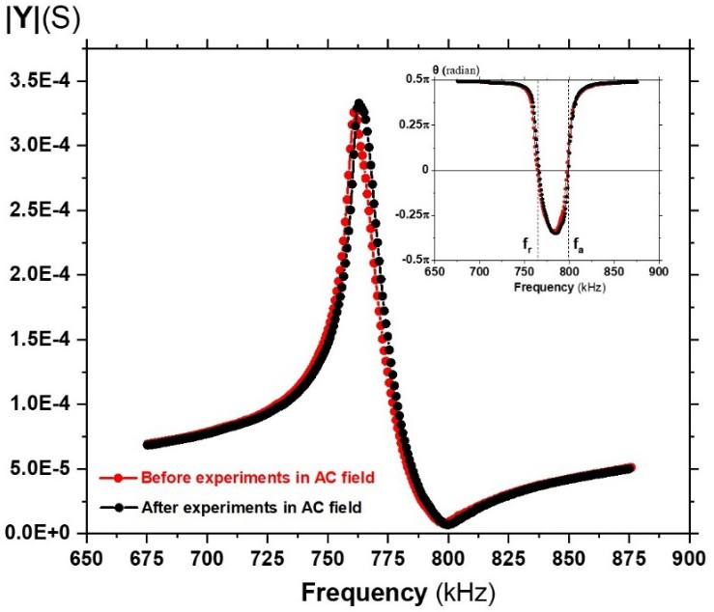

- Dielectric properties near T_{C}
The ratio of Curie-Weiss constants K' and K'', respectively above and below the transition, is dependent on frequency.


