Could the association between ozone and arterial stiffness be modified by fish oil supplementation?

Abstract
Background: Arterial stiffness is an important predicting factor for cardiovascular disease. However, no epidemiological studies have ever explored the modification effects of fish oil on the association between ozone and arterial stiffness.
Methods: Study participants were drawn from the UK biobank, and a total of 142,726 middle-aged and older adults were included in this study with complete information. Ozone was obtained from Community Multiscale Air Quality (CMAQ) model matched to residential addresses, fish oil from self-reported intake, and arterial stiffness was obtained from arterial stiffness index (ASI) based on device measurements. Firstly, we applied a double robust approach to explore the association between ozone or fish oil intake and arterial stiffness, adjusting for potential confounders at the individual and regional levels. Then, the modifying effect of fish oil was further explored by stratified analysis.
Results: The mean age of all participants was 57 years; after considering the weights of covariates and adjusting for confounding, annual average ozone exposure was associated with ASI (beta:0.233 [95%CI: 0.196 to 0.270], P<0.001), and we found compared to participants who did not consume fish oil, participants who took fish oil had a lower ASI (beta: -0.051 [95%CI: -0.097 to -0.005], P=0.030). Stratified analysis showed lower effect estimates on the ozone-arterial stiffness relationship in fish oil consuming participants (P=0.040).
Conclusion: Long-term ozone exposure was associated with higher levels of arterial stiffness, in contrast to fish oil consumption, which showed a protective association. In the general population, fish oil consumption might provide protection against ozone-related arterial stiffness.
Keywords: Ozone, fish oil, arterial stiffness, double robust approach

Introduction
An ageing population is increasing the burden of cardiovascular disease (CVD). Early vascular aging (EVA) is an important standard for early CVD screening and intervention. Arterial stiffness (AS) is a key non-invasive hallmark of EVA,¹ and an independent predictor of cardiovascular risk,² directly related to atherosclerosis,^{3,4} CVD events,⁵ cognitive decline,⁶⁻⁸ inflammatory diseases,⁹ dementia,¹⁰ and diabetes mellitus¹¹. Referring to the rigidity of the arterial wall, AS is mainly affected by structural components (such as elastin and collagen) of the arterial wall, vascular smooth muscle tone, and transmural distending pressure. ¹². At present, arterial stiffness is a high-priority therapeutic target for improving the global burden of cardiovascular disease.² Pulse wave velocity (PWV) is the gold standard for assessing arterial stiffness. However, PWV is time-consuming and can be easily affected by measurers, while arterial stiffness index (ASI) is more rapid, simple, and operator independent, with good coordination, and is confirmed highly correlated to carotid-femoral PWV. ¹³ So, it can be regarded as an alternative metric to measure AS in a large population.

The current studies on the association of air pollution with AS are heterogeneous. Several studies focus on the association of particulate matter¹⁴⁻¹⁶, volatile organic compounds,¹⁷ black charcoal,¹⁸ nitrogen dioxide (NO₂) and nitrogen oxides (NO_{X})¹⁹ with arterial stiffness. We found only a few papers exploring the association between short-term exposure to ozone and arterial stiffness, which reported inconsistent results. A panel study showed that each quartile increase in ozone exposure resulted in a 4.8% increase in the cardio-ankle vascular index (CAVI), which is another indicator for AS assessment.²⁰ Nevertheless, a research from the Framingham Heart Study indicated that short-term exposure to ozone is not associated with CF-PWV ¹⁶. To date, the association between long-term ozone exposure and AS remains unclear.

Fish oil is rich in two important omega-3 polyunsaturated fatty acids (ω-3 PUFA), called eicosapentaenoic acid (EPA) and docosahexaenoic acid (DHA), and has been proved to have a beneficial effect on arterial stiffness. A meta-analysis summarizing 14 randomized clinical trials (RCTs) drew a conclusion that fish oil can offer vascular protection from ozone exposure ²¹, which is consistent with some trials on animal.²² As for evidence in humans, fish oil could alleviate the systemic oxidative stress and lung function decrements caused by ozone exposure in young adults, according some random control trials²³. However, to the best of our knowledge, there are no studies exploring whether fish oil modifies the effect of ozone on arterial stiffness among the older adults, who are at high risk of arterial stiffness and cardiovascular disease.

In this cross-sectional study based on UK Biobank, we assessed the independent association of ozone and fish oil with the risk of arterial stiffness in the middle aged and older adults. Then, we explored whether fish oil could modify the association between ozone and arterial stiffness.

Method:
Study design and population
We conducted a cross-sectional observational study using data from UK Biobank. A detailed description of the study design is available elsewhere²⁴. Briefly, adults aged 40 to 69 years who lived near 22 assessment centres in the United Kingdom (England, Wales and Scotland) were recruited, and ultimately over 500,000 people were involved in the baseline survey from March 2006 to December 2010. Participants provided a comprehensive range of individual-level information, including socio-demographic, lifestyle and health-related data through touch screen questionnaires and verbal interviews. Besides, UK biobank also obtained health information through physical examinations and bio-sampling.

Among the 502,412 participants in baseline, we excluded people who lacked data on arterial stiffness index (n= 332,652), and participants without ozone concentration information (n= 1642). Furthermore, those with records obtained from inpatient hospital data, primary care or death record data of cardiovascular disease including ischemic heart disease (ICD 10, I20-I25), heart failure (ICD 10, I50), stroke (ICD 10, I60-I64), or record of any kind of cancer diagnosis before study baseline were excluded (n= 25392). Overall, 142,726 participants were included in our analysis (Figure 1). The North West Multi-Center Research Ethics Committee granted ethical approval for the UK Biobank and the participants provided electronically signed consent.

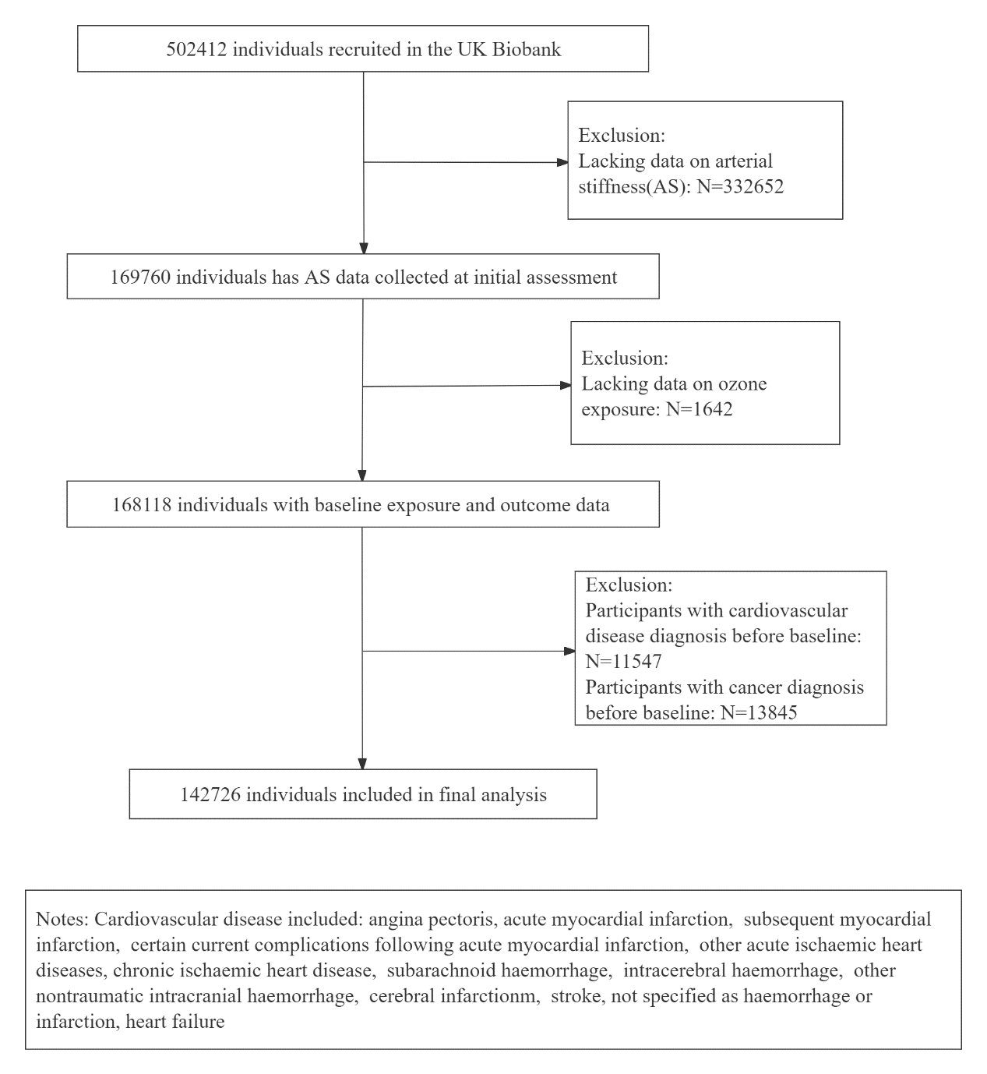

Figure 1 Flow chart of the study sample

Arterial stiffness measurement
Our health outcome is AS. Participants were asked to exhale and inhale at rest slowly, during which the PulseTrace PCA2 (CareFusion, San Diego, CA, USA) device was clipped at the finger (usually the index finger) and over a period of 10-15 seconds the device would capture the pulse waveform using an infrared sensor²⁵. The time interval between the systolic peak and the second diastolic peak in the pulse waveform, defined as the peak-to-peak time (PPT), reflects the stiffness of the artery, with more stiffness resulting in shorter PPT ²⁶. As this time is related to height, the ASI was calculated by dividing the individual's height (in metres) by PPT. The measurement is simple, rapid and is correlated with PWV²⁷.

Air pollution exposure measurement
In this study, ozone concentrations were estimated mainly using Weather Researching and Forecasting (WRF) model and Community Multiscale Air Quality (CMAQ) model, combining anthropogenic and natural emissions data ^{28,29}. We used annual mean ozone concentrations in 2019 at a spatial resolution of 20m×20m. Annual mean concentration in 2010 for particulate matter with aerodynamic diameter ≤2.5 μm (PM2.5), NO2, and NOx was obtained from UK biobank. The European Study of Cohorts for Air Pollution Effects project's Land Use Regression (LUR) model was used to make estimates of the regional variability in yearly mean air pollutant concentrations.³⁰. Annual air pollutants concentrations were assigned based on a 1000 m buffer of each participant's residential address using address information provided by UK Biobank (https://biobank.ndph.ox.ac.uk/showcase/ukb/docs/UKgrid.pdf). Air pollutants levels are reported in µg/m³.

Covariates assessment
Individual-level covariates included age (continuous), sex (male, female), smoking status (never, previous, current), alcohol status (never and special occasions only as not often, other status as often), ethics (white, other). Variables of financial and work aspects including, employment (in paid employment or self-employed as active, other status as inactive); Townsend deprivation (five classifications, least deprived to most deprived); highest level of education (with or without College or University). Dietary and lifestyle variables included, fish intake (≥2 times per week and < 2 times per week), vegetable intake including raw and cooked vegetable intake, (≥4 tablespoons and <4 tablespoons per day), fruit intake, defined as the daily intake of fresh fruit (≥3 pieces and <3 pieces); red meat intake includes total intake of beef, lamb and pork (classified as ≤2 times per week, >2 times per week), vitamin intake (classified as yes or no)^{31,32}. Sedentary status combines the time spent watching TV, using the computer and driving during the day, and after excluding values that exceed 14 hours (greater than 99.5% of the distribution), the values are divided into two categories: ≥4 hours and ＜4 hours^{33,34}.

We conducted multiple imputation (m = 5) using a chain equation based on the proportion of missing data to the overall observations, with all covariates included in the imputation equation³⁵. In the sensitivity analysis we additionally adjusted for family history of cardiovascular diseases, hypertension, diabetes. The history of any first-degree relative, father, mother, siblings was taken into account³⁶.

Statistical analyses
We used a doubly robust approach, which has been increasingly used to investigate the association between air pollution and health outcomes³⁷⁻³⁹. The approach includes two stages, the first stage was using a linear model to calculate the inverse probability weight (IPW) of exposure based on the selected covariates, considering the influence of outliers, we assigned values over 99th percentile to the 99th percentile and values less than 1st percentile to the 1st percentile. The second stage was a multiple linear regression, adjusting for the same confounding factors for the analysis.

Based on prior knowledge and existing literature, using the online DAGitty tool, we develop a directed acyclic graph (DAG) to identify potential covariates that need adjusting (e Figure 1)^{40,41}. We fitted three models, model 1 adjusted for age, sex, smoking status, and alcohol status. Model 2 further adjusted for socio-economic factors, including Townsend deprivation, education, ethnicity, and employment. Model 3 further adjusted for some diet and lifestyle factors including fish intake, vegetable intake, fruit intake, red meat intake, vitamin intake, and sedentary status. We used model 3 as the main model in our study. We also investigated the trend in the association between ozone and AS by converting it to a categorical variable based on the ozone quintile and by including the median of each classification as a continuous variable in the model. A stratified analysis of fish oil intake was then conducted, group comparison was evaluated by adding interaction terms in the model 3.

We further conduct several sensitivity analyses, (1) Only included White participants as more than 90% of the UK biobank population is White people. (2) Excluding participants who changed the home address from baseline to 2019. (3) We used the two-pollutant model to test the robustness of our main results by controlling for PM_{2.5}, NO₂, and NOx separately. (4) We further adjusted for family history of heart disease, stroke, hypertension and diabetes.

All analyses were performed in R software. (4.2.0, R Foundation for Statistical Computing, Vienna, Austria) using packages “tidyverse”, “mice”, “WeightIt”, and “survey”. Two-tailed 95% confidence intervals (CI) are given for beta (β), and we estimated the association between ozone and AS per 10 μg/m³ increment.

Results
The characteristics of the participants are shown in table 1. Among 142671 participants, 54.6% were female, the average age is 57 years old. 56.7% never smoke, and 79.3% often drink alcohol. About one-third of participants had obtained a university or college degree, and there were slightly more participants in active work status than inactive work status (58.5% and 41.5% respectively). For dietary supplements, about two-thirds of the population took fish oil, and the proportion of vitamins taken was similar. The mean concentration of ozone exposure in the population was 45.83 μg/m³, while PM_{2.5}, NO₂, and NOx were 9.89μg/m³, 27.14μg/m³, 42.79μg/m³ respectively.

Table 1 Participant Characteristics at the UK Biobank Assessment
 | Level | Overall (N=142726)
Age (median [IQR]) |  | 57.00 [50.00, 63.00]
Sex (%) | Male | 64742 (45.4)
 | Female | 77980 (54.6)
Smoking status (%) | Never | 80905 (56.7)
 | Previous | 47468 (33.3)
 | Current | 14353 (10.1)
Alcohol status (%) | Not often | 29497 (20.7)
 | Often | 113229 (79.3)
Education (%) | Other | 93113 (65.2)
 | University or college degree | 49613 (34.8)
Ethnicity (%) | Other | 12930 (9.1)
 | White | 129796 (90.9)
Employment (%) | Active | 83561 (58.5)
 | Inactive | 59165 (41.5)
Townsend deprivation (%) | Q1 (least deprived) | 23319 (16.3)
 | Q2 | 27793 (19.5)
 | Q3 | 29155 (20.4)
 | Q4 | 32713 (22.9)
 | Q5 (most deprived) | 29746 (20.8)
Sedentary (%) | No | 48335 (33.9)
 | Yes | 94391 (66.1)
Fish oil intake (%) | No | 99661 (69.8)
 | Yes | 43065 (30.2)
Vitamin intake (%) | No | 96851 (67.9)
 | Yes | 45875 (32.1)
Vegetable intake (%) | >=4 tablespoons per day | 49334 (34.6)
 | <4 tablespoons per day | 93392 (65.4)
Red meat intake (%) | >=2 times a week | 21122 (14.8)
 | <2 times a week | 121604 (85.2)
Fruit intake (%) | >=3 pieces per day | 92190 (64.6)
 | <3 pieces per day | 50536 (35.4)
Fish intake (%) | >=2 times a week | 13030 (9.1)
 | <2 times a week | 129696 (90.9)
Ozone (median [IQR]) |  | 45.83 [42.24, 48.91]
PM_{2.5} (median [IQR]) (N=140910) |  | 9.89 [9.31, 10.43]
NO₂ (median [IQR])  (N=140910) |  | 27.14 [22.08, 31.85]
NO_{x} (median [IQR])  (N=140910) |  | 42.79 [35.20, 50.13]
ASI (median [IQR]) |  | 8.92 [6.84, 11.10]

We found positive association between per 10μg/m³ increase in ozone and AS under all three adjusted models, the beta (95%CI) for fully adjusted model is 0.233 [CI: 0.196 to 0.270]. We found a beneficial association between fish oil intake and ASI, compared to non-fish oil consuming participants, those who took fish oil were associated with lower ASI (-0.051 [-0.097 to -0.005]; model 3). When ozone was considered as a quintile variable, taken the lowest quintile as reference, participants exposure in the highest quintile was associated with higher ASI (0.323 [CI: 0.268 to 0.379]). Also, a significant positive trend was found between ozone exposure levels and ASI (p for trend <0.001).

Table 2 the association between ozone exposure with fish oil and arterial stiffness. β coefficients and 95% CI per 10 μg/m3 increment.
Exposure | Model1ª |  | Model2^{b} |  | Model3^{c}
Exposure | β (95%CI) | P | β (95%CI) | P | β (95%CI) | P
Ozone (continuous) | 0.214 (0.182 to 0.246) | <0.001 | 0.242 (0.207 to 0.277) | <0.001 | 0.233 (0.196 to 0.270) | <0.001
Fish oil consumption | -0.048 (-0.088 to -0.008) | 0.020 | -0.051 (-0.091 to -0.011) | 0.013 | -0.051 (-0.097 to -0.005) | 0.030
Quartiles of ozone
Q1 | Reference | Reference | Reference | Reference | Reference | Reference
Q2 | 0.218 (0.164 to 0.273) | <0.001 | 0.239 (0.184 to 0.294) | <0.001 | 0.229 (0.172 to 0.285) | <0.001
Q3 | 0.378 (0.304 to 0.451) | <0.001 | 0.390 (0.317 to 0.464) | <0.001 | 0.372 (0.297 to 0.448) | <0.001
Q4 | 0.389 (0.339 to 0.439) | <0.001 | 0.425 (0.372 to 0.477) | <0.001 | 0.402 (0.348 to 0.455) | <0.001
Q5 | 0.298 (0.247 to 0.349) | <0.001 | 0.347 (0.293 to 0.401) | <0.001 | 0.323 (0.268 to 0.379) | <0.001
P for trend | <0.001 |  | <0.001 |  | <0.001
Notes:
a: Model 1 adjusted for: age, sex, smoking status, alcohol status
b: Model 2 further adjusted for: Townsend deprivation, education, ethnicity, employment
c: Model 3 further adjusted for: fish intake, vegetable intake, fruit intake, red meat intake, vitamin intake, sedentary status
d: The trend test is based on the median of each quintile as a continuous variable.

Table 3 shows estimates from stratified analyses by fish oil intake. We found that ozone exposure had lower estimate on ASI in fish oil intake people, and the effect modification was statistically significant (P interaction=0.040). After adjustment for other air pollutants including PM_{2.5}, NO₂, NO_{X}, the modification effect was still strong.

Table 3 Effect modification of fish oil in the association between ozone exposures and arterial stiffness. β coefficients and 95% CI per 10 μg/m3 increment.
Exposure | fish oil consumption | β (95% CI) | P value for interaction
Ozone | No | 0.260(0.216 to 0.304) | ref
Ozone | Yes | 0.173(0.107 to 0.239) | 0.040
Ozone + PM_{2.5} | No | 0.253(0.206 to 0.300) | ref
Ozone + PM_{2.5} | Yes | 0.163(0.094 to 0.231) | 0.038
Ozone + NO₂ | No | 0.244(0.193 to 0.295) | ref
Ozone + NO₂ | Yes | 0.149(0.075 to 0.222) | 0.038
Ozone + NOx | No | 0.252(0.204 to 0.300) | ref
Ozone + NOx | Yes | 0.164(0.094 to 0.234) | 0.038

To test the robustness of the model, several sensitivity analyses were conducted. Estimates for ozone and fish oil remained significant in the two-pollutant model (Table 4). After excluding participants who experienced address change from baseline to 2019, the associations of ozone and fish oil with ASI were still strong in the three adjusted models (Table s1). In analyses that included only white participants, the results remained consistent with the main model (Table S2). In addition, the results were stable after further adjustment for family history of cardiovascular diseases, hypertension, and diabetes (Table S3).

Table 4 the association between ozone with fish oil exposure and arterial stiffness further adjusted for other air pollutants. β coefficients and 95% CI per 10 μg/m3 increment.
Exposure |  | Model | β (95%CI) | P
ozone | +PM_{2.5}^{d} | Model1ª | 0.222 (0.187 to 0.257) | <0.001
fish oil consumption | +PM_{2.5}^{d} | Model1ª | -0.045 (-0.086 to -0.005) | 0.029
ozone | +PM_{2.5}^{d} | Model2^{b} | 0.232 (0.194 to 0.270) | <0.001
fish oil consumption | +PM_{2.5}^{d} | Model2^{b} | -0.059 (-0.101 to -0.016) | 0.007
ozone | +PM_{2.5}^{d} | Model3^{c} | 0.225 (0.186 to 0.263) | <0.001
fish oil consumption | +PM_{2.5}^{d} | Model3^{c} | -0.048 (-0.094 to -0.002) | 0.043
ozone | +NO₂e | Model1 ª | 0.226 (0.187 to 0.265) | <0.001
fish oil consumption | +NO₂e | Model1 ª | -0.045 (-0.086 to -0.005) | 0.029
ozone | +NO₂e | Model2 ^{b} | 0.221 (0.180 to 0.263) | <0.001
fish oil consumption | +NO₂e | Model2 ^{b} | -0.059 (-0.101 to -0.016) | 0.007
ozone | +NO₂e | Model3 ^{c} | 0.216 (0.174 to 0.258) | <0.001
fish oil consumption | +NO₂e | Model3 ^{c} | -0.048 (-0.094 to -0.002) | 0.043
ozone | +NO_{x}^{f} | Model1 ª | 0.224 (0.188 to 0.260) | <0.001
fish oil consumption | +NO_{x}^{f} | Model1 ª | -0.045 (-0.086 to -0.005) | 0.029
ozone | +NO_{x}^{f} | Model2 ^{b} | 0.232 (0.193 to 0.271) | <0.001
fish oil consumption | +NO_{x}^{f} | Model2 ^{b} | -0.059 (-0.101 to -0.016) | 0.007
ozone | +NO_{x}^{f} | Model3 ^{c} | 0.225 (0.185 to 0.264) | <0.001
fish oil consumption | +NO_{x}^{f} | Model3 ^{c} | -0.048 (-0.094 to -0.001) | 0.043
Notes:
a: Model 1 adjusted for: age, sex, smoking status, alcohol status
b: Model 2 further adjusted for: Townsend deprivation, education, ethnicity, employment
c: Model 3 further adjusted for: fish intake, vegetable intake, fruit intake, red meat intake, vitamin intake, sedentary status
d: Further adjusted for: PM_{2.5} on Model 1 to Model 3, N= 140910
e: Further adjusted for: NO₂ on Model 1 to Model 3, N= 140910
f: Further adjusted for: NO_{x} on Model 1 to Model 3, N= 140910

Discussion
Using baseline data from UK biobank with 142,726 adults, we found a positive association between ozone exposure and ASI and a protective association between fish oil intake and ASI in middle-aged and older adults in the UK. In the general population, taking fish oil might provide protection against ozone-related arterial stiffness.

To the best of our knowledge, this is the first epidemiological study on the association between long-term ozone exposure and arterial stiffness. Previously, only a handful of studies have investigated the relationship between short-term ozone exposure and arterial stiffness. Some suggest an adverse association of ozone exposure with AS. A cross-sectional study conducted in the US included 73 participants at risk of cardiovascular disease and observed a positive association between short-term (one day) ozone concentration and several indicators of arterial stiffness. ⁴². By measuring ozone exposure during 5-6 days of working time in 17 healthy male postal workers, Wu et al. found in panel study that increased concentrations were significantly associated with increased CAVI²⁰. However, a cross-sectional study among 731 hypertensive patients only found an association between O₃ concentration and AS in untreated patients and in the female subgroup.⁴³. According to a study of 3927 participants from the Framingham offspring and third-generation cohorts, short-term exposure to ozone was not associated with CF-PWV ¹⁶. Similarly, another study of 89 healthy adults found no or negative (protective) associations. ⁴⁴.

It should be noted, however, that the above studies have different study designs, sample sizes, exposure times, and arterial stiffness metrics. With the benefit of larger sample size, we have used a homogeneous approach and found an adverse association between annual average ozone exposure and arterial stiffness. In addition, we apply a double robust analysis that helps to improve the grade of observational study evidence by balancing the weights of covariates across exposures and controlling for confounders in the regression model of the outcome.

We found a protective association between fish oil and arterial stiffness in middle-aged and older population, which are consistent with several intervention studies. Chu et al. included 14 randomized controlled trials by meta-analysis, and the pooled results showed that fish oil significantly reduced the level of arterial stiffness compared to controls²¹. A prospective study of more than 2,000 men aged 45-59 years with a median follow-up of 17.8 years showed that PUFA intake was inversely associated with aortic pulse wave velocity ⁴⁵. Tousoulis et al. found omega-3 PUFA improved arterial stiffness in 29 middle-aged adults with metabolic syndrome⁴⁶. However, a recent study in middle-aged obese adults at high cardiac risk observed no significant effect of n-3 FA supplementation on arterial stiffness³³. Due to data limitations, we could not further explore the association between the main ingredients contained in fish oil or years of consumption and arterial stiffness in the general population, so long follow-up and/or exposure estimation improvement studies are necessary.

To the extent of our knowledge, this is the first population-based study which explore the modifying effects of fish oil on the association between ozone and arterial stiffness. But fish oil has been found to protect against other air pollutants-related diseases. Chen et al. found that fish oil may provide important protection against ozone-induced decreases in lung function³². Tong et al. found that fish oil supplements prevented the adverse cardiac effects associated with ambient air particles⁴⁷. In another RCT study, researchers found that fish oil supplementation was associated with reduced short-term subclinical cardiovascular conditions related to PM_{2.5} exposure in healthy young participants ⁴⁸. We found that fish oil consumption mitigated the association between ozone exposure and increase in ASI. And by using the double robust model, the interaction coefficients were derived on an additive basis, allowing for the direct identification of additional prevalence attributable to fish oil in a stratified analysis⁴⁹.

Several possible mechanisms might be underlying the associations. The inflammatory cytokines produced in the respiratory tract after ozone exposure trigger a systemic inflammatory response that may cause adverse cardiovascular status⁴⁴. One study using UK biobank showed an association between chronic inflammatory disease and the incidence of arterial stiffness⁵⁰. Omega-3 polyunsaturated fatty acids from fish oil play an important role in limiting oxidative and inflammatory damage⁵¹. Previous studies have shown that in rats fed a fish oil diet, aortic vasoconstriction induced by ozone exposure was eliminated, suggesting a cardiovascular protective effect of fish oil⁵². An interventional study conducted in a group of healthy young people found a significant benefit of daily fish oil supplementation on acute oxidative responses caused by combined atmospheric oxides (O₃ and NO₂)²³.

There are several strengths in our study. Firstly, it is the first study to investigate the modifying effect of fish oil on the association of long-term exposure to ozone with AS in the older adults, which will provide a theoretical basis for the contribution of fish oil on the prevention of arterial stiffness and other cardiovascular disease caused by ozone in people at high risk. Secondly, we used a doubly-robust causal approach to assess the association of ozone with AS, to some extent, it makes up for the defects caused by the cross-section design.

There are also some limitations in this study. One concern about the findings was that the cross-sectional design is not able to provide casual association. However, we applied the doubly-robust approach, which can produce an unbiased estimator if either the inverse probability weighting model or the outcome model is correctly specified to large populations studies, which provide relatively robust evidence for our study. Secondly, ozone concentration in 2019 might not reflect its exposure at baseline. Nevertheless, air pollution emissions remained relatively stable from 2010 to 2019 in the UK⁵³, and spatial variability captured by CMAQ air pollution modelling has been shown to be stable. Moreover, we exclude participants who changed their address to test the robustness of the results. Thirdly, we used ASI to measure AS, which may be affected by peripheral blood vessels, and the accuracy of aortic stiffness is lower than PWV. But it is confirmed that ASI is highly correlated to CF-PWV, and it is more rapid, simple, and operator independent, which makes it suitable for studies in large population. Fourthly, we only included data from the UK biobank, which may limit the generalization of the findings, but a large number of populations could provide an indication of the association between ozone and AS. Lastly, the unrecognized confounding factors in the study might also influence the results, and more prospective studies strictly designed are required in the future.

Conclusion
Through a cross-sectional study we found long-term ozone exposure was associated with higher levels of arterial stiffness, in contrast to fish oil consumption, which showed a protective association. Moreover, taking fish oil might provide protection against ozone-related arterial stiffness. Further cohort studies are needed to explore the association in the future.

References:
1 Boutouyrie, P. & Sønder, T. K. in Early Vascular Aging (EVA) (eds Peter M. Nilsson, Michael H. Olsen, & Stéphane Laurent) 75-82 (Academic Press, 2015).
2 Chirinos, J. A., Segers, P., Hughes, T. & Townsend, R. Large-Artery Stiffness in Health and Disease: JACC State-of-the-Art Review. J Am Coll Cardiol 74, 1237-1263, doi:10.1016/j.jacc.2019.07.012 (2019).
3 Herrington, D. M. et al. Relationship between arterial stiffness and subclinical aortic atherosclerosis. Circulation 110, 432-437, doi:10.1161/01.Cir.0000136582.33493.Cc (2004).
4 van Popele, N. M. et al. Association between arterial stiffness and atherosclerosis: the Rotterdam Study. Stroke 32, 454-460, doi:10.1161/01.str.32.2.454 (2001).
5 Mattace-Raso, F. U. et al. Arterial stiffness and risk of coronary heart disease and stroke: the Rotterdam Study. Circulation 113, 657-663, doi:10.1161/circulationaha.105.555235 (2006).
6 Araghi, M. et al. Association of aortic stiffness with cognitive decline: Whitehall II longitudinal cohort study. European journal of epidemiology 35, 861-869, doi:10.1007/s10654-019-00586-3 (2020).
7 Walker, A. E. et al. Greater impairments in cerebral artery compared with skeletal muscle feed artery endothelial function in a mouse model of increased large artery stiffness. J Physiol 593, 1931-1943, doi:10.1113/jphysiol.2014.285338 (2015).
8 Winder, N. R., Reeve, E. H. & Walker, A. E. Large artery stiffness and brain health: insights from animal models. Am J Physiol Heart Circ Physiol 320, H424-h431, doi:10.1152/ajpheart.00696.2020 (2021).
9 Berger, M., Fesler, P. & Roubille, C. Arterial stiffness, the hidden face of cardiovascular risk in autoimmune and chronic inflammatory rheumatic diseases. Autoimmunity reviews 20, 102891, doi:10.1016/j.autrev.2021.102891 (2021).
10 Hughes, T. M. et al. Arterial stiffness and dementia pathology: Atherosclerosis Risk in Communities (ARIC)-PET Study. Neurology 90, e1248-e1256, doi:10.1212/wnl.0000000000005259 (2018).
11 Cohen, J. B. et al. Arterial Stiffness and Diabetes Risk in Framingham Heart Study and UK Biobank. Circ Res 131, 545-554, doi:10.1161/circresaha.122.320796 (2022).
12 Cheung, Y.-f. in Paediatric Cardiology (Third Edition) (eds Robert H. Anderson et al.) 91-116 (Churchill Livingstone, 2010).
13 Vallée, A. Association between serum uric acid and arterial stiffness in a large-aged 40-70 years old population. J Clin Hypertens (Greenwich) 24, 885-897, doi:10.1111/jch.14527 (2022).
14 Baumgartner, J. et al. Household air pollution and measures of blood pressure, arterial stiffness and central haemodynamics. Heart 104, 1515-1521, doi:10.1136/heartjnl-2017-312595 (2018).
15 Walker, E. S. et al. Acute differences in pulse wave velocity, augmentation index, and central pulse pressure following controlled exposures to cookstove air pollution in the Subclinical Tests of Volunteers Exposed to Smoke (SToVES) study. Environ Res 180, 108831, doi:10.1016/j.envres.2019.108831 (2020).
16 Ljungman, P. L. S. et al. Long- and short-term air pollution exposure and measures of arterial stiffness in the Framingham Heart Study. Environ Int 121, 139-147, doi:10.1016/j.envint.2018.08.060 (2018).
17 Gilbey, S. E. et al. The Association between Exposure to Residential Indoor Volatile Organic Compounds and Measures of Central Arterial Stiffness in Healthy Middle-Aged Men and Women. Int J Environ Res Public Health 19, doi:10.3390/ijerph19020981 (2022).
18 Provost, E. B. et al. Short-term fluctuations in personal black carbon exposure are associated with rapid changes in carotid arterial stiffening. Environ Int 88, 228-234, doi:10.1016/j.envint.2015.12.023 (2016).
19 Wu, C. F. et al. Association of short-term exposure to fine particulate matter and nitrogen dioxide with acute cardiovascular effects. Sci Total Environ 569-570, 300-305, doi:10.1016/j.scitotenv.2016.06.084 (2016).
20 Wu, C.-f. et al. Effects of personal exposure to particulate matter and ozone on arterial stiffness and heart rate variability in healthy adults. Am J Epidemiol 171, 1299-1309, doi:10.1093/aje/kwq060 (2010).
21 Chu, Z. et al. Clinical effectiveness of fish oil on arterial stiffness: A systematic review and meta-analysis of randomized controlled trials. Nutr Metab Cardiovasc Dis 31, 1339-1348, doi:10.1016/j.numecd.2020.12.033 (2021).
22 Tong, H. et al. Fish oil and olive oil-enriched diets alleviate acute ozone-induced cardiovascular effects in rats. Toxicology and applied pharmacology 409, 115296, doi:10.1016/j.taap.2020.115296 (2020).
23 Jiang, Y. et al. Alleviated systemic oxidative stress effects of combined atmospheric oxidant capacity by fish oil supplementation: A randomized, double-blinded, placebo-controlled trial. Ecotoxicol Environ Saf 184, 109598, doi:10.1016/j.ecoenv.2019.109598 (2019).
24 Sudlow, C. et al. UK biobank: an open access resource for identifying the causes of a wide range of complex diseases of middle and old age. PLoS Med 12, e1001779, doi:10.1371/journal.pmed.1001779 (2015).
25 Biobank, U. Arterial Pulse-Wave Velocity, <https://biobank.ndph.ox.ac.uk/showcase/ukb/docs/Pulsewave.pdf> (2011).
26 Alty, S. R., Angarita-Jaimes, N., Millasseau, S. C. & Chowienczyk, P. J. Predicting arterial stiffness from the digital volume pulse waveform. IEEE Trans Biomed Eng 54, 2268-2275 (2007).
27 Woodman, R. J. et al. Assessment of central and peripheral arterial stiffness: studies indicating the need to use a combination of techniques. Am J Hypertens 18, 249-260 (2005).
28 Dimakopoulou, K. et al. Development and Evaluation of Spatio-Temporal Air Pollution Exposure Models and Their Combinations in the Greater London Area, UK. 19, 5401 (2022).
29 Williams, M. L. et al. The Lancet Countdown on health benefits from the UK Climate Change Act: a modelling study for Great Britain. Lancet Planet Health 2, e202-e213, doi:10.1016/s2542-5196(18)30067-6 (2018).
30 Eeftens, M. et al. Development of Land Use Regression models for PM(2.5), PM(2.5) absorbance, PM(10) and PM(coarse) in 20 European study areas; results of the ESCAPE project. Environmental science & technology 46, 11195-11205, doi:10.1021/es301948k (2012).
31 Wang, M. et al. Ambient air pollution, healthy diet and vegetable intakes, and mortality: a prospective UK Biobank study. Int J Epidemiol 51, 1243-1253, doi:10.1093/ije/dyac022 (2022).
32 Chen, H. et al. Fish oil blunts lung function decrements induced by acute exposure to ozone in young healthy adults: A randomized trial. Environ Int 167, 107407, doi:10.1016/j.envint.2022.107407 (2022).
33 Hearon, C. M. et al. 1 Year HIIT and Omega-3 Fatty Acids to Improve Cardiometabolic Risk in Stage-A Heart Failure. JACC Heart Fail 10, 238-249, doi:10.1016/j.jchf.2022.01.004 (2022).
34 van de Vegte, Y. J., Said, M. A., Rienstra, M., van der Harst, P. & Verweij, N. Genome-wide association studies and Mendelian randomization analyses for leisure sedentary behaviours. Nat Commun 11, 1770, doi:10.1038/s41467-020-15553-w (2020).
35 White, I. R., Royston, P. & Wood, A. M. Multiple imputation using chained equations: Issues and guidance for practice. Stat Med 30, 377-399, doi:10.1002/sim.4067 (2011).
36 Inouye, M. et al. Genomic Risk Prediction of Coronary Artery Disease in 480,000 Adults: Implications for Primary Prevention. J Am Coll Cardiol 72, 1883-1893, doi:10.1016/j.jacc.2018.07.079 (2018).
37 Xu, H. et al. Increased allostatic load associated with ambient air pollution acting as a stressor: Cross-sectional evidence from the China multi-ethnic cohort study. Science of The Total Environment 831, 155658, doi:https://doi.org/10.1016/j.scitotenv.2022.155658 (2022).
38 Danesh Yazdi, M. et al. Long-Term Association of Air Pollution and Hospital Admissions Among Medicare Participants Using a Doubly Robust Additive Model. Circulation 143, 1584-1596, doi:10.1161/CIRCULATIONAHA.120.050252 (2021).
39 Xue, T. et al. Long-term PM exposure and depressive symptoms in China: A quasi-experimental study. Lancet Reg Health West Pac 6, 100079, doi:10.1016/j.lanwpc.2020.100079 (2021).
40 Diemer, E. W., Hudson, J. I. & Javaras, K. N. More (Adjustment) Is Not Always Better: How Directed Acyclic Graphs Can Help Researchers Decide Which Covariates to Include in Models for the Causal Relationship between an Exposure and an Outcome in Observational Research. Psychother Psychosom 90, 289-298, doi:10.1159/000517104 (2021).
41 Textor, J., van der Zander, B., Gilthorpe, M. S., Liskiewicz, M. & Ellison, G. T. Robust causal inference using directed acyclic graphs: the R package 'dagitty'. Int J Epidemiol 45, 1887-1894, doi:10.1093/ije/dyw341 (2016).
42 Riggs, D. W. et al. Residential proximity to greenness mitigates the hemodynamic effects of ambient air pollution. Am J Physiol Heart Circ Physiol 320, H1102-H1111, doi:10.1152/ajpheart.00689.2020 (2021).
43 Di Pilla, M. et al. Impact of seasonality and air pollutants on carotid-femoral pulse wave velocity and wave reflection in hypertensive patients. PLoS One 12, e0172550, doi:10.1371/journal.pone.0172550 (2017).
44 Day, D. B. et al. Association of Ozone Exposure With Cardiorespiratory Pathophysiologic Mechanisms in Healthy Adults. JAMA Intern Med 177, 1344-1353, doi:10.1001/jamainternmed.2017.2842 (2017).
45 Reinders, I. et al. Higher Plasma Phospholipid n-3 PUFAs, but Lower n-6 PUFAs, Are Associated with Lower Pulse Wave Velocity among Older Adults. J Nutr 145, 2317-2324, doi:10.3945/jn.115.212282 (2015).
46 Tousoulis, D. et al. Omega-3 PUFAs improved endothelial function and arterial stiffness with a parallel antiinflammatory effect in adults with metabolic syndrome. Atherosclerosis 232, 10-16, doi:10.1016/j.atherosclerosis.2013.10.014 (2014).
47 Tong, H. et al. Omega-3 fatty acid supplementation appears to attenuate particulate air pollution-induced cardiac effects and lipid changes in healthy middle-aged adults. Environ Health Perspect 120, 952-957, doi:10.1289/ehp.1104472 (2012).
48 Lin, Z. et al. Cardiovascular Benefits of Fish-Oil Supplementation Against Fine Particulate Air Pollution in China. J Am Coll Cardiol 73, 2076-2085, doi:10.1016/j.jacc.2018.12.093 (2019).
49 Yazdi, M. D. et al. Long-term effect of exposure to lower concentrations of air pollution on mortality among US Medicare participants and vulnerable subgroups: a doubly-robust approach. Lancet Planet Health 5, e689-e697, doi:10.1016/S2542-5196(21)00204-7 (2021).
50 Dregan, A. Arterial stiffness association with chronic inflammatory disorders in the UK Biobank study. Heart (British Cardiac Society) 104, 1257-1262, doi:10.1136/heartjnl-2017-312610 (2018).
51 Raygan, F. et al. A comparison between the effects of flaxseed oil and fish oil supplementation on cardiovascular health in type 2 diabetic patients with coronary heart disease: A randomized, double-blinded, placebo-controlled trial. Phytotherapy Research 33, 1943-1951, doi:https://doi.org/10.1002/ptr.6393 (2019).
52 Snow, S. J. et al. Ozone-Induced Vascular Contractility and Pulmonary Injury Are Differentially Impacted by Diets Enriched With Coconut Oil, Fish Oil, and Olive Oil. Toxicol Sci 163, 57-69, doi:10.1093/toxsci/kfy003 (2018).
53 Department for Environment Food & Rural Affairs. Air quality statistics: an annual update on concentrations of major air pollutants in the UK, <https://webarchive.nationalarchives.gov.uk/ukgwa/20201225100256/https://www.gov.uk/government/statistics/air-quality-statistics> (2020).

Supplementary files
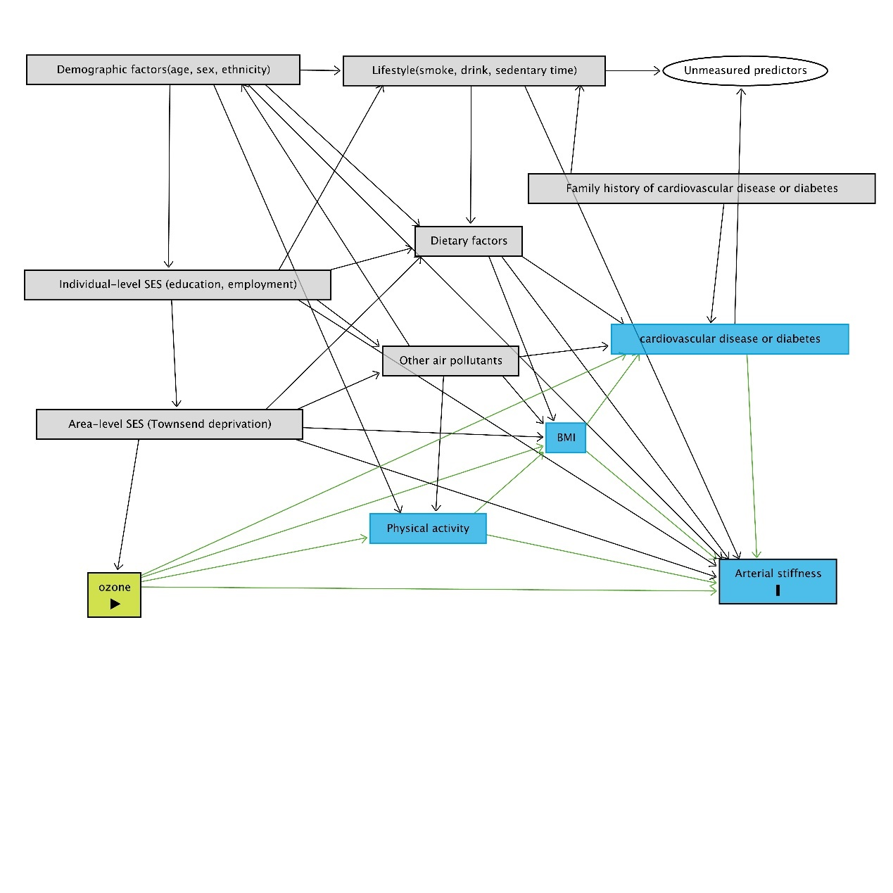
Figure S1 Directed acyclic graph for the association between ozone and arterial stiffness
Notes:
Gray boxes represent adjusted variables in the model, blue boxes represent variables along the causal chain of exposure and outcome, and white ovals represent unidentified confounders.
Dietary factors: fish intake, vegetable intake, fruit intake, red meat intake, vitamin intake.

Table s1 The association between ozone with fish oil exposure and arterial stiffness after excluding participants who changed the home address from baseline to 2019. β coefficients and 95% CI per 10 μg/m3 increment.
Modelª | Exposure | β (95%CI) | p
Model 1^{b} | Ozone | 0.222 (0.187 to 0.257) | <0.001
Model 1^{b} | Fish oil intake | -0.051 (-0.095 to -0.008) | 0.021
Model 2^{c} | Ozone | 0.253 (0.214 to 0.291) | <0.001
Model 2^{c} | Fish oil intake | -0.055 (-0.098 to -0.011) | 0.013
Model 3^{d} | Ozone | 0.242 (0.202 to 0.282) | <0.001
Model 3^{d} | Fish oil intake | -0.055 (-0.105 to -0.005) | 0.030
Notes:
a: N= 124,550
b: Model 1 adjusted for: age, sex, smoking status, alcohol status
c: Model 2 further adjusted for: Townsend deprivation, education, ethnicity, employment
d: Model 3 further adjusted for: fish intake, vegetable intake, fruit intake, red meat intake, vitamin intake, sedentary status

Table S2 the association between ozone with fish oil exposure and arterial stiffness only included White participants. β coefficients and 95% CI per 10 μg/m3 increment.
Model ª | Exposure | β (95%CI) | p
Model 1^{b} | Ozone | 0.233 (0.200 to 0.265) | <0.001
Model 1^{b} | Fish oil intake | -0.059 (-0.100 to -0.019) | 0.004
Model 2^{c} | Ozone | 0.238 (0.204 to 0.272) | <0.001
Model 2^{c} | Fish oil intake | -0.060 (-0.100 to -0.019) | 0.004
Model 3^{d} | Ozone | 0.223 (0.187 to 0.259) | <0.001
Model 3^{d} | Fish oil intake | -0.051 (-0.096 to -0.005) | 0.028
Notes:
a: N= 129,796
b: Model 1 adjusted for: age, sex, smoking status, alcohol status
c: Model 2 further adjusted for: Townsend deprivation, education, ethnicity, employment
d: Model 3 further adjusted for: fish intake, vegetable intake, fruit intake, red meat intake, vitamin intake, sedentary status

Table S3 The association between ozone with fish oil exposure and arterial stiffness further adjusted for family history of cardiovascular diseases, hypertension, diabetes. β coefficients and 95% CI per 10 μg/m³ increment.
Model | Exposure | β (95%CI) | p
Model 1ª | ozone | 0.226 (0.195 to 0.258) | <0.001
Model 1ª | fish oil intake | -0.053 (-0.092 to -0.014) | 0.008
Model 2^{b} | ozone | 0.243 (0.207 to 0.280) | <0.001
Model 2^{b} | fish oil intake | -0.062 (-0.105 to -0.020) | 0.004
Model 3^{c} | ozone | 0.236 (0.199 to 0.272) | <0.001
Model 3^{c} | fish oil intake | -0.050 (-0.096 to -0.004) | 0.032
Notes:
a: N= 139,170
b: Model 1 adjusted for: age, sex, smoking status, alcohol status, family history of cardiovascular diseases, family history of hypertension, family history of diabetes
c: Model 2 further adjusted for: Townsend deprivation, education, ethnicity, employment
d: Model 3 further adjusted for: fish intake, vegetable intake, fruit intake, red meat intake, vitamin intake, sedentary status

