Supplementary information:

Poison Mitigation Strategies for the use of Impure Hydrogen in Electrochemical Hydrogen Pumps and Fuel Cells

C Jacksonª, LFJM Raymakers^{b}, MJJ Mulder^{b}, ARJ Kucernakª
ªDepartment of Chemistry, Imperial College London, Imperial College Rd, London, UK, SW7 2AZ
^{b}HyET (Hydrogen) BV, Westervoortsedijk 71K, 6827 AV Arnhem, The Netherlands

Contents
1. Explosion limits in Hydrogen and air/oxygen systems 1
2. Ozone generation 1
3. Tables of J_{min} for each impure H₂ feed 2
4. Offline regeneration of EHP cells – H₂ + 20 ppm CO 3
5. Offline regeneration of EHP cells – SMR-WGS H₂ 4
6. Offline regeneration of EHP cells – H₂ + 5 ppm H₂S 5
7. Offline regeneration of EHP cells – SMR-WGS-H₂S H₂ 6
8. References 6

Explosion limits in Hydrogen and air/oxygen systems
In hydrogen-air mixtures, the explosive limits are 3.4 – 4.4% (lower explosive limit) to 73.1 – 77.6% (upper explosive limit) of air in H₂ from 20 – 100 °C and 1 – 5 bar[1]. Thus, at concentrations of less than 3.4% air in H₂, the mixture is not explosive, or at concentrations of above 77.6% air in H₂, the mixture is not explosive. In hydrogen-oxygen mixtures, the explosive limits are 3.8 – 4.6% (lower explosive limit) to 94.6 – 95.4% (upper explosive limit) of O₂ in H₂ from 20 – 80 °C and 1 – 5 bar[1]. Thus, at concentrations of less than 3.8% O₂ in H₂, the mixture is not explosive, or at concentrations of above 95.4% O₂ in H₂, the mixture is not explosive. The lower explosion limits for hydrogen-air and hydrogen-oxygen mixtures are similar, with hydrogen-oxygen as a slightly higher value, due to the similar mean molar heat capacities of O₂ (31.594 kJ.mol⁻¹) and N₂ (33.536 kJ.mol⁻¹), as described by Chen[2].

Ozone generation
Ozone is predominately generated by three techniques, ultraviolet exposure of O₂ or air, electrolysis of perchloric acid or electrical discharge applied to O₂ or air[3]. When using electrical discharge applied to O₂, up to 7% O₃ in O₂ may be generated using ~ 11 kWh/kg and if the electrical discharge is applied to air, up to 4% O₃ in air with ~ 25 kWh/kg energy requirement[4]. However, if air is used as an oxygen source, N₂ in air may react to form N₂O and N₂O₅[4].
In this work, an ozone generator (BMT801; BMT Messtechnik GmbH, Germany) powered with a power supply (EA-PS 2032-025, EA Elektro-Automatik GmbH & Co.KG) was used to generate ~4% O₃ in O₂ using pure O₂ as a feed. The ozone composition was confirmed by UV/Vis dual beam spectrometer (UV4-200, ATI-Unicam) at the known ozone UV absorption peak (λ_{max} = 253.7nm, ε=3000±30 dm³ mol⁻¹ cm⁻¹) [5].

Tables of J_{min} for each impure H₂ feed

Table S1: Long term limiting EHP performance as a function of mitigation strategy when operating with different feeds. Long term extrapolated performance $\left(\frac{j_{min}}{j_{max}}\right)$ in %, for the EHP polarised at 100 mV and 200 mV, with and without an O₂ or O₂/O₃ bleed, using Pt/Pt or PtRu/Pt MEAs. See Eq. 17.
 |  | Extrapolated steady-state performance with mitigation strategy $\left(\frac{j_{min}}{j_{max}}\right)$/ %
Anode/Cathode | Feed | Voltage / mV | No mitigation | O₂ bleed | O₂/O₃ bleed
Pt/Pt | H₂+20 ppm CO | 100 | 0.0 | 29.3 | 41.0
Pt/Pt | H₂+20 ppm CO | 200 | 0.0 | 72.7 | 73.6
PtRu/Pt | H₂ | 100 | 96.5 | - | -
PtRu/Pt | H₂ | 200 | 93.9 | - | -
PtRu/Pt | H₂+20 ppm CO | 100 | 0.0 | 89.3 | 91.2
PtRu/Pt | H₂+20 ppm CO | 200 | 0.0 | 88.5 | 88.9
PtRu/Pt | SMR-WGS | 100 | 2.6 | 48.5ª | 59.7
PtRu/Pt | SMR-WGS | 200 | 4.6 | 66.2ª | 72.6
PtRu/Pt | H₂ + 100 ppb H₂S | 100 | 85.4ª | 98.5 | 98.1
PtRu/Pt | H₂ + 100 ppb H₂S | 200 | 84.4ª | 98.8 | 97.8
PtRu/Pt | H₂ + 1 ppm H₂S | 100 | 14.5ª | 6.3 | 58.6
PtRu/Pt | H₂ + 1 ppm H₂S | 200 | 2.2ª | 0.0 | 15.8
PtRu/Pt | SMR-WGS-H₂S | 100 | 1.1 | 33.6 | 66.7
PtRu/Pt | SMR-WGS-H₂S | 200 | 0.0 | 61.5 | 73.5
ª oscillating, unstable current decay

Offline regeneration of EHP cells – H₂ + 20 ppm CO

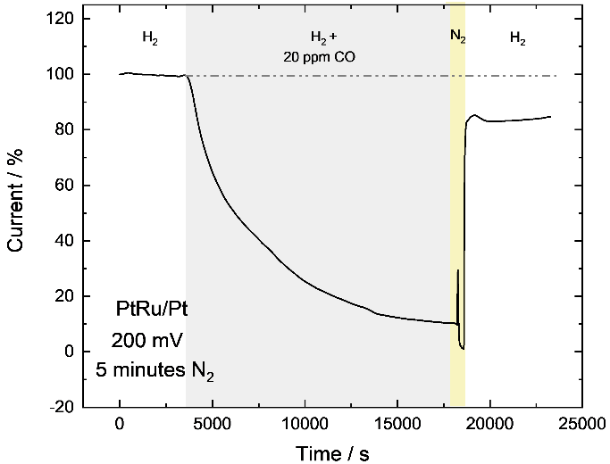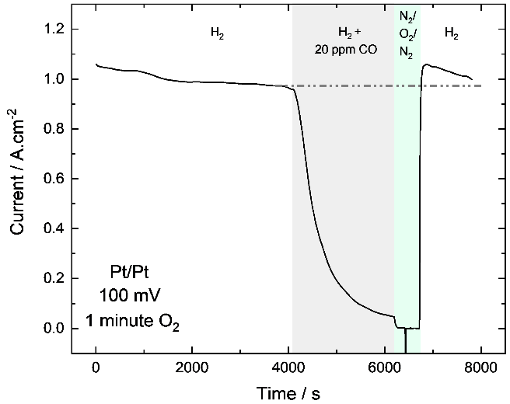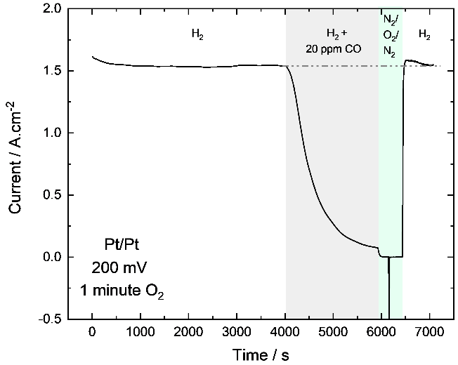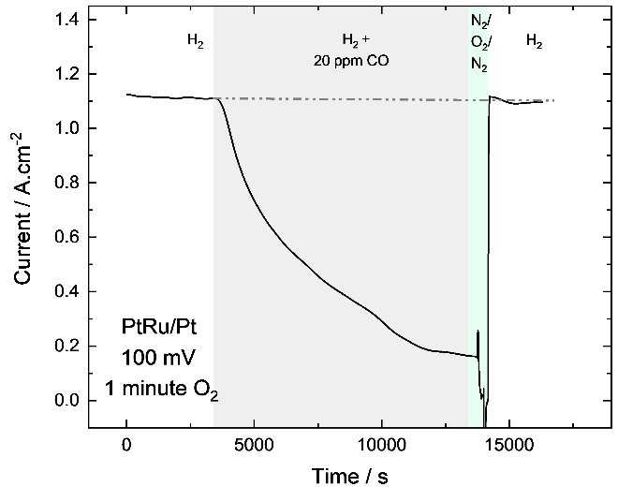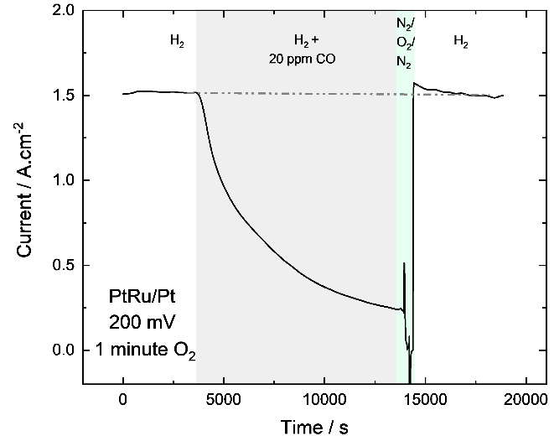
A
B
C
E
D
Figure S1: Effect of offline N₂ and O₂ treatment on EHP recovery after operation on H₂+20 ppm CO. Chronoamperometry at a cell temperature of 35 °C, feed to the anode at a RH of 75% and flowrate of 200 mL.min⁻¹ of N₂, H₂, H₂+20 ppm CO, or 50 mL.min⁻¹ O₂/~4% O₃ + O₂. Gas composition as indicated on the graph with offline O₂ potentiostatic. A) PtRu/Pt MEA at 200 mV with 5 minutes N₂, B) Pt/Pt MEA at 100 mV with 1 minute O₂, C) Pt/Pt MEA at 200 mV with 1 minute O₂, D) PtRu/Pt MEA at 100 mV with 1 minute O₂, E) PtRu/Pt MEA at 200 mV with 1 minute O₂.

Offline regeneration of EHP cells – SMR-WGS H₂
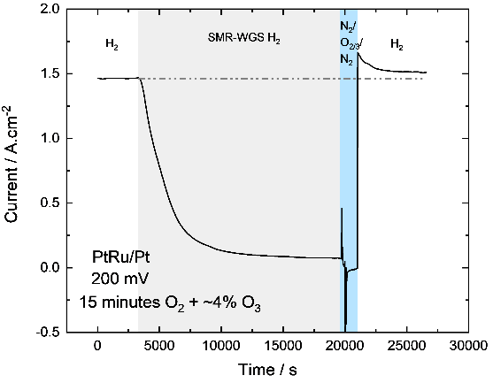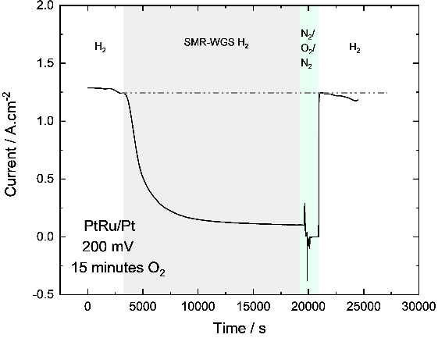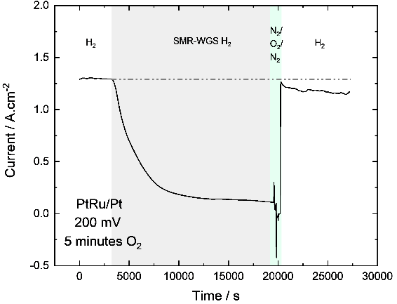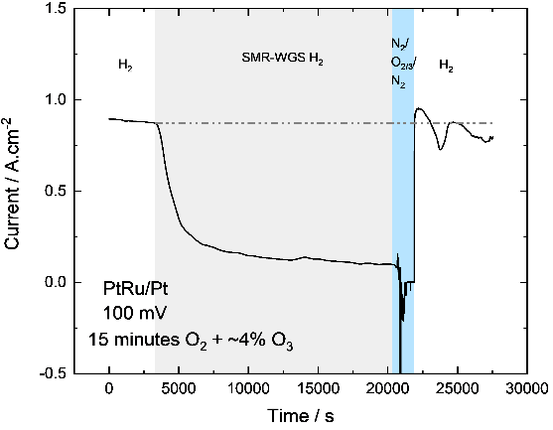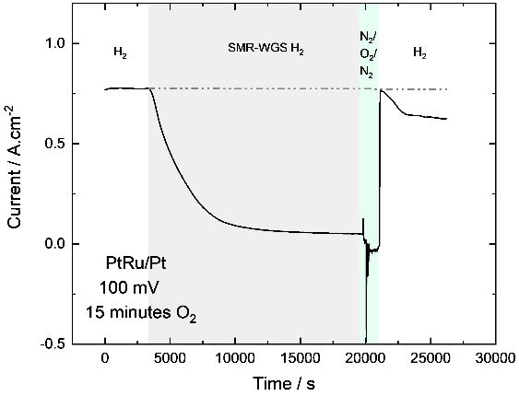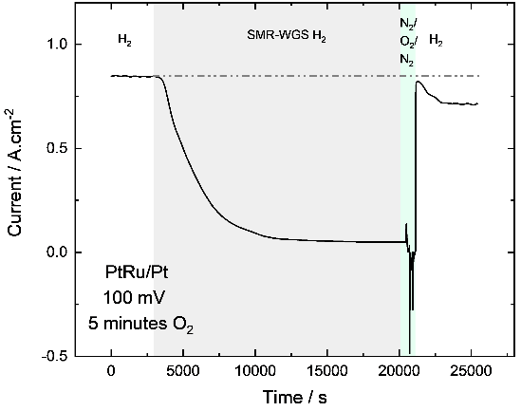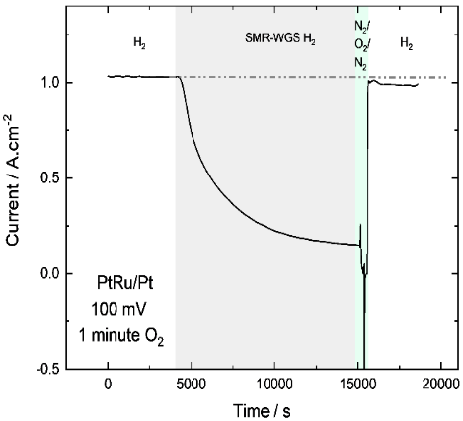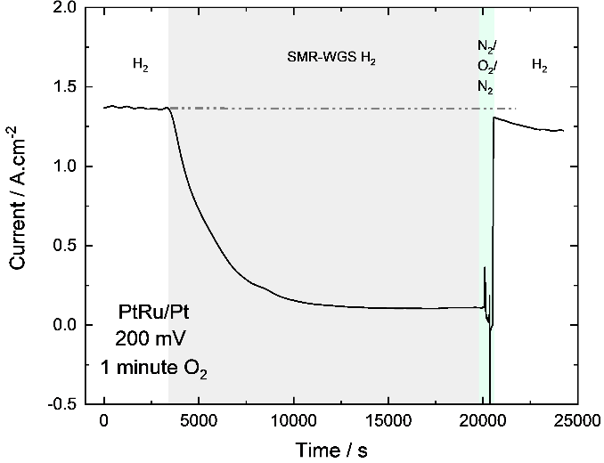
A
B
E
F
C
D
H
G
Figure S2: Effect of offline O₂ treatment on EHP recovery after operation on SMR-WGS H₂. Chronoamperometry at a cell temperature of 35 °C, feed to the anode at a RH of 75% and flowrate of 200 mL.min⁻¹ of N₂, SMR-WGS H₂, or 50 mL.min⁻¹ O₂/~4% O₃ + O₂. Gas composition as indicated on the graph with offline O₂ potentiostatic. A) PtRu/Pt MEA at 100 mV with 1 minute O₂, B) PtRu/Pt MEA at 100 mV with 5 minutes O₂, C) PtRu/Pt MEA at 100 mV with 15 minutes O₂, D) PtRu/Pt MEA at 100 mV with 15 minutes ~4% O₃ + O₂ and E) PtRu/Pt MEA at 200 mV with 1 minute O₂, F) PtRu/Pt MEA at 200 mV with 5 minutes O₂, G) PtRu/Pt MEA at 200 mV with 5 minutes O₂, H) PtRu/Pt MEA at 200 mV with 15 minutes ~4% O₃ + O₂.

Offline regeneration of EHP cells – H₂ + 5 ppm H₂S
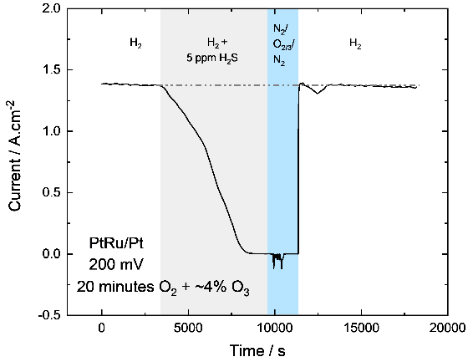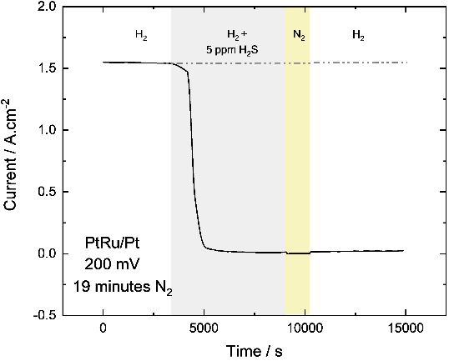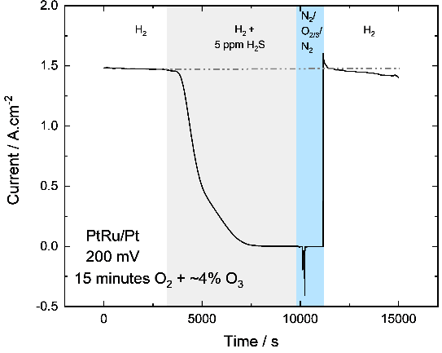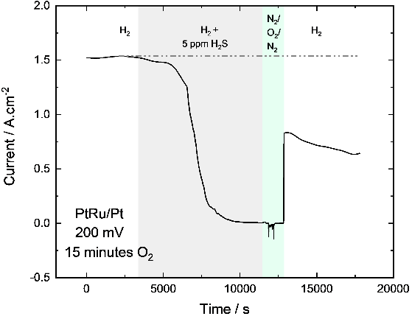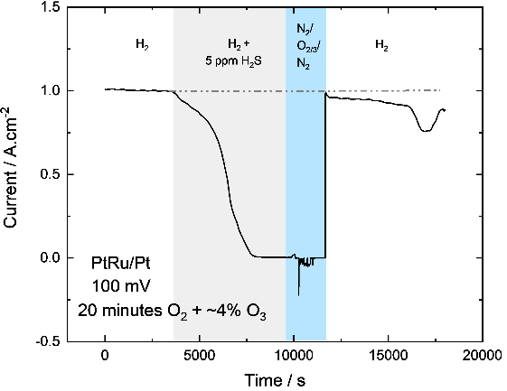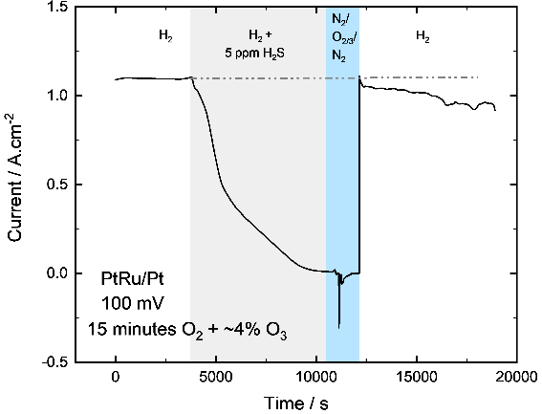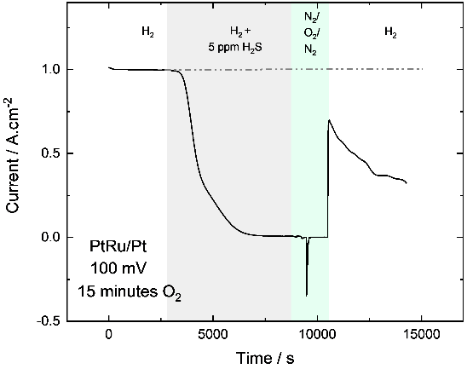
A
B
C
D
E
F
G
Figure S3: Effect of offline N₂ and O₂ treatment on EHP recovery after operation on H₂+5 ppm H₂S. Chronoamperometry at a cell temperature of 35 °C, feed to the anode at a RH of 75% and flowrate of 200 mL.min⁻¹ of N₂, H₂, H₂+5 ppm H₂S or 50 mL.min⁻¹ O₂/~4% O₃ + O₂. Gas composition as indicated on the graph with offline O₂ potentiostatic. A) PtRu/Pt MEA at 100 mV with 15 minutes O₂, B) PtRu/Pt MEA at 100 mV with 15 minutes ~4% O₃ + O₂, C) PtRu/Pt MEA at 100 mV with 20 minutes ~4% O₃ + O₂ D) PtRu/Pt MEA at 200 mV with 15 minutes O₂ and E) PtRu/Pt MEA at 200 mV with 15 minutes ~4% O₃ + O₂ F) PtRu/Pt MEA at 200 mV with 20 minutes ~4% O₃ + O₂, G) PtRu/Pt MEA at 200 mV with 19 minutes N₂.

Offline regeneration of EHP cells – SMR-WGS-H₂S H₂
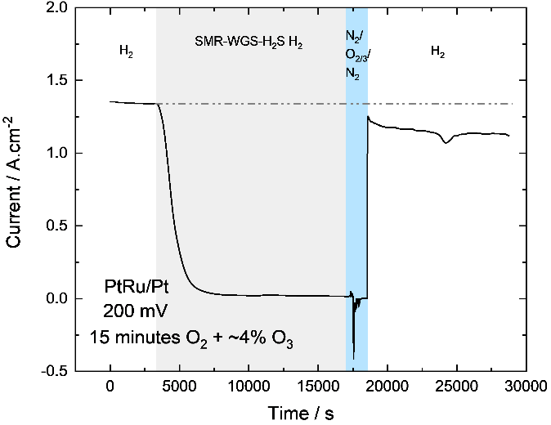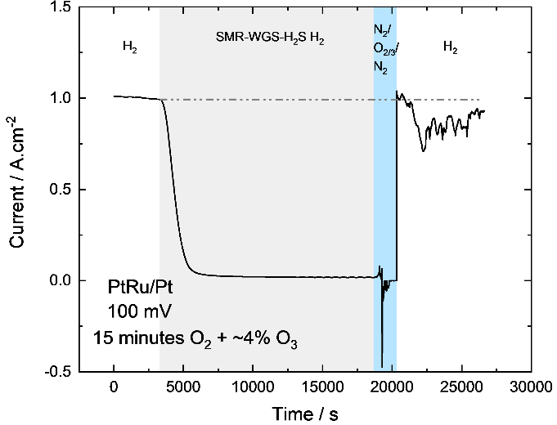Figure S4: Effect of offline N₂ and O₂/O₃ treatment on EHP recovery after operation with SMR-WGS-H₂S H₂. Chronoamperometry at a cell temperature of 35 °C, feed to the anode at a RH of 75% and flowrate of 200 mL.min⁻¹ of N₂, H₂, SMR-WGS-H₂S H₂, or 50 mL.min⁻¹ O₂/~4% O₃ + O₂. Gas composition as indicated on the graph with offline O₂ potentiostatic. A) PtRu/Pt MEA at 100 mV with 15 minutes ~4% O₃ + O₂ and B) PtRu/Pt MEA at 200 mV with 15 minutes ~4% O₃ + O₂.
A
B

References
[1] V. Schroeder, K. Holtappels, in, 2005.
[2] C.-C. Chen, Industrial & Engineering Chemistry Research, 50 (2011) 10283-10291.
[3] P.A. Balakrishnan, A. Arunagiri, P.G. Rao, in, 2002, pp. 77-86.
[4] S. Stucki, Process Technologies for Water Treatment, Springer US, 2013.
[5] K. Rakness, G. Gordon, B. Langlais, W. Masschelein, N. Matsumoto, Y. Richard, C.M. Robson, I. Somiya, Ozone-Science & Engineering, 18 (1996) 209-229.

