Supplementary Material

Appendix 1. Previous study designs
The open label (OL) parent study (Study VX13-809-011B) was a phase 3, open-label, single arm, multicentre study that evaluated the safety, tolerability, and efficacy of lumacaftor/ivacaftor therapy over 24 weeks.1 Eligible participants had a percent predicted forced expiratory volume in 1 second (ppFEV₁) ≥40% and investigator-determined stable disease. Fifty-eight children aged 6 to 11 years with cystic fibrosis homozygous for F508del-CFTR received lumacaftor 200 mg/ivacaftor 250 mg every 12 hours for 24 weeks (in addition to their usual standard-of-care medications for cystic fibrosis). Children then completed a 2-week washout and either attended a safety follow-up visit or rolled over into Study 110.
The randomised controlled trial (RCT) parent study (Study VX14-809-109) was a phase 3, randomised, double-blind, placebo-controlled, multicentre study evaluating the efficacy and safety of lumacaftor/ivacaftor in children aged 6 to 11 years with cystic fibrosis homozygous for F508del-CFTR.² The primary outcome was lung clearance index at 2∙5% of normalised tracer gas concentration (LCI_{2∙5}). Eligible participants had a ppFEV₁ ≥70%, an LCI_{2∙5} ≥7∙5 (the upper limit of normal for the age group), and investigator-determined stable disease at screening. A total of 204 children were randomised 1:1 to receive either lumacaftor 200 mg/ivacaftor 250 mg or matched placebo every 12 hours for 24 weeks and either attended a safety follow-up visit or rolled over into Study 110.

Appendix 2. Additional outcomes

Summary of pulmonary exacerbation endpoints
Pulmonary exacerbations (PEx) during the lumacaftor/ivacaftor treatment period were evaluated only in children from the RCT study. The median time to first PEx could not be estimated in the placebo to lumacaftor/ivacaftor (P→L/I) group because <50% of children in the group had a PEx. The third quartile of time to first PEx could not be estimated for either the P→L/I or lumacaftor/ivacaftor to lumacaftor/ivacaftor (L/IàL/I) group because <75% of children in each group had events during the lumacaftor/ivacaftor treatment period. The median time to first PEx during the treatment period for the L/IàL/I group was 720 (interquartile range, 278·00-not estimable) days.
Pulmonary exacerbations occurred in 51 children (49·5%) in the L/IàL/I group (cumulative rate from the RCT study and Study 110 [120 weeks]) and in 31 children (32·3%) in the P→L/I group (from Study 110 only [96 weeks]). The event rate per patient-year in the L/I→L/I group was 0·45 (95%CI, 0·33 to 0·61) and in the PàL/I group was 0·30 (95% CI, 0·21 to 0·43).
Few of the events in the L/I→L/I or P→L/I groups required hospitalisation or antibiotic treatment. The median time to first PEx requiring hospitalisation could not be estimated for either group.

Rate of change in lung function endpoints
The rate of change in lung function endpoints (lung clearance index at 2∙5% [LCI_{2∙5}] and 5∙0% [LCI_{5∙0}] of normalised tracer gas concentration and percent predicted forced expiratory volume in 1 second [ppFEV₁]) was analysed on data starting on Day 15 after the first dose of lumacaftor/ivacaftor treatment (in either the parent study or Study 110) using a linear mixed model. In this analysis, a rate of change equal to zero would indicate that treatment effects were stable from Day 15 onwards.
LCI_{2·5} and LCI_{5·0} decreased rapidly (improved) by Day 15 after treatment initiation, and these improvements were sustained up to Week 96 in Study 110. The LCI_{2·5} rate of change, expressed as slope (95% CI), was −0·01 (−0·12 to 0·09), and the LCI_{5·0} rate of change was 0·00 (−0·04 to 0·04).
The ppFEV₁ rate of change from day 15 after the first dose of lumacaftor/ivacaftor remained stable or increased once children started treatment with lumacaftor/ivacaftor, resulting in a positive rate of change of 0·58 (95% CI, 0·02 to 1·14).

Ophthalmological assessments
Nine of 239 children (3·8%) had cataracts/lens opacities during Study 110, which were not considered visually significant and did not lead to lumacaftor/ivacaftor interruption or discontinuation. No AE related to lens findings was considered serious. All lens findings were present at parent study baseline, resolved with continued lumacaftor/ivacaftor treatment, or were associated with confounding risk factors (e.g., corticosteroid use or family history).

Table S1. Definition of adverse events of special interest: elevated transaminases and respiratory events
Elevated Transaminases | Respiratory Events
Alanine aminotransferase abnormal  Alanine aminotransferase increased  Aspartate aminotransferase abnormal  Aspartate aminotransferase increased  Transaminases abnormal  Transaminases increased  Liver function test abnormal  Liver function test increased  Hypertransaminasaemia  Hepatic enzyme abnormal  Hepatic enzyme increased | Chest discomfort  Dyspnoea  Respiration abnormal  Asthma  Bronchial hyperreactivity  Bronchospasm  Wheezing

Table S2. Adverse events leading to treatment discontinuation
Number of Patients | 4 | 1 | 1 | 1 | 1 | 1
Adverse Events | Increased ALT  Increased AST | Autoimmune hepatitis | CF hepatic disease | Forced expiratory volume decreased  Respiration abnormal  Asthma | Abdominal pain  Diarrhoea  Vomiting | Hot flush  Urticaria

All events leading to treatment discontinuation were considered either related or possibly related to lumacaftor/ivacaftor. The majority of events had outcomes of recovery/resolution.
ALT, alanine aminotransferase; AST, aspartate aminotransferase; CF, cystic fibrosis.

Table S3. Adverse events of special interest
Participants
(N=239)
Respiratory events, n (%) | 44 (18·4)
Respiration abnormal | 14 (5·9)
Wheezing | 12 (5·0)
Asthma | 10 (4·2)
Dyspnoea | 10 (4·2)
Chest discomfort | 5 (2·1)
Elevated transaminase events, n (%) | 46 (19·2)
Increased ALT | 45 (18·8)
Increased AST | 32 (13·4)
ALT, alanine aminotransferase; AST, aspartate aminotransferase.

Table S4. Additional secondary endpoints
 | L/I→L/Iª  (N=143) | P→L/Iª  (N=96)
Absolute change from parent study BL at week 96 of the extension study, LS mean (95% CI; SE)
LCI_{5·0} | −0·21 (−0·36 to −0·06; 0·08)^{b} [N=117] | −0·31 (−0·49 to −0·13; 0·09)^{b} [N=96]
Relative change in ppFEV₁, % | 4·9 (2·2 to 7·5; 1·3) | 0·5 (−2·9 to 4·0; 1·8)
TSQM global satisfaction domain, points | 5·1 (1·7 to 8·4; 1·7) | 3·9 (−0·6 to 8·5; 2·3)
BL, baseline; LCI_{5·0}, lung clearance index (turnovers required to reduce the concentration of tracer gas to 5·0% of its starting concentration); L/I→L/I, lumacaftor/ivacaftor to lumacaftor/ivacaftor group; LS, least squares; P→L/I, placebo to lumacaftor/ivacaftor group; ppFEV₁, percent predicted forced expiratory volume in 1 second; TSQM, Treatment Satisfaction Questionnaire for Medication.
ª Calculated from the children with data available at both time points.
^{b} Children evaluable for LCI (ie, LCI set) included 96 children in the P→L/I group and 117 children in the L/I→L/I group.

Figure S1. Extension study design
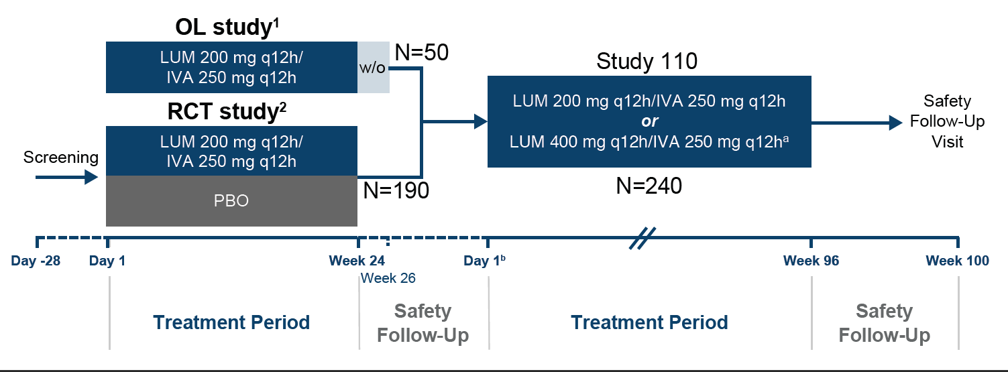

IVA, ivacaftor; LUM, lumacaftor; OL, open label; PBO, placebo; q12h, every 12 hours; RCT, randomised controlled trial; w/o, 2-week washout.
ª Once children reached age 12, they began receiving LUM 400 mg q12h/IVA 250 mg q12h at the next scheduled visit.
^{b} The day 1 visit of Study 110 was the same day as the week 24 visit (last treatment period visit) of the RCT study or the week 26 visit (safety follow-up visit) of the OL study for participants at Study 110 sites that had been activated by the time the Week 24 Visit (RCT study) or the Week 26 Visit (OL study) had been completed. The Day 1 Visit of Study 110 did NOT coincide with the Week 24 Visit (last Treatment Period visit) of the RCT study or the Week 26 Visit (Safety Follow-up Visit) of the OL study for participants at Study 110 sites that had NOT been activated by the time the Week 24 Visit (RCT study) or the Week 26 Visit (OL study) had been completed. Participants at these nonactive sites had to repeat any Study 110 Day 1 assessments (in addition to completing Study 110-specific Day 1 events/assessments) that were specified to be performed at the Week 24 Visit (RCT study) or the Week 26 Visit (OL study).

Figure S2. Study design schematic (including observational cohort and treatment period 2)

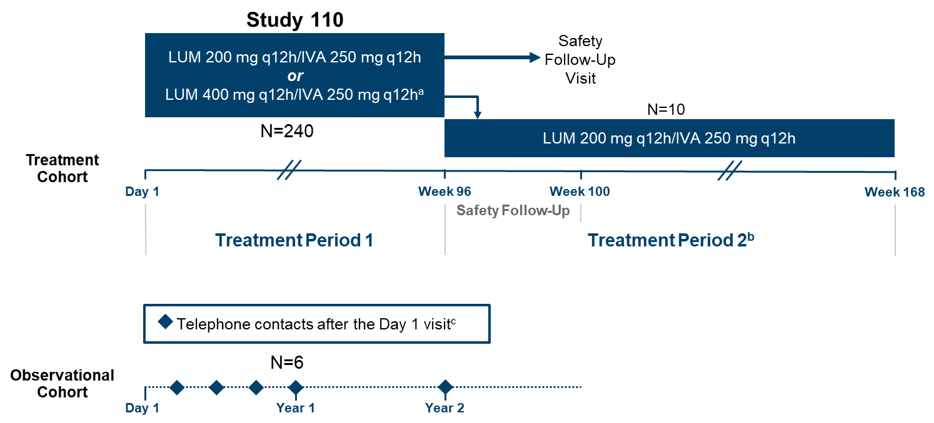
IVA, ivacaftor; LUM, lumacaftor; q12h, every 12 hours.
ª Participants who turned 12 years of age in the parent study or on Day 1 of Study 110 began receiving LUM 400 mg/IVA 250 mg on Day 1. Participants who turned 12 years of age after the Day 1 visit of Study 110
began receiving LUM 400 mg/IVA 250 mg at their next scheduled visit.
^{b} At selected sites, some participants aged 6 through 11 years in the treatment cohort who completed treatment period 1 of Study 110 entered treatment period 2. Week 96 of treatment period 1 was the start of treatment period 2.
^{c} A telephone contact was made every 3 to 4 months during the first year and at approximately 2 years (± 4 weeks).

References

1 Milla CE, Ratjen F, Marigowda G, et al. Lumacaftor/Ivacaftor in patients aged 6-11 years with cystic fibrosis and homozygous for F508del-CFTR. Am J Respir Crit Care Med 2017; 195(7): 912-20.
2 Ratjen F, Hug C, Marigowda G, et al. Efficacy and safety of lumacaftor and ivacaftor in patients aged 6-11 years with cystic fibrosis homozygous for F508del-CFTR: a randomised, placebo-controlled phase 3 trial. Lancet Respir Med 2017; 5(7): 557-67.

