Hydrogen supply chain optimisation for the transport sector –Focus on hydrogen purity and purification requirements
ªD. Wickham, ªA.D. Hawkes, ^{b,c*}F. Jalil-Vega
ªDepartment of Chemical Engineering, Imperial College London, SW7 2AZ, United Kingdom
^{b}Faculty of Engineering and Sciences, Universidad Adolfo Ibáñez, Diagonal Las Torres 2640, Peñalolén, Santiago, Chile
^{c}Instituto Sistemas Complejos de Ingeniería, Chile

Abstract
This study presents a spatially-resolved optimisation model to assess cost optimal configurations of hydrogen supply chains for the transport sector up to 2050. The model includes hydrogen grades and separation/purification technologies, offering the possibility to assess the effects that hydrogen grades play in the development of cost-effective hydrogen supply chains, including the decisions to repurpose gas distribution networks or blending hydrogen into them. The model is implemented in a case study of Great Britain, for a set of decarbonisation and learning rate scenarios. A base case with a medium carbon price scenario shows that the total discounted cost of the hydrogen supply chain is significantly higher than shown in previous studies, largely due to the additional costs from purification/separation needed to meet hydrogen purity standards for transport applications. Furthermore, it was shown that producing hydrogen from steam methane reforming with carbon capture and storage; installing new transmission pipelines; repurposing the gas distribution network to supply 100% hydrogen; and purifying hydrogen with a pressure swing adsorption system locally at the refuelling station; is a cost optimal configuration for the given technoeconomic assumptions, providing hydrogen at £6.18 per kg at the pump. Purification technologies were found to contribute to 14% and 30% of total discounted investment and operation costs respectively, highlighting the importance of explicitly including them into hydrogen supply chain models for the transport sector.
Keywords: Hydrogen, hydrogen-to-vehicle, gas distribution network, hydrogen purity, hydrogen purification, hydrogen supply chain

Introduction
Global concern around environmental climate change due to fossil fuel consumption and raised CO₂ emissions is growing rapidly [1], spurring organisations and governments to implement strategies in order to mitigate and adapt to climate change effects. As advised by the Intergovernmental Panel on Climate Change in 2018 [2], the Paris Climate Agreement aims to limit the global temperature rise to a 1.5ºC increase. To combat this, new solutions regarding energy systems are being developed and proposed worldwide. Hydrogen, when produced from low-carbon supply chains, has been recognised as a potential future alternative in the replacement of fossil fuels [3]. Particularly, attention has been drawn towards sectors which up until now have proven to be difficult to decarbonise [4], such as the transport and heating sectors [5].
Hydrogen for use in the transport sector -as opposed to the heating sector- has the caveat that it has to meet specific purity standards, otherwise it will poison the membrane of fuel cell electric vehicles [6]. This work focuses on the development of a low-carbon hydrogen supply chain for the transport sector. Up until now, no supply chain model for the transport sector was identified in the literature which considers hydrogen purity, as well as hydrogen purification requirements. This is vital, as excluding this level of granularity can cause an under-estimation of the cost of a hydrogen supply chain. The novelty of this work is that it proposes a spatially-resolved supply chain methodology and optimisation model for hydrogen for the transport sector, which explicitly includes hydrogen purity and purification technologies, considering their costs and technical requirements, in addition to the production and transportation technologies in a hydrogen supply chain. No previous hydrogen supply chain model includes hydrogen purity and purification technologies, which is crucial for transport applications, to avoid poisoning the fuel cells in fuel cell electric vehicles. Furthermore, the model is implemented for a case study of Great Britain, to display its robustness and applicability to different scenarios and research questions, serving as a basis for researchers to apply this framework and the data here presented in future models and analyses with an international focus.
This article is organised as follows: A background section firstly presents the main components in hydrogen supply chains and how they play a role in developing a decarbonised transport sector; and secondly analyses existing hydrogen supply chain models, leading to the aims of this work. The methodology section describes the proposed model, the main input data and assumptions, and the cases and scenarios for which the model was implemented. The results and discussion section lays out the main results for the case studies and scenarios, finishing with a conclusion which summarises the main findings of this work.

Background

Hydrogen supply chains for transport
The automotive industry has been under increasing pressure to decarbonise [7]. Transport accounts for around 18% of primary energy use and 17% of global CO₂ emissions [8], and is considered a difficult-to-decarbonise sector. Hydrogen, therefore, offers an alternative that could provide a solution to the vehicular market globally. The main advantages of using hydrogen as an alternative fuel is that it is emission-free at the point of use; it can be produced using a wide range of energy sources; and it can be stored with minimal energy loses over time [9].
Hydrogen can be used as a fuel in the transport sector through either Internal Combustion Engines (ICEs) [10], or through Fuel Cells [11]. Hydrogen ICEs work on the same thermal combustion principle that is currently used in fossil fuel powered cars. Fuel Cell Electric Vehicles (FCEVs) work on the principle of using a fuel cell stack (most commonly a Proton Exchange Membrane (PEM)) to pass compressed hydrogen over a membrane and react it with oxygen to create an electrical current in an external circuit. This external circuit powers an electrical motor, which in turn powers the wheels. Hydrogen as a fuel for FCEVs has to meet specific purity standards, otherwise it will poison the membrane of the fuel cell. At the moment of completing this study, the most up-to-date standard is the ISO 14687-2:2012 standard for hydrogen fuel being used in a PEM fuel cell application for road vehicles [6].
In order to take the hydrogen from production through to the refuelling station pump, a supply chain has to be developed. The potential hydrogen supply chain can be broken down into five main components: production, transmission, separation/purification, distribution, and refuelling stations as seen in Figure 1. Each component of the supply chain includes potential technologies to serve each function, as described in Table 1. Another aspect to be carefully considered at each section is the grade of hydrogen, as this can affect the overall cost and configuration of the supply chain downstream. As covered in Section 2.2, hydrogen purity in hydrogen supply chain optimisation is yet to be considered, and doing this can highlight the granularity in the cost optimum way of developing hydrogen supply chains in the future.
Figure 1:Potential hydrogen supply chain schematic for transport industry.
Table 1: Components of a hydrogen supply chain and possible technology options for each component.
Supply chain component | Explanation | Technology Options
Production | Production of hydrogen can occur either in a large-scale centralised facility where it will benefit from economies of scale and higher production efficiencies. However, it requires substantial hydrogen transportation measures to be installed [12]. Alternatively, production can be distributed, closer to the demand, so it requires less of a transport infrastructure, however, it misses out on the benefits of economies of scale [13]. | - Steam methane reforming  - Membrane methane reforming  - Gasification  - Pyrolysis  - Electrolysis
Transmission | Transmission can be considered the ‘motorway’. It refers to the part of hydrogen transportation that moves the bulk from centralised production sites to ‘substations’ closer to the hydrogen demand [14]. | - Dedicated hydrogen pipeline  - Repurposing gas transmission network  - Truck/trailers
Distribution | Distribution can be considered the ‘city streets’. It refers to the last leg of the hydrogen transport system, delivering smaller quantities to the end user (in the case for the transport sector, to refuelling stations) [14]. | - Dedicated hydrogen pipeline  - Repurposing gas distribution network  - Truck/trailers
Separation/Purification | Separation and purification is required in the hydrogen supply chain in order to adhere to ISO 14687-2:2012 standards [6]. Separation and purification can be installed at various places in the supply chain, depending on the desired configuration. It can be placed in a large-scale centralised facility, where it can increase the purity of hydrogen from transmission, and feed it into the distribution system. One of the main advantages to this approach is, like in production, a large centralised purification facility will benefit from economies of scale. However, purifying hydrogen at this stage will required pure hydrogen to be distributed to the refuelling station which could incur higher transportation costs.  Separation and purification can also be placed locally at the refuelling site. One of the main advantages to this is hydrogen can be any grade up to this point (included being blended into a gas distribution network) allowing for cheaper transportation costs. However, a main drawback of this method is small scale localised separation and purification will not benefit from economies of scale. | - Pressure swing adsorption  - Cryogenic distillation  - Selective membranes  - Electro-chemical purification
Refuelling Station | Hydrogen refuelling stations is the point of dispensing the fuel to the end of use application, in this case the FCEV. Major work has been completed by developing equipment standards and refuelling protocols for high pressure (700 bar) and fast dispensing (<3min) and there are four types of refuelling stations [15]. | - Stations receiving liquid hydrogen requiring evaporation and compression facilities.  - Stations receiving compressed hydrogen (200bar) from trailers requiring high-compression units.  - Stations receiving compressed hydrogen ( ̴100bar) from pipeline requiring high- compression units.  - Stations with onsite hydrogen production from electrolysis requiring compress from 15 to 700 bar.

Hydrogen supply chain systems modelling
Because of the vast array of technology combinations in a hydrogen supply chain, energy systems modelling - specifically optimisation modelling - is an essential tool to compare all combinations simultaneously in order to minimise investment and operational costs, and emissions of a proposed supply chain. Furthermore, developing an energy systems model allows for the inclusion of other factors, such as spatial aspects, in order to achieve a greater level of resolution of estimations (e.g. capital costs of hydrogen transmission or distribution technologies).
Almansoori and Shah [16] present one of the first studies to be completed on modelling and optimisation of a hydrogen supply chain, with the UK as a case study, from a whole systems point of view. This early work considered a relatively simple supply chain by comparison to more recent models, however, spurred a new generation of research that developed on the principles and methodology set out in this paper. This model lacked any sort of renewable hydrogen generation, possibly as a result of the progress of renewable energy production technologies at the time of the publication and did not have a temporal aspect included in the formulation. The uptake of FCEVs in the model was also optimistic, as it considered all cars to adopt the hydrogen powertrain. This is unlikely as recent studies show that hydrogen powertrains are more cost-effective for certain market niches and thus unlikely to dominate the whole of the transport sector [17].
The next set of optimisation models identified were those that focus more on a specific range of technologies, often resulting in an exclusion or decrease in detail of other aspects of the hydrogen supply chain. Yang and Ogden [18] looked in great detail at the delivery section of the hydrogen supply chain, for two scenarios: 1) A centralised plant to a centralised delivery point; 2) Centralised plant to a distributed Hydrogen Refuelling Station (HRS). Their research was used to analyse how hydrogen’s phase state and transportation technologies can affect the overall cost of delivery, and which is the most optimal for the previously stated scenarios with a high and low demand. They concluded that pipelines are favoured under high demand and long delivery distances; liquid hydrogen transported on trucks are favoured for medium demands over medium distances; and for small demands over small distances compressed gas trucks are preferred.
Johnson and Ogden [19] and Baufumé et al. [20] both brought in the aspect of using GIS systems to provide a highly detailed spatial structure to their optimisation models. Both models utilised GIS modelling to identify existing production and refuelling station facilities, using optimisation modelling to match these two assets up with the least cost. Both models, however, lack a temporal aspect and only restrict production to current infrastructure limits the possibilities.
Although not specifically the transport sector, Dodds and Demoullin [21] assessed the conversion of the UK’s gas distribution network to supply hydrogen for the heating sector, with a particular emphasis on the technical and safety aspects, and developed a whole methodical process of analysing it from this perspective. Once they identified that hydrogen could technically be transported in low-pressure distribution pipelines, they utilise the UK-MARKAL model to assess the economic benefit. They conclude that converting the gas networks to hydrogen is a lower-cost residential decarbonisation pathway for the UK than those previously identified.
Reuß et al. [22] look at hydrogen supply chain modelling from a slightly different aspect. They analysed whether the current favoured methodology of representing the supply chain as a Linear Problem Formulation gives an accurate account of the dynamics of the supply chain by comparing it to a non-linear formulation. To achieve this, they develop both a linear and non-linear supply chain model for hydrogen pipelines in Germany with a spatial aspect (excluding temporal aspects, presumably to help reduce the computational requirements to run the model). Their results show that although the non-linear formulation for a systems wide model does provide a slightly more accurate account, and thus allows for lower global minima when compared to the linear model, the drastic increase in computational burden to run the non-linear model completely negates any of these benefits.
The next big step in hydrogen supply chain modelling identified in this literature review was the introduction of sector coupling as a concept and methodology. One of the first models developed in this space was by Samsatli et al. [23] who looked at the development of a hydrogen supply chain for the Great Britain’s (GB) transport market, utilising the STeMES model (Samsatli et al [24]). They also introduced the concept of allowing the model to choose to either transmit the energy as electricity or as hydrogen and conducted a detailed GIS study of the land availability for wind farms. Their results indicated that all of GB’s domestic transport demand can be met by on-shore wind through appropriately designed and operated hydrogen-electricity networks.
Robinius et al. [25] was one of the first papers to note this increasing trend in integrating the electricity and hydrogen supply chains and coined the term “Sector Coupling”, which was then used to model a sector coupling scenario for power and transport sectors in Germany [26]. In these two papers, Robinius et al. lay out the general principles behind sector coupling and develop a working definition. They then go on to produce the spatial and temporal model METIS with a case study of the power and transport sector in Germany. The whole concept behind sector coupling was allowing the utilisation of surplus electricity generated in power sector to be used to produce hydrogen through the form of electrolysis. Results showed that surge power from wind farms in the North could supply 75% of the German transport market with hydrogen, which showed the potential of linking both the power and transportation industry.
Reuß et al. [27] took sector coupling a step further and was one of the first to consider hydrogen storage in detail in order to overcome the issues with hydrogen production from renewable energy generation. Reuß et al. [28] developed this concept and broke down the transportation of hydrogen into transmission and distribution, in particular the setup of a transmission pipeline with gaseous trailer distribution, by producing a spatial and temporal hydrogen supply chain model for Germany up to 2050. They also consider production through PEM electrolysis, as it allows the utilisation of excess renewable energy generation (however, the model does not take into consideration the actual hourly variation in surplus electrical energy generated by renewables), plus storage in salt caverns to overcome the seasonal variance in production. Their research showed the importance of salt caverns, as well as transmission pipelines, as key technologies for future hydrogen infrastructure systems.
Colbertaldo et al. [29] also took the sector coupling approach to analyse the development of supply chains for the Italian vehicular market through a spatially and temporally explicit model. Their work expands on previous sector coupling models by integrating a wider range of production technologies ranging from renewables to conventional fossil fuels, as well as considering both power sector electric energy storage (e.g. pumped hydro and batteries) and hydrogen storage. Furthermore, the model takes into consideration the load due to plug-in electric vehicles as well as those from hydrogen vehicles. Their work displayed the potential for a majority of hydrogen demand for the transport sector to be met by surplus renewables (~80%) whilst also meeting 57% of the plug-in electric vehicle demand.
Carrera et al. [30] also developed a hydrogen and methane optimisation model taking into consideration sector coupling through Power-to-Hydrogen and Power-to-Methane concepts whilst applying it to the Occitania region of France. Potrč et al. [31] propose a detailed study of sector coupling by considering the development of hydrogen supply chains along with a wide variety of other energy vectors such as renewable electricity; biomass; and waste resources across the whole of Europe, decarbonising the transport and power sectors with a 10-year temporal resolution up to 2050. One of the disadvantages of the scale of this work is that it loses all spatial resolution, as each country is modelled as one geographic node, and only the production side of the energy system is considered in detail. The next set of hydrogen supply chain models that were identified in this literature review were those that took into consideration not only the economic aspects but also integrating emissions reduction into the Objective Function of the model. Almansoori and Betancourt-Torcat [32] propose an optimisation model, with the specific application of emission constraints in Germany for the year 2030, through the integration of carbon taxes to impose a financial burden on heavy greenhouse as emitting processes. The model assesses the primary energy source production technologies, storage, and distribution networks as well as including Carbon Capture and Storage technologies.
Moreno-Benito et al. [33] also took a similar approach and looked at an optimisation of a full hydrogen supply chain in the UK, with a temporal logistic diffusion model that reaches a 50% share of the market by 2070, and a spatial characterisation of both regional and local scale considerations. The model takes into consideration tightening GHG emissions, as well as being one of the first models to take into consideration the discounted cash flow; residual value of the infrastructure and inclusion of Carbon Capture and Storage technologies.
Ochoa et al. [34] developed a hydrogen supply chain model for hydrogen for the transport sector in Occitania, France, using a multi-objective formulation, which includes costs, carbon emissions, and risk, under demand uncertainty. Fazli-Khalaf et al. [35] developed a mixed probabilistic programming method to account for mixed uncertainties in hydrogen supply chain inputs, adding metrics for reliability and social responsibility. Ehrenstein et al. [36] took the aspect of including environmental impacts into the model a step further, applying the optimisation supply chain model of Almansoori and Shah [16] to the concept of planetary boundaries; a set of biophysical limits critical for the safe operation of the planet. This allowed them to run a wide set of scenarios to identify the wider scale financial and large-scale environmental impacts from hydrogen supply chain design configurations. Finally, Cantú et al. [37] took the model from Almansoori and Shah [16] and applied a more efficient tool for the design of sustainable hydrogen supply chains considering both economic and environmental factors. This study proposes a hybrid solution strategy that reformulates the original problem into a bi-level optimisation problem. The upper level (discrete problem) consists of finding the optimal location for production plants and storage facilities, whereas the lower level (continuous problem) minimises their corresponding costs. The results show that the proposed hybrid approach produces an accurate approximation of the Pareto-optimal fronts more efficiently than the exact solution approach.
There are abundant hydrogen supply chain models developed and all have come far from the original developed by Almansoori and Shah [16] - taking into account a wide range of technologies and applying various different methodologies. Up until now, they all have included the main components of Production, Transportation (sometimes split into Transmission and Distribution), Storage, and Hydrogen Refuelling Stations, neglecting the inclusion of hydrogen separation/purification technologies into the methodology and development of the supply chain model. Table 2 summarises the main features of the models reviewed, breaking them down into the specific characteristics of each of the models and their methodologies, as well as highlighting the lack of inclusion of hydrogen purity and separation/purification technologies.
Table 2: Summary of hydrogen supply chain model features.
Ref | Country | Production | Transportation | Storage | Refuelling | Purification
[16] | United Kingdom | - SMR  - Coal Gasification  - Biomass Gasification | - Tanker Trucks (GH2 & LH2)  - Rail Car (GH2 & LH2)  - Spatial Aspect | - Storage Vessels (GH2)  - Super Insulated Storage Vessels (LH2) | No | No
[18] | N/A | N/A | - Tanker Trucks (GH2 & LH2)  - Pipeline  - No Spatial Aspect | - Storage Vessels (GH2)  - Super Insulated Storage Vessels (LH2)  - Pipeline storage (GH2) | Yes | No
[19] | Southwestern USA | - Coal Gasification (with CCS) | - Pipeline (GH2)  - Spatial Aspect | No | No | No
[28] | Germany | - PEM electrolysis from windfarms data in [26] | - Pipeline  - Tanker Truck  - Spatial Aspect | - Storage vessels. (GH2)  - Geological formations (GH2)  - Super insulated storage vessels (LH2).  - LOHC tanks. | Yes | No
[20] | Germany | - Electrolysis using off-shore wind.  - Lignite gasification. | - Pipeline (GH2)  - Spatial Aspect | No | Yes, Existing Stations | No
[21] | United Kingdom | - SMR (With/without CCS)  - Coal gasification (with/without CCS)  - Biomass gasification (with/without CCS) | - Pipeline (GH2)  - Spatial Aspect | No | N/A | No
[22] | Germany | - Renewable Electricity Sources | - Pipeline (GH2)  - Spatial Aspect | - Geological Formations (GH2) | No | No
[25, 26] | Germany | - Renewable Electricity Sources | - Pipeline (GH2)  - Spatial Aspect | - Geological formations (GH2) | Yes | No
[23] | United Kingdom | - Electrolysis from wind turbines. | - Pipeline (GH2)  - Electricity transmission lines.  - Spatial Aspect | - Geological Formations (GH2)  - Storage vessels. (GH2) | Yes | No
[29] | Italy | - SMR  - Coal Gasification  - Biomass Gasification  - Renewable Electricity Sources | - Pipeline (GH2)  - Electricity transmission lines.  - Spatial Aspect | - Battery Storage  - Pumped Hydro  - Compressed Hydrogen (GH2) | No | No
[30] | Occitania, France | - SMR  - Electrolysis from Wind  - Electrolysis from Solar  - Electrolysis from Hydro  - Electrolysis from Grid | - Tanker Truck (GH2)  - Spatial Aspect | - Compressed Hydrogen Tanks (GH2) | Yes | No
[31] | European Union | - Gasification  - SMR  - Electrolysis | - Not Considered | - Not Considered | No | No
[33] | United Kingdom | - SMR; Coal gasification; Biomass gasification (with/without CCS)  - Electrolysis from wind | - Tanker (LH2 & GH2)  - Pipelines (GH2)  - Spatial Aspect | - Storage Vessels (GH2)  - Super Insulated Storage Vessels (LH2) | Yes | No
[32] | Germany | - SMR; Coal gasification; (with CCS)  - Biomass gasification | - Tanker Trucks (GH2 & LH2)  - Rail Car (GH2 & LH2)  - Spatial Aspect | - Storage Vessels (GH2)  - Super Insulated Storage Vessels (LH2) | No | No
[34] | Occitania, France | - SMR,  - Central electrolysis, and distributed electrolysis | - Tanker Truck (LH2) | - Storage vessels (LH2) | Yes, existing stations | No
[36] | United Kingdom | - SMR  - Electrolysis from wind  - Electrolysis from solar PV  - Electrolysis from nuclear | - Tanker Trucks (GH2 & LH2)  - Rail Car (GH2 & LH2) | - Storage Vessels (GH2)  - Super Insulated Storage Vessels (LH2) | No | No
[37] | United Kingdom | - SMR  - Electrolysis from wind  - Electrolysis from solar PV  - Electrolysis from hydro  - Electrolysis from nuclear | - Tanker Truck (LH2) | - None | No | No
[38, 39] | N/A | - SMR; Coal gasification; Biomass gasification (with/without CCS)  - Electrolysis | - Tank trucks (GH2 & LH2)  - Shipping (LH2)  - Pipeline (GH2)  - No Spatial Aspect | - Super insulated storage vessels (LH2)  - Geological Formations (GH2)  - Storage vessels (GH2) | Yes | No

Conclusion from the literature and aims of this work
As discussed in this review, several HSC models have been proposed in the literature, with differing approaches and assumptions. More recent developments in hydrogen supply chain model development mainly fall into three categories: The first focusing on high technical details of specific aspects of the HSC; the second taking the whole supply chain into the power sector (sector coupling); and finally, those that take into consideration emissions as well as economics in the objective function (either through carbon emissions costs, or multi-objective optimisation methods). However, to the best of the authors’ knowledge, there have been no models developed that include the costing of purification technologies while simultaneously including the whole supply chain from production through to refuelling stations. No current model has taken into consideration hydrogen purification technologies and purity grades that would be required to meeting FCEVs standards as mentioned in Section 2.1.
Therefore, the main objective of this work is to formulate and implement a spatially-resolved optimisation model to assess cost-effective pathways for full hydrogen for transport supply chains, from production to refuelling stations, while taking into consideration purification technologies and purity grades. The model will then be applied to the transport sector of Great Britain, to display its robustness and applicability for different research questions, serving as a basis for researchers to apply this framework in future models and analyses with an international focus.

Materials and methods

Model description
This work proposes a linear programme model that optimises a hydrogen supply chain to provide hydrogen demands for transport. It takes into account different components of a hydrogen supply chain and minimises the total net present value of the system’s costs for a modelled time horizon from 2020 to 2050.
The model makes decisions on investment and decommissioning of equipment every 5-year periods, for production, regional transportation, local transportation, purification, and refuelling station technologies and infrastructure. The decision variables include the capacity and operation of different technologies available in the components of the supply chain, their location, and the year in which they are installed. Furthermore, the model can also choose the grade of hydrogen at each component of the supply chain, by either purifying or not, leading to clarification of what layout of purification is most cost-effective (i.e. hub and spoke, or distributed purification). Operational decisions include the total rate of production in each zone, the total transportation rate from one zone to another, the total transportation rate within each zone, and the total purification rate of hydrogen in each zone.
Hydrogen grade is assumed to take on one of four forms - pure, which is assumed to be ~100-99.97% hydrogen; clean, assumed to be ~99.97-99% hydrogen; dirty, assumed to be ~99-95% hydrogen; and blended, assumed to be ~20% hydrogen.
The model is formulated so that hydrogen can be delivered at a specific grade $g$; produced through production technology $p$; transmitted through transportation technology $l$ from zone $z$ to $z^{'}$, and distributed through transportation technology $l$ in zone $z$; purified either at a central location in each zone, or localised at the refuelling station using purification technology $c$. Figure 2 shows a schematic of all the potential pathways hydrogen can take in the supply chain model.
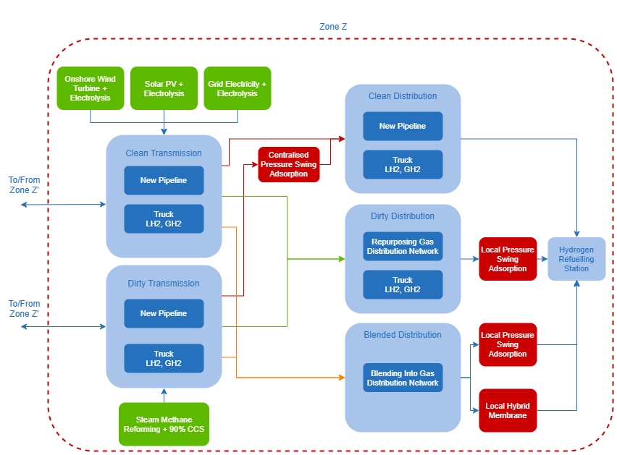
Figure 2: Hydrogen infrastructure network diagram showing all potential supply chain pathways; Green blocks show production technologies; blue blocks show transportation technologies; red blocks show purification technologies.

Model formulation: main constraints
The model proposed in this research is formulated as a linear programme optimisation model that minimises the net present value of the total system’s cost through 2050. This section shows the main constraints for the model formulation. The nomenclature and whole formulation can be found in Appendix A and Appendix B, respectively.

Objective function
The objective function, shown in Equation (1), minimises the total net present value of the capital and operating costs of the hydrogen supply chain. The total cost includes production facilities operating and capital costs ($POC$ and $PCC$); transportation operating costs and capital costs ($TOC$ and $TCC$); purification facilities operating costs and capital costs ($PurOC$ and $PurCC$); refuelling station facilities operating and capital costs ($RFOC$ and $RFCC$); and the cost associated with carbon emissions ($CARBON$). The total cost subtracts the salvage cost of assets at the end of the modelling time horizon ($PSV$, $TSV$, $PurSV$ and $RFSV$ for production facilities, transportation facilities, purification facilities and refuelling station facilities, respectively).
 | $$\min{TC}=\min\left[POC+PCC+TOC+TCC+PurOC+PurCC+RFOC+RFCC-PSV-TSV-PurSV-RFSV+CARBON\right]$$ | (1)

Material balances
Equation (2) shows the material balance in a zone $z$. This equation states that the hydrogen that is being produced in a zone (${PR}_{p,z,g,y}$) plus the hydrogen that is being transported into the zone ($Q_{l,z^{'},z,g,y}$), need to equate the flow of hydrogen leaving the zone ($Q_{l,z,z^{'},g,y}$) plus the hydrogen that is being consumed within ($QLOC_{l,z,g,y})$, for each time period. The term $QLOC_{l,z,g,y}$ is the flow of hydrogen that is going into the local transportation network via transportation mode $l$. As shown in Equation (3), it is assumed that all the hydrogen flowing to the localised distribution network in zone $z$ is being used to supply the refuelling station demand of the same zone.
 | $$\sum_{p,g}{{PR}_{p,z,g,y}}+\sum_{l,z^{'},g}{Q_{l,z^{'},z,g,y}}-\sum_{l,z^{'},g}{Q_{l,z,z^{'},g,y}}-\sum_{l,g}{QLOC_{l,z,g,y}}=0 ∀z,y$$ |  | (2)
$$\frac{\overline{D_{z,y}}}{α}=\sum_{l,g}{QLOC_{l,z,g,y}} ∀z,y$$ |  | (3)
Next, the material balance for clean hydrogen grade was considered. Clean hydrogen can either be produced in zone $z$ by clean hydrogen production technology $p$ (such as electrolysis) in the subset $CP(p)$, or it can enter zone $z$ from transmission from zone $z^{'}$, through transportation technology $l$ transporting clean hydrogen, in the subset $CL(l)$. A third way clean hydrogen can enter a zone is by dirty hydrogen being cleaned in a centralised hub in zone $z$, so that it may enter clean hydrogen distribution, represented by the flow variable $QCLEANED_{z,y}$.
Clean hydrogen may leave zone $z$, by transmission out to zone $z^{'}$ through transportation technology $l$ in the subset $CL(l)$. It can also flow into the localised clean distribution system in zone $z$ through transportation technology $l$ in the subset $CL(l)$. Finally, it can be added into dirty hydrogen distribution, or blended into the local gas distribution network represented by the variables $QDIRTIED_{z,y}$ and $QBLEND_{z,y}^{Clean}$, respectively. This is shown in Equation (4).
 | $$\sum_{p∈CP(p)}{{PR}_{p,z, clean,y}}+\sum_{l∈CL\left(l\right),z^{'}}{Q_{l,z^{'},z,clean,y}}-\sum_{l∈CL\left(l\right),z^{'}}{Q_{l,{z,z}^{'},clean,y}}-\sum_{l∈CL\left(l\right)}{QLOC_{l,z,clean,y}}+QCLEANED_{z,y}-QDIRTIED_{z,y}-QBLEND_{z,y}^{Clean}=0 ∀z,y$$ | (4)
A third material balance considered is for dirty hydrogen. Dirty hydrogen may enter zone $z$ through production from a dirty production technology $p$ in the subset of $DP(p)$; or it may flow into the zone $z$ through transmission from zone $z^{'}$, using transportation technology $l$ in the subset of $l∈DL(l)$.
Dirty hydrogen can flow out of zone $z$ through transmission to an external zone $z^{'}$ using transportation technology $l$; or it may enter the dirty localised distribution network using transportation technology $l$ in the subset of $l∈DL(l)$. It was also assumed that dirty hydrogen can flow into the clean material balance by passing through a centralised purification hub, or it can be blended into the local gas distribution network, shown by the variables $QCLEANED_{z,y}$ and $QBLEND_{z,y}^{Dirty}$, respectively. The material balance for dirty hydrogen is represented by Equation (5).
 | $$\sum_{p∈DP(p)}{{PR}_{p,z,dirty,y}}+\sum_{l∈DL\left(l\right),z^{'}}{Q_{l,z^{'},z, dirty,y}}-\sum_{l∈DL\left(l\right),z^{'}}{Q_{l,{z,z}^{'},dirty,y}}-\sum_{l∈Dl\left(l\right)}{QLOC_{l,z,dirty,y}}-QCLEANED_{z,y}+QDIRTIED_{z,y}-QBLEND_{z,y}^{Dirty}=0 ∀z,y$$ | (5)
Finally, as blending into the gas distribution network was considered, the flow of clean hydrogen and dirty hydrogen into the blended distribution network are represented by the variables$QBLEND_{z,y}^{Clean}$ and $QBLEND_{z,y}^{Dirty}$, respectively, shown in Equation (6).
 | $$QBLEND_{z,y}^{Clean}+QBLEND_{z,y}^{Dirty}-\sum_{l∈Bl\left(l\right)}{QLOC_{l,z, blend,y}}=0 ∀z,y$$ | (6)
Further flow constraints, such as hydrogen being transported between neighbour zones, or positive flow variables were included, and can be found in Appendix B.

Production facility constraints
Installed production facility capacity must be greater than, or equal to the rate of production of hydrogen, multiplied by the associated capacity factor of the production technology, as seen in Equation (7).
 | $$PR_{p,z,g,y}≤IPRCap_{p,z,g,y}⋅CapFactor_{p,z} ∀p,z,g,y$$ | (7)
Furthermore, since installed onshore wind farms and solar PV raise concerns around land availability, Equation (8) limits the installed capacity of electrolysis production from onshore wind and Equation (9) limits the installed capacity of hydrogen production from solar PV. The factor $2\sqrt{3}$ assumes the wind turbines are installed in a hexagonal grid; $5⋅R^{W}$ assumes the turbines will be spaced 5 turbine radii away from each other (where $R^{W}$ is the radius of one turbine); $PCap^{Turbine,Max}$ is the maximum production capacity of a wind turbine; and $A_{z}$ is the land availability for onshore wind turbine farms in each zone. $PCap^{SolarPV}$ represents the installed area of which 1kWp of solar PV takes up.
 | $$2\sqrt{3}⋅{\left(5×R^{W}\right)}^{2}⋅\left(\frac{IPRCap_{OnshoreWind,z,g,y}}{PCap^{Turbine,Max}}\right) ≤A_{z} ∀z,g,y$$ | (8)
 | $$\frac{IPRCap_{SolarPV,z,g,y}}{PCap^{SolarPV}} ≤A_{z} ∀z,g,y$$ | (9)
Further production facility constraints include standard lifetime constraints and non-negative variables, which are found in Appendix B.

Transportation constraints
Transportation is composed by local intra-zonal distribution and regional inter-zonal transmission. This is represented in the model by having two different variables for flow of hydrogen, $QLOC_{l,z,g,y}$ and $Q_{l,z,z^{'},g,y}$, respectively. The installed transport capacity for both local distribution and regional transmission must be greater than their respective flows, as represented by Equations (10) and (11).
 | $$QLOC_{l,z,g,y}≤ITCap_{l,z,g,y}^{L} ∀l,z,g,y$$ | (10)
 | $$Q_{l,z,z^{'},g,y}≤ ITCap_{l,z,z^{'},g,y}^{R} ∀l,z,z^{'}g,y$$ | (11)
Regional transmission capacity can only be established between neighbouring zones, as expressed in Equation (12).
 | $$ITCap_{l,z,z^{'},g,y}^{R}≤M⋅Neigh\left(z,z^{'}\right) ∀l,z,z^{'},g,y$$ | (12)
Further non-negativity and lifetime constraints can be found in Appendix B.

Purification constraints
Purification was considered at two stages:
- Centralised – Large scale, in the centroid of a zone where hydrogen can be purified from dirty grade to clean grade.
- Localised – At the refuelling station, where hydrogen can be purified from dirty grade to pure grade; from clean grade to pure grade; or it can be separated and purified from a blend to pure grade.
The centralised flow of hydrogen that needs to be purified from a dirty to a clean grade is represented by the variable $QCLEANED_{z,y}$, whereas the localised flow of hydrogen to be purified from a dirty grade; a clean grade; and separated and purified are represented by the variables$QLOC_{l,z,dirty,y}$, $QLOC_{l,z,clean,y}$ and $QLOC_{l,z,blend,y}$, respectively.
The sum of all centralised purification technology capacity must be larger than the flow of hydrogen from a dirty to a clean grade, and is represented by Equation (13).
 | $$QCLEANED_{z,y}≤\sum_{c}{IPurCAP_{c,z,y}^{C,Dirty}} ∀z,y$$ | (13)
The sum of all localised purification technologies purifying hydrogen from a clean to a pure grade must be larger than the sum of all flows from transport technology $l$, transporting clean hydrogen entering the localised distribution network. This is represented by Equation (14).
 | $$\sum_{l∈CL\left(l\right), g∈CG(g)}{QLOC_{l,z,g,y}}≤\sum_{c}{IPurCAP_{c,z,y}^{L,Clean}} ∀z,y$$ | (14)
The sum of all localised purification technologies purifying hydrogen from a dirty to a pure grade must be larger than the sum of all flows from transport technology $l$, transporting dirty hydrogen entering the localised distribution network. This is represented by Equation (15).
 | $$\sum_{l∈DL\left(l\right),g∈DG(g)}{QLOC_{l,z,g,y}}≤\sum_{c}{IPurCAP_{c,z,y}^{L,Dirty}} ∀z,y$$ | (15)
Finally, the sum of all localised separation technologies, separating and purifying hydrogen from a blended to a pure grade must be larger than the sum of all flows from transport technology $l$, transporting blended hydrogen entering the localised distribution network. This is shown in Equation (16).
 | $$\sum_{l∈BL\left(l\right),g∈BG(g)}{QLOC_{l,z,g,y}}≤\sum_{c}{IPurCAP_{c,z,y}^{L,Blend}} ∀z,y$$ | (16)

Refuelling station constraints and storage
It was assumed that the installed refuelling station capacity for hydrogen in zone $z$ and time-period $y$ must be equal to or larger than the total amount of hydrogen delivered in the same zone in the same time period, as represented by Equation (17).
 | $$\frac{\overline{D_{z,y}}}{α}≤IRFCap_{z,y} ∀z,y$$ | (17)
Since hydrogen demand for transport does not have a significant seasonal variance, there would be no driver for the model to choose hydrogen storage if it were considered as an independent part of the supply chain, and thus the model would not appropriately size hydrogen storage. Storage was only considered to be located at the refuelling stations. The cost associated with hydrogen storage was added onto the refuelling station costing parameters, shown in detail in Appendix C.13.

Carbon emissions
Carbon emissions were included and costed in the model, and were assumed to arise from three main parts:
- Production
- Transportation
- Purification
Annual carbon emissions from production, transportation, and purification technologies are calculated using the emission factors for each technology and multiplying by the relevant operation units. Details can be found in Appendix B. Annual carbon emissions for the system are costed in the objective function using UK carbon prices.

Modelled area and input parameters
Great Britain (GB) was chosen as the case study, because as previously stated, it has strong intentions of decarbonising the transport industry. Furthermore, Great Britain shows potential and interest in utilising its current gas distribution network to either repurpose to supply 100% hydrogen, or to blend into the network. Therefore, this provided a strong grounding for researching and gaining a better understanding of how hydrogen grades and purification play a role in the hydrogen supply chain.
This section provides a summary of the collected data and assumptions used in this work. A more detailed and comprehensive walkthrough of the methodology and assumptions applied to result in the techno-economic parameters for each supply chain component entered in the model can be found in Appendix C.

Spatial parameters
In this work, GB was divided into 34 zones based on counties. Table 3 and Figure 3 display the zone numbers with the associated counties. Splitting GB into zones allows the model to have a spatial aspect applied to it, where hydrogen demand is assumed in each zone, and the model can choose what zone to install various components of the supply chain, as well as regional transport capacity from one to another.
Table 3: Number and name of zones of Great Britain considered in this work.
Number | Area | Number | Area
1 | Bedfordshire and Hertfordshire | 18 | Kent
2 | Berkshire, Buckinghamshire and Oxfordshire | 19 | Lancashire
3 | Cheshire | 20 | Leicestershire, Rutland and Northamptonshire
4 | Cornwall and Isles of Scilly | 21 | Lincolnshire
5 | Cumbria | 22 | London
6 | Derbyshire and Nottinghamshire | 23 | Manchester and Merseyside
7 | Devon | 24 | North Eastern Scotland
8 | Dorset and Somerset | 25 | North Yorkshire
9 | East Anglia | 26 | Northumberland and Tyne and Wear
10 | East Wales | 27 | Shropshire and Staffordshire
11 | East Yorkshire | 28 | South Western Scotland
12 | Eastern Scotland | 29 | South Yorkshire
13 | Essex | 30 | Surrey, East and West Sussex
14 | Gloucestershire, Wiltshire and Bristol/Bath Area | 31 | Tees Valley and Durham
15 | Hampshire and Isle of Wight | 32 | West Midlands
16 | Herefordshire, Worcestershire and Warwickshire | 33 | West Wales and The Valleys
17 | Highlands and Islands | 34 | West Yorkshire
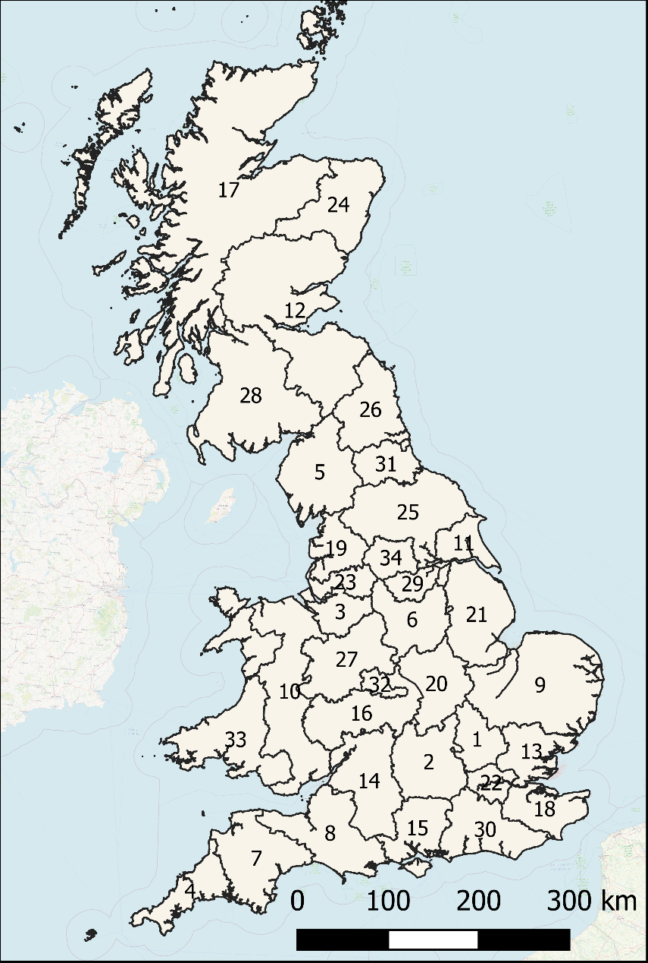
Figure 3: Zones considered in this study
Regional transportation distances were considered as the distances between the centroids of each zone. These values were obtained using GIS software, and a summary of these can be found in Table 14, Appendix C.1.
Distribution distances within zones were considered as all trunk and primary roads and obtained using GIS software. An increase in the local distribution distances for each time period was assumed in order to better represent the increased number of hydrogen refuelling stations as FCEVs gain a larger penetration in the market (thus leading to larger distances travelled to distribute the hydrogen from the centre of the zone out to the refuelling station). The values obtained from the GIS software were set as the distance within each zone in time-period 2050, assuming by 2050 most refuelling stations will have hydrogen as an option. A linear increase in this value between the time periods 2020 to 2050 was assumed. A summary of these values can be found in Table 15 in Appendix C.2.

Demand estimation
The Department for Business Energy & Industrial Strategy’s (BEIS) annual fuel demand for road transport up to 2018 [40] was used to estimate the demand for hydrogen throughout the time-periods considered in this study. First the demand for fuel transport was converted from tonnes of oil per year into kWh (Equation (C.1) in Appendix C.3). The demand for fuel transport was then split into demand for diesel and petrol, as petrol and diesel powertrains have different thermal efficiencies. Using the average thermal efficiency of a petrol motor (~20% [41]) and of a diesel motor (~25% [41]), the total amount of energy delivered from the fuel through the drivetrain was calculated.
The energy delivered through the drivetrain, has to be matched by a hydrogen drivetrain. However, hydrogen drivetrains have a different efficiency (~40-60% [42]). Therefore, the required amount of hydrogen is less than the amount of petrol/diesel required (in terms of kWh energy) to deliver the same amount of kWh through the drivetrain. In this study, it was assumed the hydrogen powertrain to be 50% efficient.
The calculated transport fuel demand for 2018 converted to kWh of hydrogen was taken as the estimate of the total demand for hydrogen for transport in each time period if there was 100% penetration of FCEVs (the maximum possible demand for hydrogen for transport in GB). However, the adoption of a new powertrain is not instantaneous, and the penetration of new technologies into the market usually adopts ‘S’ shaped curves. The market’s estimated adoption of FCEVs used for this study was based upon three main sources [43-45], from which the penetration scenario was developed. The percentage market penetration of FCEVs was then multiplied by the maximum hydrogen transport fuel demand in each time period, to give the total demand GB, seen in Table 4 and Figure 4.
Table 4: Percentage penetration of fuel cell electric vehicles in the transport market in each time period, with associated total hydrogen demand for GB.
Year | 2020 | 2025 | 2030 | 2035 | 2040 | 2045 | 2050
Market Penetration (%) | 2 | 7 | 15 | 25 | 35 | 44 | 50
Total H₂ Demand in GB with Penetration Factor (GWh) | 3,961 | 13,863 | 29,706 | 49,510 | 69,313 | 87,137 | 99,019
Total H₂ Demand in GB with 100% FCEV Penetration (GWh) | 198,038.552

Figure 4: Graphical representation of the percentage penetration of fuel cell electric vehicles in the transport market.
Finally, to estimate the demand in each zone, the total demand for GB was multiplied by the fraction of the population that lives in each zone compared to the whole population in GB (See Appendix C.3, Table 16). The results for demand projections can be seen Appendix C.4, Table 17.

Fuel and electricity prices, emission factors, and carbon prices
The price of gas, coal and electricity was estimated up to 2035 by the Department for Business Energy & Industrial Strategy (BEIS) [46, 47]. In order to obtain fuel prices for all time periods considered in this study, the data from BEIS was extended to 2050 using Excel’s inbuilt forecasting tool. The prices used in this work are shown in Appendix C.5, Table 18.
Table 5 shows the UK’s electricity grid emission factors used in this work.
Table 5: Project emission factors for the UK's electricity grid. Grid average industrial consumption base [46].
Year | Emission Factor (kg_{CO2}/kWh_{e})
2020 | 0.1354
2025 | 0.1015
2030 | 0.0798
2035 | 0.0394
2040 | 0.0394
2045 | 0.0330
2050 | 0.0266
Different cases and scenarios described in section 3.4 were investigated. For the base case, the carbon prices used are shown in Table 6.
Table 6: Low, mid and high carbon prices used in the base case optimisation model. Data obtained from BEIS [46].
Year | Mid-Cost (£/tCO2) | Low-Cost (£/tCO2) | High-Cost (£/tCO2)
2020 | 69.27 | 34.64 | 103.92
2025 | 75.05 | 37.53 | 112.58
2030 | 80.83 | 40.41 | 121.24
2035 | 118.35 | 59.18 | 177.53
2040 | 155.88 | 77.94 | 233.82
2045 | 193.40 | 96.70 | 290.10
2050 | 230.92 | 115.46 | 346.39

Production technologies
Production from onshore wind and onshore solar PV were constrained by land availability for windfarms and by capacity factors. Average wind and solar PV capacity factors were taken at the centroid for each zone from [48]. For wind turbines, a hub height of 80m was assumed, using the MERRA-2 (global) 2019 dataset, and a turbine model of Vestas V90 2000. For solar PV, a 10% system’s loss was considered, with a tilt and azimuth of 35° and 180°. A full breakdown of the capacity factors used in the model can be found in Appendix C.6, Table 20. Land availability for windfarms and solar PV was adapted from Samsatli et al. [23], which used GIS mapping with Great Britain split into 16 zones. This was done through a two-step process: First, the 34 zones considered in this study were described as fractions of the 16 zones used in [23]. Second, land availability for the 34 zones of this study were obtained by multiplying the fraction of the zones as referred to [23], with the land availability of the corresponding zones from [23]. For example, the land availability for zone 1 in this study was estimated using Equation (18).
 | $$Area_{Z1}=0.15⋅Area_{z11}^{Samsatli et al.}+0.1⋅Area_{z13}^{Samsatli et al.}$$ | (18)
A summary of these results can be found in Appendix C.6, Table 20. Furthermore, the radius and maximum production capacity of a wind turbine used in Equation (8) were also taken from [23] to be 35m and 2.86 MW, respectively. The area of solar PV capacity used in Equation (9) was assumed to be 6 kWp/m² [49].
Production from steam methane reforming (plus CCS) was constrained to zones that have connections to identified offshore carbon capture and storage sites. This information was obtained from [50] and cross checked with [51]. This identified that production from steam methane reforming was only feasible in zones 10, 11, 18, 23, 24 and 26.
Finally, Table 7 shows technoeconomic parameters for production technologies used as inputs in this model. Further assumptions can be found in Appendix C.7 and C.8. Finally, it was assumed that hydrogen being produced from steam methane reforming was of ‘dirty’ grade for this model, and hydrogen being produced from electrolysis was of ‘clean’ grade for this model.

Table 7: Summary of techno-economic parameters of production technologies used in the model; ª[51], ^{b}[52, 53], ^{c}[54], adjusted by inflation.
 |  | 2020 | 2025 | 2030 | 2035 | 2040 | 2045 | 2050
SMR | CAPEXª (£/kW_{H2}) | 732.02 | 687.59 | 648.67 | 611.95 | 577.32 | 544.64 | 513.81
SMR | Fixed OPEXª (Percentage of OPEX) | 3.6 | 3.8 | 4.0 | 4.3 | 4.5 | 4.8 | 5.1
SMR | Variable OPEXª (£/kWh_{H2}) | 0.032 | 0.039 | 0.043 | 0.043 | 0.047 | 0.050 | 0.054
SMR | Operating Lifetime^{b} (yr) | 25 | 25 | 25 | 25 | 25 | 25 | 25
SMR | Emission Factor^{b} (kg_{CO2e}/kWh_{H2}) | 0.030 | 0.030 | 0.030 | 0.030 | 0.030 | 0.030 | 0.030
Alkaline Electrolysis | CAPEXª (£/kW_{H2}) | 949.00 | 822.00 | 742.00 | 721.00 | 700.00 | 689.00 | 677.00
Alkaline Electrolysis | Fixed OPEXª (Percentage of OPEX) | 2.79 | 2.79 | 2.79 | 2.79 | 2.79 | 2.79 | 2.79
Alkaline Electrolysis | Variable OPEXª (£/kWh_{H2}) | 0.0802 | 0.0856 | 0.0857 | 0.0824 | 0.0934 | 0.0989 | 0.1040
Alkaline Electrolysis | Operating Lifetime^{b} (yr) | 5 | 5 | 10 | 10 | 10 | 10 | 15
Alkaline Electrolysis | Emission Factor^{a,c} (kg_{CO2e}/kWh_{H2}) | 0.207 | 0.152 | 0.118 | 0.058 | 0.057 | 0.048 | 0.038
PEM Electrolysis | CAPEXª (£/kW_{H2}) | 1279.62 | 806.55 | 620.42 | 573.50 | 526.58 | 516.92 | 506.26
PEM Electrolysis | Fixed OPEXª (Percentage of OPEX) | 2.79 | 2.79 | 2.79 | 2.79 | 2.79 | 2.79 | 2.79
PEM Electrolysis | Variable OPEXª (£/kWh_{H2}) | 0.0865 | 0.0890 | 0.0869 | 0.0830 | 0.0934 | 0.0989 | 0.1040
PEM Electrolysis | Operating Lifetime (yr) | 5 | 5 | 10 | 10 | 10 | 10 | 15
PEM Electrolysis | Emission Factor^{a,c} (kg_{CO2e}/kWh_{H2}) | 0.224 | 0.158 | 0.120 | 0.058 | 0.057 | 0.048 | 0.038
SOEC Electrolysis | CAPEXª (£/kW_{H2}) | 1984 | 1442 | 1142 | 1008 | 881 | 821 | 760
SOEC Electrolysis | Fixed OPEXª (Percentage of OPEX) | 2.79 | 2.79 | 2.79 | 2.79 | 2.79 | 2.79 | 2.79
SOEC Electrolysis | Variable OPEXª (£/kWh_{H2}) | 0.0614 | 0.0647 | 0.0639 | 0.0608 | 0.0684 | 0.0723 | 0.0759
SOEC Electrolysis | Operating Lifetime^{b} (yr) | 5 | 5 | 5 | 5 | 5 | 10 | 10
SOEC Electrolysis | Emission Factor^{a,c} (kg_{CO2e}/kWh_{H2}) | 0.159 | 0.115 | 0.08 | 0.043 | 0.042 | 0.035 | 0.028
Alkaline Electrolysis Solar | CAPEXª (£/kW_{H2}) | 2029.58 | 1744.42 | 1556.72 | 1435.60 | 1330.92 | 1243.50 | 1155.40
Alkaline Electrolysis Solar | Fixed OPEXª (Percentage of OPEX) | 3.39 | 3.39 | 3.39 | 3.39 | 3.39 | 3.39 | 3.39
Alkaline Electrolysis Solar | Variable OPEXª (£/kWh_{H2}) | 0.00 | 0.00 | 0.00 | 0.00 | 0.00 | 0.00 | 0.00
Alkaline Electrolysis Solar | Operating Lifetime^{b} (yr) | 5 | 5 | 10 | 10 | 10 | 10 | 15
Alkaline Electrolysis Solar | Emission Factor^{a,c} (kg_{CO2e}/kWh_{H2}) | 0.00 | 0.00 | 0.00 | 0.00 | 0.00 | 0.00 | 0.00
PEM Electrolysis Solar | CAPEXª (£/kW_{H2}) | 2359.95 | 1728.91 | 1435.42 | 1288.56 | 1157.90 | 1071.20 | 984.17
PEM Electrolysis Solar | Fixed OPEXª (Percentage of OPEX) | 3.39 | 3.39 | 3.39 | 3.39 | 3.39 | 3.39 | 3.39
PEM Electrolysis Solar | Variable OPEXª (£/kWh_{H2}) | 0.00 | 0.00 | 0.00 | 0.00 | 0.00 | 0.00 | 0.00
PEM Electrolysis Solar | Operating Lifetime^{b} (yr) | 5 | 5 | 10 | 10 | 10 | 10 | 15
PEM Electrolysis Solar | Emission Factor^{a,c} (kg_{CO2e}/kWh_{H2}) | 0.00 | 0.00 | 0.00 | 0.00 | 0.00 | 0.00 | 0.00
SOEC Electrolysis Solar | CAPEX (£/kW_{H2}) | 2359.95 | 1728.91 | 1435.42 | 1288.56 | 1157.90 | 1071.20 | 984.17
SOEC Electrolysis Solar | Fixed OPEX (Percentage of OPEX) | 3.39 | 3.39 | 3.39 | 3.39 | 3.39 | 3.39 | 3.39
SOEC Electrolysis Solar | Variable OPEX (£/kWh_{H2}) | 0.00 | 0.00 | 0.00 | 0.00 | 0.00 | 0.00 | 0.00
SOEC Electrolysis Solar | Operating Lifetime (yr) | 5 | 5 | 10 | 10 | 10 | 10 | 15
SOEC Electrolysis Solar | Emission Factor (kg_{CO2e}/kWh_{H2}) | 0.00 | 0.00 | 0.00 | 0.00 | 0.00 | 0.00 | 0.00
Alkaline Electrolysis Wind | CAPEXª (£/kW_{H2}) | 3078.15 | 2469.36 | 2016.38 | 1706.84 | 1462.78 | 1279.76 | 1134.45
Alkaline Electrolysis Wind | Fixed OPEXª (Percentage of OPEX) | 2.79 | 2.79 | 2.79 | 2.79 | 2.79 | 2.79 | 2.79
Alkaline Electrolysis Wind | Variable OPEXª (£/kWh_{H2}) | 0.0147 | 0.0147 | 0.0147 | 0.0147 | 0.0147 | 0.0147 | 0.0147
Alkaline Electrolysis Wind | Operating Lifetime^{b} (yr) | 5 | 5 | 10 | 10 | 10 | 10 | 15
Alkaline Electrolysis Wind | Emission Factor^{a,c} (kg_{CO2e}/kWh_{H2}) | 0.00 | 0.00 | 0.00 | 0.00 | 0.00 | 0.00 | 0.00
PEM Electrolysis Wind | CAPEXª (£/kW_{H2}) | 3408.52 | 2453.85 | 1895.08 | 1559.81 | 1289.77 | 1107.46 | 963.21
PEM Electrolysis Wind | Fixed OPEXª (Percentage of OPEX) | 2.79 | 2.79 | 2.79 | 2.79 | 2.79 | 2.79 | 2.79
PEM Electrolysis Wind | Variable OPEXª (£/kWh_{H2}) | 0.0147 | 0.0147 | 0.0147 | 0.0147 | 0.0147 | 0.0147 | 0.0147
PEM Electrolysis Wind | Operating Lifetime^{b} (yr) | 5 | 5 | 10 | 10 | 10 | 10 | 15
PEM Electrolysis Wind | Emission Factor^{a,c} (kg_{CO2e}/kWh_{H2}) | 0.00 | 0.00 | 0.00 | 0.00 | 0.00 | 0.00 | 0.00
SOEC Electrolysis Wind | CAPEX (£/kW_{H2}) | 4113.01 | 3089.60 | 2416.23 | 1994.18 | 1644.18 | 1411.82 | 1216.96
SOEC Electrolysis Wind | Fixed OPEX (Percentage of OPEX) | 2.79 | 2.79 | 2.79 | 2.79 | 2.79 | 2.79 | 2.79
SOEC Electrolysis Wind | Variable OPEX (£/kWh_{H2}) | 0.0147 | 0.0147 | 0.0147 | 0.0147 | 0.0147 | 0.0147 | 0.0147
SOEC Electrolysis Wind | Operating Lifetime (yr) | 5 | 5 | 5 | 5 | 5 | 10 | 10
SOEC Electrolysis Wind | Emission Factor (kg_{CO2e}/kWh_{H2}) | 0 | 0 | 0 | 0 | 0 | 0 | 0

Hydrogen transmission
Hydrogen transmission was considered for three transportation technologies. Newly installed pipeline transmission was considered as the only pipe transportation technology option, as repurposing the current gas transmission work in GB seems unlikely due to steel embrittlement issues [55]. At the time of writing this paper, there has been project funding submitted by National Grid Gas Transmission and DNV-GL, called HyNTS that will look at the technical parameters of supplying hydrogen blends and 100% hydrogen in the National Transmission System [56]. However, as this project has not yet started, there is no scientific or engineering information to be used in this study.
Techno-economic parameters for new transmission pipelines and transmission through trucks with compressed gaseous and liquid hydrogen are shown in Table 8. A detailed breakdown of calculations and assumptions for both pipeline and truck transmission can be found in Appendix C.9 and C.10.
Table 8: Summary of techno-economic parameters for hydrogen transmission used in the model; ª[56], ^{b}[52], ^{c}[57].
New Transmission Pipeline | CAPEXª (£/kW_{H2}-km) | 0.2665
New Transmission Pipeline | Fixed OPEXª (Percentage of OPEX) | 0.22
New Transmission Pipeline | Variable OPEX (£/kWh_{H2}-km) | -
New Transmission Pipeline | Operating Lifetime^{b} (yr) | 40
New Transmission Pipeline | Emission Factor (kg_{CO2e}/kWh_{H2}) | -
Truck Transmission Compressed Gaseous Hydrogen | CAPEX^{b} (£/kW_{H2}-km) | 0.0768
Truck Transmission Compressed Gaseous Hydrogen | Fixed OPEX^{b} (Percentage of OPEX) | 12
Truck Transmission Compressed Gaseous Hydrogen | Variable OPEX^{b} (£/kWh_{H2}-km) | 41.03x10⁻⁵ (+ 2.41 x10⁻⁴ £/kWh_{H2})
Truck Transmission Compressed Gaseous Hydrogen | Operating Lifetime^{b} (yr) | 15
Truck Transmission Compressed Gaseous Hydrogen | Emission Factor^{c} (kg_{CO2e}/kWh_{H2}-km) | 6.77 x10⁻⁴
Truck Transmission Liquid Hydrogen | CAPEX^{b} (£/kW_{H2}-km) | 0.101
Truck Transmission Liquid Hydrogen | Fixed OPEX^{b} (Percentage of OPEX) | 2
Truck Transmission Liquid Hydrogen | Variable OPEX^{b} (£/kWh_{H2}-km) | 4.02x10⁻⁵ (+ 9.58 x10⁻⁴ £/kWhH2)
Truck Transmission Liquid Hydrogen | Operating Lifetime^{b} (yr) | 15
Truck Transmission Liquid Hydrogen | Emission Factor^{c} (kg_{CO2e}/kWh_{H2}-km) | 3.46 x10⁻⁴

Hydrogen distribution
Various hydrogen distribution technologies were included in this research. Firstly, new, fit-for-purpose distribution pipelines were considered. The CAPEX and lifetime parameters were obtained from [52, 53]. Since there was little literature regarding the fixed OPEX of new distribution pipelines, it was assumed it would have the same value of new transmission pipelines [56]. An advantage of using new fit-for-purpose pipelines is there would be neglectable contamination picked up when distributing the hydrogen – however, one main drawback is the large upfront capital costs.
The next distribution transportation technology included in this study was truck distribution. A very similar approach to truck transmission transportation was taken for obtaining the techno-economic parameters seen in Table 8, with a key difference being the assumed average speed of the truck.
Repurposing the gas distribution network in order to supply 100% hydrogen is also a concept being considered in GB, as shown from the literature review. A benefit to repurposing the GDN to supply 100% hydrogen is the slightly lower upfront capital cost associated with the technology – however, one main drawback is that hydrogen would become contaminated when distributed through it.
Finally, blending into the GDN was also included. This was considered a fundamental cornerstone of this research to see how hydrogen grades affect the supply chain, and whether the cheaper transportation of hydrogen through blending into the local GDN could outweigh the additional costs of separation and purification at the end of use application. Since works such as HyDeploy 1 & 2 [58] have shown with current HDPE pipelines in the GDN are able to supply up to 20%_{Vol} hydrogen (accompanied with the steel mains replacement programme [59]), it was assumed there would be negligible costs associated with repurposing the GDN to supply blended hydrogen. The main advantage to blending hydrogen into the GDN is the very low capital expense (assumed to be zero in this study) – however, a large drawback is the additional expense in the supply chain due to separation and purification requirements at the end point of use.
Table 9 shows a summary of the techno-economic parameters used in the model. Details and assumptions made for all distribution technologies can be found in Appendix C.11 and C.12.
Table 9: Summary of techno-economic parameters for hydrogen distribution used in model; ^{a[52] b}[56] ^{c}[57]
New Distribution Pipeline | CAPEXª (£/kW_{H2}-km) | 2.657
New Distribution Pipeline | Fixed OPEX^{b} (Percentage of OPEX) | 0.22
New Distribution Pipeline | Variable OPEX (£/kWh_{H2}-km) | -
New Distribution Pipeline | Operating Lifetimeª (yr) | 40
New Distribution Pipeline | Emission Factor (kg_{CO2e}/kWh_{H2}) | -
Truck Distribution Compressed Gaseous Hydrogen | CAPEXª (£/kW_{H2}-km) | 0.154
Truck Distribution Compressed Gaseous Hydrogen | Fixed OPEXª (Percentage of OPEX) | 12
Truck Distribution Compressed Gaseous Hydrogen | Variable OPEXª (£/kWh_{H2}-km) | 6.16x10⁻⁵ (+ 9.58 x10⁻⁴ £/kWh_{H2})
Truck Distribution Compressed Gaseous Hydrogen | Operating Lifetimeª (yr) | 15
Truck Distribution Compressed Gaseous Hydrogen | Emission Factor^{c} (kg_{CO2e}/kWh_{H2}-km) | 6.77 x10⁻⁴
Truck Distribution Liquid Hydrogen | CAPEXª (£/kW_{H2}-km) | 0.201
Truck Distribution Liquid Hydrogen | Fixed OPEXª (Percentage of OPEX) | 2
Truck Distribution Liquid Hydrogen | Variable OPEXª (£/kWh_{H2}-km) | 1.52x10⁻⁵ (+ 2.41 x10⁻⁴ £/kWh_{H2})
Truck Distribution Liquid Hydrogen | Operating Lifetimeª (yr) | 15
Truck Distribution Liquid Hydrogen | Emission Factor^{c} (kg_{CO2e}/kWh_{H2}-km) | 3.46 x10⁻⁴
Repurposing GDN (100% Hydrogen) | CAPEX^{b} (£/kW_{H2}-km) | 1.08
Repurposing GDN (100% Hydrogen) | Fixed OPEX^{b} (Percentage of OPEX) | 0.22
Repurposing GDN (100% Hydrogen) | Variable OPEX (£/kWh_{H2}-km) | -
Repurposing GDN (100% Hydrogen) | Operating Lifetimeª (yr) | 40
Repurposing GDN (100% Hydrogen) | Emission Factor (kg_{CO2e}/kWh_{H2}-km) | -
Blending with GDN (20% Hydrogen) | CAPEX (£/kW_{H2}-km) | -
Blending with GDN (20% Hydrogen) | Fixed OPEX^{b} (Percentage of OPEX) | 0.22
Blending with GDN (20% Hydrogen) | Variable OPEX (£/kWh_{H2}-km) | -
Blending with GDN (20% Hydrogen) | Operating Lifetimeª (yr) | 40
Blending with GDN (20% Hydrogen) | Emission Factor (kg_{CO2e}/kWh_{H2}-km) | -

Hydrogen refuelling stations
The cost of hydrogen storage was lumped into the hydrogen refuelling station techno-economic parameters. The analysis was based on a research by Xu et al. [60], which estimates the capital and operational costs of hydrogen refuelling stations with on-site production, with a capacity ranging from 100 – 1000 kg_{H2}/day. It proposes a bulk storage capacity of 30% of the daily capacity, and a 14% cascade storage to meet any varied demand profile at the refuelling station. Since the hydrogen refuelling station contained on-site production (something that is not considered in this work), the techno-economic parameters in Table 10 were obtained by excluding any equipment associated with hydrogen production from the analysis, and the values were validated with [11]. Assumptions and methods can be found in Appendix C.13.
Table 10: Summary of hydrogen refuelling station techno-economic parameters used in the model; ª[60]
Hydrogen Refuelling Station | CAPEXª (£/kW_{H2}) | 305.60
Hydrogen Refuelling Station | Fixed OPEXª (Percentage of OPEX) | 12.7
Hydrogen Refuelling Station | Variable OPEX (£/kWh_{H2}-km) | -
Hydrogen Refuelling Station | Operating Lifetimeª (yr) | 10
Hydrogen Refuelling Station | Emission Factor (kg_{CO2e}/kWh_{H2}) | -

Hydrogen purification/separation
Although hydrogen purification/separation is not a new concept, techno-economic data for hydrogen purification for the specific application of hydrogen supply chains was sparse. As previously stated, to the authors knowledge, there has been very little research completed that looks at conducting a techno-economic analysis considering multiple hydrogen purification technology options, while also considering a range of hydrogen concentrations in the inlet stream for the use in hydrogen supply chains.
Two purification/separation technologies were considered in this study – PSA and a membrane hybrid system. PSA is one of the most common forms of hydrogen purification technologies in industry [61]. The hybrid system shows great potential, even in a lab/pilot scale environment, particularly when separating hydrogen out of a natural gas/hydrogen blend [62].
Two pieces of literature were used as the basis for the techno-economic analysis. First, a report by the National Renewable Energy Laboratory [63] which considered separation and purification costs from a low-pressure (8 bar) and high-pressure (40 bar) pipeline, with a 10%_{vol} and 20%_{vol} hydrogen concentration inlet. The high-pressure inlet PSA system was used to estimate the parameters for the centralised PSA unit (purifying hydrogen from the transmission system, and re-injecting into distribution system). The low-pressure inlet PSA unit was used to estimate the parameters for the localised PSA units with a clean, dirty and blended hydrogen grade input.
Second, Nordio et al. [62] considered a range of novel hybrid hydrogen separation/purification technologies with a range of configurations. From this work, configuration B was selected to be used in this study due to its low cost while maintaining a hydrogen purity output that adhered to ISO 14687-2:2012 standards. The system includes two ceramic supported thin Pd-Ag membranes, with a mechanical compressor in between, a vacuum pump and an electrochemical hydrogen compressor combined. Only the inlet from a blended lower pressure was considered (i.e. separating/purifying hydrogen from the blended GDN transportation technology). The paper only considered one concentration inlet of 20% vol of hydrogen, so it was not possible to estimate the reduced cost of purification of hydrogen from having a higher purity inlet stream. Table 11 shows a summary of the techno-economic parameters for hydrogen purification/separation used in the model, with an annual learning rate applied to PSA of 2.5%, and 5% for the membrane system.
Table 11: Summary of hydrogen purification/separation techno-economic parameters used in the model; ª[63] ^{b} [62]
 |  | 2020 | 2025 | 2030 | 2035 | 2040 | 2045 | 2050
PSA (Centralised) | Assumed Inlet Purity | ~95% Hydrogen by Volume (Dirty)
PSA (Centralised) | CAPEXª (£/kW_{H2}) | 653.79 | 576.05 | 507.56 | 447.20 | 394.03 | 347.18 | 305.90
PSA (Centralised) | Variable OPEXª (£/kWh_{H2}) | 0.033 | 0.036 | 0.036 | 0.035 | 0.040 | 0.042 | 0.045
PSA (Centralised) | Operating Lifetimeª (yr) | 25 | 25 | 25 | 25 | 25 | 25 | 25
PSA (Centralised) | Emission Factorª (kg_{CO2e}/kWh_{H2}) | 0.081 | 0.061 | 0.048 | 0.024 | 0.024 | 0.020 | 0.016
PSA (Local) | Assumed Inlet Purity | ~20% Hydrogen by Volume (Blended)
PSA (Local) | CAPEXª (£/kW_{H2}) | 7746.70 | 6825.58 | 6013.99 | 5298.90 | 4668.84 | 4113.70 | 3624.56
PSA (Local) | Variable OPEXª (£/kWh_{H2}) | 0.0489 | 0.0516 | 0.0522 | 0.0511 | 0.0559 | 0.0583 | 0.0607
PSA (Local) | Operating Lifetimeª (yr) | 25 | 25 | 25 | 25 | 25 | 25 | 25
PSA (Local) | Emission Factorª (kg_{CO2e}/kWh_{H2}) | 0.081 | 0.061 | 0.048 | 0.024 | 0.024 | 0.020 | 0.016
PSA (Local) | Assumed Inlet Purity | ~95% Hydrogen by Volume (Dirty)
PSA (Local) | CAPEXª (£/kW_{H2}) | 2499.91 | 2202.66 | 1940.76 | 1709.99 | 1506.67 | 1327.52 | 1169.67
PSA (Local) | Variable OPEXª (£/kWh_{H2}) | 0.0371 | 0.0398 | 0.0404 | 0.0393 | 0.0441 | 0.0465 | 0.0489
PSA (Local) | Operating Lifetimeª (yr) | 25 | 25 | 25 | 25 | 25 | 25 | 25
PSA (Local) | Emission Factorª (kg_{CO2e}/kWh_{H2}) | 0.081 | 0.061 | 0.048 | 0.024 | 0.024 | 0.020 | 0.016
PSA (Local) | Assumed Inlet Purity | ~99% Hydrogen by Volume (Clean)
PSA (Local) | CAPEXª (£/kW_{H2}) | 2426.17 | 2137.69 | 1883.51 | 1659.55 | 1462.22 | 1288.36 | 1135.17
PSA (Local) | Variable OPEXª (£/kWh_{H2}) | 0.0369 | 0.0397 | 0.0402 | 0.0391 | 0.0440 | 0.0464 | 0.0488
PSA (Local) | Operating Lifetimeª (yr) | 25 | 25 | 25 | 25 | 25 | 25 | 25
PSA (Local) | Emission Factorª (kg_{CO2e}/kWh_{H2}) | 0.081 | 0.061 | 0.048 | 0.024 | 0.024 | 0.020 | 0.016
Membrane Hybrid (Local) | Assumed Inlet Purity | ~20% Hydrogen by Volume (Blended)
Membrane Hybrid (Local) | CAPEX^{b} (£/kW_{H2}) | 10118.92 | 7829.83 | 6058.57 | 4688.01 | 3627.49 | 2806.88 | 2171.91
Membrane Hybrid (Local) | Variable OPEX^{b} (£/kWh_{H2}) | 0.0882 | 0.0893 | 0.0895 | 0.0891 | 0.0910 | 0.0919 | 0.0929
Membrane Hybrid (Local) | Operating Lifetime^{b} (yr) | 25 | 25 | 25 | 25 | 25 | 25 | 25
Membrane Hybrid (Local) | Emission Factor^{b} (kg_{CO2e}/kWh_{H2}) | 0.081 | 0.061 | 0.048 | 0.024 | 0.024 | 0.020 | 0.016
Appendix C.14 and C.15 show the assumptions and calculations used for hydrogen purification/separation technologies.

Further assumptions
A discount rate of 5% was assumed [33, 64].

Case study definition
Three case studies corresponding to different scenarios were implemented and studied in this work, plus a sensitivity analysis. All cases were implemented in GAMS software and solved using CPLEX solver. The three cases and sensitivity analysis are defined as follows:
- Base Case – Analysing optimal hydrogen supply chain configurations for low, medium, and high carbon prices (Table 6).
- Case 1 – Analysing how the hydrogen supply chain configuration is affected by extending the carbon price, in order to achieve a deeper level of decarbonisation for hydrogen in the transport sector in Great Britain.
- Case 2 – Exploring the feasibility of blending hydrogen into the local gas distribution network by varying the learning rate of separation/purification technologies.
- Sensitivity Analysis – Looking at the effect of gas price and solar PV CAPEX variation through a sensitivity analysis. The gas price was varied in accordance with BEIS’s high and low future estimates [46, 47], and the solar PV CAPEX was varied by assuming a learning rate range of 5-10%.
The Base Case has 182 blocks of equations with 3,196,906 single equations, and 65 blocks of variables with 3,600,990 single variables. It took 47.681 seconds to generate, and 107.526 seconds to execute.

Results and discussion
This section presents the results for the three cases described previously.

Base Case
The first component of the supply chain that was assessed was the installed production capacity methods of hydrogen. For all three carbon price scenarios, it was observed that steam methane reforming made up most of the production capacity for all time periods. PEM electrolysis powered by wind turbines was seen to be introduced in 2050 for all carbon price scenarios, as shown in Figure 5 and Figure 6. Unlike previous studies on hydrogen supply chain optimisation for transport in GB that considered conventional fossil fuel production methods and electrolysis [33, 64], in this study hydrogen production from electrolysis was selected by the model in 2050 - even in the base case. This could reflect the fact that estimated electrolysis prices have dropped significantly in recent years, as estimated by the Hydrogen Council [65].

Figure 5: Hydrogen production technologies installed capacity, low and mid carbon price. | Figure 6: Hydrogen production technologies installed capacity, high carbon price.

It is important to also note that the model does not choose to install hydrogen production through electrolysis and solar PV production. There are two main reasons for this: The first is due to the low-PV capacity factors observed around the UK as seen Table 20, which range from 10.2-13.6%. The second is due to the coarse temporal resolution of the model, which is constrained by computational limitations. As renewables fluctuate greatly, an assumption around capacity factors had to be made on an annual basis as seen in Equation (7). This resolution, for example, does not allow to model possible curtailment, which could result in solar PV for hydrogen production to be more cost effective. Greater matching of the production rate from solar PV and the demand for hydrogen for transport may be achievable, however, this analysis would have to be done on a case-by-case basis or for a smaller model, as it would require at least an hourly temporal resolution to identify these synergies, which would make this case study not tractable.
As the carbon price is varied from low to high, only a minor increase in adoption of wind PEM production is observed by 2050 at the high carbon price: 26.1% of total production (3389 MW) at the high carbon price, versus 23.4% (2994 MW) of total production at mid and low carbon prices. Furthermore, it is worth noting that the increase in overall installed capacity observed by 2050 at the high carbon price is due to the requirement for the model to take into consideration the average annual capacity factors for renewable wind production. Thus, renewable hydrogen production must have a larger installed capacity to achieve the same level of production of hydrogen from its conventional fossil fuel counterparts.
When comparing the results from this model to other hydrogen supply chain models focusing on transport in GB, it can be seen that these results are in-line with other models’ results, and potentially show slightly more renewable hydrogen production penetration. Agnolucci et al. [66] studied the development of a hydrogen supply chain in GB using the SHIPmod model, which included hydrogen production from SMR, coal gasification, biomass gasification, and electrolysis from renewables, including spatial configurations of CCS infrastructure. Hydrogen produced from electrolysis was not selected in any of their modelled scenarios, which highlights that renewable power to produce hydrogen was not cost competitive under their assumptions. Moreno-Benito et al. [33] studied the optimal design of a hydrogen supply chain for the transport sector in the UK. In the base case scenario, all hydrogen production is via SMR with CCS, and there is no hydrogen production from electrolysis paired with renewables. Moreover, for a scenario that assumed that CCS was never developed, the model chose to import hydrogen internationally. Only when international hydrogen imports were constrained did the model see any hydrogen production from renewable sources, with the earliest installed capacity of this technology being in 2060. However, hydrogen production from electrolysis costs have dropped since Moreno-Benito et al. was published [67]. Furthermore, analysing the economic assumptions of renewable hydrogen production in Moreno-Benito et al. [33], it is observed that although the capital cost of the plant is not adversely high in comparison to other studies, the variable unit production cost was assumed to be within the range of £3.99 - £4.50 per kg of hydrogen. The present study found these costs to lie in the range of £0.49 - £3.49 per kg of hydrogen, which suggests why this model sees renewable hydrogen production being installed, albeit in small amounts, by 2050.
Conversely, analysing the reasons as to why this model only chooses to produce hydrogen from renewable sources in 2050, one of the reasons is its large upfront CAPEX, compared to that of SMR + CCS. Using cost assumptions for the UK, the model chooses to install SMR + CCS, as it is considered one of the cheapest ways to produce hydrogen that is relatively low carbon, and a central piece in the UK’s decarbonisation strategy [5, 68]. Although widespread deployment of large-scale CCS is yet to be seen [69], the underlying assumption is that CCS will be a feasible technology, and that it can be deployed at large scale, as global CCS capacity has increased by 33% in the past year [70]. Another element that may affect renewable green hydrogen production is that even though relatively high wind capacity factors were considered – in the range of 33-50% – one of the limitations of this model is that it does not implement a fine temporal resolution. Modelling on an hourly basis may allow for the interplay of energy storage and the total installed capacity of renewables to be better studied (i.e. a cost optimal sizing of both intermittent production and storage would result in a lower Total Discounted cost than just installing a larger production capacity), and for the potential to achieve a better electricity price from using curtailed wind production. A finer time-slicing and better storage/curtailment representation were excluded from this study to maintain computational tractability, as the focus was on hydrogen purification infrastructure and purity requirements. Analysing the spatial aspect of the production methods Figure 7 to Figure 12 show the zones where production capacity of SMR and PEM electrolysis from wind turbines are installed by 2050. Steam methane reforming plants were installed in all zones that had access to planned CCS projects, which included zones 10, 11, 18, 23, 24 and 26. PEM electrolysis powered from wind turbines were installed in zones 4 and 12, which had the two largest annual wind capacity factors out of all the zones.
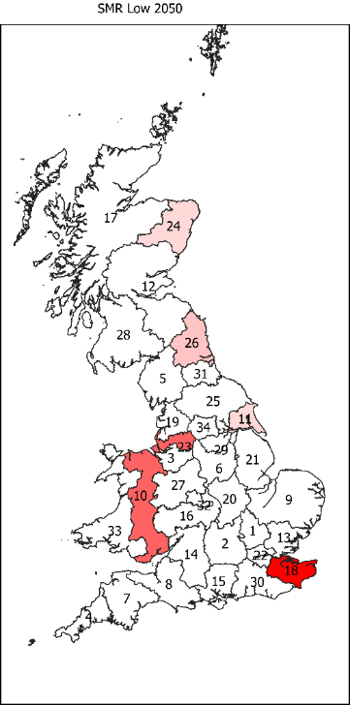  Figure 7: Installed SMR capacity in 2050 - low carbon price | 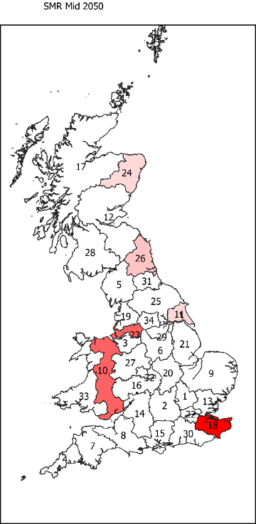  Figure 8: Installed SMR capacity in 2050 – mid carbon price | 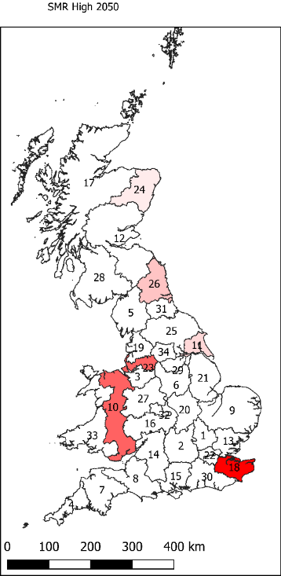  Figure 9: Installed SMR capacity in 2050 – high carbon price. | 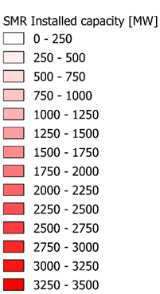
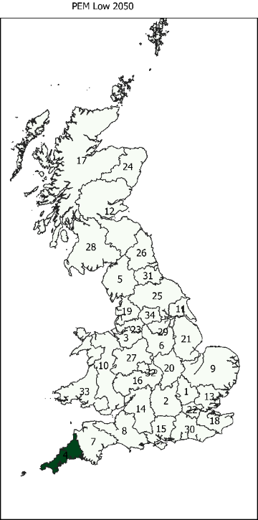  Figure 10: Installed PEM from wind capacity in 2050 - low carbon price | 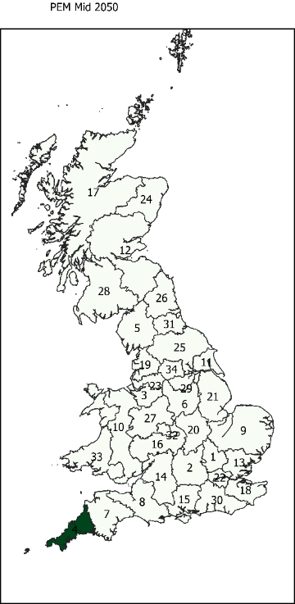  Figure 11: Installed PEM from wind capacity in 2050 - mid carbon price | 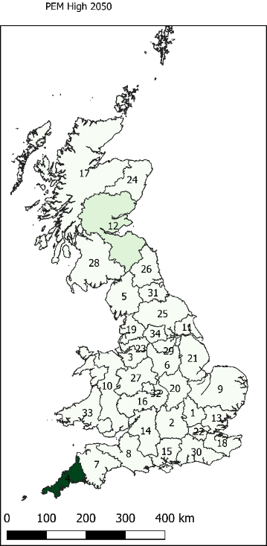  Figure 12: Installed PEM from wind capacity in 2050 - high carbon price | 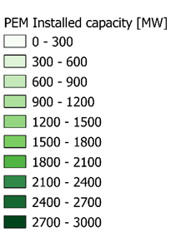

The second component of the supply chain assessed by this model is regional and local hydrogen transportation. Since the distances between and within zones are fixed, transportation capacity is in kW and represents the flow of hydrogen over that length in a given zone and time period. Figure 13, Figure 14, and Figure 15 show the installed capacity of repurposing the GDN for local transportation for all three carbon price scenarios by 2050. For all carbon price scenarios, the model chose to repurpose the gas distribution network to supply 100% hydrogen for local distribution in all zones and time periods (apart from zone 17 in 2050, which will be discussed later). This shows that for the case of this model the costs saved by repurposing the GDN, in comparison to other distribution technologies, outweighs the additional purification requirements at the refuelling stations. The results show an insight into the way the current GDN network could be coupled with the transport sector. In particular it highlights that if the GDN is to be utilised to distribute hydrogen for the transport sector int GB, it shows greatest potential when paired with large scale projects such as H21 – Leeds City Gate [56]. Although H21 – Leeds City Gate is focused around using hydrogen to decarbonise the heating industry, the additional requirement of purification to achieve a purity that meets ISO 14687-2:2012 standards is offset by the cost savings from repurposing the GDN. Furthermore, coupling sectors such as heating, and transport could reap benefits of economy of scale, and thus make both hydrogen for transport and heat cheaper for the public in GB. It must be noted however, this was just a preliminary study which does not consider all the finessed technical details required in converting the GDN over to 100% hydrogen. Further investigation including the details of the current installed networks, as seen in the H21 report, would be required to ensure that repurposing the GDN is technically feasible.
As previously mentioned, the model chose to distribute hydrogen by blending it into the gas distribution network in zone 17 in 2050. This highlights a limitation with optimisation modelling. Even though this is the minimum cost solution for these demands and techno economic parameters, it is not feasible to repurpose the GDN in 2020, to then start blending hydrogen with natural gas in 2050, even if it becomes cheaper at this time.
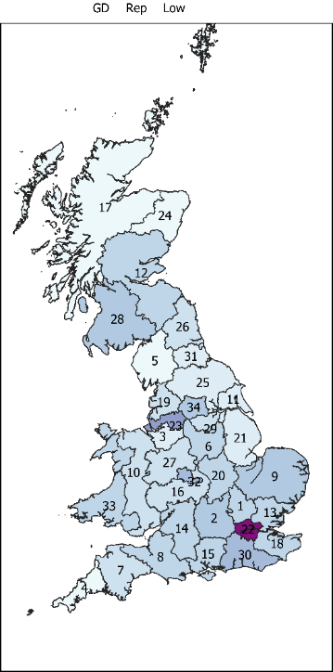  Figure 13: Installed capacity of repurposed GDN in 2050 - low carbon price. | 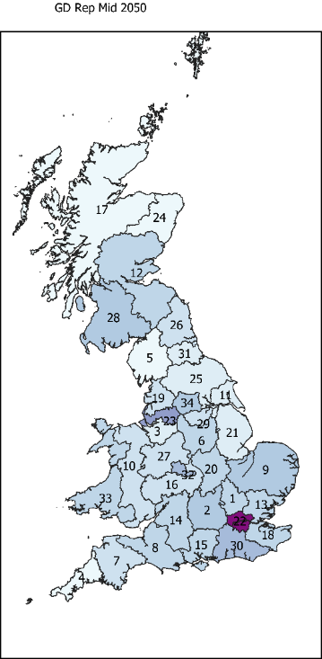  Figure 14: Installed capacity of repurposed GDN in 2050 - mid carbon price. | 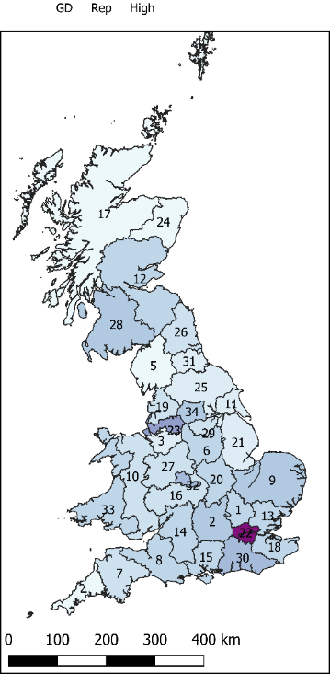  Figure 15: Installed capacity of repurposed GDN in 2050 - high carbon price. | 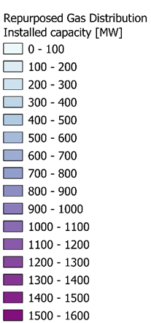

With regards to regional transportation, the model chose to install new pipelines as regional transportation for all carbon price scenarios and for all time periods. This was expected due to pipeline transmission having a very low operational cost that outweighs its large upfront capital expenditure. Figure 16 to Figure 21 show the schematic layout of the transmission pipelines in 2040 and 2050 for all carbon price scenarios. It is worth noting that the schematic configuration of transmission pipelines remains the same from 2020 through to 2040 for all carbon prices. However, in 2050, this starts to change as more transmission pipelines are installed making the zones more interconnected. This can be explained by the installation of renewable electrolysis production from wind turbines in 2050, causing hydrogen production to occur in more zones.
Moreover, it is important to note that liquified truck transport on both a regional and local level was not selected by the model. This is in line with previous evidence showing that hydrogen transport via pipelines is the most cost-effective technology within European countries and the UK [71], mainly because of the short distances involved, and because gas distribution networks are already in place and can be repurposed for gaseous hydrogen transport. Repurposing the gas distribution network was the preferred distribution method chosen by the model in this work, at it is highly cost-effective because of the already established infrastructure. This means that repurposing the grid is at a much lower CAPEX than building new infrastructure or transporting by truck at large volumes.
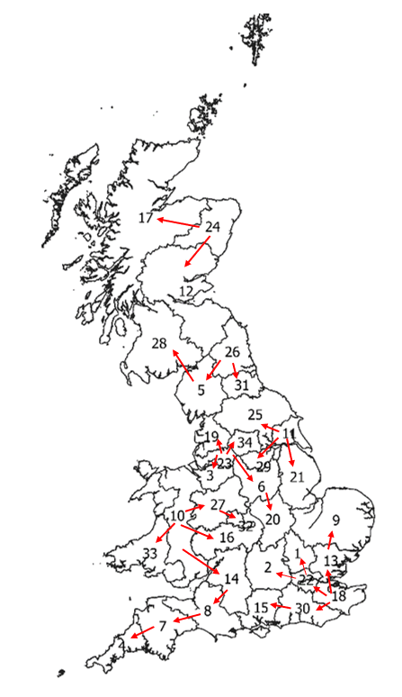  Figure 16: Schematic layout of transmission pipeline in 2040, low carbon price scenario. | Figure 17: Schematic layout of transmission pipeline in 2040, mid carbon price scenario. | Figure 18 : Schematic layout of transmission pipeline in 2040, high carbon price scenario.
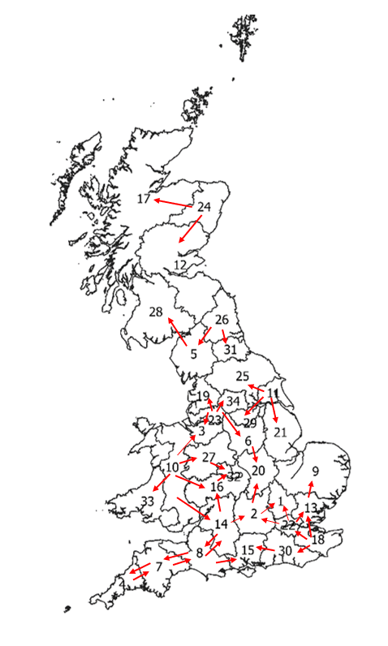  Figure 19: Schematic layout of transmission pipeline in 2050, low carbon price scenario. | Figure 20: Schematic layout of transmission pipeline in 2050, mid carbon price scenario. | Figure 21: Schematic layout of transmission pipeline in 2050 with high carbon price scenario.
A third component of the supply chain assessed in this model was purification technologies. The model chose to install Pressure Swing Adsorption (PSA) locally at the refuelling station for all time periods and zones. The way the model was formulated, it chooses to install purification technologies based on the purity grade of hydrogen at the inlet. As the GDN is repurposed for all zones and time periods, all PSA systems installed had a “dirty” inlet. The only exception to this was zone 17 in 2050, where the installed PSA had a blended inlet. Figure 22, Figure 23, and Figure 24, show the installed capacity of PSA purification technology for the low, mid and high carbon price scenarios in 2050.

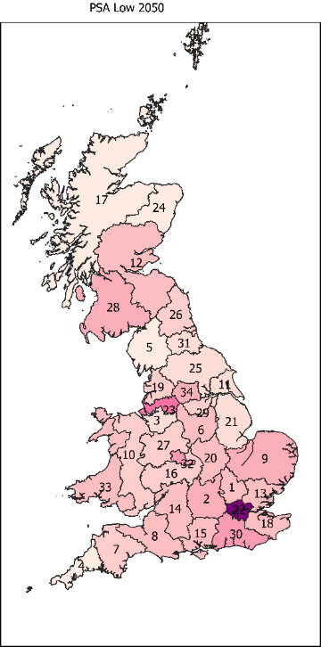  Figure 22: Installed local PSA purification capacity in 2050 - low carbon price. | 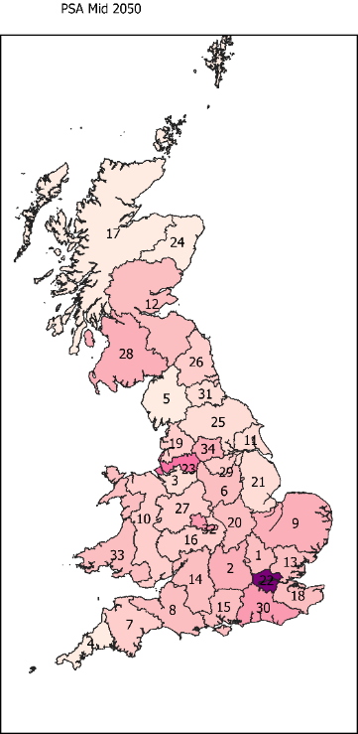  Figure 23: Installed local PSA purification capacity in 2050 - mid carbon price. | Figure 24: Installed local PSA purification capacity in 2050 - high carbon price. | 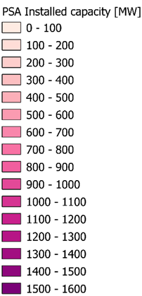

Table 12 shows the cost of hydrogen production on a £/kg basis, for all three carbon price scenarios. A report lead by The Hydrogen Council [65] identified that in order for hydrogen to be competitive to meet a large share of the mobility energy demand by 2030, the cost of hydrogen at the pump must be within the range of 6 $/kg (4.56 £/kg). Although the costs of hydrogen seen in Table 12 are above this value, there is possibility for them to be decreased, either through sector coupling with the heating sector (which this study did not consider), and through government incentives in order to encourage the adoption of more sustainable transportation fuels.
Table 12: Hydrogen production costs for low, mid, and high carbon price scenarios
Scenario | Cost of hydrogen production (£/kg)
Scenario | Carbon Costs Included | Carbon Costs Excluded
Low carbon price | 6.37 | 6.18
Mid carbon price | 6.56 | 6.18
High carbon price | 6.75 | 6.18
Figure 25 shows the yearly CO₂ emissions for the three carbon price scenarios. As would be expected, the carbon emissions are relatively similar for all three base case scenarios, except for the high carbon price having a slightly lower carbon emission in 2050 due to the installed capacity of renewable electrolysis hydrogen production.

Figure 25: Comparison of annual carbon emissions for carbon price scenarios.

Model Cost Validation
When compared to similar work, a study done by Reuß et al. [28] which looked at hydrogen supply chain optimisation for the transport sector in Germany estimated the cost of hydrogen at the nozzle to lay between the range of €6.10/kg to €8.87/kg (£5.44/kg - £7.91/kg), which locates the cost from this study in the mid-value. Moreno-Benito et al. [33] found the cost of hydrogen at the pump to range from £5.3 - £2.0 in a UK case study. While this cost is significantly lower than what was found in this study, Moreno-Benito et al does not take into consideration hydrogen grades and purification requirements, possibly underestimating the optimal cost. Figure 26 shows that purification CAPEX and OPEX contributes a significant amount to the final discounted cost: 14% and 30% respectively for the mid carbon price scenario (all other scenarios exhibit a similar distribution of the TDC). This highlights the importance of including purification technologies in the hydrogen supply chain for the transport sector.

Figure 26: Total discounted cost breakdown for the mid carbon price scenario

CCS not commercially available
One of the most important assumptions in the modelled case study is that CCS becomes commercially viable at large scales. A further scenario was modelled constraining all hydrogen production from SMR, in effect assuming that CCS never becomes a commercially viable option.
Figure 27 shows the installed hydrogen production capacity over time. An interesting thing to note is that the model chooses to initially install alkaline electrolysis locally to the demand in 2020, powered by electricity from the grid (see Figure 31). In 2025 it switches to production by SOEC, again locally to the demand and powered by grid electricity (see Figure 32). Finally moving from 2025 through to 2040 the model gradually transfers hydrogen production from SOEC powered from grid electricity to PEM powered from wind farms as seen in Figure 27 to Figure 30.

Figure 27: Evolution of installed hydrogen production capacity when CCS is not commercially viable
This can be explained as hydrogen production from renewables is too expensive in 2020 when compared to non-renewable electrolysis, and the carbon price is too low to negate the vastly greater CAPEX. Furthermore, the model chooses to first install alkaline electrolysis, which has the lowest CAPEX of all electrolysis options in 2020. However, moving into 2025, SOEC (which is a relatively immature technology when compared to the others) sees a significant drop in CAPEX. This, added to its higher efficiency, allows SOEC to not only produce hydrogen for a cheaper price, but also avoids the increasing carbon taxes, as less grid electricity is required to produce the same amount of hydrogen. Finally, as carbon prices rise to a significant level by 2040, hydrogen production from electrolysis using electricity from the grid no longer becomes economically viable. This is where PEM electrolysis becomes the favoured production technology, as although it does not have the lowest CAPEX, it has by far the highest efficiency as has been previously discussed. Finally, as would be expected, this increases the cost of hydrogen at the pump to around £7.85/kg excluding carbon costs.

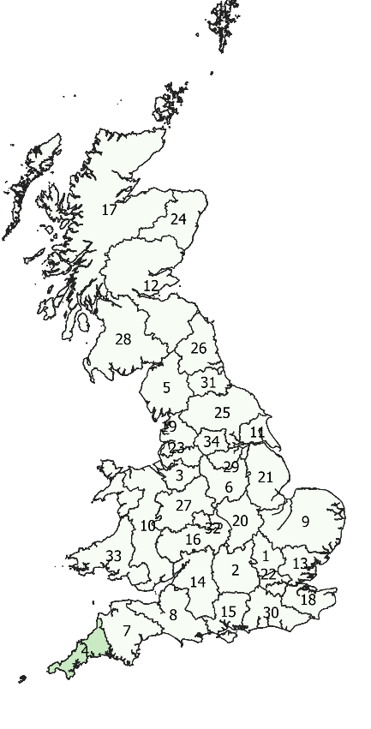  Figure 28: PEM installed capacity 2030. | 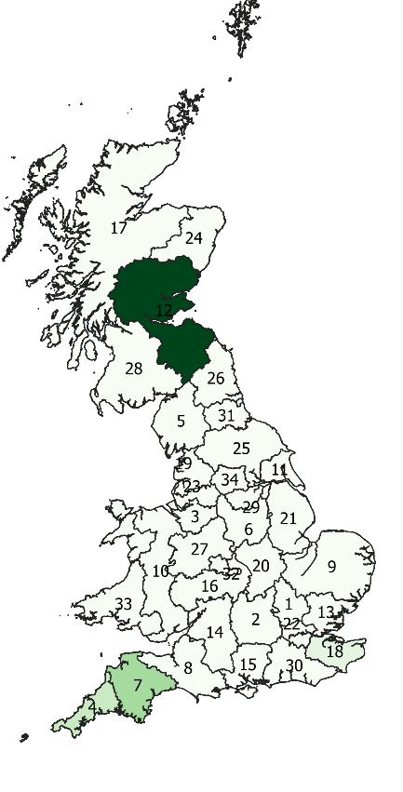  Figure 29: PEM installed capacity 2040. | 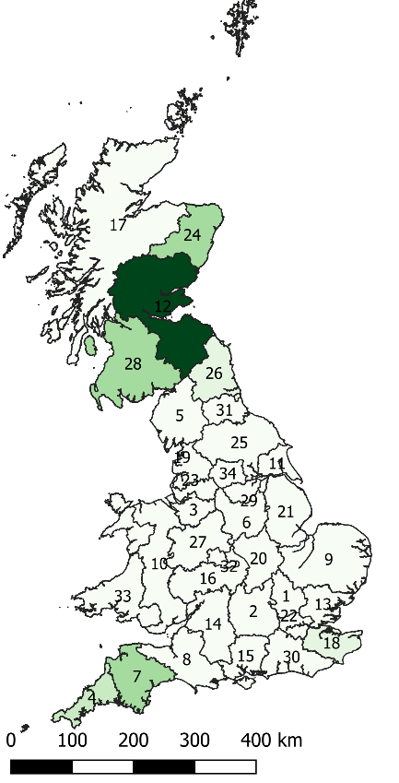  Figure 30: PEM installed capacity 2050. | 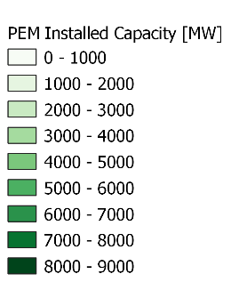
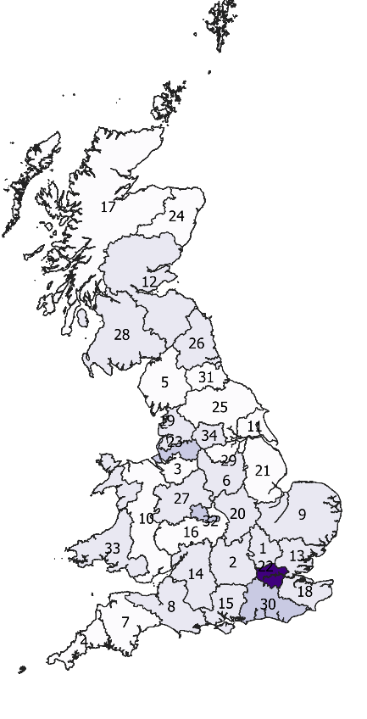  Figure 31: Alkaline electrolyser installed capacity 2020. | 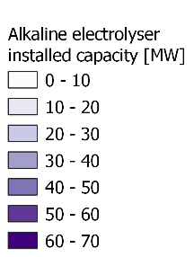 | 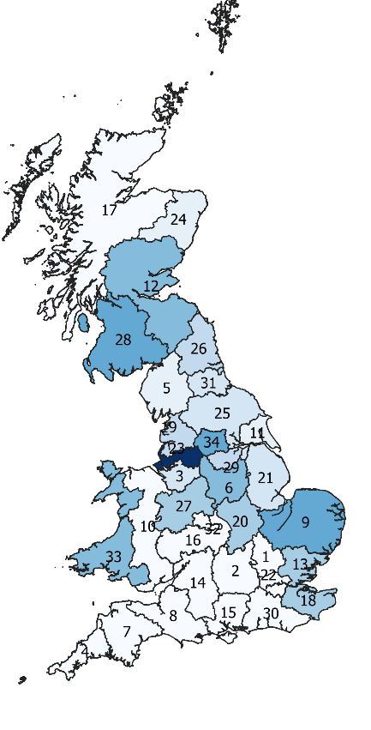  Figure 32: SOEC installed capacity 2030. | 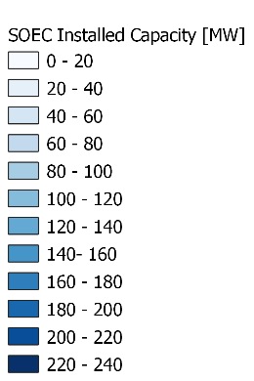

Case 1
As shown in the base case, the highest carbon price scenario forced 2.7% installed production capacity to be from renewable methods in 2050. However, it was decided to extend the carbon price to analyse the trade-off between decarbonising the supply chain and the increase in TDC as more renewable production methods are installed. A carbon price factor (CPF) which multiplies the mid-carbon price was applied.
For all carbon price factors considered, production from renewable sources was seen to be introduced in 2040 at the earliest. Figure 33 to Figure 35 show the installed hydrogen production technologies in 2040 to 2050 for the various CPF. For a carbon price factor of 3.8 to 4, renewable wind electrolysis makes up 86% of the total installed capacity by 2050. Increased total capacity with higher levels of electrolysis from wind reflect wind turbine capacity factors.
The rest of the supply chain configuration remains relatively similar. Regional transportation is favoured via newly installed pipelines; local transportation is favoured via repurposing the GDN to supply 100% hydrogen; and purification is favoured via PSA, installed locally at the refuelling station (purifying hydrogen from a dirty to a pure grade). With a CPF of 4, hydrogen production from SMR was installed in the same zones as the base case scenarios, and production from PEM electrolysers powered by wind was installed in zones 7, 4, 12 and 24.
Figure 33: Installed hydrogen production capacity for CPF – 2040 | Figure 34: Installed hydrogen production capacity for CPF – 2045
Figure 35: Installed hydrogen production capacity for CPF – 2050
A key aspect of this case study was to analyse the annual carbon emissions of the supply chain as the carbon price factor is increased, which is shown Figure 36. For all carbon price factors, the annual emissions decrease in the time period 2050, relative to 2045. However, at much higher carbon price factors, such as 4, annual carbon emissions in 2050 drop to almost the same level as 2030, while producing approximately 233% more hydrogen relative to 2030.

Figure 36: Comparison of annual carbon emissions for carbon price factors (CPF)
With regards to the total discounted cost for different CPF, Figure 37 shows how the increased adoption of renewable production methods affects the cost of the supply chain and the corresponding cost of hydrogen at the pump, excluding the costs due to carbon emissions. Costs due to carbon emissions were removed from the TDC to analyse the cost of installed renewable infrastructure alone, without the interference of the increased costs due to carbon emissions. As can be seen, with a carbon price factor of 4, there is an additional total cost of £1.32 billion. However, this reduces the carbon emissions of the supply chain by 3,500 [ktonnes] over the 30-year operating period. Furthermore, the price of hydrogen at the pump is £6.30, which is only 2% higher for the customer than to mid-carbon price assumption.

Figure 37: TDC and cost of hydrogen at the pump for different CPF, excluding cost of carbon.
Finally, the question that was left to answer from this case study is what carbon price factor forces the model to completely decarbonise production of hydrogen for transport by 2050, and what effect would this have on the price of the hydrogen at the pump? After extending the CPF further, it was found that a value of 6 leads to the model choosing to fully decarbonise the supply chain by 2050. As Figure 38 shows, production from SMR is phased out by 2045, with a significant uptake of wind capacity. This figure also highlights the significant increase in installed production capacity required when producing hydrogen from renewables, due to the capacity factor, which takes into consideration the intermittency of renewables. When compared to the base case - mid carbon price scenario - the installed production capacity in the whole of GB in 2050 is 12.6 GW greater. Hydrogen production capacity from wind PEM electrolysis in 2050 was installed in zones 4, 7, 12, 18, 24, 26 and 28 for the CPF value of 6.

Figure 38: Total installed production capacity over time for CPF=6.
The TDC of the supply chain, excluding the costs due to carbon emissions, is £69.2 billion, which equates to £6.54 per kg of hydrogen. Full decarbonisation compared to the base case costs an additional £3.8 billion and abates a total of 6.05$×$10⁶ tonnes of CO₂ for the transport sector, which equates to £628.39/tCO₂. The cost of emission avoidance calculated in the H21 – Leeds Citygate report [56] was estimated to be £291.4/tCO₂. The value, however, considers decarbonising the heating sector and not the transport sector, which is much more expensive due to purification requirements. Additionally, considering sector-coupling would enable to lower the cost of CO₂ abatement.

Case 2
From the base case, it was identified that local distribution via repurposing the GDN to supply 100% hydrogen was the most cost optimal method. However, the conceptual idea of blending hydrogen into the GDN for the transport sector is being considered in some projects [72, 73]. Therefore, the objective of this case study was to adapt the supply chain model to investigate what is the cost of hydrogen separation/purification equipment at which blending into the GDN would be a cost-effective distribution method. In order to implement this into the model, the learning rate of both PSA and membrane hydrogen separation/purification equipment was varied between 1 and 15%. Furthermore, since blending into the GDN is the main focus of this case study, the option of repurposing the GDN to supply 100% hydrogen was removed from the model.
Figure 39 to Figure 42 show the installed transportation capacity as the learning rate of the PSA system was varied, from 2035 onwards, as blending into the GDN does not occur until 2035 at the earliest even for higher learning rates. As can be seen a learning rate of 15% is required for almost a full adoption of blending into the GDN by 2050. This raises the question as to whether there is much benefit of blending hydrogen into the GDN in 2035, as emission constraints should be greater by this time, therefore, there would be a reduced usage of natural gas for the heating sector and thus the opportunity for sector coupling could be lost by this point. Figure 43 to Figure 48 show the installed capacity of blending into the GDN in the different zones, for the time periods of 2040 and 2050, with PSA learning rates of 2%; 8% and 15%. These specific scenarios were chosen as they highlight significant steps in the evolution of the configuration of the supply chain.
The results show that the model favours blending into the GDN in specific zones based on two main factors: First if the zone has a relatively large local distribution length, and secondly if the zone has a high demand for hydrogen. An example of high demand resulting in the model favouring blending into the GDN is zone 22 (greater London), which adopts a large installed capacity relative to other zones for all three of the learning rates. On the other hand, zone 12 is an example of a zone that has a relatively large distribution length, but not a specifically high demand – with a local distribution length of approximately 3,400 km and a relatively mid-level demand of around 3,300 kWh in 2050. This result can be explained as blending into the GDN was assumed to have no additional CAPEX and a relatively low OPEX, thus making it cheaper than other transportation options. However, the additional cost of installed separation/purification equipment was large. Therefore, in order for blending into the GDN to be a cost optimal distribution method, there has to be a high transportation of hydrogen through the GDN, either through a large capacity (in kW), or through a long local distribution distance (in km). Thus, allowing the costs savings from blending into the GDN to outweigh the additional costs of installing separation/purification equipment.

Figure 39: Local transportation capacity for PSA learning rates, 2035. | Figure 40: Local transportation capacity for PSA learning rates, 2040.
Figure 41: Local transportation capacity for PSA learning rates, 2045. | Figure 42: Local transportation capacity for PSA learning rates, 2050.

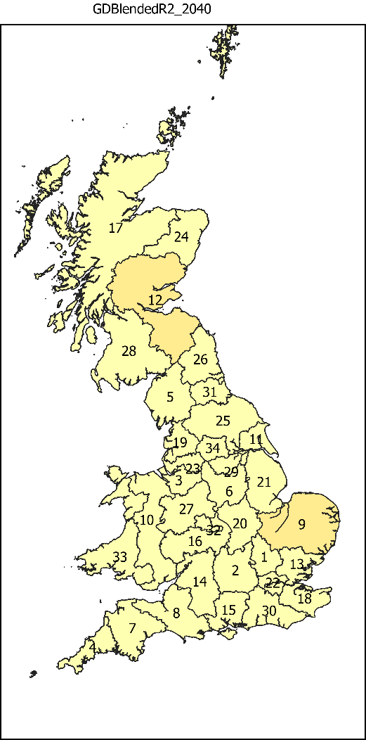  Figure 43: Installed GDN blending capacity with a learning rate of 2%, 2040. | 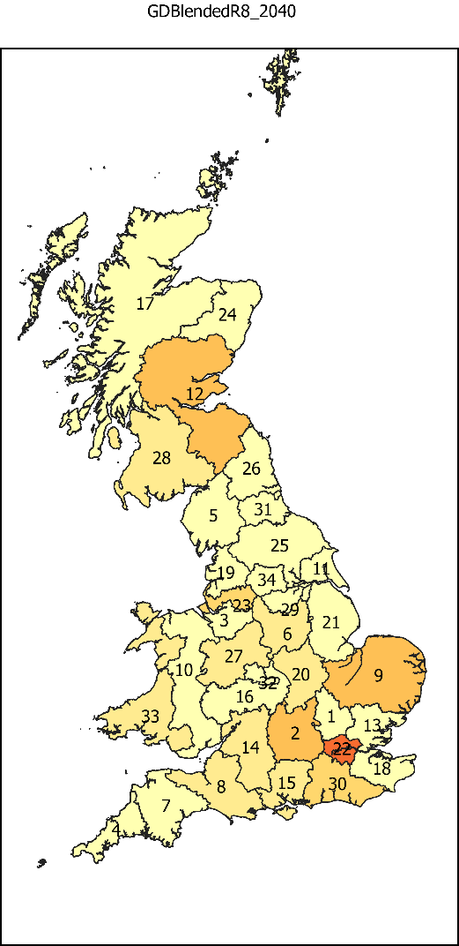  Figure 44: Installed GDN blending capacity with a learning rate of 8%, 2040. | 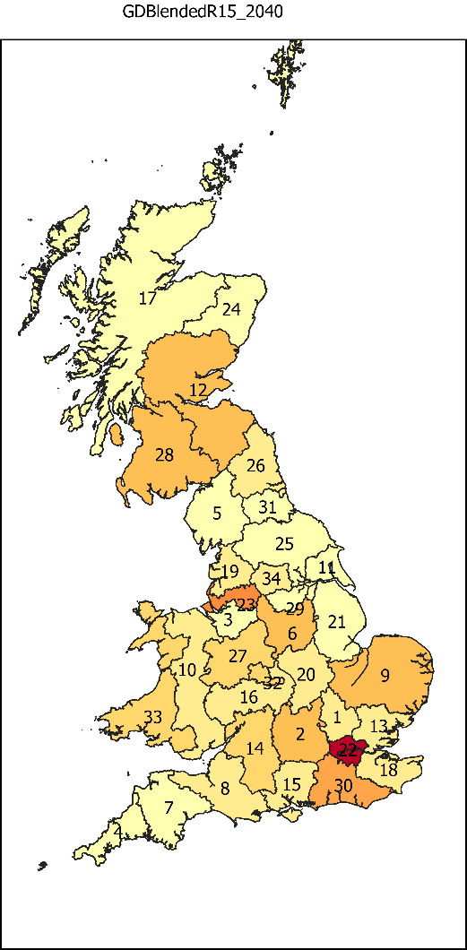  Figure 45: Installed GDN blending capacity with a learning rate of 15%, 2040. | 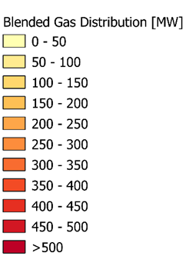
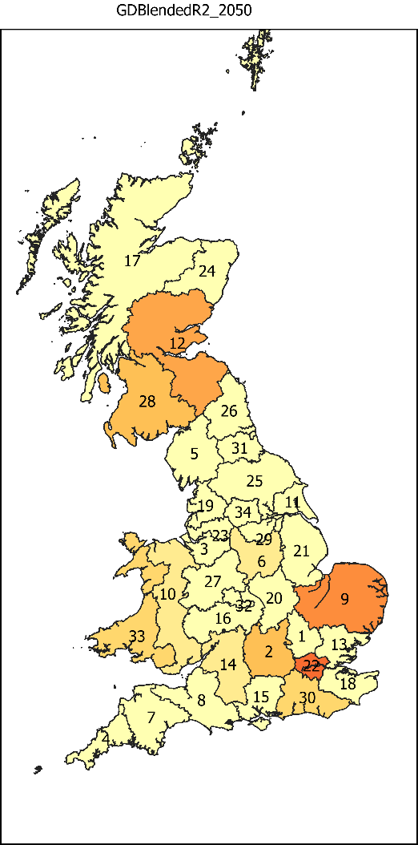  Figure 46: Installed GDN blending capacity with a learning rate of 2%, 2050. | 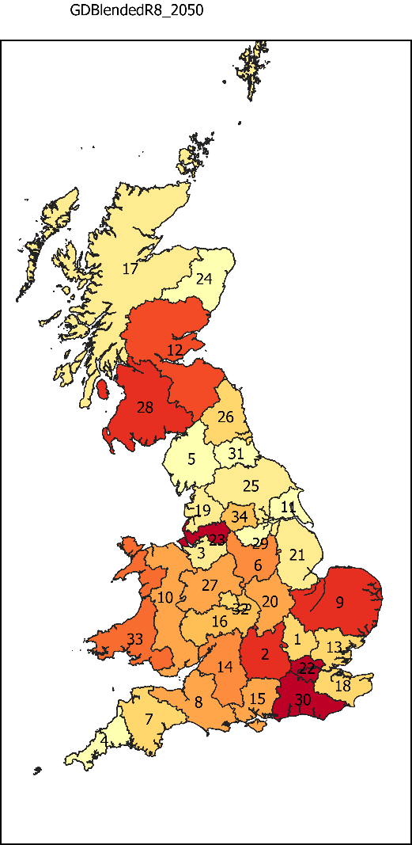  Figure 47: Installed GDN blending capacity with a learning rate of 8%, 2050. | 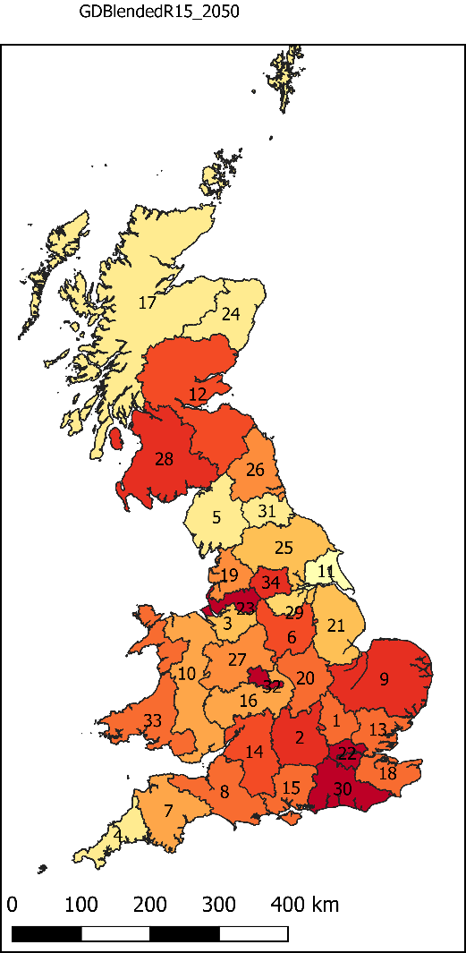  Figure 48: Installed GDN blending capacity with a learning rate of 15%, 2050.

The total discounted cost is largely affected by the prevention of repurposing the gas distribution network. With the original learning rate of a PSA system at 2.5%, the total discounted cost would lie between the value of 70.1 – 69.2 £bn, representing an additional cost of £4.7 – £3.8 billion compared to the base case - mid carbon price scenario. This highlights the possible cost savings that could be attained from repurposing the hydrogen distribution network to supply 100% hydrogen. On the other end of the spectrum, with a learning rate of 15%, the TDC is £62.6, which equates to £5.91 per kg of hydrogen, placing the cost of hydrogen-at-pump more within the values found by Moreno-Benito et al.[33]. This shows that with high PSA learning rates, the TDC may be lower than that found in the base case. However, these results must be critically analysed from two main points. Firstly, since PSA is a well-established technology, a high learning rate would be unlikely, and thus the same level of adoption of blending into the GDN would not be cost effective. Secondly, even if PSA does experience a learning rate of 15%, the model chooses to install new pipelines for local distribution in all zones up to 2030. The approach of installing new pipelines up until 2030 and then starting to blend into the GDN, could be the cost-optimal solution, but might be impractical. A higher spatial detail (individual pipe-level) would be needed to analyse the rationality of this pathway, to ensure that newly fit-for-purpose pipelines do not end as a redundant asset, thus leading to the same problem that repurposing/blending hydrogen into the GDN was trying to combat in the first place.

Figure 49: Hydrogen production costs for different PSA learning rate scenarios
With regards to varying the hybrid membrane system learning rates, the effect on the hydrogen supply chain configuration was very small. The analysis was therefore extended for learning rates of up to 25%. Figure 50 shows the total participation of blending hydrogen into the GDN as a percentage of the total distribution capacity. The results obtained for all learning rate variations between 0 and 12% were the same. As shown in Figure 50, even for learning rates greater than 15%, there was still a relatively low adoption of blending into the GDN in comparison to adjusting the PSA learning rate. This highlights the extreme cost reductions required for novel technologies such as the membrane hybrid systems required to enable blending into the GDN to become an economically feasible distribution method.

Figure 50: Participation of blending hydrogen into de GDN as a percentage of total distribution capacity for hybrid membrane separation system learning rates of 12%-25%.

Sensitivity analysis
In order to study the effect of uncertain parameters in modelled outcomes, a sensitivity analysis was conducted on gas prices and solar PV learning rates, in addition to the carbon price variation presented previously.

Gas prices
The Base Case was run with low and high gas price estimates as provided by BEIS [46, 47]. These values can be seen in Table 19. As shown in Figure 51 and Figure 52, the variation in gas prices has a large effect on the installed production capacity. For the high gas price scenario, final PEM + electrolysis installed capacity in 2050 ends up being 9.3 GW (versus 3 GW in the base case scenario). Furthermore, in the low gas price scenario, there is no PEM + electrolysis by 2050. This highlights the vast effect that a small change in the gas price can have on the overall configuration of hydrogen production in the model.
Figure 51: Installed production capacity for high gas price scenario. | Figure 52: Installed production capacity for low gas price scenario.

Solar PV learning rates
Lastly, since solar PV CAPEX prices continue to drop at a faster rate than originally anticipated [74], it was decided to include a sensitivity analysis around the price of solar PV by varying its learning rate between 5-10%. As shown in Table 13, increasing solar PV’s learning rate has a small effect on overall installed production capacity of each technology by 2050. This is because, as previously mentioned in this study, solar PV capacity factors are extremely low in the UK when compared to those of wind. This means that even though solar PV at high learning rates might have a significantly smaller CAPEX than wind; due to the formulation of the model, the coarse temporal resolution, and the low PV capacity factor in the UK, installed capacity of solar PV must be doubled to produce hydrogen from solar PV versus wind, resulting in an overall higher total discounted cost.
Table 13: Total installed hydrogen production capacity in 2050 for various solar PV learning rates.
Solar PV Learning Rate | SMR + CCS installed capacity [MW] | PEM + Wind installed capacity [MW] | Alkaline + Solar PV installed capacity [MW]
5% | 9,780.78 | 2,993.83 | 15.09
6% | 9,780.10 | 2,993.83 | 19.35
7% | 9,780.10 | 2,993.83 | 19.35
8% | 9,780.10 | 2,993.83 | 19.35
9% | 9,780.10 | 2,993.83 | 19.35
10% | 9,780.10 | 2,993.83 | 19.35

Conclusion
This study presented a spatially-resolved supply chain methodology and optimisation model for hydrogen for the transport sector. The novelty of this work is that the proposed supply chain model explicitly includes hydrogen purity and purification technologies, considering their costs and technical requirements, in addition to the production and transportation technologies in a hydrogen supply chain. No previous hydrogen supply chain model includes hydrogen purity and purification technologies, which is crucial for fuel cell electric vehicles in transport applications, where hydrogen must be over 99.97% pure in order to avoid poisoning the fuel cells. The model offers the possibility to assess potential cost optimal configurations of hydrogen supply chains up to 2050 for the transport sector, and the effects that hydrogen grades play in the development of them, including the decision to repurpose gas distribution networks, or blend hydrogen into them.
The model was implemented for a case study of Great Britain, to illustrate possible uses and its applicability. In this case, the model was used to analyse different decarbonisation and learning rate scenarios, and the additional costs incurred for achieving different decarbonisation levels by 2050. The base case showed that the total discounted cost of the hydrogen supply chain is significantly more than that shown in previous studies that looked at Great Britain, largely due to the additional costs due to purification/separation. This highlights the importance of considering hydrogen grades and associated costs in a supply chain, especially for the transport sector, as hydrogen fuel cells require a high purity input. This work suggests that hydrogen supply chain models largely underestimate total supply chain costs when purification technologies are not incorporated. Because hydrogen purity is essential for transport applications, the most important recommendation derived from this study is to take into account purification technologies when estimating hydrogen lifecycle costs and optimal infrastructure configurations globally.
This work suggests that the cost optimal use of the currently installed gas distribution network for the transport sector is to repurpose it to supply 100% hydrogen, which can provide insights into strategic planning for gas distribution network operators. Furthermore, it was shown that producing hydrogen from steam methane reforming with carbon capture and storage; installing new transmission pipelines; repurposing the gas distribution network to supply 100% hydrogen; and purifying hydrogen with a pressure swing adsorption system locally at the refuelling station; was the cost optimal configuration for the given technoeconomic assumptions, providing hydrogen at £6.18 per kg at the pump. This suggests that for countries or regions which have extensive gas distribution networks, repurposing these networks for hydrogen distribution can be cost-effective, and could avoid sunken assets in the pathway to reach stringent decarbonisation targets.
The model was then further extended to analyse the effect of increasing the cost of carbon emissions on the supply chain configuration and the total discounted cost. When the model is forced to decarbonise hydrogen production, there is a relatively small increase in cost of the supply chain, leaving the price at the pump being £6.54 per kg, and a carbon avoidance cost of £291.4/tCO₂. This shows that from a systems perspective, achieving deeper decarbonisation levels does not affect the final total discounted cost hugely, and poses the question as to how can policymakers incentivise these decarbonised supply chains, in addition to carbon prices.
Finally, the model was used to analyse the capital cost reductions required for hydrogen separation and purification technologies, in order to make blending into the gas distribution network to become an economically viable distribution method. As would be expected, an extremely high learning rate would be needed in order for this to happen, which highlights the question as to whether blending hydrogen into the gas distribution network to supply the transport sector is an effective use of a potentially redundant asset in a decarbonising world.
Lastly, the goal of this study was to provide a model that could design a hydrogen supply chain for the transport sector, that took into consideration hydrogen purification. This could be progressed further by integrating it into a wider scale model that takes into account other sectors, such as heating, in order to allow the assessment of sector coupling. Furthermore, an even deeper analysis and development of databases for hydrogen purification and separation technologies could identify an option that would make blending into the gas distribution network economically viable.

Acknowledgements
Francisca Jalil-Vega is supported by ANID PIA/APOYO AFB180003, and by ANID/FONDAP/15110019 SERC-Chile.

References
[1] Ogunbode CA, Doran R, Böhm G. Exposure to the IPCC special report on 1.5 °C global warming is linked to perceived threat and increased concern about climate change.
[2] IPCC. Global Warming of 1.5°C. An IPCC Special Report on the impacts of global warming of 1.5°C above pre-industrial levels and related global greenhouse gas emission pathways, in the context of strengthening the global response to the threat of climate change. 2018. Report No.: 9780470996621.
[3] The International Energy Agency (IEA). The Future of Hydrogen. 2019.
[4] The Institution of Engineering Technology, The Institution of Chemical Engineers, Institution of Mechanical Engineers, The Health Safety Executives Laboratory, Institution of Gas Engineers Managers. Transitioning to Hydrogen: Assessing the Engineering Risks and Uncertainties. 2019.
[5] Committee on Climate Change. Hydrogen in a low-carbon economy. 2018 November 2018.
[6] British Standard. BSI Standards Publication Hydrogen fuel — Product specification - BS ISO 14687-2:2012. 2012.
[7] Hickman R, Banister D. Looking over the horizon: Transport and reduced CO2 emissions in the UK by 2030. Transport Policy. 2007.
[8] Mori D, Hirose K. Recent challenges of hydrogen storage technologies for fuel cell vehicles. International Journal of Hydrogen Energy. 2009.
[9] Dincer I, Acar C. Review and evaluation of hydrogen production methods for better sustainability. International Journal of Hydrogen Energy. 2015.
[10] Verhelst S, Wallner T. Hydrogen-fueled internal combustion engines. Progress in Energy and Combustion Science. 2009;35(6):490-527.
[11] Wilberforce T, El-Hassan Z, Khatib FN, Al Makky A, Baroutaji A, Carton JG, et al. Developments of electric cars and fuel cell hydrogen electric cars. International Journal of Hydrogen Energy. 2017;42(40):25695-734.
[12] Murthy Konda NVSN, Shah N, Brandon NP. Optimal transition towards a large-scale hydrogen infrastructure for the transport sector: The case for the Netherlands. International Journal of Hydrogen Energy. 2011;36(8):4619-35.
[13] Haeseldonckx D, D'Haeseleer W. Concrete transition issues towards a fully-fledged use of hydrogen as an energy carrier: Methodology and modelling. International Journal of Hydrogen Energy. 2011.
[14] Speirs J, Balcombe P, Johnson E, Martin J, Brandon N, Hawkes A. A Greener Gas Grid: What are The Options? ; 2017.
[15] Azzaro-Pantel C. Hydrogen Supply Chains Design, Deployment and Operation: Mara Conner; 2018.
[16] Almansoori A, Shah N. Design and operation of a future hydrogen supply chain: Snapshot model. Chemical Engineering Research and Design. 2006;84(6 A):423-38.
[17] Hill N, Hilton G, Morgan-Price S, Weldon P. Zero Emission HGV Infrastructure Requirements. 2019.
[18] Yang C, Ogden J. Determining the lowest-cost hydrogen delivery mode. International Journal of Hydrogen Energy. 2007.
[19] Johnson N, Ogden J. A spatially-explicit optimization model for long-term hydrogen pipeline planning. International Journal of Hydrogen Energy. 2012.
[20] Baufumé S, Grüger F, Grube T, Krieg D, Linssen J, Weber M, et al. GIS-based scenario calculations for a nationwide German hydrogen pipeline infrastructure. International Journal of Hydrogen Energy. 2013;38(10):3813-29.
[21] Dodds PE, Demoullin S. Conversion of the UK gas system to transport hydrogen. International Journal of Hydrogen Energy. 2013;38(18):7189-200.
[22] Reuß M, Welder L, Thürauf J, Linßen J, Grube T, Schewe L, et al. Modeling hydrogen networks for future energy systems: A comparison of linear and nonlinear approaches. International Journal of Hydrogen Energy. 2019.
[23] Samsatli S, Staffell I, Samsatli NJ. Optimal design and operation of integrated wind-hydrogen-electricity networks for decarbonising the domestic transport sector in Great Britain. International Journal of Hydrogen Energy. 2016;41(1):447-75.
[24] Samsatli S, Samsatli NJ. A general spatio-temporal model of energy systems with a detailed account of transport and storage. Computers & Chemical Engineering. 2015;80:155-76.
[25] Robinius M, Otto A, Heuser P, Welder L, Syranidis K, Ryberg DS, et al. Linking the power and transport sectors - Part 1: The principle of sector coupling. Energies. 2017;10(7).
[26] Robinius M, Otto A, Syranidis K, Ryberg DS, Heuser P, Welder L, et al. Linking the power and transport sectors - Part 2: Modelling a sector coupling scenario for Germany. Energies. 2017;10(7):1-23.
[27] Reuß M, Grube T, Robinius M, Preuster P, Wasserscheid P, Stolten D. Seasonal storage and alternative carriers: A flexible hydrogen supply chain model. Applied Energy. 2017;200:290-302.
[28] Reuß M, Grube T, Robinius M, Stolten D. A hydrogen supply chain with spatial resolution: Comparative analysis of infrastructure technologies in Germany. Applied Energy. 2019;247(April):438-53.
[29] Colbertaldo P, Guandalini G, Campanari S. Modelling the integrated power and transport energy system: The role of power-to-gas and hydrogen in long-term scenarios for Italy. Energy. 2018;154:592-601.
[30] Carrera E, Azzaro-Pantel C. A methodological design framework for hydrogen and methane supply chain with special focus on Power-to-Gas systems: application to Occitania region, France. Computers & Chemical Engineering. 2021:107386.
[31] Potrč S, Čuček L, Martin M, Kravanja Z. Sustainable renewable energy supply networks optimization – The gradual transition to a renewable energy system within the European Union by 2050. Renewable and Sustainable Energy Reviews. 2021;146:111186.
[32] Almansoori A, Betancourt-Torcat A. Design of optimization model for a hydrogen supply chain under emission constraints - A case study of Germany. Energy: Pergamon; 2016. p. 414-29.
[33] Moreno-Benito M, Agnolucci P, Papageorgiou LG. Towards a sustainable hydrogen economy: Optimisation-based framework for hydrogen infrastructure development. Computers & Chemical Engineering. 2017;102:110-27.
[34] Ochoa J, Azzaro-Pantel C, Aguilar-Lasserre A. Optimization of a hydrogen supply chain network design under demand uncertainty by multi-objective genetic algorithms. Computers & Chemical Engineering. 2020;140:106853.
[35] Fazli-Khalaf M, Naderi B, Mohammadi M, Pishvaee MS. Design of a sustainable and reliable hydrogen supply chain network under mixed uncertainties: A case study. International Journal of Hydrogen Energy. 2020;45(59):34503-31.
[36] Ehrenstein M, Galán-Martín Á, Tulus V, Guillén-Gosálbez G. Optimising fuel supply chains within planetary boundaries: A case study of hydrogen for road transport in the UK. Applied Energy. 2020;276:115486.
[37] Cantú VH, Azzaro-Pantel C, Ponsich A. A Novel Matheuristic based on bi-level optimization for the multi-Objective design of hydrogen supply chains. Computers & Chemical Engineering. 2021;152:107370.
[38] Bolat P, Thiel C. Hydrogen supply chain architecture for bottom-up energy systems models. Part 1: Developing pathways. Pergamon; 2014. p. 8881-97.
[39] Bolat P, Thiel C. Hydrogen supply chain architecture for bottom-up energy systems models. Part 2: Techno-economic inputs for hydrogen production pathways. Pergamon; 2014. p. 8898-925.
[40] BEIS. Road transport energy consumption at regional and local authority level: Department for Business, Energy, and Industrial Strategy,; 2020 [Available from: https://www.gov.uk/government/statistical-data-sets/road-transport-energy-consumption-at-regional-and-local-authority-level].
[41] Hirz M. What is an efficiency of modern average car IC engines? 2016.
[42] Energy USDo. Hydrogen Fuel Cells Fact Sheet. 2006:2-.
[43] McKinsey Company. A portfolio of power-trains for Europe: a fact-based analysis The role of Battery Electric Vehicles, Plug-in Hybrids and Fuel Cell Electric Vehicles. 2010.
[44] Dodds PE, Ekins P. A portfolio of powertrains for the UK: An energy systems analysis. Elsevier Ltd; 2014.
[45] Almaraz SDL. Multi-Objective Optimisation of a Hydrogen Supply Chain. 2014.
[46] BEIS. Fossil fuel price assumptions: Department for Business, Energy, and Industrial Strategy,; 2020 [Available from: https://www.gov.uk/government/collections/fossil-fuel-price-assumptions].
[47] BEIS. Updated energy and emissions projections 2018: Department for Business, Energy, and Industrial Strategy,; 2019 [35-]. Available from: https://assets.publishing.service.gov.uk/government/uploads/system/uploads/attachment_data/file/794590/updated-energy-and-emissions-projections-2018.pdf%0Ahttps://www.gov.uk/government/uploads/system/uploads/attachment_data/file/239937/uep_2013.pdf].
[48] Renewables.ninja [Available from: https://www.renewables.ninja/].
[49] In Balance Energy. Solar and Electrical Services & Systems 2021 [cited 2021. Available from: https://www.inbalance-energy.co.uk/articles/solar_panels_pv_calculator.html].
[50] BEIS. Clean Growth The UK Carbon Capture Usage and Storage deployment pathway An Action Plan. The Department for Business, Energy, and Industrial Strategy,; 2018.
[51] Element Energy. Hydrogen supply chain evidence base. 2018.
[52] IEA. The Future of Hydrogen Report: Assumptions. International Energy Agency; 2019.
[53] IEA. The Future of Hydrogen. International Energy Agency; 2019.
[54] BEIS. Green Book supplementary guidance: valuation of energy use and greenhouse gas emissions for appraisal - GOV.UK: Department for Business, Energy, and Industrial Strategy,; 2020 [Available from: https://www.gov.uk/government/publications/valuation-of-energy-use-and-greenhouse-gas-emissions-for-appraisal].
[55] OFGEM, National Grid Gas Transmission, Dnv G. L. Network Innovation Competition Screening Submission Pro forma - HyNTS. 2020.
[56] Sadler D, Cargill A, Crowther M, Rennie A, Watt J, Burton S, et al. H21 - Leeds City Gate. 2016.
[57] McKinnon A, Piecyk M. Measuring and Managing CO 2 Emissions of European Chemical Transport. Edinburgh.
[58] HyDeploy. Hydrogen is vital to tackling climate change - HyDeploy [Available from: https://hydeploy.co.uk/].
[59] HSE. The Health And Safety Executive's Enforcement Policy for The Replacement of Iron Gas Mains. 2001.
[60] Xu X, Xu B, Dong J, Liu X. Near-term analysis of a roll-out strategy to introduce fuel cell vehicles and hydrogen stations in Shenzhen China. Applied Energy. 2017;196:229-37.
[61] Martin JR, Gottzmann CF, Notaro F, Stewart HA. Gas Separation by Pressure Swing Adsorption. 31. Boston, MA: Springer; 1986. p. 1071-86.
[62] Nordio M, Wassie SA, Van Sint Annaland M, Pacheco Tanaka DA, Viviente Sole JL, Gallucci F. Techno-economic evaluation on a hybrid technology for low hydrogen concentration separation and purification from natural gas grid. International Journal of Hydrogen Energy. 2020.
[63] Melaina MW, Antonia O, Penev M. Blending Hydrogen into Natural Gas Pipeline Networks: A Review of Key Issues. NREL; 2013.
[64] Almansoori A, Shah N. Design and operation of a stochastic hydrogen supply chain network under demand uncertainty. International Journal of Hydrogen Energy. 2012;37(5):3965-77.
[65] Hydrogen Council. Path to hydrogen competitiveness: A cost perspective. 2020.
[66] Agnolucci P, Akgul O, McDowall W, Papageorgiou LG. The importance of economies of scale, transport costs and demand patterns in optimising hydrogen fuelling infrastructure: An exploration with SHIPMod (Spatial hydrogen infrastructure planning model). International Journal of Hydrogen Energy. 2013;38(26):11189-201.
[67] IRENA. Green Hydrogen Cost Reduction: Scaling up Electrolysers to Meet the 1.5⁰C Climate Goal. International Renewable Energy Agency, Abu Dhabi; 2020.
[68] HM Government. Industrial Decarbonisation Strategy. 2021.
[69] Abdulla A, Hanna R, Schell KR, Babacan O, Victor DG. Explaining successful and failed investments in U.S. carbon capture and storage using empirical and expert assessments. Environmental Research Letters. 2020;16(1):014036.
[70] Global CCS Institute. Global Status of CCS 2020. 2020.
[71] Wang A, Jens J, Mavins D, Moultak M, Schimmel M, Leun Kvd, et al. European Hydrogen Backbone - Analysing future demand, supply, and transport of hydrogen. 2021.
[72] HyNet. HyNet - Hydrogen Energy and Carbon Capture, Usage and Storage [Available from: https://hynet.co.uk/].
[73] Cadent Gas. HyMotion: HG2V Innovation to Reduce CO2 Emissions HG2V (Hydrogen Grid to Vehicle). 2018.
[74] IRENA. Renewable Power Generation Costs in 2019. Abu Dhabi: International Renewable Energy Agency; 2020.
[75] Office for National Statistics. UK: county population 2018 | Statista 2019 [Available from: https://www.statista.com/statistics/971694/county-population-england/].
[76] Office for National Statistics. Regional population of Scotland 2018 Statistic | Statista 2019 [Available from: https://www.statista.com/statistics/865968/scottish-regional-population-estimates/].
[77] Office for National Statistics. Regional population of Wales 2018 | Statista 2019 [Available from: https://www.statista.com/statistics/971295/regional-population-wales/].
[78] Statista. Energy and Enviroment 2021 [Available from: https://www.statista.com/statistics/499507/average-solar-pv-cost-per-kw-installed-uk/].
[79] Hydrogen Europe. Hydrogen Europe - Hydrogen transport & distribution [Available from: https://hydrogeneurope.eu/hydrogen-transport-distribution].
[80] National Grid Gas. Climate Change Adaptation Reporting - Second Round Response. National Grid; 2016.
[81] The Engineering Toolbox. Hydrogen - Density and Specific Weight [Available from: https://www.engineeringtoolbox.com/hydrogen-H2-density-specific-weight-temperature-pressure-d_2044.html].

Appendix

Nomenclature
Sets
$$c$$ | Purification technology $∈\{PSACentral$: Centralised pressure swing adsorption, $PSALocal_{Dirty}$: Localised pressure swing adsorption with dirty grade hydrogen as the inlet, $PSALoc{al}_{Clean}$: Localised pressure swing adsorption with clean grade hydrogen as the inlet, $PSALoc{al}_{Blend}$: Localised pressure swing adsorption with blended grade hydrogen as the inlet, $MemLoc{al}_{Blend}$: Localised hybrid membrane purification with blended grade hydrogen as the inlet. | -
$$g$$ | Hydrogen grade $∈\{Blend,Dirty, Clean\}$ | -
$$l$$ | Transportation technology $∈\{Truc{kGH}_{Dirty}, Truc{kGH}_{Clean}, Truc{kLH}_{Dirty}, Truc{kLH}_{Clean}, NewTransmissionPipeline_{Dirty}, NewTransmissionPipeline_{Clean}, NewDistributionPipeline_{Dirty}, NewDistributionPipeline_{Clean}, RepurposingGasDistributionNetwork, BlendingGasDistributionNetwork\}$ | -
$$p$$ | Production technology $∈\{SMR:$Steam methane reforming with CCS$, AlkalineElectrolysis$: Alkaline electrolyser connected to electricity grid$, PEMElectrolysis$: PEM electrolyser connected to electricity grid$, SOECElectrolysis$:SOEC Electrolyser connected to electricity grid$, AlkalineElectrolysis_{Wind}$: Alkaline electrolyser connected to onshore windfarm$, PEMElectrolysis_{Wind}$:PEM electrolyser connected to onshore windfarm$, SOECElectrolysis_{Wind}$:SOEC electrolyser connected to onshore windfarm,$AlkalineElectrolysis_{Solar}$: Alkaline electrolyser connected to solar PV$, PEMElectrolysis_{Solar}$:PEM electrolyser connected to solar PV$, SOECElectrolysis_{Solar}$:SOEC electrolyser connected to solar PV$\}$ | -
$$y$$ | Time period $∈\{2015, 2020, …,2050\}$ | -
$$z$$ | Zone $∈\{1,2,…,34\}$ | -
Parameters
$$A_{z}$$ | Land available for onshore wind turbines in zone $z$ | $$km^{2}$$
$$α$$ | Number of operating hours of the supply chain in a year. | $$\frac{Hours}{year}$$
$$β^{RF}$$ | Number of days worth of hydrogen storage installed at refuelling stations. | $$Day(s)$$
$$CapFactor_{p,z}$$ | Capacity factor of production technology $p$ in zone $z$ | -
$$CarbonPrice_{y}$$ | Cost associated with carbon emissions in time period $y$ | $$\frac{£}{kg_{CO2}}$$
$${CCost}_{c,y}^{L,Dirty}$$ | Capital costs of localised purification, purifying dirty hydrogen to pure hydrogen, via technology $c$, in time period $y$. | $$\frac{£}{kW}$$
$${CCost}_{c,y}^{C,Dirty}$$ | Capital costs of centralised purification, purifying dirty hydrogen to pure hydrogen, via technology $c$, in time period $y$. | $$\frac{£}{kW}$$
$${CCost}_{c,y}^{L,Blend}$$ | Capital costs of localised purification, purifying blended hydrogen to pure hydrogen, via technology $c$, in time period $y$. | $$\frac{£}{kW}$$
$${CCost}_{c,y}^{L,Clean}$$ | Capital costs of localised purification, purifying clean hydrogen to pure hydrogen, via technology $c$, in time period $y$. | $$\frac{£}{kW}$$
$$CCost_{p,g,y}^{P}$$ | Capital cost of production technology $p$, producing hydrogen of grade $g$, in time period $y$. | $$£/kW$$
$$CCost_{y}^{RF}$$ | Capital costs of refuelling station in time period $y$. | $$\frac{£}{kW}$$
$$CCost_{l,g,y}^{Trans,L}$$ | Local transport capital cost of technology $l$, transporting hydrogen of grade $g$, in time period $y$. | $$\frac{£}{kW-km}$$
$$CCost_{l,g,y}^{Trans,R}$$ | Regional transport capital cost of technology $l$, transporting hydrogen of grade $g$, in time period $y$. | $$\frac{£}{kW-km}$$
$$\overline{D_{z,y}}$$ | The demand for hydrogen for transport in zone $z$, in time period $y$ | $$kWh$$
$$DFOC_{y}$$ | Discount operating factor in time period $y$ | -
$$d^{L}(z)$$ | Local distribution distance. | $$km$$
$$d^{R}(z,z^{'})$$ | Regional transmission distance. | $$km$$
$$EmissionFactor_{p,y}^{Prod}$$ | Carbon emission factor of production, via technology $p,$ in time period $y$ | $$\frac{kg_{CO2}}{kWh}$$
$$EmissionFactor_{c,y}^{Pur}$$ | Carbon emission factor of purification, via technology $c$, in time period $y$. | $$\frac{kg_{CO2}}{kWh}$$
$$EmissionFactor_{l,y}^{Tran,L}$$ | Carbon emission factor of local transportation, via technology $l,$ in time period $y$ | $$\frac{kg_{CO2}}{kWh-km}$$
$$EmissionFactor_{l,y}^{Tran,R}$$ | Carbon emission factor of regional transportation, via technology $l,$ in time period $y$ | $$\frac{kg_{CO2}}{kWh-km}$$
$${FixedOPEXTrans}_{l}$$ | Fixed operational cost of transport via technology $l$ as a percentage of capital cost | $$\%$$
$${ Lprod}_{p}$$ | Lifetime of production technology $p$. | $$Year$$
$${ Lpur}_{c}$$ | Lifetime of purification technology $c$. | $$Year$$
$$Lref$$ | Lifetime of refuelling station. | $$Year$$
$${ Ltrans}_{l}$$ | Lifetime of transportation technology $l$. | $$Year$$
$$LUT_{l,g}$$ | Loading/unloading time of trucks transporting hydrogen in grade $g$. | $$\frac{£}{kWh}$$
$$M$$ | Large value | -
$$Neigh(z,z^{'})$$ | Matrix of 1’s and 0’s indicating whether zone $z$ and $z^{'}$ are neighbouring. | -
$${OCost}_{c,y}^{C,Dirty}$$ | Operating costs of centralised purification, purifying dirty hydrogen to clean hydrogen, via technology $c$, in time period $y$. | $$\frac{£}{kWh}$$
$${OCost}_{c,y}^{L,Blend}$$ | Operating costs of localised purification, purifying blended hydrogen to pure hydrogen, via technology $c$, in time period $y$. | $$\frac{£}{kWh}$$
$${OCost}_{c,y}^{L,Clean}$$ | Operating costs of localised purification, purifying clean hydrogen to pure hydrogen, via technology $c$, in time period $y$. | $$\frac{£}{kWh}$$
$${OCost}_{c,y}^{L,Dirty}$$ | Operating costs of localised purification, cleaning dirty hydrogen to pure hydrogen, via technology $c$, in time period $y$. | $$\frac{£}{kWh}$$
$${OCost}_{p,g,y}^{P}$$ | Operating cost of production technology $p$, producing hydrogen of grade $g$, in time period $y$. | $$£/kWh$$
$${OCost}_{y}^{RF}$$ | Operating costs of refuelling station in time period $y$. | $$\frac{£}{kWh}$$
$${OCostT}_{l,g,y}^{L}$$ | Operating cost of local transport via technology $l$, of grade $g$, in time period $y$ | $$\frac{£}{kWh-km}$$
$${OCostT}_{l,g,y}^{R}$$ | Operating cost of regional transport via technology $l$, of grade $g$, in time period $y$ | $$\frac{£}{kWh-km}$$
$$PCap^{Turbine,Max}$$ | Maximum production capacity of a wind turbine | $$kW$$
$$ProdFixedOPEX_{p}$$ | Fixed operating cost of production technology as a percentage of capital cost. | $$\%$$
$$r$$ | Discount rate | $$\%$$
$$R^{W}$$ | Radius of wind turbine | $$m$$
$$y_{final}$$ | The final year of the model’s operation (2051) | -
Variables
$$CARBON$$ | Cost associated with carbon emission of supply chain | $$£$$
$$DPRCap_{p,z,g,y,y^{'}}$$ | Decommissioned capacity of production technology $p$, in zone $z$, of grade $g$ installed in time period$y$ and decommissioned in time period$y^{'}$. | $$kW$$
$$DPurCAP_{c,z,y,y^{'}}^{C,Dirty}$$ | Decommissioned centralised purification capacity, purifying dirty hydrogen to clean via technology $c$, in zone $z$, installed in time period $y$ and decommissioned in time period $y^{'}$. | $$kW$$
$$DPurCAP_{c,z,y^{'},y^{*}}^{L,Blend}$$ | Decommissioned localised purification capacity at refuelling station, purifying blended hydrogen to pure via technology $c$, in zone $z$, installed in time period $y$ and decommissioned in time period $y^{'}$. | $$kW$$
$$DPurCAP_{c,z,y,y^{'}}^{L,Clean}$$ | Decommissioned localised purification capacity at refuelling station, purifying clean hydrogen to pure via technology $c$, in zone $z$, installed in time period $y$ and decommissioned in time period $y^{'}$. | $$kW$$
$$DPurCAP_{c,z,y^{'},y^{*}}^{L,Dirty}$$ | Decommissioned localised purification capacity at refuelling station, purifying dirty hydrogen to pure via technology $c$, in zone $z$, installed in time period $y$ and decommissioned in time period $y^{'}$. | $$kW$$
$$DRFCap_{z,y,y^{'}}$$ | Decommissioned refuelling station capacity in zone $z$, installed in time period $y$ and decommissioned in time period $y^{'}$. | $$kW$$
$$DTCap_{l,z,g,y,y^{'}}^{L}$$ | Decommissioned capacity of local distribution via technology $l$, in zone $z$, of grade $g$ installed in time period$y$ and decommissioned in time period$y^{'}$. | $$kW$$
$$DTCap_{l,z,z^{'},g,y,y^{'}}^{R}$$ | Decommissioned capacity of transmission via technology $l$, from zone $z$ to zone $z^{'}$, of grade $g$ installed in time period$y$ and decommissioned in time period$y^{'}$. | $$kW$$
$$IPRCap_{p,z,g,y}$$ | Installed capacity of production technology $p$, in zone $z$, of grade $g$ in time period$y$. | $$kW$$
$$IPurCAP_{c,z,y}^{C,Dirty}$$ | Installed centralised purification capacity, purifying hydrogen from dirty to clean via technology $c$, in zone $z$ and time period $y$. | $$kW$$
$$IPurCAP_{c,z,y}^{L,Blend}$$ | Installed localised purification capacity at refuelling station, purifying blended hydrogen to pure via technology $c$, in zone $z$ and time period $y$. | $$kW$$
$$IPurCAP_{c,z,y}^{L,Clean}$$ | Installed localised purification capacity at refuelling station, purifying clean hydrogen to pure via technology $c$, in zone $z$ and time period $y$. | $$kW$$
$$IPurCAP_{c,z,y}^{L,Dirty}$$ | Installed localised purification capacity at refuelling station, purifying dirty hydrogen to pure via technology $c$, in zone $z$ and time period $y$. | $$kW$$
$$IRFCap_{z,y}$$ | Installed refuelling station capacity in zone $z$ and time period $y$. | $$kW$$
$$ITCap_{l,z,g,y}^{L}$$ | Installed capacity of local distribution via technology $l$, in zone $z$, of grade $g$, in time period$y$. | $$kW$$
$$ITCap_{l,z,z^{'},g,y}^{R}$$ | Installed capacity of transmission via technology $l$, from zone $z$ to zone $z^{'}$, of grade $g$ in time period$y$. | $$kW$$
$$NPRCap_{p,z,g,y}$$ | Newly installed capacity of production technology $p$, in zone $z$, of grade $g$ installed in time period$y$. | $$kW$$
$$NPurCAP_{c,z,y}^{C,Dirty}$$ | Newly Installed centralised purification capacity, purifying hydrogen from dirty to clean via technology $c$, in zone $z$, installed in time period $y$. | $$kW$$
$$NPurCAP_{c,z,y}^{L,Blend}$$ | Newly installed localised purification capacity at refuelling station, purifying blended hydrogen to via technology $c$, in zone $z$, installed in time period $y$. | $$kW$$
$$NPurCAP_{c,z,y}^{L,Clean}$$ | Newly Installed localised purification capacity, purifying clean hydrogen to via technology $c$, in zone $z$, installed in time period $y$. | $$kW$$
$$NPurCAP_{c,z,y}^{L,Dirty}$$ | Newly installed localised purification capacity at refuelling station, purifying dirty hydrogen to via technology $c$, in zone $z$, installed in time period $y$. | $$kW$$
$$NRFCap_{z,y}$$ | Newly installed refuelling station capacity in zone $z$, installed in time period $y$. | $$kW$$
$$NTCap_{l,z,g,y}^{L}$$ | Newly installed capacity of local distribution via technology $l$, in zone $z$, of grade $g$ in time period$y$. | $$kW$$
$$NTCap_{l,z,z^{'},g,y}^{R}$$ | Newly installed capacity of transmission via technology $l$, from zone $z$ to zone $z^{'}$, of grade $g$ in time period$y$. | $$kW$$
$$PCC$$ | Total production facilities capital cost. | $$£$$
$$POC$$ | Total production facilities operating cost. | $$£$$
$${PR}_{p,z,g,y}$$ | Production rate of technology $p$, in zone $z$, of grade $g$ in time period $y$. | $$kW$$
$$ProdCOEmission_{y}$$ | Annual carbon emissions due to production in time period $y$ | $$kgCO_{2}/year$$
$$PSV$$ | Total production facilities salvage value. | $$£$$
$$PurCC$$ | Total purification capital costs. | $$£$$
$$PurCOEmission_{y}$$ | Annual carbon emissions due to purification in time period $y$ | $$kgCO_{2}/year$$
$$PurOC$$ | Total purification operating costs. | $$£$$
$$PurSV$$ | Total purification salvage value | $$£$$
$$Q_{l,z,z^{'},g,y}$$ | Flowrate of hydrogen from zone $z$ into zone $z^{'}$, via transport technology $l$, of grade $g$ in time period $y$. | $$kW$$
$$QBLEND_{z,y}^{Clean}$$ | Flowrate of hydrogen being fed from clean transmission to blended distribution in zone $z$, in time period $y$. | $$kW$$
$$QBLEND_{z,y}^{Dirty}$$ | Flowrate of hydrogen being fed from dirty transmission to blended distribution in zone $z$, in time period $y$. | $$kW$$
$$QCLEANED_{z,y}$$ | Flowrate of hydrogen being clean from dirty to clean grade in zone $z$, in time period $y$. | $$kW$$
$$QDIRTIED_{z,y}$$ | Flowrate of hydrogen being fed from clean transmission to dirty distribution in zone $z$, in time period $y$. | $$kW$$
$$QLOC_{l,z,g,y}$$ | Flowrate of hydrogen into the local distribution of zone $z$, via transport technology $l$, of grade $g$ in time period $y$. | $$kW$$
$$RFOC$$ | Total refuelling station operating costs. | $$£$$
$$RFSV$$ | Total refuelling station salvage value | $$£$$
$$TC$$ | Total cost of hydrogen supply chain. | $$£$$
$$TCC$$ | Total transport capital cost. | $$£$$
$$TOC$$ | Total transportation operating costs. | $$£$$
$$TOC^{L}$$ | Local transportation operating cost | $$£$$
$$TOC^{R}$$ | Regional transportation operating cost | $$£$$
$$TranCOEmission_{y}$$ | Annual carbon emissions due to transportation in time period $y$ | $$kgCO_{2}/year$$
$$TSV$$ | Total transport salvage value | $$£$$
$$VPRCap_{p,z,g,y,y^{'}}$$ | Vintage capacity of production technology $p$, in zone $z$, of grade $g$ installed in time period$y$ and running in time period$y^{'}$. | $$kW$$
$$VPurCAP_{c,z,y,y^{'}}^{C,Dirty}$$ | Vintage centralised purification capacity, purifying dirty hydrogen to clean via technology $c$, in zone $z$, installed in time period $y$ and operating in time period $y^{'}$. | $$kW$$
$$VPurCAP_{c,z,y,y^{'}}^{L,Blend}$$ | Vintage localised purification capacity at refuelling station, purifying blended hydrogen to pure via technology $c$, in zone $z$, installed in time period $y$ and operating in time period $y^{'}$. | $$kW$$
$$VPurCAP_{c,z,y,y^{'}}^{L,Clean}$$ | Vintage localised purification capacity at refuelling station, purifying clean hydrogen to pure via technology $c$, in zone $z$, installed in time period $y$ and operating in time period $y^{'}$. | $$kW$$
$$VPurCAP_{c,z,y,y^{'}}^{L,Dirty}$$ | Vintage localised purification capacity at refuelling station, purifying dirty hydrogen to pure via technology $c$, in zone $z$, installed in time period $y$ and operating in time period $y^{'}$. | $$kW$$
$$VRFCap_{z,y,y^{'}}$$ | Vintage refuelling station capacity in zone $z$, installed in time period $y$, operating in time period $y^{'}$ | $$kW$$
$$VTCap_{l,z,g,y,y^{'}}^{L}$$ | Vintage capacity of local distribution via technology $l$, in zone $z$, of grade $g$, installed in time period$y$ and running in time period$y^{'}$. | $$kW$$
$$VTCap_{l,z,z^{'},g,y,y^{'}}^{R}$$ | Vintage capacity of transmission via technology $l$, from zone $z$ to zone $z^{'}$, of grade $g$ installed in time period$y$ and operating in time period$y^{'}$. | $$kW$$
Subsets
$$BL(l)$$ | Transportation technologies $l$ that can transport blended hydrogen. | -
$$CL(l)$$ | Transportation technologies $l$ that can transport clean hydrogen. | -
$$CP(p)$$ | Production technologies $p$ that can produce clean hydrogen. | -
$$DL(l)$$ | Transportation technologies $l$ that can transport dirty hydrogen. | -
$$DP(p)$$ | Production technologies $p$ that can produce dirty hydrogen. | -

Model formulation

Objective function
The objective function, shown in Equation (B.1), is to minimise the overall total costs of the hydrogen supply chain, which is made up of production facilities operating and capital costs ($POC$ and $PCC$); transportation operating costs and capital costs ($TOC$ and $TCC$); purification facilities operating costs and capital costs ($PurOC$ and $PurCC$); refuelling station facilities operating and capital costs ($RFOC$ and $RFCC$); and the cost associated with carbon emissions ($CARBON$). The total cost Equation also takes away the salvage cost of the production facilities, transportation facilities, purification facilities and refuelling station facilities ($PSV$, $TSV$, $PurSV$ and $RFSV$).
 | $$\min{TC}=\min\left[POC+PCC+TOC+TCC+PurOC+PurCC+RFOC+RFCC-PSV-TSV-PurSV-RFSV+CARBON\right]$$ | (B.1)

Material balances
Material balance in a zone $z$:
 | $$\sum_{p,g}{{PR}_{p,z,g,y}}+\sum_{l,z^{'},g}{Q_{l,z^{'},z,g,y}}-\sum_{l,z^{'},g}{Q_{l,z,z^{'},g,y}}-\sum_{l,g}{QLOC_{l,z,g,y}}=0 ∀z,y$$ | (B.2)
No regional transportation of a zone to itself ($z=z^{'}$):
 | $$Q_{l,z,z^{'},g,y}=0 ∀l,z=z^{'},g,y$$ | (B.3)
Hydrogen can only flow to neighbouring zones, where $Neigh\left(z,z^{'}\right)$ is a matrix consisting of 1 if zone $z$ and $z^{'}$ are neighbours, and a 0 otherwise; and $M$ is a sufficiently large value.
 | $$Q_{l,z,z^{'},g,y}≤M⋅Neigh\left(z,z^{'}\right) ∀l,z,z^{'},g,y$$ | (B.4)
All hydrogen flowing to the localised distribution network in zone $z$ is being used to supply the refuelling station demand of the same zone:
 | $$\frac{\overline{D_{z,y}}}{α}=\sum_{l,g}{QLOC_{l,z,g,y}} ∀z,y$$ | (B.5)
Dirty hydrogen can be cleaned in a centralised hub in zone $z$, so that it may enter clean hydrogen distribution ($QCLEANED_{z,y}$). Hydrogen can be added into dirty hydrogen distribution, or blended into local gas distribution network represented by the variables $QDIRTIED_{z,y}$ and $QBLEND_{z,y}^{Clean}$, respectively. Equation (B.6) shows the material balance in zone $z$ for $clean$ hydrogen grade:
 | $$\sum_{p∈CP(p)}{{PR}_{p,z,clean,y}}+\sum_{l∈CL\left(l\right),z^{'}}{Q_{l,z^{'},z,clean,y}}-\sum_{l∈CL\left(l\right),z^{'}}{Q_{l,{z,z}^{'},clean,y}}-\sum_{l∈CL\left(l\right)}{QLOC_{l,z,clean,y}}+QCLEANED_{z,y}-QDIRTIED_{z,y}-QBLEND_{z,y}^{Clean}=0 ∀z,y$$ | (B.6)
Dirty hydrogen may flow into the clean material balance by passing through a centralised purification hub, or blended into the local gas distribution network, thus leaving the dirty material balance, shown by the variables $QCLEANED_{z,y}$ and $QBLEND_{z,y}^{Dirty}$, respectively. Equation (B.7) shows the material balance in zone $z$ for $dirty$ hydrogen grade:
 | $$\sum_{p∈DP(p)}{{PR}_{p,z,dirty,y}}+\sum_{l∈DL\left(l\right),z^{'}}{Q_{l,z^{'},z, dirty,y}}-\sum_{l∈DL\left(l\right),z^{'}}{Q_{l,{z,z}^{'},dirty,y}}-\sum_{l∈Dl\left(l\right)}{QLOC_{l,z,dirty,y}}-QCLEANED_{z,y}+QDIRTIED_{z,y}-QBLEND_{z,y}^{Dirty}=0 ∀z,y$$ | (B.7)
Balance of clean and dirty hydrogen blended into distribution network:
 | $$QBLEND_{z,y}^{Clean}+QBLEND_{z,y}^{Dirty}-\sum_{l∈Bl\left(l\right)}{QLOC_{l,z, blend,y}}=0 ∀z,y$$ | (B.8)

Production Facility Constraints
Installed production facility capacity must be greater than, or equal to the rate of production of hydrogen, multiplied by the associated capacity factor of the production technology:
 | $$PR_{p,z,g,y}≤IPRCap_{p,z,g,y}⋅CapFactor_{p,z} ∀p,z,g,y$$ | (B.9)
Maximum installed capacity of electrolysis production from onshore wind:
 | $$2\sqrt{3}⋅{\left(5×R^{W}\right)}^{2}⋅\left(\frac{IPRCap_{OnshoreWind,z,g,y}}{PCap^{Turbine,Max}}\right) ≤A_{z} ∀z,g,y$$ | (B.10)
Maximum installed capacity of electrolysis production from solar PV:
 | $$\frac{IPRCap_{SolarPV,z,g,y}}{PCap^{SolarPV}} ≤A_{z} ∀z,g,y$$ | (B.11)
The installed capacity of production facilities can be described as all vintage capacity independently of when it was installed:
 | $$IPRCap_{p,z,g,y^{'}}=\sum_{y=0}^{y^{'}}{VPRCap_{p,z,g,y,y^{'}}} ∀p,z,g,y^{'}$$ | (B.12)
The vintage production capacity is the new production capacity of each year minus what has previously been decommissioned:
 | $$VPRCap_{p,z,g,y,y^{*}}=NPRCap_{p,z,g,y}-\sum_{y^{'}=0}^{y^{*}}{DPRCap_{p,z,g,y,y^{'}}} ∀p,z,g,y≤y^{*}$$ | (B.13)
Equipment is decommissioned once it has reached its lifetime:
 | $$NPRCap_{p,z,g,y}=\sum_{y^{'}=0}^{y +{ Lprod}_{p}}{DPRCap_{p,z,g,y,y^{'}}} ∀p,z,g,y$$ | (B.14)
Boundary conditions:
 | $$VPRCap_{p,z,g,y,y^{'}}=0 ∀p,z,g,y>y^{'}$$ |  | (B.15)
 | $$DPRCap_{p,z,g,y,y^{'}}=0 ∀p,z,g,y≥y^{'}$$ | (B.16)

Transportation Constraints
Transportation is made up of local intra-zonal distribution and regional inter-zonal transmission. This is represented in the model by having two different variables for flow of hydrogen, $QLOC_{l,z,g,y}$ and $Q_{l,z,z^{'},g,y}$, representing the local distribution and regional transmission in kW, respectively. The installed transport capacity for both local distribution and regional transmission must be greater than their respective flows, as represented by Equations (B.17) and (B.18):
 | $$QLOC_{l,z,g,y}≤ITCap_{l,z,g,y}^{L} ∀l,z,g,y$$ | (B.17)
 | $$Q_{l,z,z^{'},g,y}≤ ITCap_{l,z,z^{'},g,y}^{R} ∀l,z,z^{'}g,y$$ | (B.18)
Installed capacity for regional transmission is established only between neighbouring zones:
 | $$ITCap_{l,z,z^{'},g,y}^{R}≤M⋅Neigh\left(z,z^{'}\right) ∀l,z,z^{'},g,y$$ | (B.19)
As the same with production capacities, local and regional transportation capacities are made up of installed capacity, vintage capacity, newly installed capacity, and decommissioned capacity. These are all represented by Equations (B.20)-(B.29).
 | $$ITCap_{l,z,g,y^{'}}^{L}=\sum_{y=0}^{y^{'}}{VTCap_{l,z,g,y,y^{'}}^{L}} ∀l,z,g,y^{'}$$ | (B.20)
 | $$VTCap_{l,z,g,y,y^{*}}^{L}=NTCap_{l,z,g,y}^{L}-\sum_{y^{'}=0}^{y^{*}}{DTCap_{l,z,g,y,y^{'}}^{L}} ∀l,z,g,y≤y^{*}$$ | (B.21)
 | $$NTCap_{l,z,g,y}^{L}=\sum_{y^{'}=0}^{y +{ Ltrans}_{l}}{DTCap_{l,z,g,y,y^{'}}^{L}} ∀l,z,g,y$$ |  | (B.22)
 | $$ITCap_{l,z,z^{'},g,y^{'}}^{R}=\sum_{y=0}^{y^{'}}{VTCap_{l,z,z^{'},g,y,y^{'}}^{R}} ∀l,z,z^{'},g,y^{'}$$ | (B.23)
 | $$VTCap_{l,z,z^{'},g,y,y^{*}}^{R}=NTCap_{l,z,z^{'},g,y}^{R}-\sum_{y^{'}=0}^{y^{*}}{DTCap_{l,z,z^{'},g,y,y^{'}}^{R}} ∀l,z,z^{'},g,y≤y^{*}$$ | (B.24)
 | $$NTCap_{l,z,z^{'},g,y}^{R}=\sum_{y^{'}=0}^{y +{ Ltrans}_{l}}{DTCap_{l,z,z^{'},g,y,y^{'}}^{R}} ∀l,z,z^{'},g,y$$ |  | (B.25)
 | $$VTCap_{l,z,g,y,y^{'}}^{L}=0 ∀l,z,g,y>y^{'}$$ |  |  | (B.26)
 | $$DTCap_{l,z,g,y,y^{'}}^{L}=0 ∀l,z,g,y≥y^{'}$$ |  | (B.27)
 | $$VTCap_{l,z,z^{'},g,y,y^{'}}^{R}=0 ∀l,z,z^{'},g,y>y^{'}$$ |  |  | (B.28)
 | $$DTCap_{l,z,z^{'},g,y,y^{'}}^{R}=0 ∀l,z,z^{'},g,y≥y^{'}$$ |  | (B.29)

Purification Constraints
Purification was considered at two stages:
- Centralised – Large scale, in the centroid of a zone where hydrogen can be purified from dirty grade to clean grade.
- Localised – At the refuelling station, where hydrogen can be purified from dirty grade to pure grade; from clean grade to pure grade or it can be separated and purified from a blend to pure grade.
The centralised flow of hydrogen that needs to be purified from a dirty to clean grade is represented by the variable $QCLEANED_{z,y}$, whereas the localised flow of hydrogen to be purified from a dirty grade; a clean grade; and separated and purified is represented by the variables$QLOC_{l,z,g=dirty,y}$, $QLOC_{l,z,g=clean,y}$ and $QLOC_{l,z,g=blend,y}$, respectively.
The sum of capacities of all centralised purification technologies must be larger than the flow of hydrogen from a dirty to clean grade:
 | $$QCLEANED_{z,y}≤\sum_{c}{IPurCAP_{c,z,y}^{C,Dirty}} ∀z,y$$ | (B.30)
The sum of all localised purification technologies, purifying hydrogen from a clean to a pure grade must be larger than the sum of all flows from transport technology $l$, transporting clean hydrogen entering the localised distribution network:
 | $$\sum_{l∈CL\left(l\right), g∈CG(g)}{QLOC_{l,z,g,y}}≤\sum_{c}{IPurCAP_{c,z,y}^{L,Clean}} ∀z,y$$ | (B.31)
The sum of all localised purification technologies, purifying hydrogen from a dirty to a pure grade must be larger than the sum of all flows from transport technology $l$, transporting dirty hydrogen entering the localised distribution network:
 | $$\sum_{l∈DL\left(l\right),g∈DG(g)}{QLOC_{l,z,g,y}}≤\sum_{c}{IPurCAP_{c,z,y}^{L,Dirty}} ∀z,y$$ | (B.32)
The sum of all localised separation technologies, separating and purifying hydrogen from a blended to a pure grade must be larger than the sum of all flows from transport technology $l$, transporting blended hydrogen entering the localised distribution network:
 | $$\sum_{l∈BL\left(l\right),g∈BG(g)}{QLOC_{l,z,g,y}}≤\sum_{c}{IPurCAP_{c,z,y}^{L,Blend}} ∀z,y$$ | (B.33)
As for production and transportation capacities, Equations (B.34)-(B.53) show equations for vintage capacities, newly installed capacities and decommissioned capacities:
 | $$IPurCAP_{c,z,y'}^{C,Dirty}=\sum_{y=0}^{y^{'}}{VPurCAP_{c,z,y,y^{'}}^{C,Dirty}} ∀c,z,y^{'}$$ | (B.34)
 | $$VPurCAP_{c,z,y,y^{*}}^{C,Dirty}=NPurCAP_{c,z,y}^{C,Dirty}-\sum_{y^{'}=0}^{y^{*}}{DPurCAP_{c,z,{y,y}^{'}}^{C,Dirty}} ∀c,z,y≤y^{*}$$ | (B.35)
 | $$NPurCAP_{c,z,y}^{C,Dirty}=\sum_{y^{'}=0}^{y +Lpur_{c}}{DPurCAP_{c,z,y,y^{'}}^{C,Dirty}} ∀c,z,y$$ |  | (B.36)
 | $$IPurCAP_{c,z,y^{'}}^{L,Clean}=\sum_{y=0}^{y^{'}}{VPurCAP_{c,z,y,y^{'}}^{L,Clean}} ∀c,z,y^{'}$$ | (B.37)
 | $$VPurCAP_{c,z,y,y^{*}}^{L,Clean}=NPurCAP_{c,z,y}^{L,Clean}-\sum_{y^{'}=0}^{y^{*}}{DPurCAP_{c,z,{y,y}^{'}}^{L,Clean}} ∀c,z,y≤y^{*}$$ | (B.38)
 | $$NPurCAP_{c,z,y}^{L,Clean}=\sum_{y^{'}=0}^{y +LPur_{c}}{DVPurCAP_{c,z,y,y^{'}}^{L,Clean}} ∀c,z,y$$ |  | (B.39)
 | $$IPurCAP_{c,z,y^{'}}^{L,Dirty}=\sum_{y=0}^{y^{'}}{VPurCAP_{c,z,y,y^{'}}^{L,Dirty}} ∀c,z,y^{'}$$ |  | (B.40)
 | $$VPurCAP_{c,z,y,y^{*}}^{L,Dirty}=NPurCAP_{c,z,y}^{L,Dirty}-\sum_{y^{'}=0}^{y^{*}}{DPurCAP_{c,z,{y,y}^{'}}^{L,Dirty}} ∀c,z,y≤y^{*}$$ |  | (B.41)
 | $$NPurCAP_{c,z,y}^{L,Dirty}=\sum_{y^{'}=0}^{y +LPur_{c}}{DPurCAP_{c,z,y,y^{'}}^{L,Dirty}} ∀c,z,y$$ |  | (B.42)
 | $$IPurCAP_{c,z,y^{'}}^{L,Blend}=\sum_{y=0}^{y^{'}}{VPurCAP_{c,z,y,y^{'}}^{L,Blend}} ∀c,z,y^{'}$$ |  | (B.43)
 | $$VPurCAP_{c,z,y,y^{*}}^{L,Blend}=NPurCAP_{c,z,y}^{L,Blend}-\sum_{y^{'}=0}^{y^{*}}{DPurCAP_{c,z,{y,y}^{'}}^{L,Blend}} ∀c,z,y≤y^{*}$$ |  | (B.44)
 | $$NPurCAP_{c,z,y}^{L,Blend}=\sum_{y^{'}=0}^{y +LPur_{c}}{DPurCAP_{c,z,y,y^{'}}^{L,Blend}} ∀c,z,y$$ |  | (B.45)
 | $$VPurCAP_{c,z,y,y^{'}}^{C}=0 ∀c,z,y>y^{'}$$ |  |  | (B.46)
 | $$DPurCAP_{c,z,y,y^{'}}^{C}=0 ∀c,z,y≥y^{'}$$ |  | (B.47)
 | $$VPurCAP_{c,z,y,y^{'}}^{L,Clean}=0 ∀c,z,y>y^{'}$$ |  |  | (B.48)
 | $$DPurCAP_{c,z,y,y^{'}}^{L,Clean}=0 ∀c,z,y≥y^{'}$$ |  | (B.49)
 | $$VPurCAP_{c,z,y,y^{'}}^{L,Dirty}=0 ∀c,z,y>y^{'}$$ |  | (B.50)
 | $$DPurCAP_{c,z,y,y^{'}}^{L,Dirty}=0 ∀c,z,y≥y^{'}$$ |  | (B.51)
 | $$VPurCAP_{c,z,y,y^{'}}^{L,Blend}=0 ∀c,z,y>y^{'}$$ |  | (B.52)
 | $$DPurCAP_{c,z,y,y^{'}}^{L,Blend}=0 ∀c,z,y≥y^{'}$$ |  | (B.53)

Refuelling Station Constraints
It was assumed the installed refuelling station capacity for hydrogen in zone $z$ and time-period $y$ must be equal to or larger than the total amount of hydrogen delivered in the same zone in the same time period:
 | $$\frac{\overline{D_{z,y}}}{α}≤IRFCap_{z,y} ∀z,y$$ | (B.54)
As with the rest of the components of the hydrogen supply chain, refuelling stations have associated vintage capacities, newly installed capacities and decommissioned capacities, represented by Equations (B.55)-(B.59):
 | $$IRFCap_{z,y^{'}}=\sum_{y=0}^{y^{'}}{VRFCap_{z,y,y^{'}}} ∀z,y^{'}$$ |  | (B.55)
 | $$VRFCap_{z,y,y^{*}}=NRFCap_{z,y}-\sum_{y^{'}=0}^{y^{*}}{DRFCap_{z,y,y^{'}}} ∀z,y≤y^{*}$$ |  | (B.56)
 | $$NRFCap_{z,y}=\sum_{y^{'}=0}^{y+Lref}{DRFCap_{z,y,y^{'}}} ∀z,y$$ |  | (B.57)
 | $$VRFCap_{z,y,y^{'}}=0 ∀z,y>y^{'}$$ |  | (B.58)
 | $$DRFCap_{z,y,y^{'}}=0 ∀z,y≥y^{'}$$ | (B.59)

Carbon Emissions
Carbon emissions were included in the model and are assumed to arise from three main parts:
- Production
- Transportation
- Purification
Annual carbon emissions from production facilities:
 | $$ProdCOEmission_{y}=\sum_{p,z,g}{\left[EmissionFactor_{p,y}^{Prod}⋅α⋅IP{RCap}_{p,z,g,y}\right] ∀y}$$ | (B.60)
Annual carbon emissions from transport technologies:
 | $$TranCOEmission_{y}=\sum_{l,z,z^{'},g}{\left[EmissionFactor_{l,y}^{Tran,R}⋅α⋅ITCap_{l,z,z^{'},g,y^{'}}^{R}⋅dR\left(z,z^{'}\right)\right]}+\sum_{l,z,g}{\left[EmissionFactor_{l,y}^{Tran,L}⋅α⋅ITCap_{l,z,g,y^{'}}^{L}⋅dL\left(z\right)\right]} ∀y$$ | (B.61)
Annual carbon emissions from purification technologies:
 | $$PurCOEmission_{y}=\sum_{c,z}{\left[EmissionFactor_{c,y}^{Pur}⋅α⋅IPurCap_{c,z,y}^{C,Clean}\right]}+\sum_{c,z}{\left[EmissionFactor_{c,y}^{Pur}⋅α⋅IPurCap_{c,z,y}^{L,Clean}\right]}+\sum_{c,z}{\left[EmissionFactor_{c,y}^{Pur}⋅α⋅IPurCap_{c,z,y}^{L,Dirty}\right]}+\sum_{c,z}{\left[EmissionFactor_{c,y}^{Pur}⋅α⋅IPurCap_{c,z,y}^{L,Blend}\right]} ∀y$$ | (B.62)

Cost components
It was assumed the infrastructure of the whole supply chain will be operating on a yearly basis within each 5-year time interval, thus operational expenditure must be discounted on a yearly basis. This is represented by the discount operating factor ($DFOC_{y}$) and is calculated using the following Equations:
 | $DFOC_{y_{0}}=1$;  $$DFOC_{y}=\left[\frac{1}{{\left(1+r\right)}^{y-y_{0}}}+\frac{1}{{\left(1+r\right)}^{y-y_{0}+1}}+\frac{1}{{\left(1+r\right)}^{y-y_{0}+2}}+\frac{1}{{\left(1+r\right)}^{y-y_{0}+3}}+\frac{1}{{\left(1+r\right)}^{y-y_{0}+4}} ∀ y_{0}< y<2050\right];$$  $$DFOC_{2050}=\left[\frac{1}{{\left(1+r\right)}^{2050-y_{0}}} \right]$$ | (B.63)

Production technologies
Operating costs of production facilities considers variable operation expenditure (feedstock and associated energy requirements), and fixed annual operational expenditure as a percentage of CAPEX:
 | $$POC=\sum_{p,z,g,y}{\left[\left(α⋅{OCost}_{p,g,y}^{P}⋅IP{RCap}_{p,z,g,y}\right)∙DFOC_{y}\right]}+\left[\sum_{p,z,g,y}{ProdFixedOPEX_{p}∙\left[\left(CCost_{p,g,y}^{P}⋅IPRCap_{p,z,g,y}\right)∙DFOC_{y}\right]}\right]$$ | (B.64)
Capital costs of production facilities’ newly installed capacity in each year:
 | $$PCC=\sum_{p,z,g,y}{\left[\left(CCost_{p,g,y}^{P}⋅NPRCap_{p,z,g,y}\right)∙\frac{1}{{\left(1+r\right)}^{y-y_{0}}}\right]}$$ | (B.65)
Salvage value (cost of the production facilities in the supply chain after depreciation) at the end of the modelled time horizon:
 | $$PSV=\sum_{p,z,g,y}{\left[\left(CCost_{p,g,y}^{P}⋅VPRCap_{p,z,g,y,y^{'}=2050}\right)∙\frac{{ Lprod}_{p}-\left(y_{final}-y\right)}{{ Lprod}_{p}}∙\frac{1}{{\left(1+r\right)}^{y_{final}}}\right]}$$ | (B.66)

Transportation technologies
In this model, the transport operational costs were broken down into regional costs (transmission) and local costs (distribution). This was done to allow for a higher level of granularity, as well as technical aspects such as the current gas transmission network not currently being suitable for transporting hydrogen, compared to the current gas distribution network being able to transport hydrogen.
The regional transport operating costs, represented by Equation (B.66), like the production operating costs was split into two parts. The former part is the variable transportation costs, which is the installed regional transport capacity ($ITCap_{l,z,z^{'},g,y}^{R}$), multiplied by the cost to transport a unit of hydrogen parameter ${OCostT}_{l,g,y}^{R}$ for transport technology $l$ in £/kWh-km. The unit transportation cost parameter is assumed to be equal to zero for pipelines, however, for trucks it takes into consideration the driver and fuel costs. The variable cost of transporting a unit of hydrogen also considers the cost associated with the loading and unloading time required at the start and end of the journey, represented by the parameter $LUT_{l}$, in £/kWh. Again, this parameter is assumed to be equal to zero for pipelines, but for trucks this includes the cost associated with the driver’s wage.
The latter part of Equation (B.66) takes into consideration the fixed annual operational expenditure, represented as a percentage of the capital cost (${FixedOPEXTrans}_{l}$), multiplied by the installed regional transportation capacity, $CCos{tT}_{l,g,y}^{R}$. Both the variable and fixed operational expenditure are multiplied by the distance between the centroids of two zones, represented by the parameter $d^{R}\left(z,z^{'}\right)$.
 | $$TOC^{R}=\left[\sum_{l,z,z^{'},g,y}{[(α⋅{OCostT}_{l,g,y}^{R}⋅}ITCap_{l,z,z^{'},g,y}^{R}⋅d^{R}\left(z,z^{'}\right)+(α⋅LUT_{l}×ITCap_{l,z,z^{'},g,y}^{R}))∙DFOC_{y}]\right]+\left[\sum_{l,z,z^{'},g,y}{{FixedOPEXTrans}_{l}∙\left[\left(CCos{tT}_{l,g,y}^{R}⋅ITCap_{l,z,z^{'},g,y}^{R}⋅d^{R}\left(z,z^{'}\right)\right)∙DFOC_{y}\right]}\right]$$ | (B.67)
The local transport operational costs were formulated in the same way to the regional transport operating costs, as shown in Equation (B.68). The difference between local and regional transport was the two operational costs were multiplied by the distribution distances within each zone, represented by the parameter $d^{L}\left(z\right)$.
 | $$TOC^{L}=\left[\sum_{l,z,g,y}{[(α⋅{OCostT}_{l,g,y}^{L}⋅}ITCap_{l,z,g,y^{'}}^{L}⋅d^{L}\left(z\right)+(α⋅LUT_{l}⋅QLOC_{l,z,g,y}))∙DFOC_{y}]+{FixedOPEXTrans}_{l}∙\left[\sum_{l,z,g,y}{\left[\left(CCos{tT}_{l,g,y}^{L}×ITCap_{l,z,z^{'},g,y}^{L}⋅d^{L}\left(z\right)\right)∙DFOC_{y}\right]}\right]\right]$$ | (B.68)
The total transportation operational cost is the summation of the local and regional transportation operating costs.
 | $$TOC=TOC^{R}+TOC^{L}$$ | (B.69)
Capital costs of transportation is determined by the newly installed capacity and is made up of local and regional transport:
 | $$TCC=\sum_{l,z,g,y}{\left[\left(CCost_{l,g,y}^{Trans,L}⋅NTCap_{l,z,g,y}^{L}⋅d^{L}(z)\right)∙\frac{1}{{\left(1+r\right)}^{y-y_{0}}}\right]}+\sum_{l,z,z^{'},g,y}{\left[\left(CCost_{l,g,y}^{Trans,R}⋅NTCap_{l,z,z^{'},g,y}^{R}⋅d^{R}(z,z^{'})\right)∙\frac{1}{{\left(1+r\right)}^{y-y_{0}}}\right]}$$ | (B.70)
Salvage value of transportation technologies at the end of the time horizon:
 | $$TSV=\sum_{l,z,g,y}{\left[\left(CCost_{l,g,y}^{Trans,L}⋅VTCap_{ll,z,g,y,y^{'}=2050}^{L}\right)∙\frac{{ Ltrans}_{l}-\left(y_{final}-y\right)}{{ Ltrans}_{l}}∙\frac{1}{{\left(1+r\right)}^{y_{final}}}\right]}+\sum_{l,z,z^{'},g,y}{\left[\left(CCost_{l,g,y}^{Trans,R}⋅VTCap_{l,z,z^{'}g,y,y^{'}=2050}^{R}\right)∙\frac{{ Ltrans}_{l}-\left(y_{final}-y\right)}{{ Ltrans}_{l}}∙\frac{1}{{\left(1+r\right)}^{y_{final}}}\right]}$$ | (B.71)

Purification technologies
The operating cost of purification is split into four parts; the operating cost of centralised purification of clean hydrogen; the localised purification of clean hydrogen; the localised purification of dirty hydrogen; and the separation and purification of blended hydrogen, represented in Equation (B.72). Variable and fixed operational expenditure are not separated, due to the format of techno-economic data of hydrogen purification technologies.
 | $$PurOC=\sum_{c,z,y}{\left[\left(α⋅IPurCAP_{c,z,y}^{C,Clean}⋅{OCost}_{c,y}^{C,Dirty}\right)∙DFOC_{y}\right]}+\sum_{c,z,y}{\left[\left(α⋅IPurCAP_{c,z,y}^{L,Clean}⋅{OCost}_{c,y}^{L,Clean}\right)∙DFOC_{y}\right]}+\sum_{c,z,y}{\left[\left(α⋅IPurCAP_{c,z,y}^{L,Dirty}⋅{OCost}_{c,y}^{L,Dirty}\right)∙DFOC_{y}\right]}+\sum_{c,z,y}{\left[\left(α⋅IPurCAP_{c,z,y}^{L,Blend}⋅{OCost}_{c,y}^{L,Blend}\right)∙DFOC_{y}\right]}$$ | (B.72)
Capital costs of purification technologies, represented by capital cost of centralised purification of dirty hydrogen; local purification of clean hydrogen; local purification of dirty hydrogen; and local separation and purification of blended hydrogen, respectively:
 | $$PurCC=\sum_{c,z,y}{\left[\left(NPurCAP_{c,z,y}^{C}⋅{CCost}_{c,y}^{C,Dirty}\right)∙\frac{1}{{\left(1+r\right)}^{y-y_{0}}}\right]}+\sum_{c,z,y}{\left[\left(NPurCAP_{c,z,y}^{L,Clean}⋅{CCost}_{c,y}^{L,Clean}\right)∙\frac{1}{{\left(1+r\right)}^{y-y_{0}}}\right]}+\sum_{c,z,y}{\left[\left(NPurCAP_{c,z,y}^{L,Dirty}⋅{CCost}_{c,y}^{L,Dirty}\right) ∙\frac{1}{{\left(1+r\right)}^{y-y_{0}}}\right]}+\sum_{c,z,y}{\left[\left(NPurCAP_{c,z,y}^{L,Blend}⋅{CCost}_{c,y}^{L,Blend}\right) ∙\frac{1}{{\left(1+r\right)}^{y-y_{0}}}\right]}$$ | (B.73)
Salvage value of purification technologies at the end of the modelled time horizon:
 | $$PurSV=\sum_{c,z,y}{\left[\left(VPurCAP_{c,z,y,y^{'}=2050}^{C}⋅{CCost}_{c,y}^{C,Dirty}\right)∙\frac{Lpur_{c}-\left(y_{final}-y\right)}{Lpur_{c}}∙\frac{1}{{\left(1+r\right)}^{y_{final}}}\right]}+\sum_{c,z,y}{\left[\left(VPurCAP_{c,z,y,y^{'}=2050}^{L,Clean}⋅{CCost}_{c,y}^{L,Clean}\right)∙\frac{Lpur_{c}-\left(y_{final}-y\right)}{Lpur_{c}}∙\frac{1}{{\left(1+r\right)}^{y_{final}}}\right]}+\sum_{c,z,y}{\left[\left(VPurCAP_{c,z,y,y^{'}=2050}^{L,Dirty}⋅{CCost}_{c,y}^{L,Clean}\right)∙\frac{Lpur_{c}-\left(y_{final}-y\right)}{Lpur_{c}}∙\frac{1}{{\left(1+r\right)}^{y_{final}}}\right]}+\sum_{c,z,y}{\left[\left(VPurCAP_{c,z,y,y^{'}=2050}^{L,Blend}⋅{CCost}_{c,y}^{L,Blend}\right)∙\frac{Lpur_{c}-\left(y_{final}-y\right)}{Lpur_{c}}∙\frac{1}{{\left(1+r\right)}^{y_{final}}}\right]}$$ | (B.74)

Refuelling stations
The total refuelling station operating cost takes into consideration the operating cost of the refuelling station itself, and the installed localised storage at the refuelling station represented by the first and second half of Equation (B.75). Parameter ${OCost}_{y}^{RF}$, represents the operating cost of the hydrogen refuelling station and the storage in £/kW.
 | $$RFOC=\sum_{z,y}{\left[\left({OCost}_{y}^{RF}⋅IRFCap_{z,y}\right)∙{DFOC}_{y}\right]}$$ | (B.75)
The capital cost of refuelling stations is calculated by the newly installed capacity multiplied by the capital cost of converting a refuelling station to supply hydrogen. The parameter $CCost_{y}^{RF}$ includes the capital cost associated with installing a hydrogen pump and all the ancillaries, as well as on-site hydrogen storage in £/kW.
 | $$RFCC=\sum_{z,y}{\left[\left(CCost_{y}^{RF}⋅NRFCap_{z,y}\right)∙\frac{1}{{\left(1+r\right)}^{y-y_{0}}}\right]}$$ | (B.76)
Salvage value of refuelling stations:
 | $$RFSV=\sum_{z,y}{\left[\left(CCost_{y}^{RF}⋅VRFCap_{z,y,y^{'}=2050}\right)∙\frac{Lref-\left(y_{final}-y\right)}{Lref}∙\frac{1}{{\left(1+r\right)}^{y_{final}}}\right]}$$ | (B.77)

Carbon costs
Total cost of carbon:
 | $$CARBON=\sum_{y}{\left[\left(ProdCOEmission_{y}⋅CarbonPrice_{y}\right)∙DFOC_{y}\right]}+\sum_{y}{\left[\left(TranCOEmission_{y}⋅CarbonPrice_{y}\right)∙DFOC_{y}\right]}+\sum_{y}{\left[\left(PurCOEmission_{y}⋅CarbonPrice_{y}\right)∙DFOC_{y}\right]}$$ | (B.78)

Non-negativity Constraints
Finally, all continuous variables in the model are defined as non-negative.

Input parameters

Distances between zones

Table 14: Assumed distances between the centre of zones (Beeline km).
Zones | z1 | z2 | z3 | z4 | z5 | z6 | z7 | z8 | z9 | z10 | z11 | z12 | z13 | z14 | z15 | z16 | z17 | z18 | z19 | z20 | z21 | z22 | z23 | z24 | z25 | z26 | z27 | z28 | z29 | z30 | z31 | z32 | z33 | z34
z1 |  | 58.81 | 206.40 | 358.80 | 342.09 | 150.27 | 276.61 | 192.34 | 92.00 | 213.67 | 215.89 | 514.01 | 61.98 | 127.93 | 121.37 | 131.15 | 682.37 | 106.50 | 262.15 | 76.06 | 139.05 | 50.32 | 227.55 | 608.91 | 261.89 | 381.71 | 168.78 | 456.20 | 185.64 | 99.64 | 319.76 | 122.99 | 265.97 | 221.51
z2 | 58.81 |  | 192.32 | 300.08 | 341.53 | 158.11 | 217.92 | 134.25 | 149.48 | 172.38 | 243.05 | 519.39 | 114.26 | 69.41 | 78.08 | 92.04 | 685.33 | 137.62 | 257.05 | 86.72 | 172.02 | 72.47 | 218.99 | 622.33 | 276.41 | 393.46 | 144.91 | 451.27 | 197.14 | 96.92 | 331.90 | 100.87 | 218.85 | 228.81
z3 | 206.40 | 192.32 |  | 350.34 | 155.57 | 79.85 | 287.16 | 244.47 | 235.06 | 103.91 | 154.01 | 335.96 | 261.83 | 189.01 | 257.22 | 114.17 | 497.72 | 312.82 | 70.19 | 132.46 | 149.75 | 251.55 | 31.45 | 448.61 | 132.80 | 225.20 | 53.09 | 259.92 | 85.35 | 288.38 | 170.61 | 91.55 | 153.96 | 81.42
z4 | 358.80 | 300.08 | 350.34 |  | 483.95 | 387.56 | 82.23 | 167.84 | 448.97 | 246.83 | 487.10 | 650.81 | 407.82 | 232.34 | 259.83 | 272.91 | 788.33 | 402.19 | 411.33 | 355.85 | 440.37 | 353.57 | 379.18 | 774.47 | 482.63 | 567.48 | 308.93 | 551.52 | 418.84 | 333.23 | 518.81 | 310.02 | 210.30 | 429.53
z5 | 342.09 | 341.53 | 155.57 | 483.95 |  | 191.99 | 431.36 | 398.26 | 338.24 | 243.68 | 176.47 | 180.39 | 387.26 | 344.57 | 411.05 | 269.64 | 343.89 | 446.23 | 85.77 | 266.50 | 232.37 | 391.34 | 125.03 | 295.44 | 107.07 | 89.22 | 208.66 | 115.99 | 160.30 | 434.21 | 74.13 | 243.58 | 273.98 | 123.04
z6 | 150.27 | 158.11 | 79.85 | 387.56 | 191.99 |  | 314.43 | 252.41 | 158.72 | 156.69 | 99.92 | 364.67 | 196.74 | 184.11 | 234.17 | 117.58 | 532.52 | 254.38 | 115.28 | 75.60 | 70.70 | 199.95 | 86.99 | 464.43 | 118.50 | 235.64 | 84.70 | 306.81 | 39.27 | 244.98 | 173.89 | 80.12 | 214.82 | 71.88
z7 | 276.61 | 217.92 | 287.16 | 82.23 | 431.36 | 314.43 |  | 85.99 | 367.00 | 187.88 | 414.35 | 605.40 | 325.87 | 150.65 | 180.11 | 197.44 | 752.30 | 322.71 | 352.90 | 276.63 | 362.92 | 272.05 | 317.65 | 726.04 | 416.69 | 510.39 | 240.78 | 511.24 | 348.10 | 254.49 | 457.74 | 235.07 | 167.98 | 362.86
z8 | 192.34 | 134.25 | 244.47 | 167.84 | 398.26 | 252.41 | 85.99 |  | 283.71 | 162.94 | 350.59 | 577.69 | 239.98 | 71.85 | 96.32 | 136.75 | 733.92 | 238.14 | 314.29 | 202.31 | 291.05 | 186.08 | 275.91 | 692.87 | 364.28 | 469.01 | 192.45 | 491.91 | 289.49 | 171.11 | 411.79 | 172.80 | 172.21 | 310.81
z9 | 92.00 | 149.48 | 235.06 | 448.97 | 338.24 | 158.72 | 367.00 | 283.71 |  | 276.81 | 177.52 | 494.01 | 74.27 | 216.75 | 211.20 | 200.12 | 662.86 | 136.18 | 271.41 | 114.68 | 106.28 | 120.75 | 245.70 | 574.35 | 240.08 | 356.23 | 215.57 | 454.06 | 179.79 | 170.42 | 297.12 | 176.94 | 334.22 | 216.38
z10 | 213.67 | 172.38 | 103.91 | 246.83 | 243.68 | 156.69 | 187.88 | 162.94 | 276.81 |  | 250.32 | 419.71 | 275.64 | 131.95 | 209.74 | 82.67 | 572.25 | 309.70 | 165.62 | 162.26 | 222.91 | 244.29 | 132.36 | 538.82 | 236.69 | 322.95 | 72.03 | 330.04 | 179.91 | 264.27 | 272.22 | 100.04 | 59.25 | 184.54
z11 | 215.89 | 243.05 | 154.01 | 487.10 | 176.47 | 99.92 | 414.35 | 350.59 | 177.52 | 250.32 |  | 317.27 | 241.49 | 280.64 | 321.12 | 217.29 | 485.75 | 305.20 | 139.76 | 156.55 | 77.69 | 265.07 | 139.49 | 398.31 | 69.64 | 179.08 | 180.26 | 287.86 | 70.46 | 315.53 | 121.94 | 179.68 | 305.66 | 80.42
z12 | 514.01 | 519.39 | 335.96 | 650.81 | 180.39 | 364.67 | 605.40 | 577.69 | 494.01 | 419.71 | 317.27 |  | 552.60 | 524.96 | 590.65 | 450.01 | 169.14 | 614.46 | 266.06 | 440.27 | 389.26 | 564.14 | 305.34 | 126.06 | 255.16 | 138.33 | 389.04 | 105.70 | 328.37 | 609.59 | 197.19 | 423.18 | 441.50 | 292.83
z13 | 61.98 | 114.26 | 261.83 | 407.82 | 387.26 | 196.74 | 325.87 | 239.98 | 74.27 | 275.64 | 241.49 | 552.60 |  | 182.76 | 154.03 | 193.13 | 721.72 | 63.97 | 311.76 | 129.39 | 164.75 | 56.48 | 279.89 | 639.74 | 297.53 | 416.71 | 228.37 | 502.87 | 227.23 | 99.82 | 355.72 | 183.25 | 327.76 | 264.40
z14 | 127.93 | 69.41 | 189.01 | 232.34 | 344.57 | 184.11 | 150.65 | 71.85 | 216.75 | 131.95 | 280.64 | 524.96 | 182.76 |  | 77.82 | 75.03 | 685.98 | 196.34 | 258.96 | 130.47 | 219.32 | 134.98 | 219.72 | 635.87 | 299.32 | 409.01 | 135.97 | 445.97 | 222.33 | 139.18 | 349.81 | 106.70 | 165.43 | 246.88
z15 | 121.37 | 78.08 | 257.22 | 259.83 | 411.05 | 234.17 | 180.11 | 96.32 | 211.20 | 209.74 | 321.12 | 590.65 | 154.03 | 77.82 |  | 144.88 | 754.57 | 142.61 | 325.45 | 164.71 | 249.53 | 97.62 | 286.39 | 696.82 | 352.67 | 468.14 | 205.52 | 516.89 | 273.43 | 74.79 | 407.08 | 167.50 | 240.95 | 303.43
z16 | 131.15 | 92.04 | 114.17 | 272.91 | 269.64 | 117.58 | 197.44 | 136.75 | 200.12 | 82.67 | 217.29 | 450.01 | 193.13 | 75.03 | 144.88 |  | 611.66 | 228.02 | 183.97 | 89.15 | 167.86 | 162.66 | 144.71 | 560.99 | 227.56 | 334.62 | 61.32 | 372.55 | 153.31 | 187.50 | 276.11 | 37.66 | 135.81 | 174.22
z17 | 682.37 | 685.33 | 497.72 | 788.33 | 343.89 | 532.52 | 752.30 | 733.92 | 662.86 | 572.25 | 485.75 | 169.14 | 721.72 | 685.98 | 754.57 | 611.66 |  | 783.45 | 429.18 | 608.03 | 558.37 | 732.36 | 468.18 | 134.94 | 424.31 | 306.69 | 550.34 | 242.21 | 496.89 | 777.01 | 366.30 | 587.29 | 584.76 | 460.89
z18 | 106.50 | 137.62 | 312.82 | 402.19 | 446.23 | 254.38 | 322.71 | 238.14 | 136.18 | 309.70 | 305.20 | 614.46 | 63.97 | 196.34 | 142.61 | 228.02 | 783.45 |  | 367.94 | 182.11 | 228.11 | 65.41 | 333.91 | 703.31 | 359.77 | 479.37 | 273.28 | 561.17 | 287.28 | 69.46 | 418.04 | 227.20 | 356.04 | 324.11
z19 | 262.15 | 257.05 | 70.19 | 411.33 | 85.77 | 115.28 | 352.90 | 314.29 | 271.41 | 165.62 | 139.76 | 266.06 | 311.76 | 258.96 | 325.45 | 183.97 | 429.18 | 367.94 |  | 186.09 | 170.47 | 310.26 | 39.28 | 378.60 | 89.01 | 157.49 | 123.22 | 194.85 | 93.28 | 351.10 | 108.27 | 158.11 | 205.48 | 61.67
z20 | 76.06 | 86.72 | 132.46 | 355.85 | 266.50 | 75.60 | 276.63 | 202.31 | 114.68 | 162.26 | 156.55 | 440.27 | 129.39 | 130.47 | 164.71 | 89.15 | 608.03 | 182.11 | 186.09 |  | 89.09 | 124.84 | 151.86 | 538.93 | 191.72 | 310.44 | 102.59 | 380.23 | 113.13 | 169.42 | 248.49 | 62.28 | 220.16 | 147.47
z21 | 139.05 | 172.02 | 149.75 | 440.37 | 232.37 | 70.70 | 362.92 | 291.05 | 106.28 | 222.91 | 77.69 | 389.26 | 164.75 | 219.32 | 249.53 | 167.86 | 558.37 | 228.11 | 170.47 | 89.09 |  | 187.67 | 151.27 | 475.21 | 134.38 | 252.39 | 151.54 | 348.00 | 77.19 | 238.50 | 192.07 | 131.97 | 281.95 | 111.99
z22 | 50.32 | 72.47 | 251.55 | 353.57 | 391.34 | 199.95 | 272.05 | 186.08 | 120.75 | 244.29 | 265.07 | 564.14 | 56.48 | 134.98 | 97.62 | 162.66 | 732.36 | 65.41 | 310.26 | 124.84 | 187.67 |  | 274.58 | 659.15 | 312.20 | 432.03 | 209.54 | 504.83 | 235.83 | 51.77 | 370.08 | 163.56 | 291.27 | 271.48
z23 | 227.55 | 218.99 | 31.45 | 379.18 | 125.03 | 86.99 | 317.65 | 275.91 | 245.70 | 132.36 | 139.49 | 305.34 | 279.89 | 219.72 | 286.39 | 144.71 | 468.18 | 333.91 | 39.28 | 151.86 | 151.27 | 274.58 |  | 417.25 | 106.85 | 193.88 | 84.14 | 232.29 | 77.53 | 313.89 | 140.21 | 119.29 | 178.22 | 60.50
z24 | 608.91 | 622.33 | 448.61 | 774.47 | 295.44 | 464.43 | 726.04 | 692.87 | 574.35 | 538.82 | 398.31 | 126.06 | 639.74 | 635.87 | 696.82 | 560.99 | 134.94 | 703.31 | 378.60 | 538.93 | 475.21 | 659.15 | 417.25 |  | 347.41 | 228.87 | 501.31 | 231.43 | 425.88 | 707.40 | 290.56 | 531.00 | 564.47 | 393.61
z25 | 261.89 | 276.41 | 132.80 | 482.63 | 107.07 | 118.50 | 416.69 | 364.28 | 240.08 | 236.69 | 69.64 | 255.16 | 297.53 | 299.32 | 352.67 | 227.56 | 424.31 | 359.77 | 89.01 | 191.72 | 134.38 | 312.20 | 106.85 | 347.41 |  | 119.93 | 175.96 | 218.51 | 79.29 | 360.00 | 58.27 | 192.69 | 284.99 | 53.92
z26 | 381.71 | 393.46 | 225.20 | 567.48 | 89.22 | 235.64 | 510.39 | 469.01 | 356.23 | 322.95 | 179.08 | 138.33 | 416.71 | 409.01 | 468.14 | 334.62 | 306.69 | 479.37 | 157.49 | 310.44 | 252.39 | 432.03 | 193.88 | 228.87 | 119.93 |  | 276.56 | 136.27 | 197.31 | 479.42 | 62.01 | 303.17 | 358.91 | 164.77
z27 | 168.78 | 144.91 | 53.09 | 308.93 | 208.66 | 84.70 | 240.78 | 192.45 | 215.57 | 72.03 | 180.26 | 389.04 | 228.37 | 135.97 | 205.52 | 61.32 | 550.34 | 273.28 | 123.22 | 102.59 | 151.54 | 209.54 | 84.14 | 501.31 | 175.96 | 276.56 |  | 311.44 | 110.51 | 241.82 | 219.91 | 46.09 | 130.58 | 122.09
z28 | 456.20 | 451.27 | 259.92 | 551.52 | 115.99 | 306.81 | 511.24 | 491.91 | 454.06 | 330.04 | 287.86 | 105.70 | 502.87 | 445.97 | 516.89 | 372.55 | 242.21 | 561.17 | 194.85 | 380.23 | 348.00 | 504.83 | 232.29 | 231.43 | 218.51 | 136.27 | 311.44 |  | 276.21 | 545.90 | 170.11 | 351.15 | 344.55 | 238.96
z29 | 185.64 | 197.14 | 85.35 | 418.84 | 160.30 | 39.27 | 348.10 | 289.49 | 179.79 | 179.91 | 70.46 | 328.37 | 227.23 | 222.33 | 273.43 | 153.31 | 496.89 | 287.28 | 93.28 | 113.13 | 77.19 | 235.83 | 77.53 | 425.88 | 79.29 | 197.31 | 110.51 | 276.21 |  | 282.29 | 135.37 | 116.70 | 235.30 | 37.26
z30 | 99.64 | 96.92 | 288.38 | 333.23 | 434.21 | 244.98 | 254.49 | 171.11 | 170.42 | 264.27 | 315.53 | 609.59 | 99.82 | 139.18 | 74.79 | 187.50 | 777.01 | 69.46 | 351.10 | 169.42 | 238.50 | 51.77 | 313.89 | 707.40 | 360.00 | 479.42 | 241.82 | 545.90 | 282.29 |  | 417.41 | 197.35 | 304.07 | 316.86
z31 | 319.76 | 331.90 | 170.61 | 518.81 | 74.13 | 173.89 | 457.74 | 411.79 | 297.12 | 272.22 | 121.94 | 197.19 | 355.72 | 349.81 | 407.08 | 276.11 | 366.30 | 418.04 | 108.27 | 248.49 | 192.07 | 370.08 | 140.21 | 290.56 | 58.27 | 62.01 | 219.91 | 170.11 | 135.37 | 417.41 |  | 243.39 | 313.75 | 103.73
z32 | 122.99 | 100.87 | 91.55 | 310.02 | 243.58 | 80.12 | 235.07 | 172.80 | 176.94 | 100.04 | 179.68 | 423.18 | 183.25 | 106.70 | 167.50 | 37.66 | 587.29 | 227.20 | 158.11 | 62.28 | 131.97 | 163.56 | 119.29 | 531.00 | 192.69 | 303.17 | 46.09 | 351.15 | 116.70 | 197.35 | 243.39 |  | 158.32 | 140.20
z33 | 265.97 | 218.85 | 153.96 | 210.30 | 273.98 | 214.82 | 167.98 | 172.21 | 334.22 | 59.25 | 305.66 | 441.50 | 327.76 | 165.43 | 240.95 | 135.81 | 584.76 | 356.04 | 205.48 | 220.16 | 281.95 | 291.27 | 178.22 | 564.47 | 284.99 | 358.91 | 130.58 | 344.55 | 235.30 | 304.07 | 313.75 | 158.32 |  | 235.27
z34 | 221.51 | 228.81 | 81.42 | 429.53 | 123.04 | 71.88 | 362.86 | 310.81 | 216.38 | 184.54 | 80.42 | 292.83 | 264.40 | 246.88 | 303.43 | 174.22 | 460.89 | 324.11 | 61.67 | 147.47 | 111.99 | 271.48 | 60.50 | 393.61 | 53.92 | 164.77 | 122.09 | 238.96 | 37.26 | 316.86 | 103.73 | 140.20 | 235.27

Distances within Zones
Table 15: Assumed distances within each zone for each time-period [km].
 | Year
Zone | 2020 | 2025 | 2030 | 2035 | 2040 | 2045 | 2050
1 | 159.23 | 318.46 | 477.69 | 636.92 | 796.16 | 955.39 | 1114.62
2 | 386.53 | 773.05 | 1159.58 | 1546.10 | 1932.63 | 2319.15 | 2705.68
3 | 152.29 | 304.58 | 456.87 | 609.16 | 761.45 | 913.74 | 1066.04
4 | 118.28 | 236.56 | 354.84 | 473.13 | 591.41 | 709.69 | 827.97
5 | 158.30 | 316.60 | 474.90 | 633.20 | 791.50 | 949.80 | 1108.10
6 | 263.83 | 527.66 | 791.49 | 1055.32 | 1319.15 | 1582.98 | 1846.81
7 | 209.69 | 419.37 | 629.06 | 838.74 | 1048.43 | 1258.11 | 1467.80
8 | 238.77 | 477.53 | 716.30 | 955.07 | 1193.84 | 1432.60 | 1671.37
9 | 425.40 | 850.81 | 1276.21 | 1701.62 | 2127.02 | 2552.42 | 2977.83
10 | 339.41 | 678.81 | 1018.22 | 1357.62 | 1697.03 | 2036.43 | 2375.84
11 | 70.77 | 141.54 | 212.31 | 283.08 | 353.86 | 424.63 | 495.40
12 | 480.56 | 961.12 | 1441.69 | 1922.25 | 2402.81 | 2883.37 | 3363.94
13 | 151.27 | 302.53 | 453.80 | 605.06 | 756.33 | 907.60 | 1058.86
14 | 259.69 | 519.37 | 779.06 | 1038.75 | 1298.44 | 1558.12 | 1817.81
15 | 197.35 | 394.70 | 592.05 | 789.40 | 986.74 | 1184.09 | 1381.44
16 | 251.69 | 503.37 | 755.06 | 1006.74 | 1258.43 | 1510.12 | 1761.80
17 | 594.47 | 1188.95 | 1783.42 | 2377.89 | 2972.37 | 3566.84 | 4161.31
18 | 179.28 | 358.56 | 537.84 | 717.12 | 896.40 | 1075.68 | 1254.96
19 | 136.27 | 272.53 | 408.80 | 545.07 | 681.34 | 817.60 | 953.87
20 | 236.70 | 473.41 | 710.11 | 946.82 | 1183.52 | 1420.22 | 1656.93
21 | 178.07 | 356.15 | 534.22 | 712.30 | 890.37 | 1068.44 | 1246.52
22 | 312.40 | 624.80 | 937.20 | 1249.60 | 1562.00 | 1874.40 | 2186.80
23 | 247.05 | 494.11 | 741.16 | 988.21 | 1235.27 | 1482.32 | 1729.37
24 | 167.76 | 335.53 | 503.29 | 671.06 | 838.82 | 1006.59 | 1174.35
25 | 180.39 | 360.78 | 541.17 | 721.57 | 901.96 | 1082.35 | 1262.74
26 | 186.12 | 372.24 | 558.36 | 744.49 | 930.61 | 1116.73 | 1302.85
27 | 247.94 | 495.88 | 743.83 | 991.77 | 1239.71 | 1487.65 | 1735.59
28 | 361.81 | 723.61 | 1085.42 | 1447.23 | 1809.03 | 2170.84 | 2532.65
29 | 102.01 | 204.01 | 306.02 | 408.02 | 510.03 | 612.03 | 714.04
30 | 307.87 | 615.74 | 923.62 | 1231.49 | 1539.36 | 1847.23 | 2155.11
31 | 113.39 | 226.78 | 340.17 | 453.57 | 566.96 | 680.35 | 793.74
32 | 135.04 | 270.09 | 405.13 | 540.17 | 675.22 | 810.26 | 945.30
33 | 353.84 | 707.68 | 1061.52 | 1415.35 | 1769.19 | 2123.03 | 2476.87
34 | 167.71 | 335.42 | 503.13 | 670.84 | 838.55 | 1006.26 | 1173.97

Share of population in each zone
The population size for each zone is estimated using the Office for National Statics population estimate by regions of the England, Scotland and Wales for 2018 [75-77].
Table 16: Estimated population size in each zone of GB considered in this work. Data from Office for National Statics [75-77].
Grid | Name | Population | Proportion
1 | Bedfordshire and Hertfordshire | 1,853,710 | 0.0287
2 | Berkshire, Buckinghamshire and Oxfordshire | 2,407,590 | 0.0373
3 | Cheshire | 1,059,270 | 0.0164
4 | Cornwall and Isles of Scilly | 568,210 | 0.0088
5 | Cumbria | 498,890 | 0.0077
6 | Derbyshire and Nottinghamshire | 2,207,520 | 0.0342
7 | Devon | 1,194,170 | 0.0185
8 | Dorset and Somerset | 1,737,690 | 0.0269
9 | East Anglia | 2,514,760 | 0.0390
10 | East Wales | 1,168,030 | 0.0181
11 | East Yorkshire | 600,260 | 0.0093
12 | Eastern Scotland | 2,158,500 | 0.0335
13 | Essex | 1,832,750 | 0.0284
14 | Gloucestershire, Wiltshire and Bristol/Bath Area | 2,099,670 | 0.0326
15 | Hampshire and Isle of Wight | 1,985,790 | 0.0308
16 | Herefordshire, Worcestershire and Warwickshire | 1,355,180 | 0.0210
17 | Highlands and Islands | 370,820 | 0.0058
18 | Kent | 1,846,480 | 0.0286
19 | Lancashire | 1,498,300 | 0.0232
20 | Leicestershire, Rutland and Northamptonshire | 1,841,080 | 0.0285
21 | Lincolnshire | 1,087,660 | 0.0169
22 | London | 8,908,080 | 0.1381
23 | Manchester and Merseyside | 4,235,640 | 0.0657
24 | North Eastern Scotland | 489,030 | 0.0076
25 | North Yorkshire | 1,101,660 | 0.0171
26 | Northumberland and Tyne and Wear | 1,456,640 | 0.0226
27 | Shropshire and Staffordshire | 1,629,120 | 0.0253
28 | South Western Scotland | 2,352,640 | 0.0365
29 | South Yorkshire | 1,402,920 | 0.0218
30 | Surrey, East and West Sussex | 2,893,770 | 0.0449
31 | Tees Valley and Durham | 924,000 | 0.0143
32 | West Midlands | 2,916,460 | 0.0452
33 | West Wales and The Valleys | 1,970,620 | 0.0306
34 | West Yorkshire | 2,320,210 | 0.0360
 | Total | 64,487,120 | 1

Hydrogen demand estimation data
 | $$Fuel Energy\left(kWh\right)=Fuel Energy \left(tonne of oil equiv per year\right)⋅11630\left(\frac{kWh}{tonne of oil equiv}\right)$$  $$10 \left(kWh\right)=7.5 \left(tonne of oil equiv per year\right)⋅11630\left(\frac{kWh}{tonne of oil equiv}\right)$$ | (C.1)

Table 17: Assumed hydrogen demand within each zone and time period considered in the model.
Zone | Name | Population | Proportion | Demand (GWh/Year)
 |  |  |  | 2020 | 2025 | 2030 | 2035 | 2040 | 2045 | 2050
1 | Bedfordshire and Hertfordshire | 1,853,710.00 | 0.0287 | 113.85 | 398.49 | 853.91 | 1,423.18 | 1,992.45 | 2,504.79 | 2,846.35
2 | Berkshire, Buckinghamshire, and Oxfordshire | 2,407,590.00 | 0.0373 | 147.87 | 517.56 | 1,109.05 | 1,848.41 | 2,587.78 | 3,253.21 | 3,696.83
3 | Cheshire | 1,059,270.00 | 0.0164 | 65.06 | 227.71 | 487.95 | 813.25 | 1,138.55 | 1,431.32 | 1,626.50
4 | Cornwall and Isles of Scilly | 568,210.00 | 0.0088 | 34.90 | 122.15 | 261.74 | 436.24 | 610.74 | 767.78 | 872.48
5 | Cumbria | 498,890.00 | 0.0077 | 30.64 | 107.25 | 229.81 | 383.02 | 536.23 | 674.12 | 766.04
6 | Derbyshire and Nottinghamshire | 2,207,520.00 | 0.0342 | 135.58 | 474.55 | 1,016.89 | 1,694.81 | 2,372.74 | 2,982.87 | 3,389.62
7 | Devon | 1,194,170.00 | 0.0185 | 73.35 | 256.71 | 550.09 | 916.82 | 1,283.54 | 1,613.60 | 1,833.64
8 | Dorset and Somerset | 1,737,690.00 | 0.0269 | 106.73 | 373.55 | 800.46 | 1,334.10 | 1,867.74 | 2,348.02 | 2,668.20
9 | East Anglia | 2,514,760.00 | 0.0390 | 154.46 | 540.59 | 1,158.42 | 1,930.69 | 2,702.97 | 3,398.02 | 3,861.39
10 | East Wales | 1,168,030.00 | 0.0181 | 71.74 | 251.09 | 538.05 | 896.75 | 1,255.45 | 1,578.28 | 1,793.50
11 | East Yorkshire | 600,260.00 | 0.0093 | 36.87 | 129.04 | 276.51 | 460.85 | 645.18 | 811.09 | 921.69
12 | Eastern Scotland | 2,158,500.00 | 0.0335 | 132.57 | 464.01 | 994.31 | 1,657.18 | 2,320.05 | 2,916.63 | 3,314.35
13 | Essex | 1,832,750.00 | 0.0284 | 112.57 | 393.98 | 844.25 | 1,407.08 | 1,969.92 | 2,476.47 | 2,814.17
14 | Gloucestershire, Wiltshire and Bristol/Bath Area | 2,099,670.00 | 0.0326 | 128.96 | 451.36 | 967.21 | 1,612.01 | 2,256.81 | 2,837.14 | 3,224.02
15 | Hampshire and Isle of Wight | 1,985,790.00 | 0.0308 | 121.97 | 426.88 | 914.75 | 1,524.58 | 2,134.41 | 2,683.26 | 3,049.16
16 | Herefordshire, Worcestershire and Warwickshire | 1,355,180.00 | 0.0210 | 83.23 | 291.32 | 624.26 | 1,040.43 | 1,456.60 | 1,831.16 | 2,080.86
17 | Highlands and Islands | 370,820.00 | 0.0058 | 22.78 | 79.71 | 170.82 | 284.70 | 398.57 | 501.06 | 569.39
18 | Kent | 1,846,480.00 | 0.0286 | 113.41 | 396.94 | 850.58 | 1,417.63 | 1,984.68 | 2,495.02 | 2,835.25
19 | Lancashire | 1,498,300.00 | 0.0232 | 92.02 | 322.09 | 690.19 | 1,150.31 | 1,610.44 | 2,024.55 | 2,300.62
20 | Leicestershire, Rutland and Northamptonshire | 1,841,080.00 | 0.0285 | 113.08 | 395.77 | 848.09 | 1,413.48 | 1,978.87 | 2,487.72 | 2,826.96
21 | Lincolnshire | 1,087,660.00 | 0.0169 | 66.80 | 233.81 | 501.03 | 835.05 | 1,169.06 | 1,469.68 | 1,670.09
22 | London | 8,908,080.00 | 0.1381 | 547.13 | 1,914.96 | 4,103.48 | 6,839.13 | 9,574.78 | 12,036.87 | 13,678.26
23 | Manchester and Merseyside | 4,235,640.00 | 0.0657 | 260.15 | 910.53 | 1,951.13 | 3,251.89 | 4,552.65 | 5,723.33 | 6,503.78
24 | North Eastern Scotland | 489,030.00 | 0.0076 | 30.04 | 105.13 | 225.27 | 375.45 | 525.63 | 660.79 | 750.90
25 | North Yorkshire | 1,101,660.00 | 0.0171 | 67.66 | 236.82 | 507.48 | 845.79 | 1,184.11 | 1,488.60 | 1,691.59
26 | Northumberland and Tyne and Wear | 1,456,640.00 | 0.0226 | 89.47 | 313.13 | 671.00 | 1,118.33 | 1,565.66 | 1,968.26 | 2,236.65
27 | Shropshire and Staffordshire | 1,629,120.00 | 0.0253 | 100.06 | 350.21 | 750.45 | 1,250.75 | 1,751.05 | 2,201.32 | 2,501.50
28 | South Western Scotland | 2,352,640.00 | 0.0365 | 144.50 | 505.74 | 1,083.74 | 1,806.23 | 2,528.72 | 3,178.96 | 3,612.45
29 | South Yorkshire | 1,402,920.00 | 0.0218 | 86.17 | 301.58 | 646.25 | 1,077.08 | 1,507.92 | 1,895.67 | 2,154.17
30 | Surrey, East and West Sussex | 2,893,770.00 | 0.0449 | 177.73 | 622.07 | 1,333.01 | 2,221.68 | 3,110.35 | 3,910.15 | 4,443.35
31 | Tees Valley and Durham | 924,000.00 | 0.0143 | 56.75 | 198.63 | 425.64 | 709.40 | 993.15 | 1,248.54 | 1,418.79
32 | West Midlands | 2,916,460.00 | 0.0452 | 179.13 | 626.95 | 1,343.46 | 2,239.10 | 3,134.73 | 3,940.81 | 4,478.19
33 | West Wales and The Valleys | 1,970,620.00 | 0.0306 | 121.03 | 423.62 | 907.76 | 1,512.93 | 2,118.11 | 2,662.76 | 3,025.87
34 | West Yorkshire | 2,320,210.00 | 0.0360 | 142.51 | 498.77 | 1,068.80 | 1,781.33 | 2,493.86 | 3,135.14 | 3,562.66
 | Total | 64,487,120.00 | 1.00 | 3,960.77 | 13,862.7 | 29,705.78 | 49,509.64 | 69,313.49 | 87,136.96 | 99,019.28

Gas, coal, and electricity price forecasting
Data for the cost of wholesale gas, coal, and electricity prices has been estimated by BEIS [46, 47] up until 2035. This information was extended up to 2050 using Excel’s inbuilt forecasting tool. Forecasted prices, lower, and upper bounds are shown in Table 18.
Table 18: Forecasted prices for wholesale electricity, gas, and coal; data up to 2035 from BEIS [46, 47]. FP: Forecasted price. LCBP: Lower confidence bound price. UCBP: Upper confidence bound price.
 | Gas Price (p/kWh) |  |  |  |  | Coal Price (p/kWh) |  |  |  |  | Electricity Price (p/kWh)
Year | Price [50] | FP | LCBP | UCBP | Price [51] |  | FP | LCBP | UCBP | Price [51] |  | FP | LCBP | UCBP
2001 | 1.0 |  |  |  | 0.5094 |  |  |  |  | 2.5
2002 | 0.7 |  |  |  | 0.4068 |  |  |  |  | 2.1
2003 | 0.9 |  |  |  | 0.5494 |  |  |  |  | 2.5
2004 | 1.4 |  |  |  | 0.8839 |  |  |  |  | 2.8
2005 | 2.0 |  |  |  | 0.7193 |  |  |  |  | 4.6
2006 | 2.5 |  |  |  | 0.7390 |  |  |  |  | 4.8
2007 | 2.0 |  |  |  | 0.9969 |  |  |  |  | 3.4
2008 | 2.6 |  |  |  | 1.6262 |  |  |  |  | 8.1
2009 | 2.4 |  |  |  | 0.7723 |  |  |  |  | 4.3
2010 | 2.1 |  |  |  | 0.9934 |  |  |  |  | 4.8
2011 | 2.4 |  |  |  | 1.2906 |  |  |  |  | 5.3
2012 | 2.7 |  |  |  | 0.9557 |  |  |  |  | 5.0
2013 | 2.9 |  |  |  | 0.8383 |  |  |  |  | 5.5
2014 | 2.6 |  |  |  | 0.7532 |  |  |  |  | 4.5
2015 | 2.2 |  |  |  | 0.5563 |  |  |  |  | 4.2
2016 | 1.8 |  |  |  | 0.5886 |  |  |  |  | 4.0
2017 | 1.7 |  |  |  | 0.8094 |  |  |  |  | 5.1
2018 | 2.6 |  |  |  | 0.8480 |  |  |  |  | 5.8
2019 | 2.5 |  |  |  | 0.8103 |  |  |  |  | 5.5
2020 | 2.4 |  |  |  | 0.8103 |  |  |  |  | 5.2
2021 | 2.4 |  |  |  | 0.8103 |  |  |  |  | 5.1
2022 | 2.6 |  |  |  | 0.8103 |  |  |  |  | 5.3
2023 | 2.6 |  |  |  | 0.8103 |  |  |  |  | 5.3
2024 | 2.8 |  |  |  | 0.8103 |  |  |  |  | 5.6
2025 | 2.9 |  |  |  | 0.8103 |  |  |  |  | 5.7
2026 | 2.9 |  |  |  | 0.8197 |  |  |  |  | 5.7
2027 | 3.0 |  |  |  | 0.8197 |  |  |  |  | 5.9
2028 | 3.0 |  |  |  | 0.8197 |  |  |  |  | 5.7
2029 | 3.1 |  |  |  | 0.8197 |  |  |  |  | 5.7
2030 | 3.2 |  |  |  | 0.8197 |  |  |  |  | 5.8
2031 | 3.2 |  |  |  | 0.8197 |  |  |  |  | 5.9
2032 | 3.2 |  |  |  | 0.8197 |  |  |  |  | 5.9
2033 | 3.2 |  |  |  | 0.8197 |  |  |  |  | 6.1
2034 | 3.2 |  |  |  | 0.8197 |  |  |  |  | 5.8
2035 | 3.2 | 3.2 | 3.2 | 3.2 | 0.8197 |  | 0.8197 | 0.8197 | 0.8197 | 5.6 |  | 5.6 | 5.6 | 5.6
2036 |  | 3.2 | 2.6 | 3.8 |  |  | 0.8227 | 0.4318 | 1.2135 |  |  | 6.1 | 4.3 | 7.9
2037 |  | 3.3 | 2.5 | 4.1 |  |  | 0.8241 | 0.3869 | 1.2613 |  |  | 6.2 | 4.3 | 8.1
2038 |  | 3.3 | 2.4 | 4.3 |  |  | 0.8256 | 0.3464 | 1.3048 |  |  | 6.3 | 4.3 | 8.2
2039 |  | 3.4 | 2.3 | 4.5 |  |  | 0.8271 | 0.3091 | 1.3451 |  |  | 6.3 | 4.3 | 8.3
2040 |  | 3.4 | 2.2 | 4.7 |  |  | 0.8285 | 0.2744 | 1.3827 |  |  | 6.4 | 4.4 | 8.5
2041 |  | 3.5 | 2.1 | 4.8 |  |  | 0.8300 | 0.2417 | 1.4183 |  |  | 6.5 | 4.4 | 8.6
2042 |  | 3.5 | 2.1 | 5.0 |  |  | 0.8315 | 0.2108 | 1.4521 |  |  | 6.6 | 4.4 | 8.7
2043 |  | 3.6 | 2.1 | 5.1 |  |  | 0.8330 | 0.1814 | 1.4845 |  |  | 6.7 | 4.5 | 8.8
2044 |  | 3.7 | 2.0 | 5.3 |  |  | 0.8344 | 0.1533 | 1.5155 |  |  | 6.7 | 4.5 | 9.0
2045 |  | 3.7 | 2.0 | 5.4 |  |  | 0.8359 | 0.1263 | 1.5455 |  |  | 6.8 | 4.5 | 9.1
2046 |  | 3.8 | 2.0 | 5.6 |  |  | 0.8374 | 0.1003 | 1.5744 |  |  | 6.9 | 4.6 | 9.2
2047 |  | 3.8 | 1.9 | 5.7 |  |  | 0.8389 | 0.0752 | 1.6025 |  |  | 7.0 | 4.6 | 9.4
2048 |  | 3.9 | 1.9 | 5.8 |  |  | 0.8403 | 0.0509 | 1.6297 |  |  | 7.1 | 4.6 | 9.5
2049 |  | 3.9 | 1.9 | 6.0 |  |  | 0.8418 | 0.0273 | 1.6563 |  |  | 7.1 | 4.7 | 9.6
2050 |  | 4.0 | 1.9 | 6.1 |  |  | 0.8433 | 0.0044 | 1.6822 |  |  | 7.2 | 4.7 | 9.7
Table 19 shows low and high gas price projections used for the sensitivity analysis.
Table 19: Low and high gas price estimates [46, 47].
 | High gas price (p/kWh) | Low gas price (p/kWh)
2020 | 3.3 | 1.9
2025 | 3.6 | 2.1
2030 | 3.7 | 2.1
2035 | 3.7 | 2.1
2040 | 4.7 | 2.2
2045 | 4.1 | 2.2
2050 | 5.7 | 2.3

Wind capacity factors and land availability for wind turbines
Table 20: Wind capacity factors used in the model ([48]; assuming a hub height of 80m, using a Vestas V90 2000 turbine model, with the MERRA-2 (global) 2019 dataset) and available land for onshore wind turbines within each zone.
Name | Zone Number | Wind Capacity Factor (%) | Solar PV Capacity Factor (%) | Area (km²)
Bedfordshire and Hertfordshire | 1 | 34.4 | 13 | 74.49
Berkshire, Buckinghamshire and Oxfordshire | 2 | 34.6 | 12.9 | 126.01
Cheshire | 3 | 34.3 | 12.1 | 120.29
Cornwall and Isles of Scilly | 4 | 50.8 | 13.6 | 111.05
Cumbria | 5 | 38.5 | 11.6 | 125.08
Derbyshire and Nottinghamshire | 6 | 34.5 | 12.3 | 159.12
Devon | 7 | 42.7 | 13.2 | 133.26
Dorset and Somerset | 8 | 38.1 | 13.2 | 194.95
East Anglia | 9 | 38.4 | 13 | 250.64
East Wales | 10 | 35.0 | 12.2 | 242.90
East Yorkshire | 11 | 39.2 | 12.3 | 35.57
Eastern Scotland | 12 | 46.2 | 11.4 | 328.20
Essex | 13 | 37.9 | 13.2 | 69.18
Gloucestershire, Wiltshire and Bristol/Bath Area | 14 | 34.4 | 12.8 | 168.81
Hampshire and Isle of Wight | 15 | 38.3 | 13.2 | 62.03
Herefordshire, Worcestershire and Warwickshire | 16 | 33.1 | 12.5 | 154.04
Highlands and Islands | 17 | 37.1 | 10.2 | 110.80
Kent | 18 | 42.2 | 13.6 | 49.80
Lancashire | 19 | 37.6 | 11.9 | 60.15
Leicestershire, Rutland and Northamptonshire | 20 | 33.7 | 12.6 | 155.45
Lincolnshire | 21 | 37.2 | 12.4 | 119.70
London | 22 | 36.0 | 13.2 | 30.67
Manchester and Merseyside | 23 | 36.0 | 12 | 30.07
North Eastern Scotland | 24 | 42.7 | 11.1 | 140.19
North Yorkshire | 25 | 36.8 | 12.4 | 216.34
Northumberland and Tyne and Wear | 26 | 41.1 | 12 | 64.94
Shropshire and Staffordshire | 27 | 33.2 | 12.3 | 234.38
South Western Scotland | 28 | 40.8 | 11.3 | 210.21
South Yorkshire | 29 | 35.5 | 12.4 | 35.57
Surrey, East and West Sussex | 30 | 39.4 | 13.5 | 85.78
Tees Valley and Durham | 31 | 38.8 | 12.9 | 32.47
West Midlands | 32 | 33.0 | 12.5 | 28.14
West Wales and The Valleys | 33 | 40.2 | 12.7 | 212.83
West Yorkshire | 34 | 35.4 | 12.3 | 35.57

Steam Methane Reforming Data
The variable OPEX cost was calculated using the natural gas requirement of 1.355 kWh_{NG}/kWh_{H2} for SMRs [51], multiplied by natural gas prices shown in Table 18, plus the variable OPEX for SMRs of 0.00013 £/kWh_{H2} [51]. Equation (C.2) shows an example of calculating the variable OPEX in 2020.
 | $$Variable OPEX_{2020}=\left[1.355\left(kWh_{NG}\right)⋅0.02357\left(\frac{£}{kWh_{NG}}\right)\right]+0.00013\left(\frac{£}{kWh_{H2}}\right)=0.032 \left(\frac{£}{kWh_{H2}}\right)$$ | (C.2)

Electrolysis production data

Conventional electrolysis data
Table 21: Calculated electrolyser efficiencies for each time period; original data from [51], corrected by inflation.
Year | Alkaline Electrolyser Efficiency (kWh_{elec}/kWh_{H2}) | PEM Efficiency (kWh_{elec}/kWh_{H2}) | SOEC Efficiency (kWh_{elec}/kWh_{H2})
2020 | 1.53 | 1.65 | 1.17
2025 | 1.50 | 1.56 | 1.14
2030 | 1.48 | 1.50 | 1.11
2035 | 1.47 | 1.48 | 1.08
2040 | 1.46 | 1.46 | 1.07
2045 | 1.45 | 1.45 | 1.06
2050 | 1.44 | 1.44 | 1.05
The variable OPEX of electrolysers was calculated using the aforementioned electrical efficiency, multiplied by the cost of electricity in the corresponding time period (Table 18). Equation (C.3) shows an example calculation of the variable OPEX for a PEM electrolyser in 2020.
 | $$PEM Variable OPEX_{2020}=1.65\left(\frac{kWh_{elec}}{kWh_{H2}}\right)⋅0.05239\left(\frac{£}{kWh_{elec}}\right)=0.0802\left(\frac{£}{kWh_{H2}}\right)$$ | (C.3)
Finally, the emission factor due to conventional electrolysis production was calculated using the electrical efficiency, multiplied by the electricity grid carbon emissions (Table 5).

Wind electrolysis data
CAPEX is estimated by using the same values for the conventional electrolysis equipment, plus the CAPEX associated with installing the renewable wind equipment [51] (which estimates an onshore windfarm cost of £64.3m to produce 31.2 MW of hydrogen). After adjusting for inflation this was estimated at 2128.91 £/kW_{H2}. In order to project the cost of onshore windfarms for future time periods, an annual learning rate of 5% was assumed [23]. The variable OPEX was taken as 0.0147 £/kWh_{H2} [51] which takes into consideration the variable OPEX of the electrolyser and the onshore windfarm.

Solar PV electrolysis data
CAPEX for Solar PV was estimated using data from BEIS [78] which gives the average Solar PV installation costs from 2016 to 2020. The data was then extended out to 2050 by using Excel’s inbuilt forecaster tool and added to the electrolysis CAPEX data to provide the cost of the whole system. Results for the Solar PV CAPEX can be seen in Table 22.

Table 22: Solar PV CAPEX (£/kWp). Data from 2016 - 2020 [78]
Year | CAPEX (£/kWp)
2020 | 1080.33
2025 | 922.36
2030 | 815.00
2035 | 715.06
2040 | 631.32
2045 | 554.28
2050 | 477.90

Pipeline transmission CAPEX and OPEX
For pipeline transmission, the H21 – Leeds Citygate report [56] was used as a starting point for assumptions and economic values, and are summarised in Table 23.
Table 23: Newly installed transmission pipeline costing data from desktop study; adapted from [56].
Details | Length (km) | Diameter (mm) | CAPEX (£) | % of total CAPEX | CAPEX (£/km) | Total OPEX (£) | OPEX (£/year)
Pipeline from SMR facility to PRI | 114 | 650 | 125090000 | 56% | 1097280.70 | 500000 | 281126.39
Pipeline from salt cavern to PRI | 76 | 450 | 71000000 | 32% | 934210.53 | 500000 | 159564.90
17 Bar Transmission ring around Leeds | 24 | 400 | 20540000 | 9% | 855833.33 | 500000 | 46161.45
Connections to existing MP Distribution in 17 locations | - | - | 5850000 | 3% | - | 500000 | 13147.249
 |  | Total | 222480000
Next it was assumed that the 17 bar transmission ring around the city and the connections to existing MP distribution grid will be excluded from the costing parameters inputted into the model. This was considered an appropriate estimate as transmission was being modelled to the centroid of each zone, which in effect would be an overestimate.
The CAPEX and fixed OPEX were then converted to a £/kW-km basis by taking estimated values regarding the gas velocity and density [52], with values of 15 m/s and 7.9 kg/m³ respectively. These values along with the cross-sectional area of the pipeline where used to calculate the mass flow (kg/s), which was then converted to the energy flow/capacity (kW) (Table 24).
Table 24: Shows the calculated capacity of the two transmission pipelines in the H21 report [56].
Diameter (mm) | CAPEX (£/km) | OPEX (£/km) | Cross-Sectional Area (m2) | Energy Flow/Capacity (MW)
650 | 1097280.70 | 2466.02 | 0.332 | 4713.91
450 | 934210.53 | 2099.54 | 0.159 | 2259.33
These estimated capacities where then used to convert the CAPEX and fixed OPEX to a £/kW-km basis, by plotting a graph of cost (£/km) against capacity (kW) and, drawing a linear regression through the points (Figure 53 and Figure 54). Finally, the fixed annual OPEX (£/kW-km) was converted to a percentage of the CAPEX (£/kW-km).
Figure 53: Transmission pipeline CAPEX (£m/km) against pipeline capacity (kW). | Figure 54: Transmission pipeline OPEX (£m/km) against pipeline capacity (kW).

Truck Transmission (CH₂ and LH₂)
The base truck transmission techno-economic parameters were taken from [52]. CAPEX was converted to a £/kW-km basis by dividing the capital cost of a truck estimated to be 140,600 (£/unit) (after adjusting for currency), by its estimated capacity and speed. The capacity was selected to be 1,100 (kg/unit) [79] (36,630 kWh/unit when converted to an energy basis), and the average truck speed assumed as 50 km/h [12]. Equation (C.4) shows this calculation.
 | $$CAPEX\left(\frac{£}{kW∙km}\right)=\frac{140600\left(\frac{£}{unit}\right)}{36630\left(\frac{kWh}{unit}\right)⋅50\left(\frac{km}{h}\right)}=7.68⋅{10}^{-2}\left(\frac{£}{kW∙km}\right)$$ | (C.4)
The variable OPEX takes into consideration the cost of fuel and labour. Fuel costs were calculated using the estimated fuel cost of 0.988 £/L and the estimated fuel efficiency of 2.55 km/L [12]; and the aforementioned estimated truck capacity. The labour costs were calculated using an estimated driver wage of £17.48 per hour [12]; the aforementioned average speed of the truck; and the capacity of a vehicle. This is shown in Equation (C.5).
 | $$Variable OPEX=\left[\frac{0.988\left(\frac{£}{L}\right)}{2.55\left(\frac{km}{L}\right)×36630\left(\frac{kWh}{unit}\right)}\right]+\left[\frac{17.48\left(\frac{£}{h}\right)}{50\left(\frac{km}{h}\right)×36630\left(\frac{kWh}{unit}\right)}\right]=2.01×{10}^{-5}\left(\frac{£}{kWh∙km}\right)$$ | (C.5)
The value of $2.01×{10}^{-5}\left(\frac{£}{kWh∙km}\right)$ was multiplied by two, assuming that the truck will have to make a return journey to the depot, giving a final variable OPEX value of $4.02×{10}^{-5}\left(\frac{£}{kWh∙km}\right)$ as seen in Table 8. On top of this, there is a cost associated with the loading/unloading time of the truck at the start and end of the journey. As this cost is only based on the number of trucks transmitting hydrogen from one zone to another and not based on the distance the truck is travelling, the parameter should be in the form of £/kWh. This value was calculated using the aforementioned drivers’ wage; truck capacity; and the estimated loading/unloading time of 2 hours per trip [52] [4]. This gives an additional variable OPEX of $9.58×{10}^{-4}\left(\frac{£}{kWh}\right)$ (as seen in Table 8). Equation (C.6) shows how this was calculated.
 | $$Variable OPEX=\frac{17.48\left(\frac{£}{h}\right)×2\left(\frac{h}{unit}\right)}{36630\left(\frac{kWh}{unit}\right)}=9.58×{10}^{-4}\left(\frac{£}{kWh}\right)$$ | (C.6)
Finally, the total emission factor for truck transmission was calculated multiplying the estimated emission factor for a truck of 62 g_{CO2}/tonne-km, and the estimated weight of a truck of 40 tonnes [57], and dividing by the truck capacity, to obtain a value of 6.77$×$10⁻⁴ kg_{CO2}/kWh-km. This value is then multiplied by 2 (assuming a return journey of truck to depot) in order to obtain a final emission factor of 1.35$×$10⁻³ kg_{CO2}/kWh-km as seen in Table 8.
Liquefied trailer transmission techno-economic parameters were taken from [52]. CAPEX was converted to a £/kW-km basis by dividing the capital cost of a truck, estimated to be 721,400 (£/unit) (after adjusting for currency), by its estimated capacity and speed. The capacity was taken to be 4,300 (kg/unit) from [52] (143,190 kWh when converted to an energy basis), and the average truck speed was assumed to be 50 km/h [12]. Equation (C.7) shows this calculation.
 | $$CAPEX\left(\frac{£}{kW∙km}\right)=\frac{721400\left(\frac{£}{unit}\right)}{143190\left(\frac{kWh}{unit}\right)⋅50\left(\frac{km}{h}\right)}=1.01⋅{10}^{-1}\left(\frac{£}{kW∙km}\right)$$ | (C.7)
The variable OPEX takes into consideration the cost of fuel and labour. Fuel costs were calculated using the estimated fuel cost of 0.988 £/L and the estimated fuel efficiency of 2.55 km/L [12]; and the aforementioned estimated truck capacity. The labour costs were calculated using an estimated driver wage of £17.48 per hour [12]; the aforementioned average speed of the truck; and the capacity of a vehicle. This is shown in Equation (C.8).
 | $$Variable OPEX=\left[\frac{0.988\left(\frac{£}{L}\right)}{2.55\left(\frac{km}{L}\right)×143190\left(\frac{kWh}{unit}\right)}\right]+\left[\frac{17.48\left(\frac{£}{h}\right)}{50\left(\frac{km}{h}\right)×143190\left(\frac{kWh}{unit}\right)}\right]=5.15×{10}^{-6}\left(\frac{£}{kWh∙km}\right)$$ | (C.8)
The value of $5.15×{10}^{-6}\left(\frac{£}{kWh∙km}\right)$ was multiplied by two, assuming that the truck will have to make a return journey to the depot, giving a final variable OPEX value of $1.03×{10}^{-5}\left(\frac{£}{kWh∙km}\right)$ as seen in Table 8. On top of this, there is a cost associated with the loading/unloading time of the truck at the start and end of the journey. As this cost is only based on the number of trucks transmitting hydrogen from one zone to another and not based on the distance the truck is travelling, the parameter should be in the form of £/kWh. This value was calculated using the aforementioned drivers’ wage; truck capacity; and the estimated loading/unloading time of 2 hours per trip [52] [4]. This gives an additional variable OPEX of $2.41×{10}^{-4}\left(\frac{£}{kWh}\right)$. Equation (C.9) shows how this was calculated.
 | $$Variable OPEX=\frac{17.48\left(\frac{£}{h}\right)×2\left(\frac{h}{unit}\right)}{143190\left(\frac{kWh}{unit}\right)}=2.41×{10}^{-4}\left(\frac{£}{kWh}\right)$$ | (C.9)
Finally, the total emission factor for truck transmission was calculated multiplying the estimated emission factor for a truck of 62 g_{CO2}/tonne-km, and the estimated weight of a truck of 40 tonnes [57], and dividing by the truck capacity, to obtain a value of 6.77$×$10⁻⁴ kg_{CO2}/kWh-km. This value is then multiplied by 2 (assuming a return journey of truck to depot) in order to obtain a final emission factor of 1.35$×$10⁻³ kg_{CO2}/kWh-km as seen in Table 9. It must be noted that efficiency penalties are already included in the techno-economic parameters taken from [52], hence why there is no efficiency parameter included in the above equations.

Pipeline Distribution

Repurposing the Gas Distribution Network (To Supply 100% Hydrogen)
Table 25 shows the cost of upgrading and reinforcing the gas distribution system for the low; medium and intermediate pressure tiers to supply hydrogen [51, 56]. The costing data was converted from a £/km basis to a £/kW-km basis. It is assumed that converted distribution infrastructure has the same lifetime and fixed OPEX as a newly installed transmission pipeline (40 years and 0.22% of the CAPEX respectively [52, 56]). Actual operating pressure ranges of the pressure tiers in the GDN [80] were then used to estimate the hydrogen density ranges for the corresponding pressure tiers [81]. Finally, the capacity range for each pressure tier was calculated using the cross-sectional area of the pipes, an assumed gas velocity of 15 m/s [52], and the calculated densities. Results are shown in Table 25.
Table 25: Capital expenditure for repurposing different gas distribution pressure tiers [51]. Low and high operating pressure and corresponding hydrogen densities for the various pressure tiers in the gas distribution network ª [80] ^{b} [81].
Pressure Tier | Cost (£/km) | Assumed Pipe Diameter (mm) | Low Operating Pressure (bar)ª | High Operating Pressure (bar)ª | Low Density (kg/m3)^{b} | High Density (kg/m3)^{b} | Low Capacity (kW) | High Capacity (kW)
Intermediate | 400,000 | 268 | 2 | 7 | 2.50 | 8.80 | 250949 | 883972
Medium | 350,000 | 229 | 0.075 | 2 | 0.14 | 2.50 | 10110 | 184371
Low | 200,000 | 127 | 0.03 | 0.075 | 0.064 | 0.137 | 1469 | 3120
Figure 55 plots the cost for each GDN pressure tier (£/km) vs the low and high capacities for the corresponding pressure tier. A linear interpolation shows that the CAPEX (£/kW-km) of repurposing the GDN lies within the range of 1.65 – 0.51 £/kW-km. A middle value of 1.08 £/kW-km was assumed.

Figure 55: Capital cost in £/km vs pipeline capacity in kW, with linear lines of best fit for the low capacity assumption (in blue), and the high capacity assumption (in orange).

Newly Installed Distribution Pipelines
Newly installed distribution pipelines’ CAPEX was estimated from [52]. Since the CAPEX was given in the form of £/km for a low- and high-pressure distribution pipeline, it was converted into a £/kW-km so basis to be used in the model. Estimated CAPEX (£m/km) and designed throughput (ktonnes/y & tonnes/y) were converted into a hydrogen energy basis (kW). Table 26 shows these values.
Table 26: CAPEX (£/km) and design throughput (kg/s) of a low and high pressure new hydrogen distribution pipeline; data adapted from [52].
 | CAPEX (£m/km) | Throughput (kg/s) | Capacity (kW)
High Pressure | 0.38 | 1.2 | 143856.0
Low Pressure | 0.228 | 0.0116 | 1387.0
CAPEX (£/km) was then plotted against the capacity (kW) for the low- and high-pressure pipeline, and a linear interpolation was drawn.

Figure 56: CAPEX (£/km) vs capacity (kW) for a newly installed hydrogen distribution pipeline.

Truck Distribution (CGH₂ and LH₂)
Truck distribution techno-economic parameters were estimated using the same methodology as for truck transmission (both compressed gas and liquid hydrogen) (Appendix C.10), with the only difference between the two transportation methods was the assumed average truck speed was 25 km/h for distribution [12].

Hydrogen Refuelling Stations
Table 27 shows a summary of the breakdown of CAPEX and OPEX costs of hydrogen refuelling stations [60], after removing equipment associated with on-site hydrogen production; capacities converted to an energy basis (kW); and prices corrected for currency and inflation. Hydrogen storage was lumped into the costing of the hydrogen refuelling station. Xu et al. [60] assume a bulk storage of 30% of the daily refuelling station capacity, and a 14% cascade storage in order to accommodate for demand fluctuations.
Table 27: Capital, operation and maintenance cost for a range of hydrogen refuelling station capacities; data adapted from [60].
 | Capacity (kW) | 138.75 | 693.75 | 13875
Capital (£1000) | CAPEX Total | 617.191 | 2255.96 | 4132.44
Capital (£1000) | Compressor for bulk storage | 23.69794 | 85.79458 | 149.2569
Capital (£1000) | Compressor for cascade storage | 29.80317 | 107.8859 | 187.8162
Capital (£1000) | Bulk storage | 44.4236 | 148.6945 | 249.9932
Capital (£1000) | Cascade storage | 31.24915 | 104.4316 | 175.6058
Capital (£1000) | Dispensers | 48.1992 | 48.1992 | 48.1992
Capital (£1000) | Engineering & Home office | 49.16318 | 196.9741 | 371.5355
Capital (£1000) | Civil & site | 196.8134 | 787.8963 | 1486.142
Capital (£1000) | Control and Safety | 118.088 | 472.7538 | 891.6852
Capital (£1000) | Contingency | 75.75308 | 303.3336 | 572.2048
O&M (£1000) | OPEX Total | 56.0 | 264.9 | 526.3
O&M (£1000) | Power | 0 | 0.160664 | 3.855936
O&M (£1000) | Water | 1.927968 | 9.63984 | 19.27968
O&M (£1000) | Lease of land | 38.88069 | 194.4034 | 388.7265
O&M (£1000) | Maintenance | 15.18275 | 60.65066 | 114.4731
To determine the CAPEX and OPEX on a £/kW basis, the total CAPEX and OPEX (£) were plotted against their associated daily capacities (kW) (Figure 57 and Figure 58). The linear interpolations were used as the linearised CAPEX and OPEX for a refuelling station, with values of 305.6 £/kW for the CAPEX and 12.7% for OPEX when considered as a percentage of the CAPEX.
Figure 57: CAPEX (£) vs daily capacity (kW) for a hydrogen refuelling station; data adapted from [60]. | Figure 58: OPEX (£) vs daily capacity (kW) for a hydrogen refuelling station; data adapted from[60].
To validate these results, they were compared to CAPEX of a hydrogen refuelling station assumed in a previous hydrogen supply chain optimisation study [12], shown in Equation (C.10).
 | $$HRS CAPEX \left(1000\$\right)=925⋅{\left(Cap\left(\frac{kg}{day}\right)\right)}^{0.76}$$ | (C.10)
The equation was used (after correction for currency and units) to estimate the CAPEX for a range of capacities, and plotted in Figure 59. Through a linear interpolation, an estimated CAPEX of 302.7 £/kW was obtained, validated the value of 305.6 £/kW used in this study.

Figure 59: CAPEX (£1000) vs hydrogen refuelling station capacity; CAPEX vs capacity relation from [12].

PSA Hydrogen Purification

Localised PSA Hydrogen Purification
Localised PSA purification techno-economic parameters which considered the cost of separating and purifying hydrogen from a 10%_{vol} and 20%_{vol} hydrogen/methane mixture, from a low pressure pipeline (8 bar) for a range of 100 – 1000 kg_{H2}/day were considered [63]. Using these capacities and an assumed equipment lifetime of 25 years, the total lifetime throughput of the system was estimated (Table 28).
Table 28: Estimated lifetime throughput and total cost of equipment for a range of localised PSA capacities, with a hydrogen concentration inlet of 10% and 20% by vol. ª [63]
 | Cost ($/kgH₂)ª | Capacity Output (kg/day) ª | Lifetime | Lifetime Throughput (kg) | Cost Over Lifetime ($)
10%_{vol} Hydrogen Inlet Conc. | 8.3 | 100 | 25 | 912500 | 7,573,750
10%_{vol} Hydrogen Inlet Conc. | 6.2 | 150 | 25 | 1368750 | 8,486,250
10%_{vol} Hydrogen Inlet Conc. | 5.4 | 225 | 25 | 2053125 | 11,086,875
10%_{vol} Hydrogen Inlet Conc. | 4.9 | 320 | 25 | 2920000 | 14,308,000
10%_{vol} Hydrogen Inlet Conc. | 4.5 | 400 | 25 | 3650000 | 16,425,000
10%_{vol} Hydrogen Inlet Conc. | 4.25 | 480 | 25 | 4380000 | 18,615,000
10%_{vol} Hydrogen Inlet Conc. | 4 | 550 | 25 | 5018750 | 20,075,000
10%_{vol} Hydrogen Inlet Conc. | 3.9 | 620 | 25 | 5657500 | 22,064,250
10%_{vol} Hydrogen Inlet Conc. | 3.7 | 715 | 25 | 6524375 | 24,140,188
10%_{vol} Hydrogen Inlet Conc. | 3.6 | 800 | 25 | 7300000 | 26,280,000
10%_{vol} Hydrogen Inlet Conc. | 3.3 | 1000 | 25 | 9125000 | 30,112,500
20%_{vol} Hydrogen Inlet Conc. | 7.4 | 100 | 25 | 912500 | 6,752,500
20%_{vol} Hydrogen Inlet Conc. | 4 | 150 | 25 | 1368750 | 5,475,000
20%_{vol} Hydrogen Inlet Conc. | 3.4 | 225 | 25 | 2053125 | 6,980,625
20%_{vol} Hydrogen Inlet Conc. | 3 | 320 | 25 | 2920000 | 8,760,000
20%_{vol} Hydrogen Inlet Conc. | 2.8 | 400 | 25 | 3650000 | 10,220,000
20%_{vol} Hydrogen Inlet Conc. | 2.6 | 480 | 25 | 4380000 | 11,388,000
20%_{vol} Hydrogen Inlet Conc. | 2.5 | 550 | 25 | 5018750 | 12,546,875
20%_{vol} Hydrogen Inlet Conc. | 2.3 | 620 | 25 | 5657500 | 13,012,250
20%_{vol} Hydrogen Inlet Conc. | 2.2 | 715 | 25 | 6524375 | 14,353,625
20%_{vol} Hydrogen Inlet Conc. | 2.1 | 800 | 25 | 7300000 | 15,330,000
20%_{vol} Hydrogen Inlet Conc. | 2 | 1000 | 25 | 9125000 | 18,250,000
A breakdown of total cost into CAPEX, OPEX and energy as 61%, 30% and 9%, respectively, was applied to the total cost [63]. Results are shown in Table 29, corrected for inflation and currency. The CAPEX was plotted against the capacity (kW), and OPEX plotted against the lifetime throughput (£/kWh). Both were linearly interpolated to find the CAPEX on a £/kW basis and OPEX on a £/kWh basis, for a 10% and 20% hydrogen concentration input (see Figure 60 to Figure 63).
Table 29: Estimated CAPEX (£) and OPEX (£) of localised PSA equipment for a range of capacities, with a hydrogen concentration inlet of 10% and 20% by vol.
 | Capacity (kW) | CAPEX (£) | OPEX (£)
10%_{vol} Hydrogen Inlet Conc. | 139 | 4,481,315 | 3,905,146
10%_{vol} Hydrogen Inlet Conc. | 208 | 5,021,233 | 4,375,646
10%_{vol} Hydrogen Inlet Conc. | 312 | 6,559,998 | 5,716,569
10%_{vol} Hydrogen Inlet Conc. | 444 | 8,465,906 | 7,377,433
10%_{vol} Hydrogen Inlet Conc. | 555 | 9,718,515 | 8,468,991
10%_{vol} Hydrogen Inlet Conc. | 666 | 11,014,317 | 9,598,190
10%_{vol} Hydrogen Inlet Conc. | 763 | 11,878,185 | 10,350,990
10%_{vol} Hydrogen Inlet Conc. | 860 | 13,055,205 | 11,376,679
10%_{vol} Hydrogen Inlet Conc. | 992 | 14,283,517 | 12,447,065
10%_{vol} Hydrogen Inlet Conc. | 1110 | 15,549,624 | 13,550,386
10%_{vol} Hydrogen Inlet Conc. | 1388 | 17,817,277 | 15,526,484
20%_{vol} Hydrogen Inlet Conc. | 139 | 3,995,389 | 3,481,696
20%_{vol} Hydrogen Inlet Conc. | 208 | 3,239,505 | 2,822,997
20%_{vol} Hydrogen Inlet Conc. | 312 | 4,130,369 | 3,599,321
20%_{vol} Hydrogen Inlet Conc. | 444 | 5,183,208 | 4,516,795
20%_{vol} Hydrogen Inlet Conc. | 555 | 6,047,076 | 5,269,595
20%_{vol} Hydrogen Inlet Conc. | 666 | 6,738,170 | 5,871,834
20%_{vol} Hydrogen Inlet Conc. | 763 | 7,423,865 | 6,469,368
20%_{vol} Hydrogen Inlet Conc. | 860 | 7,699,223 | 6,709,323
20%_{vol} Hydrogen Inlet Conc. | 992 | 8,492,902 | 7,400,958
20%_{vol} Hydrogen Inlet Conc. | 1110 | 9,070,614 | 7,904,392
20%_{vol} Hydrogen Inlet Conc. | 1388 | 10,798,350 | 9,409,991
Figure 60: OPEX (£) vs total throughput (kWh) of localised hydrogen PSA purification, with a 10% hydrogen inlet concentration. | Figure 61: CAPEX (£) vs capacity (kW) of localised hydrogen PSA purification, with a 10% hydrogen inlet concentration.
Figure 62: OPEX (£) vs total throughput (kWh) of localised hydrogen PSA purification, with a 20% hydrogen inlet concentration. | Figure 63: CAPEX (£) vs capacity (kW) of localised hydrogen PSA purification, with a 20% hydrogen inlet concentration.
The CAPEX (£/kW) and OPEX (£/kWh) for a 10% and 20% hydrogen concentration inlet were then used to predict the same values for higher inlet concentrations, by plotting the CAPEX and OPEX obtained vs the hydrogen inlet concentration (see Figure 64 and Figure 65), and assuming a power interpolation to describe the drop in CAPEX and OPEX as the hydrogen inlet concentration increases. The resulting equations were then used to estimate the CAPEX and OPEX of a localised PSA system with a 95% hydrogen concentration inlet (assumed to be dirty grade in the model), and a 99% hydrogen concentration inlet (assumed to be clean grade). These values are shown in Table 30.
Figure 64: Estimated OPEX (£/kWh) vs hydrogen inlet concentration (% vol) for a localised PSA unit, with a power line of best fit. | Figure 65: Estimated CAPEX (£/kWh) vs hydrogen inlet concentration (% vol) for a localised PSA unit, with a power line of best fit.
Table 30: Summary of OPEX (£/kWh) and CAPEX (£/kW) of localised PSA units with an inlet hydrogen concentration of 20%, 95% and 99% by vol.
Hydrogen Inlet Concentration (%) | OPEX (£/kWh) | CAPEX (£/kW)
20 | 0.0226 | 7746.7
95 | 0.0056 | 2499.9
99 | 0.0054 | 2426.2
Next, the cost of energy was included into the OPEX value as an energy requirement estimate of 0.60 kWh_{e}/kWh_{H2} [62]. This value was then multiplied by the wholesale electricity price in the corresponding year and added on to the OPEX seen in Table 30. Finally, the CAPEX was assumed to have an annual learning rate of 2.5% to give the values seen in Table 11.

Centralised PSA Hydrogen Purification
Hydrogen separation and purification was considered from a high-pressure pipeline with a 10% and 20% hydrogen concentration inlet [63]. The same approach as for localised PSA purification was taken to estimate the techno-economic parameters for centralised PSA. Table 31 and Table 32 show the calculated parameters. Figure 66 to Figure 69 show the CAPEX (£) versus capacity (kW) and the OPEX versus lifetime throughput (kWh), for both the 10% and 20% hydrogen concentration inlets.
Table 31: Estimated lifetime throughput and total cost of equipment for a range of central PSA capacities, with a hydrogen concentration inlet of 10% and 20% by vol. ª[63]
 | Cost ($/kgH2)ª | Capacity Output (kg/day) ª | Lifetime | Lifetime Throughput (kg) | Cost Over Lifetime ($)
10%_{vol} Hydrogen Inlet Conc. | 1.3 | 100 | 25 | 912500 | 1,186,250
10%_{vol} Hydrogen Inlet Conc. | 0.82 | 150 | 25 | 1368750 | 1,122,375
10%_{vol} Hydrogen Inlet Conc. | 0.64 | 225 | 25 | 2053125 | 1,314,000
10%_{vol} Hydrogen Inlet Conc. | 0.54 | 320 | 25 | 2920000 | 1,576,800
10%_{vol} Hydrogen Inlet Conc. | 0.47 | 400 | 25 | 3650000 | 1,715,500
10%_{vol} Hydrogen Inlet Conc. | 0.42 | 480 | 25 | 4380000 | 1,839,600
10%_{vol} Hydrogen Inlet Conc. | 0.39 | 550 | 25 | 5018750 | 1,957,313
10%_{vol} Hydrogen Inlet Conc. | 0.35 | 620 | 25 | 5657500 | 1,980,125
10%_{vol} Hydrogen Inlet Conc. | 0.33 | 715 | 25 | 6524375 | 2,153,044
10%_{vol} Hydrogen Inlet Conc. | 0.32 | 800 | 25 | 7300000 | 2,336,000
10%_{vol} Hydrogen Inlet Conc. | 0.3 | 1000 | 25 | 9125000 | 2,737,500
20%_{vol} Hydrogen Inlet Conc. | 1.13 | 100 | 25 | 912500 | 1,031,125
20%_{vol} Hydrogen Inlet Conc. | 0.72 | 150 | 25 | 1368750 | 985,500
20%_{vol} Hydrogen Inlet Conc. | 0.58 | 225 | 25 | 2053125 | 1,190,813
20%_{vol} Hydrogen Inlet Conc. | 0.48 | 320 | 25 | 2920000 | 1,401,600
20%_{vol} Hydrogen Inlet Conc. | 0.41 | 400 | 25 | 3650000 | 1,496,500
20%_{vol} Hydrogen Inlet Conc. | 0.36 | 480 | 25 | 4380000 | 1,576,800
20%_{vol} Hydrogen Inlet Conc. | 0.32 | 550 | 25 | 5018750 | 1,606,000
20%_{vol} Hydrogen Inlet Conc. | 0.29 | 620 | 25 | 5657500 | 1,640,675
20%_{vol} Hydrogen Inlet Conc. | 0.27 | 715 | 25 | 6524375 | 1,761,581
20%_{vol} Hydrogen Inlet Conc. | 0.26 | 800 | 25 | 7300000 | 1,898,000
20%_{vol} Hydrogen Inlet Conc. | 0.24 | 1000 | 25 | 9125000 | 2,190,000
Table 32: Estimated CAPEX (£) and OPEX (£) of central PSA equipment for a range of capacities, with a hydrogen concentration inlet of 10% and 20% by vol.
 | Capacity (kW) | CAPEX (£) | OPEX (£)
10%_{vol} Hydrogen Inlet Conc. | 139 | 611,649 | 300,811
10%_{vol} Hydrogen Inlet Conc. | 208 | 578,714 | 284,614
10%_{vol} Hydrogen Inlet Conc. | 312 | 677,519 | 333,206
10%_{vol} Hydrogen Inlet Conc. | 444 | 813,023 | 399,847
10%_{vol} Hydrogen Inlet Conc. | 555 | 884,539 | 435,019
10%_{vol} Hydrogen Inlet Conc. | 666 | 948,527 | 466,489
10%_{vol} Hydrogen Inlet Conc. | 763 | 1,009,221 | 496,338
10%_{vol} Hydrogen Inlet Conc. | 860 | 1,020,984 | 502,123
10%_{vol} Hydrogen Inlet Conc. | 992 | 1,110,144 | 545,972
10%_{vol} Hydrogen Inlet Conc. | 1110 | 1,204,479 | 592,367
10%_{vol} Hydrogen Inlet Conc. | 1388 | 1,411,499 | 694,180
20%_{vol} Hydrogen Inlet Conc. | 139 | 531,664 | 261,474
20%_{vol} Hydrogen Inlet Conc. | 208 | 508,139 | 249,905
20%_{vol} Hydrogen Inlet Conc. | 312 | 614,002 | 301,968
20%_{vol} Hydrogen Inlet Conc. | 444 | 722,687 | 355,420
20%_{vol} Hydrogen Inlet Conc. | 555 | 771,619 | 379,485
20%_{vol} Hydrogen Inlet Conc. | 666 | 813,023 | 399,847
20%_{vol} Hydrogen Inlet Conc. | 763 | 828,079 | 407,252
20%_{vol} Hydrogen Inlet Conc. | 860 | 845,958 | 416,045
20%_{vol} Hydrogen Inlet Conc. | 992 | 908,299 | 446,705
20%_{vol} Hydrogen Inlet Conc. | 1110 | 978,639 | 481,298
20%_{vol} Hydrogen Inlet Conc. | 1388 | 1,129,199 | 555,344
Figure 66: OPEX (£) vs total throughput (kWh) of centralised hydrogen PSA purification, with a 10% hydrogen inlet concentration. | Figure 67: CAPEX (£) vs capacity (kW) of centralised hydrogen PSA purification, with a 10% hydrogen inlet concentration.
Figure 68: OPEX (£) vs total throughput (kWh) of centralised hydrogen PSA purification, with a 20% hydrogen inlet concentration. | Figure 69: CAPEX (£) vs capacity (kW) of centralised hydrogen PSA purification, with a 20% hydrogen inlet concentration.
The CAPEX (£/kW) and OPEX (£/kWh) for a 10% and 20% hydrogen concentration inlet were used to predict the same values for a 95% inlet concentration, as before (see Figure 70 and Figure 71). The obtained power equations were used to estimate the CAPEX and OPEX of a centralised PSA system with a 95% hydrogen concentration inlet (dirty grade in the model). Values are shown in Table 33.
Figure 70: Estimated linearized OPEX (£/kWh) vs hydrogen inlet concentration (% vol) for a central PSA unit, with a power line of best fit. | Figure 71: Estimated linearized CAPEX (£/kW) vs hydrogen inlet concentration (% vol) for a central PSA unit, with a power line of best fit.
Table 33: OPEX (£/kWh) and CAPEX (£/kW) of central PSA unit with an inlet hydrogen concentration of 95% by vol.
Hydrogen Inlet Conc (%) | OPEX (£/kWh) | CAPEX (£/kW)
95 | 0.0014 | 653.8
The cost of energy was included into the OPEX as before [62]. This value was then multiplied by the wholesale electricity price in the corresponding year and added on to the OPEX seen in Table 33. Finally, the CAPEX was assumed to have an annual learning rate of 2.5%, to give the values seen in Table 11.

Localised Hybrid Membrane Purification
The hybrid membrane purification techno-economic parameters were based on Nordio et al. [62], which summarised the CAPEX (€) and fixed OPEX (€/kg) values for a range of configurations of hybrid membrane purification units with a 20% hydrogen concentration inlet. The CAPEX was divided by the purification capacity to obtain the value on a €/(kg per day) basis, adjusted for currency, and converted from mass to energy units (Table 34).
Table 34: CAPEX (£/kW) and fixed OPEX (£/kWh) for hybrid membrane purification (configuration B); data taken from M. Nordio et al. [62]
CAPEX (£/kW) | Fixed OPEX (£/kWh)
10118.9 | 0.0757
The fixed OPEX (£/kWh) was added to the electricity consumption of the technology (0.239 kWh_{e}/kWh_{H2}) [62] and multiplied by the cost of wholesale electricity for the corresponding time period. The CAPEX (£/kW) was assumed to have a 5% annual learning rate. Emissions from the purification technology were estimated by applying the electricity consumption by the associated emission factor from the electricity grid in the corresponding time-period.

