A Systematic Exploration of WO₃/ TiO₂ Heterojunction Phase Space for Applications in Photoelectrochemical Water Splitting
Francesca Pinto,ª Anna Wilson,ª Benjamin Moss,ª Andreas Kafizas^{a,b,c,}*
ªDepartment of Chemistry, Molecular Science Research Hub, Imperial College London, White City, London, W12 0BZ, U.K.
^{b}Grantham Institute for Climate Change and\ the Environment, Imperial College London, South Kensington, London, SW7 2AZ, U.K.
^{c}London Centre for Nanotechnology, Imperial College London, SW7 2AZ, U.K.
*corresponding author: a.kafizas@imperial.ac.uk

Abstract
Recent work has shown that heterojunction photoelectrodes can achieve synergistically higher water splitting activity than their parent materials. To optimise the performance in such layered systems, it is necessary to develop new methods capable of assessing heterojunction phase space. Herein we explore WO₃/ TiO₂ heterojunction phase space as model system.
Using chemical vapour deposition, 71 unique photoanodes were grown (15 single layer; 56 heterojunction). The materials were physically characterised using XRD, Raman, SEM, EDX analysis and UV-vis transmission spectroscopy. Various key performance indicators were measured. Within this WO₃/ TiO₂ heterojunction phase space, onset potentials ranged from ∼0.45 to ∼0.81 V_{RHE}; IPCEs at 350, 375 and 400 nm ranged from ∼0.6 to ∼50.9%, ∼0.1 to ∼30.0%, ∼0 to ∼15.6%, respectively; and TSPs ranged from ∼0.01 to ∼0.94 mA.cm⁻². Contour plots allowed us to identify regions of heterojunction phase space with high activity and establish trends. We identified an electronic barrier to charge transfer between the heterojunction layers that required a sufficiently high applied potential (≥ 1.0 V_{RHE}) to be surpassed and for synergetic improvements in activity to be observed.
We recommend that the methods developed herein, for assessing the performance of sample libraries of heterojunction photoelectrodes, be used alongside combinatorial synthesis methods and high throughout photoelectrochemical measurements to optimise promising heterojunction systems more rigorously and rapidly.

1. Introduction
Photoelectrochemical water splitting is a promising method for producing renewable hydrogen fuel from sunlight.¹ Since its inception in 1972,² several hundred materials have been studied,³ and numerous strategies have been developed to improve their activity.⁴ One of the most favoured strategies is to form a heterojunction (a junction formed between two dissimilar semiconductors). This enables photogenerated charge to spatially separate across the junction, thereby reducing recombination losses.⁵ The most active photoelectrochemical devices are heterostructures, showing solar-to-hydrogen efficiencies of up to ∼19%.⁶ Optimising the performance of heterojunctions is less trivial than for a single layer. Consequently, there have been far more studies on optimising the photoelectrochemical activity of single layer materials^{7–9} than heterojunction systems.¹⁰
Numerous heterojunction systems have been explored for applications in photocatalytic water splitting,¹¹ which include WO₃/TiO₂ photoanodes for water oxidation.^{12–18} The WO₃/TiO₂ heterojunction has also been explored for general applications in photocatalysis,^{19–24} showing record high efficiency in the oxidation of a model organic pollutant.²⁵ These two semiconductors form a type II staggered heterojunction, where the bands align in a fashion that provides a thermodynamic driving force for photogenerated charges to move in opposing directions, and therefore, reduce deleterious electron-hole recombination.²⁶ Also, the more narrow bandgap of WO₃ (∼2.5 to 2.8 eV)²⁷ with respect to (TiO₂ ∼3.2 eV)²⁸ extends the activity of the WO₃/TiO₂ heterojunction into the visible region.
Herein, using WO₃/TiO₂ as an archetypal system, we explore heterojunction phase space – a two dimensional representation of this layered system, where each dimension represents the synthetic parameters used to form each layer – for applications as a photoanode to drive water oxidation. Using chemical vapour deposition processes, 71 discrete samples were synthesised in a systematic manner. Irradiating from the front and the back, the photoelectrochemical performance of all samples was rigourosly evalulated. Several key performance indicators²⁹ were assessed, which included the onset potential of photoelectrochemical water oxidation, the quantum efficiency of water oxidation at a range of applied potentials (at 375 nm) and wavelengths (at 1.23 V_{RHE}), and the theoretical solar photocurrent at 1 sun irradiance (at 1.23 V_{RHE}). Contour plots were used to represent the large body of data generated. These allowed us to identify regions of high, intermediate, and low activity across WO₃/TiO₂ heterojunction phase space and facilitated the development of physical-functional property relationships. We envisage that the analytical methods developed herein can be applied to other promising heterojunction systems and optimise their function for photoelectrochemical water splitting applications.

2. Experimental

2.1. Synthesis of the WO₃, TiO₂ and WO₃/ TiO₂ heterojunction photoanodes
Photoanodes were grown on F-doped SnO₂ (FTO) electrodes (TEK 15; 2.5 × 2.7 cm) using chemical vapour deposition (CVD) methods at atmospheric pressure, inside a cold wall reactor (Figure S1). The FTO electrodes were cleaned with successive 15 min sonications (UT8031/EUK, 40 kHz, 100 W, Shesto) in 50:50 deionised water: soap mixture, deionised water, isopropanol and then acetone. During the CVD reaction, the FTO electrodes were heated from their underside using a graphite block (Olmec) and cartridge heater (Watlow Firerod 750 W). Precursors were carried into the CVD reactor using argon gas (99.99%, BOC), with the flow rate controlled using a flowmeter (FLGXIS221, RM&C). The precursors were carried into the reactor through a baffle manifold to ensure laminar flow. The inlet to the reactor was equipped with a cooling water jacket to prevent any prior decomposition of the precursor before entering the reactor. All heating elements in the systems were controlled using Pt-Rh thermocouples and a Eurotherm PID controller (3216).

2.1.1 CVD synthesis of WO₃
WO₃ photoanodes were grown using an aerosol-assisted chemical vapour deposition (AA-CVD) process, using a method reported by Blackman et al.³⁰ A stock precursor solution was made by dissolving tungsten hexacarbonyl (0.6 g, 11.4 mM) in a mixture of acetone (100 ml) and methanol (50 ml). The stock solution was sonicated for 15 mins to dissolve the solid and stored in the dark to prevent photo-decomposition. For CVD reactions, a specific volume of the stock solution was aerosolised using an ultrasonic humidifier (2 MHz, Liquifog, Johnson Matthey) and carried at flow rate of 4 L.min⁻¹ into the heated reactor where the FTO electrodes were located. Reactions were carried out at 375 °C. A range of WO₃ photoanodes were produced, using a set volume for each deposition; 10, 20, 30, 40, 50, 60, 70 and 80 ml. Following the complete transfer of the precursor solution, the coating was allowed to cool to room temperature under a flow of argon. The coatings were then annealed at 500 °C in air for 12 h. Herein, single layer WO₃ photoanodes are named WO₃ - X ml, where X represents the volume transferred during the CVD reaction.

2.1.2 CVD synthesis of TiO₂
TiO₂ photoanodes were grown using an atmospheric pressure chemical vapour deposition (AP-CVD) process, using a similar method to Evans et al.³¹ Titanium tetra-isopropoxide (TTIP; excess) was heated to 120 °C using an oil bath, reaching a vapour pressure of ~52 Torr.³² Vapours were carried at flow rate of 3 L.min⁻¹ into the heated reactor where the FTO electrodes were located. Reactions were carried out at 450 °C. A range of TiO₂ photoanodes were produced, using a set reaction time for each deposition; 2, 3, 4, 6, 10, 12 and 14 mins. At the end of the reaction, the coating was annealed at 500 °C under a flow of argon (2 L.min⁻¹) for 45 mins to improve crystallinity. The coating was subsequently cooled to room temperature under a flow of argon. Herein, single layer TiO₂ photoanodes are named TiO₂ - Y mins, where Y represents the reaction time during the CVD reaction.

2.1.3 CVD synthesis of WO₃/TiO₂ heterojunctions
WO₃/ TiO₂ heterojunctions were grown on FTO electrodes from the sequential CVD deposition of WO₃ and TiO₂ (as outlined above). These sequential steps and the list of 71 unique samples synthesised in this work (15 single layer; 56 heterojunction) are summarised in Scheme 1. Herein, heterojunction WO₃/ TiO₂ photoanodes are named WO₃ - X/ TiO₂ - Y mins, where X represents the volume transferred during the WO₃ synthesis step and Y represents the reaction time during the TiO₂ synthesis step.

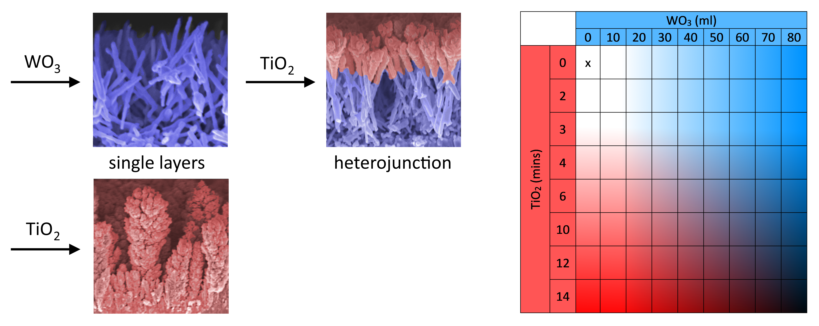
Scheme 1: Synthesis scheme depicting the various types of photoanode grown herein, which include WO₃ and TiO₂ single layer materials and WO₃/TiO₂ heterojunctions (with representative side-on SEMs shown). The grid in the bottom right shows the 71 unique samples synthesised herein, with blue and red shading representing the WO₃ and TiO₂ layers, respectively.

2.2. Physical characterisation
X-ray diffraction (XRD) patterns were measured on a modified Bruker-Axs D8 diffractometer with parallel beam optics equipped with a PSD LinxEye silicon strip detector. X-rays were generated using a Cu source (V = 40 kV, I = 30 mA) with Cu K_{α1} (λ = 1.54056 Å) and Cu K_{α2} radiation (λ = 1.54439 Å) emitted with an intensity ratio of 2:1. The incident beam was held at 1° with respect to the sample and the angular range of the patterns collected between 6° ≤ 2θ ≤ 70° with a step size of 0.034°. Patterns were compared with standards from the Physical Sciences Data-Science (PSDS) database.³³ Lattice parameters and the average crystallite size of each sample was determined by fitting a Le Bail model to each diffraction pattern using GSAS-EXPGUI software.³⁴ Raman spectra were obtained using a Horiba LabRam Infinity equipped a helium-neon laser (633 nm, 25 mW). The system was calibrated to a silicon reference. Samples were analysed over the 50 - 1100 cm⁻¹ range and compared with standards from the RRUFF project database.³⁵ Scanning electron microscopy (SEM) images and energy-dispersive X-ray spectroscopy analysis (EDX) was carried out using a Zeiss Leo Gemini 1525 instrument (1.8 kV). To prevent charging, samples were sputter coating with a thin layer of chromium (~15 nm). Ultra-violet visible (UV-Vis) transmission spectroscopy was performed on a Shimadzu UV-vis 2600 spectrophotometer equipped with an integrating sphere. Samples were measured over the 185 - 1400 nm range, with 1 nm resolution.

2.3. Photoelectrochemical water splitting measurements
All photoelectrochemical measurements were carried out in a custom polyetheretherketone (PEEK) cell with quartz windows (0.5 cm²) front and back. Measurements were conducted using a three electrode configuration, with Pt mesh as the counter electrode and Ag/AgCl in sat. KCl_{(aq)} as the reference electrode (0.197 V_{NHE} at 25 °C; Metrohm). The PEC performance of all samples were measured in an acidic electrolyte (0.1 M H₂SO₄; pH ~1.2). To compare the effect of a hole scavenger, the PEC performance of select samples were measured in phosphate buffer (0.05 M K₂HPO₄ and 0.05 M KH₂PO₄; pH 6.7) with and without the hole scavenger sodium sulfite (0.5M Na₂SO₃). The water used in all electrolytes was Milli-Q-water (Millipore Corp., 18.2 MΩ·cm at 25 °C).
An Autolab potentiostat (PGSTAT12 with an FRA2 module) was used to apply voltage and measure currents. All applied voltages are reported vs the reversible hydrogen electrode (V_{RHE}), converted using the Nernst equation:
$V_{RHE}=V_{Ag/AgCl}+\left(0.0591×pH\right)+V_{Ag/AgCl}^{∅}$ (Eq 1)
where $V_{Ag/AgCl}$ is the applied potential vs the reference electrode and $V_{Ag/AgCl}^{∅}$ is the standard potential of the reference electrode.
The light source used to measure current-voltage (JV) curves and incident photon to current efficiency (IPCE) curves was an ozone-free xenon lamp (75 W, Hamamatsu) coupled to a monochromator (OBB-2001, Photon Technology International). Light intensities were measured using an optical power meter (PM 100, Thorlabs) coupled with a power sensor (S120UV, Thorlabs).
For JV curves, the monochromator was set to a wavelength of 375 nm (2.6 mW.cm⁻²) to photoexcite the photoanodes. JV curves were measured by sweeping the voltage from cathodic to anodic potentials (0.45 - 2.45 V_{RHE}) at a rate of 50 mV.s⁻¹ in the light and dark. Generally speaking, the onset potential is the potential at which a certain current density is recorded, or a potential at which the measured current visibly deviates from the background signal.³⁶ In this work, the onset potential was defined as the V_{RHE} at which an IPCE of > 0.1 % is reached using 375 nm irradiation.
For IPCE measurements, the light and dark current was measured at a fixed voltage of 1.23 V_{RHE} for a range of wavelengths between 250 and 475 nm in 25 nm intervals. The IPCE was calculated using the following equation:
$IPCE\left(\%\right)={{(I}_{ph}×1239.8)}/{(P_{mono}×λ})×100$ (Eq 2)
where I_{ph} is the photocurrent (mA.cm⁻²), 1239.8 is the multiplication of Planck’s constant with the speed of light (eV.nm), P_{mono} is the light power at a given wavelength (mW.cm⁻²) and λ is the wavelength of the monochromated light (nm).
The solar water splitting activity was calculated using IPCE measurements. This theoretical solar photocurrent (TSP) was determined by multiplying the IPCE with the AM1.5 solar spectrum, and converting this into a current:²⁹
$$TSP \left(mA.cm^{-2}\right)=\int_{E_{bg} (nm)}^{280 nm}{IPCE×AM1.5 }×1000/ 1C$$
(Eq 3)
where AM1.5 is the solar photon flux (photons.cm⁻²), E_{bg} is the material bandgap and 1C is 6.241 x 10¹⁸ electrons per second.
A significant volume of data was generated from the PEC analysis of 71 unique photoanode samples. On numerous occasions, the data is represented in the form of a contour plot. To better visualise trends and reduce the effect of sample variability and/or outliers, the data was plot using adjacent averages.

3. Results and Discussion

3.1. Synthesis
To systematically explore WO₃/TiO₂ heterojunction phase space for applications in photoelectrochemical water splitting, 71 discrete WO₃, TiO₂ and WO₃/TiO₂ photoanodes (15 single layer samples, 56 heterojunction samples) were grown using CVD. WO₃ layers were grown using an AA-CVD method, where the aerosol of a tungsten source (W(CO)₆), dissolved in a 2:1 acetone:methanol solution, was carried into a heated reactor where the electrode was located. This equated to a mass flow of 0.114 mmol of tungsten being carried into the reactor per 10 ml transferred. As-deposited single layer WO₃ coatings were blue, and turned light yellow after annealing in air at 500 °C. The coatings were translucent and could be removed from the FTO electrode by abrasion, failing the ScotchTM tape test.³⁷ TiO₂ layers were grown using an AP-CVD method, where the vapours of a titanium source (TTIP; ~52 Torr) were carried into a heated reactor where the electrode was held. With the carried gas flow rate used (2 L.min⁻¹) this equated to mass flow of 6.08 mmol of titanium being carried into the reactor per minute of reaction.³⁸ As-deposited single layer TiO₂ coatings were transparent and well-adhered to the FTO electrode, passing the ScotchTM tape test. Thinner samples (TiO₂ - 2 mins to TiO₂ - 6 mins) showed colour bands due to optical interference; a consequence of the flat topography of these coatings. Thicker samples (TiO₂ - 10 mins to TiO₂ - 14 mins) were more were translucent and did not show these colour bands. For the synthesis of single layer coatings, the growth rate of WO₃ coatings was ~2400 nm per mmol of tungsten transferred and the growth rate of TiO₂ coatings was ~42 nm per mmol of titanium transferred. WO₃/TiO₂ heterojunctions were translucent and light yellow in appearance, and like single layer WO₃ coatings, could be removed from the FTO electrode by abrasion, failing the ScotchTM tape test.

3.2. Physical characterisation

3.2.1. XRD and Raman spectroscopy
XRD patterns and Raman spectra were measured for 11 select samples (5 single layer; 6 heterojunction). XRD showed that the crystal structure adopted by WO₃ and TiO₂ in both single layer and heterojunction samples was monoclinic γ-WO₃ (P2₁/n, a = 7.3271(2) Å, b = 7.5644(2) Å, c = 7.7274(3) Å, β = 90.488(3)°)³⁹ and tetragonal anatase TiO₂ (I4₁/amd, a = 3.7710(9) Å, b = 3.7710(9) Å, c = 9.430(2) Å),⁴⁰ respectively (Figure 1). Peaks at 2Θ of 23.3, 23.8 and 24.6° corresponded to the primary (002), (020) and (200) planes in γ-WO₃, and the peak at 2Θ of 25.4° corresponded to the primary (101) plane of anatase TiO₂. Peaks at 2Θ of 26.6, 34.2, 37.8 and 51.6° were due to diffraction from the underlying FTO electrode; cassiterite tetragonal SnO₂ (P4₂/mnm, a = 4.737(1) Å, b = 4.737(1) Å, c = 3.185(1) Å). No additional phases or impurities were observed.
XRD patterns were fit using a Le Bail model to determine the lattice parameters and average crystallite sizes of the WO₃ and TiO₂ components (Table S1). For single layers of WO₃ (Figure S2), the unit cell volume deviated by up to 1.1% from a power standard in thinner coatings (WO₃ - 20 ml to 40 ml). However, in thicker coatings (WO₃ - 60 ml to 80 ml) the unit cell volume was more similar to a power standard, deviating by less than 0.1% (Figure S3a). The average crystallite size in single layers of WO₃ increased quite steadily with coating thickness from ~27 nm in WO₃ - 20 ml to ~75 nm in WO₃ - 80 ml (Figure S3b). This was coupled with an increasing preference of growth in the (002) plane at 2ϴ of 23.3°. For the single layer of TiO₂ measured (TiO₂ - 12 mins) the unit cell contracted by 1.1% with respect to a powder standard and possessed an average crystallite size of ~42 nm. Le Bail fitting of a series of WO₃/TiO₂ heterojunctions showed that there was no significant change in unit cell volume in either layer. This indicated that ion migration between the two layers was not significant. As found in single layer WO₃ coatings, WO₃/TiO₂ heterojunctions showed the same tendency to grow in the (002) direction as the thickness of the WO₃ coating was increased. In general, the average crystallite size of the WO₃ component in the heterojunctions was lower than single layer coatings, which may have been caused by the TiO₂ coating process. However, the average crystallite size of the TiO₂ layer in heterojunction coatings was similar to what was observed in the single layer.

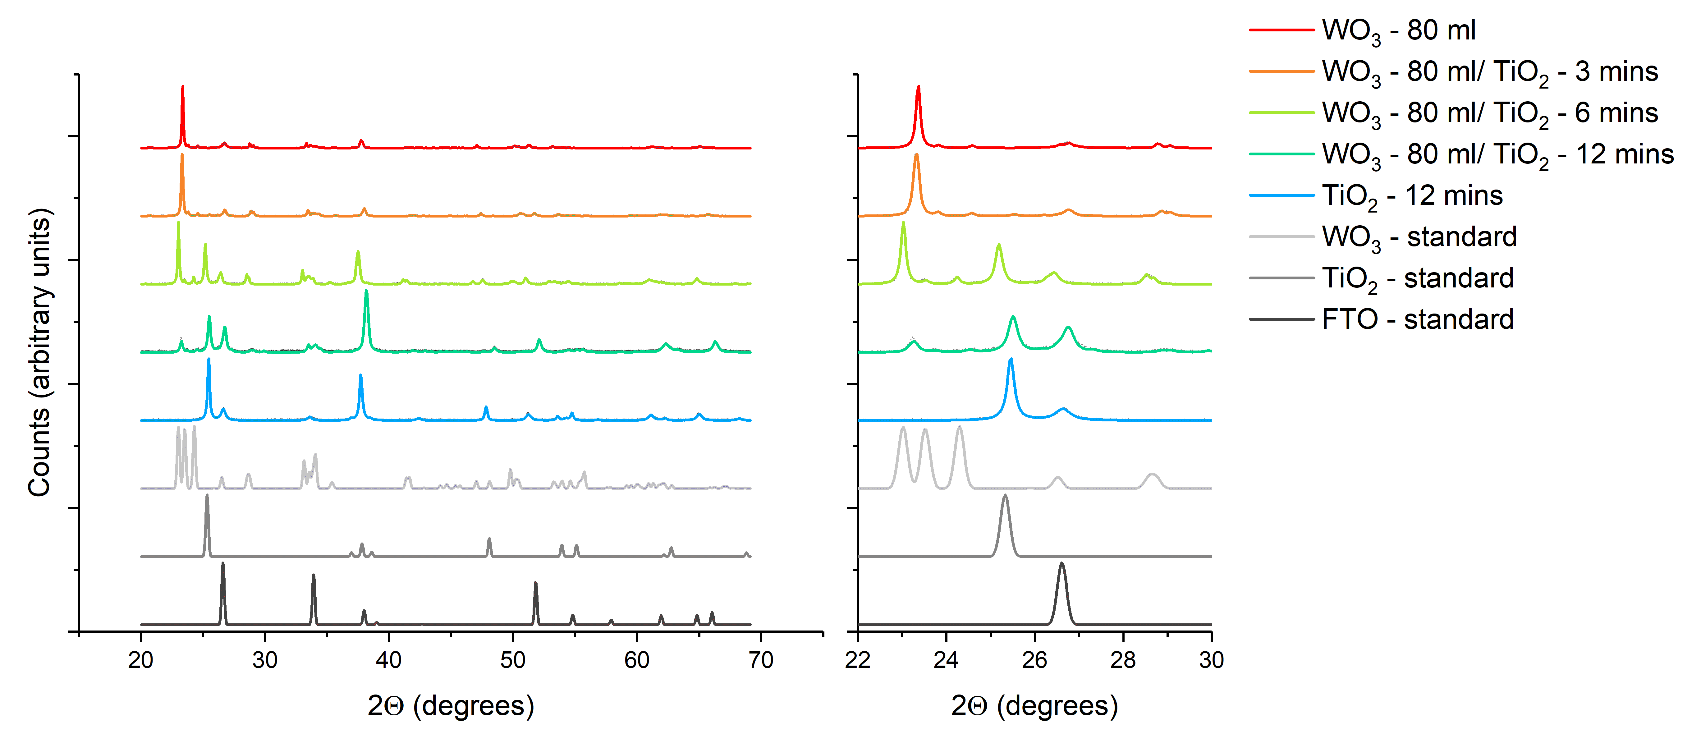
Figure 1: Selected XRD patterns from a series of photoanodes where 80 ml of WO₃ was grown and varying amounts of TiO₂ was deposited on top. Patterns are plot alongside WO₃, TiO₂ and FTO standards for comparison. A close up view of the 2Θ region between 22 and 30⁰ is shown on the right.

Raman spectroscopy supported our findings from XRD, showing that the crystal structure adopted by WO₃ and TiO₂ in both single layer and heterojunction samples was monoclinic γ-WO₃ and anatase TiO₂, respectively (Figure S4). No additional phases were observed. Previous studies have shown that the wavenumber of the primary Raman scattering band in anatase TiO₂ (E_{g} ~144 cm⁻¹) increases when W-ions are incorporated within the TiO₂ unit cell.⁴¹ No significant shifts in this band were observed herein, providing further support that ion migration between the two layers was not significant.

3.2.2. SEM and EDX analysis
The topography of select WO₃, TiO₂ and WO₃/ TiO₂ heterojunction coatings were investigated by SEM. Single layers of WO₃ formed nanoneedle structures (Figure 2), as previously observed by Blackman et al for WO₃ coatings grown using the same method.³⁰ The density of nanoneedle growth and the width of nanoneedles increased with deposition volume from WO₃ - 40 ml (Figure 2a) to WO₃ - 80 ml (Figure 2b), an effect also observed by Parkin et al.⁴² Single layers of TiO₂ formed dendritic nanocolumns that grew thicker towards their peak (
Figure S5). Previous work by Evans et al. on TiO₂ coatings grown using a similar method found their structures were more globular and compact.³¹ Differences observed herein may be related to the substrate, where an FTO electrode was used in this work and stainless steel was used in theirs. In WO₃/TiO₂ heterojunctions, the nanostructure of the WO₃ host was preserved after coating with TiO₂, forming a coating with a similar dendritic structure to single layers of TiO₂ (Figure 2c). Side-on SEM images showed that the TiO₂ layer did not coat the entire length of the WO₃ nanoneedle, forming a thicker coating towards the tip
Figure S5). Recent experimental and modelling studies of WO₃ nanoneedle/ TiO₂ heterojunctions have shown that this system forms a type II staggered heterojunction; ^{25,26} with the band alignment shown in the supporting information (Figure S6).

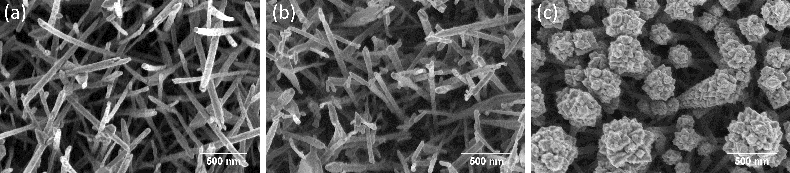
Figure 2: Top-down SEM images at 100,000 magnification of (a) WO₃-40 ml, (b) WO₃ - 80 ml and (c) WO₃ - 80 ml/ TiO₂ - 6 mins.

The thicknesses of our coatings, measured using side-on SEM images, are summarised in Table 1. From the FTO electrode, an ultra-thin layer of SiO₂ (~50 to ~70 nm thick) is observed beneath the FTO layer (~330 to ~450 nm thick). In single layers of WO₃ and TiO₂, coating thickness increased quite linearly with deposition volume and reaction time. In WO₃, coating thickness increased from ~750 nm in WO₃ - 40 ml to ~1800 nm WO₃ - 80 ml. In TiO₂, coating thickness increased from ~400 nm in TiO₂ - 4 mins to ~3000 nm TiO₂ - 12 mins. In WO₃/ TiO₂ heterojunctions, the thickness of the WO₃ layer was relatively unchanged, with respect to the single layer, after coating with TiO₂. However, the TiO₂ layer was significantly less thick in heterojunctions as compared with single layers. For example, the TiO₂ layer in the WO₃ - 80 ml/ TiO₂ - 12 mins heterojunction was ~1250 nm thick, whereas the TiO₂ layer in TiO₂ - 12 mins was ~3000 nm thick. This decrease in TiO₂ growth rate may be caused by the vastly higher surface area of the WO₃ scaffold, as compared with the relatively flat FTO electrode. EDX analysis of a representative WO₃ - 80 ml/ TiO₂ - 6 mins sample showed that Ti, W, O and Sn were present, with no impurity elements observed.

Table 1: Summary of the thicknesses of the SiO₂, FTO, WO₃ and TiO₂ layers observed from side-on SEM images from a series of select photoanodes.
 |  | Layer thickness (nm)
 |  | SiO₂ | FTO | WO₃ |  |  | TiO₂
 |  | Average |  | Min | Max | Average | Min | Max | Average
Single layer | TiO₂ - 6 mins | ~60 | ~350 | - | - | - | ~370 | ~420 | ~400
Single layer | TiO₂ - 10 mins | ~50 | ~450 | - | - | - | ~1560 | ~2490 | ~2000
Single layer | TiO₂ - 12 mins | no | ~440 | - | - | - | ~1650 | ~4370 | ~3000
Single layer | WO₃ - 40 ml | ~70 | ~330 | ~640 | ~860 | ~750 | - | - | -
Single layer | WO₃ - 60 ml | ~60 | ~390 | ~1520 | ~1700 | ~1600 | - | - | -
Single layer | WO₃ - 80 ml | ~50 | ~350 | ~1510 | ~2110 | ~1800 | - | - | -
Hetero-junction | WO₃ - 40 ml/ TiO₂ 4 mins | ~50 | ~360 | ~1160 | ~1400 | ~1200 | ~500 | ~1200 | ~850
Hetero-junction | WO₃ - 60 ml/ TiO₂ 6 mins | ~60 | ~360 | ~940 | ~1510 | ~1250 | ~560 | ~1300 | ~925
Hetero-junction | WO₃ - 80 ml/ TiO₂ 12 mins | ~60 | ~370 | ~1560 | ~2020 | ~1800 | ~910 | ~1620 | ~1250
no = not observed

3.2.3. UV-vis transmission spectroscopy
UV-vis transmission spectroscopy was carried out on select samples over the 185 - 1400 nm range. Transmission spectra of a series of single layer WO₃ and TiO₂ samples are shown in Figure S7. For the single layer WO₃ samples (Figure S7a), the degree of transmission in the visible and near-infrared regions decrease as coating thickness increases. This is attributed to the growth of longer and more densely packed nanoneedles that increasingly scatter light. An increasingly red-shifted band edge was also observed; increasing from ∼310 nm in WO₃ - 10ml to ∼400 nm in WO₃ - 80ml. Similar trends were observed in single layer TiO₂ samples (Figure S7b), where increases in coating thickness resulted in reduced transmission in the visible and near-infrared regions and a red-shifting of the band edge; from ∼300 nm in TiO₂ - 2 mins to ∼350 nm in TiO₂ - 14 mins. In a select series of WO₃/ TiO₂ heterojunctions, where the thickness of the TiO₂ layer was held constant, the band edge red-shifted as the WO₃ layer thickness was increased (Figure 3a).
Optical bandgaps were determined from Tauc plots⁴³ (Figure S8). These bandgaps are shown in a 3D bar chart in Figure 3b, and the values listed in Table S2. The derived bandgaps for single layer WO₃ and TiO₂ coatings ranged from ∼2.75 to ∼2.90 eV and ∼3.19 to ∼3.23 eV, respectively, and were both in agreement with literature reports (WO₃ ∼2.5 to 2.8 eV; TiO₂ ∼3.2 eV).^{27,28} The bandgap in WO₃ single layers decreased as coatings were made thicker; in agreement with previous reports.^{42,44} The bandgap in heterojunction samples was mostly controlled by the thickness of the WO₃ layer, with bandgap values ranging from ∼2.78 eV in WO₃ - 20 ml/ TiO₂ - 3 mins to ∼3.05 eV in WO₃ - 20 ml/ TiO₂ - 12 mins.

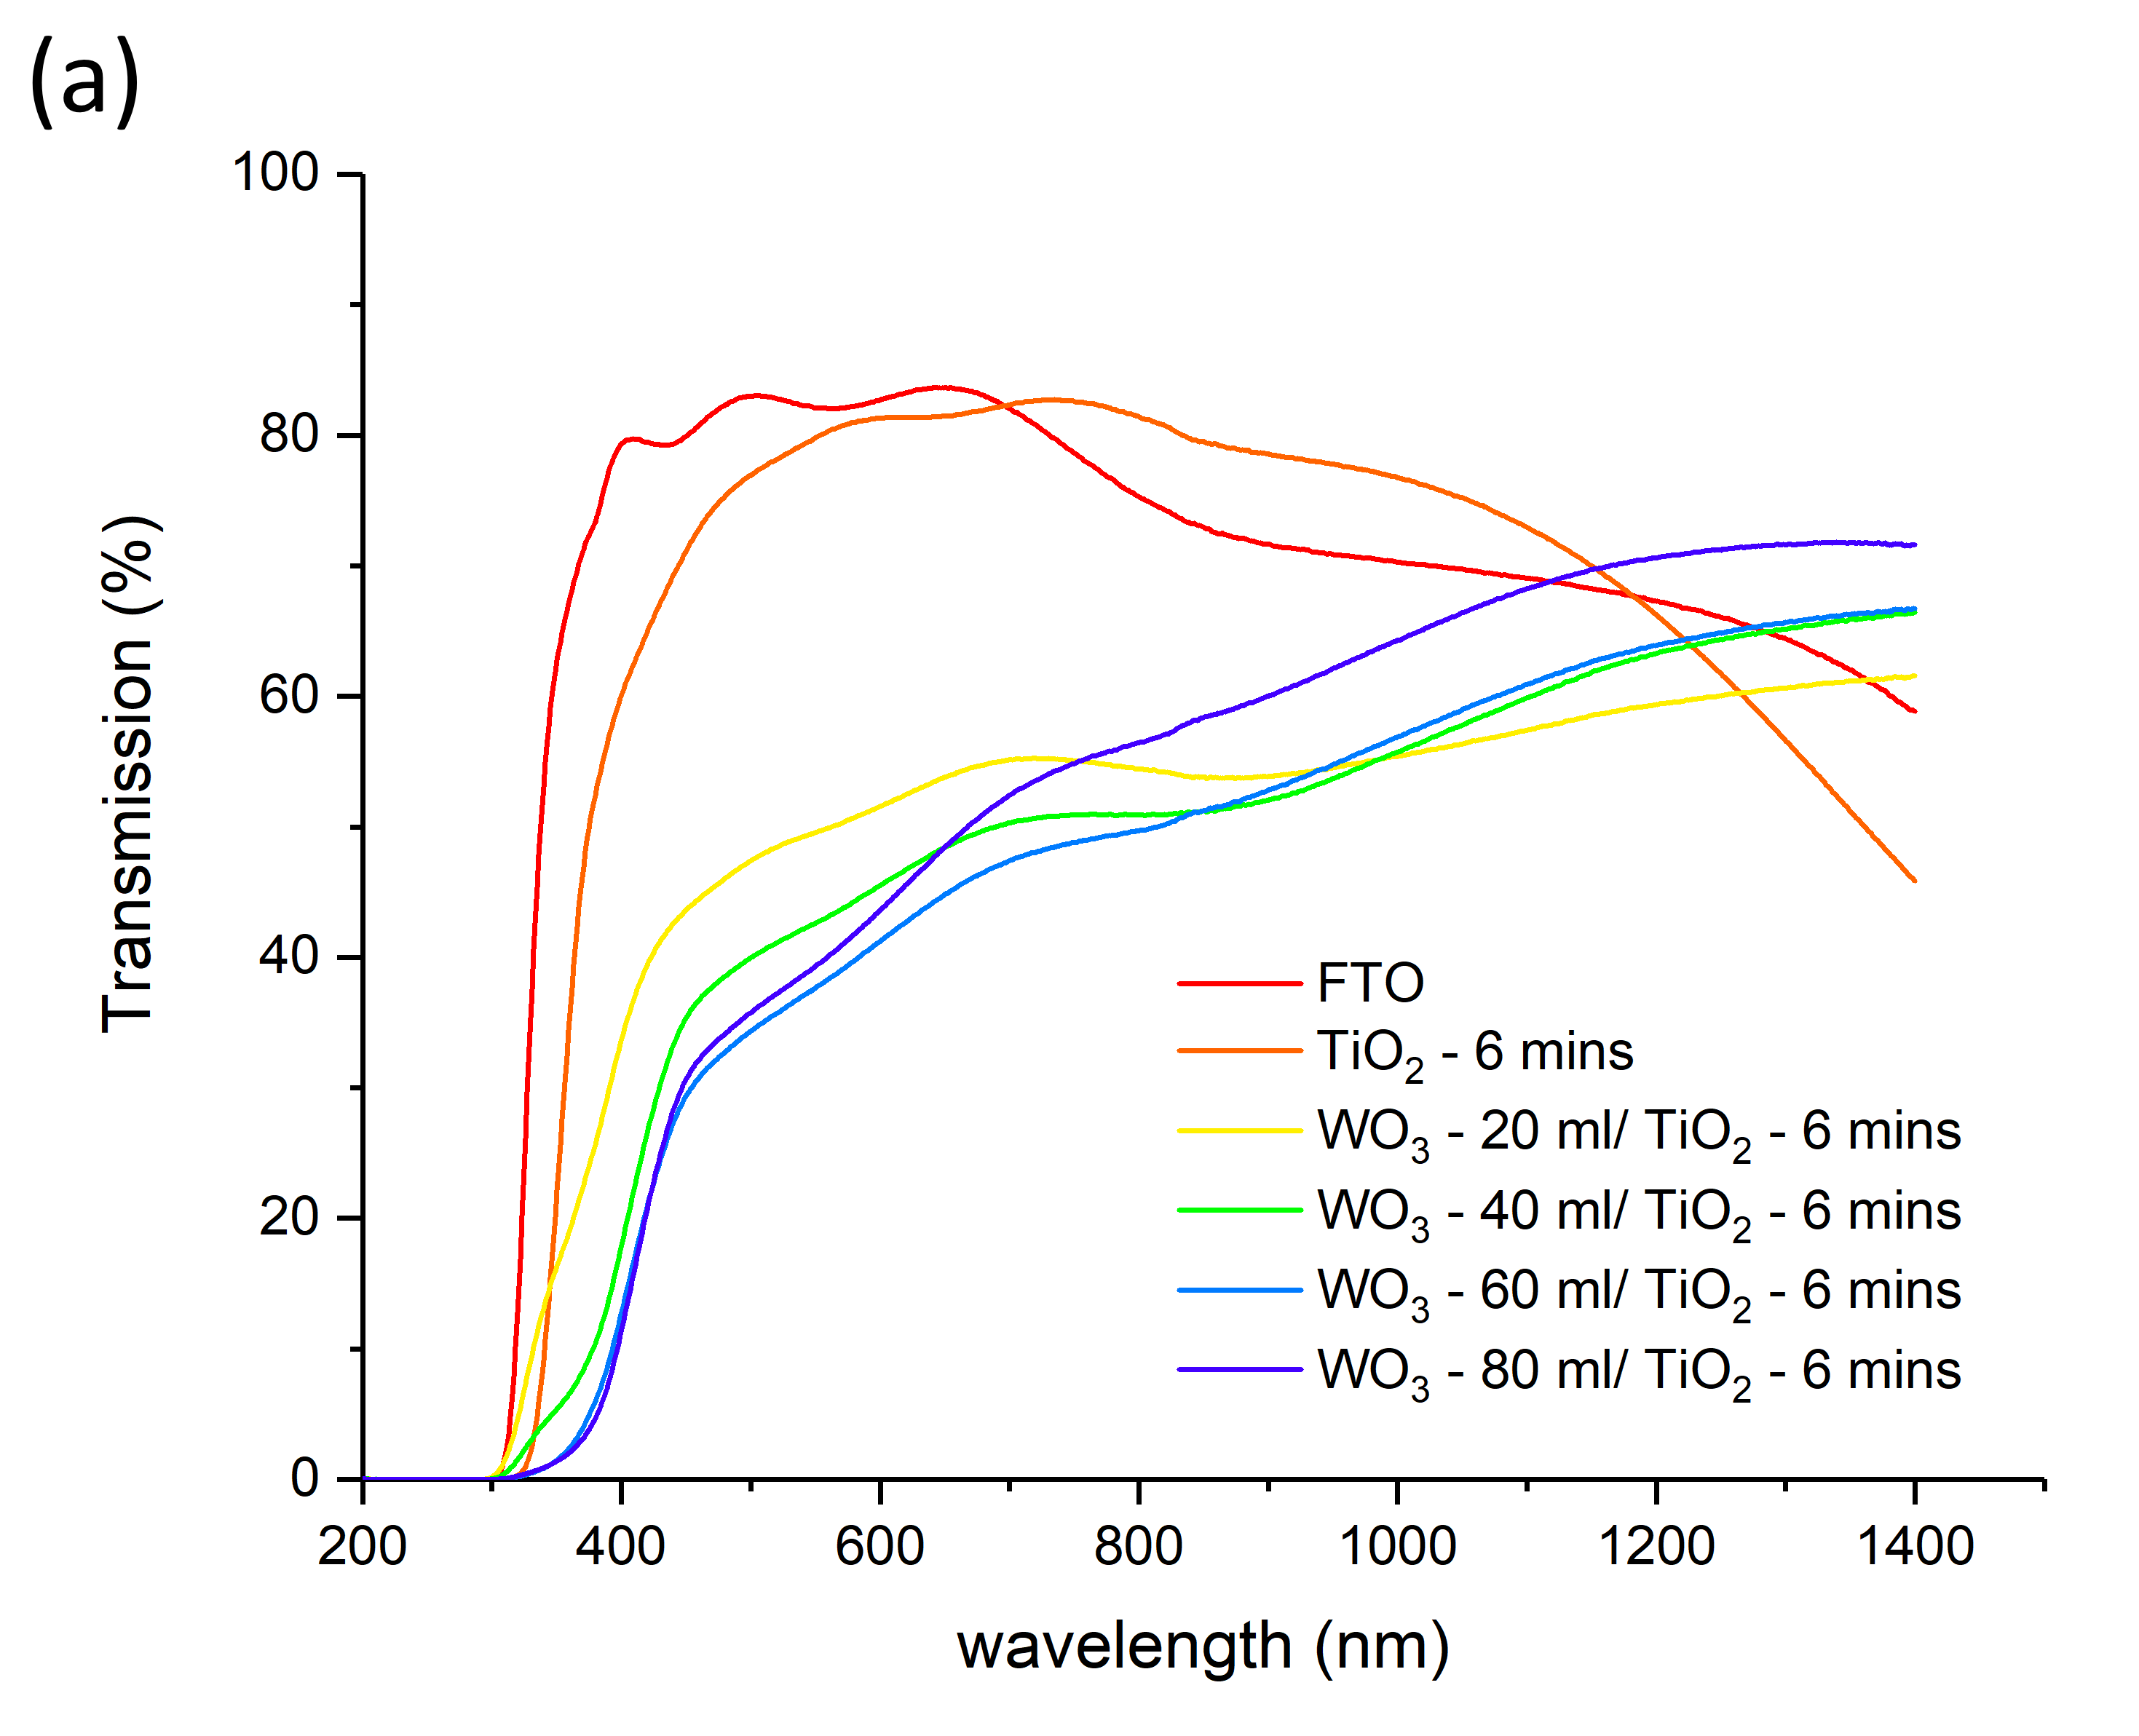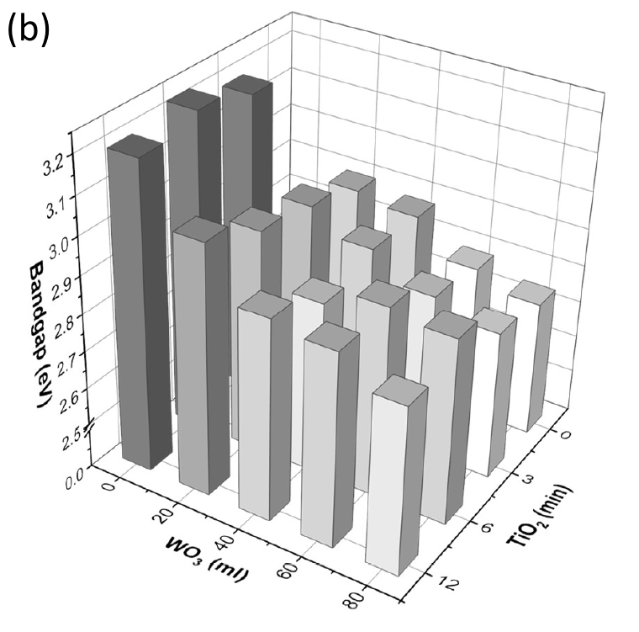
Figure 3: (a) UV-vis transmission (%) spectroscopy of an example series of WO₃/ TiO₂ heterojunction photoanodes, where the TiO₂ layer thickness was held constant with a 6 mins deposition time. (b) The indirect allowed optical bandgaps (eV) determined from a Tauc plot of UV-vis transmission data for a series of photoanodes.

3.2.4. Photoelectrochemical water splitting
The photoelectrochemical properties of all 71 photoanodes (15 single layer; 56 heterojunction) were investigated in a three electrode configuration (0.1 M H₂SO₄; pH = 1.18). To evaluate their potential use as photoanodes in water splitting devices, certain key performance indicators²⁹ were measured. These include: (i) the onset potential in which photocurrent, and therefore water oxidation was observed, (ii) the quantum efficiency of water oxidation at one wavelength (375 nm) for a range of applied potentials, (iii) the quantum efficiency of water oxidation at a range of wavelengths at one applied potential (1.23 V_{RHE}) and (iv) the theoretical solar photocurrent at one applied potential (1.23 V_{RHE}). All measurements were carried out under front and back irradiation conditions.

3.2.4.1. Current-voltage curves and onset potentials
JV curves were measured from 0.45 - 2.45 V_{RHE} in the dark and in the light (375 nm; 2.6 mW.cm⁻²). Measurements were carried out for both front and back irradiation. In Figure 4a, example JV curves are shown for WO₃ - 60 ml, TiO₂ - 10 mins and WO₃ - 60 ml/ TiO₂ - 10 mins under front irradiation. In WO₃ - 60 ml, we see an onset potential for photoelectrochemical water oxidation at ∼0.55 V_{RHE}; similar to literature reports for this material.²⁷ The photocurrent rises to a plateau of ∼0.09 mA.cm⁻² at ∼0.9 V_{RHE}, which corresponds to an IPCE of ∼12%. The onset for dark electrocatalysis is observed at ∼1.9 V_{RHE}. In TiO₂ - 10 mins, we see an earlier onset potential for water oxidation at ∼0.45 V_{RHE}, similar to literature reports for this material,⁴⁵ and an earlier plateau photocurrent, reaching ∼0.03 mA.cm⁻² at ∼0.6 V_{RHE}, which corresponds to an IPCE of ∼4%. The onset for dark electrocatalysis is observed later at ∼2.1 V_{RHE}. In the WO₃ - 60 ml/ TiO₂ - 10 mins heterojunction we see an onset potential of ∼0.55 V_{RHE}; similar to the WO₃ single layer. Although the photocurrent shows a lower fill factor than its parent materials, the plateau photocurrent is significantly higher, reaching ∼0.18 mA.cm⁻² at ∼1.8 V_{RHE}, which corresponds to an IPCE of ∼23%. The onset for dark electrocatalysis is observed at ∼2.0 V_{RHE}, a value between what was observed for the two single layer materials. The case of back irradiation for the same three samples is shown in Figure S9a. Similar behaviours were observed for these three photoanodes, with near analogous onset potentials and photocurrent trends. Of note, photocurrents under back irradiation are marginally higher, with WO₃ - 60 ml, TiO₂ - 10 mins and WO₃ - 60 ml/ TiO₂ - 10 mins showing plateau photocurrents of ∼0.10, ∼0.04 and ∼0.25 mA.cm⁻², and therefore IPCEs of ∼13, ∼5 and ∼32%, respectively. For both front and back irradiation, synergetic increases in photocurrent were observed in this heterojunction (with respect to its parent materials).
The onset potentials of all 71 photoanodes under front irradiation are summarised in a contour plot (Figure 4b). General trends are observed for the three types of photoanode – WO₃, TiO₂ and WO₃/ TiO₂. A region therefore higher onset potential (yellow-red in graph, 0.60 to 0.68 V_{RHE}), is located in the region of WO₃ - 10 to 80 ml/ TiO₂ - 0 to 2 mins single layer and heterojunction phase space (i.e. single layer WO₃ photoanodes and WO₃/ TiO₂ heterojunctions where the TiO₂ layer is thin). A region of dark blue-light blue, and therefore lower onset potential (0.44 to 0.52 V_{RHE}), is located in the region of WO₃ - 0 to 30 ml/ TiO₂ - 10 to 14 mins single layer and heterojunction phase space (i.e. thick single layer TiO₂ photoanodes and WO₃/ TiO₂ heterojunctions where the WO₃ layer is thin and the TiO₂ layer is thick). Finally, a region of dark green-light green, and therefore intermediate onset potential (0.52 to 0.60 V_{RHE}), is primarily located in the region of WO₃ - 40 to 80 ml/ TiO₂ - 6 to 14 mins heterojunction phase space (i.e. WO₃/ TiO₂ heterojunctions where the WO₃ and TiO₂ layers are thick). Our analysis shows that the onset potentials in our WO₃/ TiO₂ heterojunctions are, broadly speaking, an average of the two parent materials. This is in agreement with recent modelling work on the WO₃/TiO₂ heterojunction, which showed that Fermi level equilibration and the action of light results in an “electron-notch” forming between the TiO₂ and WO₃ conduction band energy levels, resulting in a barrier for electron transfer from TiO₂ to WO₃ of ∼0.09 to 0.11 meV.²⁶ It is noteworthy that a near analogous increase in onset potential between our single layer TiO₂ (average ∼0.50 V) and WO₃/TiO₂ heterojunctions (average ∼0.60 V) are observed herein. The onset potentials for the case of back irradiation are also summarised in a contour plot (Figure S9b). Trends are broadly quite similar to what is observed under front irradiation; the only exceptions of note being that: (i) lower onset potentials were reached in single layer TiO₂ samples at lower thicknesses and (ii) thicker heterojunctions located in the region WO₃ - 60 to 80 ml/ TiO₂ - 6 to 12 mins showed markedly higher onset potentials. The onset potential values for all 71 samples are tabulated in the supporting information (Table S3).
To better understand the observed differences in surface activity, we measured the photoelectrochemical behaviour of 3 select samples (2 single layer and 1 heterojunction material) in the presence and absence of a hole scavenger using 375 nm light (Figure S10). By reducing the barrier for hole transfer to occur, this experiment allows one to probe the efficiency of charge carrier separation.⁴⁶ The plateau photocurrents achieved with and without a sulfite hole scavenger were similar for the 3 samples analysed, which showed that with sufficient applied potential, the charge carrier separation efficiency could be raised to an intrinsic limit at the wavelength studied. More significant differences were observed in the onset potentials for the photo and electrocatalytic oxidation reactions. With regards to electrocatalytic oxidation, the 3 samples showed a cathodic reduction in onset potential of ~1.2 V_{RHE} when the hole scavenger was present. However, with regards to photocatalytic oxidation, only the WO₃ sample (WO₃ - 30 ml) showed any significant change in onset potential, decreasing cathodically from ~0.65 V_{RHE} to ~0.45 V_{RHE} when the hole scavenger was added (Figure S10a). For the TiO₂ (TiO₂ - 4 mins; Figure S10b) and WO₃/ TiO₂ heterojunction samples (WO₃ - 30 ml/ TiO₂ - 12 mins; Figure S10c) the onset potentials and photocurrents were near analogous in the presence and absence of the hole scavenger. This indicated that surface hole transfers to the electrolyte occurred primarily through the TiO₂ layer in the heterojunction. And given the photocurrent density in the heterojunction (~34 μA.cm⁻² at 0.75 V_{RHE} with a hole scavenger; ~24 μA.cm⁻² without) was higher than the combined performance of WO₃ (~22 μA.cm⁻² at 0.75 V_{RHE} with a hole scavenger; ~11 μA.cm⁻² without) and TiO₂ (~0.92 μA.cm⁻² at 0.75 V_{RHE} with a hole scavenger; ~0.59 μA.cm⁻² without), this also indicated holes were primarily formed in the WO₃ layer in the heterojunction (for this excitation wavelength of 375 nm).

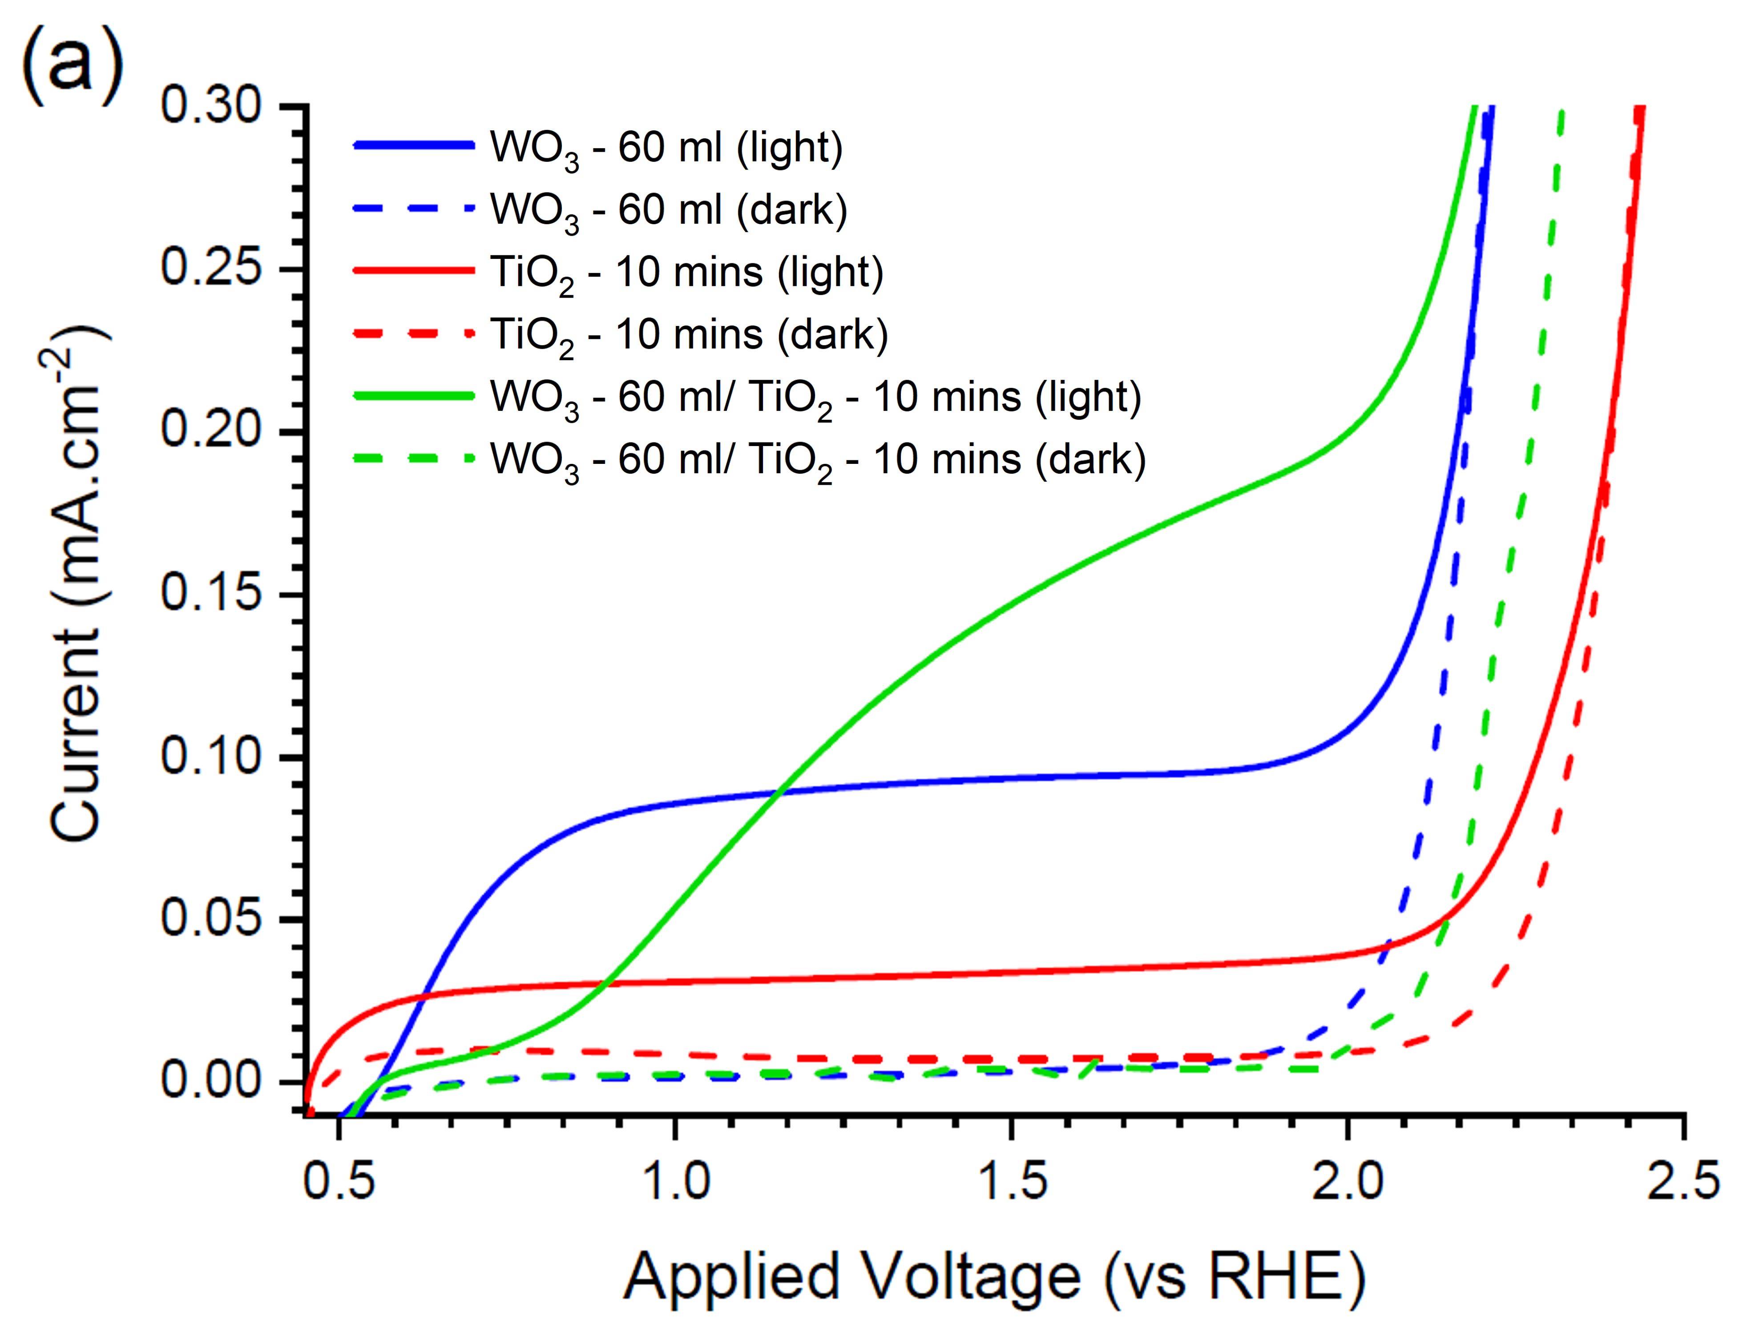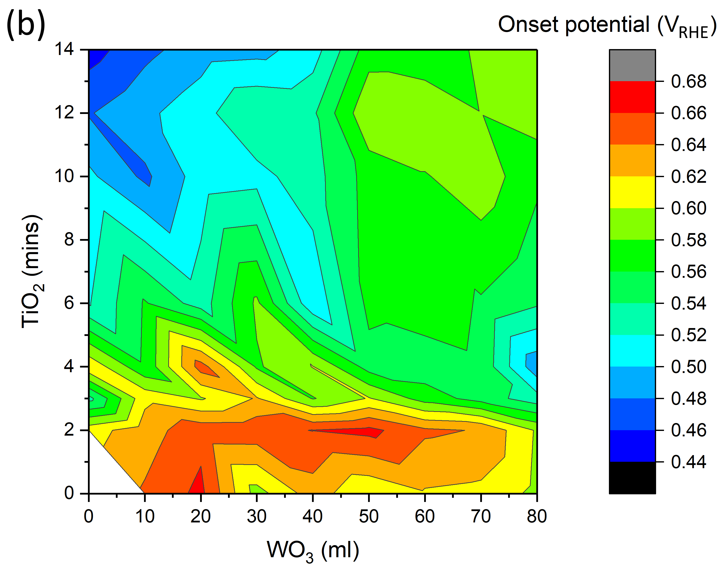
Figure 4: (a) Current-voltage curves of select photoanodes measured in 0.1 M H₂SO₄ electrolyte (pH = 1.18) for dark (dashed lines) and front irradiation (solid lines) conditions. Photoanodes were irradiated from the front using monochromatic 375 nm light (2.6 mW.cm⁻²). The voltage was swept from cathodic to anodic potentials from 0.45 to 2.45 V_{RHE} (50 mV.s⁻¹). (b) A contour plot of the onset potentials (V_{RHE}) observed in JV curves under front irradiation for all WO₃, TiO₂ and WO₃/TiO₂ photoanodes synthesised herein.

3.2.4.2. IPCE
As the JV curves of all 71 unique photoanodes were measured using monochromatic 375 nm light of a known power (2.6 mW.cm⁻²), photocurrents could be converted into IPCEs. Contour plots of the IPCE at 375 nm for the applied potentials of 0.75, 1.0 and 1.5 V_{RHE} when irradiated from the back are shown in Figure 5. At 0.75 V_{RHE} (Figure 5a), the highest IPCEs (yellow-red region; ∼5.25 to 7.00 %) are observed in single layer WO₃ phase space, from WO₃ - 40 to 80 ml. Regions of intermediate IPCE (dark green-light green regions; ∼2.45 to 4.90 %) are observed in WO₃ - 0 to 20 ml/ TiO₂ - 8 to 14 mins single layer and heterojunction phase space and WO₃ - 60 to 80 ml/ TiO₂ - 10 to 14 mins heterojunction phase space. And regions of low IPCE (dark blue-light blue; ∼0 to 2.1 %) are observed in WO₃ - 0 to 30 ml/ TiO₂ - 0 to 6 mins single layer and heterojunction phase space. At 1.0 V_{RHE} (Figure 5b), a new region of highest IPCE emerges (yellow-red region; ∼10.5 to 15.0 %) in the region of WO₃ - 50 to 80 ml/ TiO₂ - 4 to 14 mins heterojunction phase space. Intermediate IPCEs (dark green-light green; ∼5.25 to 9.75%) are now primarily found in single layer WO₃ phase space, from WO₃ - 20 to 80 ml, and WO₃ - 10 to 40 ml/ TiO₂ - 8 to 14 mins heterojunction phase space. And low IPCEs (dark blue-light blue; ∼0 to 4.5 %) are found in WO₃ - 0 to 20 ml/ TiO₂ - 2 to 8 mins heterojunction phase space. At 1.5 V_{RHE} (Figure 5c), we see near analogous trends to 1.0 V_{RHE}, with IPCEs now reaching ∼24%. For the case of front irradiation (Figure S11), near analogous trends are observed at 0.75, 1.0 and 1.5 V_{RHE} to those found under back irradiation. However, marginally lower IPCEs were attained; with the highest IPCEs at 1.5 V_{RHE} reaching ∼20%.
Overall, this analysis shows that at low applied potentials (≤ 0.75 V_{RHE}), single layer WO₃ photoanodes possess the highest IPCEs at 375 nm. But at higher applied potentials (≥ 1.0 V_{RHE}), WO₃/TiO₂ heterojunctions overtake single layer WO₃ photoanodes and show higher IPCEs. This shows that there is a barrier to charge transfer between the heterojunction layers in our WO₃/TiO₂ heterojunctions at low applied potentials (≤ 0.75 V_{RHE}) that is overcome at higher applied potentials (≥ 1.0 V_{RHE}), resulting in improvements in performance with respect to the parent materials.

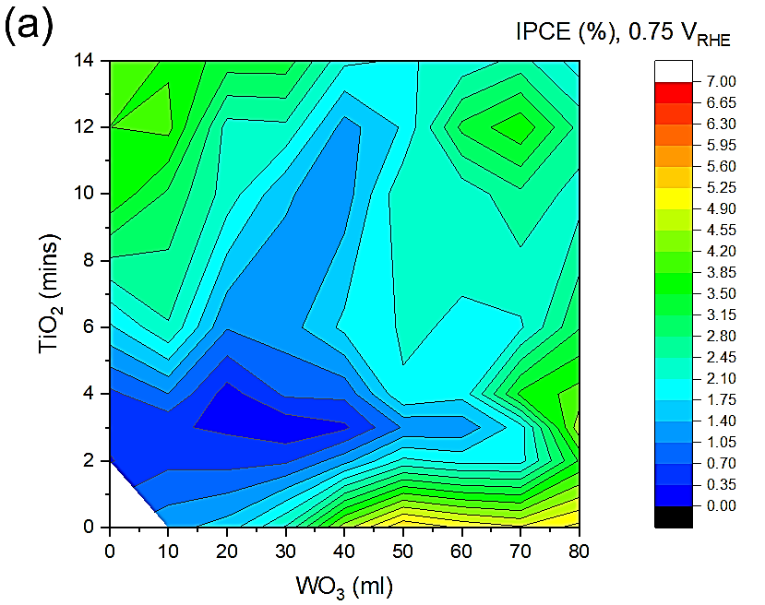 | 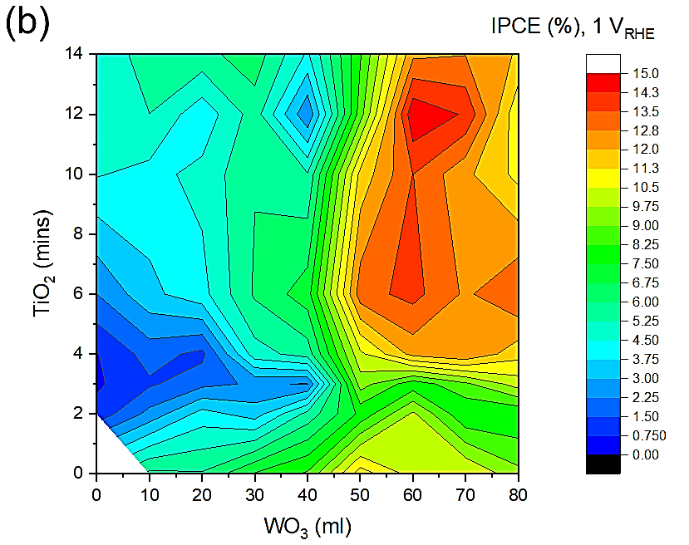
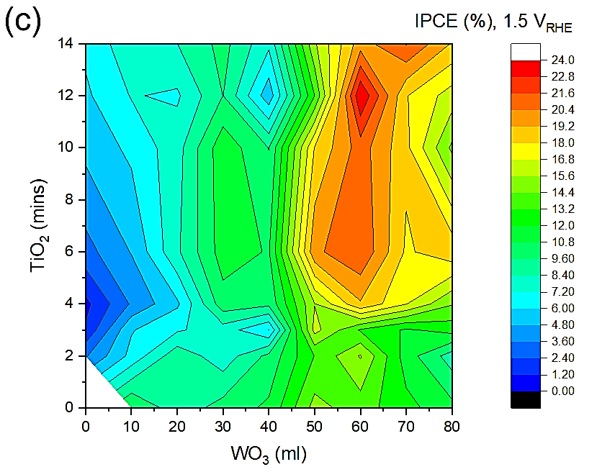 | Figure 5: Contour plots of the IPCEs (%) at 375 nm observed under back irradiation for (a) 0.75 V_{RHE}, (b) 1.0 V_{RHE} and (c) 1.5 V_{RHE} for all WO₃, TiO₂ and WO₃/TiO₂ photoanodes synthesised herein. All samples were measured in a 0.1 M H₂SO₄ electrolyte (pH = 1.18).

The IPCE behaviour was also measured at a range of wavelengths (250 - 475 nm; 25 nm intervals) at 1.23 V_{RHE}; the thermodynamic potential of water oxidation. Figure 6 shows the IPCEs for front and back irradiation of an example series of WO₃/ TiO₂ heterojunctions, where the TiO₂ deposition time was held constant at 3 mins (Figure 6). Under front irradiation, we see a general trend where the IPCEs increase with WO₃ layer thickness; with IPCEs in WO₃ - 80 ml/ TiO₂ - 3 mins approaching ∼52% at 300 nm and ∼32% at 350 nm (Figure 6a). Of note, a significant increase in visible light activity is observed on going from single layer TiO₂ (E_{bg} ∼3.2 eV; ∼390 nm) to the WO₃/ TiO₂ heterojunction (E_{bg} ∼2.8 eV; ∼440 nm), with no IPCE observed in TiO₂ - 3 mins ≥ 400 nm and no IPCE observed in WO₃ - 80 ml/ TiO₂ - 3 mins ≥ 450 nm. Under back irradiation, markedly lower IPCEs were observed in the hard UV region, due to parasitic absorption of light from the FTO electrode (E_{bg} ∼3.6 eV; Figure 6a). In the soft UV and blue regions, marginally lower IPCEs were observed than under front irradiation; with the IPCE in WO₃ - 80 ml/ TiO₂ - 3 mins approaching ∼27% at 350 nm.

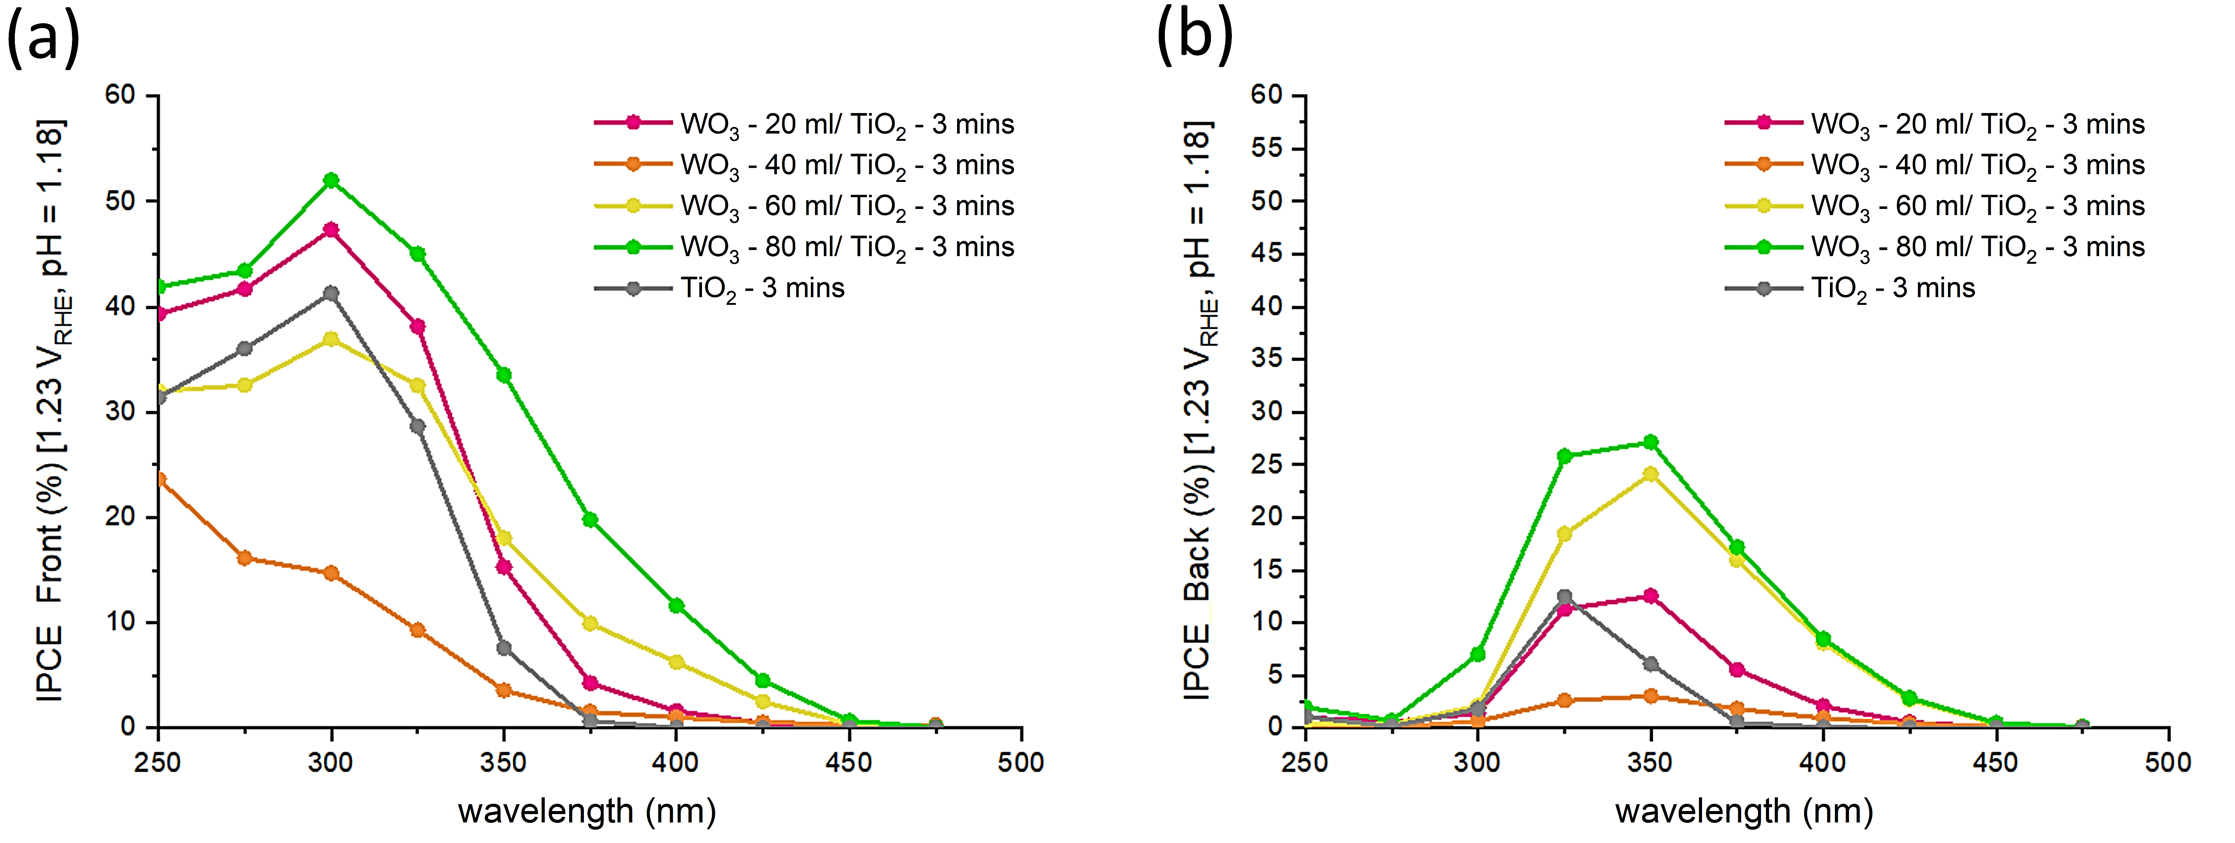
Figure 6: IPCEs (%) of an example series of WO₃/ TiO₂ heterojunction photoanodes, where the TiO₂ layer thickness was held constant with a 3 mins deposition time, for (a) front and (b) back irradiation. Samples were measured at 1.23 V_{RHE} in 0.1 M H₂SO₄ (pH = 1.18).

Contour plots of the IPCEs at 1.23 V_{RHE} for the select wavelengths of 350, 375 and 400 nm are shown in Figure 7 for front irradiation and Figure S12 for back irradiation.
We will first discuss the observed trends for the case of front irradiation. Under 350 nm irradiation (Figure 7a), the region with the highest IPCEs (yellow-red; ∼31.5 to 44 %) is found in WO₃ - 10 to 30 ml/ TiO₂ - 10 to 14 mins heterojunction phase space. Intermediate IPCEs (dark green-light green; ∼21.5 to 29 %) are primarily found in WO₃ - 40 to 80 ml/ TiO₂ - 4 to 14 mins heterojunction phase space. And low IPCEs (dark blue-light blue; ∼4 to 14 %) are found in WO₃ - 0 to 40 ml/ TiO₂ - 0 to 4 mins single layer and heterojunction phase space. Under 375 nm irradiation (Figure 7b), the region with the highest IPCEs (yellow-red; ∼11 to 16 %) changes location, and is found sporadically in WO₃ - 50 to 80 ml/ TiO₂ - 0 to 14 mins single layer and heterojunction phase space. Intermediate IPCEs (dark green-light green; ∼5 to 10 %) are primarily found in WO₃ - 20 to 40 ml/ TiO₂ - 8 to 14 mins heterojunction phase space. And low IPCEs (dark blue-light blue; ∼0 to 4 %) are found in WO₃ - 0 to 30 ml/ TiO₂ - 2 to 6 mins single layer and heterojunction phase space. Under 400 nm irradiation (Figure 7c), similar trends to those observed under 375 nm irradiation are found; the key differences being that IPCEs are lower, reaching ∼8%, and all single layer TiO₂ photoanodes show near zero activity as this wavelength is at the band edge of the material.
We will now discuss the observed trends for the case of back irradiation. Under 350 nm irradiation (Figure S12 a), the regions with the highest IPCEs (yellow-red; ∼24 to 34 %) are found in WO₃ - 10 to 30 ml/ TiO₂ - 10 to 14 mins and WO₃ - 50 to 80 ml/ TiO₂ - 4 to 14 mins heterojunction phase space. And the region of lowest IPCEs (dark blue-light blue; ∼4 to 10 %) is found in WO₃ - 0 to 40 ml/ TiO₂ - 2 to 4 mins single layer and heterojunction phase space. Under 375 nm irradiation (Figure S12b), the region with the highest IPCEs (yellow-red; ∼14 to 20 %) is found primarily in WO₃ - 50 to 80 ml/ TiO₂ - 2 to 14 mins heterojunction phase space. And the lowest IPCEs (dark blue-light blue; ∼0 to 6 %) are generally found in WO₃ - 0 to 30 ml/ TiO₂ - 2 to 6 mins single layer and heterojunction phase space. Under 400 nm irradiation (Figure S12c), similar trends to those observed under 375 nm irradiation are found, with IPCEs reaching ∼10%.
Within the heterojunction phase space, there were several cases where synergistic improvements in activity were observed. For example, under front irradiation, WO₃ - 30 ml/ TiO₂ - 10 mins showed IPCEs of 48.8, 15.9 and 5.9 % at 350, 375 and 400 nm, respectively (Table S4). These values were more than additive with respect to the parent materials, where WO₃ - 30 ml and TiO₂ - 10 mins showed 12.5, 7.4 and 3.2% and 33.9, 4.3 and 0.4 % at 350, 375 and 400 nm, respectively. Such synergistic improvements can be attributed to the beneficial effect of a junction in spatially separating photogenerated charge.⁵
Comparing the IPCE trends for front and back irradiation, we find that IPCEs at 350 nm were generally lower under back irradiation. However, at 375 nm and 400 nm, IPCEs were generally higher under back irradiation. Also, comparing the IPCEs for the different wavelengths of light, we find the general trend that IPCEs decrease when higher wavelengths of light were used; decreasing from up to ∼44% at 350 nm to up to ∼10 % at 400 nm. This effect is caused by differences in the penetration depth of light, and where light is primarily absorbed in the coating. In TiO₂, the penetration depths of 350, 375 and 400 nm light are ∼300, 2000 and 3000 nm, respectively.⁴⁵ And in WO₃, the penetration depths of 350, 375 and 400 nm light are ∼300, 500 and 700 nm, respectively.⁴² Under front irradiation, 350 nm light is absorbed relatively close to the surface of both TiO₂ and WO₃, and therefore, hole carriers have a relatively short distance to travel to the material surface and oxidise water. However, 400 nm light is absorbed much deeper in both TiO₂ and WO₃, meaning hole carriers have a longer distance to travel to the material surface and oxidise water. Given the relatively short hole carrier diffusion lengths in these materials (TiO₂ ∼10 nm; WO₃ ∼150 nm),⁴⁷ a much smaller fraction of hole carriers will reach the material surface, and therefore explains the finding that lower IPCEs are observed when higher wavelengths of light are used. This effect is compounded by the reduced absorption of higher wavelengths of light at the band edge of these materials. The IPCE values at 350, 375 and 400 nm for all 71 samples are tabulated in the supporting information (Table S4).

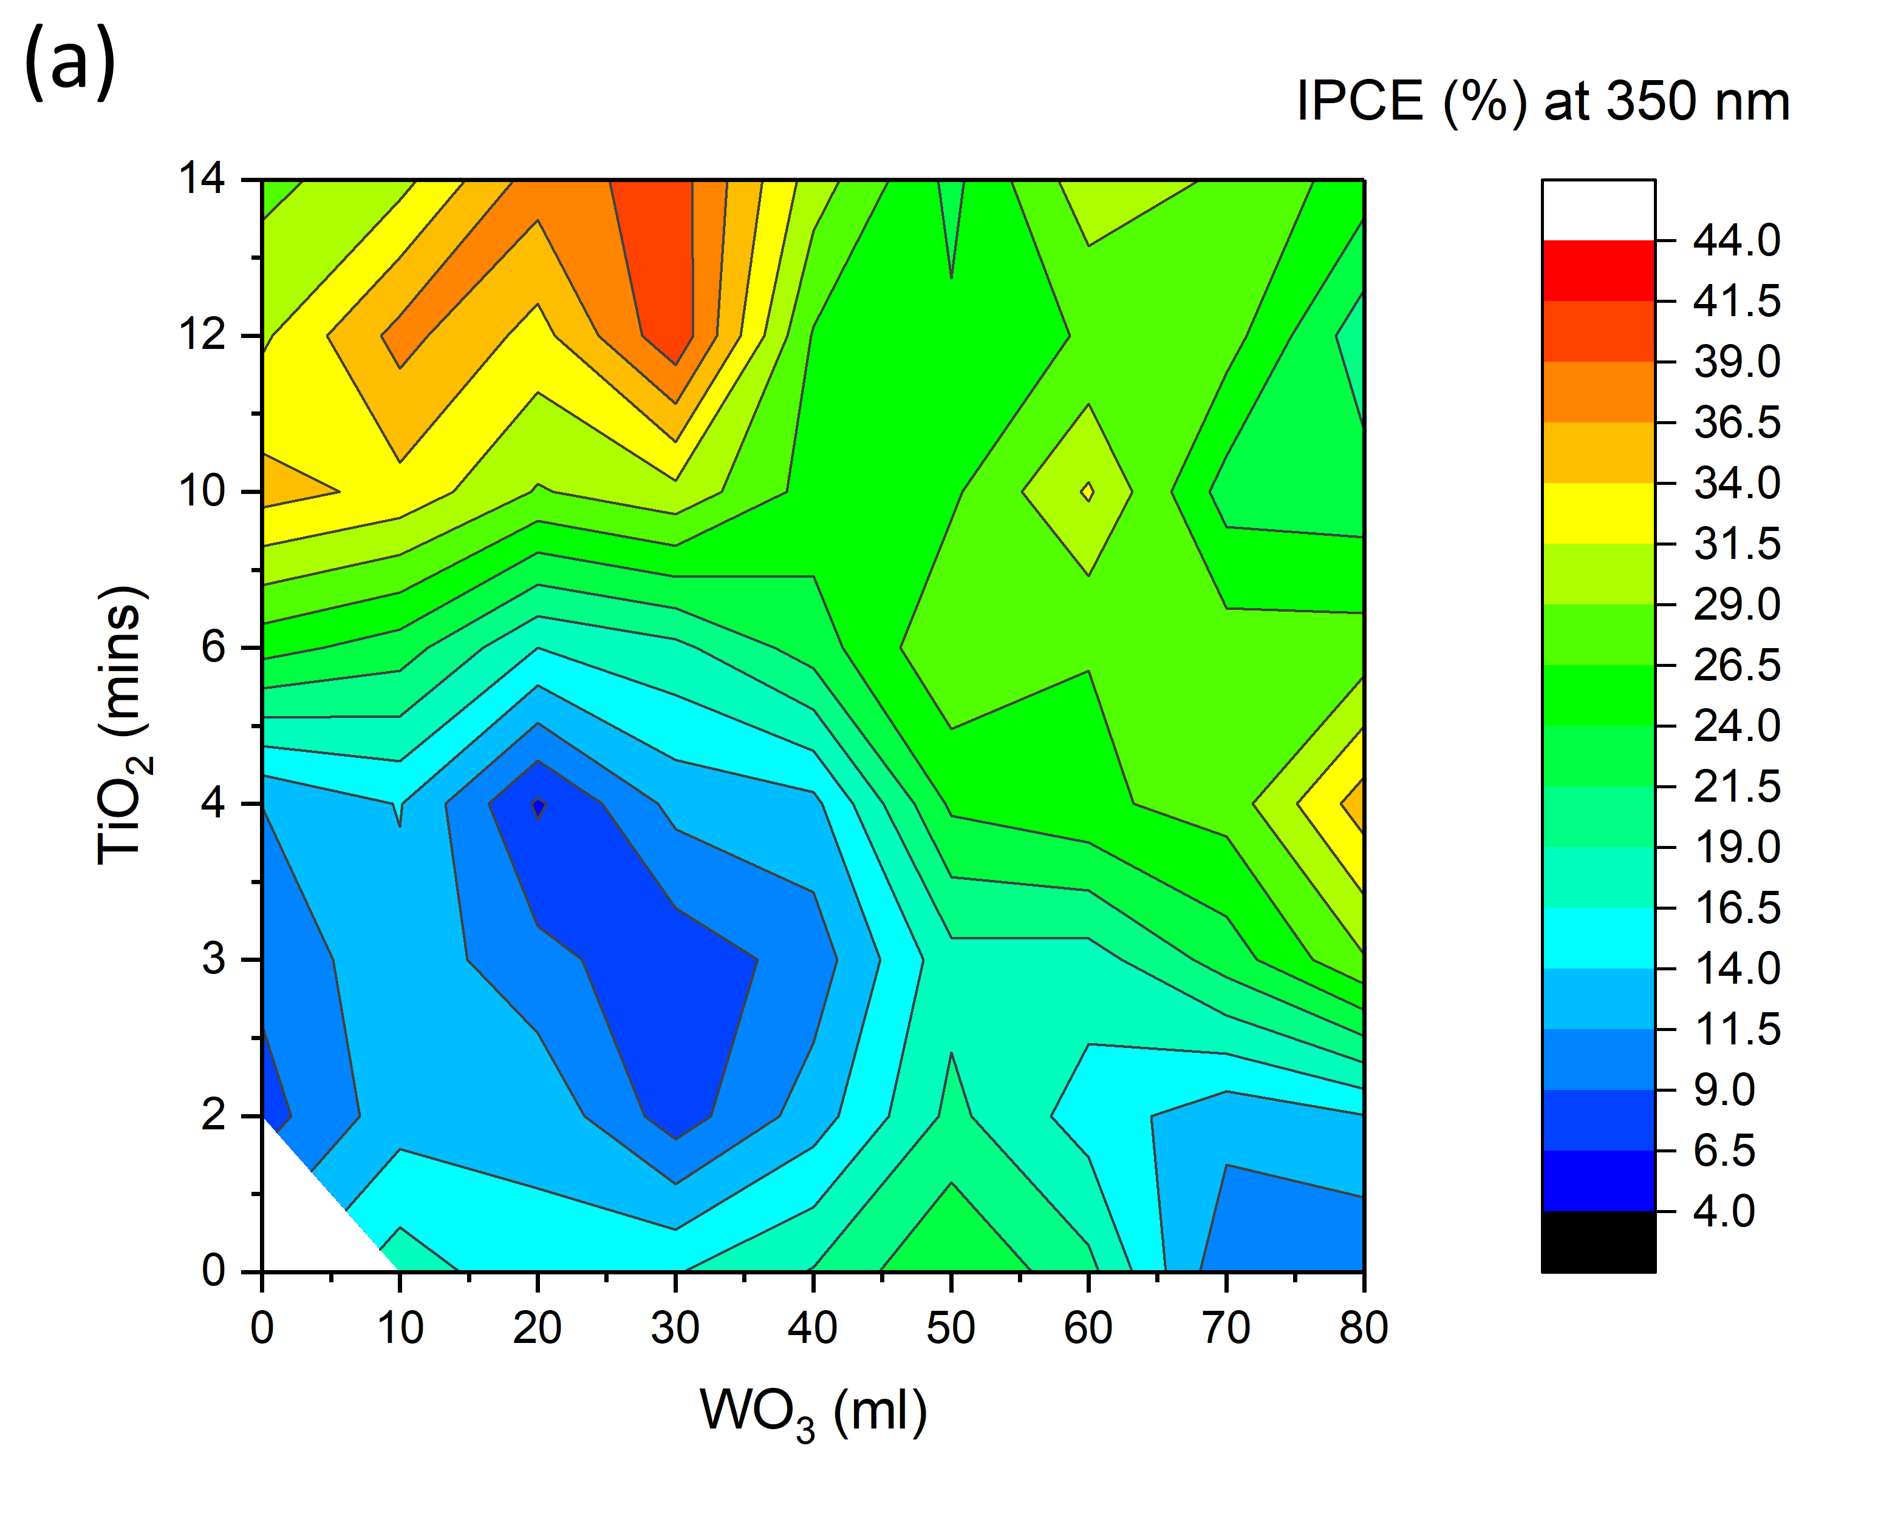 | 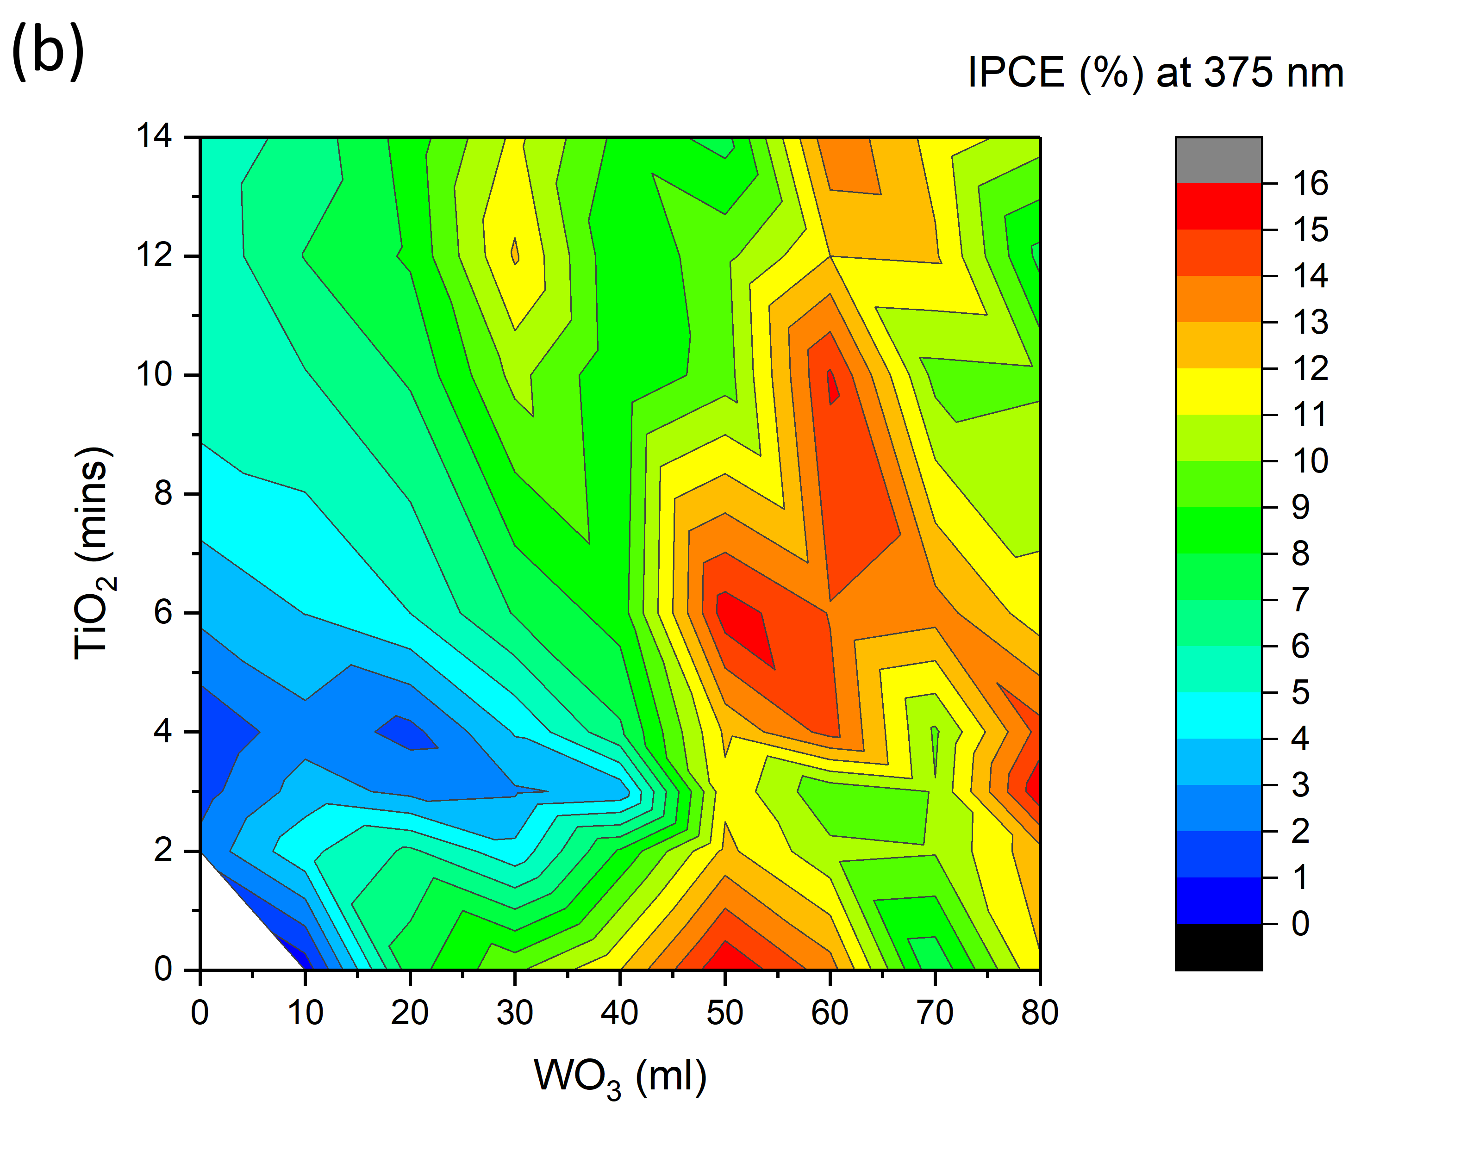
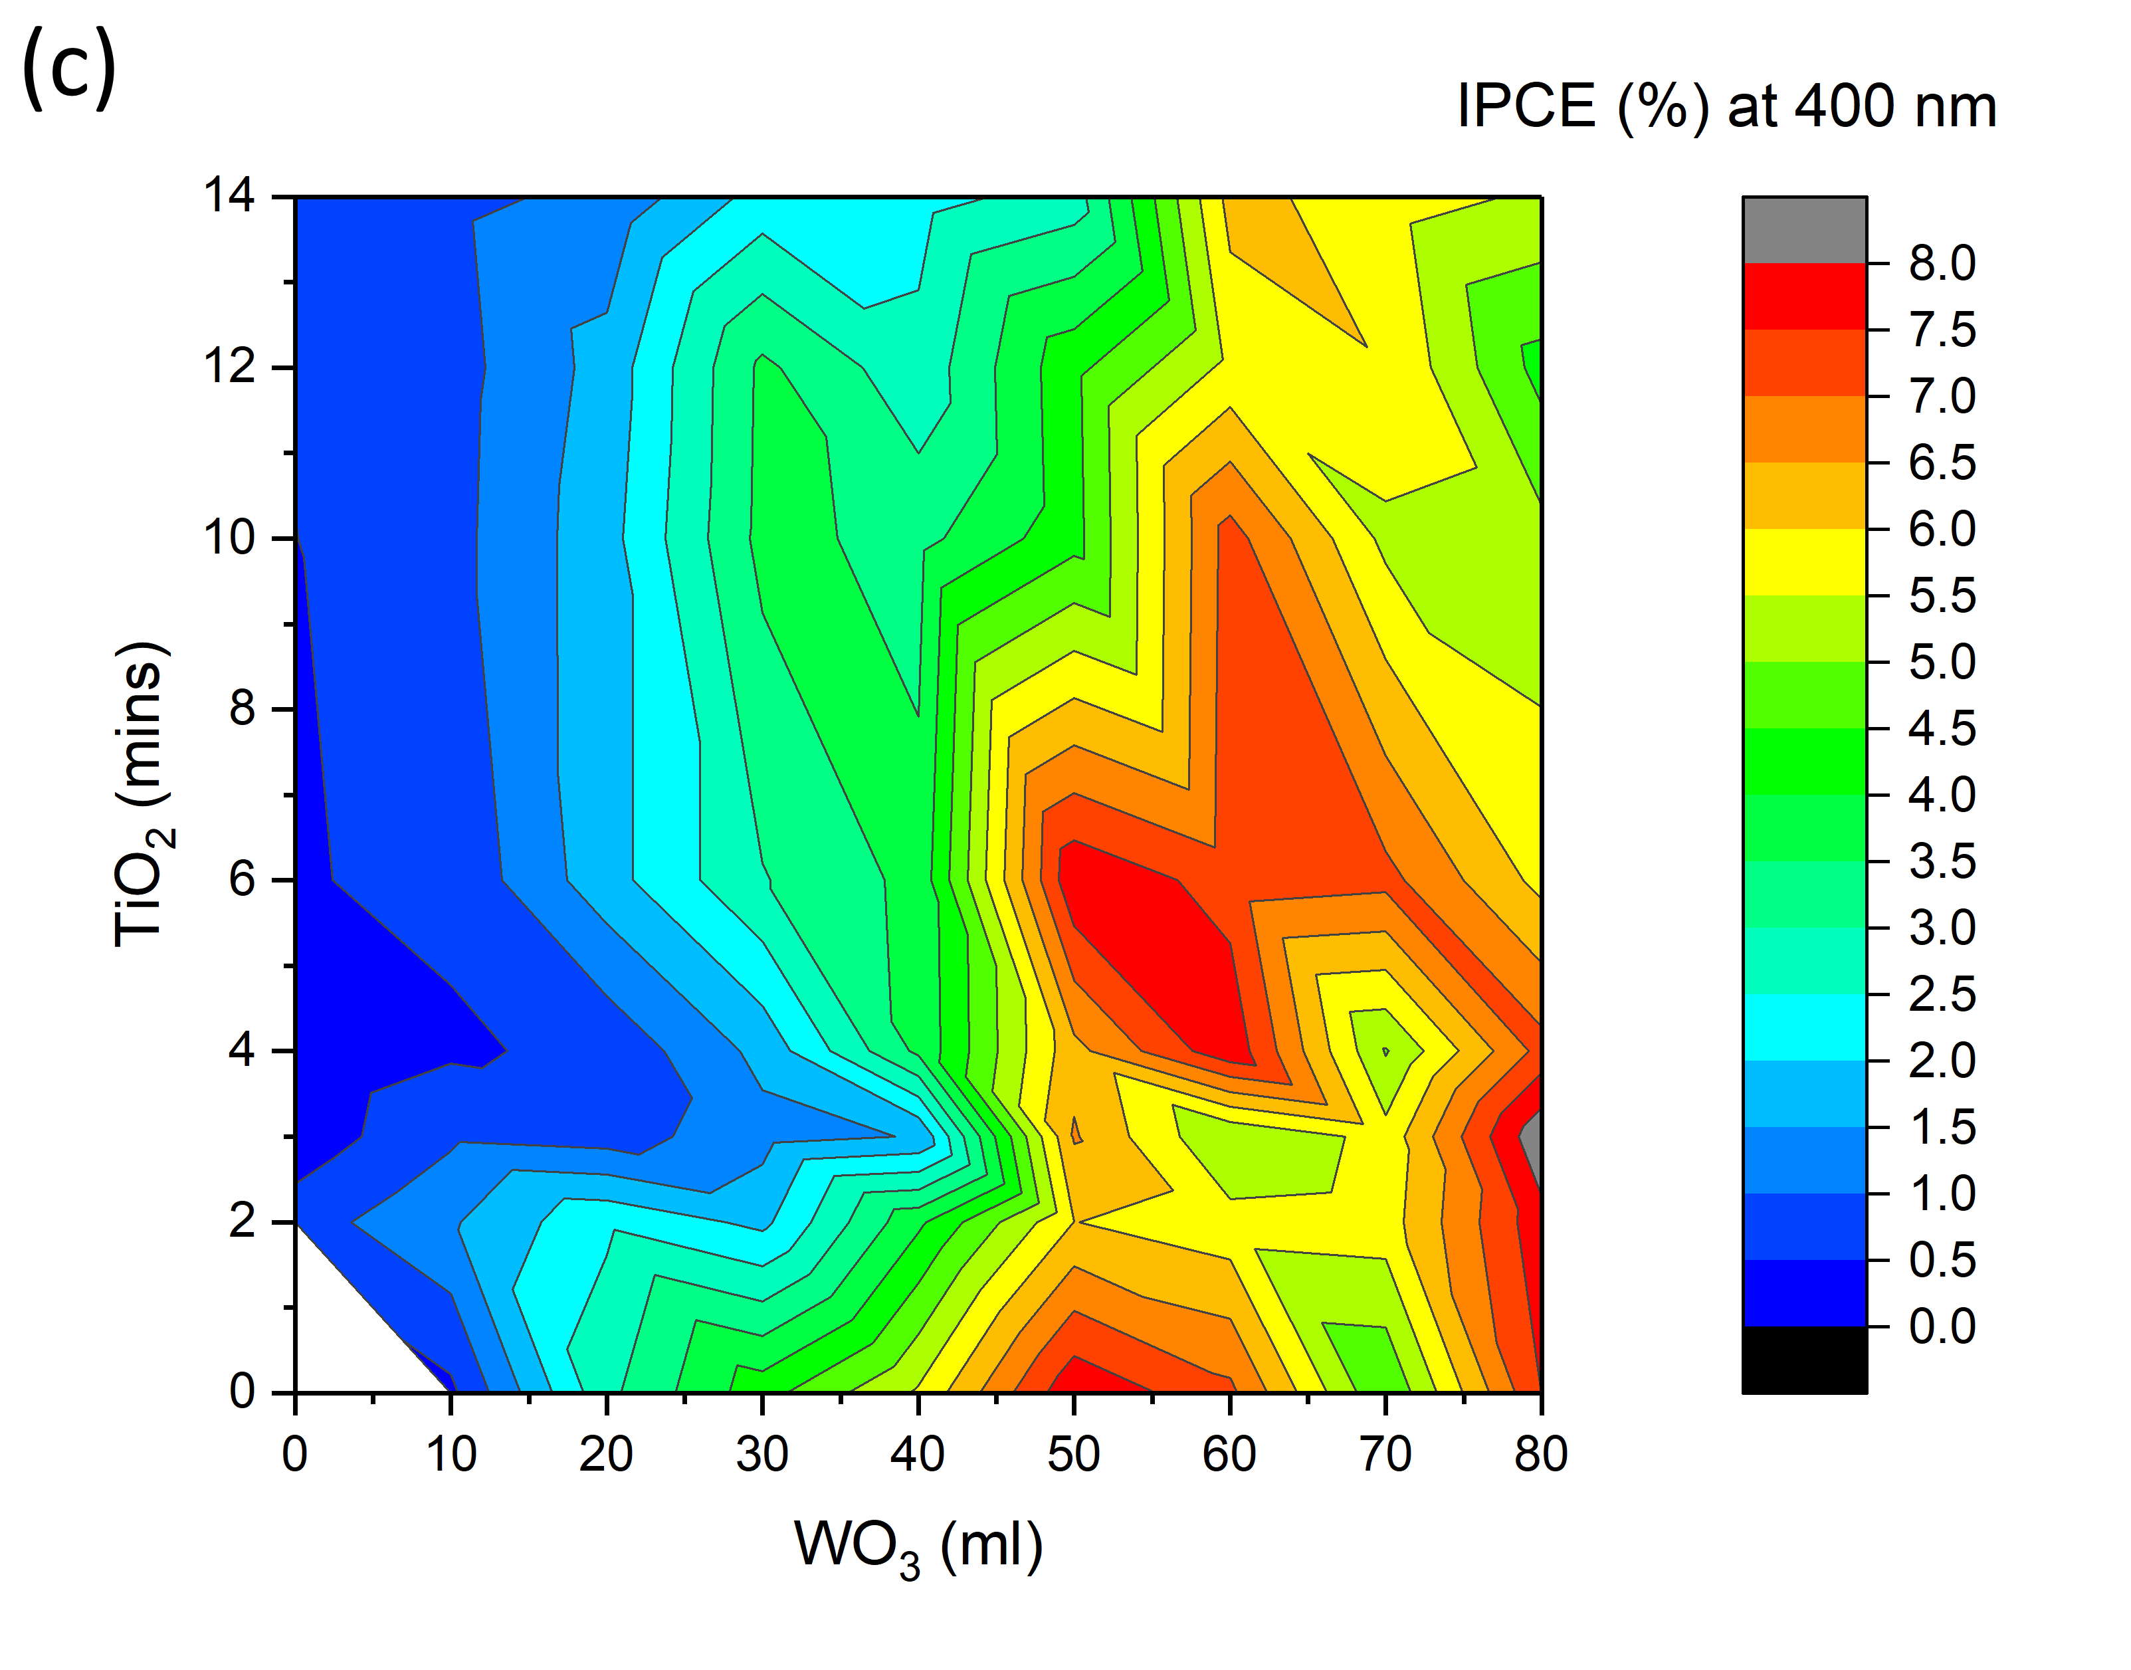 | Figure 7: Contour plots of the IPCEs (%) observed under front irradiation at 1.23 V_{RHE} for (a) 350 nm, (b) 375 nm and (c) 400 nm for all WO₃, TiO₂ and WO₃/TiO₂ photoanodes synthesised herein. All samples were measured in a 0.1 M H₂SO₄ electrolyte (pH = 1.18).

3.2.4.3. TSP
The TSP is a method that uses the IPCE (measured at a range of suitable wavelengths) to predict the photocurrent that would be observed at 1 sun (AM 1.5; 100 mW.cm⁻²).⁴⁸ A diagramatic example of how this is calculated is shown in Figure 8a. The TSP was calculated for all 71 unique photoanodes synthesised herein, for both front (Figure 8b) and back irradiation (Figure S13).
For the case of front irradiation (Figure 8b), a contour plot shows that there are two regions of high TSP (yellow-red; 0.55 to 0.75 mA.cm⁻²) that mostly spanned WO₃ - 20 to 40 ml/ TiO₂ - 10 to 14 mins and WO₃ - 50 to 80 ml/ TiO₂ - 2 to 10 mins heterojunction phase space. A region of low TSP (dark blue- light blue; 0.10 to 0.30 mA.cm⁻²) spanned WO₃ - 0 to 40 ml/ TiO₂ - 2 to 4 mins single layer and heterojunction phase space. This showed that thinner photoanodes were less active than thicker photoanodes, and in part, may be caused by their higher light transmittance (Figure 3a and Figure S7). For the case of back irradiation (Figure S13), a contour plot shows that there is, broadly speaking, one region of high TSP (yellow-red; 0.55 to 0.75 mA.cm⁻²) that spanned WO₃ - 60 to 80 ml/ TiO₂ - 2 to 14 mins heterojunction phase space. A region of low TSP (dark blue- light blue; 0.10 to 0.30 mA.cm⁻²) was again observed in WO₃ - 0 to 40 ml/ TiO₂ - 2 to 4 mins single layer and heterojunction phase space.
As sunlight contains more light in the visible than in the UV region, photoanodes with higher IPCEs in the visible (Figure 7c and Figure S12c) generally showed higher TSPs. In general, heterojunctions showed higher TSPs than their parent materials. The most active sample under front irradiation was WO₃ - 30 ml/ TiO₂ - 10 mins, with a TSP of 0.87 mA.cm⁻², and the most active sample under back irradiation was WO₃ - 80 ml/ TiO₂ - 3 mins, with a TSP of 0.94 mA.cm⁻². Both heterojunctions showed synergistic improvements in TSP with respect to their parent materials (Table S5), and again, can be attributed to the beneficial effect of forming a junction. The TSP values for all 71 samples are tabulated in the supporting information (Table S5).

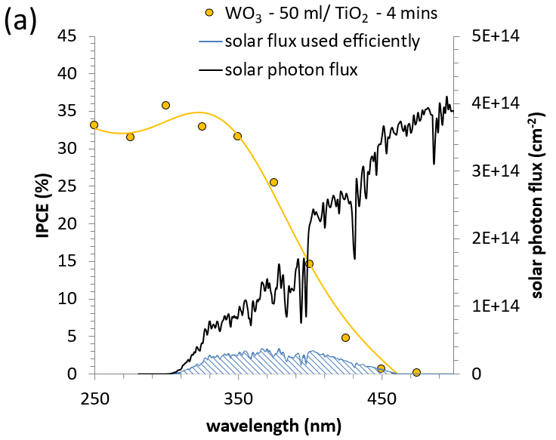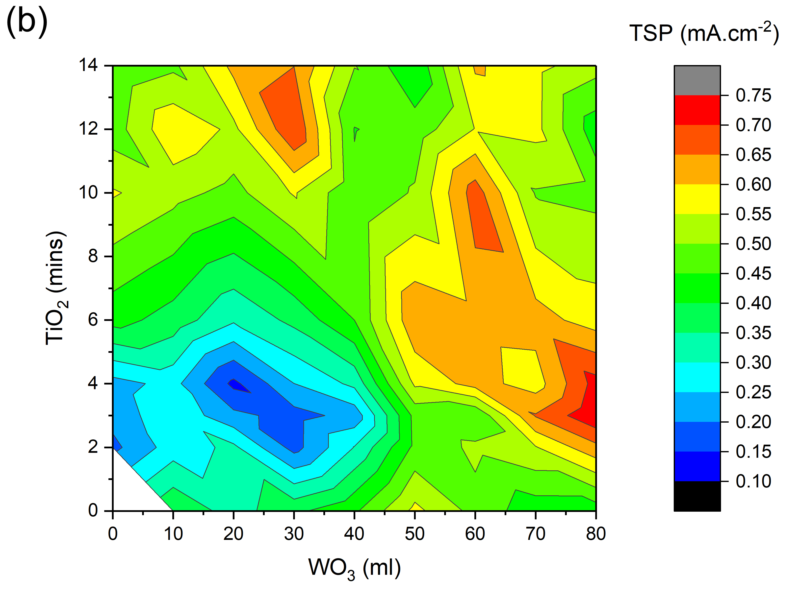

Figure 8: (a) Example calculation of the TSP (mA.cm⁻²) for the photoanode WO₃ - 50 ml/ TiO₂ - 4 mins from IPCE data measured at 1.23 V_{RHE} in 0.1 M H₂SO₄ electrolyte (pH = 1.18) under front irradiation. (b) Contour plot of the TSPs (mA.cm⁻²) from IPCE data measured at 1.23 V_{RHE} V_{RHE} in 0.1 M H₂SO₄ electrolyte (pH = 1.18) under front irradiation for all WO₃, TiO₂ and WO₃/TiO₂ photoanodes synthesised herein.

3.2.4.4. Comparisons with the literature
Various composite and heterojunction WO₃/ TiO₂ photoanodes have been examined for applications in photoelectrochemical water splitting,^{10,12–18} albeit less rigorously than herein (i.e. with typically smaller numbers of samples synthesised, and their photoelectrochemical properties measured less comprehensively). The photoelectrochemical performance of WO₃, TiO₂ and WO₃/TiO₂ photoanodes are summarised in Table 2 alongiside the best performing photoanodes from the work herein. Unless stated, all photocurrents reported in this section were measured at 1.23 V_{RHE} and 1 sun irradiance. It should be noted that the both the electrolyte and pH was not constant across all studies compared herein, where the pH varied from ~0.6 to ~13.8. Although this is unlikely to have an effect on the performance of TiO₂, which has been shown to have near analogous photoelectrochemical activity in acid, neutral and basic pH,⁴⁵ it will likely affect the performance of WO₃, which shows varied photoelectrochemical activity at different pH.⁴⁹
Na et al. synthesised mesoporous WO₃/TiO₂ composite photoanodes using a two-step process.¹⁸ First P25 TiO₂ paste was screen printed onto an FTO electrode, and then impregnated with WO₃ using a sol-gel process. Photoanodes showed stable photocurrents of up to ~0.7 mA.cm⁻². Mojgan et al. grew WO₃/ TiO₂ nanotube composites by anodizing Ti foil in a W-rich electrolyte.¹⁷ Photocurrents of up to ~0.1 mA.cm⁻² were observed using a 35 W Xe lamp. Davarzadeh et al. also grew WO₃/ TiO₂ nanotube composites using an anodization route, attaining higher photocurrents of ~0.8 mA.cm⁻².¹⁶ Chen et al. grew WO₃/TiO₂ composite photoanodes using a two-step process. TiO₂ nanorods were grown by anodization of Ti foil, and then impregnated with WO₃ nanoparticles using a hydrothermal method.¹³ Photocurrents of up to ~2.7 mA.cm⁻² were observed.
Zhao et al. synthesised WO₃/TiO₂ heterojunction photoanodes using a physical vapour deposition processes, where WO₃ nanorods were coated with a conformal TiO₂ shell.¹² Photoanodes showed photocurrents of up to ~0.025 mA.cm⁻² and IPCEs nearing 2.5% at 400 nm. Ludwig et al. grew combinatorial libraries of mesoporous WO₃/ nanocolumn TiO₂ heterojunctions using physical vapour deposition processes that showed photocurrents of up to ~0.11 mA.cm⁻².¹⁰ Sun et al. synthesised WO₃/ TiO₂ heterojunction photoanodes using a two-step process, where WO₃ nanoplates were grown using a sol-gel route and TiO₂ nanoprickles were grown on top using a chemical bath deposition.¹⁵ They saw photocurrents of up to ~1.7 mA.cm⁻² and IPCEs of ~72% at 400 nm. The best performing WO₃/ TiO₂ heterojunction herein (WO₃ - 80 ml/ TiO₂ - 3 mins; back irradiation) showed a TSP of ~0.94 mA.cm⁻² and an IPCE of ~16% at 400 nm.
It is interesting to note that, to our knowledge, the best performing WO₃/TiO₂ photoanodes from the literature (up to ~2.7 mA.cm⁻²)¹³ show lower photoelectrochemical activity than the best performing WO₃ photoanode to date (~3.7 mA.cm⁻²; Table 2).⁵⁰ This is likely due to the greater number of studies on WO₃ alone than the WO₃/ TiO₂ heterojunction, resulting in further advances in its optimisation. Interestingly, the best performing TiO₂ photoanode to date (~2.6 mA.cm⁻²)⁵¹ shows similar photoelectrochemical activity to the best performing WO₃/TiO₂ photoanodes from the literature. Comparing the performance of our single layer WO₃ and TiO₂ photoanodes to those also grown using CVD methods in the literature, we see lower performances. For WO₃, our nanoneedles (up to ~0.71 mA.cm⁻²) showed lower activity than nanoneedles grown using an analogous method (~1.24 mA.cm⁻²).⁴² This difference may be attributed to their use of a dense WO₃ seed layer, which improved the density of WO₃ nanoneedle growth. For TiO₂, our nanocolumn anatase (up to ~0.56 mA.cm⁻²) showed lower photoelectrochemical activity than nanocolumn anatase:rutile TiO₂ grown using a similar method (~1.2 mA.cm⁻²).⁴⁸ This difference is likely due to the presence of rutile in their photoanode, which extends light absorption into the visible and improves solar harvesting.

Table 2: Summary of the synthesis, microstructure, and photocatalytic water oxidation activity for some of the best performing WO₃, TiO₂ and WO₃/ TiO₂ photoanodes reported in the literature to date.
 | Material | Synthesis |  | 1.23 V_{RHE} |  | Reference
 | Material | Synthesis | electrolyte (pH) | Photocurrent (mA.cm⁻²) | IPCE | Reference
WO₃ | WO₃ nanoplates | Hydrothermal | 0.1 M H₂SO₄  (ns) | ~3.7 | ~55% at 400 nm | Wang et al.⁵⁰
WO₃ | WO₃ nanoneedles on a  dense seed layer | AA-CVD | 0.5 M H₂SO₄  (~0.6) | ~1.24ª | ~27% at 400 nm | Parkin et al.⁴²
WO₃ | WO₃ nanoneedles | AA-CVD | 0.1 M H₂SO₄  (~1.2) | ~0.71ª | ~10% at 400 nm | herein
TiO₂ | TiO₂ nanowires  (80:20 anatase:rutile) | Mechanochemical synthesis + drop cast | 1.0 M NaOH  (~13.8) | ~2.6 | ~90% at 350 nm | Liu et al.⁵¹
TiO₂ | TiO₂ nanocolumns  (95:5 anatase:rutile) | Pulsed pressure CVD | 1.0 M NaOH  (~13.6) | ~1.2ª | ~85% at 350 nm | Krumdieck et al.⁴⁸
TiO₂ | TiO₂ nanocolumns  (anatase) | AP-CVD | 0.1 M H₂SO₄  (~1.2) | ~0.56ª | ~36% at 350 nm | herein
WO₃/ TiO₂  composite | Mesoporous WO₃/ TiO₂ composite | Screen printing + sol-gel | 0.1 M Na₂SO₄  (~6.8) | ~0.7 | ns | Na et al.¹⁸
WO₃/ TiO₂  composite | WO₃/ TiO₂ nanotube composite | Anodization | 1.0 M KOH  (~13.6) | ~0.1^{b} | ns | Mojgan et al.¹⁷
WO₃/ TiO₂  composite | WO₃/ TiO₂ nanotube composite | Anodization | 1.0 M NaOH  (~13.6) | ~0.8 | ns | Davarzadeh et al.¹⁶
WO₃/ TiO₂  composite | WO₃ nanoparticles/ TiO₂ nanotube composite | Anodization + hydrothermal | 0.1 M Na₂SO₄  (ns) | ~2.7 | ns | Chen et al.¹³
WO₃/ TiO₂ heterojunction | WO₃ nanorods/TiO₂ shell heterojunction | Physical vapour deposition | 0.5 M NaClO₄ (~7.2) | ~0.025 | ~2.5% at 400 nm | Zhao et al.¹²
WO₃/ TiO₂ heterojunction | WO₃ mesopore/ TiO₂ nanocolumn heterojunctions | Physical vapour deposition | 0.5 M NaClO₄  (~3.7) | ~0.11 | ns | Ludwig et al.⁵²
WO₃/ TiO₂ heterojunction | WO₃ nanoplate/ TiO₂ nanoprickle heterojunctions | Sol-gel + chemical bath deposition | 0.5 M NaClO₄ (~7.2) | ~1.7 | ~72% at 400 nm | Zhao et al.¹²
WO₃/ TiO₂ heterojunction | WO₃ nanoneedles/ TiO₂ dendrites heterojunction | AA-CVD/ AP-CVD | 0.1 M H₂SO₄  (~1.2) | ~0.94ª | ~16% at 400 nm | herein
All photocurrents measured using solar simulated light at 1 sun power (100 mW.cm⁻²) unless specified. ªTSP; ^{b}35 W Xe lamp, light power not stated; ns = not stated.

The methodologies developed herein, for assessing and comparing the photoelectrochemical performance of a relatively large catalogue of heterojunction photoelectrodes (71 unique samples in this work), enabled us to readily find regions of heterjunction phase space of high activity (for solar conditions and specific wavelengths) and identify performance trends. Although the relationships identified herein are likely only applicable to WO₃/ TiO₂ heterojunction systems with similar heterostructure, grown using similar methods, the methods developed herein are generalizable, and can be applied to other promising heterojunction systems to identify regions of high activity. These can also be used to establish new understanding of physical-functional property relationships and the creation of new design rules for producing more active heterojunction materials. Also, we envisage that when these methods are used alongside combinatorial methods for growing photoelectrodes,⁵³ and high throughout photoelectrochemical analysis,^{54,55} this will result in the more rapid optimisation of heterojunction systems.

4. Conclusion
Herein, we systematically explored WO₃/TiO₂ heterojunction phase space for applications in photoelectrochemical water splitting, synthesising 71 unique photoanodes (15 single layer; 56 heterojunction) using chemical vapour deposition processes. The heterojunctions were composed of WO₃ nanoneedles (up to ~1800 nm thick) and TiO₂ nanocolumns (up to ~1250 nm thick). The WO₃ and TiO₂ layers adopted monoclinic γ-WO₃ and tetragonal anatase structures, respectively. Bandgaps ranged from ∼2.78 to ∼3.05 eV. Their photoelectrochemical performance was measured under front and back irradiation. New methods were developed to analyse the large body of data generated. Within this heterojunction phase space, onset potentials ranged from ∼0.45 to ∼0.81 V_{RHE}; IPCEs at 350, 375 and 400 nm ranged from ∼0.6 to ∼50.9%, ∼0.1 to ∼30.0%, ∼0 to ∼15.6%, respectively; and TSPs ranged from ∼0.01 to ∼0.94 mA.cm⁻². Contour plots of these parameters allowed us to identify regions of high, intermediate and low activity, and were used to form physical-functional property relationships. Exploration of this heterojunction phase space showed that there is a barrier to charge transfer across the junction at low applied potentials (typically < 1.0 V_{RHE}), and that a sufficiently high potential (typically ≥ 1.0 V_{RHE}) is necessary for synergetic improvements in activity to be observed. In addition, hole scavenger experiments indicated that the oxidation of water occurred primarily on the TiO₂ layer in the WO₃/ TiO₂ heterojunction.
For front irradiation, the most active photoanode under solar conditions was WO₃ - 30 ml/ TiO₂ - 10 mins, reaching a TSP of ∼0.87 mA.cm⁻². This sample was grown from the transfer of 30 ml of a tungsten precursor to grow the WO₃ nanoneedle layer (~500 nm thick) and the transfer of vapours for 10 mins of a titanium precursor to grow the TiO₂ nanocolumn layer (~1,100 nm thick). For back irradiation, the most active photoanode under solar conditions was WO₃ - 80 ml/ TiO₂ - 3 mins, reaching a TSP of ∼0.94 mA.cm⁻². This sample was grown from the transfer of 80 ml of a tungsten precursor to grow the WO₃ nanoneedle layer (~1,800 nm thick) and the transfer of vapours for 3 mins of a titanium precursor to grow the TiO₂ nanocolumn layer (~600 nm thick). We envisage that the analytical methods developed herein can be used to optimise other promising heterojunction systems for applications in photoelectrochemical water splitting, especially when coupled with combinatorial synthesis and high throughput photoelectrochemical analyses.

Acknowledgements
A. K. thanks the EPSRC for a Capital Award Emphasising Support for Early Career Researchers and the Royal Society for an Equipment Grant (RSG\R1\180434). B.M. thanks the EPSRC for a doctoral training partnership. A.W. thanks the EPSRC for a DTP studentship. Lee Tooley and Steve Atkins are thanked for constructing our chemical vapour deposition apparatus.

Associated Content

Supporting Information
Schematic of the CVD equipment used to grow the WO₃/ TiO₂ heterojunction coatings herein, measured and Le Bail modelled XRD patterns of select WO₃/ TiO₂ heterojunction coatings, Raman spectroscopy of select WO₃/ TiO₂ heterojunction coatings, Side-on SEM images of select WO₃/ TiO₂ heterojunction coatings, band energy diagram of the WO₃/ TiO₂ heterojunction, UV-visible transmission spectroscopy and derived bandgap energies of select WO₃/ TiO₂ heterojunction coatings, current-voltage curves of select WO₃/ TiO₂ heterojunction coatings under back irradiation, contour plot of the photocatalytic onset potentials of all WO₃/ TiO₂ heterojunctions under back irradiation, current-voltage curves of select WO₃/ TiO₂ heterojunction coatings with and without s hole scavenger, contour plots of the IPCE at 375 nm of all WO₃/ TiO₂ heterojunctions at various applied potentials, contour plots of the IPCE of all WO₃/ TiO₂ heterojunctions at various wavelengths under back irradiation, contour plot of the TSP of all WO₃/ TiO₂ heterojunctions at 1.23 V_{RHE}.

TOC
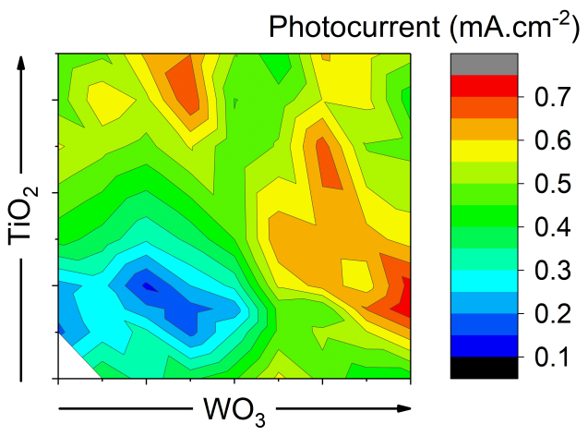

References
(1) Sivula, K.; van de Krol, R. Semiconducting Materials for Photoelectrochemical Energy Conversion. Nat. Rev. Mater. 2016, 1, 15010. https://doi.org/10.1038/natrevmats.2015.10.
(2) Fujishima, A.; Honda, K. Electrochemical Photolysis of Water at a Semiconductor Electrode. Nature 1972, 238 (5358), 37–38. https://doi.org/10.1038/238037a0.
(3) Osterloh, F. E. Inorganic Materials as Catalysts for Photochemical Splitting of Water. Chem. Mater. 2008, 20 (1), 35–54. https://doi.org/10.1021/cm7024203.
(4) Afroz, K.; Moniruddin, M.; Bakranov, N.; Kudaibergenov, S.; Nuraje, N. A Heterojunction Strategy to Improve the Visible Light Sensitive Water Splitting Performance of Photocatalytic Materials. J. Mater. Chem. A 2018, 21696–21718. https://doi.org/10.1039/c8ta04165b.
(5) Moniz, S. J. A.; Shevlin, S. A.; Martin, D. J.; Guo, Z. X.; Tang, J. Visible-Light Driven Heterojunction Photocatalysts for Water Splitting-a Critical Review. Energy Environ. Sci. 2015, 8 (3), 731–759. https://doi.org/10.1039/c4ee03271c.
(6) Cheng, W. H.; Richter, M. H.; May, M. M.; Ohlmann, J.; Lackner, D.; Dimroth, F.; Hannappel, T.; Atwater, H. A.; Lewerenz, H. J. Monolithic Photoelectrochemical Device for Direct Water Splitting with 19% Efficiency. ACS Energy Lett. 2018, 3 (8), 1795–1800. https://doi.org/10.1021/acsenergylett.8b00920.
(7) Zhou, L.; Shinde, A.; Suram, S. K.; Stein, H. S.; Bauers, S. R.; Zakutayev, A.; Duchene, J. S.; Liu, G.; Peterson, E. A.; Neaton, J. B.; Gregoire, J. M. Bi-Containing n-FeWO4 Thin Films Provide the Largest Photovoltage and Highest Stability for a Sub-2 Ev Band Gap Photoanode. ACS Energy Lett. 2018, 3 (11), 2769–2774. https://doi.org/10.1021/acsenergylett.8b01514.
(8) Zhou, L.; Shinde, A.; Guevarra, D.; Toma, F. M.; Stein, H. S.; Gregoire, J. M.; Haber, J. A. Balancing Surface Passivation and Catalysis with Integrated BiVO 4 /(Fe-Ce)O x Photoanodes in PH 9 Borate Electrolyte. ACS Appl. Energy Mater. 2018, 1 (10), 5766–5771. https://doi.org/10.1021/acsaem.8b01377.
(9) Suram, S. K.; Zhou, L.; Shinde, A.; Yan, Q.; Yu, J.; Umehara, M.; Stein, H. S.; Neaton, J. B.; Gregoire, J. M. Alkaline-Stable Nickel Manganese Oxides with Ideal Band Gap for Solar Fuel Photoanodes. Chem. Commun. 2018, 54 (36), 4625–4628. https://doi.org/10.1039/c7cc08002f.
(10) Khare, C.; Sliozberg, K.; Meyer, R.; Savan, A.; Schuhmann, W.; Ludwig, A. Layered WO3 / TiO2 Nanostructures with Enhanced Photocurrent Densities. Int. J. Hydrogen Energy 2013, 38 (36), 15954–15964. https://doi.org/10.1016/j.ijhydene.2013.09.142.
(11) Rodríguez-Gutiérrez, I.; García-Rodríguez, R.; Rodríguez-Pérez, M.; Vega-Poot, A.; Rodríguez Gattorno, G.; Parkinson, B. A.; Oskam, G. Charge Transfer and Recombination Dynamics at Inkjet-Printed CuBi2O4 Electrodes for Photoelectrochemical Water Splitting. J. Phys. Chem. C 2018, 122 (48), 27169–27179. https://doi.org/10.1021/acs.jpcc.8b07936.
(12) Smith, W.; Wolcott, A.; Fitzmorris, R. C.; Zhang, J. Z.; Zhao, Y. Quasi-Core-Shell TiO2/WO3 and WO3/TiO2 Nanorod Arrays Fabricated by Glancing Angle Deposition for Solar Water Splitting. J. Mater. Chem. 2011, 21 (29), 10792–10800. https://doi.org/10.1039/C1JM11629K.
(13) Sun, W.; Wang, D.; Ur, Z.; Wei, N.; Chen, S. 3D Hierarchical WO3 Grown on TiO2 Nanotube Arrays and Their Photoelectrochemical Performance for Water Splitting. J. Alloys Compd. 2017, 695, 2154–2159. https://doi.org/10.1016/j.jallcom.2016.11.061.
(14) Lai, C. W.; Sreekantan, S. Electrochimica Acta Incorporation of WO3 Species into TiO2 Nanotubes via Wet Impregnation and Their Water-Splitting Performance. Electrochim. Acta 2013, 87, 294–302. https://doi.org/10.1016/j.electacta.2012.09.022.
(15) Zeng, Q.; Bai, J.; Li, J.; Zhou, B.; Sun, Y. A Low-Cost Photoelectrochemical Tandem Cell for Highly-Stable and Efficient Solar Water Splitting. Nano Energy 2017, 41 (August), 225–232. https://doi.org/10.1016/j.nanoen.2017.09.032.
(16) Momeni, M. M.; Ghayeb, Y.; Davarzadeh, M. Single-Step Electrochemical Anodization for Synthesis of Hierarchical WO 3 – TiO 2 Nanotube Arrays on Titanium Foil as a Good Photoanode for Water Splitting with Visible Light. J. Electroanal. Chem. 2015, 739, 149–155. https://doi.org/10.1016/j.jelechem.2014.12.030.
(17) Ghayeb, Y.; Mohsen, M.; Mojgan, M. WO 3 – TiO 2 Nanotubes Modified with Tin Oxide as Efficient and Stable Photocatalysts for Photoelectrochemical Water Splitting. J. Iran. Chem. Soc. 2020, 17 (5), 1131–1140. https://doi.org/10.1007/s13738-019-01842-9.
(18) Wei, P.; Lin, K.; Meng, D.; Xie, T.; Na, Y. Photoelectrochemical Performance for Water Oxidation Improved by Molecular Nickel Porphyrin-Integrated WO3/TiO2 Photoanode. ChemSusChem 2018, 11 (11), 1746–1750. https://doi.org/10.1002/cssc.201800705.
(19) Khan, H.; Rigamonti, M. G.; Patience, G. S.; Boffito, D. C. Spray Dried TiO2/WO3 Heterostructure for Photocatalytic Applications with Residual Activity in the Dark. Appl. Catal. B Environ. 2018, 226, 311–323. https://doi.org/https://doi.org/10.1016/j.apcatb.2017.12.049.
(20) Kang Yong Song; Myun Kyu Park; Young Tae Kwon; Hyun Woo Lee; Won Jo Chung; Wan In Lee. Preparation of Transparent Particulate MoO3/TiO2 and WO3/TiO2 Films and Their Photocatalytic Properties. Chem. Mater. 2001, 13, 2349–2355. https://doi.org/10.1021/cm000858n.
(21) Miyauchi, M.; Nakajima, A.; Watanabe, T.; Hashimoto, K. Photoinduced Hydrophilic Conversion of TiO2/WO3 Layered Thin Films. Chem. Mater. 2002, 14 (11), 4714–4720. https://doi.org/10.1021/cm020355c.
(22) Do, Y. R.; Lee, W.; Dwight, K.; Wold, A. The Effect of WO3 on the Photocatalytic Activity of TiO2. J. Solid State Chem. 1994, 108, 198–201. https://doi.org/10.1006/jssc.1994.1031.
(23) Tae Kwon, Y.; Yong Song, K.; In Lee, W.; Jin Choi, G.; Rag Do, Y. Photocatalytic Behavior of WO3-Loaded TiO2 in an Oxidation Reaction. J. Catal. 2000, 191, 192–199. https://doi.org/10.1006/jcat.1999.2776.
(24) Lu, B.; Li, X.; Wang, T.; Xie, E.; Xu, Z. WO3 Nanoparticles Decorated on Both Sidewalls of Highly Porous TiO2 Nanotubes to Improve UV and Visible-Light Photocatalysis. J. Mater. Chem. A 2013. https://doi.org/10.1039/c3ta01444d.
(25) Sotelo-Vazquez, C.; Quesada-Cabrera, R.; Ling, M.; Scanlon, D. O.; Kafizas, A.; Thakur, P. K.; Lee, T.-L.; Taylor, A.; Watson, G. W.; Palgrave, R. G.; Durrant, J. R.; Blackman, C. S.; Parkin, I. P. Evidence and Effect of Photogenerated Charge Transfer for Enhanced Photocatalysis in WO3/TiO2 Heterojunction Films: A Computational and Experimental Study. Adv. Funct. Mater. 2017, 27 (18), 1605413. https://doi.org/10.1002/adfm.201605413.
(26) Iqbal, A.; Kafizas, A.; Sotelo-Vazquez, C.; Wilson, R.; Ling, M.; Taylor, A.; Blackman, C.; Bevan, K.; Parkin, I.; Quesada-Cabrera, R. Charge Transport Phenomena in Heterojunction Photocatalysts: The WO3/TiO2 System as an Archetypical Model. ACS Appl. Mater. Interfaces 2021, 13, 9781−9793. https://doi.org/10.1021/acsami.0c19692.
(27) Liu, X.; Wang, F.; Wang, Q. Nanostructure-Based WO3 Photoanodes for Photoelectrochemical Water Splitting. Phys. Chem. Chem. Phys. 2012, 14, 7894–7911. https://doi.org/10.1039/c2cp40976c.
(28) Schneider, J.; Matsuoka, M.; Takeuchi, M.; Zhang, J.; Horiuchi, Y.; Anpo, M.; Bahnemann, D. W. Understanding TiO2 Photocatalysis: Mechanisms and Materials. Chem. Rev. 2014, 114 (19), 9919–9986. https://doi.org/10.1021/cr5001892.
(29) Moss, B.; Babacan, O.; Kafizas, A.; Hankin, A. A Review of Inorganic Photoelectrode Developments and Reactor Scale-Up Challenges for Solar Hydrogen Production. Adv. Energy Mater. 2021, 2003286, 1–43. https://doi.org/10.1002/aenm.202003286.
(30) Ling, M.; Blackman, C. Growth Mechanism of Planar or Nanorod Structured Tungsten Oxide Thin Films Deposited via Aerosol Assisted Chemical Vapour Deposition (AACVD). Phys. Status Solidi C 2015, 877 (7), 869–877. https://doi.org/10.1002/pssc.201510047.
(31) Evans, P.; Pemble, M. E.; Sheel, D. W. Precursor-Directed Control of Crystalline Type in Atmospheric Pressure CVD Growth of TiO2 on Stainless Steel. Chem. Mater. 2006, 18 (24), 5750–5755. https://doi.org/10.1021/cm060816k.
(32) Siefering, K. L.; Griffin, G. L. Growth Kinetics of CVD TiO2: Influence of Carrier Gas. J. Electrochem. Soc. 1990, 137 (4), 1206. https://doi.org/10.1149/1.2086632.
(33) Home | Physical Sciences Data science Service https://www.psds.ac.uk/ (accessed Sep 27, 2019).
(34) Toby, B. H. EXPGUI, a Graphical User Interface for GSAS. J. Appl. Crystallogr. 2001, 34, 210–213.
(35) RRUFF database of Raman spectroscopy, X-ray diffraction and chemistry of minerals http://rruff.info/ (accessed Sep 26, 2019).
(36) Botz, A. J. R.; Nebel, M.; Rincón, R. A.; Ventosa, E.; Schuhmann, W. Onset Potential Determination at Gas-Evolving Catalysts by Means of Constant-Distance Mode Positioning of Nanoelectrodes. Electrochim. Acta 2015, 179, 38–44. https://doi.org/https://doi.org/10.1016/j.electacta.2015.04.145.
(37) Sotelo-Vazquez, C.; Noor, N.; Kafizas, A.; Quesada-Cabrera, R.; Scanlon, D. O.; Taylor, A.; Durrant, J. R.; Parkin, I. P. Multifunctional P-Doped TiO2 Films: A New Approach to Self-Cleaning, Transparent Conducting Oxide Materials. Chem. Mater. 2015, 27 (9), 3234. https://doi.org/10.1021/cm504734a.
(38) Betsch, R. J. Parametric Analysis of Control Parameters in MOCVD. J. Cryst. Growth 1986, 77, 210–218.
(39) Vogt, T.; Woodward, P. M.; Hunter, B. A. The High-Temperature Phases of WO3. J. Solid State Chem. 1999, 144 (1), 209–215. https://doi.org/10.1006/JSSC.1999.8173.
(40) Weirich, T. E.; Winterer, M.; Seifried, S.; Hahn, H.; Fuess, H. Rietveld Analysis of Electron Powder Diffraction Data from Nanocrystalline Anatase, TiO2. Ultramicroscopy 2000, 81 (3–4), 263–270. https://doi.org/10.1016/S0304-3991(99)00189-8.
(41) Kafizas, A.; Dunnill, C. W.; Parkin, I. P. Combinatorial Atmospheric Pressure Chemical Vapour Deposition (CAPCVD) of Niobium Doped Anatase; Effect of Niobium on the Conductivity and Photocatalytic Activity. J. Mater. Chem. 2010, 20 (38), 8336–8349. https://doi.org/10.1039/c0jm01244k.
(42) Kafizas, A.; Francàs, L.; Sotelo-Vazquez, C.; Ling, M.; Li, Y.; Glover, E.; McCafferty, L.; Blackman, C. S.; Darr, J. A.; Parkin, I. P. Optimizing The Activity of Nano-Needle Structured WO3 Photoanodes for Solar Water Splitting – Direct Synthesis Via Chemical Vapor Deposition. J. Phys. Chem. C 2017, 121 (11), 5983–5993. https://doi.org/10.1021/acs.jpcc.7b00533.
(43) Tauc, J. Optical Properties and Electronic Structure of Amorphous Ge and Si. Mater. Res. Bull. 1968, 3 (1), 37–46. https://doi.org/10.1016/0025-5408(68)90023-8.
(44) Ling, M.; Blackman, C. S.; Palgrave, R. G.; Sotelo-Vazquez, C.; Kafizas, A.; Parkin, I. P. Correlation of Optical Properties, Electronic Structure, and Photocatalytic Activity in Nanostructured Tungsten Oxide. Adv. Mater. Interfaces 2017, 1700064. https://doi.org/10.1002/admi.201700064.
(45) Kafizas, A.; Ma, Y.; Pastor, E.; Pendlebury, S. R.; Mesa, C.; Francas, L.; Le Formal, F.; Noor, N.; Ling, M.; Sotelo-Vazquez, C.; Carmalt, C. J.; Parkin, I. P.; Durrant, J. R. Water Oxidation Kinetics of Accumulated Holes on the Surface of a TiO2 Photoanode: A Rate Law Analysis. ACS Catal. 2017, 7, 4896–4903. https://doi.org/10.1021/acscatal.7b01150.
(46) Prasad, U.; Prakash, J.; Gupta, S. K.; Zuniga, J.; Mao, Y.; Azeredo, B.; Kannan, A. N. M. Enhanced Photoelectrochemical Water Splitting with Er- and W-Codoped Bismuth Vanadate with WO3 Heterojunction-Based Two-Dimensional Photoelectrode. ACS Appl. Mater. Interfaces 2019, 11 (21), 19029–19039. https://doi.org/10.1021/ACSAMI.9B00150/SUPPL_FILE/AM9B00150_SI_001.PDF.
(47) Kafizas, A.; Godin, R.; Durrant, J. R. Charge Carrier Dynamics in Metal Oxide Photoelectrodes for Water Oxidation. Semicond. Semimetals 2017, 97, 3–46. https://doi.org/10.1016/bs.semsem.2017.02.002.
(48) Gardecka, A. J.; Bishop, C.; Lee, D.; Corby, S.; Parkin, I. P.; Kafizas, A.; Krumdieck, S. High Efficiency Water Splitting Photoanodes Composed of Nano-Structured Anatase-Rutile TiO2 Heterojunctions by Pulsed-Pressure MOCVD. Appl. Catal. B Environ. 2018, 224 (October 2017), 904–911. https://doi.org/10.1016/j.apcatb.2017.11.033.
(49) Hill, J. C.; Choi, K. Effect of Electrolytes on the Selectivity and Stability of N-Type WO3 Photoelectrodes for Use in Solar Water Oxidation. J. Phys. Chem. C 2012, 116, 7612–7620.
(50) Wang, S.; Chen, H.; Gao, G.; Butburee, T.; Lyu, M.; Thaweesak, S.; Yun, J.; Du, A.; Liu, G.; Wang, L. Synergistic Crystal Facet Engineering and Structural Control of WO3 Films Exhibiting Unprecedented Photoelectrochemical Performance. Nano Energy 2016, 24, 94–102. https://doi.org/10.1016/j.nanoen.2016.04.010.
(51) Liu, M.; de Leon Snapp, N.; Park, H. Water Photolysis with a Cross-Linked Titanium Dioxide Nanowire Anode. Chem. Sci. 2011, 2 (1), 80–87. https://doi.org/10.1039/C0SC00321B.
(52) Khare, C.; Sliozberg, K.; Meyer, R.; Savan, A.; Schuhmann, W.; Ludwig, A. Layered WO3/TiO2 Nanostructures with Enhanced Photocurrent Densities. Int. J. Hydrogen Energy 2013, 38 (36), 15954–15964. https://doi.org/10.1016/j.ijhydene.2013.09.142.
(53) McGinn, P. J. Thin-Film Processing Routes for Combinatorial Materials Investigations—A Review. ACS Comb. Sci. 2019, 21, 501–515. https://doi.org/10.1021/acscombsci.9b00032.
(54) Kollender, J. P.; Mardare, A. I.; Hassel, A. W. Photoelectrochemical Scanning Droplet Cell Microscopy (PE-SDCM). ChemPhysChem 2013, 14 (3), 560–567. https://doi.org/10.1002/cphc.201200656.
(55) Gregoire, J. M.; Xiang, C.; Liu, X.; Marcin, M.; Jin, J. Scanning Droplet Cell for High Throughput Electrochemical and Photoelectrochemical Measurements. Rev. Sci. Instrum. 2013, 84 (2). https://doi.org/10.1063/1.4790419.

