Deconstructing depression and negative symptoms of schizophrenia; differential and longitudinal immune correlates, and response to minocycline treatment

Carl R Krynicki¹, Paola Dazzan², Carmine M Pariante^{3,}, Nicholas M Barnes⁴, Rachel C Vincent⁴, Alex Roberts⁴, Annalisa Giordano², Andrew Watson⁵, John Suckling^{6,7}, Thomas R E Barnes⁸, Nusrat Husain^{,9,10,11}, Peter B Jones^{6,7}, Eileen Joyce⁵, Stephen M Lawrie¹³, Shôn Lewis^{9,10}, Bill Deakin⁹* Rachel Upthegrove^{1,14*} and the BeneMin Study team

- Institute for Mental Health, University of Birmingham, UK.
- Department of Psychological Medicine, Institute of Psychiatry, Psychology and Neuroscience, King’s College London, London, UK
- Stress, Psychiatry and Immunology Lab & Perinatal Psychiatry, The Maurice Wohl Clinical Neuroscience Institute, King’s College London, London, UK
- Institute of Clinical Sciences, College of Medical and Dental Sciences, University of Birmingham
- The Department of Clinical and Motor Neuroscience, UCL Queen Square Institute of Neurology, London, UK
- Brain Mapping Unit, Department of Psychiatry, Herchel Smith Building for Brain and Mind Sciences, University of Cambridge
- Cambridgeshire & Peterborough NHS Foundation Trust, Cambridge, UK;
- Centre for Psychiatry, Imperial College London, London, UK;
- Division of Neuroscience and Experimental Psychology, University of Manchester, Manchester, UK;
- MAHSC, The University of Manchester, Manchester, UK;
- Lancashire & South Cumbria NHS Foundation Trust, Accrington, UK;
- Division of Psychology and Mental Health, University of Manchester, Manchester, UK;
- Division of Psychiatry, Centre for Clinical Brain Sciences, University of Edinburgh, Edinburgh, UK
- Forward thinking Birmingham, Birmingham Women’s and Children’s Hospital NHS Foundation Trust
*joint senior authors.
Corresponding author: Carl R Krynicki. School of Psychology, University of Birmingham, Edgbaston, B152SA.

Abstract:
Background: Immune dysfunction has been implicated in negative symptoms of schizophrenia and also in depression. These disorders are frequently co-morbid, with some symptoms such as anhedonia and apathy common to both. The anti-inflammatory agent minocycline may be ineffective in schizophrenia, but more positive effects have been seen in depression. Our aim was to investigate the role of immune dysfunction in depression and sub-domains of negative symptoms in schizophrenia by investigating their intercorrelation and the influence of treatment with minocycline.
Methods: We analysed longitudinal data from 207 patients within 5 years of onset of schizophrenia, from the randomised double-blind, placebo-controlled trial of minocycline (BeneMin). Symptom ratings and circulating IL-6, C-reactive protein (CRP) and TNF-α concentrations were collected at baseline and repeated over twelve months. The sample was not stratified by CRP prior to randomisation. Positive and Negative Syndrome Scale composite ratings of avolition-apathy and diminished expression, Calgary Depression Scale total scores, and immune markers were examined cross-sectionally using Spearman’s rank, and longitudinally by linear mixed effect models that included body mass index and minocycline. Additionally, post hoc analysis of the sample stratified by elevated CRP (>1 mg/l and <10 mg/l at baseline) was carried out to assess whether minocycline had any effect on specific symptoms in an immune active sub-group of patients.
Results: Depression and avolition-apathy were significantly positively related, and depression correlated weakly with IL-6 at baseline. Diminished expression was associated with increased TNF-α both cross-sectionally and longitudinally. CRP was unrelated to any symptom domain. Minocycline did not affect any individual symptom or sub-domain in the full sample or in the immune active sub-group.
Discussion: IL-6 may have some specificity to depression in early schizophrenia. TNF-α may be an indicator of immune dysfunction relevant to negative symptoms, and our longitudinal findings add to this evidence. However, minocycline continues to show very little promise as a treatment for any symptom dimension of early schizophrenia.
Key words: Depression, negative symptoms, inflammation, cytokines, minocycline.

Word count: 3919

Introduction
Negative symptoms of schizophrenia respond poorly to existing antipsychotic medication and are a prime target for new treatments. However, the term negative symptoms encompasses a diverse group of symptoms that potentially reflect different mechanistic processes. Negative symptoms have been separated by factor analysis into two sub-domains of avolition-apathy, which has positive loadings on avolition, asociality and anhedonia, and diminished expression, which has positive loadings on blunted affect and alogia (Liemburg et al., 2013, Messinger et al., 2011, Richter et al., 2019). Some evidence suggests these domains may respond differently to adjunctive treatment given with antipsychotic medication; for example Zoccalli et al. (2004) found that avolition-apathy and anhedonia-asociality, were statistically significantly improved in patients receiving a mirtazapine augmentation of clozapine, while there was no significant difference between the groups for alogia or affective flattening. Similarly, Barnes et al. (2016) found that citalopram reduced avolition-apathy, but had no beneficial effect on reducing total negative symptoms or diminished expression.
Immune dysfunction may offer non-dopaminergic targets for new treatments in schizophrenia. Of particular relevance to negative symptoms, the microglial hypothesis of schizophrenia proposes that the grey matter volume loss often reported in patients with this disorder may be the result of microglial activation in response to, and further triggering, the release of pro-inflammatory cytokines (Monji et al., 2009, Bloomfield et al., 2016). Alternatively, immune dysfunction may exert effects via the ventral striatum and prefrontal cortex; with previous evidence of decreased functional connectivity related to increased circulating inflammatory markers and decreased motivation (Felger et al., 2016). Replicated findings have shown elevated peripheral pro-inflammatory cytokines, such as TNF-α, and IL-6, even in medication naïve patients with psychosis, (Upthegrove et al., 2014, Miller and Goldsmith, 2017).
Pro-inflammatory cytokines are elevated in depression in a literature that is probably more extensive than that for schizophrenia (Maes, 1995, Bell et al., 2017), and depressive symptoms are commonly experienced in schizophrenia, particularly in early phases of illness (Upthegrove et al., 2010, Koreen et al., 1993, Hafner et al., 2005). It is possible that the common finding of elevated markers of inflammation in negative symptoms of schizophrenia and also in depression relates to a shared underlying mechanism, or that the findings in schizophrenia are related purely to the presence of affective co-morbidity. In support of the former, Khandaker et al. (2014) found, in a prospective cohort, that high IL-6 levels at age nine was associated with risk of depression or a psychotic disorder diagnosed at age eighteen. Goldsmith et al. (2019) recently found that higher levels of TNF-α were associated with primary negative symptoms in thirty-seven individuals at clinical high risk for psychosis, and that in chronic schizophrenia, elevated TNF-α may show a specific relationship with primary negative symptoms including blunted affect and alogia.
There has been much interest in the anti-inflammatory properties of minocycline in schizophrenia, however our recent BeneMin study has given a clear negative result (Deakin et al., 2018), also recently seen in Bipolar disorder (Husain et al., 2020). In contrast, the findings of relevant clinical trials suggest more promise for minocycline in unipolar depression (Soczynska et al., 2012, Pae et al., 2008, Savitz et al., 2018a). The lack of effect of minocycline in schizophrenia could indicate that there is no microglial activation on which an anti-inflammatory agent could exert effect, and this inference is supported by several negative PET radioligand binding studies (Notter and Meyer, 2017, Tuisku et al., 2019). Another possibility is that immune mechanisms are associated with a particular patient subgroup, or symptom cluster, but this is hidden by the clinical heterogeneity that is prevalent in early psychosis.
Previous studies measuring immune dysfunction in clinical samples of patients with psychosis have largely been small scale and/or cross-sectional in nature. Even combining these small studies in large meta-analyses still risks compounding type 1 errors. In the present study, we conducted a secondary analysis of the large (> 200 patients), longitudinal BeneMin data set. We tested the hypothesis that immune mechanisms might be involved in processes underlying depression and particular negative symptom sub-domains. We predicted that depression would be associated with avolition-apathy and would be related to an increase in IL-6 and CRP, in keeping with previous evidence in depression (Khandaker et al., 2014), and that diminished expression would be associated with increased TNF-α. We further explored the possible effects of minocycline on depression, avolition-apathy and diminished expression in those patients with schizophrenia with evidence of immune activation (as defined by elevated CRP) at baseline.

Methodology

Design and Intervention
This present analysis used data collected from all participants in the BeneMin study. The full trial protocol and primary outcomes have already been published (Deakin et al., 2018) and Lisiecka et al. (2015). However, in brief, recruitment took place between April 2013 and March 2015 in eight UK centres. Ethical approval was granted by the North West Greater Manchester Central UK NHS Research Ethics Committee reference 11/NW/0218, (trial Registration: Current Controlled Trials ISRCTN49141214, NIHR EME grant number 2010-022463-35). Participants were randomly allocated to either minocycline (100 mg capsules twice daily for two weeks and then increased to 300 mg daily for the remainder of the twelve-month study period), or matching placebo, in addition to their current treatment regimen.
Two hundred and seven participants were recruited from Early Intervention in Psychosis (EIP) services across eight of the participating BeneMin sites and were followed-up at two months, six months, nine months, and twelve months from baseline. Participants were included if they were aged between sixteen and forty years and within five years of a diagnosis of schizophrenia, schizophreniform or schizoaffective disorder as assessed by the research team, with the presence of positive symptomology as measured by a score greater than two for one or more items (P1 delusions, P2 conceptual disorganisation, P3 hallucinatory behaviour, or P6 suspiciousness) of the Positive and Negative Syndrome Scale (PANSS) (Kay et al., 1987). Participants were also required to give written informed consent and be fluent in English. Participants were excluded if they posed a current serious risk of suicide or violence or had a current diagnosis of substance misuse. There was no exclusion criteria for participants with comorbidities or use of anti-inflammatory medication prior to blood withdraw.

Materials
For this analysis, data included demographic information (age, gender, BMI and ethnicity), clinical measures (PANSS (Kay et al., 1987) and Calgary Depression Scale in Schizophrenia (Addington et al., 1990), and circulating serum cytokines at baseline, two, six, nine and twelve months.
The avolition-apathy sub-domain of negative symptoms was derived from PANSS items G13 (disturbance of volition), N2 (emotional withdrawal) and N4 (passive/apathetic social withdrawal).
The diminished expression sub-domain of negative symptoms was the sum of PANSS items N1 (blunted affect), N3 (poor rapport) and N6 (lack of spontaneity and flow of conversation). This algorithm was based on Barnes et al. (2016) which was itself derived from Blanchard and Cohen (2006) and Marder and Kirkpatrick (2014) and included the two sub-domains of negative symptoms generated by an exploratory factor analysis of PANSS items by Liemburg et al. (Liemburg et al., 2013).
For cytokine analysis, samples were taken in a 9ml ethylenediamine tetraacetic acid (EDTA) tube to prevent coagulation. The EDTA tube was then placed in a centrifuge for fifteen minutes at 2000g. Following centrifugation, the plasma supernatant was extracted and stored at -80ºC within four hours of withdrawal. The samples were then processed by Meso Scale Discovery Piezoelectric Plate (Rockville, MD, USA) V-PLEX sandwich immunoassays. Multiplex-assays included IL-6, TNF-α, and CRP. Minocycline was assayed in fifty-six plasma samples to assess compliance at month one, in addition to a seven-point adherence scale.

Statistical analysis
All the data were analysed using Statistical Package for the Social Sciences (SPSS v.22) and STATA (v.10). All the data were treated as interval data and statistical significance set at one-tailed P<.05. Participants with a CRP greater than 10mg were excluded from analysis, unless otherwise stated, as this may suggest an acute infection rather than chronic, low grade immune activation.

Cross sectional cytokine correlations with symptom domains
Spearman’s correlations between avolition-apathy, diminished expression and depression and inflammatory markers were reported at baseline, and six and twelve months.

Longitudinal relationships between avolition-apathy, diminished expression, depression, and cytokines
To determine the longitudinal relationship between avolition-apathy, diminished expression, depression and inflammatory markers, separate linear mixed effect models were constructed. In three separate models, avolition-apathy, diminished expression and depression were each treated as the dependant variable. Repeated scores at baseline, six and twelve months of the other clinical variables together with IL-6, CRP, TNF-α were entered as the predictor variables, covarying for age and BMI.
All variables were treated as time-varying co-variates. The design involved clustering effects (visit nested within participants), so a hierarchical model was developed in each model to reflect the study design and investigate the relationship between predictor variables. A restricted maximum likelihood approach was adopted in the construction of the models to estimate covariance parameters and provide an estimate of the variance components, which is able to take into consideration an unbalanced or incomplete data set (i.e. with missing data). An unstructured covariance matrix was specified in the analysis, to ensure that there were no constraints on the values and therefore each variance and covariance was estimated from the data. Linear mixed effects modelling is a longitudinal analysis whereby longitudinal data can be analysed using a single statistical technique, rather than a series of cross-sectional linear regression analyses, thus assessing the relationship between variables over time allowing for the correlation between repeated measurements from the same patient over time, giving better estimates of precision for effects.

Effect of minocycline on avolition-apathy, diminished expression, and depression
An exploratory analysis of treatment effect of minocycline on avolition-apathy, diminished expression, and depression was carried out in a subgroup stratified by a baseline CRP level between 1–10 mg/l. A linear mixed effects model was created where treatment allocation was treated as a fixed variable and clinical variables (avolition-apathy, diminished expression and depression) were considered random effects, time-varying co-variates. The study design involved clustering effects (visit was nested within participants), so a hierarchical model of one layer was developed to reflect the study design (study participants nested within study sites).

Results

Descriptive data (Table 1)
In the full sample (n = 207), there were more male participants (n = 149, 72%), ages ranged from 17 to 40 years (M = 25.76, SD = 5.21), with 54% being White British. Seventy-nine (38%) participants dropped out of the study by month twelve, which was evenly split by treatment arm (39 taking placebo and 40 taking minocycline). One hundred and twenty-nine participants completed the twelve month assessments. See supplementary material for the participants flow through the study.
BMI ranged from 16.3 - 60.2 at baseline, (n = 197, M = 27.9, SD = 7.0), and 17.9 – 54.9 at twelve months (n = 111, M = 29.4, SD = 7.1). Wilcoxon Signed Rank Test revealed a statistically significant reduction in BMI over twelve months z = -3.20, p < .001, effect size = .22.
Total PANSS negative symptom subscale (sum of the original PANSS negative subscale) scores reduced from 17.2 at baseline to 15.0 at month two and remained stable thereafter. Calgary depression (CDSS) scores reduced over twelve months, with the mean CDSS score at baseline being 5.4, reducing to 3.7 at two months, 3.5 at six months and then rising slightly to 3.6 at nine months and 3.8 at twelve months from baseline (see figure 1). Table 1 shows the baseline scores for negative symptoms, depression, BMI, cytokine concentrations and demographic information.
Mean CRP concentrations were 2.51mg at baseline, 2.46mg at 6 months and 2.47mg at 12 months. Mean concentrations for IL-6 and TNF-α over 12 months can be seen in figure 2.
***Insert Table 1 and figures 1 and 2 about here***

Cross sectional cytokine correlations with symptom domains (Table 2)
At baseline, there was significant but small positive correlation between depression (total CDSS score) and IL-6; r = .14, n = 187, p = .04. There was a significant positive correlation between diminished expression and TNF-α at the twelve month assessment; r = .25, n = 101, p =.01. There were no other significant positive correlations between cytokines and depression, avolition-apathy, or expressive-deficits.
There were significant positive correlations between all inflammatory markers (IL-6, CRP and TNF-α) at all time points (baseline, six months, and twelve months) (see Table 2).
*** Insert table 2 about here***

Longitudinal relationships between avolition-apathy, diminished expression, depression and cytokines (Table 3)
Depression was significantly associated with avolition-apathy. B coefficients indicate that as depression increased by one unit, avolition-apathy scores increased by .14 units. Depression was not significantly associated with diminished expression. BMI was not significantly associated with avolition-apathy (B = -.01, p = .58), diminished expression (B = -.02, p = .49) or depression (B = -.02, p = .52). EPSE was not associated with avolition-apathy (B = .07, p = .15) but was significantly associated with diminished expression (B = .13, p = .02).
Diminished expression was significantly associated with TNF-α (B = .75, p = .005). B coefficients indicate that as TNF-α increased by one normalised unit, on average over successive visits, diminished expression score increased by .75 units.
*** Insert Table 3 about here***

Effect of minocycline on avolition-apathy, diminished expression and depression (Table 4)
In the full sample, there were no significant difference in depression (B = -.30, p = .54), avolition-apathy (B = .44, p = .15), or diminished expression (B = .34, p = .39) between treatment arms at baseline or at twelve months (see Table 4). Being allocated to either the placebo or minocycline arm of the study did not lead to a reduction of avolition-apathy, diminished expression, or depression.
***Insert Table 4 about here***
In the subgroup analysis of those with a CRP >1 mg/l and <10 mg/l at baseline (n = 123, 84 were excluded), being allocated to minocycline or placebo was not a significant predictor in any of the regression models (depression: B = -.48, p = .33, n = 123; avolition-apathy: B = .08, p = .84, n = 123 or diminished expression: B = .34, p = .51, n = 123).

Discussion
There have been very few longitudinal studies of negative symptoms of schizophrenia with repeated measures of inflammatory markers, and none that have taken a sub-domain approach or investigated the role of affective comorbidity. The aim of this secondary analysis of a large, longitudinal data set was to investigate any relationships between immune dysfunction and depression and related and independent sub-domains of negative symptoms in early schizophrenia, and to determine whether such relationships were modified by minocycline. We found a weak association between depression IL-6 at baseline, however there was no significant association between depression and IL-6 longitudinally. Depression and avolition were significantly associated longitudinally. Also, concentrations of IL-6, CRP and TNF-α were positively correlated at each time point. However, only diminished expression, a composite of blunted affect, poor rapport and lack of spontaneity and flow of conversation, was significantly associated with immune markers both cross-sectionally and longitudinally, specifically TNF-α. The addition of minocycline to standard antipsychotic therapy in early schizophrenia did not lead to an evident improvement of any negative or depressive symptoms in an immune active subgroup. Our findings add to the literature in a number of ways.
First, this study’s results suggest that depression may be related to negative symptoms of schizophrenia via avolition-apathy, and this adds to similar findings by Stiekema et al. (2016) in a small chronic schizophrenia sample. Previous studies have largely investigated total negative symptoms (Krynicki et al., 2018), but the negative symptom construct may consist of sub-domains of avolition-apathy and diminished expression, which have different underlying mechanisms. Depression and avolition-apathy potentially have shared underlying anhedonic related mechanisms such as reward processing and reduced motivation. Harrison et al.(2016, 2009) gave healthy subjects an immune challenge with typhus vaccine, and reported that elevated peripheral IL-6 levels were related to reduced reward processing and functional connectivity change in the subgenual anterior cingulate cortex, and ventral striatum. Noto et al. (2015b) also showed that those patients with schizophrenia and co-morbid depression had higher levels of IL-6, compared with those without depressive comorbidity. In our findings at baseline, when depression symptoms were highest, there was a significant association with levels of IL-6. However, after this point there was no correlation between IL-6 and depression at cross-section, nor was there a longitudinal association between depression and IL-6.
Secondly, whilst increased levels of inflammatory cytokines have been reported consistently in patients with schizophrenia (Potvin et al., 2008, Laskaris et al., 2016, Miller et al., 2014, Noto et al., 2015a) including those with medication-naïve psychosis (Upthegrove et al., 2014), treatment-resistant first-episode illness (Mondelli et al., 2015) and in acute relapse (Miller et al., 2011), few studies have related cytokines to symptomatology beyond total positive and negative symptom scores. Goldsmith et al. (2019) (2018) showed that levels of TNF-α predicted negative symptoms in clinical high-risk subjects who subsequently transitioned to psychosis in the North American Longitudinal Study (NAPLS) cohort. This same group also recently reported that levels of TNF-α predicted blunted affect and alogia, which is similar to the diminished expression domain, in a sample of fifty-six patients with established schizophrenia versus twenty-eight healthy controls. Our present findings show that diminished expression covaries with changes in levels of TNF-α over time, and this may be indicative of enduring primary negative symptoms. Primary negative symptoms represent a domain of symptoms that are intrinsic to the schizophrenia disease process (Carpenter et al., 1985) and are therefore independent of the causes of secondary negative symptoms (such as extrapyramidal side effects, depression, substance abuse and positive symptoms). Given the correlation between diminished expression and positive symptoms at the six month assessment, and the significant association between EPSE and diminished expression longitudinally, the suggestion that diminished expression is a primary negative symptom is purely speculative and requires further research.
It is interesting, although speculative, to consider why findings for TNF-α and IL-6 are differently related to symptoms in schizophrenia, given that they are both generalised as pro-inflammatory cytokines. However, IL-6 (previously termed a ‘band master’ of the innate immune system) has pleiotropic effects including inflammatory effects via trans-signalling of its soluble receptor, and at the same time anti-inflammatory via membrane bound receptors and classical signalling pathways. Thus, elevated levels of IL-6 associated with acute symptoms, be these avolition or depression or both, may reflect an appropriate anti-inflammatory response to a pro-inflamed status or an imbalance between them. Further clarification will need experimental medicine studies of the real-time functionality of immune cells such as those reported with infliximab and other treatments in depression (McIntyre et al., 2019).
In contrast to IL-6, it may be that levels of TNF-α are consistently raised regardless of acute illness status, i.e. as a trait marker of primary deficit schizophrenia. A review by Capuzzi et al (2017) demonstrated levels of TNF-α, IL-17 and IFN-γ were other potential trait markers, unaffected by symptom load or treatment effects in pooled data from 34 studies and 422 subjects, with follow up across all studies of 4 weeks (Capuzzi et al., 2017). Our single large sample and extended follow up adds further to this evidence, as results suggested TNF-α levels related to diminished expression longitudinally, although this association was only present at the 12 month assessment implying that there may be a dynamic relationship between diminished expression and TNF-α. This may suggest that while primary negative symptoms and diminished expression are generally stable, within the first years of schizophrenia there may be a more dynamic process, with TNF-α being associated with the diminished expression sub-domain (Goldsmith et al., 2018). Precisely how individual cytokine measurements might reflect differing mechanisms of diverse symptoms remains speculative. However, diminished expression is an enduring symptom that could emerge following chronic low-grade macrophage activation and its effects on neurodevelopment (Roomruangwong et al., 2019).
The final aim of this research was to assess the effect of minocycline on depression and negative symptoms. There was no evidence from this study that minocycline has effect on the negative symptom subdomains or depression in early schizophrenia. Minocycline was hypothesised to reduce negative symptoms and depression through a neuroprotective role in reducing the microglia activation as found in those with schizophrenia in PET imaging, for example (van Berckel et al., 2008) and (Bloomfield et al., 2016). However, in narrative review of the PET literature, others have failed to find evidence of such microglial activation (Kahn and Sommer, 2015, 2017). Three published randomised controlled clinical trials have used minocycline to treat depression, two of which suggest that there may be a significant effect (Husain et al., 2017, Emadi-Kouchak et al., 2016), with one negative result (Dean et al., (2017). In bipolar disorder, Savitz et al. (2018b) reported a greater reduction in depression in patients with elevated IL-6 levels at baseline when given minocycline, and this may suggest that effectiveness is evident in a subset of individuals with present immune activation. However, we found no evidence of this effect in our secondary analysis of depression co-morbid with schizophrenia, or negative symptom sub-domains in those with active inflammation. Further symptom specific biomarker related research with sufficient numbers and statistical modelling may be needed before further trials of anti-inflammatory agents can be adequately targeted in schizophrenia.
There are several potential limitations of the present study. First, this study had a high patient drop-out rate, although in keeping with longitudinal studies of schizophrenia, which could explain the reduction in symptom scores from baseline as those experiencing the higher symptom load may have been more likely to have left the study. To overcome this limitation, a linear mixed effect model was used to analyse data, which can account for missing data and retain statistical power in analysis. Another limitation is that antidepressant and antipsychotic medication has not been included as a co-variate in the analysis as this data was not robustly available. However, the most commonly used oral medication was olanzapine followed by risperidone, aripiprazole and amisulpride. Antidepressant medication was also prescribed for around 20% of patients across the treatment groups. This raises a potential limitation as antidepressant medication may impact peripheral cytokine levels (Mondelli et al., 2015). Also, the mean and median levels of CRP, IL-6 and TNF-α were generally low in the group as a whole compared with previous research. Also, although we co-varied for BMI, other key variables such as smoking status, illicit drug use were not included in the analysis as this data was not captured, a limitation given that smoking can impact on concentrations of inflammatory markers (O'Connor et al., 2009). A final limitation with this of this study is the phenomenological overlap between negative symptoms and depression (with common elements of clinical presentation such as diminished range of emotional expression, anhedonia, social withdrawal, and apathy), as highlighted in a systematic review by Krynicki et al. (2018). Moreover, the overlap in rating scales used to measure depression and negative symptoms may confound the findings of this study. However, the use of the CDSS may partially overcome this limitation.
This longitudinal study with repeated assessment over twelve months offers some support that depression and the avolition-apathy sub domain of negative symptoms are related. IL-6 may represent a biomarker of these more motivationally relevant symptoms, although the relationship between depression and IL-6 was weak and only evident at baseline. Diminished expression is associated with levels of TNF-α longitudinally which may suggest that TNF-α is trait biomarker for primary negative symptoms. Finally, this new analysis found that minocycline, when given in combination with an antipsychotic medication, did not lead to a reduction of any negative symptom sub-domain or depressive symptoms in early schizophrenia.

Acknowledgements:
The authors are grateful to all participants who gave up their time to take part in the study and acknowledge the work of all of the research teams at the participating BeneMin sites.

Conflict of interest:
CRK: no conflict of interest
PD: no conflict of interest
CMP reports that, in the past 5 years, he has received research funding from Johnson & Johnson, a pharmaceutical company interested in the development of anti-inflammatory medications for use in psychiatry, and from MRC-funded and Wellcome-funded research consortia that also include GlaxoSmithKline, Johnson & Johnson, and Lundbeck; however, the work in this publication is completely independent from this funding.
NB: Is a paid consultant, shareholder, and Director of Celentyx Ltd.
RV: No conflict of interest
AR: No conflict of interest
AG: No conflict of interest
AW: No conflict of interest
JS: No conflict of interest.
TREB: In the last three years, has been a member of scientific advisory boards for Otsuka/Lundbeck, Newron Pharmaceuticals and Gedeon Richter/Recordati and received speaker fees from Janssen.
NH: reports that he is the chair of the board of trustees of Manchester Global Foundation, a Charitable Incorporated Organisation (CIO) registered in England and Wales; he is a past Trustee of Lancashire Mind, Pakistan Institute of Living & Learning and Abasseen Foundation. NH reports that he established an independent general hospital (Remedial Centre) in Karachi Pakistan, this is now owned and operated by his sibling, the hospital is also attached to a pharmacy. Nusrat Husain reports that he has received an honorarium and travel grants from various pharmaceutical industries.
PBJ: Has been a member of scientific advisory boards for Ricordati and Johnson & Johnson in the past three years.
EJ: No conflict of interest
SML: In the last three years, has received personal funding from Janssen and Sunovion, and research funding from Janssen.
SL: Director of Affigo, a not for profit digital start up. Medical Director of Xenzone (remunerated).
BD reports grants from P1vital and grants and personal fees from Autifony outside the submitted work.
RU: Declares grants from Medical Research Council, grants from National Institute for Health Research: Health Technology Assessment, grants from European Commission - Research: The Seventh Framework Programme, personal speaker fees from Sunovion, outside the submitted work.

References
ADDINGTON, D., ADDINGTON, J. & SCHISSEL, B. 1990. A depression rating scale for schizophrenics. Schizophr Res, 3, 247-51.
BARNES, T. R. E., LEESON, V. C., PATON, C., COSTELLOE, C., SIMON, J., KISS, N., OSBORN, D., KILLASPY, H., CRAIG, T. K. J., LEWIS, S., KEOWN, P., ISMAIL, S., CRAWFORD, M., BALDWIN, D. & LEWI 2016. Antidepressant Controlled Trial For Negative Symptoms In Schizophrenia (ACTIONS): a double-blind, placebo-controlled, randomised clinical trial. Health Technol Assess, 20.
BELL, J. A., KIVIMAKI, M., BULLMORE, E. T., STEPTOE, A. & CARVALHO, L. A. 2017. Repeated exposure to systemic inflammation and risk of new depressive symptoms among older adults. Transl Psychiatry, 7, e1208.
BLANCHARD, J. J. & COHEN, A. S. 2006. The Structure of Negative Symptoms Within Schizophrenia: Implications for Assessment. Schizophrenia Bulletin, 32, 238-245.
BLOOMFIELD, P. S., SELVARAJ, S., VERONESE, M., RIZZO, G., BERTOLDO, A., OWEN, D. R., BLOOMFIELD, M. A. P., BONOLDI, I., KALK, N., TURKHEIMER, F., MCGUIRE, P., PAOLA, V. D. & HOWES, O. D. 2016. Microglial Activity in People at Ultra High Risk of Psychosis and in Schizophrenia: An [11C]PBR28 PET Brain Imaging Study. American Journal of Psychiatry, 173, 44-52.
CAPUZZI, E., BARTOLI, F., CROCAMO, C., CLERICI, M. & CARRÀ, G. 2017. Acute variations of cytokine levels after antipsychotic treatment in drug-naive subjects with a first-episode psychosis: a meta-analysis. Neuroscience & Biobehavioral Reviews, 77, 122-128.
CARPENTER, W. T., JR., HEINRICHS, D. W. & ALPHS, L. D. 1985. Treatment of negative symptoms. Schizophrenia Bulletin, 11, 440-52.
DEAKIN, B., SUCKLING, J., BARNES, T. R. E., BYRNE, K., CHAUDHRY, I. B., DAZZAN, P., DRAKE, R. J., GIORDANO, A., HUSAIN, N., JONES, P. B., JOYCE, E., KNOX, E., KRYNICKI, C., LAWRIE, S. M., LEWIS, S., LISIECKA-FORD, D. M., NIKKHESLAT, N., PARIANTE, C. M., SMALLMAN, R., WATSON, A., WILLIAMS, S. C. R., UPTHEGROVE, R. & DUNN, G. 2018. The benefit of minocycline on negative symptoms of schizophrenia in patients with recent-onset psychosis (BeneMin): a randomised, double-blind, placebo-controlled trial. The Lancet Psychiatry, 5, 885-894.
DEAN, O. M., KANCHANATAWAN, B., ASHTON, M., MOHEBBI, M., NG, C. H., MAES, M., BERK, L., SUGHONDHABIROM, A., TANGWONGCHAI, S., SINGH, A. B., MCKENZIE, H., SMITH, D. J., MALHI, G. S., DOWLING, N. & BERK, M. 2017. Adjunctive minocycline treatment for major depressive disorder: A proof of concept trial. Aust N Z J Psychiatry, 51, 829-840.
DI BIASE, M. A., ZALESKY, A., O'KEEFE, G., LASKARIS, L., BAUNE, B. T., WEICKERT, C. S., OLVER, J., MCGORRY, P. D., AMMINGER, G. P., NELSON, B., SCOTT, A. M., HICKIE, I., BANATI, R., TURKHEIMER, F., YAQUB, M., EVERALL, I. P., PANTELIS, C. & CROPLEY, V. 2017. PET imaging of putative microglial activation in individuals at ultra-high risk for psychosis, recently diagnosed and chronically ill with schizophrenia. Translational Psychiatry, 7, e1225.
EMADI-KOUCHAK, H., MOHAMMADINEJAD, P., ASADOLLAHI-AMIN, A., RASOULINEJAD, M., ZEINODDINI, A., YALDA, A. & AKHONDZADEH, S. 2016. Therapeutic effects of minocycline on mild-to-moderate depression in HIV patients: a double-blind, placebo-controlled, randomized trial. Int Clin Psychopharmacol, 31, 20-6.
FELGER, J. C., LI, Z., HAROON, E., WOOLWINE, B. J., JUNG, M. Y., HU, X. & MILLER, A. H. 2016. Inflammation is associated with decreased functional connectivity within corticostriatal reward circuitry in depression. Molecular psychiatry, 21, 1358-1365.
GOLDSMITH, D. R., HAROON, E., MILLER, A. H., ADDINGTON, J., BEARDEN, C., CADENHEAD, K., CANNON, T., CORNBLATT, B., MATHALON, D., MCGLASHAN, T., SEIDMAN, L., TSUANG, M., WOODS, S. W., WALKER, E. F. & PERKINS, D. O. 2019. Association of baseline inflammatory markers and the development of negative symptoms in individuals at clinical high risk for psychosis. Brain, Behavior, and Immunity, 76, 268-274.
GOLDSMITH, D. R., HAROON, E., MILLER, A. H., STRAUSS, G. P., BUCKLEY, P. F. & MILLER, B. J. 2018. TNF-α and IL-6 are associated with the deficit syndrome and negative symptoms in patients with chronic schizophrenia. Schizophr Res, 199, 281-284.
HAFNER, H., MAURER, K., TRENDLER, G., AN, W. H. & SCHMIDT, M. 2005. The early course of schizophrenia and depression. European Archives of Psychiatry and Clinical Neuroscience, 255, 167-173.
HARRISON, N. A., BRYDON, L., WALKER, C., GRAY, M. A., STEPTOE, A. & CRITCHLEY, H. D. 2009. Inflammation causes mood changes through alterations in subgenual cingulate activity and mesolimbic connectivity. Biol Psychiatry, 66, 407-14.
HARRISON, N. A., VOON, V., CERCIGNANI, M., COOPER, E. A., PESSIGLIONE, M. & CRITCHLEY, H. D. 2016. A Neurocomputational Account of How Inflammation Enhances Sensitivity to Punishments Versus Rewards. Biol Psychiatry, 80, 73-81.
HUSAIN, A. I., CHAUDHRY, I. B., KHOSO, A. B., HUSAIN, M. O., HODSOLL, J., ANSARI, M. A., NAQVI, H. A., MINHAS, F. A., CARVALHO, A. F., MEYER, J. H., DEAKIN, B., MULSANT, B. H., HUSAIN, N. & YOUNG, A. H. 2020. Minocycline and celecoxib adjunctive as treatments for bipolar depression: a multicentre, factorial design randomised controlled trial. The Lancet Psychiatry, 7, 515 - 527.
HUSAIN, M. I., CHAUDHRY, I. B., HUSAIN, N., KHOSO, A. B., RAHMAN, R. R., HAMIRANI, M. M., HODSOLL, J., QURASHI, I., DEAKIN, J. F. W. & YOUNG, A. H. 2017. Minocycline as an adjunct for treatment-resistant depressive symptoms: A pilot randomised placebo-controlled trial. Journal of Psychopharmacology, 31, 1166-1175.
KAHN, R. S. & SOMMER, I. E. 2015. The neurobiology and treatment of first-episode schizophrenia. Molecular Psychiatry, 20, 84-97.
KAY, S. R., FISZBEIN, A. & OPLER, L. A. 1987. The positive and negative syndrome scale (PANSS) for schizophrenia. Schizophr Bull, 13, 261-76.
KHANDAKER, G. M., PEARSON, R. M., ZAMMIT, S., LEWIS, G. & JONES, P. B. 2014. Association of serum interleukin 6 and c-reactive protein in childhood with depression and psychosis in young adult life: A population-based longitudinal study. JAMA Psychiatry, 71, 1121-1128.
KOREEN, A. R., SIRIS, S. G., CHAKOS, M., ALVIR, J., MAYERHOFF, D. & LIEBERMAN, J. 1993. Depression in first-episode schizophrenia. American Journal of Psychiatry, 150, 1643-8.
KRYNICKI, C., UPTHEGROVE, R., DEAKIN, J. & BARNES, T. 2018. The relationship between negative symptoms and depression in schizophrenia: a systematic review. Acta Psychiatrica Scandinavica, 137, 380-390.
LASKARIS, L. E., DI BIASE, M. A., EVERALL, I., CHANA, G., CHRISTOPOULOS, A., SKAFIDAS, E., CROPLEY, V. L. & PANTELIS, C. 2016. Microglial activation and progressive brain changes in schizophrenia. Br J Pharmacol, 173, 666-80.
LIEMBURG, E., CASTELEIN, S., STEWART, R., VAN DER GAAG, M., ALEMAN, A. & KNEGTERING, H. 2013. Two subdomains of negative symptoms in psychotic disorders: established and confirmed in two large cohorts. J Psychiatr Res, 47, 718-25.
LISIECKA, D. M., SUCKLING, J., BARNES, T. R., CHAUDHRY, I. B., DAZZAN, P., HUSAIN, N., JONES, P. B., JOYCE, E. M., LAWRIE, S. M., UPTHEGROVE, R. & DEAKIN, B. 2015. The benefit of minocycline on negative symptoms in early-phase psychosis in addition to standard care - extent and mechanism (BeneMin): study protocol for a randomised controlled trial. Trials, 16, 71.
MAES, M. 1995. Evidence for an immune response in major depression: A review and hypothesis. Progress in Neuro-Psychopharmacology and Biological Psychiatry, 19, 11-38.
MARDER, S. R. & KIRKPATRICK, B. 2014. Defining and measuring negative symptoms of schizophrenia in clinical trials. European Neuropsychopharmacology, 737-743.
MCINTYRE, R. S., SUBRAMANIAPILLAI, M., LEE, Y., PAN, Z., CARMONA, N. E., SHEKOTIKHINA, M., ROSENBLAT, J. D., BRIETZKE, E., SOCZYNSKA, J. K. & COSGROVE, V. E. 2019. Efficacy of adjunctive infliximab vs placebo in the treatment of adults with bipolar I/II depression: a randomized clinical trial. JAMA psychiatry, 76, 783-790.
MESSINGER, J. W., TRÉMEAU, F., ANTONIUS, D., MENDELSOHN, E., PRUDENT, V., STANFORD, A. D. & MALASPINA, D. 2011. Avolition and expressive deficits capture negative symptom phenomenology: Implications for DSM-5 and schizophrenia research. Clinical psychology review, 31, 161-168.
MILLER, B. J., BUCKLEY, P., SEABOLT, W., MELLOR, A. & KIRKPATRICK, B. 2011. Meta-analysis of cytokine alterations in schizophrenia: clinical status and antipsychotic effects. Biol Psychiatry, 70, 663-71.
MILLER, B. J., CULPEPPER, N. & RAPAPORT, M. H. 2014. C-reactive protein levels in schizophrenia: a review and meta-analysis. Clin Schizophr Relat Psychoses, 7, 223-30.
MILLER, B. J. & GOLDSMITH, D. R. 2017. Towards an immunophenotype of schizophrenia: progress, potential mechanisms, and future directions. Neuropsychopharmacology, 42, 299-317.
MONDELLI, V., CIUFOLINI, S., BELVEDERI MURRI, M., BONACCORSO, S., DI FORTI, M., GIORDANO, A., MARQUES, T. R., ZUNSZAIN, P. A., MORGAN, C., MURRAY, R. M., PARIANTE, C. M. & DAZZAN, P. 2015. Cortisol and Inflammatory Biomarkers Predict Poor Treatment Response in First Episode Psychosis. Schizophrenia Bulletin, 41, 1162-1170.
MONJI, A., KATO, T. & KANBA, S. 2009. Cytokines and schizophrenia: Microglia hypothesis of schizophrenia. Psychiatry Clin Neurosci, 63, 257-65.
NOTO, C., MAES, M., OTA, V. K., TEIXEIRA, A. L., BRESSAN, R. A., GADELHA, A. & BRIETZKE, E. 2015a. High predictive value of immune-inflammatory biomarkers for schizophrenia diagnosis and association with treatment resistance. World J Biol Psychiatry, 1-8.
NOTO, C., OTA, V. K., SANTORO, M. L., ORTIZ, B. B., RIZZO, L. B., HIGUCHI, C. H., CORDEIRO, Q., BELANGERO, S. I., BRESSAN, R. A., GADELHA, A., MAES, M. & BRIETZKE, E. 2015b. Effects of depression on the cytokine profile in drug naive first-episode psychosis. Schizophr Res, 164, 53-8.
NOTTER, T. & MEYER, U. 2017. Microglia and schizophrenia: where next? : Nature Publishing Group.
O'CONNOR, M. F., BOWER, J. E., CHO, H. J., CRESWELL, J. D., DIMITROV, S., HAMBY, M. E., HOYT, M. A., MARTIN, J. L., ROBLES, T. F., SLOAN, E. K., THOMAS, K. S. & IRWIN, M. R. 2009. To assess, to control, to exclude: effects of biobehavioral factors on circulating inflammatory markers. Brain Behav Immun, 23, 887-97.
PAE, C. U., MARKS, D. M., HAN, C. & PATKAR, A. A. 2008. Does minocycline have antidepressant effect? Biomed Pharmacother, 62, 308-11.
POTVIN, S., STIP, E., SEPEHRY, A. A., GENDRON, A., BAH, R. & KOUASSI, E. 2008. Inflammatory cytokine alterations in schizophrenia: a systematic quantitative review. Biol Psychiatry, 63, 801-8.
RICHTER, J., HESSE, K., SCHREIBER, L., BURMEISTER, C. P., EBERLE, M.-C., ECKSTEIN, K. N., ZIMMERMANN, L., WILDGRUBER, D. & KLINGBERG, S. 2019. Evidence for two distinct domains of negative symptoms: Confirming the factorial structure of the CAINS. Psychiatry research, 271, 693-701.
ROOMRUANGWONG, C., NOTO, C., KANCHANATAWAN, B., ANDERSON, G., KUBERA, M., CARVALHO, A. F. & MAES, M. 2019. The role of aberrations in the immune-inflammatory response system (IRS) and the compensatory immune-regulatory reflex system (CIRS) in different phenotypes of schizophrenia: the IRS-CIRS theory of schizophrenia. Molecular neurobiology, 1-20.
SAVITZ, J. B., TEAGUE, T. K., MISAKI, M., MACALUSO, M., WURFEL, B. E., MEYER, M., DREVETS, D., YATES, W., GLEASON, O. & DREVETS, W. C. 2018a. Treatment of bipolar depression with minocycline and/or aspirin: an adaptive, 2× 2 double-blind, randomized, placebo-controlled, phase IIA clinical trial. Translational psychiatry, 8, 1-11.
SAVITZ, J. B., TEAGUE, T. K., MISAKI, M., MACALUSO, M., WURFEL, B. E., MEYER, M., DREVETS, D., YATES, W., GLEASON, O., DREVETS, W. C. & PRESKORN, S. H. 2018b. Treatment of bipolar depression with minocycline and/or aspirin: an adaptive, 2x2 double-blind, randomized, placebo-controlled, phase IIA clinical trial. Transl Psychiatry, 8, 27.
SOCZYNSKA, J. K., MANSUR, R. B., BRIETZKE, E., SWARDFAGER, W., KENNEDY, S. H., WOLDEYOHANNES, H. O., POWELL, A. M., MANIERKA, M. S. & MCINTYRE, R. S. 2012. Novel therapeutic targets in depression: Minocycline as a candidate treatment. Behavioural Brain Research, 235, 302-317.
STIEKEMA, A. P., LIEMBURG, E. J., VAN DER MEER, L., CASTELEIN, S., STEWART, R., VAN WEEGHEL, J., ALEMAN, A. & BRUGGEMAN, R. 2016. Confirmatory Factor Analysis and Differential Relationships of the Two Subdomains of Negative Symptoms in Chronically Ill Psychotic Patients. PLoS One, 11, e0149785.
TUISKU, J., PLAVÉN-SIGRAY, P., GAISER, E. C., AIRAS, L., AL-ABDULRASUL, H., BRÜCK, A., CARSON, R. E., CHEN, M.-K., COSGROVE, K. P. & EKBLAD, L. 2019. Effects of age, BMI and sex on the glial cell marker TSPO—a multicentre [11 C] PBR28 HRRT PET study. European journal of nuclear medicine and molecular imaging, 46, 2329-2338.
UPTHEGROVE, BIRCHWOOD, M., ROSS, K., BRUNETT, K., MCCOLLUM, R. & JONES, L. 2010. The evolution of depression and suicidality in first episode psychosis. Acta Psychiatr Scand, 122, 211-8.
UPTHEGROVE, R., MANZANARES-TESON, N. & BARNES, N. M. 2014. Cytokine function in medication-naive first episode psychosis: a systematic review and meta-analysis. Schizophr Res, 155, 101-8.
VAN BERCKEL, B. N., BOSSONG, M. G., BOELLAARD, R., KLOET, R., SCHUITEMAKER, A., CASPERS, E., LUURTSEMA, G., WINDHORST, A. D., CAHN, W., LAMMERTSMA, A. A. & KAHN, R. S. 2008. Microglia activation in recent-onset schizophrenia: a quantitative (R)-[11C]PK11195 positron emission tomography study. Biol Psychiatry, 64, 820-2.
ZOCCALI, R., MUSCATELLO, M. R., CEDRO, C., NERI, P., LA TORRE, D., SPINA, E., DI ROSA, A. E. & MEDURI, M. 2004. The effect of mirtazapine augmentation of clozapine in the treatment of negative symptoms of schizophrenia: a double-blind, placebo-controlled study. Int Clin Psychopharmacol, 19, 71-6.

Figures
Figure 1: The mean total PANSS negative symptom scores, avolition-apathy and expressive deficits sub-domain scores (as measured by PANSS) and CDSS depression scores over twelve months.

Figure 2: Longitudinal mean IL-6 and TNF-α levels (pg/mL).

Tables

Table 1: Demographic information and baseline characteristics
Variable
Age | Range: | Mean (M) | Standard deviation (SD)
Age | 17 - 40 | 25.76 | 5.21
 |  | N | %
Gender | Male | 149 | 73
Gender | Female | 56 | 27
Symptom domain | Range | Mean (M) | Standard deviation (SD)
Baseline CDSS total | 0-20 | 5.40 | 4.6
Positive symptoms | 9-30 | 16.8 | 4.7
Negative symptoms | 7-37 | 17.2 | 5.6
Avolition-apathy | 0-16 | 7.4 | 2.7
Expressive deficits | 0-19 | 6.5 | 3.3
Total PANSS score | 39-118 | 68.2 | 14.3
SAS baseline | 0-15 | 1.5 | 2.4
Cytokine/Acute phase protein
Hs-CRP (mg) | .10-9.70 | 2.51 | 2.37
IL-6 (pg/ml) | .01-3.83 | .57 | .48
TNF-α (pg/mL) | 1.07-5.77 | 2.43 | .64
Physical health measure
BMI | 16.3-60.02 | 27.9 | 7.0

Table 2: Spearmans Rank Correlations between inflammatory markers, CDSS and PANSS scores at baseline, 6 and 12 months.
**p <.001. *p<.005.
 |  | Diminished expression | Avolition-apathy | CDSS | BMI | CRP | IL-6 | TNF-α
Baseline | Positive Symptoms | -.06 | .11 | .30** | -.12 | .06 | -.02 | .09
Baseline | Diminished expression | - | .44** | .00 | .03 | -.04 | -.03 | .05
Baseline | Avolition-apathy | - | - | .19** | .04 | .09 | -.01 | .11
Baseline | CDSS | - | - | - | .05 | .07 | .14* | .13
Baseline | BMI | - | - | - | - | .46** | .39** | .22**
Baseline | CRP | - | - | - | - | - | .44** | .28**
Baseline | IL-6 | - | - | - | - | - | - | .34**
6 Months | Positive Symptoms | .18* | .36** | .42** | - | .01 | .01 | .13
6 Months | Diminished expression | - | .85** | .03 | - | .09 | .05 | .02
6 Months | Avolition-apathy | - | - | .24** | - | .12 | .10 | .05
6 Months | CDSS | - | - | - | - | .14 | .14 | .03
6 Months | CRP | - | - | - | - | - | .42** | .34**
6 Months | IL-6 | - | - | - | - | - | - | .28**
12 Months | Positive Symptoms | .08 | .34* | .50** | .11 | .10 | .03 | -.04
12 Months | Diminished expression | - | .88** | .13 | .03 | .09 | .08 | .25*
12 Months | Avolition-apathy | - | - | .26** | .06 | .07 | .14 | .04
12 Months | CDSS | - | - | - | .02 | .13 | .07 | .03
12 Months | BMI | - | - | - | - | .40** | .44** | .21*
12 Months | CRP | - | - | - | - | - | .48** | .29*
12 Months | IL-6 | - | - | - | - | - | - | .34**

Table 3: Linear mixed effect models of depression, negative symptom sub-domains and inflammatory markers.
Independent variable | Domain | B Coefficient | SE B | Z | p>|z| | 95% C.I. of the coefficient |  | Log likelihood | Wald χ2 | p
 |  |  |  |  |  | Lower | Upper | Log likelihood | Wald χ2 | p
Avolition-apathy | Depression | .14 | .03 | 4.41 | .000 | .07 | .20 | -918.99 | 45.08 | < .001
Avolition-apathy | CRP | .04 | .06 | .59 | .558 | -.09 | .17 | 941.45 | 24.14 | < .001
Avolition-apathy | IL-6 | .29 | .32 | .91 | .362 | -.34 | .93 | 941.45 | 24.14 | < .001
Avolition-apathy | TNF-α | .00 | .24 | .01 | .994 | -.48 | .48 | 941.45 | 24.14 | < .001
Avolition-apathy | EPSE (SAS) | .07 | .05 | 1.42 | .156 | -.03 | .19 | -1102.21 | 64.79 | <.001
Diminished expression | Depression | .03 | .02 | 1.31 | .189 | -.01 | .08 | -1762.79 | 10.50 | < .001
Diminished expression | CRP | -.08 | .07 | -1.10 | .269 | -.23 | .06 | -970.82 | 10.88 | .02
Diminished expression | IL-6 | -.15 | .34 | -.44 | .661 | -.82 | .52 | -970.82 | 10.88 | .02
Diminished expression | TNF-α | .75 | .26 | 2.83 | .005 | .23 | 1.2 | -970.82 | 10.88 | .02
Diminished expression | EPSE (SAS) | .13 | .06 | 2.20 | .028 | .01 | -.00 | -1139.54 | 10.85 | .01
Depression | CRP | .07 | .10 | .67 | .50 | -.13 | .28 | -1089.09 | 28.09 | < .001
Depression | IL-6 | .78 | .49 | 1.57 | .11 | -.19 | 1.75 | -1089.09 | 28.09 | < .001
Depression | TNF-α | -.43 | .38 | -1.13 | .25 | -1.17 | -.31 | -1089.09 | 28.09 | < .001
Footnote: The right hand p value is always significant even if the p[z] values are not significant.
All models co-vary for age and BMI

Table 4: Linear mixed effect models showing the effect of minocycline vs placebo on longitudinal changes in negative symptom sub-domains (avolition-apathy and diminished expression), and depression.
Clinical domain | n | B | SE B | Z | p>|z| | 95% C.I. of the coefficient |  | Log likelihood | Wald χ2 | p
 |  |  |  |  |  | Lower | Upper | Log likelihood | Wald χ2 | p
- Avolition-apathy | 206 | .44 | .31 | 1.42 | .15 | -.16 | 1.04 | -1785.01 | 48.47 | <.001
- Diminished expression | 205 | .34 | .40 | .84 | .39 | -.45 | 1.13 | -1779.68 | 7.97 | .01
- Depression | 204 | -.30 | .49 | -.61 | .54 | -1.28 | .67 | -2043.63 | .37 | <.001

Supplementary material
The number of participants who took part in the trial at each assessment, separated by allocation group.

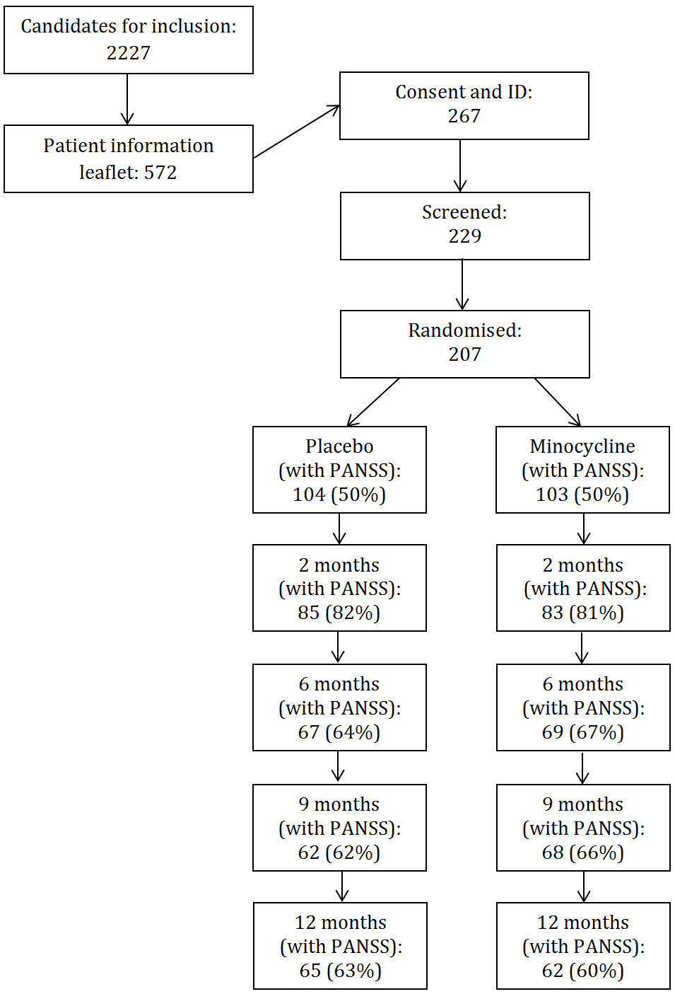

Scatter plots
Scatter plot of CDSS baseline scores and IL-6 baseline score
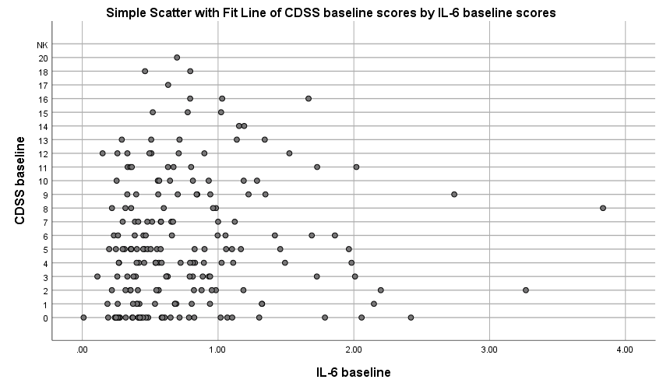
Scatter plot of PANSS Avolition-Apathy scores and CDSS baseline scores
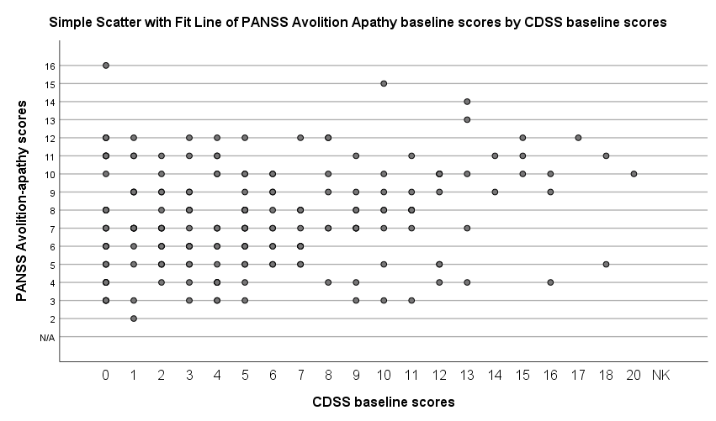
Scatter plot of baseline PANSS diminished expression scores and TNF-α scores
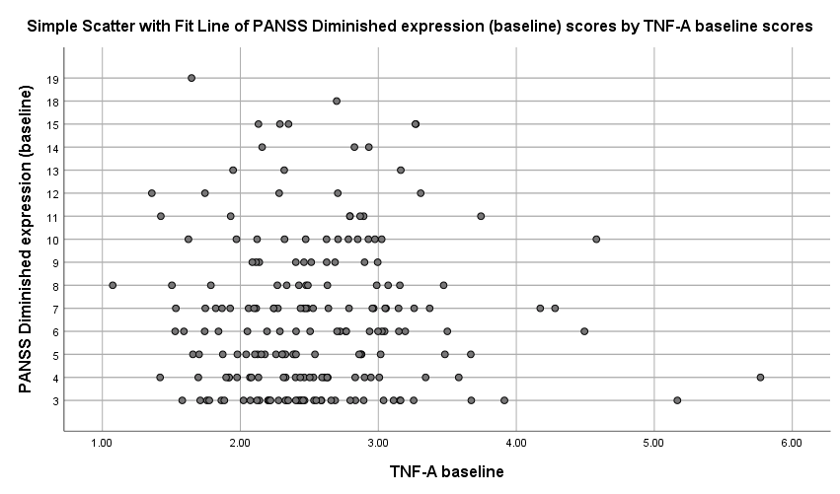
Scatter plot of 12 month PANSS diminished expression scores and TNF-α scores
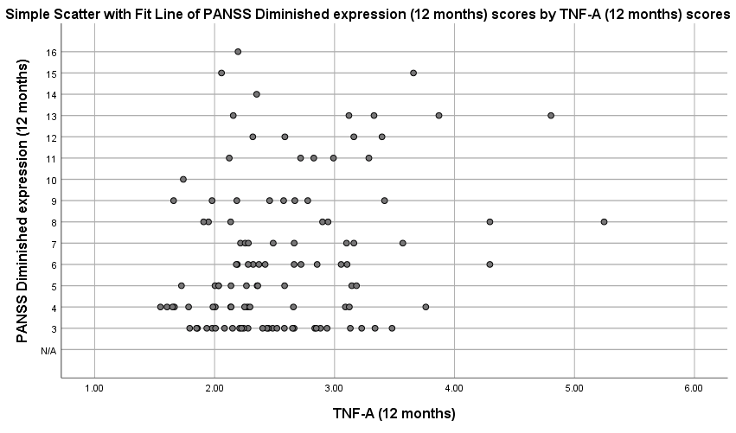

Demographic information and baseline characteristics for the stratified sample of patients by CRP (>1 mg/l and <10 mg/l at baseline)
Variable
Age | Range: |  | Mean (M) |  | Standard deviation (SD)
Age | Full sample | Stratified sample | Full sample | Stratified sample | Full sample | Stratified sample
Age | 17 - 40 | 17 - 37 | 25.7 | 26 | 5.2 | 5.2
 |  |  | N |  | %
 |  |  | Full sample | Stratified sample | Full sample | Stratified sample
Gender | Male |  | 149 | 90 | 73 | 73
Gender | Female |  | 56 | 33 | 27 | 27
Symptom domain | Range |  | Mean (M) |  | Standard deviation (SD)
 | Full sample | Stratified sample | Full sample | Stratified sample | Full sample | Stratified sample
Baseline CDSS total | 0-20 | 0 - 20 | 5.4 | 5.4 | 4.6 | 4.4
Positive symptoms | 9-30 | 9 - 29 | 16.8 | 16.9 | 4.7 | 4.4
Negative symptoms | 7-37 | 7 - 37 | 17.2 | 17.1 | 5.6 | 5.8
Avolition-apathy | 0-16 | 3 - 16 | 6.5 | 7.6 | 3.3 | 2.6
Expressive deficits | 0-19 | 3 - 19 | 7.4 | 6.4 | 2.7 | 3.4
Total PANSS score | 39-118 | 39 - 108 | 68.2 | 67.6 | 14.3 | 13.8
SAS baseline | 0-15 | 0 - 10 | 1.5 | 1.6 | 2.4 | 2
Cytokine/Acute phase protein
Hs-CRP (mg) | .10-9.7 | 1 – 9.7 | 2.5 | 3.6 | 2.3 | 2.2
IL-6 (pg/ml) | .01-3.8 | .1 – 3.8 | .5 | .8 | .4 | .5
TNF-α (pg/mL) | 1.01-5.7 | 1 – 5.1 | 2.4 | 2.5 | .6 | .5
Physical health measure
BMI | 16.3 – 60 | 18.2 – 60.2 | 27.9 | 29.2 | 7 | 6.7

