Tertiary Amine-Promoted Aziridination: Preparation of NH-Aziridines from Aliphatic α,β-Unsaturated Ketones
Alan Armstrong*ª  Robert D. C. Pullin^{a,1}  James N. Scutt^{b}  ª Department of Chemistry, Imperial College London, South Kensington, London, SW7 2AZ, U.K.  ^{b} Syngenta Ltd., Jealott’s Hill International Research Centre, Bracknell, Berkshire, RG42 6EY, U.K.  a.armstrong@imperial.ac.uk  Dedicated to Professor Steven V. Ley on the occasion of his 70th birthday | 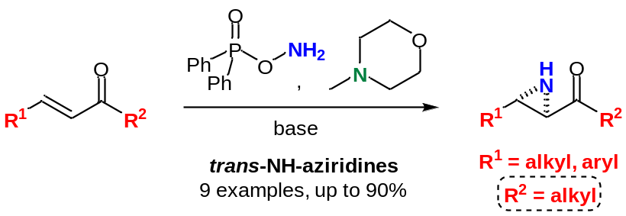

Received:
Accepted:
Published online:
DOI:
Abstract Trans-NH-aziridines were prepared from aliphatic α,β-unsaturated ketones using a tertiary amine-promoted reaction via in situ generated N-N ylides. Through use of modified conditions the reaction proved to be applicable for the diastereoselective aziridination of a range of enolisable aliphatic α,β-unsaturated ketones of varying substitution patterns.
Key words aziridines, organocatalysis, enones, aminimine, ylides, stereoselective

Aziridines, the smallest saturated aza-heterocycle, represent an important amine motif. Not only are several aziridine-containing natural products known, frequently possessing significant biological activity,² but aziridines constitute a versatile building block for synthetic manipulation through exploitation of their strained ring-system.³ As a result of their significance aziridines receive widespread interest and their stereoselective preparation remains an important challenge. Whilst several strategies for aziridine synthesis are in principle available,⁴ one potentially powerful approach involves the direct transfer of a nitrene equivalent to an alkene precursor. This can be achieved either via the use of a metal nitrenoid or use of a nucleophilic nitrene equivalent and these approaches can allow the preparation of aziridines with high stereoselectivity from a range of important alkene classes, including α,β-unsaturated carbonyl compounds, which encompasses cinnamate esters,⁵ aromatic ketones⁶ and more recently aldehydes.⁷ It is notable however that whilst the aziridination of aromatic α,β-unsaturated ketones (chalcones) can be achieved by several methods,⁶ significantly fewer reports exist concerning the aziridination of simple acyclic aliphatic α,β-unsaturated ketones.⁸ One notable study however by Melchiorre has demonstrated that a nucleophilic nitrene equivalent, in combination with a primary aminocatalyst, can allow both aliphatic acyclic and cyclic α,β-unsaturated ketones to be aziridinated enantioselectively,^{9,10} to deliver N-carbamate aziridines. However to the best of our knowledge, the direct aziridination of any aliphatic α,β-unsaturated ketones to form NH-aziridines has not been reported.
We and others have demonstrated that N-N ylides (termed aminimines or aminimides, see Scheme 1) can act as nucleophilic nitrene equivalents to deliver NH-aziridines; the formation of the NH-aziridine permits flexibility in the subsequent choice of N-functionality. The use of N-N ylides to effect aziridination was first reported by Ikeda in 1980,¹¹ and studies, by both Xu¹² and ourselves,¹³ have shown that isolated hydrazinium salts, as stoichiometric ylide precursors, can facilitate the aziridination of a variety of aromatic α,β-unsaturated ketones in high yields. Later this concept was further developed and we have demonstrated the in situ generation of aminimes, by means of the amination of tertiary amines under basic conditions (Scheme 1).^{14a,15} We have shown this method to be applicable for the diastereoselective formation of unsubstituted trans-NH-aziridines from a range of α,β-unsaturated carbonyl compounds.¹⁴ We now report, via modification of the reaction parameters, the extension of this method to the successful aziridination of a range of aliphatic α,β-unsaturated ketones.

Scheme 1 Tertiary amine-promoted aziridination
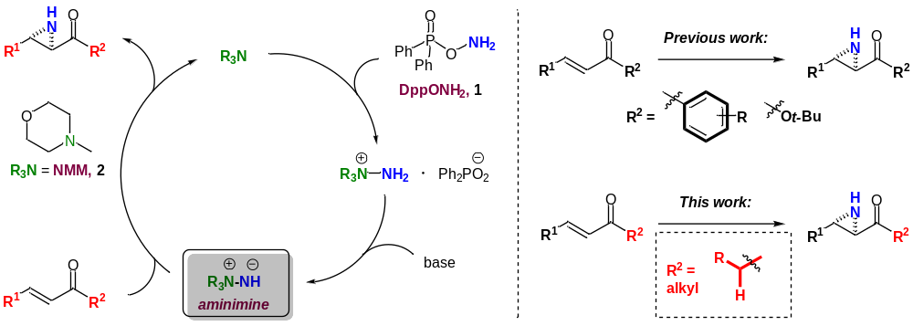
DppONH₂ = O-diphenylphosphinyl hydroxylamine (1), NMM = 4-methylmorpholine (2)

In our originally developed system aliphatic α,β-unsaturated ketones, which possess α-enolisable protons, had previously demonstrated poor reactivity.^{14a} However, we subsequently demonstrated that enones possessing alkyl groups at the β-position, and later α,β,γ,δ-unsaturated ketones (dienones) with alkyl substituents at the δ-position, both substrate classes with allylic protons, could undergo successful aziridination in good yields. Therefore we envisaged that it may be possible to extend the scope of our aziridination methodology to encompass substrates that possessed enolisable groups via an appropriate set of reaction conditions. This prompted us to select an initial substrate, commercially available (E)-4-phenyl-3-buten-2-one (3a), as a model substrate for examination (Table 1).

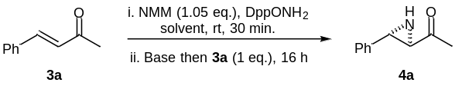Table 1 Optimisation of the conditions for the aziridination of enone 3a
Entryª | Base | Base  (equiv.) | DppONH₂  (equiv.) | Solvent | Yield^{b,c}  (%)
1 | NaOH | 2 | 1.05 | MeCN | traces
2 | i-PrOH/NaH | 2 | 1.05 | CH₂Cl₂ | 45
3 | i-PrOH/NaH | 3 | 2.0 | CH₂Cl₂ | 85 (80)
4 | NaOH | 3 | 2.0 | CH₂Cl₂ | 28
5 | MeOH/NaH | 3 | 2.0 | CH₂Cl₂ | 79
6 | EtOH/NaH | 3 | 2.0 | CH₂Cl₂ | 85
7 | t-BuOH/NaH | 3 | 2.0 | CH₂Cl₂ | 80
8 | i-PrOH/NaH | 3 | 2.0 | MeCN | 55
9 | i-PrOH/NaH | 3 | 2.0 | 1,4-dioxane | 69
10 | i-PrOH/NaH | 3 | 2.0 | DMSO | traces
ª Reaction performed on a 0.12 mmol scale
^{b} Determined by ¹H NMR spectroscopy using Bn₂O as the internal standard
^{c} Isolated yield in parentheses

In line with our previous observations, our original reaction conditions, which utilise one equivalent of aminating agent O-diphenylphosphinyl hydroxylamine (1) (DppONH₂, see Scheme 1) and two equivalents of either NaOH or i-PrOH/NaH as the base, with N-methylmorpholine (2) as the tertiary amine promoter, gave only low levels of aziridine 4a (entries 1 and 2). However, we had previously found that for lower reactivity substrates, such as dienones,^{14b} a second equivalent of aminating agent was required in order to achieve good levels of reactivity, rationalised by promoting quantitative levels of the hydrazinium intermediate (see Scheme 1). On application of these conditions (2 equiv. DppONH₂, 3 equiv. base), pleasingly the desired aziridine 4a was isolated in a high yield of 80%. Aziridine 4a was formed with exclusive trans-diastereoselectivity (³J = 2.1 Hz) (entry 3). Various bases were then screened. Whilst NaOH did not prove efficient for this transformation (entry 4), various alkoxide bases provided uniformly high yields of the aziridine (entries 5-7). Continuing with isopropoxide as the base, various polar aprotic solvents were subsequently screened to see if any further improvements in the yield could be obtained. In MeCN and 1,4-dioxane moderate levels of aziridine were observed (entries 8-9) but in DMSO only trace amounts of the aziridine was detected (entry 10), with the optimal solvent remaining CH₂Cl₂ (entry 3)

Table 2 Aziridination of aliphatic α,β-unsaturated ketones 3a-i
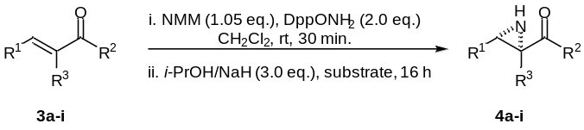

Entryª | Substrate |  | Product |  | Conversion^{b}  (%) | Yield^{c}  (%)
1 | 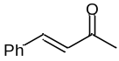 | 3a | 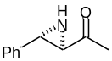 | 4a | >95 | 80
2 | 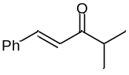 | 3b | 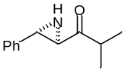 | 4b | >95 | 51
3 | 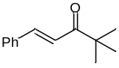 | 3c | 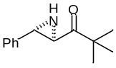 | 4c | >95 | 91
4 | 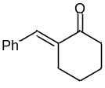 | 3d | 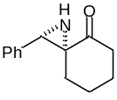 | 4d | 70 | 63
5 | 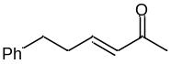 | 3e | 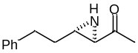 | 4e | >95 | 60
6 | 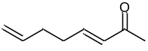 | 3f | 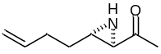 | 4f | >95 | 61
7 | 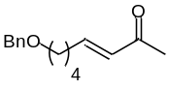 | 3g | 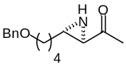 | 4g | >95 | 58
8 | 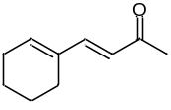 | 3h | 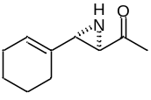 | 4h | 83 | 70
9 | 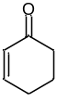 | 3i | 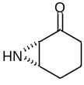 | 4i | >95 | 35
ª Reactions performed on a 0.11-0.56 mmol scale
^{b} Determined by ¹H NMR spectroscopy using Bn₂O as the internal standard
^{c} Isolated by flash column chromatography

With an effective set of reaction conditions in hand (Table 1, entry 3) we sought to investigate the aziridination of a range of different enolisable enones (Table 2). Initially we explored enones with various degrees of steric bulk at the carbonyl. As identified methyl derivative 3a gave high yields of aziridine 4a (80%) (entry 1). Isopropyl derivative 3b gave only a moderate yield of aziridine 4b (51%), despite excellent conversion of the substrate (entry 2). Whilst no further products could be isolated from the reaction mixture, the moderate yield proved reproducible (three reactions, 46-51%). tert-Butyl enone 3c was aziridinated in excellent yield (91%) (entry 3). Various other enolisable substrates were also identified for investigation, including trisubstituted enone 3d, which allowed investigation of the tolerance of the reaction to α-substitution on the alkene. Pleasingly enone 3d could be aziridinated in good yield (63%), allowing the formation of two stereogenic centres, one quaternary, with the remainder of the material unreacted substrate (entry 4). The aziridine 4d was formed exclusively as the isomer depicted (as confirmed by NOESY analysis). We were also keen to screen dialkyl-substituted enones in the reaction, which, containing both allylic and α-enolisable protons, may be anticipated to be most sensitive to the basic reaction conditions. Three substrates (3e-3g) were thus selected for screening, which possessed aromatic, olefinic and also hetero-atom functionalities in the β-alkyl chain respectively. Pleasingly aziridination of each of these dialkyl substituted enones proceeded in good yield (58-61%), albeit that each reaction showed almost complete substrate conversion (entries 5-7). The regioselective aziridination of dialkyl substituted dienone 3h could also be effected, which pleasingly afforded a good yield of vinyl aziridine 4h (70%), with the remainder of material unreacted substrate (entry 8).
Whilst both metal nitrenoids and nucleophilic nitrene equivalents have previously been employed for the aziridination of cyclic enones, generally this has provided only moderate yields for a limited substrate scope,^{8a-b,16} but more recently a broader scope of cyclic enones have been aziridinated in high enantioselectivities via aminocatalysis.^{10,17} In terms of our own methodology, our originally reported conditions for aziridination had previously shown no evidence of aziridine formation for cyclic substrates. Pleasingly we could apply the now-modified conditions to the aziridination of cyclohexenone (3i), albeit with moderate yield of aziridine 4i (35%). Nevertheless, this represents the first successful example of aziridine formation from a cyclic enone utilising our amine-promoted methodology (entry 9).¹⁸
Whilst the developed conditions for the aziridination of enolisable substrates had proved applicable to a range of examples, with generally moderate-to-good yields obtained, high substrate conversions were often observed which did not always reflect the isolated yield of aziridine. Importantly we determined that the aziridine products are stable to the reaction conditions.¹⁹ It is likely the basic reaction conditions (we generally require a hydroxide or alkoxide base) also promote unwanted side-reactions of the substrate, (such as dimer- or oligomerisation) and such decomposition of the substrate likely accounts for any discrepancy between substrate conversion and isolated yield of aziridine. Current studies are focusing on assessment of alternative aminating agents that may operate with the employment of weaker bases and therefore may permit greater tolerability to these enolisable substrates
In summary, through modification of the reaction conditions, we have demonstrated the applicability of our tertiary-amine promoted aziridination to a range of aliphatic α,β-unsaturated ketones. A range of trans-NH-aziridines were prepared from enolisable aliphatic α,β-unsaturated ketones with a variety of substitution patterns in moderate-to-good yield with exclusive trans-diastereoselectivity.
Acknowledgment
We thank the EPSRC and Syngenta (CASE award to RDCP) for their support of this work.
Supporting Information
Experimental procedures, 1H and 13C NMR spectra for all new compounds. YES (this text will be updated with links prior to publication)
Primary Data
NO (this text will be deleted prior to publication)
References and Notes
- Current address: Dr R. D. C. Pullin, Vertex Pharmaceuticals (Europe) Ltd., 86-88 Jubilee Avenue, Milton Park, Abingdon, Oxfordshire, OX14 4RW, U.K.
- For a review see: Lowden, P. A. S. In Aziridines and Epoxides in Organic Synthesis; Yudin, A. K., Ed.; Wiley-VCH: Weinheim, Germany, 2006; 399.
- For reviews see: (a) McCoull, W.; Davis, F. A. Synthesis 2000, 1347. (b) Hu, X. E. Tetrahedron, 2004, 60, 2701.
- For recent reviews see: (a) Pellissier, H. Tetrahedron 2010, 66, 1509 (b) Pellissier, H. Adv. Synth. Catal. 2014, 356, 1899 (c) Degennaro, L.; Trinchera, P.; Luisi, R. Chem. Rev. 2014, 114, 7881.
- For selected examples see: (a) Evans, D. A.; Faul, M. M.; Bilodeau, M. T.; Anderson, B. A.; Barnes, D. M. J. Am. Chem. Soc. 1993, 115, 5328 (b) Gillespie, K. M.; Sanders, C. J.; O’Shaughnessy, P.; Westmoreland, I.; Thickitt, C. P.; Scott, P. J. Org. Chem. 2002, 67, 3450 (c) Wang, X.; Ding, K. Chem. Eur. J. 2006, 12, 4568.
- For example: (a) Ma, L.; Du, D.-M.; Xu, J. J. Org. Chem. 2005, 70, 10155 (b) Ma, L.; Jiao, P.; Zhang, Q.; Xu, J. Tetrahedron: Asymmetry 2005, 16, 3718.
- For examples see: (a) Vesely, J.; Ibrahem, I.; Zhao, G.L.; Rios, R.; Córdova, A. Angew. Chem., Int. Ed. 2007, 46, 778 (b) Arai, H.; Sugaya, N.; Sasaki, N.; Makino, K.; Lectard, S.; Hamada, Y. Tetrahedron Lett. 2009, 50, 3329 (c) Deiana, L.; Zhao, G.-L.; Lin, S.; Dziedzic, P.; Zhang, Q.; Leijonmarck, H.; Córdova, A. Adv. Synth. Catal. 2010, 352, 3201 (d) Deiana, L.; Dziedzic, P.; Zhao,G.-L.; Vesely, J.; Ibrahem, I.; Rios, R.; Sun, J.; Córdova, A. Chem. Eur. J. 2011, 17, 7904 (e) Desmarchelier, A.; Pereira deSant’Ana, D.; Terrasson, V.; Campagne, J. M.; Moreau, X.; Greck, C.; Marcia deFigueiredo, R. Eur. J. Org. Chem. 2011, 4046 (f) Molnar, I. G.; Tanzer, E.-M.; Daniliuc, C.; Gilmour, R. Chem. Eur. J. 2014, 20, 794.
- Isolated examples have been reported; examples include: (a) Fioravanti, S.; Pellacani, L.; Tabanella, S.; Tardella, P. A. Tetrahedron 1998, 54, 14105 (b) Tung, S.; Yudin, A. K. J. Am. Chem. Soc., 2002, 124, 530 (c) Chen, D.; Timmons, C.; Guo, L.; Xu, X.; Li, G. Synthesis 2004, 2479 (d) Zibinsky, M.; Stewart, T.; Prakash, G. K. S.; Kuznetsov, M. A. Eur. J. Org. Chem. 2009 , 3635
- Pesciaioli, F.; De Vincentiis, F.; Galzerano, P.; Bencivenni, G.; Bartoli, G.; Mazzanti, A.; Melchiorre, P. Angew. Chem. Int. Ed. 2008, 47, 8703.
- De Vincentiis, F.; Bencivenni, G.; Pesciaioli, F.; Mazzanti, A.; Bartoli, G.; Galzerano, P.; Melchiorre, P. Chem. Asian. J. 2010, 5, 1652.
- Ikeda, I.; Machii, Y.; Okahara, M. Synthesis 1980, 650.
- Xu, J.; Jiao, P. J. Chem. Soc., Perkin Trans. 1 2002, 1491.
- Armstrong, A.; Carbery, D. R.; Lamont, S. G.; Pape, A. R.; Wincewicz, R. Synlett 2006, 2504.
- (a) Armstrong, A.; Baxter, C. A.; Lamont, S. G.; Pape, A. R.; Wincewicz, R. Org. Lett. 2007, 9, 351. (b) Armstrong, A.; Pullin, R. D. C.; Jenner, C. R.; Scutt, J. N. J. Org. Chem. 2010, 75, 3499. (c) Armstrong, A.; Ferguson, A. Beilstein J. Org. Chem. 2012, 8, 1747. (d) Armstrong, A; Pullin, R. D. C.; Jenner, C. R.; Foo, K.; White, A. J. P.; Scutt, J. N. Tetrahedron: Asymmetry 2014, 25, 74.
- See also: (a) Shen, Y.-M.; Zhao, M.-X.; Xu, J.; Shi, Y. Angew. Chem. Int. Ed. 2006, 45, 8005 (b) Page, P. C. B.; Bordogna, C.; Strutt, I.; Chan, Y.; Buckley, B. R. Synlett 2013, 24, 2067.
- Fioravanti, S.; Mascia, M. G.; Pellacani, L.; Tardella, P. A. Tetrahedron 2004, 60, 8073.
- Menjo, Y.; Hamajima, A.; Sasaki, N.; Hamada, Y. Org. Lett. 2011, 13, 5744.
- For the aziridination certain cyclic enones see using N-N ylides, see: (a) Oves, D.; Ferrero, M.; Fernandez, S.; Gotor, V. J. Org. Chem. 2002, 68, 1154 (b) De, S. R.; Ghorai, S. K.; Mal, D. J. Org. Chem., 2009, 74, 1598.
- Aziridine 4e was re-submitted to the reaction conditions in place of the enone substrate and was recovered in quantitative amounts.
- Representative procedure for enone aziridination: N-Methylmorpholine (14 µL, 0.125 mmol) was added dropwise over 1 min. to a solution of O-diphenylphosphinyl hydroxylamine (56.0 mg, 0.24 mmol) in CH₂Cl₂ (2 mL) at room temperature and the mixture stirred for 0.5 h. i-PrOH (28 µl, 0.36 mmol) and NaH (60% dispersion in mineral oil, 14.4 mg, 0.36 mmol) were then added sequentially followed by addition of trans-4-phenyl-3-buten-2-one (3a) (17.5 mg, 0.12 mmol) in CH₂Cl₂ (1 mL) and the mixture allowed to stir at room temperature for 16 h. The reaction was quenched by the addition of saturated aq. NH₄Cl solution and the aq. layer separated and extracted with CH₂Cl₂, dried (Na₂SO₄), filtered and concentrated in vacuo. Purification by flash column chromatography (15% EtOAc/n-hexane) afforded (2R*,3S*)-1-[-3-phenyl-aziridin-2-yl]-ethanone (4a) (15.6 mg, 80%) as a colourless oil; R_{f}: (15% EtOAc/n-hexane) 0.30; δ_{H} (400 MHz, CDCl₃); 7.38-7.27 (5H, m, 5 x PhH), 3.04 (1H, d, J 2.0, 3-CHN), 2.86 (1H, d, J 2.1, 2-CHN), 2.38 (3H, s, CH₃), 2.29 (1H, br, NH); δ_{C} (100 MHz, CDCl₃) 204.5, 138.2, 128.5, 127.8, 126.1, 46.8, 43.0, 29.6.

Checklist (have these on hand for manuscript submission in ScholarOne):
- cover letter, including a statement of the work’s significance
- full mailing address, telephone and fax numbers, and e-mail address of the corresponding author
- email address for each author
- original Word file
- original graphics files zipped into one zip file
- eye-catching graphical abstract as an individual file
- 5–8 key words
- separate Supporting Information file
- separate zipped Primary Data files including cover sheet (optional)

Useful links:
- SYNLETT homepage
- SYNLETT information and tools for authors
- Graphical abstract samples (PDF file download)
- What is “Primary Data”?
- ScholarOne (manuscript submission)

