Reducing China’s road transport sector CO₂ emissions to 2050: technologies, costs and decomposition analysis

Ajay Gambhir (Corresponding author)ª*, a.gambhir@imperial.ac.uk +44 (0)207 594 6363
Lawrence KC Tse^{b}, lawrence.tse@imperial.ac.uk
Danlu Tong^{c}, tongdanlu@gmail.com
Ricardo Martinez-Botas^{b}, r.botas@imperial.ac.uk
ªGrantham Institute, Imperial College London, South Kensington Campus, London, SW7 2AZ, UK.
^{b}Department of Mechanical Engineering, Imperial College London, South Kensington Campus, London, SW7 2AZ, UK.
^{c}BP Plc, Pangbourne Castrol Technology Centre, Whitchurch Hill, Pangbourne, Berkshire (formerly of Department of Chemical Engineering, Imperial College London, South Kensington Campus, London, SW7 2AZ, UK).

1 Introduction
China is now the source of over one quarter of global CO₂ emissions[1], with much of its recent CO₂ emissions growth driven by electricity and heat demand[2]. In the future, the transport sector, which has already been responsible for an eight-fold increase in final oil consumption since 1990[3], could be a major contributor of future CO₂ emissions growth, with sales of new passenger cars reaching approximately 10 million in the first half of 2014 alone[4], compared to a total passenger car population of only about 20 million in 2007[5]. Estimates of future vehicle population growth vary, as explained in this paper, but some scenarios place China’s road vehicle population (excluding motorcycles) at over 600 million by 2050[6],[7], an approximate ten-fold increase compared to 2009 figures [6]. Hence, Chinese road transport CO₂ emissions, which were less than 300 MtCO₂ in 2007 [5], could grow to become a major contributor of global CO₂ emissions by 2050. Investigating the costs and CO₂ emissions reductions potential of deploying a range of low-carbon technologies in this sector is therefore of paramount importance.
The intended contribution of this study is threefold – first, it sets out in detail which sub-sectors, vehicle technologies and fuels contribute to the total reduction in CO₂ emissions in China’s road transport sector to 2050, when moving from a business-as-usual scenario to a low-carbon scenario, by using a method called decomposition analysis (described in Annex A) to split the CO₂ emissions savings into their constituent parts. Secondly, it also decomposes the total road transport sector costs of the low-carbon vehicle technologies in 2050, when compared to their business-as-usual alternatives. When considered in conjunction with the CO₂ emissions decomposition analysis, this allows an assessment of the CO₂ emissions reduction cost of each vehicle and drivetrain type in 2050. This type of analysis could serve as a useful tool to help policy-makers, vehicle manufacturers, international financiers and others focused on China’s decarbonisation to decide which technologies, for which vehicle types, are most important and least costly to reduce road transport CO₂ emissions. Thirdly, it provides a model (available in full in the supplementary material) of China’s road transport sector, which allows a widespread analysis of the low-carbon options in the sector as it develops and grows over the coming decades. The model is sufficiently flexible and accessible that it can be adapted to any country or region using appropriate inputs.
A sector-specific scenario analysis such as this contrasts with the whole-system nature of national and global energy system and integrated assessment models (as reviewed for example in the Intergovernmental Panel on Climate Change’s Fifth Assessment Report [8]). Whilst advantageous in setting out the overall shape of the energy system transformation across the economy that is required to meet a particular CO₂ or GHG target, such whole system models do not necessarily allow a simple sector-specific analysis of different technologies and measures. This approach, by contrast, allows the investigation of the incremental impact on Chinese road transport sector costs and CO₂ emissions reductions of changing particular assumptions (such as discount rates, fossil fuel prices and technology penetration rates). This is advantageous from the perspective that policy is unlikely to be made at an economy-wide, but rather sector-specific, level, and it is therefore important to examine detailed changes at this level. The obvious limitation of a scenario analysis is that it does not provide a least-cost optimised technology mix to meet a given CO₂ target. Nevertheless, the detailed cost analysis does allow important insights to be gained on the relative cost-effectiveness of different mitigation options, as is shown in this paper.
This study builds on a number of recent analyses on the future growth, energy demand and CO₂ emissions from China's road transport sector[5],[9],[10], which are discussed in the following sections. It is the first that we are aware of which adds a sector-wide economic analysis to the low-carbon scenario, including the derivation of a marginal abatement cost curve for the different mitigation measures.
The rest of this paper is structured as follows: Section 2 sets out the current status of China’s road transport sector, including its impact on CO₂ emissions and oil demand, as well as highlighting the key technologies on which the Chinese government has focused in its future plans to achieve energy efficiency and low-carbon goals; Section 3 describes the model and its structure and main features, as well as the input assumptions used; Section 4 discusses the results from the central low-carbon scenario developed for this study; Section 5 explores a selection of relevant sensitivities around the main assumptions, in order to highlight which areas are worthy of further consideration when planning low-carbon investments and policy in the Chinese road transport sector; Section 6 concludes.

2 China’s road transport sector
China’s rate of vehicle growth over the last decade has been extremely rapid, as a result of increasing per capita wealth and a growing population. This growth in vehicle population has also resulted in a significant growth in fuel demand and CO₂ emissions, as well as an increase in local air pollution. Table 1 outlines some key statistics showing the growth rate in vehicles, energy demand and CO₂ emissions.
Table 1: Vehicle population, CO₂ emissions, fuel demand in China’s road transport sector since 2002
 | Vehicle stockª (excluding motorcycles)/ millions | Total energy demand^{b}/ PJ | CO₂ emissions^{b} / MtCO₂
2002 | 20.1 | 2,636 | 186
2003 | 23.3 | 2,876 | 203
2004 | 26.3 | 3,149 | 222
2005 | 30.9 | 3,395 | 240
2006 | 36.1 | 3,613 | 255
2007 | 42.4 | 4.032 | 284
2008 | 49.6 | 4,773 | 336
2009 | 62.8 | 5,485 | 337
Notes: ª sourced from Huo and Wang (2012) [6]; ^{b} sourced from Ou et al (2010) [5]
Looking forward, there are a number of recent projections of vehicle population growth in China. Ou et al (2010) estimate that the number of road vehicles (excluding motorcycles) will grow from 74 million in 2010 to 498 million in 2050 [5]. This is relatively low compared to more recent estimates. For example Huo and Wang (2012) use a detailed method based on analysis of vehicle purchasing behaviours to estimate that the number of road vehicles (again excluding motorcycles) in 2050 will reach between 530 and 623 million by 2050, depending on the assumed saturation level of car ownership in China (noting that Japan is somewhere in the middle of this range, but the US is well above it [6]). Hao et al (2011) project growth to 607 million road vehicles by 2050 [11], whilst Wang et al (2011), using a much more aggressive growth rate based on looking at other countries with similar growth dynamics, project approximately 450 - 550 million road vehicles by as soon as 2030 [12]. However, China’s National Development and Reform Commission’s Energy Research Institute (ERI) projected a similar figure to Ou et al’s (2010) estimate, with 501 million road vehicles excluding motorcycles by 2050[13]. Considering motorcycles themselves, Ou et al (2010) and China’s ERI have both projected about 115-120 million by 2050 [5], [13].
The implications for this vehicle growth rate on CO₂ emissions depend on the scenario assumed for the penetration of different low-carbon technologies. These range from the increasing share of sales of low-carbon drivetrains such as fuel cell, electric and plug-in hybrid electric vehicles, as well as vehicles running on natural gas (either liquefied petroleum gas or compressed natural gas), the increased share of more efficient internal combustion and hybrid vehicles, as well as the degree to which biofuels (bio-ethanol and bio-diesel) make up an increasing share of petrol and diesel fuels for conventional internal combustion engine and hybrid vehicles. The penetration rates into new vehicle sales of these lower-carbon vehicles can be determined either through subjective scenario analysis, or through an approach which optimises the future vehicle technology mix such that a specified future CO₂ emissions limit is met at least cost.
This approach relies on a scenario analysis rather than cost-optimising analysis, but this is informed by current activity in the vehicle market in China, which is focused on improving fuel efficiency of internal combustion engine vehicles, increasing the share of alternative drivetrain vehicles such as electric vehicles, and reducing the CO₂ emissions intensity of gasoline and diesel through increased blending of biofuels. In terms of fuel efficiency, there is a concerted focus on increasing average fuel consumption in new vehicles, with levels at the beginning of this decade around 7.8 litre/100km for passenger cars, due to fall to 6.9 l/100km by 2015 and towards 5 l/km by 2020 [9]. In terms of alternative drivetrains, uptake of electric vehicles is being promoted, initially for buses, taxis and some light duty vehicles (LDVs) [9]. In addition, the blending of biofuels with petrol and diesel is also being promoted [9]. China's 12th Five Year Plan emphasised the development of energy efficient internal combustion engines in the short term (2010-2015), electric vehicles in the medium term (2015-2020), and hydrogen fuel cells vehicles in the longer term (after 2020) [14].
Looking further ahead, China’s energy technology roadmap to 2050 includes objectives to introduce alternative fuel technologies including electric and hydrogen fuel cell vehicles, as well as the development of next-generation biofuels from both land-based energy crops and algae [15]. And according to the

As shown by Figure 1, China’s 12th (2011-2015) and 13th (2016-2020) Five Year Plans will see it reduce its average passenger car CO₂ emissions levels to close to the world leaders (the European Union and Japan) by 2020.
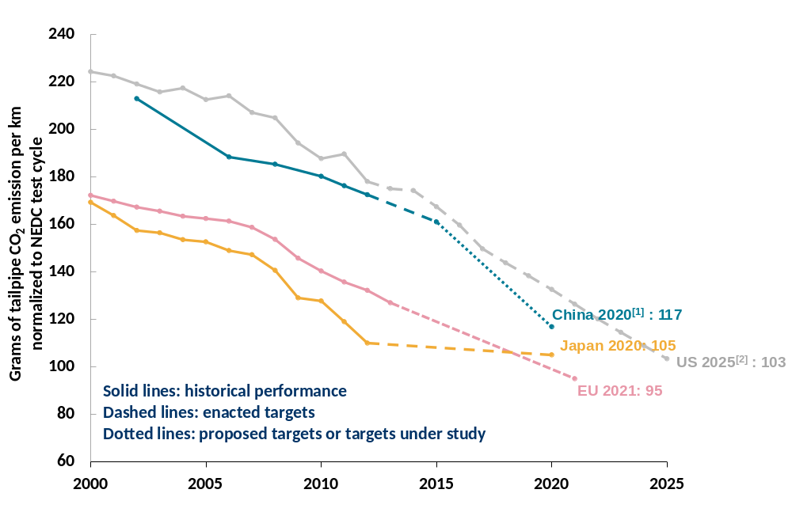
Figure 1: New car CO₂ emissions and standards in different world regions
Data source: The International Council on Clean Transportation (ICCT), 2014 [16]
Notes: NEDC = New European Driving Cycle; LDV = light duty vehicles; [1] China's target reflects gasoline vehicles only. The target may be higher after new energy vehicles are considered; [2] The U.S. standards are fuel economy standards set by the US National highway Traffic Safety Administration
There are a range of projections of future scenarios for alternative fuel vehicles in China, as shown for light duty vehicles (which make up the majority of all road vehicles) in table 2 below. These in general show a large penetration of electric and hybrid vehicles in 2050, according to the most aggressive low-carbon scenarios. However, the studies differ markedly in terms of the share of hydrogen fuel cell vehicles. Recent studies have assessed the impact of more aggressive penetrations of non-conventional vehicles. For example, Sorrentino et al (2014) explore the impact on China’s private car fleet of an almost 40% penetration of electric vehicles, with the rest plug-in hybrid electric, by 2050 [17]. Ou et al (2013) assess the implications of about 50% penetration of electric vehicles and 28% penetration of fuel cell vehicles in new passenger vehicle sales by 2050 [18]. As explained in Section 3, the central scenario developed for this study uses a combination of assumptions based on these studies. There is still considerable uncertainty around the impact of emerging policies in China’s 13th and subsequent Five Year Plans. As the impact of long term low-carbon road transport policy goals on different vehicle drivetrain penetration rates becomes clearer, the model may be used to investigate the impact of these policies and targets on road transport sector costs, CO₂ emissions and fuel demand.
Table 2: Example shares of light duty vehicle (LDVs) drivetrains in China in 2050
Share of LDV sales in 2050 (%) | Fuel Cell | Electric | Hybrid | Gasoline / diesel | Natural Gas
ERI (2009) [19] | 20-40 | 40-60 | 30 | 0 | 0
Ou et al (2010) [5] | 0 | 40 | 60 | 0 | 0
IEA (2012) [20] | 15 | 30 | 50 | <5 | <5
Huo et al (2012)ª [9] | 0 | 52 | 48 |  | 0
ERI (2012)^{b} [21] | 15 | 25 | 35 | 0 | 25
LBNL (2012)^{b} [22] | 0 | 70 | 25 | 5 | 0
Notes: ª Refers to “Electrification scenario” for private LDVs only, and 2050 penetration rather than sales; ^{b} For cars only (i.e. excludes light duty trucks), and 2050 penetration rather than sales

3 Methods
The model used for the basis of this analysis (see Supplementary Material) follows the basic structure and approach elaborated in Ou et al (2010) [5]. This approach has been chosen as a basis because of the breadth of different vehicle types, drivetrain options and the detail with which the model has been specified. In summary, the model has the following attributes:
- 9 vehicle types: Heavy duty trucks (HDTs), Medium duty trucks (MDTs), Light Duty Trucks (LDTs), Mini Trucks (MTs), Heavy Duty Buses (HDBs), Light Duty Buses (LDBs), Cars, Minivans (MVs) and Motorcycles (MCs).
- Conventional drivetrain types based on four different fuels: gasoline, diesel, liquefied petroleum gas (LPG) and condensed natural gas (CNG).
- Low-carbon drivetrains consisting of electric vehicles (EVs) and hybrid electric vehicles (HEVs) s in three variants (mild, full and plug-in).
The model has been extended to include fuel cell vehicles (FCVs) as a low-carbon drivetrain option, reflecting growing interest and investment in this technology. For example, as shown in Table 2, the Chinese Energy Research Institute’s publicly-available 2050 Pathways calculator [21] includes scenarios of increasing shares of both electric and fuel cell vehicles, and the International Energy Agency’s (2012) Energy Technology Perspectives “2 degrees Scenario” also includes significant sales of fuel cell light duty vehicles in China in the period to 2050 [20].
The model structure is shown in Figure 2. A control panel worksheet includes input assumptions (for each vehicle type) on the sales, vehicle lifetimes, average annual distance travelled, percentage of new sales accounted for by each drivetrain type in each year, level of efficiency of each drivetrain type, cost (purchase and maintenance) of each drivetrain type, and assumptions on fuel prices in 2050.
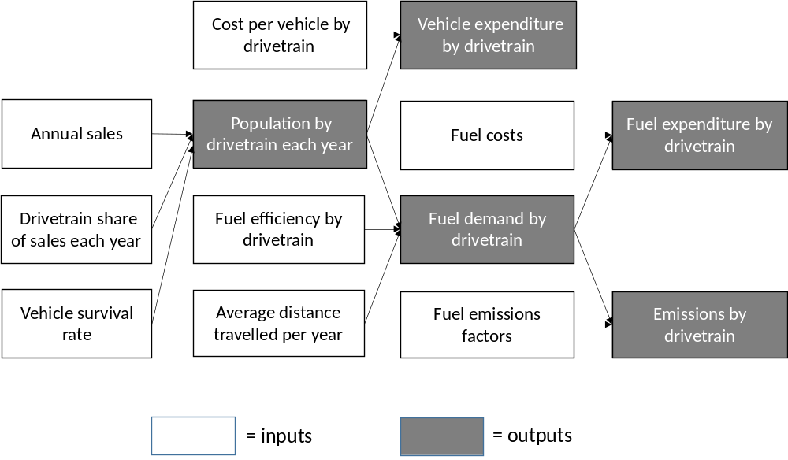
Figure 2: Schematic of China road transport model inputs and outputs
These control panel variables are linked to their respective worksheets which are set up to calculate the annual vehicle population for each vehicle type, the share of this vehicle population of each drivetrain type, the fuel and CO₂ emissions of each vehicle and drivetrain type for each year, and the annual cost (including annualised purchase, operation and maintenance, as well as fuel costs) of each vehicle type and drivetrain type for 2050.
The model uses estimates of different vehicle/drivetrain costs for the year 2050 (as detailed in Annex A), in order to calculate the total transport system cost, consisting of vehicles and fuels used, in the year 2050. This cost includes, as a crude estimate, that of additional infrastructure required for electric and fuel cell vehicles, by applying a mark-up to the electricity and hydrogen fuel costs as explained in table 3. The model does not represent a detailed infrastructure development framework for electric and fuel cell vehicles. This would include accounting for changes to electricity demand profiles placed on the electricity system by vehicle batteries and appropriate strategies (such as battery swapping, charge time management and other coordination strategies) to minimise infrastructure costs [17], [23], [24], [25], [26], [27].
Purchase costs of vehicles are annualised using a specified discount rate, which can be varied on the control panel. As discussed in Section 4, this allows quick analysis of a key parameter affecting the overall cost of transitioning to a low carbon system.
The model also calculates the contribution that is made by each vehicle and drivetrain type to total road transport sector CO₂ emissions reductions and also to the difference in cost, when comparing the low-carbon with the business-as-usual scenario, according to the principles in Figure 3. This figure shows that, for an example low-carbon vehicle (LCV), both CO₂ emissions reductions and cost differences between the low-carbon and business-as-usual scenarios are calculated for each drivetrain and vehicle type by comparing CO₂ emissions and costs of the LCV to those from the standard internal combustion engine vehicle (ICEV) which is substituted by the LCV. The marginal abatement cost (MAC) is the ratio of the cost difference (which may be positive or negative, depending on whether the LCV is more or less expensive than the ICEV) and the CO₂ emissions reductions achieved through the substitution.
In practice CO₂ emissions reductions are achieved not just through the substitution of low-carbon alternative fuel vehicles for their more carbon-intensive counterparts, but also through increasing fuel efficiency, as well as through decreased CO₂ intensity of fuels (most notably through biofuel blending, or in the case of electric vehicles, through a reduction in the CO₂ intensity of electricity production). In order to calculate the marginal abatement cost for each of these effects, a full decomposition analysis is required to disaggregate CO₂ emissions reductions and cost differences into those that result from an increased share of low-carbon drivetrain types (such as hybrids, electric and fuel cell vehicles), those that result from an increase in energy efficiency of each drivetrain type, and those that result from a reduction in the CO₂ intensity of the fuel used in each drivetrain type (for example as a result of increased biofuel blending, or decreased CO₂ intensity of electricity). The precise method to decompose the total CO₂ emissions reductions and cost differences (i.e. to allocate them to each of these effects) is the logarithmic mean division index (LMDI) method, the advantages of which are that it offers a perfect decomposition with all factors summing to total CO₂ emissions reductions, and that it offers relative ease of computation [28]The method has already been demonstrated in detail for the decomposition of CO₂ emissions reductions into their various components in the UK transport sector [29] and it allows a very detailed analysis of those technological shifts which lead to the greatest reduction in CO₂ emissions. The decomposition methodology is set out in detail in Annex A.
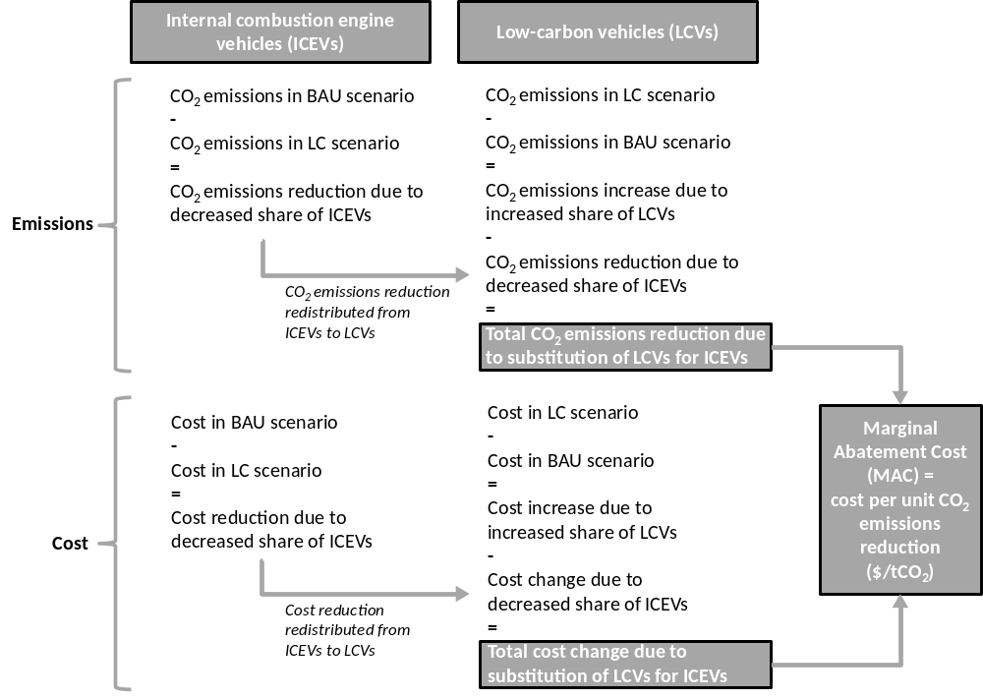
Figure 3: Approach to determine marginal abatement cost (MAC) for each drivetrain type
Notes: BAU = business-as-usual; LC = Low Carbon
Furthermore, the additional cost in 2050 of each low carbon vehicle/drivetrain type is also calculated in the model and decomposed according to the LMDI method, as described in Annex A. Dividing this cost by the quantity of CO₂ reduced by each vehicle/drivetrain type gives the marginal abatement cost (MAC) in 2050 of each vehicle/drivetrain type, a key metric in identifying the most cost-effective technological transitions. The marginal abatement cost specifies the cost of achieving a unit of CO₂ emissions savings when comparing a reference scenario (in this case a business-as-usual scenario) with a low-carbon scenario. Although an imperfect measure of the relative merits of different CO₂ emissions reduction options, this measure is nevertheless a useful way of identifying relatively cost-effective and costly measures to reduce CO₂ emissions [30].
Table 3 sets out the basic assumptions in the model. All input tables within the model itself include sources to relevant input data.
Table 3: Major assumptions in the model
Data inputs | Major assumptions | Notes and caveats
Vehicle growth rates to 2050 | Growth to 500 million vehicles (excluding motorcycles) by 2050, of which 400 million cars. | Based on Ou et al (2010) [5]. Varied in sensitivity analysis in section 5.
Vehicle average distance travelled | Heavy-duty trucks and buses 40,000 km per year; Medium-duty trucks 24,000 km per year; Light- and mini-trucks 20,000 km per year; Light-duty buses 30,000 km per year; Cars 15,000 km per year, Minivans 16,000 km per year, motorcycles 4,000 km per year (all by 2050) | Ou et al (2010) [5], using projections based on current data from Yan and Crookes (2009) [31]
Vehicle median lifetimes (survival rates) | 15 years (mini-vans), 13 years (buses), 12 years (cars), 11 years (medium and light duty trucks), 8 years (heavy duty trucks), 7 years (motorcycles) 6 years (mini trucks), | Yan and Crookes (2009) [31]as cited in Ou et al (2010) [5]
Share of drivetrain types in new vehicle sales to 2050 in business-as-usual scenario | For minivans, cars, buses light duty trucks and mini-trucks, by 2050 20% of new sales are hybrids, and 10% are fuel cell and electric vehicles.  For heavy and medium duty trucks, by 2050 20% of new sales are hybrids, but no fuel cell or electric vehicles by 2050. | Ou et al (2010) [5] for ICE, natural gas vehicles and hybrids, with own assumptions informed by IEA (2012) [20] and ERI (2014) [21] for fuel cell and electric vehicles.
Share of drivetrain types in new vehicle sales to 2050 in low-carbon scenario | For minivans, cars, buses, light duty trucks and mini-trucks, by 2050 60% of new vehicle sales are hybrids, and 40% are fuel cell and electric vehicles.  For heavy and medium duty trucks, by 2050 60% of new vehicle sales are hybrids, and 20% are fuel cells. | Ou et al (2010) [5] for ICE, natural gas vehicles and hybrids, with own assumptions informed by IEA (2012) [20] and ERI (2014) [21] for fuel cell and electric vehicles. Varied in sensitivity analysis in Section 5.
Fuel efficiency | All trucks, buses and motorcycles: efficiency improves at 0.3% per year to 2030, then no further improvements.  Cars and minivans: efficiency improves at 1.3% per year (except for diesel which is 15% per year) to 2030, then no further improvements. | Ou et al (2010) [5], tested for passenger cars in sensitivity analysis in Section 5.
Vehicle cost estimates | By 2050 most truck electric, fuel cell and hybrid electric vehicle costs are approximately equal to ICE drivetrains.  Bus fuel call and electric vehicles about 10-20% more expensive than ICE drivetrains.  Cars and minivan electric vehicles 25-75% more expensive than ICE. | Sources for specific vehicle figures detailed in Annex B – main sources are UK DECC (n.d.) [32] and ETSAP (2010) [33]. All costs in US$2010, converted from GBP using an exchange rate of $1.6/£
Blend of biofuels in gasoline and diesel | Business-as-usual: 10% by energy in 2050, of which 40% 1st generation, 60% 2nd generation.  Low-Carbon: 25% in 2050, of which 20% 1st generation, 80% 2nd generation. | Own assumptions informed by projected production of biofuels from Ou et al (2010) [5].
Fuel CO₂ emissions factors | Gasoline 99 gCO₂ /MJ, Diesel 102 gCO₂/MJ, Liquefied petroleum gas 77 gCO₂/MJ, Compressed natural gas 99 gCO₂/MJ, Bioethanol (1st generation) 115 gCO₂/MJ, Bioethanol (2nd generation) 4 gCO₂/MJ, Biodiesel (1st generation) 79 gCO2/MJ, Biodiesel (2nd generation) 1 gCO₂/MJ. Electricity 185 gCO₂/ MJ in business-as-usual, 15 gCO₂/ MJ in low-carbon scenario, Hydrogen 23 gCO₂/MJ. | Ou et al (2010) [5] for all well-to-wheel emissions factors except for electricity in low-carbon scenario, which is derived from ERI (2014) [21] and hydrogen, based on Shah et al (2013) [34].
Fuel prices (US$2010) | In 2050, gasoline and diesel about $17.5/GJ, biofuels $19/GJ, Liquefied petroleum gas and Compressed natural gas $9.5/GJ by 2050.  Electricity rises from $12/GJ (in business-as-usual) to $22/GJ (low-carbon), and hydrogen is $33/GJ. | Shah et al (2013) [34]using central fossil fuel assumptions of oil production cost at £100/bbl in 2050, gas at $1/therm in 2050.
Electric charging and hydrogen infrastructure costs | A 50% mark-up is applied to the 2050 electricity and hydrogen fuel costs to account for capital and operational costs of infrastructure. | Ou et al (2013) estimate this mark-up for electricity costs by 2050 [18]

4 Results
The low-carbon scenario results in CO₂ emissions from the road transport sector of 1.24 GtCO₂ per year by 2050, compared to almost 2.08 GtCO₂ per year in the business-as-usual scenario, as shown in Figure 4. This figure also shows that there is a peak in road transport CO₂ emissions in 2030, before they fall to a level of about twice their 2010 level by 2050, in spite of an almost fourfold increase in the road vehicle population over the period 2010-2050. The implication is that the CO₂ intensity of the transport sector would reduce by a factor of about two during this time period.
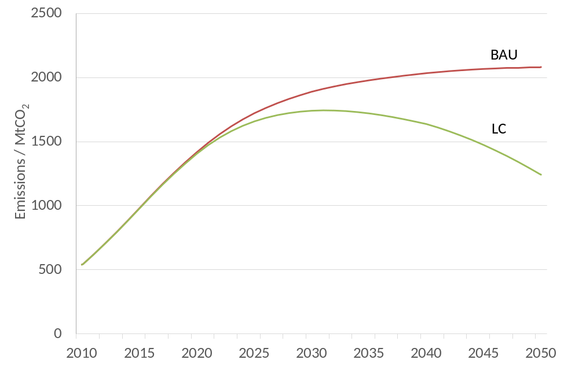
Figure 4: Total well-to-wheels CO₂ emissions for China’s road transport sector to 2050
Notes: BAU = business-as-usual; LC = Low Carbon
These CO₂ emissions reductions are to a large extent driven by reductions in the passenger car and heavy duty truck (HDT) sectors, which are in combination responsible for about three quarters of total road transport CO₂ emissions by 2050 in the business-as-usual scenario. Figure 5 shows the derived marginal abatement cost (MAC) curve for the whole road transport sector, highlighting those vehicle and drivetrain types which contribute the most to the overall CO₂ emissions reductions by 2050, as well as the cost of these measures per tonne of CO₂ reduced against the business-as-usual scenario in 2050. The figure shows that in most cases the substitution of low-carbon trucks for their business-as-usual alternatives results in cost savings by 2050, whereas the low-carbon passenger car options are in most cases significantly more costly measures. These results follow from the assumptions made on the relative purchase and operating costs of low-carbon vehicles versus their business-as-usual alternatives. Specifically, the assumed purchase costs of fuel cell and battery electric trucks are similar to those of ICE trucks by 2050, reflecting the fact that the drivetrain consists of a relatively small share of the vehicle cost. Additionally, the assumed operation and maintenance (O&M) costs of fuel cell and battery electric trucks are assumed to be less than those of their ICE counterparts by 2050, reflecting the assumption that they would require less maintenance as a result of fewer mechanical parts. These cost assumptions, compared with the significantly higher efficiency of fuel cell and battery electric trucks compared to ICE trucks, result in much lower annual costs for the low-carbon vehicles, which rapidly pay back the marginal additional purchase cost.
For passenger cars, however, a more conservative set of assumptions is used for purchase costs in 2050. Specifically, fuel cell cars are 20% more expensive to purchase than ICE cars, whilst electric vehicles are 60% more expensive. These result in significant marginal abatement costs for these vehicles. Given that they represent the greatest CO₂ emissions reduction potential (seen by the width of the bars in Figure 5), this indicates the high dependency of future road transport decarbonisation cost on assumptions on just these two vehicle types. As such, variation in the costs for trucks, which significantly reduce the overall road transport sector cost, are explored in the sensitivity analysis.
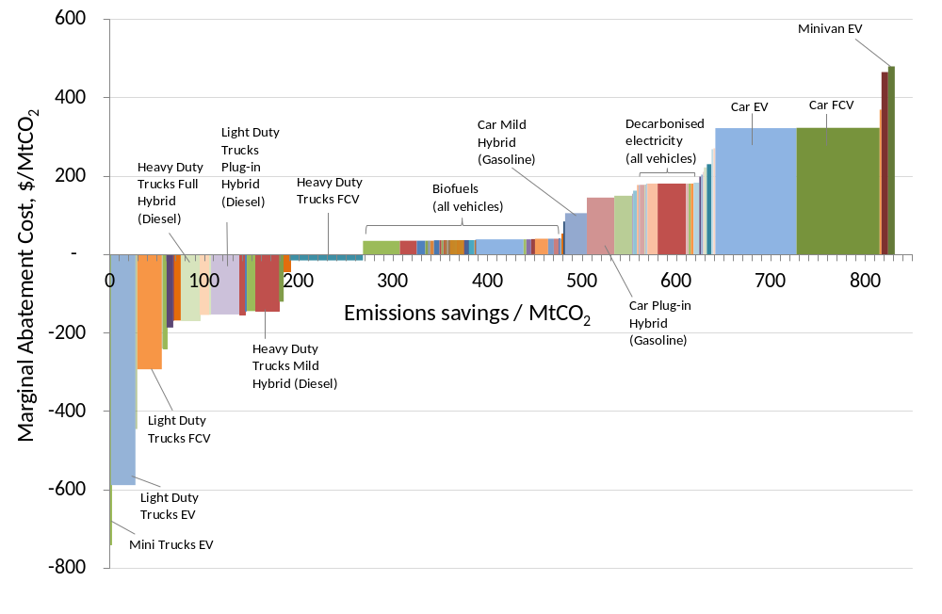
Figure 5: Marginal Abatement Cost curve in 2050
Notes: All cost figures in US$2010; EV = Electric Vehicle; FCV = Fuel Cell Vehicle; Colours / shading for clarity only (i.e. different abatement options are not colour-coded)
The area under the MAC curve represents the total additional annual cost in 2050 for the low carbon scenario when compared to the business-as-usual scenario, and is (US2010)$64 billion, which represents the sum of additional annualised purchase costs (at the assumed discount rate of 5%), additional operation and maintenance costs for vehicles, and additional wholesale fuel costs (including a mark-up to account for electric charging and hydrogen infrastructure costs) . This compares to a total business-as-usual scenario annual cost of (US2010)$4,996 billion in 2050, hence a 1.3% increase.. Neither the low-carbon nor business-as-usual scenario includes retail costs to sell fuels, nor any taxes levied on vehicle sales and ownership or fuel sales. As is explored in the sensitivity analysis, this total cost differential is sensitive to a number of key assumptions, including discount rates, vehicle costs and fuel costs.
As well as CO₂ emissions savings, the low-carbon scenario also results in decreased reliance on fossil fuels, particularly gasoline and diesel, as shown in figure 6, which shows the fossil fuel demand in the business-as-usual and low-carbon scenarios.
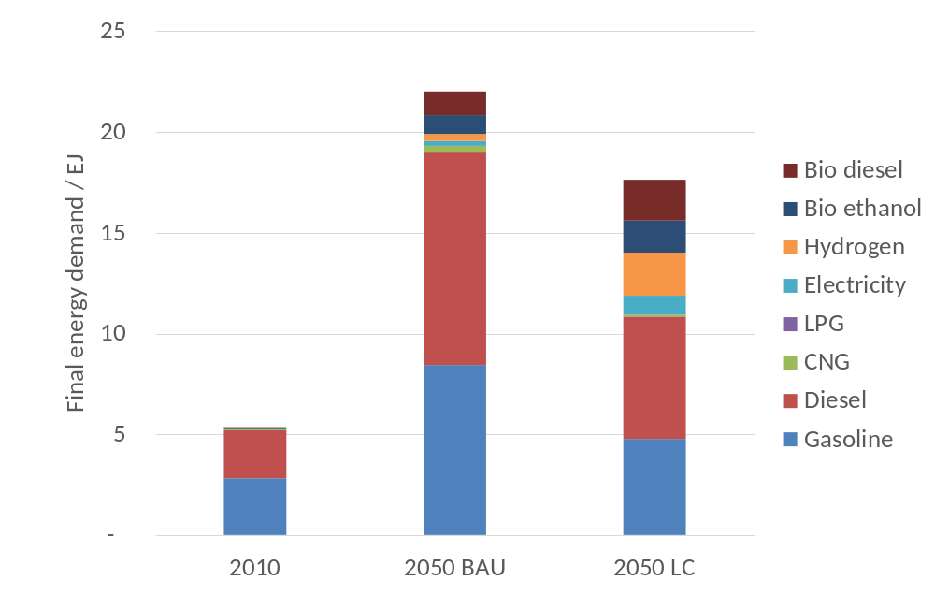
Figure 6: Fuel demand in China’s road transport sector in 2010 and 2050
Notes: BAU = Business-as-usual; LC = Low Carbon; LPG = Liquefied Petroleum Gas; CNG = Compressed Natural Gas
The significantly reduced reliance on oil products in the low-carbon scenario, the demand for which is 43% lower than the business-as-usual level by 2050 (though still twice the 2010 level) is a potentially very important motivation towards the adoption of low-carbon vehicle technologies, aside from their impact on CO₂ emissions. Local air pollutant emissions levels might also be considerably reduced compared to the business-as-usual scenario - a factor which is worth modelling more accurately in further analysis which accounts for the location and density of road vehicles usage.

5 Sensitivity analysis of main results
The model allows relatively straightforward testing of a range of sensitivities. For example, as discussed in Section 3, the vehicle growth rate figures assumed are somewhat lower than in the analysis of Huo and Wang (2012) [6]. Increasing growth rates such that the passenger car population in 2050 is 499 million (in line with Huo and Wang’s 2012 projections [6]) rather than 377 million as based on the Ou et al (2010) projections [5], results in 2050 business-as-usual CO₂ emissions of 2.37 GtCO₂ in 2050, and low carbon CO₂ emissions of 1.41 GtCO₂, as shown in figure 7. As can be seen from the figure, the low-carbon scenario CO₂ emissions increase by less than the business-as-usual CO₂ emissions, as a result of the lower CO₂ intensity of passenger cars in the low-carbon scenario. The total additional annual cost of the road transport sector in the low-carbon scenario in 2050 increases from (US2010)$64 billion to (US2010)$93 billion, 1.6% higher than the business-as-usual road transport sector cost of (US2010)$5,700 billion in this higher car population scenario.
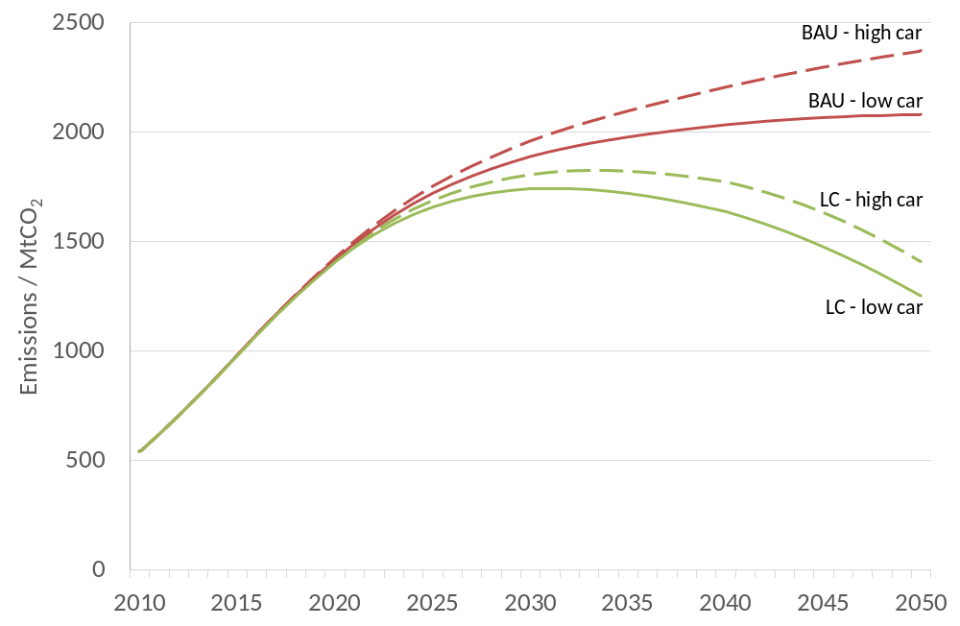
Figure 7: CO₂ emissions using sensitivity analysis with higher growth rate of passenger cars
Notes: BAU = Business-as-usual; LC = Low Carbon; High car = high passenger car growth scenario; Low car = low passenger car growth scenario
Other key sensitivities worthy of exploration are the financing rate (i.e. the discount rate) applied to the purchase cost of vehicles, as well as the assumed fossil fuel prices in 2050. There have been a number of analyses of mitigation costs using discount rates based on a “social” rate of return on capital, often considered risk-free and broadly equivalent to the borrowing rate for governments in stable economic times [35]. By contrast, a risk-weighted discount rate, taking into account private investment risks of defaults on loan repayments, is also used, with values closer to a market weighted average cost of capital (WACC) typically experienced by private firms making investments, or consumers making private purchases. The former, social discount rate is often closer to 5% (with some analyses using 3.5%) and the latter closer to 10%. For an economy-wide analysis such as this, in which the aim is to capture the societal cost of a low-carbon transition, it is more appropriate to consider the lower, essentially risk-free, discount rate. However, it is worth investigating the impact on total transport sector cost of increasing the discount rate towards a private market level which accounts for the risk of default in loan repayments, as shown in figure 8.
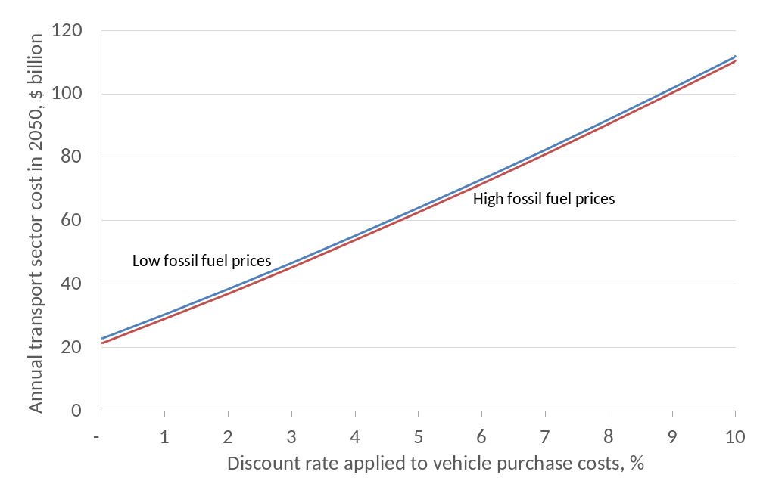
Figure 8: Total annual road transport sector cost in 2050, at a range of discount rates
Notes: All cost figures in US$2010; high fossil fuel prices for 2050: oil $150/bbl; gas $1.3/therm, compared to low fossil fuel prices: oil $100/bbl; gas $1/therm
Figure 8 shows that, as expected, the lower the discount rate, the less the contribution to cost from the higher purchase costs of lower-carbon vehicles, and the more significant the offsetting value of the fuel savings resulting from increased penetrations of hybrid, electric and fuel cell vehicles.
For higher fossil fuel prices, the additional road transport sector cost in 2050 for the low-carbon scenario with a discount rate of 5% is (US2010)$63 billion, or 1.2% of the business-as-usual road transport sector cost of (US2010)$5,180 billion, in 2050 (as explained in Section 4, the equivalent figures for the lower fossil fuel price scenario are (US2010)$64 billion and 1.3%). The absolute cost differential between this higher fossil fuel price case and the lower fossil fuel price case narrows (slightly) as the discount rate increases, since the more valuable fuel savings in the higher fossil fuel price case become increasingly insignificant compared to the annualised vehicle purchase costs, which increase with the increasing discount rate. Nevertheless, this analysis indicates that concessional (i.e. subsidised) borrowing rates may be a useful policy lever towards making low-carbon investments in the transport sector more attractive. In both fossil fuel price scenarios, as the discount rate rises towards 10%, the significant increase in additional road transport sector cost for the low-carbon scenario does not represent an additional economy-wide cost to China, but rather a transfer from borrowers to lenders, since the latter will profit from making risk-adjusted loans to borrowers to fund vehicle purchases in this scenario.
Other sensitivities explored are summarised in table 4. This shows that, because of the higher efficiency of diesel passenger cars, and the similarity between diesel and gasoline fuel prices and vehicle costs assumed, there is much to be gained in CO₂ emissions and cost savings by increasing the share of diesel cars in the low-carbon scenario, from 20% to 80% of new car sales in 2050. However, the higher particulate levels associated with diesel combustion would need to be carefully considered and mitigated if this strategy were to be followed. A key result from the cost analysis is that, owing to lower operation and maintenance (O&M) costs, electric and fuel cell trucks actually make significant cost savings compared to ICE trucks by 2050. The significance of the input cost assumptions can be seen by raising the O&M truck costs to the same level as those for ICE drivetrains, resulting in a (US2010)$44 billion per year (or 70%) increase in the overall additional cost of the low-carbon scenario by 2050. Much will therefore depend on whether these drivetrain types actually will require less O&M activity than ICE engines – clearly it is too early to tell given the immaturity of these technologies.
Further sensitivity analysis is focused on motorcycles, which are barely included in the mitigation analysis since the only difference between the business-as-usual and low-carbon scenarios is the use of biofuels in the latter. If we assume that there is a fast growth of the electric motorcycle market by 2050, however, this does not result in significant additional CO₂ emissions savings (847 MtCO₂ compared to 839 MtCO₂ in the central low-carbon scenario) but it does lead to significant cost escalation as a result of the modest additional cost of electric motorcycles compared to ICE ones being repeated throughout a large national motorcycle population (almost 120 million by 2050), and the fact that by 2050 the annual distance travelled is relatively low, which means fuel savings do not offset this additional purchase cost. The sensitivity around increased share of natural gas cars (in this case, liquefied petroleum gas, which is assumed to have a lower well-to-wheels CO₂ intensity than compressed natural gas [31]) is undertaken given the focus on natural gas in the Chinese Energy Research Institute’s 2050 Pathways Calculator scenarios [21], and demonstrates that additional annual savings of 36 MtCO₂ can be achieved by 2050, at a lower cost than the central scenario owing to the lower fuel price outweighing the higher purchase cost of such vehicles, when compared to diesel and gasoline vehicles.
A further sensitivity is used to explore the impact of improving fuel efficiency in the low-carbon scenario over and above that in the business-as-usual scenario, since in the central case these are assumed to improve at the same rate for all vehicle types. The results, unsurprisingly, indicate that, assuming greater drivetrain efficiency can be achieved with no vehicle cost increase (e.g. due to further downsizing or light-weighting) the CO₂ emissions and cost benefits could be very significant. As expected, improving energy efficiency is therefore a key strategy for achieving CO₂ emissions savings at least cost.
Finally, the extremely low-carbon well-to-wheels value for both second generation bioethanol (4gCO₂/MJ, compared to 115gCO₂/MJ for first generation, and to 99gCO₂/MJ for gasoline) and for second generation biodiesel (1gCO₂/MJ, compared to 79gCO₂/MJ for first generation, and to 102gCO₂/MJ for gasoline) are, according to figure 5, highly influential in achieving such significant CO₂ emissions reductions from biofuels. Assuming a much higher CO₂ intensity of both fuels (50gCO₂/MJ, about half the level of gasoline and diesel) doubles the average MAC of biofuels, and reduced 2050 CO₂ emissions savings by 80 MtCO₂, or about 10% of total savings in 2050. Clearly the challenge is to achieve levels of lifecycle CO₂ emissions close to carbon-neutrality from the production and distribution of these fuels.

Table 4: Sensitivity analyses on key parameters in the model
Sensitivity | Rationale | Impact
Share of diesel sales in ICE and hybrid cars and minivans rises from 20% to 80% in the low-carbon scenario by 2050, compared to 20% in the business-as-usual scenario | Diesel engine efficiency is expected to be higher than gasoline, and with similar purchase costs and fuel prices, a shift to diesel could provide additional CO₂ abatement at relatively low cost (albeit with higher levels of local pollutants) | Mitigation in 2050 increased from 839 to 891 MtCO₂, whilst additional cost of low-carbon scenario reduced from $64 billion to $52 billion
Increased annual operation and maintenance costs of all trucks fuel cell vehicles so that they match those of ICE vehicles. | Conservative assumption to reflect possibility that the low-carbon vehicles are no cheaper to maintain than ICE. | Road transport sector additional cost increases from $64 billion to $108 billion. MAC for mini-truck EVs increases from -$739/tCO₂ to -$137/tCO₂
Electric motorcycles make up 40% of sales by 2050, rising linearly from 0% in 2010. | Central low-carbon scenario assumes motorcycle drivetrains remain entirely ICE, but electric motorcycle technology is already being deployed in some regions. 2050 electric motorcycle sales share matches the combined fuel cell and electric vehicle share for cars by 2050 (i.e. 40%). | CO₂ emissions savings increase from 839 to 847 MtCO_{2.} Additional cost of low-carbon scenario increases from $64 billion to $75 billion, with a MAC of $1,263/tCO₂ for the shift from ICE to electric motorcycles, assuming a modest additional purchase cost of electric motorcycles ($10,000 compared to $8,300 for ICE) and no difference in O&M costs.
Increased share of natural gas passenger cars, such that liquefied petroleum gas cars make up 80% of ICE (non-hybrid) drivetrain sales by 2050, growing linearly from 0% in 2010, to make up 12% of all cars by 2050. | China 2050 Pathways calculator [21] has 25% of cars powered by natural gas by 2050 in its most ambitious low-carbon option, whereas the central case in this study has virtually zero. | CO₂ emissions reductions increase from 839 to 875 MtCO₂ with total additional low-carbon road transport sector costs decreasing from $64 billion to $58 billion. MAC of liquefied petroleum gas vehicles is $69/tCO₂.
Increased fuel efficiency of passenger cars in the low-carbon scenario, with all vehicle efficiencies improving at 1.3% (1.5% for diesel) per annum between 2030 and 2050. | Central case assumes no efficiency improvements beyond 2030, so this case continues the pre-2030 rate of annual efficiency improvements to 2050. | CO₂ emissions reductions increase from 839 to 924 MtCO₂ and total additional cost of low-carbon scenario falls from $64 billion to $35 billion in 2050. Average MAC of energy efficiency improvements is -$200/tCO₂ for diesel and gasoline cars
Increased CO₂ emissions factors of second generation biofuels such that both bioethanol and biodiesel have well-to-wheels factor of 50gCO₂/MJ (as opposed to 1-4gCO₂/MJ in central case) | Conservative assumption to explore the impact of failing to achieve virtual carbon neutrality in biofuel production. | CO₂ emissions reductions fall from 839 to 762 MtCO₂ and average MAC of biofuels increases from about $35/tCO₂ to about $70/tCO₂.
Notes: All costs in (US$2010)

6 Conclusion
Using a scenario model of projections of China’s road transport sector to 2050, it has been demonstrated that this sector’s CO₂ emissions could be reduced from a projected 2.08 to 1.24 GtCO₂ per year by 2050, which would make a significant contribution to reducing global CO₂ emissions in line with international ambition to tackle climate change. These CO₂ emissions reductions would cost (US2010)$64 billion per year by 2050, a 1.3% increase on the annualised purchase, operation and maintenance and fuel costs of the Chinese road transport sector by 2050. This figure does not include the costs of supporting infrastructure such as hydrogen transport or electric vehicle charging networks. Neither does the figure include an economic evaluation of the additional benefits of the low-carbon scenario, which potentially greater energy security resulting from oil demand which is more than 40% lower by 2050 when comparing the business-as-usual and low-carbon scenarios, nor reduced local pollution from gasoline and diesel vehicles.
A range of sensitivity analyses is used to test key uncertainties in the model projections. The analysis is based on an assumed discount rate of 5% to annualise vehicle purchase costs, and relatively conservative fossil fuel price projections (using oil price projections at (US2010)$100/barrel by 2050). Higher fossil fuel prices (oil at (US2010)$150/barrel by 2050) would reduce the decarbonisation cost to (US2010)$63 billion per year by 2050, a 1.2% increase on the business-as-usual scenario. By contrast, higher discount rates would raise decarbonisation costs. In addition, cost-effective measures to achieve further decarbonisation could be undertaken, including increasing the share of diesel cars (though this could raise challenges in terms of increased particulate pollution) and achieving continued energy efficiency improvements beyond 2030.
As noted, the model does not include a detailed representation of infrastructure development for fuel cell and electric vehicles, including considerations of vehicle charging and grid integration issues. Nor does it make assumptions on future low-carbon vehicle policies in China – the scenarios as presented are based purely on what are deemed reasonable penetration rates of different vehicle drivetrain types, with reference to a range of other studies.
In summary, there is potentially much to be gained, in terms of reduced CO₂ emissions and reduced oil demand, from the increasing penetration of a range of low-carbon vehicle types throughout the Chinese road transport sector, with cars and heavy-duty trucks providing the biggest potential emissions reduction gains as a result of their assumed population growth rate and large annual distance travelled. The model provided as a supplement to this paper can be used to further investigate the costs and benefits of a number of further scenarios around the penetration of low-carbon vehicles.

Acknowledgements
The authors would like to thank the UK Government’s Department of Energy and Climate Change (DECC) and Department for Environment, Food and Rural Affairs (DEFRA), who jointly funded the initial research that led to this paper through the AVOID programme. Details of this programme are available at www.avoid.uk.net.

Annex A – Calculation of CO₂ emissions, costs and decomposition analysis
Emissions E in year t from each vehicle type i and each drivetrain type j are calculated as follows, for each year 2010 to 2050:
$E_{t}=\sum_{i}{\sum_{j}{{{p_{i}a}_{i}s}_{i,j}e_{i,j}f_{j}}}$ (1)
where for each year t:
- p_{i} is the population of vehicle type i
- a_{i} is the activity level (in this case average distance travelled per year) for vehicle type i
- s_{i,j} is the share of drivetrain type j for vehicle type i
- e_{i,j} is the energy consumption per unit distance travelled for vehicle type i and drivetrain type j
- f_{,j} is the emissions per unit energy consumed by drivetrain j (which depends on the fuel used)

Total annualised vehicle costs in 2050, C, are calculated, for the chosen discount rate d, as follows:
$C=\sum_{i}{\sum_{j}{\left.p_{i}s_{i,j}\left[PMT\left(d,n_{i},P_{i,j}\right)+m_{i,j}\right]\right.}}$ (2)
where:
- p_{i} is the population of vehicle type i
- s_{i,j} is the share of drivetrain type j for vehicle type i
- PMT is the Microsoft Excel in-built function for a constant loan repayment rate
- P_{i,j} is the purchase cost of vehicle type i and drivetrain type j
- n_{i} is the lifetime of vehicle type i (assumed uniform across drivetrains)
- d is the discount rate (uniformly applied to all vehicle and drivetrain types)
- m_{i,j} is the annual operation and maintenance cost of vehicle type i and drivetrain type j

Total fuel costs in 2050, F, are calculated as follows:
$F=\sum_{i}{\sum_{j}{{p_{i}a}_{i}{s_{i,j}e}_{i,j}c_{j}}}$ (3)
where:
- p_{i} is the population of vehicle type i
- a_{i} is activity for vehicle type i in 2050
- s_{i,j} is the share of drivetrain type j for vehicle type i
- e_{i,j} is energy use per unit activity for vehicle type i and drivetrain j in 2050
- c_{j} is the fuel cost per unit energy for drivetrain j (which depends on the fuel used)

The emissions savings and cost differential decomposition are only calculated for 2050. For each vehicle type i, CO₂ emissions E_{i} in 2050 are given by:
$E_{i}=\sum_{j}{{{p_{i}a}_{i}s}_{i,j}e_{i,j}f_{j}}$ (4)
It follows that each component can be assigned a share of the total emissions difference between the business-as-usual scenario for each vehicle type i, E_{i}^{BAU} and the low-carbon scenario E_{i}^{LC}, as follows:
- Population p_{i} and activity a_{i} is held constant between scenarios, so emissions reductions are not allocated to these factors.
- The emissions difference due to a change in share of each drivetrain type j, $∆E_{i, s }$, is given by:
$∆E_{i, s }= \sum_{j}{\frac{E_{i,j}^{LC }- E_{i,j}^{BAU }}{{\ln{E_{i,j}^{LC }}}^{ }- \ln{E_{i,j}^{BAU }}}*ln \frac{s_{i,j}^{LC}}{s_{i,j}^{BAU}}}$ (5)
where:
- $E_{i,j}^{LC }$ and $E_{i,j}^{BAU }$are the emissions from vehicle type i and drivetrain type j in the low-carbon and business-as-usual scenarios respectively.
- $s_{i,j}^{LC }$ and $s_{i,j}^{BAU }$are the shares (of the total number of vehicle type i) of vehicle type i and drivetrain type j in the low-carbon and business-as-usual scenarios respectively.

- The emissions difference due to a change in energy intensity of each drivetrain type j, $∆E_{i,s }$, is given by:
$∆E_{i,e }= \sum_{j}{\frac{E_{i,j}^{LC }- E_{i,j}^{BAU }}{{\ln{E_{i,j}^{LC }}}^{ }- \ln{E_{i,j}^{BAU }}}*ln \frac{e_{i,j}^{LC}}{e_{i,j}^{BAU}}}$ (6)
where:
- $e_{i,j}^{LC }$ and $e_{i,j}^{BAU }$are the energy intensity of vehicle type i and drivetrain type j in the low-carbon and business-as-usual scenarios respectively.

- The emissions difference due to a change in specific emissions of each drivetrain type j, $∆E_{i,f }$, is given by:
$∆E_{i,f }= \sum_{j}{\frac{E_{i,j}^{LC }- E_{i,j}^{BAU }}{{\ln{E_{i,j}^{LC }}}^{ }- \ln{E_{i,j}^{BAU }}}*ln \frac{f_{i,j}^{LC}}{f_{i,j}^{BAU}}}$ (7)
where:
- $f_{i,j}^{LC }$ and $f_{i,j}^{BAU }$are the emissions intensity (i.e. emissions per unit energy use) of vehicle type i and drivetrain type j in the low-carbon and business-as-usual scenarios respectively.
For each vehicle type i, total annual cost in 2050, T_{i}, is given by the sum of the annualised purchase and maintenance cost, C_{i}, and annual fuel cost, F_{i}:
$T_{i}=C_{i}+F_{i}=\sum_{j}{{p_{i}s_{i,j}C}_{i,j}}+\sum_{j}{p_{i}a_{i}s_{i,j}e_{i,j}}c_{j}$ (8)
As with allocation of emissions, each component can be assigned a share of the total cost difference between the business-as-usual cost for each vehicle type i, T_{i}^{BAU} and the low-carbon scenario cost, T_{i}^{LC}, as follows:
- Population p_{i} and activity a_{i} is held constant between scenarios, so emissions reductions are not allocated to these factors.
- The annualised purchase and maintenance cost difference between the business-as-usual scenario, C_{i}^{BAU}, and the low-carbon scenario, C_{i}^{LC}, depends solely on the difference in share of each drivetrain type j, $∆C_{i, s }$, as given by:
$∆C_{i, s }= \sum_{j}{\frac{C_{i,j}^{LC }- C_{i,j}^{BAU }}{{\ln{C_{i,j}^{LC }}}^{ }- \ln{C_{i,j}^{BAU }}}*ln \frac{s_{i,j}^{LC}}{s_{i,j}^{BAU}}}$ (9)
where:
- $C_{i,j}^{LC }$ and $C_{i,j}^{BAU }$are the 2050 annualised purchase and maintenance cost of vehicle type i and drivetrain type j in the low-carbon and business-as-usual scenarios respectively.

- The annual fuel cost difference between the business-as-usual scenario, T_{i}^{BAU}, and the low-carbon scenario, T_{i}^{LC}, is the sum of:
  - the difference in cost resulting from a change in the share of each drivetrain type j, $∆T_{i, s }$, as given by:

$∆T_{i,s }= \sum_{j}{\frac{T_{i,j}^{LC }- T_{i,j}^{BAU }}{{\ln{T_{i,j}^{LC }}}^{ }- \ln{T_{i,j}^{BAU }}}*ln \frac{s_{i,j}^{LC}}{s_{i,j}^{BAU}}}$ (10)
where:
  - $T_{i,j}^{LC }$ and $T_{i,j}^{BAU }$are the annual 2050 fuel costs for each vehicle type i and drivetrain type j in the low-carbon and business-as-usual scenarios respectively.
  - $s_{i,j}^{LC }$ and $s_{i,j}^{BAU }$are the shares (of the total number of vehicle type i) of vehicle type i and drivetrain type j in the low-carbon and business-as-usual scenarios respectively.

  - the difference in cost resulting from a change in energy intensity of each drivetrain type j, $∆T_{i, e }$, as given by:

$∆T_{i,e }= \sum_{j}{\frac{T_{i,j}^{LC }- T_{i,j}^{BAU }}{{\ln{T_{i,j}^{LC }}}^{ }- \ln{T_{i,j}^{BAU }}}*ln \frac{e_{i,j}^{LC}}{e_{i,j}^{BAU}}}$ (11)
where:
  - $e_{i,j}^{LC }$ and $e_{i,j}^{BAU }$are the energy intensity of vehicle type i and drivetrain type j in the low-carbon and business-as-usual scenarios respectively.

  - the difference in cost resulting from a change in unit fuel cost for each drivetrain type j, $∆T_{i, c }$, as given by:

$∆T_{i,c }= \sum_{j}{\frac{T_{i,j}^{LC }- T_{i,j}^{BAU }}{{\ln{T_{i,j}^{LC }}}^{ }- \ln{T_{i,j}^{BAU }}}*ln \frac{c_{j}^{LC}}{c_{j}^{BAU}}}$ (12)
where:
  - $c_{i,j}^{LC }$ and $c_{i,j}^{BAU }$are the unit fuel cost for drivetrain type j (which depends solely on the drivetrain, rather than vehicle type) in the low-carbon and business-as-usual scenarios respectively.
As Kesicki (2013) notes [29], the LMDI methodology assigns emissions reductions to ICE vehicles as a result of their reduced share in the low-carbon scenario when compared to the business-as-usual scenario (according to equation 5 above). By contrast, low-carbon vehicles, which increase their share of the vehicle stock when comparing the low-carbon with the business-as-usual scenario, have an emissions increase assigned to them. The figure of interest, however, is the emissions reduction achieved as a result of substituting the low-carbon fuel vehicle for the ICE vehicle. Hence, it is necessary to assign a share of emissions reductions associated with the reduced share of ICE vehicles to the low-carbon vehicles. This is done through a two-stage redistribution protocol:
- Within ICE vehicles, if there is an increase in the number of natural gas (liquefied petroleum gas and/or compressed natural gas) vehicles when comparing the low-carbon to the business-as-usual scenario, then it is assumed that these increase their share at the expense of ICE gasoline and diesel vehicles. As such, they are assigned a share of the total emissions reduction resulting from the reduced share of gasoline and diesel ICE vehicles, as follows (using liquefied petroleum gas vehicles as an example):

$∆{E(R)}_{i,LPG, s}= \frac{n_{i,LPG}^{LC }- n_{i,LPG}^{BAU }}{n_{i,ICE(G\&D)}^{BAU }- n_{i,ICE(G\&D)}^{LC }}* ∆E_{i, ICE\left(G\&D\right), s }$ (13)

where:
- $∆{E(R)}_{i,LPG, s}$ denotes the change in emissions which is redistributed to liquefied petroleum gas vehicles from gasoline and diesel ICE vehicles.
- $n_{i,LPG}^{LC } and n_{i,LPG}^{BAU }$ denote the number of liquefied petroleum gas vehicles in the low-carbon and business-as-usual scenarios respectively.
- $n_{i,ICE(G\&D)}^{LC } and n_{i,ICE(G\&D)}^{BAU }$ denote the number of gasoline and diesel ICE vehicles in the low-carbon and business-as-usual scenarios respectively
- $∆E_{i, ICE\left(G\&D\right), s }$denotes the change in emissions resulting from the change in the share of gasoline and diesel ICE vehicles when comparing the business-as-usual and low-carbon scenarios.
The resulting emissions reductions allocated to liquefied petroleum gas vehicles are then subtracted from the emissions reductions assigned to the gasoline and diesel ICE vehicles, in proportion to the relative change in the number of gasoline and diesel ICE vehicles. Hence, the redistribution of emissions reductions away from gasoline ICE vehicles is given as follows:
$∆{E(R)}_{i,ICE(G), s}= \frac{n_{i,ICE(G)}^{LC }- n_{i,ICE(G)}^{BAU }}{n_{i,ICE(G\&D)}^{BAU }- n_{i,ICE(G\&D)}^{LC }}* ∆{E(R)}_{i, LPG, s }$ (14)
where:
  - $∆{E(R)}_{i,ICE(G), s}$ denotes the change in emissions allocated to ICE gasoline vehicles (as a result of their change in vehicle share when comparing the low-carbon and business-as-usual scenarios) which is redistributed to liquefied petroleum gas vehicles.
  - $n_{i,ICE(G)}^{LC } and n_{i,ICE(G)}^{BAU }$ denote the number of ICE gasoline vehicles in the low-carbon and business-as-usual scenarios respectively.

If there is a reduction in the number of natural gas vehicles when comparing the low-carbon with the business-as-usual scenario, then it is assumed that the reduction in emissions that is associated with this reduction in the number of gas vehicles is distributed to the other low-carbon vehicles, as explained in stage 2 of the redistribution protocol directly below.

- After the redistribution (where relevant) of natural gas vehicle emissions to gasoline and diesel ICE vehicles, ICE vehicle emissions reductions are redistributed to alternative fuel vehicles as follows:
  - Each diesel hybrid vehicle drivetrain (mild, full and plug-in) is allocated a portion of the emissions reductions that are assigned to diesel ICE vehicles as a result of the reduction in their share. The diesel ICE vehicle emissions reductions redistributed to each diesel hybrid drivetrain is calculated as follows (using mild diesel hybrids as an example):
$∆{E(R)}_{i,MHybrid(D), s}= \frac{n_{i,MHybrid(D)}^{LC }- n_{i,MHybrid(D)}^{BAU }}{n_{i,ICE(D)}^{BAU }- n_{i,ICE(D)}^{LC }}* ∆E_{i,ICE(D), s }$ (15)
Where:
  - $∆{E(R)}_{i,MHybrid(D), s}$ denotes the emissions change redistributed to mild hybrid diesel vehicles from from ICE diesel vehicles (as a result of their change in vehicle share when comparing the low-carbon and business-as-usual scenarios), for each vehicle type i.
  - $∆E_{i,ICE(D), s}$ denotes the change in emissions allocated to ICE diesel vehicles as a result of their change in vehicle share when comparing the low-carbon and business-as-usual scenarios.
  - $n_{i,MHybrid(D)}^{LC } and n_{i,MHybrid(D)}^{BAU }$ denote the number of mild hybrid diesel vehicles in the low-carbon and business-as-usual scenarios respectively., for each vehicle type i.
  - $n_{i,ICE(D)}^{LC } and n_{i,ICE(D)}^{BAU }$ denote the number of ICE diesel vehicles in the low-carbon and business-as-usual scenarios respectively, for vehicle type i.

  - Gasoline hybrid vehicles are allocated a portion of the emissions reductions assigned to gasoline ICE vehicles as a result of the reduction in their share, in the same way as for diesel hybrids.
  - After allocating ICE diesel and gasoline vehicle emissions reductions to diesel and gasoline hybrids as described in steps a and b, the remaining emissions reductions allocated to gasoline and diesel ICE vehicles as a result of their decreased share, plus emissions reductions assigned to natural gas vehicles (in the case that their share does not increase when comparing the low-carbon to business-as-usual scenario) are allocated to fuel cell and electric vehicles, in proportion to their relative increase in vehicle share when comparing the low-carbon to the business-as-usual scenario.

The same principle of redistribution (and the same two-stage protocol) is used to assign to the low-carbon vehicles the decrease in costs that results from a decrease in the share of ICE vehicles (when comparing the low-carbon to business-as-usual scenario).

Once the appropriate emissions and cost differences between the business-as-usual and low-carbon scenarios have been allocated to each vehicle drivetrain type, the marginal abatement cost can be calculated simply as the cost change divided by the emissions change.

Annex B - Vehicle cost assumptions
Vehicle type | Drivetrain | Purchase cost | O&M cost | Assumptions
Car | FCV | £17,505 | £1,477
 | EV | £22,944 | £1,145
 | Mild HEV |  |  | Additional purchase cost above ICE assumed as 1/3rd of difference between ICE and Plug-in HEV.  O&M cost saving over ICE assumed as 1/3rd cost saving of Plug-in HEV over ICE
 | Full HEV |  |  | Additional cost above ICE assumed as 2/3rd of difference between ICE and Plug-in HEV
 | Plug-in HEV | £16,685 | £1,451 | Average of range given in source
 | ICE diesel/ gasoline | £14,247 | £1,535 | Average of range given in source
 | ICE CNG |  |  | Purchase cost assumed 10% higher purchase cost than ICE diesel/gasoline, based on ETSAP (2010).  O&M cost assumed the same as ICE diesel/gasoline.
 | ICE LPG |  |  | Purchase cost assumed 10% higher purchase cost than ICE diesel/gasoline, based on ETSAP (2010) [33].  O&M cost assumed the same as ICE diesel/gasoline.
Source: | http://2050-calculator-tool-wiki.decc.gov.uk/pages/63 (using MARKAL 3.26)
Heavy-duty trucks | FCV | £63,563 | £11,825
 | EV | £63,563 | £11,825
 | Mild HEV | £63,463 |  | Additional purchase cost above ICE assumed as 1/3rd of difference between ICE and Plug-in HEV.  O&M cost saving over ICE assumed as 1/3rd cost saving of Plug-in HEV over ICE
 | Full HEV | £63,463 |  | Additional cost above ICE assumed as 2/3rd of difference between ICE and Plug-in HEV
 | Plug-in HEV | £63,463
 | ICE diesel/ gasoline | £63,363 | £15,000
Source: | DECC (n.d.) [32] (using MARKAL 3.26 data costs) figures in UK GBP (£)
Heavy duty Buses | FCV | £187,266 | £20,154
 | EV | £205,266 | £19,897
 | Mild HEV |  |  | Additional purchase cost above ICE assumed as 1/3rd of difference between ICE and Plug-in HEV.  O&M cost saving over ICE assumed as 1/3rd cost saving of Plug-in HEV over ICE
 | Full HEV |  |  | Additional cost above ICE assumed as 2/3rd of difference between ICE and Plug-in HEV
 | Plug-in HEV | £179,843 | £24,766
 | ICE diesel/ gasoline | £168,377 | £24,766
 | ICE CNG |  |  | Purchase cost assumed 10% higher purchase cost than ICE diesel/gasoline, based on ETSAP (2010) [33].  O&M cost assumed the same as ICE diesel/gasoline.
 | ICE  LPG |  |  | Purchase cost assumed 10% higher purchase cost than ICE diesel/gasoline, based on ETSAP (2010) [33].  O&M cost assumed the same as ICE diesel/gasoline.
Source: | DECC (n.d.) [32] (using MARKAL 3.26 data costs) figures in UK GBP (£)

Other vehicle assumptions:
Vehicle type | Cost assumption | Basis
Medium-duty trucks | All costs 75% of heavy-duty trucks | Interpolation between heavy-duty and light-duty trucks
Light-duty trucks | All costs 50% of heavy-duty trucks | http://www.commercialtrucktrader.com/ Suggests light-duty trucks about $50,000 compared to about $100,000 for heavy duty trucks
Mini-trucks | All costs 33% of heavy-duty trucks | http://www.commercialtrucktrader.com/ Cheapest of light trucks are $30-35,000, compared to $100,000 for heavy-duty trucks
Light Duty Bus | LDB costs are 40% of HDB costs | http://www.alibaba.com/showroom/15-passenger-mini-bus.html Suggests minibuses are of the order $20,000 in China, compared to about $50,000 for coaches:http://www.alibaba.com/trade/search?fsb=y&IndexArea=product_en&CatId=&SearchText=coach
Minivan | 50% higher than car | Assuming a vehicle type like Honda Odyssey at $27-40,000 compared to medium car prices of $20,000. http://usnews.rankingsandreviews.com/cars-trucks/Honda_Odyssey/
Motorcycle | 50% of car | Own assumption.
Notes: EV = Electric Vehicle, FCV = Fuel Cell Vehicle; HEV = Hybrid Electric Vehicle; ICE = Internal Combustion Vehicle; LPG = Liquefied Petroleum Gas; CNG = Compressed Natural Gas; O&M = Operation and Maintenance

References
[1] PBL Netherlands Environmental Assessment Agency, European Commission Joint Research Centre. Trends in Global CO2 Emissions - 2013 Report. 2013.
[2] International Energy Agency. CO2 emissions from fuel combustion - 2013 edition. OECD / IEA; 2013.
[3] International Energy Agency. World Energy Outlook 2013. OECD / IEA; 2013.
[4] China Association of Automobile Manufacturers. The sales and production of passenger cars enjoyed a significant year-on-year growth 2014. http://www.caam.org.cn/AutomotivesStatistics/20140711/1405124350.html.
[5] Ou X, Zhang X, Chang S. Scenario analysis on alternative fuel/vehicle for China’s future road transport: Life-cycle energy demand and GHG emissions. Energy Policy 2010;38:3943–56.
[6] Huo H, Wang M. Modeling future vehicle sales and stock in China. Energy Policy 2012;43:17–29. doi:10.1016/j.enpol.2011.09.063.
[7] Wang M, Huo H, Johnson L, He D. Projection of Chinese Motor Vehicle Growth, Oil Demand, and CO2 Emissions Through 2050 2006.
[8] Intergovernmental Panel on Climate Change. Climate Change 2014: Mitigation of Climate Change (Working Group III of the Fifth Assessment Report). United Nations; 2014.
[9] Huo H, Wang M, Zhang X, He K, Gong H, Jiang K, et al. Projection of energy use and greenhouse gas emissions by motor vehicles in China: Policy options and impacts. Energy Policy 2012;43:37–48. doi:10.1016/j.enpol.2011.09.065.
[10] He L-Y, Chen Y. Thou shalt drive electric and hybrid vehicles: Scenario analysis on energy saving and emission mitigation for road transportation sector in China. Transp Policy 2013;25:30–40. doi:10.1016/j.tranpol.2012.11.006.
[11] Hao H, Wang H, Yi R. Hybrid modeling of China’s vehicle ownership and projection through 2050. Energy 2011;36:1351–61. doi:10.1016/j.energy.2010.10.055.
[12] Wang Y, Teter J, Sperling D. China’s soaring vehicle population: Even greater than forecasted? Energy Policy 2011;39:3296–306. doi:10.1016/j.enpol.2011.03.020.
[13] Kejun J, Qiang L, Xing Z, Xiulian H. Technology roadmap for low carbon society in China. J Renew Sustain Energy 2010;2:031008. doi:10.1063/1.3458415.
[14] Energy Storage China. Electric vehicle technology development “12th Five Year Plan” Special Plan 2014. http://www.escn.com.cn/news/show-170984.html.
[15] Chinese Academy of Sciences. Energy Science & Technology in China: A Roadmap to 2050. Springer; Science Press Beijing; 2009.
[16] ICCT. Global Comparison of Passenger Car and Light-commercial Vehicle Fuel Economy/GHG Emissions Standards 2014.
[17] Sorrentino M, Rizzo G, Sorrentino L. A study aimed at assessing the potential impact of vehicle electrification on grid infrastructure and road-traffic green house emissions. Appl Energy 2014;120:31–40. doi:10.1016/j.apenergy.2014.01.040.
[18] Ou X, Zhang Q, Zhang X, Zhang X. China’ New Energy Passenger Vehicle Development Scenario Analysis Based on Life Time Cost Modelling. Low Carbon Econ 2013;4:71–9. doi:http://dx.doi.org/10.4236/lce.2013.42008.
[19] Jiang K, Hu X, Liu Q, Zhuang X. Low-Carbon Economy Scenario Studies up to 2050. Energy Research Institute, NDRC; 2009.
[20] International Energy Agency. Energy Technology Perspectives 2012 Pathways to a Clean Energy System. IEA ; OECD; 2012.
[21] Energy Research Institute, China. China 2050 Pathways (online calculator tool) 2012. http://2050pathway-en.chinaenergyoutlook.org/pathways/11101101101110110101101011110110111101101110111111111011110111011111111100111/primary_energy_chart.
[22] Zhou N, Fridley D, Khanna NZ, Ke J, McNeil M, Levine M. China’s energy and emissions outlook to 2050: Perspectives from bottom-up energy end-use model. Energy Policy 2013;53:51–62. doi:10.1016/j.enpol.2012.09.065.
[23] Su W, Chow M-Y. Computational intelligence-based energy management for a large-scale PHEV/PEV enabled municipal parking deck. Appl Energy 2012;96:171–82. doi:10.1016/j.apenergy.2011.11.088.
[24] Luo Z, Hu Z, Song Y, Xu Z, Lu H. Optimal Coordination of Plug-In Electric Vehicles in Power Grids With Cost-Benefit Analysis #x2014;Part I: Enabling Techniques. IEEE Trans Power Syst 2013;28:3546–55. doi:10.1109/TPWRS.2013.2262318.
[25] Schmidt J, Eisel M, Kolbe LM. Assessing the potential of different charging strategies for electric vehicle fleets in closed transport systems. Energy Policy 2014;74:179–89. doi:10.1016/j.enpol.2014.08.008.
[26] Cai H, Jia X, Chiu ASF, Hu X, Xu M. Siting public electric vehicle charging stations in Beijing using big-data informed travel patterns of the taxi fleet. Transp Res Part Transp Environ 2014;33:39–46. doi:10.1016/j.trd.2014.09.003.
[27] Luo Z, Hu Z, Song Y, Xu Z, Lu H. Optimal Coordination of Plug-in Electric Vehicles in Power Grids With Cost-Benefit Analysis #x2014;Part II: A Case Study in China. IEEE Trans Power Syst 2013;28:3556–65. doi:10.1109/TPWRS.2013.2252028.
[28] Ang BW, Zhang FQ, Choi K-H. Factorizing changes in energy and environmental indicators through decomposition. Energy 1998;23:489–95. doi:10.1016/S0360-5442(98)00016-4.
[29] Kesicki F. Marginal Abatement Cost Curves: Combining Energy System Modelling and Decomposition Analysis. Environ Model Assess 2013;18:27–37. doi:10.1007/s10666-012-9330-6.
[30] Kesicki F, Ekins P. Marginal abatement cost curves: a call for caution. Clim Policy 2012;12:219–36. doi:10.1080/14693062.2011.582347.
[31] Yan X, Crookes RJ. Reduction potentials of energy demand and GHG emissions in China’s road transport sector. Energy Policy 2009;37:658–68. doi:10.1016/j.enpol.2008.10.008.
[32] Department of Energy and Climate Change, UK. 2050 Calculator Wiki n.d. http://2050-calculator-tool-wiki.decc.gov.uk/pages/1.
[33] Energy Technology Systems Analysis Programme. ETSAP Energy demand technology notes - transport 2010. http://www.iea-etsap.org/Energy_Technologies/Energy_Demand.asp.
[34] Shah N, Vallejo L, Cockerill T, Gambhir A, Heyes A, Hills T, et al. Halving Global CO2 by 2050: Technologies and Costs 2013.
[35] Committee on Climate Change. Building a low-carbon economy - the UK’s contribution to tackling climate change 2008.

This model is based in Microsoft Excel and does not contain any macros or specific visual basic code.

