New Phytologist Supporting Information, “Components of leaf-trait variation along environmental gradients”, (Ning Dong: lead and corresponding author), Colin Prentice, Brad Evans, Ian Wright, Henrique Togashi, Stefan Caddy-Retalic, Francesca McInerney, Ben Sparrow, Emrys Leitch and Andrew Lowe. Accepted by12 March 2020.

Figure S1 the distributions of leaf trait and key environments.

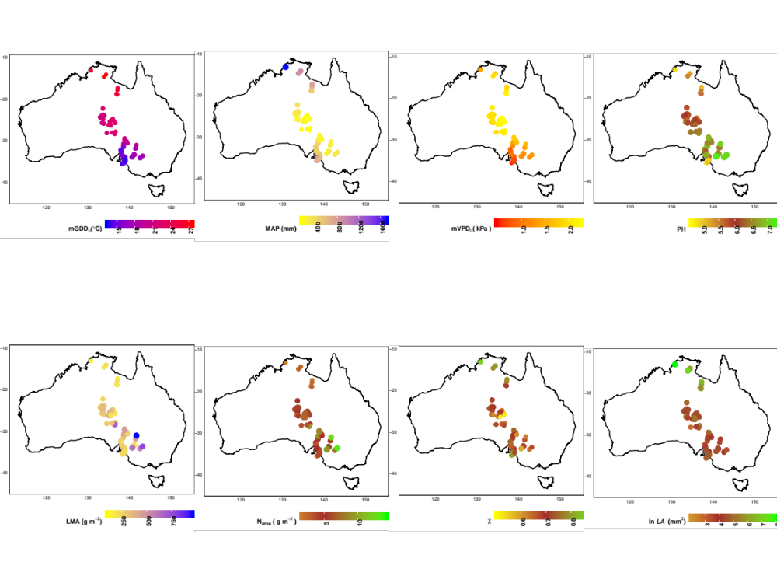

Figure S2. Partial residual plots for multiple linear regression of ln N_{area} (g m⁻²) as a function of χ (c_{i:}c_{a}, from δ13C), ln I_{L} (mean canopy PAR; mmol m^{–2} s^{–1}), MAT (˚C), ln LMA (g m^{–2}), factor ‘N-fixer’, and soil C:N ratio. ln represented log-transformed. Blue lines are the regression lines, grey dots represent species values.

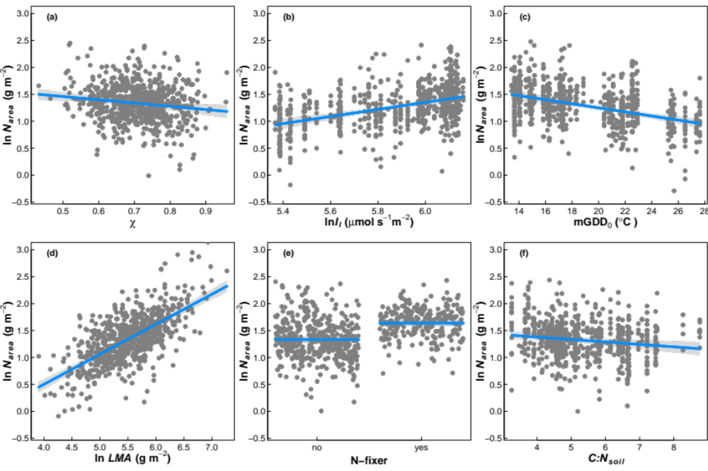

Figure S3. Partial residual plots of the mixed-effect regression models with species as a random variable for key plant traits as a function of mean growing-season temperature (mGDD0, ˚C), mean growing-season vapour pressure deficit (mVPD0, kPa) and soil pH.
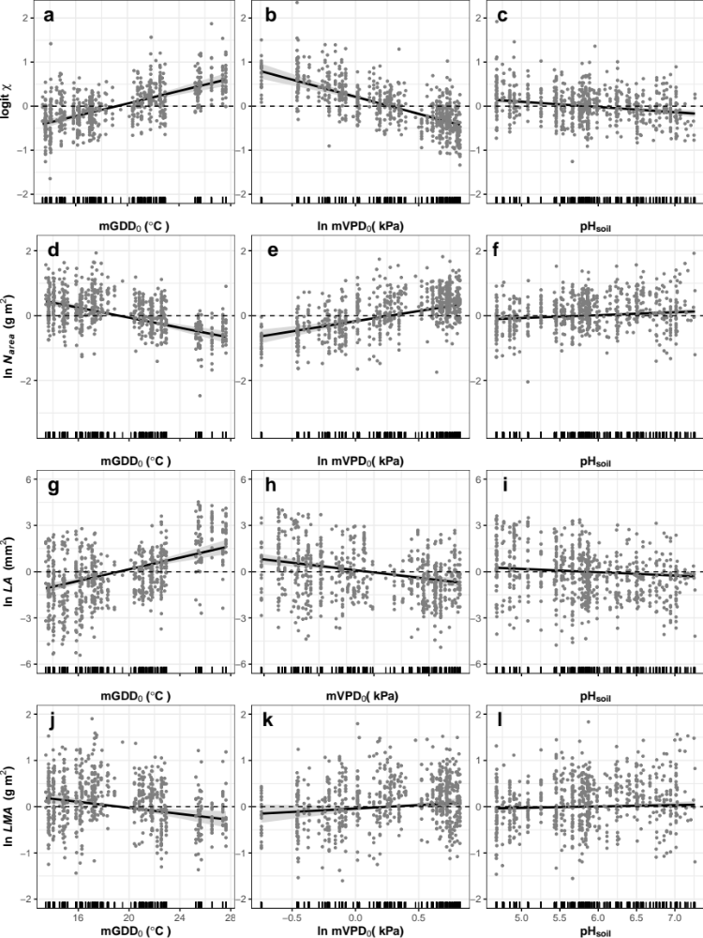
Figure S4. Partial residual plots of for key plant traits as a function of mean growing-season temperature (mGDD0, ˚C), mean growing-season vapour pressure deficit (mVPD0, kPa) and soil pH, where soil pH was used gam function to treat as nonlinear variable in the regression model.
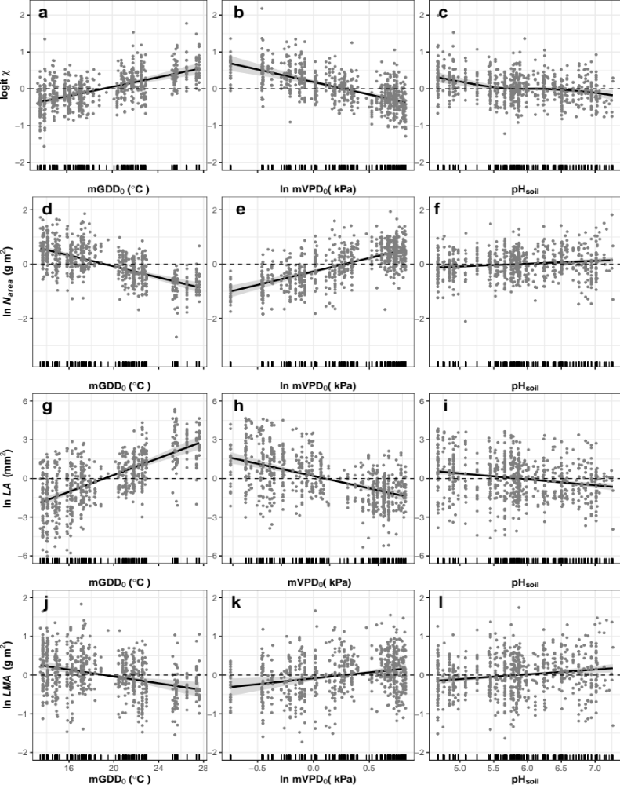
Table S1 List of environment variables and plant traits.

Abbreviation | Variables | Unit
LMA | leaf mass per area | g m^{–2}
N_{area} | leaf nitrogen per area | g m^{–2}
LA | leaf area | mm²
χ | ratio of leaf-internal to ambient CO₂ | –
MAT | Annual mean temperature | ˚C
mGDD₀ | Growing-season mean temperature | ˚C
MAP | Annual precipitation | mm
VPD | Vapour pressure deficit | kPa
mVPD₀ | Growing-season mean vapour pressure deficit | kPa
C:N_{soil} | Soil C:N ratio | –
pH_{soil} | soil pH | –

Table S2 Multiple linear regression comparison with or without soil variables for ln N_{area} (g m^{–2}) as a function of χ (c_{i:}c_{a}, from δ¹³C), ln (mean canopy PAR, I_{L}) (mmol m^{–2} s^{–1}), mGDD0 (˚C), ln LMA (g m^{–2}), the factor ‘N-fixer’, soil C: N _{soil} and pH at species level. Theoretical slopes are derived from mean condition of research sites, using methods in Dong et al, 2017.

 | ln N_{area} |  |  | Theoretical value
χ | -0.60*** | -0.61*** | -0.56*** | –0.60
 | (–0.98, –0.23) | (–0.98, –0.24) | (–0.94, –0.19)
ln I_{L} | 0.81*** | 0.66*** | 0.74*** | 1
 | (0.62, 1.00) | (0.44,0.87) | (0.52,0.96)
mGDD₀ | –0.04*** | –0.04*** | –0.04*** | -0.05
 | (–0.05, –0.03) | (–0.05, –0.03) | (–0.05, –0.03)
Ln LMA | 0.56*** | 0.56*** | 0.56*** | --
 | (0.51,0.61) | (0.51,0.61) | (0.51,0.61)
N-fixer (yes) | 0.30*** | 0.31*** | 0.30*** | --
 | (0.24,0.36) | (0.25,0.36) | (0.24,0.35)
C: N _{soil} |  | –0.05*** |  | --
 |  | (–0.07, –0.02)
 |  |  | 0.02⁺ | --
pH_{soil} |  |  | (–0.01, 0.05)
R² | 61.8% | 62.3% | 61.9%

Note: Numbers in parentheses are 95% confidence limits + for p < 0.1, ***p<0.001

Table S3. Cross-correlation table of all plant traits and environmental variables. Red represents positive correlation, blue represents negative correlation.

 | N_{mass} | N_{area} | LMA | LA | χ | mGDD0 | VPD | MAP | pH | C:N_{soil}
N_{mass} |  | 0.41 | –0.35 | –0.13 | –0.14 | 0.08 | 0.21 | –0.28 | 0.15 | –0.21
N_{area} |  |  | 0.68 | –0.15 | –0.32 | -0.09 | 0.17 | –0.5 | 0.39 | –0.24
LMA |  |  |  | –0.01 | –0.21 | –0.14 | 0 | –0.26 | 0.25 | –0.08
LA |  |  |  |  | 0.15 | 0.32 | 0.09 | 0.4 | –0.18 | 0.04
χ |  |  |  |  |  | –0.01 | –0.29 | 0.58 | –0.42 | 0.28
mGDD0 |  |  |  |  |  |  | 0.86 | 0.04 | 0.16 | –0.44
VPD |  |  |  |  |  |  |  | –0.43 | 0.42 | –0.59
MAP |  |  |  |  |  |  |  |  | –0.62 | 0.4
pH |  |  |  |  |  |  |  |  |  | –0.49
C:N_{soil}
Note: N_{area}, leaf nitrogen per area; N_{mass}, leaf nitrogen per mass. MAP, annual mean precipitation.

Table S4 The heterogeneity table for the regression models of leaf traits as a function of mean growing-season temperature (mGDD0, ˚C), mean growing-season vapour pressure deficit (mVPD0, kPa) and soil pH in Figure 2.

Trait | Environment | Heterogeneous | p | Common slope
logit χ | mGDD₀ | No | 0.45 | 0.058
logit χ | ln mVPD₀ | No | 0.57 | –0.742
logit χ | pH_{soil} | No | 0.96 | –0.115
ln N_{area}  (g m⁻²) | mGDD₀ | No | 0.11 | –0.141
ln N_{area}  (g m⁻²) | ln mVPD₀ | No | 0.7 | 0.505
ln N_{area}  (g m⁻²) | pH_{soil} | Yes | <0.001
ln LA  (cm⁻²) | mGDD₀ | Yes | <0.013
ln LA  (cm⁻²) | mVPD₀ | Yes | <0.001
ln LA  (cm⁻²) | pH_{soil} | Yes | <0.001
ln LMA  (g m⁻²) | mGDD₀ | No | 0.90 | –0.046
ln LMA  (g m⁻²) | ln mVPD₀ | No | 0.24 | 0.199
ln LMA  (g m⁻²) | pH_{soil} | Yes | 0.045

Table S5 Coefficients for the mixed effect regression models of leaf traits as a function of mean growing-season temperature (mGDD₀, ˚C), mean growing-season vapour pressure deficit (mVPD₀, kPa) and soil pH in Figure S4 with species as a random variable.

Traits | Environment | Slope | R² | p
Logit χ | mGDD₀ | 0.07 | 32% | <0.001
Logit χ | ln mVPD₀ | –0.77 | 32% | <0.001
Logit χ | pH_{soil} | –0.12 | 32% | <0.001
ln N_{area}  (g m⁻²) | mGDD₀ | –0.08 |  | <0.001
ln N_{area}  (g m⁻²) | ln mVPD₀ | 0.63 | 22% | <0.001
ln N_{area}  (g m⁻²) | pH_{soil} | 0.09 |  | <0.01
ln LA  (cm⁻²) | mGDD₀ | 0.18 |  | <0.01
ln LA  (cm⁻²) | mVPD₀ | –0.84 | 20% | <0.001
ln LA  (cm⁻²) | pH_{soil} | –0.22 |  | <0.01
ln LMA  (g m⁻²) | mGDD₀ | –0.03 |  | <0.01
ln LMA  (g m⁻²) | ln mVPD₀ | 0.14 | 6% | >0.05
ln LMA  (g m⁻²) | pH_{soil} | 0.03 |  | >0.05

Reference:

Dong N, Prentice IC, Evans BJ, Caddy-Retalic S, Lowe AJ, Wright IJ. 2017a. Leaf nitrogen from first principles: field evidence for adaptive variation with climate. Biogeosciences 14(2): 481-495.

