On Alteration Rate Renewal Stage of Nuclear Waste Glass Corrosion
Michael I. Ojovan¹
¹Department of Materials Science and Engineering, The University of Sheffield, UK; m.ojovan@sheffield.ac.uk
Abstract: The three generically accepted stages of glass corrosion are reviewed with focus on final stage termed alteration rate renewal (or resumption) stage when the glass may re-start corroding with the rate similar to that at the initial stage. It is emphasized that physical state and physical changes that occur in the near-surface layers can readily lead to an effective increase of leaching rate which is similar to alteration rate renewals. Experimental data on long-term (during few decades) corrosion of radioactive borosilicate glass K26 designed to immobilize high-sodium operational NPP radioactive waste evidence on resumption-like effects of radionuclides (^{137,134}Cs) leaching. The cause of that was however related not to chemical changes in the leaching environment but rather to physical state of glass surface due to formation of small cracks and new pristine glass areas in contact with water.
Introduction:
Vitrification is one of the best solutions in providing safety of nuclear waste storage, transportation and final disposal [1-3]. France, India, Japan, Russia, Slovakia, South Korea, the UK and USA have currently vitrification facilities in operation for the immobilisation of high level nuclear waste (HLW) and low and intermediate level nuclear waste (LILW), with Germany having recently completed their HLW vitrification program [2-6]. Table 1 gives data on HLW vitrification programs (see [2] for details). Except for alkali-aluminophosphate glass used in Russia, borosilicate glass has been universally selected as the vitreous wasteform to immobilize HLW [5, 6] whereas some LILW waste streams such as legacy waste accumulated from various nuclear development programs are preferable immobilized using bespoke selected silicate or phosphate systems better suited for particular waste compositions.

Table 1 Operational data of HLW vitrification programmes
Country (Facilities) | Performance
France (R7/T7, AVM) | 8252, 291⋅10⁶ TBq to 2019
USA (DWPF, WVDP, WTP) | 7870 tonnes, 2.7⋅10⁶ TBq to 2012
Russia (EP-500) | 6200 tonnes, 23.8⋅10⁶ TBq to 2010
UK (WVP) | 2200 tonnes, 33⋅10⁶ TBq to 2012
Belgium (Pamela) | 500 tonnes, 0.5⋅10⁶ TBq. Completed.
Japan, Tokai | 70 tonnes, 0.4⋅10⁶ Ci* to 2007
Germany (Karlsruhe) | 55 tonnes, 0.8⋅10⁶ TBq. Completed.
India (WIP, AVS, WIP) | 28 tonnes, 0.26⋅10⁶ Ci to 2012
Slovakia (Bohunice) | 1.53 m³ to 2012
*1 Ci = 0.037 TBq

The long-term behaviour of nuclear waste glass in disposal environment is an important input feature in safety assessment programs and models used to assess the ultimate safety of disposal [2]. Indeed, the safety of disposal relies directly on the ability to accurately forecast the source term described by formal calculations of fluxes of radionuclides potentially released from waste packages and the fate of radionuclides within the geosphere for periods up to hundreds of thousands and millions of years. E.g. in the US the compliance period was extended to one million years as part of the performance assessment-viability assessment resulting in adding further complexity to the safety analysis [7]. Understanding of corrosion mechanisms of glasses therefore is of primary importance with many works under way [4, 8-12]. The primary mechanism responsible for the release of radionuclides from nuclear waste glass is through reactions of the glass with the aqueous environment in a disposal facility. The resistance of glass to aqueous corrosion e.g. glass durability, is not solely an intrinsic property of the glass, but is rather the response of glass to a range of environmental factors [2-6, 8-12]. Nuclear waste glass corrosion by groundwater involves coupled processes such as surface reactions, transport properties to and from the reacting glass surface, and ion exchange between the solid glass and the surrounding solution and alteration products at various scales that need to be well understood to develop predictive kinetic models [4, 8-12]. Several interrelated processes can take place at the glass surface during corrosion: water diffusion, ion exchange between hydrogenated species and alkalis weakly bound to glass formers (i.e. interdiffusion), hydrolysis of covalent and ionic-covalent Si–O–M bonds (M = Si, Al, Zr, Fe, Zn, etc.), condensation of species detached from the glass surface, and precipitation of crystalline phases from amorphous phases and soluble species. Similar by nature processes occur on corrosion of sodium-aluminophosphate HLW glasses used in Russia [13].
GLASS CORROSION MECHANISMS
Under conditions representative of geological disposal environments three main stages can be identified: I – the initial rate, II – the residual rate, and in some cases III – a resumption of relatively rapid alteration (Figure 1).
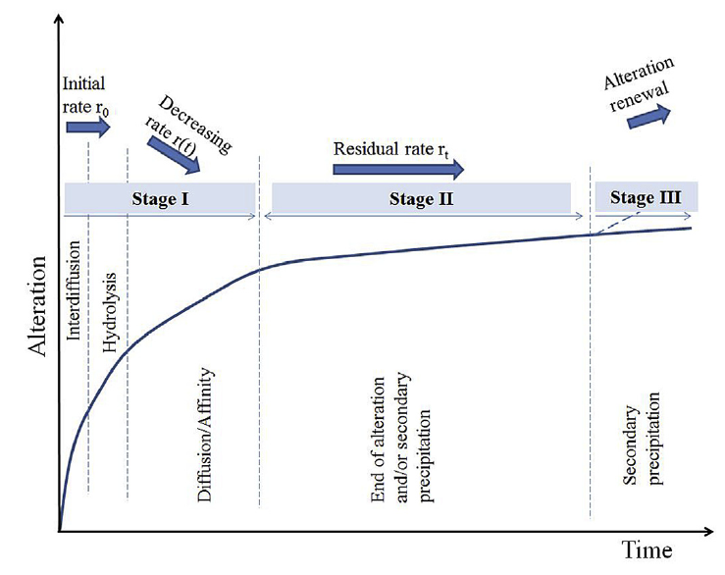
Fig. 1. Schematic of glass corrosion processes in typical geological disposal conditions when the water in contact with glass is stagnant

The time that the glass remains in each stage depends strongly on environmental parameters that impact the rates of individual reactions (e.g., temperature, pH, solution composition and flow, glass composition). In fast flowing environments, the solution remains dilute and Stage I dominates for long periods that might be unlimited [11, 14]. Moreover, in this case it is possible to assess the time needed for transition from one (interdiffusion) to another (hydrolysis) mechanism of corrosion as well as the pH dependence of corrosion rate which has a typical U-shaped form [15]. Note that interdiffusion occurs in every kinetic stage but typically acts alone only for relative short times if the temperature is not too low (Figure 2).

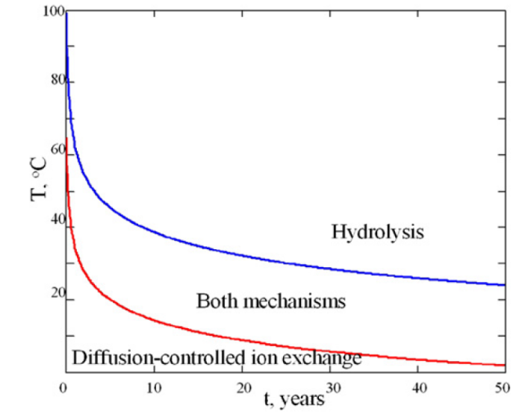
Fig. 2. Corrosion mechanisms of British magnox-waste glass in flowing water. The lower the temperature the longer a mechanism lasts

In slow flowing or static conditions (also termed confined [2]), Stage II is quickly achieved. The associated residual rate appears to best represent the behaviour of ancient natural and man-made glasses that have been exposed for thousands to millions of years [11]. Moreover, it was many times emphasized that the residual rate is most probably due to interdiffusion and that the ion exchange stage will persist for geological timescales in silica saturated conditions [2, 14, 16].
During glass dissolution, a surface “gel” layer resembling a membrane forms through which ions exchange between the glass and the groundwater. The hydrated gel layer exhibits acid/base properties which are manifested as the pH dependence of the thickness and nature of the gel layer. The gel layer ages into clay or zeolite minerals by Ostwald ripening. Zeolite mineral assemblages (forming at higher pH and in Al3+ rich glasses) may cause the dissolution rate to increase which is undesirable for long-term performance of glass in the environment.
Resumption i.e. Stage III has been identified in selected systems when large amounts of secondary phases such as calcium-silicate hydrates (CSH), magnesium silicates, iron silicates, or aluminosilicate zeolites precipitate. However, the Stage III of corrosion behaviour has not always been observed, with some systems exhibiting slow alteration rates representative of Stage II behaviour for long periods of exposure [11].
SURFACE LAYERS ON GLASS
Silica-rich surface layers formed on nuclear glass surfaces can be transport limiting, however the detailed processes by which the alteration layers form and rate limiting reactions or phenomena attributed to the layers are still under debate [11, 17-19]. Silica from the glass, along with other glass components such as Al, Zr, and Ca, form an amorphous, porous, and hydrated interfacial surface layer by one of two processes:
(1) reorganization via hydrolysis/condensation reactions in which SiO2 tetrahedra are not completely detached from the glass and/or
(2) dissolution and reprecipitation of species in aqueous solution.
The structure of alteration layers on glass surface can be complex and in some cases form multi-layers – lamellae [20-22], which indicate on a non-linear kinetics of corrosion process [23-25]. The protective passivation can change over time as conditions change and the alteration layers evolve. The alteration films are amorphous, thermodynamically unstable and can dissolve, ripen, or crystallize. The crystallization of secondary phases also occurs through direct precipitation from solution. These processes can both occur progressively and can result in the loss of any protective properties of the interfacial layer and change the geochemical properties of the solution in contact with the uncorroded glass, either of which in turn can lead to accelerated glass dissolution rate [11].
Zeolite precipitation, with detrimental consequences for glass durability, has typically been seen in laboratory experiments performed at high pH [26]. However other physical processes, such as mechanical stress or radiation damage, could also disrupt glass passivation by surface layers. The formation of hydrated surface layers has the potential to generate mechanical stress [27]:
(i) within the layer itself, forming cracks and thus promoting direct contact between the fluid and the pristine glass surface, or
(ii) within the glass, creating fresh surfaces in the pristine material.
If fresh surfaces are created, it is then critical to assess if the passivating effect is re-established over time [11]. The overview by Franken et.al. [11] noted that except in rare cases [28], there is no evidence in the literature for a dramatic increase of nuclear glass alteration due to stress effects.
In this work we present experimental data on long-term (over a decade) environmental corrosion of radioactive borosilicate glass K26 that immobilized high-sodium radioactive waste of NPP. We give evidence on resumptions of radionuclides (^{137,134}Cs) leaching, that however was caused not by chemical changes in the leaching environment but rather to changes of physical state of glass surface. Small cracks formed on the surface in contact with water and that caused the resumption-like effects.

EXPERIMENTAL
The nuclear waste glass K26 was designed to immobilize operational NPP LILW [29-31]. Real radioactive wastes with specific activity up to 37 MBq/L from NPP’s with water-water (WWER) and channel type (RBMK) reactors have been vitrified [31]. The volume reduction factor in the process of vitrification has varied from 4·2 to 4·5. Losses (carryover) of radioactive Cs from the melter in the process of vitrification have been below 3·5%. Table 2 gives data on glass composition.

Table 2 Composition of nuclear waste glass K26 (BS8, BS9, BS10), wt.%.
Oxide | SiO₂ | B₂O₃ | Al₂O₃ | CaO | Na₂O | Fe₂O₃ | Misc
Content | 43.01±1.93 | 6.55±0.60 | 3.06±0.30 | 13.72±0.14 | 23.93±0.71 | 1.90±0.143 | 7.83

The radioactive waste glass K26 produced was disposed of at the experimental site for observation and safety evaluation (Figure 3) [29]. Samples of glasses from open area (designation BS8, BS9, BS10) [32]) were retrieved for analyses of glass status whereas the repository was unsealed after 12 years of exposure and samples of waste glass K26 were taken for analyses.

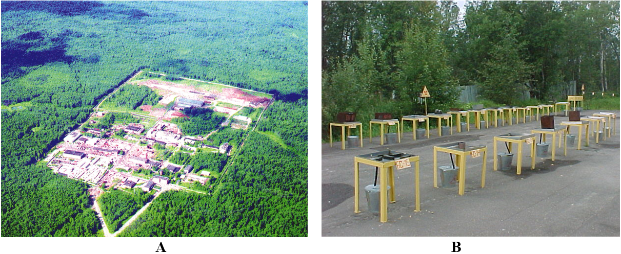
Fig. 3. (A) An aerial view of testing site; (B) Nuclear waste glass samples BS8, BS, 9, BS10 on open testing area

The surface of glass was investigated using the SEMs JEOL 5300 and 5610 and a TEM JEOL 2010F with an Oxford Instruments ISIS EDS system. A DRON-4 diffractometer (Fe Kα radiation) was used for XRD analysis of the near surface corrosion products. To perform XRD analysis, specimens of the altered glass were scraped from surfaces of the glass blocks and collected on aluminium targets.
Results and discussion
SEM examination of glass demonstrated that the glass surface was altered due to corrosion processes (Figure 4). The alteration layer was found to be chemically inhomogeneous and non-uniform both in thickness and structure in the case of glass tested in the underground repository (Figure 4(A)). Light contrast crystalline inclusions on the surface of altered glass which are presumably calcite deposits [29, 30].
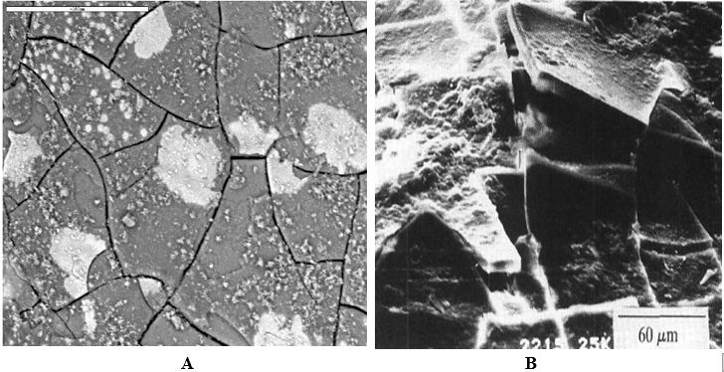
Fig. 4 . SEM images of glass surface: (A) sample K26 from underground repository; (B) sample BS8 from open testing area

The thickness of layers formed on glasses tested in the repository was impossible to measure due to layer nonuniformity. This contrasted to well defined altered layers formed on the same composition glass (samples BS8, BS9, BS10) tested in open site conditions (Figure 4(B)) [32]. Hence the alteration of glass is different in the conditions of repository compared with that of open area tests.
XRD analysis demonstrated that the alteration layer on glass K26 is amorphous with only small amounts of crystalline inclusions being present namely: alpha quartz, calcite (CaCO₃), aluminium hydrochlorides, and molybdenum compounds [29, 30]. A view of K26 glass surface is shown in Figure 5 along with two EDS spectra from different places on it. The portion of the glass without secondary phase layer on it (lower part in left part of Figure 5) shows a rather porous and hydrated glass, which can be a gel layer formed on a pristine glass e.g. an amorphous layer which possible fractured during dessication before SEM observation.
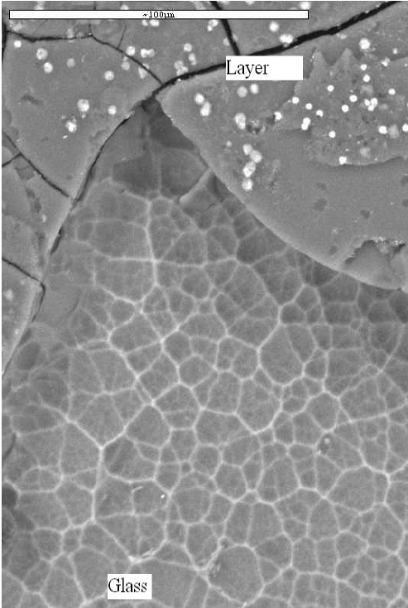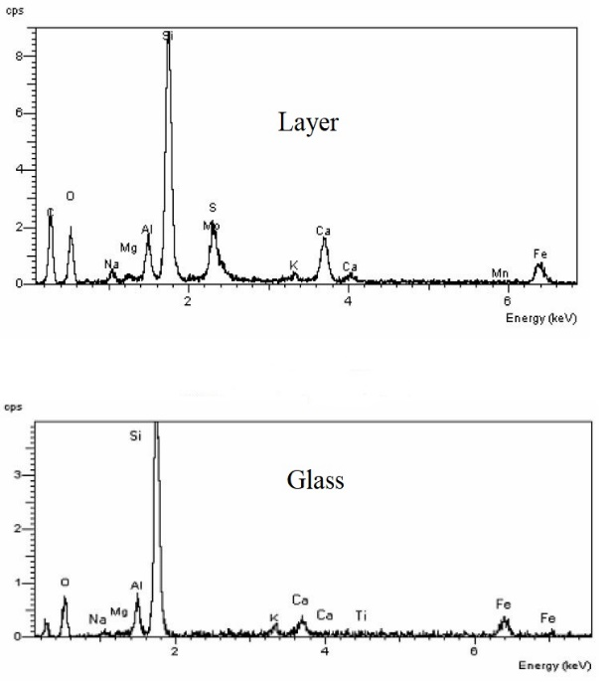
Fig. 5. SEM image of altered layers on the glass K26 and EDS spectra of the layer and altered glass.

EDS measurements of the surface revealed several phases which were confidently identified (Alpha quartz, Calcite, Hematite/Magnetite, Anatase/Rutile) and three potential phases (Ankerite, Ilmenite, Perovskite) [29].
The ¹³⁷Cs normalised mass loss NM (g/cm²) was obtained using equation NM = A/qS, where A (Bq) is the total amount of ¹³⁷Cs leached out from the nuclear waste glass, S (cm²) is the surface area of the glass in contact with groundwater and q (Bq/g) is the specific ¹³⁷Cs content in K26 glass. The average leaching rate NR/t, where t is time, gradually diminished during the test period from 9·4×10⁻⁷ over the first year to 2·2×10⁻⁷ g/cm² day after 16 years [30, 33].
It has been found however that leaching of ¹³⁷Cs has a pronounced nonmonotonic behaviour [32-35]. There were many observed fluctuations of leaching behaviour when leaching rates increased by orders of magnitude moreover leaching rate jumps were higher and more frequent for open area tests [32-35] compared to the same glass behaviour in near surface repository conditions (Figure 6).
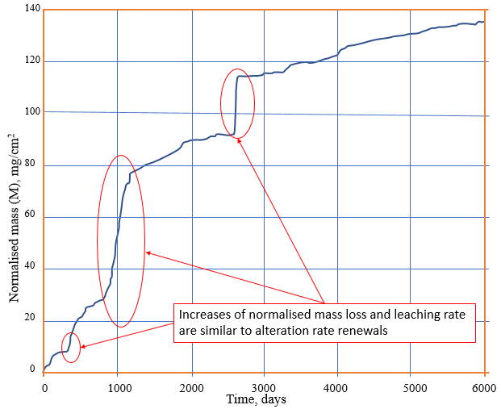
Fig. 6. The normalized mass losses of ¹³⁷Cs from glass

The jumps in the leaching process are most probably caused by formation of new surface areas of pristine glass due to micro-cracks formation that contact water. Indeed, many small cracks have been detected on the glass surface after prolonged tests in the open area conditions which form with time an entire network over the surface of the glass (Fig. 4(B)).
Although similar to resumption Stage III, the jumps in mass losses caused by cracks formation do not continue indefinite and follow the stages I and II (see Figure 1) with release rates returning gradually to small values characteristic to Stage II of residual rate. That type of behaviour allows calculating normalised leaching rates of glasses and effective diffusion coefficients using computer codes that account for newly formed areas of fresh glass in contact with water [34].
The genesis of crack formation on the surface of glassy wasteform is however not well investigated although it is known that fresh (pristine) glass areas will increase the leaching rates [11], and that formation of cracks could be responsible for the fluctuating character of radionuclide leaching. This assumption alone could not quantitatively characterise the magnitudes of leaching rate increase that were detected experimentally because the corroded mass increases at the times of leaching rate jumps are significant. They cannot be entirely explained by the increase of water contacting surface on crack formation. An account of real state of glass after cracking is needed that includes effective enrichment of fresh glass surfaces with alkali.
Ii is important that both experimental works [35] and molecular dynamic simulations [36] have proved that the freshly formed glass surfaces are indeed enriched in alkali elements including ^{137,134}Cs. An account of enrichment effects on glass fragmentation allows to explain quantitatively the magnitude of jumps [35]. Recent experiments with partial immersion test methodology that are reproducing more realistically the conditions in which water comes into contact with glassy wasteforms [37] can also involve mechanisms of degradation of near-surface layers analysed herewith.
Conclusion
Physical state and physical changes that occur in the near-surface layers of nuclear waste glasses can readily lead to effective increases of leaching rate similar to alteration rate renewals. This was demonstrated by experimental data on long-term corrosion tests of radioactive borosilicate glass K26 designed to immobilise high-sodium operational NPP radioactive waste. The cause of effects that are similar to alteration rate resumption can be formation of small cracks on the surface that result in new alkali-enriched fresh-glass areas in contact with water.
References
- J.C. Marra, M.I. Ojovan. Vitrification of Radioactive Wastes. Glass International, 37 (4), 19-21 (2014).
- M.I. Ojovan, W.E. Lee, S.N. Kalmykov. An introduction to nuclear waste immobilisation. Third edition, Elsevier, Amsterdam, 497 pp. (2019).
- S. Gin, P. Jollivet, M. Tribet, S. Peuget, S. Schuller. Radionuclides containment in nuclear glasses: an overview. Radiochim. Acta, 105 (11): 927–959 (2017).
- S. Gin , A. Abdelouas, L. Criscenti, W. Ebert, K. Ferrand, T. Geisler, M. Harrison, Y. Inagaki, S. Mitsui, K. Mueller, J. Marra, C. Pantano, E. Pierce, J. Ryan, J. Schofield, C. Steefel, J. Vienna. An international initiative on long-term behavior of high-level nuclear waste glass. Mater. Today, 16, 243-248 (2013).
- C.M. Jantzen. Historical development of glass and ceramic waste forms for high level radioactive waste. In: Ojovan M. Handbook of Advanced Radioactive Waste Conditioning Technologies. Woodhead, Cambridge. 159-172 (2011).
- C.M. Jantzen. Development of glass matrices for HLW radioactive wastes. Ibid, 230-292 (2011).
- F. Diaz-Maurin, R.C. Ewing. Mission Impossible? Socio-Technical Integration of Nuclear Waste Geological Disposal Systems. Sustainability, 10, 4390 (2018).
- D. Bacon, E. Pierce. Development of long-term behaviour models. In: Ojovan M. Handbook of Advanced Radioactive Waste Conditioning Technologies. Woodhead, Cambridge, 433-454 (2011).
- J. Vienna, J. Ryan, S. Gin, Y. Inagaki. Current understanding and remaining challenges in modeling long-term degradation of borosilicate nuclear waste glass. International Journal of Applied Glass Science, 4 (4), 283-294 (2013).
- S. Gin. Open scientific questions about nuclear glass corrosion. Procedia Materials Science, 7, 163 – 171 (2014).
- G.S. Frankel, J.D. Vienna, J. Lian, J.R. Scully, S. Gin, J.V. Ryan, J. Wang, S.H. Kim, W. Windl, J. Du. A comparative review of the aqueous corrosion of glasses, crystalline ceramics, and metals. Npj Materials Degradation, 15, 1-17 (2018).
- R.J. Hand. Chemical durability of nuclear waste glass. ICG Summer School on Glass. Montpelier, 8-12.07.2019
- P.P. Poluektov, O.V. Schmidt, V.A. Kascheev, M.I. Ojovan. Modelling aqueous corrosion of nuclear waste phosphate glass, J. Nucl. Mater., 484, 357–366 (2017).
- M.I. Ojovan, A.S. Pankov, W.E. Lee. The ion exchange phase in corrosion of nuclear waste glasses. J. Nucl. Mater., 358, 57-68 (2006).
- M.I. Ojovan, W.E. Lee. About U-shaped Glass Corrosion Rate/pH Curves for Vitreous Nuclear Wasteforms. Innovations in Corrosion and Materials Science, 7 (1), 30-37 (2017).
- B.P. McGrail, D.H. Bacon, J.P. Icenhower, F.M. Mann, R.J. Puigh, H.T. Schaef, S.V. Mattigod. Near-field performance assessment for a low-activity waste glass disposal system: laboratory testing to modelling results. J. Non-Cryst. Solids, 298, 95-111 (2001).
- Gin, S. et al. The controversial role of inter-diffusion in glass alteration. Chem. Geol. 440, 115–123 (2016).
- Gin S, Jollivet P, Fournier M, Angeli F, Frugier P, Charpentier T. Origin and consequences of silicate glass passivation by surface layers. Nat Commun., 6: 6360 (2015).
- S. Gin, M. Collin, P. Jollivet, M. Fournier, Y. Minet, L. Dupuy, T. Mahadevan, S. Kerisit, J. Du. Dynamics of self-reorganization explains passivation of silicate glasses. Nat Commun., 9 (1): 2169 (2018).
- R. Newton. Some Problems in the Dating of Ancient Glass by Counting the Layers in the Weathering Crust, Glass Technology, 7, (1), 22–25 (1966).
- R.G. Newton, Another unsolved problem concerning weathering layers, Glass Technol. 29 (2), 78–79 (1988).
- T. Geisler, A. Janssen, D. Scheiter, T. Stephan, J. Berndt, A. Putnis. Aqueous corrosion of borosilicate glass under acidic conditions: a new corrosion mechanism. J. Non-Cryst. Solids, 356, 1458–1465 (2010).
- T. Geisler, T. Nagel, M.R. Kilburn, A. Janssen, J.P. Icenhower, R.O.C. Fonseca, M. Grange, A.A. Nemchin. The mechanism of borosilicate glass corrosion revisited. Geochimica et Cosmochimica Acta, 158, 112-129 (2015).
- Y. Wang, C.F. Jove-Colon, K.L. Kuhlman. Nonlinear dynamics and instability of aqueous dissolution of silicate glasses and minerals. Sci Rep., 6: 30256 (2016).
- O. Schalm, W. Anaf. Laminated altered layers in historical glass: Density variations of silica nanoparticle random packings as explanation for the observed lamellae. J. Non-Cryst. Solids, 442, 1–16 (2016).
- M. Fournier, S. Gin, P. Frugier. Resumption of nuclear glass alteration: state of the art. J. Nucl. Mater. 448, 348–363 (2014).
- T. Fett T., Guin, J.P., Wiederhorn, S. M. Stresses in ion-exchange layers of sodalime-silicate glass. Fatigue Fract. Eng. Mater. Struct. 28, 507–514 (2005).
- L.M. Neill, S. Gin, T. Ducasse, T.D. Echave, M. Fournier, P. Jollivet, A. Gourgiotis, N.A. Wall. Various effects of magnetite on international simple glass (ISG) dissolution: implications for the long-term durability of nuclear glasses. Npj Mater. Degrad. 1, 1-11 (2017).
- N.V. Ojovan, I.V. Startceva, A.S. Barinov, A.V. Mokhov, M.I. Ojovan, G. Moebus. Secondary phases on the surface of real vitrified radioactive waste disposed in a loamy soil. Mat. Res. Soc. Symp. Proc. 807, 139-144 (2004).
- M.I. Ojovan, W.E. Lee, A.S. Barinov, I.V. Startceva, D.H. Bacon, B.P. McGrail, J.D. Vienna. Corrosion of low level vitrified radioactive waste in a loamy soil. Glass Technol., Eur. J. Glass Sci. Technol. A, 47 (2), 48-55 (2006).
- I.A. Sobolev, S.A. Dmitriev, F.A. Lifanov, A.P. Kobelev, S.V. Stefanovsky, M.I. Ojovan. Vitrification processes for low, intermediate radioactive and mixed wastes. Glass Technology, 46, 28-35 (2005).
- I.A. Sobolev, M.I. Ojovan, O.G. Batykhnova, N.V. Ojovan, T.D. Scherbatova, Waste glass leaching and alteration under conditions of open site tests, Mater. Res. Soc. Symp. Proc. 465, 245–252 (1997).
- M.I. Ojovan, R.J. Hand, N.V. Ojovan, W.E. Lee. Corrosion of alkali-borosilicate waste glass K-26 in non-saturated conditions. J. Nucl. Mat. 340, 12-24 (2005).
- M.I. Ozhovan, K.N. Semenov, Determination of leaching factors and effective diffusion coefficients of radionuclides from the results of long term tests, At. Energy, 3 (1991) 257–258.
- M.I. Ojovan. Mass spectrometric evidencing on modified random network microstructure and medium range order in silicate glasses. J. Non-Cryst. Solids, 434, 71-78 (2016).
- M. Ren, L. Deng, J. Du. Bulk, surface structures and properties of sodium borosilicate and boroaluminosilicate nuclear waste glasses from molecular dynamics simulations. J. Non-Cryst. Solids, 476, 87-94 (2017).
- R.K. Chinnam, P.C.M. Fossati, W.E. Lee. Degradation of partially immersed glass: A new perspective. J. Nucl. Mat. 503, 56-65 (2018).

