MOF-808 and its hollow fibre adsorbents for efficient diclofenac removal
Nicholaus Prasetya and K. Li*
Barrer Centre, Department of Chemical Engineering, Imperial College London, Exhibition Road, London SW7 2AZ, United Kingdom
* Corresponding author: kang.li@imperial.ac.uk

Abstract
The popularity of diclofenac, one of the highly effective non-steroidal anti-inflammatory drugs (NSAIDs), has led to its excessive consumptions. Consequently, its presence in water bodies is continually increasing and poses serious threats to ecosystems. Adsorption processes have been employed to address this issue. However, most of the commercially available adsorbents such as activated carbon, zeolite, etc. suffer from relatively low diclofenac adsorption capacity (100-200 mg g⁻¹) and slow kinetics. Herein, we explore the potential of MOF-808 as a superior adsorbent for diclofenac removal. Benefitting from its high specific surface area and large pore aperture, the maximum diclofenac adsorption capacity achieved in this study reaches 833 mg g⁻¹ with almost 95% removal within first hour. This performance is one of the highest reported adsorbents for diclofenac removal so far and has led us to have further commercial exploitation by employing a yttria-stabilised zirconia (YSZ) hollow fibre support where the MOF-808 adsorbent is deposited on its outer surface. Such a configuration is beneficial from a practical point-of-view, as it eliminates the requirement of separation of powdered adsorbents from treated water once the adsorption process finishes. Also, the hollow fibre configuration not only substantially increases the surface-area-to-volume ratio of adsorption systems, but also reduces the maldistribution of flows commonly unavoidable in conventional packed bed adsorption columns. The high-efficiency of the MOF-808 hollow fibre adsorbent is exhibited by retainment of its equilibrium adsorption capacity of 796 mg g⁻¹. More importantly, the MOF-808 hollow fibre adsorbent can withstand at least 4 adsorption-regeneration cycles without any significant reduction in the adsorption performances, indicating the potential for possible commercialisation of the MOF-808 adsorbent for diclofenac removal from water.
Keywords: MOF-808, diclofenac sodium, metal-organic framework, adsorption

- Introduction
The rising demand of pharmaceuticals and personal care products (PPCP) along with the continuous growing of global population has sparked the concern regarding their negative consequences to the environment. Non-steroidal anti-inflammatory drug (NSAID) is a typical example of highly consumed PPCP that is usually prescribed to reduce pain and inflammation. As an over-the-counter product in almost every pharmacy, NSAIDs are easily accessed and extensively consumed. As a consequence, their occurrence in the environment can no longer be neglected, particularly because of its possibility to contaminate drinking-water [1].
Diclofenac (2-[2,6-dichlorophenylamino]phenylethanoic acid) is one of the most popular NSAIDs, which can be orally or topically applied in a monosodium form [2]. Despite its efficacy as a painkiller, diclofenac poses an environmental risk for European surface waters and has also been identified as one of the NSAIDs with the highest acute toxicity [3,4]. This has been proven by a number of investigations reporting the negative consequences of the compound once it is released to the surrounding environment, in particular to the living organisms. In this case, its toxic effect has been reported for bacteria, algae, vulture population and freshwater fish through various mechanisms such as renal failure [5–8]. Moreover, such organic micropollutants does also have the potential to exacerbate the toxicity of a particle pollutant in a drinking water system, which can induce more health risks for human beings [9].
To address the above issue, diclofenac must be removed from water bodies before it becomes accumulated and poses a serious threat to human beings. Therefore, a number of treatment processes have been proposed to effectively remove diclofenac from the water such as adsorption [10,11], degradation by Fenton-like oxidation [12], ozonation [13,14] and photocatalysis [15,16]. Ideally, the pollutants should be completely removed by converting them into smaller molecules. However, this usually poses various challenges such as the requirement of highly-oxidizing agents, high cost and the presence of unfavourable or toxic by-products [17]. Therefore, among the widely-investigated strategies, adsorption process is considered as one of the most promising options, in particular for drinking water and wastewater treatment, because of various advantages such as high efficiency, process simplicity, low cost and applicability to be used at low pollutants concentration [18–20].
Up to now, various potential adsorbents have been studied for diclofenac removal from water including zeolite [21,22], activated carbon [23,24], graphene oxide [25,26], mesoporous silica [27,28] and metal-organic frameworks (MOF) [29–31]. Among the potential adsorbents, MOFs are considered as one of the most promising options because of their numerous advantages such as large surface area, pore size tunability and customisable pore functionalisation. Despite these positive aspects, the MOFs that are to be applied for diclofenac removal need to be carefully selected, especially their framework stability in an aqueous environment. This is because a number of MOFs are not stable in the aqueous environment resulting in the framework degradation and loss of crystallinity in the presence of moisture [32]. Such a drawback would hinder the efficacy of MOFs in adsorbing diclofenac from the aqueous streams.
To overcome this deficiency, MOFs constructed from zirconium as the metal ion can be considered as a promising option. This is because the high valence of zirconium metal ion creates a robust MOF framework through a strong Lewis acid-base interaction. Benefitted from its excellent framework stability, a number of studies have been performed on the utilisation of the zirconium-based MOFs for various liquid separation such as desalination [33] and nanofiltration [34]. In addition, the efficacy of zirconium-based MOFs have also been investigated for adsorption of various contaminants from water bodies [29,35] including the removal of diclofenac [30]. However, there are two main drawbacks associated with the current use of zirconium-based MOF for diclofenac removal. Firstly, the total adsorption capacity of the currently investigated MOFs is not exceptional. For instance, the use of the well-known UiO-66 and PCN-208 only resulted in the maximum diclofenac adsorption around 100-200 mg g⁻¹ [29,30,36], which is comparable with the performance of most activated carbon [37–39]. Addressing the challenge, MOF functionalization, such as through the introduction of sulfonic acid and amine groups, then needs to be carried out to improve the adsorption performance [29,30]. Secondly, they may also suffer from a relatively low kinetic adsorption process, resulting in a relatively long time to reach the adsorption equilibrium. This was observed, for example, in PCN-206 where only about 30% of diclofenac was adsorbed during the first hour and required at least 40 hour for the adsorption process to reach the equilibrium [36].
Therefore, in this study, we have explored the potential of using another zirconium-based MOF, called MOF-808. Since its first report in 2014 [40], the MOF-808 has gained increased interests because of its numerous positive properties such as excellent framework stability [41], adjustable properties through defect engineering [42] and potential for various post-modification processes [43,44]. The MOF-808 has been investigated for various applications such as for a proton-conducting materials [45], adsorbents [41], sensors [46] and catalysts [47]. Considering its high specific surface area and large pore aperture that suit well with the size of the diclofenac molecule, we thus selected it as a potential high-performance adsorbent for diclofenac removal. In addition to the fundamental thermodynamic and kinetic studies of MOF-808 for diclofenac removal, we have also developed the MOF-808 hollow fibre adsorbents for further commercial exploitation, as the hollow fibre configuration not only substantially increases the surface-area-to-volume ratio of the adsorption systems, but also reduces the maldistribution of flows commonly unavoidable in conventional packed bed adsorption columns [48,49].
- Materials and methods
  - Chemicals
Zirconyl chloride octahydrate (ZrOCl₂.8H₂O), trimesic acid (H₃BTC) and diclofenac sodium were purchased from Sigma Aldrich UK. Dimethylformamide (DMF), formic acid, N-methyl-2-pyrrolidone (NMP) were purchased from VWR UK. YSZ nanopowder was purchased from Inframat Advanced Materials, United States. Activated carbon was provided by Chemviron.
  - Synthesis of MOF-808
MOF-808 was synthesized according to the published literatures with a slight modification [40,50]. In a typical synthesis, 0.257 gram of ZrOCl₂.8H₂O and 0.056 gram of trimesic acid was firstly dissolved in a 1:1 mixture of DMF and formic acid (24 mL) in a glass vial. The solution was ultrasonicated for approximately 15 minutes to completely dissolve all the MOF precursors. The solution was then put in a preheated convective oven at 120°C for 48 hours and cooled down to room temperature. The resultant white product at the bottom of the vial was collected and washed with DMF and methanol. The products were then immersed in methanol until further use.
  - Fabrication of YSZ hollow fibre support and MOF-808 hollow fibre adsorbent
The YSZ hollow fibre support was prepared based on the previous publication with some adjustments [51]. Briefly, 150 grams of YSZ nanopowder was dispersed in 140 grams of NMP and 2 grams of dispersant. The suspension was then put in the planetary miller for 2 days. Afterwards, PMMA was added to the suspension (20 wt% against NMP) and the suspension was then transferred into roller miller to undergo further milling for two days to completely dissolve the polymer binder. Afterwards, the suspension was transferred into a beaker glass and was degassed for approximately 4 hours to remove air bubbles before the suspension was spun into hollow fibre precursors. During the spinning process, the suspension and bore flow rate were set to be 9 and 16 mL min⁻¹, respectively, without air gap between the spinneret and the water bath. The spun precursor was then left in the water bath for 1 day followed by drying and straightening at ambient condition. After that, the precursor was sintered at 1135°C to obtain the final YSZ hollow fibre with dimensions of outer diameter (OD) and inner diameter (ID) at approximately 2 mm and 1.6 mm, respectively.
The MOF-808 hollow fibre adsorbent was then prepared by a solvothermal method. In this case, a polycrystalline layer of MOF-808 was grown on the outer surface of the YSZ hollow fibre support. The YSZ hollow fibre was firstly cleaned using acetone in ultrasonic bath and dried in an oven at 60°C. Afterwards, the hollow fibres with both ends sealed were immersed in the MOF-808 synthesis solution vertically using a Teflon holder. The composition of the MOF-808 synthesis solution and synthesis conditions were kept the same as those in the synthesis of MOF-808 powder. After the synthesis finished, the MOF-808 hollow fibre adsorbent was washed with DMF and methanol. The MOF-808 hollow fibre adsorbent was left dried at room temperature overnight which was then followed by drying in a convective oven at 100°C.
  - Characterisations
Powder X-Ray Diffraction (PXRD) spectra was collected using PANanlytical XRD instrument. The voltage and current were set at 40 kV and 40 mA, respectively. Fourier Transformed Infrared (FTIR) spectra were collected using Benchtop FTIR Cary Spectrometer. Scanning electron microscopy (SEM) using LEO Gemini 1525 FEGSEM was employed to obtain the micrographs of the gold-coated samples. Specific surface area of the materials was measured at -196°C using Quantachrome iQ3 instrument by using nitrogen as the adsorbate. About 60 mg of samples were used during the measurement. Before the measurement took place, all the samples were in-situ degassed in the instrument at 110°C for 20 hours.
For the adsorption studies, the concentration of diclofenac in the solution was determined by taking the UV-Vis absorbance value at 277 nm. The absorbance of the samples was collected by using Thermo Fisher Scientific Nanodrop UV-Vis spectrophotometer.
  - Studies of diclofenac adsorption
Before the adsorption process, the MOF was firstly dried at 100°C for overnight in a convective oven. During the adsorption study, a stock solution of 1 mg mL⁻¹ diclofenac sodium in deionized water was prepared. For the adsorption isotherm study, the stock solution was diluted into various diclofenac solutions with different concentrations. The adsorbent dosage was maintained to be approximately 2 mg in 4 mL solution. After the introduction of the adsorbent into the solution, the suspensions were then ultrasonicated and put in a roller miller. The adsorption process was left undisturbed for 24 hours at 24°C and pH around 6. Afterwards, the liquid was filtered out using a Sartorius Minisart® 0.22 µm syringe filter and the concentration of diclofenac of the filtrate was determined by using UV-Vis spectrophotometer. It should be noted that, during the adsorption study, there is a possibility that a pollutant may adsorb onto the membrane material of the syringe filter. Therefore, a control experiment was performed to evaluate this possibility. From the Figure S1, it can be seen that, in the absence of adsorbent, only a negligible amount of diclofenac was adsorbed onto the syringe filter. Therefore, it can be safely assumed that the diclofenac adsorption contribution from the syringe filter can be neglected.
Meanwhile, for the kinetic study of diclofenac adsorption, the stock solution was firstly diluted to 0.6 mg mL⁻¹. During this experiment, the adsorbent dosage was maintained at 10 mg in 20 mL solution. The adsorbent was then introduced into the solution and sonicated for 1 minute to enhance the dispersion. Afterwards, the suspension was put in a roller miller to maintain the homogeneity of the suspension. At a certain period of time (5, 10, 20, 40, 60, 120, 180, 240 and 300 minutes), around 1 mL of suspension was taken out and filtered using a Sartorius Minisart® 0.22 µm syringe filter to separate the adsorbent from the suspension. The concentration of diclofenac in the suspension was then determined by measuring the absorbance of the filtrate, which was obtained from the previous filtration, using UV-Vis spectrophotometer. As in the adsorption isotherm study, the kinetic experiment of diclofenac adsorption was also performed at ambient temperature (24°C) and pH around 6.
To investigate the effect of temperature on the adsorption process, four different temperatures were used: 5°C, 24°C, 45°C, and 65°C. For adsorption process at 5°C, the glass vial containing MOF-808 was put inside a 5°C cold room storage. Meanwhile, for adsorption process at both 45°C and 65°C, the glass vial containing MOF-808 was immersed in a controlled-temperature oil bath. In addition to the temperature, the effect of pH was also investigated. In this case, the pH solution of the diclofenac solution was carefully adjusted using either 1M HCl or 1M NaOH. Lastly, the effect of coexisting cation and anion species were also studied by adjusting the concentration of each species to be 1 meq. The adsorption process was then proceeded for 24 hours to ensure the equilibrium condition was achieved.
To study the kinetic performance of MOF-808 hollow fibre adsorbents, the MOF-808 hollow fibre adsorbent was firstly put inside a glass vial containing 0.2 mg mL⁻¹ of diclofenac solution. As in the study for the MOF-808 powder, the glass vial was then put in a roller miller and the concentration of the solution was periodically checked using UV-Vis spectrophotometer (10, 20, 40, 60, 120, 240, 360, 1560 mins). Meanwhile, to study the regenerability of the MOF-808 hollow fibre adsorbent, the hollow fibre adsorbent was vertically fixed using a Teflon holder and placed in a glass vial containing 0.05 mg mL⁻¹ of diclofenac solution. The diclofenac adsorption process was then performed for 8 hours under continuous stirring. The diclofenac concentration before and after the adsorption process were then determined by using UV-Vis spectrophotometer. After the adsorption process, the diclofenac solution was then replaced with a mixture of methanol and acetic acid (9:1 v/v) to wash the MOF-808 hollow fibre adsorbent for overnight and then dried at 100ºC. Afterwards, the MOF-808 hollow fibre adsorbent was re-exposed to the same diclofenac solution to undergo another cycle of adsorption process.
The amount of diclofenac adsorbed on the MOF-808 was calculated using the following equation:
$$q=\frac{(C_{o}-C_{t})V}{m}$$
where q is the adsorbent capacity or the adsorbed amount of the diclofenac (mg g⁻¹), C_{o} and C_{t} are the initial and final concentration of diclofenac in the solution (mg L⁻¹), respectively, V is the volume of the solution (mL) and m is the amount of MOF-808 used during the adsorption study (g).
- Results and discussions
  - MOF-808 particles characterisations
In MOF-808, each zirconium secondary building unit (SBU) is connected to six trimesate linkers. The presence of formate anions is necessary to balance the charge in the framework. Two types of pores exist in MOF-808 as shown in Figure 1. The first one is formed by a tetrahedral cage with the diameter around 0.48 nm. Meanwhile, the second type is an adamantane pore with diameter around 1.84 nm. The presence of the latter adamantane pore is beneficial for diclofenac removal. This is because, considering the smaller molecular size of the diclofenac than the MOF-808 pore, the diclofenac can diffuse easily into the pore to reach the active adsorption sites. Therefore, a fast adsorption kinetic with high diclofenac adsorption capacity can be expected in MOF-808.
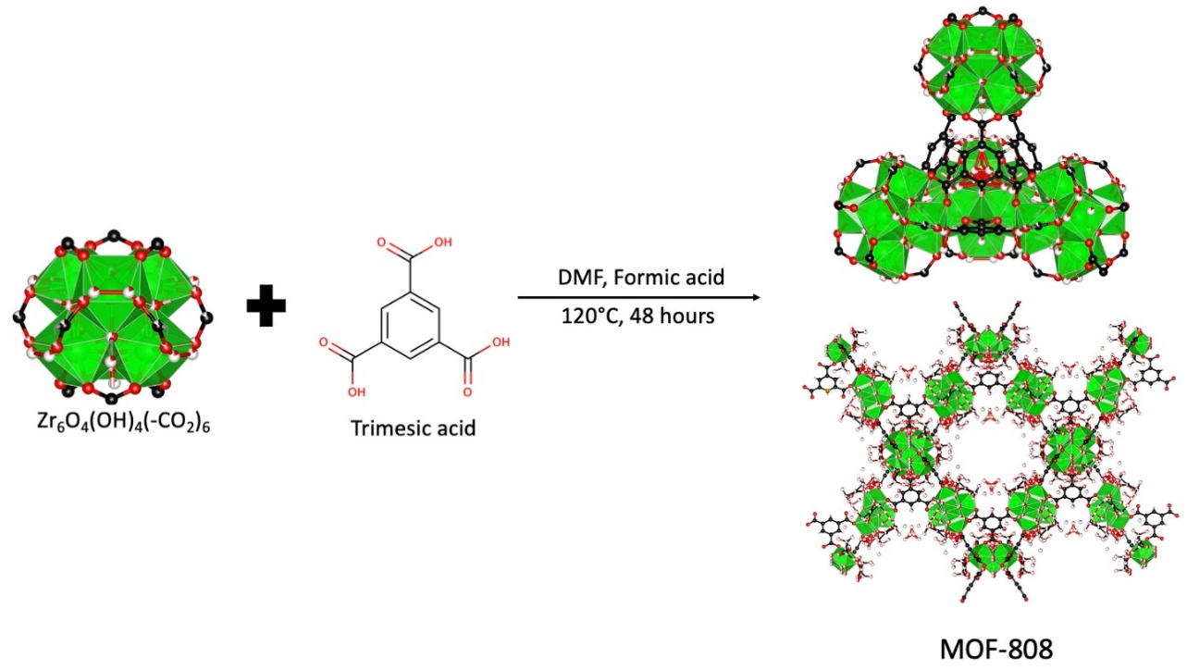
Figure 1. The synthesis of MOF-808 depicting its inorganic building block and ligands. The tetrahedral and adamantane cage is shown at the top and bottom, respectively
The micrograph of the MOF-808 powder synthesised in this study is shown in Figure 2 (A) with a higher magnification micrograph is given in Figure S2 of the Supporting Information. It can be seen from the figure that MOF-808 is crystallised as a nano powder in an octahedral shape with the size ranging between 200-400 nm. PXRD pattern of the samples was collected to confirm the purity of the samples with the diffractogram as shown in Figure 2 (B). It can be seen that the pattern and the relative intensity of MOF-808 spectrum synthesized in this study matches well with the calculated pattern. The absence of unidentified peaks from the PXRD pattern indicates the high crystal purity of the samples.
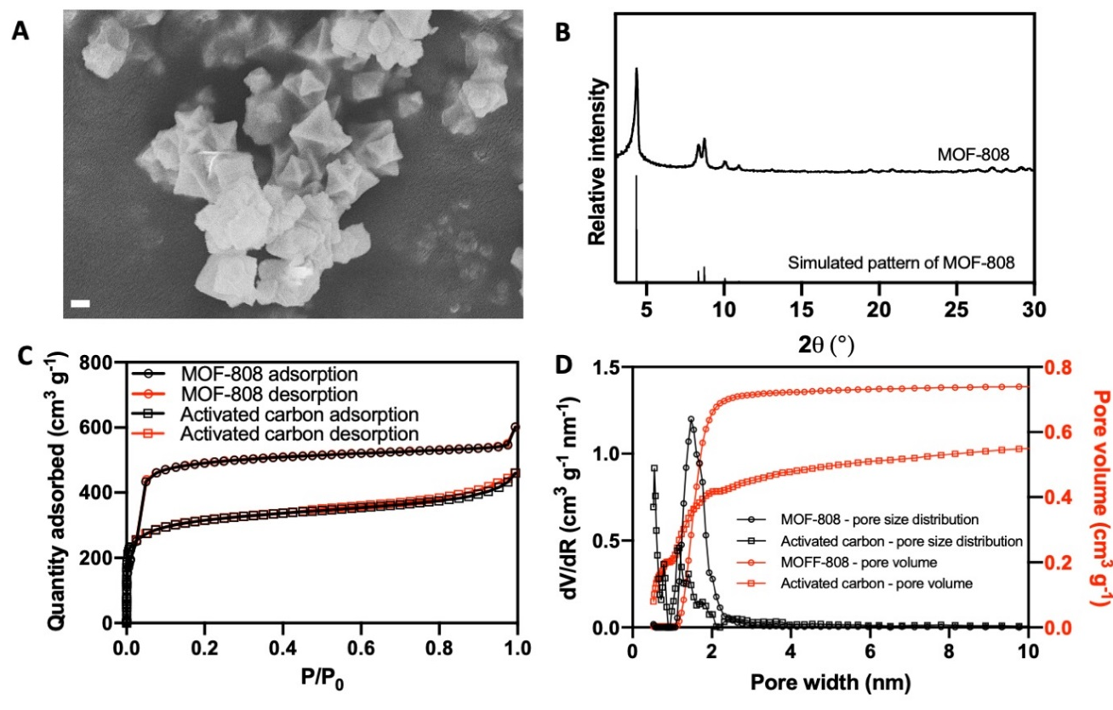
Figure 2. MOF-808 particle characterisations: (A) micrograph image of the MOF-808 (200 nm scalebar), (B) PXRD diffractograms of the MOF-808 and its simulated pattern, (C) nitrogen adsorption of MOF-808 and activated carbon at -196°C and (D) pore size distribution and pore volume of MOF-808 and activated carbon.
The porosity of the MOF-808 was analysed through the physisorption process employing nitrogen as adsorbate at 77 K and the results are given in Figure 2(C) together with a commercial activated carbon for comparison purpose. As shown, the MOF-808 exhibits type-1 isotherm indicating the presence of micropores within its structure. The calculated BET surface area of the sample is around 1517 m² g⁻¹, which is comparable to other findings [46,47,52,53]. Compared with the surface area of the commercial activated carbon, which is around 981 m² g⁻¹, the surface area of MOF-808 is significantly higher. The high surface area of the MOF-808 is beneficial for adsorption process since it can provide more active adsorptive sites. Further analyses on the pore volume and the pore size distribution as shown in Figure 2 (D) also reveal the superiority of MOF-808 compared to that of the activated carbon. The pore volume of MOF-808 is found to be around 0.75 cm³ g⁻¹ which is considerably higher than that of the activated carbon (0.63 cm³ g⁻¹). MOF-808 also possesses a narrow pore size distribution peaking at around 1.6 nm while the activated carbon shows the pore aperture at around 1 nm. The relatively large pore volume and opening of the MOF-808 are beneficial for the adsorption kinetics because of the ease of access to the available adsorption sites. Through these various characterisations, it can be safely inferred that a high purity MOF-808 has been successfully synthesised.
  - Diclofenac adsorption studies on MOF-808
Following the successful synthesis of the MOF-808, diclofenac adsorption study on MOF-808 was performed. Firstly, the adsorption isotherm for both the MOF-808 and activated carbon were evaluated and the results are presented in Figure 3 (A) where it is clearly demonstrated that there is a stark difference in terms of maximum adsorption capacity for these two adsorbents. The saturation capacity of the activated carbon is found to be at around 170 mg g⁻¹, which is comparable with literature values (100-200 mg g⁻¹) performed for diclofenac removal using activated carbon [24,37–39], while the saturation capacity of MOF-808 is found to be around 830 mg g⁻¹, almost 5 times higher than the activated carbon. This result highlights the superiority of MOF-808 for the removal of diclofenac from water bodies compared with the activated carbon. As explained above, the superiority of diclofenac adsorption capacity of MOF-808 compared with the activated carbon may arise from the relatively large surface area of the former and thus providing more active sites for diclofenac adsorption.
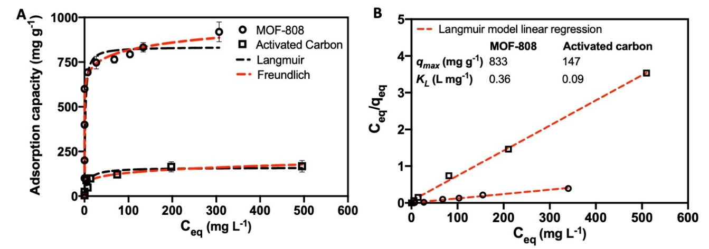
Figure 3. Diclofenac adsorption isotherm (A) and the Langmuir fitting of the isotherm (B) of the MOF-808 and activated carbon
The isotherms were then analysed based on the Langmuir, Freundlich, Hill and Dubinin-Radushkevich (D-R) models, and the results given in Table S1 are plotted in Figure 3 (B) and Figure S3-S5 of Supporting Information, respectively. As can be seen from Table S1, the R² for both Langmuir and Freundlich models are significantly higher than the rest of the models. Furthermore, the Langmuir model does seem to fit better than the Freundlich model to describe diclofenac adsorption phenomenon in both MOF-808 and activated carbon (0.9903 and 0.9979 vs 0.9296 and 0.9392, respectively). Since Freundlich model describes multilayer adsorption on an energetically heterogeneous surface, it can thus be inferred that the diclofenac adsorption process occurs through the formation of diclofenac monolayer on the energetically homogeneous surfaces in both adsorbents. Furthermore, although both Hill and D-R models do not give a good correlation, both models may still give some insights on the nature of the adsorption. From the Hill mode, the adsorption process on both adsorbents may be considered as a non-cooperative phenomenon since both adsorbents have Hill constant around 1 [54]. Meanwhile, from the D-R model, it may be inferred that the diclofenac adsorption on both adsorbents mainly occurs through the physisorption process because the magnitude of the E parameter (mean free energy of adsorption) is less than 8 kJ mol⁻¹ [55].
Having studied the adsorption isotherm, the adsorption kinetics of both adsorbents were also evaluated and the results are given in Figure 4 (A) which depicts that both adsorbents can reach the equilibrium adsorption capacity within 5 hours. Although both adsorbents reach the saturation point at about the same time, a stark difference is observed regarding the time required to reach a certain capacity level. From the results, it can be seen that about 95% of the equilibrium diclofenac adsorption capacity can be obtained in MOF-808. Within the same timeframe, activated carbon can only achieve around 64% of its equilibrium adsorption capacity. This indicates the fast removal of diclofenac possessed by MOF-808. Considering the molecular size of diclofenac sodium (0.96 x 0.708 x 0.472 nm) [56], the fast removal of diclofenac can then be attributed to the relatively large pore aperture of MOF-808 (1.6 nm), which gives less diffusional resistances compared to that of activated carbon (1 nm).
The diclofenac adsorption kinetic was further analysed based on pseudo-first-order and pseudo-second-order. The results for this analysis are given in Table S2 and also plotted in Figure S6 of Supporting Information and Figure 4 (B), respectively. Based on their R² values given in Table S2, the pseudo-second order model gives better fit compared to the pseudo-first order for both adsorbents. The equilibrium capacity of MOF-808 and activated carbon is found to be at 833 mg g⁻¹ and 196 mg g⁻¹, respectively. This value fits well with the maximum adsorption capacity obtained through Langmuir model. Meanwhile, the kinetic rate constants for both MOF-808 and activated carbon were found to be at 3 x 10⁻⁴ and 1.1 x 10⁻⁴ g mg⁻¹ min⁻¹, respectively, thus revealing the faster diclofenac removal achieved by the former.
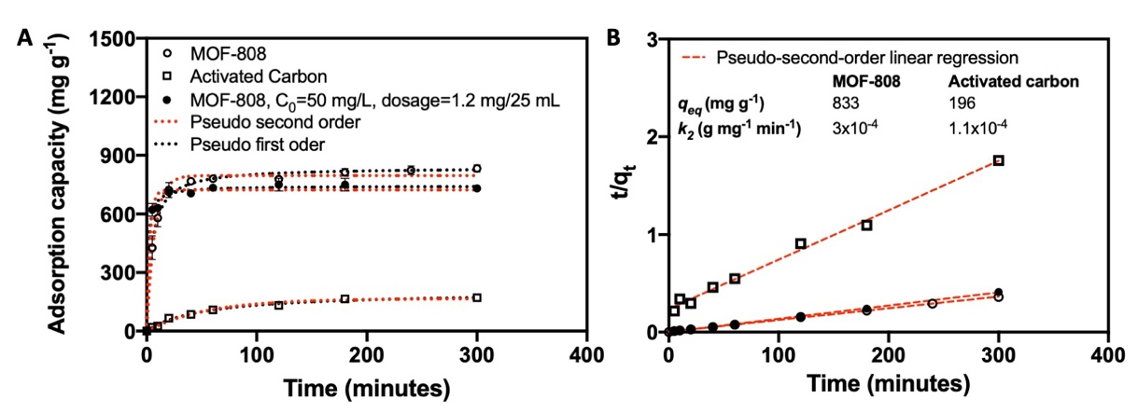
Figure 4. Diclofenac adsorption kinetic study (A) and pseudo-second order fitting (B) of the MOF-808 and activated carbon
Although a great diclofenac adsorption performance has been exhibited by the MOF-808, the adsorption capacity of an adsorbent can be influenced by various factors including adsorbent dosage and the adsorbate initial concentration [23,57]. Considering the relatively high concentration of diclofenac (600 mg L⁻¹) and adsorbent dosage (10mg/20mL) used so far in this study, we further assessed the adsorption performance of MOF-808 at lower initial diclofenac concentration (50 mg L⁻¹) and adsorbent dosage (1mg/25mL). This particular study is important to give an insight when employing MOF-808 in real settings considering the low concentration of diclofenac that is usually found in water bodies [58]. The kinetic results for this condition are also presented in Figure 4 (A). It can be seen that about 95% of the equilibrium adsorption capacity can be reached within 1 hour. This behaviour is similar with the investigation where higher initial diclofenac concentration and adsorbent dosage were used. However, the equilibrium adsorption capacity in this condition is found to be slightly lower at around 740 mg g⁻¹. This may be attributed by several reasons including lower adsorbent-adsorbate interaction and lower driving force for diclofenac to be adsorbed on the MOF-808 pores [59,60]. Despite this, it can still be safely inferred that the adsorption performance of MOF-808 is not heavily impaired, as only around 10% decrease in the equilibrium adsorption capacity was observed.
An analysis based on the intra-particle diffusion model is also performed in order to elucidate the diffusion process during the diclofenac adsorption. The results for this analysis for MOF-808 and activated carbon are then given in Figure 5 (A) and (B), respectively. From the result, it can be seen that a biphasic behaviour of intra-particle diffusion model does exist for MOF-808. This indicates that the adsorption process of diclofenac into the MOF-808 does occur through two main steps: diclofenac diffusion to the adsorbent surface for the fast initial adsorption rate (first stage) and then followed by the diffusion of the diclofenac into the micropore of the MOF-808 to reach the equilibrium [27,61]. In this case, an intermediate step, which is usually indicated by the presence of an additional linear step before the equilibrium phase, is not observed [62,63]. This then indicates the absence of gradual adsorption process within the pore of MOF-808 which may be attributed to the relatively large pore aperture of MOF-808 so the diclofenac transport within the inner adsorbent surface is not significantly inhibited resulting in the rapid establishment of the equilibrium adsorption condition. Meanwhile, the existence of multilinearity in the intra-particle diffusion analysis of the activated carbon is not obvious and thus can still be linearly fitted with the intraparticle diffusion model. In this case, the diclofenac adsorption process is then governed by the intra-particle diffusion [64].
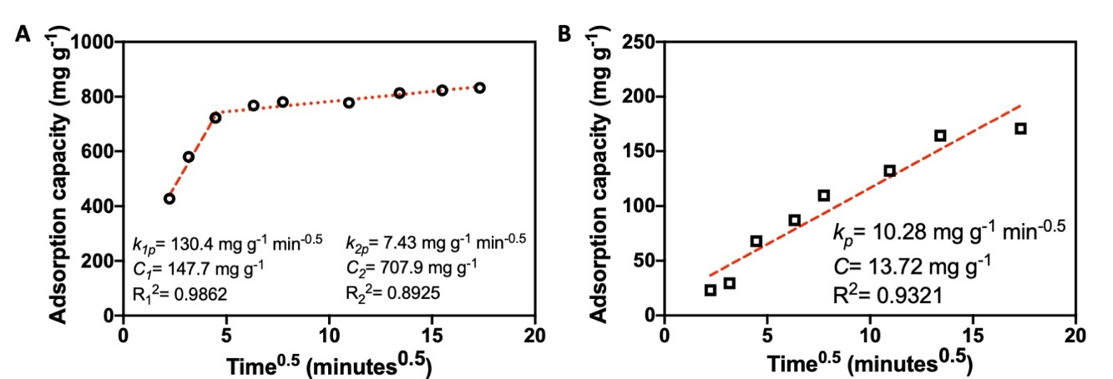
Figure 5. Intra-particle diffusion analysis of diclofenac adsorption on MOF-808 (A) and activated carbon (B)
The effects of pH on the diclofenac adsorption on MOF-808 were also studied and the results are shown in Figure 6 (A). Four different pH was used to elucidate the effect of pH on the adsorption capacity of MOF-808, i.e. 5.5, 6, 7.8 and 9.5. In this case, further reduction in pH was not feasible as the diclofenac started to precipitate. From the results, it can be seen that adjusting the pH at a slightly acidic condition would only give a minimal impact on the diclofenac adsorption capacity of the MOF-808. At pH 5.5, the diclofenac adsorption capacity of the MOF-808 was found to be at 800 mg g⁻¹. When the pH is further increased, a more obvious trend can be observed with the reduction of diclofenac adsorption capacity. At pH 9.5, the diclofenac adsorption capacity of the MOF-808 was found to be at 760 mg g⁻¹, which is about 10% lower than the MOF-808 without pH adjustment.
This trend was also previously observed in the study of utilization of UiO-66-NH₂ for diclofenac removal [30]. It was found that only a slight change was observed regarding the diclofenac adsorption capacity within the range of pH studied. In this case, a lower diclofenac adsorption capacity at higher pH can be ascribed to the negative surface charge of the MOF-808. From the zeta potential measurement, it was found that surface charge of MOF-808 at pH 6 was 16 mV. The positive charge of the MOF-808 may be responsible in building an electrostatic interaction between the MOF-808 and the diclofenac anion. Once the pH is further increased, the surface charge of the MOF-808 becomes more negative, thus resulting in repulsion between the MOF-808 surface and diclofenac anion, giving in the reduction of adsorption capacity.
The effect of temperatures on the diclofenac adsorption capacity of the MOF-808 was also studied and the results are given in Figure 6 (B). As shown in the figure, resembling the trend with the change of pH, only a slight variation in the diclofenac adsorption capacity of MOF-808 is observed when the operating temperature is increased from 5°C to 65°C. At 65°C, the diclofenac adsorption capacity was found to be at 760 mg g⁻¹, which is around 20% lower than the adsorption capacity at 5°C. This trend is different with the one that was previously observed in UiO-66 where an increase in diclofenac adsorption capacity was observed at higher temperature [30]. A further thermodynamic evaluation, as shown in Table S3, also reveals that the ∆H is found to be at -6.1 kJ mol⁻¹. Therefore, since higher operating temperature leads to lower adsorption capacity, the diclofenac adsorption in MOF-808 is an exothermic process. This may be caused by the decreased MOF-808-diclofenac interaction as the temperature is elevated because of the increased interaction between diclofenac and the solvent [65]. As with ∆H, it can also be seen from Table S3 that the change in entropy (∆S) is also negative and is around -5.9 J mol⁻¹ K⁻¹. This suggests the reduction of randomness of the diclofenac upon adsorption on the MOF-808 surface. Across the temperatures studied, the ∆G value is always negative. Therefore, the diclofenac adsorption process on the MOF-808 surface occurs spontaneously. The increasing value of ∆G with increasing temperature indicates that lower temperature is favourable for the adsorption process.
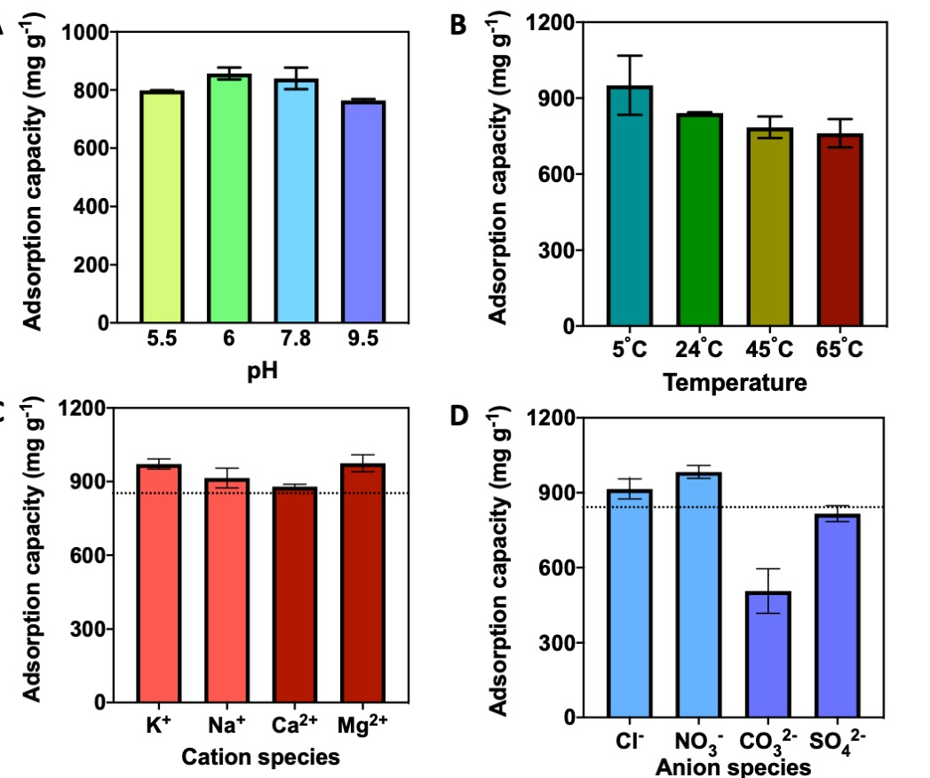
Figure 6. The effect pH (A), temperature (B), cation species (C) and anion species (D) on the adsorption capacity of MOF-808
The impact of the presence of various cation and anion species on the adsorption process was also studied and the result is shown in Figure 6 (C) and (D), respectively. From the Figure 6 (C), it can be seen that the presence of monovalent and divalent cations can increase the adsorption capacity of MOF-808 with a varying degree. This may then be attributed to the enhancement of electrostatic effect. In contrast, as shown in Figure 6 (D), the presence of anion species is observed for being able to both increase and decrease the diclofenac adsorption capacity of MOF-808. In the presence of divalent anion species of CO₃²⁻ and SO₄²⁻, it can be seen that lower diclofenac adsorption capacity is obtained than in the normal condition. This can then be attributed by the competitive adsorption phenomenon. During the adsorption process, the anion species may compete with the diclofenac anion to get adsorbed on the surface of the positively-charged MOF-808. Such a competition results in the reduction of the available adsorption sites for diclofenac anion and thus resulting in the decrease of the adsorption capacity. However, this trend is not observed for monovalent anion, particularly in the presence of NO₃⁻ anion where the adsorption capacity of MOF-808 can be slightly increased. This may then be attributed from various aspects. First, compared with the monovalent anions, anion species with dual charge have a stronger adsorptive tendency and thus enabling them to more effectively disrupt the diclofenac adsorption process on MOF-808 and thus reducing the adsorption capacity [66]. Secondly, this may also come from an effective salting-out effect from the monovalent anion in this system that leads to the reduction of the interaction between water molecules and diclofenac [67]. This is because, upon the introduction of the salt ions, the diclofenac must now compete with the salt ions to interact with the water molecules. With the reduced interaction between the diclofenac and water molecules, the diclofenac can then have stronger interaction with the MOF-808 surface. As a result, the total adsorption capacity is increased.
During the adsorption process, various mechanisms can occur on the MOF-808 surface which supports its relatively high adsorption capacity and kinetic. First, from Figure 7 (A), it can be seen that the diclofenac adsorption does not alter the crystalline structure of the MOF-808 as revealed by the PXRD pattern. There is also no change in the MOF-808 crystal shape after the adsorption process as observed through the micrograph of MOF-808 after adsorption process.
A change, however, can be observed in the FTIR spectra of the MOF-808 after the adsorption process as shown in Figure 7 (B). From the spectra, it can be seen that some additional peaks belonging to the diclofenac compounds are present in the MOF-808 which clearly indicates the presence of diclofenac in the pore of MOF-808. For example, the peak pair coming at around 1500 cm⁻¹ and 1557 cm⁻¹ can be ascribed to the C=C aromatic bonding and δ_{N-H} of the adsorbed diclofenac within the MOF-808 pores, respectively [68,69]. Despite this clear evidence, it can also be seen that the peaks that come at around 1577 cm⁻¹ and 1452 cm⁻¹ for diclofenac experience a reduction in intensity after being adsorbed in MOF-808 as they only appear as a small shoulder from the neighbouring peaks. A similar observation regarding the intensity reduction was also previously observed during the diclofenac adsorption on the goethite [69]. As the peaks are associated to the asymmetric and symmetric stretching of the carboxylate group in the diclofenac [68], this can indicate the different environment experienced by the carboxylate group and their involvement in the diclofenac adsorption process. In this case, the carboxylate group from the diclofenac may then be involved to interact with the cationic sites in Zr cluster. As previously explained in other zirconium-based MOFs, there is a tendency in the formation of Zr-OH₂⁺ structure in an incomplete-coordinated Zr cluster [70]. The carboxylate group from the diclofenac anion may then interact with the cationic clusters during the adsorption process.
In addition to the electrostatic interaction between the carboxylate group and the cationic Zr cluster, other adsorption mechanisms may also play a role. From the previous results, it can be seen that a reasonable amount of diclofenac can still be adsorbed in various pH condition and in the presence of coexisting anion species. This then indicates that the carboxylate-Zr cluster interaction is not the sole governing mechanism because if that were the case, the adsorption capacity would be significantly affected by the change of pH and the presence of anions since they can competitively adsorb on the cationic Zr sites. In this case, a π- π stacking interaction between the aromatic ring of diclofenac and the aromatic ring in the trimesate ligand may also contribute in rendering the MOF-808 with an exceptional adsorption capacity. Such an interaction has also been previously proposed in explaining the exceptional uptake of zirconium MOFs towards ibuprofen and furosemide [70]. Therefore, it can be inferred that both the π- π interaction and electrostatic interaction are the main mechanisms during the diclofenac adsorption process in MOF-808.
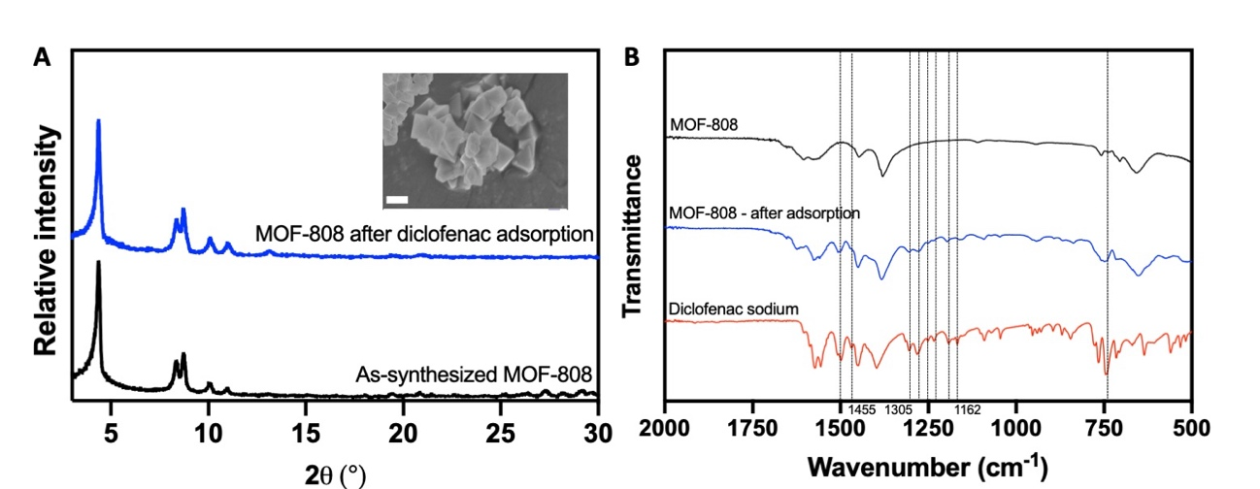
Figure 7. PXRD pattern (A and FTIR spectra) of the MOF-808 before and after the diclofenac adsorption. Inset: micrograph of MOF-808 after the diclofenac adsorption
The performance comparison of MOF-808 for diclofenac removal against other MOFs is given in Table 1. From the table, it can be seen that MOF-808 can outperform most of the MOFs that have been investigated for diclofenac removal, which usually have maximum adsorption capacity between 200-500 mg g⁻¹. In this case, the closest counterparts for MOF-808 are [Cu(BTTA)]_{n}.2DMF and MIL-100(Fe) which show around 650 mg g⁻¹ and 773 mg g⁻¹ of diclofenac adsorption capacity, respectively [71,72]. This can then be ascribed to relatively large pore width owned by the MOFs. This feature is important to ensure that the diclofenac can easily access the available adsorption sites in the MOF pores. The relatively high adsorption capacity exhibited by MOF-808 and MIL-100(Fe) than [Cu(BTTA)]_{n}.2DMF can also be related by the fact that both MOFs have a relatively large surface area (1517 and 1235 m² g⁻¹ for MOF-808 and MIL-100(Fe), respectively) and thus providing more abundance sites for the adsorption of diclofenac. This is also corroborated from the surface area analysis of MOF-808 after the adsorption process. From Figure S8 of the Supporting Information, it is found that the BET surface area of the MOF-808 after the diclofenac adsorption reduces to be around 27 m² g⁻¹. This then indicates that the diclofenac molecule can efficiently utilize almost all the available surface area of the MOF-808 that results in a high diclofenac adsorption capacity. In addition, the fact that the surface area of the former is slightly higher than the latter and the possibility of coordination bonding with the diclofenac may also explain the relatively higher adsorption capacity of MOF-808 than MIL-100(Fe). In addition to relatively higher adsorption capacity, from the kinetic point of view, MOF-808 can also offer a very efficient adsorption process. This is clearly shown by the ability of the MOF-808 to reach about 95% of its equilibrium adsorption capacity in about 1 hour compared with just about 45% adsorption capacity obtained in MIL-100(Fe) within the same time window. This highlights the potential to employ MOF-808 as a highly efficient adsorbent for diclofenac removal.
Table 1. Performance comparison of various MOFs for diclofenac removal by adsorption process
Adsorbent | q_{max} (mg g⁻¹)ª | q_{1hour}/q_{eq} (%)^{b} | Ref
{[Cu₂(L).(H₂O)₂](1.x solvent)} | 490 | 10 | [73]
[Cu(BTTA)]_{n}.2DMF | 650 | 16 | [72]
MIL-53(Al) | 422 | 90 | [74]
MIL-100 (Fe) | 773 | 50 | [71]
UiO-66-NH₂ | 555 | 62.5 | [30]
UiO-66 | 189 | 64 | [29]
18%SO₃H-UiO-66 | 263 | 65 | [29]
ZIF-8 | 100 | 32 | [31]
CTAB-ZIF-67 | 51 | 100 | [75]
PCN-206 | 490 | 30 | [36]
MOF-808 | 830 | 95 | This study
ª=estimated from the adsorption isotherm study
^{b}=estimated from the adsorption kinetic study
  - Diclofenac adsorption on MOF-808 hollow fibre adsorbent
To further exploit the commercial potential of MOF-808 for diclofenac removal, we further performed a study on immobilizing the MOF-808 on the outer surface of a hollow fibre support. This study is important because employment of nano-size powders as adsorbent may pose a significant challenge when they have to be separated from the water bodies for regeneration. Current commercial approach is to employ a binder to form the adsorbent into a certain geometry such as pellets or cylinders, which are then packed as a packed column for adsorption. Use of binders would inevitably reduce the accessible surface areas for the adsorbent. Our approach of using a YSZ hollow fibre support would not only solve the above issue, but also minimalize the maldistribution of flows commonly unavoidable in conventional packed bed configurations [76]. In this case, growing a layer of MOF-808 on a hollow fibre support can be a feasible alternative to avoid the reduction of the adsorbent surface area as well as to minimise flow maldistribution of the adsorption column in order to maximise its adsorption capability.
The MOF-808 layer can be simply grown on the outer surface of a YSZ hollow fibre support by a solvothermal method. As can be seen in Figure 8 (A), the polycrystalline MOF-808 was successfully grown on the hollow fibre outer surface. It covers largely the whole surface of the hollow fibre. The thickness of the MOF-808 layer is relatively thin and is around 3 µm as shown in Figure 8 (B). The benefit of having the thin layer is that it would not significantly hinder the diffusion process of diclofenac to reach the active sites of MOF-808 that is located at the bottom of the layer during the adsorption. Therefore, the efficiency of the adsorption can be well maintained.
The adsorption kinetic of the MOF-808 hollow fibre adsorbent was studied by measuring the solution concentration at certain time intervals and the results are presented in Figure 8 (C). It can be seen that the equilibrium adsorption capacity of the MOF-808 hollow fibre adsorbent is around 796 mg g⁻¹. This value is slightly lower than the equilibrium capacity in MOF-808 powder (833 mg g⁻¹) as shown in Figure 4. This may be caused by the presence of inactive surface area in the MOF-808 hollow fibre adsorbent, which may be located at the boundary between MOF-808 and the YSZ hollow fibre, resulting in a slight decrease in the adsorption performance. Despite this, the MOF-808 hollow fibre adsorbent could still retain about 95% equilibrium adsorption capacity of the MOF-808 powder which suggests that the polycrystalline MOF-808 on the hollow fibre can still maintain its high efficiency in removing diclofenac from water bodies. Although both the MOF-808 powder and MOF-808 hollow fibre adsorbent has a comparable equilibrium adsorption capacity, it should be noted that the MOF-808 hollow fibre adsorbent has lower adsorption rate constant. This then indicates that the adsorption process in the MOF-808 hollow fibre adsorbent occurs more slowly than in the MOF-808 particles.
The intra-particle diffusion model is then used to gain further insight on the lower adsorption rate constant of the MOF-808 hollow fibre adsorbent. The analysis result is then shown in Figure 8 (D). From the result, as also observed in MOF-808 particles, two linear regions can also be seen in the intra-particle diffusion model on MOF-808 hollow fibre adsorbent. This then also indicates that two steps are involved in the adsorption process: diclofenac diffusion from the bulk liquid to the surface of MOF-808 followed by the intra-particle diffusion process. Despite the similarity, it can also be observed that there is a stark difference on the K₁ and K₂ value for the MOF-808 and the MOF-808 hollow fibre adsorbent. The k_{1p} and k_{2p} value are found to be around 130.4 and 7.43 mg g⁻¹ min^{-0.5}, respectively, for MOF-808 particles. Meanwhile, both values decrease significantly to be around 3.84 and 1.85 mg g⁻¹ min^{-0.5}, respectively, for the MOF-808 hollow fibre adsorbent. This then shows that the diclofenac molecule diffuses at a slower pace in the MOF-808 hollow fibre adsorbent than in the MOF-808 particles. The most significant inhibition may then come from the first stage of the diffusion where the diclofenac diffuses from the bulk solution onto the surface of MOF-808 since the k_{1p} value decreases almost 40 times in the MOF-808 hollow fibre adsorbent. This may then be attributed to the additional resistance from the polycrystalline layer of MOF-808 which hinders the diffusion process of diclofenac from the bulk solution to the active site of the MOF-808, particularly to the MOF-808 that is located at the bottom of the polycrystalline layer. Despite this, it can be safely inferred that the high efficiency of MOF-808 for diclofenac removal can still be well maintained in this form since its equilibrium adsorption capacity is still comparable with the MOF-808 particles.
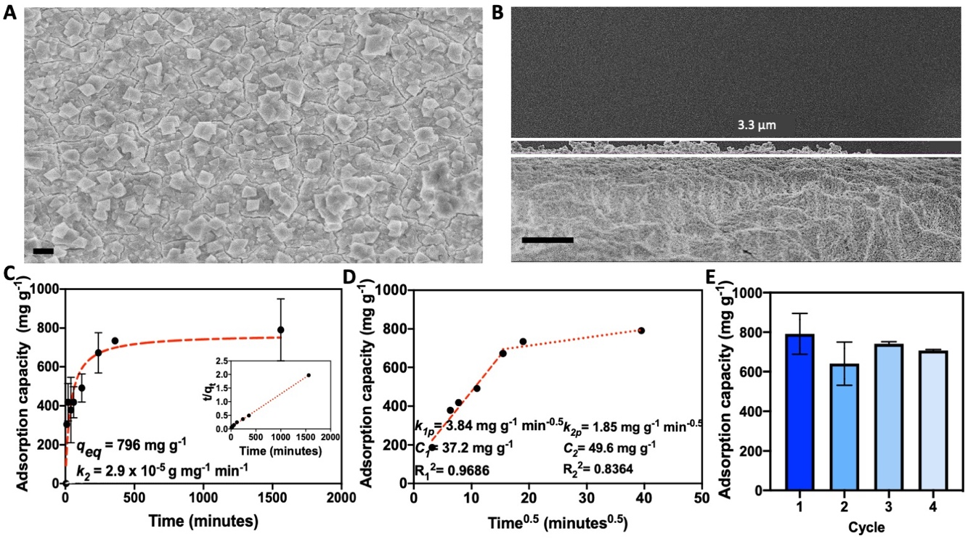
Figure 8. The top surface (A), cross section (B), diclofenac adsorption kinetic (inset: pseudo-second-order kinetic analysis) (C), intra-particle diffusion model (D) and the performance study of diclofenac adsorption-regeneration (E) of the MOF-808 hollow fibre adsorbent. The scalebar is 2 µm and 10 µm for (A) and (B), respectively.
Finally, adsorption-regeneration cycles of the MOF-808 hollow fibre adsorbent was performed and the results are given in Figure 8 (D). As can be seen, the fresh adsorbent has the adsorption capacity of around 800 mg g⁻¹. This value also confirms the predicted equilibrium adsorption capacity from the early kinetic study. After the first adsorption took place, the adsorbent was regenerated by washing with a mixture of methanol and acetic acid, followed by drying before undergoing another cycle of adsorption process. It can be seen that the adsorption capacity of the reused MOF-808 hollow fibre adsorbent was found to be in the range between 600-700 mg g⁻¹. The slight decrease in the diclofenac adsorption capacity may be due to various factors such as the inadequate washing for removal of all the adsorbed diclofenac or some detachments of MOF-808 particles from the support. However, the reduction of the adsorption capacity can be considered small, as more than 80% of the initial adsorption capacity of the MOF-808 hollow fibre adsorbent is well maintained. It follows that the adsorbed diclofenac can be effectively removed from the MOF-808 pores during regeneration process. In addition to the effective regeneration, growing the MOF-808 as a polycrystalline layer on the YSZ hollow fibre support would eliminate the use of binders for making commercial adsorbents, increase the surface-area-to-volume ratio of adsorption systems as well as reduce the maldistribution of flows commonly unavoidable in conventional packed bed configurations. These advantages highlight the readiness for employing the MOF-808 hollow fibre adsorbent in real application for diclofenac removal.
- Conclusions
In this study, we have successfully shown the superiority of MOF-808 as an adsorbent for diclofenac removal. The high surface area and large pore aperture of the MOF-808 renders it to be one of the highest reported adsorbents to date with maximum adsorption capacity at 833 mg g⁻¹ and a fast adsorption kinetic where about 95% diclofenac removal can be reached within 1 hour. This promising potential has also been further exploited successfully by fabricating a MOF-808 hollow fibre adsorbent. This approach has benefits for commercial exploitation, as the hollow fibre adsorbent retains its exceptional adsorption performance. Benefitting from the excellent MOF-808 framework stability, the MOF-808 hollow fibre adsorbent can withstand at least 4 adsorption-regeneration cycles without any significant compromise in its adsorption performances. This study highlights the MOF-808 as a promising adsorbent to address the issue of diclofenac pollution.
- Acknowledgments
The authors gratefully acknowledge the Engineering and Physical Science Research Council Funding (Grant Number EP/R029180/1).
- References
[1] World Health Organization, Pharmaceuticals in drinking-water, (2012).
[2] P. Apopei, C. Orha, M.I. Popescu, C. Lazau, F. Manea, C. Catrinescu, C. Teodosiu, Diclofenac removal from water by photocatalysis- assisted filtration using activated carbon modified with N-doped TiO2, Process Safety and Environmental Protection. 138 (2020) 324–336. https://doi.org/10.1016/j.psep.2020.03.012.
[3] S. Zhou, C. Di Paolo, X. Wu, Y. Shao, T.-B. Seiler, H. Hollert, Optimization of screening-level risk assessment and priority selection of emerging pollutants–The case of pharmaceuticals in European surface waters, Environment International. 128 (2019) 1–10.
[4] M. Cleuvers, Aquatic ecotoxicity of pharmaceuticals including the assessment of combination effects, Toxicology Letters. 142 (2003) 185–194. https://doi.org/10.1016/S0378-4274(03)00068-7.
[5] J.L. Oaks, M. Gilbert, M.Z. Virani, R.T. Watson, C.U. Meteyer, B.A. Rideout, H.L. Shivaprasad, S. Ahmed, M.J.I. Chaudhry, M. Arshad, Diclofenac residues as the cause of vulture population decline in Pakistan, Nature. 427 (2004) 630–633.
[6] J. Schwaiger, H. Ferling, U. Mallow, H. Wintermayr, R.D. Negele, Toxic effects of the non-steroidal anti-inflammatory drug diclofenac: Part I: histopathological alterations and bioaccumulation in rainbow trout, Aquatic Toxicology. 68 (2004) 141–150.
[7] Y. Zhang, S.-U. Geißen, C. Gal, Carbamazepine and diclofenac: Removal in wastewater treatment plants and occurrence in water bodies, Chemosphere. 73 (2008) 1151–1161. https://doi.org/10.1016/j.chemosphere.2008.07.086.
[8] J.O. Ighalo, A.G. Adeniyi, Mitigation of Diclofenac Pollution in Aqueous Media by Adsorption, ChemBioEng Reviews. 7 (2020) 50–64.
[9] Y. Zhuang, B. Han, R. Chen, B. Shi, Structural transformation and potential toxicity of iron-based deposits in drinking water distribution systems, Water Research. 165 (2019) 114999.
[10] M. Cantarella, S.C. Carroccio, S. Dattilo, R. Avolio, R. Castaldo, C. Puglisi, V. Privitera, Molecularly imprinted polymer for selective adsorption of diclofenac from contaminated water, Chemical Engineering Journal. 367 (2019) 180–188.
[11] K. Sun, Y. Shi, X. Wang, J. Rasmussen, Z. Li, J. Zhu, Organokaolin for the uptake of pharmaceuticals diclofenac and chloramphenicol from water, Chemical Engineering Journal. 330 (2017) 1128–1136.
[12] K.V. Plakas, A. Mantza, S.D. Sklari, V.T. Zaspalis, A.J. Karabelas, Heterogeneous Fenton-like oxidation of pharmaceutical diclofenac by a catalytic iron-oxide ceramic microfiltration membrane, Chemical Engineering Journal. 373 (2019) 700–708.
[13] F.J. Beltrán, P. Pocostales, P. Alvarez, A. Oropesa, Diclofenac removal from water with ozone and activated carbon, Journal of Hazardous Materials. 163 (2009) 768–776. https://doi.org/10.1016/j.jhazmat.2008.07.033.
[14] W. Chen, X. Li, Z. Pan, S. Ma, L. Li, Effective mineralization of Diclofenac by catalytic ozonation using Fe-MCM-41 catalyst, Chemical Engineering Journal. 304 (2016) 594–601.
[15] J. Diaz-Angulo, J. Lara-Ramos, M. Mueses, A. Hernández-Ramírez, G.L. Puma, F. Machuca-Martínez, Enhancement of the oxidative removal of diclofenac and of the TiO2 rate of photon absorption in dye-sensitized solar pilot scale CPC photocatalytic reactors, Chemical Engineering Journal. 381 (2020) 122520.
[16] F. Wang, Y. Wu, Y. Wang, J. Li, X. Jin, Q. Zhang, R. Li, S. Yan, H. Liu, Y. Feng, Construction of novel Z-scheme nitrogen-doped carbon dots/{0 0 1} TiO2 nanosheet photocatalysts for broad-spectrum-driven diclofenac degradation: Mechanism insight, products and effects of natural water matrices, Chemical Engineering Journal. 356 (2019) 857–868.
[17] W. Li, B. Mu, Y. Yang, Feasibility of industrial-scale treatment of dye wastewater via bio-adsorption technology, Bioresource Technology. 277 (2019) 157–170.
[18] L.F. Delgado, P. Charles, K. Glucina, C. Morlay, The removal of endocrine disrupting compounds, pharmaceutically activated compounds and cyanobacterial toxins during drinking water preparation using activated carbon—A review, Science of The Total Environment. 435–436 (2012) 509–525. https://doi.org/10.1016/j.scitotenv.2012.07.046.
[19] L. Joseph, B.-M. Jun, M. Jang, C.M. Park, J.C. Muñoz-Senmache, A.J. Hernández-Maldonado, A. Heyden, M. Yu, Y. Yoon, Removal of contaminants of emerging concern by metal-organic framework nanoadsorbents: A review, Chemical Engineering Journal. 369 (2019) 928–946.
[20] Y. Zhuang, Y. Kong, X. Wang, B. Shi, Novel one step preparation of a 3D alginate based MOF hydrogel for water treatment, New Journal of Chemistry. 43 (2019) 7202–7208.
[21] F.S. Wanyonyi, A. Pembere, G.K. Mutua, F. Orata, H. Louis, Computational screening of zeolites for the adsorption of selected pharmaceutical pollutants, SN Applied Sciences. 2 (2020) 1–9.
[22] D. Smiljanić, B. de Gennaro, F. Izzo, A. Langella, A. Daković, C. Germinario, G.E. Rottinghaus, M. Spasojević, M. Mercurio, Removal of emerging contaminants from water by zeolite-rich composites: A first approach aiming at diclofenac and ketoprofen, Microporous and Mesoporous Materials. 298 (2020) 110057.
[23] B.N. Bhadra, P.W. Seo, S.H. Jhung, Adsorption of diclofenac sodium from water using oxidized activated carbon, Chemical Engineering Journal. 301 (2016) 27–34.
[24] J.L. Sotelo, G. Ovejero, A. Rodríguez, S. Álvarez, J. Galán, J. García, Competitive adsorption studies of caffeine and diclofenac aqueous solutions by activated carbon, Chemical Engineering Journal. 240 (2014) 443–453.
[25] S.-W. Nam, C. Jung, H. Li, M. Yu, J.R. Flora, L.K. Boateng, N. Her, K.-D. Zoh, Y. Yoon, Adsorption characteristics of diclofenac and sulfamethoxazole to graphene oxide in aqueous solution, Chemosphere. 136 (2015) 20–26.
[26] B.Y.Z. Hiew, L.Y. Lee, X.J. Lee, S. Gan, S. Thangalazhy-Gopakumar, S.S. Lim, G.-T. Pan, T.C.-K. Yang, Adsorptive removal of diclofenac by graphene oxide: optimization, equilibrium, kinetic and thermodynamic studies, Journal of the Taiwan Institute of Chemical Engineers. 98 (2019) 150–162.
[27] N. Suriyanon, P. Punyapalakul, C. Ngamcharussrivichai, Mechanistic study of diclofenac and carbamazepine adsorption on functionalized silica-based porous materials, Chemical Engineering Journal. 214 (2013) 208–218.
[28] M. Barczak, M. Wierzbicka, P. Borowski, Sorption of diclofenac onto functionalized mesoporous silicas: Experimental and theoretical investigations, Microporous and Mesoporous Materials. 264 (2018) 254–264.
[29] Z. Hasan, N.A. Khan, S.H. Jhung, Adsorptive removal of diclofenac sodium from water with Zr-based metal–organic frameworks, Chemical Engineering Journal. 284 (2016) 1406–1413.
[30] S. Zhuang, R. Cheng, J. Wang, Adsorption of diclofenac from aqueous solution using UiO-66-type metal-organic frameworks, Chemical Engineering Journal. 359 (2019) 354–362.
[31] B.N. Bhadra, I. Ahmed, S. Kim, S.H. Jhung, Adsorptive removal of ibuprofen and diclofenac from water using metal-organic framework-derived porous carbon, Chemical Engineering Journal. 314 (2017) 50–58. https://doi.org/10.1016/j.cej.2016.12.127.
[32] S. Zuluaga, E.M. Fuentes-Fernandez, K. Tan, F. Xu, J. Li, Y.J. Chabal, T. Thonhauser, Understanding and controlling water stability of MOF-74, Journal of Materials Chemistry A. 4 (2016) 5176–5183.
[33] X. Liu, N.K. Demir, Z. Wu, K. Li, Highly water-stable zirconium metal–organic framework UiO-66 membranes supported on alumina hollow fibers for desalination, Journal of the American Chemical Society. 137 (2015) 6999–7002.
[34] Y. Cai, D. Shi, G. Liu, Y. Ying, Y. Cheng, Y. Wang, D. Chen, J. Lu, D. Zhao, Polycrystalline zirconium metal-organic framework membranes supported on flexible carbon cloth for organic solvent nanofiltration, Journal of Membrane Science. 615 (2020) 118551.
[35] V. Bon, I. Senkovska, J.D. Evans, M. Wöllner, M. Hölzel, S. Kaskel, Insights into the water adsorption mechanism in the chemically stable zirconium-based MOF DUT-67–a prospective material for adsorption-driven heat transformations, Journal of Materials Chemistry A. 7 (2019) 12681–12690.
[36] L. Zhang, B. Guo, H. He, X. Zhang, Y. Feng, W. Fan, J. Cao, G. Lu, Y. Chen, D. Sun, Fabrication of (4, 10) and (4, 12)-Connected Multifunctional Zirconium Metal–Organic Frameworks for the Targeted Adsorption of a Guest Molecule, Inorganic Chemistry. 59 (2019) 695–704.
[37] A.O.A. El Naga, M. El Saied, S.A. Shaban, F.Y. El Kady, Fast removal of diclofenac sodium from aqueous solution using sugar cane bagasse-derived activated carbon, Journal of Molecular Liquids. 285 (2019) 9–19.
[38] M. Bernardo, S. Rodrigues, N. Lapa, I. Matos, F. Lemos, M.K.S. Batista, A.P. Carvalho, I. Fonseca, High efficacy on diclofenac removal by activated carbon produced from potato peel waste, International Journal of Environmental Science and Technology. 13 (2016) 1989–2000.
[39] F. Tomul, Y. Arslan, F.T. Başoğlu, Y. Babuçcuoğlu, H.N. Tran, Efficient removal of anti-inflammatory from solution by Fe-containing activated carbon: Adsorption kinetics, isotherms, and thermodynamics, Journal of Environmental Management. 238 (2019) 296–306.
[40] H. Furukawa, F. Gandara, Y.-B. Zhang, J. Jiang, W.L. Queen, M.R. Hudson, O.M. Yaghi, Water adsorption in porous metal–organic frameworks and related materials, Journal of the American Chemical Society. 136 (2014) 4369–4381.
[41] Z.-Q. Li, J.-C. Yang, K.-W. Sui, N. Yin, Facile synthesis of metal-organic framework MOF-808 for arsenic removal, Materials Letters. 160 (2015) 412–414.
[42] C. Ardila-Suarez, S. Perez-Beltran, G.E. Ramirez-Caballero, P.B. Balbuena, Enhanced acidity of defective MOF-808: effects of the activation process and missing linker defects, Catalysis Science & Technology. 8 (2018) 847–857.
[43] X. Meng, H.-N. Wang, L.-S. Wang, Y.-H. Zou, Z.-Y. Zhou, Enhanced proton conductivity of a MOF-808 framework through anchoring organic acids to the zirconium clusters by post-synthetic modification, CrystEngComm. 21 (2019) 3146–3150.
[44] K. Healey, W. Liang, P.D. Southon, T.L. Church, D.M. D’Alessandro, Photoresponsive spiropyran-functionalised MOF-808: postsynthetic incorporation and light dependent gas adsorption properties, Journal of Materials Chemistry A. 4 (2016) 10816–10819.
[45] H.-B. Luo, Q. Ren, P. Wang, J. Zhang, L. Wang, X.-M. Ren, High proton conductivity achieved by encapsulation of imidazole molecules into proton-conducting MOF-808, ACS Applied Materials & Interfaces. 11 (2019) 9164–9171.
[46] H.-Q. Zheng, C.-Y. Liu, X.-Y. Zeng, J. Chen, J. Lü, R.-G. Lin, R. Cao, Z.-J. Lin, J.-W. Su, MOF-808: a metal–organic framework with intrinsic peroxidase-like catalytic activity at neutral pH for colorimetric biosensing, Inorganic Chemistry. 57 (2018) 9096–9104.
[47] H.-H. Mautschke, F. Drache, I. Senkovska, S. Kaskel, F.L. i Xamena, Catalytic properties of pristine and defect-engineered Zr-MOF-808 metal organic frameworks, Catalysis Science & Technology. 8 (2018) 3610–3616.
[48] J.Y. Chong, B. Wang, P.C. Sherrell, F.M. Pesci, C. Mattevi, K. Li, Fabrication of Graphene-Covered Micro-Tubes for Process Intensification, Advanced Engineering Materials. 21 (2019) 1900642. https://doi.org/10.1002/adem.201900642.
[49] K. Li, Ceramic membranes for separation and reaction, John Wiley & Sons, 2007.
[50] P. Liu, E. Redekop, X. Gao, W.-C. Liu, U. Olsbye, G.A. Somorjai, Oligomerization of Light Olefins Catalyzed by Brønsted-Acidic Metal–Organic Framework-808, J. Am. Chem. Soc. 141 (2019) 11557–11564. https://doi.org/10.1021/jacs.9b03867.
[51] X. Liu, C. Wang, B. Wang, K. Li, Novel Organic-Dehydration Membranes Prepared from Zirconium Metal-Organic Frameworks, Advanced Functional Materials. 27 (2017) 1604311. https://doi.org/10.1002/adfm.201604311.
[52] K. Xuan, Y. Pu, F. Li, J. Luo, N. Zhao, F. Xiao, Metal-organic frameworks MOF-808-X as highly efficient catalysts for direct synthesis of dimethyl carbonate from CO2 and methanol, Chinese Journal of Catalysis. 40 (2019) 553–566.
[53] M.C. de Koning, M. van Grol, T. Breijaert, Degradation of paraoxon and the chemical warfare agents VX, tabun, and soman by the metal–organic frameworks UiO-66-NH2, MOF-808, NU-1000, and PCN-777, Inorganic Chemistry. 56 (2017) 11804–11809.
[54] D. Ringot, B. Lerzy, K. Chaplain, J.-P. Bonhoure, E. Auclair, Y. Larondelle, In vitro biosorption of ochratoxin A on the yeast industry by-products: Comparison of isotherm models, Bioresource Technology. 98 (2007) 1812–1821. https://doi.org/10.1016/j.biortech.2006.06.015.
[55] P.S. Kumar, S. Ramalingam, S.D. Kirupha, A. Murugesan, T. Vidhyadevi, S. Sivanesan, Adsorption behavior of nickel(II) onto cashew nut shell: Equilibrium, thermodynamics, kinetics, mechanism and process design, Chemical Engineering Journal. 167 (2011) 122–131. https://doi.org/10.1016/j.cej.2010.12.010.
[56] A.I. Moral-Rodriguez, R. Leyva-Ramos, F. Carrasco-Marín, M.I. Bautista-Toledo, A.F. Pérez-Cadenas, Adsorption of Diclofenac from Aqueous Solution onto Carbon Xerogels: Effect of Synthesis Conditions and Presence of Bacteria, Water, Air, & Soil Pollution. 231 (2020) 1–12.
[57] J. Dai, X. Xiao, S. Duan, J. Liu, J. He, J. Lei, L. Wang, Synthesis of novel microporous nanocomposites of ZIF-8 on multiwalled carbon nanotubes for adsorptive removing benzoic acid from water, Chemical Engineering Journal. 331 (2018) 64–74. https://doi.org/10.1016/j.cej.2017.08.090.
[58] L. Lonappan, S.K. Brar, R.K. Das, M. Verma, R.Y. Surampalli, Diclofenac and its transformation products: environmental occurrence and toxicity-a review, Environment International. 96 (2016) 127–138.
[59] M.D.G. de Luna, W. Budianta, K.K.P. Rivera, R.O. Arazo, Removal of sodium diclofenac from aqueous solution by adsorbents derived from cocoa pod husks, Journal of Environmental Chemical Engineering. 5 (2017) 1465–1474.
[60] V.O. Leone, M.C. Pereira, S.F. de Aquino, L.C.A. de Oliveira, S. Corrêa, T. de C. Ramalho, L.V.A. Gurgel, A.C. da Silva, Adsorption of diclofenac on a magnetic adsorbent based on maghemite: experimental and theoretical studies, New Journal of Chemistry. 42 (2018) 437–449.
[61] L. Wu, C. Du, J. He, Z. Yang, H. Li, Effective adsorption of diclofenac sodium from neutral aqueous solution by low-cost lignite activated cokes, Journal of Hazardous Materials. 384 (2020) 121284.
[62] W.S. Alencar, E.C. Lima, B. Royer, B.D. dos Santos, T. Calvete, E.A. da Silva, C.N. Alves, Application of aqai stalks as biosorbents for the removal of the dye Procion Blue MX-R from aqueous solution, Separation Science and Technology. 47 (2012) 513–526.
[63] S. Álvarez-Torrellas, A. Rodríguez, G. Ovejero, J. García, Comparative adsorption performance of ibuprofen and tetracycline from aqueous solution by carbonaceous materials, Chemical Engineering Journal. 283 (2016) 936–947.
[64] H.-T. Fan, W. Sun, B. Jiang, Q.-J. Wang, D.-W. Li, C.-C. Huang, K.-J. Wang, Z.-G. Zhang, W.-X. Li, Adsorption of antimony (III) from aqueous solution by mercapto-functionalized silica-supported organic–inorganic hybrid sorbent: mechanism insights, Chemical Engineering Journal. 286 (2016) 128–138.
[65] M. Antunes, V.I. Esteves, R. Guégan, J.S. Crespo, A.N. Fernandes, M. Giovanela, Removal of diclofenac sodium from aqueous solution by Isabel grape bagasse, Chemical Engineering Journal. 192 (2012) 114–121.
[66] X. Mi, S. Zhou, Z. Zhou, M. Vakili, Y. Qi, Y. Jia, D. Zhu, W. Wang, Adsorptive removal of diclofenac sodium from aqueous solution by magnetic COF: Role of hydroxyl group on COF, Colloids and Surfaces A: Physicochemical and Engineering Aspects. 603 (2020) 125238.
[67] W. Wang, S. Deng, D. Li, L. Ren, B. Wang, J. Huang, Y. Wang, G. Yu, Adsorptive removal of organophosphate flame retardants from water by non-ionic resins, Chemical Engineering Journal. 354 (2018) 105–112. https://doi.org/10.1016/j.cej.2018.08.002.
[68] J. Janićijević, D. Krajišnik, B. Čalija, B.N. Vasiljević, V. Dobričić, A. Daković, M.D. Antonijević, J. Milić, Modified local diatomite as potential functional drug carrier—A model study for diclofenac sodium, International Journal of Pharmaceutics. 496 (2015) 466–474.
[69] Y. Zhao, F. Liu, X. Qin, Adsorption of diclofenac onto goethite: adsorption kinetics and effects of pH, Chemosphere. 180 (2017) 373–378.
[70] S. Lin, Y. Zhao, Y.-S. Yun, Highly Effective Removal of Nonsteroidal Anti-inflammatory Pharmaceuticals from Water by Zr(IV)-Based Metal–Organic Framework: Adsorption Performance and Mechanisms, ACS Appl. Mater. Interfaces. 10 (2018) 28076–28085. https://doi.org/10.1021/acsami.8b08596.
[71] S. Zhuang, Y. Liu, J. Wang, Mechanistic insight into the adsorption of diclofenac by MIL-100: Experiments and theoretical calculations, Environmental Pollution. 253 (2019) 616–624.
[72] W. Liu, X. Shen, Y. Han, Z. Liu, W. Dai, A. Dutta, A. Kumar, J. Liu, Selective adsorption and removal of drug contaminants by using an extremely stable Cu (II)-based 3D metal-organic framework, Chemosphere. 215 (2019) 524–531.
[73] Z. Luo, S. Fan, J. Liu, W. Liu, X. Shen, C. Wu, Y. Huang, G. Huang, H. Huang, M. Zheng, A 3D stable metal–organic framework for highly efficient adsorption and removal of drug contaminants from water, Polymers. 10 (2018) 209.
[74] A. Karami, R. Sabouni, M. Ghommem, Experimental investigation of competitive co-adsorption of naproxen and diclofenac from water by an aluminum-based metal-organic framework, Journal of Molecular Liquids. (2020) 112808.
[75] K.-Y.A. Lin, H. Yang, W.-D. Lee, Enhanced removal of diclofenac from water using a zeolitic imidazole framework functionalized with cetyltrimethylammonium bromide (CTAB), Rsc Advances. 5 (2015) 81330–81340.
[76] C. Wang, M. Lee, X. Liu, B. Wang, J.P. Chen, K. Li, A metal–organic framework/α-alumina composite with a novel geometry for enhanced adsorptive separation, Chemical Communications. 52 (2016) 8869–8872.

