

Supplementary Materials for

The protein LEM promotes CD8⁺ T cell immunity through effects on mitochondrial respiration

Isobel Okoye, Lihui Wang, Katharina Pallmer, Kirsten Richter,
Takahuru Ichimura,, Robert Haas, Josh Crouse, Onjee Choi, Dean Heathcote,
Elena Lovo, Claudio Mauro, Reza Abdi, Annette Oxenius, Sophie Rutschmann
and Philip G Ashton-Rickardt.

correspondence to: p.ashton-rickardt@imperial.ac.uk

This PDF file includes:

Materials and Methods
Figs. S1 to S19
Tables. S1 to S3

Materials and Methods

Mice
Retro mutant mice were generated in a C57BL/6J background. C57BL/6J and C57BL/6J Thy1.1 congenics, were purchased from Charles River, (Lille, France) and bred in Central Biomedical Services (Imperial College London, London, U.K.). Mice were kept under specific pathogen-free conditions in individually ventilated cages. All animal procedures have been authorized in a British Home Office Animals Act License (PPL70/6490), or in accordance with the guidelines of the animal experimentation law (SR 455.163; TVV) of the Swiss Federal Government (animal experimentation number 127/2011) or the Institutional Animal Care and Use Guidelines of Brigham and Women’s Hospital, Harvard Medical School. The N-ethyl-N-nitrosourea (ENU) mutagenesis was performed as previously described (11).
The Retro phenotype was identified in ENU G3 mice as the level of np396⁺ CD8⁺ cells being > 6-times higher than littermate controls. Additional G3 mice were generated from the original G1xG2 breeding pair then intercrossed to produce G4 mice, which were then set up in breeding pairs. G4 mice in breeding pairs that gave >20 consecutive Retro phenotype G5 mice were each designated as being homozygous for the Retro mutation. Back-crossing of G4 Retro homozygous mutant to C57BL/6 wild-type controls revealed that the Retro phenotype in inherited in semi-dominant fashion with heterozygous mice exhibiting an intermediate phenotype for np396⁺ CD8⁺ level compared to wild-type and Retro homozygous mutant (Fig. S1a).
Mice harboring the BC055111^{tm1a(KOMP)Wtsi} allele (KO first_condition_ready_40636) were obtained from the NIH Knock-Out Mouse Project (KOMP) Repository at UC Davis (www. knockoutmouse.org). This allele generates a null allele through splicing to a lacZ-trapping element contained in the targeting cassette (20). Targeted JM8.4 C57BL/6N ES cells were verified by genomic sequencing across the locus harboring the targeting vector and flanking endogenous regions (MGI: 2681853) and by long-range PCR using primers specific for vector sequence (5’-CAC ACC TCC CCC TGA ACC TGA AAC-3’ and non-vector genomic sequence outside the homology region (5’-CAA GAG CAA GCA GCT CCT CAA GAT GAC-3’) on two clones (EPD0132_1_C01 and EPD0132_1_H01) (31) (Fig S8). Chimeric mice were generated by microinjection of ES cells (black) into BALB/c (albino) blastocyst then germ-line transmission verified after backcrossing to C57BL/6J mice and PCR. Intercross of mice heterozygous for the BC055111^{tm1a(KOMP)Wtsi} allele (KO allele) failed to generate any progeny homozygous for the mutation (n=47 progeny; 4 separate breeding pairs). Therefore heterozygous BC055111 KO mice were used for experiments.

LCMV infections

Mice were infected with either LCMV C13 (10⁶ plaque forming units (pfu) (i.v.), or LCMV Armstrong (primary infection- 2x10⁵ pfu i.p. or secondary infection- 10⁶ pfu i.p). LCMV titer was measured in the spleen using a quantitative (Q)-PCR method to detect LCMV gp33 mRNA calibrated by standard curves with LCMV gp33 gene plasmid (32). For in vivo antioxidant experiments MnTBAP (5mg/kg) was injected (i.p) on day 0 at the same time as LCMV C13 then every day for 8 days (28).

Immunological Assays

Flow-cytometric analysis was performed after antibody and tetramer staining of lymphocytes (11). For intracellular staining (ICS), first cells were stained for surface markers then fixed and permeabilised using the BD intracellular cytokine staining kit using manufacturer’s recommendations. To measure T cell proliferation, mice were fed 0.8 mg/ml BrdU in drinking water on day 6 of infection and analyzed on day 8. For adoptive transfer experiment, total CD8 T cells (Thy1.2⁺) were purified from pooled splenocytes from several mice (donor) using anti-CD8 magnetic beads (Miltenyi) then transferred (10⁷) to C57BL/6 thy1.1⁺ recipients by i.v. injection (14). The level of donor thy1.2⁺ np396⁺ CD8⁺ cells were determined by antibody and tetramer staining. Anti-LCMV CTL activity of splenocyte populations was measured using standard Cr⁵¹- release assays (effector to target (E/T) ratio of 10:1) with EL4 pulsed with np396 peptide(33). For in vitro PD-1 up-regulation, CD8 T cells (10⁶/ml) were incubated for 3 days with plate-bound anti-CD3 antibody (10μg/ml overnight binding) (34). For in vitro stimulation for proliferation studies, CD8 T cells (10⁶/ml) were incubated for 3 days with plate bound anti-CD3 (3μg/ml overnight binding) and anti-CD28 (6μg/ml overnight binding). The level of mROS was measured by staining np396⁺CD8⁺ cells with MitoSOX red (Molecular Probes) on day 8 after infection with LCMV C13(27).
To generate anti-LEM antibodies first DNA corresponding to LEM amino acid 24-383 (M.W. 42kD) was amplified by PCR (incorporating N-terminal 10xHis tag primers: F 5’-TTA AGA AGG AGA TAT ACC ATG GGT TCT GAT AAG ATT CAC CAC CAT CAT CAC CAT CAT CAC CAC CAC GGC GTC-3’; R 5’-AAT CTG ACG CCT TCG CTC GAT TGG AGC CAC CCG CAG TT CGA-3’) then cloned into the p2N E. coli expression vector. The region of the LEM between the amino acids 24-383 was expressed as a fusion protein with a N-terminal 10x His tag then purified on Ni-columns using standard procedures. Rabbits were immunized with rLEM (0.2mg in Complete Freund’s Adjuvant then 2 boosts of 0.1mg in Incomplete Freund’s Adjuvant) then anti-LEM antibodies affinity purified using the immunizing antigen immobilized by CnBr cross-linking. Anti-LEM was used at 1μg/ml and goat anti-rabbit IgG-APC used at 1/1000 dilution (LifeTechnologies).

Melanoma Challenge

Mice were injected (i.v.) with B16-F10 melanoma cells (6)(C57BL/6; American Tissue Culture Collection) (3x10⁵) then after 5 weeks pulmonary melanoma metastases were analyzed in the lungs. The entire lung was digested and purified on a ficol gradient and the % of CD3⁺ CD8⁺ (CTL) from gated lymphocytes determined (6).

Genomic analysis

Exome sequencing was performed on genomic DNA (5μg) from Retro homozygous mutant mice. Exon capture (Agilent Sure Select All Exon 50 MB kit), fragment library construction and next generation sequencing (NGS) (paired-end 50 x 35 bases 2 quads per sample using the SOLiD v4 platform) were performed by Edge Bio. Average read lengths were 42.5$±$ 7.5bp with 493,715,014 reads resulting in 18,687,888,095 total bases. Of this sequence, 66.7% (1256 Mb) was mapped to the reference M. Musculus (mm9) (C57BL/6J strain) genome giving on average 33.7 x coverage of the mouse exome (37Mb). Using DNANexus cloud based data analysis, homozygous nucleotide variants caused by substitution or insertion/deletion (INDEL) were identified (coverage was 5-80 reads).
Homozygous nucleotide variants were amplified from genomic DNA by PCR using the JumpStart REDtaq ReadyMix (Sigma). PCR samples were purified by QIAquick PCR Purification Kit (Qiagen) then sequenced (MRC CSC Genomics Core Laboratory, Imperial College London) and the data analysed with Sequencher software (Gene Codes Corporation). Primers used were: Scn9a: Forward (F): 5’-CCC TAT TCT TTC CCT CCC ATC-3’;Reverse (R):5'-GTT GTT GGG ATC CGC TGT TC-3’. Ppig F: 5’-CAA GAG ATG CAG AGA GCT CAG-3’R: 5’-CTG ATG TCT CTC TCT TTG CTT TC-3’. BC055111 F: 5’-GAA GCA GAT CCA AAG TGA CAT TC-3’R: 5’-GAG TTT ATCA AAC ATC TGG AGC-3’. SemaN F: 5'-AAC CTT CTC TTC TGC TTT CTT TG-3'
R: 5'-GTC TGG CTT TCT ACT TGA CAC AC-3'. Itpr1 F: 5’-CAA AGA GCT TGA CAG TCC CTC-3'; R: 5’-ATT CCA CAG AAA TAT GAG CAC TG-3’. Zc3h4 F: 5’- CAC AGA TGT TGG CTG ATG ATG-3' R: 5’- GGA CAA TAT ACT CAC CTC ACG C-3’. Entpd3: 5’- CAC TGT TTG CTC TAA GGA GTG C -3’R: 5- GAA AGT TGC TCT TGG CTG TTT C-3’Dux F: 5’-CTC AAA GAG GTC CAT CAG AGG C-3’; R: 5’-GTC TTG ATC TTG AGC TGT GGG-3’.

Gene Function and Expression Analysis

Synthetic genes encoding BC055111 (wild-type and Retro mutant sequences), C1ORF177 and Crif1 open reading frames (ORF) preceded by a mini gene encoding 3xFLAG epitope tag were assembled from oligonucleotides and PCR products (Gene Art). Fragments were cloned into the MIGR1 retroviral vector using Xho1 and EcoR1 cloning sites in the forward (sense) and reverse (antisense) orientations. Retroviruses were packaged for transduction of mouse or human cells (35). CTLL-2 cells were cultured with rIL-2 50U/ml in RPMI-10% FBS then the number of GFP⁺ cell measured over time. For NMD and validation of CRIF1 function experiments, magnetic bead sorted CD8 T cells (10⁶/ml) from wild-type or Retro mutant mice were cultured in IL-2, IL-7, IL-15 cytokines (all 100ng/ml eBiosceinces). For Lem mRNA stability experiments, NMD was inhibited by incubation with emetine (10h at 100μg/ml) and transcription inhibited by actinomycin D (4h at 2μg/ml) after 3 days of culture (21). For CRIF1 function experiments, CD8 T cells were transduced with MIGR1-Crif1-AS or MIGR1 vector alone retrovirus on day 2 (35) and on day 4 adoptively transferred to C57BL/6 recipients (5x10⁶ GFP⁺ cells per mouse). Recipient mice were infected with LCMV C13 and the number of GFP⁺ CD8⁺ cells measured in the spleen after 8 days. Human CD8 T cells were purified from normal donor peripheral blood mononuclear cells (PBMC) by magnetic bead sorting then cultured (10⁶/ml) with anti-CD3 antibody (OKT3, 50ng/ml) and IL-2 (600U/ml) for 2 days then transduced with MIGR1 (36) and the number of GFP⁺ cell measured over time.

For Q-PCR, mRNA was isolated using the Qiagen microRNA kit then cDNA was prepared using the Invitrogen SuperScript III kit and oligo (dT). Q-PCR reactions were run using the SYBR Green PCR Master mix (Applied Biosystems) on a 7900HT Fast Real-Time PCR system (Applied Bio- systems). Primer sequences for the following genes were: BC055111 (Lem) F: 5’-CGC GCA ACA TCA TGT CC ACC A-3’; R: 5’-GCC CAA CTT CTG TTC CAG GAA C-3’. gapdh F 5’- ACC ACA GTC CAT GCC ATC AC -3’. The sequence for control the control β2-microglubilin gene was from (35). For the knock down of Lem mRNA, cytokine cultured CD8 T cells were transduced with lentivirus encoding microRNA 30-adapted shRNA (Lem antisense sequence: 5’-TCT GCC ATG AGT CTG TCT CG-3’) in the GIPZ shRNAmir-30-GFP vector (GE Dharmacon), or scrambled negative control shRNA, at a multiplicity of infection (MOI) or 50:1 using manufacturer’s protocol. Cells were then activated for 3 days on anti-CD3 and anti-CD28 and the % of BrdU cells measured after pulsing from day 1 to day 3.

Protein analysis

Analysis of LEM amino acid sequence predicts the presence of at least two IU domains (GeneSilicoMetaDisorder Service: iicmb.genessilico.pl). Wild-type Lem ORF was cloned into pEGTetR as bait by gap repair homologous recombination in yeast Y322 after co-transformation of the PCR product from amplified ORF (primers: F 5’- CTT AAA TGT GAA AGT GGG TCC GAA TTC ATG AGA CCT CGC ACC CAC GG -3’; R 5’- CAT AAA TCA TAA GAA ATT CGC CTC GAG TTA AGG AGT AGG ATC TGA ATT GTA GTC C-3’) (24). The bait junction was sequenced to confirm the correct reading frame then about 7 x 10⁶ independent cDNA clones from a mouse embryonic library were screened in yeast dropout (glucose) medium lacking leucine, histidine, trytophan, and uracil. Plasmids were prepared from 23 yeast colonies that can grow on the selection plates and expressed lacZ (blue on the X-gal plates). Lem ORF bait was transformed into Y322 cells (haploid MATα) and the prey clones into EGY42 (haploid MAT), which were then streaked as lines in selection plates (HW/Glu for Y322 and L/Glu for EGY42). After 2-3 days, bait strains and prey strains were replicated onto YPD plates as columns (bait strains) and rows (prey strains) and incubated overnight at 30ºC. The intersections of these columns and rows contained diploid yeast formed from haploid bait and prey yeast cells. These mated grids were replicated onto two selection plates that examined the expression of URA3 (Ura-/glucose + 1 g/ml 6-AU) and LacZ reporters (X-gal/glucose). One pair of known interactors was included as both positive and negative controls. Relative interaction strength were estimated with different grades for cell growth as a result of URA3 expression, and additionally scored with levels of blue intensity on X-gal plates as a function of LacZ expression. Y2H was performed by ProteinLinks Inc.

All Western blotting, co-IP and RIP experiments were performed on magnetic bead sorted CD8 T cells (Miltenyi Biotech) from the spleens of day 4 LCMV C13 infected mice. Western blots (2 x 10⁶ cells) were performed as before (33) using the following antibodies: goat anti-BC055111 peptide antibody (sc-245602 Santa Cruz, 1/300 dilution); rabbit anti- LEM recombinant protein (in-house, 1/400 dilution); rabbit anti-C1ORF177 recombinant protein (Atlas antibodies HPA035890 1/200 dilution); rabbit anti-CRIF1 (ProteinTech 1620-1-AP 1/300 dilution); rabbit anti-SF2 monoclonal antibody (Abcam ab 133689 clone EPR8240, 0.5μg/ml); mouse anti-β actin monoclonal antibody (Abcam ab8226 0.4μg/ml) ; goat anti-ND1 peptide antibody (sc-65237 Santa Cruz, 1/200); mouse anti-UQCRC2 monoclonal antibody (A11143 Lifetechnologies, 0.4μg/ml); mouse anti-COX1 monoclonal antibody (A6403 Lifetechnologies, 2μg/ml); mouse anti-ATP5A1 monoclonal antibody (A21350 Lifetechnologies, 0.5μg/ml); goat anti-MRPL23 (G-13) (sc-131603 Santa Cruz, 1/200) then protein G-peroxidase 1/3000 (Sigma-Aldrich). Signal strength was measured by densitometry (BioRad Image analyser) and expressed as arbitrary units. For co-IP, lysates were prepared from cells (2x10⁷ CD8 T cells) using 25mM Tris. HCl pH 7.4, 150mM NaCl, 1mM EDTA, 1% NP40, 5% glycerol (ThermoScientific) supplemented with 1x protease inhibitor cocktail (Sigma-Aldrich). Co-IP was performed with rabbit anti-rLEM antibody (4μg) or rabbit IgG (4μg) coupled to amino link resin, according to manufacturer’s procedure (ThermoScientific) followed by Western blot (on 1/10 co-IP material- equivalent to 2x10⁶ cells of input detergent extract) to identify LEM-associated proteins. For comparison RNA bound to ASF2 was recovered by RIP using anti-ASF2 antibody (3μg) from CD8 T cells using the Imprint RNA RIP kit according to manufacturer’s procedure (Sigma Aldrich). Q-PCR on cDNA was used to measure the level of Lem mRNA in RIP material. The Retro mutation (A1304G mutation in exon 2) is predicted to abolish an ASF2 binding site in Lem mRNA (Wild-type: CAGAAGG to Retro: CAGAGGG)(22).

Confocal Immunofluorescence microscopy

LEM/CRIF1 Co-localization: CD8+ T cells (10⁵/well) were purified from C57BL/6 splenocytes using anti- CD8 MACS beads (Miltenyi Biotech) then cultured with plate bound anti-CD3ε (145-2C11 BD Pharmingen) and anti-CD28 (37.51 Biolegend) for 3 days. Cytospins of CTL were fixed and stained then imaged using a Nikon C1 confocal system using standard fixation and staining methods (16). All primary antibodies were used at 1/100. For the secondary antibodies, anti-goat Cy3 was used at 1/400 and anti-rabbit DyLight 488 at 1/100 (Jackson Immunochemicals). Co-localization of was quantified by measuring Pearson’s correlation coefficient of staining for LEM (red) and CRIF1 (green) from optical cell slices (n=62) issued from 4 independent experiments. Pearson’s correlation coefficient >0.5 is considered strongly correlative.

LEM/CRIF1/Mitochondria co-localization: In vitro generated CTL (as above) were stained with Mito Tracker CM-H2 Xros (Molecular Probes) according to manufacturer's instructions. Then incubated on poly-L-Lysine (Sigma-Aldrich) coated coverslips for 1 h at 37°C and fixed with 2% PFA-PBS for 10 min at 4°C (10⁵ cells). Cells were permeabilized with 0.1% Triton X in PBS for 5 min at 4° and subsequently blocked with 2% BSA-PBS for 1 h at RT before staining with rabbit-anti-CRIF-1 (anti-GADD45GIP1 Proteintech) and goat-anti-BC055111 (Santa Cruz Biotechnology, Inc.) for 1 h at room temperature (1/100 dilution). Cells were stained with secondary antibodies ant-rabbit IgG Alexa 647 (A21245 Life technologies), anti-goat IgG Alexa 488 (A 11078 Life technologies) (both at 1/400) and DAPI (Sigma Aldrich) for 1 h at room temperature. Cells were embedded in ProLong Gold Antifade Mountant (Molecular Probes) then examined and photographed with Leica SP8 using a 63x oil immersion objective and were analyzed with Volocity (Improvision). MARIS 8.0.2, Huygens Professional 4.2.2 and FIJI software were used for image processing. FIJI was used to perform image handling and necessary format conversions. Huygens Professional 4.2.2 was used to deconvolve the images. 3D co-localization analyses were performed using IMARIS 8.0.2 software (Bitplane; Zurich, Switzerland). Co-distribution of CRIF1 and LEM was quantified using pixel-based correlations estimators. Pearson’s correlation coefficients (PCC) were measured only in the domains where molecule interaction matters (i.e. inside of cells), which was accomplished by using “region of interests” (ROIs). To compute PCC values, IMARIS co-localization module was used. To avoid subjectivity CRIF1 and LEM thresholds were automatically determined using Costes algorithms. The observed correlations have a P-Value = 1.000 within the distribution of random images defined by the point spread function width of 0.272 μm (which according to Costes algorithm means that 0% of the 200 random images have a larger correlation than the observed one). Random images were generated by smoothing white noise with a Gaussian point spread function of specified width.
Metabolic analysis

All metabolic experiments (expect mROS measurements - day 8 see Immunological Assays) were performed on magnetic bead sorted CD8 T cells (Miltenyi Biotech) from the spleens of day 4 LCMV C13 infected mice. Immuno-capture enzyme assays for OXPHOS complexes I (Abcam ab 109720) and IV (Abcam Ab109878) were performed on 5mg of protein extracts using dipstick assays according to manufacturer’s procedure (MitoSciences). Oxygen consumption rate (OCR) and Extracellular acidification rate (ECAR) was measured using the 24 well Extracellular Flux Analyzer XF24 (Seahorse Bioscience) according to the manufacturer’s protocol (37). Cells were equilibrated with DMEM lacking bicarbonate and HEPES at 37°C for one hour in an incubator lacking CO2. OCR and ECAR were measured followed by sequential treatments with glucose (11mM), oligomycin A (5μM), carbonyl cyanide 4-(trifluoromethoxy) phenyl- hydrazone (FCCP, 10μM), antimycin A (2μM) + rotenone (2μM) + 2-deoxy-D-glucose (2-DG, 50mM) (37). Measurements were normalized to cell number in each well. A minimum of 6 wells representing 6 mice were used per condition in any given experiment.
To measure OXPHOS gene expression Q-PCR (see above) was used to measure mRNA levels using the following primers(25): Crif1 F: 5’- TAT CTC CTG CGG CTC TCT GT-3’, R: 5’-CTT CTG CTT TCG CCA GTT TT-3’, Nd1 F: 5’-ACG CAA AAT CTT AGG GTA CA-3’, R: 5’- GAG TGA TAG GGT AGG TGC AA-3’, Uqcrc2 F: 5’-ATC AAA AGG GGC AAC AAC AC-3, R: 5’- CAC TCA GGA AGC CCT CTG AC-3’, Cox1 F: 5’- ATT CGA GCA GAA TTA GGT CA-3’ R 5’-CTC CGA TTA TTA GTG GGA CA-3’, Atp5a1 F: 5’- AGG CCT ATC CTG GTG ATG TG-3’, R: 5’-CTT CAT GGT ACC TGC CAC CT-3’). The relative number of mitochondria per cell the ratio of mitochondrial (m) DNA to nuclear (n) DNA measured by determined by measuring the ratio of the level of 12SrRNA (mitochondria) to 18SrRNA (nucleus) using by Q-PCR (25) using the following primers: 12S F: 5’-GAC AGC TAA GAC CCA AAC TG-3’, R: 5’-TTA GCA AGA GAT GGT GAG GT-3’, 18S F: 5’- TCA TAA GCT TGC GTT GAT TA- 3’ R: 5’- TAG TCA AGT TCG ACC GTC TT-3’. Mitochondrial mass was determined by staining of surface stained cells with MitoTracker green FM (38).

Statistics

Significant differences were determined using two-tailed student t-tests. For survival curves Geha-Breslow-Wilcoxon tests were used to determine significant differences. For CIM co-staining Pearson’s correlation coefficients were determined
.

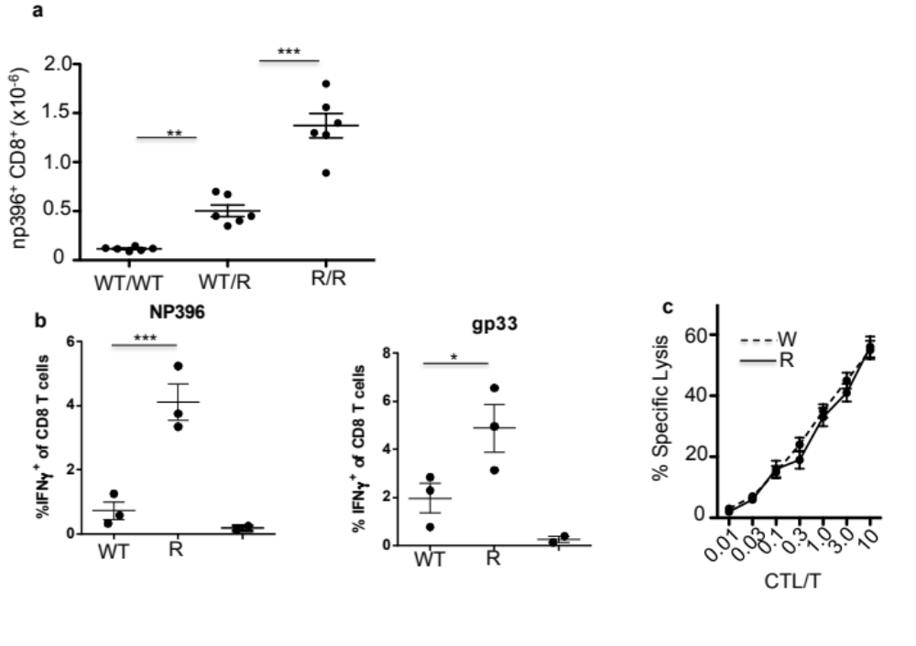

Fig. S1.
a. The Retro mutation has a semi-dominant phenotype. Retro homozygous (R/R) were back-crossed with WT C57BL/6 mice (WT/WT) to produce Retro heterozygous (WT/R) mice. Mice were infected with LCMV C13 then on day 8 p.i. the level of np396⁺ CD8⁺ cells was determined in the spleen. p<0.05, **p<0.005, ***p<0.0005. Two-tailed student t-tests were used. Each data set is representative of at least 4 individual experiments. b. Increased levels of IFN-γ producing CD8 T cells in Retro mutant mice. Mice were infected with LCMV C13 then on day 8 p.i. 8 splenocytes were re-stimulated with either gp 33 or np 396 peptide then CD8 ⁺ cells stained for intracellular IFN-γ. The level of IFN-γ of CD8 T cells was also determined in un-infected WT mice (right hand data points). Shown are the means ± sem (n=3 mice). Two-tailed student t-tests were used. Each data set is representative of at least 2 individual experiments. c. CTL activity normalized for frequency of LCMV-specific CD8 T cell. Mice were infected with LCMV C13 on day 8 p.i. the frequency of np396⁺ CD8⁺ determined (CTL). Target (T) cells pulsed with np 396 peptide were incubated with CTL at various ratios and specific lysis measured. Mean ± sem (n=5 mice). Each data set is representative of at least 2 individual experiments.

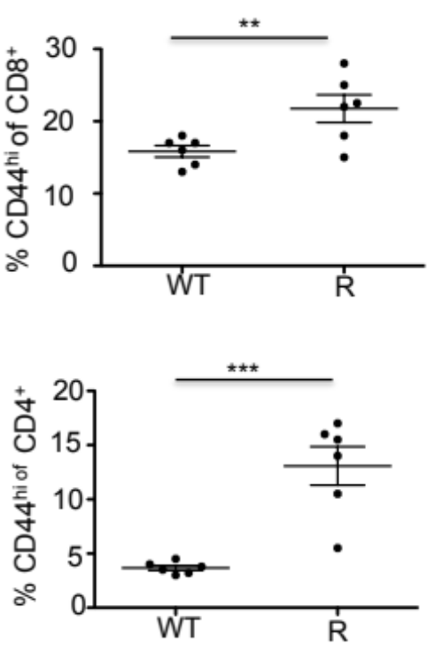

Fig. S2
Increase in activated phenotype (CD44^{hi}) T cells in Retro mutant mice. Histogram for % CD44^{hi} of either CD8⁺ or CD4⁺ cells in the spleens of wild-type (W) or Retro mutant mice. Mean ± sem, n= 6 mice) *** p<0.0001, ** p<0.001. Two-tailed student t-tests were used. Each data set is representative of at least 3 individual experiments.

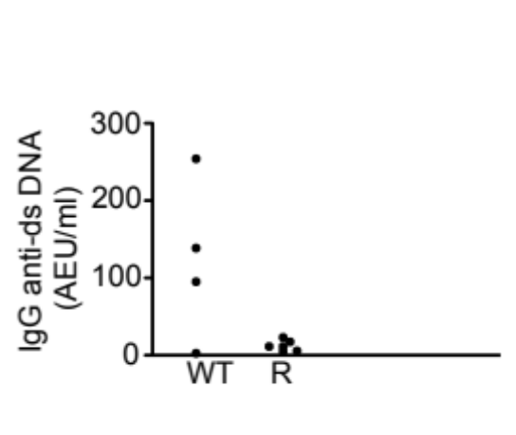

Fig. S3
Anti-double stranded (ds) DNA antibodies in the serum of WT and Retro mutant (R). Titer is represented as Arbitrary ELISA Unit (AEU)/ml from a standard curve of anti-ds DNA antibody. (n=4-5 mice). Two-tailed student t-tests were used. . Each data set is representative of at 2 individual experiments.

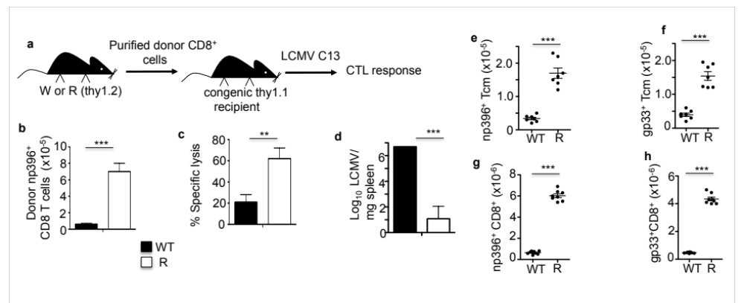

Fig. S4
The Retro mutation acts directly on CD8 T cells and also increases memory responses. a. Adoptive transfer experiment. b. Mean number of donor WT or Retro mutant (R) np396⁺ CD8⁺ splenocytes. c. ex vivo CTL activity. d. LCMV C13 Titer. Number of np396⁺ CD8⁺ (e) and (f) gp33⁺ CD8⁺ Tcm splenocytes on day 70 after acute infection with LCMV Armstrong. Mice were re-infected with LCMV Armstrong then after 5 days the number of secondary np396⁺ CD8⁺ (g) and gp33⁺ CD8⁺ (h) splenocytes determined. Mean ± sem, n=6-10 mice. Each data set is representative of at least 3 individual experiments. ***p<0.0005, **p<0.001. Two-tailed student tests were used.

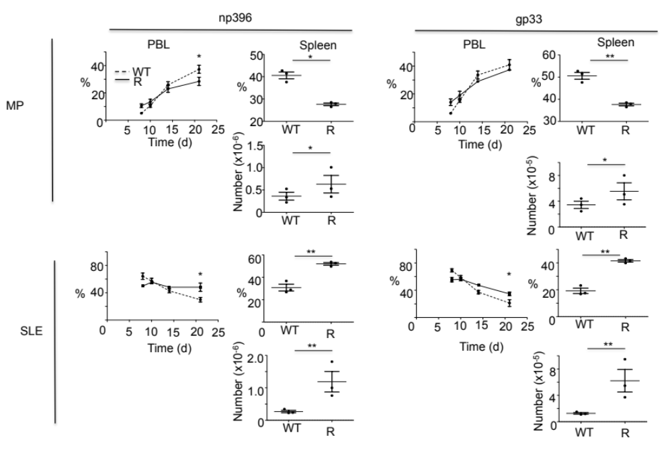

Fig.S5
Memory Precursors in Retro mutant mice. Levels of memory precursors (MP: KLRG1^{lo} CD127⁺ of either gp33⁺ CD8⁺ or np396⁺ CD8⁺ cells) and short-lived effectors (SLE: KLRG1^{hi} CD127⁻ of either gp33⁺ CD8⁺ or np396⁺ CD8⁺ cells) were determined in peripheral blood leukocytes (PBL) or spleen of wild-type (WT) or Retro mutant (R) mice after infection with LCMV Armstrong (2x10⁵ pfu i.p.). Scatter plots are from day 21 after infection. (n=3 mice of each type ± sem). Each data set is representative of at least 3 individual experiments.*p<0.05, ** p<0.025. Two-tailed student tests were used.

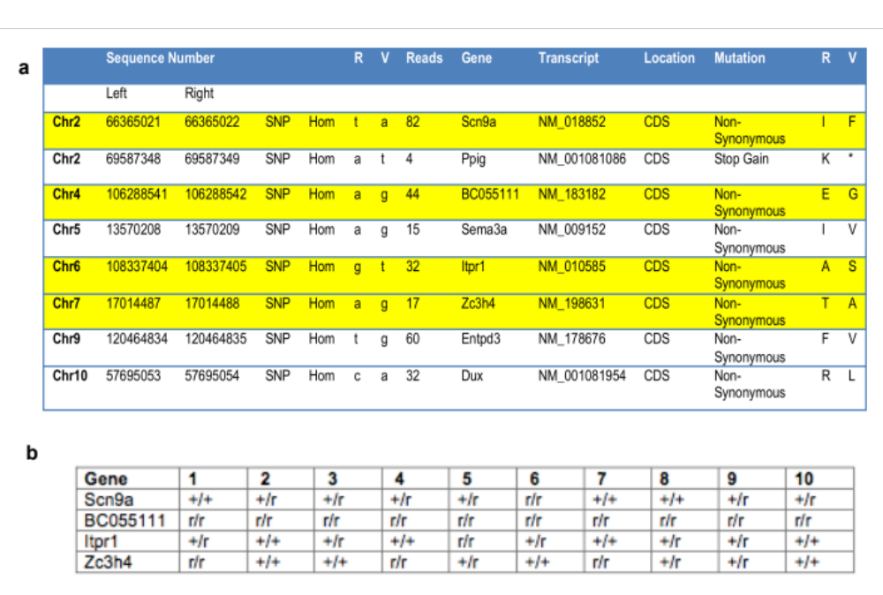

Fig.S6
SNV associated with the Retro phenotype. a. Shown are the 8 homozygous SNV in the coding sequence of genes (CDS) after comparing the whole exome of DNA from a Retro homozygous mutant mouse (Variant –V) with the reference C57BL/6J sequence from NCBI (Reference –R). The sequence number on the relevant chromosome is indicated. The number of sequencing reads covering the SNV is indicated (Reads). All mutations were non-synonomous (amino acid substitution) expect for the SNP in Ppig that resulted in a putative STOP codon. Indicated in yellow are the 4 SNV that were not found in the parental C57BL/6J strain (Charles River sub-strain) used for the ENU-mutagenesis and so are associated with the Retro line. b. The four Retro-associated SNVs were each present on different chromosomes and so we determined which segregated with the Retro homozygous mutant phenotype after LCMV C13 infection of the progeny of heterozygote inter-crosses. Shown are the genotypes for 10 progeny of the intercross of Retro heterozygous mice which exhibited a Retro homozygous phenotype (> 6-fold higher level of splenic np396⁺ CD8⁺ cells compared to WT on day 8 after infection). Mutant Retro alleles (r) and wild-type alleles (+) are indicated

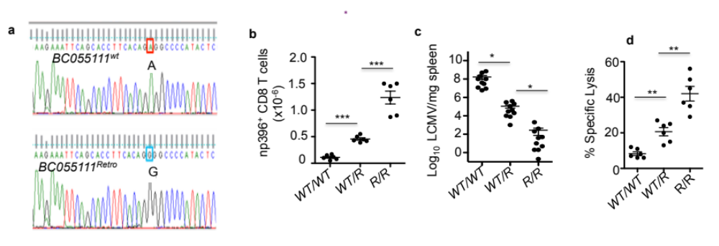

Fig.S7
The Retro mutation and its effect on CTL response to LCMV C13. a. Sequence of exon 2 region of BC055111 reveals an A to G mutation at position 1304 in WT compared to Retro (R) homozygous mutant mice. Mice were infected with LCMV C13 then on day 8 p.i. b. Number of np396⁺ CD8⁺ splenocytes. c. LCMV titer and d. % specific CTL lysis. Each data set is representative of at least 3 individual experiments. . ***p<0.005, **p<0.03, *p<0.05. Two-tailed student tests were used.

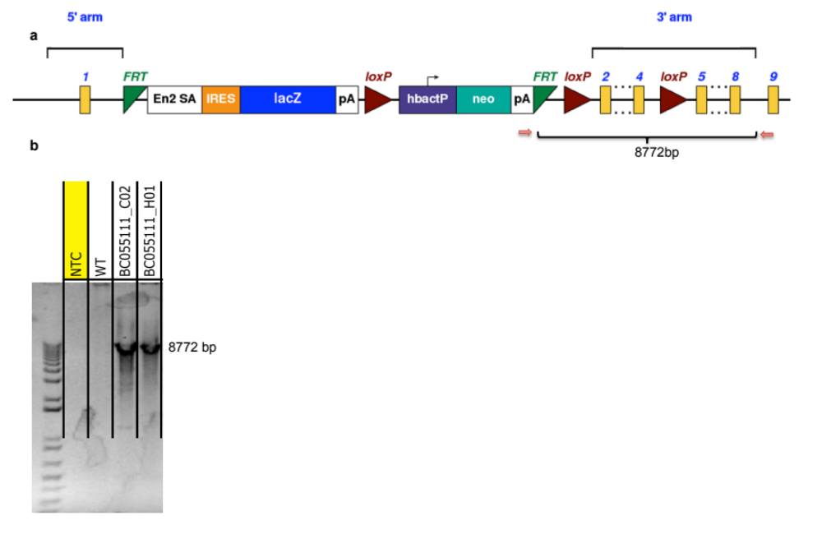

Fig.S8
Generation of mice harboring BC055111 KO allele. a. The BC055111 ^{tm1a (KOMP)Wtsi} allele is predicted to be a null allele through splicing to a lacZ trapping element contained in the targeting cassette. The trapping cassette includes the mouse En2 splice Acceptor (En2 SA) and SV40 poly adenylation (pA) signals, which are highly effective in creating null alleles in mice. Position of the PCR primers is shown by red arrows as is the expected size of the PCR product (Forward: within pA of neo, Reverse outside of 3’ homology arm in between exon 8 and 9). b. Validation of the BC055111 ^{tm1a (KOMP)Wtsi} allele by long range PCR on DNA from two ES clones harboring BC055111 targeted alleles (C02 and H01) yielded product with the expected size. PCR on no-template control (NTC) or WT did not give a PCR product.

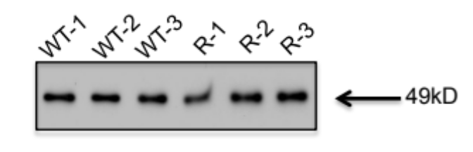

Fig.S9
Expression of LEM from synthetic ORFs. The purpose of this experiment was to determine if the Retro mutation in the Lem gene affects the qualitative function of the LEM protein. We predict that the Retro mutation (A1304) would make an E to G substitution in amino acid 50 of LEM (E50G mutation). We generated synthetic open reading frames (ORF) (lacking introns and un-translated mRNA sequences), corresponding to the WT or Retro mutant gene sequences, under the control of a transgenic promoter. Western Blots on SDS total cell extracts (0.5mg) from CTLL-2 cells transduced independently with either MIGR1 encoding ORFs with either WT (WT-1, WT-2, WT-3) or Retro mutant (R-1, R-2, R-3) coding sequences. Westerns were probed with goat- BC055111 antibody then protein G-HRP. We detected equal intensity bands in all batches of transduced CTLL-2 cells. Therefore the Retro mutation had no effect on the expression of LEM encoded by the synthetic ORFs in MIGR1 retroviruses. We found that the ability of the ORF with the Retro sequence was no better than wild-type at driving the proliferation of CTLL-2 cells after culture with IL-2 (Fig. 3j). Therefore, we conclude that the putative E50G mutation in LEM does not increase the ability of LEM to drive T cell proliferation. Rather, we conclude that increased expression of LEM in Retro mutant cells is responsible for increased proliferation. In other words, the Retro mutation has a quantitative rather than a qualitative effect on LEM.

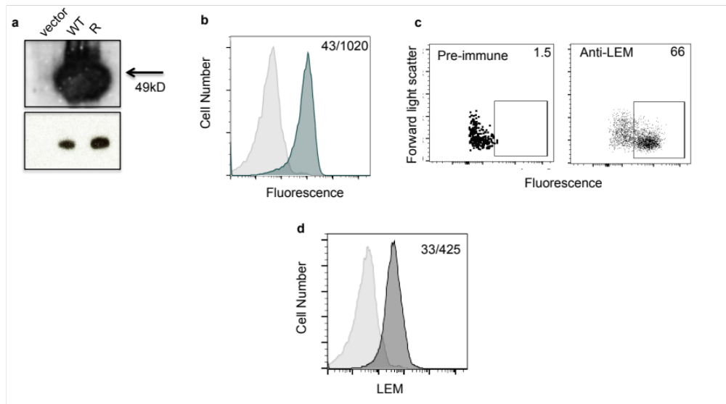

Fig. S10
Rabbit anti-recombinant LEM antibody. a. Western Blots. SDS total cell extracts (0.5mg) from CTLL-2 cells transduced with either MIGR1 encoding wild-type (W) or Retro mutant LEM (R) (Fig. 3j) were probed with rabbit anti-recombinant LEM antibody (0.2mg/ml) then protein G-HRP. We detected a strong band corresponding to LEM in CTLL-2 cells expressing transgenic WT or R LEM and a weaker endogenous band in vector alone transduced cells. The anti-LEM antiserum was then used for co-IP experiments. Upper panel – long exposure, bottom panel – short exposure. b. Intracellular staining and flow-cytometry on CTLL-2 cells expressing LEM (WT) (dark histogram) or vector-transduced CTLL-2 cells (light histogram) were stained with anti-LEM (1/1000) then anti-rabbit IgG APC (1/1000). Mean fluorescence levels for each histogram are indicated in top right corner. c. Intracellular staining and flow-cytometry with either pre-immune or anti-LEM antibody (each 1/1000) on day 3 WT CD8 T cells after activation on anti-CD3/CD28. The % positive is indicated. d. Intracellular staining and flow-cytometry for LEM on CD44^{lo} CD62L^{hi} CD8⁺ cells (light histogram) or CD44^{hi} CD62L^{lo} CD8⁺ (dark histogram) splenocytes on day 2 after infection of Retro mutant mice with LCMV C13. Mean fluorescence levels for each histogram are indicated in top right corner.

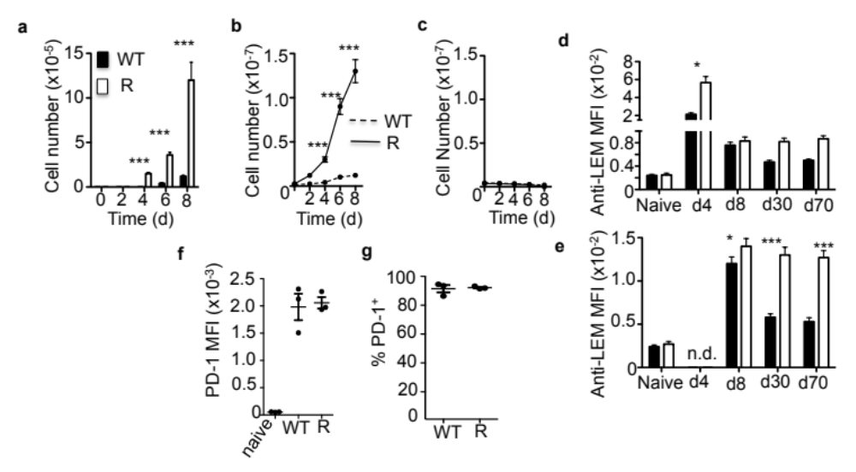

Fig. S11
Effect of LEM expression on levels of activated CD8 T cells. WT and Retro mutant (R) mice were infected with LCMV C13 a. Mean number of np396⁺ CD8⁺ splenocytes. b. Mean number of CD44^{hi} CD62L^{lo} CD8⁺ splenocytes (activated CD8 T cells). c. Mean number of CD44^{lo} CD62L^{hi} CD8⁺ splenocytes (naïve CD8 T cells). WT and Retro lines overlap. Mice were infected with LCMV Armstrong. MFI of anti-LEM staining on (c) CD44^{hi} CD62L^{lo} CD8⁺ or (d) np396⁺ CD8⁺ splenocytes. f. MFI of PD-1 staining for naive CD8 T cells or after anti-CD3 antibody activation g % PD-1⁺. Each data set is representative of at least 3 individual experiments. . Mean ± sem (n=4-6 mice). *** p<0.001; ** p<0.005, * p<0.01. Two-tailed student tests were used. The number of activated CD8 T cells (Fig. S11b) and np396⁺ CD8⁺ cells (Fig. S11a) but not naïve CD8 T cells (Fig. S1c) were increased in Retro mutant compared to WT mice after LCMV C13 infection. After acute infection of WT mice with LCMV Armstrong, LEM was maximally up-regulated in day 4 activated CD8 T cells (Fig. S11d). LEM was up-regulated in LCMV np396-specific CD8 T cells in both day 8 effectors and day 30 and 70 memory CD8 T cells (Fig. S11e). There was no difference in either PD-1 level (Fig.S11f) or % PD-1⁺ (Fig. S11g) after in vitro TCR stimulation of Retro mutant compared to WT purified CD8 T cells.

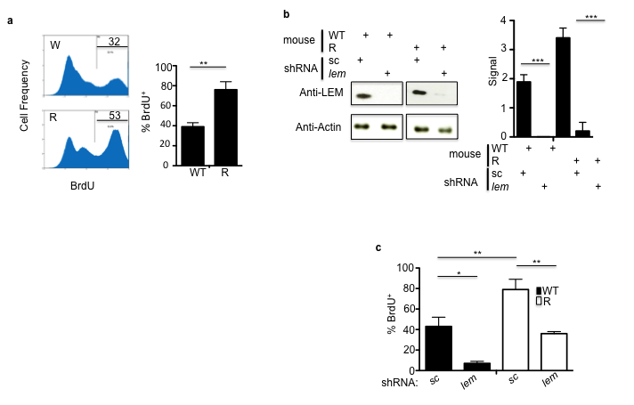
Fig. S12
In vitro proliferation of CD8 T cells requires LEM expression. a. Flow cytometry histograms showing % BrdU positive CD8 T cells from WT and R mice after 3 days of culture on anti-CD3 and anti-CD28 antibodies. Cells were pulsed with BrdU from day 1 to day 3. Bar graph of Mean +/- sem (n=4 mice) % BrdU. b. Western blots for LEM or β−actin on WT or R CD8 T cells from an individual transduction with lentivirus encoding shRNA specific for lem message or scrambled (sc) control after culture with IL-2, IL-7 and IL-15 (all at 100ng/ml). Histograms for mean signal strength (+/- sem) from Westerns on LEM after 4 individual transductions. c. Transduced cells were activated on anti-CD3 and anti-CD28 antibodies for 3 days and % BrdU determined. Cells were pulsed with BrdU from day 1 to day 3. Bar graph for mean ± sem (n=4 transductions). Each data set is representative of at least 3 individual experiments. ***p<0.0001, ** p<0.005, *p<0.05. Two-tailed student tests were used.

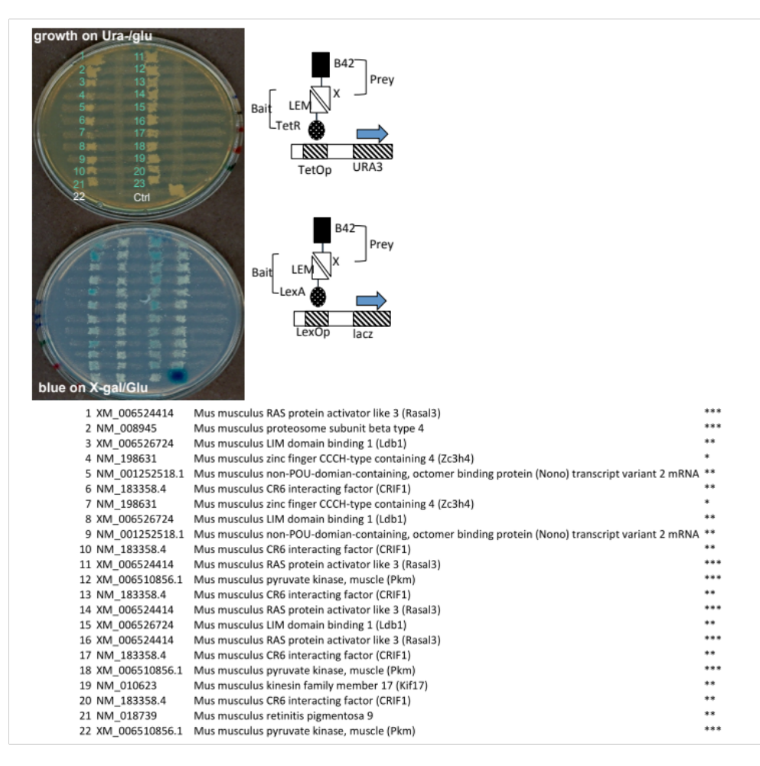

Fig.S13
Yeast two-hybrid analysis on LEM. A. Bait strains and prey strains were replicated onto YPD plates as columns (bait strains) and rows (prey strains) and incubated overnight at 30ºC. The intersections of these columns and rows contained diploid yeast formed from haploid bait and prey yeast cells. These mated grids were replicated onto two selection plates that examined the expression of URA3 (Ura⁻/glucose + 1 mg/ml 6-AU) and LacZ reporters (X-gal/glucose). One pair of known interactors was included as both positive and negative controls. Relative interaction strength were estimated with different grades for cell growth as a result of URA3 expression, and additionally scored with levels of blue intensity on X-gal plates as a function of LacZ expression. 22 bait clones were identified. b. The intensity of β-gal staining is indicated by the number of stars. Several genes are represented by multiple clones.
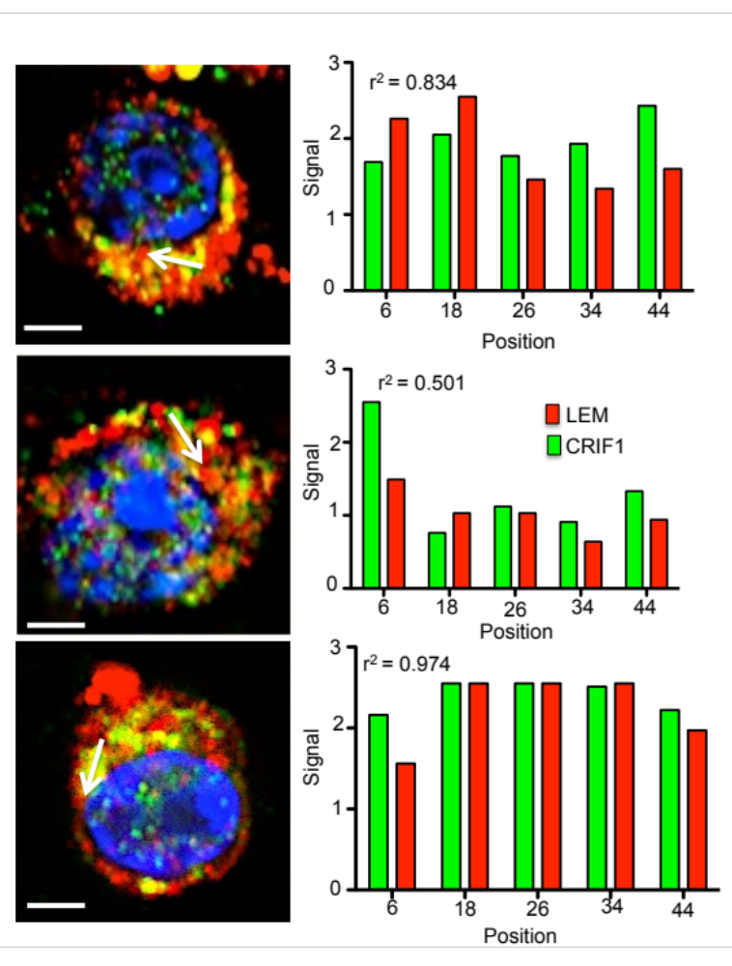
Fig. S14
Co-localization of LEM and CRIF1. CIM images of 3 different activated T cells were subjected to 1-D analysis green (CRIF1) and red fluorescence (LEM) signal intensity. Bar = 2.5μm. Five positions (6-44) were selected along a given white scan line (arrow indicating direction) and the red and green signal measured. Correlation between strength of red and green signal along a scanned line was determined by calculated the Pearson’s correlation coefficent.r²>0.5 is considered strongly correlative. For each experiment >60 optical slices were examined. Shown is data from one of three experiments. All three experiments had mean Pearson’s correlation coefficents >0.5.
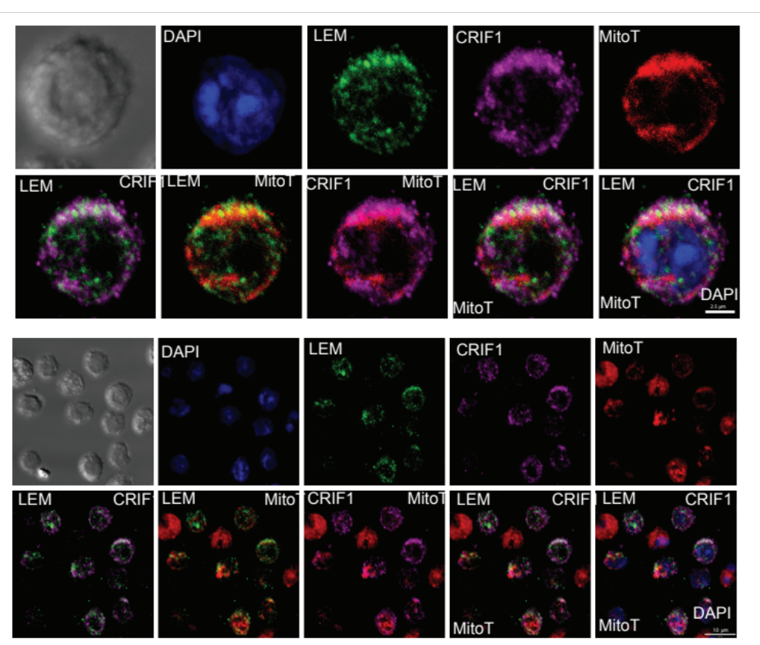

Fig.S15
Staining of CTL for LEM and CRIF1 in the mitochondria. Top. High power CIM images of a CTL stained with DAPI (blue) for nuclei or mitotracker red (MitoT) for mitochondria and antibodies against LEM and CRIF1. Overlay between LEM (green) and CRIF1 (violet) is indicated by white, LEM and MitoT (red) by yellow/orange, CRIF1 and MitoT by purple. Bar= 2.5μm. Bottom. Low power CIM images of multiple CTL stained as above. Bar= 10μm. Each data set is representative of at least 2 individual experiments.

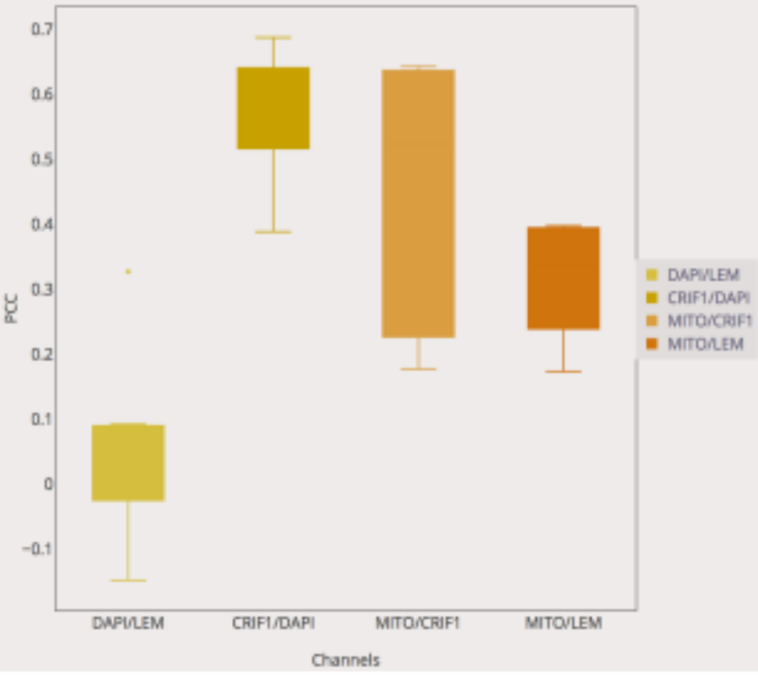

Fig. S16.
Co-distribution of CRIF1 and LEM. Distribution of Pearson’s correlation coefficients (PCC) for CTL stained with DAPI, CRIF1, LEM and Mitotracker red (Fig. S15). Co-localization was performed on 7 datasets each with 20 Z-planes (N=140 images). A total of 70 cells were examined for the whole experiment. The PCC for LEM/Mitotracker red and CRIF1/Mitotracker and the analysis supports co- distribution of both proteins in mitochondria. In addition PCC indicate that CRIF1 but not LEM is located in the nucleus. Blocks indicate the range of PCC and are ± sem.

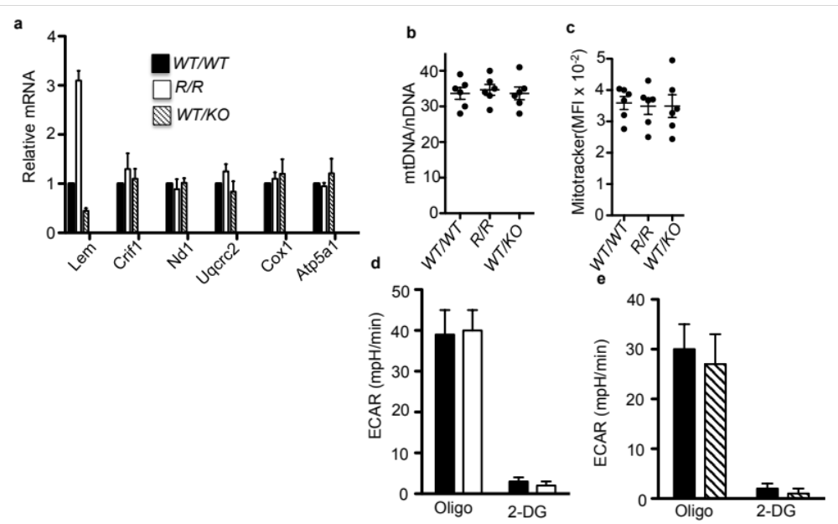

Fig .S17
LEM and mitochondrial activity. In all experiments CD8 T cells were from mice on day 4 p.i. with LCMV C13. a. Real-time PCR measurement of mRNA for genes encoding mitochondrial proteins. Shown is the mean (+/-) sem (n=6 mice) of mRNA relative to the WT (WT/WT). There was no statistical difference between WT and Retro mutant (R/R) or LEM heterozygous KO (W/KO). b. Number of mitochondria determined by the ratio of mtDNA to nDNA determined by real-time PCR for mitochondrial and nuclear rRNA genes. Shown is the mean (+/-) sem (n=6 mice). There was no statistical difference between WT and Retro mutant (R/R) or LEM heterozygous KO (WT/KO). c. Mass of mitochondria per CTL measured by mean fluorescence intensity (MFI) staining with Mitotracker. Shown is the mean ± sem (n=6 mice). There was no statistical difference between WT and Retro mutant (R/R) or LEM heterozygous KO (WT/KO). d and e. Glycolysis was measured by Extracellular Acidification Rate (ECAR) and initiated by the injection of glucose then oligomycin (oligo) to reach maximal ECAR (t=35min). Glycolysis was terminated by injection of 2-deoxyglucose (2-DG) (t=119min). Shown is the mean ± sem (n=6 mice). Each data set is representative of at least 3 individual experiments. Two-tailed student t-tests were used

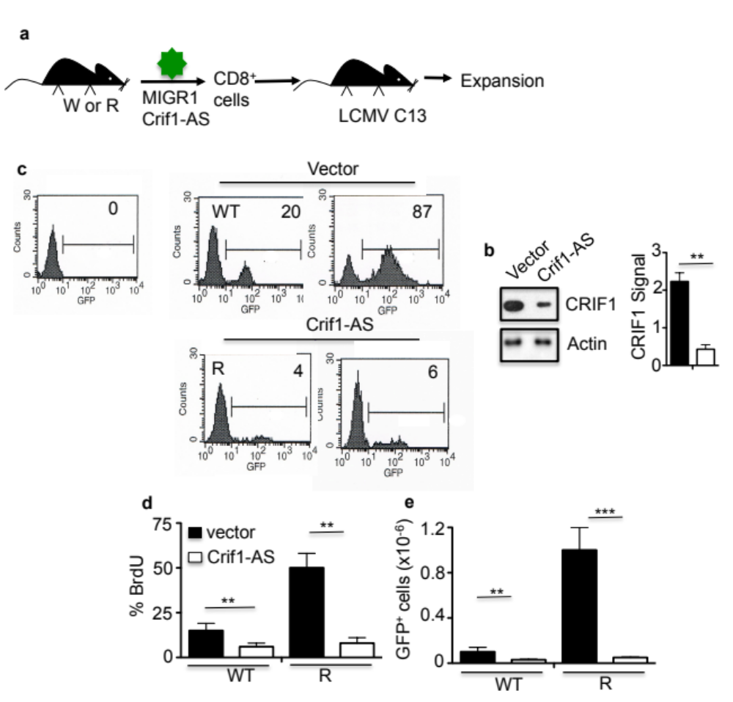

Fig. S18
Effect of Crif-AS on expansion of CD8 T cells. a. Cytokine cultured CD8 T cells were transduced with MIGR1 retrovirus encoding Crif1-AS or vector alone then equal numbers of GFP ⁺ cells (5x10⁶) were adoptively transferred to C57BL/6 recipient mice. b. Western blot on GFP⁺ CD8 T cells transduced with MIGR1 vector alone (vector) or MIGR1 encoded Crif1-AS after adoptive transferred and infection with LCMV C13. Bar graph for signal strength. There was about an 80% knock-down in CRIF1 expression. c. Histograms for the percentage of GFP⁺ cells on gated CD8⁺ cells from the spleens of mice on day 8 p.i. with LCMV C13. Top left histogram is from an infected recipient mice that did not receive GFP⁺ CD8 T cells. Percentage GFP⁺ is shown in top right corner. Bar graph for mean % BrdU d, or e number of donor GFP⁺ cells transduced with either vector alone or Crif1-AS. % BrdU fold-increase in R over WT: V = 3 Crif1-AS = 0; number GFP⁺ cells fold-increase in R over WT: V = 10, Crif1-AS = 2. Mean ± sem (n=6 mice). These data representative of 3 independent experiments. **p<0.005, ***p<0.0005. Two-tailed student tests were used.

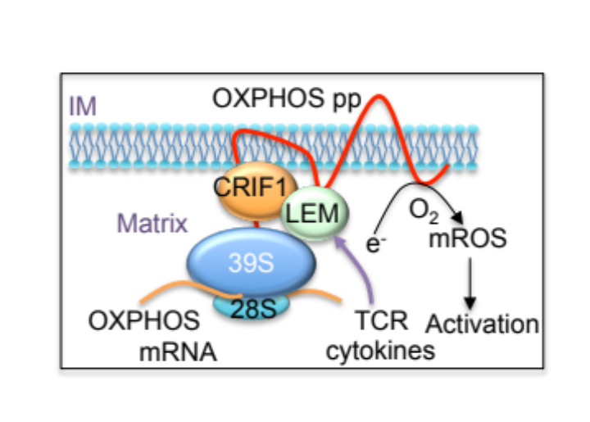

Fig. S19
Model for LEM function in mitochondria. LEM associates with CRIF1 as part of a complex that includes 39S subunit of the mitoribosome and OXPHOS polypeptides (pp). LEM facilitates the insertion of nascent OXPHOS polypeptides into the inner membrane (IM) of the mitochondrion. OXPHOS activity results in the production of ROS in mitochondria (mROS), which leads to T cells activation. LEM expression is induced by both TCR and cytokine signals.

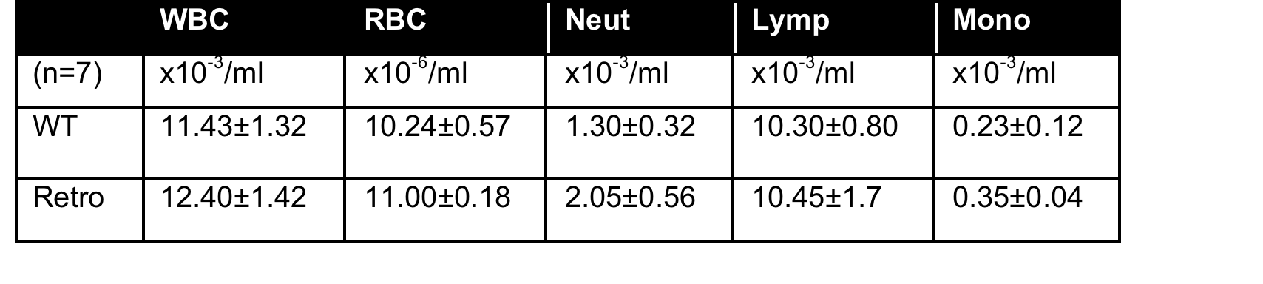

Table S1.
Blood and lymphoid populations in Retro mutant mice. Leukocyte levels were determined by flow-cytometry of peripheral blood. 14 month old C57BL/6 WT or Retro mutant mice were analyzed. Each data set is representative of at least 3 individual experiments.

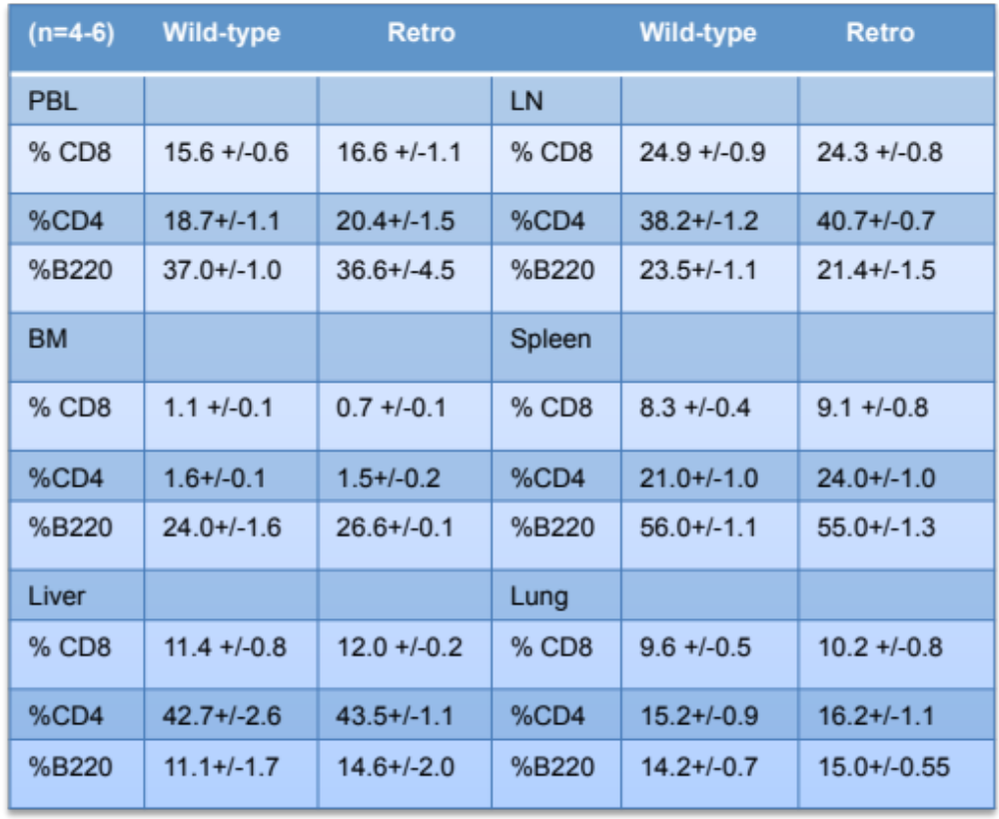

Table S2.
Lymphocyte levels from peripheral blood leukocytes (PBL), bone marrow (BM), liver, lymph-node (LN), spleen and lung determined by staining for B220, CD3, CD8 and CD3 surface makers. 14 month old C57BL/6 wild-type or Retro mutant mice were analyzed. Mean +/- sem (n=4-6 mice). Each data set is representative of at least 3 individual experiments.

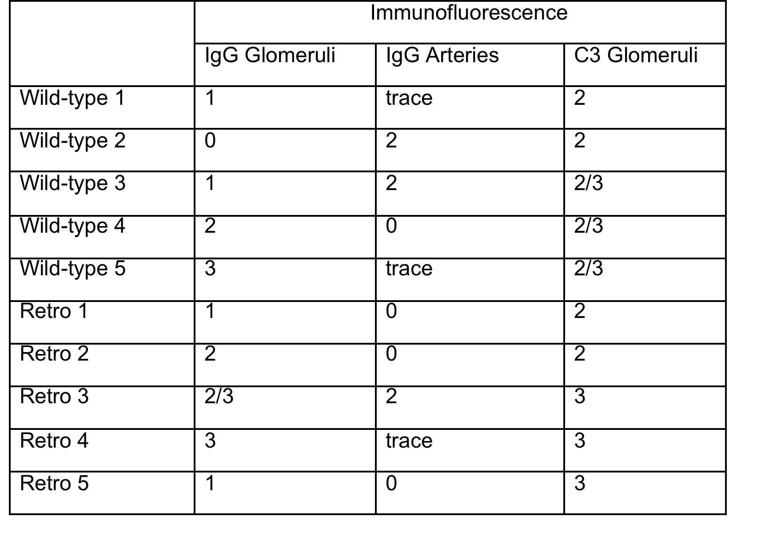

Table S3.
Auto-antibodies in Retro mutant mice. Five (1-5) 14 month old C5BL/6J wild-type or Retro mutant mice were examined for the deposition of IgG or C3 complement in kidney glomeruli or arteries using immunofluorescence to score extent of staining (0-5 range). Mice were scored blindly. There was no significant difference in the scores between WT and Retro mutant mice.

