Supplementary Material
S1. Packing Density of the Catalyst Layers: Packing densities of the catalyst layers with the various carbon catalysts were calculated by dividing the respective catalyst loading by the cross-sectional thickness of MEAs. For obtaining cross section images, MEAs were immersed in liquid nitrogen for about 5 minutes. Subsequently, a section of the MEA was blade cut and fixed on the SEM sample holder. Electron microscopy was carried out on a Hitachi TM-3000 tabletop electron microscope. For the high resolution images, a high resolution field emission gun scanning electron microscope (LEO Gemini 1525 FEGSEM) was used. The average thickness of the catalyst layers, from SEM images, was determined with the public domain Java image processing program, ImageJ. [1] Figure S1 illustrates images taken of MEAs of catalysts B, Dan and Dant at a loading of 4 mg cm⁻². The resulting packing density of the catalyst layers was, 0.40 g cm⁻³ for catalyst B based MEAs, ~0.31 g cm⁻³ for catalyst Dan based MEAs and ~0.27 g cm⁻³ for catalyst Dant based MEAs.

Catalyst B
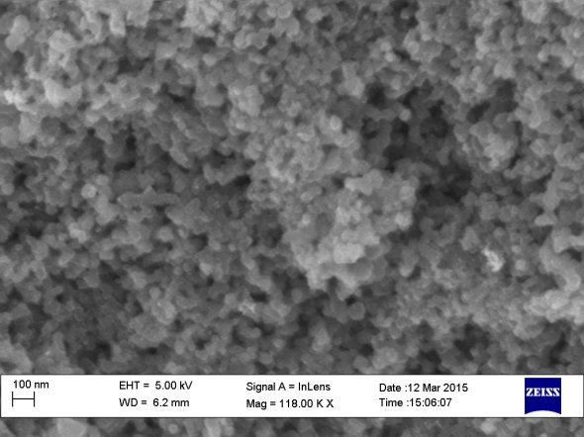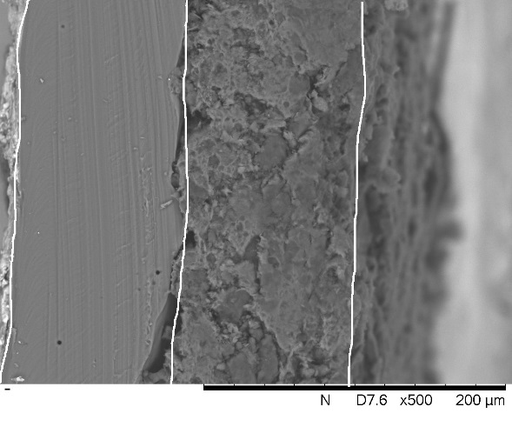
NafionTM
CL Nanostructure
~100 μm
CL
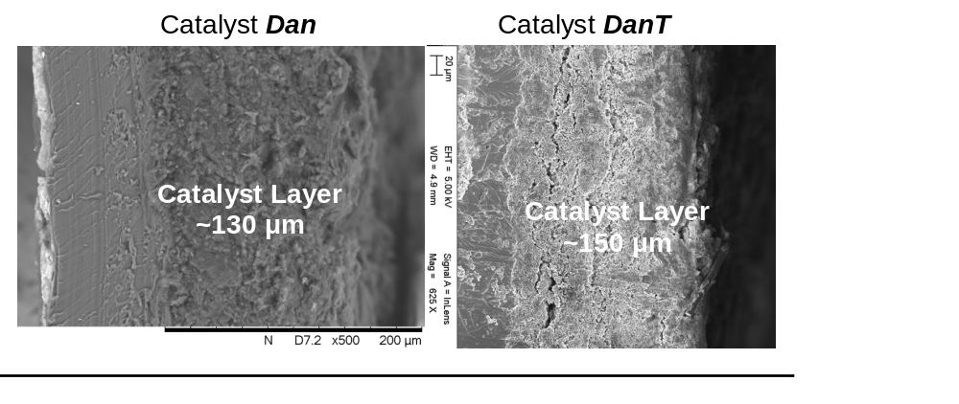
Figure S1: Scanning electron microscopy images of the membrane electrode assembly illustrating the measured packing density of the catalyst layers prepared with the carbon catalyst B at ~0.4 g cm⁻³, Dan at ~0.31 g cm⁻³ and Dant at ~0.27 g cm⁻³. Catalysts at a loading of 4 mg cm⁻², and an I/C ratio of 1.0 for B and Dant and 1.5 for Dan, where the NafionTM membrane is a N115. The appropriate nanostructure of the prepared catalyst layers is illustrated on the higher magnification image for catalyst B.

S2. Ohmic Overvoltages in a PEFC
S2.1 High Frequency Resistance
This resistance is the sum of the electric resistance (contact and bulk materials resistances) and proton transport resistance (through the electrolyte membrane). $R_{Ω}$ is routinely measured by AC impedance spectroscopy at high frequencies and because of such it is normally referred to as the high frequency resistance. Figure S2 shows a complex impedance plot for a MEA employed in this work. Results show that with a membrane NafionTM N115 and the materials utilized in this study (Toray carbon paper GDL (with a microporous layer) and a carbon catalyst) under the present experimental conditions, a typical value for $R_{Ω}$ was 0.2 Ω cm². For experiments utilizing the membrane NafionTM NR212, a typical value obtained for $R_{Ω}$ was 0.06 Ω cm², of which ~0.04 Ω cm² is the contribution from the proton transport in the electrolyte membrane (NafionTM conductivity is ~0.13 S cm⁻¹ at 100%RH and 80 °C [2]). These values of $R_{Ω}$ were obtained through fittings of the experimental data, further details in the next section.

S2.2 Proton Conduction Overvoltage in the Cathode Catalyst Layer
Transport of protons in the catalyst layer of PEFCs is hindered by an ion transport resistance, which can be assessed experimentally through electrochemical impedance spectroscopy. Eikerling and Kornyshev [3] have derived analytical expressions correlating the cathode catalyst layer structure/composition with the AC impedance response of PEFCs. Among the special cases described in this model, there is the proton transport resistance signature in the EIS spectrum, which appears as a 45⁰ straight line in the high frequency domain, as clearly observed in the inset of Figure S2 (dashed line). Eikerling and Kornyshev have also pointed out that the developed model can be approximated by using a finite transmission line equivalent circuit, therefore experimental data can be readily fitted with this element and the proton transport resistance in the catalyst layer obtained (for further details refer to experimental section).

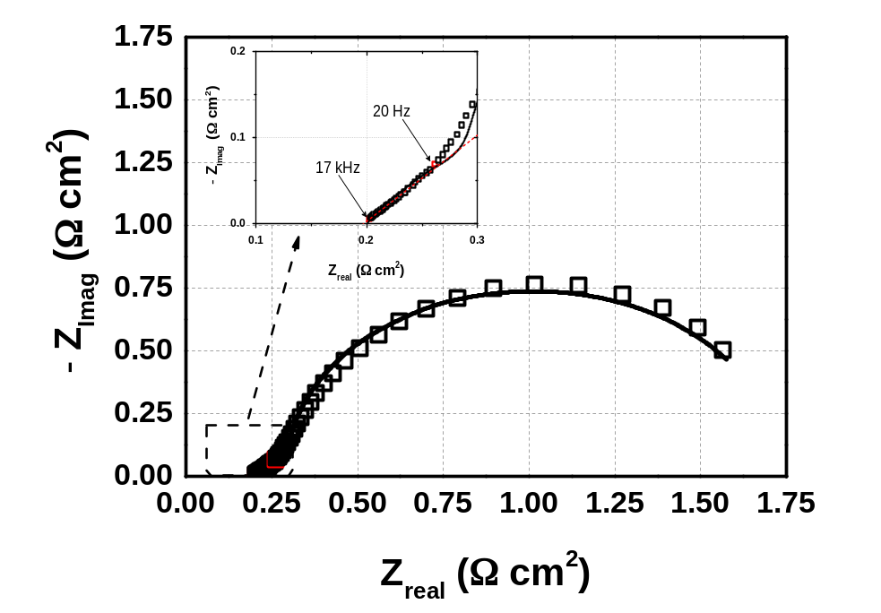
Figure S2: Complex plane impedance plot of a single PEFC cell fed with H₂/O₂. Symbols stand for experimental data and line to the equivalent circuit (finite transmission line) fitting result. Inset highlights the characteristic feature of the proton transport resistance in the cathodic catalyst layer. Dashed red line corresponds to 45º line. MEA is composed of carbon catalyst B at a loading of 4 mg cm⁻² and an I/C ratio of 1 on a Toray carbon paper THP60 with microporous layer, a NafionTM N115 membrane and a commercial electrode as anode (Johnson Matthey, 0.4mg_{Pt} cm⁻²). The EIS experiment was carried out under galvanostatic control at a current density equivalent to a cell potential of 0.6V, with an AC perturbation of 5% of the DC current for a frequency range between 100 kHz and 0.1 Hz. Cell hardware temperature at 80 ⁰C and water humidification at 95 ⁰C_{anode} and 85 ⁰C_{cathode}, with H₂ at 160ccm and O₂ at 450ccm, both anode and cathode compartments were pressurized to 210 kPa gage (O₂ partial pressure at 244 kPa_{abs}).

With the NafionTM ionomer utilized in this study (1050EW NafionTM ionomer) and the carbon catalysts at a loading of 4 mg cm⁻², under the present experimental conditions (see Fig. 02 and 03), a typical $R_{H^{+}}^{cath}$ value of 0.1 Ω cm² was obtained through equivalent circuit fitting of the AC impedance experimental results (i.e. Fig. S2). For platinum based MEAs, a typical value for $R_{H^{+}}^{cath}$ was 0.03 Ω cm².

S3. Theoretical PEFC Voltage ($E_{cell}^{theor}$):
The theoretical cell voltage ($E_{cell}^{theor}$) in equation 02 of the main text is the difference between anode and cathode reaction equilibrium potentials, or the hydrogen oxidation reaction and the oxygen reduction reaction equilibrium potential described by the Nernst equation for the respective partial pressure of the gases in the flow field:

$E_{{cell}_{(P_{H_{2}},P_{O_{2}}, T )}}^{theor}=E_{cell}^{Ɵ}+\frac{RT}{2F}ln\left[\frac{\left(\frac{P_{H_{2}, FF}^{an}}{P^{Ɵ}}\right){\left(\frac{P_{O_{2}, FF}^{cath}}{P^{Ɵ}}\right)}^{1/2}}{\left(\frac{P_{H_{2}O}^{cath}}{P^{Ɵ}}\right)}\right]$ eq. S1

where $R$ is the universal gas constant (8.314 J mol⁻¹ K⁻¹); $T$ is the temperature in Kelvin (K); $F$ is the Faraday constant (96487 C equiv⁻¹); $P_{H_{2}, FF}^{an}$ is the partial pressure of hydrogen in the flow field; $P_{O_{2}, FF}^{cath}$ is the partial pressure of oxygen in the flow field; $P_{H_{2}O}^{cath}$ is the partial pressure of reaction product water (when liquid water is produced $P_{H_{2}O}^{cath}$ = 1); $P^{Ɵ}$ is the standard pressure (1 atm); and $E_{cell}^{Ɵ}$ is the standard equilibrium potential of the fuel cell reaction at the operational temperature ($E_{cell}^{Ɵ}$= 1.229 V at 25 ⁰C and 1atm), given by:

$E_{cell}^{Ɵ}=1.229-0.0008456(T-298.15)$ eq. S2

Under the experimental conditions (see caption of Fig. 02) of the present work, the theoretical cell potential ($E_{{cell}_{(P_{H_{2}},P_{O_{2}}, T )}}^{theor}$) is 1.202 Volts for H₂/O₂ partial pressures at 217 kPa_{abs}/244 kPa_{abs} and is 1.178 Volts for H₂/O₂ partial pressures at 100 kPa_{abs}/100 kPa_{abs}. It is noteworthy that the minor effect of temperature over the specific heat capacities (H and S) is neglected in this calculation, which is acceptable for temperatures below 100 ⁰C.

S5. Further IR-free Tafel like Plots of PEFCs:
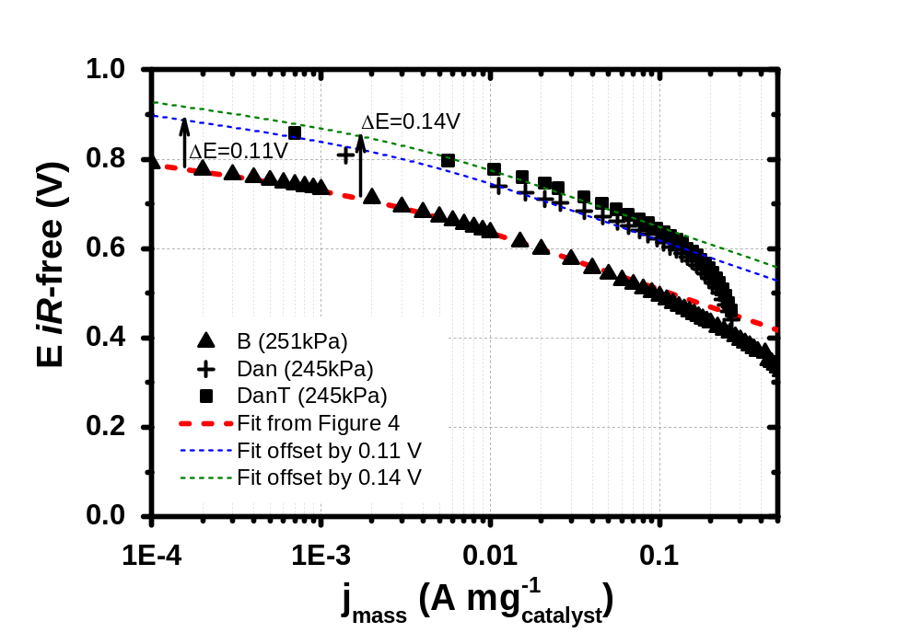
Figure S3: H₂/O₂ resistance corrected polarization response for catalyst B, Dan, Dant with the fitting line generated for the data in Figure 3(b) (paper), and overlaid on data for catalyst B. Parameters for fit (----): α_{eff,1=}1.45; α_{eff,2=}0.53; E_{changeover}=0.722 V; j_{Echangeover}=1.25 ×10⁻³ A mg⁻¹.

S6. Further Electrochemical Impedance Spectroscopy Results of PEFCs: Mass Transport
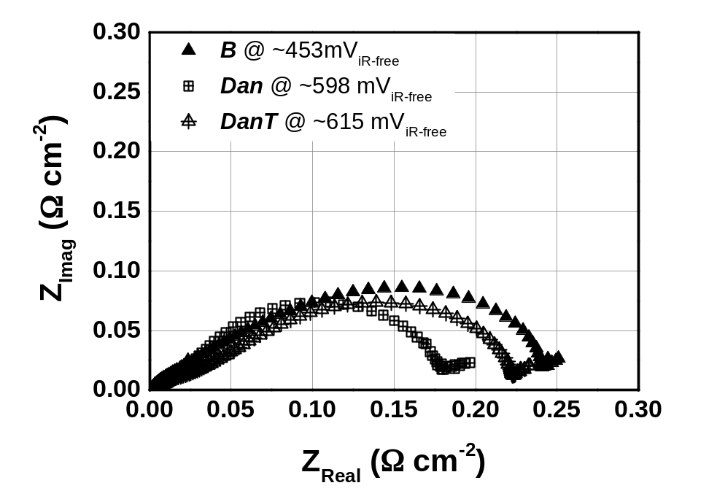
Figure S4: Complex plane impedance plot of a single PEFC cell fed with H₂/O₂. MEAs are composed of different carbon catalysts at a loading of 4 mg cm⁻². Symbols stand for: triangle for carbon catalyst B; crossed square for catalyst Dan; crossed triangle for catalyst Dant. Experimental conditions are as per Fig. S2, S3 and S4. Real resistances are high frequency resistance corrected.
References:
[1] http://rsb.info.nih.gov/ij/index.html. ImageJ is a public domain Java image processing program inspired by NIH Image, Accessed on 27/01/2016.
[2] Thiago Lopes, Dae Sik Kim, Yu Seung Kim, and Fernando Henry Garzon. Ionic transport and water vapor uptake of ammonium exchanged perfluorosulfonic acid membranes. Journal of The Electrochemical Society, 159 (3): B265–B269, 2012.
[3] M Eikerling and A.A Kornyshev. Electrochemical impedance of the cathode catalyst layer in polymer electrolyte fuel cells. Journal of Electroanalytical Chemistry, 475 (2): 107 – 123, 1999.

