Title

Birthweight and patterns of postnatal weight gain in very and extremely preterm babies in England and Wales from 2008-2019
Sam F Greenbury PhD ¹, Elsa D Angelini PhD ¹, Kayleigh Ougham MSc ², Cheryl Battersby FRCPCH ², Christopher Gale MRCPCH ², Sabita Uthaya FRCP ², Neena Modi FMedSci ²

- National Institute for Health Research Imperial Biomedical Research Centre, Institute for Translational Medicine and Therapeutics Data Science Group, Imperial College London, London, UK

- Section of Neonatal Medicine, Chelsea and Westminster Hospital campus, School of Public Health, Faculty of Medicine, Imperial College London, London, UK

Correspondence:
Professor Neena Modi
School of Public Health, Faculty of Medicine, Imperial College London, Section of Neonatal Medicine, Chelsea and Westminster Hospital campus, 369 Fulham Road, London SW10 9NH, UK
Imperial College London
Email: n.modi@imperial.ac.uk
Tel: +44 (0) 20 3315 5101

Manuscript word count: 3561

Research in context
Evidence before this study: Neonatal management is heavily influenced by preterm growth charts, a variety of which exist around the world and are constructed either using fetal weight estimates or cross-sectional birthweights of babies born at different gestational ages. Both depict a trajectory leading to the weight of a baby born at full-term. Whether this pattern is optimal for a preterm baby is unknown. We searched PubMed for studies examining patterns of preterm postnatal weight gain. We included keywords (weight gain OR growth) AND (preterm birth) AND (growth charts). We additionally reviewed all “similar articles” in identified publications. We set no search date limits. We identified 262 papers none of which compared longitudinal weight measurements in infants with and without major morbidities, or made comparisons over time.
Added value of this study: Our whole population study involving 90,817 infants shows that the birthweight of extremely and very preterm babies has remained stable over 12 years. Early postnatal weight loss has decreased and subsequent weight gain has increased. In babies without major morbidity, weight velocity follows a consistent trajectory regardless of gestational age, but weight at term is consistently below the weight of babies born at full-term. The only other study attempting to provide longitudinal postnatal growth data on healthy preterm babies, INTERGROWTH-21, is limited in utility to guide neonatal practice as it included only 201 preterm infants, of whom only 28 were below 34 weeks’ gestation.
Implications of all the available evidence: In paediatric practice the ideal pattern of weight gain reflects growth in healthy children. This conceptual framework is problematic for neonatal care, as preterm birth is inherently an abnormal phenomenon and the optimal pattern of postnatal growth, namely the pattern associated with healthy long-term outcomes, is unknown. Attempting to mimic the pattern of intrauterine growth risks promoting accelerated weight gain. The consistent weight velocity identified in this study offers opportunity to construct novel preterm growth curves despite lack of knowledge of optimal postnatal weight gain.

Abstract (298w)
Background: Intrauterine and postnatal weight are widely regarded as biomarkers of fetal and neonatal wellbeing, but optimal weight gain following preterm birth is unknown. In this cohort study, we describe changes over time in birthweight and postnatal weight gain in very and extremely preterm babies, in relation to major morbidity and healthy survival.
Methods: We used whole population data from the UK National Neonatal Research Database for infants below 32 weeks gestation admitted to neonatal units in England and Wales over 2008-2019. We employed non-linear Gaussian process to estimate trends, and Bayesian multilevel regression to estimate unadjusted and adjusted coefficients. We evaluated birthweight; weight change birth to 14 days (ΔW14); weight at 36 weeks postmenstrual age (PMA); associated z-scores; and longitudinal weights for babies surviving to 36 weeks PMA with and without major morbidities.
Findings: The cohort comprised 90,817 infants. Over the 12-year period mean (95% Compatibility Interval) differences adjusted for antenatal, postnatal and demographic variables were birthweight: 0g (-7, 7); birthweight z-score: -0∙01 (-0∙05, 0∙03); ΔW14: 39g (26, 51); ΔW14 z-score: 0∙14 (0∙08, 0∙19); weight 36 weeks PMA: 105g (81, 128); weight 36 weeks PMA z-score: 0∙27 (0∙21, 0∙33). Greater weight at 36 weeks PMA was robust to adjustment for enteral nutritional intake. In babies surviving without major morbidity, weight velocity in all gestational age groups stabilised at around 34 weeks PMA at 16-25 g/day along parallel centile lines.
Interpretation: The birthweight of extremely and very preterm babies has remained stable over 12 years. Early postnatal weight loss decreased, subsequent weight gain increased but weight at 36 weeks PMA is consistently below birth centile. In babies without major morbidity, weight velocity follows a consistent trajectory offering opportunity to construct novel preterm growth curves despite lack of knowledge of optimal postnatal weight gain.

Funding: UK Medical Research Council

Introduction
Growth monitoring is an essential component of obstetric and neonatal care. In obstetric practice, standards are constructed from ultrasound biometry, including estimates of fetal weights. Identification of a reduction in intrauterine weight using fetal size or velocity charts is a key factor driving an obstetric decision to deliver a baby preterm. Obstetric and neonatal practice has advanced over the years leading to a greater willingness to deliver babies before intrauterine growth restriction is advanced. However, the majority of preterm babies are born following the spontaneous onset of preterm labour. There is broad agreement that the weights of babies born extremely preterm are generally lower than fetuses of the same gestational age that remain in utero; in other words most will have experienced some degree of intrauterine growth restriction, a reflection of the impact of adverse pregnancy circumstances on fetal weight gain. For this reason, most babies born very preterm weigh less at birth than babies of equivalent gestational age that remain in utero ¹⁻³. Thus, at 28-32 weeks' gestation, the 50th centile for birthweight compares approximately with the 10th centile for fetal weight ¹.
In paediatric practice the ideal pattern of weight gain is that which reflects growth in healthy children. This conceptual framework is problematic for neonatal care, as preterm birth is inherently an abnormal phenomenon. Neonatal management is hence heavily influenced by preterm growth charts, a variety of which exist around the world ⁴⁻⁶. Preterm charts are constructed either using fetal weight estimates or cross-sectional birthweights of babies born at different gestational ages. Both depict a trajectory leading by 40 weeks postmenstrual age (PMA) to the weight of a baby born at full-term. Preterm growth charts therefore drive clinical practice towards achieving third trimester weight gain at a rate that exceeds that in utero. The steepness of the trajectory of postnatal weight gain for an individual baby will depend on the degree of intrauterine growth restriction, the magnitude of early postnatal weight loss, and the assiduity with which practitioners strive to achieve the pattern of weight gain depicted by growth charts. Whether this pattern is optimal for a preterm baby is unknown. Illness severity is also a major determinant of growth and though this has reduced in preterm babies over time, survival of the most immature babies with the most challenging care requirements, has risen.
Our aims were to determine the change over time in birth weight, early postnatal weight loss, and weight at 36 weeks PMA in babies born below 32 weeks gestation. We also examined postnatal weight gain in relation to sex, and survival with and without major morbidities.

Methods
Study design and population: We utilised routine clinical data from the National Neonatal Research Database (NNRD) ^{7, 8}. This holds a predefined set of detailed, real-world data (the Neonatal Data Set, a National Health Service Information Standard), extracted at regular intervals from the Electronic Patient Records of all admissions to neonatal units in England, Wales and Scotland (the UK Neonatal Collaborative). The Neonatal Data Analysis Unit at Imperial College London receives and quality-assures these data, prior to incorporation into the NNRD. We obtained patient-level data on all infants born below 32 completed week’s gestation over the years 2008 to 2019 inclusive who were admitted to neonatal units in England and Wales. The Health Research Authority, and Health and Care Research Wales, approved the study (ID 273001). All neonatal units agreed to the inclusion of their data in the study. No additional data cleaning was employed.
Outcomes: We examined the change over time in birthweight (BW), weight change from birth to 14 days (ΔW14), weight at 36 weeks PMA (W36) and associated z-scores (BWz; ΔW14z; W36z). We chose to use W36 as most babies born below 32 weeks gestation remain in neonatal care up to this point, with progressive discharge thereafter.
We calculated weight z-scores for boys and girls using the L, M and S values from the UK-WHO preterm reference data ^{4, 9}. In order to calculate the z-score at a given postmenstrual age in days, we interpolated LMS values as these were only available weekly in the original reference table.
Analyses: We employed two approaches; first, a non-linear Gaussian process regression to model trends in average monthly weight without adjusting for factors that might have altered over time (such as the gestational age distribution of babies admitted to neonatal units) using two additive covariance kernels: a radial basis function to model medium to long-term trends (greater than half a year and less than 20 years) and a white noise function to model Gaussian noise. We fitted hyperparameters by maximizing the log marginal likelihood. We measured the quality of fit by training the model on 80% of randomly selected data, compared the 20% held-out data with the predicted values and visually inspected this against the 95% prediction interval ¹⁰.
Second, we used Bayesian multiple linear regression to model BW and BWz, ΔW14 and ΔW14z and W36 and W36z as a function of several predictors. Here, we assumed a multilevel structure and modelled group variation across birth year categories. We standardized all variables (mean-centred and normalised by standard deviations). We used weakly regularizing Normal (0, 1) priors for non-categorical regression coefficients and an Exponential (1) prior for the standard deviation σ of groups of coefficients of the same category ¹¹. To assess differences between the years 2019 and 2008, we considered the posterior distribution of the difference in regression coefficients. We fitted the models using the No-U-Turn Sampler with 2,000 tuning steps and 2,000 samples implemented in the pymc3 ¹² package in Python. We determined model convergence of the No-U-Turn Sampler by checking the R-hat statistic was close to 1 and the effective sample size for posterior distributions was at least 10 across two independent chains ¹³.
We adjusted birthweight for antenatal and birth variables. We additionally adjusted ΔW14 and ΔW14z and W36 and W36z for postnatal variables. We also conducted an adjusted regression in which we included the type (maternal milk; pasteurised donor milk; formula) and daily volume of enteral intake to 36 weeks PMA, use of fortifier and age at first feed, over the period 2011 (the first year for which these data are available) to 2019. The full list of variables included in the adjusted analyses is provided in Supplementary Table S1. We report the mean, standard deviation and 95% Compatibility Intervals (CI) for all parameter estimates unless otherwise stated. We use Compatibility Interval instead of “confidence” or “credible” interval to avoid inferences of confidence and credibility ¹¹.
We analysed longitudinal weight by gestational age category using values averaged across all available measurements on a given day. We calculated W36 as the median for weights at 36 to 37 weeks PMA. We combined data on infants of 23 weeks gestational age and below, as numbers were small.
We examined postnatal weight gain in babies that survived to 36w PMA with and without major morbidity (surgical necrotising enterocolitis (NEC); severe brain injury (SBI); bronchopulmonary dysplasia (BPD); treated retinopathy of prematurity (ROP)), and in those that died. We modelled adjusted differences by introducing an indicator variable for each morbidity. Whether a morbidity was present in an infant was determined at final discharge, not at the time of the weight measurement.
We defined surgical NEC as any diagnosis requiring surgery; SBI as any seizures, hypoxic ischaemic encephalopathy, intracranial haemorrhage (grade 3/4 periventricular haemorrhage and terms that indicate other intracranial haemorrhage using our previous definition as applicable to very preterm babies ¹⁴), white matter injury, stroke, central nervous system infection or kernicterus; BPD as any respiratory support at 36 weeks PMA; and treated ROP as any unilateral or bilateral diagnosis treated by retinal laser or intra-vitreal injection.
Role of funding source: The funder had no role in study design, collection, analysis, and interpretation of data, writing of the report, or the decision to submit the paper for publication.

Results
The total cohort comprised 90,817 infants born from 20 to 32 weeks gestation; these included 2,522 at 23 weeks gestation, 153 at 22 weeks, 8 at 21 weeks, and one at 20 weeks. Of these, 9% died and 58% survived without a major morbidity; 4% developed surgical NEC, 11% SBI, 27% BPD and 3% treated ROP. A single daily weight record was available for 98.2% of infants; 1.0% had two or more records; 0.8%of daily weights were missing. There are different final sample sizes for each analysis dependent on the variables included.
Fig 1 shows monthly BW, ΔW14 and W36, and BWz, ΔW14z and W36z over the 12-year period. The mean differences [95% prediction interval] between 2019 and 2008 were BW: 2g [-48, 52], ΔW14: 40g [17, 62] and W36: 129g [70g, 189g]. The mean differences for the z-scores were BWz -0∙04 [-0∙16, 0∙07], ΔW14z 0∙16 [0∙06, 0∙25] and W36z 0∙29 [0∙16, 0∙43]. The respective coefficients of determination (R²) for held-out data were BW -7%, ΔW14 90%, W36 78%, BWz 26%, ΔW14z 57% and W36z, 81%. Table 1 shows the mean, standard deviation and 95% CI for unadjusted and adjusted differences between 2019 and 2008, including adjustment for nutritional intake. These provide corroboration that birthweight remained stable over the period, weight loss over the first two postnatal weeks decreased, and weight at 36w PMA increased.
Fig 2 shows weight trajectories for babies surviving with and without major morbidity. The curves represent the raw data, hence lack of smoothness arises from small numbers of babies at low gestational ages.
In babies with intact survival, weight velocity stabilised at 16-25g/day in all gestational age groups at around 34 weeks PMA, converging towards term.
The mean (SD) weight velocities at 34 weeks PMA by gestational age category were 23w GA 16 (13) g/day; 24w GA 21 (14) g/day; 25w GA 21 (20) g/day; 26w GA 23 (18) g/day; 27w GA 23 (19) g/day; 28w GA 23 (19) g/day; 29w GA 24 (22) g/day; 30w GA 25 (24) g/day; 31w GA 23 (21) g/day.
Table 2 shows mean adjusted weights and z-scores by gestational age for boys and girls surviving to 36 weeks PMA without major morbidity. Boys weighed more than girls at birth but had a lower mean BWz. Boys showed greater weight gain by 14 days. At 36w PMA, boys weighed more than girls and had a higher z-score.

We report unadjusted and adjusted differences in BWz and W36z in babies with and without each morbidity in Table 3. Infants developing NEC, ROP, and BPD, had a lower BWz than those without these morbidities and those that survived. Infants with NEC and ROP had lower W36z than those without these morbidities.
All parameter estimates for regression analyses are available upon request.

Discussion
In this large, whole population observational study spanning 12 years, we identified no evidence of substantial change in the birthweights of very and extremely preterm babies. However, day 14 weight increased, indicating reduced postnatal weight loss, and weight at 36 weeks PMA increased. These findings were stable to adjustment for antenatal, postnatal and demographic variables, and additionally for the latter, enteral nutritional intake. We found diverging trajectories of weight gain from shortly after birth between infants who survived or went on to die, and between those with intact and non-intact survival. In babies surviving without major morbidity, after the initial postnatal weight loss, weight gain stabilised along parallel centile lines below birth centile in all gestational age groups. At 36w PMA, weight z-score in babies without major morbidities was lower than birth centile. Though boys weighed more than girls at birth their birthweight z-score was lower, indicating greater likelihood of intrauterine growth restriction relative to the reference data. However, by 36w PMA, boys not only weighed more than girls, but had a higher weight z-score, indicating more rapid weight gain.
Our cohort included over 90,000 infants. Thus, the patterns identified can reasonably be considered representative of infants admitted to neonatal care. Our data were not obtained specifically for research but derived from “real-world” electronic patient records. We did not have information on babies that died prior to neonatal admission. However, our conclusions were robust to alternate analytical methods and we have previously shown that NNRD data include the majority of very and extremely preterm livebirths, with discrepancies due to death before admission to neonatal care largely confined to babies at the margins of viability ⁷. We accept that our unadjusted estimates are subject to potential confounding and our adjusted estimates subject to potential bias. In addition, missingness may introduce selection bias. Analyses using statistical approaches, such as matching, would be a good avenue for future work and would benefit from availability of even larger sample sizes than our present study. The question of how to include mortality in the modelling framework is also challenging. The approach we adopted is based on a number of considerations, chief amongst which is that babies with morbidities and those who die are an important constituent of the overall cohort and therefore we felt it would be inappropriate to exclude them from this descriptive study, excepting for where we focus on analyses specific to intact survivors. We chose not to consider interactions between specific morbidities and other multiple possible variables (such as sex, gestational age, birth-weight, region, year of birth, neonatal network, socio-demographic group) as this would have been arbitrary and laid ourselves open to the charge of opportunistic selection from among the myriad resulting models. There would also be the question of inclusion of other higher order terms. Therefore, we chose to focus on a simple model with linear terms. However, we agree that future work involving a principled model selection approach, would be of great interest. Of note, the only other study to our best knowledge, that has attempted to provide postnatal growth data on healthy preterm babies, INTERGROWTH-21 ¹⁵, is limited in utility to guide neonatal practice as it included only 201 preterm infants, of whom only 28 were below 34 weeks’ gestation.
The finding that birthweight has remained relatively unchanged over 12 years suggests obstetric practice has not moved to earlier delivery of babies with intrauterine growth restriction. However, it is noteworthy that mean BWz for boys and girls in our study was consistently negative in comparison with the reference data which were derived from babies born between 1983-1993 and included only 2143 livebirths of 23-31 weeks gestation.⁴ Our observation suggests very preterm infants weighed more three to four decades ago than they do now, in keeping with the greater likelihood of survival over time of infants with greater degrees of growth restriction. Our findings that postnatal weight loss reduced over time and weight at 36 weeks PMA increased were robust to adjustment for multiple factors including enteral nutrition. This may be attributable to the early introduction of parenteral nutrition, universal in this cohort of babies, and to the improved physiological stability that has accompanied the evolution of modern neonatal intensive care. Infants who developed surgical NEC, treated ROP, or died had lower birthweight z-scores, illustrating a clear relationship with poor intrauterine growth. These babies also had lower weight z-scores at 36w PMA, with decline evident from shortly after birth, before the onset of the disease. Babies who developed BPD also had lower mean birthweight z-score and slower initial weight gain, but by 36 weeks PMA their weight z-score was higher than average. The trajectories of babies with and without SBI were indistinguishable. Poor enteral feed tolerance is a plausible explanation for the slower weight gain in babies who go on to develop surgical NEC or who died from NEC that was apparent from well before disease onset. While higher metabolic rate and/or poor enteral tolerance might account for the initial slow weight gain of babies developing BPD, the reasons for subsequent catch-up - such as increased nutritional delivery - can only be a matter of conjecture. The association of lower weight gain with severe ROP is in keeping with studies showing an inverse relationship with the growth promoting hormone, IGF1 ¹⁶. A further possibility is that this reflects physiological instability, associated with ROP, and estimated to account for around half of the variance in preterm weight gain ¹⁷. The relevance of our findings to clinical practice is that faltering weight gain should provoke consideration of non-nutritional as well as nutritional causes.
Our general conclusion that in very preterm babies, postnatal weight follows a trajectory of an initial drop over the first two weeks followed by stabilisation below birth centile, is comparable to our previous work involving a much smaller cohort over a shorter period of time ¹⁸. In our present study the z-scores for all gestational age groups converged towards term, with greater variation after this point reflecting the progressively smaller number of infants after 36 weeks PMA as they are discharged from neonatal care, and as remaining infants are likely to have complex morbidities. Other studies ^{5, 6, 19} have shown that preterm infants gain in weight along a lower mean centile approximately parallel to the UK ⁴, US ²⁰ and Italian ⁵ preterm growth chart curves. These studies include diverse preterm populations and highly variable nutritional practices. Thus, for example in the US, nutrient enrichment (fortification) of human milk feeds is a standard of care. However, in the UK, less than 40% of very and extremely preterm babies receive nutrient enrichment ²¹. In the INTERGROWTH study, the babies received nutrient-enriched feeds of human milk but these investigators also found that 40 weeks PMA, weight was lower than babies born at full-term. The consistency of this finding indicates that the weight of a very preterm baby following intrauterine velocity, will be lower at term than that of a baby born at full-term. When coupled with stabilisation along parallel centiles in all gestational age groups, our data suggest that postnatal third trimester weight gain follows a pre-set velocity, as is the case throughout childhood.
The view that a preterm baby should achieve the weight of a full-term baby by 37-40 weeks PMA as depicted by preterm growth charts, has dominated neonatal practice despite lack of supporting evidence. This appears to have arisen from an opinion voiced by the American Academy of Pediatrics in 1977 ²². However, full-term weight is not predictive of later neurodevelopment ²³ and no trials to date deliberately targeting faster weight gain have shown sustained neurodevelopmental benefit. As shown clearly by our data and that of other investigators, very preterm babies rarely achieve birth centile by full-term. A further aspect of the clinical utility of our study is therefore to question, as do other authors, ²⁴ the value of the terms “postnatal growth restriction” or “postnatal growth failure” for babies that do not reach their birth centile. These are widely used and variably defined, usually as a weight below the 10th percentile or a weight z-score below -1.3 at around 36-40 weeks’ PMA, but imply suboptimal health status, giving credence to exhortations to pursue so-called “aggressive” nutritional practices that promote rapid weight gain. This is a potentially dangerous strategy because research over many decades, involving multiple species including humans, show clear relationships between faster postnatal weight gain, especially after a period of growth restriction, earlier onset of age-associated disorders and shorter lifespans ²⁵⁻²⁶. Epidemiological data from around the world show that adults born preterm, especially men, are at greater risk of earlier onset of hypertension, ischaemic heart disease, heart failure, chronic renal impairment, type 2 diabetes, the metabolic syndrome, and reduced longevity ²⁷⁻³¹. A legitimate concern therefore, is whether promoting weight gain to achieve full-term weight by term, as depicted by current preterm growth charts, might exacerbate these risks.
Clinicians can alter weight gain by manipulating nutrient density in babies receiving feeds by nasogastric tube, but several authors have noted convergence after a period of self-regulated suckling ³², an observation that also suggests weight gain follows a pre-set trajectory. Additionally, despite slower weight gain, breast-fed babies have superior functional outcomes compared with those formula-fed. It would be speculative to suggest a magnitude of change that might be clinically relevant, hence we have refrained from doing so. However, we suggest instead that a primary focus for neonatal care should be to discharge a preterm baby breast-feeding, rather than achieving the weight of a full-term baby at term. We also suggest that nutritional and other clinical research studies should focus on evaluating functional health and neurodevelopmental outcomes, rather than weight gain.
Might there be better approaches to constructing preterm growth charts and guiding clinical practice in the absence of knowledge of optimal postnatal weight gain? All babies regardless of gestational age experience postnatal weight loss. This is in large part due the normal, physiological loss of extracellular fluid, equivalent to about 10% of total body water or about 6-8% of body weight for a baby born below 32 weeks’ gestation ³³. An additional variable decline in postnatal weight occurs if nutritional intake is inadequate to prevent catabolic loss of body solids, but this should not occur in modern-day neonatal intensive care. Therefore, preterm charts constructed to mirror intrauterine weight velocity following initial physiological weight loss, and not designed to converge with full-term growth curves at 40 weeks PMA might be preferable. At term, an infant could be reassigned to a full-term chart accepting that this will be at a lower centile than that at birth. For the moment, in the face of uncertainty, we caution against didactic approaches that promote trajectories of weight gain to regain birth centile.

Acknowledgements
We gratefully acknowledge the contribution of all UK Neonatal Collaborative neonatal units to the National Neonatal Research Database and Mr Richard Colquhoun, Research Manager. Contributing neonatal units and their clinical leads are listed in Supplementary table S2.
We acknowledge funding for SG through a Medical Research Council award held by NM. The funder had no role in study design, collection, analysis, and interpretation of data, writing of the report, or the decision to submit the paper for publication.

Data sharing statement
The National Neonatal Research Database is a UK national data asset. Details of access procedures are available https://www.imperial.ac.uk/neonatal-data-analysis-unit/neonatal-data-analysis-unit/utilising-the-national-neonatal-research-database/

Contributor statement

NM conceptualised the study and wrote the first draft of the paper. All authors contributed to subsequent drafts and agreed the final version submitted. KO and SG carried out data curation. SG and EA undertook data analyses. NM, CB, CG, and SU contributed to clinical interpretation of the findings. KO and SG verified the underlying data. All authors had full access to all study data and take responsibility for the integrity of the data, the accuracy of the analysis, and the decision to submit for publication. All authors have seen and approved the final text.

Declaration of interests

NM reports grants outside the submitted work from the Medical Research Council, National Institute of Health Research, March of Dimes, British Heart Foundation, HCA international, Health Data Research UK, Shire Pharmaceuticals, Chiesi Pharmaceuticals, Prolacta Life Sciences, and Westminster Children’s Research Fund; NM is a member of the Nestle Scientific Advisory Board and accepts no personal remuneration for this role. NM reports travel and accommodation reimbursements from Chiesi, Nestle and Shire.

CG reports grants from the National Institute for Health Research and Canadian Institute for Health Research in support of randomised controlled trials of nutritional interventions in preterm neonates.

All other authors report no declarations of interest.

References
1 Salomon LJ, Bernard JP, Ville Y Estimation of fetal weight: reference range at 20-36 weeks' gestation and comparison with actual birth-weight reference range Ultrasound Obstet Gynecol 2007; 29(5):550-5
2 Bukowski R, Gahn D, Denning J, Saade G. Impairment of growth in fetuses destined to deliver preterm. Am J Obstet Gynecol 2001; 185:463-7
- Zeitlin J, Ancel PY, Saurel-Cubizolles MJ, Papiernik E. The relationship between intrauterine growth restriction and preterm delivery: an empirical approach using data from a European case-control study. BJOG 2000; 107:750-8
- Cole TJ, Williams AF, Wright CM, RCPCH Growth Chart Expert Group. Revised birth centiles for weight, length and head circumference in the UK-WHO growth charts. Ann Hum Biol 2011; 38(1):7-11
5 Bertino E, Coscia A, Mombrò M, Boni L, Rossetti G, Fabris C, et al. Postnatal weight increase and growth velocity of very low birthweight infants. Arch Dis Child Fetal Neonatal Ed 2006; 91(5):F349-56
6 Fenton TR, Nasser R, Eliasziw M, Kim JH, Bilan D, Sauve R. Validating the weight gain of preterm infants between the reference growth curve of the fetus and the term infant. BMC Pediatr 2013; 13:9
7 Modi N, Ashby D, Battersby C, Brocklehurst P, Chivers Z, Costeloe K, Draper ES, Foster V, Kemp J, Majeed A, Murray J, Petrou S, Rogers K, Santhakumaran S, Saxena S, Statnikov Y, Wong H, Young A. Developing routinely recorded clinical data from electronic patient records as a national resource to improve neonatal health care: the Medicines for Neonates research programme NIHR Journals Library Southampton (UK) 2019 Sep
8 Modi N Information technology infrastructure, quality improvement and research: the UK National Neonatal Research Database. Transl Pediatr 2019; 8(3):193-8
9 Smoothing reference centile curves: the LMS method and penalized likelihood. Cole TJ, Green PJ. Stat Med. 1992; 11(10):1305-19
10 Pedregosa F, Varoquaux G, Gramfort A, Michel V, Thirion B. Scikit-learn: Machine Learning in Python. Journal of Machine Learning Research 2011; 12:2825-30
11 McElreath R. Statistical Rethinking 2020; Chapter 7, pp:214-5. Chapman and Hall/CRC ISBN 9780367139919
12 Salvatier J, Wiecki TV, Fonnesbeck C. Probabilistic programming in Python using PyMC3. PeerJ Computer Science 2016; 2:e55 https://doi.org/10.7717/peerj-cs.55
13 Gelman A, Carlin JN, Stern HS, DunsonDB, Vehtari A, Rubin DB. Bayesian Data Analysis 3 2014; chapter 11 pp 287-8; Chapman and Hall; CRC ISBN 9781439840955
14 Gale C, Statnikov Y, Jawad S, Uthaya SN, Modi N; Brain Injuries expert working group. Neonatal brain injuries in England: population-based incidence derived from routinely recorded clinical data held in the National Neonatal Research Database. Arch Dis Child Fetal Neonatal Ed 2018; 103:F301-F306
15 Villar J, Giuliani F, Bhutta ZA et al; International Fetal and Newborn Growth Consortium for the 21st Century. Postnatal growth standards for preterm infants: the preterm postnatal follow-up study of the INTERGROWTH-21st Project. Lancet Glob Health. 2015; 3(11):e681-91
16 Cakir B, Hellström W, Tomita Y, Fu Z, Liegl R, Winberg A, Hansen-Pupp I, Ley D, Hellström A, Löfqvist C, Smith LE. IGF1, serum glucose, and retinopathy of prematurity in extremely preterm infants. JCI Insight. 2020; 5(19):e140363
17 Corpeleijn WE, Kouwenhoven SM, van Goudoever JB. Optimal growth of preterm infants World Rev Nutr Diet 2013; 106:149-55

18 Cole TJ, Statnikov Y, Santhakumaran S, Pan H, Modi N on behalf of the Neonatal Data Analysis Unit and the Preterm Growth Investigator Group Birth weight and longitudinal growth in infants below 32 weeks gestation: a UK population study Arch Dis Child Fetal Neonatal Ed 2014; 99(1):F34-40
19 Rochow N, Raja P, Liu K, Fenton T, Landau-Crangle E, Göttler S, et al. Physiological adjustment to postnatal growth trajectories in healthy preterm infants. Pediatr Res 2016; 79(6):870-9
20 Fenton TR, Kim JH. A systematic review and meta-analysis to revise the Fenton growth chart for preterm infants. BMC Pediatr 2013; 13:59
21 Greenbury SF, Ougham K, Wu J, Battersby C, Gale C, Modi N, Angelini ED Identification of variation in nutritional practice in neonatal units in England and association with clinical outcomes using agnostic machine learning. Scientific Reports 2021; 11:7178
22 American Academy of Pediatrics Committee on Nutrition. Nutritional needs of low-birth-weight infants. Pediatrics. 1977; 60(4):519-30
23 Fenton TR, Nasser R, Creighton D, Tang S, Sauve R, Bilan D, Fenton CJ, Eliasziw M. Weight, length, and head circumference at 36 weeks are not predictive of later cognitive impairment in very preterm infants. J Perinatol. 2020 Oct 9. doi: 10.1038/s41372-020-00855-0. Online ahead of print
24 Fenton TR, Cormack B, Goldberg D, Nasser R, Alshaikh B, Eliasziw M, Hay WW, Hoyos A, Anderson D, Bloomfield F, Griffin I, Embleton N, Rochow N, Taylor S, Senterre T, Schanler RJ, Elmrayed S, Groh-Wargo S, Adamkin D, Shah PS. "Extrauterine growth restriction" and "postnatal growth failure" are misnomers for preterm infants. J Perinatol 2020; 40:704-714
25 Jimenez-Chillaron JC, Patti ME. To catch up or not to catch up: is this the question? Lessons from animal models Curr Opin Endocrinol Diabetes Obes 2007; 14(1):23-9
26 Ozanne SE, Hales CN Poor fetal growth followed by rapid postnatal catch-up growth leads to premature death Mech Ageing Dev 2005; 126(8):852-4
27 Parkinson JRC, Hyde MJ, Gale C, Santhakumaran S, Modi N Preterm birth and features of the metabolic syndrome in adult life: a systematic review and meta-analysis Pediatrics 2013; 131(4):e1240-63
28 Prior E, Modi N Adult Outcomes after Preterm Birth. Postgraduate Medical Journal Published Online First: 11 August 2020. doi: 10.1136/postgradmedj-2020-137707
29 Crump C, Sundquist J, Winkleby MA, Sundquist K. Gestational age at birth and mortality from infancy into mid-adulthood: a national cohort study. Lancet Child Adolesc Health. 2019; 3:408-17
30 Crump C, Sundquist J, Sundquist K. Risk of hypertension into adulthood in persons born prematurely: a national cohort study Eur Heart J 2020; 41(16):1542-50
31 Crump C, Howell EA, Stroustrup A, McLaughlin MA, Sundquist J, Sundquist K. Association of preterm birth with risk of ischemic heart disease in adulthood. JAMA Pediatr 2019; 173(8):736-43
32 Embleton ND, Cooke RJ. Protein requirements in preterm infants: effect of different levels of protein intake on growth and body composition. Pediatr Res 2005; 58(5):855-60
33 Tang W, Ridout D, Modi N The influence of respiratory distress syndrome on body composition during the first week after birth. Arch Dis Child 1997; 77(1):F28-F31

Table 1
Mean, standard deviation (SD) and 95% compatibility interval (CI) for differences in weights and z-scores between 2019 and 2008 estimated from unadjusted and adjusted regressions
BW: birthweight; ΔW14: weight change from birth to 14 days; W36: weight at 36 weeks PMA and associated z-scores (BWz; ΔW14z; W36z)
Adjustment for:
ª antenatal/perinatal/demographic variables
^{b} antenatal/perinatal/demographic and postnatal variables
^{c} antenatal/perinatal/demographic, postnatal and nutritional variables
^{d} difference between 2019 and 2011 (the period when nutritional data were available)

 | Unadjusted |  |  | Adjusted
 | Mean (g) | SD (g) | 95% CI (g) | Mean (g) | SD (g) | 95% CI (g)
BWª | 2 | 5 | [-8, 13] | 0 | 3 | [-7, 7]
ΔW14^{b} | 39 | 3 | [33, 45] | 39 | 7 | [26, 51]
W36^{b} | 123 | 8 | [107, 141] | 105 | 12 | [81, 128]
W36^{c,d} | - | - | - | 88 | 12 | [65, 110]
 | Mean (z) | SD (z) | 95% CI (z) | Mean (z) | SD (z) | 95% CI (z)
BWzª | -0∙07 | 0∙02 | [-0∙11, -0∙04] | -0∙01 | 0∙02 | [-0∙05, 0∙03]
ΔW14z^{b} | 0∙15 | 0∙01 | [0∙13, 0∙18] | 0∙14 | 0∙03 | [0∙08, 0∙19]
W36z^{b} | 0∙30 | 0∙02 | [0∙26, 0∙34] | 0∙27 | 0∙03 | [0∙21, 0∙33]
W36z^{c,d} | - | - | - | 0∙22 | 0∙03 | [0∙17, 0∙27]

Table 2
Mean adjusted weights and z-scores by gestational age for boys and girls without major morbidity
BW: birthweight; ΔW14: weight change from birth to 14 days; W36: weight at 36 weeks PMA and associated z-scores (BWz; ΔW14z; W36z)
Adjustment for:
ª antenatal/perinatal/demographic variables and morbidities
^{b} antenatal/perinatal/demographic and postnatal variables and morbidities

 |  | Gestational age (weeks)
Sex | Dependent variable | 23 | 24 | 25 | 26 | 27 | 28 | 29 | 30 | 31
Boys | BWª (g) | 551 | 681 | 812 | 943 | 1074 | 1205 | 1336 | 1467 | 1597
Boys | BWzª | -0∙28 | -0∙27 | -0∙25 | -0∙24 | -0∙23 | -0∙21 | -0∙20 | -0∙19 | -0∙17
Boys | ΔW14^{b} (g) | 32 | 34 | 36 | 38 | 40 | 42 | 44 | 46 | 48
Boys | ΔW14z^{b} | -0∙81 | -0∙82 | -0∙84 | -0∙86 | -0∙88 | -0∙90 | -0∙92 | -0∙94 | -0∙96
Boys | W36^{b} (g) | 2049 | 2068 | 2087 | 2106 | 2125 | 2144 | 2163 | 2182 | 2202
Boys | W36z^{b} | -1∙78 | -1∙73 | -1∙68 | -1∙63 | -1∙58 | -1∙53 | -1∙48 | -1∙43 | -1∙38
Girls | BWª (g) | 484 | 614 | 745 | 876 | 1007 | 1138 | 1269 | 1400 | 1530
Girls | BWzª | -0∙25 | -0∙24 | -0∙22 | -0∙21 | -0∙20 | -0∙18 | -0∙17 | -0∙16 | -0∙14
Girls | ΔW14^{b} (g) | 26 | 28 | 30 | 32 | 34 | 36 | 38 | 40 | 42
Girls | ΔW14z^{b} | -0∙81 | -0∙83 | -0∙84 | -0∙86 | -0∙88 | -0∙90 | -0∙92 | -0∙94 | -0∙96
Girls | W36^{b} (g) | 1935 | 1954 | 1973 | 1992 | 2011 | 2030 | 2049 | 2068 | 2087
Girls | W36z^{b} | -1∙86 | -1∙81 | -1∙76 | -1∙71 | -1∙66 | -1∙61 | -1∙56 | -1∙51 | -1∙46

Table 3
Unadjusted and adjusted differences in BWz and W36z by morbidity
BWz: birthweight z-score; W36z: weight at 36 weeks PMA z-score

Adjusted for
ª antenatal/perinatal/demographic variables and morbidities
^{b} antenatal/perinatal/demographic and postnatal variables and morbidities

Variable | Morbidity | Unadjusted |  |  | Adjusted
 |  | Mean (z) | SD (z) | 95% CI (z) | Mean (z) | SD (z) | 95% CI (z)
BWzª | SBI | 0∙00 | 0∙01 | [-0∙02, 0∙02] | 0∙08 | 0∙02 | [0∙05, 0∙11]
 | ROP | -0∙35 | 0∙02 | [-0∙38, -0∙31] | -0∙15 | 0∙02 | [-0∙20, -0∙10]
 | NEC | -0∙30 | 0∙02 | [-0∙34, -0∙27] | -0∙08 | 0∙03 | [-0∙14, -0∙03]
 | Died | -0∙24 | 0∙01 | [-0∙26, -0∙22] | -0∙37 | 0∙05 | [-0∙47, -0∙27]
 | BPD | -0∙39 | 0∙01 | [-0∙40, -0∙37] | -0∙34 | 0∙01 | [-0∙36, -0∙32]
W36z^{b} | SBI | -0∙08 | 0∙01 | [-0∙11, -0∙06] | -0∙09 | 0∙01 | [-0∙12, -0∙07]
 | ROP | -0∙45 | 0∙02 | [-0∙48, -0∙41] | -0∙18 | 0∙02 | [-0∙22, -0∙14]
 | NEC | -0∙53 | 0∙02 | [-0∙57, -0∙49] | -0∙28 | 0∙02 | [-0∙32, -0∙23]
 | Died | -0∙96 | 0∙04 | [-1∙03, -0∙88] | -0∙38 | 0∙04 | [-0∙46, -0∙29]
 | BPD | -0∙20 | 0∙01 | [-0∙21, -0∙18] | 0∙09 | 0∙01 | [0∙07, 0∙11]

Figure 1
Longitudinal trends in BW and BWz (top), ΔW14 and ΔW14z (middle), and W36 and W36z (bottom) by birth year
Each dot represents the monthly mean. The blue line corresponds to the fitted posterior mean and the shaded red region the 95% prediction interval. The red points not used in fitting the Gaussian process provide insight into the quality of the model fit.
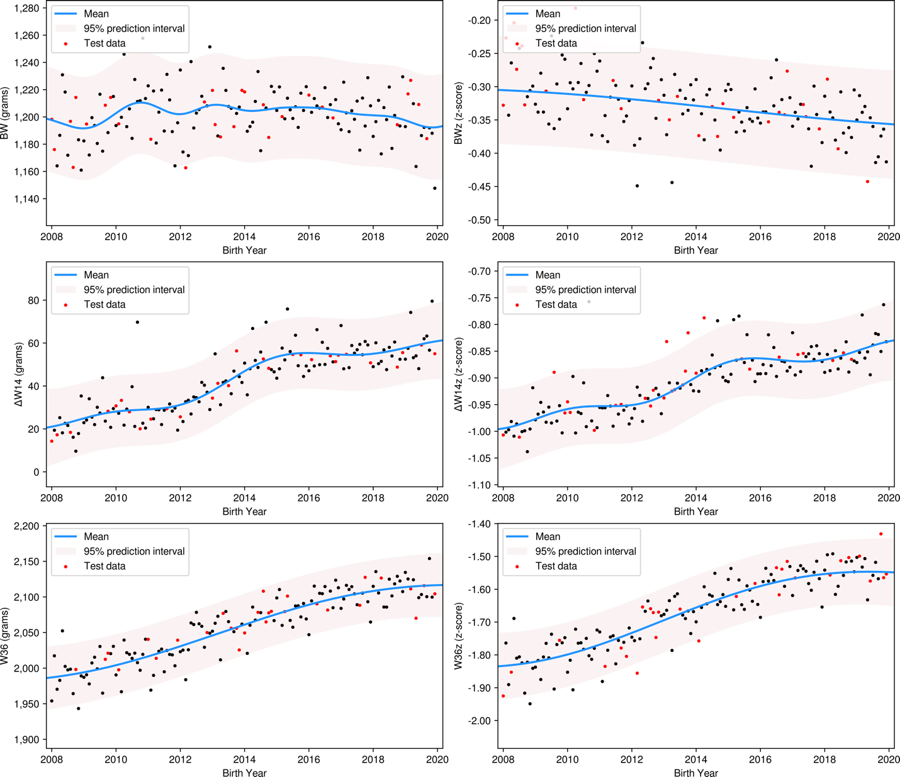

Figure 2 Panels 1-4
Postnatal weight gain
Panel 1: Weight z-scores by postmenstrual age and gestational age group in babies surviving without major morbidity; the horizontal lines show the 3rd, 10th and 50th percentiles; the gradients of the z-scores are depicted as a “velocity fan” in the lower left corner. The grey lines show the 3rd (dotted), 10th (dashed), 50th (solid), 90th (dashed) and 97th (dotted) percentiles. Centile curves are derived from the LMS values for each sex using the UK-WHO reference table.
Panel 2: Weight (g) (7-day rolling average) for boys and girls by postmenstrual age and gestational age group; the gradients of the weight velocities are depicted as a “velocity fan” in the lower right of each plot. The grey lines show the 3rd (dotted), 10th (dashed), 50th (solid), 90th (dashed) and 97th (dotted) percentiles.
Panel 3: Weight z-scores by postmenstrual age in babies with and without BPD, surgical NEC, SBI, treated ROP, babies that died and survived, and babies that survived without any major morbidity (blue line) compared with babies that died or had one or more major morbidity (orange line).
Panel 4: Weight (g) by postmenstrual age in babies with and without BPD, surgical NEC, SBI, treated ROP, babies that die and survive, and babies with and without a major morbidity
The blue lines depict infants without the outcome; orange, infants with the outcome; the horizontal lines show the 3rd, 10th and 50th percentiles. The grey lines show the 3rd (dotted), 10th (dashed), 50th (solid), 90th (dashed) and 97th (dotted) percentiles averaged over boys and girls at a given PMA

Figure 2: Panels 1-2
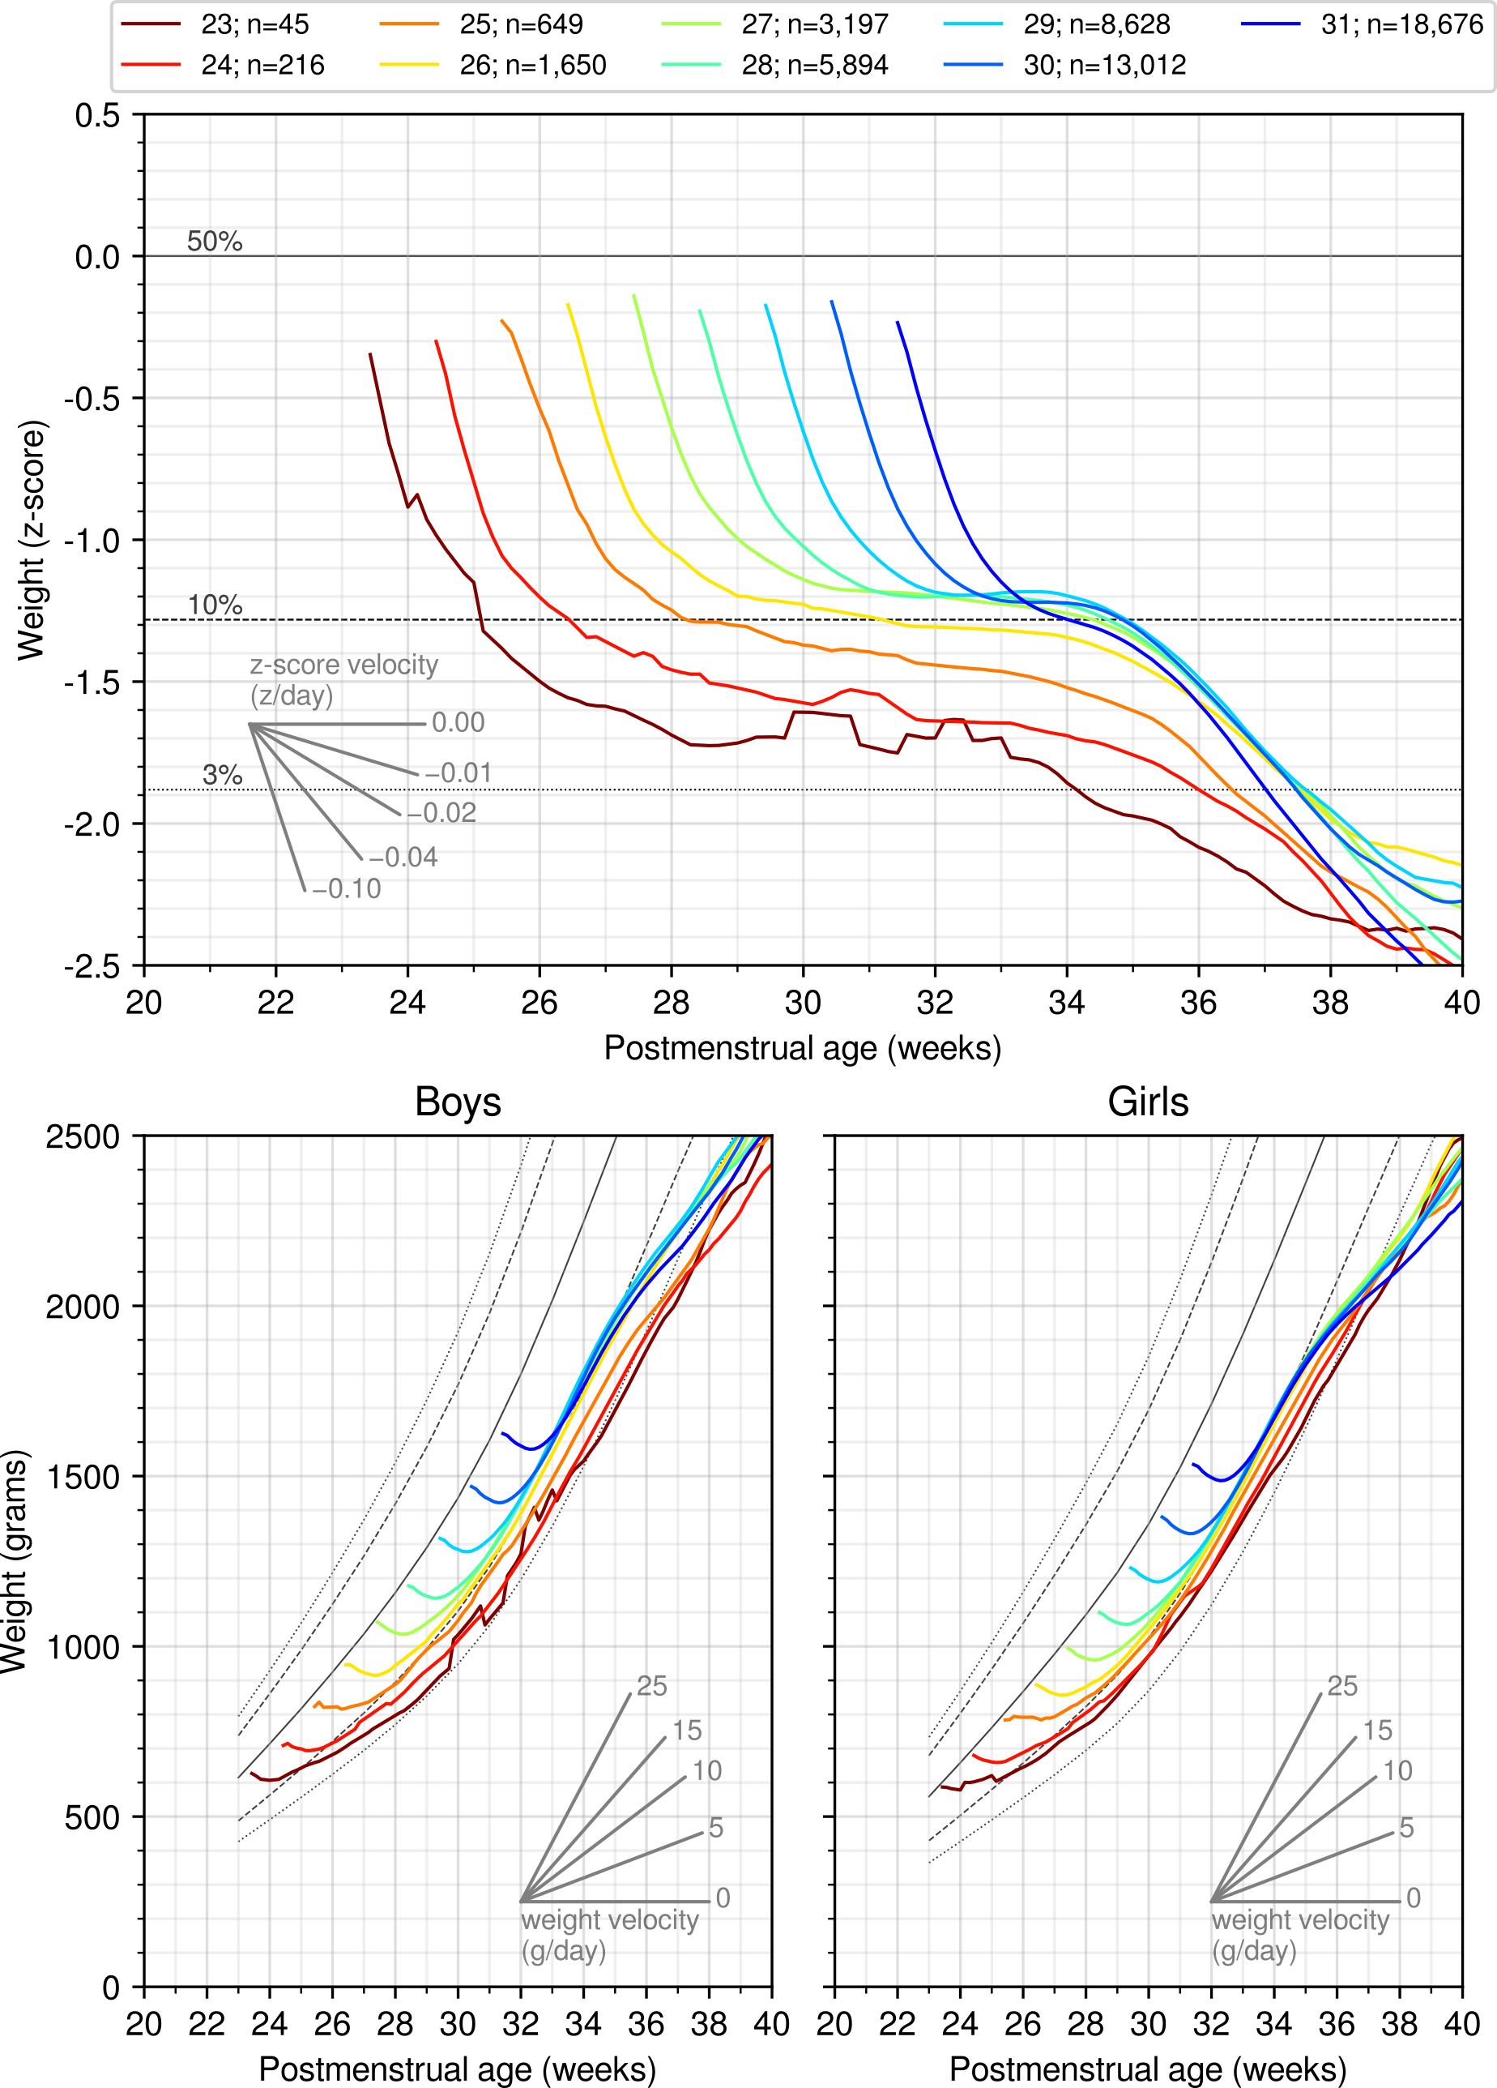

Figure 2: Panels 3-4
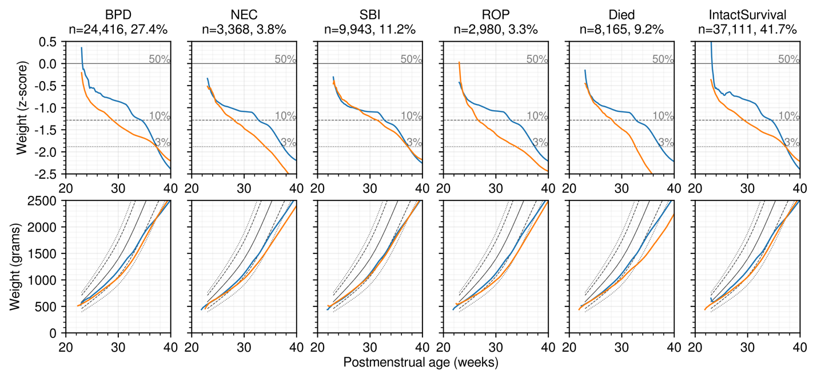

Supplementary Table S1
Variables utilised in the regression models

Category: the set of variables; Variable: the National Neonatal Research Database variable name; Description: the description of each variable; Missingness: the percentage of missing values

Category | Variable | Description | Missingness (%)
Antenatal/  Perinatal/  Demographic | BW_UKWHO | Birth weight z-score | 2.1%
 | BirthMonth | Birth month (Jan=1, Dec=12) | 0.0%
 | BirthNDAULevel | Level of neonatal unit of birth (0, 1, 2, 3) | 0.1%
 | BirthRegion | Region of birth | 1.9%
 | BirthYear | Year of birth | 0.0%
 | CSectionElective | Whether an elective Caesarean section | 6.3%
 | CSectionEmergency | Whether an emergency Caesarean section | 6.3%
 | CongenMalCardiac | Whether a cardiac congenital malformation | 1.5%
 | CongenMalNonCardiac | Whether a non-cardiac congenital malformation | 1.5%
 | DeliveredInLabour | Whether baby was delivered following labour | 6.3%
 | PresentationOfFetusAtDelivery | Whether delivery was breech, cephalic or transverse | 18.4%
 | Female | Whether infant was a girl | 1.9%
 | GestationWeeks | Gestational age in completed weeks | 0.0%
 | IMDdecile | Decile of Index of Multiple Deprivation of maternal residence | 6.4%
 | MaternalHypertension | Whether maternal hypertension | 1.5%
 | MaternalPyrexiaInLabour38c | Whether significant maternal pyrexia in labour | 23.7%
 | MultipleFetuses | Whether there was more than one infant delivered | 1.9%
 | MumAge | The age of the mother at infant's birth | 0.8%
 | MumEthnicity | Maternal ethnicity coded as Asian, Black, White, Mixed, Other, Chinese | 11.9%
 | ParentsConsanguinous | Whether parents were consanguineous | 23.5%
 | PreviousPregnancy | Whether there had been a previous pregnancy | 15.6%
 | SmokingInPregnancy | Whether the mother smoked during pregnancy | 15.5%
 | SteroidsAntenatal | Whether the mother received a course of steroids at any time during pregnancy | 1.2%
Postnatal | Apgar_1min | Apgar score 1 minute after birth | 10.7%
 | Apgar_5min | Apgar score 5 minutes after birth | 11.3%
 | IntubationAtResuscitation | Whether intubation occurred at resuscitation | 0.0%
 | MeconiumStainedLiquor | Whether meconium present in liquor following rupture of membranes or at delivery | 15.4%
 | Resuscitation | Whether infant required resuscitation using medications or chest compression | 10.1%
 | Transfer3Begin | Whether the infant was transferred to another unit in the first 3 postnatal days | 0.0%
Nutritional | BMF_DaysToPMA36 | The number of days breast milk fortifier provided up to 36w postmenstrual age | 2.4%
 | DBM_AtEnteralBegin | Whether the infant had human donor milk on first day of enteral nutrition | 5.8%
 | DBM_DaysToPMA36 | The number of days of human donor milk provided up to 36w postmenstrual age | 2.4%
 | Age_AtEnteralBegin | The age in days at which enteral nutrition began | 5.8%
 | FM_AtEnteralBegin | Whether the infant had formula milk on first day of enteral nutrition | 5.8%
 | FM_DaysToPMA36 | The number of days of formula milk provided up to 36w postmenstrual age | 2.4%
 | MM_AtEnteralBegin | Whether the infant had maternal milk on first day of enteral nutrition | 5.8%
 | MM_DaysToPMA36 | The number of days of maternal milk provided up to 36w postmenstrual age | 2.4%
 | MedianVolume_DaysToPMA36 | The median daily volume of milk of any type across all days up to 36w postmenstrual age | 39.6%
Morbidities and conditions | BPD | Whether the infant had bronchopulmonary dysplasia (BPD) | 9.8%
 | Died | Whether the infant died | 0.2%
 | NEC | Whether the infant had surgical treatment for or died with necrotising enterocolitis (NEC) | 0.0%
 | IntactSurvival | Whether an infant survived without any morbidities (BPD, NEC, ROP, SBI) | 0.0%
 | ROP | Whether the infant had treated retinopathy of prematurity (ROP) | 0.0%
 | SBI | Whether the infant had severe brain injury (SBI) | 0.0%

Supplementary Table S2
UK Neonatal Collaborative hospitals and lead clinicians in England and Wales

Hospital | Lead clinician
Airedale General | Dr Matthew Babirecki
Arrowe Park | Dr Anand Kamalanathan
Barnet | Dr Tim Wickham
Barnsley District General | Dr Kavi Aucharaz
Basildon | Dr Aashish Gupta
Basingstoke & North Hampshire | Dr Nicola Paul
Bassetlaw District General | Dr L M Wong
Bedford | Dr Anita Mittal
Birmingham City | Dr Penny Broggio
Birmingham Heartlands | Dr Pinki Surana
Birmingham Women's | Dr Matt Nash
Bradford Royal Infirmary | Dr Sunita Seal
Broomfield, Chelmsford | Dr Ahmed Hassan
Calderdale Royal Hospital | Dr Karin Schwarz
Chelsea & Westminster | Dr Shu-Ling Chuang
Chesterfield & North Derbyshire Royal | Dr Aiwyne Foo
Colchester General | Dr Jo Anderson
Conquest | Dr Graham Whincup
Countess of Chester | Dr Stephen Brearey
Croydon University | Dr John Chang
Cumberland Infirmary | Dr Yee Aung
Darent Valley | Dr Abdul Hasib
Darlington Memorial Hospital | Dr Mehdi Garbash
Derriford Hospital | Dr Alex Allwood
Diana Princess of Wales | Dr Pauline Adiotomre
Doncaster Royal Infirmary | Dr Nigel Brooke
Dorset County | Dr Abby Deketelaere
East Surrey | Dr K Abdul Khader
Epsom General | Dr Ruth Shephard
Frimley Park | Dr Sanghavi Rekha
Furness General | Dr Anas Olabi
George Eliot | Dr Mukta Jain
Gloucester Royal | Dr Jennifer Holman
Good Hope | Dr Pinki Surana
Great Western | Dr Stanley Zengeya
Guy's & St Thomas' | Dr Geraint Lee
Harrogate District | Dr Sobia Balal
Hereford County | Dr Cath Seagrave
Hillingdon | Dr Tristan Bate
Hinchingbrooke | Dr Hilary Dixon
Homerton | Dr Narendra Aladangady
Hull Royal Infirmary | Dr Hassan Gaili
Ipswich | Dr Matthew James
James Cook University | Dr M Lal
James Paget | Dr Ambadkar
Kettering General | Dr Poornima Pandey
Kings College | Dr Ravindra Bhat
King's Mill | Dr Simon Rhodes
Kingston | Dr Vinay Pai
Lancashire Women and Newborn Centre | Dr Savi Sivashankar
Leeds | Dr Lawrence Miall
Leicester General | Dr Jonathan Cusack
Leicester Royal Infirmary | Dr Venkatesh Kairamkonda
Leighton | Dr Michael Grosdenier
Lincoln County | Dr Kollipara
Lister | Dr J Kefas
Liverpool Women's | Dr Christopher Dewhurst
Luton & Dunstable | Dr Jennifer Birch
Macclesfield District General | Dr Gail Whitehead
Manor | Dr Krishnamurthy
Medway Maritime | Dr Ghada Ramadan
Milton Keynes General | Dr I Misra
Musgrove Park | Dr Chris Knight
New Cross | Dr Tilly Pillay
Newham General | Dr Imdad Ali
Nobles | Dr Prakash Thiagarajan
Norfolk & Norwich University | Dr Mark Dyke
North Devon District | Dr Michael Selter
North Manchester General | Dr P Kamath
North Middlesex University | Dr Neeraj Jain
Northumbria Specialist Emergency Care | Vivien Spencer
Northampton General | Dr Subodh Gupta
Northwick Park | Dr Richard Nicholl
Nottingham City | Dr Steven Wardle
Nottingham University | Dr Steven Wardle
Ormskirk District General | Dr Andreea Bontea
John Radcliffe | Dr Eleri Adams
Peterborough City | Dr Katharine McDevitt
Pilgrim | Dr Ajay Reddy
Pinderfields General (Pontefract General Infirmary) | Dr David Gibson
Poole General | Prof Minesh Khashu
Princess Alexandra | Dr Chinnappa Reddy
Princess Anne | Dr Mark Johnson
Princess Royal | Dr P Amess
Princess Royal (previously Royal Shrewsbury) | Dr Deshpande
Princess Royal University | Dr Elizabeth Sleight
Queen Alexandra | Dr Charlotte Groves
Queen Charlotte's | Dr Lidia Tyszcuzk
Queen Elizabeth, Gateshead | Dr Dennis Bosman
Queen Elizabeth, King's Lynn | Dr Glynis Rewitzky
Queen Elizabethl, Woolwich | Dr Olutoyin Banjoko
Queen Elizabeth the Queen Mother | Dr Bushra Abdul-Malik
Queen's Hospital, Burton on Trent | Dr Dominic Muogbo
Queen's Hospital, Romford | Dr Khalid Mannan
Queen's Hospital, Romford 2 | Dr Anand Shirsalkar
Rosie Maternity, Addenbrookes | Dr Angela D'Amore
Rotherham District General | Dr Shameel Mattara
Royal Albert Edward Infirmary | Dr Christos Zipitis
Royal Berkshire | Dr Peter De Halpert
Royal Bolton | Dr Paul Settle
Royal Cornwall | Dr Paul Munyard
Royal Derby | Dr John McIntyre
Royal Devon & Exeter | Dr David Bartle
Royal Hampshire County | Dr Lucinda Winckworth
Royal Lancaster Infirmary | Dr Joanne Fedee
Royal Oldham | Dr Natasha Maddock
Royal Preston | Dr Richa Gupta
Royal Stoke University | Dr Alison Moore
Royal Surrey County | Dr Ben Obi
Royal Sussex County | Dr Phil Amess
Royal United Hospital | Dr Stephen Jones
Royal Victoria Infirmary | Dr Naveen Athiraman
Russells Hall | Dr Mahadevan
Salisbury District | Dr Jim Baird
Scarborough General | Dr Kirsten Mack
Scunthorpe General | Dr Pauline Adiotomre
Southend | Dr Vineet Gupta
Southmead | Dr Alison Pike
St George's | Dr Charlotte Huddy
St Helier | Dr Salim Yasin
St Mary's, Isle of Wight | Dr Sian Butterworth
St Mary's, London | Dr Lidia Tyszcuzk
St Mary's, Manchester | Dr Ngozi Edi-Osagie
St Michael's | Dr Pamela Cairns
St Peter's | Dr Peter Reynolds
St Richard's | Dr Nick Brennan
Stepping Hill | Dr Carrie Heal
Stoke Mandeville | Dr Sanjay Salgia
Sunderland Royal | Dr Majd Abu-Harb
Tameside General | Dr Jacqeline Birch
The Jessop Wing, Sheffield | Dr Porus Bastani
The Royal Free | Dr Marice Theron
The Royal London | Dr Vadivelam Murthy
Torbay | Dr Siba Paul
Tunbridge Wells | Dr Hamudi Kisat
University College | Dr Giles Kendall
University Hospital Coventry | Dr Kate Blake
University Hospital Lewisham | Dr Ozioma Obi
University Hospital of North Durham | Dr Mehdi Garbash
University Hospital of North Tees | Dr Hari Kumar
Victoria Hospital, Blackpool | Dr Chris Rawlingson
Warrington | Dr Delyth Webb
Warwick | Dr Bird
Watford General | Dr Sankara Narayanan
West Cumberland | no lead
West Middlesex University | Dr Eleanor Hulse
West Suffolk | Dr Ian Evans
Wexham Park | Dr Rekha Sanghavi
Whipps Cross University | Dr Caroline Sullivan
Whiston | Dr Ros Garr
Whittington | Dr Wynne Leith
William Harvey | Dr Vimal Vasu
Worcestershire Royal | Dr Liza Harry
Worthing | Dr Katia Vamvakiti
Wythenshawe | Dr Ngozi Edi-Osagie
Yeovil District | Dr Megan Eaton
York District | Dr Sundeep Sandhu

Wales
Hospital | Lead clinician
Singleton | Dr Arun Ramachandran
Princess of Wales | Dr Kate Creese
Royal Gwent | Dr Sunil Reddy
Nevill Hall Hospital | Dr Sunil Reddy
Glan Clwyd l | Dr Ian Barnard
Wrexham Maelor | Dr Brendan Harrington
Ysbyty Gwynedd | Dr Mike Cronin
University Hospital of Wales | Dr Alok Sharma
Prince Charles | Dr Iyad Al-Muzaffar
Glangwili General | Dr Prem Pitchaikani
Withybush | Dr Vishwa Narayan

