Two-Dimensional Organic Tin Halide Perovskites with Tunable Visible Emission and Their Use in Light Emitting Devices

Luis Lanzetta¹, Jose Manuel Marin-Beloqui¹, Irene Sanchez-Molina¹, Dong Ding¹ and Saif A. Haque¹*

¹Department of Chemistry and Centre for Plastic Electronics, Imperial College London, South Kensington Campus, London SW7 2AZ, U.K.
AUTHOR INFORMATION
Corresponding Author
* s.a.haque@imperial.ac.uk

Abstract
Hybrid organic lead trihalide perovskites continue to generate significant interest for use in optoelectronic devices such as solar cells and light emitting devices. However, the toxicity of lead is considered one of the main obstacles to the commercialization of this technology. Although challenging, the replacement of lead by tin is currently the most promising alternative. Herein, we explore a class of low-dimensional, lead-free perovskite materials (2D (PEA)₂SnI_{x}Br_{4-x}, where PEA ≡ C₆H₅CH₂CH₂NH₃⁺) with tunable optical properties in the visible region of the spectrum. Specifically, we show that 2D, (PEA)₂SnI₄ perovskite exhibits superior photoluminescence properties than conventional 3D CH₃NH₃SnI₃ and that (PEA)₂SnI₄ can act as a sensitizer on mesoporous TiO₂. We go onto demonstrate visible (~630 nm) electroluminescence from a device employing a (PEA)₂SnI₄ emitter sandwiched between ITO/PEDOT:PSS and F8/LiF/Al as hole and electron injection electrodes, respectively. These devices reach a luminance of 0.15 cd/m² at 4.7 mA/cm² and an efficacy of 0.029 cd/A at 3.6 V. This proof-of-principle device indicates a viable path to low-dimensional, lead-free perovskite optoelectronics.
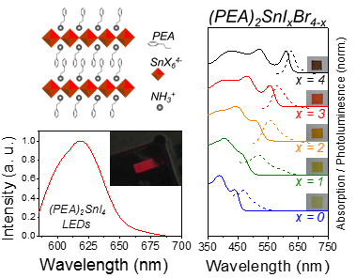
TOC GRAPHICS

Organic lead halide perovskites have been reported as an outstanding class of semiconducting materials for optoelectronic applications, with numerous examples in the specific fields of solar cells^{1–5} and light-emitting diodes (LEDs)^{6–9}. The main advantages that make this family of materials attractive for such applications are their low-cost preparation via solution processing, good charge transport properties and their structural flexibility for optical band-gap tuning^{10,11}. However, the relatively low stability of perovskite materials¹² and the high toxicity of lead remains a problem. Lead-free perovskite alternatives based on tin (e.g. 3D CH₃NH₃SnI₃) have already been investigated both as absorbers^{13–15} and light emitters^{16,17} in optoelectronic devices with promising results. However, the replacement of Pb²⁺ by Sn²⁺ worsens the stability of the perovskite material, as tin in its 2+ oxidation state is prone to undergo oxidation in ambient conditions. More specifically, degradation of CH₃NH₃SnI₃ perovskites is known to introduce p-type self-doping in the material due to the spontaneous formation of Sn⁴⁺ species/Sn²⁺ vacancies in the structure, which makes the perovskite material exhibit metal-like behaviour^{18–21}. Unfortunately, the high intrinsic conductivity of tin-based hybrid perovskites usually compromises device performance, reproducibility and stability due to the unwanted carrier recombination and current leakage²¹. At present, the most commonly used method to partially overcome this issue involves the addition of tin(II) halides in perovskite film processing solutions to act as vacancy modulators^{15,21,22}. However, self-doping in tin-based perovskites remains an issue to the realization of lead-free optoelectronic devices. As such, the design and synthesis of Sn-based perovskite materials with preferable innate semiconducting properties and improved stability is needed.
Interestingly, Mitzi et al. have demonstrated that the metallic conductivity of conventional 3D organic tin halide perovskites can be suppressed by progressively reducing the crystal dimensionality, causing a metal-to-semiconductor shift when increasing the 2D or layered character of the perovskite structure²³. Therefore, this class of 2D hybrid tin-based perovskites represents a pathway to overcome the aforementioned intrinsic limitations of their 3D counterparts. In addition to the undesired metallic behaviour of conventional 3D CH₃NH₃SnI₃ perovskites, the ability to tune the emission properties in such 3D tin based materials into the visible (e.g. red, green and blue) also remains a challenge, with reports based only on NIR emitters^{16,17}. Herein, we demonstrate tunable visible emission properties (e.g. ~ 640 nm to ~ 450 nm) in 2D (PEA)₂SnI_{x}Br_{4-x} through varying the I/Br ratio.
Despite the preferable properties shown by layered 2D tin-based materials, their incorporation in optoelectronic and electronic devices remains largely unexplored, with only few examples in literature based on field-effect transistors^{24–26}. Whilst the lead-containing version of reduced-dimensionality perovskites^{27–29} has been recently used in the fabrication of solar cells with enhanced ambient stability^{27,30–32}, as well as in light emitting devices^{33–40}, tin-based materials are yet to be exploited in photovoltaic and light emitting diode applications. In this study, we present the preparation and optical characterization of tunable 2D (PEA)₂SnI_{x}Br_{4-x} (PEA ≡ C₆H₅CH₂CH₂NH₃⁺; x = 0 to 4) perovskite thin films. More specifically, we demonstrate that: (i) 2D (PEA)₂SnI₄ exhibits superior photoluminescence properties relative to CH₃NH₃SnI₃ and (ii) 2D (PEA)₂SnI₄ perovskites can function as a light harvesting agent and sensitizer on mesoporous TiO₂. Moreover, to demonstrate that reduced dimensionality, 2D (PEA)₂SnI_{x}Br_{4-x} perovskites can be used in optoelectronic devices we report light emitting diodes based on (PEA)₂SnI₄ emitter layers.
2D (PEA)₂SnI_{x}Br_{4-x} perovskites were prepared as described in the experimental section (see Supporting Information). In order to achieve full 2D structure, the methylammonium cation in the CH₃NH₃SnI_{x}Br_{3-x} perovskite formula was replaced by a phenylethylammonium (PEA) cation with the purpose of introducing steric hindrance during crystallisation. This is known to drive a self-assembly crystallisation process in which an alternating stack of organic-inorganic layers is obtained (Figure 1a). It has been previously shown that semiconducting character of the inorganic layers in the 2D material provides smaller energy-level gaps that act as charge carrier radiative recombination sites by concentrating electrons and holes in these regions and strengthening their mutual interaction (increase in exciton binding energy^{41,42}). Powder X-Ray Diffraction (P-XRD) patterns of (PEA)₂SnI₄ perovskite thin films (Figure 1b) confirm the high crystallinity of our samples. The presence of only (00l) reflections in the XRD spectrum suggests parallel orientation of the perovskite planes with respect to the substrate, as previously reported for this family of materials^{24,43}. P-XRD data of all the synthesized (PEA)₂SnI_{x}Br_{4-x} perovskites (Figure S1) confirms the presence of isostructural crystal lattices in this family of tunable materials. We note that no peaks corresponding to SnI₂, SnBr₂, PEAI or PEABr were detected in the X-Ray diffraction patterns, thus confirming complete reaction between both precursors. From the (002) reflections we estimate a separation (d spacing) between inorganic layers of d = 16.06 (for x = 4) and 16.34 (for x = 3, 2, 1, 0) Å, indicating that Br replacement slightly increases the distance between the perovskite sheets.
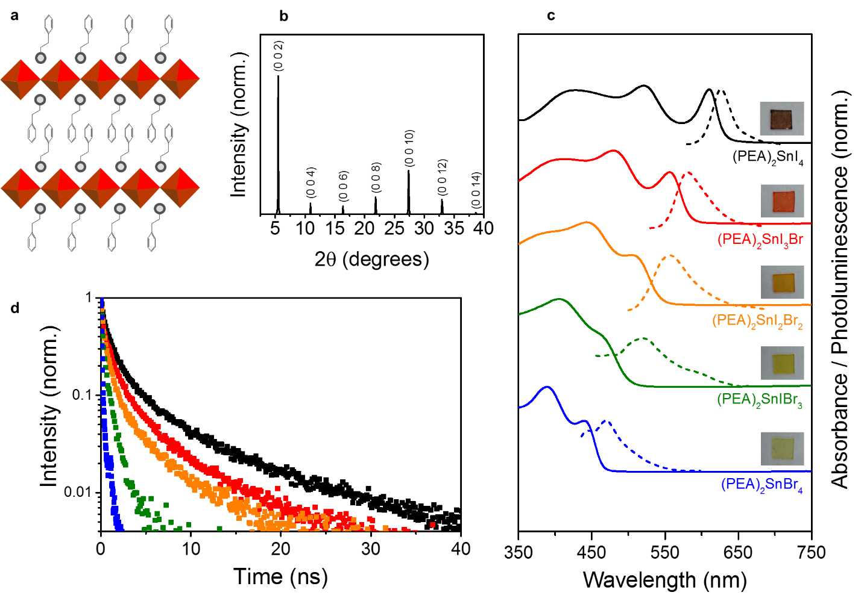
Figure 1. a, General crystal schematic of a (PEA)₂SnI_{x}Br_{4-x} perovskite (light grey balls: -NH₃⁺ groups; red polyhedra: corner-sharing SnX₆⁴⁻ octahedra, where X represents a halide) with alternating organic-inorganic layers. b, P-XRD pattern of a (PEA)₂SnI₄ thin film processed on glass. Peaks were assigned to crystal planes by using literature references²⁴. c, Normalised absorbance (solid lines) and photoluminescence (dashed lines) spectra of (PEA)₂SnI₄ (black lines), (PEA)₂SnI₃Br (red lines), (PEA)₂SnI₂Br₂ (orange lines), (PEA)₂SnIBr₃ (green lines) and (PEA)₂SnBr₄ (blue lines) perovskite thin films processed on glass (photographs of samples shown for each x value). d, Time-resolved PL of (PEA)₂SnI₄ (black squares; probe: 635 nm), (PEA)₂SnI₃Br (red squares; probe: 580 nm), (PEA)₂SnI₂Br₂ (orange squares; probe: 556 nm), (PEA)₂SnIBr₃ (green squares; probe: 522 nm) and (PEA)₂SnBr₄ (blue squares; probe: 468 nm) obtained with 404 nm excitation.
In Figure 1c we present the UV-Vis absorption and photoluminescence properties of (PEA)₂SnI_{x}Br_{4-x}. It can be seen that optical absorption and emission spectra of perovskite (PEA)₂SnI_{x}Br_{4-x} films become more blue-shifted with increasing bromide content. The optical band gaps of (PEA)₂SnI_{x}Br_{4-x} films were estimated to be ~1.97, ~2.13, ~2.28, ~2.47, and ~2.66 eV for samples with x = 4, 3, 2, 1 and 0, respectively. In the absorbance spectra (solid lines), sharp absorption bands can be observed, which are attributed to the excitonic behaviour of these materials. We note that the optical band gap of perovskites becomes larger when reducing the dimensionality of the material from 3D CH₃NH₃SnI₃ to 2D (PEA)₂SnI₄ (1.26 eV vs 1.97 eV, respectively; see Figure S2). We attribute this to a quantum size effect, as reported elsewhere for similar perovskite materials^{27,44}. On the other hand, the photoluminescence (PL) spectra of (PEA)₂SnI_{x}Br_{4-x} (dashed lines) exhibit peaks at 627 (x = 4), 580 (x = 3), 556 (x = 2), 522 (x = 1) and 468 (x = 0) nm. The variation in the steady-state PL peak wavelengths of our perovskites is linear with respect to the x value in (PEA)₂SnI_{x}Br_{4-x}, which is consistent with the Vegard’s law (Figure S3). We note that the small Stokes shift observed in these 2D perovskites (x = 4: 16 nm; x = 3: 24 nm; x = 2: 52 nm; x = 1: 55 nm; x = 0: 29 nm) suggests minimal vibronic lattice relaxation after photon absorption, as expected from a reduced dimensionality crystalline material. Red-shifted emission tails in mixed-halide (PEA)₂SnI_{x}Br_{4-x} PL spectra become more prominent with higher bromide content in perovskites, which may be related to defect luminescence in the perovskites with increased Br content. Time-resolved PL decays of (PEA)₂SnI_{x}Br_{4-x} are shown in Figure 1d. It is pertinent to note that an increase in Br leads to shorter decay lifetimes (x = 4: τ₁ = 8.85 ± 0.18 ns; x = 3: τ₁ = 5.99 ± 0.18 ns; x = 2: τ₁ = 5.52 ± 0.21 ns; x = 1: τ₁ = 5.24 ± 1.57 ns; x = 0: τ₁ = 1.84 ± 0.69 ns; see Table S1 for fitting details). This observation is consistent with Br-rich perovskites exhibiting higher lattice disorder¹⁷, causing crystal defects that act as trap states and give rise to shorter-lived photoluminescence. This assertion is supported by Photoluminescence Quantum Efficiency (PLQE) values presented in Table 1. These data show that increasing the Br content in the mixed iodide-bromide perovskites (e.g. (PEA)₂SnI_{x}Br_{4-x} where x = 3 to 1) leads to a reduction in PLQE values.
We next consider the photophysical properties of tin-based 2D perovskites relative to conventionally used 3D hybrid organic tin halide perovskite materials (Figure 2a). For this purpose, we compared the photoluminescence properties of 2D (PEA)₂SnI₄ and the prototypical compound namely 3D CH₃NH₃SnI₃. Time-resolved PL decays were collected by measuring the emission at ~ 900 nm for CH₃NH₃SnI₃ and 635 nm for (PEA)₂SnI₄ following excitation at 404 nm. The corresponding steady-state PL spectra normalised to sample absorption (Figure S4) are shown in Figure 2a (inset). From the data presented in Figure 2a (inset), it can be seen that CH₃NH₃SnI₃ exhibits a relatively weak emission band centred at ~ 950 nm (blue curve); this observation being in agreement with previous work¹⁰. In contrast, (PEA)₂SnI₄ displays a more intense (~7.5 times) and blue shifted emission (red curve) relative to CH₃NH₃SnI₃. As can be seen in Figure 2a, (PEA)₂SnI₄ thin films show PL dynamics with a noticeably longer decay time relative to CH₃NH₃SnI₃ (dominant time constant τ₁: 8.851 ± 0.176 ns vs 0.109 ± 0.005 ns, respectively; see Table S1). Decay times obtained for 3D CH₃NH₃SnI₃ perovskite are comparable to those previously reported in literature¹⁶. Our observation of a longer time constant τ₁ in (PEA)₂SnI₄ relative to CH₃NH₃SnI₃ is consistent with a higher PL quantum efficiency in the 2D material. This is in agreement with the directly measured photoluminescence quantum efficiency (PLQE) values ((PEA)₂SnI₄: 0.24%, CH₃NH₃SnI₃: 0.01%; Table 1). The better PLQE of (PEA)₂SnI₄ as compared to CH₃NH₃SnI₃ is consistent with the aforementioned excitonic character of (PEA)₂SnI₄. The 2D structure of this material provides a greater spatial confinement of electrons and holes, which in turn leads to a stronger Coulomb interaction between them than that occurring in its 3D counterpart, thus increasing the likelihood of radiative recombination.
Sample | PLQE (%)
CH₃NH₃SnI₃ | 0.01
(PEA)₂SnI₄ | 0.24
(PEA)₂SnI₃Br | 0.13
(PEA)₂SnI₂Br₂ | 0.12
(PEA)₂SnIBr₃ | 0.02
(PEA)₂SnBr₄ | 0.04
Table 1. Photoluminescence Quantum Efficiency (PLQE) values for (PEA)₂SnI₄, (PEA)₂SnI₃Br, (PEA)₂SnI₂Br₂, (PEA)₂SnIBr₃, (PEA)₂SnBr₄ and CH₃NH₃SnI₃ thin films processed on glass.
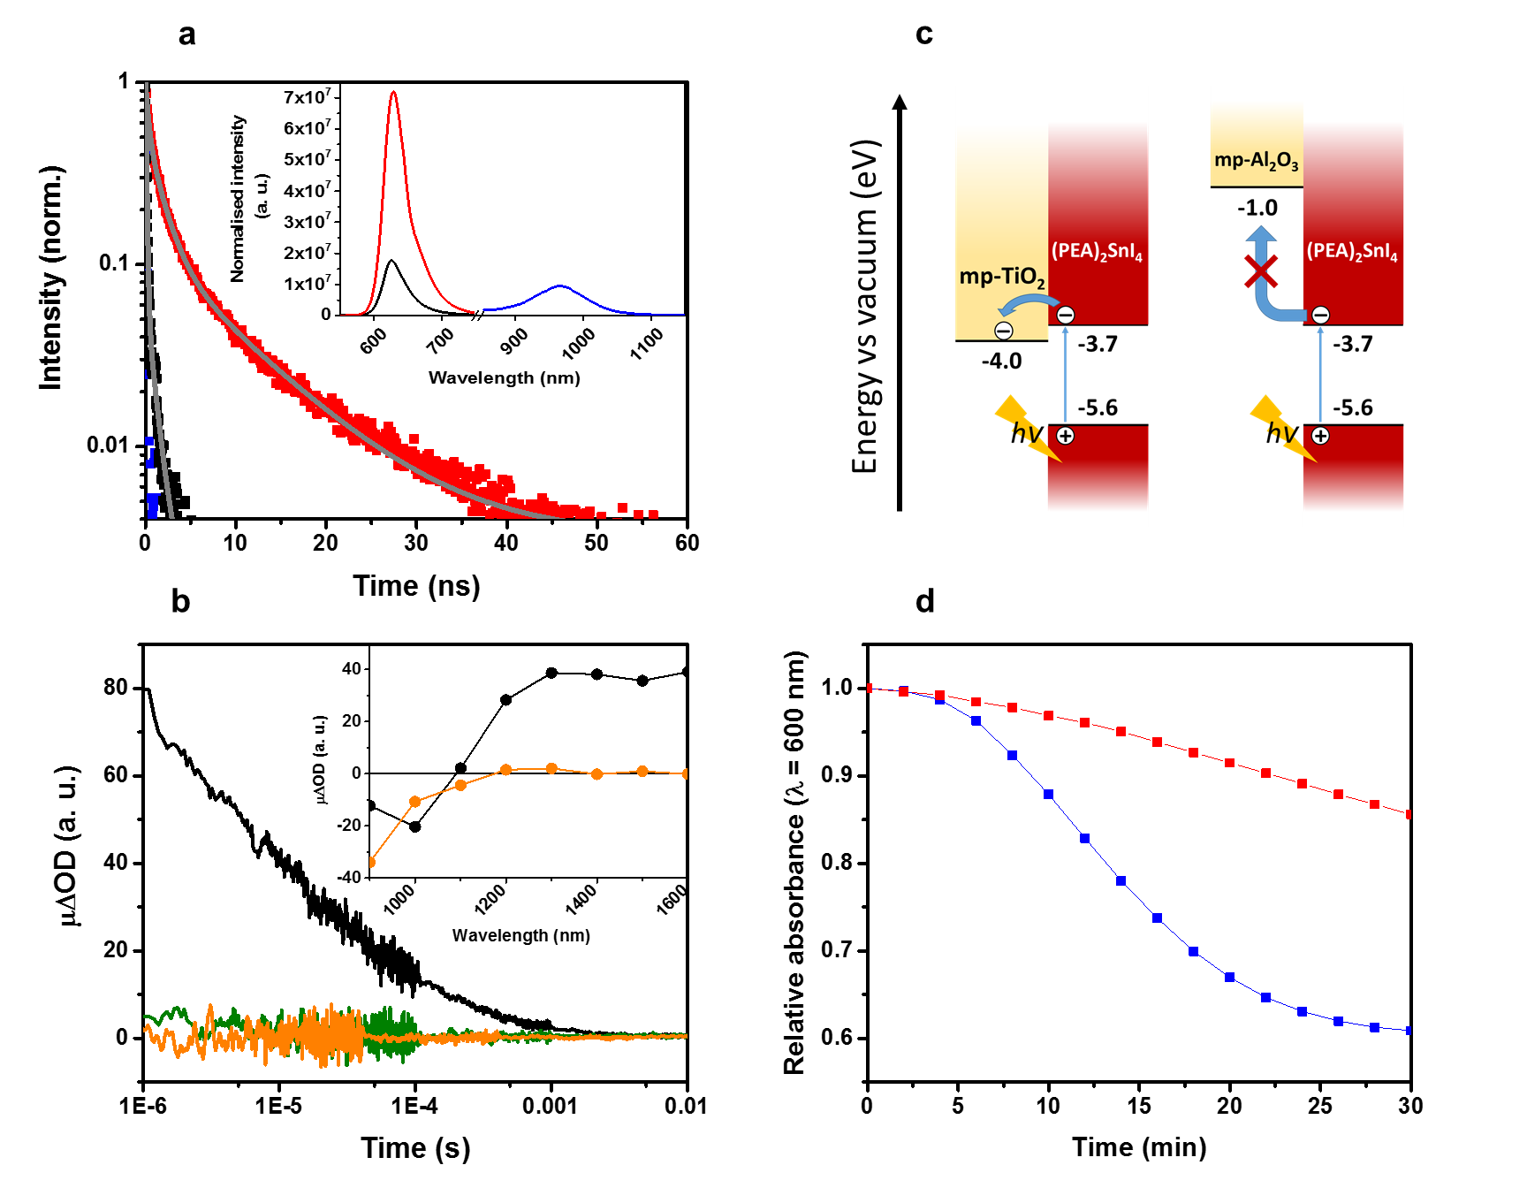
Figure 2. a, Time-resolved PL corresponding to (PEA)₂SnI₄ (red squares; probe: 635 nm; grey line: triexponential fitting), mp-TiO₂/(PEA)₂SnI₄ (black squares; probe: 635 nm; grey line: biexponential fitting) and CH₃NH₃SnI₃ (blue squares; probe: 900 nm) films, obtained with 404 nm excitation. Inset: steady-state PL spectra of (PEA)₂SnI₄ (red line), mp-TiO₂/(PEA)₂SnI₄ (black curve) and CH₃NH₃SnI₃ (blue line) registered after 500 nm excitation (spectra were normalised to the absorption of each sample at 500 nm). b, µ-TAS signals of mp-TiO₂/(PEA)₂SnI₄ (black trace; pump: 567 nm), mp-Al₂O₃/(PEA)₂SnI₄ (green trace; pump: 567 nm) and mp-TiO₂/CH₃NH₃SnI₃ (orange trace; pump: 567 nm) samples registered at 1600 nm. Inset: transient absorption spectra of mp-TiO₂/(PEA)₂SnI₄ (black circles) and mp-TiO₂/CH₃NH₃SnI₃ (orange circles) samples. c, Energy band diagrams showing photoinduced interfacial electron transfer from (PEA)₂SnI₄ to mp-TiO₂ (left) and the absence of interfacial electron transfer from (PEA)₂SnI₄ to mp-Al₂O₃ (right). Energy values obtained from literature references^{26,45,46}. d, Time evolution of relative absorption at 600 nm of (PEA)₂SnI₄ (red squares) and CH₃NH₃SnI₃ (blue squares) thin films processed on mp-Al₂O₃ and measured under dark and air conditions.
Next, we investigated whether (PEA)₂SnI₄ can act as a sensitizer on mesoporous (mp) TiO₂. To this end, the (PEA)₂SnI₄ perovskite was deposited onto mp-TiO₂ layers to form mp-TiO₂/(PEA)₂SnI₄ heterojunctions as described in the methods section (Supporting Information); in this architecture, TiO₂ functions as the electron acceptor and (PEA)₂SnI₄ as the electron donor. First, PL quenching was used to study photoinduced charge separation in mp-TiO₂/(PEA)₂SnI₄ films. Figure 2a (inset) presents the steady-state PL for mp-TiO₂/(PEA)₂SnI₄ (red curve) and pristine (PEA)₂SnI₄ films (black curve) following excitation of the perovskite at 500 nm (spectra normalised to sample absorption at 500 nm; Figure S3). By evaluation of the peak heights, we observe a 4-fold decrease in the (PEA)₂SnI₄ PL signal when depositing the material onto mp-TiO₂. PL quenching in (PEA)₂SnI₄/mp-TiO₂ films was further investigated using via time-resolved PL spectroscopy (Figure 2a). We note that the dominant lifetime τ₁ is shorter for mp-TiO₂/(PEA)₂SnI₄ (black squares) than for control (PEA)₂SnI₄ sample (red squares), (1.529 ± 0.644 ns vs 8.851 ± 0.176 ns, respectively; see Table S1). This observation is consistent with less carriers recombining radiatively in the mp-TiO₂/perovskite sample.
Next, we turned to microsecond Transient Absorption Spectroscopy (µs-TAS) to obtain direct evidence for the presence of charge separation in mp-TiO₂/(PEA)₂SnI₄ films (Figure 2b). Pulsed optical excitation (567 nm, 7 μJ·cm⁻², 4 Hz) of mp-TiO₂/(PEA)₂SnI₄ resulted in the appearance of a broad transient absorption feature in the near-infrared region (Figure 2b, inset black circles) which we mainly attribute to oxidised (PEA)₂SnI₄, although a small contribution of electrons in TiO₂ cannot be excluded. The dynamics of the charge recombination reaction between electrons in the TiO₂ and photo-oxidized (PEA)₂SnI₄ were determined by monitoring the decay of the transient absorption band at 1600 nm. Typical kinetic traces (Figure 2b; black curve) display multi-exponential behaviour on micro–millisecond timescales similar to those generally observed in TiO₂/dye systems. We note that the absence of a growth in ΔOD signal on early timescales in the mp-TiO₂/(PEA)₂SnI₄ sample indicates that the primary charge separation reaction (Figure 2c, left panel) is occurring on time scales faster than the instrument response (IR) of our transient spectrometer (IR ~ 100 ns). We further note that no transient absorption feature, and therefore charge separation, was observed in control mp-Al₂O₃/(PEA)₂SnI₄ samples (Figure 2b; green curve); this observation being consistent with the unfavourable energy level alignment at the mp-Al₂O₃/(PEA)₂SnI₄ heterojunction, as illustrated in Figure 2c (right panel). Moreover, it is pertinent to note that in contrast to the mp-TiO₂/(PEA)₂SnI₄ system no transient absorption features were observed in mp-TiO₂/3D CH₃NH₃SnI₃ films (Figure 2b, orange trace) in any of the analysed probe wavelengths in the TAS spectrum (Figure 2b, inset orange circles). This observation suggests that interfacial charge carrier recombination kinetics in this system is either occurring on timescales faster than the instrument response of the spectrometer or that the yield of charge separation is negligible. In contrast, optical excitation of the mp-TiO₂/(PEA)₂SnI₄ system is likely to result in the formation of tightly bound excitons (electron-hole pairs) in (PEA)₂SnI₄. It is highly plausible that the energy difference (ΔE ~ 0.3 eV, Figure 2c) between the conduction band edges of the TiO₂ and (PEA)₂SnI₄ provides the necessary driving force to overcome the exciton binding energy of (PEA)₂SnI₄ (~0.190 eV⁴³) and split the electron-hole pair. The present findings clearly show that (PEA)₂SnI₄ can function as a sensitiser on mp-TiO₂ leading to high-yield and long-lived charge separation.
The next question that arises relates to the origin of the superior photoluminescence properties of (PEA)₂SnI₄ as compared to CH₃NH₃SnI₃. Most probably, this behaviour can be attributed to the previously mentioned self-doping of the 3D material, CH₃NH₃SnI₃. The unwanted oxidation of Sn²⁺ to Sn⁴⁺ and the formation of Sn²⁺ vacancies increase the background concentration of free holes in the valence band of perovskite, which in turn could make photoexcited electrons in the conduction band recombine back to the ground state unusually fast (consistently with the short decay time constant in CH₃NH₃SnI₃; Table S1) and non-radiatively⁴⁷. Moreover, low-dimensional perovskites show semiconducting properties^{23,48} and represent a way of intrinsically avoiding unwanted metallic behaviour seen in conventional 3D materials. Interestingly, we also find that the 2D (PEA)₂SnI₄ perovskite displays better stability than CH₃NH₃SnI₃ when aged under ambient air in the dark as shown in Figure 2d. Raw absorbance versus ageing profiles are presented in the Supporting Information of this manuscript (Figure S5). We therefore believe that an increase in the organic cation size provides a physical barrier to slow down oxygen diffusion into the perovskite film and its subsequent degradation, as observed in layered hybrid lead perovskites³⁰.
So far, we have shown that 2D (PEA)₂SnI₄ displays superior light emission properties, and in particular PL properties, relative to 3D CH₃NH₃SnI₃. This observation raises an obvious question, namely if (PEA)₂SnI₄ can be used as an emitter in visible electroluminescent devices. To investigate this, we fabricated light emitting diodes with the following architecture, [ITO/PEDOT:PSS/(PEA)₂SnI₄/F8/LiF/Al], as illustrated in Figure 3a. PEDOT:PSS and F8 were selected as hole and electron injection layers to help confine the charge carriers in (PEA)₂SnI₄, thus favouring exciton formation and radiative recombination (see Figure 3b for device energy diagram). In addition, the small energy difference between the contacts and their respective adjacent layers allows efficient charge carrier injection. Devices were prepared as described in the Experimental Section. Briefly, (PEA)₂SnI₄ films were deposited onto PEDOT:PSS coated ITO glass substrates by spin-coating from a DMF solution containing PEAI and SnI₂ (2:1 molar ratio) followed by mild annealing at 80ºC. Following deposition of F8, a LiF/Al top contact was evaporated as a low-workfunction cathode. Cross-sectional scanning electron microscopy images (Figure 3c) confirmed perovskite layer compactness and the layered structure of our device. From the data presented in Figure 3c, device layer thicknesses were estimated to be ~230 nm ((PEA)₂SnI₄), ~150 nm (F8) and ~130 nm (LiF/Al).
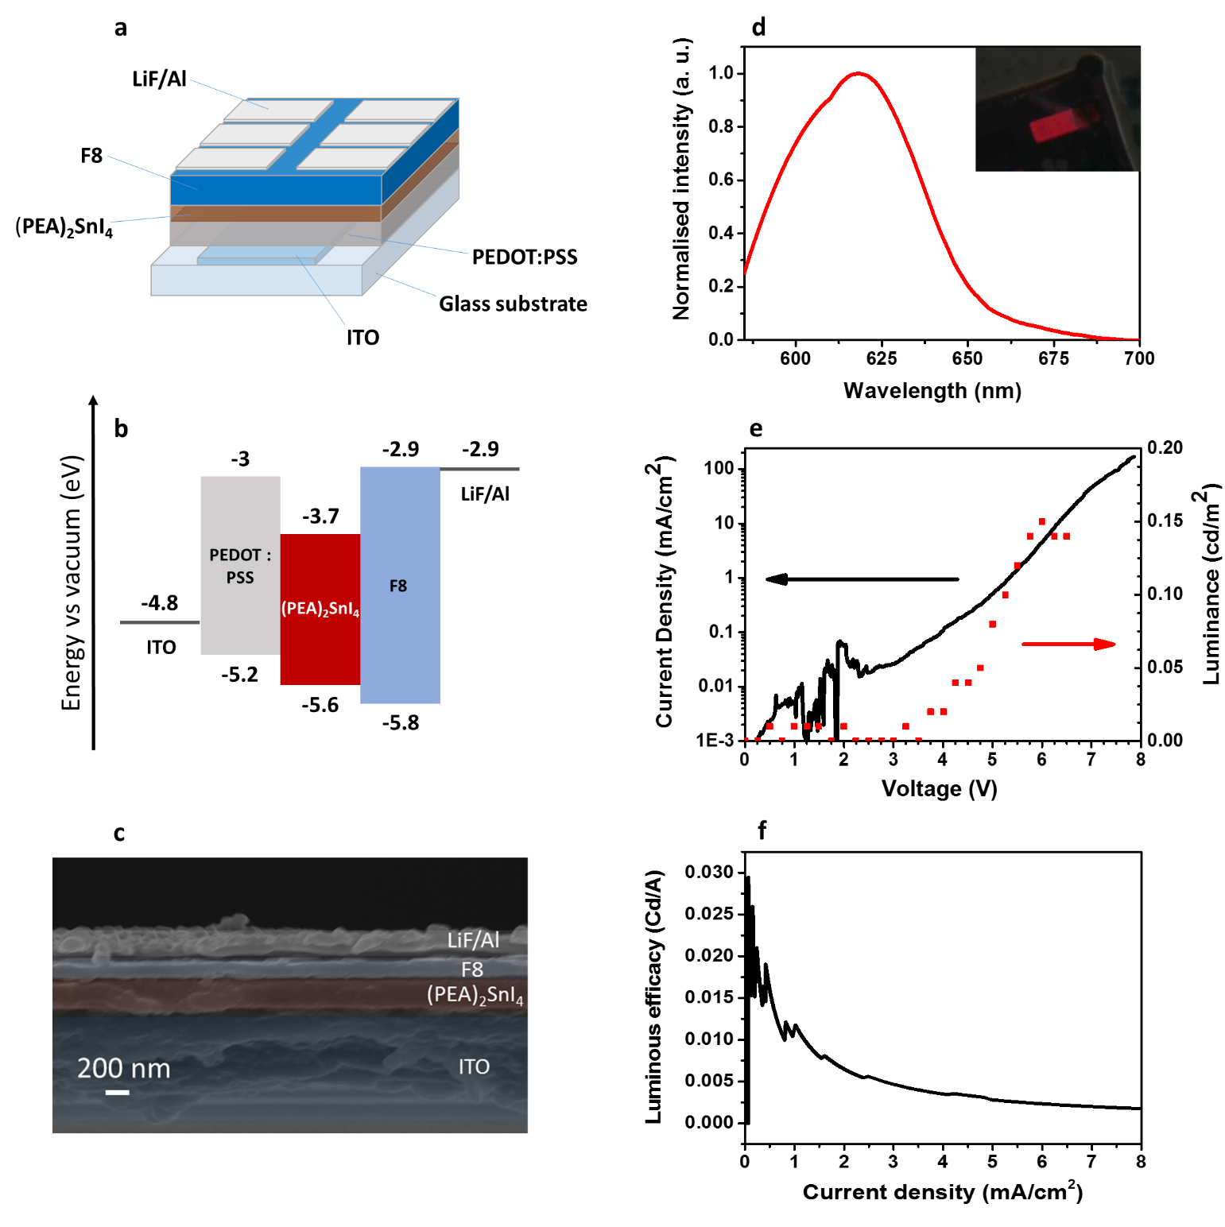
Figure 3. a, Device structure of the (PEA)₂SnI₄ LED. b, Energy levels vs vacuum of the different layers that define the LED. Values were obtained from literature references^{6,26,49,50}. c, Cross-section image of the ITO/PEDOT:PSS/(PEA)₂SnI₄/F8/LiF/Al device (scale bar: 200 nm). d,. Electroluminescence spectrum of a (PEA)₂SnI₄ device, registered by applying a 4 V bias to the device. Inset: image of the LED under operation. e, Current density-voltage (black line) and luminance-voltage (red dots) curves of the (PEA)₂SnI₄ device. f, Luminous efficacy curve of the LED.

The electroluminescence (EL) spectral characteristics of the (PEA)₂SnI₄ LED are shown in Figure 3d along with a photograph of a functioning device. Device characterisation experiments were performed under N₂ in a sealed environmental chamber. The data presented in Figure 3d shows that the light emitted by the (PEA)₂SnI₄ devices is red (peak ~618 nm), and it represents the first example of visible light electroluminescence on 2D lead-free perovskite. The luminance and current density vs voltage characteristics are presented in Figure 3e, while the luminous efficacy vs current chart can be found in Figure 3f. The turn-on voltage was found to be around 3.6 V (current efficacy: ~0.029 cd/A), and the device appeared brighter as the voltage progressively increased. The maximum luminance achieved was 0.15 cd/m² at 6 V potential difference (ITO positive with respect to Al) with a current density of 4.7 mA/cm², corresponding to a current efficacy of ~0.003 Cd/A.
The modest efficiency of our proof-of-concept (PEA)₂SnI₄ LEDs suggests that the device architecture is not optimal. More specifically, top-view Scanning Electron Microscopy images (Figure S6) reveal that topography in (PEA)₂SnI₄ consists in micron-sized, interconnected perovskite islands that might not facilitate full coverage when applying the F8 layer. Further morphology and perovskite formation optimisation is expected to improve device performance. Additionally, we believe that further enhancements in performance may also be realized by tuning the orientation of the layered perovskite with respect to the substrate to facilitate electrically driven exciton generation and radiative decay. We note that the relatively broad EL spectrum seen in our LEDs may be related to perovskite morphology and/or to the presence of emissive excitons in trap states arising from crystal defects. Further, detailed studies addressing device optimization and fabrication with Br-containing (PEA)₂SnI_{x}Br_{4-x} will form part of our future work and will be reported in due course.
In summary, in this paper we have reported on the processing and characterisation of (PEA)₂SnI_{x}Br_{4-x}, a family of 2D layered perovskite materials that show tunable visible light absorption and emission properties via halide band gap engineering. More importantly, the superior light emission properties of (PEA)₂SnI₄ over its 3D CH₃NH₃SnI₃ counterpart are demonstrated via steady-state/time-resolved PL spectroscopy, as (PEA)₂SnI₄ emits more intensely upon photoexcitation, shows higher PLQE and exhibits much slower radiative recombination kinetics than CH₃NH₃SnI₃. We have also shown that (PEA)₂SnI₄ effectively sensitizes mp-TiO₂. We suggest that the preferable properties of this 2D material arise from the semiconducting behaviour it acquires when adopting this dimensionality²³, in contrast with the p-type metallic character of CH₃NH₃SnI₃ caused by the intrinsic presence of Sn⁴⁺ traces in its structure as a result of Sn²⁺ oxidation^{20,21}. Additionally, we demonstrate superior air stability of (PEA)₂SnI₄ versus CH₃NH₃SnI₃. We report a first example of visible, lead-free perovskite light-emitting diode based on 2D (PEA)₂SnI₄ as the emitter. This proof-of-principle demonstration of electroluminescence from low-dimensionality Sn(II) perovskites offers promising prospects for the development of lead-free perovskite optoelectronics.

ASSOCIATED CONTENT
Supporting Information.
Materials and Methods, perovskite XRD patterns, absorption spectra of 2D and 3D perovskites, variation of steady-state PL peak wavelengths of (PEA)₂SnI_{x}Br_{4-x} vs x, steady-state PL normalization details, perovskite absorbance versus ageing profiles, top-view SEM image of (PEA)₂SnI₄ and fitting parameters of time-resolved PL decays.
AUTHOR INFORMATION
Corresponding author
*email address: s.a.haque@imperial.ac.uk
Notes
The authors declare no competing financial interest.
ACKNOWLEDGMENT
S.A.H. acknowledges financial support from EPRSC via EP/M023532/1, EP/K010298/1 and EP/K030671/1 grants.

REFERENCES
(1) Kojima, A.; Teshima, K.; Shirai, Y.; Miyasaka, T. Organometal Halide Perovskites as Visible-Light Sensitizers for Photovoltaic Cells. J. Am. Chem. Soc. 2009, 131, 6050–6051.
(2) Kim, H.-S.; Lee, C.-R.; Im, J.-H.; Lee, K.-B.; Moehl, T.; Marchioro, A.; Moon, S.-J.; Humphry-Baker, R.; Yum, J.-H.; Moser, J. E.; et al. Lead Iodide Perovskite Sensitized All-Solid-State Submicron Thin Film Mesoscopic Solar Cell with Efficiency Exceeding 9%. Sci. Rep. 2012, 2, 591.
(3) Lee, M. M.; Teuscher, J.; Miyasaka, T.; Murakami, T. N.; Snaith, H. J. Efficient Hybrid Solar Cells Based on Meso-Superstructured Organometal Halide Perovskites. Science 2012, 338, 643–647.
(4) Stranks, S. D.; Eperon, G. E.; Grancini, G.; Menelaou, C.; Alcocer, M. J. P.; Leijtens, T.; Herz, L. M.; Petrozza, A.; Snaith, H. J. Electron-Hole Diffusion Lengths Exceeding 1 Micrometer in an Organometal Trihalide Perovskite Absorber. Science 2013, 342, 341–344.
(5) Burschka, J.; Pellet, N.; Moon, S.-J.; Humphry-Baker, R.; Gao, P.; Nazeeruddin, M. K.; Grätzel, M. Sequential Deposition as a Route to High-Performance Perovskite-Sensitized Solar Cells. Nature 2013, 499, 316–319.
(6) Tan, Z.-K.; Moghaddam, R. S.; Lai, M. L.; Docampo, P.; Higler, R.; Deschler, F.; Price, M.; Sadhanala, A.; Pazos, L. M.; Credgington, D.; et al. Bright Light-Emitting Diodes Based on Organometal Halide Perovskite. Nat. Nanotechnol. 2014, 9, 1–6.
(7) Cho, H.; Jeong, S.-H.; Park, M.-H.; Kim, Y.-H.; Wolf, C.; Lee, C.-L.; Heo, J. H.; Sadhanala, A.; Myoung, N.; Yoo, S.; et al. Overcoming the Electroluminescence Efficiency Limitations of Perovskite Light-Emitting Eiodes. Science 2015, 350, 1222–1225.
(8) Li, G.; Tan, Z. K.; Di, D.; Lai, M. L.; Jiang, L.; Lim, J. H. W.; Friend, R. H.; Greenham, N. C. Efficient Light-Emitting Diodes Based on Nanocrystalline Perovskite in a Dielectric Polymer Matrix. Nano Lett. 2015, 15, 2640–2644.
(9) Veldhuis, S. A.; Boix, P. P.; Yantara, N.; Li, M.; Sum, T. C.; Mathews, N.; Mhaisalkar, S. G. Perovskite Materials for Light-Emitting Diodes and Lasers. Adv. Mater. 2016, 28, 6804–6834.
(10) Stoumpos, C. C.; Malliakas, C. D.; Kanatzidis, M. G. Semiconducting Tin and Lead Iodide Perovskites with Organic Cations: Phase Transitions, High Mobilities, and Near-Infrared Photoluminescent Properties. Inorg. Chem. 2013, 52, 9019–9038.
(11) Protesescu, L.; Yakunin, S.; Bodnarchuk, M. I.; Krieg, F.; Caputo, R.; Hendon, C. H.; Yang, R. X.; Walsh, A.; Kovalenko, M. V. Nanocrystals of Cesium Lead Halide Perovskites (CsPbX3, X = Cl, Br, and I): Novel Optoelectronic Materials Showing Bright Emission with Wide Color Gamut. Nano Lett. 2015, 15, 3692–3696.
(12) Aristidou, N.; Sanchez-Molina, I.; Chotchuangchutchaval, T.; Brown, M.; Martinez, L.; Rath, T.; Haque, S. A. The Role of Oxygen in the Degradation of Methylammonium Lead Trihalide Perovskite Photoactive Layers. Angew. Chemie Int. Ed. 2015, 54, 8208–8212.
(13) Noel, N. K.; Stranks, S. D.; Abate, A.; Wehrenfennig, C.; Guarnera, S.; Haghighirad, A.; Sadhanala, A.; Eperon, G. E.; Pathak, S. K.; Johnston, M. B.; et al. Lead-Free Organic-Inorganic Tin Halide Perovskites for Photovoltaic Applications. Energy Environ. Sci. 2014, 7, 3061–3068.
(14) Hao, F.; Stoumpos, C. C.; Cao, D. H.; Chang, R. P. H.; Kanatzidis, M. G. Lead-Free Solid-State Organic–Inorganic Halide Perovskite Solar Cells. Nat. Photonics 2014, 8, 489–494.
(15) Liao, W.; Zhao, D.; Yu, Y.; Grice, C. R.; Wang, C.; Cimaroli, A. J.; Schulz, P.; Meng, W.; Zhu, K.; Xiong, R.-G.; et al. Lead-Free Inverted Planar Formamidinium Tin Triiodide Perovskite Solar Cells Achieving Power Conversion Efficiencies up to 6.22%. Adv. Mater. 2016, 28, 9333–9340.
(16) Hong, W.-L.; Huang, Y.-C.; Chang, C.-Y.; Zhang, Z.-C.; Tsai, H.-R.; Chang, N.-Y.; Chao, Y.-C. Efficient Low-Temperature Solution-Processed Lead-Free Perovskite Infrared Light-Emitting Diodes. Adv. Mater. 2016, 28, 8029–8036.
(17) Lai, M. L.; Tay, T. Y. S.; Sadhanala, A.; Dutton, S. E.; Li, G.; Friend, R. H.; Tan, Z. K. Tunable Near-Infrared Luminescence in Tin Halide Perovskite Devices. J. Phys. Chem. Lett. 2016, 7, 2653–2658.
(18) Mitzi, D. B.; Feild, C. a.; Schlesinger, Z.; Laibowitz, R. B. Transport, Optical, and Magnetic Properties of the Conducting Halide Perovskite CH₃NH₃SnI₃. J. Solid State Chem. 1995, 159–163.
(19) Takahashi, Y.; Obara, R.; Lin, Z.-Z.; Takahashi, Y.; Naito, T.; Inabe, T.; Ishibashi, S.; Terakura, K. Charge Transport in Tin-Iodide Perovskite CH₃NH₃SnI₃: Origin of High Conductivity. Dalton Trans. 2011, 40, 5563–5568.
(20) Takahashi, Y.; Hasegawa, H.; Takahashi, Y.; Inabe, T. Hall Mobility in Tin Iodide Perovskite CH₃NH₃SnI₃: Evidence for a Doped Semiconductor. J. Solid State Chem. 2013, 205, 39–43.
(21) Kumar, M. H.; Dharani, S.; Leong, W. L.; Boix, P. P.; Prabhakar, R. R.; Baikie, T.; Shi, C.; Ding, H.; Ramesh, R.; Asta, M.; et al. Lead-Free Halide Perovskite Solar Cells with High Photocurrents Realized Through Vacancy Modulation. Adv. Mater. 2014, 26, 7122–7127.
(22) Marshall, K. P.; Walker, M.; Walton, R. I.; Hatton, R. A.; Kojima, A.; Teshima, K.; Shirai, Y.; Miyasaka, T.; Xu, T.; Chen, L.; et al. Enhanced Stability and Efficiency in Hole-Transport-Layer-Free CsSnI₃ perovskite photovoltaics. Nat. Energy 2016, 1, 16178.
(23) Mitzi, D. B.; Feild, C. A.; Harrison, W. T. A.; Guloy, A. M. Conducting Tin Halides with a Layered Organic-Based Perovskite Structure. Nature 1994, 369, 467–469.
(24) Kagan, C. R.; Mitzi, D. B.; Dimitrakopoulos, C. D. Organic-Inorganic Hybrid Materials as Semiconducting Channels in Thin-Film Field-Effect Transistors. Science 1999, 286, 945–947.
(25) Mitzi, D. B.; Dimitrakopoulos, C. D.; Rosner, J.; Medeiros, D. R.; Xu, Z.; Noyan, C. Hybrid Field-Effect Transistor Based on a Low-Temperature Melt-Processed Channel Layer. Adv. Mater. 2002, 14, 1772–1776.
(26) Matsushima, T.; Hwang, S.; Sandanayaka, A. S. D.; Qin, C.; Terakawa, S.; Fujihara, T.; Yahiro, M.; Adachi, C. Solution-Processed Organic–Inorganic Perovskite Field‐Effect Transistors with High Hole Mobilities. Adv. Mater. 2016, 28, 10275–10281.
(27) Quan, L. N.; Yuan, M.; Comin, R.; Voznyy, O.; Beauregard, E. M.; Hoogland, S.; Buin, A.; Kirmani, A. R.; Zhao, K.; Amassian, A.; et al. Ligand-Stabilized Reduced-Dimensionality Perovskites. J. Am. Chem. Soc. 2016, 138, 2649–2655.
(28) Cheng, Z.; Lin, J. Layered Organic–Inorganic Hybrid Perovskites: Structure, Optical Properties, Film Preparation, Patterning and Templating Engineering. Cryst. Eng. Comm. 2010, 12, 2646.
(29) Zhang, Y.; Liu, J.; Wang, Z.; Xue, Y.; Ou, Q.; Polavarapu, L.; Zheng, J.; Qi, X.; Bao, Q. Synthesis, Properties, and Optical Applications of Low-Dimensional Perovskites. Chem. Commun. 2016, 52, 13637–13655.
(30) Smith, I. C.; Hoke, E. T.; Solis-Ibarra, D.; McGehee, M. D.; Karunadasa, H. I. A Layered Hybrid Perovskite Solar-Cell Absorber with Enhanced Moisture Stability. Angew. Chemie 2014, 126, 11414–11417.
(31) Cao, D. H.; Stoumpos, C. C.; Farha, O. K.; Hupp, J. T.; Kanatzidis, M. G. 2D Homologous Perovskites as Light-Absorbing Materials for Solar Cell Applications. J. Am. Chem. Soc. 2015, 137, 7843–7850.
(32) Tsai, H.; Nie, W.; Blancon, J.-C.; Stoumpos, C. C.; Asadpour, R.; Harutyunyan, B.; Neukirch, A. J.; Verduzco, R.; Crochet, J. J.; Tretiak, S.; et al. High-Efficiency Two-Dimensional Ruddlesden–Popper Perovskite Solar Cells. Nature 2016, 536, 312–316.
(33) Era, M.; Morimoto, S.; Tsutsui, T.; Saito, S. Organic-Inorganic Heterostructure Electroluminescent Device Using a Layered Perovskite Semiconductor (C₆H₅C₂H₄NH₃)₂PbI₄. Appl. Phys. Lett. 1994, 65, 676–678.
(34) Hattori, T.; Taira, T.; Era, M.; Tsutsui, T.; Saito, S. Highly Efficient Electroluminescence from a Heterostructure Device Combined with Emissive Layered Perovskite and an Electron-Transporting Organic Compound. Chem. Phys. Lett. 1996, 254, 103–108.
(35) Chondroudis, K.; Mitzi, D. B. Electroluminescence from an Organic−Inorganic Perovskite Incorporating a Quaterthiophene Dye within Lead Halide Perovskite Layers. Chem. Mater. 1999, 11, 3028–3030.
(36) Byun, J.; Cho, H.; Wolf, C.; Jang, M.; Sadhanala, A.; Friend, R. H.; Yang, H.; Lee, T. Efficient Visible Quasi-2D Perovskite Light-Emitting Diodes. Adv. Mater. 2016, 18, 7515–7520.
(37) Liang, D.; Peng, Y.; Fu, Y.; Shearer, M. J.; Zhang, J.; Zhai, J.; Zhang, Y.; Hamers, R. J.; Andrew, T. L.; Jin, S. Color-Pure Violet Light-Emitting Diodes Based on Layered Lead Halide Perovskite Nanoplates. ACS Nano 2016, 10, 6897–6904.
(38) Pan, J.; Quan, L. N.; Zhao, Y.; Peng, W.; Murali, B.; Sarmah, S. P.; Yuan, M.; Sinatra, L.; Alyami, N.; Liu, J.; et al. Highly Efficient Perovskite Quantum Dot Light-Emitting Diodes by Surface Engineering. Adv. Mater. 2016, 28, 8718–8725.
(39) Yuan, M.; Quan, L. N.; Comin, R.; Walters, G.; Sabatini, R.; Voznyy, O.; Hoogland, S.; Zhao, Y.; Beauregard, E. M.; Kanjanaboos, P.; et al. Perovskite Energy Funnels for Efficient Light-Emitting Diodes. Nat. Nanotechnol. 2016, 11, 872–877.
(40) Kim, Y.-H.; Cho, H.; Lee, T.-W. Metal Halide Perovskite Light Emitters. Proc. Natl. Acad. Sci. 2016, 113, 11694–11702.
(41) Ishihara, T.; Takahashi, J.; Goto, T. Optical Properties Due to Electronic Transitions in Two-Dimensional Semiconductors (C_{n}H_{2n+1}NH₃)₂PbI₄. Phys. Rev. B 1990, 42, 11099–11107.
(42) Ishihara, T. Optical Properties of PbI-Based Perovskite Structures. J. Lumin. 1994, 60–61 (C), 269–274.
(43) Papavassiliou, G. C.; Koutselas, I. B.; Terzis, a.; Whangbo, M.-H. Structural and Electronic Properties of the Natural Quantum-Well System (C₆H₅CH₂CH₂NH₃)₂SnI₄. Solid State Commun. 1994, 91, 695–698.
(44) Sichert, J. A.; Tong, Y.; Mutz, N.; Vollmer, M.; Fischer, S.; Milowska, K. Z.; Cortadella, R. G.; Nickel, B.; Cardenas-Daw, C.; Stolarczyk, J. K.; et al. Quantum Size Effect in Organometal Halide Perovskite Nanoplatelets. Nano. Lett. 2015, 15, 6521–6527.
(45) Boix, P. P.; Nonomura, K.; Mathews, N.; Mhaisalkar, S. G. Current Progress and Future Perspectives for Organic/Inorganic Perovskite Solar Cells. Mater. Today 2014, 17, 16–23.
(46) Odier, P.; Rifflet, J. C.; Loup, J. P. Electron Emission Measurements and the Defect Structure of α-Al₂O₃. J. Mater. Sci. 1984, 19, 2121–2135.
(47) Parrott, E. S.; Milot, R. L.; Stergiopoulos, T.; Snaith, H. J.; Johnston, M. B.; Herz, L. M. E ffect of Structural Phase Transition on Charge-Carrier Lifetimes and Defects in CH₃NH₃SnI₃ Perovskite. J. Phys. Chem. Lett. 2016, 7, 1321–1326.
(48) Liu, X.; Chen, S.; Hauser, J.; Laukhin, V.; Decurtins, S.; Aschauer, U.; Liu, S. X. Low-Dimensional Tin(II) Iodide Perovskite Structures Templated by an Aromatic Heterocyclic Cation. Cryst. Growth Des. 2016, 16, 5230–5237.
(49) Sutherland, B. R.; Sargent, E. H. Perovskite Photonic Sources. Nat. Photonics 2016, 10, 295–302.
(50) Liu, J.; Zhang, H.; Dong, H.; Meng, L.; Jiang, L.; Jiang, L.; Wang, Y.; Yu, J.; Sun, Y.; Hu, W.; et al. High Mobility Emissive Organic Semiconductor. Nat. Commun. 2015, 6, 10032–10039.

