A Model for Interpreting Surface Crystallisation using QCM: Theory and Experiments
Tomer Lapidot, Kyra L. Sedransk Campbell, Jerry Y. Y. Heng*
Surfaces and Particle Engineering Laboratory, Department of Chemical Engineering, Imperial College London, South Kensington Campus, London SW7 2AZ, U.K.
* Corresponding author: jerry.heng@imperial.ac.uk
Phone: +44-(0)207-594-0784. Fax: +44-(0)207-594-5700 Web: www.imperial.ac.uk/spel

ABSTRACT
Surface crystallisation of calcium sulphate was investigated using a dissipation crystal quartz microbalance (QCM-D) together with microscopy to understand the mechanical property changes occurring during the growth process. The use of optical microscopy and SEM revealed that needle-shaped crystals grow as clusters on the QCM sensor’s surface, not in uniform layers. As crystallisation growth progressed, QCM-D revealed inversions between negative and positive frequency shifts. This behaviour, a function of the growth of crystals in clusters, is not adequately predicted by existing models. As such, a new mass-to-frequency conversion model is proposed herein to explain the observed frequency inversions. This model is derived from a lumped element approach with point-contact loading and Mason equivalent circuit theory. Critically, the physical phenomena occurring form the basis of the model, particularly addressing the three sources of impedance. When a crystal nucleates and grows, its inertial impedance is considered along with a Kelvin-Voigt link with a hydration layer. A comparison between the proposed model and experimental data, of both frequency and dissipation data for the first four harmonics, shows good agreement for the supersaturations ($S=C/C^{*}$) of S=3.75, S=3.48, and S=3.22. Additionally, significant improvements over existing models for the case of surface crystallisation are observed. The proposed model was therefore able to explain that frequency inversions are caused by a shift from inertia-dominated to elastic-dominated impedance, occurring as a result of crystal growth. Using the nucleation induction time and nucleation rates, determined with imaging, an additional understanding of the crystals’ mechanical properties (stiffness and dampening) was obtained.
KEYWORDS: Quartz Crystal Microbalance, Kelvin-Voigt Model, Liquid Hydration Layer, Surface Crystallisation, Mason Circuits
INTRODUCTION
Dissipation quartz crystal microbalance (QCM-D) can measure resonance at various overtones, as well as monitor dissipation (or complex frequency) shifts. This technique can be used to probe the viscoelastic properties of deposited materials, e.g. the storage and loss moduli, which extends QCM beyond a simple gravimetric tool. Applications of QCM-D extend to a wide range of research topics including self-assembled monolayers,^{1,2} viscoelastic polymers,^{3,4} adsorption of biological macromolecules (e.g. proteins^{5,6} and DNA⁷), and electrochemical reactions (Electrochemical-QCM).^{8,9} Due to the wide variety of applications, interpretation of raw QCM data depends on the acoustic nature of the process being examined. The Sauerbrey¹⁰ model, which states that a negative frequency shift is proportional to the mass deposited on the sensor, is widely used for many modern applications. This model is only suitable for simple systems such as thin and uniform layers in a vacuum, as it neglects key factors that influence the surface impedance including: viscoelasticity, properties of the surrounding fluid, and multilayer adsorption. To address these limitations, viscoelastic models¹¹⁻¹⁵ based on Mason equivalent circuit theory have been developed. The Mason circuit model uses the electro-mechanical equivalency of harmonic oscillators to account for viscoelastic effects. This approach can be tailored to specific applications with relative ease, making it the popular alternative to the Sauerbrey model.
The improvements made by the viscoelastic Mason circuit model are notable in the application of non-uniform deposits such as point-contact loads. This has been investigated through particle adsorption experiments¹⁶ where positive frequency shifts were reported during mass deposition. This is contrary to the negative shifts predicted by the Sauerbrey equation.¹⁷⁻¹⁹ One application of point contact loading is crystallisation fouling, where aqueous inverse solubility salts (calcium carbonate and calcium sulphate) are deposited on heat exchanger surfaces.²⁰⁻²³ Traditionally such fouling of calcium salts has been measured using microscopy, where nucleation and growth are calculated by image analysis.²⁴ Investigation of crystallisation fouling using QCM can provide deeper insight into the mechanical properties of the adsorbed crystals, which cannot be measured through imaging. As fouling is undesirable in industrial applications, the removal of crystalline growth relies on an understanding of mechanical properties.
The intricacy in interpreting the frequency shifts, and subsequent conversion into mass measurements, requires the novel Mason circuit model proposed in this work. Although current models are very effective at interpreting frequency shifts of uniform viscoelastic layers, they are not suitable for describing a heterogeneous population of crystals in solution. The model herein advances previous viscoelastic models for crystalline point-contact load by accurately addressing the complex frequency shifts at multiple overtones. This is accomplished by considering the physics of surface crystallisation, accounting for both frequency and dissipation measurements, and observations of higher overtone behaviour. This approach paired with the traditional imaging methods provides a complete picture of the crystallisation process.

THEORY
The Mason equivalent circuit model addresses the resonance frequency of the QCM sensor as a complex number, where the real component ($∆f$) accounts for the energy stored (by the quartz sensor) and the imaginary ($∆Γ$) accounts for the energy lost due to thermal or viscous dampening. Together they are referred to as the complex frequency shift,$∆\tilde{f}$.
 | $$\frac{∆\tilde{f}}{f_{f}}=\frac{∆f+i∆Γ}{f_{f}}=\frac{i}{πA_{q}Z_{q}}Z_{load}$$ | (1)
Equation 1 is known as the small load approximation, where: $f_{f}$ is the fundamental resonance of the unloaded sensor ($5 MHz$), $A_{q}$ is the active area of the sensor ($7.70∙{10}^{-5} m^{2}$), and $Z_{q}$ is the acoustic impedance of quartz ($8.84∙{10}^{6} kg m^{-2} s^{-1}$), and$Z_{load}$ is the total load imposed by a population of crystals on the QCM sensor’s surface.
For clarity, the deposited calcium sulphate crystals will be referred to as ‘crystals’ and the quartz crystal QCM sensor will be referred to as the ‘QCM sensor’. Assuming every crystal behaves as a point load impedance $Z_{c}(m)$ (that depends on the crystal’s mass), the total impedance,$Z_{load}$, must be described as a population density function,$N(m)$. This function describes the evolution of the crystal size distribution with time. The mass distribution in Equation 2 is analogous to the heterogeneity equation discussed by Johannsmann,²⁵ which utilies an angular resonance frequency distribution instead. The modification of a mass, rather than resonance distribution is equivalent, and was found to be more convenient in this application. Therefore, the total surface impedance can be written as the convolution of the population density function and the impedance of a point load crystal,
 | $$\frac{∆\tilde{f}}{f_{f}}=\frac{i}{πA_{q}Z_{q}}\int_{0}^{∞}{N\left(m\right)Z_{c}\left(m\right) dm}$$ | (2)
The evolution of the population density function in time can be described using the population balance equation. This equation is used to account for the size of every crystal on the QCM sensor, which eliminates the need to treat the surface as rough. The population balance equation addresses crystallisation on a smooth surface where crystals grow through a two-step process. The first step is heterogeneous nucleation where crystals are born on a substrate from a supersaturated salt solution.²⁶ The second step is growth, where nuclei grow into larger crystals. Assuming constant nucleation and growth, the crystal population density function is given as,
 | $$\frac{∂N}{∂t}+G\frac{∂N}{∂m}=Jδ\left(m-m^{*}\right)$$ | (3)
When the population density function is solved analytically using Laplace transformes, a resulting expression for$N$ is (for negligibly small nuclei$m^{*}≅0$, Supplementaty Material S.1),
 | $$N=\frac{J}{G}\left(1-H\left(m-Gt\right)\right)$$ | (4)
The impedance of a crystal can be represented through a lumped element model that contains a mass-spring-dashpot system. In this study, the spring-dashpot component is described by a Kelvin-Voigt viscoelastic link ($Z_{link}$) since the crystals are solid (as opposed to the Maxwell model which describes viscoelastic liquids).²⁷ In addition to the mass of the crystal itself, it is important to consider trapped liquid oscillating with the crystals (assuming a no slip boundary condition at the crystal-solution interface). The trapped liquid, referred to as the hydration layer²⁸⁻³⁰, contributes significantly to the total impedance of the system. The mass of the trapped liquid can be estimated by considering the penetration depth of the evanescent wave extending into the semi-infinite medium ($δ_{liq}=252 nm$ for the fundamental harmonic in water).²⁵ This layer extends over the interface of the calcium sulphate crystal with the solution. The impedance of the trapped Newtonian liquid is given by Equation 5, ^{31,32}
 | $$A_{liq}Z_{liq}=A_{liq}\sqrt{iωρ_{liq}η}=\left(1+i\right)A_{liq}\sqrt{\frac{ωρ_{liq}η}{2}}$$ | (5)
The impedance of the trapped liquid depends on the crystal’s area of contact with the liquid,$A_{liq}$. With time, the crystals grow thereby increasing contact area and in turn the mass of the hydration layer. The constant $α_{s}$ relates the mass of a crystal to its contact surface area (Equation 6). This relation uses a rectangular prism (appropriate for needle-shaped crystals) configuration with a base area$A_{c}$ and lateral length of$L_{c}$, to provide a reasonable approximation for the crystal shape. Here$A_{c}$ is assumed to be constant since the crystal’s lateral length is far greater than its base length ($\sqrt{A_{c}}≪L_{c}$). For this reason, the base areas of the crystal are neglected in the calculation of$A_{liq}$ as they are far smaller than the area of the lateral faces.
 | $$α_{s}=\frac{A_{liq}}{m}=\frac{4\sqrt{A_{c}}L_{c}+2A_{c}}{ρ_{c}A_{c}L_{c}}≅\frac{4\sqrt{A_{c}}L_{c}}{ρ_{c}A_{c}L_{c}}=\frac{4}{ρ_{c}\sqrt{A_{c}}}$$ | (6)
Given that the density of calcium sulphate dihydrate is$ρ_{c}=2320 kg m^{-3}$ and base area of a crystal is$A_{c}=3 {μm}^{2}$, then the calculated value of$α_{s}=1000 m^{2} {kg}^{-1}$.
The total impedance of a single crystal is therefore obtained by combining the mass, Kelvin-Voigt, and hydration layer impedances in parallel,
 | $$Z_{c}=\frac{1}{\frac{1}{iωm}+\frac{1}{Z_{link}}+\frac{1}{A_{liq}Z_{liq}}}=\frac{1}{\frac{1}{iωm}+\frac{iω}{k+iωr}+\frac{1}{\left(1+i\right)α_{s}m\sqrt{\frac{ρ_{liq}ηω}{2}}}}$$ | (7)
The predicted frequency shift from the crystallisation process is obtained by substituting the crystal population density function (Equation 4) and crystal impedance (Equation 7) into Equation 2 to give,
 | $$\frac{∆\tilde{f}}{f_{f}}=\frac{iJ}{πA_{q}Z_{q}G}\int_{0}^{∞}{\frac{1-H(m-Gt)}{\frac{1}{iωm}+\frac{iω}{k+iωr}+\frac{1}{\left(1+i\right)α_{s}m\sqrt{\frac{ρηω}{2}}}} dm}$$ | (8)
The complete Mason circuit which includes the crystal impedance is predicted by Figure 1.
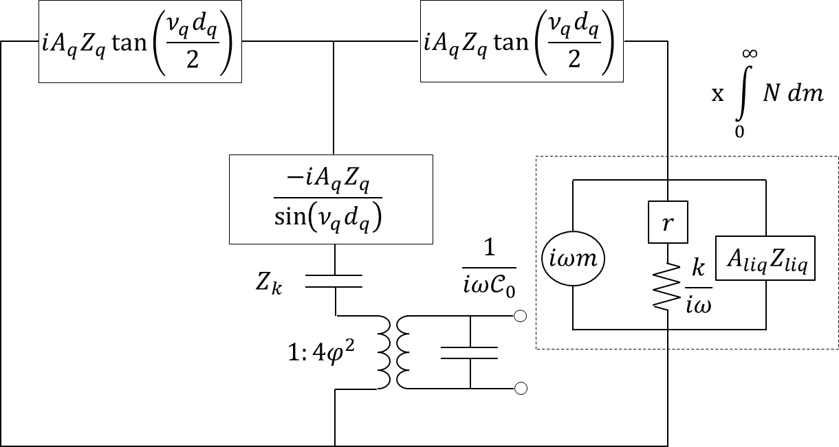 | 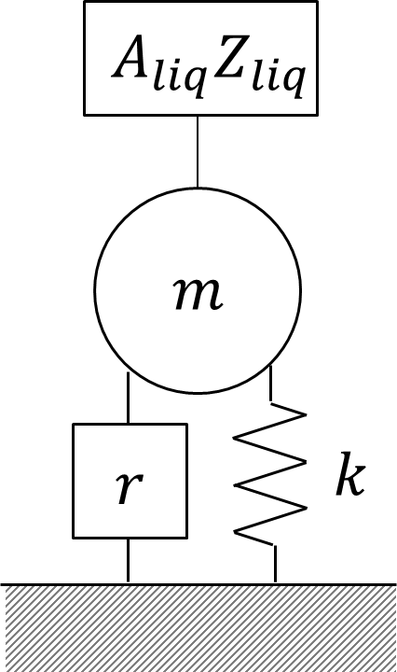
a | b
Figure 1. Mason equivalent circuit for crystallisation on QCM surface. a. The central branch contains the electro-mechanical conversion through a transformer component with coil ratio$4φ^{2}$. $C_{0}$ represents parasitic capacitance which may arise due to charge build on the sensor’s electrodes, and $Z_{k}$ represents piezoelectric stiffening. b. Schematic of the crystal’s equivalent circuit model.

EXPERIMENTAL METHOD
Two reservoirs containing sodium sulphate and calcium chloride (both 99% Sigma-Aldrich®, used as received) solutions (concentration set to 1:1 molar ratio) were degassed with helium for 30 minutes prior to every experiment. Each solution was pumped at 1.9 $mL \min^{-1}$ by a dual channel peristaltic pump to a lightly stirred mixing. A third reservoir containing deionised water was fed by a separate pump at 5.4$mL \min^{-1}$ (total flow$Re=130$) into the well-mixed chamber (residence time of 30 seconds). The mixture was subsequently fed to a customised flow cell (Longshore Systems Engineering Ltd.) designed to maximise flow over the QCM quartz sensor at high throughput at 56.0 ± 0.5$°C$. Imaging was done using a Veho microscope camera; snapshots of the sensor surface were taken at 15 minute intervals focused on the centre of the sensor. Images were analysed using ImageJ. QCM measurements were acquired using the E1 q-Sense system, with a gold coated quartz sensor. Cleaning was performed by submerging the sensor in Helmanax-III solution for one hour, after which it was rinsed and ultrasonicated in ethanol (99% Sigma) for ten minutes. The sensor was then dried with nitrogen, and ozone/UV cleaned for a minimum of ten minutes. The experiment was repeated three times for three concentrations of sodium sulphate: 30.0, 32.5, and 35.0 g$L^{-1}$, which correspond to supersaturations of S=3.22, S=3.48, and S=3.75 respectively (Supersaturation is defined as the ratio of concentration to solubility: $S=C/{C^{*}}$). ³³

RESULTS AND DISCUSSION
IMAGING
The crystals on the sensor surface were observed using microscopy. To confirm the calcium sulphate crystal morphology, a higher magnification microscope image (after drying) reveal needle-shape crystals (Figure 2a). Individual crystals adopt a prismatic shape and tend to grow in three dimensional crystal clusters (Figure 2b). Figure 2 shows that Equation 4 is an appropriate population balance model since adjacent clusters do not merge (unlike the birth-and-spread Avrami model,³⁴ for example) but remain as individual entities.
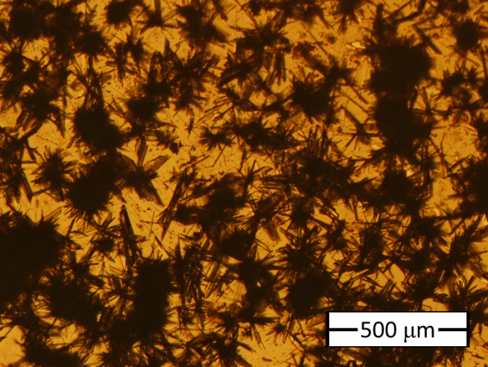 | 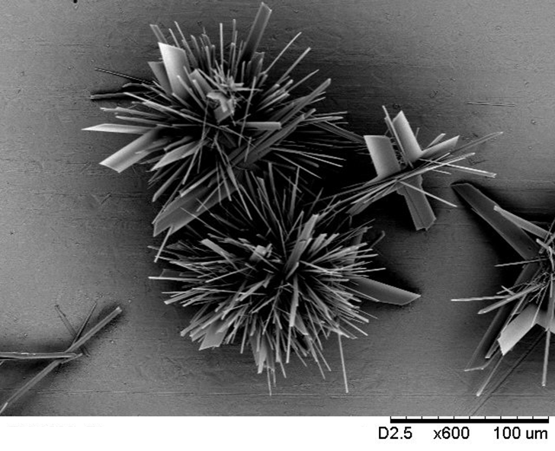
a | b
Figure 2. Calcium sulphate crystallisation at S=3.75. (a) Calcium sulphate crystals deposited on gold surface of the QCM surface. (b) Higher magnification SEM image of three adjacent clusters.
The number of crystals at each time step was determined for all three supersaturation levels ($S$) (Figure 3). The increase in supersaturation level results in not only a faster rate of nucleation ($J$), but also a shorter induction time ($t_{D}$, a period of time where the solution is supersaturated, but no crystallisation is detected). This is expected from classical nucleation theory.²⁶

 |  | $$S=3.75$$  $$(min)$$ | $$S=3.48$$  $$(min)$$ | $$S=3.22$$  $$(min)$$
 |  | 4.) 75 | 8.) 120 | 12.) 195
 |  | 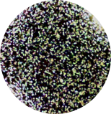 | 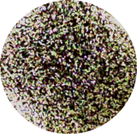 | 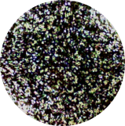
 |  | 3.) 60 | 7.) 90 | 11.) 165
 |  | 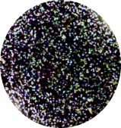 | 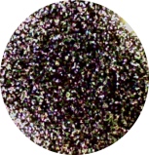 | 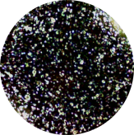
 |  | 2.) 45 | 6.) 75 | 10.) 135
 |  | 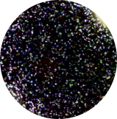 | 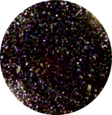 | 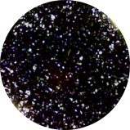
 |  | 1.) 30 | 5.) 60 | 9.) 105
 |  | 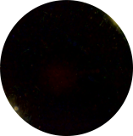 | 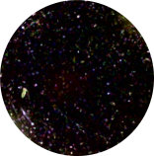 | 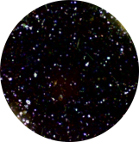
a | b
Figure 3. a. The number of crystals is shown at four time steps for supersaturation concentrations of S=3.22 (red), S=3.48 (blue), and S=3.75 (black), determined using image analysis. Gradients of the lines represent nucleation rates ($J$) and x-axis intercepts indicates nucleation induction times ($t_{D}$). b. Corresponding microscope images used to calculate number of crystals at each time frame.

QCM
Calcium sulphate deposition at three supersaturation levels (S=3.22, S=3.48, S=3.75) were tested on a gold coated QCM quartz sensor. Both the first four harmonic resonances for frequency (Figure 4a-d) and dissipation (Figure 4e-h) were measured. Noise generated by the pumps was smoothed using a linear local regression filter.
As crystals accumulate on the gold surface, the first harmonic (Figure 4a) displays a negative frequency shift consistently for all supersaturations. The third overtone demonstrates some frequency inversions (Figure 4b) at lower supersaturations tested, however at the highest supersaturation tested (3.75) this was not observed. A continued progression is observed in the fifth overtone (Figure 4c). Clear inversion is observed at the lowest supersaturation (3.22), significant inversion in the intermediate supersaturation (3.48), and inversion is observed for some trials at the highest supersaturation (3.75). Finally, the seventh overtone (Figure 4d) shows fully positive frequency shifts for all three supersaturations.
The variability amongst trials at the same supersaturation is expected and observed (Figure 4) due to the stochastic nature of crystallisation, where random nucleation and growth occurs on the sensor. As a result, the multiple trials are critical to collectively accurately represent the behaviours occurring with changing supersaturation. Most notably, some trials are susceptible to of both a negative and positive frequency shift at a single supersaturation (e.g. third overtone S=3.48). Dissipation shifts measured simultaneously (Figure 4e-h) show a consistent positive increase in all harmonics due to the increase in dampening experienced by the QCM sensor.

a | e
b | f
c | g
d | h
Figure 4. QCM results of the calcium sulphate crystallisation for supersaturations: S=3.22, S=3.48, S=3.75 (each showing three trials), (a-d) frequency harmonics (1,3,5, and 7), (e-h) frequency dissipation (1,3,5, and 7).

COMPARISON OF MODEL AND EXPERIMENTAL DATA
The agreement between the experimental data and the model for the first four harmonics is examined in Figure 5. The comparison is shown for a single trial at every supersaturation tested (additional trials are shown in Supplementary Materials S.2). The final form of the model is provided by Equation 9,
 | $$\frac{∆\tilde{f}}{f_{f}}=\left\{\begin{matrix}0 & t<t_{D} \\ \frac{iJ}{πAZ_{q}G}\int_{0}^{∞}{\frac{1-H(m-G(t-t_{D}))}{\frac{1}{iωm}+\frac{iω}{k+iωr}+\frac{1}{\left(1+i\right)α_{s}m\sqrt{\frac{ρ_{liq}ηω}{2}}}} dm} & t≥t_{D}\end{matrix}\right.$$ | (9)
Nucleation rate$(J)$ and induction time$(t_{D})$ are variables estimated by image analysis (Figure 3), which leaves the stiffness$(k)$, dampening$(r)$ and growth rate$(G)$ as fitting parameters (three degrees of freedom). Data was analysed using Matlab® and QTM (courtesy of Johannsmann³⁵). In the Matlab® optimisation toolbox, a multivariable constrained non-linear minimisation algorithm was used to search for the global minimum of the square of the difference between the model and experimental data. All frequency and dissipation overtones were fitted simultaneously with equal weighting.
The model agrees well with experimental results for both frequency and dissipation shifts for the first four harmonics. The model successfully captures the negative shifts observed at the fundamental overtone and the gentle inversions found in the higher overtones. Such features cannot be produced by conventional uniform layer viscoelastic models since they do not account for a nucleating-growing population of point load impedances. A comparison between the proposed model and several conventional models (including the Sauerbrey model, viscoelastic film in liquid model, and standard Kelvin-Voigt model) is available in Supplementary Material S.3. Model agreement is better at lower supersaturation experiments for both frequency and dissipation across all overtones (with only three degrees of freedom) by employing a physically accurate description of the mechanics of crystallisation. At high supersaturation experiments (S=3.75), some minimal deviation is observed where an early prediction of the third overtone’s inversion (Figure 5a) and an underestimation of the fundamental dissipation (Figure 5b) occurs in the model. Variation of fitting parameters ($G$,$k$, and $r$) with supersaturation is given in Supplementary Material S.4.

a | d
b | e
c | f
Figure 5. Agreement between experiment (dots) at S=3.75 (a,d) S=3.48 (b,e), and S=3.22 (c,f) and the model described by Equation 8 (lines). (a-c) Frequency shifts, (d-f) Dissipation shifts (scaled to overtone).

Critically, the model’s accuracy allows for significant utility in understanding the mechanical properties underlying crystallisation growth, particularly using the frequency inversions. When crystals are young, the impedance experienced by the QCM sensor is dominated by inertial, rather than elastic, forces. The newly formed crystals that nucleate on the sensor’s surface act as rigid bodies because their natural resonance is much higher than that of the sensor ($ω_{c}=\sqrt{k/m}$). The inertial driven behaviour observed in the model can be emphasised by taking the limit of the impedance as the mass of the crystal approaches zero.
 | $$\lim_{m→0}{Z_{c}}=\left(\frac{ωα_{s}\sqrt{\frac{ρ_{liq}ηω}{2}}\left(1-i\right)}{iω+\left(1+i\right)α_{s}\sqrt{\frac{ρ_{liq}ηω}{2}}}\right)m$$ | (10)
When approaching this limit, the crystal impedance ($Z_{c}∝m$) and negative frequency shift ($∆f∝-m$,) are both proportional to change in mass, similar to the behaviour described by the Sauerbrey equation. The contribution of the impedance imposed by the hydration layer plays an important part when approaching this limit as it contributes to both the frequency and dissipation shifts observed. The added dampening provided by the hydration layer accounts for the large dissipation shifts observed experimentally, which are otherwise underestimated by a standard Kelvin-Voigt model.
After this initial period the crystals grow into a more macroscopic structure. As a result, the magnitude of inertial impedance increases and surpasses that of the elastic impedance. The frequency inversion occurs when the crystal’s elasticity becomes the dominating impedance. When the mass of the crystals becomes extremely large, the impedance is determined by the Kelvin-Voigt component only.
 | $$\lim_{m→∞}{Z_{c}}=r-i\frac{k}{ω}$$ | (11)
The shift from inertial to elastic impedance is depicted by Figure 6b. The imaginary component of the crystals’ impedance (black curve) follows Equation 10 (blue curve), then changes sign (green point) and asymptotically approaches Equation 11 (red line).

a |  | b
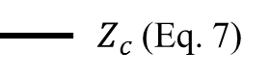 | 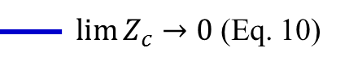 |  | 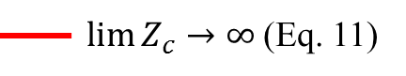
Figure 6. Variation of the crystal’s impedance (at$n=1$) with mass (Equation 7, in black), transitioning from the inertial regime (Equation 10, in blue) to the elastic regime (Equation 11, in red). (a) Real component corresponds to dissipation shift. (b) Imaginary component corresponds to frequency shift. Inversion point highlighted in green. Here$k={10}^{5}$,$r={10}^{-3}$,$α_{s}={10}^{3}$.

CONCLUSION
A novel model was derived from the well-established equivalent Mason circuit theory for the purpose of correctly analysing surface crystallisation using a QCM-D. The model proposed herein utilises both the liquid impedance imposed by the salt solution and the Kelvin-Voigt viscoelasticity model to accurately represent the physical phenomena occurring in crystal growth. This model shows good agreement with both the frequency and dissipation shifts observed experimentally in crystallisation for all supersaturation conditions tested. Alternative models are far less successful in correctly predicting the critical frequency inversions for different harmonic overtones. With the use of an appropriate QCM-D model, traditional microscopic imaging of calcium sulphate crystallisation provides a more mechanistic understanding of the crystallisation process. Nucleation rates and induction times at various supersaturations were calculated using image analysis. The proposed model was used to determine the crystallisation growth rates and extract the stiffness and dampening constants of the surface crystallisation process.

NOMENCLATURE
Symbol | Description | Units
$$A_{c}$$ | Crystal contact area with surface | $$m^{2}$$
$$A_{liq}$$ | Area of crystal-liquid interface | $$m^{2}$$
$$A_{q}$$ | Quartz active area | $$m^{2}$$
$$C$$ | Concentrations | $$mol m^{3}$$
$$C^{*}$$ | Solubility | $$mol m^{3}$$
$$C_{0}$$ | Parasitic capacitance | $$F$$
$$D$$ | Dissipation | -
$$d_{q}$$ | Thickness of QCM sensor | $$m$$
$$e_{26}$$ | Piezoelectric stress coefficient | $$C m^{-2}$$
$$f$$ | Frequency | $$Hz$$
$$\tilde{f}$$ | Frequency (as a complex number) | $$Hz$$
$$f_{f}$$ | Fundamental frequency of unload quartz | $$Hz$$
$$G$$ | Crystal mass growth rate | $$kg s^{-1}$$
$$H$$ | Heaviside function | -
$$J$$ | Crystal nucleation rate | $$s^{-1}$$
$$k$$ | Stiffness constant | $$N m^{-1}$$
$$k$$ | Integration constant | -
$$L$$ | Laplace transform | -
$$L_{c}$$ | Length of crystal | $$m$$
$$m$$ | Crystal mass | $$kg$$
$$m^{*}$$ | Mass of critical nucleus | $$kg$$
$$N$$ | Number density of crystals | $$m^{-1}$$
$$\hat{N}$$ | Laplace density function | $$m^{-1}$$
$$n$$ | Harmonic overtone | -
$$r$$ | Dampening constant | $$kg s^{-1}$$
$$S$$ | Supersaturation | -
$$s$$ | Laplace transform space | $$m^{-1}$$
$$T$$ | Temperature | $$K$$
$$t$$ | Time | $$s$$
$$t_{D}$$ | Nucleation induction time | $$s$$
$$x$$ | Radial position on QCM sensor | $$m$$
$$Z_{c}$$ | Impedance of crystal | $$kg s^{-1}$$
$$Z_{k}$$ | Piezoelectric stiffening impedance | $$kg s^{-1}$$
$$Z_{liq}$$ | Liquid impedance | $$kg s^{-1} m^{-2}$$
$$Z_{load}$$ | Impedance on quartz surface (point) | $$kg s^{-1}$$
$$Z_{q}$$ | Quartz acoustic impedance | $$kg s^{-1} m^{-2}$$
$$α_{s}$$ | Shape factor | $$m^{2} {kg}^{-1}$$
$$Γ$$ | Complex frequency | $$Hz$$
$$δ$$ | Dirac delta function | -
$$δ_{w}$$ | Evanescent wave depth penetration | $$m$$
$$ζ$$ | Dampening coefficient of viscoelastic layer | -
$$η$$ | Viscosity | $$kg s^{-1} m^{-1}$$
$$ν_{q}$$ | Quartz wavenumber | $$m^{-1}$$
$$ρ_{c}$$ | Density of crystal | $$kg m^{-3}$$
$$ρ_{d}$$ | Density of quartz | $$kg m^{-3}$$
$$φ$$ | Turns ratio | -
$$ω$$ | Angular frequency | $$Hz$$

ACKNOWLEDGMENT
The PhD studentship, supported by the Alan Howard Scholarships for Tomer Lapidot, is gratefully acknowledged. The authors acknowledge Doron Lapidot for the many fruitful ideas and interesting discussions, as well as assisting in the design of the customised QCM flow cell. The authors would also like to thank Prof. Diethelm Johannsmann for his technical input and helpful discussions in the development of the proposed model.

SUPPORTING INFORMATION
Supporting information includes four additional supplementary sections for the interested reader. Section S.1 provides the full derivation of Equation (4) using Laplace transforms. The second provides the model’s fittings to experimental data. Since the experiment was repeated three times at each supersaturation, one of the trials’ fitting is provided in the body of the work (Figure 5), and the fitting of the additional two trials is provide in section S.2. Section S.3 compares conventionally used models, such as the Sauerbrey model, uniform viscoelastic film in liquid model, and a standard Kelvin-Voigt model to the proposed model. Section S.4 depicts the values of the model’s fitted parameters (G, k, and r) at the three supersaturations tested.

REFERENCES
1. Tanahashi, M.; Matsuda, T. J of Biomed. Mater. Res. 1997, 34 (3), 305-315.
2. Karpovich, D. S.; Blanchard, G. J. Langmuir 1994, 10 (9), 3315-3322.
3. Domack, A.; Prucker, O.; Rühe, J.; Johannsmann, D. Phys. Rev. E 1997, 56 (1), 680-689.
4. Molino, P. J.; Wallace, G. G.; Hanks, T. W. Synt. Met. 2012, 162 (15–16), 1464-1470.
5. Wang, B.; Liu, Z.; Xu, Y.; Li, Y.; An, T.; Su, Z.; Peng, B.; Lin, Y.; Wang, Q. J. Mater. Chem. 2012, 22 (34), 17954-17960.
6. Patel, A. R.; Kerwin, B. A.; Kanapuram, S. R. J. Pharm. Sci. 2009, 98 (9), 3108-3116.
7. Willner, I.; Patolsky, F.; Weizmann, Y.; Willner, B. Talanta 2002, 56 (5), 847-856.
8. Jerkiewicz, G.; Vatankhah, G.; Lessard, J.; Soriaga, M. P.; Park, Y.-S. Electrochim. Acta 2004, 49 (9–10), 1451-1459.
9. Baute, N.; Martinot, L.; Jérôme, R. J. Electroanal. Chem. 1999, 472 (1), 83-90.
10. Sauerbrey, G. Z. Phys. 1959, 155 (2), 206-222.
11. Johannsmann, D. Macromol. Chem. Phys. 1999, 200 (3), 501-516.
12. Voinova, M. V.; Rodahl, M.; Jonson, M.; Kasemo, B. Phys. Scr. 1999, 59 (5), 391.
13. Sherrit, S.; Leary, S. P.; Dolgin, B. P.; Bar-Cohen, Y. Ultrasonics Symposium, 1999. Proceedings. 1999 IEEE, 1999; 1999; pp 921-926 vol.2.
14. Takamichi, N.; Toyosaka, M. Jpn. J. Appl. Phys. 1990, 29 (5R), 963.
15. Johannsmann, D., Studies of Viscoelasticity with the QCM. In Piezoelectric Sensors, Steinem, C.; Janshoff, A., Eds. Springer Berlin Heidelberg: 2007; Vol. 5, pp 49-109.
16. Johannsmann, D.; Reviakine, I.; Richter, R. P. Anal. Chem. 2009, 81 (19), 8167-8176.
17. Tellechea, E.; Johannsmann, D.; Steinmetz, N. F.; Richter, R. P. Langmuir 2009, 25 (9), 5177-5184.
18. Serizawa, T.; Kamimura, S.; Akashi, M. Colloids Surf. A 2000, 164 (2), 237-245.
19. Pomorska, A.; Shchukin, D.; Hammond, R.; Cooper, M. A.; Grundmeier, G.; Johannsmann, D. Anal. Chem. 2010, 82 (6), 2237-2242.
20. Abdel-Aal, N.; Satoh, K.; Sawada, K. J. Cryst. Growth 2002, 245 (1–2), 87-100.
21. Gabrielli, C.; Keddam, M.; Khalil, A.; Maurin, G.; Perrot, H.; Rosset, R.; Zidoune, M. J. Electrochem. Soc. 1998, 145 (7), 2386-2396.
22. Hoang, T. A.; Rohl, A. L.; Jeffrey, M. I.; Ang, H. M. Dev. Chem. Eng. Min. Process. 2006, 14 (1-2), 313-321.
23. Lin, N. H.; Shih, W.-Y.; Lyster, E.; Cohen, Y. J. Colloid Interface Sci. 2011, 356 (2), 790-797.
24. Linnikov, O. D. Desalination 1999, 122 (1), 1-14.
25. Johannsmann, D. The Quartz Crystal Microbalance in Soft Matter Research. Springer: London, 2014.
26. Kashchiev, D. Nucleation. Butterworth-Heinemann: Oxford, 2000.
27. Olsson, A. L. J.; van der Mei, H. C.; Johannsmann, D.; Busscher, H. J.; Sharma, P. K. Anal. Chem. 2012, 84 (10), 4504-4512.
28. Bingen, P.; Wang, G.; Steinmetz, N. F.; Rodahl, M.; Richter, R. P. Anal. Chem. 2008, 80 (23), 8880-8890.
29. Reviakine, I.; Johannsmann, D.; Richter, R. P. Anal. Chem. 2011, 83 (23), 8838-8848.
30. Ramos, J. J. I.; Moya, S. E. Macromol. Rapid Commun. 2011, 32 (24), 1972-1978.
31. Keiji Kanazawa, K.; Gordon Ii, J. G. Anal. Chim. Acta 1985, 175, 99-105.
32. Daikhin, L.; Gileadi, E.; Katz, G.; Tsionsky, V.; Urbakh, M.; Zagidulin, D. Anal. Chem. 2002, 74 (3), 554-561.
33. Bock, E. Can. J. Chem. 1961, 39 (9), 1746-1751.
34. Avrami, M. J. Chem. Phys. 1939, 7 (12), 1103-1112.
35. Johannsmann, D. QCM Modelling. http://www.pc.tu-clausthal.de/en/research/johannsmann-group/qcm-modelling/.

For TOC Only
