Online Social Networking Services in the Management of Patients with Diabetes Mellitus: Systematic Review and Meta-Analysis of Randomised Controlled Trials

Authors: Tania Toma
Thanos Athanasiou
Leanne Harling
Ara Darzi
Hutan Ashrafian

Institution: Department of Surgery and Cancer, Imperial College London, London, UK.

Corresponding Author:

Dr Hutan Ashrafian
Department of Surgery and Cancer,
Imperial College London
10th Floor Queen Elizabeth the Queen Mother (QEQM) Building,

St Mary’s Hospital
South Wharf Road
London
W2 1NY
United Kingdom

Key Words: ‘social networking services’; ‘telemedicine’; ‘diabetes’; ‘HbA1c’

Word Count:

Funding: This research has received no specific funding
Competing Interests: None

Abstract

Aims
The global escalation of web-based and mobile technologies has led to the worldwide adoption of online social networking tools. In the setting of diabetes care, social networking services (SNS) can facilitate real-time communication and feedback of blood glucose and other physiological data between patients and healthcare professionals. This systematic review and meta-analysis aims to summarise the current evidence surrounding the role of online social networking services in diabetes care.

Methods
We performed a systematic literature review of the Medline, EMBASE and PsychINFO databases to detect all studies reporting HbA1c (glycosylated haemoglobin) as a measure of glycaemic control for social networking services in diabetes care. HbA1c, clinical outcomes and the type of technology used in the diabetes interventions were extracted. Study quality and publication bias were assessed.

Results
34 randomised controlled trials incorporating a total of 2550 patients fulfilled our inclusion criteria and were analysed using random effects modelling. SNS interventions beneficially reduced HbA1c by 0.46% (95%CI [-0.58, -0.34]) when compared to controls, however with significant heterogeneity (I²=74%). Sensitivity analysis of high quality studies confirmed these results by revealing an HbA1c decrease of 0.43% (95%CI ). SNS also produced a significant improvement in systolic and diastolic blood pressure (reductions of 3.47mmHg and 1.84mmHg respectively), triglycerides (-11.05mg/dL, 95%CI [-20.92, -1.18]) and total cholesterol (-5.74mg/dL, 95%CI [-9.71, -1.78]). Subgroup analysis according to diabetes type showed that Type 2 diabetes patients had a significantly greater reduction in HbA1c than those with Type 1 diabetes (-0.55, 95%CI [-0.68, -0.42] vs. -0.12, 95%CI [-0.32, 0.08]).

Conclusions
Online social networking services provide a novel, feasible approach to improving glycaemic control, particularly in patients with Type 2 diabetes. Further mechanistic and cost-effectiveness studies are required to improve our understanding of SNS and its efficacy in diabetes care.

Word Count: 290

Introduction

Diabetes mellitus is a highly prevalent metabolic disorder, which demands continuous medical care, patient education, self-management and regular access to support systems [1]. Approximately 347 million people have diabetes worldwide and this figure is expected to increase to 366 million by 2030, representing 4.4% of the global population [2, 3]. Furthermore, as a result of the systemic complications of diabetes including cardiovascular, renal, neurological and eye disease[4], diabetes has a significant global financial burden, costing the global economy $471 billion in 2012 [5]. Prospective studies such as the Diabetes Control and Complications Trial (DCCT) and UK Prospective Diabetes Study (UKPDS) demonstrated that blood glycaemic control significantly reduces the risk of diabetic comorbidities [6, 7] including cardiovascular risk, retinopathy, nephropathy and neuropathy.

Diabetic patients have been traditionally monitored via conventional face-to-face clinician visits with their healthcare provider. Although a number of measures of diabetic control may be utilised, the most common is the measurement of blood glycosylated haemoglobin (HbA1c), a measure of the exposure of the erythrocyte to glucose, which provides a means to predict the risk of development of long-term complications[8]. However, the advancement of social networking through the development of mobile phone and web-based technologies and their increased accessibility in nearly all populations has prompted investigations into alternative methods of chronic disease-management[9]. By the end of 2011 there were 6 billion mobile phone subscriptions, corresponding to a global penetration of 86%, and 2.3 billion Internet users worldwide, where 70% of households in developed countries had Internet access [10]. The ubiquity of these devices and their relatively low cost of distributing information make them an effective medium to incorporate social networking into diabetes care [9].

Online social networking services (SNS) can be defined as, “web-based services that allow individuals to (1) construct a public or semi-public profile within a bounded system, (2) articulate a list of other users with whom they share a connection, and (3) view and traverse their list of connections and those made by others within the system. The nature and nomenclature of these connections may vary from site to site (Boyd and Ellison).” (http://jcmc.indiana.edu/vol13/issue1/boyd.ellison.html) When orientated to managing diabetes, SNS can facilitate real-time, synchronous communication and the feedback of blood glucose and other physiological data between patients and healthcare professionals. Furthermore, it can assist in providing online education, peer support, and decision advice[12] within diabetic communities in a digital environment.

Results from previous systematic reviews assessing Internet and telephone use for diabetes control are conflicting. Two reviews (published in 2005 and 2010) evaluated the use of telemedicine to monitor blood glucose, with the main intervention being the use of modems and telephone lines to transmit data [13, 14]. In both studies, there was insufficient evidence to suggest the telemedicine intervention improved glycaemic control. Two more recent reviews published in 2011 evaluated the use of more updated mobile or Internet tools to monitor blood glucose and concluded with an improvement in the intervention groups, suggesting patient willingness to receive alternative methods of diabetes care [15, 16]. Over the past decade there has been an expansion in the use of social networking services as well as a refinement in its definition. The objective of this study was therefore to produce an up-to-date systematic review and meta-analysis of randomised controlled trials assessing the use of social networking services via mobile and web-based tools, compared with standard care, in managing glycaemic control in patients with diabetes through the assessment of HbA1c.

Methods

Search strategy
Studies published in the English language were identified by searching the following databases: MEDLINE (1946 to August 2013), EMBASE (from 1974 to August 2013), PSYCHINFO (from 1967 to August 2013). We used combinations of the search terms: "social network”, “diabetes”, “mobile phone", "cellular phone", "text message", "smart phone", SMS, web, web-based, internet, internet-based, HbA1c, A1c, "glycosylated haemoglobin", and "glycosylated hemoglobin." Reference lists of identified publications were also searched for potential studies for inclusion. A summary of our search strategy is shown in Figure 1.

Selection criteria
Titles and abstracts were assessed and the full-text articles fulfilling the following inclusion criteria were obtained: (1) Randomized controlled trials, of parallel, cluster or crossover design, (2) Studies assessing patients with Type 1 or Type 2 diabetes, (3) Trials reporting means and standard deviations of HbA1c values of control and intervention groups at baseline and follow-up, (4) Studies defining social networking services through the utilization of interactive web-based tools or mobile technology (e.g cellular phones, PDAs and webcams), to facilitate communication or transmission of data between patients or with their healthcare providers. Adjunct use of telephone lines was acceptable providing it was not the primary intervention.

Exclusion Criteria
Studies were excluded from this review if: (1) They did not use HbA1c as an outcome measure; (2) they did not compare intervention with a control group; (3) they were non-randomized or were reviews, case reports, comments or editorials; (4) they included participants with gestational diabetes, and (5) they used non-wireless technology, such as telephone lines, as the primary method of exchanging information.

Based on these criteria, two independent reviewers assessed the eligibility of studies by title and abstract review (T.T, H.A). All potentially eligible studies were retrieved in full for further evaluation. If eligible articles contained missing data, contact was made with study authors to obtain additional information.

Data extraction and analysis
Two authors (TT, HA) independently extracted the following data from each paper using a standardised spreadsheet including: first author, source of article, year of publication, study population (Type 1 or Type 2 diabetes), age and numbers of patients, follow up period, type of intervention, duration of diabetes, body mass index (BMI), percentage educated at university or college and frequency of data transmission. Our primary outcome was glycemic control, measured by HbA1c before and after intervention. Secondary outcomes included systolic and diastolic blood pressure and lipid profiles (triglycerides, total cholesterol, HDL cholesterol, LDL cholesterol). Study designs were categorized as randomized controlled trials, randomized crossover trials or cluster randomized controlled trials.

Meta-analysis was performed in line with recommendations from the Cochrane Collaboration and in accordance with both PRISMA (Preferred Reporting Items for Systematic Reviews and Meta-Analyses) guidelines.[17] Analysis was conducted by use of Review Manager® Version 5.0 for Windows (The Cochrane Collaboration, Software Update, Oxford, UK) and STATA v.11 statistical analysis software.

Data was analysed using a random effects model. Continuous data were investigated using weighted mean difference (WMD) as the summary statistic, reported with 95% confidence intervals (CI). All included trials were published after 1997, post HbA1c-DCCT standardisation, therefore the standard mean difference (SMD) was not needed to summarise treatment effects ^{(PMID: 23554942)}. The point estimate of the WMD was considered statistically significant at p < 0.05, if the 95% confidence interval did not include the value zero. Categorical variables were analysed using the odds ratio (OR). An OR of < 1 favoured the treatment group and the point estimate of the OR is considered statistically significant at the p < 0.05 level, if the 95 % confidence interval does not include the value 1.

Heterogeneity
Inter-study heterogeneity was explored using the Chi²-statistic, but the I² value was calculated to quantify the degree of heterogeneity across trials that could not be attributable to chance alone. When I² was more than 50%, significant statistical heterogeneity was considered to be present.

Methodological Quality
We assessed the methodological quality of each study using the Jadad scale. A total score ranging between 1 and 5 was given to each study, with 1 being the lowest possible score, and 5 the highest. A maximum of 2 points each was awarded for methods of randomization and blinding. An additional point was awarded if all participants were accounted for after withdrawals and dropouts. Studies scoring ≥3 were classified as high quality whilst those scoring <3 were of low quality.

Risk of Bias Assessment
The Cochrane Collaboration’s tool was used to assess the risk of bias of included studies. Studies were rated according to five predefined categories: (1) Adequacy of sequence generation; (2) Quality of allocation concealment; (3) Quality of blinding; (4) Freedom of incomplete data and (5) Freedom of selective reporting. The risk of bias in each area was scored as high, low, or unclear.
The quality of evidence for each important outcome was evaluated using the GRADE (Grading of Recommendations Assessment, Development and Evaluation) scale, which assesses five main areas: (1) study limitations (losses to follow up, lack of allocation concealment, lack of blinding); (2) indirectness of evidence; (3) inconsistency of results; (4) imprecision and (5) publication bias. The quality of evidence was categorized as high, moderate, low or very low.

Subgroup Analysis
Analyses of the effect of SNS on HbA1c were performed for the following subgroups: (i) Population: Type 1 or Type 2 diabetes; (ii) Intervention type: Internet, or a combination of both mobile phones and Internet; (iii) Quality: high or low quality, where high quality studies scored >3 on the Jadad scale. Sensitivity analysis was performed by excluding high quality studies with a Jadad score of >2.

Results

Search Results

Thirty-four studies fulfilled our inclusion criteria, producing a pooled data set of 4977 patients, of whom 2550 were randomised to an SNS intervention group and 2427 to a control group. The characteristics of included studies are shown in Supplementary Table 1.

Studies were conducted in a variety of locations. 11 were published in the USA, 11 in Korea, 3 in Canada and 1 in each of the following countries: India, Israel, Turkey, France, Finland, Iran, Taiwan, Italy and the UK. Included studies were published between the years 2002 to 2013. The total number of participants in each study ranged from 30 to 1665 and intervention periods ranged from 3 months to 5 years. The mean age of participants ranged from 14.6 to 70.9 years, and BMI ranged from 21.3 to 35.95. No variables differed significantly between the control and intervention groups at baseline, except for the duration of diabetes with a significant mean difference of -0.76% (95% CI: -1.40 to -0.12, P<0.02, I²=23%) favouring the intervention group.

Characteristics of Interventions
Several modes of delivery were used to implement the SNS interventions. 15 studies used solely web-based tools [18-30], 3 used cellular or mobile technology [31-33], and 16 used a combination of both [34-49]. 10 of these studies adopted a messaging service between the patient and provider to maintain contact and involved the use of secure email, SMS or online chat-rooms [18, 20, 23, 25, 31, 33, 43, 44, 46, 50]. 7 studies had an online educational element, delivering non-personalised information and recommendations regarding diet, exercise and adjustment of medications [18, 20, 23, 26, 31, 45, 50]. 7 studies allowed shared access of online electronic medical records between the patient and provider [20, 23, 34, 37, 43, 47, 49], whilst 5 studies provided an interface to graphically display blood glucose data [23, 34, 35, 50, 51]. Only 3 studies lacked the facility to upload blood glucose readings [21, 26, 29]. 3 studies encouraged social networking between patients via peer-support forums and live chat-rooms [21, 28, 44]. 2 interventions involved videoconferencing via the Internet with a nurse provider [27, 47] and 3 studies involved the adjunct use of telephone lines [37, 42, 51].

Frequency of Transmission
15 studies commented on the participants’ usage of the social networking interventions. The majority of studies resulted in data transmission at a minimum frequency of once per week. 4 studies reported the total number of interactions between patients and providers, which ranged from 432 to 1662 [19, 34, 41, 42]. 4 studies calculated the frequency of communication between patients or providers with the number of messages ranging from 8.4 to 52 per patient over the whole intervention period [19, 24, 25, 33, 49]. 4 further studies using web-based programmes reported on the number of logins at follow-up, with the highest frequency being 42.3 ± 32.3 (SD) logins per patient[20, 24, 43, 51]. 2 of these studies observed a significant decrease in the number of website logins from baseline to follow-up[43, 51]. Further details of data transmission and characteristics of the individual study interventions are provided in table 2.

Patient Satisfaction
In general, participants were satisfied with the interventions delivered [26, 27, 30, 37, 42, 48]. Features that were particularly well received included direct communication with providers, prompt feedback of results and the ability to review data online. However, SNS may not be suitable for all diabetic patients. Several studies reported operating or technical difficulties when using SNS, resulting in higher attrition rates. Problems included the inability to transmit results wirelessly and participants reluctant to use the more complicated web-based programs [33, 35, 37, 47]. These more sophisticated interventions could be supplemented with a pre-intervention training period to increase adherence and patient willingness to use SNS [44, 47].

Primary Outcomes

A summary of the results of all primary outcomes is shown in Table 1.

All 34 studies reported HbA1c levels at baseline and follow up. At baseline there was no significant difference in HbA1c between the control and intervention group. At follow-up the pooled 34 trials showed a significant reduction in HbA1c favouring the intervention group, with a mean reduction of 0.46% (95% CI: -0.58 to -0.34, P<0.00001), however heterogeneity was high (I²=74%). A significant mean difference of -0.45% (95% CI: -0.60 to -0.29, P<0.00001) favouring the intervention group was observed in the change in HbA1c between baseline and follow-up, but also with significant heterogeneity (I²=81%) (Figure 2 (a)-(c)).

We conducted a repeat search strategy which included non-randomised controlled trials, resulting in a total of 41 studies with 5575 participants (2851 in the intervention group and 2724 in the control group). After performing a meta-analysis with the additional studies, we also observed a significant mean reduction in HbA1c favouring the intervention group (-0.49%, 95% CI: -0.64 to -0.34, I²=86%). The results are consistent even in non-randomised settings.

Secondary Outcomes

A summary of the results of all secondary outcomes is shown in Table 1.

Lipids
At follow up, 10 studies with a total of 989 patients reported on triglycerides (518 in the intervention group and 471 in the control group). A significant reduction of 11.05% (95% CI: -20.92 to -1.18, P=0.03, I²=0) in those using SNS was observed. A significant mean difference of -5.74 (95% CI: -9.71 to -1.78, P=0.005, I²=53%) favouring the intervention group was also observed in levels of total cholesterol at follow up. 12 studies with 1166 participants (608 and 558 in the intervention and control group respectively) were included. The 11 studies reporting HDL-cholesterol (total of 1100 patients) showed a mean difference of 1.90 (95% CI: 0.24 to 3.57, P=0.02, I²=19%) favouring the control group. 9 studies reported LDL-cholesterol at follow up, however there was no significant effect in either control or intervention group.

Blood Pressure
5 studies with a total of 2580 patients (1317 in the intervention group and 1263 in the control group), reported on systolic and diastolic blood pressure at follow-up. There was a significant mean difference in systolic blood pressure (-3.47mmHg, 95% CI: -5.01 to -1.94, P<0.00001, I²=0%) and diastolic blood pressure (-1.84mmHg, 95% CI: -2.98 to -0.70, P=0.002, I²=29%) favouring the intervention groups.

Subgroup Analyses
Subgroup analysis was performed in order to determine the effects of the following demographic and intervention variables on change in HbA1c: Diabetes type (Type 1 or 2), Intervention type (mobile/internet) (Table 2). Among 7 studies including only patients with Type 1 diabetes, there was no significant reduction in HbA1c. In comparison, there was a significantly larger effect size in Type 2 diabetic patients from 21 studies, with an improvement in HbA1c of 0.55% (95% CI: -0.68 to -0.42, p<0.00001, I²=64%). Subgroup analysis among 14 low quality studies (Jadad score of <3) showed a greater improvement in HbA1c compared to the pooled results from 20 high quality studies (-0.50%, 95% CI: -0.69 to -0.31, p<0.00001, I²=62% vs. -0.43%, 95% CI: -0.59 to -0.26, p<0.00001, I²=79%). Further subgroup analysis was performed among studies using the Internet only and studies using mobiles and Internet combined. The pooled reduction in HbA1c in the intervention group from 16 studies combining the use of mobile and Internet (-0.54, 95% CI: -0.72 to -0.37, P<0.00001, I²=71%) was marginally greater compared to the reduction in 15 studies using Internet only (-0.51, 95% CI: -0.68 to -0.34, P<0.00001, I²=82%).

Sensitivity Analyses

Methodological quality of studies
According to the Jadad scale 20 studies were categorized as high quality (scores ranging from 3-5) and 14 as low quality (scores of 2 or less). Due to the nature of the interventions, the blinding of providers or participants was not feasible in any study. Only 6 studies reported the blinding of data collectors [27, 35, 37, 44, 46, 47]. As a result, no study met all the assessment criteria and the highest possible Jadad score given was 4 [35, 37, 46].

Sensitivity analysis of high quality studies with a Jadad score > xx

Sensitivity analysis of studies with a Jadad score of less than 2 still showed a significant pooled reduction in HbA1c of -0.48% (95% CI: -0.73 to -0.23, P=0.0001, I²=4%). The results of sensitivity analysis are shown in Table 2.

Risk of Bias
The Cochrane Collaboration’s tool was used to assess risk of bias in the included trials (Figure 3). Although all trials were randomised and therefore at a lower risk of bias, only 11 studies clearly described the sequence generation process [18, 22, 23, 25, 31, 35, 39, 40, 46, 49, 50]. Risk of bias due to poor allocation concealment was unclear in all but 6 studies [18, 20, 21, 37, 47, 50]. 6 studies reported the blinding of data collectors [27, 35, 37, 44, 46, 47], however, the blinding of patients or providers was not mentioned in any study using SNS. 16 studies were free of incomplete outcome data [18-20, 22, 24, 25, 27, 30-33, 40, 44, 47, 50, 51].There was a high risk of bias due to incomplete outcome data in 1 study, which analysed data using an as-treated approach [21]. Risk of bias in this domain was unclear in the remaining 17 studies due to the insufficient reporting of attrition rates. 26 trials were free of selective outcome reporting, 6 did not adequately report all primary outcomes [18, 25, 31, 33, 48, 50] and it was unclear if all outcomes were reported in 2 studies [19, 29].

Funnel plot assessment was used to evaluate publication bias for all primary and secondary outcomes. Further statistical analysis was performed using Egger’s test to reveal any significant small study effects. Eggers Test revealed significant small study effects for the following secondary outcomes: Baseline total cholesterol (Co-efficient of Bias 0.511, SE 0.096, t 5.8; P>|t| <0.0001; 95% CI [0.303, 0.719]) and post-operative HDL (Co-efficient of Bias 2.125, SE 0.610, t 3.48; P>|t| 0.010; 95% CI [0.683, 3.566]). Exploration of funnel plots demonstrated the studies by McKay and Yoon to be significant outliers for the baseline cholesterol and post-operative HDL outcomes respectively (Figure 4). However, repeat analysis of all RCTs excluding these studies did not reveal any change in effect significance for either outcome. Analysis of all other outcomes did not reveal funnel plot asymmetry.

Discussion

This systematic review included 34 randomised controlled trials evaluating the use of online social networking services, to assess the improvement of HbA1c as a measure of glycaemic control in patients with Type 1 or Type 2 diabetes. Social networking services are founded upon three main principals; 1) they are web-based applications 2) they allow users to construct a public or semi-public online profile and 3) they facilitate communication and information exchange between individuals or communities through online connections. These social networks are initiated and maintained in online spaces via the Internet and increasingly through the use of mobile phones.

Our pooled results indicate that SNS significantly reduces levels of HbA1c by 0.46%. However, this should be interpreted with caution due to the presence of significant heterogeneity (I² =74%). Sensitivity analysis of high quality studies confirmed these results by revealing an HbA1c decrease of 0.43% (95%CI ). In addition to a reduction in HbA1c, we found SNS to be associated with significant improvements in blood pressure, total cholesterol and triglycerides. Our analysis also suggests that SNS has a significantly greater effect among Type 2 diabetes patients compared to Type 1 patients.

HbA1c (glycosylated haemoglobin) is a biological marker used in the diagnosis and monitoring of diabetes mellitus, which correlates with the mean glucose concentration of plasma and is dependent of exposure to glucose and the half-life of the erythrocyte [8]. HbA1c thus gives an estimate of the average blood glucose control over the preceding 2-3 months and is now accepted as a validated measure of diabetes management [6, 52]. Despite observing an overall improvement in HbA1c, validation of the efficacy of a 0.46% decline is needed, as well as investigations as to whether this reduction translates to diabetic outcomes. In comparison one recent meta-analysis of the new generation anti-obesity drug Lorcaserin revealed a comparable HbA1c decrease of 0.4%[53] whereas a meta-analysis of the new class of anti-diabetic bile acid sequestrant Colesevelam demonstrated an HbA1c decrease of 0.5%[54].

The use of online social networking services (SNS) in society has increased at a remarkable rate in the last decade, with the percentage of American adults using SNS rising from 8% in 2005 to 67% by the end of 2012 [55]. There are now over 1.2 billion users of social media and networking sites, representing 82% of the world’s online population [56]. This global phenomenon has increased the connectivity of individuals and radically transformed the way we communicate [57], particularly in healthcare, as a result of the unification of providers and patient micro-communities in digital landscapes. Healthcare management has conventionally relied upon face-to-face interpersonal communication in the clinical setting, however, although in its infancy, the clinical adoption of SNS has introduced alternate modes of interaction. Patients now have the opportunity to network with an online community of physicians and patients with similar conditions, seeking to share information and receive support [58]. This is evident in a previous study evaluating the content posted by members of diabetic community on the social networking platform Facebook®, where patients were able to share past experiences and receive disease-management advice from others [59]. Furthermore, SNS is proving to be a powerful tool for field experts and organisations to disseminate and broadcast medical information [60]. The studies included in this review demonstrate the increasing potential for SNS in diabetes care and present novel ways of expanding the use of SNS to include direct communication with physicians, real-time personalised feedback and online access to personal results.

Diabetes management typically requires modifications to lifestyle patterns through diet, pharmacotherapy and metabolic surgery[61], however, maintaining these changes are often difficult. Potential mechanisms of action of social networking services on beneficial diabetes outcomes include the provision of social support to encourage anti-diabetic actions, access to a social network for group encouragement, a favourable communication medium for generation X and Y individuals, and in particular, the reinforcement of behavioural therapeutic strategies to improve glycaemic index. These behavioural therapies characteristically involve applying psychological principles to empower patients to make and sustain necessary lifestyle adaptations[62]. As a result, SNS ‘shifts the locus of control to the patient,’ enabling increased patient-centeredness and a richer engagement in their own management of diabetes and glycaemic control [63]. The results of our subgroup analysis demonstrate that patients with Type 2 diabetes were particularly responsive to using SNS whereas participants with Type 1 diabetes showed no significant reduction in HbA1c. A possible explanation for this significant disparity is that SNS is particularly suited to targeting the modifiable lifestyle risk factors, such as obesity and physical inactivity, which predominantly contribute to the incidence of Type 2 diabetes [64], whereas Type 1 diabetic patients suffer from an inherent lack of pancreatic insulin production.

Our results also reveal a significant improvement in HbA1c in studies using internet only interventions (data -0.51)) or mobile and internet interventions (data -0.54)). Whereas mobile only interventions did not significantly reduce HbA1c levels (-0.2). This may reflect some of the communicative mechanisms through which diabetes control can be achieved through on-line or combined on-line/mobile platforms, as opposed to stand alone mobile platforms in disease management. This therefore requires further research studies to clarify the relative therapeutic benefits of these modalities.

An advantage of SNS in diabetes care is its versatility, enabling providers to offer a plethora of services on a diverse range of platforms including cellular phones, PDAs and internet-based programmes. These devices are often interlinked, and our results demonstrate a slight benefit to combining both mobile and Internet technology. The participatory nature of SNS also assists in the delivery of educational outcomes as well as the facilitation of online supportive relationships, which subsequently promote a sense of belonging and self-esteem in users (benefits of social networking). As a consequence of Internet access and mobile technology becoming nearly ubiquitous worldwide, SNS allows populations even in remote areas to receive healthcare and communicate with physicians at a distance [9]Darzi ref lancet. The variety of countries throughout which these studies were carried out also reflects the global applicability of SNS.

However, negative aspects of SNS in healthcare have also been identified and must be considered when determining its role in diabetes management. Due to its wide-reaching nature, providers must remain vigilant in maintaining confidentiality as well as online professionalism when communicating with patients [65]. The distribution of unreliable or incorrect information, especially in forums and online chat-rooms must also be monitored [66]. These obstacles may explain why surprisingly, no study in our review exploited the already established, but less private and secure, social networking giants such as ‘Facebook®’, or ’Twitter’ as a mode of communication and transmitting personal data. Future research could determine whether these more widespread, popular methods of communication could be utilised in a more secure and equally effective way to aid glycaemic control. Other disadvantages include a lack of willingness to comply with newer, more complicated SNS technologies, especially if frequent technological and operating failures are reported [33, 47].

Traditionally policy makers have focused on ‘cybercitizenship', a concept originally associated with online safety and risk-management, although it has now expanded to include the notion of how users engage and express themselves in digital environments. Social networking services (SNS) policy today is also predominantly aimed at controlling and governing the use of SNS, however, increasing support is necessary to harness its potential to foster health benefits in online patient micro-communities. The growing support of SNS from governmental and non-governmental organisations is is increasingly recognised where there is evidence for the adoption of SNS in connection with mental illnesses. This signifies the opportunity in future policy to implement SNS in other domains of healthcare, such as diabetes care (benefits of social networking). Considerations about cost, quality, safety and the scalability and sustainability of SNS are also necessary for policy makers to decide whether the implementation of SNS in diabetes care is expedient [67]. However, the scarcity of investigations into the cost of SNS is reflected by the fact only one study reported the cost of the intervention per patient ($8 over the whole period) [33]. The lack of robust evidence on the cost-effectiveness of SNS in diabetes care leads to a requirement to assess economic viability. We predict that as SNS becomes more globally available (darzi lancet ref) the demand curve can favourably decrease the cost of these technological interventions so that they may become increasingly economically effective.

SNS may also have a role in targeting other diabetes-related comorbidities. Our meta-analysis showed a significant reduction of 3.47 mmHg and 1.84 mmHg in participants using SNS for systolic and diastolic blood pressure respectively. Hypertension is a common comorbidity of diabetes as well as a component of metabolic syndrome. It is estimated that approximately 20-25% of adult Americans suffer from metabolic syndrome, as characterized by a cluster of risk factors including impaired glucose regulation, elevated levels of triglycerides, decreased levels of HDL-cholesterol, hypertension and obesity[68]. In addition to the potential of SNS to improve blood pressure, our results showed a significant improvement in levels of triglycerides and total cholesterol. However, there may be confounding factors as to why SNS had no significant improvement in LDL and HDL-cholesterol. The generally small study sizes and limited number of trials reporting on these outcomes is likely to be accountable for this and these outcomes require further investigation in future work.

Advantages | Disadvantages
Size of the potential audience due to the ubiquity of mobile and Internet software | Risk of breaching confidentiality through less private and secure mediums
The versatility of SNS, demonstrated by its accessibility on a range of platforms including websites, mobile phones and PDAs | Circulation of inaccurate information in online forums and chat rooms
An effective medium to deliver behavioural therapeutic strategies to improve glycaemic index | Potential for loss of online professionalism between patients and providers
A participatory nature where patients and providers benefit from real-time, synchronous communication, facilitating the rapid exchange of information and data in online spaces | Technical or operating issues in connection with wireless devices
Communication can be achieved remotely, allowing interactions to occur anytime and anywhere | Reluctance to deviate from traditional face-to-face interactions in a clinical setting
The opportunity to provide social support in online diabetic patient networks

The ability to deliver educational modules in a digital environment

Potential to target other diabetes related co-morbidities, particularly metabolic syndrome.

Strengths and Limitations
This is the first meta-analysis to have defined social networking services as a single concept in the context of diabetes care. In statistically appraising pooled data from 34 randomised controlled trials, this review is the largest and most robust within the current literature. However, our review also has a number of limitations that should be considered when interpreting the results presented here. Firstly, significant heterogeneity within our results may be attributable to a range of possible confounding factors. In addition to an assortment of sample sizes and follow-up periods, variation in study design resulted in differing cohorts and patient demographics, as well as differences in randomisation procedures. Despite this, our results remain robust following subgroup and sensitivity analyses.

When assessing methodological quality, we also note that the blinding of healthcare providers was not feasible in any study, contributing to a potential source of performance bias. For example, physicians may provide more motivation and encouragement to participants using SNS in the intervention groups. This resulted in lowering the quality score assigned to most studies. The 4 lowest scoring studies included 3 conference abstracts, which were given a score of 1 due to the limited information available. However, the actual quality of these studies may be higher than perceived. Other key methodological flaws included the failure to adequately report the process of allocation concealment and sequence generation. Only two studies fulfilled the criteria for both these domains [18, 50]. Another limitation was a significant mean difference in duration of diabetes favouring the intervention group at baseline, suggesting confounding and selection bias. However, after conducting subgroup analysis of both high and low quality studies, it was found that this significant difference at baseline was only present among low quality studies (-1.35%, 95% CI: -2.16 to -0.54, p=0.001, I²=0%).

Conclusion
In summary, we demonstrate that the use of online social networking services can improve HbA1c control in diabetic patients. SNS offers a novel, feasible approach to improving glycaemic control in comparison with standard medical management. In addition, significant reductions in blood pressure, triglycerides and total cholesterol suggest the potential use of SNS to target the monitoring and treatment of metabolic syndrome. From a global public health perspective, our results also indicate that SNS may be more efficient when orientated towards patients with Type 2 diabetes rather than Type 1 disease. However, larger randomised controlled trials in addition to mechanistic and cost-effectiveness studies are needed to further our understanding of SNS and its efficacy in diabetes care.

References

[1] Standards of medical care in diabetes--2013. Diabetes care 2013;36 Suppl 1:S11-66.
[2] Wild S, Roglic G, Green A, Sicree R, King H. Global prevalence of diabetes: estimates for the year 2000 and projections for 2030. Diabetes care 2004;27:1047-1053.
[3] World_Health_Organisation. Diabetes: Factsheet No.312. http://www.who.int/mediacentre/factsheets/fs312/en/index.html date last accessed).
[4] Standards of medical care for patients with diabetes mellitus. Diabetes care 2003;26 Suppl 1:S33-50.
[5] International_Diabetes_Federation. IDF DIABETES ATLAS UPDATE 2012. http://www.idf.org/diabetesatlas/5e/Update2012 (01 March 2013, date last accessed).
[6] Effect of intensive blood-glucose control with metformin on complications in overweight patients with type 2 diabetes (UKPDS 34). UK Prospective Diabetes Study (UKPDS) Group. Lancet 1998;352:854-865.
[7] Effect of intensive diabetes treatment on the development and progression of long-term complications in adolescents with insulin-dependent diabetes mellitus: Diabetes Control and Complications Trial. Diabetes Control and Complications Trial Research Group. The Journal of pediatrics 1994;125:177-188.
[8] Calisti L, Tognetti S. Measure of glycosylated hemoglobin. Acta bio-medica : Atenei Parmensis 2005;76 Suppl 3:59-62.
[9] Wagner TH, Baker LC, Bundorf MK, Singer S. Use of the Internet for health information by the chronically ill. Preventing chronic disease 2004;1:A13.
[10] ITU_World_Telecommunication/ICT_Indicators_Database. Key statistical highlights: ITU data release June 2012. http://www.itu.int/ITU-D/ict/statistics/material/pdf/2011 Statistical highlights_June_2012.pdf date last accessed).
[11] von Muhlen M, Ohno-Machado L. Reviewing social media use by clinicians. Journal of the American Medical Informatics Association : JAMIA 2012;19:777-781.
[12] Roblin DW. The potential of cellular technology to mediate social networks for support of chronic disease self-management. Journal of health communication 2011;16 Suppl 1:59-76.
[13] Farmer A, Gibson OJ, Tarassenko L, Neil A. A systematic review of telemedicine interventions to support blood glucose self-monitoring in diabetes. Diabetic medicine : a journal of the British Diabetic Association 2005;22:1372-1378.
[14] Shulman RM, O'Gorman CS, Palmert MR. The impact of telemedicine interventions involving routine transmission of blood glucose data with clinician feedback on metabolic control in youth with type 1 diabetes: a systematic review and meta-analysis. International journal of pediatric endocrinology 2010;2010.
[15] Liang X, Wang Q, Yang X, Cao J, Chen J, Mo X et al. Effect of mobile phone intervention for diabetes on glycaemic control: a meta-analysis. Diabetic medicine : a journal of the British Diabetic Association 2011;28:455-463.
[16] Angeles RN, Howard MI, Dolovich L. The Effectiveness of Web-Based Tools for Improving Blood Glucose Control in Patients with Diabetes Mellitus: A Meta-Analysis. Canadian Journal of Diabetes 2011;35:344-352.
[17] Moher D, Liberati A, Tetzlaff J, Altman DG. Preferred reporting items for systematic reviews and meta-analyses: the PRISNSA statement. BMJ 2009;339:b2535.
[18] Majors AW, Ng TC, Xue M, Meaney TF. Monitoring therapeutic response of human superficial tumors using phase-encoded spectroscopy. Magnetic resonance in medicine : official journal of the Society of Magnetic Resonance in Medicine / Society of Magnetic Resonance in Medicine 1989;12:369-378.
[19] Cho JH, Chang SA, Kwon HS, Choi YH, Ko SH, Moon SD et al. Long-term effect of the Internet-based glucose monitoring system on HbA1c reduction and glucose stability: a 30-month follow-up study for diabetes management with a ubiquitous medical care system. Diabetes care 2006;29:2625-2631.
[20] McCarrier KP, Ralston JD, Hirsch IB, Lewis G, Martin DP, Zimmerman FJ et al. Web-based collaborative care for type 1 diabetes: a pilot randomized trial. Diabetes technology & therapeutics 2009;11:211-217.
[21] Mulvaney SA, Rothman RL, Wallston KA, Lybarger C, Dietrich MS. An internet-based program to improve self-management in adolescents with type 1 diabetes. Diabetes care 2010;33:602-604.
[22] Tildesley HD, Mazanderani AB, Ross SA. Effect of Internet therapeutic intervention on A1C levels in patients with type 2 diabetes treated with insulin. Diabetes care 2010;33:1738-1740.
[23] Avdal EU, Kizilci S, Demirel N. The effects of web-based diabetes education on diabetes care results: a randomized control study. Computers, informatics, nursing : CIN 2011;29:TC29-34.
[24] Kwon HS, Cho JH, Kim HS, Song BR, Ko SH, Lee JM et al. Establishment of blood glucose monitoring system using the internet. Diabetes care 2004;27:478-483.
[25] Cho JH, Kwon HS, Kim HS, Oh JA, Yoon KH. Effects on diabetes management of a health-care provider mediated, remote coaching system via a PDA-type glucometer and the Internet. Journal of telemedicine and telecare 2011;17:365-370.
[26] Kim CJ, Kang DH. Utility of a Web-based intervention for individuals with type 2 diabetes: the impact on physical activity levels and glycemic control. Computers, informatics, nursing : CIN 2006;24:337-345.
[27] Izquierdo RE, Knudson PE, Meyer S, Kearns J, Ploutz-Snyder R, Weinstock RS. A comparison of diabetes education administered through telemedicine versus in person. Diabetes care 2003;26:1002-1007.
[28] Tjam EY, Sherifali D, Steinacher N, Hett S. Physiological Outcomes of an Internet Disease Management Program vs. In-person Counselling:A Randomized, Controlled Trial. Canadian Journal of Diabetes 2006;30:397-405.
[29] Lapp J, White N H. Social Networking and Peer Support (SNAPS) in Adolescents With Type 1 Diabetes Mellitus (T1D): A Pilot Study. Diabetes 2012;61:A166-A212.
[30] McKay HG, Glasgow RE, Feil EG, Boles SNS, Barrera M. Internet-based diabetes self-management and support: initial outcomes from the diabetes network project. Rehabilitation Psychology 2002;47:31-48.
[31] Shetty AS, Chamukuttan S, Nanditha A, Raj RK, Ramachandran A. Reinforcement of adherence to prescription recommendations in Asian Indian diabetes patients using short message service (SNSS)--a pilot study. The Journal of the Association of Physicians of India 2011;59:711-714.
[32] Lim S, Kang SNS, Shin H, Lee HJ, Won Yoon J, Yu SH et al. Improved glycemic control without hypoglycemia in elderly diabetic patients using the ubiquitous healthcare service, a new medical information system. Diabetes care 2011;34:308-313.
[33] Rossi MC, Nicolucci A, Di Bartolo P, Bruttomesso D, Girelli A, Ampudia FJ et al. Diabetes Interactive Diary: a new telemedicine system enabling flexible diet and insulin therapy while improving quality of life: an open-label, international, multicenter, randomized study. Diabetes care 2010;33:109-115.
[34] Benhamou PY, Melki V, Boizel R, Perreal F, Quesada JL, Bessieres-Lacombe S et al. One-year efficacy and safety of Web-based follow-up using cellular phone in type 1 diabetic patients under insulin pump therapy: the PumpNet study. Diabetes & metabolism 2007;33:220-226.
[35] Farmer AJ, Gibson OJ, Dudley C, Bryden K, Hayton PM, Tarassenko L et al. A randomized controlled trial of the effect of real-time telemedicine support on glycemic control in young adults with type 1 diabetes (ISRCTN 46889446). Diabetes care 2005;28:2697-2702.
[36] Harno K, Kauppinen-Makelin R, Syrjalainen J. Managing diabetes care using an integrated regional e-health approach. Journal of telemedicine and telecare 2006;12 Suppl 1:13-15.
[37] Holbrook A, Thabane L, Keshavjee K, Dolovich L, Bernstein B, Chan D et al. Individualized electronic decision support and reminders to improve diabetes care in the community: COMPETE II randomized trial. CMAJ : Canadian Medical Association journal = journal de l'Association medicale canadienne 2009;181:37-44.
[38] Kim CS, Park SY, Kang JG, Lee SJ, Ihm SH, Choi MG et al. Insulin dose titration system in diabetes patients using a short messaging service automatically produced by a knowledge matrix. Diabetes technology & therapeutics 2010;12:663-669.
[39] Kim HS. A randomized controlled trial of a nurse short-message service by cellular phone for people with diabetes. International journal of nursing studies 2007;44:687-692.
[40] Kim HS, Song MS. Technological intervention for obese patients with type 2 diabetes. Applied nursing research : ANR 2008;21:84-89.
[41] Kumar VS, Wentzell KJ, Mikkelsen T, Pentland A, Laffel LM. The DAILY (Daily Automated Intensive Log for Youth) trial: a wireless, portable system to improve adherence and glycemic control in youth with diabetes. Diabetes technology & therapeutics 2004;6:445-453.
[42] Landau Z, Mazor-Aronovitch K, Boaz M, Blaychfeld-Magnazi M, Graph-Barel C, Levek-Motola N et al. The effectiveness of Internet-based blood glucose monitoring system on improving diabetes control in adolescents with type 1 diabetes. Pediatric diabetes 2012;13:203-207.
[43] Liu CT, Yeh YT, Lee TI, Li YC. Observations on online services for diabetes management. Diabetes care 2005;28:2807-2808.
[44] Moattari M, Hashemi M, Dabbaghmanesh MH. The impact of electronic education on metabolic control indicators in patients with diabetes who need insulin: a randomised clinical control trial. Journal of clinical nursing 2013;22:32-38.
[45] Noh JH, Cho YJ, Nam HW, Kim JH, Kim DJ, Yoo HS et al. Web-based comprehensive information system for self-management of diabetes mellitus. Diabetes technology & therapeutics 2010;12:333-337.
[46] Quinn CC, Shardell MD, Terrin ML, Barr EA, Ballew SH, Gruber-Baldini AL. Cluster-randomized trial of a mobile phone personalized behavioral intervention for blood glucose control. Diabetes care 2011;34:1934-1942.
[47] Shea S, Weinstock RS, Teresi JA, Palmas W, Starren J, Cimino JJ et al. A randomized trial comparing telemedicine case management with usual care in older, ethnically diverse, medically underserved patients with diabetes mellitus: 5 year results of the IDEATel study. Journal of the American Medical Informatics Association : JAMIA 2009;16:446-456.
[48] Yoo HJ, Park MS, Kim TN, Yang SJ, Cho GJ, Hwang TG et al. A Ubiquitous Chronic Disease Care system using cellular phones and the internet. Diabetic medicine : a journal of the British Diabetic Association 2009;26:628-635.
[49] Yoon KH, Kim HS. A short message service by cellular phone in type 2 diabetic patients for 12 months. Diabetes research and clinical practice 2008;79:256-261.
[50] McMahon GT, Gomes HE, Hickson Hohne S, Hu TM, Levine BA, Conlin PR. Web-based care management in patients with poorly controlled diabetes. Diabetes care 2005;28:1624-1629.
[51] Glasgow RE, Kurz D, King D, Dickman JM, Faber AJ, Halterman E et al. Twelve-month outcomes of an Internet-based diabetes self-management support program. Patient education and counseling 2012;87:81-92.
[52] Kilpatrick ES. Haemoglobin A1c in the diagnosis and monitoring of diabetes mellitus. Journal of clinical pathology 2008;61:977-982.
[53] Stefanie CN, Darren L, William LB. Lorcaserin: A Novel Serotonin 2C Agonist for the Treatment of Obesity. Current medical research and opinion 2013.
[54] Ooi CP, Loke SC. Colesevelam for type 2 diabetes mellitus. Cochrane Database Syst Rev 2012;12:CD009361.
[55] Pew_Research_Centre. Pew Internet: Social Networking (full detail). http://pewinternet.org/Commentary/2012/March/Pew-Internet-Social-Networking-full-detail.aspx (01 March 2013, date last accessed).
[56] World_Economic_Forum. Social Networks. http://reports.weforum.org/global-agenda-council-2012/councils/social-networks/ - overlay/issue-browser (01 March 2013, date last accessed).
[57] Segreti J, Nelson JA, Goodman LJ, Kaplan RL, Trenholme GM. In vitro activities of lomefloxacin and temafloxacin against pathogens causing diarrhea. Antimicrobial agents and chemotherapy 1989;33:1385-1387.
[58] Rozenblum R, Bates DW. Patient-centred healthcare, social media and the internet: the perfect storm? BMJ quality & safety 2013;22:183-186.
[59] Greene JA, Choudhry NK, Kilabuk E, Shrank WH. Online social networking by patients with diabetes: a qualitative evaluation of communication with Facebook. Journal of general internal medicine 2011;26:287-292.
[60] Wake DJ, Cunningham SG. ‘Digital Diabetes’- Looking to the Future. The British Journal of Diabetes & Vascular Disease 2013;13:13-20.
[61] Ashrafian H, Athanasiou T, Li JV, Bueter M, Ahmed K, Nagpal K et al. Diabetes resolution and hyperinsulinaemia after metabolic Roux-en-Y gastric bypass. Obesity reviews : an official journal of the International Association for the Study of Obesity 2011;12:e257-272.
[62] Hampson SE, Skinner TC, Hart J, Storey L, Gage H, Foxcroft D et al. Behavioral interventions for adolescents with type 1 diabetes: how effective are they? Diabetes care 2000;23:1416-1422.
[63] Hawn C. Take two aspirin and tweet me in the morning: how Twitter, Facebook, and other social media are reshaping health care. Health Aff (Millwood) 2009;28:361-368.
[64] Tuomilehto J, Lindstrom J, Eriksson JG, Valle TT, Hamalainen H, Ilanne-Parikka P et al. Prevention of type 2 diabetes mellitus by changes in lifestyle among subjects with impaired glucose tolerance. The New England journal of medicine 2001;344:1343-1350.
[65] Greysen SR, Kind T, Chretien KC. Online professionalism and the mirror of social media. Journal of general internal medicine 2010;25:1227-1229.
[66] Adams SA. Revisiting the online health information reliability debate in the wake of "web 2.0": an inter-disciplinary literature and website review. International journal of medical informatics 2010;79:391-400.
[67] Car J, Huckvale K, Hermens H. Telehealth for long term conditions. BMJ 2012;344:e4201.
[68] American_Heart_Association. What is Metabolic Syndrome? http://www.heart.org/idc/groups/heart-public/@wcm/@hcm/documents/downloadable/ucm_300322.pdf (01 March 2013, date last accessed).

Table 1: Overall results from analysis of primary and secondary outcomes

Outcome | N |  |  | Overall effect |  |  | Heterogeneity
Outcome | Studies | Control | Intervention | Mean Difference | 95% CI | p | Chi² | p | I²
(a) Primary Outcomes
HbA1c | 34 | 2427 | 2550 | -0.46 | -0.58, -0.34 | <0.00001 | 124.67 | <0.00001 | 74
Change in HbA1c | 34 | 2427 | 2550 | -0.45 | -0.60, -0.29 | <0.00001 | 169.88 | <0.00001 | 81
(b) Secondary Outcomes
Systolic Blood Pressure(mmHg) | 5 | 1263 | 1317 | -3.47 | -5.01, -1.94 | <0.00001 | 1.88 | 0.76 | 0
Diastolic Blood Pressure(mmHg) | 5 | 1263 | 1317 | -1.84 | -2.98, -0.70 | 0.002 | 5.61 | 0.23 | 29
Triglyceride(mg/dL) | 10 | 471 | 518 | -11.05 | -20.92, -1.18 | 0.03 | 8.73 | 0.46 | 0
Total Cholesterol(mg/dL) | 12 | 558 | 608 | -5.74 | -9.71, -1.78 | 0.005 | 23.57 | 0.01 | 53
HDL(mg/dL) | 11 | 1.90 | 525 | 575 | 0.24, 3.57 | 0.02 | 12.42 | 0.26 | 19
LDL(mg/dL) | 9 | 1373 | 1446 | -1.15 | -5.19, 2.88 | 0.58 | 15.06 | 0.06 | 47

Outcome | N |  |  | Overall effect |  |  | Heterogeneity
Outcome | Studies | Control | Intervention | Mean difference | 95% CI | p | Chi² | p | I²
Type 1 diabetes | 7 | 236 | 262 | -0.12 | -0.32, 0.08 | 0.26 | 5.31 | 0.51 | 0
Type 2 diabetes | 21 | 1181 | 1229 | -0.55 | -0.68, -0.42 | <0.00001 | 55.69 | <0.0001 | 64
Type 1 and Type 2 diabetes | 6 | 1010 | 1059 | -0.44 | -0.82, -0.05 | 0.03 | 18.41 | 0.002 | 73
Internet only interventions | 15 | 667 | 716 | -0.51 | -0.68, -0.34 | <0.00001 | 75.52 | <0.00001 | 82
Mobile only interventions | 3 | 177 | 194 | -0.20 | -0.43, 0.03 | 0.09 | 1.47 | 0.48 | 0
Mobile and Internet | 16 | 1676 | 1727 | -0.54 | -0.72, -0.37 | <0.00001 | 51.36 | <0.00001 | 71
High quality studies | 20 | 1863 | 1940 | -0.43 | -0.59, -0.26 | <0.00001 | 89.58 | <0.00001 | 79
Low quality studies | 14 | 564 | 610 | -0.50 | -0.69, -0.31 | <0.00001 | 34.10 | 0.001 | 62
Table 2: Results from subgroup and sensitivity analysis

Figure 1: Search Strategy
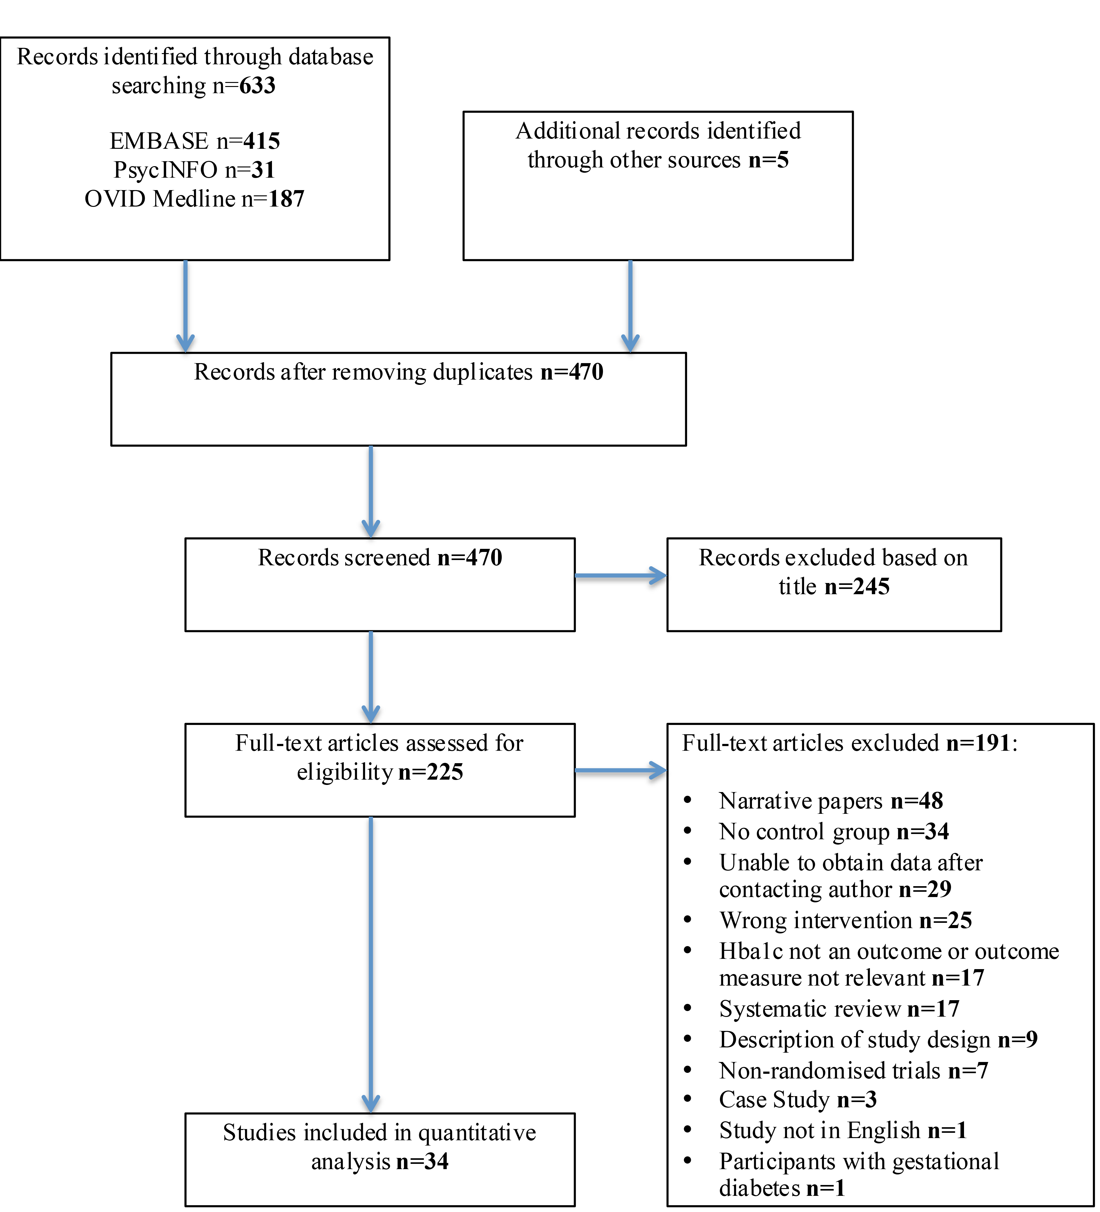

Figure 2: Forrest plots demonstrating the effect of social networking services on HbA1c: (a) at baseline; (b) post-intervention; (c) change in HbA1c

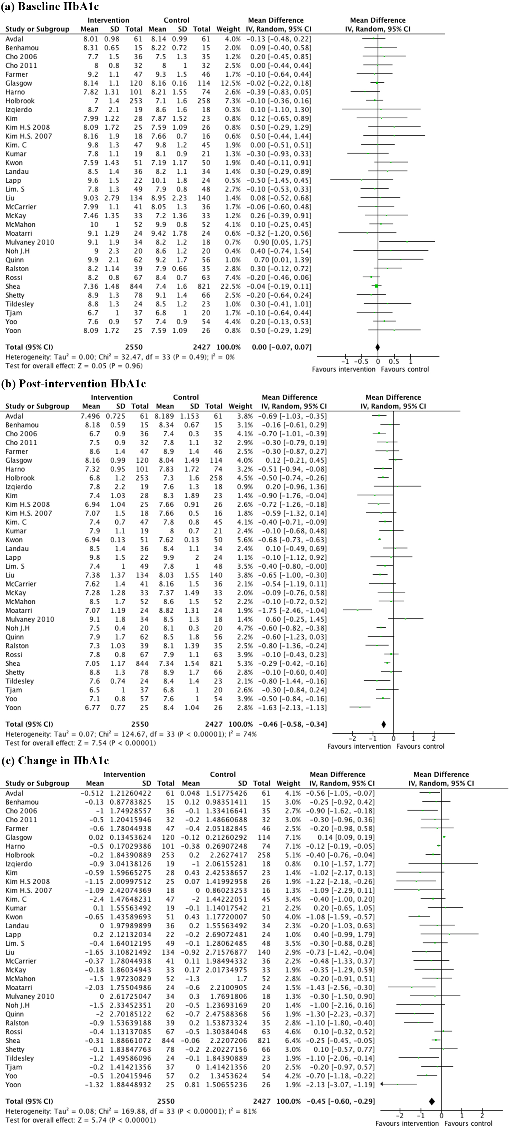

Figure 3: Risk of Bias Analysis: (a) Risk of Bias Summary, (b) Risk of Bias Graph

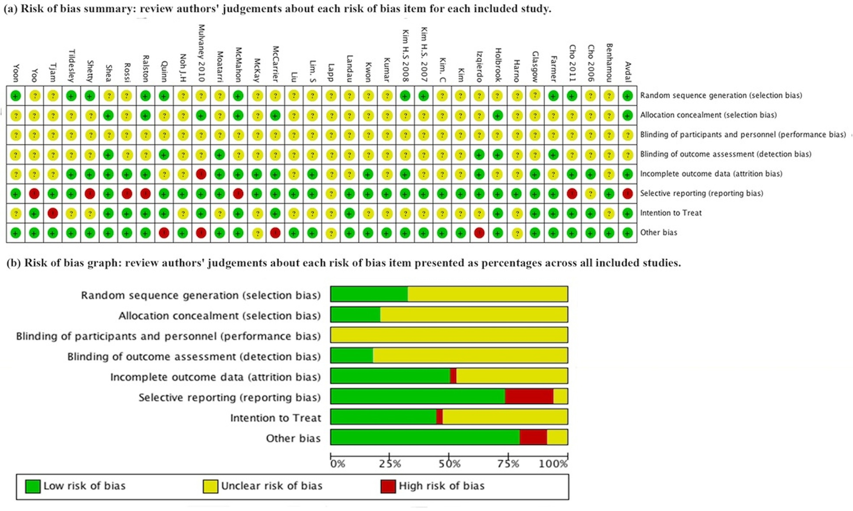

Figure 4: Funnel plots demonstrating asymmetry with subsequent statistically significant small study effects for (a) Baseline total cholesterol and (b) Post-intervention HDL outcomes

