Supporting Information

Cu isotopes in marine black shales record the Great Oxidation Event

Ernest Chi Fru¹*, Nathalie Pérez Rodríguez¹, Camille A. Partin², Stefan V. Lalonde, Per Andersson⁴, Dominik Weiss⁵, Abderazzak El Abani⁶, Ilia Rodushkin⁷, Kurt Konhauser⁸.

¹Stockholm University, Department of Geological Sciences and Bolin Centre for Climate Research, SE-10691, Stockholm, Sweden
²University of Saskatchewan, Department of Geological Sciences, 114 Science Place,
Saskatoon, SK S7N 5E2, Canada.
³ CNRS–UMR 6538 Laboratoire Domaines Océaniques Institut Universitaire Européen de la Mer Université de Bretagne Occidentale Technopôle Brest-Iroise, Place Nicolas Copernic, Plouzané 29280 France
⁴Swedish Museum of Natural History, Department of Geosciences, Box 50 007
SE-104 05 Stockholm, Sweden.
⁵Imperial College, Department of Earth Science and Engineering, Royal School of Mines, London SW7 2BP, UK.
⁶Université de Poitiers UMR 7285-CNRS, Institut de Chimie des Milieux et Matériaux de Poitiers - 5, rue Albert Turpin (Bât B35) 86073 Poitiers cedex.
⁷ALS Laboratory Group. ALS Scandinavia AB. Aurorum 10. S-977 75 Luleå, Sweden.
⁸Department of Earth and Atmospheric Sciences, University of Alberta, Edmonton, Alberta T6G 2EG, Canada.

Analyzed geological formations
Copper concentrations in shales and BIFs are compiled from the literature and unpublished data (see Table S1 & S2). The black shale samples analyzed in this study originate from marginal marine sediments deposited from ~2.66 to 2.084 Ga. South African samples cover a drill core depth of 85-2440 m, with ages constrained to ~2.66-2.32 Ga. The oldest originate from the Bothaville Formation, a part of the protobasinal rocks of the Ventersdorp Supergroup. They are composed of deltaic shoreline facies and characterized by dolomite, shales and clastic sediments (2). The overlying ~2.6 Ga Black Reef Formation separates the Ventersdorp Supergroup from the Chuniespoort Group, in the Transvaal Supergroup. The Chuniespoort Group hosts the Malmani Subgroup black shales that formed in a shallow seaway, constrained by detrital zircon U-Pb dating to an age of ~2.588±0.006-2.46±0.005 Ga (1). This transitions through the Penge Iron, Duitschland and Rooihoogte Formations, to the ~2.32 Ga Timeball Hill Formation, deposited in a shallow to deep marine environment, in the heart of the GOE (1, 3). The Francevillian series shales in Gabon are unmetamorphosed and devoid of hydrothermal influence (4, 5). This 35,000 km² sedimentary package, dated to ~2.15-2.084 Ga, owes its origin to authigenic marine processes and oxidative continental weathering (see 4, 5, 6). The sampled 2.083±0.006 Ga FD records the Shunga-Francevillian Event, when global atmospheric oxygen content may have experienced a dramatic demise characterized by extremely light δ¹³C_{org} values (4, 5). The older and underlying FB2 Formation is marked by ferruginous conditions, transitioning from the underlying FB1 Formation (4). Altogether, 70 samples from Gabon (n=36) and South Africa (n=34) were initially screened by bulk chemical analysis for Cu content. From this filtering, 22 samples were selected for isotopic analysis.
The geological history of sedimentary Cu distribution was reconstructed from concentrations preserved in shales and sedimentary iron formations (IFs) (see Table S1 & S2 for details). The IF data was normalized to Fe, because Fe(III)(oxyhydr)oxides have been shown to have a high affinity for Cu (7, 8) and because Fe(oxyhydr)oxide precipitation is believed to have controlled the chemistry of trace elements in the Fe-rich Precambrian oceans (9, 10).

Sample preparation for Cu and Fe isotope analysis
See supplementary information for details of the analyzed geological formations. About 0.1 g powdered samples were pre-treated with 1 ml concentrated HNO₃ in closed Teflon capsules overnight on a hot plate set at 150°C to break down organic materials. Continuous acid digestion was performed with HF-HNO₃ and HNO₃ at 150°C and 205°C, respectively. Bulk elemental composition of digested samples was done by inductively coupled plasma optical mass spectrometry (ICP-OES), with detection limits in the ppb range and precision better than 3%. For isotopic analysis, SEASTAR reagents were used. Digested samples were purified using anion-exchange on AGMP-1 resin columns (Bio-Rad Laboratories) (see 11, 12). Dissolved samples were evaporated and redissolved 3 times in 10M HCl to remove traces of HNO₃. Cu elution by 8 mL 10M HCl was followed by 8 mL 5M HCl to and then 6 mL 5% HCl to collect iron. All fractions were evaporated and redissolved in 5 mL 0.3 HNO₃.

Bulk stable isotopes of C, S and N analysis
Powdered samples were combusted in a Carlo Erba NC2500 analyser and analysed in a Finnigan MAT Delta V mass spectrometer, via a split interface to reduce gas volume. Prior to organic carbon isotope analysis a few drops of 2M HCl were added to 5 mg of sample in a silver capsule and left overnight at 60°C. Reproducibility was calculated to be better than 0.15‰ for δ¹³C and δ¹⁵N and 0.2‰ for δ³⁴S. Data are presented using the delta notation in ‰ using Pee Dee Belemnite (PDB), Cañon Diablo meteorite (CDT) and air as reference standards for C, S and N, respectively. Total C, S and N concentrations were measured simultaneously during isotope analysis. The relative error was <1% for all measurements. For the analysis of the δ¹³C_{org} from total carbon, samples were acidified with concentrated HNO₃ acid to remove carbonates.

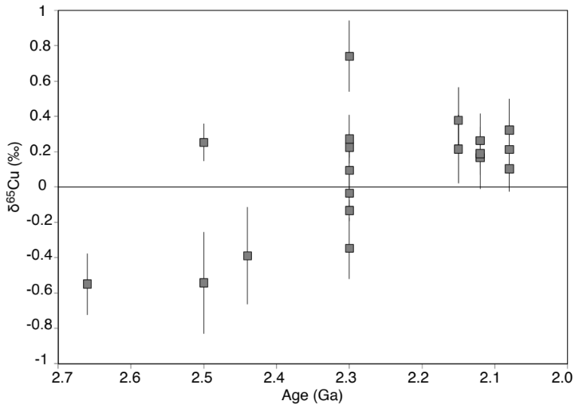

Fig. S1. Individual black shale δ⁶⁵Cu values over the studied interval.

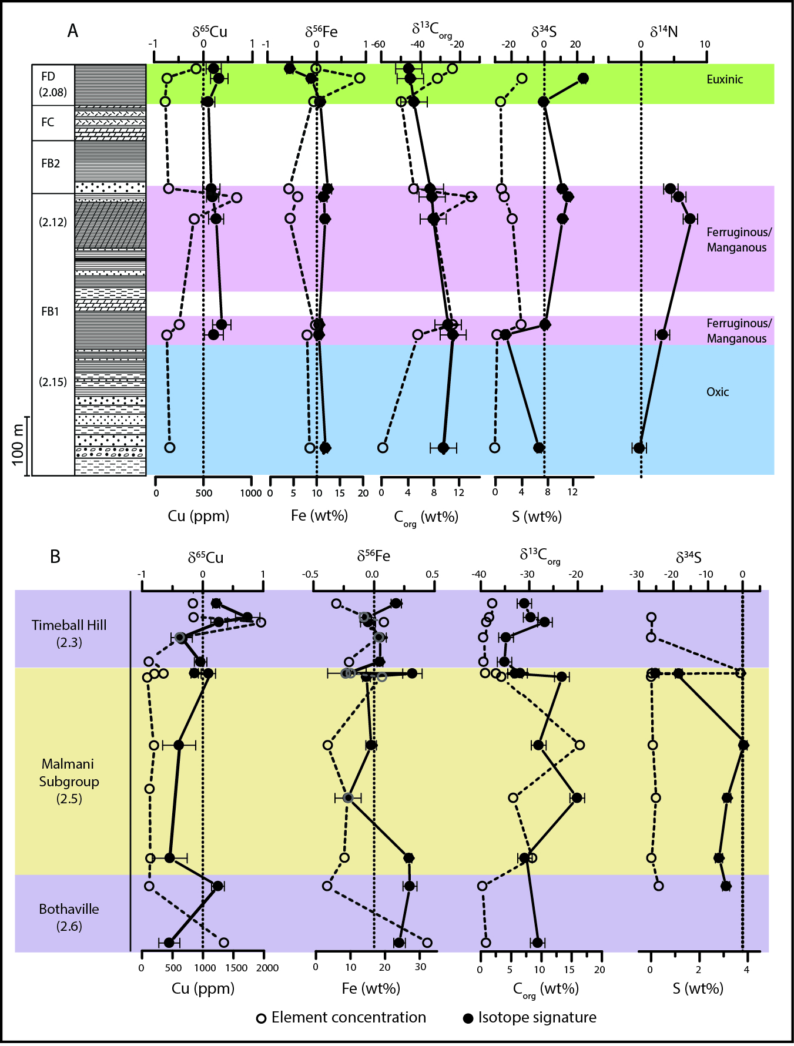

(2.3 Ga)
(2.5 Ga)
(2.6 Ga)

(2.15 Ga)
(2.12 Ga)
(2.15 Ga)

Fig. S2. Chemostratigraphic isotope composition trends for analyzed shales in the Francevillian Series (A) and Transvaal Supergroup (B).

Fig. S3. Relationship between S and Cu/Fe molar ratios in analyzed dataset, expected to tract changes in sedimentary S content after the GOE, since marine sulfate content is believed to increase during this transition

A
B

Fig. S4. Sedimentary Mn concentrations in the IFs (A) and shales (B) screened for Cu isotope trends in this study.

References
- Bekker A, et al. (2004) Dating the rise of atmospheric oxygen. Nature 42:117–120.
- Eriksson PG, Altermann W, Catuneanu O, van der Merwe, Bumby AJ (2001) Major influences of the 2.67-2.1 Ga Transvaal basin, Kaapvaal craton. Sedimen Geol 141-141:205–213.
- Canfield DE (2005) The early history of atmospheric oxygen: Hommage to Robert M. Garrels. Annual Rev Earth Plan Sci 33:1–36.
- Canfield DE, et al. (2013) Oxygen dynamics in the aftermath of the Great Oxidation of Earth’s atmosphere. Proc Natl Acad Sci U.S.A. 110:16736–16741.
- Ngombi-Pemba L, El Albani A, Meunier A, Grauby O, Gauthier-Lafaye F (2014) From detrital heritage to diagenetic transformations, the message of clay minerals contained within shales of the Palaeoproterozoic Francevillian basin (Gabon) Precambrian Res 255:63–76.
- Bros R, Stille P, Gauthier-Lafaye F, Weber F, Clauer N (1992) Sm-Nd isotopic dating of Proterozoic clay material- and example from the Francevillian sedimentary series, Gabon. Earth Plan Sci Lett 113:207–218.
- Balistrieri LS, Murray JW (1982) The adsorption of Cu, Pb, Zn, and Cd on goethite from major ion seawater. Geochim Cosmochim Acta 46:I253–1265.
- Tripathy SS, Kanungo (2005) Adsorption of Co²⁺, Ni²⁺, Cu²⁺ and Zn²⁺ from 0.5 M Nacl and major ion seawater on a mixture of δ-MnO₂ and amorphous FeOOH. J Colloid Inter Sci 284:30–38.
- Poulton SW, Canfield DE (2011) Ferruginous conditions: A dominant feature of the ocean through Earth's history. Elements 7:107–112.
- Planavsky NJ, McGoldrick P, Scott CT, Li C, Reinhard CT, Kelly AE, Chu X, Bekker A, Love GD, Lyons TW (2011) Widespread iron-rich conditions in the mid-Proterozoic ocean. Nature 477:448-451.
- Maréchal CN, Telouk P, Albarede F (1999) Precise analysis of copper and zinc isotopic compositions by plasma-source mass spectrometry. Chem Geol 156:251–273.
- Maréchal C, Albaréde F (2002) Ion-exchange fractionation of copper and zinc isotopes. Geochim Cosmochim Acta 66:1499–1509.

