Faecal Calprotectin in Primary Care – Is Its Current Use Supported by the Evidence?

Introduction:
Faecal calprotectin (FC) is a calcium-binding cytosolic protein which is secreted by neutrophils (1). Its use is well-established as a screening test for gastrointestinal inflammation with multiple studies showing elevated levels in patients with inflammatory bowel disease (IBD) compared to control groups, such as patients with irritable bowel syndrome (IBS). It also has a role in the management of IBD due to its correlation with markers of disease activity (2). Its low cost and potential ability to reduce unnecessary secondary care referrals have led to its widespread adoption in primary care (3).
However, concerns have previously been raised that patients with a borderline elevated calprotectin may be referred for unnecessary investigation (4). In addition, many of the initial FC research studies were performed in a secondary care setting, despite its widespread use in primary care. In this article the guidelines for FC use will be reviewed, as well as its evidence in primary care. We will make suggestions for best practice and highlight areas in which outstanding questions and uncertainties remain.
Guidelines and supporting evidence:
NICE guidelines on FC:
The NICE guidelines currently recommend the use of FC in patients with new onset lower gastrointestinal symptoms, where a differential diagnosis includes IBD or IBS, and specialist referral is being considered (5). Lower gastrointestinal symptoms are defined as abdominal pain or discomfort, bloating or a change in bowel habit over a minimum of six weeks. It is also stated that FC should only be used if cancer is not suspected, defined by symptoms described in the NICE guideline on suspected cancer, due to the inadequate sensitivity of FC for detecting colorectal neoplasia (6). Patients meeting criteria for suspected colorectal cancer (CRC) should undergo faecal immunochemical (FIT) testing which has been shown to outperform FC for diagnosing CRC (7). Whilst not specifically discussed in the NICE guidelines, other published guidelines, including the NICE endorsed consensus paper, advise avoiding FC use in patients with bloody diarrhoea who will require endoscopic assessment irrespective of FC result, and in patients with recent NSAID use due to their association with higher FC levels (8)(9)(10).
Diagnostic performance of FC:
The NICE FC guidelines were based upon a systematic review and economic analysis performed in 2013 (11). For the performance of FC in differentiating between IBS and IBD, seven studies were analysed giving FC a pooled sensitivity of 93% and specificity of 94% (using a cut-off of 50µg/g). The economic analysis suggested that at these anticipated levels of performance, FC cost would be offset by a reduction in subsequent endoscopic investigations performed. Combined scoring systems using clinical data coupled with FC testing may further improve diagnostic performance (12). Whilst the NICE guidelines acknowledge uncertainty surrounding the effect of pre-analytical factors on FC levels, one of the advantages of FC is its stability of up to three days at room temperature, making its use suitable in healthcare settings such as primary care where rapid sample processing is not possible (13)
FC in primary care and re-testing strategies to improve performance:
The diagnostic performance of FC, particularly its sensitivity, and its potential to reduce costs have meant that its use has become widespread in primary care. A review of The Healthcare Network Improvement (THIN) database in 2016 (covering about 6% of the UK population) found 17072 patients had had at least one FC test performed and the use of FC has continued to increase subsequently (3). An increase in the proportion of remote consultations during the Covid-19 pandemic may also have increased the use of tests, such as FC, which can screen for more serious conditions.
However, the meta-analysis by Waugh et al, on which the NICE guidelines were based, is limited by the fact that all studies were secondary care-based with low numbers of participants. Subsequent larger studies in secondary care have tended to support the finding of this meta-analysis with regards to the sensitivity of FC (14). However, in a primary care setting where the prevalence of IBD is lower, use of FC at a cut-off of 50µg/g is less specific, potentially resulting in unnecessary referrals and invasive investigations (4). The findings of Freeman et al’s analysis of the THIN database confirm this, reporting a sensitivity of 92.9% and specificity of 61.5% (at a threshold of 50µg/g), compared to 93% and 94% in the Waugh meta-analysis (3).
This concern has led to the NICE-approved York Faecal Calprotectin Care Pathway (YFCCP) which advocates the use of FC testing as a diagnostic tool within a decision tree (15). This approach was supported in the NICE consensus document which produced a similar pathway building on the work of the YFCCP (8). Both pathways suggest using an initial higher threshold of 100µg/g, rather than the 50µg/g suggested in the original NICE guidance, due to data suggesting this increase improves specificity without significantly impacting sensitivity (16). The pathways then suggest the re-testing of results over this threshold: patients with two consecutive results <250µg/g are then defined as low risk for IBD and treated for IBS in primary care initially, with routine referral only if symptoms persist despite first line treatment (15). The consensus pathway suggests that patients with an initial FC level of >250 µg/g are considered for immediate gastroenterology referral if symptoms are severe or worsening whilst the YFCCP suggests all positive tests are repeated. Both pathways suggest that FC should only be used on patients under the age of 60, due to increasing risks of colorectal cancer above this age. A study of 1005 patients found a sensitivity for FC of 94% and specificity of 92% when the YFCCP was followed, as well as demonstrating its cost-effectiveness (15)(17). The British Society of Gastroenterology (BSG) IBD guidelines broadly support the approach of the YFCCP, though note the lack of published evidence to confidently recommend re-testing strategies (10).
Areas of ongoing uncertainty:
Managing borderline results:
One of the key uncertainties surrounding FC is the level above which results should be considered raised, leading to difficulties managing patients with borderline elevated results. The YFCCP attempts to address this, though this approach has not been widely validated beyond the evidence described above. Re-testing strategies also need to consider patient compliance: return rates as low as 35% have been reported for FC in IBD patients, raising questions of adherence to this strategy in real-world clinical practice (18). Diagnostic delays are associated with worse clinical outcomes for IBD patients and therefore the potential increased time to secondary care referral, caused by multiple tests being performed in primary care, also needs to be considered (19).
Patient selection for FC testing:
There is also uncertainty surrounding exactly which patients should be targeted for FC testing in primary care. The NICE guidelines state that all patients with “lower gastrointestinal symptoms” are eligible, as long as cancer is not suspected, but some speciality guidelines (such as the BSG guidelines on IBD and IBS) suggest only patients with chronic diarrhoea as their primary symptom should be targeted (10)(20).
In fact, there are no specific data on the performance of FC in patients without diarrhoea, who are passing formed stools.
There is also a lack of clarity as to whether there should be a clearly defined age cut-off for the use of FC. Many studies have excluded older adults (with varying age thresholds) due to the higher risk of cancer in this age group (21). The BSG guidelines and YFCCP recommend age cut-offs of 40 and 60 respectively but no clear threshold is recommended in the NICE guidance (analysis of FC usage in clinical practice confirms its frequent use in older adults) (3).
Technical considerations:
In addition, whilst stability at room temperature for up to three days is a strength of FC, there remain outstanding technical questions, with studies showing both intra-individual and inter-assay variability (13)(22). The role of recently developed FC home testing kits in primary care pathways also needs to be clarified, high usability scores suggest they may be a method of improving compliance (23) (24).
Conclusions and recommendations:
FC’s high sensitivity for detecting IBD, as well as its low cost, makes it a useful diagnostic tool in primary care. However, our review of the evidence suggests more research is needed in the following areas:
- The use of FC in older adults and in patients presenting with symptoms other than diarrhoea.
- The exact role of re-testing strategies – evidence suggests the YFCCP may improve FC performance but more validation studies are needed to definitively recommend this approach.
- The respective roles of FC and FIT testing and how best to use each test in patients presenting with lower gastrointestinal symptoms.
- The optimal way to standardise collection procedures and FC analysis, as well as the role of point-of-care home testing kits.
We would recommend the use of FC in younger patients presenting with diarrhoea who do not meet criteria for more urgent referral, where there is a differential of IBD and IBS (Figure 1). Re-testing strategies should be agreed at a local level, with referral thresholds determined by the FC assay used and capacity of local services.
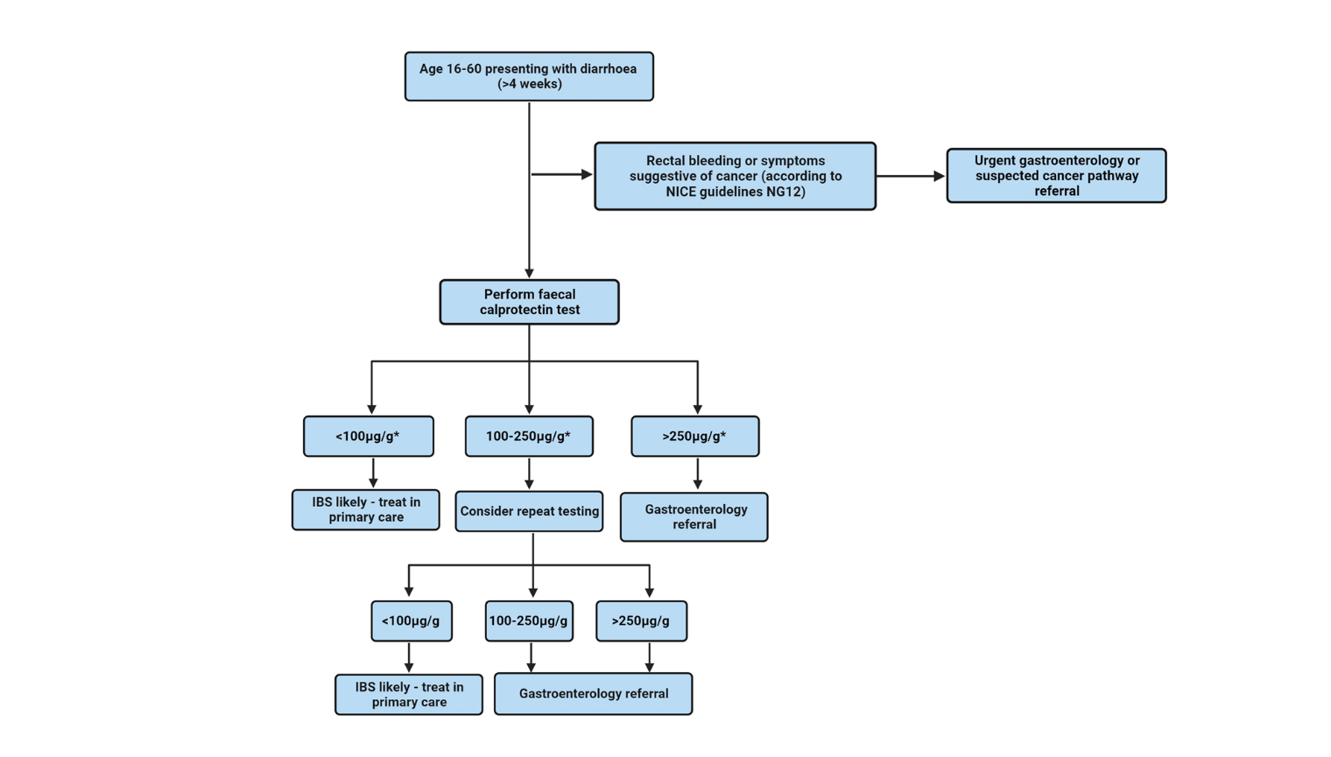
Figure 1: Proposed flowchart for FC testing in primary care based upon existing guidelines (8)(15)(10)(20).* Exact thresholds to be determined locally and dependent on FC assay used. Image created with Biorender.com.
References:
1. Jukic A, Bakiri L, Wagner EF, Tilg H, Adolph TE. Calprotectin: from biomarker to biological function. Gut. 2021 Oct;70(10).
2. Turner D, Ricciuto A, Lewis A, D’Amico F, Dhaliwal J, Griffiths AM, et al. STRIDE-II: An Update on the Selecting Therapeutic Targets in Inflammatory Bowel Disease (STRIDE) Initiative of the International Organization for the Study of IBD (IOIBD): Determining Therapeutic Goals for Treat-to-Target strategies in IBD. Gastroenterology. 2021;160(5).
3. Freeman K, Taylor-Phillips S, Willis BH, Ryan R, Clarke A. Test accuracy of faecal calprotectin for inflammatory bowel disease in UK primary care: a retrospective cohort study of the THIN data. BMJ Open. 2021 Feb;11(2):e044177.
4. Conroy S, Hale MF, Cross SS, Swallow K, Sidhu RH, Sargur R, et al. Unrestricted faecal calprotectin testing performs poorly in the diagnosis of inflammatory bowel disease in patients in primary care. J Clin Pathol. 2018 Apr;71(4).
5. National Institute for Health and Care Excellence. Faecal calprotectin diagnostic tests for inflammatory diseases of the bowel (DG11). . London; 2013.
6. von Roon AC, Karamountzos L, Purkayastha S, Reese GE, Darzi AW, Teare JP, et al. Diagnostic precision of fecal calprotectin for inflammatory bowel disease and colorectal malignancy. Am J Gastroenterol. 2007 Apr;102(4):803–13.
7. Turvill J, Mellen S, Jeffery L, Bevan S, Keding A, Turnock D. Diagnostic accuracy of one or two faecal haemoglobin and calprotectin measurements in patients with suspected colorectal cancer. Scand J Gastroenterol. 2018 Dec 2;53(12):1526–34.
8. CSO Faecal Calprotectin Working Group. https://www.nice.org.uk/guidance/dg11/resources/endorsed-resource-consensus-paper-pdf-4595859614. 2023. Faecal Calprotectin in Primary Care as a Decision Diagnostic for Inflammatory Bowel Disease and Irritable Bowel Syndrome.
9. Meling TR, Aabakken L, Røseth A, Osnes M. Faecal Calprotectin Shedding after Short-Term Treatment with Non-Steroidal Anti-Inflammatory Drugs. Scand J Gastroenterol. 1996 Jan 8;31(4):339–44.
10. Lamb CA, Kennedy NA, Raine T, Hendy PA, Smith PJ, Limdi JK, et al. British Society of Gastroenterology consensus guidelines on the management of inflammatory bowel disease in adults. Gut. 2019 Dec;68(Suppl 3):s1–106.
11. Waugh N, Cummins E, Royle P, Kandala NB, Shyangdan D, Arasaradnam R, et al. Faecal calprotectin testing for differentiating amongst inflammatory and non-inflammatory bowel diseases: systematic review and economic evaluation. Health Technol Assess (Rockv). 2013 Nov;17(55).
12. Fiorino G, Bonovas S, Gilardi D, Di Sabatino A, Allocca M, Furfaro F, et al. Validation of the Red Flags Index for Early Diagnosis of Crohn’s Disease: A Prospective Observational IG-IBD Study Among General Practitioners. J Crohns Colitis. 2020 Dec 2;14(12):1777–9.
13. Lasson A, Stotzer PO, Öhman L, Isaksson S, Sapnara M, Strid H. The intra-individual variability of faecal calprotectin: a prospective study in patients with active ulcerative colitis. J Crohns Colitis. 2015 Jan;9(1).
14. Kennedy NA, Clark A, Walkden A, Chang JCW, Fascí-Spurio F, Muscat M, et al. Clinical utility and diagnostic accuracy of faecal calprotectin for IBD at first presentation to gastroenterology services in adults aged 16-50 years. J Crohns Colitis. 2015 Jan;9(1).
15. Turvill J, O’Connell S, Brooks A, Bradley-Wood K, Laing J, Thiagarajan S, et al. Evaluation of a faecal calprotectin care pathway for use in primary care. Prim Health Care Res Dev. 2016 Sep 22;17(05):428–36.
16. Turvill J. High negative predictive value of a normal faecal calprotectin in patients with symptomatic intestinal disease. Frontline Gastroenterol. 2012 Jan;3(1):21–8.
17. Holmes H, McMaster J, Davies H, Vaines V, Turvill J. Evaluation of the Cost-Utility of the York Faecal Calprotectin Care Pathway. Expert Rev Pharmacoecon Outcomes Res. 2022 Apr 3;22(3):521–8.
18. Maréchal C, Aimone‐Gastin I, Baumann C, Dirrenberger B, Guéant J, Peyrin‐Biroulet L. Compliance with the faecal calprotectin test in patients with inflammatory bowel disease. United European Gastroenterol J. 2017 Aug;5(5):702–7.
19. Nguyen VQ, Jiang D, Hoffman SN, Guntaka S, Mays JL, Wang A, et al. Impact of Diagnostic Delay and Associated Factors on Clinical Outcomes in a U.S. Inflammatory Bowel Disease Cohort. Inflamm Bowel Dis. 2017 Oct;23(10):1825–31.
20. Vasant DH, Paine PA, Black CJ, Houghton LA, Everitt HA, Corsetti M, et al. British Society of Gastroenterology guidelines on the management of irritable bowel syndrome. Gut. 2021 Jul;70(7):1214–40.
21. Walker GJ, Moore L, Heerasing N, Hendy P, Perry MH, McDonald TJ, et al. Faecal calprotectin effectively excludes inflammatory bowel disease in 789 symptomatic young adults with/without alarm symptoms: a prospective UK primary care cohort study. Aliment Pharmacol Ther. 2018 Apr;47(8).
22. Juricic G, Brencic T, Tesija-Kuna A, Njegovan M, Honovic L. Faecal calprotectin determination: impact of preanalytical sample treatment and stool consistency on within- and between-method variability. Biochem Med (Zagreb). 2019 Feb 15;29(1).
23. Bello C, Roseth A, Guardiola J, Reenaers C, Ruiz-Cerulla A, Van Kemseke C, et al. Usability of a home-based test for the measurement of fecal calprotectin in asymptomatic IBD patients. Digestive and Liver Disease. 2017 Sep;49(9):991–6.
24. Haisma SM, Galaurchi A, Almahwzi S, Adekanmi Balogun JA, Muller Kobold AC, van Rheenen PF. Head-to-head comparison of three stool calprotectin tests for home use. PLoS One. 2019;14(4):e0214751.

