URINARY PROTON NMR SPECTROSCOPY OF A BANGLADESHI COHORT WITH HEPATITIS-B RELATED HEPATOCELLULAR CARCINOMA CORROBORATES A URINARY FINGERPRINT FOR LIVER CANCER
I. Jane Cox¹, Abil E. Aliev², Mary M.E. Crossey³, Mahvish Dawood³, Mamun Al-Mahtab⁴, S.M.F. Akbar⁵, S. Rahman⁴, Antonio Riva¹, Roger Williams¹, Simon D. Taylor-Robinson³
¹Institute of Hepatology, London, Foundation for Liver Research, London, UK²Department of Chemistry, UCL, London, UK, ³Department of Hepatology & Gastroenterology, Imperial College London, London, UK,⁴Department of Hepatology, Bangabandhu Sheikh Mujib Medical University, Dhaka, Bangladesh, ⁵Department of Medical Sciences, Toshiba General Hospital, Tokyo, Japan.
Corresponding author: I. Jane Cox PhD, Institute of Hepatology, London, Foundation for Liver Research, 69-75 Chenies Mews, London WC1E 6HX, UK. Tel: 020 7255 9830. Fax: 020 7380 0405. Email: j.cox@researchinliver.org.uk.
Word count: 3134
Number of figures: 4; number of tables: 3.
List of abbreviations: proton nuclear magnetic resonance (¹H NMR), non-cirrhotic chronic hepatitis B related liver disease (CHB), cirrhosis (CIR), healthy volunteers (CTR), hepatitis B virus (HBV), hepatocellular carcinoma (HCC),
Conflict of interest: none
Financial support: none

Abstract
Background & Aims: Increasing evidence points to the reproducibility of urinary metabolic profiling using nuclear magnetic resonance (NMR) spectroscopy to provide a chemical fingerprint of hepatocellular carcinoma (HCC). Clinical HCC cohorts from Egypt and West Africa have been studied and this study aimed to establish if a similar urinary NMR profile could be identified in a Bangladeshi HCC cohort on a background of HBV infection. Methods: Urine samples from 42 patients with HCC (39 patients with HCC-HBV), 47 with cirrhosis on a background of HBV, 46 with chronic hepatitis B and 7 healthy controls were analysed using NMR spectroscopy. Results: Urinary NMR profiles from HCC differed to controls, non-cirrhosis and cirrhosis across a range of metabolites, including reduced hippurate and creatinine levels and increased carnitine levels, corroborating previous findings from Egyptian and West African patients. Conclusions: Urinary NMR changes in HBV-related HCC are consistent with the diverse effects of liver cancer on metabolic pathways and gut bacterial action and could form the basis for the development of a cost-effective HCC dipstick screening test.
Abstract word count: 167

Key words: urinary metabolic profiling, NMR spectroscopy, hepatocellular carcinoma, hepatitis B, cirrhosis, Bangladesh.
Key Points
- The urinary NMR profile of patients with HBV- HCC differs from healthy controls, patients with non-cirrhotic chronic hepatitis B liver disease and cirrhosis on a background of HBV in a Bangladeshi population
- The urinary NMR changes in HBV- HCC in a Bangladeshi population corroborate those published from various African populations with HCC
- These findings support the idea that a urinary dipstick test for HCC might be feasible

Introduction
The prevalence of hepatocellular carcinoma (HCC) in Asia was estimated to be approximately 460,000 in 2000 [1]. Studies have shown that the hepatitis-B virus (HBV) underlies 33% of the HCC cases in Bangladesh [2]. Bangladesh is considered a region of intermediate prevalence for HBV infection and the lifetime risk of HBV infection is 20-60% [3]. While HBV infection is mainly transmitted during infancy and childhood in Bangladesh, all age groups are affected.

It is estimated that 2 billion people, one-third of the world-wide population, have been infected by HBV [4] and that approximately 400 million people are living with a chronic form of the disease [5]. Chronic HBV results in a wide range of liver diseases, spanning asymptomatic acute hepatitis to hepatocellular carcinoma (HCC). Recent studies have concluded that serum α-fetoprotein (AFP) lacks sufficient sensitivity to be widely used as a surveillance test for HCC [6]. Ultrasound-based surveillance is generally considered more sensitive than AFP, but the images can be both equipment- and user-dependent [6]. In addition, these procedures are generally unavailable in resource-constrained countries of Asia and Africa that harbour the majority population of HBV-related liver cirrhosis and HCC. A simple and versatile biomarker for the early stages of HCC, when treatment would still be effective, would therefore be of considerable value, both in Bangladesh and in parts of the world of high HBV prevalence.

There has recently been considerable interest in analysing the chemical composition of urine to establish if one or more urinary biomarkers can be used to distinguish HCC from cirrhosis or uncomplicated chronic HBV infection. Urinary metabolic profiling using nuclear magnetic resonance (NMR) spectroscopy may provide objective diagnostic and prognostic assessment for range of diseases [7]. It would be particularly valuable if subtle changes in the chemical composition of urine could be interpreted to improve early diagnosis of HCC. Diagnosis is currently often not made until such a late stage that treatment measures are ineffective. Clinical cohorts from Egypt [8], Nigeria [9, 10] and The Gambia [10] have been studied and consensus is emerging for an identifying urinary fingerprint of HCC. The aim of this study was to establish if a similar urinary NMR fingerprint for HCC could be identified in a Bangladeshi cohort, since these patients have a different environmental and genetic background to the African populations.

Patients and methods
Patient selection
Bangladeshi urine samples were collected with informed consent from patients attending the Department of Hepatology, Bangabandhu Sheikh Mujib Medical University, Dhaka, Bangladesh. Ethical approval was granted by the research ethics committee at Bangabandhu Sheikh Mujib Medical University and Imperial College London, and the study conformed to the 1975 Declaration of Helsinki.
A total of 152 subjects, all of Indian ethnic origin, were recruited for the study between January 2013 and November 2014. The study cohort comprised 46 patients with HCC (diagnosed by imaging techniques and/or histology and/or elevated serum AFP) on a background of hepatitis-B (43 patients), hepatitis-C (one patient) and cryptogenic (two patients); 50 patients with clinical or histologically confirmed hepatitis-B related cirrhosis (CIR), 48 patients with non-cirrhotic chronic hepatitis-B related liver disease (CHB) and eight healthy volunteers with no history of liver disease from the same Bangladeshi population (CTR).
Urine sample collection and preparation for NMR analysis
A full dietary and medication history was recorded for each subject. Mid-stream urine samples were collected in the morning into tubes and stored at -20ºC, 2 to 4 h after collection in Bangladesh, until transport to the Institute of Hepatology, London, UK on dry ice and by air. Samples were thawed in London and prepared for NMR analysis according to standard methodology [9]. Specifically 400 µL of urine was mixed with 200 µL of phosphate buffer solution. After centrifuging, 550 µL of buffered urine was transferred into a 5 mm diameter glass NMR tube (Norell 502-7 from Glass Precision Engineering Ltd, Leighton Buzzard, UK) for proton nuclear magnetic resonance (¹H NMR) spectroscopy at the Department of Chemistry, University College London. Samples remained in a sample queue at 21°C on the auto sampler for up to 6 h until NMR data acquisition.
¹H NMR spectral acquisition
The urine samples were prepared for NMR study and analysed in a random order. ¹H NMR spectra were recorded on a Bruker Avance III 600 NMR spectrometer operating at ¹H NMR frequency of 600.13 MHz equipped with a 5 mm DCH cryoprobe and a 60-position sample changer BACS60. Data acquisition and processing were performed using standard TopSpin (version 3.2) software. NMR spectra were recorded at 300 K. Temperature calibration was carried out using a sample of 99.8% deuterated MeOD in a 5 mm NMR tube. A standard water suppression sample of 2mM sucrose in 90%H₂O+10%D₂O with DSS (4,4-dimethyl-4-silapentane-1-sulfonic acid) was used for manual iterative optimisation of high-order shims (z6 in particular) via inspection of the shape of the residual water signal after presaturation. Each sample was shimmed using a modified topshim routine, in which the z shim is incremented by +24 units at the final stage in order to achieve optimum resolution for organic species dissolved in water. The increment applied was determined using a sample of H₂O:CD₃CN (3:1) with a small amount of DSS added to it. This sample was shimmed using first ²H of CD₃CN, and then ¹H of H₂O. The change of the z shim on going from the shimming using CD₃CN to that using H₂O was -24 units. The deuterium lock phase was autocorrected both before and after shimming. The presaturation frequency (o1, Hz) was determined using a single 360° pulse sequence followed by further manual iterations where the phase of the pre-saturated residual water signal was monitored and dispersive contributions were minimised. This was done for the first sample for each set of 20-25 samples and the o1 value was then kept constant for the remaining samples. The variation in the o1 value for all samples was found to be within less than ±0.5 Hz. Similarly, probe tuning and matching was carried out manually for the first sample in each set of 20-25 samples and then kept unchanged for the remaining samples of the set. ¹H NMR spectra with water presaturation during relaxation delay were acquired using a standard pulse sequence noesygppr1d, which suppresses effectively the probe background signal giving a flat baseline. In addition, a digital filter (known as "BASEOPT" under TopSpin) with a pre-optimised correction for filter delay (1.0 μs in our case) was used to give spectra with a flat baseline, which required no first order phase correction. Prior to the start of data acquisition for each sample, the 90º pulse was determined (typically 14 μs) and the power level was adjusted for a 25 Hz-wide solvent presaturation automatically. Four dummy scans were used for equilibration followed by 64 scans collected into 144K points with a total repetition time of 8.0 s at each scan (acquisition time = 4.0 s; relaxation delay = 4.0 s). NMR spectra were processed using the Bruker AMIX data processing package and the KnowItAll Informatics System v9.0 (Bio-Rad, Philadelphia, PA). Free induction decays were zero-filled and multiplied by an exponential function with a 0.3 Hz line-broadening factor, prior to Fourier transformation. All NMR spectra were automatically phased and a baseline correction was applied. The NMR spectra were referenced to TSP (δ 0.00 ppm). NMR spectral analysis included peaks in the range δ 0.50-9.50 ppm, excluding the region δ 4.50-6.40 ppm, to remove the residual water signal and variation in urea signal due to proton exchange. The urinary NMR peaks were assigned to metabolites on the basis of chemical shifts and coupling patterns and with reference to the published literature [8-13].
Statistical analysis
Demographic and blood biochemistry data between subject groups were compared using an independent sample Kruskal-Wallis one-way ANOVA test with pairwise multiple comparisons (IBM® SPSS® v21), and a P-value of < 0.05 was considered significant.
The NMR data were analysed using principal component analysis (PCA) (KnowItAll Informatics System v9.0) and orthogonal partial least squared discriminant analysis (OPLS-DA) techniques (SIMCA v14 (Umetrics AB, Umeå, Sweden)). Using the intellibucketing option in KnowItAll v9.0, the NMR spectra were subdivided into smaller regions, or ‘buckets’, of about 0.02 ppm. Regions corresponding to particular metabolites were additionally selected, including those assigned to hippurate (7.82-7.85 ppm, 7.61-7.66 ppm, 7.52-7.58 ppm); creatinine (3.0425-3.0550 ppm, 4.04-4.07ppm); creatine (3.035-3.0425 ppm); citrate (2.64-2.72 ppm, 2.52-2.58 ppm) and dimethylamine (2.72-2.74ppm). All spectral regions were integrated, normalised to the sum of the total spectral integral and mean-centred prior to multivariate analysis. PCA was performed to highlight outliers and clustering (KnowItAll v9.0). PCA was then repeated with all outliers excluded and the metabolites contributing to the separation of groupings were identified from the loadings plot. This final data set was also analysed by OPLS-DA using SIMCA v14. The discriminatory power of the model was validated using leave-one-out cross validation. An R2 value was determined to give a measure of the goodness of fit by the model. A cross-validated Q2 statistic (based on a 1:7 leave one out algorithm) was calculated as a quantitative measure of the predictability of the model for the Y variable, where a positive Q2 indicated a good predictive.
The NMR spectral regions corresponding to the most important discriminatory metabolite peaks, as determined by the PCA and OPLS-DA loadings plots, were normalised to the sum of the total spectral integral, and differences in these relative metabolite signal levels were compared between the subject groups using an independent samples Kruskal-Wallis one-way ANOVA test with all pairwise multiple comparisons (IBM® SPSS® v21). Within the patient sub-groups, the relative metabolite levels were compared using Mann-Whitney U test for a comparison of HBeAg status and also treatment with anti-viral therapy. A Benjamini−Hochberg adjustment [14] was applied to the obtained P-values to acquire the level of significance for multiple testing, with a declared level of statistical significance of P < 0.05.

Results
Subject demographics
Nine samples from across the four cohorts were identified as outliers on subsequent NMR analysis (one CTR, two CHB, three CIR and three HCC). In addition, one HCC subject was excluded for diagnostic uncertainty. The final study cohort therefore comprised 142 subjects (7 CTR, 46 CHB, 47 CIR and 42 HCC) and subject demographics are summarised in Table 1. There were significant differences in age (P < 0.001), weight (P < 0.001) and BMI (P < 0.001) across the four sub-groups. For example, the CHB cohort was significantly younger than each of the CIR (P = 0.000) and HCC (P < 0.001) cohorts and the BMI was significantly lower in the HCC cohort compared to CTR (P = 0.001) and CIR (P < 0.001) cohorts. Whilst 83% of CIR subgroup was male the control group was entirely male, and so the urinary NMR data were analysed both as a complete cohort and as a subset of males only.
The majority of subjects had eaten a similar diet of rice, dhal, water with vegetables, fish or chicken, in the six hours prior to collection of a urine sample. The patients reported a varied drug history: the majority of the CHB group were taking multivitamins, although some were also taking an oral antiviral drug (n=10, entecavir or tenofovir) and/or an oral proton pump inhibitor (PPI) (omeprazole, pantoprazole); the CIR group reported a combination of non-absorbable sugars (lactulose), PPI (omeprazole, pantoprazole), oral antiviral (n=7, entecavir, tenofovir or telbivudine) and/or multivitamins; the HCC cohort reported a wider range of medication including oral antiviral (entecavir, tenofovir), hormonal therapy (tamoxifen), PPI (omeprazole, pantoprazole), beta blockers, non-absorbable sugars (lactulose), multivitamins and pain killers (including tramadol).
Serum Biochemical Analysis
A summary of the median (range) values for the available serum ALT, ALP, bilirubin, albumin, AFP and creatinine levels is shown in Table 2. Serum ALT was significantly raised in the HCC group compared to controls (P < 0.001) and patients with CHB (P < 0.001) or CIR (P = 0.006); serum ALP was raised in the HCC group compared to CHB (P < 0.001). Serum AFP was generally markedly elevated in HCC, although two HCC patients showed AFP ≤20 ng/mL in the presence of large space occupying lesion(s) in the right lobe of the liver observed on axial imaging. Serum creatinine levels were significantly reduced in the HCC group compared to the CIR group (P = 0.004).
Representative urinary NMR spectra
Illustrative urinary ¹H NMR spectra from each of the four subject groups (CTR, CHB, CIR and HCC) are summarised in Figure 1. The spectral resolution was defined by a TSP linewidth of <1Hz in all NMR data sets. On visual inspection, a number of trends could be seen across the four subject groups, including a reduction in hippurate and an increase in creatine comparing CTR, CHB, CIR through to HCC (Figures 1A-D and 1A’-D’ respectively).
Analyses of the urinary NMR spectra
Nine outliers were identified on five iterations of PCA: one CTR showing particularly high levels of hippurate; two CHB showing high levels of glucose and lactate and overlap of creatinine into the creatine peak; three CIR showing either high glucose, high glucose and lactate, or ethanol present; and three HCC showing either paracetamol resonances, absence of creatine and creatinine, or unassigned additional dominant peaks.
A three-factor PCA scores plot of the final study cohort of 142 subjects is illustrated in Figure 2 and shows clustering of each of the four sub-groups. Metabolites which contributed to the discrimination between groups in the loadings plot included acetate, creatine, creatinine, dimethyamine (DMA), formate, glycine, hippurate and trimethylamine-N-oxide (TMAO). An OPLS-DA plot is illustrated in Figure 3 and the R2(X), R2(Y) and Q2 values were 0.468, 0.289 and 0.195 respectively.
Acetate, carnitine, citrate, creatine, creatinine, DMA, hippurate and TMAO metabolite levels were significantly different across the four groups considering both all subjects (Table 3) and only the males. A comparison of relative metabolite levels between HCC vs CTR and/or HCC vs CHB in all subjects confirmed that carnitine was significantly increased in HCC and creatinine, hippurate and TMAO were significantly reduced in HCC (Figure 4). A significant increase in carnitine and significant reductions in creatinine and hippurate were observed in the HCC group compared to CIR group (Figure 4).
HBeAg negative patients showed a significant increase in creatinine (P = 0.001) compared to HBeAg positive patients in the CHB subgroup; in the CIR group HBeAg negative patients showed a significant decrease in DMA (P = 0.004) compared to HBeAg positive patients; and in the HCC subgroup [tbc].
There were no differences in metabolite levels in the HCC or CHB groups comparing subjects receiving antiviral treatment with those not. However, subjects receiving antiviral therapy in the CIR group (n=7) showed a decrease in creatine levels (P = 0.002) compared to those not taking antiviral treatment (n=40).
Discussion
In this study of Bangladeshi subjects, all of Indian ethnic origin, the urinary NMR metabolic profile measured in patients with HCC was distinguishable from the urinary profile of patients with CIR and CHB and also healthy control subjects. The majority of the patients (131 patients) had a background of CHB, whilst one cirrhotic patient and two patients with HCC were defined as cryptogenic and one HCC subject had a background of HCV. Metabolites which contributed to the differences in urinary NMR profiles of HCC compared to CIR, CHB and/or CTR included acetate, carnitine, citrate, creatine, creatinine, DMA, hippurate and TMAO. Within all [tbc] the patient subgroups, metabolite differences were also observed according to HBeAg status and, only in CIR, to treatment with oral antiviral therapy.
Our findings extend previous studies using urinary NMR to identify metabolic changes in HCC. Previous studies showed urinary NMR changes in HCC could be distinguished from CIR and CTR in patient cohorts from Egypt, Nigeria and The Gambia, with HCC on a background of either chronic HCV [15, 16] or chronic HBV [16, 17]. An NMR pattern is emerging for separating HCC from CIR and CTR which includes a reduction in hippurate, citrate, creatinine, TMAO and an increase in acetate, carnitine and creatine. In this population, neither glycine nor formate was significantly different in HCC between the other study cohorts, although both of these metabolites were identified as discriminators in the West African study. Overall, given that the urinary profile of HCC could be distinguished from CIR, CHB and CTR, this study provides further support for the suggestion that a diagnostic marker may be feasible as consistent urinary NMR changes are seen across differing ethnicities as well as varying disease aetiologies.
The urinary metabolite changes observed in HCC subjects relate to alterations in both host and gut bacterial metabolism. For example, citrate is a tricarboxylic acid cycle intermediate and a reduced urinary concentration of citrate might be in agreement with Warburg’s hypothesis of altered mitochondrial aerobic respiration and heightened physiological stress of cancer cells [8]. The alterations observed in carnitine are interesting and the increase in HCC is consistent with all the previous urinary NMR profiling studies in HCC [8-10]; carnitine plays an essential role in mitochondrial metabolic pathways and can be absorbed from the diet or synthesis in the liver, kidney and testis and reabsorbed via the renal system [8]. Increased urinary carnitine will therefore correspond to excess carnitine ingestion, biosynthesis or poor reabsorption. Carnitine is required for energy metabolism, enabling fatty acids to enter the mitochondria for β-oxidation [18]. Elevated urinary carnitine levels may therefore reflect tumour overproduction of tumour carnitine to fuel mitochondrial activity and maintain rapid growth [8]. Further evidence of heightened β -oxidation is shown by relatively higher acetate in the urine of HCC patients than in controls [10]. Advanced HCC can be complicated by cancer cachexia with associated sarcopenia, and urinary creatinine concentration has been suggested as a biomarker of sarcopenia [19] but, in combination with other factors, urinary NMR creatinine concentration may contribute to a biomarker panel for HCC. Our findings observed for urinary creatine suggests an elevation in HCC compared to controls but a reduction in CIR compared to controls; creatine has a direct function in cellular energy transport and it may be that creatine is elevated in rapidly growing cells and, indeed, urinary creatine levels may be increased 24 hours after partial hepatectomy in rats [20].
The urinary changes in DMA, hippurate and TMAO implicate alterations in the gut microbiome. TMAO is an aliphatic amine and the oxidation product of trimethylamine (TMA), derived from dietary sources typically formed by bacterial degradation of choline, it is likely that a decrease in TMAO reflects dysregulation of the intestinal microbiota. DMA can also be a product of gut bacterial metabolism of dietary choline, although it can originate from the N-methylation of methylamines of from the breakdown of creatine. Whilst diet was not controlled for the study, the observation that HBeAg status might also have an influence on DMA levels, does suggest that gut bacterial metabolism might have pathophysiological consequences in CHB and HCC. Hippurate is an acyl glycine formed by the conjugation of benzoate with glycine in liver and kidney mitochondria. Benzoate is formed via the metabolism of gut microbes from dietary aromatic compounds. It has been suggested that decreased hepatic function in patients with HCC results in less efficient benzoate conjugation and lower urinary hippurate excretion levels.
[To discuss further, when the remaining clinical data are received from Dr Mamun: urinary differences according to HBeAg status and also patient subgroup; urinary NMR changes according to antiviral treatment within each patient subgroup; BCLC stage.]
There are a number of limitations to this present study. There was a logistical delay between sample collection and sample analysis, as the Bangladeshi samples were archived, stored and transported to London for NMR analysis, although this would not be expected to have had any impact on the urinary NMR profile. The NMR urinary profile from nine subjects were shown to be outliers using PCA, and confounding factors included high levels of glucose and overlapping peaks from unreported over-the-counter medication. These factors need to be considered for developing an NMR analysis protocol for inclusion of all NMR data sets, without obscuring overlapping peaks in the spectral regions with outlier resonances. There was gender imbalance between the sub-groups, but analysing the male subjects as a separate cohort did not alter the urinary NMR differences seen across the patient groups.
In conclusion, urinary NMR changes in HCC are consistent with the diverse effects of liver cancer on human physiology and gut bacterial action and may aid the development of a cost-effective HCC urinary dipstick screening test.

Acknowledgements
We thank colleagues at the Institute of Hepatology, London (Drs M Briones, S Chokshi, J Coombes, P Manka) and Imperial College London (Ms A Ledlie, Drs N Ladep, MJW McPhail, MIF Shariff, CA Wadsworth) for advice and helpful discussions. MMEC is supported by a Fellowship from the Sir Halley Stewart Trust, Cambridge, UK. MMEC, MD and SDT-R are grateful to the UK NIHR Biomedical Facility at Imperial College London for infrastructure support. Dr Peter Gierth (Bruker UK) is thanked for his help with the initial setup of NMR measurements at UCL Chemistry, including optimisations of shimming routines.

Tables
Table 1. Subject Demographics of the Bangladeshi Study Cohort
Table 2. Serum Biochemistry Profiles (Median (Range)) of Subject Cohorts
Table 3. A Comparison of Relative Signal Levels of Discriminatory Metabolites between Study Cohorts

Table 1 Subject Demographics of the Bangladeshi Study Cohort
Group¹ | n | Median age (range) yrs | M:F  (% male) | Aetiology | HBeAg positive n (%) | Median height (range) cm | Median weight (range) kg | Median BMI (range) kg/m²
CTR | 7 | 37 (24 - 46) | 7:0 (100%) | n/a | n/a | 170 (152 - 173) | 65 (54 - 85) | 26.0 (18.7-29.4)
CHB | 46 | 27 (15 - 45) | 40:6 (87%) | HBV (100%) | 27  (59%) | 166 (147 - 180) | 55 (35 - 79) | 20.6 (13.9-26.6)
CIR | 47 | 42 (15 - 67) | 39:8 (83%) | HBV (98%)  cryptogenic HBV (2%) | 21  (45%) | 165 (142 – 175) | 58 (42 - 82) | 21.9 (14.9-29.3)
HCC | 42 | 48 (27 - 90) | 38:3 (90%) | HBV (93%)  HCV (2%)  cryptogenic (5%) | tbc  (tbc%) | 162 (145 - 180) | 48 (38 - 75) | 18.3 (12.3-25.2)

¹Healthy controls (CTR); chronic hepatitis-B related liver disease (CHB); cirrhosis (CIR); hepatocellular carcinoma (HCC)

Table 2. Serum Biochemistry Profiles (Median (Range))
Group¹ | ALT²  U/L | ALP²  U/L | Bil²  mg/dL | Alb²  g/dL | AFP²  ng/mL | Creatinine²  mg/dL
CTR | 31 (18-42) [7/7] | n/a | n/a | n/a | n/a | n/a
CHB | 40 (22-232) [32/46] | 96 (63-171) [14/46] | 1.4 (0.4-2.2) [5/46] | 3.4 (2.9-3.9) [2/46] | n/a | 1.4 (1.3-1.5) [2/46]
CIR | 51 (10-243) [30/47] | 286 (75-558) [5/47] | 1.9 (0.3-22.4) [19/47] | 2.7 (1.5-39.0) [20/47] | 6 (2-12) [4/47] | 1.4 (0.8-2.8) [17/47]
HCC | 74 (28-332) [32/42] | 259 (82-648) [25/42] | 1.8 (0.3-21.5) [28/42] | 3.1 (1.3-35.0) [26/42] | 4900 (4-70000) [34/42] | 0.9 (0.4-1.3) [23/42]

¹Healthy controls (CTR); chronic hepatitis-B related liver disease (CHB); cirrhosis (CIR); hepatocellular carcinoma (HCC)
²Alanine transaminase (ALT); alkaline phosphatase (ALP); bilirubin (Bil); albumin (Alb); α-fetoprotein (AFP); unavailable (n/a); [number of subjects included/total number of subjects in sub-group]

Table 3. A Comparison of Relative Signal Levels (mean+sd) of Discriminatory Metabolites between Study Cohorts¹
Selected metabolites |  | Study cohort (number of subjects in group)² |  |  |  | P value³
Metabolite | δ /ppm (multiplicity) of peak analysed | CTR (n=7) | CHB (n=46) | CIR (n=47) | HCC (n=42)
Acetate | 1.92 (s) | 0.34+0.03 | 0.57+0.64 | 1.70+2.14 | 1.24+1.49 | 0.007
Carnitine | 3.23 (s) | 0.57+0.41 | 0.42+0.22 | 0.44+0.53 | 1.19+1.04 | 0.000
Citrate | 2.52 (d) | 1.49+0.61 | 1.35+0.61 | 1.19+1.21 | 1.07+0.46 | 0.005
Creatine | 3.03 (s) | 1.34+0.35 | 1.24+0.38 | 1.07+0.95 | 1.54+1.82 | 0.007
Creatinine | 3.04 (s) | 10.88+1.30 | 10.06+1.76 | 7.74+3.00 | 5.85+1.83 | 0.000
DMA | 2.72 (s) | 2.14+0.57 | 2.11+0.58 | 1.95+1.21 | 1.91+0.45 | 0.022
Formate | 8.46 (s) | 0.07+0.03 | 0.07+0.05 | 0.16+0.16 | 0.16+0.18 | 0.059
Glycine | 3.56 (s) | 1.04+0.39 | 0.84+0.42 | 0.74+0.38 | 0.79+0.63 | 0.129
Hippurate | 7.85 (d) | 0.99+0.47 | 0.85+0.47 | 0.44+0.35 | 0.28+0.30 | 0.000
TMAO | 3.27 (s) | 1.79+0.44 | 1.95+0.77 | 1.62+1.04 | 1.32+0.75 | 0.000

¹ Percentage normalised metabolite signal level relative to total NMR signal in the region 0.50-9.50 ppm (excluding 4.50-6.40 ppm)
²Healthy controls (CTR); chronic hepatitis-B related liver disease (CHB); cirrhosis (CIR); hepatocellular carcinoma (HCC)
³ Significance for independent samples Kruskal-Wallis one-way ANOVA test with pairwise multiple comparisons
Figure legends
Figure 1. Illustrative urinary ¹H NMR spectra from (A, A’) healthy controls (CTR), (B, B’) chronic hepatitis-B related liver disease (CHB), (C,C’) cirrhosis (CIR) and (D, D’) hepatocellular carcinoma (HCC showing (A-D) the aliphatic region 0.5-4.5 ppm and (A’-D’) the aromatic region 6.4-9.5 ppm. Each NMR spectrum is scaled independently.
The more prominent peaks are assigned and include acetate (Ace), carnitine (Car), citrate (Cit), creatine (Cr), creatinine (Crn), dimethylamine (DMA), formate (For), glycine (Gly), hippurate (Hip), histidine (His), trimethylamine-N-oxide (TMAO).
Figure 2. (A) Principal components analysis (PCA) scatter plot showing clustering and separation of healthy controls (CTR, ●), chronic hepatitis-B related liver disease (CHB, ●), cirrhosis (CIR, ●) and hepatocellular carcinoma (HCC, ●) subgroups. (B) The associated loadings plot illustrating the metabolites contributing to the separation of the sub-groups.
Figure 3. Scores plot of orthogonal partial least squares discriminant analysis (OPLS-DA) model of CTR (●), CHB (●), CIR (●) and HCC (●) subgroups. R2(X), R2(Y) and Q2 values were 0.468, 0.289 and 0.195 respectively.
Figure 4. Boxplots of selected metabolites (acetate, carnitine, citrate, creatine, creatinine, dimethylamine (DMA), formate, glycine, hippurate, trimethylamine-N-oxide (TMAO)) showing the results of a comparison of signal levels (normalised to 1) using an independent-samples Kruskal-Wallis test.

Figure 1
Crn
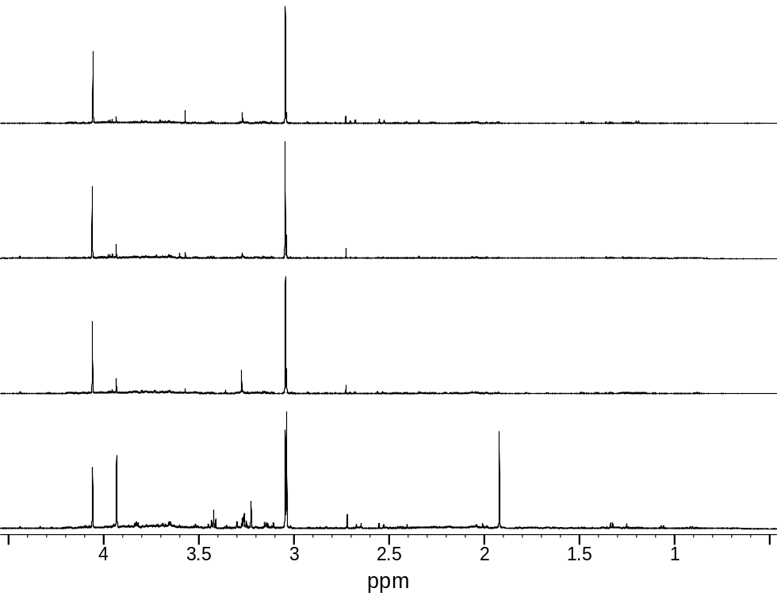
Crn Cr
Cit
DMA
Gly
TMAO
Car
Ace
Cr
Crn
Crn
D
C
A
B
Hip
His
His
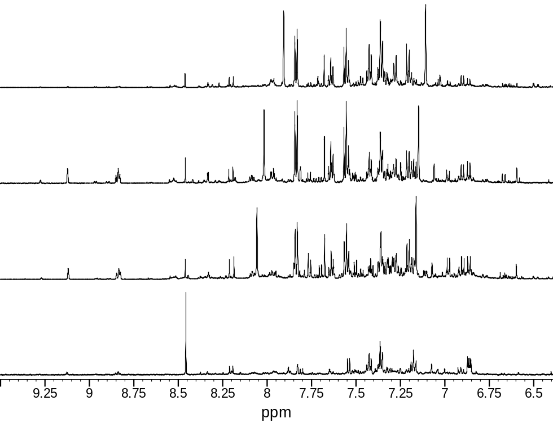
Hip
Hip
For
D’
C’
A’
B’’

Figure 2
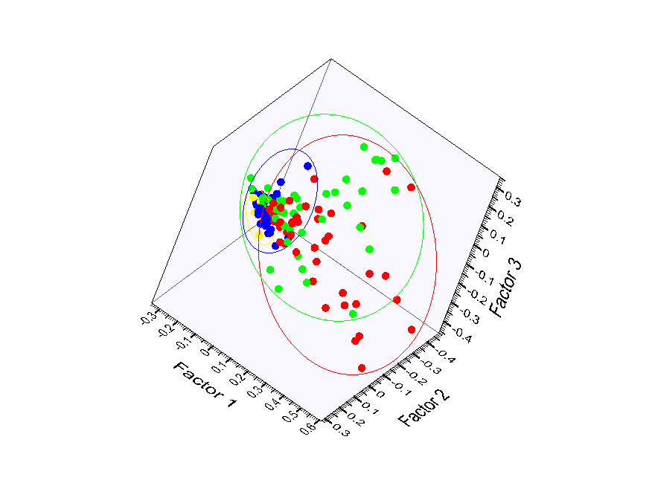A

B
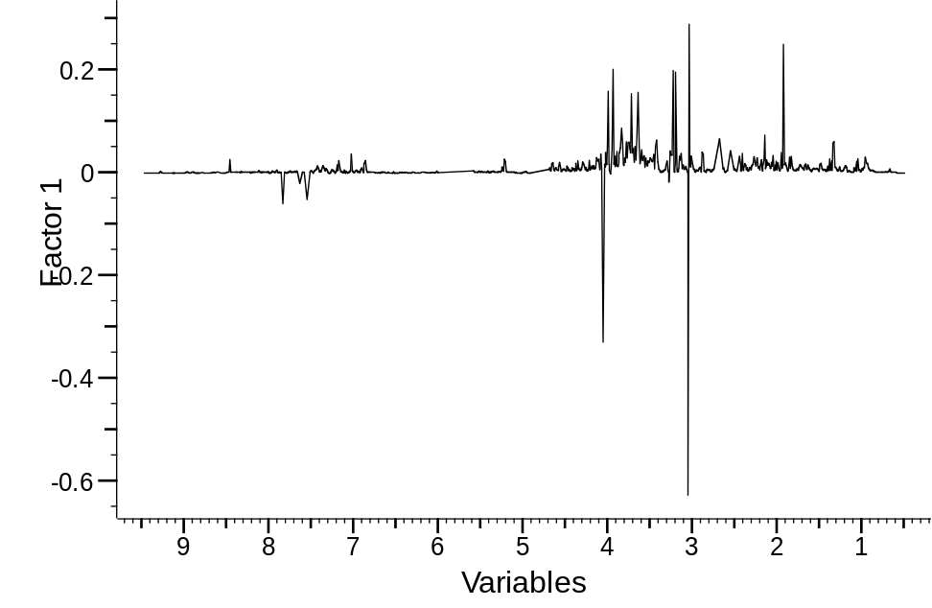

Figure 3

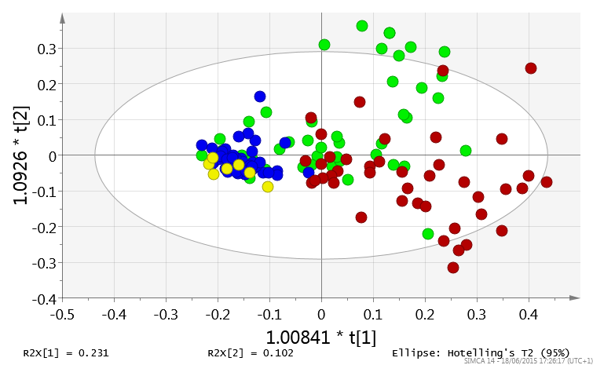

Figure 4
Acetate  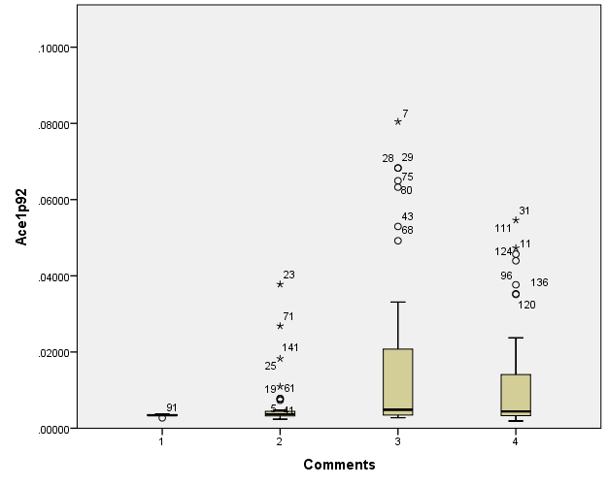  CTR CHB CIR HCC  Carnitine  P=0.029  P | Carnitine  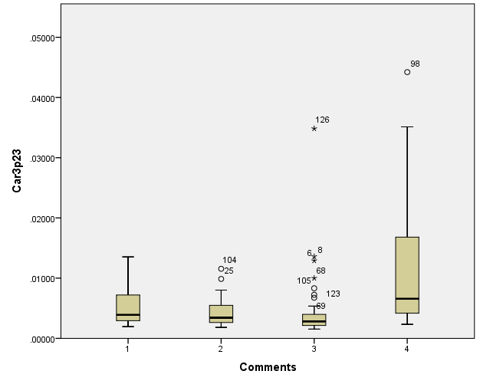  CTR CHB CIR HCC  P=0.000 P=0.000  P
Citrate  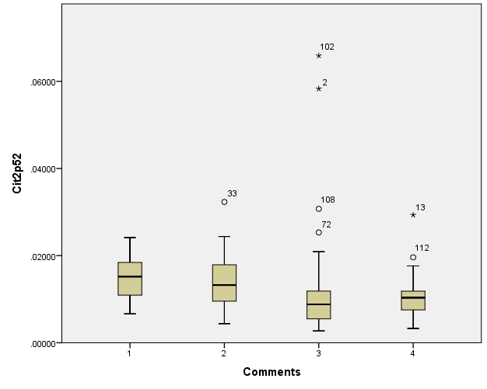  CTR CHB CIR HCC  Creatine  P=0.009  P | Creatine  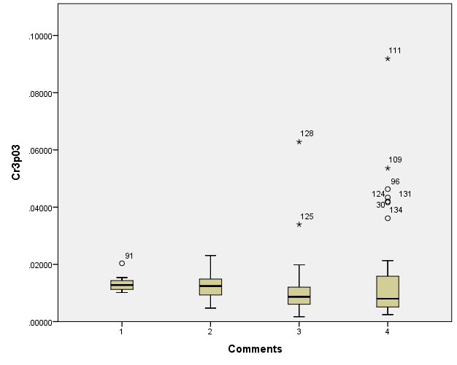  CTR CHB CIR HCC  P=0.019  P
Creatinine  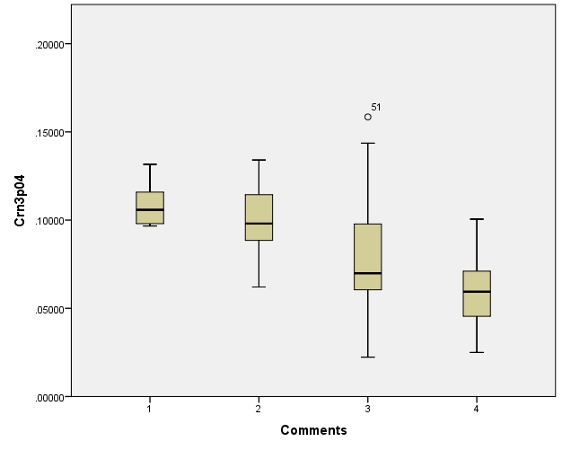  CTR CHB CIR HCC  P=0.000  P=0.000  P =0.011 P=0.000  P=0.019  DMA | DMA  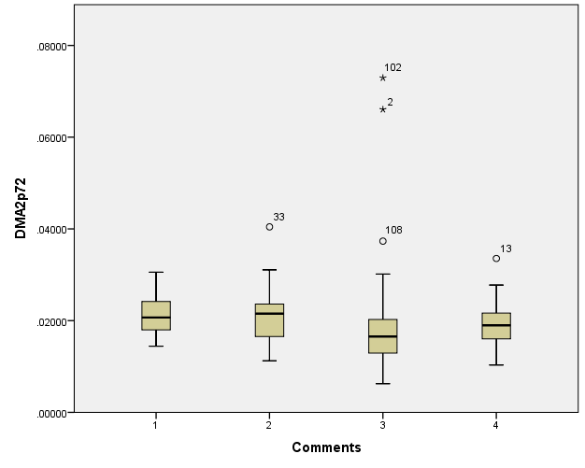  CTR CHB CIR HCC  P=0.019  P
Formate  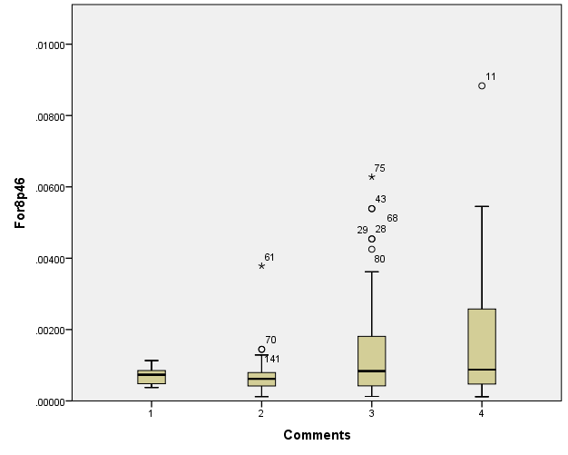  CTR CHB CIR HCC  Glycine | Glycine  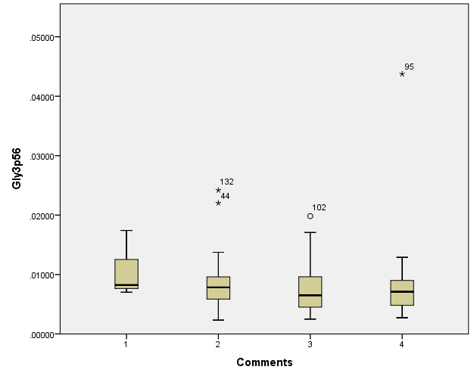  CTR CHB CIR HCC
Hippurate  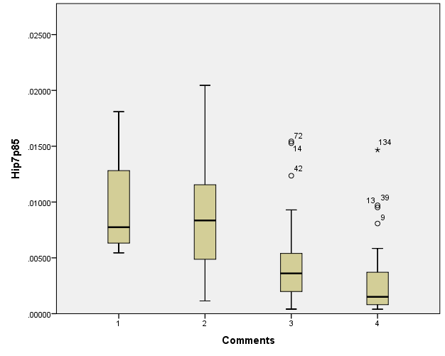  CTR CHB CIR HCC  P=0.000  P=0.000  P=0.028  P=0.000  P  TMAO | TMAO  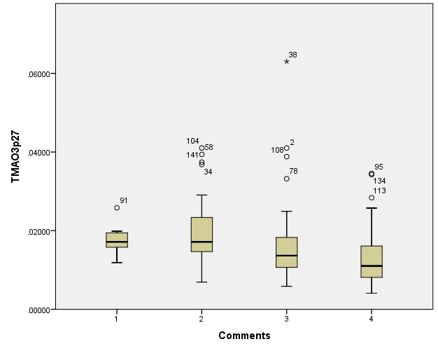  CTR CHB CIR HCC  P=0.000  P=0.018  P
Reference List
Hippurate
Formate
Creatinine
Citrate
Acetate

[1] Al-Mahtab M, Uddin H, Akbar SM. Epidemiology and Risk Factors of Hepatocellular Carcinoma in Asia. Journal of Gastroenterology and Hepatology Research 2014;3:1019-23.
[2] Khan M, Zaki KM, Ahmed KU, Ali SM, Islam N. Clinical profile: prognostic index in hepatocellular carcinoma. Bangladesh Med Res Counc Bull 1991;17:49-62.
[3] Mahtab MA, Rahman S, Karim MF, Khan M, Foster G, Solaiman S et al. Epidemiology of hepatitis B virus in Bangladeshi general population. Hepatobiliary Pancreat Dis Int 2008;7:595-600.
[4] Franco E, Bagnato B, Marino MG, Meleleo C, Serino L, Zaratti L. Hepatitis B: Epidemiology and prevention in developing countries. World J Hepatol 2012;4:74-80.
[5] Thio CL, Guo N, Xie C, Nelson KE, Ehrhardt S. Global elimination of mother-to-child transmission of hepatitis B: revisiting the current strategy. Lancet Infect Dis 2015.
[6] Daniele B, Bencivenga A, Megna AS, Tinessa V. Alpha-fetoprotein and ultrasonography screening for hepatocellular carcinoma. Gastroenterology 2004;127:S108-S112.
[7] Dona AC, Jimenez B, Schafer H, Humpfer E, Spraul M, Lewis MR et al. Precision high-throughput proton NMR spectroscopy of human urine, serum, and plasma for large-scale metabolic phenotyping. Anal Chem 2014;86:9887-94.
[8] Shariff MI, Gomaa AI, Cox IJ, Patel M, Williams HR, Crossey MM et al. Urinary metabolic biomarkers of hepatocellular carcinoma in an Egyptian population: a validation study. J Proteome Res 2011;10:1828-36.
[9] Shariff MI, Ladep NG, Cox IJ, Williams HR, Okeke E, Malu A et al. Characterization of urinary biomarkers of hepatocellular carcinoma using magnetic resonance spectroscopy in a Nigerian population. J Proteome Res 2010;9:1096-103.
[10] Ladep NG, Dona AC, Lewis MR, Crossey MM, Lemoine M, Okeke E et al. Discovery and validation of urinary metabotypes for the diagnosis of hepatocellular carcinoma in West Africans. Hepatology 2014;60:1291-301.
[11] Bouatra S, Aziat F, Mandal R, Guo AC, Wilson MR, Knox C et al. The human urine metabolome. PLoS One 2013;8:e73076.
[12] Wishart DS, Tzur D, Knox C, Eisner R, Guo AC, Young N et al. HMDB: the Human Metabolome Database. Nucleic Acids Res 2007;35:D521-D526.
[13] Heinzmann SS, Merrifield CA, Rezzi S, Kochhar S, Lindon JC, Holmes E et al. Stability and robustness of human metabolic phenotypes in response to sequential food challenges. J Proteome Res 2012;11:643-55.
[14] Benjamini Y, Hochberg Y. Controlling the False Discovery Rate: a practical and powerful approach to multiple testing. J Royal Stat Soc Ser B 1995;57:289-300.
[15] Shariff MI, Gomaa AI, Cox IJ, Patel M, Williams HR, Crossey MM et al. Urinary metabolic biomarkers of hepatocellular carcinoma in an Egyptian population: a validation study. J Proteome Res 2011;10:1828-36.
[16] Ladep NG, Dona AC, Lewis MR, Crossey MM, Lemoine M, Okeke E et al. Discovery and validation of urinary metabotypes for the diagnosis of hepatocellular carcinoma (HCC) in West Africans. Hepatology 2014.
[17] Shariff MI, Ladep NG, Cox IJ, Williams HR, Okeke E, Malu A et al. Characterization of urinary biomarkers of hepatocellular carcinoma using magnetic resonance spectroscopy in a Nigerian population. J Proteome Res 2010;9:1096-103.
[18] Vaz FM, Wanders RJ. Carnitine biosynthesis in mammals. Biochem J 2002;361:417-29.
[19] Pahor M, Manini T, Cesari M. Sarcopenia: clinical evaluation, biological markers and other evaluation tools. J Nutr Health Aging 2009;13:724-8.
[20] Bollard ME, Contel NR, Ebbels TM, Smith L, Beckonert O, Cantor GH et al. NMR-based metabolic profiling identifies biomarkers of liver regeneration following partial hepatectomy in the rat. J Proteome Res 2010;9:59-69.

