Acute Treatment with Omecamtiv Mecarbil to Increase Contractility in Acute Heart Failure (ATOMIC-AHF):
A randomized, ascending-dose cohort,
placebo-controlled study

Short title: ATOMIC-AHF: Omecamtiv mecarbil in acute HF
Authors: John R. Teerlink, MD,* G. Michael Felker, MD,† John J. V. McMurray, MD,‡
Piotr Ponikowski, MD,^{x} Marco Metra, MD,§ Gerasimos S. Filippatos, MD,|| Justin A. Ezekowitz, MBBCh MSc,# Kenneth Dickstein, MD,** John G. F. Cleland, MD,†† Jae B. Kim, MD,‡‡ Lei Lei, PhD,‡‡ Beat Knusel, MD,‡‡ Andrew A. Wolff, MD,^{xx} Fady I. Malik, MD,^{xx} and
Scott M. Wasserman, MD,‡‡ on behalf of the ATOMIC-AHF Investigators
From the *School of Medicine, University of California San Francisco and Section of Cardiology, San Francisco Veterans Affairs Medical Center, San Francisco, CA, USA; †Division of Cardiology, Duke University School of Medicine, Durham, NC, USA; ‡British Heart Foundation Cardiovascular Research Centre, University of Glasgow, Glasgow, UK; ^{x}Department of Heart Diseases, Medical University, Clinical Military Hospital, Wroclaw, Poland; §Cardiology, Department of Medical and Surgical Specialties, Radiological Sciences and Public Health; University of Brescia, Brescia, Italy; ||Department of Cardiology, Athens University Hospital Attikon, Athens, Greece; #Canadian VIGOUR Centre at the University of Alberta, Edmonton, Alberta, Canada; **Cardiology Division, University of Bergen, Stavanger University Hospital, Norway; ††National Heart & Lung Institute, Royal Brompton & Harefield Hospitals, Imperial College, London, UK; ‡‡Amgen, Inc., Thousand Oaks, CA, USA; ^{xx}Cytokinetics, Inc., South San Francisco, CA, USA.

The ATOMIC-AHF study was funded by Amgen, Inc. in collaboration with Cytokinetics, Inc. Dr. Teerlink received research grants from Amgen, Cytokinetics, Mast Therapeutics, Novartis, Sorbent, and Trevena and has served as a consultant to Amgen, Cytokinetics, Mast Therapeutics, Novartis, Trevena. Dr. Felker has received research grants from Amgen, Roche Diagnostics, Novartis, Otsuka, and NHLBI, and has served as a consultant for Amgen, Novartis, Roche Diagnostics, Singulex, Trevena, Celladon, Bristol Meyers Squibb, Merck, and Medtronic. Dr. McMurray's employer, Glasgow University, has been paid by Cytokinetics/Amgen for his time spent working on the clinical trial program with omecamtiv mecarbil. Dr McMurray has had travel and accommodation costs paid be Cytokinetics/ Amgen in relation to advisory board and clinical trial meetings about omecamtiv-mecarbil. Dr. Ponikowski has received consultancy and speaker's honoraria from Amgen, Bayer, Cardiorentis, Johnson & Johnson, Novartis, and Servier. Dr. Metra has received consulting fees from Bayer, MAST-Therapeutics, Novartis, Servier and Trevena. Dr Filippatos has received research grants and /or consulting fees from Bayer, Novartis, Cardiorentis, Vifor and the European Union. Dr. Ezekowitz has received research grants from Amgen and other disclosures are available online at www.vigour.ualberta.ca. Dr. Dickstein has received honoraria and research support from Abbott, Amgen, Astra Zeneca, Bayer, Biotronik, Boston Scientific, Johnson & Johnson, Medtronic, Merck, Novartis, Pfizer,Sanofi, Servier, Sorin, St. Jude. Dr. Cleland has received research grants from Alere, Amgen, Roche Diagnostics, Novartis, Philips, Servier and StealthPeptides and has served as a consultant for Amgen, Novartis, Philips, Roche Diagnostics, Merck, Medtronic, Servier and Zoll. Dr. Kim was an employee of Amgen. Drs. Wolff and Malik are employees and stockholders of Cytokinetics. Drs. Lei, Knusel and Wasserman are employees and stockholders of Amgen.
Corresponding author:
John R. Teerlink, M.D., FACC
San Francisco VA Medical Center
Cardiology, 111C
4150 Clement Street
San Francisco, CA 94121-1545 USA
Phone: +1-415-221-4810, x4160
Fax: +1-415-750-6950
email: john.teerlink@ucsf.edu

Abstract:
Background: Omecamtiv mecarbil (OM) is a selective cardiac myosin activator that increases myocardial function in healthy volunteers and patients with chronic heart failure.
Objectives: ATOMIC-AHF evaluated the pharmacokinetics, pharmacodynamics, tolerability, safety, and efficacy of OM in patients with acute heart failure (AHF).
Methods: Patients admitted for AHF with left ventricular (LV) ejection fraction ≤40%, dyspnea, and elevated plasma concentrations of natriuretic peptides were randomized to receive a double-blind, 48-hour intravenous infusion of placebo or OM in three sequential, escalating-dose cohorts.
Results: In 606 patients, OM did not improve the primary endpoint of dyspnea relief (three OM dose groups and pooled placebo; Placebo, 41%; OM Cohort 1, 42%; Cohort 2, 47%; Cohort 3, 51%; p=0.33), nor any of the secondary outcomes studied. In supplemental, pre-specified analyses, OM resulted in greater dyspnea relief at 48 hours (placebo, 37%; OM, 51%; p=0.034) and through 5 days (p=0.038) in the high dose cohort. OM exerted plasma concentration-related increases in LV systolic ejection time (p<0.0001) and decreases in end-systolic dimension (p<0.05). The adverse event profile and tolerability of OM were similar to placebo without increases in ventricular or supraventricular tachyarrhythmias. Plasma troponin concentrations were higher in OM-treated patients compared to placebo (median difference at 48 hours, 0.004 ng/mL), but with no obvious relationship to OM concentration (p=0.95).
Conclusions: In patients with AHF, intravenous OM did not meet the primary endpoint of dyspnea improvement, but was generally well-tolerated, increased systolic ejection time, and may have improved dyspnea in the high dose group. (ATOMIC-AHF; NCT01300013)

Keywords: acute heart failure, omecamtiv mecarbil, cardiac myosin activator, dyspnea, inotrope, arrhythmia
Abbreviations and Acronyms:
AHF = acute heart failure
ATOMIC-AHF = Acute Treatment with Omecamtiv Mecarbil to Increase Contractility in Acute Heart Failure
BP = blood pressure
EF = ejection fraction
IV = intravenous
LV = left ventricle/ ventricular
OM = omecamtiv mecarbil
PD = pharmacodynamic(s)
PK = pharmacokinetic(s)

Introduction
The morbidity and mortality associated with acute heart failure (AHF) remains substantial and there have been few therapeutic advances for this syndrome over recent decades suggesting that new therapies for AHF are a major unmet medical need (1). Although AHF is a heterogeneous condition, impaired cardiac contractility is a central pathophysiologic feature in at least half of these patients and may be a key therapeutic target. However, trials of many inotropic agents have failed to demonstrate either efficacy or safety due to adverse effects such as arrhythmias, hypotension and myocardial ischemia (2) and consequently, recent guidelines limit their use to patients with cardiogenic shock or evidence of marked end-organ hypoperfusion (3,4).
Omecamtiv mecarbil (OM) is a selective small molecule activator of cardiac myosin that prolongs myocardial systole (5). In contrast to traditional inotropes which increase the rate of myocardial contraction and shorten the duration of systole, OM increases stroke volume by extending the duration of systole without changing the velocity of myocardial contraction (i.e. no change in pressure with respect to time, +dP/dt). In preclinical models, OM increased cardiac contractility and stroke volume without apparent effects on myocardial oxygen demand (6) or cardiac myocyte calcium transients (5), which are putative mechanisms of harm for traditional inotropic agents such as beta-agonists and phosphodiesterase-3 inhibitors. In healthy volunteers (7) and in patients with chronic heart failure and systolic dysfunction (8), OM increased stroke volume and cardiac output while decreasing heart rate. In the Acute Treatment with Omecamtiv Mecarbil to Increase Contractility in Acute Heart Failure (ATOMIC-AHF; NCT01300013, clinicaltrials.gov) study, we sought to evaluate the pharmacokinetics, pharmacodynamics, safety, tolerability, and efficacy of intravenous OM in patients with AHF.

Methods
Study design and oversight
ATOMIC-AHF was a prospective, Phase 2, randomized, double-blind, placebo-controlled, dose-escalation, sequential-cohort trial comparing omecamtiv mecarbil (OM) with placebo in patients hospitalized for AHF. Patients were enrolled from 106 centers in Europe, Australia and North America. Each participating center’s institutional review board approved the study and all participants provided written informed consent. The Executive Committee was responsible for the trial design, and the National Leaders supervised patient recruitment and clinical management of the trial. An independent Data Monitoring Committee (DMC) regularly reviewed unblinded data prepared by an external biostatistical group. An independent Clinical Events Committee (CEC; Duke Clinical Research Institute) adjudicated deaths, rehospitalizations and major cardiovascular events. The authors vouch for the completeness and accuracy of the data and the analyses as well as the fidelity of the study to the protocol.
Patients
This study enrolled men and women aged 18 through 85 years of age with a history of chronic heart failure and left ventricular (LV) ejection fraction ≤40%, who were admitted for AHF and had dyspnea at rest or with minimal exertion, and had increased plasma concentrations of natriuretic peptides (BNP ≥400 pg/mL or NT-proBNP ≥1600 pg/mL; BNP ≥600 pg/mL or NT-proBNP ≥2400 pg/mL with atrial fibrillation). Eligible patients had persistent dyspnea two hours after the receipt of at least 40 mg of intravenous furosemide (or equivalent dose of alternative loop diuretic) and were randomized within 24 hours of their initial intravenous dose of loop diuretic (the initial portion of Cohort 1 required randomization within 16 hours of presentation, after which the protocol was amended to allow enrollment out to 24 hours after first diuretic dose). Patients receiving intravenous inotropic agents (other than dopamine at a dose of ≤5 mcg/kg/min) were excluded. Other major exclusions were acute coronary syndrome within 30 days, blood pressure (BP) >160/100 mmHg, systolic BP (SBP) <90 mmHg, or heart rate (HR) <60 or >110 bpm, estimated glomerular filtration rate (eGFR) calculated by the Modification of Diet in Renal Disease (MDRD) equation <20 mL/min/1.73m² during screening, severe pulmonary disease and significant stenotic valvular disease.
Randomization and Masking
Subjects were centrally randomized 1:1 to receive intravenous omecamtiv mecarbil or matching placebo within each cohort. Randomization through an interactive voice response system was stratified by geographic region (North America and Australia vs. rest of the world) and by planned participation in the pharmacokinetic (PK)/ pharmacodynamic (PD) sub-study.
Procedures
ATOMIC-AHF enrolled three sequential cohorts (~200 patients per cohort; Online Supplement Figure 1) targeting mean OM plasma concentrations at 48 hours of 115 ng/mL, 230 ng/mL and 310 ng/mL with three escalating dose regimens (Cohort 1: 7.5 mg/hr x 4-hour loading infusion followed by a 1.5 mg/hr x 44-hour maintenance infusion; Cohort 2: 15 mg/hr x 4-hour, then 3 mg/hr x 44-hour infusion; Cohort 3: 20 mg/hr x 4-hour, then 4 mg/hr x 44-hour infusion). As specified by protocol, there was a pause in enrollment between cohorts to allow for a DMC safety data review; enrollment resumed upon their recommendation. Through pharmacokinetic and -dynamic modeling, these doses were designed to attain progressively higher target plasma concentrations, with the low dose anticipated to have minimal cardiac effect, an intermediate dose, and the high dose chosen to maximize the pharmacodynamic response and minimize the occurrence of excessive plasma concentrations in the great majority of patients (>99%). Patients received OM or placebo infused over 48 hours and had to remain in hospital for at least 24 hours after termination of the infusion (Online Supplement Figure 2). Patients were evaluated in person during hospitalization and on day 30 and by telephone at 6 months for vital status.
Outcomes
The primary efficacy endpoint evaluated dyspnea improvement using a patient-reported seven-level Likert scale. A responder was defined as a patient with minimally, moderately or markedly improved dyspnea by 6 hours after the start of infusion, and moderately or markedly improved dyspnea at 24 and 48 hours, without experiencing worsening heart failure or death from any cause by 48 hours. Worsening heart failure was defined as worsening symptoms or signs of heart failure necessitating initiation, reinstitution or intensification of intravenous or mechanical heart failure treatment.
Secondary endpoints included other evaluations of symptoms and clinical events. Patients were asked to report their absolute current severity of dyspnea on an 11-point numerical rating scale (NRS; range 0-10) and their current level of both dyspnea and general well-being (patient global assessment, PGA) relative to baseline using seven-level Likert scales. The NRS scales were administered at baseline, and both the Likert and NRS scales were administered at 6, 24, and 48 hours and on days 3, 4, 5, on discharge and day 30. Other secondary endpoints were death from any cause or worsening heart failure within 7 days of initiation of investigational product, dyspnea NRS score area under the curve (baseline through 5 days or discharge, whichever came first), dyspnea and PGA by Likert scale over time, PGA response, change from baseline in NT-proBNP, length of initial hospital stay, and days alive out of hospital until day 30. Protocol-specified exploratory endpoints included the incidence of adjudicated deaths, incidence of supraventricular tachycardia (SVT) or ventricular tachycardia (VT) arrhythmias requiring treatment, renal impairment, cardiovascular events, and hospital readmissions.
Patients in sinus rhythm could participate in a pharmacokinetic/ pharmacodynamic (PK/PD) sub-study that provided additional PK data through supplementary blood sampling and explored the relationship between OM plasma concentrations and select echocardiographic measurements. Echocardiograms were obtained at baseline, 24 hours, and 48 hours.
ATOMIC-AHF employed standardized, intensive serial monitoring of cardiac troponin plasma concentrations in all patients using a sensitive cardiac troponin I assay (cTnI; Siemens ADVIA Centaur TnI-Ultra; 10% coefficient of variation =0.03 ng/mL, 99th percentile upper reference limit (URL) =0.04 ng/mL) (9). Samples were obtained at baseline and then at 4, 15, 24, 48, 72 hours, day 5 or day of discharge and day 30 after initiation of study drug.
The CEC adjudicated all rehospitalizations, deaths and cases of potential myocardial ischemia or infarction. A CEC review for potential myocardial ischemia or infarction could be triggered by either the investigators or the CEC through clinical evidence of an event (chest pain, ECG changes, etc.) or by pre-specified changes in cardiac troponins (>0.04 ng/mL in patients without prior detectable cTnI or increase in cTnI of >0.03 ng/mL in patients with prior detectable cTnI). Adverse events and serious adverse events were recorded through day 30.
Statistical analysis
All analyses were performed in patients who received at least one dose of investigational product. The planned sample size of 600 patients provided 88% power to detect superiority of one of the OM doses over placebo for the primary endpoint of dyspnea response, assuming response rates of 23% and 40% in the placebo and OM groups, respectively (10). For the primary endpoint, Fisher’s protected least significant difference (LSD) method (11) was used to ensure that the overall type I error rate was controlled at a significance level of 0.05 under the complete null hypothesis. Using this method, the three OM dose groups and a single pooled placebo group were first compared by using the Cochran-Mantel-Haenszel (CMH) test with region as a stratification factor. If this overall testing achieved the 0.05 significance level, comparisons between each OM group with the pooled placebo group were performed with significance level of 0.05. Otherwise the procedure stopped and all remaining p-values were considered only descriptive. In pre-specified analyses, the LSD method was repeated comparing the placebo and OM patients within each cohort, and the placebo groups from each of the three cohorts were compared in a test of homogeneity. Missing data for the primary endpoint were imputed as a “non-responder”. Subjects who died or had a worsening heart failure event by 48 hours were classified as non-responders, irrespective of their dyspnea scores.
Binary secondary efficacy endpoints of PGA response, worsening heart failure, and death or worsening heart failure were also analyzed using CMH test. Change from baseline in NT-proBNP and dyspnea area under the curve of NRS were analyzed using ANCOVA model including treatment as a main factor, with region and the endpoint’s baseline value as covariates. Analyses of ordinal secondary endpoints (dyspnea and PGA by Likert scale, days alive out of hospital) were performed using the van Elteren test with region as a stratification factor when comparing OM groups with pooled placebo, and cohort and region as stratification factors when comparing each OM group with each individual placebo. Length of initial hospital stay was analyzed as time to discharge using a Cox regression survival model. All comparisons were adjusted for region. PGA response was imputed in the same way as the primary endpoint. For the endpoints of dyspnea and PGA by 7-point Likert scale at each scheduled assessment, after subject death or worsening heart failure, the score was imputed using the individual subjects’ worst scale observed. For NT-proBNP, missing data were imputed using last observation carried forward (LOCF). Other secondary endpoints were calculated without imputation.
A repeated measures multiple linear regression model was used to examine the relationship of omecamtiv mecarbil plasma concentration and pharmacodynamic variables of interest where patients on placebo were included as having a plasma concentration of zero. Safety data and adjudicated endpoints were reported with descriptive statistics using observed data without imputation.
Role of Funding Source
The ATOMIC-AHF study was funded by Amgen, Inc. in collaboration with Cytokinetics, Inc. The design of the study protocols was the responsibility of the authors, Amgen and Cytokinetics, Inc. All statistical analyses were done by Amgen, Inc. All authors have reviewed the manuscript and related documents in full, and approved submission. The authors not employed by the sponsor had ultimate editorial authority and the corresponding author had full access to the study data and was responsible for submission of the manuscript.

Results
Patient Population
From May, 2011 to April, 2013, 613 patients were enrolled in ATOMIC-AHF from 106 centers in 19 countries and 606 received investigational product (Online Supplement Figure 3). Patients enrolled in this study (Table 1) were aged 66±11 years (mean±SD), predominantly white (88%) and male (77%) with multiple co-morbidities. Prior to the index admission, most patients were on guideline-recommended pharmacologic therapy for chronic symptomatic heart failure (>80% NYHA class II-III). Investigators attributed the cause of heart failure to coronary artery disease in 62% of patients and mean LV ejection fraction was 26±8 %. At baseline, most patients also had impaired renal function, elevated troponin and raised plasma NT-proBNP concentrations. Some heterogeneity between treatment groups was evident despite randomization; for example, more patients assigned to OM had elevated troponins (median pooled placebo, 0.044 ng/mL; pooled OM, 0.054 ng/mL). Additionally, differences in baseline characteristics emerged between the cohorts over time during the two year enrollment period, including increasing enrollment from Eastern European sites, decreasing non-white representation, fewer patients hospitalized for HF within the 12 months prior to enrollment, and greater baseline troponin concentrations. A protocol amendment resulted in a longer time from first diuretic dose to randomization in the later cohorts compared to the first cohort.
Efficacy Evaluation: Primary Endpoint
The response rates of the primary endpoint of dyspnea relief within 48 hours among the placebo groups of the three cohorts were not statistically different (p=0.316) and therefore, as specified in the protocol, the pooled placebo group was used for the statistical analysis of the primary endpoint. The global test of dyspnea relief response rate was similar among the three individual OM cohorts and did not differ from the pooled placebo group (p=0.331), although the response rate did improve numerically with increasing OM dose (Central Illustration, Panel A). Thus, the primary endpoint was not achieved. However as noted above due to the months-long time delays between cohorts for DMC reviews, differences in time to randomization, region of enrollment and baseline characteristics were observed amongst the cohorts, so a pre-specified supplemental analysis of comparisons between placebo and OM groups within each cohort was performed (Central Illustration, Panel B). In cohort 3, there was a 41% relative improvement in dyspnea relief at 48 hours (14% absolute difference: placebo 37%, OM 51%; nominal p=0.034). An exploratory post-hoc logistic regression analysis across all cohorts demonstrated greater dyspnea response rates with higher total dose (response rate ratio per 50 mg increase in OM dose: 1.06, 95% CI 1.01-1.11, p=0.025 adjusting for region, cohort, age, baseline dyspnea NRS, and duration between presentation and randomization as covariates; p=0.035 unadjusted), or with increased OM exposure integrated as the area under the curve of OM plasma concentrations (response rate ratio per increase of 4000 hr*ng/mL in AUC_{48hr}: 1.06, 95% CI 1.02-1.11, p=0.007 adjusted; p=0.016 unadjusted).
Efficacy Evaluation: Secondary Endpoints
There were no statistically significant differences for any of the secondary endpoints when OM treatment cohorts were compared to the pooled placebo (Table 2). However, analysis of the dyspnea NRS area under the curve through day 5 noted increased dyspnea improvement in cohort 3 OM treated patients compared to its matching placebo group (nominal p=0.038), supporting potential symptom improvement in the highest dose cohort. The incidence of death or worsening heart failure through day 7 was driven primarily by worsening heart failure events with numerically fewer events in patients assigned to OM rather than placebo within each cohort.
Efficacy Evaluation: Pre-specified Exploratory Endpoints
The exploratory endpoints of global rank score, total intravenous loop diuretic use, chronic HF medication at discharge, and health resource utilization were similar between the OM and placebo groups. Supraventricular tachycardia requiring treatment from baseline to discharge occurred in 12 placebo treated subjects and 3 OM treated subjects, while ventricular tachycardia requiring treatment occurred in 2 patients treated with placebo and 4 OM treated patients. Renal impairment (defined as creatinine increase ≥ 0.3 mg/dL or ≥ 25% from baseline at day 5 or discharge) occurred in 52 (17.2%) patients who received placebo compared with 36 (11.9%) OM treated subjects. Within each cohort, numerically fewer patients assigned to OM developed renal impairment than did those assigned to placebo, although this did not attain statistical significance (Online Supplement Figure 4).
Pharmacokinetics and Pharmacodynamics
The three dosing regimens targeted OM mean plasma concentrations at 48 hours (C₄₈) of 115, 230 and 310 ng/mL. The actual measured C₄₈ for the respective cohorts were 148±49, 311±115 and 425±173 ng/mL (mean±SD). There was a concentration-dependent reduction in heart rate (p<0.0001) and increase in blood pressure (p=0.0017) from baseline with OM relative to placebo (Table 3). The echocardiographic sub-study enrolled 89 of the planned 240 subjects and showed that OM caused plasma concentration-dependent increases in LV systolic ejection time (p<0.0001; Figure 1). The mean placebo-corrected increase in systolic ejection time was 23, 34 and 53 msec for OM concentration ranges of 88-200, 201-300, and >300 ng/mL respectively (p <0.005 for the difference from placebo for all ranges). There was also a significant concentration-related decrease in LV end-systolic dimension (p<0.05).
Safety and Tolerability
Of the 606 patients who received infusions, 92% (281/303) of patients assigned to placebo and 93% (282/303) assigned to OM completed 48-hours; the mean duration of infusion was similar across all groups. There were 191 (63%) patients reporting any adverse event in the placebo group compared to 177 (58%) in the OM group (Table 4). Rates for serious adverse events were similar in those assigned to placebo (n=70; 23%) and OM (n=66; 22%).
All-cause rehospitalizations (placebo: n= 47, 15.5%; OM: n= 39, 12.9%) and rehospitalizations for heart failure (placebo: n=19, 6.3%; OM: n=22, 7.3%) within 30 days were similar between pooled OM and placebo. There were 10 deaths (3.3%) within 30 days in patients assigned to placebo compared to 8 (2.6%) in those assigned to OM; all cardiovascular (Table 4). By 6-months, 39 deaths (12.9%) had occurred amongst patients assigned to placebo and 38 (12.5%) amongst those assigned to OM.
Adverse event rates for supraventricular and ventricular tachyarrhythmias and myocardial ischemia were similar in patients assigned to placebo or OM (Table 4). Investigators reported supraventricular tachyarrhythmia adverse events in 20 (6.6%) patients in the pooled placebo compared to 11 (3.6%) in the OM group, predominantly due to atrial fibrillation or flutter. Reports of ventricular tachyarrhythmias were similar between in patients assigned to placebo (n=18, 5.9%) and to OM (n=16, 5.3%), and there were 5 (1.7%) placebo treated patients with reported adverse events related to myocardial ischemia compared with 9 (3.0%) OM treated patients. The CEC-confirmed three (1.0%) post-randomization myocardial infarctions (MI) in the placebo group compared to seven (2.3%) in the OM-treated cohorts (Online Supplemental Table 1).
Cardiac troponin I was intensively monitored throughout the study with 4750 samples centrally analyzed at a blinded core laboratory. The median baseline cardiac troponin I in the pooled OM groups was 0.054 ng/mL (Q1,Q3 0.026 to 0.095 ng/mL) compared with 0.044 ng/mL (Q1, Q3 0.023 to 0.080 ng/mL) in the pooled placebo group. The median change from baseline at the end of study drug infusion (48 hours) was 0.000 ng/mL (Q1,Q3 -0.017 to 0.012 ng/mL) for the pooled OM group and -0.004 ng/mL (Q1,Q3 -0.017 to 0.001 ng/mL) for the pooled placebo group. Within cohort 3, the change from baseline troponin in the high dose OM group versus the cohort 3 placebo was 0.001 ng/mL (Q1,Q3 -0.011 to 0.021 ng/mL) and -0.005 ng/mL (Q1,Q3 -0.015 to 0.001 ng/mL), respectively. OM exposure (C_{max}, Figure 2, Panels A and B or C_{48h}, Online Supplement Figure 5, Panels A and B) did not predict the maximum change from baseline in troponin I. In similar analyses based upon the 89 patients in the PK/PD substudy, neither the maximal change in systolic ejection time nor the maximal change in left ventricular end-systolic dimension predicted the maximum change from baseline in troponin I (Online Supplement Figure 6 & 7).

Discussion
In ATOMIC-AHF, a Phase 2 dose-finding study, omecamtiv mecarbil (OM) did not improve the primary endpoint of dyspnea or any pre-specified secondary outcome when compared to the pooled placebo group. However, there was a suggestion of greater dyspnea relief in the high dose OM cohort compared with its concurrent placebo group as assessed by both the Likert and numerical ranking scale (NRS). OM appeared generally well-tolerated with approximately dose-proportional pharmacokinetics associated with prolonged ventricular systole and decreased LV end-systolic dimensions. Although there was a small numerical excess of episodes of myocardial ischemia in OM treated patients, this difference was not temporally related to study drug exposure. There were small increases in plasma troponin in patients assigned to OM, although there was no apparent relationship to OM plasma concentrations. There was no increase in symptomatic hypotension or arrhythmias in the OM treated patients.
Omecamtiv mecarbil improves cardiac performance through a novel mechanism of selectively activating cardiac myosin. The pharmacodynamic signature of this mechanism of action is the prolongation of myocardial systole and has been demonstrated in healthy volunteers (7) and patients with chronic heart failure (8). Importantly, this same signature was evident in patients with AHF in ATOMIC-AHF, and the relationship between the omecamtiv mecarbil plasma concentrations and the prolongation of the systolic ejection time in ATOMIC-AHF was nearly identical to that seen in the prior two studies. These findings demonstrate that this mechanism of action is operative in AHF, and provides evidence that this effect translated into a physiologic benefit with a significant reduction in the left ventricular end-systolic dimension, consistent with an improvement in cardiac performance and a finding related to improved long-term survival (12). Interestingly, it has long been recognized that patients with reduced cardiac output or ejection fraction have decreased systolic ejection times (13) and thus, OM may be viewed as effectively normalizing the ejection time.
Dyspnea at rest or with minimal exertion is the most common presenting symptom in patients with AHF and remains a clinically meaningful endpoint (14). Omecamtiv mecarbil increases cardiac output and reduces LV filling pressures in animal models (5,6) and improves cardiac function in humans (7,8), providing a mechanism for dyspnea relief in patients. Prior trials have suggested that selection of symptomatic patients and objective signs of congestion early in their hospital course provides the best opportunity to demonstrate a clinical benefit on dyspnea (15,16). In ATOMIC-AHF, dyspnea relief was evaluated by a responder variable requiring early and sustained improvement in dyspnea compared to standard therapy without evidence of clinical worsening within the first 48 hours. In an attempt to increase the power of this Phase 2 study for a symptom endpoint, the primary analysis pre-specified a comparison among the pooled placebo group and the individual omecamtiv mecarbil dose cohorts. This endpoint was not met, and may reflect a failure of OM to improve dyspnea. However, there were major differences in the characteristics and behavior of the placebo group between the cohorts, undermining the validity of the pooled placebo group as the comparator; the placebo response rate was much higher than predicted (41% actual versus 23% predicted), reducing the power of the trial to observe a beneficial treatment effect; and patients were randomized on average 15 hours after presentation, a significantly longer period of time than in a recent clinical trial (16), potentially limiting the ability to discern a treatment effect. When the effect of high dose OM was compared to the matching placebo, a 14% absolute (41% relative) treatment-effect emerged at 48 hours, which was additionally supported by analyses suggesting a relationship between OM dose, as well as plasma concentrations, and dyspnea improvement. Patients treated with OM in the high dose cohort 3 also had improvements in their dyspnea relief as measured by the NRS over 5 days.
Increased troponins in patients admitted for acute heart failure (17) have been related to increased long-term mortality in some studies (18-20), but not in others (21). Previous clinical studies demonstrated that the dose-limiting toxicity of OM is the provocation of myocardial ischemia, and thus ATOMIC-AHF employed intensive sampling of cardiac troponin in all patients, with additional sampling when there was any clinical suspicion of ischemia. Consistent with other studies in AHF (19,21), baseline troponin was greater than the 99th percentile URL in over half the enrolled patients. An analysis of the troponin change from baseline over time revealed a slightly higher troponin concentration in patients assigned to OM compared to placebo at 48h. In an analysis of pooled data, there was no apparent relationship between OM exposure (either C_{max} or C_{48h}) and the maximal troponin increase from baseline. In addition, analysis for the echocardiographic substudy revealed no relationship between maximal change in either systolic ejection time or LV end-systolic dimension and the maximal change in troponin. The absence of a discernible association of either OM exposure, its pharmacodynamic signature of its mechanism of action (SET) or one of its main physiologic effects (LVESD) with the small magnitude of the troponin change make it difficult to draw definitive conclusions about the clinical significance of these troponin findings. While most studies have demonstrated that OM inhibits nonactin-dependent cardiac myosin ATPase (5,22) and does not increase myocardial oxygen consumption (6), a recent study in anesthetized animals suggested OM-related increased myocardial oxygen consumption (23). Although methodological limitations undermine this study (24), these data, combined with the small numerical increase in the incidence of myocardial infarction, support the need for continued assessment of the possibility that OM may contribute to myocardial ischemia in ongoing and future studies.
Currently available inotropes have demonstrated pro-arrhythmic effects that have been linked to increased mortality. Dobutamine, dopamine, milrinone and levosimendan all have well-recognized adverse effects of tachycardia which can limit their clinical utility. In the OPTIME-HF trial, patients treated with milrinone had a greater than two-fold risk of developing ventricular tachycardia or fibrillation and a three-fold risk of developing new atrial fibrillation or flutter during the index hospitalization (25). In the REVIVE II trial, levosimendan treatment increased heart rate by 2-8 bpm, remaining statistically significant for at least 5 days, and was associated with a 50% increase in ventricular tachycardia, and four-fold increases in ventricular extrasystoles and atrial fibrillation compared to placebo (26). These pro-arrhythmic effects are inextricably linked to these agents’ mechanisms of action, which increase intracellular cAMP and calcium as the means to increase contractility. As a cardiac myosin activator, omecamtiv mecarbil does not increase these intracellular signals and effectors (5) and has had no evidence of increased arrhythmogenicity in prior clinical studies (7,8). In ATOMIC-AHF, OM decreased heart rate compared to placebo and did not increase the risk of supraventricular or ventricular tachyarrhythmias. OM improves left atrial function and reduces volumes in healthy volunteers and such an effect might reduce the propensity to atrial arrhythmias (7,27).
Worsening heart failure during the initial hospitalization has emerged as a clinically important event with both short and long-term prognostic implications (19,28-30). In ATOMIC-AHF, there were too few events to evaluate this endpoint meaningfully, although there were numerically fewer worsening heart failure events amongst patients assigned to OM rather than placebo within each cohort. Both milrinone (25) and levosimendan (26) have been associated with increases in mortality; in the current study, 180-day all-cause mortality was 12.9% in the placebo and 12.5% in the omecamtiv mecarbil group. More data are required to confirm or exclude differences in mortality.
In conclusion, ATOMIC-AHF provides the basis for additional investigation of intravenous OM in patients with decompensated heart failure, as well as the development of oral omecamtiv mecarbil for the treatment of patients with chronic heart failure, as is currently being explored in the COSMIC-HF study (ClinicalTrials.gov, NCT01786512).

References:
1. Felker GM, Pang PS, Adams KF, et al. Clinical Trials of Pharmacological Therapies in Acute Heart Failure Syndromes Lessons Learned and Directions Forward. Circ-Heart Fail 2010;3:314-325.
2. Hasenfuss G, Teerlink JR. Cardiac inotropes: current agents and future directions. Eur Heart J 2011;32:1838-45.
3. McMurray JJ, Adamopoulos S, Anker SD, et al. ESC Guidelines for the diagnosis and treatment of acute and chronic heart failure 2012: The Task Force for the Diagnosis and Treatment of Acute and Chronic Heart Failure 2012 of the European Society of Cardiology. Developed in collaboration with the Heart Failure Association (HFA) of the ESC. Eur Heart J 2012;33:1787-847.
4. Yancy CW, Jessup M, Bozkurt B, et al. 2013 ACCF/AHA guideline for the management of heart failure: a report of the American College of Cardiology Foundation/American Heart Association Task Force on Practice Guidelines. J Am Coll Cardiol 2013;62:e147-239.
5. Malik FI, Hartman JJ, Elias KA, et al. Cardiac myosin activation: a potential therapeutic approach for systolic heart failure. Science 2011;331:1439-43.
6. Shen YT, Malik FI, Zhao X, et al. Improvement of cardiac function by a cardiac myosin activator in conscious dogs with systolic heart failure. Circ Heart Fail 2010;3:522-7.
7. Teerlink JR, Clarke CP, Saikali KG, et al. Dose-dependent augmentation of cardiac systolic function with the selective cardiac myosin activator, omecamtiv mecarbil: a first-in-man study. Lancet 2011;378:667-75.
8. Cleland JG, Teerlink JR, Senior R, et al. The effects of the cardiac myosin activator, omecamtiv mecarbil, on cardiac function in systolic heart failure: a double-blind, placebo-controlled, crossover, dose-ranging phase 2 trial. Lancet 2011;378:676-83.
9. Newby LK, Jesse RL, Babb JD, et al. ACCF 2012 expert consensus document on practical clinical considerations in the interpretation of troponin elevations: a report of the American College of Cardiology Foundation task force on Clinical Expert Consensus Documents. J Am Coll Cardiol 2012;60:2427-63.
10. Teerlink JR, Metra M, Felker GM, et al. Relaxin for the treatment of patients with acute heart failure (Pre-RELAX-AHF): a multicentre, randomised, placebo-controlled, parallel-group, dose-finding phase IIb study. Lancet 2009;373:1429-39.
11. Hsu J. Multiple comparisons; theory and methods. London: Chapman & Hall, 1996.
12. Kramer DG, Trikalinos TA, Kent DM, Antonopoulos GV, Konstam MA, Udelson JE. Quantitative evaluation of drug or device effects on ventricular remodeling as predictors of therapeutic effects on mortality in patients with heart failure and reduced ejection fraction: a meta-analytic approach. J Am Coll Cardiol 2010;56:392-406.
13. Weissler AM, Harris WS, Schoenfeld CD. Systolic time intervals in heart failure in man. Circulation 1968;37:149-59.
14. West RL, Hernandez AF, O'Connor CM, Starling RC, Califf RM. A review of dyspnea in acute heart failure syndromes. Am Heart J 2010;160:209-14.
15. O'Connor CM, Starling RC, Hernandez AF, et al. Effect of nesiritide in patients with acute decompensated heart failure. N Engl J Med 2011;365:32-43.
16. Teerlink JR, Cotter G, Davison BA, et al. Serelaxin, recombinant human relaxin-2, for treatment of acute heart failure (RELAX-AHF): a randomised, placebo-controlled trial. Lancet 2013;381:29-39.
17. Januzzi JL, Jr., Filippatos G, Nieminen M, Gheorghiade M. Troponin elevation in patients with heart failure: on behalf of the third Universal Definition of Myocardial Infarction Global Task Force: Heart Failure Section. Eur Heart J 2012;33:2265-71.
18. Metra M, Bettari L, Pagani F, et al. Troponin T levels in patients with acute heart failure: clinical and prognostic significance of their detection and release during hospitalisation. Clin Res Cardiol 2012;101:663-72.
19. Metra M, Cotter G, Davison BA, et al. Effect of serelaxin on cardiac, renal, and hepatic biomarkers in the Relaxin in Acute Heart Failure (RELAX-AHF) development program: correlation with outcomes. J Am Coll Cardiol 2013;61:196-206.
20. O'Connor CM, Fiuzat M, Lombardi C, et al. Impact of serial troponin release on outcomes in patients with acute heart failure: analysis from the PROTECT pilot study. Circ Heart Fail 2011;4:724-32.
21. Felker GM, Hasselblad V, Tang WH, et al. Troponin I in acute decompensated heart failure: insights from the ASCEND-HF study. Eur J Heart Fail 2012;14:1257-64.
22. Liu Y, White HD, Belknap B, Winkelmann DA, Forgacs E. Omecamtiv Mecarbil modulates the kinetic and motile properties of porcine beta-cardiac myosin. Biochemistry 2015;54:1963-75.
23. Bakkehaug JP, Kildal AB, Engstad ET, et al. Myosin Activator Omecamtiv Mecarbil Increases Myocardial Oxygen Consumption and Impairs Cardiac Efficiency Mediated by Resting Myosin ATPase Activity. Circ Heart Fail 2015;8:766-75.
24. Teerlink JR, Malik FI, Kass DA. Letter by Teerlink et al Regarding Article, “The Myosin Activator Omecamtiv Mecarbil Increases Myocardial Oxygen Consumption and Impairs Cardiac Efficiency Mediated by Resting Myosin ATPase Activity”. Circ Heart Fail 2015;8:DOI: 10.1161/CIRCHEARTFAILURE.115.002492.
25. Cuffe MS, Califf RM, Adams KF, Jr., et al. Short-term intravenous milrinone for acute exacerbation of chronic heart failure: a randomized controlled trial. Jama 2002;287:1541-7.
26. Packer M, Colucci WS, Fisher L, et al. Effect of levosimendan on the short-term clinical course of patients with acutely decompensated heart failure. J Am Coll Cardiol Heart Fail 2013;1:103-111.
27. Habibzadeh MR, Schiller NB, Malik FI, et al. Effect of the Selective Cardiac Myosin Activator, Omecamtiv Mecarbil, on Left Atrial Performance in Healthy Men. J Card Fail 2010;16:S72-S72.
28. Cotter G, Metra M, Weatherley BD, et al. Physician-determined worsening heart failure: a novel definition for early worsening heart failure in patients hospitalized for acute heart failure--association with signs and symptoms, hospitalization duration, and 60-day outcomes. Cardiology 2010;115:29-36.
29. Kelly JP, Mentz RJ, Hasselblad V, et al. Worsening heart failure during hospitalization for acute heart failure: Insights from the Acute Study of Clinical Effectiveness of Nesiritide in Decompensated Heart Failure (ASCEND-HF). Am Heart J 2015;170:298-305.
30. Butler J, Gheorghiade M, Kelkar A, et al. In-hospital worsening heart failure. Eur J Heart Fail 2015.

Figure Titles and Legends:
Central Illustration: Effect of Omecamtiv mecarbil on Dyspnea relief, Panel A, Comparison with pooled placebo and Panel B, Comparison with paired placebo groups.
Figure 1: Relationship between Omecamtiv mecarbil concentrations and left ventricular systolic ejection times
Figure 2: Maximal omecamtiv mecarbil concentrations and peak troponin concentrations, Panel A (range -40 to 100 ng/mL) and Panel B with expanded y-axis (range -4 to 4 ng/mL) excluding outliers

Table 1: Baseline Characteristics
 | Pooled |  | Cohort 1 |  | Cohort 2 |  | Cohort 3
Characteristic | Placebo  (N = 303) | OM  (N = 303) | Placebo  (N = 103) | OM  (N = 103) | Placebo  (N = 99) | OM  (N = 99) | Placebo  (N = 101) | OM  (N = 101)
Demographics
Age years, mean (SD) | 66 (11) | 66 (11) | 65 (13) | 65 (12) | 66 (10) | 66 (10) | 66 (10) | 68 (11)
Sex – male, n (%) | 230 (75.9) | 236 (77.9) | 81 (78.6) | 78 (75.7) | 69 (69.7) | 81 (81.8) | 80 (79.2) | 77 (76.2)
Race, n (%)
White | 270 (89.1) | 260 (85.8) | 87 (84.5) | 87 (84.5) | 91 (91.9) | 82 (82.8) | 92 (91.1) | 91 (90.1)
Non-White | 33 (10.9) | 43 (14.2) | 16 (15.5) | 16 (15.5) | 8 (8.1) | 17 (17.2) | 9 (8.9) | 10 (9.9)
Region, n (%)
Eastern Europe | 160 (52.8)* | 164 (54.1) | 41 (39.8) | 46 (44.7) | 59 (59.6) | 55 (55.6) | 60 (59.4) | 63 (62.4)
Western Europe | 62 (20.5)* | 58 (19.1) | 24 (23.3) | 19 (18.5) | 15 (15.2) | 19 (19.2) | 23 (22.8) | 20 (19.8)
United States/ Canada/ Australia | 81 (26.7)* | 81 (26.7) | 38 (36.9) | 38 (36.9) | 25 (25.3) | 25 (25.3) | 18 (17.8) | 18 (17.8)
Heart Failure History
Ischemic heart disease,  n (%) | 189 (62.4) | 189 (62.4) | 66 (64.1) | 64 (62.1) | 56 (56.6) | 58 (58.6) | 67 (66.3) | 67 (66.3)
Years from HF diagnosis, mean (SD) | 5.7 (5.5) | 5.9 (5.4) | 6.3 (6.3) | 6.3 (6.2) | 5.1 (4.8) | 5.6 (5.0) | 5.5 (5.3) | 5.8 (5.0)
NYHA Class prior to decompensation, n (%)
NYHA I | 9 (3.0) | 6 (2.0) | 5 (4.9) | 4 (3.9) | 4 (4.0) | 2 (2.0) | 0 (0.0) | 0 (0.0)
NYHA II | 97 (32.2) | 89 (29.4) | 28 (27.2) | 27 (26.2) | 27 (27.3) | 26 (26.3) | 42 (42.4) | 36 (35.6)
NYHA III | 153 (50.8) | 151 (49.8) | 52 (50.5) | 53 (51.5) | 54 (54.5) | 52 (52.5) | 47 (47.5) | 46 (45.5)
NYHA IV | 42 (14.0) | 57 (18.8) | 18 (17.5) | 19 (18.4) | 14 (14.1) | 19 (19.2) | 10 (10.1) | 19 (18.8)
Hospitalized for AHF in past 12 months, n (%) | 157 (52)* | 169 (56) | 65 (63) | 64 (62) | 53 (54) | 59 (60) | 39 (39) | 46 (46)
Most recent LVEF (%), mean (SD) | 26 (8) | 26 (8) | 26 (7) | 26 (8) | 26 (8) | 25 (7) | 28 (8) | 28 (7)
Selected Co-morbidities, n (%)
Prior Myocardial Infarction | 146 (48.5) | 161 (53.1) | 58 (57.4) | 55 (53.4) | 41 (41.4) | 48 (48.5) | 47 (46.5) | 58 (57.4)
Persistent Atrial Fibrillation or Flutter | 100 (33.0) | 98 (32.3) | 27 (26.2) | 30 (29.1) | 41 (41.4) | 32 (32.3) | 32 (31.7) | 36 (35.6)
Paroxysmal Atrial Fibrillation or Flutter | 62 (20.5)* | 70 (23.1) | 29 (28.2) | 20 (19.4) | 18 (18.2) | 26 (26.3) | 15 (14.9) | 24 (23.8)
Diabetes Mellitus | 136 (44.9) | 133 (43.9) | 43 (41.7) | 50 (48.5) | 47 (47.5) | 41 (41.4) | 46 (45.5) | 42 (41.6)
Hypertension | 244 (80.5) | 249 (82.2) | 80 (77.7) | 86 (83.5) | 81 (81.8) | 80 (80.8) | 83 (82.2) | 83 (82.2)
Dyslipidemia | 175 (57.8) | 170 (56.1) | 63 (61.2) | 61 (59.2) | 59 (59.6) | 58 (58.6) | 53 (52.5) | 51 (50.5)
Prior Transient Ischemic Attack | 19 (6.3) | 12 (4.0) | 4 (3.9) | 3 (2.9) | 8 (8.1) | 6 (6.1) | 7 (6.9) | 3 (3.0)
Prior Stroke | 35 (11.6) | 39 (12.9) | 11 (10.7) | 11 (10.7) | 14 (14.1) | 15 (15.2) | 10 (9.9) | 13 (12.9)
Peripheral Artery Disease | 47 (15.5) | 40 (13.2) | 18 (17.5) | 18 (17.5) | 16 (16.2) | 10 (10.1) | 13 (12.9) | 12 (11.9)
Chronic Obstructive Pulmonary Disease | 68 (22.4) | 76 (25.1) | 24 (23.3) | 28 (27.2) | 22 (22.2) | 21 (21.2) | 22 (21.8) | 27 (26.7)
Selected Baseline Outpatient Medications, n (%)
Diuretics | 270 (89.1)* | 270 (89.1) | 95 (92.2) | 90 (87.4) | 94 (94.9) | 91 (91.9) | 81 (80.2) | 89 (88.1)
ACE inhibitors/ Angiotensin Receptor Blockers | 237 (78.2) | 239 (78.9) | 84 (81.6) | 81 (78.6) | 74 (74.7) | 73 (73.7) | 79 (78.2) | 85 (84.2)
Beta blocker | 261 (86.1)* | 270 (89.1) | 94 (91.3) | 93 (90.3) | 88 (88.9) | 86 (86.9) | 79 (78.2) | 91 (90.1)
Digoxin | 70 (23.1) | 86 (28.4) | 20 (19.4) | 33 (32.0) | 28 (28.3) | 29 (29.3) | 22 (21.8) | 24 (23.8)
Mineralocorticoid Receptor Antagonist | 168 (55.5) | 173 (57.1) | 56 (54.4) | 56 (54.4) | 58 (58.6) | 58 (58.6) | 54 (53.5) | 59 (58.4)
Ivabradine | 8 (2.6) | 14 (4.6) | 3 (2.9) | 4 (3.9) | 3 (3.0) | 4 (4.0) | 2 (2.0) | 6 (5.9)
Statin (HMG CoA Reductase Inhibitor) | 168 (55.5) | 159 (52.5) | 58 (56.3) | 53 (51.5) | 50 (50.5) | 51 (51.5) | 60 (59.4) | 55 (54.5)
Characteristics on Presentation
Body mass index,  mean (SD) | 29.1 (5.9) | 29.1 (5.9) | 28.4 (5.1) | 30.1 (6.6) | 29.5 (6.8) | 28.5 (5.8) | 29.4 (5.8) | 28.7 (5.1)
Systolic BP (mmHg),  mean (SD) | 119 (18)* | 117 (17) | 115 (18) | 118 (18) | 119 (19) | 116 (17) | 123 (17) | 117 (15)
Diastolic BP (mmHg),  mean (SD) | 72 (11) | 71 (11) | 71 (10) | 71 (10) | 71 (12) | 72 (12) | 73 (12) | 70 (10)
Pulse rate (beats/min),  mean (SD) | 78 (13) | 78 (13) | 79 (13) | 78 (13) | 78 (12) | 79 (13) | 79 (13) | 78 (14)
Respiratory rate (breaths/ min), mean (SD) | 21 (5) | 22 (4) | 22 (5) | 22 (4) | 22 (4) | 22 (4) | 21 (4) | 22 (4)
O₂ saturation, mean (SD) | 95 (4) | 95 (3) | 96 (3) | 96 (3) | 94 (5) | 95 (3) | 95 (4) | 95 (3)
Dyspnea Numerical Rating Scale (NRS; range 0-10)**, mean (SD) | 5.8 (2.2) | 6.2 (1.9) | 5.9 (2.2) | 6.1 (1.9) | 5.7 (2.2) | 6.3 (1.9) | 5.8 (2.1) | 6.3 (2.0)
Troponin-I, median (IQR) (URL 0.04 ng/mL) | 0.044*  (0.023, 0.080) | 0.054  (0.026, 0.095) | 0.032  (0.017, 0.070) | 0.060  (0.0712, 0.606) | 0.051  (0.028, 0.079) | 0.044  (0.030, 0.084) | 0.047  (0.029, 0.085) | 0.056  (0.026, 0.092)
NT-proBNP (pg/mL), median (IQR) | 9026  (4704, 16208) | 9153  (4432, 16247) | 8450  (4127, 16890) | 7674  (3721, 14867) | 10856  (5648, 17009) | 10488  (5610, 16026) | 8721  (4055, 14174) | 10416  (4763, 17135)
eGFR (mL/min/1.73m²), mean (SD) | 53 (18)* | 52 (18) | 53 (19) | 52 (18) | 49 (17) | 53 (19) | 56 (17) | 50 (18)
Time from presentation to Randomization,  mean (SD) | 15.3 (8.2)* | 14.3 (8.8) | 13.7 (7.8) | 11.8 (7.6) | 16.3 (8.2) | 15.8 (9.7) | 15.9 (8.3) | 15.2 (8.7)
Time from First diuretic dose to Randomization, mean (SD) | 12.6 (7.3)* | 12.0 (7.5) | 10.9 (7.1) | 10.3 (7.3) | 13.4 (7.4) | 13.1 (7.7) | 13.6 (7.3) | 12.6 (7.3)

* denotes significant differences (p<0.05) between individual placebo cohorts.
** smaller value indicates better dyspnea condition.

Table 2: Secondary Endpoints

Secondary Endpoint | Pooled Placebo | Cohort 1 |  | Cohort 2 |  | Cohort 3
Secondary Endpoint | Pooled Placebo | Placebo  (N = 103) | OM  (N = 103) | Placebo  (N = 99) | OM  (N = 99) | Placebo  (N = 101) | OM  (N = 101)
Dyspnea Numerical Response AUC through Day 5,**  mean (95% CI) | 3.5  (3.3, 3.8) | 3.6  (3.1, 4.0) | 3.5  (3.1, 3.9) | 3.2  (2.8, 3.6) | 3.6  (3.2, 4.0) | 3.8  (3.4, 4.3) | 3.7  (3.3, 4.0)  p=0.038*
Patient Global Assessment response,  n (%) | 127  (41.9) | 35  (34.0) | 44  (42.7) | 50  (50.5) | 48  (48.5) | 42  (41.6) | 51  (50.5)
Death or Worsening Heart Failure within 7 days,  n (%) | 52  (17.2) | 25  (24.3) | 13  (12.6)  p=0.027* | 15  (15.2) | 9  (9.1) | 12  (11.9) | 9  (8.9)
Length of initial hospital stay,  median days (95% CI) | 9  (8, 9) | 9  (8,10) | 8  (7, 9) | 8  (7, 9) | 7  (7, 8) | 9  (9, 11) | 9  (8, 10)
Days alive out of hospital through 30 days,  median (95% CI) | 22  (21, 23) | 22  (21, 23) | 22  (21, 23) | 23  (22, 24) | 23  (23, 24) | 21  (20, 23) | 22  (21, 23)
NT-proBNP change from BL (pg/mL) at 48 hours,  Median (95% CI) | -1805  (-2271, -1370) | -1602  (-2099, -797) | -2076  (-2746, -1292) | -1987  (-3373, -1695) | -2161  (-4273, -1336) | -1788  (-2805, -890) | -1742  (-2517, -1017)
* Nominal p-value compared to matching placebo from same cohort; all others non-significant.

Table 3: Placebo-corrected Change from Baseline in Selected Pharmacodynamic Variables

Placebo–corrected change from baseline in… | Omecamtiv mecarbil plasma concentration |  |  | PK Slope | PK Slope  p-value
Placebo–corrected change from baseline in… | ≥88-200 ng/mL | >200-300 ng/mL | >300-787 ng/mL | PK Slope | PK Slope  p-value
Heart rate,  bpm (95% C.I.) | 0.1  (-1.4, 1.1) | -2.0 *  (-3.6, -0.4) | -2.3 †  (-3.9, -0.6) | -0.006 | <0.0001
Systolic blood pressure,  mmHg (95% C.I.) | 0.3  (-1.1, 1.7) | 0.6  (-1.2, 2.4) | 2.4 †  (0.6, 4.2) | 0.005 | 0.0017
Systolic Ejection Time,  msec (95% C.I.) | 23.4 †  (7.4, 39.4) | 33.6 ††  (19.8, 47.4) | 53.2 ††  (38.0, 68.3) | 0.113 | <0.0001
Left ventricular end-systolic dimension, cm (95% C.I.) | -0.01  (-0.4, 0.4) | -0.03  (-0.4, 0.3) | -0.23  (-0.61, 0.14) | -0.001 | 0.047
Left ventricular end-diastolic dimension, cm (95% C.I.) | -0.04  (-0.4, 0.3) | 0.05  (-0.2, 0.3) | -0.07  (-04, 0.2) | -0.0004 | 0.25
Left ventricular fractional shortening, % (95% C.I.) | -1.2  (-5.0, 2.6) | 0.5  (-2.5, 3.4) | 1.3  (-2.1, 4.7) | 0.004 | 0.26
Left ventricular stroke volume, ml (95% C.I.) | 5.5  (-2.7, 13.8) | 4.8  (-2.7, 12.2) | 6.3  (-1.7, 14.3) | 0.014 | 0.10
Note: * p<0.05; † p<0.01; †† p<0.0001; LV stroke volume based upon LV outflow tract velocity time integral; positive slope indicates increase in variable with respect to increasing OM plasma concentrations; number of echocardiographic observations within concentration ranges = 14-23.

Table 4: Adverse Events

Adverse Events (AEs),  Patient Incidence, n (%) | Pooled  Placebo  (N = 303) | Pooled  OM  (N = 303) | Cohort 1  OM  (N = 103) | Cohort 2  OM  (N = 99) | Cohort 3  OM  (N = 101)
All Adverse Events | 191 (63.0) | 177 (58.4) | 73 (70.9) | 49 (49.5) | 55 (54.5)
3 most common Adverse Events
Cardiac Failure* | 53 (17.5) | 46 (15.2) | 17 (16.5) | 14 (14.1) | 15 (14.9)
Hypokalaemia | 18 (5.9) | 20 (6.6) | 7 (6.8) | 7 (7.1) | 6 (5.9)
Hypotension | 14 (4.6) | 24 (7.9) | 14 (13.6) | 5 (5.1) | 5 (5.0)
All Serious Adverse Events | 70 (23.1) | 66 (21.8) | 24 (23.3) | 24 (24.2) | 18 (17.8)
3 most common Serious Adverse Events
Cardiac Failure* | 29 (9.6) | 26 (8.6) | 8 (7.8) | 11 (11.1) | 7 (6.9)
Renal Failure Acute | 4 (1.3) | 6 (2.0) | 2 (1.9) | 2 (2.0) | 2 (2.0)
Hypotension | 0 (0.0) | 3 (1.0) | 3 (2.9) | 0 (0.0) | 0 (0.0)
Deaths through 30 days | 10 (3.3) | 8 (2.6) | 1 (1.0) | 4 (4.0) | 3 (3.0)
Heart failure | 9 (3.0) | 4 (1.3) | 0 (0.0) | 2 (2.0) | 2 (2.0)
Sudden Cardiac Death | 1 (0.3) | 2 (0.6) | 1 (1.0) | 1 (1.0) | 0 (0.0)
Myocardial Infarction | 0 (0.0 | 1 (0.3) | 0 (0.0) | 0 (0.0) | 1 (1.0)
Other Cardiovascular | 0 (0.0) | 1 (1.0) | 0 (0.0) | 0 (0.0) | 1 (1.0)
Adverse Events leading to discontinuation of IP | 15 (5.0) | 15 (5.0) | 7 (6.8) | 4 (4.0) | 4 (4.0)
Number of subjects reporting Adverse Events of Ischemic heart disease, Myocardial infarction, troponins increased | 5 (1.7) | 9 (3.0) | 2 (1.9) | 2 (2.0) | 5 (5.0)
Number of subjects reporting Adverse Events of Supraventricular or Ventricular Tachyarrhythmia | 34 (11.2) | 26 (8.6) | 13 (12.6) | 5 (5.1) | 8 (7.9)
Supraventricular Tachyarrhythmias | 20 (6.6) | 11 (3.6) | 6 (5.8) | 0 (0.0) | 5 (5.0)
Atrial Fibrillation or Atrial Flutter | 16 (5.3) | 7 (2.3) | 3 (2.9) | 0 (0.0) | 4 (4.0)
Ventricular Tachyarrhythmias | 18 (5.9) | 16 (5.2) | 8 (7.8) | 5 (5.1) | 3 (3.0)
* Cardiac failure includes both “Cardiac failure” and “Cardiac Failure Congestive” Preferred Terms.

Central Illustration, Panel A:

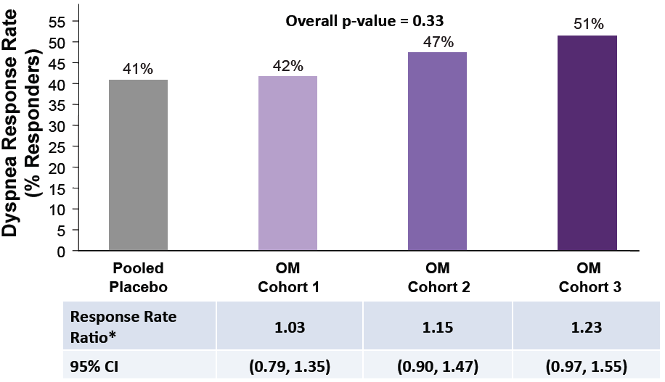
* Response rate ratio was calculated with Cochran-Mantel-Haenszel (CMH) test adjusting for region (North America and Australia vs. rest of the world)

Central Illustration, Panel B:

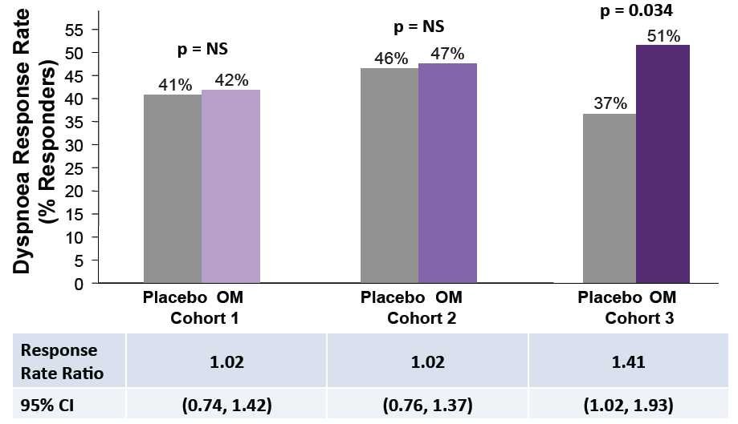

Figure 1:

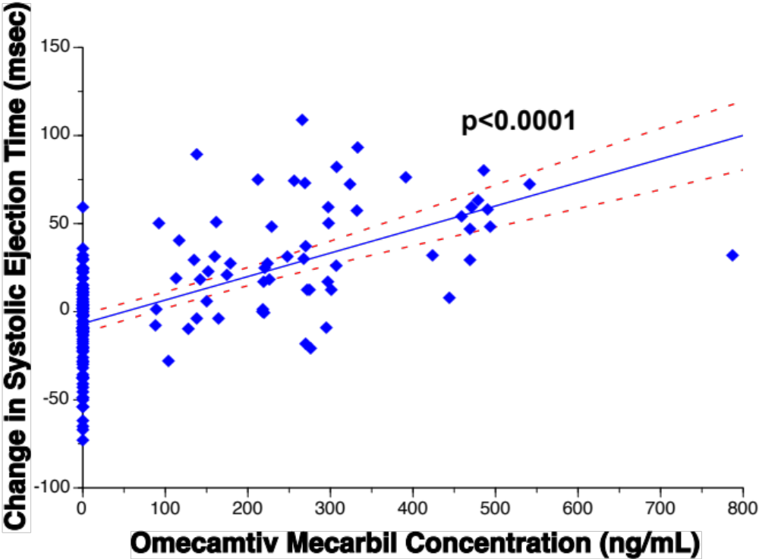

Figure 2, Panel A:
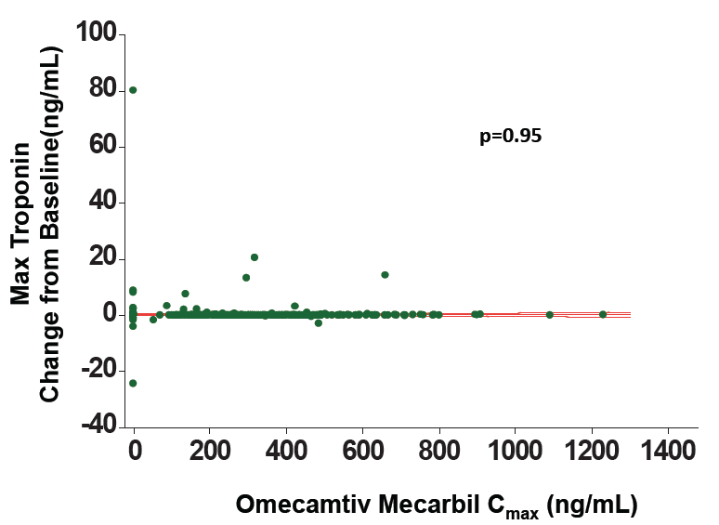
Figure 2, Panel B:
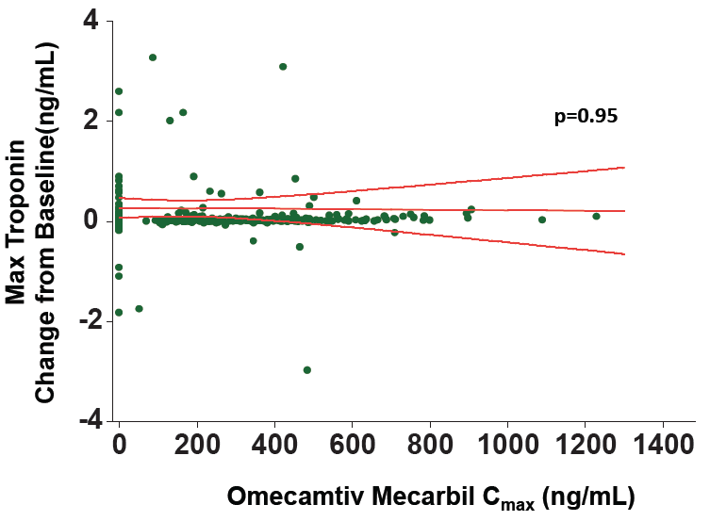

Perspectives:
Core Clinical Competencies: Recent major guidelines for acute heart failure therapies limit the use of agents that increase cardiac performance to patients with reduced ejection fractions and evidence of cardiogenic shock or markedly decreased perfusion and highlight the significant adverse event profile of these agents (3,4). No intervention that increases contractile function, such as adrenergic receptor agonists (e.g., dobutamine) or phosphodiesterase inhibitors (e.g., milrinone), or the calcium sensitizer levosimendan, has resulted in clinical efficacy without significant safety liabilities such as increased oxygen consumption, heart rate, hypotension, and arrhythmias.
Translational Implications: ATOMIC-AHF confirmed the pharmacodynamic hallmark of increased systolic ejection time in patients with AHF, while suggesting improvement in dyspnea in the high dose group. Importantly, the adverse effects of increased heart rate, hypotension, and ventricular and atrial arrhythmias were not evident. However, small increases in troponins were detected in the OM treated patients without apparent relationship to OM plasma concentrations. If confirmed in a larger, appropriately powered efficacy trial, OM may provide clinical benefit to a much broader range of patients with acute heart failure and reduced ejection fraction. The development of oral omecamtiv mecarbil for the treatment of patients with chronic heart failure is currently being explored in the COSMIC-HF study (ClinicalTrials.gov, NCT01786512).

