Figure Captions:

Figure 1 Schematic of the Wurster process and the different regions: 1) the spray zone, 2) the Wurster tube, 3) the fountain region, 4) the downbed region, and 5) the horizontal transport region.
Figure 2 A sketch of the bowl-shaped distributor: 1) nozzle, 2) solid, 3) fully-opened central base, and 4) outer annulus
Figure 3 (a) The surface mesh of the fluid bed and (b) the close-up of the bowl-shaped distributor (from top view)
Figure 4 The average vertical particle velocity along the radial direction for case #1 (VMD 1749 µm, batch size 200 g, fluidization air flow rate 73.3 m³/h and atomization air flow rate 3.50 m³/h).
Figure 5 A schematic of the spray zone
Figure 6 The cumulative cycle time distributions for different simulation times (with the first 2 s discarded), for case #1 (VMD 1749 µm, batch size 200 g, fluidization air flow rate 73.3 m³/h and atomization air flow rate 3.50 m³/h).
Figure 7 The particle velocity field at a vertical cross-section through the center of the bed (a) simulated using DEM-CFD and (b) measured using PEPT (VMD 1749 µm, batch size 200 g, fluidization air flow rate 73.3 m³/h and atomization air flow rate 3.50 m³/h).
Figure 8 The cycle time distribution (for cycles shorter than 25 s) calculated in the DEM-CFD simulation and measured in the PEPT experiment (VMD 1749 µm, batch size 200 g, fluidization air flow rate 73.3 m³/h and atomization air flow rate 3.50 m³/h).
Figure 9 (a) The mean residence times in different regions and (b) the mean fractions of the cycle time spent in different regions for case #1 (VMD 1749 µm, batch size 200 g, fluidization air flow rate 73.3 m³/h and atomization air flow rate 3.50 m³/h).
Figure 10 The solids fraction at a vertical cross-section through the center of the bed for different batch sizes: a) 200 g, b) 400 g and c) 600 g (VMD 1749 µm, fluidization air flow rate 73.3 m³/h and atomization air flow rate 3.50 m³/h).
Figure 11 The mean cycle time and RSD for different batch sizes (VMD 1749 µm, fluidization air flow rate 73.3 m³/h and atomization air flow rate 3.50 m³/h).
Figure 12 The simulated residence times in the spray zone and in the Wurster tube for different size particles.
Figure 13 The simulated residence time distributions in the spray zone for different size particles.
Figure 14 The simulated residence times of small and large particles in (a) the spray zone and in (b) the Wurster tube for different mixtures of small and large particles.
Figure 15 The simulated entrance distance into the spray zone of small and large particles for different mixtures of small and large particles.
Figure 16 The simulated relative rate of increase of the coating thickness between the large and small particles for different mixtures of small and large particles.

Figure 1 Schematic of the Wurster process and the different regions: 1) the spray zone, 2) the Wurster tube, 3) the fountain region, 4) the downbed region, and 5) the horizontal transport region.

Figure 2 A sketch of the bowl-shaped distributor: 1) nozzle, 2) solid, 3) fully-opened central base, and 4) outer annulus

Figure 3 (a) The surface mesh of the fluid bed and (b) the close-up of the bowl-shaped distributor (from top view)

Figure 4 The average vertical particle velocity along the radial direction for case #1 (VMD 1749 µm, batch size 200 g, fluidization air flow rate 73.3 m³/h and atomization air flow rate 3.50 m³/h).

Figure 5 A schematic of the spray zone

Figure 6 The cumulative cycle time distributions for different simulation times (with the first 2 s discarded), for case #1 (VMD 1749 µm, batch size 200 g, fluidization air flow rate 73.3 m³/h and atomization air flow rate 3.50 m³/h).

Figure 7 The particle velocity field at a vertical cross-section through the center of the bed (a) simulated using DEM-CFD and (b) measured using PEPT (VMD 1749 µm, batch size 200 g, fluidization air flow rate 73.3 m³/h and atomization air flow rate 3.50 m³/h).

Figure 8 The cycle time distribution (for cycles shorter than 25 s) calculated in the DEM-CFD simulation and measured in the PEPT experiment (VMD 1749 µm, batch size 200 g, fluidization air flow rate 73.3 m³/h and atomization air flow rate 3.50 m³/h).

Figure 9 (a) The mean residence times in different regions and (b) the mean fractions of the cycle time spent in different regions for case #1 (VMD 1749 µm, batch size 200 g, fluidization air flow rate 73.3 m³/h and atomization air flow rate 3.50 m³/h).

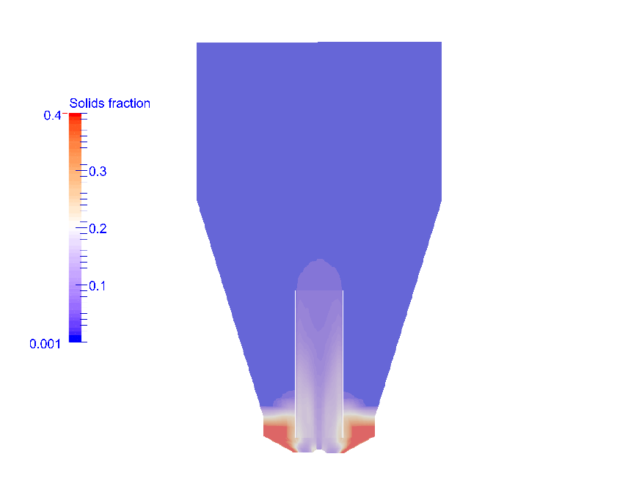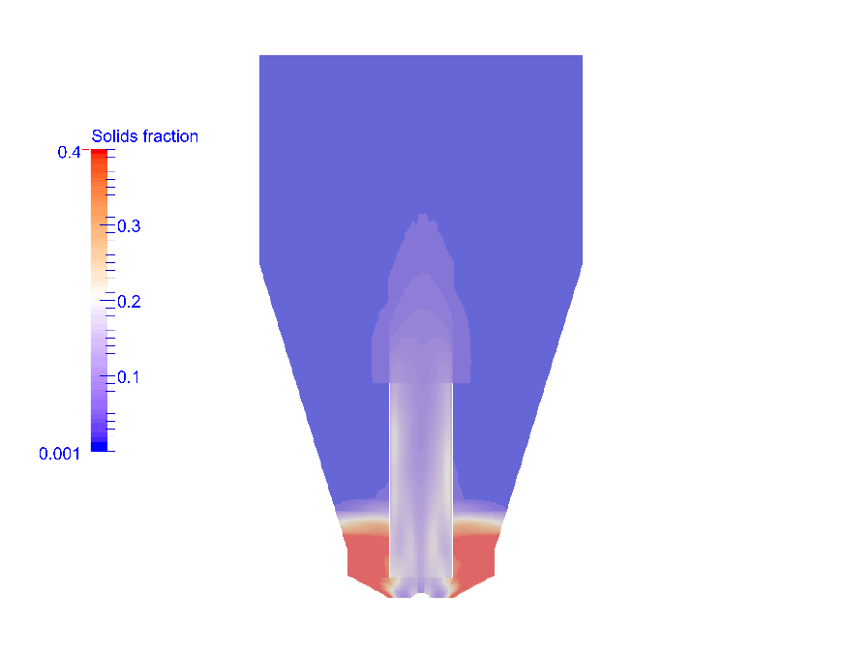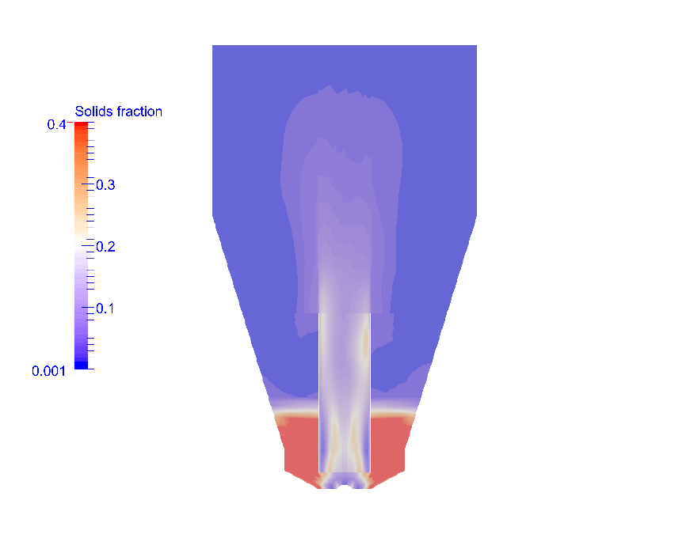
a
b
c
Figure 10 The solids fraction at a vertical cross-section through the center of the bed for different batch sizes: a) 200 g, b) 400 g and c) 600 g (VMD 1749 µm, fluidization air flow rate 73.3 m³/h and atomization air flow rate 3.50 m³/h).

Figure 11 The mean cycle time and RSD for different batch sizes (VMD 1749 µm, fluidization air flow rate 73.3 m³/h and atomization air flow rate 3.50 m³/h).

Figure 12 The simulated residence times in the spray zone and in the Wurster tube for different size particles.

Figure 13 The simulated residence time distributions in the spray zone for different size particles.

Figure 14 The simulated residence times of small and large particles in (a) the spray zone and in (b) the Wurster tube for different mixtures of small and large particles.

Figure 15 The simulated entrance distance into the spray zone of small and large particles for different mixtures of small and large particles.

Figure 16 The simulated relative rate of increase of the coating thickness between the large and small particles for different mixtures of small and large particles.

