TiO_{2-x} enhanced IR hot carrier based photodetection in metal thin film-Si junctions
Nicholas A. Güsken^{1,⊥,*}, Alberto Lauri^{1,⊥,*}, Yi Li¹, Takayuki Matsui¹, Brock Doiron¹, Ryan Bower², Anna Regoutz², Andrei Mihai², Peter K. Petrov², Rupert F. Oulton¹, Lesley F. Cohen¹, Stefan A. Maier^{1,3}
¹ The Blackett Laboratory, Department of Physics, Imperial College London, London SW7 2AZ, United Kingdom.
² Department of Materials, Imperial College London, London SW7 2AZ, United Kingdom.
³ Chair in Hybrid Nanosystems, Nanoinstitute Munich, Fakultät für Physik, Ludwig-Maximilians-Universität München, 80539 München, Germany.
* Corresponding authors: n.gusken16@imperial.ac.uk, a.lauri15@imperial.ac.uk
⊥ Author contributions: These authors contributed equally to this work.
Abstract
We investigate titanium nitride (TiN) thin film coatings on silicon for CMOS-compatible sub-bandgap charge separation upon incident illumination, which is a key feature in the vast field of on-chip photo detection and related integrated photonic devices. Titanium nitride of tunable oxidation distributions serves as an adjustable broadband light absorber with high mechanical robustness and strong chemical resistivity. Backside illuminated TiN on p-type Si (pSi) constitutes a self-powered and refractory alternative for photodetection providing a photoresponsivity of about ~1 mA/W at 1250 nm and zero bias while outperforming conventional metal coatings such as gold (Au). Our study discloses that the enhanced photoresponse of TiN/pSi in the near infra-red (IR) spectral range is directly linked to trap states in an ultrathin TiO_{2-x} interfacial interlayer which forms between TiN and Si. We show that a pSi substrate in conjunction with a few nanometer thick amorphous TiO_{2-x} film can serve as a platform for photocurrent enhancement of various other metals such as Au and Ti. Moreover, the photoresponse of Au on a TiO_{2-x}/pSi platform can be increased to about 4 mA/W under 0.45 V reverse bias at 1250 nm, allowing for controlled photo switching. A clear deviation from the typically assumed Fowler-like response is observed and an alternative mechanism is proposed to account for the metal/semiconductor TiO_{2-x} interlayer, capable of facilitating hole transport.
Keywords: Hot carriers, TiN thin films, TiO_{2-x}, sub-bandgap photodetection, CMOS compatible
Extracting energetic carriers from light absorption in so called hot carrier Schottky barrier (SB) junctions has attracted enormous attention as it allows harvesting low photon energies that have so far been omitted from semiconductor photodetectors.^{1–8} Since metals offer zero bandgap energy, their operation can in principle cover visible, mid-infrared, terahertz as well as microwave regimes, which holds great promises for gas detection,^{9,10} imaging sensors,¹¹ wavelength determination,^{12,13} power monitoring¹⁴ and sustainable power supplies^{15–17}. Taking silicon photo-detectors (with a bandgap energy of 1.1 eV)¹⁸ for instance, exploitation of SB devices can result in a highly integrated CMOS compatible and inexpensive alternative to commercially used Germanium (Ge) and Gallium Arsenic (GaAs) photodetectors at telecommunication wavelengths.^{1–3,5–8,19} SB junctions consist of a metal-semiconductor (SC) contact in which the difference in the work function of both materials leads to an energy band bending at the interface due to Fermi energy alignment on both sides via charge carrier diffusion and generation currents.¹⁸ However, this holds only true when the dipole at the interface generated by surface defects is not taken into consideration. Indeed, in the presence of surface defects and surface states, the electronegativity of the two semiconductors can be screened by the dipole at the interface. In this case the Fermi levels of the semiconductors are pinned to their charge neutrality level (CNL) modifying their position for the calculation of the band bending. This phenomenon is called Fermi level pinning. Depending on the type of majority carriers in the SC involved (p- or n-type), as well as its bandgap energy and respective work function to the metal, an accumulation layer or a Schottky barrier can form. The resulting potential barrier is smaller than the bandgap energy of the SC and can thus be overcome by excited carriers from the metal at energies below the SC bandgap, which leads to charge carrier separation. Various metals have been tested and both sp-band and d-band electron collection have been demonstrated upon light illumination and at zero-bias.^{19–21} However, a distinct carrier transfer mechanisms over junctions and new materials such as metal alloys and ceramics, as investigated here, could play a key role to further boost the performance compared to conventional SB junctions.
Titanium nitride (TiN) has been considered as a refractory plasmonic competitor to gold in a similar wavelength regime. Advantages such as low costs, mechanical robustness and strong chemical resistivity to acids, broadband heat resistance, relatively high electrical conductivity and non-corrosivity,^{16,22–25} makes it valuable for biocompatible medical sensors and implants^{26,27} as well as water splitting.¹⁶ Furthermore, its intrinsic optical properties are beneficial for broadband metamaterial absorption,^{28,29} photo thermal heating,³⁰ second harmonic generation,^{31,32} and Raman effects.³³ Hot carrier generation in TiN metal-insulator-metal (TiN-ZnO-TiN) photodetectors has been even found to outperform gold trilayers.³⁴ However, due to a strong dependence on its growth properties a comprehensive understanding of hot carrier transport via TiN has remained elusive.
Here we propose and fabricate a simple type of device with a TiN film directly on top of double-side polished p-type doped silicon. TiN-like, i.e. metallic (Figure S1) titanium oxynitride (TiO_{x}N_{y}) films grown with a low residual oxygen content³⁵ have been used, referred as TiN throughout the report. Transport in the sub-bandgap energy regime in illuminated SB junctions can often be explained by the Fowler model.^{1,19,36} However, we observe an anomalous and non-Fowler photoemission spectral response of pSi/TiN, where the most plausible reason can be attributed to a few nanometer thick amorphous TiO_{2-x} interlayer containing trap states, which forms between the TiN and pSi during growth. These deep level traps can promote hole transfer through TiO_{2-x},^{37–40} causing a deviation to the Fowler model. Our measurements support this hypothesis by comparing the response of a TiO_{2-x} free system (pSi/Au) to systems in which amorphous TiO_{2-x} interlayers have been intentionally introduced at the interface by sputtering, namely pSi/TiO_{2-x}/Ti, and pSi/TiO_{2-x}/Au. Our understanding of enhanced performance implying a trap state mediated hole transfer mechanism might stimulate further investigations of tunable metallic nitride systems for hot-carrier photodetection.
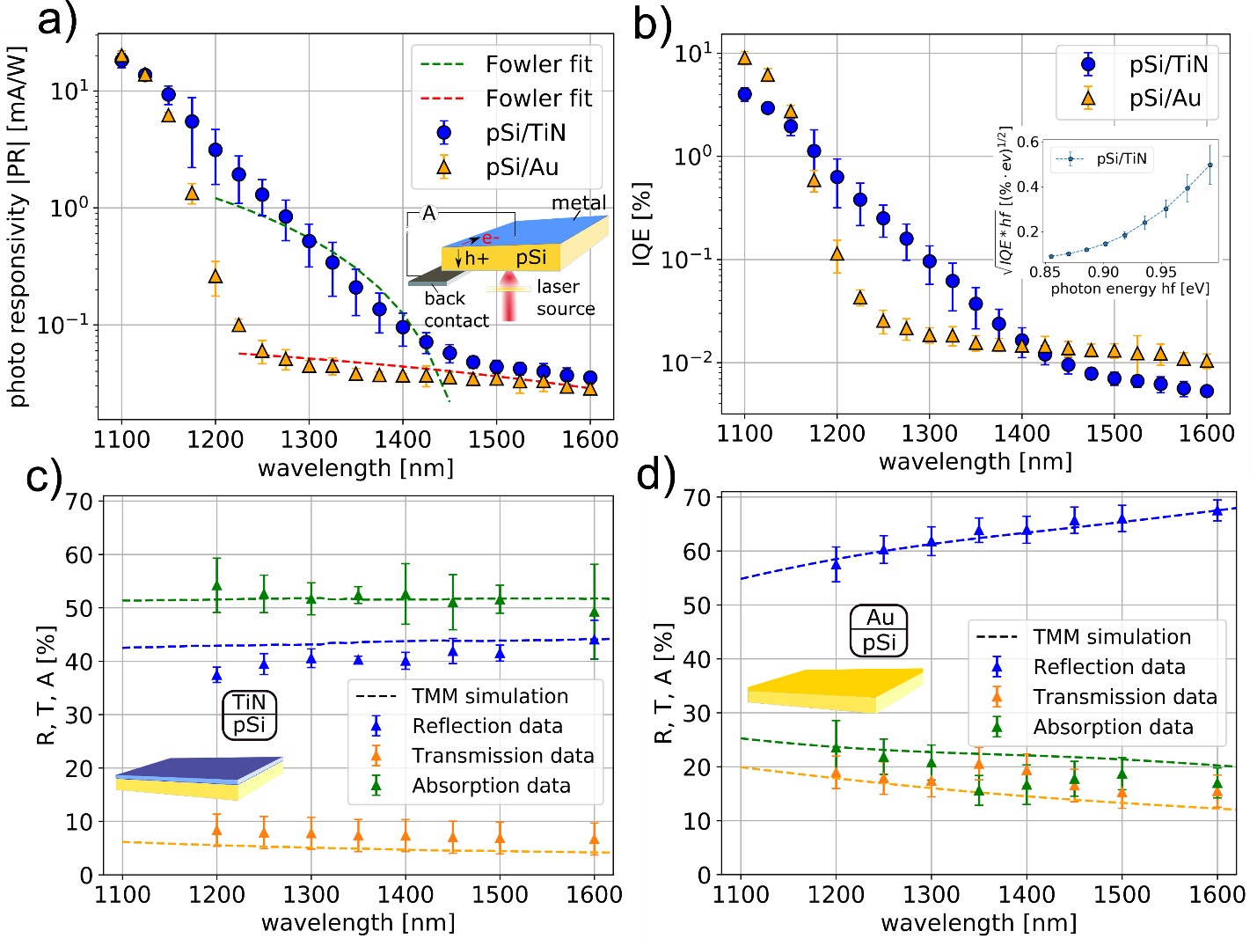
We adopt a simple back-illumination configuration of a hot carrier device which has been recently demonstrated to be an efficient solution for hot electron excitation in thin film junctions.⁴¹ It only relies on the thickness d of a given material rather than subwavelength nanostructures which is preferential as the strong photo-absorption is not achieved by plasmonic enhancement but via backside illumination of metallic thin films $(d≪λ/2π$, with the incident wavelength in air $λ$) through Si. Here, an absorption as strong as 52% has been achieved in a 50 nm TiN thin film by exploiting backside illumination and absorption enhancement via so-called zeroth order Fabry-Perot resonances.^{42,43} This approach bears the advantage that no additional patterning is needed, keeping fabrication steps to a minimum, contrary to the general case of plasmonic nanostructures, nanoparticles or gratings for instance. Our findings show that the amorphous TiO_{2-x} interlayer forming at the TiN interface during growth gives rise to a significant deviation of the photoresponse compared to a pSi/Au junction and can, in conjunction with pSi, be used as a platform for photocurrent enhancement for a range of different metal films.
Figure 1: a) Responsivity measurements at 0.3 mW of backside illuminated pSi/TiN (50 nm TiN) and pSi/Au (19 nm Au with a 2 nm Cr adhesion layer) including Fowler equation fits using the fit parameters of C_{f}= 6.6 x 10⁻²/eV with $ϕ_{B}=0.84 eV$for TiN and C_{f}= 1.2 x 10⁻³/eV with $ϕ_{B}=0.56 eV$ for Au, respectively (the TiN fit considers data from 1200 nm-1450 nm). The inset shows a schematic of a pSi/metal thin film sample including the front- and backside contacting for current read out as well as the respective directions of holes (h+) and electrons (e-). b) Calculated IQE of the measurement shown in a), using the absorption obtained in c), d). The inset in b) shows the non-linear $\sqrt{IQE*hf}$ characteristic. c), d) Reflection, transmission and absorption measurements compared to transfer-matrix-method (TMM) simulations for pSi/TiN and pSi/Au, respectively.

The opto-electric setup used for sample characterization is illustrated in the inset of Figure 1a). Micro probe tips connected to a source measuring unit were placed as electrical back- and frontside contacts and a wavelength selective super-continuum light source was used for backside illumination through a double-side polished pSi substrate (see SI, section 1). The 500 μm thick pSi ($n_{A}≈9*{10}^{14}{cm}^{-3})$ substrate assures hole collection via the backside contact. The setup enables photocurrent measurements to determine the photoresponsivity (PR) which is one of the key figures of merit to characterize photodetectors and is defined as:
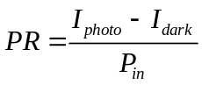 , (1)
where I_{photo} is the photo induced current, I_{dark} the dark current and P_{in} the power of the incident laser beam. The metal film thickness of Au (d=19 nm) and TiN (d=50 nm) were chosen based on analytical solution of the Fresnel equations by optimizing the thickness d under the given fabrication conditions (Figure S7).
Figure 1a) depicts the responsivity under illumination comparing a pSi/TiN with a pSi/Au junction (see SI for fabrication details). The pSi/TiN junction provides a PR signal of ≈1 mA/W at 1250 nm which is in the competitive range with comparable zero-bias photo detection studies^{8,19,41,44} whereas the PR of pSi/Au remains at ≈0.06 mA/W. Strikingly, the PR dispersions of pSi/TiN and pSi/Au deviate significantly from one another which points towards a different current generation mechanism at play. In order to clarify this difference both curves have been compared to the modified Fowler equation,^{45,46} typically used^{1,19,36} to describe the photoresponse of hot carrier SB junctions:
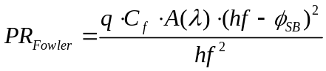, (2)
with q the elementary charge, C_{f} the Fowler emission coefficient, A(λ) the wavelength dependent absorption, hf the energy of the incident photon and Φ_{SB} the SB potential height at the SC/metal interface. From fitting the experimental data obtained for pSi/Au shown in Figure 1a), a barrier height of 0.56 eV can be extracted, which reasonably agrees with the barrier height of 0.61 eV estimated via the thermionic emission model and dark IV measurements (Figure S9, Eq. S1). Our fit excludes the tail of Si bandgap transitions which start to dominate at 1225 nm. The good agreement with the Fowler model matches well with our expectation that the response obtained by illuminating the pSi/Au thin film system can be understood by a hot carrier transfer mechanism, as equally observed in comparable studies.^{19,41} Here, sufficiently energetic intraband transitions (> Φ_{SB}) of carriers in the gold sp-band give rise to hole transfer over the SB at the pSi/Au interface and a consecutive collection in the pSi,⁴⁶ thus separating the charges. On the contrary, the response of pSi/TiN, shows an exponential PR trend which deviates from Fowler’s description (see Figure 1a), b)). However, a high PR of 1 mA/W shows that TiN can indeed be used for efficient zero bias photodetection, outperforming commercial Si detectors⁴¹ while exhibiting a dark current below 10 nA at low bias, an open circuit potential of 150 mV (Figure S12) and an internal quantum efficiency (IQE) of ≈0.2% at 1250 nm which is comparable to patterned plasmonic structures.¹⁹ The IQE is defined as:⁴⁶
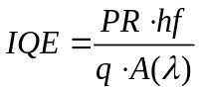, (3)
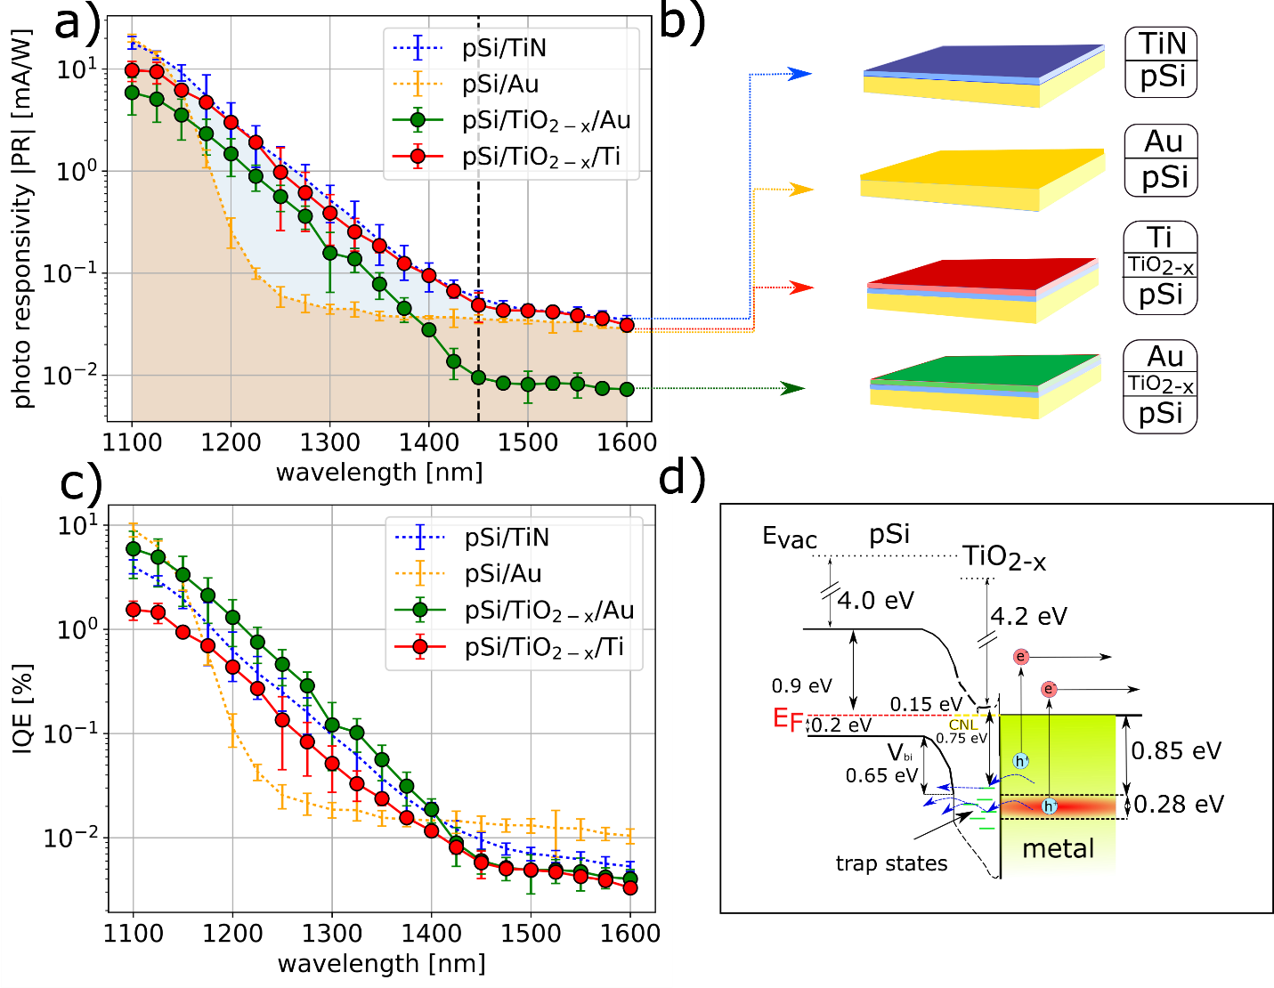
and is depicted for both systems in Figure 1b), showing that the deviating dispersion cannot be explained by differences in absorption. The inset in Figure 1b) indicates that the photoresponse follows an exponential trend in energy which deviates from the linear behavior, $\sqrt{IQE*hf}∝hf$, predicted by Fowler’s theory. The absorption spectra are in good agreement with the transfer-matrix-method (TMM) simulations for both samples as shown in Figure 1c) and Figure 1d), respectively. While the Au thin film absorbs about half as much as the TiN film, both dispersions are mostly flat which excludes a strong impact on the PR dispersion shape.
Figure 2: a) Responsivity of pSi/TiO_{2-x}/Au (19 nm) and pSi/TiO_{2-x}/Ti (50 nm) with 5 nm TiO_{2-x} each compared to pSi/TiN and pSi/Au (dotted lines, coloured area), schematically shown in b). The black dashed line indicates the cut-off wavelength. c) IQE for the samples shown in b) while the absorption was calculated via TMM simulations (Figure S6). d) Band energy diagram of the pSi/TiO_{2-x}/metal system studied, illustrating the proposed mechanism. Here, the red area from 0.85 eV to 1.13 eV marks the excitation energy equivalent to the wavelength laying to the left of the cut-off observed in a). The holes are illustrated by blue and electrons by red dots, E_{vac} is the vacuum level, E_{F} the Fermi level, V_{bi} the built-in potential and CNL the charge neutrality level.

Turning the attention onto the interface composition, it is known that TiN exhibits a few nanometer thick amorphous TiO_{2-x} surface layer which forms during growth.^{47,48} This could also be confirmed by secondary ion mass spectrometry (SIMS) shown in Figure S3. Although crystalline TiO_{2-x} generally acts as a hole blocking layer,⁴⁹ amorphous TiO_{2-x} allows for hole carrier transfer via trap states^{37–40} which consist of Ti³⁺ states and oxygen vacancies.^{24,50,51} Ti³⁺ trap states have been identified in the TiO_{2-x} film used for this study via X-ray photoelectron spectroscopy (see Figure S4).
In order to disclose the impact of the TiO_{2-x} interfacial layer and reveal its relation to the PR dispersion in hot SB junctions, a comparison between an oxide free system and oxide containing systems has been performed, illustrated in Figure 2. Here, the PR of pSi/Au is directly compared to TiO_{2-x} containing systems namely pSi/TiO_{2-x}/Ti and pSi/TiO_{2-x}/Au as illustrated in Figure 2a), b), in which a 5 nm thin amorphous TiO_{2-x} interlayer has been additionally introduced to imitate the pSi/TiN interlayer (Figure S2). We find that the introduction of an oxide interlayer allows for conversion of the PR dispersion from the Fowler like behavior, observed in an oxide free system, into a pSi/TiN like response, observed in the oxide containing system. The comparison between pSi/Au and pSi/TiO_{2-x}/Au discloses that the addition of a TiO_{2-x} thin film changes the response drastically, enhancing it between 1160 nm and 1400 nm by over one order of magnitude. The shape of the pSi/TiO_{2-x}/Au and the pSi/TiN response coincide while exhibiting the same slope cut-off value at 1450 nm. Moreover, the same holds true for the PR of a Ti thin film deposited onto the TiO_{2-x} interlayer. For pSi/TiO_{2-x}/Au however, the PR at longer wavelength (> 1400 nm) has dropped by one order of magnitude compared to Au only and TiN. This drop can be understood by taking the low absorption, A(λ), of the pSi/TiO_{2-x}/Au stack into account which is merely ≈11% compared to ≈52% in pSi/TiN and ≈25% in pSi/Au as extracted from TMM simulations (Figure S6) and absorption measurements (Figure 1c), d)).
The prominent role of the metal absorption becomes furthermore apparent when considering the IQE shown in Figure 2c). Here, all values of TiO_{2-x} containing samples lay at similar values of around 0.2% at 1250 nm. The comparison of an oxide free system with TiO_{2-x} containing samples points out that the TiO_{2-x} interlayer is at the core of the significant variation between the PR dispersion observed for pSi/Au and pSi/TiN. Indeed, the findings suggest that an amorphous TiO_{2-x} thin film in a pSi/TiO_{2-x}/metal system enables strong PR enhancement for various metals compared to an oxide free system, here explicitly shown for an Au thin film. The strong metal absorption dependence apparent from the IQE dispersion shown in Figure 2c) implies that the metal predominantly acts as an absorber while the actual TiO_{2-x}/metal interface promotes hole transport in the sub-bandgap region in a specific wavelength regime presumably via trap states as illustrated in Figure 2d). The comparison between the TiO_{2-x} free Au/pSi system and the TiO_{2-x} containing systems allows three main observations: i) deviating PR dispersion which points towards fundamental different current generation mechanisms, ii) distinct PR cut-off value separating the PR dispersion into two regimes and iii) strong PR increase for TiO_{2-x} containing systems.
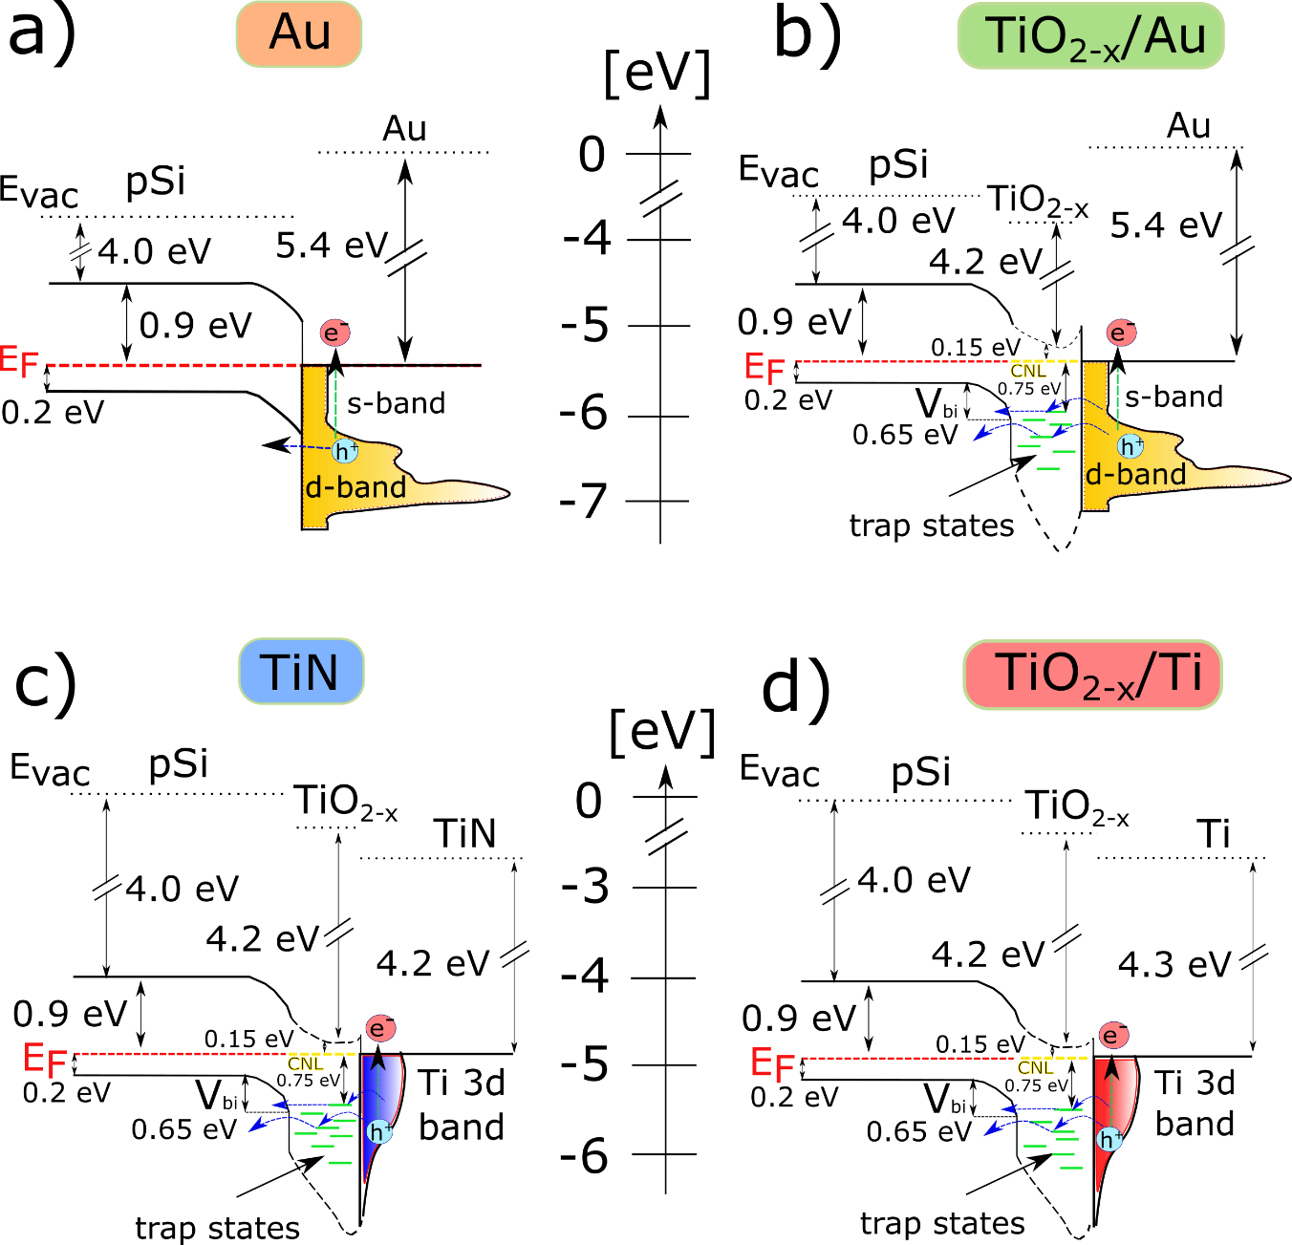
In order to further unlock the origin of the observations listed we consider the band model diagrams of each layer system, depicted in Figure 3. The band model diagram of a TiO_{2-x} free pSi/Au system is shown in Figure 3a). Here, hot hole excitation and transfer over the SB at the pSi/Au interface upon incident illumination is illustrated. This mechanism can be described by the Fowler model. Figures 3b)–d) show the pSi/TiO_{2-x}/TiN, pSi/TiO_{2-x}/Au and pSi/TiO_{2-x}/Ti systems, taking a few nanometers thin TiO_{2-x} interlayer into account which leads to Fermi level pinning at the charge neutrality level (CNL) of TiO_{2-x} (SI section 7). Amorphous TiO_{2-x} possesses a bandgap energy of about 3.2 eV,³⁸ constituting a hole barrier which is usually too large to be overcome by the excitation energies considered here (1.1 eV–0. 77 eV). However, two modifications of this hole blocking interlayer can give rise to the hole conduction observed. First, inter-bandgap trap states in amorphous TiO_{2-x} allow for trap state assisted hole transfer,^{37–39} illustrated in green in Figure 3. Second, the ≈ 5 nm thin TiO_{2-x} interlayer is strongly affected by band bending at both interfaces, resulting in an effectively lower bandgap than 3.2 eV. Based on the carrier density in the pSi and the TiO_{2-x,} we estimated a depletion region width of $≈0.9 µm$ in the pSi and $≈10 nm$ in the TiO_{2-x} at the pSi/TiO_{2-x} interface via Poisson’s equation (Eq. S4 and S5). This gives rise to a steep band profile as schematically indicated in Figure 3b)-d). The values for the hole barrier height extracted from dark IV measurements lay close to $≈0.85$ eV (see Table S1) for all TiO_{2-x} containing systems examined. The similarity of the values is due to the fact that the pSi/TiO_{2-x} interface determines the hole barrier as the TiO_{2-x}/metal barrier can be neglected for holes which are conducted via inter-gap trap states. This is in reasonable agreement with our barrier height estimate of 0.8 eV which takes pinning at the CNL into account (see SI section 7). Furthermore, the measured SB corresponds also to the cut-off value at 1450 nm, which can be understood by the fact that a SB impedes the transfer of holes with less energy than the SB height.
Figure 3: Band energy diagrams showing the simplified band alignment of a) Au/pSi b) pSi/TiO_{2-x}/Au c) pSi/TiO_{2-x}/TiN and d) pSi/TiO_{2-x}/Ti. The SB heights used are in line with $ϕ_{Au}≈0.61 eV$, $ϕ_{Au/TiO2}≈0.83 eV,$ $ϕ_{TiN}≈0.85 eV$and$ϕ_{Ti/TiO2}≈0.83 eV$, as estimated from dark IV curves using the thermionic model (see Table S1). The blue and green arrows indicate the transition of holes and electrons, respectively for excitation energies from 0.77 eV to 1.13 eV. E_{vac} is the vacuum level, E_{F} the Fermi level, V_{bi} the built-in potential and CNL the charge neutrality level.
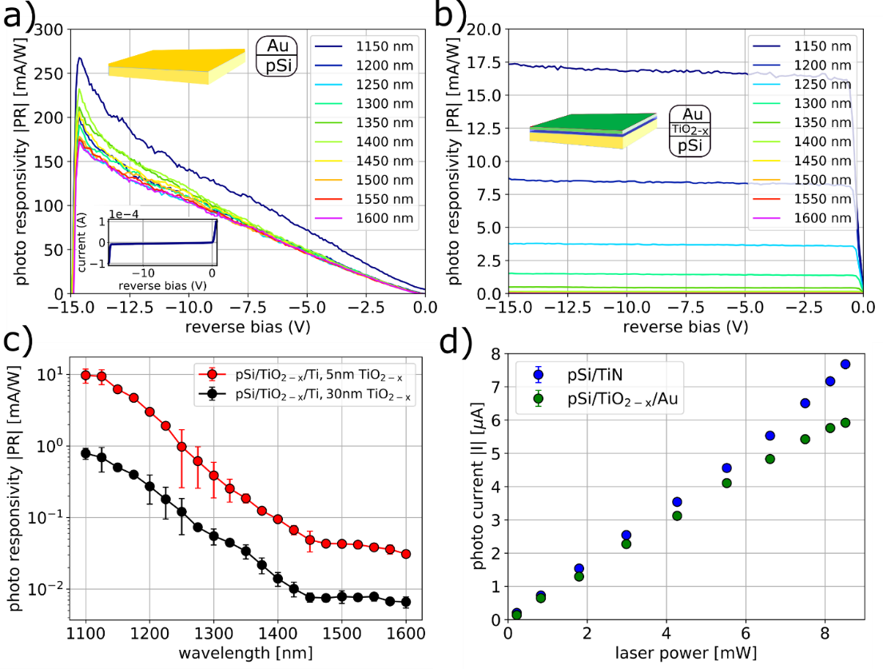
To summarize, we propose that the response to the left from the cut-off (>1450 nm) is originated in trap state assisted carrier transfer towards and over a TiO_{2-x}/pSi SB. Thus, it exhibits a different dispersion from the direct hot hole excitation over a SB observed in pSi/Au, which explains observation i). Addressing observation ii), the response to the right of the cut-off (<1450 nm) can instead be attributed to conduction through trap states that are below the pSi/TiO_{2-x} SB (≈ 0.85 eV) and are thus encountering a barrier as depicted in Figure 3b)-d). The barrier values determined under consideration of the Fermi level pinning and dark IV measurements, lay close to the cut-off value observed in the photoresponse measurements. This points to two different conduction paths for the hot holes: one above the hole barrier (left of the cut-off and strong photoresponse) and one with the additional barrier (right of the cut-off and lower photoresponse). The fact that the oxide containing systems show a stronger PR than bare pSi/Au, hints to the fact that the TiO_{2-x} interfacial layer facilitates hole injection into the pSi compared to the direct SB interface, which addresses observation iii). This, might be related to longer carrier lifetimes in the TiO_{2-x} but a detailed analysis is beyond the scope of this study.⁴⁷ Moreover, a strong current response due to the interplay with TiO_{2-x} has also been observed for hot electron conduction,^{21,52} but still remains to be fully understood.
Figure 4: a) Responsivity under reverse bias for pSi/Au in (a) and pSi/TiO_{2-x}/Au in (b) at different wavelengths and $0.3 mW$. The inset shows the dark IV. c) Responsivity without bias for pSi/TiO_{2-x}/Ti with TiO_{2-x} thicknesses of 5 nm and 30 nm, respectively at $0.3 mW$. d) Power dependence of the photocurrent at 1250 nm excitation wavelength in pSi/TiN and pSi/TiO_{2-x}/Au.
The different transfer mechanisms (observation i)) become furthermore apparent under reverse bias condition. The PR of the pSi/Au junction shown in Figure 4a) increases with reverse bias until breakdown, as the carriers can be excited over the SB and consecutively collected due to an external field. Moreover, the dark current stays at a minimum due to the Schottky barrier blocking potential.^{5–7,36} On the contrary, as shown in Figure 4b), pSi/TiO_{2-x}/Au exhibits a saturation behavior rising from ≈0.8 mA/W at zero bias to 4 mA/W at -0.45 V in reverse bias. This is typical for photodiodes in photoconductive mode and can be equally observed for pSi/TiN (Figure S13). Here, the breakdown occurs just below -15 V. The spectral dependence can be attributed to the fact that higher energies are able to excite a wider range of carriers in the metal which are consecutively available for transfer. The photocurrent in common photo diodes is created via electron-hole pair generation in the p-i-n intrinsic (i) depletion region and from trap states in the bandgap. However, the IR absorption of the 5 nm TiO_{2-x} thin film investigated here is negligible as confirmed by ellipsometry measurements (Figure S5). Thus, our observations suggest that the high PR stems from holes which are excited in the metal and transferred consecutively via trap states. This gives rise to a significantly different PR under reverse bias compared to pSi/Au, where the hot holes are transferred directly over the barrier.
We further support this hypothesis by comparing different thicknesses of the TiO_{2-x} interlayer namely 5 nm and 30 nm of the pSi/TiO_{2-x}/Ti system as shown in Figure 4c). Here, we expect an increase of the TiO_{2-x} effective bandgap as the pSi/TiO_{2-x} depletion region width stays constant which results in a decreasing PR due to a larger distance to the metal. Although the absorption in both samples deviate by less than 8% (Figure S6), the PR drops by over one order of magnitude, while the dispersion stays the same. This shows that the vicinity to the metal is crucial for a high PR but does not define the dispersion. A similar observation has been made by Tan et al.⁵³ for Au on TiO_{2-x}, where a rough Au film gave rise to plasmonic enhancement. However, this is not plausible for the smooth films used here (Figure S1). Also, carrier multiplication as reported by other groups⁵⁴ can be excluded due to a linear power dependence shown in Figure 4d). Our observations hint to the fact that a metal absorber provides holes which can travel to the pSi/TiO_{2-x} interface, where they participate in the trap state assisted carrier excitation and are consecutively injected into the pSi. With increasing TiO_{2-x} thickness, fewer holes can travel to the pSi/TiO_{2-x} depletion region as they are blocked by the TiO_{2-x} bandgap or subject to recombination in the n-type TiO_{2-x}.
In conclusion we have demonstrated Si-compatible sub-bandgap photodetection at zero bias for a backside illuminated 50 nm TiN thin film on a p-type Si substrate, exhibiting a photoresponsivity of 1 mA/W at 1250 nm. We showed that the amorphous TiO_{2-x} interlayer between the pSi and the TiN is at the origin of a distinct photoresponse which significantly differs from the one of an oxide free pSi/Au comparison sample. Moreover, we disclosed that a 5 nm amorphous TiO_{2-x} interlayer between a pSi substrate and a metal thin film leads to an increase in photoresponsivity at zero bias of about one order of magnitude compared to an oxide free system. A non-Fowler like dispersion was observed for Ti, Au and TiN and as well as a clear PR enhancement for oxide containing systems when comparing Au/pSi to Au/TiO_{2-x}/pSi. Our findings suggest that the metal merely acts as an absorber enabling hole carrier transfer via TiO_{2-x} trap states and consecutive collection in the pSi. This result is promising as the metal absorption can be further enhanced by nano-structuring to access plasmonic resonances. Additionally, the photoresponsivity of pSi/TiO_{2-x}/Au can be increased from about 0.8 mA/W to 4 mA/W at zero and 0.45 V reverse bias, respectively allowing for bias dependent photo switching. We believe that the study conducted is valuable as it emphasizes the importance to fine-tune defects in metallic nitrides and oxide interlayers for the use as hot carrier sources. Moreover, pSi/TiO_{2-x} constitutes a platform for photocurrent enhancement at zero bias based on an alternative transport mechanism which exploits oxygen interfacial vacancies, acting as hole mediating trap states. The material system explored combines the extensively studied materials TiO_{2-x} and Si with TiN which constitutes a promising candidate for a wide range of opto-electronic and plasmonic applications.

ASSOCIATED CONTENT
Supporting Information. Details about the measurement setup, photoresponse measurement from the Si-substrate, thermionic emission model including a table of expected SB heights at the interface, details about the sample fabrication and characterization, photocurrent maps, transfer matrix method (TMM) absorption calculations, estimate of the depletion zone width, photoresponse of TiN under bias and IV measurements in the dark.

AUTHOR INFORMATION
Corresponding Author
*E-mail: n.gusken16@imperial.ac.uk
*E-mail: a.lauri15@imperial.ac.uk
Orcid:
Nicholas A. Güsken: 0000-0002-4816-0666
Alberto Lauri: 0000-0001-5517-6511

Acknowledgements:
The authors acknowledge funding provided by the EPSRC Reactive Plasmonics Program (No. EP/M013812/1), the Lee-Lucas Chair in Physics and the Henry Royce Institute made through EPSRC grant EP/R00661X/1. A.L. acknowledge the funding from the WiTec scholarship for studies in nanophotonics.

References:
(1) Knight, M. W.; Wang, Y.; Urban, A. S.; Sobhani, A.; Zheng, B. Y.; Nordlander, P.; Halas, N. J. Embedding Plasmonic Nanostructure Diodes Enhances Hot Electron Emission. Nano Lett. 2013, 13 (4), 1687–1692.
(2) Knight, M. W.; Sobhani, H.; Nordlander, P.; Halas, N. J. Photodetection with Active Optical Antennas. Science 2011, 332 (6030), 702–704.
(3) Brongersma, M. L.; Halas, N. J.; Nordlander, P. Plasmon-Induced Hot Carrier Science and Technology. Nat. Nanotechnol. 2015, 10 (1), 25–34.
(4) Wen, L.; Chen, Y.; Liang, L.; Chen, Q. Hot Electron Harvesting via Photoelectric Ejection and Photothermal Heat Relaxation in Hotspots-Enriched Plasmonic/Photonic Disordered Nanocomposites. ACS Photonics 2018, 5 (2), 581–591.
(5) Casalino, M.; Coppola, G.; Iodice, M.; Rendina, I.; Sirleto, L. Near-Infrared Sub-Bandgap All-Silicon Photodetectors: State of the Art and Perspectives. Sensors 2010, 10 (12), 10571–10600.
(6) Lavirad, M. O. A.; Livieri, A. N. O.; Oy, L. A. R.; Ierre, P. Plasmonic Schottky Detectors. 2016, 24 (20), 22544–22554.
(7) Goykhman, I.; Desiatov, B.; Khurgin, J.; Shappir, J.; Levy, U. Locally Oxidized Silicon Surface-Plasmon Schottky Detector for Telecom Regime. Nano Lett. 2011, 11 (6), 2219–2224.
(8) Li, W.; Valentine, J. Metamaterial Perfect Absorber Based Hot Electron Photodetection. Nano Lett. 2014, 14 (6), 3510–3514.
(9) Boulesbaa, A.; Borguet, E.; Sil, D.; Gilroy, K. D.; Neretina, S.; Niaux, A. Seeing Is Believing: Hot Electron Based Gold Nanoplasmonic Optical Hydrogen Sensor. ACS Nano 2014, 8 (8), 7755–7762.
(10) Buso, D.; Post, M.; Cantalini, C.; Mulvaney, P.; Martucci, A. Gold Nanoparticle-Doped TiO 2 Semiconductor Thin Films: Gas Sensing Properties. Adv. Funct. Mater. 2008, 18 (23), 3843–3849.
(11) Mirzaee, S. M. A.; Lebel, O.; Nunzi, J. M. Simple Unbiased Hot-Electron Polarization-Sensitive Near-Infrared Photodetector. ACS Appl. Mater. Interfaces 2018, 10 (14), 11862–11871.
(12) Wang, F.; Melosh, N. A. Power-Independent Wavelength Determination by Hot Carrier Collection in Metal-Insulator-Metal Devices. Nat. Commun. 2013, 4, 1711.
(13) Tao, Y.; Madani, K.; Cho, E.; Rounsaville, B.; Upadhyaya, V.; Rohatgi, A. High-Efficiency Selective Boron Emitter Formed by Wet Chemical Etch-Back for n -Type Screen-Printed Si Solar Cells. Appl. Phys. Lett. 2017, 110 (2), 021101.
(14) Casalino, M.; Coppola, G.; Iodice, M.; Rendina, I.; Sassi, U.; Lombardo, A.; Milana, S.; Sundaram, R. S.; Ferrari, A. C.; Sirleto, L. Silicon Photodetectors Based on Internal Photoemission Effect: The Challenge of Detecting near Infrared Light. Int. Conf. Transparent Opt. Networks 2014, 3–6.
(15) Nishijima, Y.; Ueno, K.; Yokota, Y.; Murakoshi, K.; Misawa, H. Plasmon-Assisted Photocurrent Generation from Visible to near-Infrared Wavelength Using a Au-Nanorods/TiO2 Electrode. J. Phys. Chem. Lett. 2010, 1 (13), 2031–2036.
(16) Naldoni, A.; Guler, U.; Wang, Z.; Marelli, M.; Malara, F.; Meng, X.; Besteiro, L. V.; Govorov, A. O.; Kildishev, A. V.; Boltasseva, A.; et al. Broadband Hot-Electron Collection for Solar Water Splitting with Plasmonic Titanium Nitride. Adv. Opt. Mater. 2017, 5 (15), 1–11.
(17) Gong, T.; Munday, J. N. Angle-Independent Hot Carrier Generation and Collection Using Transparent Conducting Oxides. Nano Lett. 2015, 15 (1), 147–152.
(18) Gross, R.; Marx, A. Festkörperphysik, 2nd ed.; GmbH, W. de G., Ed.; Walter de Gruyter GmbH: Berlin/Boston, 2014.
(19) Wen, L.; Chen, Y.; Liang, L.; Chen, Q. Hot Electron Harvesting via Photoelectric Ejection and Photothermal Heat Relaxation in Hotspots-Enriched Plasmonic/Photonic Disordered Nano-Composites. ACS Photonics 2018, 5 (2), 581-591
(20) Tagliabue, G.; Jermyn, A. S.; Sundararaman, R.; Welch, A. J.; DuChene, J. S.; Pala, R.; Davoyan, A. R.; Narang, P.; Atwater, H. A. Quantifying the Role of Surface Plasmon Excitation and Hot Carrier Transport in Plasmonic Devices. Nat. Commun. 2018, 9 (1), 3394.
(21) Zheng, B. Y.; Zhao, H.; Manjavacas, A.; McClain, M.; Nordlander, P.; Halas, N. J. Distinguishing between Plasmon-Induced and Photoexcited Carriers in a Device Geometry. Nat. Commun. 2015, 6, 1–7.
(22) Banerjee, A. R.; Eath, R. O. M. H.; Orozov, D. M. M.; Ilini, D.; Emakumara, H.; Asti, U. M. N.; Hayne, I. A. I. N. T.; Obert, R. H.; Adfield, H.; Photonics, Q.; et al. Optical Properties of Refractory Metal Based Thin Films. Opt. Mater. Express 2018, 8 (8), 2072–2088.
(23) Graciani, J.; Hamad, S.; Sanz, J. F. Changing the Physical and Chemical Properties of Titanium Oxynitrides TiN1−xOx by Changing the Composition. Phys. Rev. B 2009, 80 (18), 184112.
(24) Gutiérrez Moreno, J. J.; Nolan, M. Ab Initio Study of the Atomic Level Structure of the Rutile TiO2 (110)–Titanium Nitride (TiN) Interface. ACS Appl. Mater. Interfaces 2017, 9 (43), 38089–38100.
(25) Wells, M. P.; Bower, R.; Kilmurray, R.; Zou, B.; Mihai, A. P.; Gobalakrichenane, G.; Alford, N. M.; Oulton, R. F. M.; Cohen, L. F.; Maier, S. A.; et al. Temperature Stability of Thin Film Refractory Plasmonic Materials. Opt. Express 2018, 26 (12), 15726.
(26) Lawand, N. S.; French, P. J.; Briaire, J. J.; Frijns, J. H. M. Thin Titanium Nitride Films Deposited Using DC Magnetron Sputtering Used for Neural Stimulation and Sensing Purposes. Procedia Eng. 2012, 47, 726–729.
(27) Tian, W.; Wang, Y.; Chen, L.; Li, L. Self-Powered Nanoscale Photodetectors. Small 2017, 13 (45), 1701848.
(28) Chirumamilla, M.; Chirumamilla, A.; Yang, Y.; Roberts, A. S.; Kristensen, P. K.; Chaudhuri, K.; Boltasseva, A.; Sutherland, D. S.; Bozhevolnyi, S. I.; Pedersen, K. Large-Area Ultrabroadband Absorber for Solar Thermophotovoltaics Based on 3D Titanium Nitride Nanopillars. Adv. Opt. Mater. 2017, 5 (22), 1–8.
(29) Li, W.; Guler, U.; Kinsey, N.; Naik, G. V.; Boltasseva, A.; Guan, J.; Shalaev, V. M.; Kildishev, A. V. Refractory Plasmonics with Titanium Nitride: Broadband. Adv. Mater. 2014, 26 (47), 7959–7965.
(30) Guler, U.; Ndukaife, J. C.; Naik, G. V.; Nnanna, a. G. A.; Kildishev, A.; Shalaev, V. M.; Boltasseva, A. Local Heating with Lithographically Fabricated Plasmonic Titanium Nitride Nanoparticles. Nano Lett. 2013, 13, 6078–6083.
(31) Gui, L.; Metzger, B.; Bagheri, S.; Zgrabik, C. M.; Strohfeldt, N.; Hu, E. L.; Giessen, H. Nonlinear Refractory Plasmonics with TiN Nanoantennas. Nano Lett. 2016, 16 (9), 5708-5713.
(32) Sterke, D.; Martijn, C. Doubly-Enhanced Second Harmonic Generation through Structural and Epsilon-near-Zero Resonances in TiN Nanostructures. ACS Photonics 2018, 5 (6), 2087-2093.
(33) Kharintsev, S. S.; Kharitonov, A.; Saikin, S.; Alekseev, A. M.; Kazarian, S. G. Nonlinear Raman Effects Enhanced by Surface Plasmon Excitation in Planar Refractory Nanoantennas. Nano Lett. 2017, 17 (9), 5533-5539.
(34) Ishii, S.; Shinde, S. L.; Jevasuwan, W.; Fukata, N.; Nagao, T. Hot Electron Excitation from Titanium Nitride Using Visible Light. ACS Photonics 2016, 3 (9), 1552–1557.
(35) Braic, L.; Vasilantonakis, N.; Mihai, A.; Villar Garcia, I. J.; Fearn, S.; Zou, B.; Alford, N. M. N.; Doiron, B.; Oulton, R. F.; Maier, S. A.; et al. Titanium Oxynitride Thin Films with Tunable Double Epsilon-Near-Zero Behavior for Nanophotonic Applications. ACS Appl. Mater. Interfaces 2017, 9 (35), 29857–29862.
(36) Matsui, T.; Li, Y.; Hsu, M.-H. M.; Merckling, C.; Oulton, R. F.; Cohen, L. F.; Maier, S. A. Highly Stable Plasmon Induced Hot Hole Transfer into Silicon via a SrTiO3 Passivation Interface. Adv. Funct. Mater. 2018, 28 (17), 1705829.
(37) Rittmann-Frank, M. H.; Milne, C. J.; Rittmann, J.; Reinhard, M.; Penfold, T. J.; Chergui, M. Mapping of the Photoinduced Electron Traps in TiO2 by Picosecond X-Ray Absorption Spectroscopy. Angew. Chemie Int. Ed. 2014, 53 (23), 5858–5862.
(38) Pham, H. H.; Wang, L. Oxygen Vacancy and Hole Conduction in Amorphous TiO2. Phys. Chem. Chem. Phys. 2015, 17 (1), 541–550.
(39) Hu, S.; Shaner, M. R.; Beardslee, J. A.; Lichterman, M.; Brunschwig, B. S.; Lewis, N. S. Amorphous TiO2 Coatings Stabilize Si, GaAs, and GaP Photoanodes for Efficient Water Oxidation. Science 2014, 344 (6187), 1005–1009.
(40) Abdullah, S. A.; Sahdan, M. Z.; Nafarizal, N.; Saim, H.; Bakri, A. S.; Cik Rohaida, C. H.; Adriyanto, F.; Sari, Y. Photoluminescence Study of Trap-State Defect on TiO2 Thin Films at Different Substrate Temperature via RF Magnetron Sputtering. J. Phys. Conf. Ser. 2018, 995, 012067.
(41) Krayer, L.; Tennyson, E. M.; Leite, M. S.; Munday, J. N. Near-IR Imaging Based on Hot Carrier Generation in Nanometer-Scale Optical Coatings. ACS Photonics 2018, 5 (2), 306-311.
(42) Hägglund, C.; Apell, S. P.; Kasemo, B. Maximized Optical Absorption in Ultrathin Films and Its Application to Plasmon-Based Two-Dimensional Photovoltaics. Nano Lett. 2010, 10 (8), 3135–3141.
(43) Kats, M. A.; Blanchard, R.; Genevet, P.; Capasso, F. Nanometre Optical Coatings Based on Strong Interference Effects in Highly Absorbing Media. Nat. Mater. 2013, 12 (1), 20–24.
(44) Sobhani, A.; Knight, M. W.; Wang, Y.; Zheng, B.; King, N. S.; Brown, L. V.; Fang, Z.; Nordlander, P.; Halas, N. J. Narrowband Photodetection in the Near-Infrared with a Plasmon-Induced Hot Electron Device. Nat. Commun. 2013, 4, 1643–1646.
(45) Fowler, R. H. The analysis of photoelectrical sensitivity curves for clean metals at various temperatures. Phys. Rev. 1931, 38, 107.
(46) Scales, C.; Berini, P. Thin-Film Schottky Barrier Photodetector Models. IEEE J. Quantum Electron. 2010, 46 (5), 633–643.
(47) Doiron, B.; Li, Y.; Mihai, A.; Forno, S. D.; Fearn, S.; Cohen, L. F.; Alford, N. M.; Lischner, J.; Petrov, P.; Maier, S. A.; et al. Optimizing Hot Electron Harvesting at Planar Metal-Semiconductor Interfaces with Titanium Oxynitride Thin Films. 2018, 1–21.
(48) Zimmermann, J.; Finnis, M. W.; Ciacchi, L. C. Vacancy Segregation in the Initial Oxidation Stages of the TiN(100) Surface. J. Chem. Phys. 2009, 130 (13).
(49) Jhaveri, J.; Avasthi, S.; Man, G.; McClain, W. E.; Nagamatsu, K.; Kahn, A.; Schwartz, J.; Sturm, J. C. Hole-Blocking Crystalline-Silicon/Titanium-Oxide Heterojunction with Very Low Interface Recombination Velocity. Conf. Rec. IEEE Photovolt. Spec. Conf. 2013, 3292–3296.
(50) Wehrenfennig, C.; Palumbiny, C. M.; Snaith, H. J.; Johnston, M. B.; Schmidt-Mende, L.; Herz, L. M. Fast Charge-Carrier Trapping in TiO2 Nanotubes. J. Phys. Chem. C 2015, 119 (17), 9159–9168.
(51) Antila, L. J.; Santomauro, F. G.; Hammarström, L.; Fernandes, D. L. A.; Sá, J. Hunting for the Elusive Shallow Traps in TiO2 Anatase. Chem. Commun. 2015, 51 (54), 10914–10916.
(52) Blandre, E.; Jalas, D.; Petrov, A. Y.; Eich, M. Limit of Efficiency of Generation of Hot Electrons in Metals and Their Injection inside a Semiconductor Using a Semiclassical Approach. ACS Photonics 2018, 5 (9), 3613–3620.
(53) Tan, F.; Li, T.; Wang, N.; Lai, S. K.; Tsoi, C. C.; Yu, W.; Zhang, X. Rough Gold Films as Broadband Absorbers for Plasmonic Enhancement of TiO2 Photocurrent over 400–800 Nm. Sci. Rep. 2016, 6 (1), 33049.
(54) Lee, Y. K.; Choi, H.; Lee, H.; Lee, C.; Choi, J. S.; Choi, C. G.; Hwang, E.; Park, J. Y. Hot Carrier Multiplication on Graphene/TiO2 Schottky Nanodiodes. Sci. Rep. 2016, 6, 1–9.

TOC
