A DFT Mechanistic Study on Ethylene Tri- and Tetramerization with Cr/PNP Catalysts: Single versus Double Insertion Pathways
George J. P. Britovsek*^{[a]} and David S. McGuinness*^{[b]}
[a] Dr G. J. P. Britovsek
Department of Chemistry
Imperial College London
Exhibition Rd, South Kensington, London SW7 2AZ, United Kingdom
E-mail: g.britovsek@imperial.ac.uk
[b] Dr D. S. McGuinness
School of Physical Sciences
University of Tasmania
Private Bag 75, Hobart 7001, Australia
E-mail: david.mcguinness@utas.edu.au
Supporting information for this article is given via a link at the end of the document.((Please delete this text if not appropriate))

Abstract: The mechanism of ethylene trimerization and tetramerization with a chromium–diphosphinoamine (Cr–PNP) catalyst system has been studied by theoretical (DFT) methods. Two representative ligands have been explored, namely Ph₂PN(Me)PPh₂ and (o-MeC₆H₄)₂PN(Me)P(o-MeC₆H₄)₂. Calculations on the former ligand reveal how a combination of single and double ethylene insertion mechanisms may lead to 1-hexene, 1-octene and the major side products (cyclopentanes and n-alkanes). For the latter ligand, introduction of o-alkyl substitution leads to a more sterically congested active species, which suppresses the available pathways for tetramerization and side product formation. Hence the high selectivity of o-aryl substituted PNP ligands for trimerization can be rationalized.
Introduction
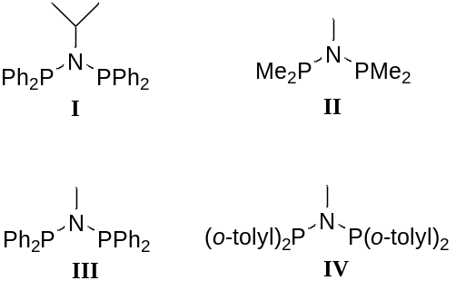The transition metal catalyzed oligomerization of ethylene to short chain linear α-olefins (LAOs) is an area of sustained research activity,^{[1]} and in particular selective oligomerizations to 1-hexene and 1-octene (trimerization and tetramerization) are currently of much interest.^{[2]} While catalysts which selectively trimerize ethylene to 1-hexene are now quite common, the number of systems which are capable of promoting tetramerization are far fewer in number.^{[3]} Of these, the diphosphinoamine ligand system (PNP, for example I) in combination with chromium, introduced and commercialized by Sasol,^{[3a]} is the most successful and also the most studied system. However, despite being discovered over a decade ago, it is only recently that the precise mechanism of 1-octene formation is beginning to be understood. Such an understanding is important as it highlights the essential catalyst attributes required for tetramerization and aids in further catalyst development.
The metallacyclic mechanism of oligomerization is believed to be responsible for both trimerization and tetramerization.^{[4]} For selective trimerization this mechanism is now quite well understood and broadly accepted, and the selective formation of 1-hexene can be rationalized on the basis of metallacycle stability (specifically chromacyclopentane versus chromacycloheptane).^{[5]} In contrast, the mode by which this cycle extends to tetramerization, but then stops to selectively yield 1-octene, is not well understood.^{[6]} We recently undertook a combined experimental and theoretical study of this system with the aim of establishing the key active species present and accounting for selective formation of 1-octene.^{[7]} The model developed invoked a competition between mono-ethylene and bis-ethylene chromacyclopentanes (Scheme 1), in which 1-hexene results from the mono-ethylene intermediate and the bis-ethylene complex leads to 1-octene (with the additional possibility of a contribution from the dashed pathway in Scheme 1). This model was able to explain the formation of not just 1-octene, but also the major side products observed (cyclopentanes and n-alkanes). Furthermore, it could explain the differing kinetics for formation of 1-hexene, 1-octene and the coproducts. Recently, we have expanded the mono- versus bis-ethylene model to explain how metallacycles may lead to Schulz-Flory and alternating olefin distributions.^{[8]}
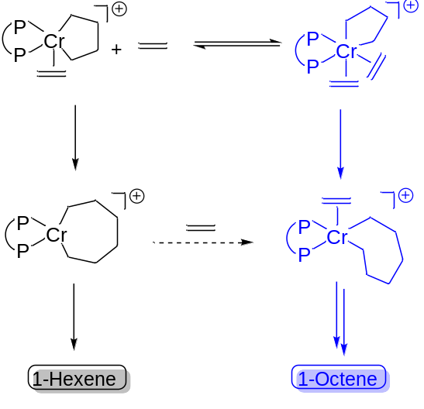
Scheme 1. Mono- and bis-ethylene routes to 1-hexene and 1-octene
Our first theoretical studies on this system utilized a smaller analogue II with methyl substitution instead of aryl substituted ligand I, such that the complete potential energy surface could be efficiently investigated.^{[7]} The model involved cationic Cr(I) and Cr(III) intermediates, with the conclusion being that a Cr(II)/Cr(IV) cycle is unlikely. While it was argued that the smaller model II is realistic, it is nonetheless the case that the most active systems feature aryl substitution. Furthermore, our experimental results were obtained with the more bulky ligand I, with phenyl and iso-propyl substitution. Given the pronounced steric effects displayed by this system,^{[9]} an extended theoretical study dealing with these aspects is warranted. This also allows further correlation of experiment and theory as an assessment of the robustness of the mechanistic model. Hence, we have now employed a larger model III to study the important transformations along the mechanistic pathway. Herein we focus on metallacycle formation, C₆ versus C₈ selectivity (mono- versus bis-ethylene), and formation of cyclopentane coproducts. We have also considered the effect of adding o-methyl substitution to the aryl group, as in ligand IV, by exploring 1-hexene and 1-octene formation with the ligand (o-MeC₆H₄)₂PN(Me)P(o-MeC₆H₄)₂.
Theoretical Calculations
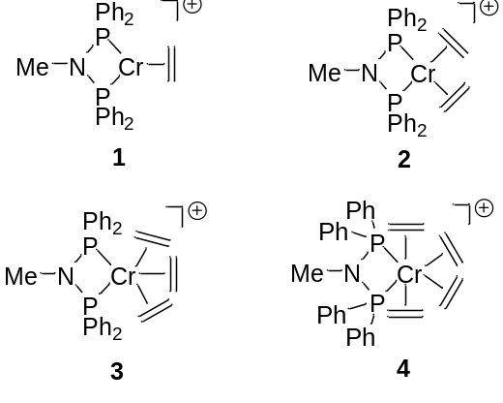Theoretical calculations throughout this paper were carried out with the Gaussian09^{[10]} program. Geometry optimization of stationary points and exploration of the potential energy surface was carried out without symmetry constraints using the M06L^{[11]} density functional in combination with the Stuttgart-Dresden^{[12]} (SDD) double-ζ valence basis set and effective core potential (ECP) for Cr and the 6-31G(d) basis set for all other atoms (referred to as BS1). Solvation and dispersion effects were incorporated into the geometry optimizations by including the polarizable continuum model (PCM, toluene),^{[13]} and Grimme’s empirical dispersion correction (GD3)^{[14]} respectively. In all cases analytical frequency calculations were carried out to verify structure optimizations and to obtain corrections to zero-point and Gibbs free energies. All minima contained no imaginary frequencies, and all transition structures contained only one imaginary frequency that exhibited vibrational modes consistent with the anticipated reaction pathway (further verified by optimization of slightly relaxed transition structures in each direction and IRC calculations). Single point energies for all structures were calculated with the M06L functional with the quadruple-ζ valence def2-QZVP^{[15]} basis set and SDD ECP on Cr, and the 6-311+G(2d,p) basis set on all other atoms (referred to as BS2, again with solvent and dispersion corrections). The Gibbs free energy (ΔG) values reported in this paper were obtained at the M06L/BS2//M06L/BS1 level. Full details of benchmarking of DFT methods against a CCSD(T)/CBS extrapolation have been reported previously.^{[7a]}
As noted above, the calculations carried out in this work include solvation and dispersion effects, which were not included in the previous study.^{[7b]} It was shown in the prior work that these effects are small in nature, but they may become more important for ligands with greater steric bulk and longer range interactions, so were therefore included herein. A further difference between this work and the prior study is that free energy estimates calculated in Gaussian (gas phase, 1 atm standard state) were corrected to better represent solution values (1 M standard state). This involves a correction to the entropy of each reactant and product of -6.36 cal·mol⁻¹·K⁻¹ at 298 K, as detailed in prior work.^{[16]}
Results and Discussion
In this work the M06L density functional has been employed for the reasons outlined in a previous benchmarking study.^{[7a]} The conclusion from this work was that the cationic active species shuttles between Cr(I) and Cr(III) formal oxidation states, with a Cr(II)–Cr(IV) cycle less favoured both kinetically and thermodynamically. The starting point for the cycle is taken as the lowest energy [(PNP)Cr(ethylene)_{n}]⁺ complex (1–4, n = 1–4). Herein, the numbering of the intermediates has been kept the same as in our previous report^{[7b]} for reasons of clarity and to allow side-by-side comparisons of the different studies. Both quartet and sextet spin states were considered for each Cr(ethylene)_{n} complex. The spin state minimum energy crossing points^{[17]} were not located in this instance, as they were previously calculated to lie below subsequent transition structures for metallacycle formation (which occurs in the quartet spin state).^{[7b]} For the phenyl-substituted PNP ligand the lowest energy ethylene complex is ⁶2 (complex 2 in the sextet state). Hence relative free energies reported are with respect to this intermediate, balanced for ethylene.
Metallacycle Formation. The computed pathways for metallacycle formation are shown in Figure 1. It can be seen that the bis and tris(ethylene) complexes in both quartet and sextet spin states are very similar in energy. The mono(ethylene) complex 1 is higher in energy in both spin states (⁶1 +6.1 kcal·mol⁻¹ and ⁴1 +13.4 kcal·mol⁻¹), while attempts to optimize the tetra(ethylene) species 4 led to dissociation of one of the ethylene ligands. This contrasts with the previous study with the more compact model ligand II, in which the tetra(ethylene) complex was stable and a corresponding transition structure for metallacycle formation was found. In the present case it appears that the greater ligand steric bulk of ligand III renders this route unfavourable. Metallacycle formation via the quartet bis and tris(ethylene) complexes have very similar barriers in each case, indicating that multiple pathways may be operative with a dependence upon the concentration of ethylene. The chromacyclopentane 6 is unstable relative to the bis(ethylene) complex, but coordination of ethylene to yield complex 7 is a downhill process. Complex 7 is formed directly from tris(ethylene) complex 3.
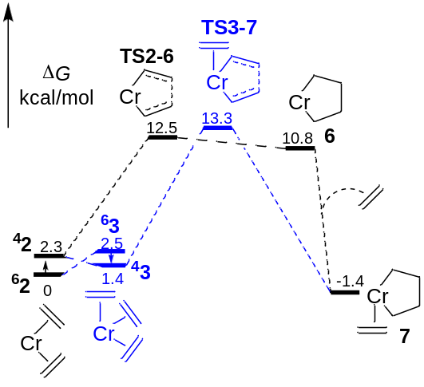
Figure 1. Relative Gibbs free energy profiles (M06L/BS2//M06L/BS1, kcal·mol⁻¹, 298 K) for metallacycle formation via Cr(ethylene)_{n} (n = 2, 3) species. All stationary points are cationic; PNP ligand and charge omitted for clarity.
Metallacycle Expansion. It is well established that metallacyclopentanes are generally stable towards termination of 1-butene,^{[18]} such that ethylene insertion to expand the metallacycle is more favourable.^{[5a-c]} This was demonstrated to be the case for the smaller model,^{[7b]} hence we have not repeated these calculations herein. Of most interest is the effect a change to phenyl substitution has on metallacycle expansion according to Figure 2. Two pathways are identified which are proposed to control the relative selectivity to 1-hexene and 1-octene. Firstly, ethylene insertion from the mono(ethylene) species 7 yields chromacycloheptane 8. Subsequent β αʹ hydrogen transfer, with formal reduction to Cr(I), gives the 1-hexene complex 12. This is believed to be the principal route to 1-hexene, both for this system and also for all other trimerization selective catalysts. The second pathway is coordination of a second ethylene unit to afford bis(ethylene) species 17. This is thought to be made possible by the bidentate (as opposed to tridentate) PNP ligand, so the effect of bulkier phenyl substitution on the energetics of this is a key question. In this case theory predicts the addition of another ethylene unit to be close to free energy neutral. Importantly, the subsequent barriers to insertion (TS7-8 and TS17-18a) are also very similar. As indicated in Figure 2, there are a number of isomers and conformers of complex 18. For clarity, only the species formed from the first insertion (18a) and that which leads to the lowest barrier for the second insertion (18f) are shown. The structures, relative energies and reactivity of each isomer of 18 are discussed in more detail in the following section.
Given the theoretical predictions presented in Figure 2, the formation of both 1-hexene and 1-octene with this system can be rationalized, along with the influence of ethylene concentration on the C₆:C₈ selectivity. The kinetics of product formation were discussed in some detail in our previous report,^{[7b]} hence a briefer analysis is included herein. A second-order ethylene dependence for 1-octene formation via bis(ethylene) complex 17 is reasonable, whereas an approximate first-order ethylene dependence for 1-hexene via 8 can be expected. An equilibrium between 7 and 17, dependent on ethylene pressure as illustrated in Scheme 1, could control the contribution of the two competing pathways. It is evident from the free energy profile in Figure 2 that a second pathway to 1-octene exists, via ethylene coordination to species 8, leading to 18 and subsequent reactions. Whether this route is competitive will depend on the rate of intermolecular ethylene association to 8 (relative to formation of 1-hexene from 8), which is difficult to judge. We previously proposed that 1-octene forms via both mono(ethylene) complex 7 and bis(ethylene) complex 17, and the energetics presented in Figure 2 continue to support this. It was shown that the experimental kinetics of 1-octene formation may be fitted to a rate equation of the form r = k[C₂H₄]² + kʹ[C₂H₄], which may be rationalized on the basis of a combination of single and double ethylene coordination pathways. At low ethylene pressure the first-order term is dominant, whereas at higher pressure the second-order process becomes the major contributing path to octene formation.^{[7b]} Thus the experimentally observed overall mixed-order kinetics which result from a combination of single and double insertion mechanisms^{[19]} are consistent with the DFT findings. Further discussion of the theoretical results in relation to the observed kinetics is included in the supporting information. Our conclusion from such a combined approach is that the bis(ethylene) pathway is important, and it may be that very high 1-octene selectivity is restricted to catalysts capable of forming a bis(ethylene)chromacyclopentane such as 17.
Reactivity of [(PNP)Cr(C₆H₁₂)(ethylene)]⁺ (18). As indicated above, there are a number of different coordination isomers or conformers of complex 18 and the structure of each along with relative energies are illustrated in Figure 3. Most of these are also linked to transition structures for further reactions which are also shown. Transition structures for insertion of the second ethylene unit to produce chromacyclononanes are indicated in blue, and β-hydride transfer reactions (β-H transfer to ethylene, to αʹ-C, or to Cr) are illustrated in red. The various structures of 18 that were located are analogous to those found with the smaller model ligand II, and it was shown in that work that barrier heights for conformer/isomer interconversion are quite low (in all cases lower than the barriers for further reaction). Facile metallacycle conformational changes and coordination isomerization are not unexpected, which suggests the various structures of 18 may be in equilibrium.
The lowest barrier for further reaction is metallacycle expansion from 18f (-2.9 kcal·mol⁻¹), which is the pathway to 1-octene formation indicated in Figure 2 (TS18f-19). Hence, the expanded theoretical model continues to predict that 1-octene

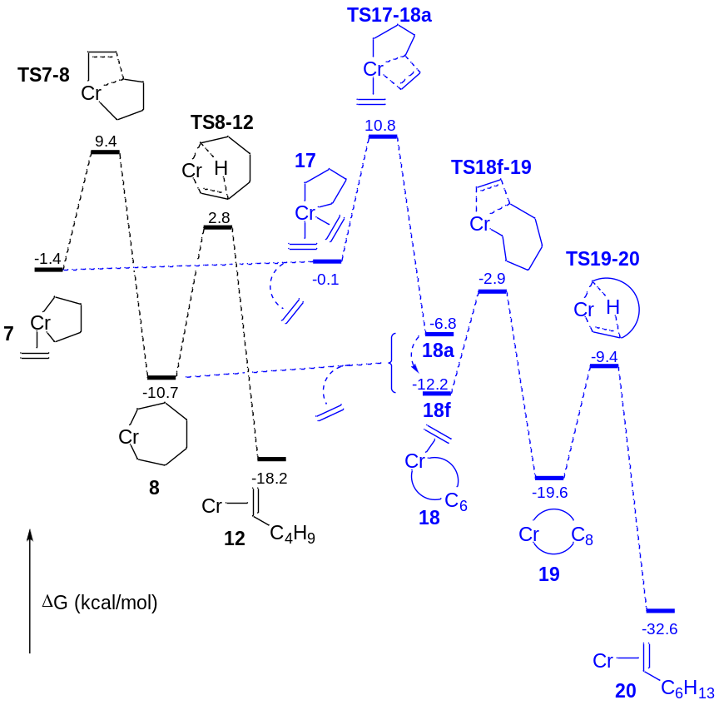
Figure 2. Relative Gibbs free energy profiles (M06L/BS2//M06L/BS1, kcal·mol⁻¹, 298 K) for formation of 1-hexene and 1-octene from [(PNP)Cr(C₄H₈)(ethylene)]⁺ (7). All stationary points are cationic; PNP ligand and charge omitted for clarity.
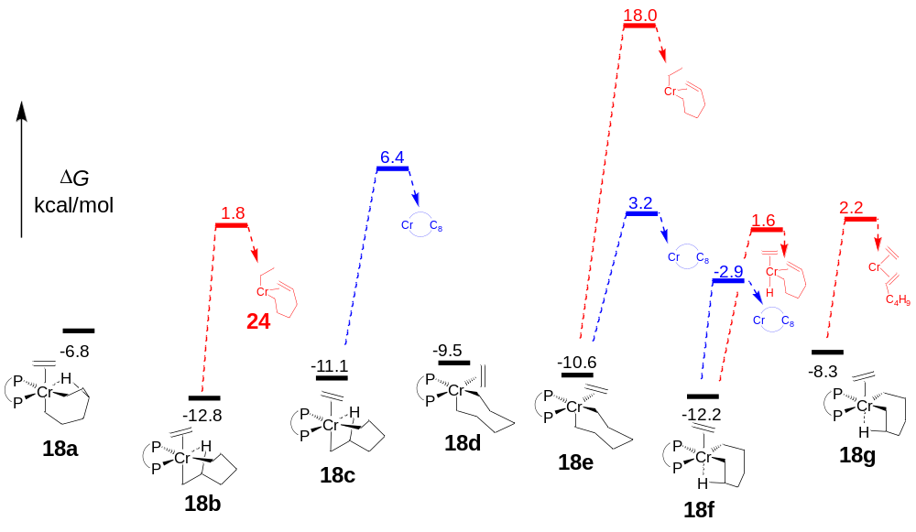
Figure 3. Relative Gibbs free energies (M06L/BS2//M06L/BS1, kcal·mol⁻¹, 298 K) of the different conformers/isomers of [(PNP)Cr(C₆H₁₂)(ethylene)]⁺ (18) along with barrier heights for further reactions (metallacycle expansion, blue, and β-hydride transfer, red). All stationary points are cationic.

will be the major product formed from bis(ethylene) complex 17, via intermediate 18.
Also of interest are the low lying β-hydride transfer pathways shown in Figure 3 which may represent secondary reactions. The transition structures for β-hydride transfer to ethylene, β-hydride transfer to chromium and β-hydride transfer to form coordinated 1-hexene are all remarkably similar, and hence all might be relevant secondary reactions. The last of these, which generates a Cr(ethylene)(1-hexene) complex from 18g, might suggest that the double coordination mechanism contributes to a proportion of the 1-hexene formed with these catalysts. This possibility is difficult to verify experimentally however. Beta-hydride transfer to chromium from 18f yields [(PNP)CrH(ethylene)(hexenyl)]⁺ but this is an endergonic process (the product lies 12.0 kcal·mol⁻¹ above 18f). Coupled with a very low barrier for the reverse reaction (2.5 kcal·mol⁻¹), this reaction is unlikely to be a significant pathway. The last possibility, β-hydride transfer to ethylene, is exergonic to form [(PNP)Cr(ethyl)(hexenyl)]⁺ (24, 6.6 kcal·mol⁻¹ below 18b), and is suggested to be the first step on the way to forming the cyclopentane coproducts^{[4d, 7b]} observed with this catalyst (see Figure 4). Hence the reactivity of this species is explored more below.
Formation of Cyclopentanes. We demonstrated previously that the chromium catalyst with PNP ligand I produces a Schulz-Flory distribution of cyclopentanes and n-alkanes as co-products (Scheme 2).^{[7b]} The most abundant cyclic products are methylcyclopentane and methylenecyclopentane (n = 0 in Scheme 2), which occur in an approximately 1:1 ratio.^{[4d]} The proposed pathway to these products, which originates from species 24, has been calculated and is shown in Figure 4. These co-products appear to result from a secondary reaction of complex 18, which is consistent with their apparent association with ethylene tetramerization (the primary reaction path from 18). As a result of β-hydride transfer to ethylene, the Cr(ethyl)(hexenyl) species 24 is formed in which the olefinic tail remains coordinated. Such a binding arrangement is effectively set up for back-biting insertion to generate [(PNP)Cr(ethyl)(cyclopentylmethyl)]⁺ 26. Methyl- and methylene
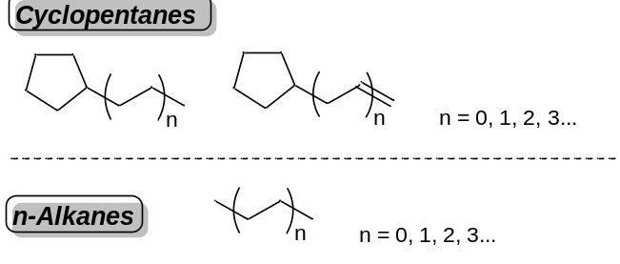
Scheme 2. Co-products formed along with 1-octene.

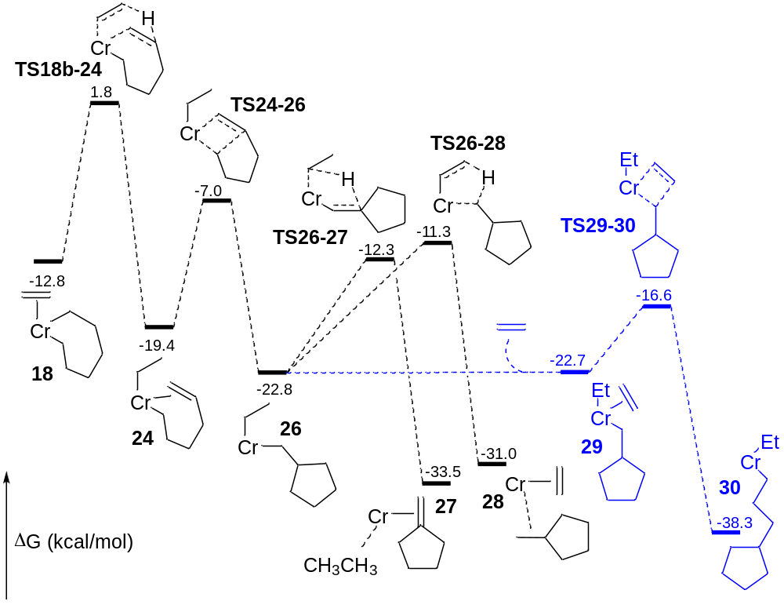
Figure 4. Relative Gibbs free energy profiles (M06L/BS2//M06L/BS1, kcal·mol⁻¹, 298 K) for formation of cyclopentanes and n-alkanes from complex 18b. All stationary points are cationic; PNP ligand and charge omitted for clarity.

cyclopentane are produced by β-hydride transfer reactions from complex 26.
The two competing barrier heights for β-hydride transfer are quite similar in energy. For a 1:1 ratio of methyl- to methylenecyclopentane the barriers should of course be identical. Given the approximate nature of DFT calculations however, it is difficult to make such precise comparisons. The very similar calculated barriers are certainly not inconsistent with the experimental findings. Ethylene coordination to 26 is also possible, followed by insertion into either of the Cr–alkyl bonds. We have calculated one such possibility, insertion into the Cr–methylcyclopentyl bond, shown in blue in Figure 4. After uptake of an additional monomer, the barrier to insertion is somewhat lower than those for β-hydride transfer. Hence a proportion of compound 26 may undergo chain elongation rather than formation of methyl- and methylenecyclopentane. The degree to which this occurs will depend on the relative rates of β-hydride transfer versus ethylene coordination and insertion. This sequence of competing propagation/termination reactions can explain the observed Schulz-Flory distribution of cyclic products and n-alkanes, and also the response of these distributions to ethylene pressure. These distributions have been analysed in detail previously. A strong correlation between experiment and theory is again evident in the present case.^{[7b]}
Effect of Ortho-Methyl Aryl Substitution. While diphenylphosphino-substitution on the PNP ligand leads to high 1-octene selectivity (up to ca. 80%), the introduction of ortho-alkyl substitution leads to a selectivity shift towards 1-hexene. Blann and coworkers showed clearly that the relative tetramerization/trimerization selectivity is influenced by both the number and size of ortho-alkyl substituents on the phenyl groups.^{[9]} We have studied this effect by modelling the reaction with one ortho-methyl substituent on each aryl group (ligand IV). It was shown that this substitution pattern is sufficient to shift the selectivity to 86–90% 1-hexene, depending on temperature and pressure.^{[9]} It is important that our theoretical results can account for this steric effect, and modelling it therefore serves as a further validation of the proposed mechanistic model.
Metallacycle formation with the substituted ligand is shown in Figure 5 (the prime symbol in subsequent numbering indicates the complex contains the o-tolyl substituted ligand IV). The main point of difference to ligand III is a more stable Cr(ethene)₂ sextet intermediate, ⁶2ʹ, relative to the quartet ⁴2ʹ. This manifests in a higher barrier for metallacycle formation relative to the lowest energy Cr(ethene)₂ species. Again metallacycle formation via bis or tris(ethylene) intermediates have similar barriers, in this case the tris(ethylene) transition state TS3ʹ-7ʹ is marginally lower. While somewhat counterintuitive, this likely reflects a situation whereby the effect of increased ligand steric bulk is not felt with the coordinatively unsaturated intermediates (2ʹ, 3ʹ and their subsequent transition structures).
The competing routes to 1-hexene and 1-octene formation commencing from complex 7ʹ are shown in Figure 6. The barrier to insertion from 7ʹ, 8.4 kcal·mol⁻¹, is little changed and actually slightly lower than the same barrier from the unsubstituted analogue 7 (10.8 kcal·mol⁻¹). The major difference between the two energy surfaces (Figures 2 and 6) is that uptake of another ethylene monomer to form the coordinatively saturated bis(ethylene) complex 17ʹ is now distinctly unfavorable. Complex 17ʹ lies 6.5 kcal·mol⁻¹ above 7ʹ, compared to 17 being 1.3 kcal·mol⁻¹ above 7. The trend indicates that additional steric bulk makes the bis(ethylene) route less favorable, and an equilibrium between 7ʹ and 17ʹ would lie heavily to the side of 7ʹ. This effect carries through to the transition state for the first insertion on the bis(ethylene) pathway (TS17ʹ-18aʹ), which is 7.7 kcal·mol⁻¹ above TS7ʹ-8ʹ (Figure 6), significantly larger than the calculated difference in insertion barriers of only 1.4 kcal·mol⁻¹ in Figure 2. Furthermore, for the alternate pathway to 1-octene via 8ʹ, the coordination of ethylene to form 18ʹ is unfavourable, and octene formation via this pathway is also less likely. Overall, the theoretical calculations are supportive of the mechanistic model comprising single and double ethylene insertion pathways. The introduction of steric bulk in the ortho position of the aryl–PNP ligands favors the mono-ethylene route to 1-hexene at the expense of alternate routes to 1-octene. With the tetramerization pathways blocked, the formation of cyclopentane coproducts is also suppressed, which explains the greater purity of the C₆ fraction with the substituted ligands.^{[9]}
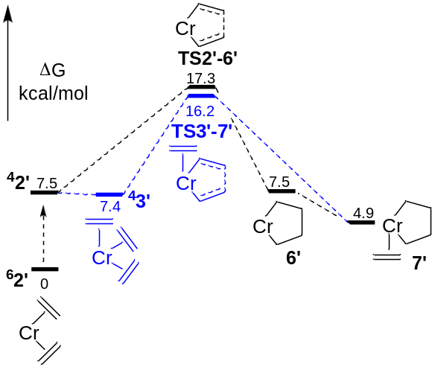
Figure 5. Relative Gibbs free energy profiles (M06L/BS2//M06L/BS1, kcal·mol⁻¹, 298 K) for metallacycle formation via Cr(ethylene)_{n} (n = 2, 3) species (ligand = (o-MeC₆H₄)₂PN(Me)P(o-MeC₆H₄)₂) All stationary points are cationic; PNP ligand and charge omitted for clarity.
Summary and Conclusions
Herein we have carried out an expanded theoretical study of the chromium–diphosphinoamine ethylene trimerization/tetramerization system. The aim was to evaluate the effect of ligand sterics, which are experimentally found to influence selectivity, and to further validate our mechanistic model which invokes competition between mono and bis(ethylene) chromacyclopentanes.
Calculations with a typical tetramerization ligand, Ph₂PN(Me)PPh₂, support the conclusions from an earlier study
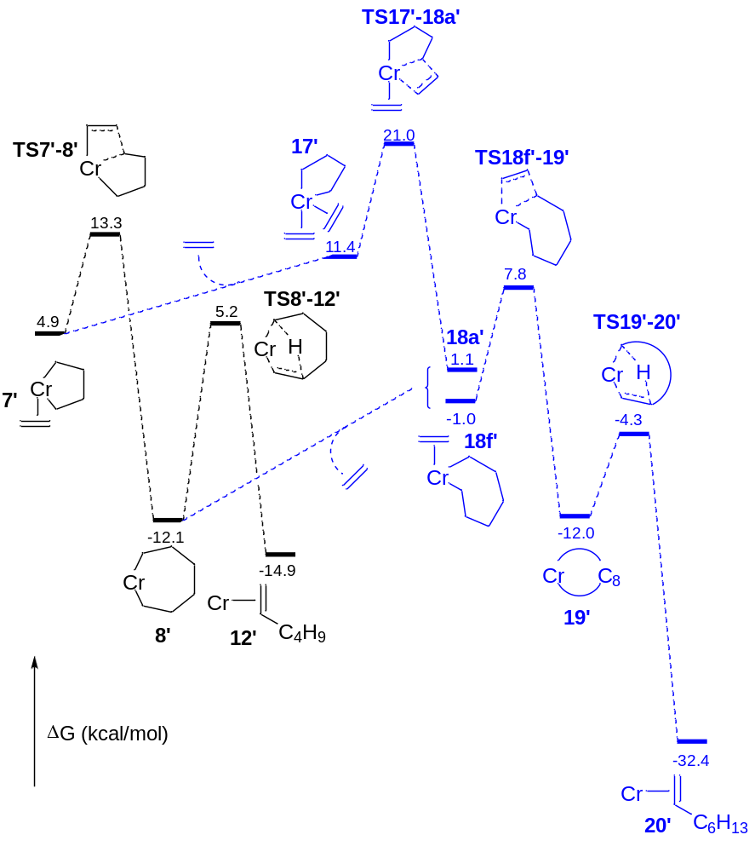
Figure 6. Relative Gibbs free energy profiles (M06L/BS2//M06L/BS1, kcal·mol⁻¹, 298 K) for formation of 1-hexene and 1-octene from [(PNP)Cr(C₄H₈)(ethylene)]⁺ (7ʹ, ligand = (o-MeC₆H₄)₂PN(Me)P(o-MeC₆H₄)₂) . All stationary points are cationic; PNP ligand and charge omitted for clarity.

on a simplified ligand. The formation of both 1-hexene and 1-octene, and also the major side products (cyclopentanes and n-alkanes) can be explained. The response of selectivity to ethylene pressure, product formation kinetics, and the statistical distribution of side products can also be rationalized.
The selectivity control available with this class of ligand, through ligand substitution, has also been investigated. To this end, the largely trimerization-specific ligand, (o-MeC₆H₄)₂PN(Me)P(o-MeC₆H₄)₂, was chosen. Calculations support the experimentally observed effect of substitution, and show that trimerization is favored due to suppression of the available pathways to 1-octene and cyclopentane side products. This study lends further support to the mechanistic model we have developed to explain ethylene trimerization and tetramerization with Cr–PNP catalysts. A follow up study will focus on the effect of different counterions and additional pendant donors, both of which also have pronounced effects on selectivity.
Acknowledgements
We thank the Australian Research Council for financial support through grant FT100100609 to D.S.M, and the University of Tasmania for Visiting Scholars funding to G.J.P.B. The Australian National Computational Infrastructure scheme and the Tasmanian Partnership for Advanced Computing are thanked for provision of computing resources.
Keywords: oligomerization • trimerization • tetramerization • chromium • homogeneous catalysis
[1] (a) P.-A. R. Breuil, L. Magna, H. Olivier-Bourbigou, Catal. Lett. 2015, 145, 173-192; (b) H. Olivier-Bourbigou, A. Forestière, L. Saussine, L. Magna, F. Favre, F. Hugues, Oil Gas Eur. Mag. 2010, 36, 97-102; (c) G. P. Belov, P. E. Matkovsky, Pet. Chem. 2010, 50, 283-289; (d) W. Keim, Angew. Chem. Int. Ed. 2013, 52, 12492-12496.
[2] (a) D. S. McGuinness, Chem. Rev. 2011, 111, 2321-2341; (b) T. Agapie, Coord. Chem. Rev. 2011, 255, 861-880; (c) P. W. N. M. van Leeuwen, N. D. Clément, M. J.-L. Tschan, Coord. Chem. Rev. 2011, 255, 1499-1517; (d) D. F. Wass, Dalton Trans. 2007, 816-819.
[3] (a) A. Bollmann, K. Blann, J. T. Dixon, F. M. Hess, E. Killian, H. Maumela, D. S. McGuinness, D. H. Morgan, A. Neveling, S. Otto, M. Overett, A. M. Z. Slawin, P. Wasserscheid, S. Kuhlmann, J. Am. Chem. Soc. 2004, 126, 14712-14713; (b) M. J. Overett, K. Blann, A. Bollmann, R. de Villiers, J. T. Dixon, E. Killian, M. C. Maumela, H. Maumela, D. S. McGuinness, D. H. Morgan, A. Rucklidge, A. M. Z. Slawin, J. Mol. Catal. A: Chem. 2008, 283, 114-119; (c) O. L. Sydora, T. C. Jones, B. L. Small, A. J. Nett, A. A. Fischer, M. J. Carney, ACS Catal. 2012, 2, 2452-2455; (d) Y. Shaikh, K. Albahily, M. Sutcliffe, V. Fomitcheva, S. Gambarotta, I. Korobkov, R. Duchateau, Angew. Chem. Int. Ed. 2012, 51, 1366-1369; (e) Y. Yang, Z. Liu, B. Liu, R. Duchateau, ACS Catal. 2013, 3, 2353-2361; (f) J. E. Radcliffe, A. S. Batsanov, D. M. Smith, J. A. Scott, P. W. Dyer, M. J. Hanton, ACS Catal. 2015, 5, 7095-7098.
[4] (a) J. R. Briggs, Chem. Commun. 1989, 674-675; (b) T. Agapie, S. J. Schofer, J. A. Labinger, J. E. Bercaw, J. Am. Chem. Soc. 2004, 126, 1304-1305; (c) T. Agapie, J. A. Labinger, J. E. Bercaw, J. Am. Chem. Soc. 2007, 129, 14281-14295; (d) M. J. Overett, K. Blann, A. Bollmann, J. T. Dixon, D. Haasbroek, E. Killian, H. Maumela, D. S. McGuinness, D. H. Morgan, J. Am. Chem. Soc. 2005, 127, 10723-10730.
[5] (a) A. N. J. Blok, P. H. M. Budzelaar, A. W. Gal, Organometallics 2003, 22, 2564-2570; (b) T. J. M. de Bruin, L. Magna, P. Raybaud, H. Toulhoat, Organometallics 2003, 22, 3404; (c) S. Tobisch, T. Ziegler, Organometallics 2003, 22, 5392-5405; (d) P. H. M. Budzelaar, Can. J. Chem. 2009, 87, 832-837; (e) Y. Qi, Q. Dong, L. Zhong, Z. Liu, P. Qiu, R. Cheng, X. He, J. Vanderbilt, B. Liu, Organometallics 2010, 29, 1588-1602; (f) Y. Yang, Z. Liu, R. Cheng, X. He, B. Liu, Organometallics 2014, 33, 2599-2607.
[6] K. P. Bryliakov, E. P. Talsi, Coord. Chem. Rev. 2012, 256, 2994-3007.
[7] (a) D. S. McGuinness, B. Chan, G. J. P. Britovsek, B. F. Yates, Aust. J. Chem. 2014, 67, 1481-1490; (b) G. J. P. Britovsek, D. S. McGuinness, T. S. Wierenga, C. T. Young, ACS Catal. 2015, 5, 4152-4166.
[8] G. J. P. Britovsek, R. Malinowski, D. S. McGuinness, J. D. Nobbs, A. K. Tomov, A. W. Wadsley, C. T. Young, ACS Catal. 2015, 5, 6922-6925.
[9] K. Blann, A. Bollmann, J. T. Dixon, F. Hess, E. Killian, H. Maumela, D. H. Morgan, A. Neveling, S. Otto, M. Overett, Chem. Commun. 2005, 620-621.
[10] M. J. Frisch, G. W. Trucks, H. B. Schlegel, G. E. Scuseria, M. A. Robb, J. R. Cheeseman, G. Scalmani, V. Barone, B. Mennucci, G. A. Petersson, H. Nakatsuji, M. Caricato, X. Li, H. P. Hratchian, A. F. Izmaylov, J. Bloino, G. Zheng, J. L. Sonnenberg, M. Hada, M. Ehara, K. Toyota, R. Fukuda, J. Hasegawa, M. Ishida, T. Nakajima, Y. Honda, O. Kitao, H. Nakai, T. Vreven, J. A. Montgomery Jr., J. E. Peralta, F. Ogliaro, M. Bearpark, J. J. Heyd, E. Brothers, K. N. Kudin, V. N. Staroverov, R. Kobayashi, J. Normand, K. Raghavachari, A. Rendell, J. C. Burant, S. S. Iyengar, J. Tomasi, M. Cossi, N. Rega, J. M. Millam, M. Klene, J. E. Knox, J. B. Cross, V. Bakken, C. Adamo, J. Jaramillo, R. Gomperts, R. E. Stratmann, O. Yazyev, A. J. Austin, R. Cammi, C. Pomelli, J. W. Ochterski, R. L. Martin, K. Morokuma, V. G. Zakrzewski, G. A. Voth, P. Salvador, J. J. Dannenberg, S. Dapprich, A. D. Daniels, Ö. Farkas, J. B. Foresman, J. V. Ortiz, J. Cioslowski, D. J. Fox, Gaussian 09, Revision A1, Gaussian, Inc., Wallingford CT 2009.
[11] Y. Zhao, D. G. Truhlar, J. Chem. Phys. 2006, 125, 194101.
[12] D. Andrae, U. Häussermann, M. Dolg, H. Stoll, H. Preuss, Theoret. Chim. Acta 1990, 77, 123-141.
[13] J. Tomasi, B. Mennucci, R. Cammi, Chem. Rev. 2005, 105, 2999-3093.
[14] S. Grimme, J. Antony, S. Ehrlich, H. Krieg, J. Chem. Phys. 2010, 132, 154104.
[15] (a) F. Weigend, R. Ahlrichs, Phys. Chem. Chem. Phys. 2005, 7, 3297-3305; (b) F. Weigend, F. Furche, R. Ahlrichs, J. Chem. Phys. 2003, 119, 12753-12762.
[16] N. M. Weliange, D. S. McGuinness, J. Patel, Organometallics 2014, 33, 4251.
[17] J. N. Harvey, M. Aschi, H. Schwarz, W. Koch, Theor. Chem. Acc. 1998, 99, 95-99.
[18] (a) J. X. McDermott, J. F. White, G. M. Whitesides, J. Am. Chem. Soc. 1973, 95, 4451-4452; (b) J. X. McDermott, J. F. White, G. M. Whitesides, J. Am. Chem. Soc. 1976, 98, 6521-6528; (c) J. X. McDermott, M. E. Wilson, G. M. Whitesides, J. Am. Chem. Soc. 1976, 98, 6529-6536.
[19] M. M. Marques, A. R. Dias, C. Costa, F. Lemos, F. Ramôa Ribeira, Polym. Int. 1997, 43, 77-85.

Entry for the Table of Contents (Please choose one layout)

Layout 1:

FULL PAPER
The mechanism of ethylene trimerization and tetramerization with Cr-diphosphinoamine complexes, and the influence of ligand sterics, is investigated through a density functional theoretical study. |  |  |  | George J. P. Britovsek* and David S. McGuinness*  Page No. – Page No.  A DFT Mechanistic Study on Ethylene Tri- and Tetramerization with Cr/PNP Catalysts: Single versus Double Insertion Pathways

