DOI: 10.1002/((please add manuscript number))
Article type: Communication

Peptide-directed spatial organization of biomolecules in dynamic gradient scaffolds

Lesley W. Chow*, Astrid Armgarth, Jean-Philippe St-Pierre, Sergio Bertazzo, Cristina Gentilini, Claudia Aurisicchio, Seth D. McCullen, Joseph A. M. Steele, and Molly M. Stevens*

Dr. L. W. Chow, A. Armgarth, Dr. J. P. St-Pierre, Dr. C. Gentilini, Dr. C. Aurisicchio, Dr. S. D. McCullen, J. A. M. Steele, Prof. M. M. Stevens
Departments of Materials and Bioengineering and Institute for Biomedical Engineering, Imperial College London, SW7 2AZ, UK
Dr. S. Bertazzo
Department of Materials, Imperial College London, SW7 2AZ, UK
Prof. M. M. Stevens
E-mail: l.chow@imperial.ac.uk, m.stevens@imperial.ac.uk

Keywords: biomimetic materials, hierarchical organization, peptide-polymer conjugates, surface functionalization, tissue engineering

A promising approach in tissue engineering involves the use of biodegradable scaffolds to direct tissue repair and regeneration while providing temporary structural support for cells. As understanding of the complex interactions between cells and the extracellular matrix (ECM) deepens, the engineering of biomaterials has evolved to more sophisticated designs and chemistries to mimic native tissues and control cell-substrate interactions.^{[1-5]} Despite these advances, engineered tissue constructs for clinical applications are often functionally inferior to native tissues. This is partly due to the inability to recreate the complex and hierarchical organization of the ECM that dynamically responds to changes in the local environment and gives biological tissues their exceptional properties and functions.^{[6]} The spatial arrangement of biomolecules within tissues conveys specific functions that are not achieved by the homogenous presentation of the basic components.^{[7-10]} Incorporation of biomolecules found in the ECM such as proteins and glycosaminoglycans (GAGs) is known to improve a scaffold’s biological function, but controlling the hierarchical distribution of these biomolecules to mimic native tissue remains challenging. Here, we designed and synthesized a versatile peptide-polymer conjugate system to functionalize scaffold surfaces with selected peptides that specifically and dynamically bind GAGs to guide their spatial arrangement. Increasing the concentration of GAG-binding peptide-polymer conjugates directly correlated with an increase in the amount of GAGs bound. Combining this functionalization approach with sequential electrospinning techniques, we generated single and dual opposing gradients of peptide concentrations that directed the spatial organization of GAGs through the thickness of the scaffold. Utilizing specific binding peptides to guide biomolecule concentration and placement mimics the dynamic, biologically relevant interactions and composition of native ECM that can evolve as the tissue is remodeled and regenerated. To our knowledge, this is the first time these strategies have been combined to direct biomolecule organization into dynamic gradients by specific binding peptides functionalized on a scaffold surface. This versatile platform can be used to recreate the ECM-like organization of biomolecules within scaffolds to achieve more functional and clinically relevant tissue engineered constructs.

Electrospinning of synthetic polymers is an attractive technique for scaffold fabrication in tissue engineering due to its simplicity and versatility to generate ECM-like fiber networks with tunable physical properties such as fiber size, mechanical strength, porosity, and orientation.^{[11-14]} Recently we fabricated anisotropic scaffolds for cartilage tissue engineering by sequential electrospinning poly(ε-caprolactone) (PCL) into fibers of distinct sizes and orientations in a continuous construct that resembles the zonal collagen network organization and mechanical properties of articular cartilage.^{[11]} Biodegradable polymers such as PCL and poly(lactic-co-glycolic acid) (PLGA) have been used in a broad range of clinical applications because of their biocompatibility;^{[10]} however, they lack the appropriate biological recognition sites or surface functionalities needed for tissue engineering applications.^{[6,15,16]} Functionalization of such polymer scaffold surfaces typically requires additional post-fabrication steps such as physisorption^{[17]} or the covalent linking of biomolecules. Covalent attachment is generally preferred over physisorption to immobilize the biomolecules at relatively high efficiency but requires chemically modifying the surfaces via aminolysis,^{[18]} hydrolysis,^{[19]} or chemical grafting^{[20]} to create suitable chemistries for linking. These modifications can lead to heterogeneous reactions with the functional molecules that can negatively affect their bioactivity and presentation as well as the topography and morphology of the scaffold structure.^{[12,13]} The biomolecules of interest can also be directly blended with the polymer in solution to functionalize in one step,^{[21]} but the fabrication conditions (i.e. organic solvents, electric fields) can denature proteins and make it difficult to control the surface exposure and conformation of the biomolecules. Peptide-polymer conjugates thus offer a unique solution to functionalize in a single step during scaffold fabrication with improved control over biomolecule spatial distribution, bioactivity and concentration with minimal impact on the scaffold morphology. Notably, short peptide sequences (less than 15 amino acids) are not susceptible to denaturation due to their limited complexity and are typically compatible with polymer fabrication conditions.^{[13]} During electrospinning, the electric field preferentially phase separates the segments so that the polymer block anchors the conjugate to the bulk fiber and the peptide is exposed on the surface.^{[12,13]} For example, Gentsch et al. showed that electrospinning with a peptide-polymer conjugate containing the canonical adhesion sequence RGDS generated RGDS-functionalized PLGA scaffolds and improved cell adhesion and migration compared to bare PLGA scaffolds.^{[13]}

In this study, we designed peptide-PCL conjugates with bioactive sequences to specifically bind and localize the GAGs within a scaffold (Figure 1). The conjugates were synthesized with PCL for co-electrospinning with PCL to complement our previous work with anisotropic scaffolds.^{[11]} The peptides presented on the scaffold surface can therefore locally bind the GAGs, guiding their concentration and placement within the scaffold. Gradients of GAGs in particular organize cytokines, chemokines, and growth factors to guide cell migration, growth, and differentiation in various biological processes such as inflammation and development.^{[22,23]} In addition, complex tissues such as articular cartilage possess specific spatial organizations of GAGs that significantly influence the tissue’s mechanical properties and biological functions.^{[9]} Controlling the arrangement of these biomolecules is therefore of great interest for the tissue engineering of functional constructs. Previous groups have covalently functionalized polymer surfaces with GAGs^{[24]} or GAG-like oligosaccharides^{[25,26]} to mediate cell behavior. Using peptides to bind the GAG heparin specifically and non-covalently, however, has been shown to improve its bioactivity by mimicking native protein-heparin interactions.^{[27-30]} This approach can attract endogenous GAGs and avoids chemical modification of GAGs, which may interfere with or inhibit their activity. GAGs such as hyaluronic acid (HA) and chondroitin sulfate (CS) are highly prevalent in the ECM and on the cell membrane and play significant roles in a variety of cell-ECM, cell-cell, and protein interactions.^{[3,31]} The peptides here specifically and non-covalently bind HA and CS to mimic the dynamic nature of native ECM and protein-GAG interactions and potentially improve function. The HA-binding peptide-PCL conjugate (HAbind-PCL; Figure 1b) contains the sequence RYPISRPRKR derived from the HA-binding region of the link protein,^{[32]} which stabilizes the interaction between HA and the proteoglycan aggrecan in articular cartilage. The CS-binding peptide-PCL conjugate (CSbind-PCL; Figure 1c) includes the sequence YKTNFRRYYRF found by phage display that has been shown to bind CS to block its inhibition of neurite outgrowth.^{[33,34]}

To prepare the conjugates, the terminal hydroxyl groups of PCL (M_{w} 14,000) were modified with a heterobifunctional linker p-maleimidophenyl isocyanate (PMPI) to generate a maleimide-functionalized PCL. This particular PCL molecular weight was chosen to prevent water solubility of the conjugates and effectively anchor the conjugate to the bulk fibers. The peptides included the specific bioactive sequence linked to a glycine spacer and cysteine on the N-terminus and were coupled to the PCL by reacting the thiol side chain of the cysteine with the maleimide group via Michael type addition.^{[35]} This versatile strategy can therefore be tailored to desired applications by simply changing the bioactive sequence sequence. HAbind-PCL and CSbind-PCL were blended at concentrations ranging from 3 to 12 mg/mL with 12% w/v unmodified PCL (M_{W} 80K) in 1,1,1,3,3,3,-hexafluoro-2-propanol (HFIP) and electrospun to form fibrous scaffolds. At these low conjugate concentrations, we did not observe significant changes to the solution viscosity, a parameter known to affect fiber formation during electrospinning.^{[12]} All conjugate/PCL solutions were electrospun under the same conditions then imaged by scanning electron microscopy (SEM) (Figure 2 and Figure S1). The addition of the conjugate did not affect the electrospinning or fiber formation at any functionalization concentration. The SEM micrographs show the fiber morphology remained similar for the control sample without conjugate compared to the scaffolds with the highest HAbind-PCL and CSbind-PCL concentrations.

We synthesized a biotinylated version of HAbind-PCL (biotinpep-PCL; Figure S2) for labeling with a streptavidin-colloidal gold conjugate to show the presence and distribution of the peptide on the fiber surface. Biotinpep-PCL and unmodified PCL were co-electrospun as described above onto conductive transmission electron microscopy (TEM) grids. The fibers were labeled with streptavidin-colloidal gold (10 nm) then imaged using a SEM with a backscattering electron detector. This technique allowed us to image the fibers without depositing a conductive coating for accurate detection of the gold, which appear as white dots on the surface of the fibers electrospun with biotinpep-PCL (Figure 3). As expected, there was no gold on the PCL only electrospun fibers, verifying the specificity of the labeling. The gold labeling on the biotinpep-PCL samples validated that the contrast in polarizability between the peptide and PCL segments effectively drove the peptide to the surface of fibers and anchored the conjugate to the bulk PCL. In addition, the gold was distributed across all biotinpep-PCL fiber surfaces imaged, suggesting the peptide is presented throughout the entire scaffold. However, there was only a slight increase observed in the concentration of gold labeling with increasing biotin-PCL concentration, suggesting not all of the peptide incorporated is presented on the surface and/or the gold labeling was not efficient.

Binding studies with fluorescently tagged GAGs (Figure 3e-f), however, confirmed the differences in peptide presentation that may not have been detectable in gold labeling by SEM. The fluorescence intensity of whole scaffolds incubated with fluorescein-HA (fluor-HA) or rhodamine-CS (rhod-CS) was measured at various timepoints. Increasing peptide-PCL concentration correlated with a significant increase in GAG binding, indicating the changes in concentration of peptide presented on the surface were sufficient to affect peptide-GAG interactions. There was some nonspecific binding of fluor-HA to the control scaffold without the HA-binding peptide, but the presence of the peptide dramatically affected the amount of HA bound. For both HAbind-PCL and CSbind-PCL scaffolds, the fluorescence intensity was statistically significant (p<0.01) between all concentrations at all timepoints except for between the PCL only and 3 mg/mL HAbind-PCL at day 7. Interestingly, the fluor-HA fluorescence signal was relatively maintained across all samples throughout the study despite no additional fluor-HA being added after the initial binding, which suggests a strong association between the HA-binding peptides presented on the scaffold surface and the biopolymer. The strong affinity may result from polyvalent interactions between the GAG and multiple peptides on the fiber surface as well as the specific pattern of amino acid residues of the HA-binding sequence RYPISPRKRKR. Derived from a HA-binding region of the native link protein, the sequence contains a motif B-X₇-B where B is a basic amino acid and X is a non-acid residue.^{[36]} Amemiya et al. compared a library of peptide sequences with the B-X₇-B motif to peptides of the same charge without the motif and found the B-X₇-B pattern to significantly increase interaction with HA.^{[36]} The spacing of the basic residues may therefore determine affinity and specificity to HA, which may enhance the bioactivity of HA by mimicking natural protein-HA interactions. Despite the strong affinity, the binding was still non-covalent and dynamic as evidenced by fluor-HA detection in the release buffer. Initially, the CSbind-PCL samples exhibited the same trend as the HAbind-PCL group where higher concentrations of the CS-binding peptide on the surface significantly increased the amount of rhod-CS bound. As the scaffolds were washed for each time point, however, some of the rhod-CS was released from the scaffold. The weaker affinity was expected based on the dissociation constant K_{d}, which was reported in the µM range.^{[33]} Since these GAG-binding peptides have the potential to dynamically interact with endogenous GAGs secreted by cells, we anticipate the CS-binding peptide can bind with CS from the ECM to replenish the GAG within the scaffold following dissociation.

The significant differences in GAG-binding despite relatively small changes in peptide concentration motivated us to sequentially electrospin varying conjugate concentrations to create a biomolecule spatial gradient organized by the peptides. In articular cartilage, GAGs exist in a gradient of increasing concentration from the articulating surface towards the bone.^{[9]} To mimic this composition, single gradients in peptide concentration were formed by sequentially electrospinning solutions containing concentrations ranging from 0 to 3 mg/mL peptide-PCL conjugate. Cross-sections of the scaffolds were imaged in bright field and fluorescence to show how the peptides guided the organization of the fluorescently-labeled GAGs (Figure 4). The fluorescence intensity plots (Figure 4b and 4d) also illustrate the GAG distribution in a gradient with respect to the depth in the scaffold. To mimic biochemical gradients of multiple components in native tissues, we sequentially electrospun opposing concentrations of HAbind-PCL and CSbind-PCL, each ranging from 0 to 3 mg/mL. The dual gradient scaffold was simultaneously labeled with both fluor-HA and rhod-CS to allow competitive binding between the peptides and their respective GAGs. The cross-section in Figure 4e shows the top of the scaffold, which contained the highest concentration of HAbind-PCL and no CSbind-PCL, is labeled primarily with fluor-HA. Towards the bottom of the scaffold without HAbind-PCL and the highest concentration of CSbind-PCL, there is an increasing fluorescence from rhod-CS. Some nonspecific binding was expected considering both GAG-binding peptides are positively charged and contain similar amino acid residues while HA and CS are highly negatively charged biopolymers that can interact with both positively charged peptides electrostatically. The peptide-GAG interactions were also designed to be dynamic, allowing for biomolecule diffusion and reorganization. Plotting both fluor-HA and rhod-CS intensities with respect to the scaffold thickness, however, showed the binding peptides were able to organize the GAGs into opposing gradients. This confirms that the peptide sequences have specific affinities for the GAGs and can be used to assemble biochemical gradients. In addition, the peptides have the potential to dynamically bind and organize endogenous GAGs into gradients within scaffolds. These GAG gradients may be of particular interest for cartilage applications where HA is known to contribute to resurfacing of the lubricating surface and CS promotes MSC differentiation into chondrogenic lineages.^{[9]}

By modifying peptide sequences, peptide-polymer conjugate concentration, and electrospinning parameters, we developed a facile strategy to create scaffolds with biomimetic gradients of biomolecules spatially organized and dynamically bound by specific binding peptides. The peptide-PCL conjugates were incorporated before scaffold fabrication and shown to functionalize the surface of electrospun fibers with HA and CS-binding peptides without affecting fiber morphology. Changing the initial conjugate concentration affected the surface functionalization and allowed control over the amount of GAGs bound to the scaffold. Varying concentrations of conjugate were sequentially electrospun to create a gradient of peptide functionalization that non-covalently guided the GAGs into depth gradients within the scaffold. Sequential electrospinning of opposing concentrations of HAbind-PCL and CSbind-PCL created peptide gradients that specifically organized contrasting gradients of HA and CS through the scaffold thickness. The versatile approach shown here combines advances in scaffold fabrication and functionalization techniques to create complex scaffolds that more closely mimic the spatial biomolecule arrangement architecture of native tissues. In addition, using peptides to non-covalently bind biomolecules of interest introduces dynamic cell-material interactions that can be programmed to evolve as the tissue regenerates and remodels. The peptide sequences can be easily tailored for desired applications while fabrication parameters can be tuned to generate specific structures and mechanical properties. This strategy provides a platform to create clinically relevant engineered tissue constructs that can achieve the exceptional properties and functions of natural biological tissues.

Supporting Information
Supporting Information is available online from the Wiley Online Library or from the author.

Acknowledgements
This work was supported by the Medical Engineering Solutions in the Osteoarthritis Centre of Excellence funded by the Wellcome Trust and the Engineering and Physical Sciences Research Council (EPSRC). The authors thank the Chemistry Mass Spectrometry and NMR Facilities, Harvey Flower Microstructural Characterization Suite, Dr. E. T. Pashuck for help with the schematic and useful discussion, and Dr. R. Chapman for help with NMR analysis.
Received: ((will be filled in by the editorial staff))
Revised: ((will be filled in by the editorial staff))
Published online: ((will be filled in by the editorial staff))

[1] E. S. Place, N. D. Evans, M. M. Stevens, Nature Materials 2009, 8, 457.
[2] M. D. Mager, V. LaPointe, M. M. Stevens, Nature Chemistry 2011, 3, 582.
[3] O. Guillame-Gentil, O. Semenov, A. S. Roca, T. Groth, R. Zahn, J. Vörös, M. Zenobi-Wong, Adv. Mater. Weinheim 2010, 22, 5443.
[4] S. Agarwal, J. H. Wendorff, A. Greiner, Adv. Mater. 2009, 21, 3343.
[5] I. C. Bonzani, J. H. George, M. M. Stevens, Current Opinion in Chemical Biology 2006, 10, 568.
[6] D. Kai, G. Jin, M. P. Prabhakaran, S. Ramakrishna, Biotechnol J 2013, 8, 59.
[7] K. Leong, C. Chua, N. Sudarmadji, W. Yeong, Journal of the Mechanical Behavior of Biomedical Materials 2008, 1, 140.
[8] M. M. Stevens, J. H. George, Science 2005, 310, 1135.
[9] L. H. Nguyen, A. K. Kudva, N. S. Saxena, K. Roy, Biomaterials 2011, 1.
[10] E. T. Pashuck, M. M. Stevens, Science Translational Medicine 2012, 4, 160sr4.
[11] S. D. McCullen, H. Autefage, A. Callanan, E. Gentleman, M. M. Stevens, Tissue Engineering Part A 2012, 18, 2073.
[12] X. Y. Sun, R. Shankar, H. G. Börner, T. K. Ghosh, R. J. Spontak, Adv. Mater. 2007, 19, 87.
[13] R. Gentsch, F. Pippig, S. Schmidt, P. Cernoch, J. Polleux, H. G. Börner, Macromolecules 2011, 44, 453.
[14] H. G. Sundararaghavan, J. A. Burdick, Biomacromolecules 2011, 12, 2344.
[15] C. Gentilini, Y. Dong, J. R. May, S. Goldoni, D. E. Clarke, B.-H. Lee, E. T. Pashuck, M. M. Stevens, Advanced Healthcare Materials 2012, 1, 308.
[16] M. S. Shoichet, Macromolecules 2009.
[17] A. Polini, S. Pagliara, R. Stabile, G. S. Netti, L. Roca, C. Prattichizzo, L. Gesualdo, R. Cingolani, D. Pisignano, Soft Matter 2010, 6, 1668.
[18] F. Causa, E. Battista, R. Della Moglie, D. Guarnieri, M. Iannone, P. A. Netti, Langmuir 2010, 26, 9875.
[19] O. Hartman, C. Zhang, E. L. Adams, M. C. Farach-Carson, N. J. Petrelli, B. D. Chase, J. F. Rabolt, Biomaterials 2010, 31, 5700.
[20] F. J. Xu, Z. H. Wang, W. T. Yang, Biomaterials 2010, 31, 3139.
[21] P. Zhao, H. Jiang, H. Pan, K. Zhu, W. Chen, J. Biomed. Mater. Res. 2007, 83A, 372.
[22] T. M. Handel, Z. Johnson, S. E. Crown, E. K. Lau, M. Sweeney, A. E. Proudfoot, Annual Review of Biochemistry 2005, 74, 385.
[23] B. Mulloy, C. C. Rider, Biochem. Soc. Trans. 2006, 34, 409.
[24] C. L. Casper, N. Yamaguchi, K. L. Kiick, J. F. Rabolt, Biomacromolecules 2005, 6, 1998.
[25] A. Lancuški, F. Bossard, S. Fort, Biomacromolecules 2013, 14, 1877.
[26] R. Gentsch, F. Pippig, K. Nilles, P. Theato, R. Kikkeri, M. Maglinao, B. Lepenies, P. H. Seeberger, H. G. Börner, Macromolecules 2010, 43, 9239.
[27] K. Rajangam, H. A. Behanna, M. J. Hui, X. Han, J. F. Hulvat, J. W. Lomasney, S. I. Stupp, Nano Lett. 2006, 6, 2086.
[28] K. Rajangam, M. S. Arnold, M. A. Rocco, S. I. Stupp, Biomaterials 2008, 29, 3298.
[29] L. W. Chow, R. Bitton, M. J. Webber, D. Carvajal, K. R. Shull, A. K. Sharma, S. I. Stupp, Biomaterials 2011, 32, 1574.
[30] L. W. Chow, L. Wang, D. B. Kaufman, S. I. Stupp, Biomaterials 2010.
[31] G. A. Hudalla, W. L. Murphy, Adv. Funct. Mater. 2011, 21, 1754.
[32] P. F. P. Goetinck, N. S. N. Stirpe, P. A. P. Tsonis, D. D. Carlone, J Cell Biol 1987, 105, 2403.
[33] K. C. Butterfield, M. Caplan, A. Panitch, Biochemistry 2010, 49, 1549.
[34] K. C. Butterfield, A. Conovaloff, M. Caplan, A. Panitch, Neuroscience Letters 2010, 478, 82.
[35] C. Boyer, A. Granville, T. P. Davis, V. Bulmus, J. Polym. Sci. A Polym. Chem. 2009, 47, 3773.
[36] K. Amemiya, T. Nakatani, A. Saito, A. Suzuki, H. Munakata, Biochimica et Biophysica Acta (BBA) - General Subjects 2005, 1724, 94.

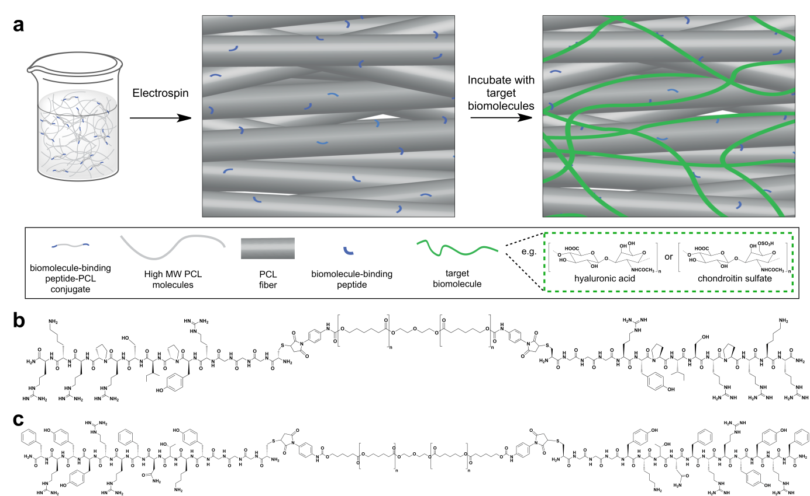
Figure 1. (a) Schematic illustration of scaffold surface functionalization by co-electrospinning high molecular weight poly(ε-caprolactone) (PCL) with peptide-PCL conjugates. The fibers are functionalized with biomolecule-binding peptides that non-covalently and specifically bind biomolecules such as glycosaminoglycans to the surface within the scaffold. The chemical structures of (a) the hyaluronic acid (HA)-binding peptide-PCL conjugate (HAbind-PCL) with the specific binding sequence RYPISPRPKR and (b) the chondroitin sulphate (CS)-binding peptide-PCL conjugate (CSbind-PCL) with the specific binding sequence YKTNFRRYYRF.
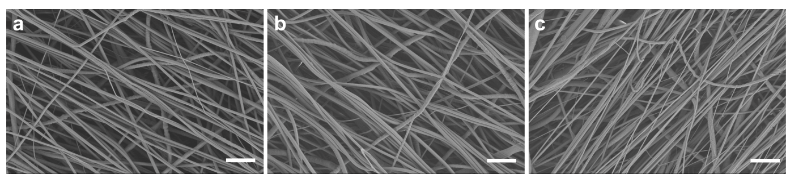
Figure 2. Representative scanning electron microscopy (SEM) images of electrospun fibers of (c) PCL only and PCL with (d) 12 mg/mL HAbind-PCL or (e) 12 mg/mL CSbind-PCL demonstrating that the peptide-PCL conjugates do not affect fiber morphology (scale bar = 10 µm).
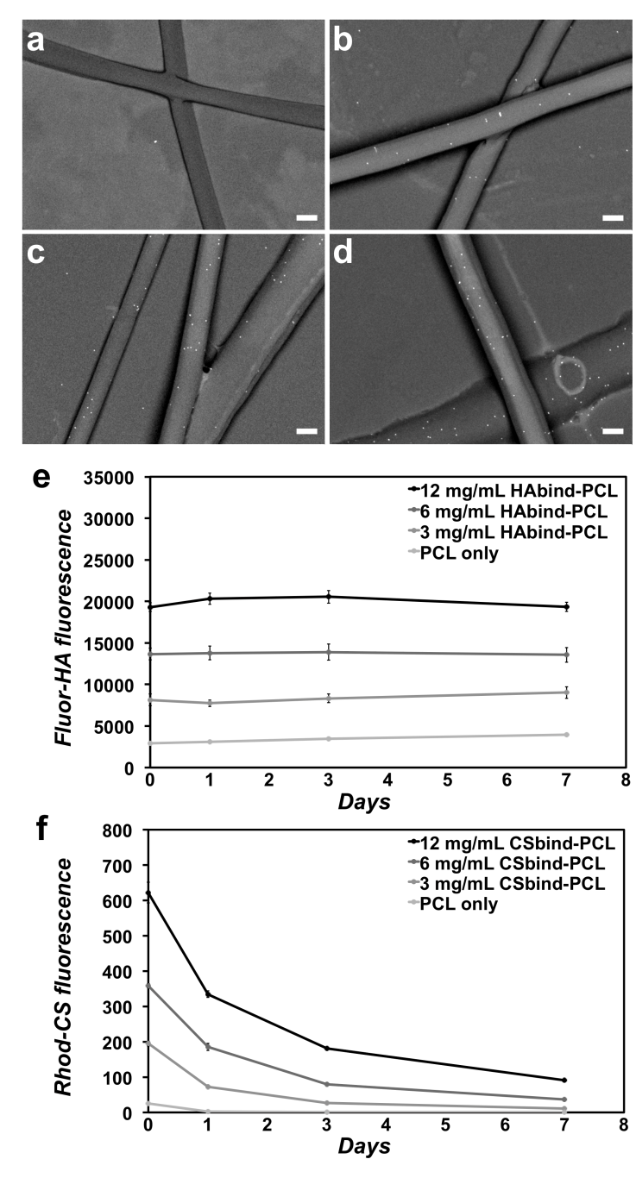
Figure 3. Scanning electron microscope (SEM) backscattering images of electrospun fibers of (a) PCL only or formed by co-electrospinning unmodified PCL with biotinylated peptide-PCL conjugates at increasing concentrations of (b) 3 mg/mL, (c) 6 mg/mL, and (d) 12 mg/mL (scale bar = 400 nm). The biotinylated peptide functionalizing the surface of the fibers was labeled with streptavidin-10nm colloidal gold (white dots). Increasing (e) HAbind-PCL and (f) CSbind-PCL concentration correlated with a significant increase in fluor-HA or rhod-CS binding, respectively, to the scaffolds. The differences in GAG binding for both HAbind-PCL and CSbind-PCL samples were statistically significant (p<0.01) at all time points between all concentrations except for the PCL only and 3 mg/mL HAbind-PCL samples at day 7.
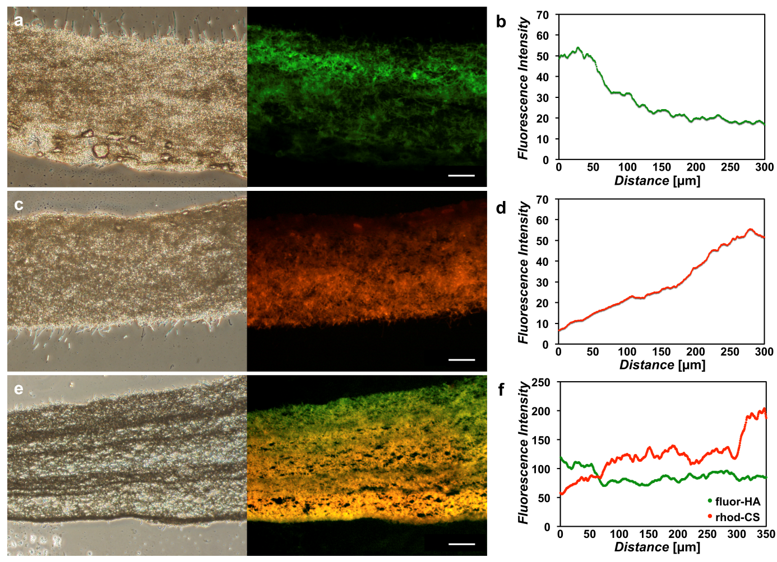

Figure 4. Phase contrast and fluorescence microscopy images of cross sections of gradient scaffolds formed by sequentially electrospinning concentrations of peptide-PCL conjugates ranging from 0 to 3 mg/mL of (a) HAbind-PCL labeled with fluor-HA (green), (c) CSbind- PCL labeled with rhod-CS (red), and (e) opposing concentrations of HAbind-PCL and CSbind-PCL labeled with fluor-HA and rhod-CS with corresponding fluorescence intensity profiles (b), (d), and (f), respectively (scale bar = 100 µm). The gradient in peptide concentrations organized the GAGs into a depth gradient through the scaffold thickness.

(The table of contents entry should be 50−60 words long (max. 400 characters), and the first phrase should be bold.)

Specific binding peptides are used to spatially organize biomolecule gradients within an electrospun fiber scaffold. Different biomolecule-binding peptide-polymer conjugates are sequentially co-electrospun with a fiber-forming host polymer to generate opposing gradients of peptide functionalization. The binding peptides specifically and non-covalently guide the spatial arrangement of biomolecules into dynamic gradients within the scaffold, mimicking biological gradients found in native tissues.

Keyword biomedical applications, biomimetics, hierarchical structures, surface modification, tissue engineering

Lesley W. Chow*, Astrid Armgarth, Jean-Philippe St-Pierre, Sergio Bertazzo, Cristina Gentilini, Claudia Aurisicchio, Seth D. McCullen, Joseph A. M. Steele, and Molly M. Stevens*

Peptide-directed spatial organization of biomolecules in dynamic gradient scaffolds



