Three-step effluent chlorination increases disinfection efficiency and reduces DBP formation and toxicity

Yu Li ª, Xiangru Zhang ^{a,*}, Mengting Yang ^{b,*}, Jiaqi Liu ª, Wanxin Li ª, Nigel J.D. Graham ^{c}, Xiaoyan Li ^{d}, Bo Yang ^{b}

ªDepartment of Civil and Environmental Engineering, The Hong Kong University of Science and Technology, Hong Kong, China
^{b}College of Chemistry and Environmental Engineering, Shenzhen University, Shenzhen 518060, China
^{c}Department of Civil and Environmental Engineering, Imperial College London, London, UK
^{d}Department of Civil Engineering, The University of Hong Kong, Hong Kong, China

ABSTRACT
Chlorination is extensively applied for disinfecting sewage effluents, but it unintentionally generates disinfection byproducts (DBPs). Using seawater for toilet flushing introduces a high level of bromide into domestic sewage. Chlorination of sewage effluent rich in bromide causes the formation of brominated DBPs. The objectives of achieving a disinfection goal, reducing disinfectant consumption and operational costs, as well as diminishing adverse effects to aquatic organisms in receiving water body remain a challenge in sewage treatment. In this study, we have demonstrated that, with the same total chlorine dosage, a three-step chlorination (dosing chlorine by splitting it into three equal portions with a 5-min time interval for each portion) was significantly more efficient in disinfecting a primary saline sewage effluent than a one-step chlorination (dosing chlorine at one time). Compared to one-step chlorination, three-step chlorination enhanced the disinfection efficiency by up to 0.73-log reduction of Escherichia coli. The overall DBP formation resulting from one-step and three-step chlorination was quantified by total organic halogen measurement. Compared to one-step chlorination, the DBP formation in three-step chlorination was decreased by up to 23.4%. The comparative toxicity of one-step and three-step chlorination was evaluated in terms of the development of embryo-larva of a marine polychaete Platynereis dumerilii. The results revealed that the primary sewage effluent with three-step chlorination was less toxic than that with one-step chlorination, indicating that three-step chlorination could reduce the potential adverse effects of disinfected sewage effluents to aquatic organisms in the receiving marine water.

Keywords: Disinfection Byproducts; DBPs; Three-step chlorination; Disinfection efficiency; Toxicity

*Corresponding authors.
E-mail addresses: xiangru@ust.hk (X. Zhang), yangmt@szu.edu.cn (M. Yang).

1. Introduction
Sewage disinfection aims at providing protection for humans from exposure to pathogenic waterborne microorganisms (Jacangelo and Trussell, 2002). Chlorine is extensively used as a disinfectant in municipal sewage treatment plants due to its effectiveness, low cost and ease of application (Lee and von Gunten, 2010; Drinan and Spellman, 2012; Shannon et al., 2008). In addition to inactivating pathogenic microorganisms, chlorine reacts with effluent organic matter present in sewage effluents to generate unintended disinfection byproducts (DBPs) (Rebhun et al., 1997; Shon et al., 2006; Krasner et al., 2009; Sedlak and von Gunten, 2011; Tang et al., 2012; Hatt et al., 2013; Huang et al., 2016; Cai et al., 2016).
To relieve the stress from fresh water shortage, seawater has been applied for toilet flushing in many coastal communities such as Hong Kong, the Marshall Islands, Kiribati, and Avalon (Mirti and Davies 2005; Tang et al, 2007). However, such a practice introduces a high level of bromide ions (65 mg/L in seawater) into the corresponding sewage disposal system, which may cause the production of brominated DBPs during disinfection of the saline sewage effluent using chlorine (Ding et al., 2013; Yang and Zhang, 2013; Yang and Zhang, 2014; Sun et al., 2009). Evidence has shown that brominated DBPs generally presented significantly higher cytotoxicity, genotoxicity, developmental toxicity and growth inhibition than their chlorinated analogs (Plewa et al., 2002; Richardson et al., 2007; Yang and Zhang, 2013; Liu and Zhang, 2014; Li J. et al., 2016). Total organic halogen (TOX), a collective parameter, is a good surrogate and a toxicity indicator for the overall halogenated DBPs in a disinfected water sample (Simmons et al., 2002; Kristiana et al., 2009; Gong et al., 2016; Zhu and Zhang, 2016). TOX includes total organic chlorine (TOCl), total organic bromine (TOBr), and total organic iodine (TOI).
For a specific disinfection unit in a sewage treatment plant, increasing the chlorine dose may increase the disinfection efficiency, but more chlorine will be consumed and thus the operational cost will be increased; also, more halogenated DBPs will be formed in the chlorinated saline sewage effluent (Ding et al., 2013). Thus, it is of great importance to develop and optimize the sewage disinfection process in order to enhance its cost-effectiveness and reduce any adverse impacts of the treated effluent on the receiving environment.
Ding (2010) reported that, with the same total chlorine dose, a three-step addition of chlorine (three-step chlorination) showed a greater disinfection efficiency than a one-step addition of chlorine (one-step chlorination), corresponding to an enhancement of 0.20-log. The result indicated that three-step chlorination had the potential to reduce the chlorine dose for the same level of Escherichia coli removal. However, this study of step-wise chlorination was still at a preliminary stage, as only disinfection efficiency was considered. It was not clear whether the reported better performance of three-step chlorination was reproducible. Additionally, compared to one-step chlorination, the comparative effect of three-step chlorination on effluent toxicity was not considered. Therefore, this study aimed to further investigate the comparative performance of three-step chlorination and the commonly used one-step chlorination, of a primary saline sewage effluent, in terms of disinfection efficiency, DBP formation and developmental toxicity.

2. Materials and methods

2.1. Chemical reagents and seawater
All the chemical solutions were prepared from chemicals of reagent grade or higher. Ultrapure water (with a resistivity of 18.2 MΩ·cm) was provided by a Cascada I Laboratory Water Purification System (PALL). A chlorine stock solution was prepared by diluting a reagent grade NaOCl solution (Allied Signal), and titrated based on the DPD/FAS method (APHA et al., 2012). Methyl tert-butyl ether (MtBE) was supplied from Sigma–Aldrich. Seawater was collected from a local bay in Hong Kong with a salinity of approximately 3.5%. Prior to use, it was filtered through a 0.45-μm membrane and autoclaved at 121 ºC for 30 min. After it was cooled to ambient temperature and aerated for 1 h with air, the seawater was used for culturing Platynereis dumerilii and testing the comparative developmental toxicity.

2.2. Collection and characterization of effluent samples from a primary saline sewage treatment plant
A total of eight undisinfected effluent samples were collected from a primary saline sewage treatment plant over a 19-month period from May 5, 2014 to December 1, 2015 covering the range of different seasons. This sewage treatment plant has a treatment capacity of 2.0×10⁶ m³/d, and is one of the largest primary sewage treatment plants in Hong Kong, and in the world. Each collected sample of primary effluent was transported immediately to the laboratory in an ice cooler to minimize any changes in its composition. Selected chemical characteristics of the undisinfected sewage effluent were measured using the samples collected on September 1 and December 1, 2015 to better understand the correlation among disinfection efficiency, DBP formation and developmental toxicity. Details of the characterization are described in the Supplementary Information (SI) and Table S1.

2.3. Chlorination of the primary saline sewage effluent
Initially, a preliminary test was conducted to choose appropriate disinfection conditions which were capable of meeting the disinfection goal (HKEPD, 2013). Aliquots of a sewage effluent sample were chlorinated by dosing 1.0‒6.0 mg/L NaOCl as Cl₂. After a 15- or 30-min contact time, each aliquot was dechlorinated with 105% of the requisite stoichiometric amount of 0.10 M Na₂S₂O₃. Generally, the disinfection efficiency increased with chlorine dose and contact time (Fig. S1). Primary sewage effluent samples which were chlorinated by dosing 4.0 mg/L of NaOCl as Cl₂ for a 30-min contact time, and by dosing 6.0 mg/L of NaOCl as Cl₂ for a 15-min contact time, were found to meet the required disinfection goal. Thus, these two representative chlorination scenarios for one-step chlorination were selected as the basis for comparing the disinfection performance of one-step and three-step chlorination.
To compare the disinfection performance of three-step chlorination and one-step chlorination, aliquots of an undisinfected primary saline sewage effluent sample were chlorinated. For one-step chlorination, 250-mL aliquots of the sewage effluents were dosed with 4.0 mg/L of NaOCl as Cl₂ for a 30-min contact time; for three-step chlorination, 250-mL aliquots of the sewage effluent sample were chlorinated with the same total chlorine dose (4.0 mg/L as Cl₂), but the dose was split into three portions at a 1:1:1 ratio and the three portions were dosed with a 5-min time interval (i.e., the first step at 0 s, the second step at 5 min, and the third step at 10 min). After disinfection with thorough mixing for a total 30-min contact time, the chlorine residual in each aliquot was measured and dechlorinated with 105% of the requisite stoichiometric amount of 0.10 M Na₂S₂O₃. To further compare the disinfection effects of three-step chlorination and one-step chlorination, the experiments above were repeated with an another representative chlorination scenario (i.e., a total chlorine dose of 6.0 mg/L as Cl₂ and a total contact time of 15 min), with the same dosing arrangements for the three-step chlorination (i.e., the 6.0 mg/L dose was split into three portions at a 1:1:1 ratio, and the three portions were dosed with a 5-min time interval from time 0 s).

2.4. Determination of disinfection efficiency
All the materials for testing the disinfection efficiency were autoclaved at 121 ºC for 15 min. E. coli, a main species in the fecal coliform group, was used as an indicator organism to assess the water quality (Sherchan et al., 2014; Lin et al., 2016). A membrane filter procedure (APHA et al., 2012) was used to quantify the E. coli concentrations before and after disinfection. Briefly, m-FC medium (Becton, Dickinson and Company) was freshly prepared prior to the test. For each undisinfected or disinfected sewage effluent sample, it was diluted stepwise to a series of aliquots with different dilution factors (10⁰, 10⁻¹, 10⁻², 10⁻³, 10⁻⁴, and 10⁻⁵). An appropriate volume of an aliquot was filtered through a 0.45-μm membrane. Then, the membrane was placed onto a pad saturated with 1.7 mL m-FC medium and the number of colony forming units (CFU) was counted after 22 h incubation at 45 ºC. The best counting range of colony forming number was 20 to 80. For each dilution factor, triplicate measurements of the corresponding aliquot were conducted. The disinfection efficiency was calculated and expressed as log reduction of the E. coli survival ratio after disinfection.

2.5. TOX measurement
The measurement of TOCl and TOBr followed the procedure used in previous studies (Hua and Reckhow, 2007; Li et al., 2010; Kristiana et al., 2009) and modified (for reasons to be given in the SI and Fig. S2) in this study, with an off-line ICS-3000 ion chromatography system with conductivity detection (Dionex, Sunnyvale, CA). The procedure is detailed in the SI. Notably, TOI was not measured in this study. According to our previous study (Gong and Zhang, 2015), compared with the unchlorinated effluent sample (collected from the same wastewater treatment plant as done in this study), the TOI concentration increased only by 0.14 μg/L as Cl when the effluent sample was chlorinated with one-step chlorination with a chlorine dose of 6.0 mg/L as Cl₂ and a contact time of 30 min. Accordingly, TOI might not significantly contribute to the TOX or toxicity variation from one-step to three-step chlorination and thus was not considered in this study.

2.6. Comparative developmental toxicity test with P. dumerilii
The procedure for pretreating sewage effluent samples prior to the developmental toxicity test was conducted according to that used in previous studies (Zhang et al., 2008; Ding et al., 2013; Gong et al., 2016; Yang and Zhang, 2016; Gong and Zhang, 2015). Briefly, each 250-mL dechlorinated sample was acidified to pH 0.5 with 70% (v/v) H₂SO₄ and saturated by adding Na₂SO₄. Subsequently, liquid-liquid extraction of the sample was conducted with 25 mL of MtBE, and 15 mL of the MtBE supernatant was transferred into a 40-mL amber glass vial and dried with nitrogen sparging (with a flow rate of 150 mL/min). The resulting solid substances therefore contained the non-volatile fraction of a DBP mixture extracted from the 150 mL sewage effluent sample. It was stored at 4 ºC and re-dissolved in 7.5 mL seawater prior to the toxicity test. Then, a concentrated sample stock solution with a concentration factor (CF) of 20× was obtained. Notably, although the volatile fraction of the DBP mixture was evaporated during sample pretreatment, it has been reported that this fraction represents a negligible contribution to the overall toxicity (Zhu, 2015). Hence, this bioassay could reveal the overall toxicity of the DBP mixture from the chlorinated sewage sample.
The marine polychaete P. dumerilii is a cosmopolitan species, widely distributed in temperate and tropical climates (Hutchinson et al., 1995), and is a useful representative organism for toxicity studies. Previously, the authors have adopted and improved an in vivo assay using the embryo-larva of P. dumerilii and increased its precision, i.e., by controlling the relative standard deviation of percent normal development to within 5%. This improved method has been employed in evaluating developmental toxicity of various individually DBPs and water samples (Yang and Zhang, 2013; Gong et al., 2016). Stock cultures of P. dumerilii were maintained according to previous studies (Dorresteijn, 1990; Hutchinson et al., 1995) and the cultural conditions are detailed in the SI. The procedure for the developmental toxicity assay is also detailed in the SI.

3. Results and discussion

3.1. Disinfection efficiencies of three-step chlorination and one-step chlorination
Fig. 1a shows the E. coli concentrations in the primary saline sewage effluent samples without chlorination, with one-step and three-step chlorination with a total chlorine dose of 4.0 mg/L as Cl₂ and a total contact time of 30 min. It includes four groups of bars for the sewage effluent samples collected on different days over a 19-month period. As shown in Fig. 1a, the E. coli concentration in the primary sewage effluent without chlorination fluctuated in the range from 0.8×10⁷ to 2.4×10⁷ CFU/100mL with a geometric mean of 1.5×10⁷ CFU/100mL. After disinfection, for one-step chlorination, the E. coli concentration decreased to 0.9×10⁴–1.9×10⁴ CFU/100mL with a geometric mean of 1.3×10⁴ CFU/100mL; for three-step chlorination, the E. coli concentration decreased to 0.2×10⁴–0.8×10⁴ CFU/100mL with a geometric mean of 0.4×10⁴ CFU/100mL. Therefore, although the E. coli concentration varied with sampling date, the E. coli concentrations in the primary effluent samples with one-step chlorination were clearly higher than those with the three-step chlorination. Fig. 1b shows the comparative disinfection efficiencies (E. coli reduction) of one-step and three-step chlorination. It should be noted that, even for the same disinfection setting (with a chlorine dose of 4.0 mg/L as Cl₂ and a contact time of 30 min), the disinfection efficiency varied with the sampling date. Previous studies (Gehr et al., 2003; Zanetti et al., 2007; Li Y. et al., 2016) have also observed that, for the same sewage and the same disinfection setting, the disinfection efficiency could vary significantly. However, the difference between the two disinfection scenarios was consistent; to be specific, the disinfection efficiencies of the three-step chlorination were significantly greater than those of the one-step chlorination. For one-step chlorination, the disinfection efficiencies for the primary effluent samples collected on the four sampling days were 3.36-, 3.15-, 3.09- and 2.61-log, respectively, while the corresponding disinfection efficiencies with the three-step chlorination were 4.09-, 3.59-, 3.48- and 3.15-log, respectively. Compared to the one-step chlorination, the three-step chlorination elevated the disinfection efficiency up to a maximum of 0.73-log.
To further compare the disinfection efficiencies of one-step and three-step chlorination, additional chlorination tests were conducted with a total chlorine dose of 6.0 mg/L as Cl₂ and a total contact of 15 min. The results shown in Fig. S3a summarize the E. coli concentrations in the primary sewage effluent samples without chlorination, with one-step and three-step chlorination, and these were found to have a similar trend as those shown in Fig. 1a. The E. coli concentrations in the primary effluent samples with one-step chlorination were significantly higher than those with three-step chlorination, with geometric means of 1.4×10⁴ CFU/100mL and 0.6×10⁴ CFU/100mL, respectively. As depicted in Fig. S3b, although the disinfection efficiencies were not consistent in different samples collected from different days due to the variation of effluent characteristics, the disinfection efficiencies of the three-step chlorination were invariably higher than those of the one-step chlorination when the total chlorine dose and contact time were the same. Compared with the one-step chlorination, the three-step chlorination enhanced the disinfection efficiency up to a maximum of 0.55-log.
The mechanism for the greater disinfection efficiency of three-step chlorination remains unclear. Due to the high concentration of ammonia (~22.6 mg/L NH₄⁺ as N) in the primary sewage effluent, monochloramine could be generated quickly once chlorine was applied to the effluent. Although complete conversion of chlorine to monochloramine was expected to finish within a short period of time (Morris, 1967), the concurrence time of chlorine and monochloramine was observed and noticed to be several seconds (SI and Fig. S4). Wolfe et al. (1984) indicated that for sub-optimal treatment conditions, such as insufficient mixing, chlorine may co-exist with monochloramine for a short time (usually for a few minutes) prior to complete monochloramine formation. It is likely that bacteria with a sublethal injury in three-step chlorination experience a shorter recovery time than those in one-step chlorination (Li Y. et al., 2016). The cell wall and plasma membrane of bacteria can be oxidized by chlorine to some extent, whereas they cannot be oxidized by monochloramine (Wolfe et al., 1984; Jacangelo et al., 1991). After the physiological barriers are weakened or partially damaged by chlorine, monochloramine can penetrate into cells readily, and further damage or inactivate the microorganism via attacking the intracellular content. However, as the chlorine residence time is expected to be extremely short, the extent of damage may be different among bacteria, with some suffering severe attack and becoming inactivated, and others only suffering partial and reversible damage. For bacteria with a damaged cell wall but intact plasma membrane, monochloramine is unlikely to be able to enter the cells and cause further damage after the disappearance of chlorine. In addition, specific functional proteins in the intact membrane can repair the damaged cell wall, leading to the recovery of those bacteria (McCrary et al., 2013; Camper and McFeters, 1979; Salton, 1967; Li Y. et al., 2016). For one-step chlorination, bacteria with injured cell walls have a relatively longer recovery time after chlorine has disappeared. In contrast, for three-step chlorination, the bacteria would encounter the second and third attack of chlorine, leading to the injury of the plasma membrane and the loss of cellular repair ability.

3.2. Comparison of DBP formation of three-step chlorination and one-step chlorination
TOCl and TOBr in the primary saline effluent samples with one-step and three-step chlorination were measured to indicate the concentrations of total chlorinated DBPs and total brominated DBPs, respectively. TOBr was normalized to the unit of μg/L as Cl and TOX was calculated as the summation of TOCl and TOBr.
Fig. 2 shows the comparative TOCl and TOBr formation of three-step and one-step chlorination with a total chlorine dose of 4.0 mg/L as Cl₂ and a total contact time of 30 min. It includes four groups of primary saline effluent samples collected on different days. As shown in Fig. 2, the TOBr concentrations in the samples with one-step chlorination were similar to those in the samples with three-step chlorination; Compared with one-step chlorination, the TOCl concentrations of three-step chlorination decreased dramatically. Because the main portion of TOX formation was TOCl, the TOX concentrations of three-step chlorination were significantly less than those of one-step chlorination. Thus, when the chlorination scenario was shifted from one-step chlorination to three-step chlorination, the TOX concentrations of the primary effluent samples from the four sampling events decreased from 201 to 160 μg/L as Cl, from 188 to 158 μg/L as Cl, from 184 to 141 μg/L as Cl, and from 140 to 126 μg/L as Cl, respectively. A maximum reduction of TOX was observed to be 23.4% in the sample collected on September 1, 2015.
A similar pattern was also found in the one-step and three-step chlorinated primary effluent samples with a total chlorine dose of 6.0 mg/L as Cl₂ and a total contact time of 15 min. As shown in Fig. S5, the TOBr concentrations of one-step and three-step chlorination were substantially the same; whereas in comparison with one-step chlorination, the TOCl concentrations of three-step chlorination decreased significantly. Similarly, when the chlorination scenario was shifted from one-step chlorination to three-step chlorination, the TOX concentrations of the primary effluent samples from all four sampling events were reduced, with the effluent sample from September 1, 2015 showing a maximum reduction of TOX from 229 to 185 μg/L as Cl (19.2%).
Table S2 lists the residual chlorine concentrations of primary effluent samples (collected on September 1 and December 1, 2015) with one-step and three-step chlorination with two representative chlorination scenarios. Then, the chlorine consumption in each effluent sample was calculated. As shown in Table S2, the chlorine consumptions of three-step chlorination were less than those of one-step chlorination, which was likely contributed to the shorter contact time for the chlorine dosed at the second and the third steps. Thus, compared to one-step chlorination, a smaller amount of chlorine in three-step chlorination reacted with the effluent organic matter in the sewage effluent, which led to the lower level of DBP formation.

3.3. Comparison of developmental toxicity of three-step chlorination and one-step chlorination
Fig. 3 and Fig. S6 show CF‒response curves of the developmental toxicity (against the marine polychaete P. dumerilii) of the primary effluent samples chlorinated with two representative chlorination scenarios (i.e., 4.0 mg/L as Cl₂ for 30 min and 6.0 mg/L as Cl₂ for 15 min), respectively. Each figure includes four charts for the primary effluent samples collected on different days and each chart shows the comparative CF‒response curves of the effluent samples with one-step and three-step chlorination. Generally, when the CF was lower than 1×, the normal developmental percentage of the chlorinated samples decreased slightly and even close to the control sample; within the CF range from 1× to 6×, the normal developmental percentage of the chlorinated samples decreased dramatically as the CF increased. Although the shape of the curves slightly varied with the sampling date, the development percentage of each primary effluent sample with three-step chlorination was substantially larger than that with one-step chlorination.
For each CF‒response curve of a chlorinated primary effluent sample, the EC₅₀ value (the CF at which the normal development percentage was 50% of that in the seawater control) and the regression coefficient (R²) were obtained based on the regression analysis, and the values are summarized in Table 1 and Table S3. It can be seen that the R² for all the curves were high, ranging from 0.984 to 0.999. A larger EC₅₀ value indicates a lower developmental toxicity and a lower toxicity potential. According to the EC₅₀ values of primary effluent samples treated with a total chlorine dose of 4.0 mg/L as Cl₂ and a total contact time of 30 min (Table 1), the developmental toxicity of the primary effluent sample with three-step chlorination was lower than that with one-step chlorination. To determine the significant difference of the EC₅₀ values of one-step and three-step chlorination, one-tailed t-statistical significance test was conducted per Tao (1994), with details shown in the SI. The results (Table 1) indicated that when the chlorination scenario was shifted from one-step chlorination to three-step chlorination, the developmental toxicity of each primary effluent sample was significantly decreased (p < 0.05 or 0.10). A similar pattern was also found in the one-step and three-step chlorinated primary effluent samples with a total chlorine dose of 6.0 mg/L as Cl₂ and a total contact time of 15 min. As shown in Table S3, the EC₅₀ values of primary effluent sample with three-step chlorination were higher than those with one-step chlorination. Thus, the developmental toxicity of primary effluent sample with three-step chlorination was also lower than that with one-step chlorination. As aforementioned, TOX is a good toxicity indicator for the overall DBPs in a disinfected water sample (Gong et al., 2016; Zhu and Zhang, 2016; Du et al., 2017) and the TOX concentrations of the three-step chlorination were confirmed as being lower than those of the one-step chlorination. Therefore, it is reasonable to conclude that the primary effluent samples with three-step chlorination were less toxic, in terms of developmental damage to the marine polychaete, than their one-step chlorination counterparts.

4. Conclusions
The disinfection effects of three-step chlorination and commonly applied one-step chlorination of a primary sewage effluent were compared, in terms of disinfection efficiency, DBP formation and developmental toxicity. The results demonstrated that three-step chlorination was generally significantly more efficient in disinfecting the effluent than one-step chlorination. Compared to one-step chlorination, three-step chlorination enhanced the disinfection efficiency for E. coli by up to 0.73-log reduction. The overall DBP formation resulting from one-step and three-step chlorination was quantified by TOX measurement. Compared to one-step chlorination, the DBP formation of three-step chlorination was decreased up to 23.4%, which was mainly associated with the reduction of chlorinated DBPs. The overall toxicity of one-step and three-step chlorination was evaluated in terms of adverse effects on the development of embryo-larva of a marine polychaete P. dumerilii. The results revealed that the primary saline sewage effluent with three-step chlorination was less toxic than that with one-step chlorination, indicating that three-step chlorination could moderate potential adverse effects of disinfected sewage effluents on aquatic organisms in receiving marine water. The results also suggested that for the same disinfection goal, three-step chlorination should consume less chlorine than the commonly used one-step chlorination.

Acknowledgements
This work was funded by the Environment & Conservation Fund and Woo Wheelock Green Fund (No. ECWW15EG07) and the Research Grants Council of the Hong Kong Special Administrative Region, China (Projects No. 623409, No. 622412 and No. C7044-14G).

Appendix A. Supplementary data
Supplementary data related to this article is available free of charge via the Internet at http://www.journals.elsevier.com/chemosphere.

References
APHA, AWWA, WEF, 2012. Standard Methods for the Examination of Water and Wastewater, twenty-second ed. American Public Health Association, Washington, DC.
Cai, W., Liu, J., Zhang, X., Ng, W.J., Liu, Y., 2016. Generation of dissolved organic matter and byproducts from activated sludge during contact with sodium hypochlorite and its implications to on-line chemical cleaning in MBR. Water Res. 104, 44‒52.
Camper, A.K., McFeters G.A., 1979. Chlorine injury and the enumeration of waterborne coliform bacteria. Appl. Environ. Microbiol. 37 (3), 633‒641.
Dorresteijn, A.W.C., 1990. Quantitative analysis of cellular differentiation during early embryogenesis of Platynereis dummerilii. Dev. Genes Evol. 199 (1), 14‒30.
Ding, G., 2010. Detection, formation and algal toxicity of polar brominated disinfection byproducts in chlorinated saline sewage effluents. Ph.D. Thesis, Department of Civil and Environmental Engineering, Hong Kong University of Science and Technology, Hong Kong.
Ding, G., Zhang, X., Yang, M., Pan, Y., 2013. Formation of new brominated disinfection byproducts during chlorination of saline sewage effluents. Water Res. 47 (8), 2710‒2718.
Drinan, J.E., Spellman, F., 2012. Water and Wastewater Treatment: A Guide for the Nonengineering Professional. CRC Press, Boca Raton, FL.
Du, Y., Wu, Q., Lu, Y., Hu, H., Yang, Y., Liu, R., Liu, F., 2017. Increase of cytotoxicity during wastewater chlorination: impact factors and surrogates, J. Hazard. Mater. http://dx.doi.org/10.1016/ j.jhazmat.2016.11.042.
Gehr, R., Wagner, M., Veerasubramanian, P., Payment, P., 2003. Disinfection efficiency of peracetic acid, UV and ozone after enhanced primary treatment of municipal wastewater. Water Res. 37 (19), 4573‒4586.
Gong, T., Zhang, X., 2015. Detection, identification and formation of new iodinated disinfection byproducts in chlorinated saline wastewater effluents. Water Res. 68, 77−86.
Gong, T., Zhang, X., Li, Y., Xian, Q., 2016. Formation and toxicity of halogenated disinfection byproducts resulting from linear alkylbenzene sulfonates. Chemosphere 149, 70‒75.
Hatt. J.W., Lamy, C., Germain, E., Tupper, M., Judd, S.J., 2013. NDMA formation in secondary wastewater effluent. Chemosphere 91 (1), 83‒87.
HKEPD, 2013. Legislation & Guidelines, Water Pollution Control Ordinance. Hong Kong Environmental Protection Department.
Hua, G., Reckhow, D.A., 2007. Comparison of disinfection byproduct formation from chlorine and alternative disinfectants. Water Res. 41 (8), 1667‒1678.
Huang, H., Wu, Q.Y., Tang, X., Jiang, R., Hu, H.Y., 2016. Formation of haloacetonitriles and haloacetamides and their precursors during chlorination of secondary effluents. Chemosphere 144, 297‒303.
Hutchinson, T.H., Jha, A.N., Dixon, D.R., 1995. The polychaete Platynereis dumerilii (Audouin and Milne-Edwards): a new species for assessing the hazardous potential of chemicals in the marine environment. Ecotoxicol. Environ. Saf. 31 (3), 271‒281.
Jacangelo, J.G., Olivieri, V.P., Kawata. K., 1991. Investigating the mechanism of inactivation of Escherichia coli B by monochloramine. J. Am. Water Works Assoc. 83 (5), 80‒87.
Jacangelo, J.G., Trussell, R.R., 2002. International report: water and wastewater disinfection-trends, issues and practices. Water Sci. Technol.: Water Supply 2 (3), 147‒157.
Krasner, S.W., Westerhoff, P., Chen, B., Rittmann, B.E., Amy, G., 2009. Occurrence of disinfection byproducts in United States wastewater treatment plant effluents. Environ. Sci. Technol. 43 (21), 8320‒8325.
Kristiana, I., Gallard, H., Joll, C., Croué, J.P., 2009. The formation of halogen-specific TOX from chlorination and chloramination of natural organic matter isolates. Water Res. 43 (17), 4177‒4186.
Lee, Y., von Gunten, U., 2010. Oxidative transformation of micropollutants during municipal wastewater treatment: comparison of kinetic aspects of selective (chlorine, chlorine dioxide, ferrate VI and ozone) and non-selective oxidants (hydroxyl radical). Water Res. 44 (2), 555‒566.
Li, J., Moe, B., Vemula, S., Wang, W., Li, X.F., 2016. Emerging disinfection byproducts, halobenzoquinones: effects of isomeric structure and halogen substitution on cytotoxicity, formation of reactive oxygen species, and genotoxicity. Environ. Sci. Technol. 50 (13), 6744‒6752.
Li, Y., Yang, M., Zhang, X., Jiang, J., Liu, J., Yau, C.F., Graham, N.J.D., Li, X., 2016. Two-step chlorination: a new approach to disinfection of a primary sewage effluent. Water Res. http://dx.doi.org/10.1016/j.watres.2016.11.019.
Li, Y., Zhang, X., Shang, C., 2010. Effect of reductive property of activated carbon on total organic halogen analysis. Environ. Sci. Technol. 44, 2105‒2111.
Lin, Y., Li, D., Gu, A.Z., Zeng, S., He, M., 2016. Bacterial regrowth in water reclamation and distribution systems revealed by viable bacterial detection assays. Chemosphere 144, 2165‒2174.
Liu, J., Zhang, X., 2014. Comparative toxicity of new halophenolic DBPs in chlorinated saline wastewater effluents against a marine alga: halophenolic DBPs are generally more toxic than haloaliphatic ones. Water Res. 65, 64‒72.
McCrary, K.J., Case, C.L.H., Gentry, T.J., Aitkenhead-Peterson, J.A., 2013. Escherichia coli regrowth in disinfected sewage effluent: effect of DOC and nutrients on regrowth in laboratory incubations and urban streams. Water Air Soil Poll. 224 (2), 1‒11.
Mirti, A.V., Davies, S., 2005. Drinking Water Quality in the Pacific Island Countries: Situation Analysis and Needs Assessment. SOPAC Joint Contribution Report 181.
Morris, J.C., 1967. Kinetics of reactions between aqueous chlorine and nitrogen compounds. In: Faust, S. D., Hunter, J. V. (Eds.), Principles and Applications of Water Chemistry. John Wiley & Sons, New York, NY, pp. 23‒53.
Plewa, M.J., Kargalioglu, Y., Vankerk, D., Minear, A.R., Wagner, D.E., 2002. Mammalian cell cytotoxicity and genotoxicity analysis of drinking water disinfection by-product. Environ. Mol. Mutagen. 40 (2), 134‒142.
Rebhun, M., Heller-Grossman, L., Manka, J., 1997. Formation of disinfection byproducts during chlorination of secondary effluent and renovated water. Water Environ. Res. 69 (6), 1154‒1162.
Richardson, S.D., Plewa, M.J., Wagner, E.D., Schoeny, R., DeMarini, D.M., 2007. Occurrence, genotoxicity, and carcinogenicity of regulated and emerging disinfection by-products in drinking water: a review and roadmap for research. Mutat. Res. 636 (1‒3), 178‒242.
Salton, M.R.J., 1967. Structure and function of bacterial cell membranes. Annu. Rev. Microbiol. 21 (1), 417‒442.
Sedlak, D.L., von Gunten, U., 2011. The chlorine dilemma. Science 331 (6013), 42‒43.
Shannon, M.A., Bohn, P.W., Elimelech, M., Georgiadis, J.G., Mariñas, B.J., Mayes, A.M., 2008. Science and technology for water purification in the coming decades. Nature 452 (7185), 301‒310.
Sherchan, S.P., Snyder, S.A., Gerba, C.P., Pepper, I.L., 2014. Online monitoring of Escherichia coli and Bacillus thuringiensis spore inactivation after advanced oxidation treatment. J. Environ. Sci. Health A Tox. Hazard Subst. Environ. Eng. 49 (8), 933‒939.
Shon, H.K., Vigneswaran, S., Snyder, S.A., 2006. Effluent organic matter (EfOM) in wastewater: constituents, effects, and treatment. Crit. Rev. Environ. Sci. Technol. 36 (4), 327‒374.
Simmons, J.E., Richardson, S.D., Speth, T.F., Miltner, R.J., Rice, G., Schenck, K.M., Hunter, E.S., Teuschler, L.K., 2002. Development of a research strategy for integrated technology-based toxicological and chemical evaluation of complex mixtures of drinking water disinfection byproducts. Environ. Health Perspect. 110 (Suppl. 6), 1013‒1024.
Sun, Y., Wu, Q., Hu, H., Tian, J., 2009. Effect of bromide on the formation of disinfection by-products during wastewater chlorination. Water Res. 43 (9), 2391‒2398.
Tang, H.L., Chen, Y.C., Regan, J.M., Xie, Y.F., 2012. Disinfection by-product formation potentials in wastewater effluents and their reductions in a wastewater treatment plant. J. Environ. Monit. 14 (6), 1515‒1522.
Tang, S.L., Yue, D.P.T., Ku, D.C.C., 2007. Engineering and Costs of Dual Water Supply Systems, IWA Publishing, London, UK.
Tao, S., 1994. Applied Mathematical Statistics. China Environmental Science press, Beijing.
Wolfe, R.L., Ward, N.R., Olson, B.H., 1984. Inorganic chloramines as drinking water disinfectants: A review. J. Am. Water Works Assoc. 76 (5), 74‒88.
Yang, M., Zhang, X., 2013. Comparative developmental toxicity of new aromatic halogenated DBPs in a chlorinated saline sewage effluent to the marine polychaete Platynereis dumerilii. Environ. Sci. Technol. 47 (19), 10868‒10876.
Yang, M., Zhang, X., 2014. Halopyrroles: a new group of highly toxic disinfection byproducts formed in chlorinated saline wastewater. Environ. Sci. Technol. 48 (20), 11846‒11852.
Yang, M., Zhang, X., 2016. Current trends in the analysis and identification of emerging disinfection byproducts. Trends Environ. Anal. Chem., 10, 24‒34.
Zanetti, F., De Luca, G., Sacchetti, R., Stampi, S., 2007. Disinfection efficiency of peracetic acid (PAA): inactivation of coliphages and bacterial indicators in a municipal wastewater plant. Environ. Technol. 28 (11), 1265‒1271.
Zhang, X., Talley, J.W., Boggess, B., Ding, G., Birdsell, D., 2008. Fast selective detection of polar brominated disinfection byproducts in drinking water using precursor ion scans. Environ. Sci. Technol. 42 (17), 6598‒6603.
Zhu, X., 2015. New species, overall kinetics, and toxicity of halogenated DBPs in chlor(am)inated drinking water. Ph.D. Thesis, Department of Civil and Environmental Engineering, Hong Kong University of Science and Technology, Hong Kong.
Zhu, X., Zhang, X., 2016. Modeling the formation of TOCl, TOBr and TOI during chlor(am)ination of drinking water. Water Res. 96, 166‒176.

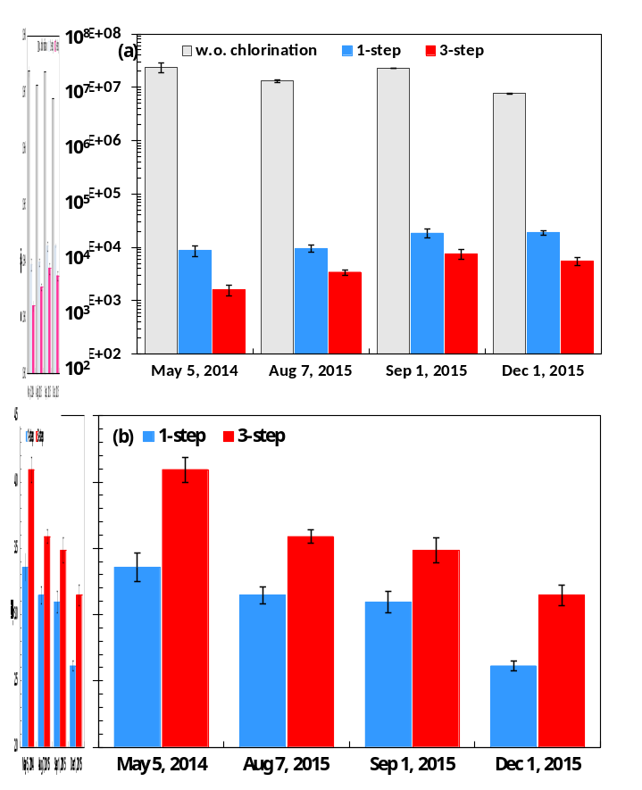
Fig. 1. (a) E. coli concentrations in the primary sewage effluent samples without or with one-step and three-step chlorination. (b) Disinfection efficiencies of the primary sewage effluent samples with one-step and three-step chlorination. The primary sewage effluent samples, collected on different days, were chlorinated with a total chlorine dose of 4.0 mg/L as Cl₂ and a total contact time of 30 min. Each error bar indicates the standard deviation of triplicate measurements.

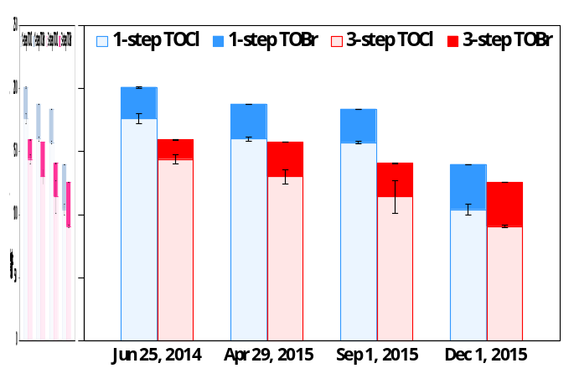
Fig. 2. TOCl and TOBr concentrations in the primary sewage effluent samples (collected on different days) with one-step and three-step chlorination with a total chlorine dose of 4.0 mg/L as Cl₂ and a total contact time of 30 min. Each error bar indicates the difference between the mean and the measured value.

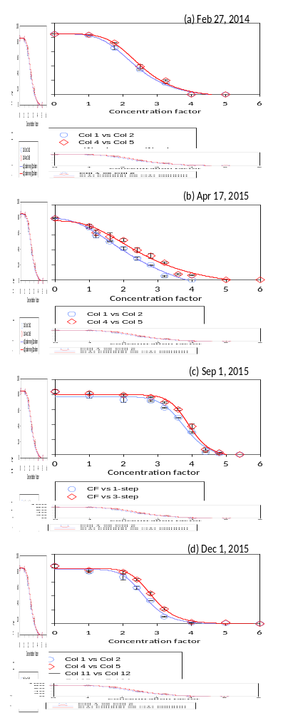
Fig. 3. Developmental toxicity of the primary sewage effluent samples with one-step chlorination ( ) and three-step chlorination ( ) with a total chlorine dose of 4.0 mg/L as Cl₂ and a total contact time of 30 min. Different charts represent samples collected on different days. Each datum presents the mean of duplicate measurements and the difference between the mean and the measured value.
Table 1
Developmental toxicity of the primary sewage effluent samples (collected on different days) with one-step and three-step chlorination with a total chlorine dose of 4.0 mg/L as Cl₂ and a total contact time of 30 min.
Effluent sample |  | EC₅₀±SD ª | R^{2 b} | t_{s} ^{c} | t_{2α[2]} ^{d} | p & α
Effluent collected  on Feb 27, 2014 | 1-step | 2.30±0.01 | 0.999 | 2.30 | 1.89 | p < 0.10
Effluent collected  on Feb 27, 2014 | 3-step | 2.44±0.08 | 0.999 | 2.30 | 1.89 | p < 0.10
Effluent collected  on Apr 17, 2015 | 1-step | 1.97±0.01 | 0.991 | 4.33 | 2.92 | p < 0.05
Effluent collected  on Apr 17, 2015 | 3-step | 2.36±0.13 | 0.985 | 4.33 | 2.92 | p < 0.05
Effluent collected  on Sep 1, 2015 | 1-step | 3.78±0.03 | 0.989 | 6.41 | 2.92 | p < 0.05
Effluent collected  on Sep 1, 2015 | 3-step | 3.92±0.02 | 0.993 | 6.41 | 2.92 | p < 0.05
Effluent collected  on Dec 1, 2015 | 1-step | 2.65±0.01 | 0.991 | 14.33 | 2.92 | p < 0.05
Effluent collected  on Dec 1, 2015 | 3-step | 2.87±0.02 | 0.998 | 14.33 | 2.92 | p < 0.05
ª the standard deviation of duplicate measurements for each chlorinated primary saline effluent sample; ^{b} the regression coefficient of the concentration factor‒response curve for each chlorinated saline primary effluent sample; ^{c} the statistic value; ^{d} the critical value for one-tailed t-test with a statistical significance level of α (Tao, 1994).

