Figure 1. Study design schematic. Flowchart depicting strategy for the three association analysis strategies (common, rare, and exonic variants), as well as replication selection criteria and numbers of samples and SNPs by stage. Subsequent transcriptome-wide association study (TWAS) analysis with S-PrediXcan and PheWAS analyses using common variant summary statistics are also presented. PP, pulse pressure.

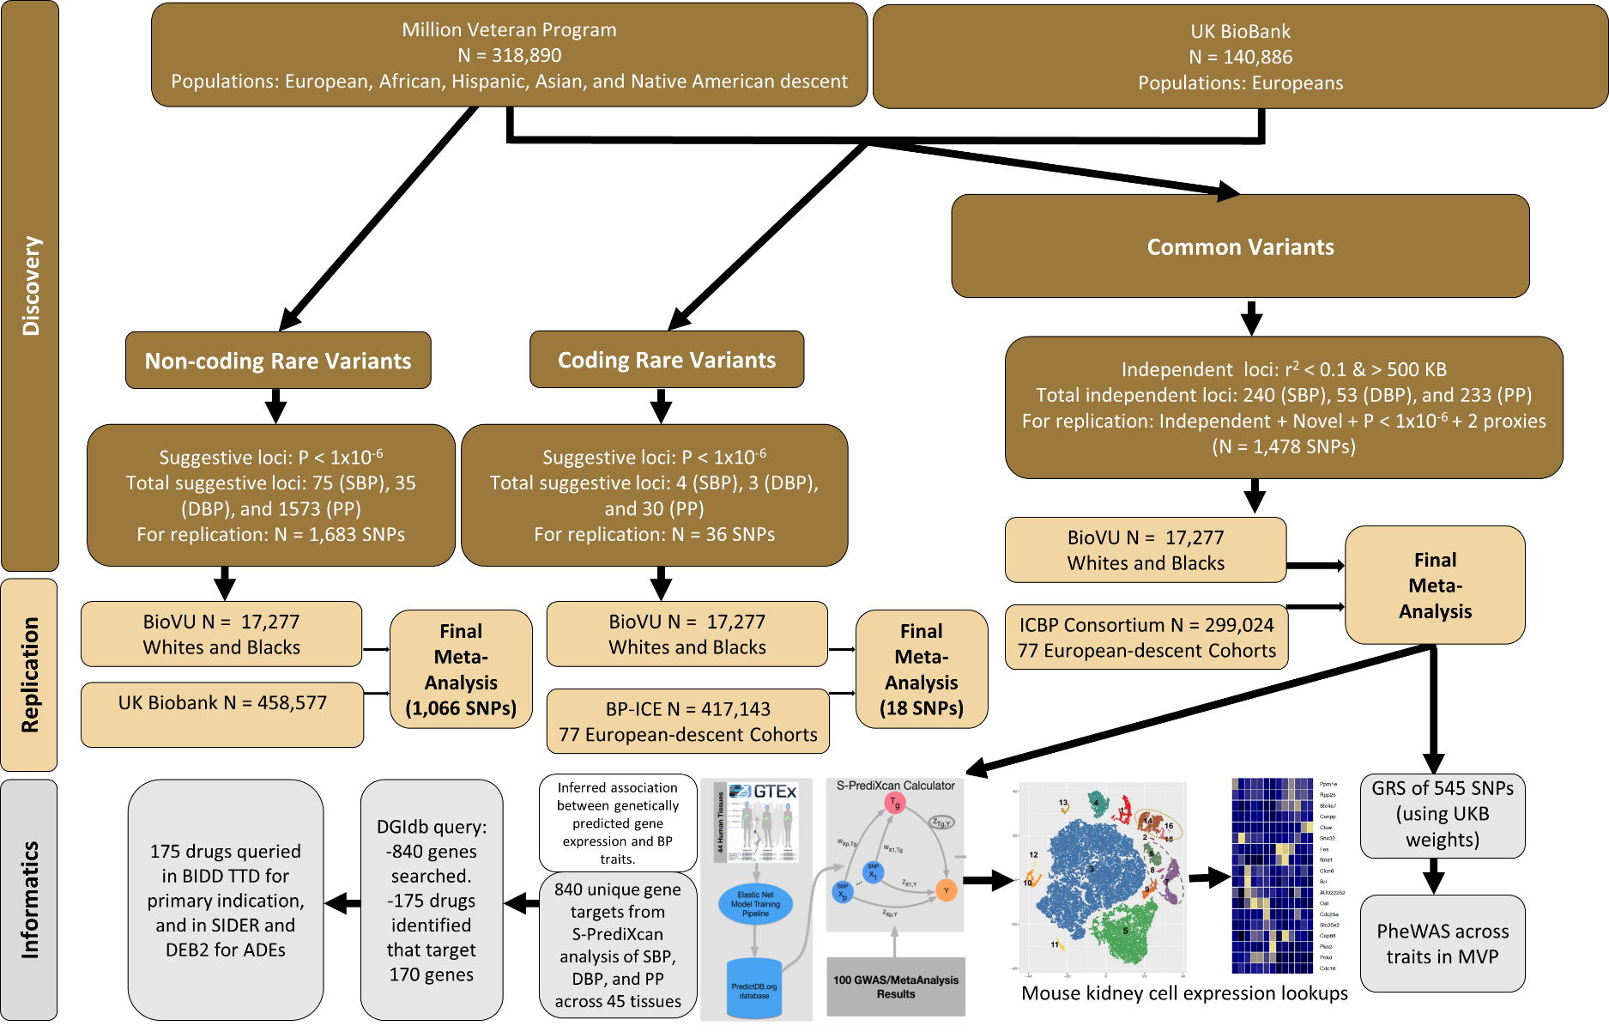
Figure 2. Manhattan plots summarizing discovery and replication meta-analysis for (A) SBP, (B) DBP, and (C) pulse pressure. Manhattan plot of the discovery + replication meta-analysis. The y axis shows the –log10 P-values and the x axis shows the chromosomal positions. The horizontal red line represents the thresholds of P-value = 5 x10⁻⁸ for genome-wide significance. SNPs in red are in previously identified loci (includes discovery only; N = 459,670 for SBP, 459,093 for DPB and 459,305 for pulse pressure) whereas SNPs in orange are in novel loci (includes discovery + replication; N = 760,226 for SBP, 767,920 for DBP and 759,768 for pulse pressure). All P values are computed for associations between genotyped or imputed SNPs and blood pressure traits as dependent variables in multivariate adjusted logistic regression models.
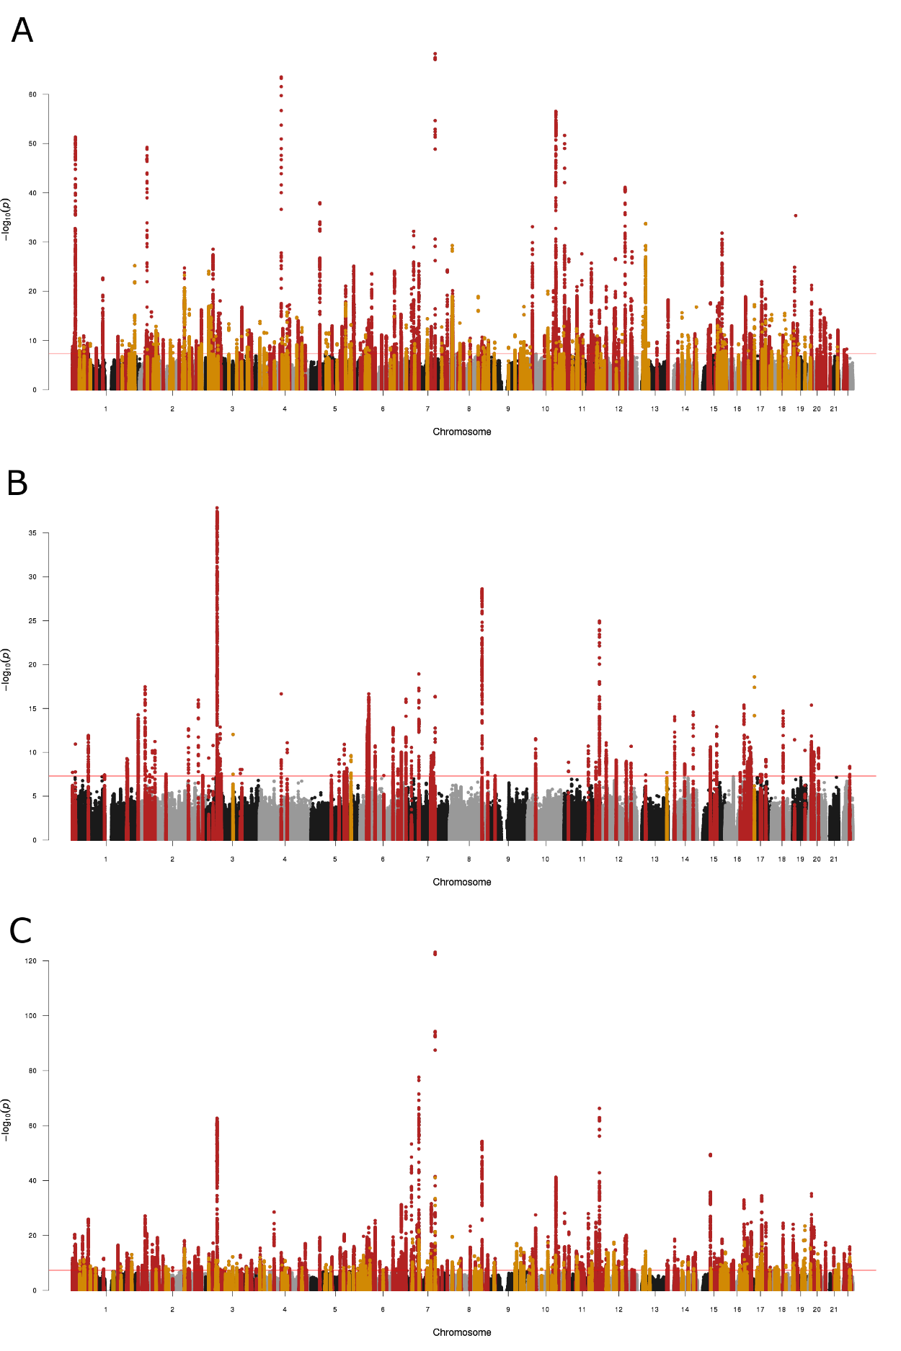

Figure 3. Mapping blood pressure-associated genes to kidney cell type clusters. Average expression level of GWAS/eQTL defined genes identified by S-PrediXcan analysis in mouse kidney cells for SBP, DBP and pulse pressure. Expression levels were determined in 43,745 kidney cells derived from 7 mice. Mean expression values of the genes were calculated in each cluster. Color scheme is based on z-score distribution. Z-scores are not corrected for multiple comparisons. Each row represents one gene and each column is single cell type cluster (as defined by Park et al.) on the heatmap. Endo: endothelial, vascular, descending loop of Henle, Podo: podocyte, PT: proximal tubule, LOH: ascending loop of Henle, DCT: distal convoluted tubule, CD-PC: collecting duct principal cell, CD-IC: CD intercalated cell, Fib: fibroblast, Macro: macrophage, Neutro: neutrophil, NK: natural killer cell.
