OPTIMISING TRIBOCHARGER DESIGNS FOR SEPARATING GRANULAR MATERIAL USING THE DISCRETE ELEMENT METHOD
Joshua N. Rasera & Jan J. Cilliers
Imperial College London

Kathryn Hadler
European Space Resources Innovation Centre

ABSTRACT
The optimisation of tribochargers using the discrete element method for the separating granular materials, essential for dry mineral beneficiation, is studied. Various tribocharger designs are compared; an optimum is identified. The suitability of the design for charging other materials is considered. We extend our analysis to simulate the conditions on the Moon, adapting the tribocharger design its unique environment. We highlight the versatility of our modelling approach and its potential for mineral processing on Earth and in space, particularly in the context of space resource utilisation. We provide insights into the adaptability and effectiveness of tribocharging technologies under diverse conditions.

INTRODUCTION
Space Resource Utilisation (SRU) is integral to human exploration and habitation of space. A critical first step for SRU is the production of oxygen from lunar regolith, as it can sustain human life and fuel space vehicles. Lunar minerals, comprising about 40% oxygen by mass, offer a rich resource for this purpose (French et al. 1991). Utilising space materials for water, fuel, and building supplies could significantly reduce the launch mass and overall cost of space missions.

Mineral beneficiation employs physical property differences like density, surface chemistry, or electromagnetic characteristics for separation (Wills & Finch, 2015; Rasera 2020). Dry processing techniques have been considered for several mineral processing applications at lab- and pilot-scale (Wills & Finch, 2015; Kelly and Spottiswood, 1989a, b, c; Manouchehri et al., 2000a, b; Trigwell et al., 2003; Dwari et al., 2009; Bittner et al., 2014; Bilici et al., 2011; Brands et al., 2001; Ballantyne & Holtham, 2010, 2014; Ireland 2010a, b, 2012; Ireland & Nicholson, 2011; Lawver 1973; Dwari et al., 2007). However, industrial-scale dry processing technologies for terrestrial applications have been limited to the use of high-tension roll separators for the separation of ilmenite and rutile from zircon in beach sands operations (Bittner et al., 2014; Dwari 2007; Wills & Finch, 2015; Lawver 1973). For the majority of mining applications, water-driven technologies, such as froth flotation and spiral concentrators, have been favoured (Wills & Finch, 2015).

Tribocharging, the frictional imparting of electrostatic charge, is a millennia-old phenomenon (Lacks 2012), yet its underlying mechanisms remain elusive (Lacks & Levandovsky, 2007; Waitukaitis et al., 2014; Zhao et al., 2003). Factors influencing charge transfer and retention include humidity, temperature, impact velocity, and material composition (Trigwell et al., 2003; Xie et al., 2016; Cruise et al., 2022).

While tribocharging in material conveyance is often seen as undesirable (Cezan et al., 2019; Mukherjee et al., 2021; Sayfidinov et al., 2018; Pingali et al., 2009), it is beneficial for recycling separation (Iuga et al., 2005, 2016; Silveira et al., 2018; Zelmat et al., 2013; Benhafssa et al., 2016; Rodrigues & Saron, 2022; Li et al., 2015; Bilici et al., 2011), printer toner application (Shinbrot et al., 2008; Noshiro et al., 1999; Anderson 1994, 1996; Takagi et al., 2003; Law et al., 1994), and dry mineral beneficiation (Kelly & Spottiswood, 1989a, b, c; Manouchehri et al., 2000a, b; Inculet et al, 1972; Ireland 2010a, b, 2012; Ireland & Nicholson, 2011; Trigwell et al., 2003; Rasera et al., 2020; Yu et al., 2024).

For separation applications, it is necessary to optimise the design of the tribocharger to maximise the charge transferred to particles of each mineral type. The aim of this work is to extend of our previous investigations into the use of the discrete element method (DEM) as a means to optimise the design of a tribocharger. We begin by presenting our modelling approach and optimised design under terrestrial conditions using PTFE spheres. We consider the suitability of the optimised tribocharger design to different materials and size classes. Finally, having validated modelling approach and demonstrated the suitability of the optimised design, extend our modelling to identify an optimal tribocharger design for use on the Moon.

Modelling Methodology
Cundall and Strack's discrete element method is of particular interest for modelling triboelectrification (Cundall 1971; Cundall & Strack 1979; Rasera et al., 2022a; Laurentie et al., 2010, 2013; Kolehmainen et al., 2016, 2017a, b; Ali et al., 1998; Pei et al., 2015; Sippola et al., 2018; Konopka et al., 2017). The DEM lends itself to coupling with tribocharging models, as parameters necessary for evaluating charge transfer are extracted easily.

Substantial effort has been put toward developing and evaluating means to model the charge transfer process (Rasera et al., 2022a. b; Yu et al., 2017; Xie et al., 2013; Hu et al., 2012; Laurentie et al, 2010, 2013; Kolehmainen, 2016, 2017a,b; Ali et al., 1998; Pei et al., 2015; Sippola et al., 2018; Konopka et al., 2017; Lacks, 2012; Duff & Lacks, 2008; Forward et al., 2009a). The tribocharging model employed in our studies uses the high-density limit of surface state theory to describe the charge transferred between two surfaces, following Schein et al. (1992), Matsusaka et al. (2000), Laurentie et al. (2010, 2013), and Kolehmainen et al (2016, 2017a, b). This model is given by the following equation:

$$σ= κ_{c}ε_{0}\left(\frac{ϕ_{i}-ϕ_{j}}{δe}-{\vec{E}}_{contact}∙{\hat{n}}_{ij}\right)$$

Here, $σ$ is the charge transferred per unit area; $κ_{c}$ is the empirically-derived charging efficiency; $ε_{0}$ is the permittivity of free space; $δ_{e}$ is the separation distance between two particles at which point charge transfer ceases; $e$ is the magnitude of the electron charge; $ϕ_{i}$ and $ϕ_{j}$ are the effective work functions; ${\vec{E}}_{contact}$ is the electrostatic field at the point of contact; and, ${\hat{n}}_{ij}$ is the unit normal vector pointing from particle i to j at the point of contact. While the use of this model has been demonstrated previously in the literature with good agreement to experimental data, this elaboration is dependent on effective work functions, a property that is not suitable for describing insulating materials (Rasera et al., 2022a, b; Schein et al., 1992). Furthermore, other studies assume the charging efficiency to simply be 1, however, we demonstrated that this term is a critical parameter for modelling the charge transfer process.

To address the first issue, the work function term is replaced by the charge transfer limitation parameter, Γ, which is effectively the electrostatic field required to drive $Δq$ to 0. The equation above it thus rearranged in terms of the quantity of charge transferred, $Δq$, as a function of the change in contact area during a collision, $ΔA$, as follows:

$$Δq=ΔAκ_{c}ε_{0}\left(Γ-{\vec{E}}_{contact}∙{\hat{n}}_{ij}\right)$$

This form of the equation makes it well-suited for implementation in a DEM solver. The parameters $Γ$ and $κ_{c}$ must be determined experimentally for both particle-particle and particle-wall interactions, and for each material pairing; a method for calculating these can be found in Rasera et al. (2022a, b). The algorithm for modelling triboelectric charging is as follows:
- Update the particle positions and velocities using the laws of motion.
- Identify contacting bodies (particles and/or walls).
- Determine the overlap and evaluate the change in contact area.
- Find the electrostatic field at the centroid of each particle. If the contact is between two particles, use linear interpolation to find the field at the point of contact. If the contact is between a particle and a wall, calculate the field at the point of contact directly.
- Evaluate the quantity of charge exchanged.
- Determine the electrostatic force acting on each particle.
- Use a Hertzian contact model to update the mechanical forces and moments.
Rasera et al. (2022a) and Cruise et al. (2022) identify two crucial design criteria for effective tribocharging: first, the maximisation of particle-wall contacts is essential for predictable charge transfer since interactions between particles are inherently random; second, it's important to limit the number of particles in a given charging space, as a higher particle count suppresses both bulk saturation charge and charge transfer. For the purposes of design optimisation, we simplify the algorithm to track only the net particle-particle and particle-wall contact areas and use these as proxies for charge transfer (Rasera et al., 2022b). This simplification reduces greatly the computational cost by removing the calculation of the local electrostatic field at each point of contact at every timestep. With respect to the second criteria, we maintain a constant particle inlet velocity of 0.08 m/s. The residence time of each particle within the domain is then tracked and compared; lower residence times imply fewer particles within the domain at any given time.

Tribocharger Design optimisation

Baseline Design
Two basic designs were considered: angled slats within a tube (at both 30° and 45° with respect to the vertical), as well as a twisted baffle design employed with success by Trigwell et al. (2009, 2012) and Quinn et al. (2013).
.
Different slat spacings were tested to ensure that particles would not build up within the tribocharger domain. This consideration was necessary to ensure that the proportion of particle-wall contacts would remain high relative to the particle-particle contacts, whilst also minimising the volume fraction of particles within the domain. Figure 1 presents a comparison of the 30° slat design with a spacing of 1.0 cm and 1.25 cm. This difference is explained by the still images from the simulations found in Figure 2: the narrower spacing reduced greatly the throughput and partially blocked the particle flow, resulting in 22-fold increase in particle-particle contact area.

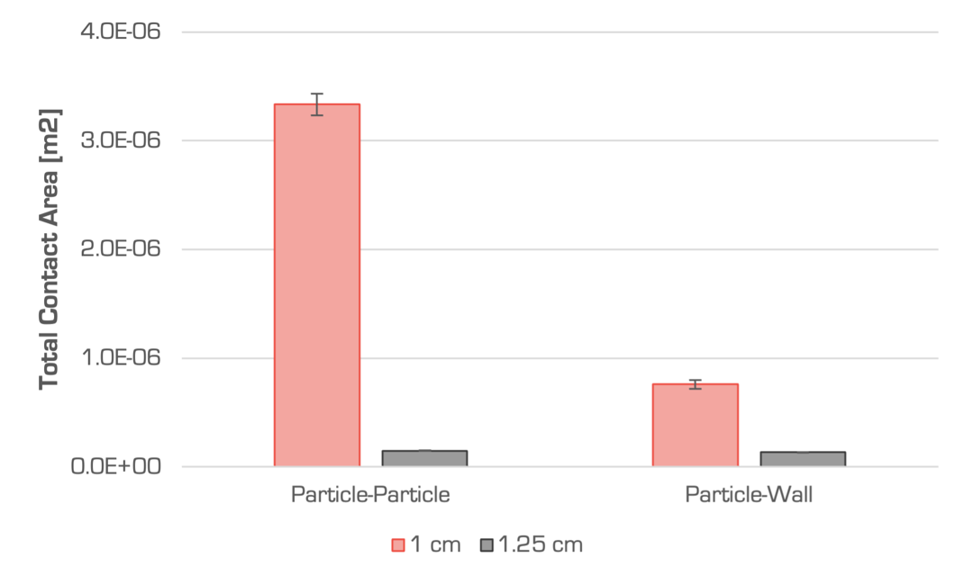
Figure 1. A comparison of the net particle-particle and particle-wall contact areas for the 30° slat design resulting from 1.0 and 1.25 cm slat spacings
The ratio of particle-particle to particle-wall contacts was made for the three preliminary designs; the simulation outputs are found in Figure 3. There were no statistically significant differences between the net particle-particle contact areas for each design. However, the twisted baffle generated significantly greater net particle-wall contact area than the slat designs. Further, it was the only design where the net particle-wall contact exceeded the net particle-particle contact area.

A subsequent study was performed to determine how the segmented design of Trigwell et al. (2009, 2012} and Quinn et al. (2013) would perform against a continuous baffle. The two 90° segments were compared to a single 180° design. The net particle-particle and particle-wall contact areas output by the simulations are found in Figure 4. The segmented design produced greater overall particle-particle and particle-wall contact areas, however the relative ratio between them was low (PW/PP = 1.03). In comparison, the continuous design generated lower overall net contact areas for both modes, but the contact ratio was significantly higher (PW/PP = 2.55). This indicates that a continuous design is preferable to a segmented one.
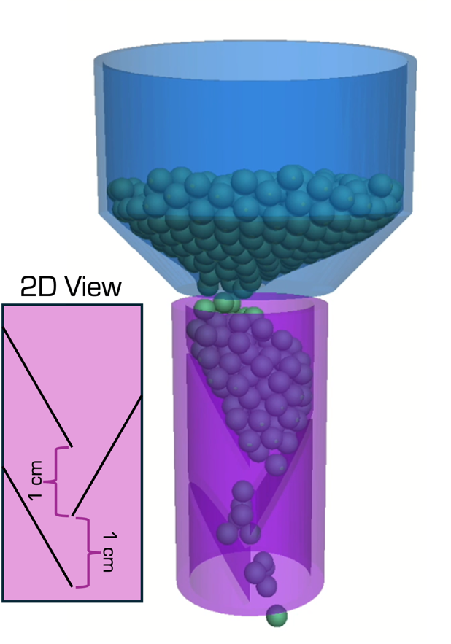  - 1.0 cm slat spacing | 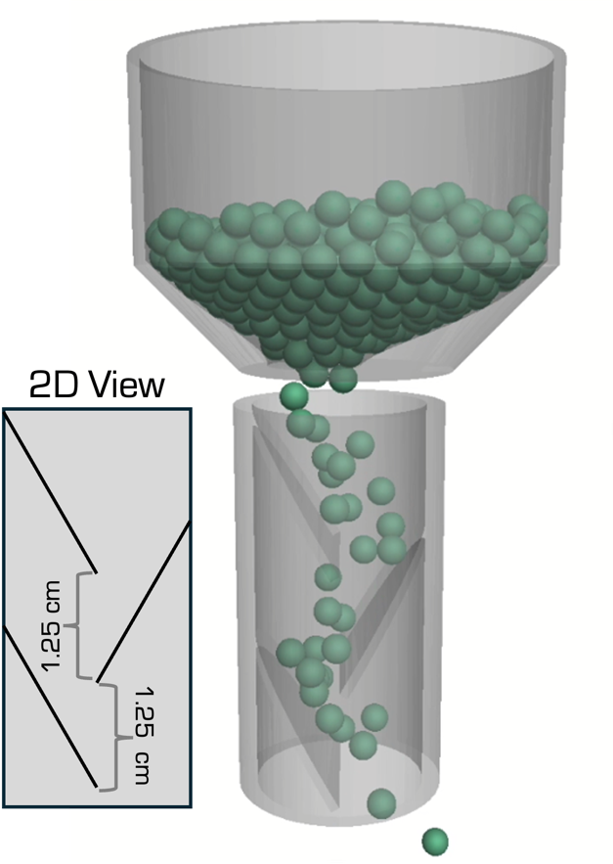  - 1.25 cm slat spacing
Figure 2. A comparison of the difference in flow behaviour between the 1.0 cm and 1.25 cm slat spacings. The small increase in slat spacing prevented the formation of blockages.
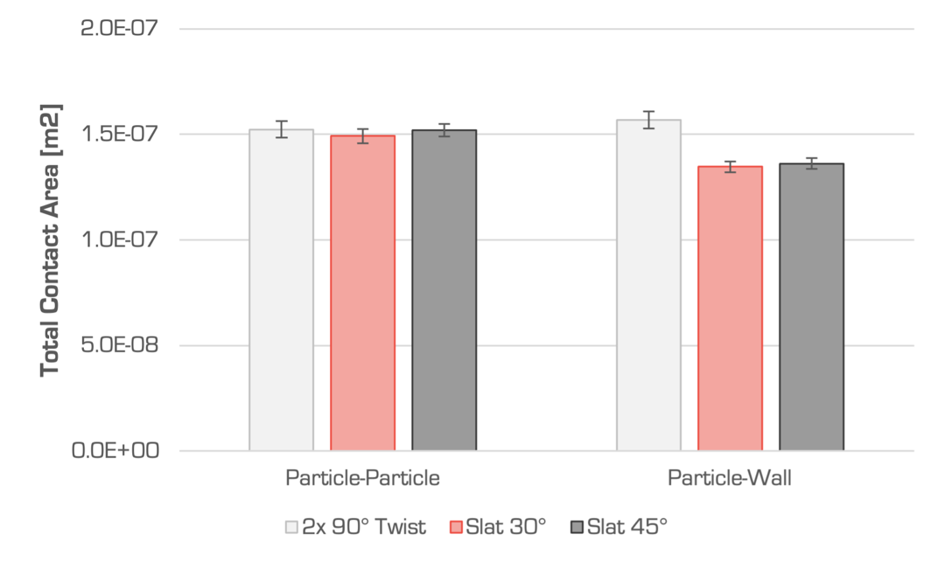
Figure 3. A comparison of the performance of the three preliminary designs found that the net particle-wall contact area accumulated by the twisted baffle design were statistically significant; error bars indicate 95% confidence intervals
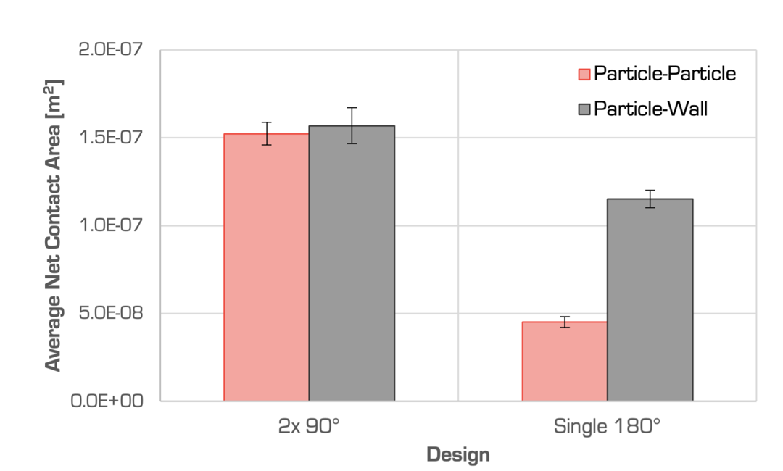
Figure 4. A comparison of a baffle comprising two 90° segments against a continuous 180° baffle (95% confidence intervals indicated)

Identification of an Optimal Design
As presented previously (Rasera et al., 2022b), we demonstrate our optimisation approach by focusing on the internal structure of the tribocharger. Specifically, we consider the effect of the charging baffle's pitch, defined as the height of one complete helical turn (360°), on the contact dynamics. For the preliminary validation of the optimisation approach, the baffle's height was kept constant at 4.5 cm. The pitch angle, determining the helical tightness, varied across designs. Five distinct pitches were assessed (Figure 5), all under a consistent particle inlet velocity of 0.08 m/s. The purpose of this was to demonstrate the validity of the optimisation method, not to find a universally optimal design. It is important to note that choice of particle and charger materials, particle size, charger geometries, and inlet flow rates may produce different optima.

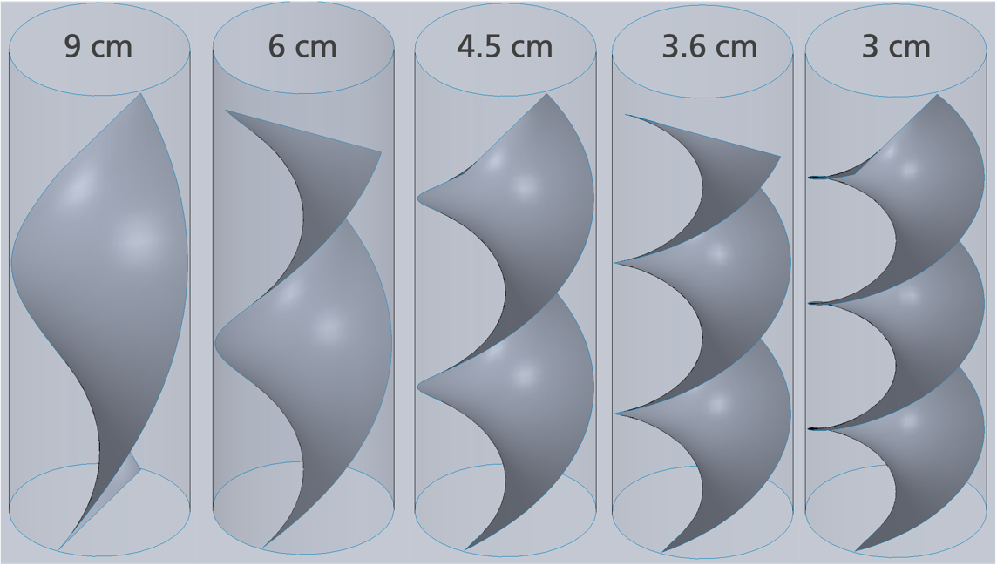
Figure 5. CAD renderings of baffles designs with varying pitch (inset) evaluated in this study. The pitch angles are 180°, 270°, 360°, 450°, and 540°, respectively
Each baffle design underwent testing using the DEM model with 150 PTFE particles, averaging 3.18 mm in radius. The analysis tracked the net particle-particle and particle-wall contact areas and recorded the residence times within the charger.

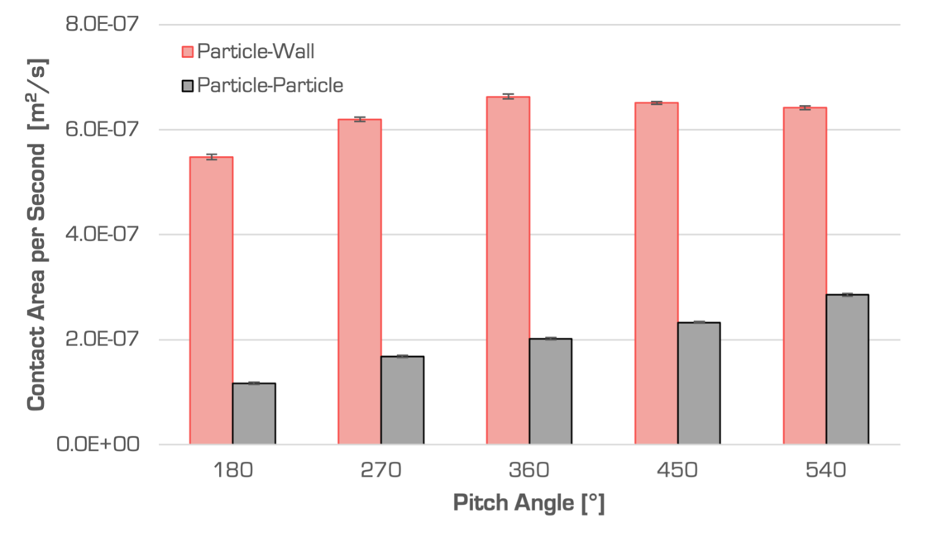
Figure 6. Summary of the net particle-particle and particle-wall contact area accumulated per second for each charger design; error bars indicate 95% confidence intervals (Rasera et al., 2022b)
The results, shown in Figure 6, reveal that while there are significant differences in particle-particle contacts among the designs, the particle-wall contacts are less distinct. The 9 cm design notably exhibited a minimum in particle-wall contacts, and the 4.5 cm pitch design showed marginally higher efficiency compared to the 6 cm pitch. However, the differences between the 6 cm, 3.6 cm, and 3 cm pitches, as well as between the 4.5 cm, 3.6 cm, and 3 cm designs, were not significant. This suggests a balance point at the 6 cm design for particle-wall area. Moreover, the 4.5 cm design had a lower particle-wall to particle-particle contact area ratio and a 32% increase in average particle residence time compared to the 6 cm design.

In summary, the 6 cm pitch design emerged as the most balanced, maximising particle-wall contact area and the ratio of particle-wall to particle-particle contacts, while also enhancing throughput compared to the 4.5 cm design. Consequently, the 6 cm pitch design was selected as optimal for this study, and all further simulations and experimental investigations proceeded with this configuration.

Design Transferability
The models employed here utilise large, ideal spheres, a methodological approach that, while effective, presents limitations in its applicability to real-world scenarios. In our previous studies (Rasera et al., 2022b, 2023), we established the robustness of our charging model for diverse sample sizes and compositions and have demonstrated the efficacy of optimised designs in laboratory settings for separating granular materials. This section aims to support these previous findings by extends our analysis to compare the performance of a charger design, initially optimised for PTFE, with other single-material species and their mixtures. Although the charger may not represent the optimal design for all species, identifying consistent performance trends across different materials can validate the broader applicability of an optimised design. Moreover, a comprehensive understanding of the interaction dynamics within the tribocharger for varied particle types is instrumental in evaluating the design's versatility and efficiency in a range of processing environments.

An investigation was conducted to compare trends in particle-wall and particle-particle contact areas across different material types. Figure 7 compares ratios of net particle-wall to net particle-particle contact areas for 1.59 mm, 3.18 mm, and 3.97 mm PTFE, PA66 and PVC particles passed through a simulated tribocharger. The data from this figure suggests a consistent trend in the relative proportions of contact areas regardless of particle type. This indicates that while a tribocharger design may not be optimised for all materials, the trends in relative proportions of particle-particle and particle-wall contact are consistent. Such a trend implies that optimising a design for one material should enhance the charging performance for other materials as well.

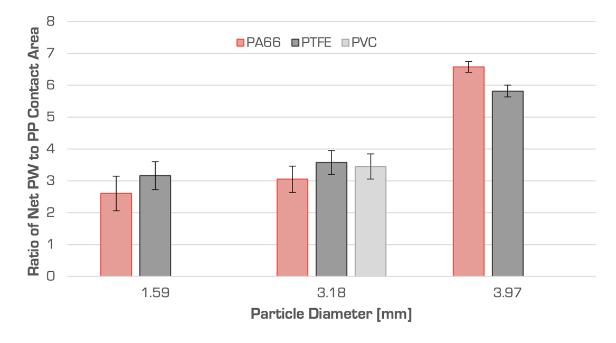
Figure 7. A comparison of the net particle-wall (PW) to net particle-particle (PP) contact areas for PA66, PTFE, and PVC particles; error bars indicate 95% confidence intervals
Subsequently, two mixed species, mixed size tests were conducted. In both cases, equal numbers of 1.59 mm and 3.97 mm particles were used. One sample was comprised of large PTFE and small PA66 particles, and the other of small PTFE and large PA66 particles. Each mixture was passed through a simulated tribocharger. Figure 8 presents the ratio of net particle-particle and particle-wall contact areas for each material at each size. Here, the particle-wall contact area was higher than the net particle-particle contact area for both particle types. The resulting ratios for each material and size are similar and consistent: larger particles have higher ratios of particle-wall to particle-particle contacts, and PTFE has a greater contact ratio to PA66.
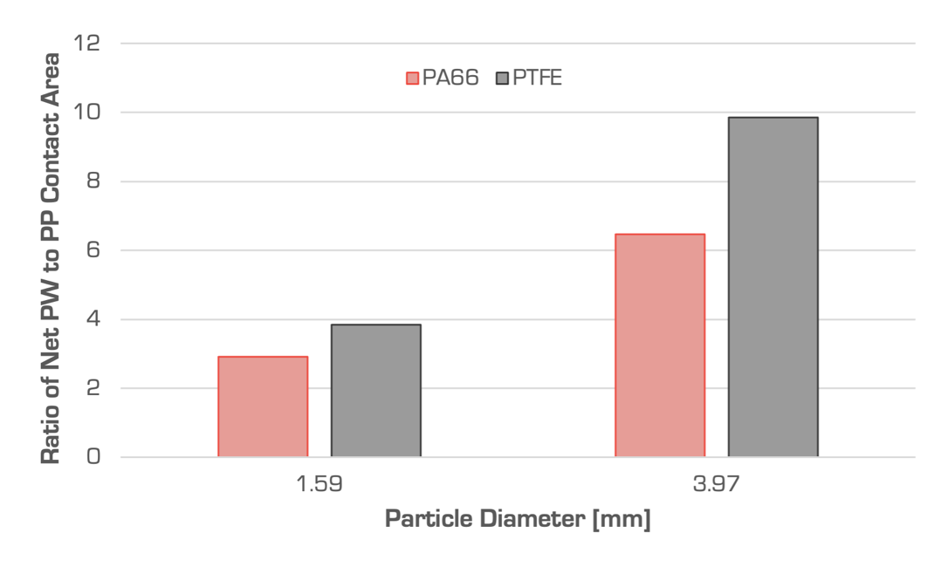
Figure 8. A comparison of the particle-wall and particle-particle contact areas experienced by a binary mixture of PTFE and PA66
The findings from this analysis support the robustness and flexibility of our tribocharger optimisation approach, revealing consistent patterns in contact area ratios across a range of materials and particle sizes. Such consistency is crucial, particularly as it suggests the method’s capacity for designing effective particle charging is not limited to a specific material type. This is particularly valuable in contexts where regular or easy access to the target environment is constrained, such as the lunar surface.

Lunar case study
As we have demonstrated the efficacy of the optimised tribocharger design in terrestrial settings, it is essential to consider the applicability of the optimisation method for lunar environments. The unique conditions of the Moon, including its lower gravity and lack of atmosphere, present distinct challenges and opportunities for mineral beneficiation. In this section, we extend the our approach to explore the feasibility and adaptations required for the tribocharger in lunar applications.

Using the approach described above, the baseline design and DEM process parameters were modified to consider a tribocharger on the lunar surface. The lunar gravity, 1/6th that of Earth’s, was used. Several modifications were made to the initial design to accommodate the lower gravity. First, the baffle length was increased, and the flow velocity reduced to accommodate bouncing and provide more opportunities for particle-wall interactions. The inlet was placed further away from the top of the baffle to prevent erroneous and problematic interactions between bouncing particles and newly generated particles. A comparison of the designs employed are found in Figure 9.

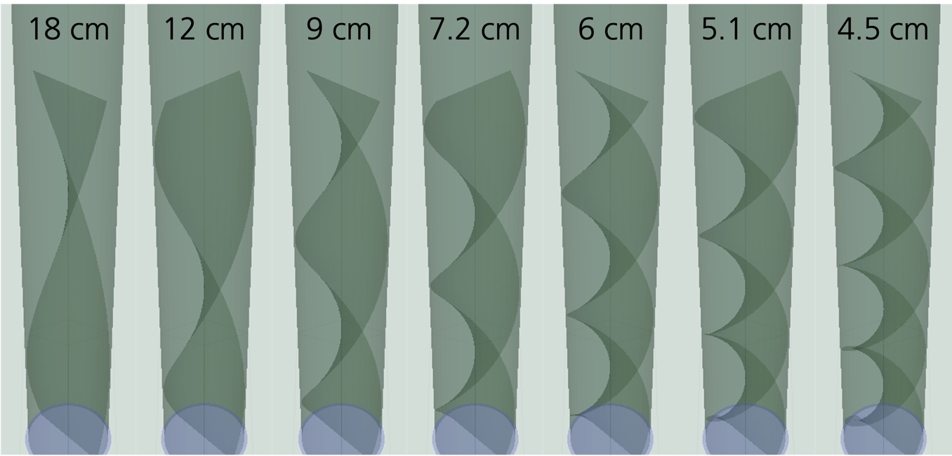
Figure 9. CAD renderings of baffle designs with varying pitch (inset) evaluates; the pitch angles are 180°, 270°, 360°, 450°, 540°, 630°, and 720°, respectively
The simulation outputs using these parameters are found in Figure 10, with error bars indicating 95% confidence intervals. Note that both the particle-wall and particle-particle contact areas are appreciably lower than for the terrestrial case. The 450° design offers optimal particle-wall contacts as there are not statistically significant differences with the 540°, 630°, and 720° designs. Furthermore, the particle-particle contact area is significantly lower for the 450° design compared to all the other designs considered.

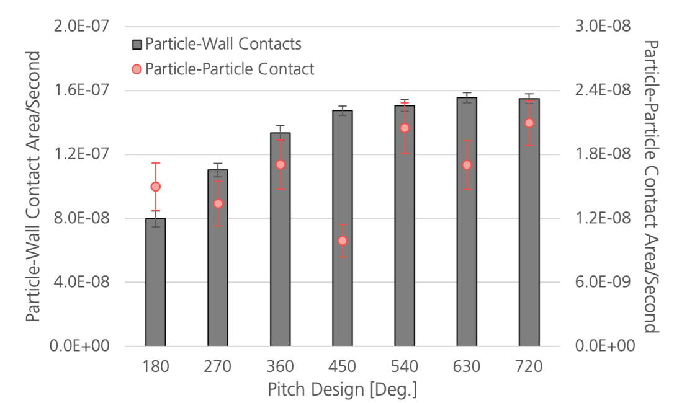
Figure 10. Summary of the net particle-particle and particle-wall contact area accumulated per second for each charger design
The proportion of particles that experienced particle-particle interactions were compared for each design (Figure 11). This comparison was made to ensure that the low particle-particle area accumulation rate of the 450° design was not due to a large proportion of particles not interacting with other particles. Furthermore, Figure 12 presents the accumulation of particle-particle and particle-wall contact area, excluding any of the particles with zero net particle-particle contact area. These analyses both suggest that the 450° design is optimal, and not an artefact of the flow characteristics.

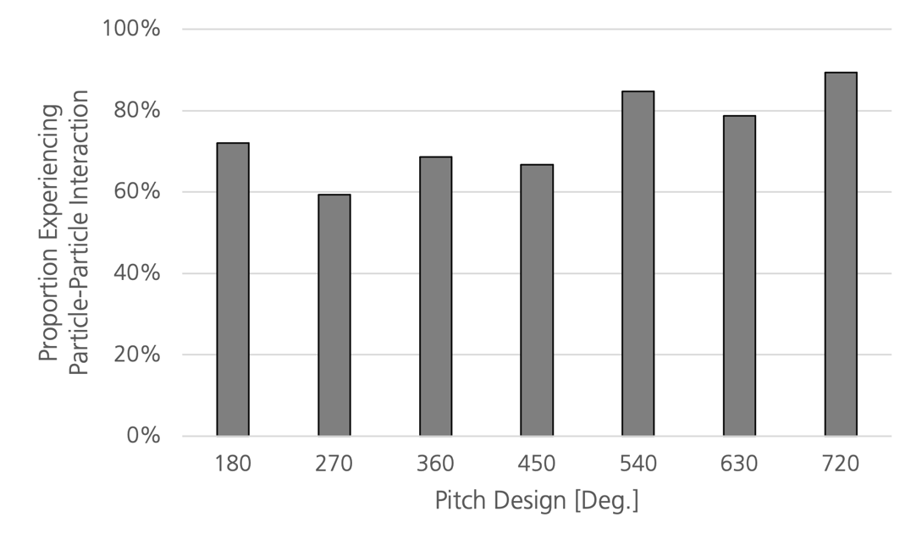
Figure 11. Proportion of the total particles in each sample that experienced particle-particle interactions whilst passing through the tribocharger
This study highlights the adaptability and flexibility of our optimisation methodology to extraterrestrial environments. By modifying the baseline design to account for lunar conditions, we've demonstrated that the principles guiding our optimisation approach remain effective, even under the Moon's environmental constraints.

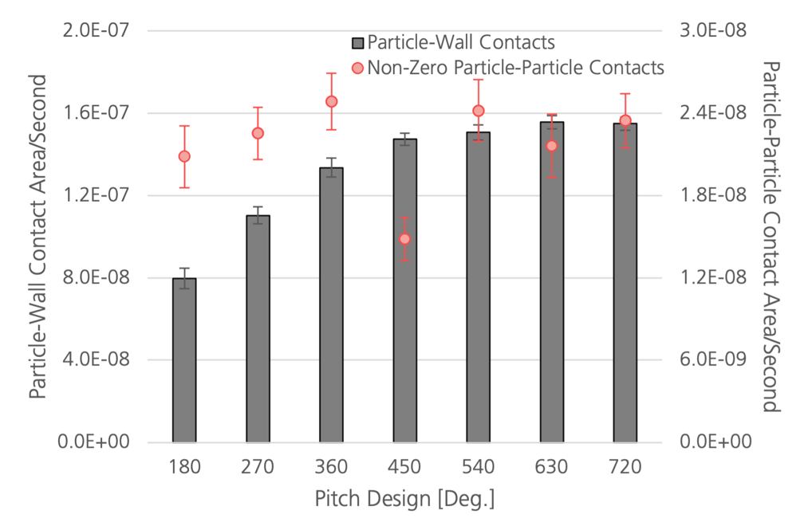
Figure 12. Summary of the net particle-particle and particle-wall contact area accumulated per second for each charger design, excluding any particles that did not experience any particle-particle interactions; error bars indicate 95% confidence intervals

Conclusion
In this study, we explore the design optimisation of tribochargers for granular material separation, demonstrating their effectiveness across both terrestrial and lunar environments. The research has established the adaptability of our design optimisation approach to different materials, sizes, and extraterrestrial conditions, notably on the Moon. This work not only advances our understanding of triboelectric charging but also opens avenues for its application in space resource utilisation and sets a foundation for future developments in extraterrestrial mining technologies.

Acknowledgements
This research has been made possible through the support of the Luxembourg National Research Fund (FNR) under Industrial Fellowship Grant 12489764.

The authors acknowledge the support of the Natural Sciences and Engineering Research Council of Canada (NSERC) [ref: 411291661]. Cette recherche a été financée par le Conseil de recherches en sciences naturelles et en génie du Canada (CRSNG), [réf: 411291661].

The authors acknowledge the generous support of Itasca Consulting Group for the provision of a PFC license as well as support and mentorship from Dr D.O. Potyondy for Dr J.N. Rasera through the Itasca Educational Partnership Program.

List of Symbols
  Symbol | Definition | Units
  $$σ$$ | Charge transfer per unit area | $$C/m^{2}$$
  $$κ_{c}$$ | Charging efficiency | -
  $$ε_{0}$$ | Permittivity of free space | $$F/m$$
  $${\vec{E}}_{contact}$$ | Electrostatic field strength at point of contact | $$V/m$$
  $$Δq$$ | Quantity of charge transferred | $$C$$
  Symbol | Definition | Units
  $$δ_{e}$$ | Charge transfer limit | $$m$$
  $$e$$ | Electron charge | $$C$$
  $$ϕ$$ | Effective work function | $$eV$$
  $${\hat{n}}_{ij}$$ | Unit normal vector | -
  $$Γ$$ | Charge transfer limitation parameter | $$V/m$$
  $$ΔA$$ | Change in contact area | $$m^{2}$$

References
Ali, F Sharmene, Ali, M Adnan, Castle, GSP, Inculet, II (1998). Charge exchange model of a disperse system of spherical powder particles. In Conference Record of 1998 IEEE Industry Applications Conference. Thirty-Third IAS Annual Meeting (Cat. No. 98CH36242) (IEEE Ed.), Vol. 3, 1884--1891.

Anderson, JH (1996). The effect of additives on the tribocharging of electrophotographic toners. Journal of electrostatics, 37(3), 197--209.

Anderson, JH, others (1994). A comparison of experimental data, model predictions for tribocharging of two-component electrophotographic developers. Journal of Imaging Science, Technology, 38(4), 378--382.

Ballantyne, Grant R, Holtham, Peter N (2010). Application of dielectrophoresis for the separation of minerals. Minerals Engineering, 23(4), 350-358.

Ballantyne, Grant R, Holtham, Peter N (2014). Evaluation of the potential for using dielectrophoresis to separate minerals. Minerals Engineering, 55, 75-79.

Benhafssa, Abdelkader Mekhalef, Zeghloul, Thami, Messal, Sara, Dascalescu, Lucian, Medles, Karim (2016). Factors that influence the efficiency of a propeller-type tribocharging device for granular plastics. IEEE Transactions on Industry Applications, 53(2), 1446--1451.

Bilici, Mihai, Dascalescu, Lucian, Dragan, Ciprian, Fati, Ovidiu, Iuga, Alexandru, Samuila, Adrian (2011). Tribocharging, electrostatic separation of mixed granular solids in fluidised bed devices. IEEE Transactions on Dielectrics, Electrical Insulation, 18(5), 1476-1483.

Bittner, James D, Hrach, FJ, Gasiorowski, SA, Canellopoulus, LA, Guicherd, H (2014). Triboelectric belt separator for beneficiation of fine minerals. Procedia Engineering, 83, 122-129.

Brands, Ludwig, Beier, Peter‐M, Stahl, Ingo (2001). Electrostatic separation. In Ullmann's Encyclopedia of Industrial Chemistry, 423--441. Wiley Online Library.

Cezan, S Doruk, Nalbant, Atakan A, Buyuktemiz, Muhammed, Dede, Yavuz, Baytekin, H Tarik, Baytekin, Bilge (2019). Control of triboelectric charges on common polymers by photoexcitation of organic dyes. Nature communications, 10(1), 1--8.

Cruise, Reuben D, Hadler, Kathryn, Starr, Stanley O, Cilliers, Jan J (2022). The effect of particle size, relative humidity on triboelectric charge saturation. Journal of Physics D: Applied Physics, , .

Cundall, Peter A (1971). A computer model for simulating progressive, large-scale movement in blocky rock system. In Proceedings of the International Symposium on Rock Mechanics, 1971, . .

Cundall, Peter A, Strack, Otto DL (1979). A discrete numerical model for granular assemblies. geotechnique, 29(1), 47--65.

Duff, Nathan, Lacks, Daniel J (2008). Particle dynamics simulations of triboelectric charging in granular insulator systems. Journal of Electrostatics, 66(1-2), 51--57.

Dwari, RK, Rao, K Hanumantha (2007). Dry beneficiation of coal—a review. Mineral Processing, Extractive Metallurgy Review, 28(3), 177--234.

Dwari, RK, Rao, K Hanumantha, Somasundaran, P (2009). Characterisation of particle tribo-charging, electron transfer with reference to electrostatic dry coal cleaning. International Journal of Mineral Processing, 91(3-4), 100--110.

Forward, Keith M, Lacks, Daniel J, Sankaran, R Mohan (2009). Triboelectric charging of lunar regolith simulant. Journal of Geophysical Research: Space Physics, 114(A10), .

Hu, Wenwen, Xie, Li, Zheng, Xiaojing (2012). Simulation of the electrification of wind-blown sand. The European Physical Journal E, 35(3), 1--8.

Inculet, Ion I, Bergougnou, Maurice A, Bauer, Stanley (1972). Electrostatic beneficiation apparatus for fluidised iron, other ores. IEEE Transactions on Industry Applications, (6), 744--748.

Ireland, Peter M (2010a). Triboelectrification of particulate flows on surfaces: Part I—Experiments. Powder Technology, 198(2), 189--198.

Ireland, Peter M (2010b). Triboelectrification of particulate flows on surfaces: Part II—Mechanisms, models. Powder Technology, 198(2), 199--210.

Ireland, Peter M, Nicholson, Kurt (2011). Analysis, comparison of particle tribochargers. Minerals Engineering, 24(8), 914--922.

Ireland, Peter M (2012). Dynamic particle-surface tribocharging: The role of shape, contact mode. Journal of Electrostatics, 70(6), 524--531.

Iuga, Alexandru, Calin, Laur, Neamtu, Vasile, Mihalcioiu, Adrian, Dascalescu, Lucian (2005). Tribocharging of plastics granulates in a fluidised bed device. Journal of Electrostatics, 63(6-10), 937--942.

Iuga, Alexandru, Samuila, Adrian, Morar, Roman, Bilici, Mihai, Dascalescu, Lucian (2016). Tribocharging techniques for the electrostatic separation of granular plastics from waste electric, electronic equipment. Particulate Science, Technology, 34(1), 45--54.

Kelly, EG, Spottiswood, DJ (1989a). The theory of electrostatic separations: A review Part I. Fundamentals. Minerals Engineering, 2(1), 33--46.

Kelly, EG, Spottiwood, DJ (1989b). The theory of electrostatic separations: A review part II. Particle charging. Minerals Engineering, 2(2), 193--205.

Kelly, EG, Spottiswood, DJ (1989c). The theory of electrostatic separations: A review part III. The separation of particles. Minerals Engineering, 2(3), 337--349.

Kolehmainen, Jari, Ozel, Ali, Boyce, Christopher M, Sundaresan, Sankaran (2016). A hybrid approach to computing electrostatic forces in fluidised beds of charged particles. AIChE Journal, 62(7), 2282--2295.

Kolehmainen, Jari, Ozel, Ali, Boyce, Christopher M, Sundaresan, Sankaran (2017a). Triboelectric charging of monodisperse particles in fluidised beds. AIChE Journal, 63(6), 1872--1891.

Kolehmainen, Jari, Sippola, Petteri, Raitanen, Oskari, Ozel, Ali, Boyce, Christopher M, Saarenrinne, Pentti, Sundaresan, Sankaran (2017b). Effect of humidity on triboelectric charging in a vertically vibrated granular bed: Experiments, modeling. Chemical Engineering Science, 173, 363--373.

Konopka, Ladislav, Kosek, Juraj (2017). Discrete element modeling of electrostatic charging of polyethylene powder particles. Journal of electrostatics, 87, 150--157.

Lacks, Daniel J, Levandovsky, Artem (2007). Effect of particle size distribution on the polarity of triboelectric charging in granular insulator systems. Journal of Electrostatics, 65(2), 107--112.

Lacks, Daniel J (2012). The unpredictability of electrostatic charging. Angewandte Chemie International Edition, 51(28), 6822--6823.

Laurentie, JC, Traoré, P, Dascalescu, L (2013). Discrete element modeling of triboelectric charging of insulating materials in vibrated granular beds. Journal of Electrostatics, 71(6), 951--957.

Laurentie, JC, Traoré Philippe, Dragan, Ciprian, Dascalescu, Lucian (2010). Numerical modeling of triboelectric charging of granular materials in vibrated beds. In 2010 IEEE Industry Applications Society Annual Meeting (IEEE Ed.), 1--6. .

Law, KY, Tarnawskyj, IW, Salamida, D, Debies, T (1994). Tribocharging Mechanism In a Model Xerographic Toner. In INTERNATIONAL CONGRESS ON ADVANCES IN NONIMPACT PRINTING TECHNOLOGIES, 122--125. .

Lawver, J E, Dyrenforth, W P (1973). Electrostatic separation. In Electrostatics, its Applications, 221--249. Wiley New York.

Li, Jia, Wu, Guiqing, Xu, Zhenming (2015). Tribo-charging properties of waste plastic granules in process of tribo-electrostatic separation. Waste management, 35, 36--41.

Manouchehri, Hamid-Reza, Hanumantha Rao, K, Forssberg, KSE (2000). Review of electrical separation methods - Part 1: Fundamental Aspects. Mining, Metallurgy, Exploration, 17(1), 23-36.

Manouchehri, Hamid-Reza, Hanumantha Rao, K , Forssberg, KSE (2000). Review of electrical separation methods - Part 2: Practical considerations. Mining, Metallurgy & Exploration, 17(3), 139-166.

Matsusaka, Shuji, Ghadiri, Mojtaba, Masuda, Hiroaki (2000). Electrification of an elastic sphere by repeated impacts on a metal plate. Journal of Physics D: Applied Physics, 33(18), 2311.

McKay, David S, Carter, James L, Boles, Walter W, Allen, Carlton C, Allton, Judith H (1994). JSC-1: A new lunar soil simulant. Engineering, construction,, operations in space IV, 2, 857--866.

Mukherjee, Raj, Sansare, Sameera, Nagarajan, Venkatraman, Chaudhuri, Bodhisattwa (2021). Discrete Element Modeling ({DEM}) based investigation of tribocharging in the pharmaceutical powders during hopper discharge. International Journal of Pharmaceutics, 596, 120284.

Noshiro, Toshihiko, Takeuchi, Manabu, ASANAE, Masumi, Ochiai, Masahisa (1999). Influence of Toner Composition on Its Tribocharging Characteristics. Journal of the Society of Powder Technology, Japan, 36(9), 679--684.

Pei, Chunlei, Wu, Chuan-Yu, England, David, Byard, Stephen, Berchtold, Harald, Adams, Michael (2015). DEM-CFD modeling of particle systems with long-range electrostatic interactions. AIChE Journal, 61(6), 1792--1803.
Pingali, Kalyana C, Hammond, Stephen V, Muzzio, Fernando J, Shinbrot, Troy (2009). Use of a static eliminator to improve powder flow. International journal of pharmaceutics, 369(1-2), 2--4.

Quinn, Jacqueline W, Captain, Jim G, Weis, Kyle, Santiago-Maldonado, Edgardo, Trigwell, Steve (2012). Evaluation of tribocharged electrostatic beneficiation of lunar simulant in lunar gravity. Journal of Aerospace Engineering, 26(1), 37--42.

Rasera, J.N., Cilliers, J. J., Lamamy, J.-A., Hadler, K. (2020). The beneficiation of lunar regolith for space resource utilisation: A review. Planetary, Space Science, 186, 104879.

Rasera, J.N., Cruise, R.D., Cilliers, J. J., Lamamy, J.-A., Hadler, K. (2022). Modelling the tribocharging process in 2D and 3D. Powder Technology, , 117607.

Rasera, J.N., Cilliers, J.J., Lamamy, J.-A., Hadler, K. (2023). A methodology for tribocharger design optimisation using the Discrete Element Method (DEM). Powder Technology, 413, 118035.

Rasera, JN, Cilliers, JJ, Lamamy, J-A, Hadler, K (2023). Experimental investigation of an optimised tribocharger design for space resource utilisation. Planetary, Space Science, 228, 105651.

Rodrigues, BM, Saron, C (2022). Electrostatic separation of polymer waste by tribocharging system based on friction with PVC. International Journal of Environmental Science, Technology, 19(3), 1293--1300.

Sayfidinov, Khaydarali, Cezan, S Doruk, Baytekin, Bilge, Baytekin, H Tarik (2018). Minimizing friction, wear,, energy losses by eliminating contact charging. Science advances, 4(11), eaau3808.

Schein, LB, LaHa, M, Novotny, D (1992). Theory of insulator charging. Physics Letters A, 167(1), 79--83.

Shinbrot, Troy, Komatsu, Teruhisa S, Zhao, Q (2008). Spontaneous tribocharging of similar materials. EPL (Europhysics Letters), 83(2), 24004.

Silveira, AVM, Cella, M, Tanabe, EH, Bertuol, DA (2018). Application of tribo-electrostatic separation in the recycling of plastic wastes. Process Safety, Environmental Protection, 114, 219--228.

Sippola, Petteri, Kolehmainen, Jari, Ozel, Ali, Liu, Xiaoyu, Saarenrinne, Pentti, Sundaresan, Sankaran (2018). Experimental, numerical study of wall layer development in a tribocharged fluidised bed. Journal of Fluid Mechanics, 849, 860--884.

Takagi, Koji, Castle, GSP, Takeuchi, Manabu (2003). Tribocharging mechanism of mono-component irregular, spherical toners in an electrophotographic development system. Powder technology, 135, 35--42.

Trigwell, Steve, Grable, Nick, Yurteri, Caner U, Sharma, Rajesh, Mazumder, Malay K (2003). Effects of surface properties on the tribocharging characteristics of polymer powder as applied to industrial processes. IEEE Transactions on Industry Applications, 39(1), 79--86.

Trigwell, Steve, Captain, James G, Arens, Ellen E, Quinn, Jacqueline W, Calle, Carlos I (2009). The use of tribocharging in the electrostatic beneficiation of lunar simulant. IEEE Transactions on Industry Applications, 45(3), 1060--1067.

Trigwell, Steve, Captain, James, Weis, Kyle, Quinn, Jacqueline (2012). Electrostatic Beneficiation of Lunar Regolith: Applications in In Situ Resource Utilisation. Journal of Aerospace Engineering, 26(1), 30--36.

Waitukaitis, Scott R, Lee, Victor, Pierson, James M, Forman, Steven L, Jaeger, Heinrich M (2014). Size-dependent same-material tribocharging in insulating grains. Physical Review Letters, 112(21), 218001.

Wills, Barry A, Finch, James (2015). Wills' mineral processing technology: an introduction to the practical aspects of ore treatment, mineral recovery. Butterworth-Heinemann.

Xie, L, Bao, N, Jiang, Y, Zhou, J (2016). Effect of humidity on contact electrification due to collision between spherical particles. AIP Advances, 6(3), 035117.

Xie, L, Li, G, Bao, N, Zhou, Jun (2013). Contact electrification by collision of homogenous particles. Journal of Applied Physics, 113(18), 184908.

Yu, Hongxiang, Xie, Li, others (2017). Numerical simulation of particle size effects on contact electrification in granular systems. Journal of Electrostatics, 90, 113--122.

Yu, Yue, Cilliers, Jan, Hadler, Kathryn, Starr, Stanley, Wang, Yanghua (2024). Dry particle size separation using electrostatic traveling wave methods. Separation, Purification Technology, 126275.

Zelmat, Mohamed El-Mouloud, Rizouga, Mohamed, Tilmatine, Amar, Medles, Karim, Miloudi, Mohamed, Dascalescu, Lucien (2013). Experimental comparative study of different tribocharging devices for triboelectric separation of insulating particles. IEEE Transactions on Industry Applications, 49(3), 1113--1118.

Zhao, Huiliang, Castle, GS Peter, Inculet, Ion I, Bailey, Adrian G (2003). Bipolar charging of poly-disperse polymer powders in fluidised beds. IEEE Transactions on Industry Applications, 39(3), 612--618.

Corresponding author: j.rasera@imperial.ac.uk

