Mechanism of Actuation in Nickel Hydroxide/Oxyhydroxide Photoactuators

Joseph H. L. Hadden*, Marie Bouchet, George Morgan, D. Jason Riley
Department of Materials, Imperial College London, Prince Consort Road, London, SW7 2AZ
Keywords
Photoactuation, Thermoactuation, Nickel Hydroxide, Nickel Oxyhydroxide, Electrochemical Actuator, thin film XRD, ToF-SIMS, Actuator.

Abstract
Understanding novel actuating materials which respond to a variety of stimuli is key in the development of micro/nanoscale robotics. In this work, the mechanism of actuation in nickel hydroxide/oxyhydroxide actuators by the intercalation/deintercalation of water is examined. This effect is studied under the stimuli of visible light, photoactuation, and by increased environmental temperature, thermoactuation.
The photoactuation has been modelled using a mechanical model, and it has been demonstrated that the experimentally observed intrinsic strain can be achieved with a low deintercalation of water, around 1%. This low level of water exchange is supported by structural changes observed during heating using thin film XRD, as well as ToF-SIMS by isotopic exchange using D₂O.
These results show the water intercalation hypothesis is both possible and measurable. Future development must take this mechanism into account when designing materials for improved actuation performance.

Introduction

Research into novel actuating materials is key in the development of new technologies such as microscale/nanoscale robotics and untethered artificial muscles. Finding actuation methods applicable on the micro/nano-length scale is one of the key challenges for micro/nanoscale robots. These length scales would be too small for conventional actuation technologies such as electromagnetic motors or pneumatic/hydraulic motors. Remotely induced actuation is also needed to produce untethered robots or devices. Compact actuating materials driven by external stimuli such as polymeric materials, ceramic materials, dynamic organic crystals, and carbon-based actuators have been introduced to meet these needs.^{1-4, 22}
Actuators based on electrodeposited layered transition metal hydroxides/oxyhydroxides such as nickel (Ni(OH)₂/NiOOH),⁵⁻⁸ and cobalt (Co_{x}O_{y}(OH)_{z})⁸⁻¹⁰ have been shown to be high-performing actuating materials. These actuators are usually based on a thin layer of active material deposited onto an inert substrate to form a bilayer. The intrinsic actuation stress developed can be on the order of 60 MPa,⁶ comparing favourably to the performance of human muscles.¹¹ These materials can rapidly actuate on the order of seconds when exposed to variety of stimuli such as light, humidity and temperature.^{6, 9} Actuation inducible by low-intensity visible light, which is less harmful to humans than ultraviolet or infrared light, is one particularly attractive property. Other photosensitive materials have very slow actuation responses that may take tens of seconds to fully actuate or may require very high light intensities but produce low actuating stress/strain.^{3, 4, 11}
Low material cost, particularly for nickel-based systems, and rapid synthetic procedures using electrodeposition make these devices attractive to industry and potentially scalable for mass production. The synthetic procedure also allows for easy patterning of the active material, giving rise to different actuating modalities.^{6, 10}
Despite their impressive performance, several key questions remain around these materials. The mechanism of actuation under different stimuli is still debated.
One potential mechanism is via the nickel hydroxide – oxyhydroxide redox couple. Under a bias of around +0.4-0.5V vs a Hg/HgO reference, nickel hydroxide will deprotonate to form the oxyhydroxide, Equation (1).¹²
$$\begin{aligned}{Ni\left(OH\right)}_{2}+ {OH}^{-} NiOOH + H_{2}O + e^{-} \#\left(1\right)\end{aligned}$$
Actuation has been shown to proceed under bias due to the different interlayer spacing between the layers of the hydroxide/oxyhydroxide material.⁵ While this mechanism is understood, having been studied extensively due to its use in battery systems, it may not be applicable to the actuation under different stimuli since there is no clear mechanism of how this redox reaction would be triggered by illumination under visible light, or a temperature increase. In addition, this voltage driven actuation has been shown to be possible in the forwards and backwards direction, but this is not the case for other stimuli.⁵
The most prevalent mechanism espoused in the literature is dependent on the hydration of the structure. It is thought that volume shrinkage accompanying the removal of intercalated water in their turbostratic structure is the mechanism through which photoactuation occurs.^{10, 13}
This mechanism is, however, not conclusively proven. Removal of water from the layered nickel hydroxide structure is notoriously difficult.¹⁶ For example, long degassing and heating protocols, of the order of hours, are required to prepare samples of these materials for analysis under vacuum, such as in XPS. How this water is rapidly desorbed under very gentle stimuli is still unknown.
In this work, experiments have been undertaken to confirm the water deintercalation chemical actuation hypothesis by inducing actuation under different atmospheres and by different stimuli. When the chemical actuation is stimulated by visible light, this has been termed photoactuation. Where this actuation is stimulated by environmental heating, this has been termed thermoactuation.
A model has been developed and tested to compare the change in degree of hydration with the actuation stress measured. Time of flight secondary ion mass spectrometry (ToF-SIMS) has also been used to directly study the intercalation of deuterated water under actuating conditions of illumination and increased temperature.

Experimental
Material Synthesis
All chemicals were purchased and used without further purification. All aqueous solutions were produced using ultra-pure deionised (UPD) water (>18.2 MΩ cm).
The synthetic method for the tri-layer actuators was based on that used by Kwan et al.⁶ and is summarized in Figure S2. Fluorine doped tin oxide (FTO) glass (2.2 mm, ~7 Ω/sq, Sigma Aldrich) was cut to strips in the range of 30 mm x 5-7 mm. A small piece of insulating tape at the top of the deposition area allowed actuators of 20-25 mm length to be produced with a sharp edge.
The strips were cleaned by sonication in ethanol for 20 mins, then water for 20 mins, and then finally dried and treated using a Novascan PSD series UV/Ozone system for 30 mins to remove any surface organics.
The Ni layer was deposited at room temperature (291-293 K) at a current density of -15 mA cm⁻² in a two-electrode set up vs a nickel plate counter electrode. The deposition electrolyte was composed of nickel sulphate (1.0 M, ≥98.0% ACS reagent grade, Sigma Aldrich), nickel chloride (0.5 M, ≥99.0%, Sigma Aldrich) and boric acid (0.5 M, 99%, Sigma Aldrich). The deposition time was varied to produce different layer thicknesses for analysis; however, a standard deposition was run for 450 seconds.
The gold layer was sputter coated onto the Ni layer using a Quorum Emitech K575X sputter coater. The coating was run at 20 mA for 30 seconds to give a gold layer approximately 20 nm in thickness.
Finally the Ni(OH)₂/Ni(OOH) actuating layer was electrodeposited in a three electrode set up using a Radiometer REF421 saturated calomel reference electrode and a platinum mesh counter electrode. Deposition was performed at a current density of 0.4 mA cm⁻² in a solution of 0.1 M nickel sulphate, sodium acetate (0.1 M, ≥99%, Sigma Aldrich), and sodium sulphate (0.1 M, 99%, VWR). The electrolyte was heated and held at 303 K during deposition and stirred constantly.
The tri-layer actuator was washed with DI water and left to dry at room temperature for at least 24 hours. The actuator was then removed from the FTO glass using copper tape to lift the actuator, giving a final area of 20 mm x 5-7 mm.
Material Characterisation
Scanning electron microscopy (SEM) and energy dispersive X-ray spectroscopy (EDX) were performed using a LEO Gemini 1525 FEG-SEM, without the addition of a conductive coating. SEM was performed at 5 kV while EDX was performed at 10 kV. Images showing the cross section of the devices were taken by cutting the device prior to measurement.
X-ray diffraction (XRD) was initially performed with a Bruker D2 PHASER desktop diffractometer using Cu-Kα radiation. The diffraction pattern was collected across a 2θ range of 6° to 70° with a step size of 0.034º. The scan rate was around 0.9 s step⁻¹ to give scans of approximately 30 mins.
Thin film XRD under variable temperature was performed using a PANalytical Empyrean using Cu-Kα radiation. The sample was heated using an Anton Parr environmental heating chamber at a rate of 1ºC min⁻¹. Diffraction patterns was collected across a 2θ range of 5° to 25° with a step size of 0.039º, giving approximately 12 minutes for a complete scan.

Electrochemical Characterisation
Photoelectrochemical characterisation and cyclic voltammetry (CV) were carried out using a Metrohm Autolab PGSTAT 12 at room temperature. Analysis was performed using a three-electrode set up, using the actuating system as the working electrode, a Pt mesh flag counter electrode, and a Radiometer Analytical Hg/HgO reference electrode. CV was performed in potassium hydroxide electrolyte (1.0 M, ACS reagent grade >85%, Sigma Aldrich).

Actuation Measurements
Unless otherwise stated, all experiments took place at room temperature (291-293 K) and a relative humidity (RH) of 40-45%. Bending curvature under actuation was measured from video recordings of actuation using AviMeca software.
A Photon Technology International A1010B xenon arc lamp powered by an LPS-220 lamp power supply was used to trigger the photoactuation behaviour. The power of the lamp was measured at approximately 100 mW cm⁻² in the focal point of the lamp light. This was found to be 20 cm from the lamp, where the actuator was held. Temperature changes were measured using a RS PRO K Input handheld digital thermometer to the nearest 0.05ºC.
Atmospheric control experiments were performed using a polyethylene Atmosbag glove bag with a zipper lock seal (50 L, Sigma Aldrich). Atmospheric change was induced using compressed nitrogen (O₂ free, BOC), or by pumping compressed air through water or deuterium oxide (99.9% D, Sigma Aldrich). Relative humidity and temperatures were measured using an RS PRO RS-91 Hygrometer.

ToF-SIMS
Time of flight secondary ion mass spectrometry was performed using an IONTOF ToF-SIMS V. Bi⁺ was used as the primary analysis ion and 1 keV Cs⁺ was used as the sputter beam. The sputter beam was set to create a crater of length and width of 300 µm, Figure S3. A square analysis area, with sides of 100 µm, was then set in the crater area. A beam current of 85 ± 3 nA was used to ensure consistency between experiments. Data were taken over a mass range from m/z = 0 to 100 for negative secondary ions. Calibration was performed using C⁻, CH⁻, CH₂⁻ CH₃⁻ O⁻, OH⁻, F⁻, and 35Cl⁻. The differences between the expected and observed masses after calibration were less than 50 ppm.
For samples exposed to a deuterated atmosphere, total exposure time was 10 minutes. Exposure to stimuli, e.g. light or temperature increase, was for one minute during this 10 minute D₂O exposure with at least one minute relaxation time following.
Results and Discussion
Materials Characterisation
Potential vs time traces for the deposition under constant current for both the Ni and Ni(OH)₂ layers are shown in Figures S4a/b. For the nickel layer, deposition in acidic conditions yields an initial peak around 2.5 V, followed by a rapid decrease and to a stable deposition potential of around 1.5 V. This is due to the highly conductive nature and matched structure of the Ni, allowing for a much lower deposition potential when depositing onto itself compared to the initial FTO.
A similar initial peak is seen in the deposition traces of Ni(OH)₂ onto the Au coated Ni layer. After the nucleation peak, the deposition potential stabilises at approximately 1.0 V. If the Ni/Au layers are omitted and Ni(OH)₂ deposition is directly onto FTO, a similar final potential is achieved for the same current density, Figure S4c.
SEM images of the individual layers in the tri-layer device, as well as edge on images are shown in Figure 1. The Ni layer, Figure 1b, exhibits lower porosity and surface roughness than the Ni(OH)₂, Figure 1c. The Ni(OH)₂ is comprised of thin sheets on the order of hundreds of nanometres. This porous structure may aid in rapid movement of water in and out of the structure, although a less densely packed layer will result in less efficient actuation.
Edge-on images show a clear division in the layered structure, allowing the layer thicknesses to be measured. Layers of thickness in the range of 1 – 5 micron were made by altering deposition times. EDX for the Ni and Ni(OH)₂ layers, Figure S5a/b, show a much increased level of oxygen in the Ni(OH)₂ layer, as expected. The elemental compositions of each layer as measured by EDX are summarised in Table S2.
XRD measurements show clear peaks which can be attributed to the FTO substrate and the Ni/Au layers in the tri-layer actuator, Figure S6. There are no clear sharp peaks however given by the active Ni(OH)₂/NiOOH in diffractograms of the tri-layer actuator. Since the Ni and Ni(OH)₂ layers are of equal thickness, and the Ni layer shows clear peaks, it would be expected that the Ni(OH)₂ layer would also show clear peaks if the material were semi-crystalline. The lack of sharp peaks in this case is attributed to the highly amorphous nature of the material giving broad peaks, and to the presence of a strong background signal from the Ni metal.
If the Ni/Au metal deposition steps are removed and Ni(OH)₂ is deposited onto FTO directly, two broad peaks for the [001] crystal face of the active layer can be seen. This can be interpreted as the α- and β-Ni(OH)₂ phases in a mixed phase material.^{14, 15} These peaks are shifted to lower 2θ values compared to literature values, but this is due to the intercalation of anions during electrochemical deposition compared to the hydrothermally produced samples.^{14, 16} Comparing the peaks seen in the FTO/Ni(OH)₂ device with the tri-layer actuator, a minor deviation in the baseline of the tri-layer actuators XRD can be seen at 2θ ~ 20º.
Electrochemical characterisation by CV showed the expected peaks for an Ni(OH)₂ coated electrode, Figure S7. The increasing current at 0.4-0.5 V corresponds to the onset of oxidation from the hydroxide form to the oxyhydroxide, Equation (1).
The presence of this oxidation peak on the first scan, and the fact the peak does not change in size or shape on subsequent scans, suggests the actuating material is originally formed in the hydroxide state, not the oxyhydroxide.

Photoactuation
As shown in previous studies,^{6, 10, 13} the Ni/Au/Ni(OH)₂ tri-layer actuators exhibit repeatable actuation behaviour under pulsed light. This response is dependent on the light intensity, with a decline in actuation speed and degree of motion when the actuator is moved out of the focal point of the light.
As the actuator thickness decreases, the response to light increases, Video S1-S4 and Appendix 1. Since the actuation is caused by light, this could mean only the surface layer of the actuator is undergoing actuation. Increasing the thickness of the actuating layer therefore will increase the weight and stiffness of the device, but not further increase the amount of material contracting on the surface.
To better understand and optimise the actuators, a chemo-mechanical model, inspired by literature sources,⁹ has been built to determine the effect of layer thickness and degree of hydration on the bending response. First hand data was collected to build and test the model, as well as data from literature sources.^{6, 9}
The bending curvature, κ, which has been shown to describe the actuating stress and strain of the system, Appendix 2, is calculated from the experimental data using Equation (2) for single loop bend, and Equation (3) for multiple loops.⁹
$$\begin{aligned}κ= \frac{2y}{x^{2 }+ y^{2}} \#\left(2\right)\end{aligned}$$
$$\begin{aligned}κ= \frac{2nπ}{L-L_{0 }} \#\left(3\right)\end{aligned}$$
The parameters x and y are the coordinates of the free end of the actuator, L is the total length of the actuator, and L₀ is the unactuated length. The bending curvature is then used to calculate the strain, ε, and stress, σ, using the mechanical model of the actuator, Appendix 2. The bending curvature vs time after illumination for different thicknesses has been plotted. The performance of the actuators, characterised by the magnitude of the bending curvature and the actuating stress achieved at a short time, improves as the actuator active layer thickness, h_{a}, decreases from h_{a} = 9 μm to h_{a} = 1 μm, Figure 2a/b.
This agrees well with the predictions of the mechanical model, which shows an optimum active layer thickness of 1.27 μm, Figure 2c,. The experimental values for bending curvature are smaller than those calculated in the model. This may be due to parts of the actuator not being directly illuminated when undergoing actuation, a scenario not considered in the model.
The mismatch strain between the metallic substrate and the Ni(OH)₂ actuating layer can be expressed as a change in the C-parameter of the Ni(OH)₂ crystal structure, Appendix 3, which is linked to the change in the degree of hydration in the material, x, Equation (4).
$\begin{aligned}ε = \frac{\left(xc_{α}+\left(1-x\right)c_{β}\right)}{(x_{0}c_{α}+\left(1-x_{0}\right)c_{β}}-1 \#\left(4\right)\end{aligned}$
Where c_{α} is the C-parameter of the alpha phase, c_{β} is the C-parameter of the beta phase, and x₀ is the initial degree of hydration in the material. This allows the change in hydration to be plotted against the initial degree of hydration for various value of intrinsic strain, Figure 3. The range of strain of 0.1%-1% was chosen as previous studies have reported strain in the region of 0.1-1% for illumination between 10-50 mW cm⁻².⁹
Previous studies have estimated the degree of hydration in Ni(OH)₂.x₀H₂O to be x₀= 0.4-0.7.¹⁶ Therefore, an intrinsic strain of 0.5% can be generated by a change in hydration of between 0.85% at x₀= 0.4 and 1.05% at x₀= 0.7. This means the relevant level of strain measured in the material can be accessed by desorbing merely ~1% of the water from the structure.
This result can explain why the actuation based on water deintercalation can be so rapid under low intensity stimuli, compared to the harsh conditions needed to fully dehydrate a sample of this layered hydroxide material.

Thermoactuation
Assuming that photoactuation is caused by the removal of intercalated water from the layered structure, there is still no confirmed method of how this water is removed. It has been hypothesised that the water is ejected due to localised temperature increases brought about by the light. This would suggest that actuation is also achievable by heating the actuators, termed thermoactuation.
This effect has been previously observed by increasing the environmental temperature to 50ºC.⁹ This temperature increase may not be realistic, however, when compared to the heating achieved under illumination.
To study the effect of temperature changes during illumination, a thermocouple was attached to an actuator and the change in temperature was measured over time, Figure 4. The temperature of the actuators is shown to increase by around 10ºC under 100 mW cm⁻² illumination. This is significantly lower than the applied temperatures in previous thermoactuation experiments.⁹ This is in the range of heating measured under Joule heating experiments previously conducted, which found a temperature rise of 2-5ºC was enough to tigger some degree of slow actuation.
The effect of increased temperature on the crystal structure of the Ni(OH)₂ actuating layer was studied using XRD, Figure 5a. As previously shown in the characterisation of the tri-layer actuators, studying the actuator as a whole device with XRD was not possible due to the large background caused by the metallic layers in the tri-layer actuator. Therefore, the Ni(OH)₂ deposited onto FTO directly was used for this experiment. It is assumed that this Ni(OH)₂ layer deposited onto FTO directly is of the same structure and composition as the actuating layer in the tri-layer actuator. This is supported by the similar morphology, Figure 1d, and identical deposition potentials under the same conditions, Figure S4.
As the sample is heated, there is a gradual shift in both the α- and β-Ni(OH)₂ [001] peak maxima to higher 2θ values. This corresponds to a decrease in interlayer d-spacing, Figure 5b. To calculate the d-spacing, each peak has been fit using Origin software using a gaussian function, with the error in the fit taken as the error in the peak maximum position.
This shift in peak position is more prominent in the α-phase [001]. This is expected as the α-Ni(OH)₂ phase is known to contain interlayer water and other anions, and is thought to be responsible for the actuating behaviour.⁸
As the temperature is increased, there is a large decrease in interlayer spacing around 10ºC above room temperature. This is also the temperature increase observed when the actuators were exposed to the Xenon arc lamp. This may go some way to explaining the efficient actuating behaviour seen under illumination by this type of lamp in this work and others.^{6, 9}
If it is assumed that when a water molecule is desorbed from the structure, we convert an α-Ni(OH)₂ domain into a β-Ni(OH)₂ domain, the percentage of material undergoing a phase change on actuation can be approximated as a weighted average of the two extremes of d-spacing.
As the temperature is increased, the estimated percentage of converted material increases from 0% at room temperature, to around 5% of the material at room temperature + 45ºC, Table 1.
Table 1: Summary of XRD under environmental heating protocols. Error given is calculated by the error in the fit of the data given by Origin software.
ΔT vs Room Temp [K] | Estimated α- Ni(OH)₂ [001] peak position [2θ] | Calculated α- Ni(OH)₂ [001] d-spacing ± 0.02 [Å] | Estimated β- Ni(OH)₂ [001] peak position [2θ] | Calculated β- Ni(OH)₂ [001] d-spacing ± 0.005 [Å] | Estimated % of converted material
0 | 9.23735 | 9.57 | 18.68217 | 4.746 | 0
5 | 9.26015 | 9.54 | 18.67647 | 4.747 | 0.481
10 | 9.39124 | 9.41 | 18.73347 | 4.733 | 3.20
15 | 9.40834 | 9.39 | 18.72777 | 4.734 | 3.55
20 | 9.41404 | 9.39 | 18.77907 | 4.722 | 3.67
25 | 9.41254 | 9.39 | 18.81897 | 4.712 | 3.64
30 | 9.39694 | 9.40 | 18.84747 | 4.705 | 3.32
35 | 9.43684 | 9.36 | 18.84177 | 4.706 | 4.13
40 | 9.45394 | 9.35 | 18.85317 | 4.703 | 4.48
45 | 9.48244 | 9.32 | 18.93567 | 4.683 | 5.05

The small percentage of conversion in the materials agrees well with the predictions of the mechanical model which require only approximately 1% of the material to be fully dehydrated for the measured actuating strain.

Actuation under different atmospheres
To further elucidate the mechanism of action of the photo/thermoactuation, both the light source and the actuator were placed into a glovebag and the actuation under different atmospheres was studied. The actuator range of motion was taken as a metric for this experiment, and the speed of actuation was discounted.
As shown in Figure 6, the actuator had an initial range of motion from 180º to 90º under an air atmosphere at 20ºC and 40% RH. Once exposed to a dry nitrogen atmosphere, this range of motion was reduced to a mere 5º of movement and was locked near the fully actuated position. This suggest either oxygen or water is necessary for actuation.
When the nitrogen is pumped through a gas trap containing water, the actuation behaviour returns to almost the full range of motion seen at the start of the experiment in air within a minute. The actuation end point returns to 90º, however the device does not fully deactuate, giving a start point 10-15º closer to the end point than at the beginning of the experiment. There is then a slow increase in the actuation range over the following two minutes. This confirms it is water, and not oxygen which allows actuation to occur.
In addition to inhibiting photoactuation, the actuation driven by change in humidity was also studied. Previous studies have already shown that actuation can be driven by changes in relative humidity.^{6, 17, 18} This humidity-driven actuation in an N₂ atmosphere was slower than the photoactuation occurring over several minutes rather than seconds, Video S5 and Figure S1. The fact actuation can be driven by a change in relative humidity alone also suggests that atmospheric water is key in actuator function.

ToF-SIMS of Tri-layer Actuators
To better understand the exchange of water with the atmosphere under different actuating stimuli, ToF-SIMS was used to study the removal and ingress of water into the actuating material. This was achieved by actuating the device in a deuterated “heavy” water saturated atmosphere.
This method has already been shown to be effective at studying deuterium exchange between a solid porous electrode and a liquid phase.¹⁹ When the device actuates, the intercalated water is removed from the structure. When the stimulus is removed, the deuterated water from the atmosphere is taken up by the structure. ToF-SIMS is then used to study the relative fraction of deuterium to hydrogen in the structure, as a way of measuring the exchange of water between the actuator and the atmosphere.
The effects of light illumination and temperature increase were chosen as the actuating stimuli in this experiment. To act as a control, samples were studied with both no deuterium exposure and exposure to the deuterium atmosphere, but with no actuating stimuli. A summary of the results can be found in Table 2.
An example depth profile for a control experiment is shown in Figure 7a. There is a consistent signal for all expected ion fragments across the first 1000 sputter seconds, before the signals begin to decrease rapidly. Since the active actuating layer is approximately one micron in thickness, this agrees well with the previously measured sputter rate of approximately 1 nm sputter depth per sputter second for these materials.¹⁹
There is a small deuterium background signal seen in these control samples, at a deuterium to hydrogen ratio (D⁻%) of 0.011-0.016%. This is expected as the natural isotopic ratio of deuterium to hydrogen is 0.0125%.²⁰ This shows there is an approximate error in the process of ±0.003%. An error in the measurement can also be estimated from the standard error calculated from the data, Table 2. At low deuterium concentrations, this has shown to be an order of magnitude lower than the error estimated from the known deuterium concentration. As the deuteride ion signal increases in intensity however, the standard error measured in the experiment becomes significantly larger. Therefore, the error will be taken as whichever is larger of the difference between the baseline and the known ratio of deuterium in the background or the standard error in the experiment.

Table 2: Summary of ToF-SIMS results showing the uptake of deuterated water under illumination and increased temperature.
Number of Actuations under 100 mW Xe Lamp Illumination | Temperature increase vs Room Temp [ºC] | Ratio of Deuteride Ion Signal to Hydride Ion Signal [%] | Standard Error in Ratio of Deuteride Ion Signal to Hydride Ion Signal [%]
0* | 0* | 0.0158 | 0.0004
0 | 0 | 0.0257 | 0.0005
1 | 0 | 0.1439 | 0.0007
3 | 0 | 0.195 | 0.006
5 | 0 | 0.203 | 0.003
0 | 5 | 0.036 | 0.001
0 | 10 | 0.430 | 0.005
0 | 30 | 2.46 | 0.04
0 | 50 | 4.81 | 0.02

After exposure to a deuterated atmosphere, but no actuating stimulus, there is a slight increase in D⁻% to around 0.025%. This represents an approximate doubling of D⁻% in the sample, but not a significant amount of unstimulated exchange with the environment.
When the sample is actuated under light in an atmosphere saturated in deuterated water, the deuterated water is exchanged with the water in the actuator structure, as shown by the increase in D⁻ signal in the depth profile, Figure 7b. The D⁻% increases by an order of magnitude to around 0.15% after one actuation, and around 0.2% after five actuations, Figure 7c. This D⁻% is most likely an under estimate of the water/deuterated water exchange as the D⁻⁻% is based on the total hydrogen in the sample, including both non-labile hydrogen in the Ni(OH)₂ lattice and intercalated water. This is a low level of deuterium exchange, but it is consistent with the 1% change in hydration predicted using the model in the previous experiment.
Actuating the device under increased temperature has a significantly more dramatic effect. Increasing the temperature by 5ºC above room temperature does not show a significantly increased deuterium uptake vs the control. Increasing the temperature by 10ºC, which is similar to the temperature increase we expect under illumination, shows a large increase in deuterium uptake up to 0.4%. Increasing the actuating temperature of the sample showed an increase in deuterium uptake up to 50ºC, which was the maximum temperature measured, Figure 7d. The measured deuterium exchange using ToF-SIMS with increased temperature agrees very well with the estimated phase change at different temperatures studied using thin film XRD.
The ToF-SIMS data show actuating under temperature increase allows for more exchange of deuterium with the atmosphere, compared to light illumination which generates a similar temperature increase, Figure 8. This can be explained by the fraction of the material undergoing actuation. In the case of a temperature increase, it might be expected that exchange occurs throughout the entirety of the porous structure. In the case of light illumination however, localised heating at the surface may mean only the fraction of the material being illuminated may participate in actuation.
Regardless of the slight difference in D⁻%, these results suggest that the temperature increase due to the light is responsible for the photoactuation behaviour of these materials. There are still questions, however, about the actuation effects at low light intensities which may not heat up to the same degree.
Further investigation is needed to deconvolute the effects of light illumination and temperature increase. It also remains to be seen if these results apply to other actuating materials of a similar structure.

Conclusions
Tri-layer actuating devices consisting of a metallic Ni/Au inert substrate layer and an active Ni(OH)₂ actuating layer have been studied to elucidate the mechanism of actuation and offer insights into the optimisation of the device.
Interstitial water from within the structure and water from the surrounding atmosphere have been shown to be vital in actuation. This has been measured indirectly through atmospheric control experiments and directly via isotopic exchange and ToF-SIMS.
Thermoactuation has been shown to be more effective at causing water exchange with the atmosphere than photoactuation. This suggests the mechanism of photoactuation is localised heating at the surface of the actuator causing the water deintercalation.
Modelling has suggested that only ~1% of the structural water needs to be desorbed in order to produce the intrinsic strain measured in experiments. This low fraction of water exchange is supported by the percentage phase change measured using XRD under heating and deuterium percentage after actuation measured by ToF-SIMS.
Further investigation into the photoelectrochemistry of the active Ni(OH)₂ layer is needed to describe how the intercalated water is desorbed, particularly at low intensities of illumination. Modelling techniques, such as DFT, have already began studying the different water environments present in layers Ni(OH)₂.²¹ Identifying which environments allow for rapid deintercalation of water will allow research to focus on maximising the number of, and stabilising, those environments.

Acknowledgements
Our thanks to S. Fearn of the Surface Analysis Facility, R. Sweeney of the X-ray diffraction suite, and the staff of the Harvey Flower Microscopy suite for training in, and the use of, their facilities in the Faculty of Engineering, Imperial College London.

AUTHOR INFORMATION
Corresponding Author
*Please direct all correspondence to Joseph H. L. Hadden (j.hadden@imperial.ac.uk) or D. Jason Riley (jason.riley@imperial.ac.uk).
Author Contributions
The manuscript was written through contributions of all authors. All authors have given approval to the final version of the manuscript.
Funding Sources
The authors declare no competing financial interest while undertaking this work.

References

1. Czaníková, K.; Krupa, I.; Ilcíková, M.; Kasák, P.; Chorvat, D.; Valentin, M.; Slouf, M.; Mosnácek, J.; Micušík, M.; Omastová, M., Photo-actuating materials based on elastomers and modified carbon nanotubes. Journal of Nanophotonics 2012, 6 (1), 063522.
2. Geryak, R.; Tsukruk, V. V., Reconfigurable and actuating structures from soft materials. Soft Matter 2014, 10 (9), 1246-1263.
3. Zhang, J.; Liu, H.; Sun, S.; Liu, Y.; Zhang, Y.; Qi, H.; Deng, S.; Chen, J., Crystal structure and actuation mechanisms in morphotropic phase boundary Pb(Zn1/3Nb2/3)O3-Pb(Zr1/2Ti1/2)O3 piezoelectric ceramic. Journal of the American Ceramic Society 2021, 104 (6), 2621-2627.
4. Wei, T.-C.; Wang, H.-P.; Liu, H.-J.; Tsai, D.-S.; Ke, J.-J.; Wu, C.-L.; Yin, Y.-P.; Zhan, Q.; Lin, G.-R.; Chu, Y.-H.; He, J.-H., Photostriction of strontium ruthenate. Nature Communications 2017, 8 (1), 15018.
5. Kwan, K.-W.; Hau, N.-Y.; Feng, S.-P.; Ngan, A. H.-W., Electrochemical actuation of nickel hydroxide/oxyhydroxide at sub-volt voltages. Sensors and Actuators B: Chemical 2017, 248, 657-664.
6. Kwan, K. W.; Li, S. J.; Hau, N. Y.; Li, W.-D.; Feng, S. P.; Ngan, A. H. W., Light-stimulated actuators based on nickel hydroxide-oxyhydroxide. Science Robotics 2018, 3 (18), eaat4051.
7. Kwan, K. W.; Xie, D.; Zhang, R.; Shan, Z.; Ngan, A. H. W., Electron-Beam Induced Water Removal, Phase Change, and Crystallization of Anodic-Electrodeposited Turbostratic Nickel Hydroxide-Oxyhydroxide. physica status solidi (a) 2018, 215 (23), 1800623.
8. Ma, W.; Kwan, K. W.; Wu, R.; Ngan, A. H. W., Chemo-mechanical instability of light-induced humidity responsive bilayered actuators. Extreme Mechanics Letters 2020, 39, 100801.
9. Kwan, K. W.; Ngan, A. H. W., A High-Performing, Visible-Light-Driven Actuating Material Responsive to Ultralow Light Intensities. Advanced Materials Technologies 2019, 4 (12), 1900746.
10. Kwan, K. W.; Ngan, A. H. W., Visible-Light-Driven, Nickel-Doped Cobalt Oxides/Hydroxides Actuators with High Stability. ACS Applied Materials & Interfaces 2020, 12 (27), 30557-30564.
11. Madden, J. D. W.; Vandesteeg, N. A.; Anquetil, P. A.; Madden, P. G. A.; Takshi, A.; Pytel, R. Z.; Lafontaine, S. R.; Wieringa, P. A.; Hunter, I. W., Artificial muscle technology: physical principles and naval prospects. IEEE Journal of Oceanic Engineering 2004, 29 (3), 706-728.
12. Bode, H.; Dehmelt, K.; Witte, J., Zur kenntnis der nickelhydroxidelektrode—I.Über das nickel (II)-hydroxidhydrat. Electrochimica Acta 1966, 11 (8), 1079-1087.
13. Kwan, K. W.; Wu, R.; Ma, W.; Ngan, A. H. W., Novel Stimuli-Responsive Turbostratic Oxides/Hydroxides for Material-Driven Robots. Advanced Intelligent Systems 2021, n/a (n/a), 2000215.
14. Hadden, J. H. L.; Ryan, M. P.; Riley, D. J., Examining the charging behaviour of nickel hydroxide nanomaterials. Electrochemistry Communications 2019, 101, 47-51.
15. McEwen, R. S., Crystallographic studies on nickel hydroxide and the higher nickel oxides. The Journal of Physical Chemistry 1971, 75 (12), 1782-1789.
16. Hall, D. S.; Lockwood, D. J.; Bock, C.; MacDougall, B. R., Nickel hydroxides and related materials: a review of their structures, synthesis and properties. Proceedings of the Royal Society A: Mathematical, Physical and Engineering Sciences 2015, 471 (2174), 20140792.
17. Taccola, S.; Greco, F.; Sinibaldi, E.; Mondini, A.; Mazzolai, B.; Mattoli, V., Toward a New Generation of Electrically Controllable Hygromorphic Soft Actuators. Advanced Materials 2015, 27 (10), 1668-1675.
18. Amjadi, M.; Sitti, M., High-Performance Multiresponsive Paper Actuators. ACS Nano 2016, 10 (11), 10202-10210.
19. Hadden, J. H. L.; Ryan, M. P.; Riley, D. J., Is Nickel Hydroxide Charging Only Skin-Deep? ACS Applied Energy Materials 2020, 3 (3), 2803-2810.
20. Rankin, D. W. H., CRC Handbook of Chemistry and Physics. 89th ed.; Taylor & Francis: 2009; Vol. 15, p 223-224.
21. Jahangiri, S.; Mosey, N. J., Molecular structure and interactions of water intercalated in nickel hydroxide. Physical Chemistry Chemical Physics 2018, 20 (16), 11444-11453.
22. Karothu, D. P., Mahmoud, J., Li, L., Colin-Molina, A., Rodríguez-Molina, B., Naumov, P., Global Performance Indices for Dynamic Crystals as Organic Thermal Actuators. Adv. Mater. 2020, 32, 1906216.

(a)
(d)
(c)
(b)
Figure 1 SEM images of tri-layer actuators (a) cross section of device (b) Ni substrate layer (c) Ni(OH)₂ active layer (d) Ni(OH)₂ deposited directly onto FTO substrate

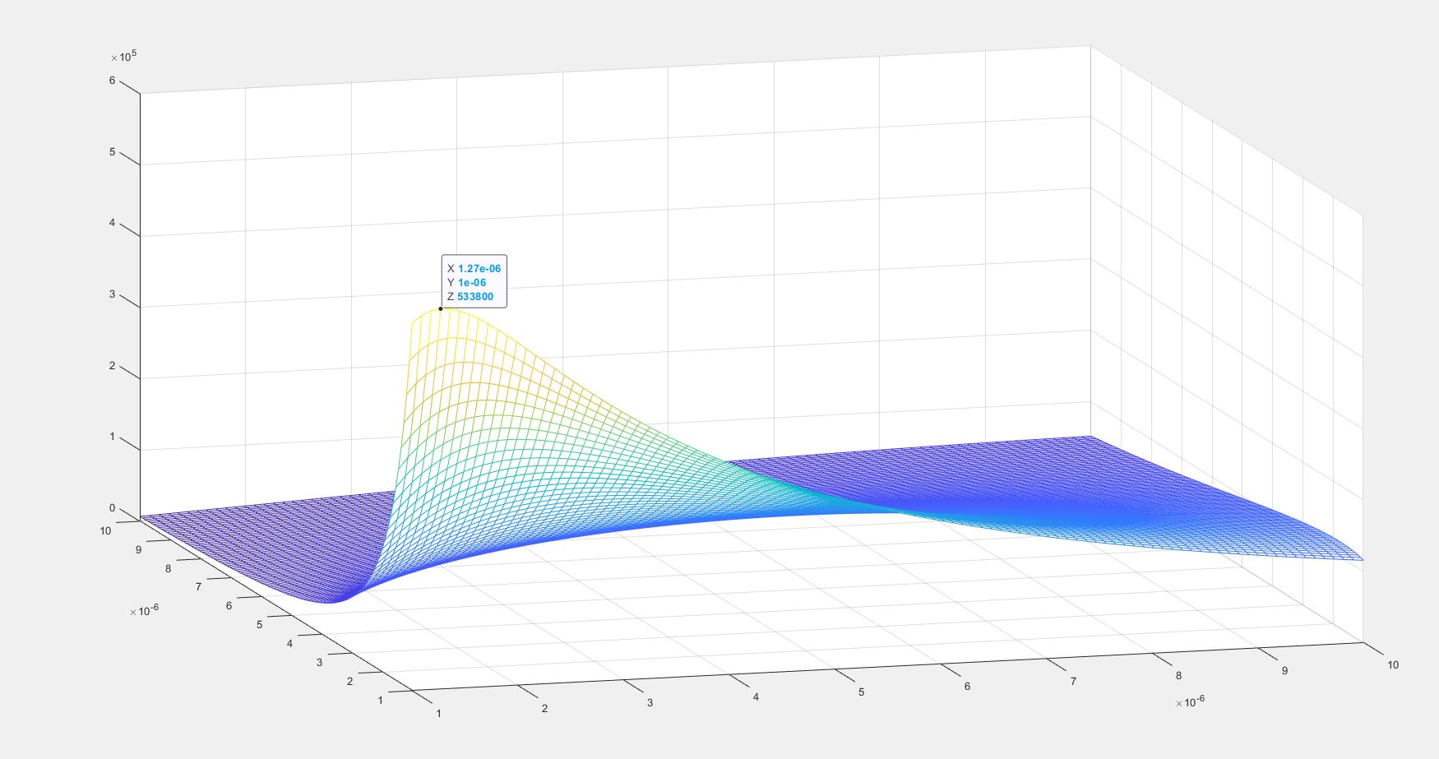
$$\frac{1}{K_{a}}×{10}^{5} {/ m}^{-1}$$
$$h_{s}/{10}^{-6} m$$
$$h_{a}/{10}^{-6} m$$
(a)
(b)
(c)

Figure 2 (a/b) Data extracted from videos of actuation under illumination by 100 mW cm⁻² Xe arc lamp. (c) Prediction of highest bending curvature as a function of thickness of actuating layer, h_{a}, and substrate layer, h_{s}, with actuating strain of -2.56%. Calculated from mechanical model, Appendix 2.

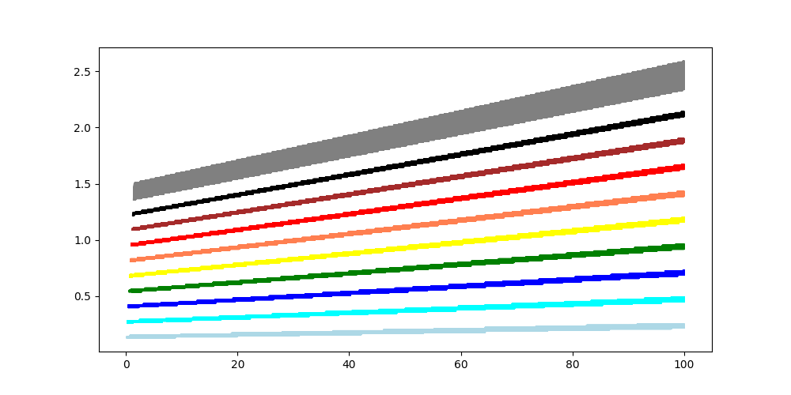
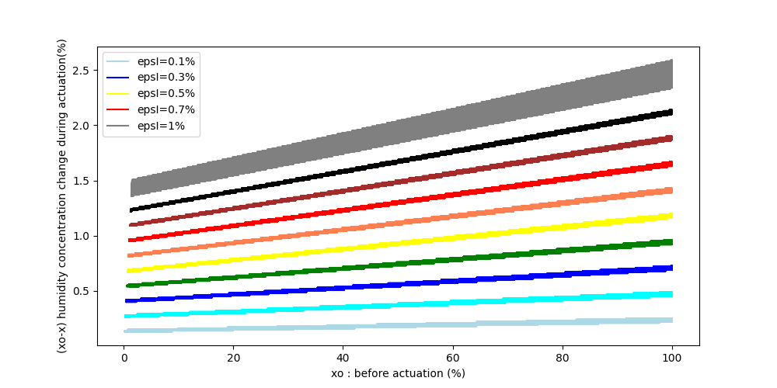
Figure 3 Estimation of change in hydration (x₀-x) % in Ni(OH)₂ actuating layer for various intrinsic strain (epsl) seen experimentally (0.1-1%), plotted vs initial degree of hydration (x₀) according to Equation (4).
Initial Degree of Hydration (x₀)
Change in Degree of Hydration (x₀-x)

Figure 4 Variation of temperature of Ni(OH)₂ actuating layer under illumination from 100 mW cm⁻² Xe lamp (black) and corresponding deflection of free end of the actuator (red).

(a)
(b)

Figure 5 (a) Thin film XRD of Ni(OH)₂ sample directly deposited onto FTO under environmental heating at various temperatures from 25ºC (RT) to 70ºC (RT+45). (b) Corresponding interlayer spacing calculated using Bragg’s Law from (001) diffraction peak of the alpha phase (black) and beta phase (red).

Figure 6 The change in the start (black) and end (red) positions of photoactuation under changing atmospheres.

(a)
(b)
(c)
(d)

Figure 8

Figure 7 ToF-SIMS data for Ni/Au/Ni(OH)₂ actuators under deuterated atmosphere (a) Typical depth profile taken before actuation but after exposure to D₂O saturated atmosphere for 10 minutes (b) Depth profile of actuator after one actuation under 100 mW cm⁻² illumination in D₂O saturated atmosphere for 10 minutes. (c) Deuteride to hydride ratio measured after different number of actuations under illumination in D₂O saturated atmosphere for 10 minutes (d) Deuteride to hydride ratio measured after different number of actuations under increased temperature in D₂O saturated atmosphere for 10 minutes

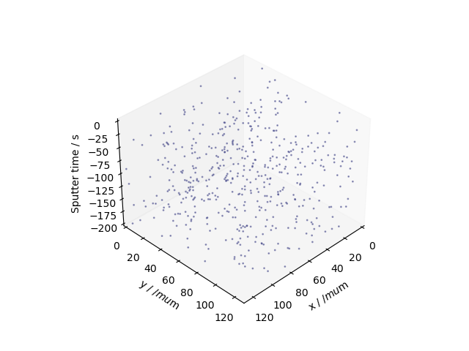
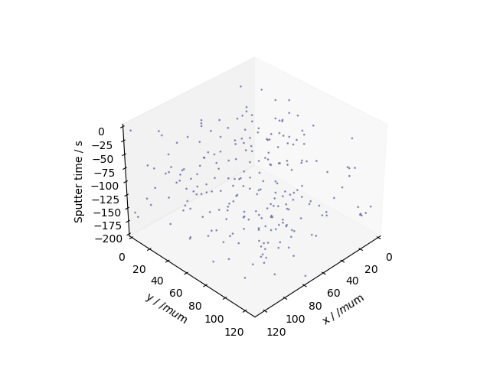
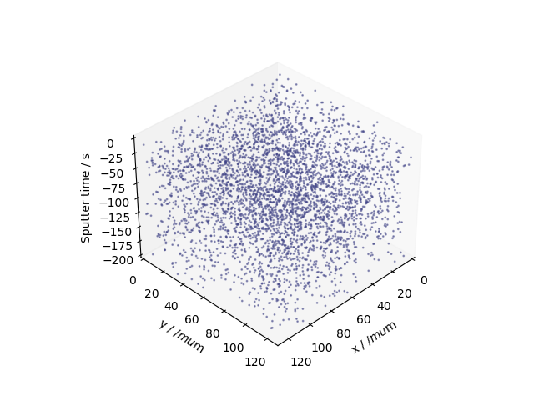
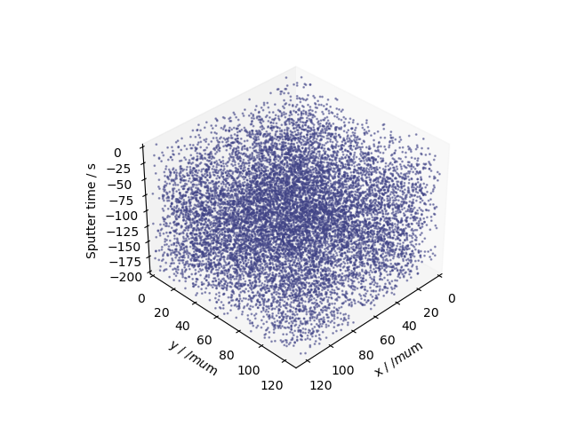
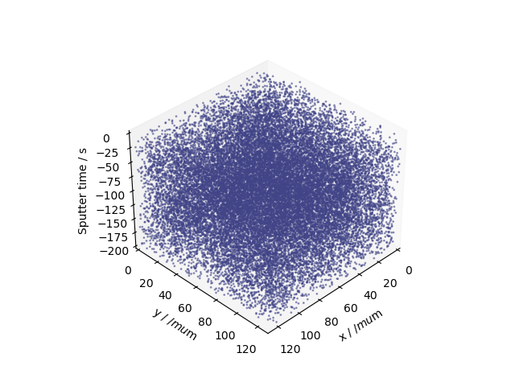
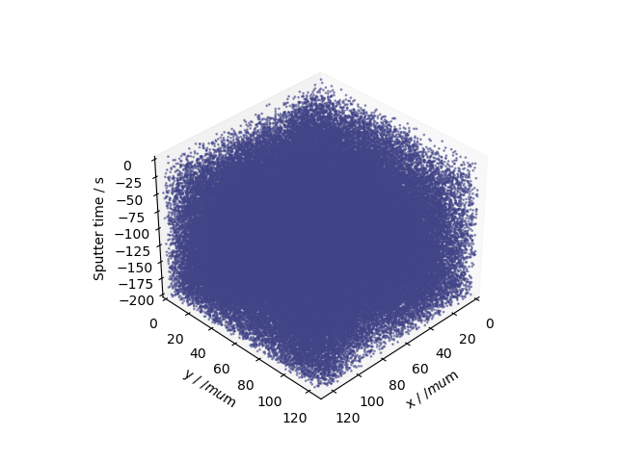
(a)
(e)
(b)
(d)
(f)
(c)

Figure 8 3D map of deuteride signal after various treatments in D₂O saturated atmosphere for 10 minutes, except (a) which had no exposure to D₂O. (b) No actuation (c) 1 actuation under 100 mW cm⁻² illumination (d) 5 actuation under 100 mW cm⁻² illumination (e) 10ºC increased temperature above room temp (f) 50ºC increased temperature above room temp.

