Tyrosine Kinase Inhibitor Gold Nanoconjugates for the Treatment of Non-Small Cell Lung Cancer
Alexander M. Cryer,*,†, Cheuk Chan†,‡, Anastasia Eftychidou†,‡, Christy Maksoudian†,‡, Mohan Mahesh‡, Teresa D. Tetley†, Alan C. Spivey,‡ and Andrew J. Thorley,†
†National Heart and Lung Institute, Imperial College London, SW7 2AZ, United Kingdom

‡Department of Chemistry, Imperial College London, SW7 2AZ, United Kingdom

KEYWORDS: gold nanoparticles, drug delivery, lung cancer, nanomedicine, afatinib

Abstract
Gold nanoparticles (AuNPs) have emerged as promising drug delivery candidates that can be leveraged for cancer therapy. Lung cancer (LC) is a heterogeneous disease that imposes a significant burden on society, with an unmet need for new therapies. Chemotherapeutic drugs such as afatinib (Afb), which is clinically approved for the treatment of epidermal growth factor receptor positive LC, is hydrophobic and has low bioavailability leading to spread around the body, causing severe side effects. Herein, we present a novel afatinib-AuNP formulation termed Afb-AuNPs, with the aim of improving drug efficacy and biocompatibility. This was achieved by synthesis of an alkyne-bearing Afb derivative and reaction with azide functionalized lipoic acid using copper catalyzed click chemistry, then conjugation to AuNPs via alkylthiol-gold bond formation. The Afb-AuNPs were found to possess up to 3.7-fold increased potency when administered to LC cells in vitro and were capable of significantly inhibiting cancer cell proliferation, as assessed by MTT assay and electric cell-substrate impedance sensing respectively. Furthermore, when exposed to Afb-AuNPs, human alveolar epithelial type I-like cells, a model of the healthy lung epithelium, maintained viability and were found to release less pro-inflammatory cytokines when compared to free drug, demonstrating the biocompatibility of our formulation. This study provides a new platform for the development of non-traditional AuNP conjugates which can be applied to other molecules of therapeutic or diagnostic utility, with potential to be combined with photothermal therapy in other cancers.

1. Introduction

Non-small cell lung cancer (NSCLC), the predominant subtype of LC, is responsible for the most cancer related deaths worldwide¹. A variety of chemotherapeutic drugs are employed to achieve disease control, however the heterogeneity of NSCLC² coupled with resistance mechanisms³ largely prevent curative outcomes. The discovery of activating (oncogenic) mutations in the tyrosine kinase domain of epidermal growth factor receptor (EGFR) in patients that responded to the tyrosine kinase inhibitor (TKI) gefitinib⁴⁻⁵ laid the foundations for personalized medicine approaches in NSCLC. This form of therapy whereby specific oncogenic mutations are targeted, improved survival for patients harboring such alterations⁶. Activating mutations in EGFR are the most common mutations in NSCLC⁷, therefore inhibition of EGFR represents an attractive therapeutic strategy. However, as with chemotherapy, these TKIs suffer from poor accumulation in the tumor and induce dose limiting toxicities due to systemic distribution around the body, limiting clinical efficacy. This is reflected in the 5-year survival rate of NSCLC, which stands at 19%⁸, highlighting an unmet need for more efficacious therapeutic options.
Nanomedicine involves the application of nanotechnology to address medical questions and has the potential to greatly enhance cancer diagnosis and therapy⁹⁻¹⁰. Of particular interest is the use of nanoparticles (NPs) for drug delivery applications¹¹. The enhanced permeability and retention (EPR) effect¹² can permit augmented accumulation of NPs at the tumor site, a phenomenon that has been documented in vivo¹³. Additionally, the decoration of NPs with polyethylene glycol (PEG) facilitates a prolonged circulatory half-life¹⁴, reduces opsonization and clearance by the mononuclear phagocyte system¹⁵, and decreases non-specific protein adsorption¹⁶, culminating in more time for NPs to accumulate in tumors. Although reliance on the EPR effect is not optimal in vivo¹⁷, these factors predicate most NP-based drug delivery strategies to solid tumors. Gold nanoparticles (AuNPs)¹⁸ are excellent candidates for drug delivery vehicles¹⁹⁻²⁰ based on their biocompatibility²¹, ease of functionalisation²², optical and photothermal properties²³⁻²⁴ as well as potential for pharmaceutical scale-up²⁵. The clinical utility of AuNP conjugates is evidenced by the success of CYT-6091, a formulation of recombinant human tumor necrosis factor-α, thiolated PEG and AuNPs, in phase I trials²⁶ as well as other preclinical studies²⁷.
We sought to develop an AuNP-conjugate platform using afatinib (Afb), a second generation TKI that has demonstrated enhanced efficacy in EGFR mutated LC over first line platinum based chemotherapy²⁸ and TKIs such as gefitinib²⁹. The native structure of Afb does not permit direct conjugation to AuNPs, therefore we synthesized a novel Afb analog containing a pedant alkynyl which was coupled to an azide functionalized lipoic acid moiety using a copper(I) catalyzed Huisgen 1,3-dipolar cycloaddition (otherwise known as a ‘click reaction’)³⁰. The cyclic disulfide group of lipoic acid enabled covalent attachment of the Afb analog to the surface of AuNPs. The AuNPs were then PEGylated for biocompatibility and colloidal stability using a heterobifunctional PEG containing sulfhydryl (-SH) and carboxyl (-COOH) groups. The resulting formulation, termed Afb-AuNPs (Figure 1), comprises of both the active component of Afb and PEG as independent entities, as opposed to the conventional strategy to PEGylate AuNPs prior to drug linkage, or via non-covalent attachment, which can affect drug loading³¹⁻³².
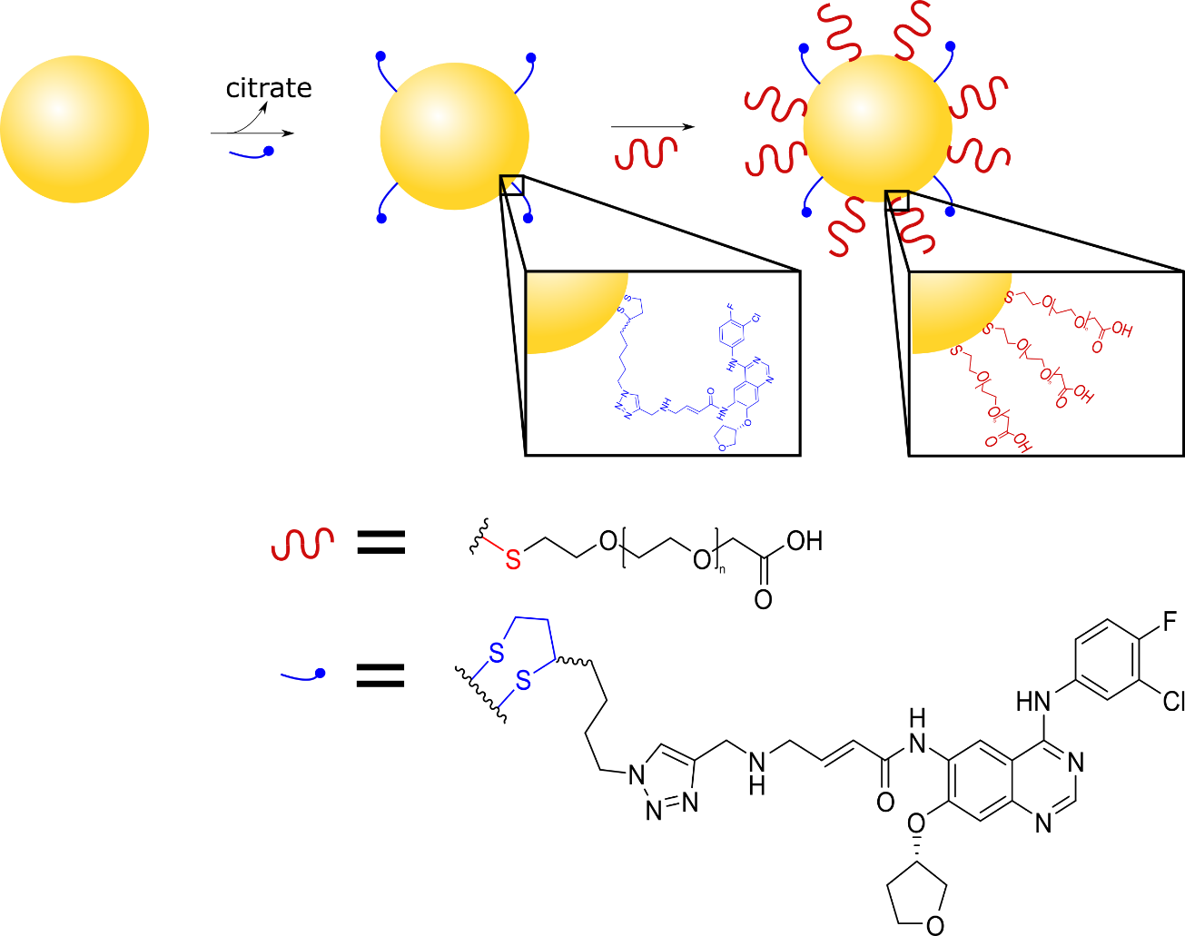
The conjugates were fully characterized prior to assessment of in vitro cytotoxicity in LC cells and human alveolar epithelial type I-like cells (TT1) cells, a unique model of the healthy lung epithelium derived from primary human alveolar type II cells³³, that we previously used to demonstrate pulmonary uptake and translocation of NPs³⁴. The real time effect on proliferation and uptake in LC cells was also evaluated. Furthermore, we examined cytokine release from LC cells and TT1 cells to gain insight into the inflammatory response upon AuNP exposure. We hypothesize that Afb-AuNPs possess enhanced anticancer activity in LC cells, particularly in cells with EGFR mutations. In this report, we demonstrate the novel synthesis and development of Afb-AuNPs, highlight the anticancer potential of such a system and applicability to other small molecules and therapeutics.

Figure 1. Schematic representation of the development of Afb-AuNPs. Citrate-capped AuNPs are first conjugated with thiolated afatinib analogs (blue) by virtue of a cyclic disulfide anchor. Subsequently, drug-bearing AuNPs are then PEGylated (red), enabled by further thiol-gold bond formation culminating in Afb-AuNPs.

2. Experimental Section
2.1. Organic synthesis. The synthesis of compounds 2-6 were performed by adaptation of a published method³⁵ from the commercially available starting material 1 (7-chloro-6-nitro-4(3H)quinazolinone). The full synthetic details and characterization of these and all other compounds (9-16) can be found in the supplementary information (Figure S1-S23).
2.2. Assembly of Afb-AuNPs. To a 1 mL solution of unmodified AuNPs (Sigma-Aldrich, UK, 500 µg/mL), 70 µL of disulfide 16 (50 µg, 1 mM in DMSO) was added dropwise and stirred for 2 hours in the dark at room temperature. The reaction mixture was subjected to centrifugal filtration at 2,800 x g for 10 minutes (10kDa MWCO, Amicon Ultra-15, regenerated cellulose, Millipore, MA, USA), washed with twice with water and re-suspended back to their original volume. This was then followed by the dropwise addition of 10 µL of 2 mM poly(ethylene glycol) 2-mercaptoethyl ether acetic acid (HS-PEG-COOH, MW 3,400; Sigma-Aldrich, UK) to the AuNPs. This was stirred overnight in the dark at room temperature. Subsequently, Afb-AuNPs were purified using centrifugal filtration as described above, re-suspended in water and stored at 4 ºC.
2.3. Characterization of Afb-AuNPs. Transmission electron microscopy was performed using a JEOL 1400 Plus electron microscope (JEOL Ltd, Hertfordshire, UK) with an accelerating voltage of 120keV. Images were captured using an AMT XR16 camera and processed using AMT image capture software (Woburn, MA, USA). Dynamic light scattering and zeta potential measurements were determined in water using a Zetasizer Nano ZS ZSP (Malvern Instruments Ltd, Worcestershire, UK) in triplicate. UV-vis spectra were obtained using 100 µL of appropriately diluted sample per well in a 96 well plate and acquired using a SpectraMax i3X (Molecular Devices, CA, USA).
2.4. Calculation of drug conjugation efficiency. To determine the amount of Afb-A bound to AuNPs, a solution of Afb-AuNPs (100 µL, 100 µg/mL) and supernatant after conjugation (100 µL) was analyzed using UV-vis spectroscopy (λ_{abs} = 345 nm). The concentration of Afb-A bound to AuNPs was calculated with reference to a calibration curve (0-500 µg/mL, R² = 0.9942).
2.5. In vitro drug release. A 1 mL solution of Afb-AuNPs was placed into a Float-A-Lyzer dialysis device (3.5 kDa MWCO, Spectrum Laboratories Inc., CA, USA) and incubated in either phosphate buffer (10 mM, pH 7.4) or acetate buffer (10 mM, pH 5.5) containing 0.5% (v/v) polysorbate 80 with mild agitation (100 rpm) at 37 °C. At predetermined time points, 1 mL of sample was taken and the removed volume was immediately replaced with fresh buffer. Absorbance measurements (λ_{abs} = 345 nm) of the release medium were acquired using a ND-1000 spectrophotometer (Thermo Fisher Scientific, DE, USA).
2.6. Cell culture and nanoparticle exposure. TT1 cells were cultured to confluence in 96-well tissue culture plates using DCCM-1 medium (Geneflow, Lichfield, UK) supplemented with 10% (v/v) newborn calf serum (NCS, Invitrogen, Paisley, UK) and 1% (v/v) penicillin/streptomycin/glutamine (PSG; Invitrogen, UK). A549 (lung adenocarcinoma) and PC-9 (lung adenocarcinoma, kindly gifted by Professor Michael Seckl, Imperial College London) were cultured in RPMI-1640 medium (Sigma-Aldrich, UK) supplemented with 10% (v/v) fetal bovine serum (FBS; Invitrogen, UK) and 1% (v/v) PSG. Cells were plated at 0.25x10⁵ per well and confluence was achieved within 48 hours. Throughout, cells were maintained in a humidified incubator at 37 °C, 5% CO₂. Confluent monolayers were treated with AuNPs, PEG-AuNPs and Afb-AuNPs dispersed in appropriate medium at concentrations ranging from 0.03-30 µg/ml of AuNP and exposures were performed in triplicate for all cell lines.
2.7. Cell viability. Following exposure to nanoparticles for 72 hours, growth media containing AuNPs was removed and cells were washed twice with sterile Dulbecco’s phosphate buffered saline (DPBS; Sigma-Aldrich, UK). Cells were then incubated in a solution of 3-(4,5-dimethylthiazol-2-yl)-2,5-diphenyltetrazolium bromide (MTT, VWR, UK), placed at 37 °C and were left until formazan crystal formation could be observed. The MTT solution was aspirated, cells were lysed and samples were analyzed spectrophotometrically (λ_{abs} = 570 nm) using a SpectraMax Plus 384 spectrophotometer (Molecular Devices, UK).
2.8. Electric cell-substrate impedance sensing (ECIS). Live cell proliferation studies were performed using the RTCA iCELLigence system with RTCA Data Analysis Software 1.0 (ACEA Biosciences, CA, USA). This system allows for label-free, real time, dynamic monitoring of cells using impedance as a readout of cell viability and proliferation. AuNPs, PEG-AuNPs and AFB-AuNPs were mixed with the cell suspensions at equivalent concentrations, seeded on a L8 E-plate (ACEA Biosciences, USA) and incubated for 0.5-2 hours at room temperature to allow cellular equilibration and adhesion. The plates were then placed in the impedance recorder in a humidified incubator at 37 °C, 5% CO₂ and measurements were taken every hour for 72 hours. A cell concentration of 0.25x10⁵ cells per well was used for all experiments. Cells grown in complete medium and medium alone were used as controls. Each treatment was assessed in triplicate or quadruplicate.
2.9. Inflammatory mediator release. Following exposure of cells to NPs for 72 hours, conditioned medium was collected and release of IL-6 and IL-8 was quantified using enzyme-linked immunosorbent assays (ELISA). Samples were analyzed in accordance with the manufacturer’s instructions (PeproTech, USA). Data were collected spectrophotometrically (λ_{abs} = 450 nm) using a SpectraMax Plus 384 spectrophotometer (Molecular Devices, UK). Results were generated from three separate experiments with three readouts per experiment.
2.10. Nanoparticle uptake. A549 cells were plated on a µ-Slide 8 well-chambered coverslip (Ibidi, Germany) at a density of 3 x 10⁵ cells per well and incubated overnight to allow cellular attachment. The cells were then exposed to Afb-AuNPs (20 µg/mL) prepared in the complete growth medium used for initial cell plating. After 3, 6 and 24 hours, Afb-AuNPs were removed and the cells were washed three times with PBS, fixed with 4% (v/v) paraformaldehyde and permeabilized with ice-cold methanol. Subsequently, cells were stained with anti-lysosomal-associated membrane protein (LAMP)-2-Alexa Fluor 488 (Thermo Fisher Scientific, UK) and Hoescht 33342 (Thermo Fisher Scientific, UK). AuNPs were visualized using a He-Ne laser, λ = 543 nm. Images were captured using a Leica TCS SP5 confocal microscope (Leica Microsystems, Germany) with a 63x objective lens and processed with ImageJ software.
2.11. Statistical analysis. Data are presented as the mean ± standard error, where n = 3 (three independent experiments performed with three different cell generations) unless otherwise stated. Statistical comparisons were selected a priori therefore significant observations were verified by t-test or one-way analysis of variance (ANOVA) with Bonferroni post-test. Prism v5 (GraphPad, USA) was used for all statistical calculations. In all analyses, a P value of <0.05 was considered significant.

3. Results and Discussion
3.1. Synthesis of an afatinib analog for conjugation to AuNPs
The first step was to synthesize an analog of Afb that retained its activity and was amenable to conjugation to AuNPs. The construction of the Afb model 16 (Scheme 1) required the synthesis of an afatinib precursor 6 and the synthesis of alkyne and azide containing units 9 and 13 which would combine via a ‘click’ reaction to form the linker portion of the construct. In brief, chlorination of commercially available 7-chloro-6-nitro-4(3H)quinazolinone 1, using POCl₃ afforded 4-chloroquinazoline 2 which was not isolated but used in the subsequent nucleophilic aromatic substitution (S_{N}Ar) reaction at C-4 with 3-chloro-4-fluoroaniline to give 4-amino quinazoline 3 (77%). Two sequential further S_{N}Ar reactions at C-7 with benzenesulfinic acid (→ 4, 87%) and then (S)-(+)-tetrahydro-3-furanol gave ether 5 (66%). Reduction of the C-6 nitro group using Raney-Ni then gave the 6-amino quinazoline core 6 (77%, Scheme 1A). Ensuring the preservation of the C-4 aniline and C-6 acrylamide groups surrounding the quinazoline core was important, as they have been shown to be critical motifs that dictate selectivity for EGFR and irreversible covalent binding via Michael addition to cysteine 797 in the EGFR kinase domain,³⁶ respectively. Indeed, X-ray crystallography of Afb bound to both wild type EGFR and the EGFR^{T790M} mutant demonstrated covalent bond formation between the acrylamide group of Afb and cysteine 797³⁷, confirming the structure-activity relationship is governed by the acrylamide group in particular.

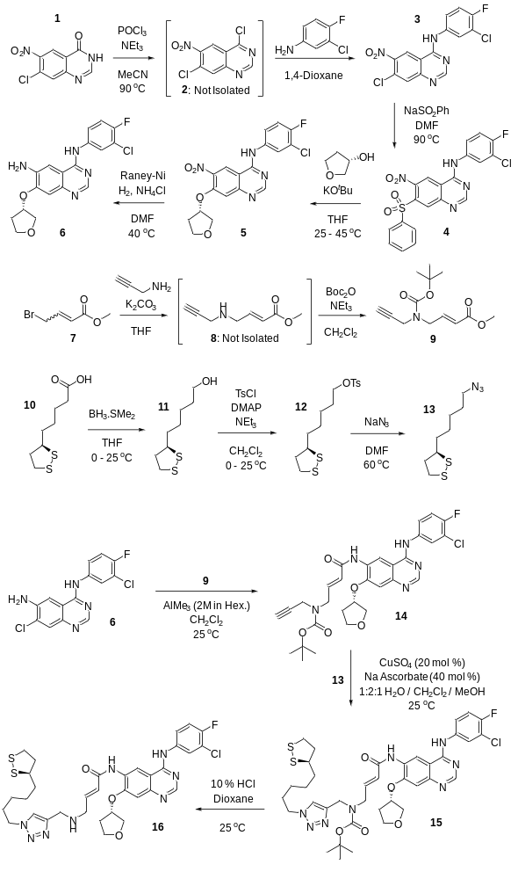
C
B
A
Scheme 1. Synthesis of afatinib analog. (A) Beginning with starting material 1, we generated the quinazoline core (compound 6) also found in afatinib, in 4 synthetic steps. (B) Synthesis of linker fragments and completion of the molecule. Compound 9 contains an alkyne and 13 has a cyclic disulfide group to allow attachment to AuNPs and an azide group for click chemistry with 9. (C) Attachment of the alkyne bearing group to the quinazoline core and subsequent click reaction and deprotection to give the final compound 16.
Synthesis of the alkyne and azide containing units 9 and 13, which were designed to combine to form the linker between the AuNPs and the 6-amino quinazoline 6, required just two steps and three steps respectively from commercial materials. Thus, the alkyne 9 was prepared by reaction of methyl trans 4-bromocrotonate 7 with propargylamine to give amine 8, which was not isolated but protected as its N-Boc derivative (48%). The azide 13, which contains the aurophilic cyclic disulfide moiety, was synthesized by reduction of (±)-α-lipoic acid 10 to give alcohol 11 (97%), tosylation to give sulfonate 12 (62%) and then azide displacement (76%). Assembly of compounds 6, 9 and 13 was orchestrated as shown in Scheme 1B. Ester 9 was coupled with quinazoline 6 by trimethylaluminium mediated amidation to give amide 12 (95%). This molecule presents a terminal alkyne in place of the dimethylamino unit found in Afb, to facilitate the click reaction. We chose to replace the dimethylamino group with propargylamine, as previous studies have shown good tolerance to substitution at this position³⁸⁻³⁹. The introduction of propargylamine gave quinazoline derivative 14 which contains an alkyne functionality to facilitate the click reaction with azide 13. To attach the two components, we therefore reacted azide 13 and alkyne 14 together in the presence of copper sulfate and sodium ascorbate to give triazole 15 (65%). Finally, Boc deprotection was achieved using 10% HCl in 1,4-dioxane to give 16 as the final product in a 98% yield (Scheme 1C).
3.2 Development and characterization of Afb-AuNPs
The construction of Afb-AuNPs began by taking commercially available citrate-capped AuNPs and tethering the Afb analog 16 (termed Afb-A) to them, followed by addition of a thiolated PEG linker, utilizing well-established alkyl thiol-gold chemistry⁴⁰. The cyclic disulfide group was used to attach Afb-A to AuNPs; by providing two Au-S bonds per molecule greater stability is achieved, thereby ensuring efficient drug loading, as single Au-S bonds have been shown to be displaced by strong nucleophiles⁴¹. One previous study that used single Au-S linkages to PEGylate AuNPs also aimed to conjugate Afb⁴². However, the conjugation yields were significantly less than presented here, potentially due to the method of coupling; EDC/NHS chemistry is well suited for nucleophilic primary amines⁴³; as Afb does not possess any, this may have prevented conjugation.
Conjugation of Afb-A was confirmed by UV-visible spectrometry. We found that 80% of Afb-A was bound to AuNPs, equivalent to 0.08 µg Afb-A per µg of AuNP (0.4 mol Afb-A per AuNP). Dynamic light scattering (DLS) measurements (Figure 2A) revealed an increase in the diameter of AuNPs confirming conjugation. Unmodified AuNPs were 40 nm, PEGylated AuNPs were approximately 43 nm and Afb-AuNPs were approximately 46 nm in diameter (Table S1). Further indirect confirmation of conjugation was evidenced by the changes in surface charge, as measured by zeta potential (Figure 2B). The zeta potential of unmodified AuNPs was -35mV, which became less negative as molecules were conjugated to the AuNP surface, owing to displacement of negatively charged citrate anions. The construct was PEGylated in order to afford increased biocompatibility and retention of a negative surface charge by virtue of free, terminal carboxyl groups. The negative surface charge also aids in preventing non-specific adsorption of proteins to the surface of the NP. Accordingly, Afb-AuNPs had a zeta potential of -19.7mV (Table S1). Optical parameters such as the extinction and scattering efficiencies of AuNPs are influenced by particle size. As such, UV-vis spectroscopy can determine the size of AuNPs based on their surface plasmon resonance (SPR), in excellent agreement with the mathematical theory that underpins the technique⁴⁴. Concordantly with DLS, UV-vis spectroscopy (Figure 2C) revealed an increase in size as AuNPs were modified. We observed a red shift in SPR of modified AuNPs, indicative of increasing particle size, further suggesting successful conjugation of Afb-A to AuNPs. The red shift in the SPR can be attributed to the increase in dielectric constant around the surface of the AuNP upon conjugation with thiolated ligands⁴⁵. Unmodified AuNPs had a λ_{max} of 523 nm, which increased when AuNPs were PEGylated, to 525 nm and increased further to 530 nm when Afb-A and PEG were conjugated to AuNPs. The release of Afb-A from AuNPs (Figure 2D) was examined at physiological and acidic pH (7.4 and 5.5 respectively). Differential rates of liberation from AuNPs were observed after as early as 2 hours whereby 41% of Afb-A had been released at pH 5.5 compared with 23% at pH 7.4. At all further time points assessed the cumulative release of Afb-A was consistently greater at pH 5.5 than that at pH 7.4. The Au-S bond is labile below pH 6 due to protonation of the S atom⁴⁶⁻⁴⁷, therefore the acidic environment may act to expedite release from the AuNP. Transmission electron microscopy (TEM) confirmed Afb-AuNPs had a spherical morphology (Figure 2E and 2F) and exhibited size measurements in agreement with those obtained using alternative methods (Figure 2G). Thus, AuNPs were successfully modified without drastically altering their physicochemical properties or compromising colloidal stability.
These physicochemical characteristics are well suited for delivery to solid tumors via the EPR effect. Afb-AuNPs are of a suitable size (~46 nm) such that they avoid renal filtration (NPs with a diameter less than 6 nm are filtered by the kidneys) and excess sequestration in the liver as larger NPs become entrapped within hepatic sinusoids⁴⁸. Moreover, a PEG sheath increases hydrophilicity which provides a steric barrier to opsonization, thereby further mitigating recognition by the RES⁴⁹. These properties are known to increase the circulatory half-life of nanoparticles in vivo⁵⁰ improving the probability for drug-bearing NPs to accumulate in tumors. Although dependence on the EPR effect for nanoparticle delivery may not be optimal for all tumor types, strategies to augment this process can be implemented⁵¹. For example, localized hyperthermia can be used to promote vascular permeability in tumors⁵².

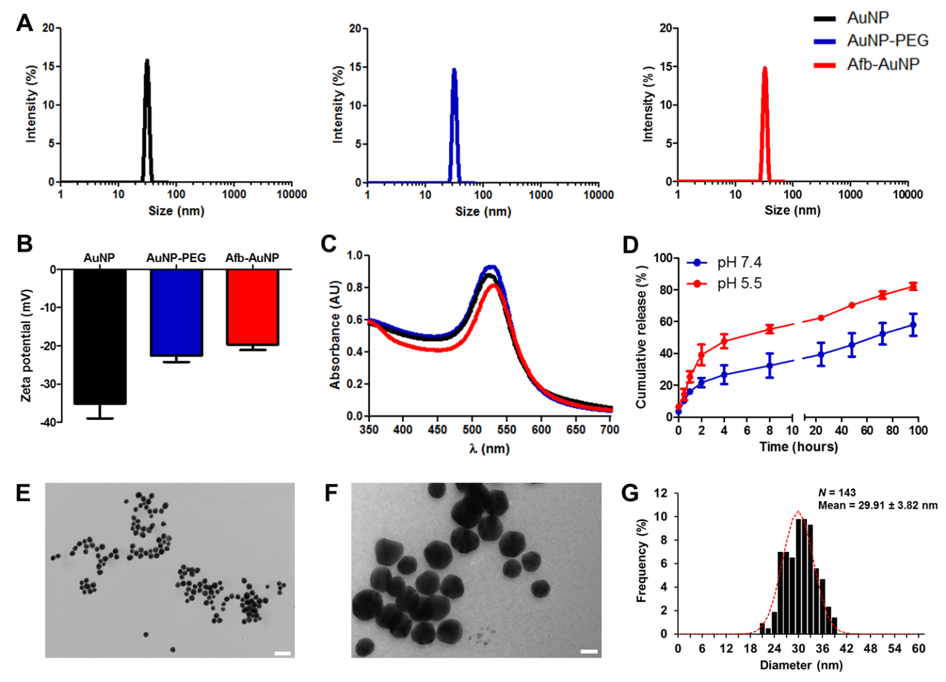

Figure 2. Characterization of Afb-AuNPs. (A) Hydrodynamic diameter measurements of AuNPs (black), AuNP-PEG (blue) and Afb-AuNPs (red) obtained by dynamic light scattering. (B) zeta potential measurements of the AuNPs mentioned above (mean ± SD, n = 3). (C) UV-vis spectra of AuNPs discerning the λ_{max} and corresponding red shifts as AuNPs are functionalized. (D) In vitro release profile of Afb-A from AuNPs at pH 7.4 or pH 5.5 (mean ± SD, n = 3). (E) transmission electron micrograph of Afb-AuNPs (40,000 x magnification, scale bar = 100 nm). (F) further magnified image of Afb-AuNPs (200,000 x magnification, scale bar = 20 nm). (G) histogram of Afb-AuNP sizes as measured by TEM (distribution presented as mean ± SD).

This approach is of particular interest when using AuNPs as drug delivery vehicles; AuNPs such as hollow nanoshells and nanorods can transform photons in the form of near infra-red light into thermal energy, creating hyperthermic regions proximal to the NPs. This intrinsic property is leveraged in the process of photothermal therapy whereby AuNPs that have accumulated in tumors thermally ablate the tissue⁵³. This modality can increase the permeability of the tumor to chemotherapy and NPs acting as a dual therapy and EPR effect enhancer⁵⁴. Moreover, terminal carboxyl groups on PEG chains can be used to attach tumor specific targeting moieties such as nucleic acids⁵⁵ or peptides⁵⁶ in an attempt to more adroitly target tumors. The work presented in this study can be combined with these functionalities for multimodal chemo and thermal therapy
3.3 Afb-AuNPs cause NSCLC cell cytotoxicity
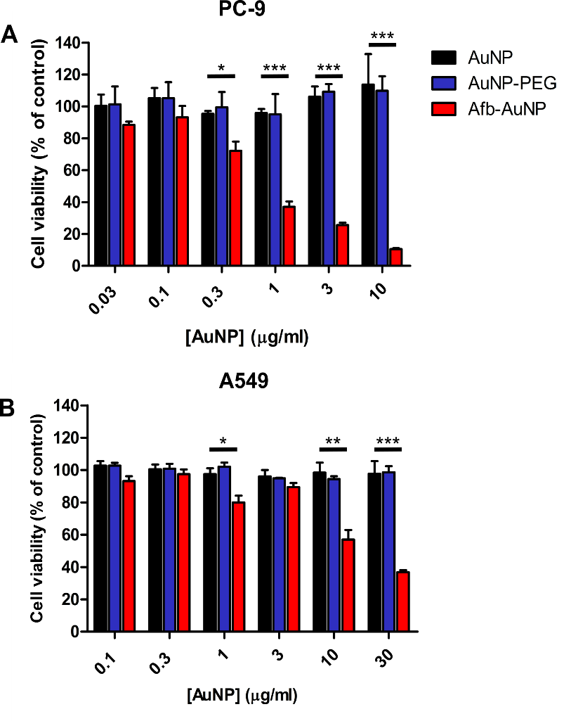
As a proof of concept, a dose response to Afb-AuNP treatment was determined using confluent monolayers of the lung adenocarcinoma cell line PC-9, which harbors a deletion within exon 19 in EGFR⁵⁷, sensitizing them to TKI therapies. AuNPs and PEGylated AuNPs were not cytotoxic at any of the doses investigated, in agreement with previous literature⁵⁸, whereas dose-dependent cytotoxicity was observed when cells were exposed to Afb-AuNPs (Figure 3A).

Figure 3. In vitro cytotoxicity of Afb-AuNPs. (A) The lung adenocarcinoma cell line PC-9 and (B) A549 were exposed to increasing concentrations of AuNPs (black), AuNP-PEG (blue) or Afb-AuNPs (red) for 72 hours and cell viability was assessed by MTT assay. Data are expressed as mean ± SEM, n = 3, *, P < 0.05; **, P < 0.01; ***, P < 0.001.
Significant reductions in cell viability (24% compared to AuNP, P < 0.05) were seen at doses as low as 0.3 µg/mL AuNP. There were further reductions in cell viability with increasing concentrations of Afb-AuNPs; at 3 µg/mL, Afb-AuNPs reduced cell viability by 81% compared to the equivalent concentration of AuNPs (P < 0.001), demonstrating both the biocompatibility of AuNPs and the therapeutic potential of Afb-AuNPs. The versatility of the system was shown by screening Afb-AuNPs in the lung adenocarcinoma cell line A549 (Figure 3B) which are wild type for EGFR expression and are not sensitive to TKIs. Despite this, Afb-AuNPs retained some efficacy, particularly at the higher doses examined. At an AuNP concentration of 10 µg/mL, Afb-AuNPs induced a 42% reduction in cell viability compared to the equivalent dose of AuNPs (P < 0.01). A further decrease in cell viability was noted at an AuNP dose of 30 µg/mL, where Afb-AuNPs elicited a 60% decrease in cell viability (P < 0.001).
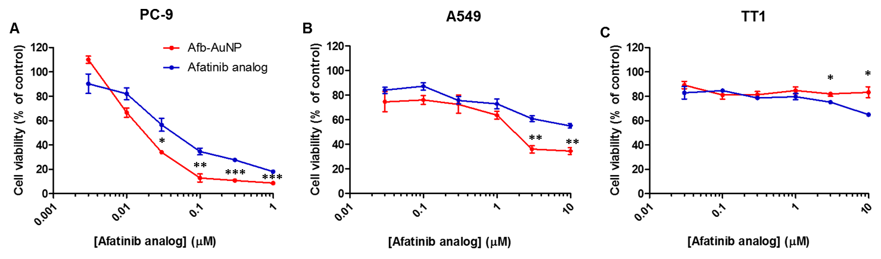
To elucidate the extent to which AuNPs were influencing the cytotoxic effect of Afb-A, the effect of free Afb-A and Afb-AuNPs at different doses was examined. In PC-9 cells (Figure 4A) Afb-AuNPs were significantly more cytotoxic than equimolar concentrations of free drug at a majority of doses studied. At 0.03 µM, Afb-A decreased cell viability by 43%, whereas Afb-AuNPs at the same drug concentration caused significantly more cell viability loss (66%, P < 0.05). This observation was recapitulated at 0.1 µM (P < 0.01) and further increased doses (P < 0.001) where Afb-AuNPs induced almost complete loss of cell viability (~ 91%). In the less sensitive A549 cells (Figure 4B) free Afb-A and Afb-AuNPs exhibited similar efficacy up to a concentration of 3 µM where Afb-AuNPs were significantly more cytotoxic than equivalent free Afb-A (64% vs 40% reduction in viability, P < 0.01), a result that was also observed at 10 µM (P < 0.01). Similar observations were also witnessed when Afb-AuNPs were compared to free Afb in a dose response fashion (Figure S24). Furthermore, the IC₅₀ of free Afb-A in PC-9 cells was found to be 0.05 µM whereas Afb-AuNPs had an IC₅₀ of 0.02 µM, representing a 2.5 fold increase in potency. Similarly, in A549 cells the Afb-A IC₅₀ was 6.08 µM compared to 1.65 µM for Afb-AuNPs, translating to a 3.7 fold potency increase; thus, we could attribute the cytotoxic effects observed to the conjugated Afb-A. Indeed, in A549 cells the IC₅₀ of Afb-AuNPs was significantly lower than that reported previously for Afb⁵⁹ which was comparable to free Afb-A. Although the mechanism underlying this increase in potency is not fully clear, one explanation could be increased intracellular concentration of Afb-A due to uptake of AuNPs⁶⁰. As Afb has been shown to alter the efflux function of P-glycoprotein⁶¹ (otherwise known as ATP-binding cassette sub-family B member 1, ABCB1), the enhanced intracellular levels of Afb-A may then serve to inhibit its own efflux over time, leading to greater or more sustained inhibition of EGFR, however further studies would be needed to explore this.

Figure 4. Dose response curves post Afb-AuNP and Afb-A treatment. (A) PC-9, (B) A549 and (C) alveolar epithelial TT1 cells were exposed to increasing concentrations of Afb-A or Afb-AuNPs for 72 hours and cell viability was assessed by MTT assay. Data are expressed as mean ± SEM, n = 3, *, P < 0.05; **, P < 0.01; ***, P < 0.001.

We also investigated the effect of free Afb-A and Afb-AuNPs on TT1 cells (Figure 4C); as these cells cover 95% of the alveolar epithelial surface⁶², the implications of toxicity to these cells could be instrumental in determining choice of therapy and its success. Moreover, examination of the normally functioning cells proximal to the disease area of interest is a procedure which is often excluded from in vitro drug delivery studies even though there is potential for drug interaction with normal cells. Afb-AuNPs and unmodified AuNPs (Figure S25) were not overtly cytotoxic at any of the doses studied, however free Afb-A was found to be significantly more cytotoxic at 3 and 10 µM (P < 0.05). This data may suggest a selectivity of Afb-AuNPs towards cancerous cells, which could be predicated on EGFR expression. Indeed, we have previously shown the distinction between TT1 cells and A549 cells and that TT1 cells better represent the alveolar epithelial type I cell⁶³ and therefore serves to more accurately reflect the differential in vivo interactions of Afb-AuNPs in the alveolar region where lung adenocarcinomas are most prevalent.
3.4 Afb-AuNPs inhibit NSCLC cell proliferation
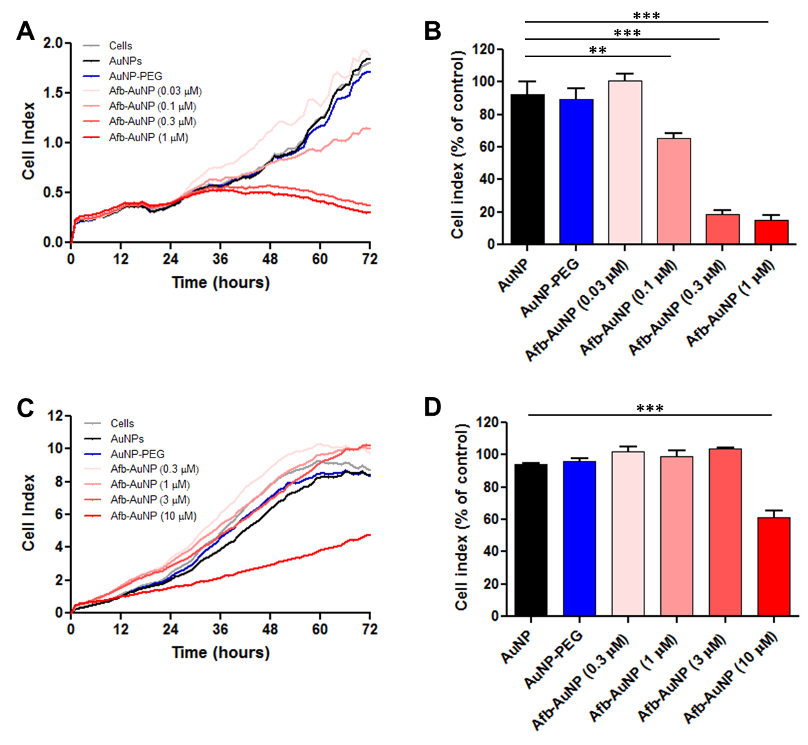
After profiling the effect of Afb-AuNPs on confluent monolayers, we next investigated the effect of Afb-AuNPs on actively proliferating cells, using a cell-impedance based system that allows for label free, real-time study of cell proliferation. A dose-dependent response to Afb-AuNPs was observed in PC-9 cells (Figure 5A), whereas AuNPs and PEGylated AuNPs did not have anti-proliferative effects (AuNP concentration was equal to the AuNP concentration in the highest dose of Afb-AuNPs), consistent with cell viability results. No significant difference was noted when cells were treated with Afb-AuNPs at a dose of 0.03 µM (Figure 5B), however 0.1 µM Afb-AuNPs significantly inhibited cell proliferation compared to AuNPs (P < 0.01). As the dose of Afb-AuNPs increased, the inhibition of proliferation was greater; 0.3 µM and 1 µM Afb-AuNPs inhibited cell proliferation by 74% and 78% respectively compared to AuNPs (P < 0.001). In A549 cells (Figure 5C), a pattern somewhat similar to cell viability studies was observed whereby only the highest dose of Afb-AuNPs was able to inhibit cell proliferation. This dose of free Afb (10 µM) was also able to inhibit cell proliferation to the same degree (Figure S26), suggesting maintenance of therapeutic efficacy using Afb-AuNPs. The biocompatibility of AuNPs and PEGylated AuNPs was again confirmed in these cells as no inhibitory effect was noted (Figure 5D), whereas Afb-AuNPs at a dose of 10 µM reduced the proliferative capacity of the cells by 33% (P < 0.001).

Figure 5. Inhibition of cell proliferation by Afb-AuNPs. (A) Representative proliferation curves of PC-9 cells upon exposure to AuNPs, AuNP-PEG, or increasing doses of Afb-AuNP. (B) quantification of cell proliferation at 72 hours (untreated cells used as control) . (C-D) as in (A-B) but cell proliferation assessed in A549 cells. Data are expressed as mean ± SEM, n = 4,**, P < 0.01; ***, P < 0.001

The intrinsic sensitivity to TKIs plays a role in the differential cytotoxicity of Afb-AuNPs, which is exemplified by these proliferation studies, whereby lower concentrations of Afb-AuNPs were required to inhibit PC-9 cell proliferation compared to A549 cells. These results corroborated those observed in the cytotoxicity studies but also demonstrated that Afb-AuNPs retained efficacy under different experimental conditions, as unmodified AuNPs were not found to significantly reduce the proliferation of either cell type. Taken together, these results demonstrate that Afb-AuNPs can act not only on confluent monolayers of cells, but also actively proliferating cancer cells, highlighting the utility of the AuNP system.
3.5 Conjugation of Afb to AuNPs attenuates inflammatory cytokine release
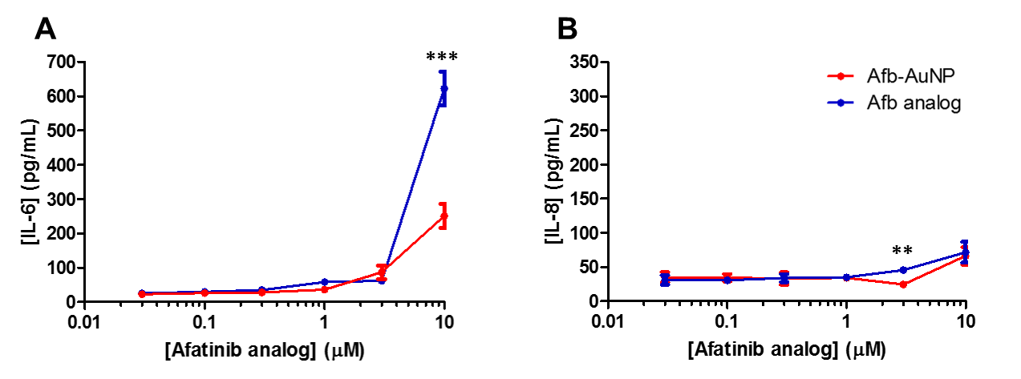
After investigating the anticancer capacity of Afb-AuNPs, we next explored the inflammatory response of the healthy alveolar epithelium upon exposure to Afb-AuNPs and the free drug equivalent. At a majority of the doses investigated, the release of interleukin (IL)-6 from TT1 cells was not significantly different between Afb-A and Afb-AuNPs (Figure 6A). A slight trend towards increased IL-6 release as the dose increased was noted, with no more than 90 pg/mL detected, suggesting a tolerability of Afb-AuNPs at the alveolar epithelial interface. At a dose of 10 µM, both Afb-AuNPs and Afb-A stimulated IL-6 release, however Afb-A elicited a 2.5 fold increase in IL-6 production compared to the equivalent dose of Afb-AuNPs (P < 0.001). We observed a similar pattern with IL-8 release from TT1 cells (Figure 6B); we noted a 1.9 fold increase in the release of IL-8 at a dose of 3 µM Afb-A compared to Afb-AuNPs (P < 0.01) however this difference was not observed at any other doses. Moreover, we did not see significant release of IL-6 or IL-8 by A549 cells when exposed to Afb-AuNPs (Figure S27) indicating the lack of immunogenicity these molecules possess. As IL-6 is heavily involved in driving pro-tumorigenic inflammation⁶⁴ this has led to its implication in the pathogenesis of LC⁶⁵. The underlying mechanism appears to centralize around an IL-6/STAT3 signaling axis whereby IL-6 fosters oncogenic signaling through activation of STAT3⁶⁶. Moreover, activated EGFR prolongs this signaling cascade⁶⁷, providing a rationale for dual anti IL-6/EFGR therapy in LC. Indeed, attenuation of pro-inflammatory cytokine release, particularly IL-6, from TT1 cells upon exposure to Afb-AuNPs compared to free Afb-A provides supporting evidence for the biocompatibility of our system.

Figure 6. Inflammatory mediator release from TT1 cells. Alveolar epithelial cells were exposed to increasing doses of Afb-A or Afb-AuNPs and the release of (A) IL-6 and (B) IL-8 from confluent monolayers was measured by ELISA. Data are expressed as mean ± SEM, n = 3,**, P < 0.01; ***, P < 0.001.
3.6 Cellular uptake of Afb-AuNPs
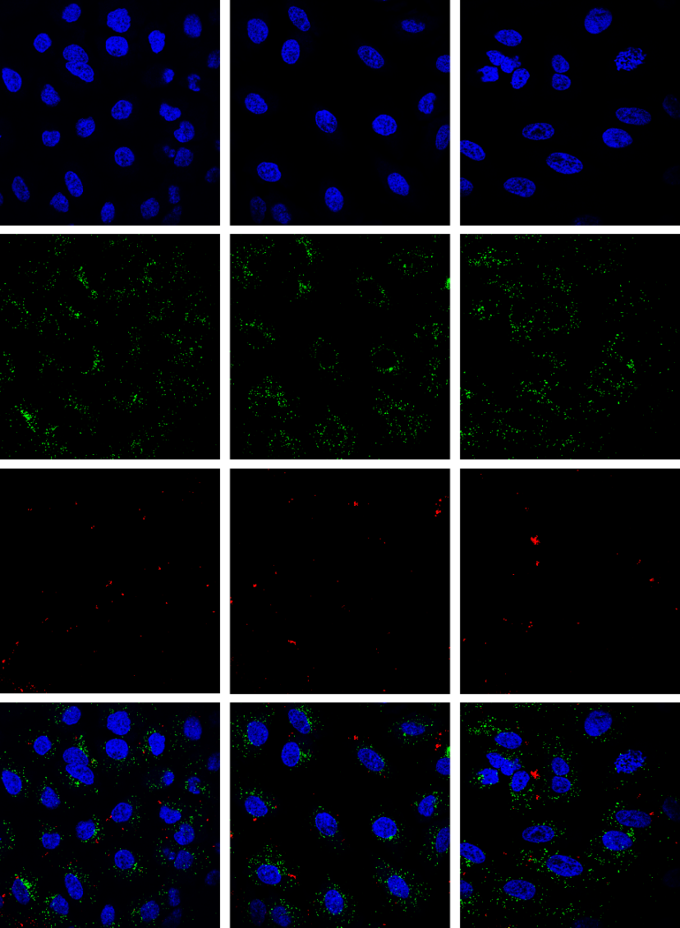
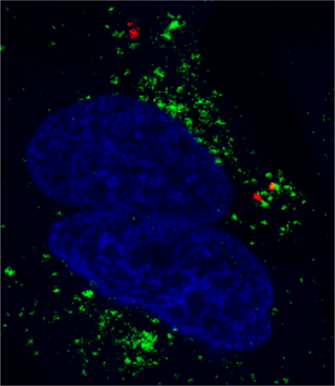
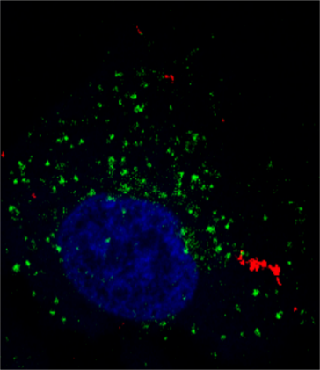
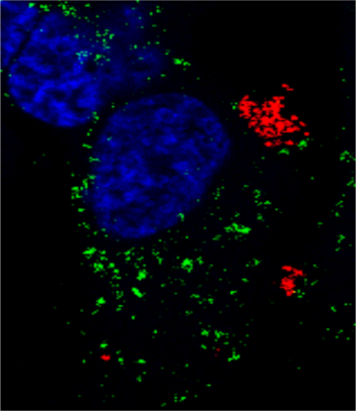
Finally, in order to better understand the intracellular fate of Afb-AuNPs, the uptake of these particles by A549 cells was investigated using confocal microscopy (Figure 7). After 3 h, there was evidence of intracellular accumulation of AuNPs suggesting surface functionalization did not prevent internalization. Visualized (in red) by virtue of their SPR, dispersed AuNPs were distributed throughout the cytoplasm and perinuclear region, and were not observed in the nucleus (blue), in agreement with previous studies using AuNPs of a similar size⁶⁸. Small clusters of AuNPs appeared to localize near to endosomal structures (merge panel) implying an endosomal route may have been utilized by the cells to internalize the particles. At 6 h post AuNP exposure, the appearance of AuNP clustering in the cytoplasm was more apparent and there was no evidence of lysosomal co-localization. When we examined the cells 24 hours post AuNP exposure, further coalescence of the AuNPs in the cytoplasm was evident, and although we did not observe signs of co-localization, larger clusters of AuNPs were found to be close to the nucleus and proximal to lysosomes which could be due to lysosomal escape, allowing for cytoplasmic release of Afb and subsequent inhibition of EGFR. AuNPs are known to be internalized into cells by endocytosis, however their method of entry is largely dependent on their physicochemical properties. The clustering dynamics we observed are consistent with the intracellular trafficking of AuNPs of approximately 50 nm in diameter whereby AuNPs were found to accumulate and cluster in lysosomes over time⁶⁹. Although we did not see direct evidence of co-localization at the 24 hour time point, Afb-AuNPs appeared to coalesce proximally to lysosomes suggesting Afb-AuNPs may be internalized by an endocytic mechanism. It has been shown previously that AuNPs of this size are taken up into cells by endocytosis⁷⁰, although future studies would be needed to fully outline the internalization process. Clustering of Afb-AuNPs via lysosomal processing could be due to increased agglomeration, as the cleavage of Afb-A and PEG from AuNPs may impact colloidal stability. Similar to the tumor microenvironment, lysosomes have an acidic pH which can lead to increased Afb-A release from AuNPs due to Au-S bond breakage. This bond cleavage results in release of the drug cargo from the AuNPs into the cytoplasm where it can subsequently bind to EGFR. A majority of Afb-A is released from AuNPs after 48 hours and may continue to be released from AuNP depots within the cell, whereas free Afb-A initially traverses the plasma membrane, it may be effluxed or inactivated as previously postulated, therefore more Afb-A becomes available over time if delivered using AuNPs providing a potential explanation for the increased potency demonstrated in the cytotoxicity studies.
3 hours
6 hours
24 hours
Nucleus
Lysosome
AuNP
Merge

Figure 7. Intracellular uptake and distribution of Afb-AuNPs. A549 cells were exposed to Afb-AuNPs for 3, 6 or 24 hours prior to imaging by confocal microscopy. The nucleus is visualized in blue, lysosomes in green and AuNPs in red. Scale bar = 15 µm.
4. Conclusion
In summary, a novel AuNP formulation was developed based on the clinically approved chemotherapeutic agent Afb. To achieve this, a molecular analog of Afb was synthesized that permitted conjugation to AuNPs, to create Afb-AuNPs. Afb-AuNPs were shown to exhibit cytotoxicity towards and inhibit proliferation of NSCLC cells whilst maintaining biocompatibility in TT1 cells, a model cell of the healthy alveolar epithelium. Afb-AuNPs were also shown to be non-inflammatory in both healthy and cancerous cells, and were internalized, despite surface modifications, however the mechanism is still to be fully elucidated. Results presented here suggest Afb-AuNPs would be promising candidates for future in vivo studies given their physicochemical properties and in vitro efficacy. Furthermore, the methodology outlined provides an avenue of exploration using other therapeutics not typically utilized for conjugation to NPs, expanding the molecular toolkit available for drug delivery.

ASSOCIATED CONTENT
Supporting Information.
The following files are available free of charge on the ACS Publications website at DOI:
Experimental details for synthesis of all compounds, ¹H and ¹³C NMR spectra of all compounds, ESI mass spectrum of compound 16, afatinib dose responses, TT1 cell viability, inhibition of cancer cell proliferation by TKIs, A549 cytokine release and table listing additional information of AuNP formulations (PDF).
AUTHOR INFORMATION
Corresponding Author
*E-mail: a.cryer14@imperial.ac.uk (A.M.C.)
Notes
The authors declare no competing financial interest
ACKNOWLEDGMENTS
This work was funded by the Medical Research Council through a Doctoral Training Partnership Research Studentship (MR/K501281/1) and an Engineering and Physical Sciences Research Council Doctoral Training Partnership (EP/M507878/1). Professor Michael Seckl is thanked for provision of PC-9 cells. Dr. Andrew Rogers is thanked for his assistance with electron and confocal microscopy. Professor Alexandra Porter is thanked for usage of characterization facilities. Mr. Richard Surgenor is thanked for his assistance with organic synthesis. C. Chan and A. Eftychidou contributed equally to this work.

REFERENCES
(1) Torre, L. A.; Bray, F.; Siegel, R. L.; Ferlay, J.; Lortet-Tieulent, J.; Jemal, A. Global Cancer Statistics, 2012. CA: Cancer J. Clin. 2015, 65, 87-108.
(2) Chen, Z.; Fillmore, C. M.; Hammerman, P. S.; Kim, C. F.; Wong, K. K. Non-Small-Cell Lung Cancers: A Heterogeneous Set of Diseases. Nat. Rev. Cancer. 2014, 14, 535-546.
(3) Rotow, J.; Bivona, T. G. Understanding and Targeting Resistance Mechanisms in NSCLC. Nat. Rev. Cancer. 2017, 17, 637-658.
(4) Lynch, T. J.; Bell, D. W.; Sordella, R.; Gurubhagavatula, S.; Okimoto, R. A.; Brannigan, B. W.; Harris, P. L.; Haserlat, S. M.; Supko, J. G.; Haluska, F. G.; Louis, D. N.; Christiani, D. C.; Settleman, J.; Haber, D. A., Activating Mutations in the Epidermal Growth Factor Receptor Underlying Responsiveness of Non-Small-Cell Lung Cancer to Gefitinib. New Engl. J. Med. 2004, 350, 2129-2139.
(5) Paez, J. G.; Janne, P. A.; Lee, J. C.; Tracy, S.; Greulich, H.; Gabriel, S.; Herman, P.; Kaye, F. J.; Lindeman, N.; Boggon, T. J.; Naoki, K.; Sasaki, H.; Fujii, Y.; Eck, M. J.; Sellers, W. R.; Johnson, B. E.; Meyerson, M. EGFR Mutations in Lung Cancer: Correlation with Clinical Response to Gefitinib Therapy. Science 2004, 304, 1497-1500.
(6) Mok, T. S. K. Personalized Medicine in Lung Cancer: What We Need To Know. Nat. Rev. Clin. Oncol. 2011, 8, 661-668.
(7) Herbst, R. S.; Morgensztern, D.; Boshoff, C. The Biology and Management of Non-Small Cell Lung Cancer. Nature 2018, 553, 446-454.
(8) Siegel, R. L.; Miller, K. D.; Jemal, A. Cancer Statistics, 2019. CA: Cancer J. Clin. 2019, 69, 7-34.
(9) Chow, E. K.; Ho, D. Cancer Nanomedicine: From Drug Delivery to Imaging. Sci. Trans. Med. 2013, 5, 216rv4.
(10) Shi, J.; Kantoff, P. W.; Wooster, R.; Farokhzad, O. C. Cancer Nanomedicine: Progress, Challenges and Opportunities. Nat. Rev. Cancer 2017, 17, 20-37.
(11) Peer, D.; Karp, J. M.; Hong, S.; Farokhzad, O. C.; Margalit, R.; Langer, R. Nanocarriers as an Emerging Platform for Cancer Therapy. Nat. Nanotechnol. 2007, 2, 751-760.
(12) Maeda, H.; Nakamura, H.; Fang, J. The EPR Effect for Macromolecular Drug Delivery to Solid Tumors: Improvement of Tumor Uptake, Lowering of Systemic Toxicity, and Distinct Tumor Imaging In Vivo. Adv. Drug Delivery Rev. 2013, 65, 71-79.
(13) Miller, M. A.; Gadde, S.; Pfirschke, C.; Engblom, C.; Sprachman, M. M.; Kohler, R. H.; Yang, K. S.; Laughney, A. M.; Wojtkiewicz, G.; Kamaly, N.; Bhonagiri, S.; Pittet, M. J.; Farokhzad, O. C.; Weissleder, R. Predicting Therapeutic Nanomedicine Efficacy Using a Companion Magnetic Resonance Imaging Nanoparticle. Sci. Trans. Med. 2015, 7, 314ra183.
(14) Gref, R.; Minamitake, Y.; Peracchia, M. T.; Trubetskoy, V.; Torchilin, V.; Langer, R. Biodegradable Long-Circulating Polymeric Nanospheres. Science 1994, 263, 1600-1603.
(15) Owens III, D. E.; Peppas, N. A. Opsonization, Biodistribution, and Pharmacokinetics of Polymeric Nanoparticles. Int. J. Pharm. 2006, 307, 93-102.
(16) Otsuka, H.; Nagasaki, Y.; Kataoka, K. PEGylated Nanoparticles for Biological and Pharmaceutical Applications. Adv. Drug Delivery Rev. 2003, 55, 403-419.
(17) Maeda, H. Toward a Full Understanding of the EPR Effect in Primary and Metastatic Tumors as well as Issues Related to its Heterogeneity. Adv. Drug Delivery Rev. 2015, 91, 3-6.
(18) Dreaden, E. C.; Alkilany, A. M.; Huang, X.; Murphy, C. J.; El-Sayed, M. A. The Golden Age: Gold Nanoparticles for Biomedicine. Chem. Soc. Rev. 2012, 41, 2740-2779.
(19) Ghosh, P.; Han, G.; De, M.; Kim, C. K.; Rotello, V. M., Gold Nanoparticles in Delivery Applications. Adv. Drug Delivery Rev. 2008, 60, 1307-1315.
(20) Giljohann, D. A.; Seferos, D. S.; Daniel, W. L.; Massich, M. D.; Patel, P. C.; Mirkin, C. A. Gold Nanoparticles for Biology and Medicine. Angew. Chem. Int. Ed. Engl. 2010, 49, 3280-3294.
(21) Alkilany, A.; Murphy, C., Toxicity and Cellular Uptake of Gold Nanoparticles: What We Have Learned So Far? J. Nanopart. Res. 2010, 12, 2313-2333.
(22) Vigderman, L.; Zubarev, E. R., Therapeutic Platforms Based on Gold Nanoparticles and Their Covalent Conjugates with Drug Molecules. Adv. Drug Delivery Rev. 2013, 65, 663-676.
(23) Huang, X.; El-Sayed, I. H.; Qian, W.; El-Sayed, M. A. Cancer Cell Imaging and Photothermal Therapy in the Near-Infrared Region by Using Gold Nanorods. J. Am. Chem. Soc. 2006, 128, 2115-2120.
(24) Koo, M.; Oh, K. T.; Noh, G.; Lee, E. S. Gold Nanoparticles Bearing a Tumor pH-Sensitive Cyclodextrin Cap. ACS Appl. Mater. Interfaces 2018, 10, 24450-24458.
(25) Paciotti, G. F.; Myer, L.; Weinreich, D.; Goia, D.; Pavel, N.; McLaughlin, R. E.; Tamarkin, L., Colloidal Gold: A Novel Nanoparticle Vector for Tumor Directed Drug Delivery. Drug Delivery. 2004, 11, 169-183.
(26) Libutti, S. K.; Paciotti, G. F.; Byrnes, A. A.; Alexander, H. R.; Gannon, W. E.; Walker, M.; Seidel, G. D.; Yuldasheva, N.; Tamarkin, L. Phase I and Pharmacokinetic Studies of CYT-6091, a Novel PEGylated Colloidal Gold-rhTNF Nanomedicine. Clin. Cancer Res. 2010, 16, 6139-6149.
(27) Paciotti, G. F.; Zhao, J.; Cao, S.; Brodie, P. J.; Tamarkin, L.; Huhta, M.; Myer, L. D.; Friedman, J.; Kingston, D. G. I. Synthesis and Evaluation of Paclitaxel-Loaded Gold Nanoparticles for Tumor-Targeted Drug Delivery. Bioconjug. Chem. 2016, 27, 2646-2657.
(28) Sequist, L. V.; Yang, J. C.-H.; Yamamoto, N.; O'Byrne, K.; Hirsh, V.; Mok, T.; Geater, S. L.; Orlov, S.; Tsai, C.-M.; Boyer, M.; Su, W.-C.; Bennouna, J.; Kato, T.; Gorbunova, V.; Lee, K. H.; Shah, R.; Massey, D.; Zazulina, V.; Shahidi, M.; Schuler, M. Phase III Study of Afatinib or Cisplatin Plus Pemetrexed in Patients With Metastatic Lung Adenocarcinoma With EGFR Mutations. J. Clin. Oncol. 2013, 31, 3327-3334.
(29) Park, K.; Tan, E.-H.; O'Byrne, K.; Zhang, L.; Boyer, M.; Mok, T.; Hirsh, V.; Yang, J. C.-H.; Lee, K. H.; Lu, S.; Shi, Y.; Kim, S.-W.; Laskin, J.; Kim, D.-W.; Arvis, C. D.; Kölbeck, K.; Laurie, S. A.; Tsai, C.-M.; Shahidi, M.; Kim, M.; Massey, D.; Zazulina, V.; Paz-Ares, L. Afatinib Versus Gefitinib as First-Line Treatment of Patients with EGFR Mutation-Positive Non-Small-Cell Lung Cancer (LUX-Lung 7): A Phase 2B, Open-Label, Randomised Controlled Trial. Lancet Oncol. 2016, 17, 577-589.
(30) Liang, L.; Astruc, D. The Copper(I)-Catalyzed Alkyne-Azide Cycloaddition (CuAAC) “Click” Reaction and its Applications. An Overview. Coordin. Chem. Rev. 2011, 255, 2933-2945.
(31) Du, Y.; Xia, L.; Jo, A.; Davis, R. M.; Bissel, P.; Ehrich, M. F.; Kingston, D. G. I. Synthesis and Evaluation of Doxorubicin-Loaded Gold Nanoparticles for Tumor-Targeted Drug Delivery. Bioconjug. Chem. 2018, 29, 420-430.
(32) Doane, T.; Burda, C. Nanoparticle Mediated Non-Covalent Drug Delivery. Adv. Drug Delivery Rev. 2013, 65, 607-621.
(33) Kemp, S. J.; Thorley, A. J.; Gorelik, J.; Seckl, M. J.; O'Hare, M. J.; Arcaro, A.; Korchev, Y.; Goldstraw, P.; Tetley, T. D. Immortalization of Human Alveolar Epithelial Cells to Investigate Nanoparticle Uptake. Am. J. Respir. Cell Mol. Biol. 2008, 39, 591-597.
(34) Thorley, A. J.; Ruenraroengsak, P.; Potter, T. E.; Tetley, T. D. Critical Determinants of Uptake and Translocation of Nanoparticles by the Human Pulmonary Alveolar Epithelium. ACS Nano 2014, 8, 11778-89.
(35) Schroeder, J.; Dziewas, G.; Fachinger, T.; Jaeger, B.; Reichel, C.; Renner, S., Process for Preparing Aminocrotonylamino-Substituted Quinazoline Derivatives. Google Patents. 2008.
(36) Wissner, A.; Overbeek, E.; Reich, M. F.; Floyd, M. B.; Johnson, B. D.; Mamuya, N.; Rosfjord, E. C.; Discafani, C.; Davis, R.; Shi, X.; Rabindran, S. K.; Gruber, B. C.; Ye, F.; Hallett, W. A.; Nilakantan, R.; Shen, R.; Wang, Y.-F.; Greenberger, L. M.; Tsou, H.-R. Synthesis and Structure−Activity Relationships of 6,7-Disubstituted 4-Anilinoquinoline-3-carbonitriles. The Design of an Orally Active, Irreversible Inhibitor of the Tyrosine Kinase Activity of the Epidermal Growth Factor Receptor (EGFR) and the Human Epidermal Growth Factor Receptor-2 (HER-2). J. Med. Chem. 2003, 46, 49-63.
(37) Solca, F.; Dahl, G.; Zoephel, A.; Bader, G.; Sanderson, M.; Klein, C.; Kraemer, O.; Himmelsbach, F.; Haaksma, E.; Adolf, G. R. Target Binding Properties and Cellular Activity of Afatinib (BIBW 2992), an Irreversible ErbB Family Blocker. J. Pharmacol. Exp. Ther. 2012, 343, 342-350.
(38) Tsou, H.-R.; Overbeek-Klumpers, E. G.; Hallett, W. A.; Reich, M. F.; Floyd, M. B.; Johnson, B. D.; Michalak, R. S.; Nilakantan, R.; Discafani, C.; Golas, J.; Rabindran, S. K.; Shen, R.; Shi, X.; Wang, Y.-F.; Upeslacis, J.; Wissner, A. Optimization of 6,7-Disubstituted-4-(arylamino)quinoline-3-carbonitriles as Orally Active, Irreversible Inhibitors of Human Epidermal Growth Factor Receptor-2 Kinase Activity. J. Med. Chem. 2005, 48, 1107-1131.
(39) Pisaneschi, F.; Nguyen, Q.-D.; Shamsaei, E.; Glaser, M.; Robins, E.; Kaliszczak, M.; Smith, G.; Spivey, A. C.; Aboagye, E. O. Development of a New Epidermal Growth Factor Receptor Positron Emission Tomography Imaging Agent Based on the 3-Cyanoquinoline Core: Synthesis and Biological Evaluation. Bioorg. Med. Chem. 2010, 18, 6634-6645.
(40) Brust, M.; Walker, M.; Bethell, D.; Schiffrin, D. J.; Whyman, R. Synthesis of Thiol-Derivatised Gold Nanoparticles in a Two-Phase Liquid–Liquid System. J. Chem. Soc. Chem. Commun. 1994, 7, 801-802.
(41) Zhang, G.; Yang, Z.; Lu, W.; Zhang, R.; Huang, Q.; Tian, M.; Li, L.; Liang, D.; Li, C. Influence of Anchoring Ligands and Particle Size on the Colloidal Stability and In Vivo Biodistribution of Polyethylene Glycol-Coated Gold Nanoparticles in Tumor-Xenografted Mice. Biomaterials. 2009, 30, 1928-1936.
(42) Coelho, S. C.; Almeida, G. M.; Pereira, M. C.; Santos-Silva, F.; Coelho, M. A. N. Functionalized Gold Nanoparticles Improve Afatinib Delivery into Cancer Cells. Expert Opin. Drug Deliv. 2016, 13, 133-141.
(43) Montalbetti, C. A. G. N.; Falque, V. Amide Bond Formation and Peptide Coupling. Tetrahedron. 2005, 61, 10827-10852.
(44) Haiss, W.; Thanh, N. T. K.; Aveyard, J.; Fernig, D. G. Determination of Size and Concentration of Gold Nanoparticles from UV−Vis Spectra. Anal. Chem. 2007, 79, 4215-4221.
(45) Amendola, V.; Meneghetti, M. Size Evaluation of Gold Nanoparticles by UV−vis Spectroscopy. J. Phys. Chem. C 2009, 113, 4277-4285.
(46) Xue, Y.; Li, X.; Li, H.; Zhang, W. Quantifying Thiol–Gold Interactions Towards the Efficient Strength Control. Nat. Commun. 2014, 5, 4348.
(47) Mani, G.; Kim, S.; Kim, K. Development of Folate-Thioglycolate-Gold Nanoconjugates by Using Citric Acid-PEG Branched Polymer for Inhibition of MCF-7 Cancer Cell Proliferation. Biomacromolecules 2018, 19, 3257-3267.
(48) Longmire, M. R.; Ogawa, M.; Choyke, P. L.; Kobayashi, H. Biologically Optimized Nanosized Molecules and Particles: More Than Just Size. Bioconjug. Chem. 2011, 22, 993-1000.
(49) Suk, J. S.; Xu, Q.; Kim, N.; Hanes, J.; Ensign, L. M. PEGylation as a Strategy for Improving Nanoparticle-Based Drug and Gene Delivery. Adv. Drug Delivery Rev. 2016, 99, 28-51.
(50) Alexis, F.; Pridgen, E.; Molnar, L. K.; Farokhzad, O. C. Factors Affecting the Clearance and Biodistribution of Polymeric Nanoparticles. Mol. Pharm. 2008, 5, 505-515.
(51) Kobayashi, H.; Watanabe, R.; Choyke, P. L. Improving Conventional Enhanced Permeability and Retention (EPR) Effects; What is the Appropriate Target? Theranostics 2013, 4, 81-89.
(52) Kong, G.; Braun, R. D.; Dewhirst, M. W. Hyperthermia Enables Tumor-specific Nanoparticle Delivery: Effect of Particle Size. Cancer Res. 2000, 60, 4440-4445.
(53) Huang, X.; Jain, P. K.; El-Sayed, I. H.; El-Sayed, M. A. Gold Nanoparticles: Interesting Optical Properties and Recent Applications in Cancer Diagnostics and Therapy. Nanomedicine 2007, 2, 681-693.
(54) von Maltzahn, G.; Park, J.-H.; Lin, K. Y.; Singh, N.; Schwöppe, C.; Mesters, R.; Berdel, W. E.; Ruoslahti, E.; Sailor, M. J.; Bhatia, S. N. Nanoparticles That Communicate In Vivo to Amplify Tumour Targeting. Nat. Mater. 2011, 10, 545-552.
(55) Conde, J.; Ambrosone, A.; Sanz, V.; Hernandez, Y.; Marchesano, V.; Tian, F.; Child, H.; Berry, C. C.; Ibarra, M. R.; Baptista, P. V.; Tortiglione, C.; de la Fuente, J. M. Design of Multifunctional Gold Nanoparticles for In Vitro and In Vivo Gene Silencing. ACS Nano 2012, 6, 8316-8324.
(56) Bartczak, D.; Kanaras, A. G. Preparation of Peptide-Functionalized Gold Nanoparticles Using One Pot EDC/Sulfo-NHS Coupling. Langmuir 2011, 27, 10119-10123.
(57) Han, H.-S.; Lim, S.-N.; An, J. Y.; Lee, K. M.; Choe, K. H.; Lee, K. H.; Kim, S. T.; Son, S.-M.; Choi, S.-Y.; Lee, H.-C.; Lee, O.-J. Detection of EGFR Mutation Status in Lung Adenocarcinoma Specimens with Different Proportions of Tumor Cells Using Two Methods of Differential Sensitivity. J. Thorac. Oncol. 2012, 7, 355-364.
(58) Kim, D.; Park, S.; Lee, J. H.; Jeong, Y. Y.; Jon, S. Antibiofouling Polymer-Coated Gold Nanoparticles as a Contrast Agent for in Vivo X-ray Computed Tomography Imaging. J. Am. Chem. Soc. 2007, 129, 7661-7665.
(59) Suzawa, K.; Toyooka, S.; Sakaguchi, M.; Morita, M.; Yamamoto, H.; Tomida, S.; Ohtsuka, T.; Watanabe, M.; Hashida, S.; Maki, Y.; Soh, J.; Asano, H.; Tsukuda, K.; Miyoshi, S. Antitumor Effect of Afatinib, as a Human Epidermal Growth Factor Receptor 2-Targeted Therapy, in Lung Cancers Harboring HER2 Oncogene Alterations. Cancer Sci. 2016, 107, 45-52.
(60) Dreaden, E. C.; Mwakwari, S. C.; Sodji, Q. H.; Oyelere, A. K.; El-Sayed, M. A. Tamoxifen-Poly(ethylene glycol)-Thiol Gold Nanoparticle Conjugates: Enhanced Potency and Selective Delivery for Breast Cancer Treatment. Bioconjug. Chem. 2009, 20, 2247-2253.
(61) Wang, S.-Q.; Liu, S.-T.; Zhao, B.-X.; Yang, F.-H.; Wang, Y.-T.; Liang, Q.-Y.; Sun, Y.-B.; Liu, Y.; Song, Z.-H.; Cai, Y.; Li, G.-F. Afatinib Reverses Multidrug Resistance in Ovarian Cancer via Dually Inhibiting ATP Binding Cassette Subfamily B Member 1. Oncotarget. 2015, 6, 26142-26160.
(62) Crapo, J. D.; Barry, B. E.; Gehr, P.; Bachofen, M.; Weibel, E. R. Cell Number and Cell Characteristics of the Normal Human Lung. Am. Rev. Respir. Dis. 1982, 126, 332-337.
(63) Swain, R. J.; Kemp, S. J.; Goldstraw, P.; Tetley, T. D.; Stevens, M. M. Assessment of Cell Line Models of Primary Human Cells by Raman Spectral Phenotyping. Biophys. J. 2010, 98, 1703-1711.
(64) Sansone, P.; Bromberg, J. Targeting the Interleukin-6/Jak/Stat Pathway in Human Malignancies. J. Clin. Oncol. 2012, 30, 1005-1014.
(65) Qu, Z.; Sun, F.; Zhou, J.; Li, L.; Shapiro, S. D.; Xiao, G. Interleukin-6 Prevents the Initiation but Enhances the Progression of Lung Cancer. Cancer Res. 2015, 75, 3209-3215.
(66) Harada, D.; Takigawa, N.; Kiura, K. The Role of STAT3 in Non-Small Cell Lung Cancer. Cancers. 2014, 6, 708-722.
(67) Wang, Y.; van Boxel-Dezaire, A. H. H.; Cheon, H.; Yang, J.; Stark, G. R. STAT3 Activation in Response to IL-6 is Prolonged by the Binding of IL-6 Receptor to EGF Receptor. Proc. Natl. Acad. Sci. 2013, 110, 16975-16980.
(68) Klein, S.; Petersen, S.; Taylor, U.; Rath, D.; Barcikowski, S. Quantitative Visualization of Colloidal and Intracellular Gold Nanoparticles by Confocal Microscopy. J. Biomed. Opt. 2010, 15, 1-11.
(69) Liu, M.; Li, Q.; Liang, L.; Li, J.; Wang, K.; Li, J.; Lv, M.; Chen, N.; Song, H.; Lee, J.; Shi, J.; Wang, L.; Lal, R.; Fan, C. Real-Time Visualization of Clustering and Intracellular Transport of Gold Nanoparticles by Correlative Imaging. Nat. Commun. 2017, 8, 15646-15646.
(70) Chithrani, B. D.; Ghazani, A. A.; Chan, W. C. W. Determining the Size and Shape Dependence of Gold Nanoparticle Uptake into Mammalian Cells. Nano Lett. 2006, 6, 662-668.

For Table of Contents only
