FULL PAPER
DOI: 10.1002/chem.200((will be filled in by the editorial staff))
Novel Chiral Zwitterionic Phosphorus Heterocycles: Synthesis, Structure, Properties and Application as Chiral Solvating Agents
Andrey E. Sheshenev,^{[a]} Ekaterina V. Boltukhina,^{[a]} Anastasiya A. Grishina,^{[b]} Ivana Cisařova,^{[c]} Ilya M. Lyapkalo^{[b]} and King Kuok (Mimi) Hii*^{[a]}
[a] Dr. A.E. Sheshenev, Dr. E.V. Boltukhina, Dr. K.K. Hii
Department of Chemistry
Imperial College London
Exhibition Road, SW7 2AZ London, United Kingdom
Fax: +44 2075945804
E-mail: mimi.hii@imperial.ac.uk
[b] A.A. Grishina, Dr. I.M. Lyapkalo
Institute of Organic Chemistry and Biochemistry AS CR, v.v.i.
Flemingovo nam. 2, 166 10 Prague 6, Czech Republic
[c] Dr. Ivana Cisařova
Department of Inorganic Chemistry
Charles University
Hlavova 2030, 12840 Prague 2, Czech Republic
Supporting information for this article is available on the WWW under http://www.chemeurj.org/ or from the author. SI includes data for new compounds, experimental procedures, crystallographic details, copies of ¹H and ¹³C NMR spectra. X-ray crystallographic structures were provided as .cif files, and also the checkpoint file for the calculated structure of compound 4a, see DOI: 10.1039/b000000x/.
In memory of Dr. Ilya M. Lyapkalo – an inspiring colleague and friend.

Abstract: A family of novel chiral zwitterionic phosphorus-containing heterocycles (zPHC) have been derived from methylene-bridged bis(imidazolines). Their structures were unambiguously determined, including single-crystal X-ray diffraction analysis for two compounds. The stability, acid-base and electronic properties of these dipolar phosphorus heterocycles were subsequently investigated. zPHCs can be successfully employed as a new class of chiral solvating agents for the enantio-differentiation of chiral carboxylic and sulfonic acids by NMR spectroscopy. The stoichiometry and binding constants for the donor-acceptor complexes formed were established by titration methods.
Keywords: phosphorus heterocycles • zwitterions • chiral solvating agents •enantio-discrimination • NMR titrations • binding constants

Introduction
Significant advances in asymmetric chemistry have expedited demand for faster methods of analysis for enantiomeric mixtures.^{[1, 2]} While chiral chromatography (LC or GC) is the accepted industrial standard for quantifying enantiomeric purity, these methods typically require several minutes, if not hours, and the assignment of the absolute stereochemistry can only be achieved by correlation with known compounds. In contrast, the use of a chiral derivatizing agent (CDA) or chiral solvating agent (CSA) allows the enantiomeric ratio to be determined in a few minutes by NMR spectroscopy^{[3]} – an available, automated and high-throughput technique available in modern laboratories. As an added advantage, the absolute stereochemistry of a particular enantiomer can also be established by further NMR experiments.^{[4]}
CSAs form diastereomeric complexes with chiral analytes via weak intermolecular interactions, which lead to chemical shift inequivalence in analogous nuclei. As the technique is non-destructive, they are inherently more desirable than CDAs, which require the formation of a covalent bond. In general, there are two main types of interactions between a CSA and the analyte: (i) Host-guest interactions that involve the intercalation of the enantiomer within a supramolecular architecture, such as cyclodextrins, crown ethers, or peptides; and/or (ii) Donor-acceptor interactions, mostly through H-bonding with certain functional groups, e.g. amines, alcohols, acids, and sulfoxides.
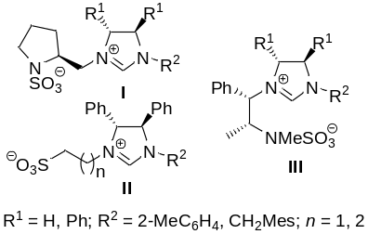
Figure 1. Chiral zwitterionic imidazolinium sulfonates/sulfamates.
To date, there has only been one report of zwitterionic CSAs, comprising of a chiral imidazolinium moiety with a sulfonate or sulfamate counteranion (Figure 1).^{[5]} These molecules could provide multiple points of ionic contact for greater chiral recognition. However, as the charges are well-separated, this can limit their solubility in organic solvents, e.g. the best-performing compound III (R¹ = Ph, R² = 2-MeC₆H₄) is not soluble in toluene.
Herein, we will disclose the preparation, characterisation and properties of a structurally-novel class of chiral zwitterionic P-heterocycles, and their potential applications as CSAs for enantio-discrimination of chiral carboxylic and sulfonic acids.
Results and Discussion
Design of zwitterionic P-heterocycles
Prior to this work, examples of zwitterionic phosphorus compounds, containing a PO₂ fragment with a positively-charged sp²-nitrogen atom, are limited to pyridinium or imidazolium adducts of metaphosphates (Figure 2).^{[6–8]} These are found to be stable, crystalline compounds that can be isolated and fully characterised.
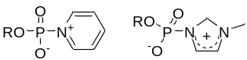
Figure 2. Known zwitterionic P^{V} compounds.
Chiral C₂-symmetric bis-oxazolines 1 (BOX, Figure 3) are a unique class of privileged ligands for many metal-catalysed asymmetric reactions.^{[9–13]} From these, the class of zwitterionic boron-BOXates 2 were derived in 2006 by Bandini et al, which were shown to be moderately successful catalysts for the asymmetric reduction of prochiral ketones.^{[14]}
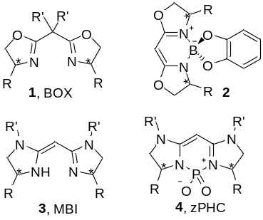
Figure 3. Zwitterionic structures derived from BOX (1) and MBI (3).
In 2007, methylene-bridged bis(imidazoline) ligands 3 (MBI) were reported as a more flexible analogue of BOX.^{[15, 16]} In this project, the MBI scaffold will be employed as a means of providing a rigid, chiral framework to construct zwitterionic P^{V} heterocycles 4, which we abbreviate herein as zPHC (Figure 3).
By embedding a negatively-charged PO₂ fragment within a bis-amidinium 6-membered ring chelate, the resultant structure may be stabilised by resonance structures IV and V (Figure 4); further fine tuning of the steric and electronic properties can be achieved by modifying N-substituents of the parent MBI.
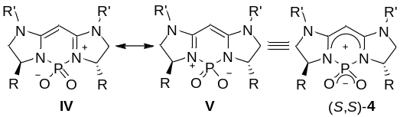
Figure 4. Resonance structures of 4.
Improved synthesis of MBIs
MBI compounds 3 were prepared from the commercially-available N-Boc protected amino acids, N-Boc-S-valine (5a), N-Boc-S-phenylalanine (5b) and N-Boc-R-phenylglycine (5c), by modifying a four-step procedure previously described by Pfaltz et al.¹⁵ (Scheme 1). The N-Boc moiety in 6 was first unmasked by using AcCl/MeOH. The resultant hydrochloride salts were then directly employed, without purification, in a reduction step with LiAlH₄, leading to an improved yield of 1,2-diamines 7. Subsequently, the transformation of 7 into the desired MBIs 3 was achieved in two steps: the condensation of diamines 7 with diethyl malonimidate dihydrochloride 8 afforded MBI derivatives 9 as HCl salts, isolated in good to excellent yields as easy-to-handle crystalline compounds. From these, the corresponding free MBI bases 3 can be released quantitatively, by treatment with 10% aq. NaOH, immediately before their deployment in the subsequent reactions.
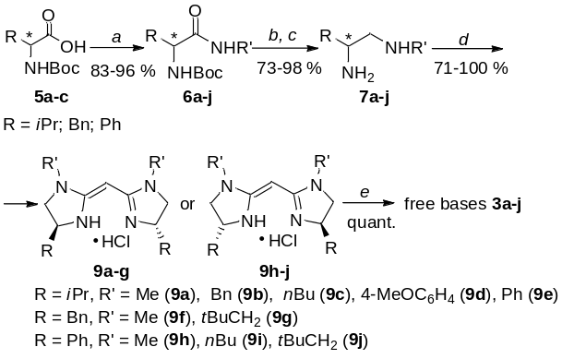
Scheme 1. Synthesis of MBI-scaffolds 3. (a) NMM, ClCO₂iBu, R'NH₂; (b) AcCl/MeOH, 0 °C to r.t., 24 h; (c) LiAlH₄, THF, reflux, 24–48 h; (d) CH₂(C(=NH)OEt)₂•2HCl (8), CH₂Cl₂, r.t. to reflux, 24–96 h; (e) NaOH/CH₂Cl₂/H₂O.
Compound 9f was transformed into its tetrafluoroborate salt by ion-exchange with 3M aq. NaBF₄, to furnish single crystals suitable for X-ray crystallographic analysis (Figure 5). The molecular structure of (S,S)-3f•HBF₄ is largely similar to its unsubstituted analogue of 2,2’-methylene-bis(4,5-dihydro-1H-imidazole) hydrochloride (H-MBI).¹⁶ The only significant difference was the dihedral angle, τ, between least-square planes of two five-member rings, being 20.09(8)º for the 3f•HBF₄, compared to 15.69(9)º for H-MBI. Nevertheless, this angle is rather flexible and can be strongly affected by N-H∙∙∙X hydrogen bonds.
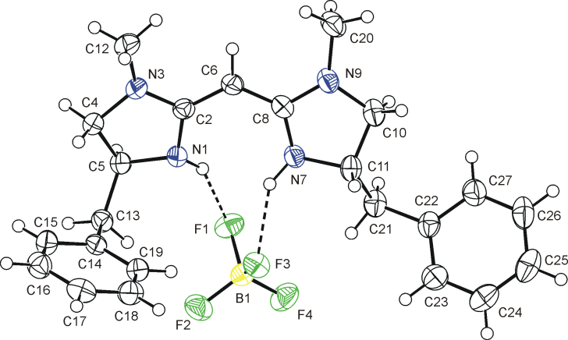
Figure 5. ORTEP representation of the molecular structure of (S,S)-3f•HBF₄. The displacement parameters are drawn on 50 % probability level. The selected bond distances and angles [Å, º]: N1-C2 1.3607(17), N1-C5 1.4797(17), C2-N3 1.3348(17), N3-C4 1.4617(17), C4-C5 1.537(2), C2-C6 1.4012(18), C6-C8 1.3928(19), N7-C8 1.3562(18), C8-N9 1.3450(16), N9-C10 1.4562(19), N7-C11 1.4754(17), C10-C11 1.522(2); C8-C6-C2 125.97(12). Hydrogen bonds parameters for N1-H1···F1: N1...F1 2.9537(14) Å, angle at H1 151º; for N7-H7...F3: N7...F3 2.9309(14) Å, angle at H7 145º.
Free MBI bases 3 exist as either one of two possible tautomeric forms in solution, which are strongly dependent upon the solvent. This was demonstrated by recording a series of ¹H NMR spectra of 3f in seven different solvents at 23 ºC (Table 1). In all cases, the conjugated tautomer (A) was thermodynamically more favourable than the unconjugated tautomer (B). The greatest stabilisation was provided by polar aprotic media, such as [D₆]DMSO and [D₆]acetone, where ratios of 13:1 and 14:1 were observed, corresponding to a relative stabilisation energy of ca. 6.5 kJ mol⁻¹. On the other hand, the lowest ratio of 3:2 was observed in CDCl₃ (ca.1 kJ mol⁻¹).
Table 1. Solvent-dependant tautomerisation of 3f at 23 ºC.
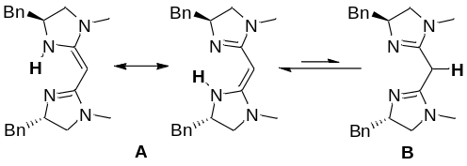
Solvent | (CD₃)₂CO | (CD₃)₂SO | C₆D₅CD₃ | C₆D₆ | CD₂Cl₂ | CD₃OD | CDCl₃
A:B^{[a]} | 14:1 | 13:1 | 12:1 | 9:1 | 6:1 | 3:1 | 3:2
[a] Determined by comparison of ¹H NMR integrals of N-CH₃ or BnCHN signals.
Synthesis of zPHCs
The phosphorus heterocycle was formed by the reaction between MBI and phosphorus oxychloride (POCl₃), performed at room temperature in dry CH₂Cl₂ or THF, and the presence of NEt₃ (Scheme 2). The reaction proceeded smoothly to afford the target zPHCs 4a-j within 24 h. Monitoring the progress of the reaction by ³¹P NMR spectroscopy, the formation of the ionic intermediate 10 can be detected in the crude reaction mixture, indicated by a distinct singlet resonance between –1 to –3 ppm. Upon treatment with a basic solution, the hydrolysis of 10 to the inner salt 4 was denoted by an upfield shift to between –13 to –15 ppm.
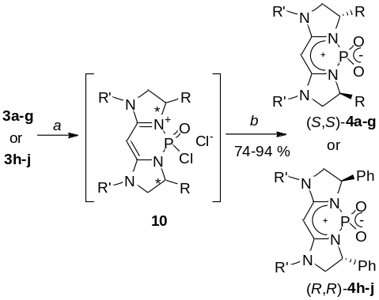
Scheme 2. Synthesis of zPHC 4. (a) POCl₃, NEt₃, CH₂Cl₂, 0 °C to r.t., 24 h; (b) 10% aq. NaOH, r.t..
The method was applied to the synthesis of a family of ten zPHCs (4a–j), which were isolated in good to excellent yields (74–94%). The zwitterionic products were fully characterised (ESI), and further confirmation was provided by single-crystal X-ray analysis of compounds 4a and 4f (Figures 6 and 7). Both molecules contain two-fold symmetry, with the C₂ axis dissecting the central methine carbon and phosphorus atom. It is interesting to note that the central six-member rings are not quite planar. Comparing the structure of these zPHC molecules with the parent MBI (Figure 5), the incorporation of PO₂ moiety does not appear to affect the conjugation within imidazolines rings, as the bond distances found in 4a and 4f are almost identical with respective distances of (S,S)-3f•HBF₄, with the exception of a more acute angle at the central methine carbon, being 118.8º and 118.6º for 4a and 4f, respectively, compared to 125.6º in 3f.
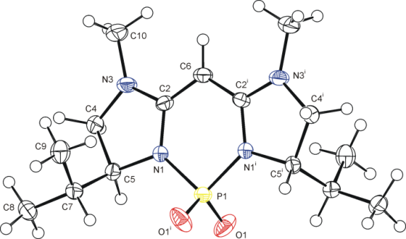
Figure 6. ORTEP representation of the molecular structure of (S,S)-4a. The displacement parameters are drawn on 50 % probability level. The selected bond distances and angles [Å, º]: P1-O1 1.4761(14), P1-N1 1.7116(16), N1-C2 1.359(2), N1-C5 1.492(2), C2-N3 1.345(2), N3-C4 1.453(3), C4-C5 1.536(3), C2-C6 1.387(2), C2-C6-C2^{i} 118.8(2). Symmetry codes: (i) −x+2, −y, z.
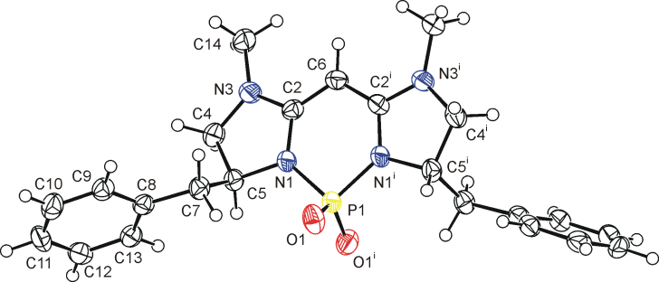
Figure 7. ORTEP representation of the molecular structure of (S,S)-4f. The displacement parameters are drawn on 50 % probability level. The selected bond distances and angles [Å, º]: P1-O1 1.4737(19), P1-N1 1.711(2), N1-C2 1.359(3), N1-C5 1.483(3), C2-N3 1.347(3), N3-C4 1.454(3), C4-C5 1.536(4), C2-C6 1.391(3), C2-C6-C2^{i} 118.6(3). Symmetry codes: (i) −x+2, −y+2, z.
The electronic properties of the zPHC compounds were investigated by performing DFT calculation of the distribution of charges in 4a (Figure 8), which showed that the molecule possesses a sizeable dipole moment of 12 D along the C₂ axis. Interestingly, while the negative charge is localised on the oxygen atoms, the positive charge is distributed extensively over the MBI framework.
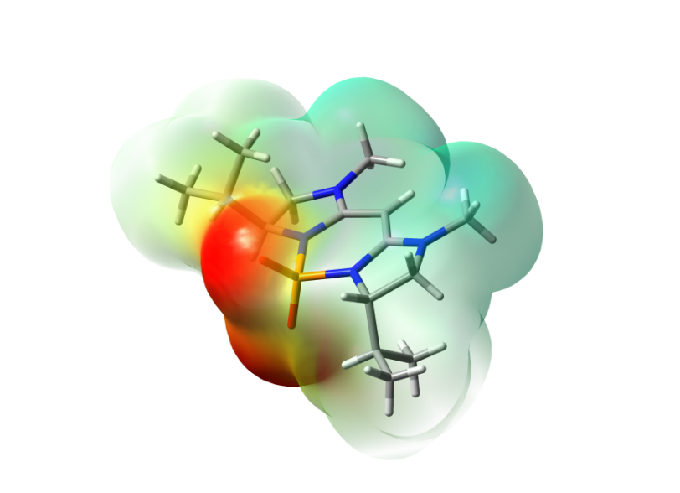
Figure 8. Electrostatic potential map of compound 4a, as determined by DFT calculation. Negative, neutral and positive potentials are represented in red, green and blue, respectively.
Properties of the P-heterocycles 4
The zPHC compounds 4 are stable as solids, which can be kept at ambient temperature for at least a year without decomposition. They are soluble in common organic solvents and, in the case of R’ = Me, water. The stability of three zPHC compounds 4a, 4f and 4h was also evaluated under neutral or basic solutions in DMSO, at ambient and elevated temperatures (Table 2). All three compounds were hydrolytically stable in a mixture of H₂O-DMSO at neutral pH up to 100 °C. Upon addition of a hydroxide base, however, slow decomposition of the phenyl-substituted zPHC 4h was detected at room temperature, which was accelerated at 100 ºC to form an intractable mixture of compounds. In contrast, zPHC analogues 4a and 4f, bearing isopropyl and benzyl substituents, respectively, were stable in the alkaline media at 100 ºC for up to 24 h, i.e. the substituents at the stereogenic C-3 and C-7 have a major effect on the stability of these molecules.
Table 2. Stability of compounds 4a, f, h (R’ = Me) in neutral and basic solutions of [D₆]DMSO/H₂O (10:1 v/v).^{[a]}
zPHC | pH | Time, h | Temperature | Decomposition, %
4a, f, h | neutral | 24  1  24 | r.t.  100 °C  100 °C | –^{[c]}  –^{[c]}  –^{[c]}
4a, f | basic^{[b]} | 24  1  24 | r.t.  100 °C  100 °C | –^{[c]}  –^{[c]}  –^{[c]}
4h | basic^{[b]} | 24  1  24 | r.t.  100 °C  100 °C | 5  15  50
[a] Monitored by ¹H NMR spectroscopy. The amount of decomposition was measured by integrating the Me (R’) signal against an internal standard (anisole). [b] [D₆]DMSO/H₂O/50% aq. KOH (10:1:1, v/v/v). [c] No decomposition observed within the detection limit.
The inherent nucleophilicity of the P–O– bond was examined by the reaction of 4a with a number of alkylating agents: BnBr, MeI, TBSOTf, and MeOTf. The formation of the phosphoric acid ester 11 was only successful by using MeOTf (Scheme 3), showing that the molecule to be weakly nucleophilic. Conversely, compound 11 is prone to hydrolysis, reverting to the zPHC 4a upon exposure to 10% aq. NaOH or KOH under ambient conditions. Thus, the cation-anion interaction between the ion pair of 11 is weaker than that found in the inner salt 4a.
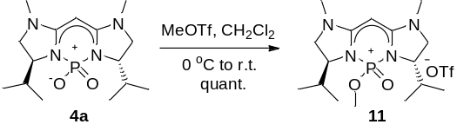
Scheme 3. Methylation of zPHC 4a.
Applications of zPHC 4 as CSAs
Chiral carboxylic acids can be found in many biologically active natural products, and constitute a class of important chiral building blocks in the development of agrochemical and pharmaceutical products. For chiral HPLC and GC to be deployed for %ee determination, the presence of a CO₂H moiety in the analyte often requires derivatization into the ester or amide, to alter its polarity and/or volatility for analysis. This can be potentially problematic, particularly if the carboxylic acid has an intrinsically low reactivity due to steric or electronic effects, as incomplete derivatization can lead to errors in analysis. Consequently, the development of CSAs for the analysis of chiral carboxylic acids is a highly topical research area. Commercially-available chiral amines, such as phenethylamine and (pseudo)ephedrines are generally not effective for acids due to the formation of ammonium carboxylate salts, which may not be soluble in the NMR solvent.^{[17]} Apart from macrocyclic receptors,^{[18, 19]} recent development of small-molecule CSAs are dominated by diamine and/or amide derivatives.^{[20-29]}
Potentially, the zPHC scaffold could provide multiple sites for dipole-dipole, hydrogen-bonding and π−π interactions, as suggested by the electron distribution shown in Figure 8. In a previous study,^{[30]} we have shown that heterocycles of type 4 possess certain basic character. With this in mind, the application of these compounds as CSAs for chiral acids was examined in this work. The initial study was carried out by recording ¹H NMR spectroscopy (400 MHz) of equimolar mixtures of racemic mandelic acid (MA) as a model analyte, with 4a, 4f, 4h or 4j at 23 ºC. The addition of a solution of receptor 4h (26.3 mM) to a solution of racemic MA (26.3 mM) in CDCl₃ caused the stereogenic C−H signal of the α-chiral acid to shift upfield and split into two equally intense singlets. Variation of the N-Me substituent in 4h to a bulky N-neopentyl in 4j did not induce significant changes in the enantio-discrimination (Figure S1, ESI). Conversely, the isopropyl- and benzyl-substituted derivatives, 4a and 4f, respectively, were ineffective CSAs.
To define the binding interactions, NMR titration experiments were performed using compounds 4h and 4j.^{[31, 32]} The effect of concentration on the chemical shift differences (ΔΔδ) was examined by the addition of 4h to a solution of (rac)-MA (Figure 9). Baseline resolution is achieved over a considerably wide concentration ratio of [4]/[(rac)-MA] (ca. 0.25−9.0), with (S)-MA undergoing the larger upfield shift.
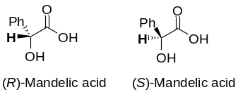
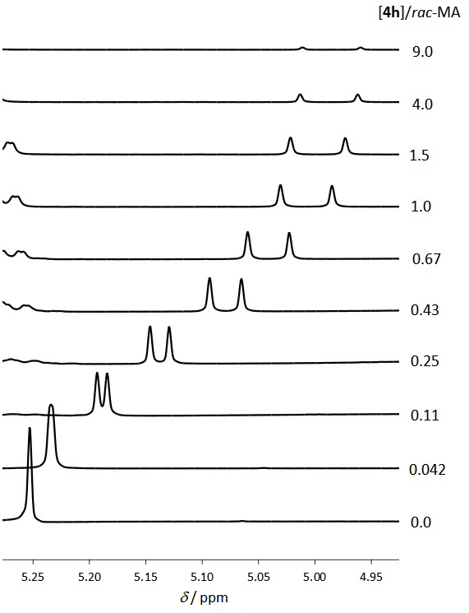
Figure 9. Variation with concentration of ΔΔδ for (rac)-MA (26.3 mM) in the presence of 4h (CDCl_{3,} 400 MHz, 23 ºC).
Figure 10 represents changes in the chemical shift non-equivalence (ΔΔδ) observed for the interaction of (rac)-MA in the presence of increasing amounts of 4h and 4j. In both cases, the enantiomeric separation increased sharply and maximum ΔΔδ values of 0.052 ppm (21 Hz) and 0.057 ppm (23 Hz) were observed for 4h and 4j, respectively, near [4]/[(rac)-MA] = 2.
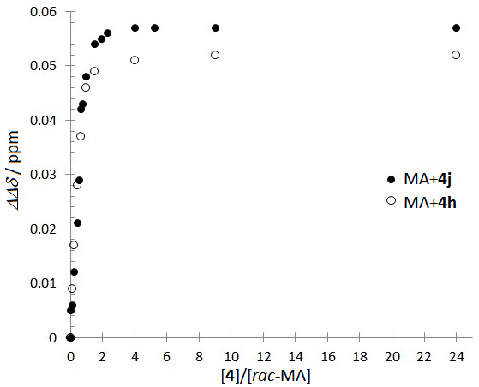
Figure 10. Chemical shift non-equivalencies (ΔΔδ) of the enantiomeric α-H signals of (rac)-MA (26.3 mM in CDCl₃; spectra collected at 23 ºC) as a function of molar ratio for the receptors 4h and 4j.
The stoichiometry of the donor-acceptor complex was established by using Job’s plots (Figure S3, ESI). Keeping the total concentration of [4h]+[MA] constant at 20.3 mM, the plot of Δδ versus the mole fraction of (R)- or (S)-MAs (X) showed a maximum at X = 0.67, providing the evidence that both enantiomers of MA form 2:1 complexes with zPHC. The binding constants of 4h for MA were subsequently determined quantitatively, by varying the concentration of single enantiomers of MA in the presence of a constant concentration of 4h (Figure 11). Using the established 1:2 complex stoichiometry, nonlinear least-squares fitting^{[33]} revealed K(S) = 341 ± 11 M⁻¹, and K(R) = 176 ± 5 M⁻¹, corresponding to a chiral recognition energy (ΔΔGº) of –0.39 kcal mol⁻¹.^{[34]}
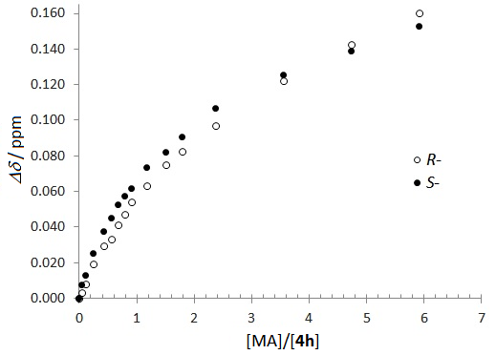
Figure 11. Plots of Δδ for the N-Me signal of 4h (5.07 mM) as a function of [MA]/[4h] ratio (CDCl₃, 400 MHz, 23 °C). ● = binding with S-MA and ○ = binding with R-MA.
Last but not least, excellent correlation between prepared and observed ee values (%ee) was established by integration of the α-proton signal of mandelic acid (ee’s between –85 to 85%) in the presence of 2 equivalents of 4h (Figure 12 and Figure S6, ESI). The excellent linearity fit showed that the method can be used to determine the enantiopurity of mandelic acid with a high level of accuracy.
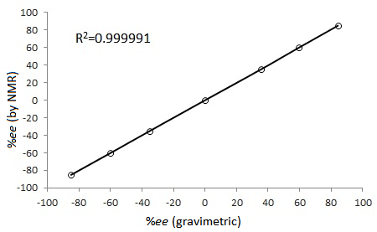
Figure 12. Correlation between the prepared and observed %ee values.
In a preliminary study, 4h was also employed for the enantio-discrimination of other types of chiral acids. We were particularly interested in dibenzoyltartaric (or tartaric acid dibenzoate, pKa = 1.85) and camphorsulfonic (pKa = 1.2) acids, which are substantially more acidic than MA (pKa = 3.41). Consequently, they present a considerable challenge for CSAs that contain Brønsted basic sites (e.g. chiral amine derivatives), which can form insoluble salts with these analytes.
Addition of an equimolar of 4h to dibenzoyltartaric acid induced an upfield shift of the methine protons (Figure 13). In this case, the protons remained chemically equivalent in each complex, i.e. the C₂ symmetry appeared to be retained, at least on the NMR timescale. A chemical shift difference of ΔΔδ = 0.12 ppm (48 Hz) was subsequently recorded, which is significantly larger than that reported with other CSAs derived from chiral amines.^{[22, 23, 25]} To date, there is only one CSA reported for the enantio-discrimination of a chiral sulfonic acid.^{[21]} Thus, we were delighted to find that 4h can induce splitting in the C8 and C9 methyl resonances of 10-camphorsulfonic acid (Figure 14). In this case, ΔΔδ of 0.0195 (7.8 Hz) and 0.0215 (8.6 Hz) ppm were recorded when [acid/4h] = 1:1, while 0.0214 (8.5 Hz) and 0.0223 (8.9 Hz) ppm were observed when the ratio was changed to 2:1.
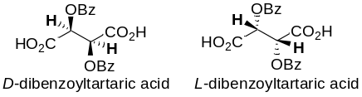
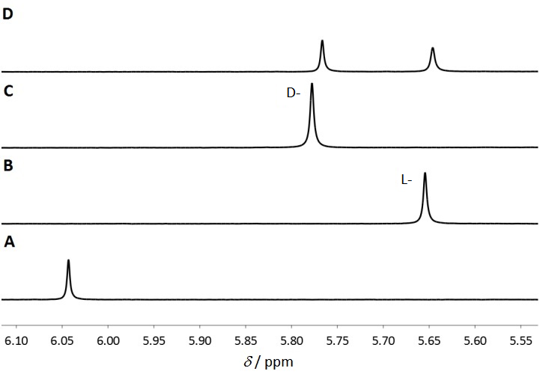
Figure 13. Resolution of dibenzoyltartaric acid by the addition of 4h (20 mM in CDCl₃, 400 MHz, 23 ºC). Signals corresponding to the methine protons are presented. A) Racemic acid; B) 4h+L-acid (100 %ee); C) 4h+D-acid (100 %ee); D) 4h+racemic acid.
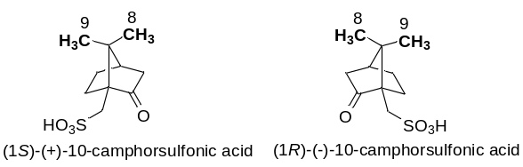
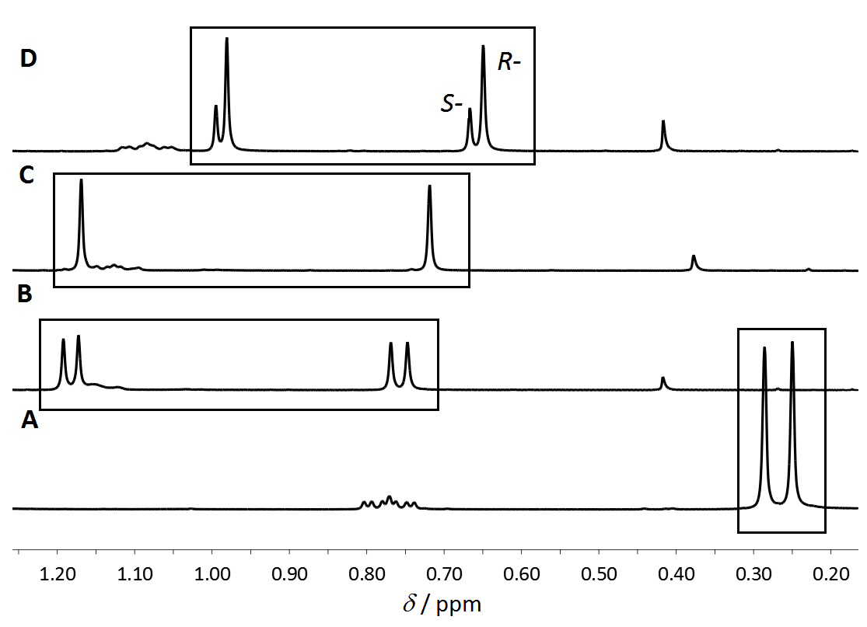
Figure 14. Resolution of camphor-10-sulfonic acid (17.2 mM in C₆D₆; 400 MHz; 23 ºC). Resonances corresponding to C8 and C9 methyl groups are presented. A) Racemic acid; B) 4h+racemic acid; C) 4h+R-acid (100 %ee); D) 4h+R-acid (35 %ee). The signals at ca. 0.4 ppm is due to residual water; other signals belong to the analyte.
Conclusion
A family of chiral zwitterionic phosphorous-containing heterocycles (zPHC) have been designed, synthesised and characterised. X-ray structural analysis and DFT calculation suggest that these zPHCs are highly polar molecules, combining a concentration of electron density on the PO₂ moiety, with a highly diffused cation within the bis-imidazoline framework. These special qualities were exploited in their application as structurally-novel chiral solvating agents, in resolving a wider range of analytes. Our preliminary studies showed that they can be used to resolve an α-hydroxyl acid, a diacid, and a sulfonic acid. Examples of such broad applicability of a CSA across different types of chiral acids are rare. The nature of the binding will be examined in our future work, including potential applications in asymmetric synthesis.
Experimental Section
General: Solvents were dried by passing through columns of molecular sieves in a solvent purification system (Innovative Technology Inc). Unless otherwise stated, materials obtained from commercial suppliers were used without further purification. Preparative separations were performed by silica gel gravity column chromatography. TLCs were visualized with molybdate dip or UV light. ¹H NMR (400 MHz), ¹³C NMR (100 MHz), ³¹P NMR (162 MHz) and ¹⁹F NMR (377 MHz) spectra were recorded at 25 °C on Bruker Avance 400 MHz spectrometers. Chemical shifts (δ) were reported in ppm relative to residual CHCl₃ (δ = 7.26) or DMSO (δ = 2.50) for ¹H NMR and CDCl₃ (δ = 77.00) or [D₆]DMSO (δ = 39.52) for ¹³C NMR. (MeO)₃P=O (δ = 3.0 ppm in CDCl₃) was used as internal standard for ³¹P NMR spectra. IR spectra were recorded on FTIR spectrometers Bruker Equinox 55 or Perkin Elmer Spectrum 100 as neat samples or as solutions in CHCl₃. High-resolution mass spectra were recorded on GTC Premier, LTQ Orbitrap XL, Micromass Autospec Premier, Micromass LCT Premier, or VG Platform II spectrometers using EI or ESI ionization methods in methanol, acetonitrile or chloroform. Optical rotation was measured on Autopol IV polarimeter. Elemental analysis was performed using PE 2400 Series II CHNS/O elemental analyzer. Melting points were determined using an Electrothermal Gallenhamp apparatus fitted with a calibrated thermometer with an error of ±2 °C. HPLC analyses were performed on Hewlett Packard 1050 HPLC machines using CHIRACEL OD and OD-H columns.
Mulliken partial charges and electrostatic potential surfaces for compound 4a were calculated by DFT using Gaussian 09 and GaussView 5.0 software, employing a B3LYP/6-311G(d,p) basis set.
X-ray Structure determination: Crystallographic data for the investigated compounds have been deposited with the Cambridge Crystallographic Data Center, CCDC 900435 (3f•HBF₄), 900436 (4a), and 900437 (4f). Copies of this information may be obtained free of charge from the Director, CCDC, 12 Union Road, Cambridge CB2 1EZ, UK (fax: +44 1223 336033; e-mail: deposit@ccdc.cam.ac.uk or www.ccdc.cam.ac.uk).
Synthesis of phosphorus zwitterionic heterocycles 4: General procedure: A mixture of the corresponding salt 9 (1 mol equiv.) and 10% aq. NaOH (15 mol equiv.) in CH₂Cl₂ (15 mL per 1 mmol of 9) was vigorously shaken in a separatory funnel for 5 min. The organic phase was separated; the aqueous phase was extracted with CH₂Cl₂ (30 mL). The combined organic phases were washed with water (20 mL), dried over MgSO₄ and concentrated to dryness under reduced pressure to provide the corresponding free base 3 quantitatively as a white solid. The free MBI base 3 was then dissolved in dry CH₂Cl₂ (5 mL per 1 mmol of salt 9), the resulting solution was cooled to 0 °C followed by the dropwise addition of phosphorous oxychloride (1 mol equiv.) and triethylamine (2 mol equiv.) under the atmosphere of dry argon. The reaction mixture was stirred for 24 h at r.t., concentrated to dryness under reduced pressure and quenched with 10% aq. NaOH (10 mol equiv.). After 12 h of stirring at r.t., the reaction mixture was extracted with CH₂Cl₂ (3×50 mL), the combined organic phases were washed with water (20 mL), dried over MgSO₄ and concentrated to afford pure inner salts 4 as white or pale yellow solids. Analytical samples of 4 were prepared by recrystallization from a suitable solvent. See ESI for further details.
Acknowledgements
AES was supported by a Marie Curie Intra-European Fellowship within the 7th European Community Framework Programme (FP7, project number: 252247). IML was supported by IOCB (grant no. Z40550506) and IC by the Ministry of Education of the Czech Republic (grant no. MSM0021620857). EVB is grateful to Dr Klaus Hellgardt (ICL) for support.
[1] Y.-C. Yip, S.-K. Wong, S.-M. Choi, TrAC, Trends Anal. Chem. 2011, 30, 628–640.
[2] A. P. Kumar, D. Jin, Y.-I. Lee, Appl. Spectrosc. Rev. 2009, 44, 267–316.
[3] D. Parker, Chem. Rev. 1991, 91, 1441–1457.
[4] a) T. J. Wenzel, C. D. Chisholm, Prog. Nucl. Magn. Reson. Spectrosc. 2011, 59, 1–63; b) N. Harada, Chirality 2008, 20, 691–723.
[5] S. Tabassum, M. A. Gilani, R. Wilhelm, Tetrahedron: Asymmetry 2011, 22, 1632–1639.
[6] P. A. Bartlett, F. R. Green, E. H. Rose, J. Am. Chem. Soc. 1978, 100, 4852–4858.
[7] T. V. Maltseva, A. A. Voityuk, Bull. Acad. Sci. USSR 1989, 38, 1177–1182.
[8] D. M. Graifer, A. V. Lebedev, A. I. Rezvukhin, M. M. Shakirov, Bull. Acad. Sci. USSR 1986, 35, 2024–2029.
[9] D. A. Evans, K. A. Woerpel, M. M. Hinman, M. M. Faul, J. Am. Chem. Soc. 1991, 113, 726–728.
[10] A. K. Ghosh, M. Packiarajan, J. Cappiello, Tetrahedron: Asymmetry 1998, 9, 1.
[11] H. A. McManus, P. J. Guiry, Chem. Rev. 2004, 104, 4151–4202.
[12] G. Desimoni, G. Faita, K. A. Jorgensen, Chem. Rev. 2006, 106, 3561–3651.
[13] G. C. Hargaden, P. J. Guiry, Chem. Rev., 2009, 109, 2505–2550.
[14] M. Bandini, A. Bottoni, P. G. Cozzi, G. P. Miscione, M. Monari, R. Pierciaccante, A. Umani-Ronchi, Eur. J. Org. Chem. 2006, 4596–4608.
[15] B. Ramalingam, M. Neuburger, A. Pfaltz, Synthesis 2007, 572–582.
[16] D. Akalay, G. Duerner, J. W. Bats, M. Bolte, M. W. Goebel, J. Org. Chem. 2007, 72, 5618–5624.
[17] S. P. Zingg, E. M. Arnett, A. T. McPhail, A. A. Bothner-By, W. R. Gilkerson, J. Am. Chem. Soc. 1988, 110, 1565–1580.
[18] F. Ma, X. Shen, X. Ming, J. Wang, O.-Y. Jie, C. Zhang, Tetrahedron: Asymmetry 2008, 19, 1576–1586.
[19] K. Tanaka, Y. Nakai, H. Takahashi, Tetrahedron: Asymmetry 2011, 22, 178–184.
[20] A. Bilz, T. Stork, G. Helmchen, Tetrahedron: Asymmetry 1997, 8, 3999–4002.
[21] M. A. Lapitskaya, G. V. Zatonsky, K. K. Pivnitsky, Mendeleev Commun. 1999, 149–151.
[22] W. Wang, F. Ma, X. Shen, C. Zhang, Tetrahedron: Asymmetry 2007, 18, 832–837.
[23] Z. Luo, C. Zhong, X. Wu, E. Fu, Tetrahedron Lett. 2008, 49, 3385–3390.
[24] W. Wang, X. Shen, F. Ma, Z. Li, C. Zhang, Tetrahedron: Asymmetry 2008, 19, 1193–1199.
[25] S. Satishkumar, M. Periasamy, Tetrahedron: Asymmetry 2009, 20, 2257–2262.
[26] B. Altava, M. I. Burguete, N. Carbo, J. Escorihuela, S. V. Luis, Tetrahedron: Asymmetry 2010, 21, 982–989.
[27] M. Periasamy, M. Dalai, M. Padmaja, J. Chem. Sci. 2010, 122, 561–569.
[28] L. Liu, M. Ye, X. Hu, X. Yu, L. Zhang, X. Lei, Tetrahedron: Asymmetry 2011, 22, 1667–1671.
[29] H. N. Naziroglu, M. Durmaz, S. Bozkurt, A. Sirit, Chirality 2011, 23, 463–471.
[30] S. Ehala, A. A. Grishina, A. E. Sheshenev, I. M. Lyapkalo, V. Kašička, J. Chrom. A 2010, 1217, 8048–8053.
[31] L. Fielding, Tetrahedron 2000, 56, 6151–6170.
[32] K. A. Connors, Binding constants: the measurement of molecular complex stability, Wiley, 1987.
[33] We thank Professor Christopher Hunter (University of Sheffield, UK) for provision of the NMRTit HGG program.
[34] ΔΔGº = –RTln[K(S)/K(R)]).
Received: ((will be filled in by the editorial staff))
Revised: ((will be filled in by the editorial staff))
Published online: ((will be filled in by the editorial staff))

Layout 2:
Catch Phrase −−−−−−−−−−−−−−− |  | 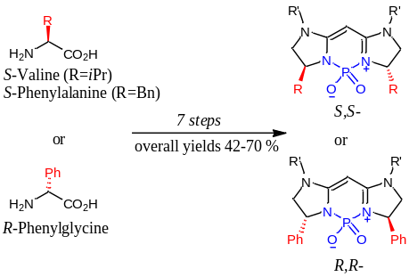
Andrey E. Sheshenev, Ekaterina V. Boltukhina, Anastasiya A. Grishina, Ivana Cisařova, Ilya M. Lyapkalo and King Kuok (Mimi) Hii*………..… Page – Page
Novel Chiral Zwitterionic Phosphorus Heterocycles: Synthesis, Structure, Properties and Application as Chiral Solvating Agents
 |  | A convenient synthetic approach to a new class of chiral zwitterionic phosphorus containing heterocycles starting from methylene bridged bis(imidazolines) was designed and executed. Stability and properties of | the synthesized compounds were investigated. The applicability of the designed compounds as CSA’s for the determination of the enantiomeric excesses of chiral acids was demonstrated.

