Organometallic chemistry using partially fluorinated benzenes
Sebastian D. Pike,^{a,}* Mark R. Crimmin,^{b,}* and Adrian B. Chaplin^{c,}*

Department of Chemistry, University of Cambridge, Lensfield Road, Cambridge CB2 1EW, UK.
Email: sp842@cam.ac.uk

Department of Chemistry, Imperial College London, South Kensington, London SW7 2AZ, UK.
Email: m.crimmin@imperial.ac.uk

Department of Chemistry, University of Warwick, Gibbet Hill Road, Coventry CV4 7AL, UK.
Email: a.b.chaplin@warwick.ac.uk

TOC graphic
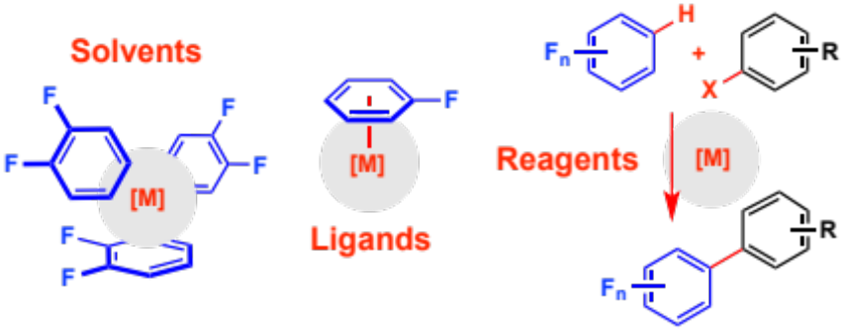

Abstract
Fluorobenzenes, in particular fluorobenzene (FB) and 1,2-difluorobenzene (1,2-DiFB), are increasingly becoming recognised as versatile solvents for conducting organometallic chemistry and transition-metal-based catalysis. The presence of fluorine substituents reduces the available π-electron density and consequently fluorobenzenes generally bind weakly to metal centres, allowing them to be used as essentially non-coordinating solvents or as readily displaced ligands. In this context, examples of well-defined complexes of fluorobenzenes are discussed, including trends in binding strength with increasing fluorination and different substitution patterns. Compared to more highly fluorinated benzenes, FB and 1,2-DiFB typically demonstrate greater chemical inertness, however, C–H and C–F bond activation reactions can be induced using appropriately reactive transition metal complexes. Such reactions are surveyed, including catalytic examples, not only to provide perspective for the use of FB and 1,2-DiFB as innocent solvent media, but also to highlight opportunities for their exploitation in contemporary organic synthesis.
Biographies
 | Sebastian Pike completed his D.Phil. at the University of Oxford in 2014 under the supervision of Prof. Andrew Weller. His thesis explored the coordination chemistry of cationic Rh(bis-phosphine) complexes with weakly binding substrates including alkanes and fluorobenzenes. Following this, he spent two years working as a post-doctoral research associate in the field of nanoparticle synthesis and catalysis at Imperial College London. In 2016 he was awarded a Herchel-Smith Research Fellowship at The University of Cambridge, where he currently studies metal-oxide cluster molecules bridging the fields of molecular and nanoparticle chemistry.
 | Mark R. Crimmin received his PhD in main group chemistry and catalysis from Imperial College London in 2008 supervised by Prof. Mike Hill (now at Bath) and Prof. Tony Barrett. In the same year, he moved to UC Berkeley to study with Prof. Bob Bergman and Prof. Dean Toste. In 2011, he returned to London as a Royal Society University Research Fellow, initially at UCL and now back at Imperial. Work in the Crimmin group focuses on new methods to break strong carbon–fluorine, carbon–oxygen and carbon–hydrogen bonds in small molecules and the development of heterobimetallic complexes for catalysis.
 | A native of New Zealand, Adrian carried out his doctoral studies at the EPFL in Switzerland before moving to the UK. He then spent four years in the group of Prof. Andrew Weller at the University of Oxford, holding the R. J. P. Williams Junior Research Fellowship in Chemistry at Wadham College during the latter two years. Following award of a Royal Society University Research Fellowship, Adrian commenced his independent academic career at the University of Warwick in 2011. Work in the Chaplin group involves synthetic organometallic chemistry of the late transition metals, focusing on the application of supramolecular inspired ligands.

Introduction
Fluorobenzenes, in particular commercially available fluorobenzene (FB) and 1,2-difluorobenzene (1,2-DiFB), are increasingly becoming recognised as versatile weakly coordinating solvents for conducting organometallic chemistry and transition metal catalysis. The presence of fluorine substituents significantly augments the physical properties and chemical reactivity compared to benzene. From a coordination chemistry perspective, such differences are exemplified by their capacity to form sandwich and half-sandwich complexes; the incorporation of fluorine reduces the total available electron density within the π-system, reducing the fluorobenzene’s ability to bind in an η⁶-manner to metal centres. For hexafluorobenzene (HFB) for instance, the partial charge over the ring is calculated to change from negative to slightly positive compared to benzene, giving it π-acidic properties (Figure 1).,, Indeed, HFB has been shown to bind Au⁻ anions by mass spectrometry.

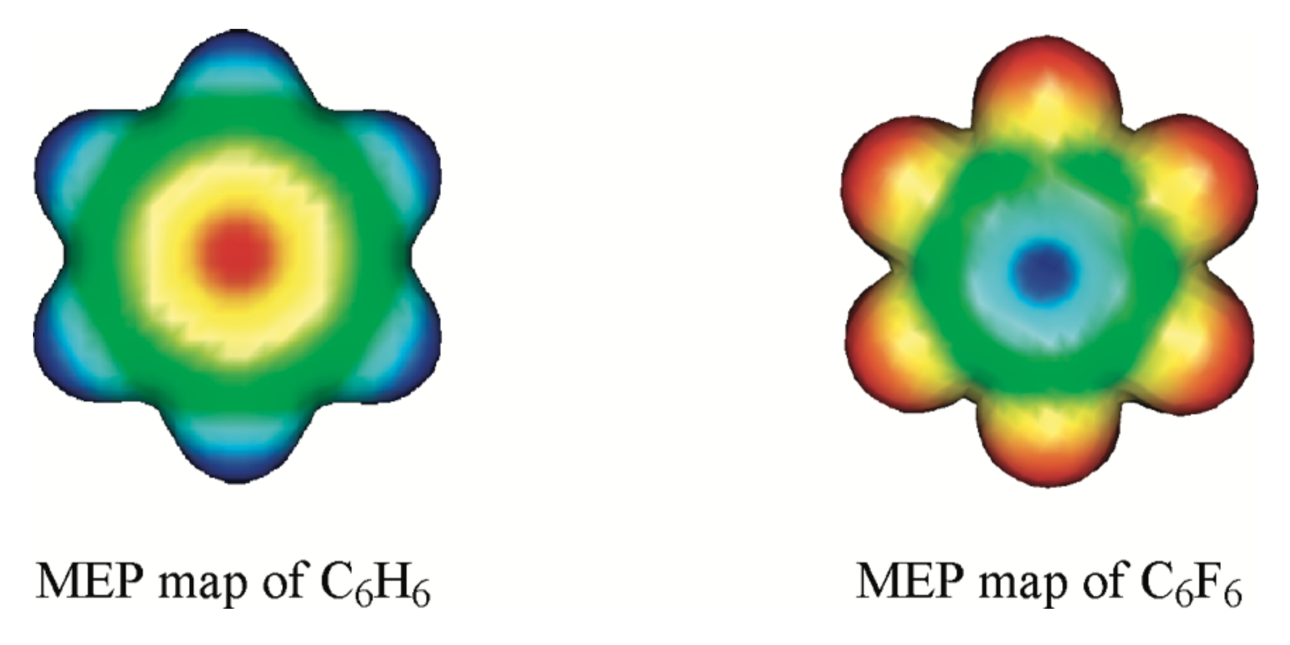
Figure 1. Electrostatic potential maps of C₆H₆ and C₆F₆; electron rich = red, electron deficient = blue. Reprinted with permission from ref. 2, Copyright 2009, American Chemical Society.

In addition to providing illustrative examples of their use as solvents, this perspective will focus on the coordination and reaction chemistry of FB and 1,2-DiFB with transition metal complexes. Such information we hope will help emphasise the many roles that these partially fluorinated benzenes can play – as solvents, labile ligands and reagents – and facilitate future use by practitioners in the field. In this sense, it is beyond the scope of this commentary to detail the chemistry of other more fluorinated arenes, heterocycles or hydrocarbons, however, where appropriate, comparisons are drawn. For more information on the bond activation chemistry of some of these molecules the interested reader is directed to number of recent monographs.,,,

Fluorobenzenes as solvents
Fluorobenzenes are widely commercially available laboratory chemicals. Unlike benzene, fluorobenzenes are not classed as carcinogens and are generally considered less toxic than toluene, although some are classed as harmful; all are highly flammable. Marking them out as useful solvents they have relatively high boiling points (81 – 95 ºC) and low melting points (−50 – +4 ºC), with FB and 1,2-DiFB having liquid windows of > 120 ºC (Table 1). For use in air and moisture sensitive chemistry FB and 1,2-DiFB may be dried over CaH₂, vacuum distilled, and stored over 3 Å molecular sieves. In our experience 1,2-DiFB, in particular, benefits from stirring over alumina prior to this procedure. It should be noted that GCMS analysis of commercially available FB and 1,2-DiFB solvents has revealed the presence of trace impurities, including phenol and chlorobenzene in FB and 1,2-C₆H₄FCl and 1,2-C₆H₄F(OH) in 1,2-DiFB.

Table 1. Melting and boiling point data for fluorobenzenes.¹⁰
C₆H_{6-n}F_{n} (isomer) | Melting point (°C) | Boiling point (°C)
n = 1 | −42 | 85
n = 2 (1,2; 1,3; 1,4) | −34; −59; −13 | 92; 83; 88
n = 3 (1,2,3; 1,2,4; 1,3,5) | −; −; −6 | 94; 88; 75
n = 4 (1,2,3,4; 1,2,4,5) | −42; 4 | 95; 90
n = 5 | −48 | 85
n = 6 | 4 | 81

FB has a dielectric constant of 5.4 at room temperature, whilst 1,2-DiFB has a value of 13.8.,, Both values are larger than that of benzene (ε = 2.3), while 1,2-DiFB has a dielectric constant greater than widely used weakly coordinating solvent dichloromethane (ε = 9.1) and even THF (ε = 7.6), but less than acetone (ε = 20.7), methanol (ε = 32.6), and nitrobenzene (ε = 34.8).^{13,} Neat FB and 1,2-DiFB are consequently suitably polar to solvate a broad range of neutral and charged organometallics, with 1,2-DiFB an excellent solvent for charged species in particular (one could also consider applications using mixed FB/1,2-DiFB systems to tune solvent polarity). Indeed for halide abstraction/salt metathesis reactions in 1,2-DiFB it is important to consider that low concentrations of inorganic salts (e.g. NaCl) can remain solvated, in comparison to CH₂Cl₂ or FB, and have subsequent impact on reaction chemistry. Moreover, both FB and 1,2-DiFB have high enough polarity to be used in electrospray ionization mass spectrometry techniques.,, In our experience NMR spectra in proteo-fluorobenzenes can be collected using internal sealed capillaries of either C₆D₆ or d₆-acetone; ¹H NMR spectra in FB and 1,2-DiFB can be referenced using the highest intensity peak of the lowest frequency multiplet or highest frequency multiplet, respectively (both δ 6.865). d₅-FB has also become commercially available. Sullivan and Meyer brought attention to 1,2-DiFB as an excellent solvent for electrochemical studies in 1989, due its low coordinating abilities, chemical inertness and the wide potential window of +2.0 to −2.2 V (relative to saturated sodium chloride calomel reference electrode). It has been subsequently employed to study the redox behaviour of a range of reactive transition metal complexes.,

Eisenstein, Faller, Crabtree and colleagues identified FB as a “less coordinating and less oxidising” solvent compared to CH₂Cl₂ during the synthesis of low-coordinate iridium complexes in 2002. More recently both FB and 1,2-DiFB have found roles as weakly-coordinating solvents in the synthesis of unusual and reactive metal complexes, particularly those that are cationic (typically containing weakly coordinating anions), e.g. [Zn₃Cp*₃]⁺, [Rh₆(PCy₃)₆(H)₁₂]²⁺, [Ir=B=N^{i}Pr₂(PMe₃)₃(H)₂]⁺, and [Pd(P^{t}Bu₃)₂]⁺,²³ and in transition metal catalysed reactions. For example, the rhodium catalysed dehydropolymerisation of H₃BNMeH₂ to form [H₂BNMeH]_{n} was found to proceed to completion over 9 times faster when conducted in FB solvent compared to in THF and was attributed to the inability of FB to reversibly coordinate to the catalyst (in contrast to THF). Likewise, the electrocatalytic oxidation of H₂ by Ni complexes, bearing phosphine ligands with pendant amine groups, exhibits significantly faster turnover in FB compared to THF and MeCN; solvents that are believed to encumber coordination of H₂ by competitively binding to the metal centres., 1,2-DiFB and HFB have also been shown to be effective solvents for conducting ruthenium catalysed olefin metathesis reactions. Although non-polar HFB (ε = 2.0)¹⁶ is a useful solvent choice for this and other reactions, it is much is more susceptible to C–F bond activation than FB and 1,2-DiFB.^{5,6,7,8}

Coordination chemistry of fluorobenzenes
Whilst fluorobenzenes are justifiably considered weakly coordinating, they may bind to a transition metal centre via several coordination modes. To begin with it is instructive to consider the relative binding energies of fluorobenzenes with naked metal cations and several experimental and theoretical studies have quantified such interactions. For instance, Schwarz and co-workers have measured the dissociation energies of {M(arene)}⁺ (M = Cr, Fe, Co) fragments by mass spectrometry, finding FB to be bound ~19 kJ∙mol⁻¹ weaker than benzene. The coordination of Cr⁺ cations to a series of fluorobenzenes (C₆H_{6−n}F_{n}; n = 0 − 6) in the gas-phase has similarly been probed by Klippenstein and Dunbar using Fourier transform ion cyclotron resonance mass spectrometry, supplemented by DFT calculations. The arene binding strength was found to decrease by ~21 kJ∙mol⁻¹ with each additional fluorine substituent. η⁶-Coordination modes were suggested by DFT calculations except for ortho-fluorinated benzenes, where chelating κ_{FF} coordination modes were predicted to be marginally more stable. Related studies using Au⁺ cations have also indicated the binding affinity of benzene (289 kJ∙mol⁻¹) is significantly larger than that of HFB (~142 kJ∙mol⁻¹). Intriguingly, the binding affinity of HFB to Au⁺ is only a little greater than to Au⁻ (~100 kJ∙mol⁻¹), marking out HFB’s ability to both donate and accept electron density.⁴

It is well established that alkene ligands bearing electron-donating substituents result in favourable donor interactions with electron-deficient metal fragments, while conversely, electron-withdrawing groups lead to effective π back-bonding interactions with electron-rich metal centres. Equivalent effects are expected for arene ligands, i.e. for electron-deficient metal centres (e.g. cationic systems) the addition of electron-withdrawing fluorine substituents will reduce an arene’s binding affinity, whilst for electron-rich complexes, capable of greater degrees of π back-bonding, a reduced or even opposite effect can be expected.

Coordination through the arene ring
The earliest examples of fluorobenzene coordination date back to 1970’s, and involve chromium and vanadium sandwich compounds synthesised via metal vapor condensation, viz. [M(η⁶-arene)₂] (M = Cr, arene = FB, 1,2-DiFB, 1,3-DiFB, 1,4-DiFB; M = V, arene = FB, 1,4-DiFB; 1, Chart 1). The relative stability of these complexes was inversely correlated with the incorporation of the electron-withdrawing fluorine substituents and attempted isolation of symmetrical chromium sandwich complexes of fluorobenzenes bearing more than two fluorine substituents proved unsuccessful. The preparation of unsymmetrical derivatives of highly fluorinated benzenes, however, was realized, i.e. [Cr(η⁶-C₆H₆)(η⁶-C₆H_{6-n}F_{n})] (n = 4 – 6). Structural characterisation of [V(η⁶-1,4-DiFB)₂] in the solid-state by X-ray diffraction interestingly revealed a small “boat” deformation of the arene rings, with a closer approach of the non-fluorinated carbon atoms consistent with increased donor ability of the associated π orbitals. This conformation has also been observed in other complexes of 1,4-DiFB. Solid-state characterisation of complexes bearing η⁶-HFB ligands is limited to a single tungsten example.

Chart 1. Coordination of fluorobenzenes through the arene ring.ª
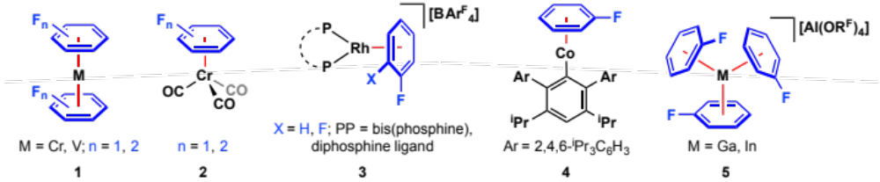
ª Ar^{F} = 3,5-(CF₃)₂C₆H₃, R^{F} = C(CF₃)₃.

In order to assess the relative donor properties of fluorobenzenes, chromium carbonyl complexes [Cr(CO)₃(η⁶-arene)] (2) are particularly useful, with the carbonyl stretching frequencies providing a convenient spectroscopic handle. Complexes of 2 featuring η⁶-C₆H_{6-n}F_{n} (n = 0, 1, 2) have all been prepared and IR data corroborates reduced arene to metal donation on increasing fluorination.,, For instance, the A₁ and E carbonyl stretching frequencies of the benzene, FB and 1,2-DiFB derivatives are 1982 and 1915, 1986 and 1922, and 1992 and 1929 cm⁻¹, respectively.⁴¹ Another readily assessed spectroscopic characteristic of these and other complexes bearing η⁶-fluoroarene ligands are the ¹H NMR signals of the arene that shift to significantly lower frequency on coordination – although these changes are offset on increasing fluorination (Table 2).,

Table 2. ¹H chemical shifts of aryl protons in η⁶-benzene, FB and 1,4-DiFB complexes (C₆D₆).^{44,45,,a}
Compound / solvent | δ_{H}(arene)
Compound / solvent | C₆H₆ | FB | 1,4-DiFB
Free arene | 7.16 | 6.8 – 6.9 | 6.50
[Cr(CO)₃(η⁶-arene)] | 4.27 | 3.6 – 4.3 | 4.27
[Ru(η⁴-COD)(η⁶-arene)] | 4.95 | 4.2 – 5.2 | 5.31
ª COD = 1,5-cyclooctadiene
As a strategy for accessing reactive low-coordinate {RhL₂}⁺ (L = phosphine, L₂ = diphosphine) fragments in solution, Weller and co-workers have prepared a range of adducts bearing FB and 1,2-DiFB as weakly coordinating ligands (3, Chart 1).^{18,19,27,,,,} Facile substitution of the arene ligands in these well-defined complexes allows them to be considered “operationally unsaturated” rhodium species in solution (vide infra). Evidence for coordination of benzenes with a higher degree of fluorination is limited to solution phase characterisation of [Rh(^{i}Bu₂PCH₂CH₂P^{i}Bu₂)(η⁶-1,2,3-TriFB)]⁺ (TriFB = C₆H₃F₃) and encumbered by η⁶-coordination of the [BAr^{F}₄]⁻ counter anion, which has typically been employed for these systems.¹⁸ Exploiting the latter observation, free energies for the coordination of a range of arenes relative to [BAr^{F}₄]⁻ have been determined by NMR spectroscopy for the {Rh{^{i}Bu₂PCH₂CH₂P^{i}Bu₂)}⁺ fragment in CD₂Cl₂ at 298 K.¹⁸ More favorable coordination was observed in the order: benzene (> +25 kJ∙mol⁻¹) >> PhCl (+18 ± 3 kJ∙mol⁻¹) > FB (+14 ± 1 kJ∙mol⁻¹) > PhCF₃ (+3.6 ± 0.2 kJ∙mol⁻¹) > 1,4-DiFB (–2.5 ± 0.2 kJ∙mol⁻¹) ≈ 1,2-DiFB (–2.9 ± 0.2 kJ∙mol⁻¹) > 1,3-DiFB (–6.1 ± 0.3 kJ∙mol⁻¹) >> 1,2,3-TriFB (–14 ± 1 kJ∙mol⁻¹). This trend was also corroborated using collision induced dissociation studies in the gas phase using electrospray ionisiaton mass spectrometry, which allows for “fast and easy comparison of the binding affinity of arene ligands to cationic organometallic fragments” (Chart 2).¹⁸ Using this method, the effect of the composition of the diphosphine ligand in 3 was also assessed, and notably rhodium fragments bearing smaller bite angle diphosphine ligands were found to bind fluorobenzene more strongly.

Chart 2. Gas phase fragmentation of [Rh(diphosphine)(η⁶-fluoroarene)]⁺ complexes.
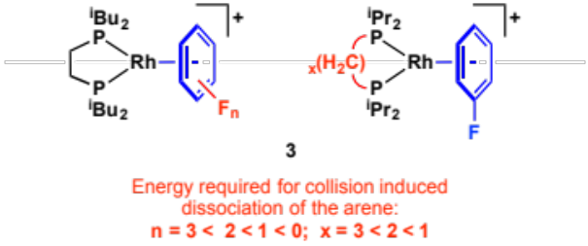

In comparison to the systems described above, Power and co-workers have prepared Co(I)-aryl systems that conversely demonstrate enhanced η⁶-binding of FB compared to benzene and, moreover, toluene. Linear paramagnetic complexes [CoAr*(η⁶-arene)] (Ar* = 2,6-(2,4,6-^{i}Pr₃C₆H₂)₂-3,5-^{i}Pr₂C₆H; arene = benzene, toluene, FB; 4, Chart 1) were prepared by reduction of [CoAr*Cl]₂ in arene solvent and crystallographically characterised. Inspection of the solid-state metrics of these complexes revealed a shorter Co–centroid (1.557(5) Å) distance for the FB derivative, in comparison to benzene (1.634(2) Å) and even more so for the toluene analogue (1.659(1) Å), implicating the presence of significant metal π back-bonding. Under equivalent conditions, reduction of [CoAr*Cl]₂ in HFB instead resulted in C–F bond activation and formation of K[CoAr*(C₆F₅)F].

Outside of the transition elements, FB adducts of Ga(I) and In(I) prepared by Krossing and co-workers through the oxidation of gallium/indium metal with Ag[Al(OR^{F})] in the arene solvent merit special mention. Of the three polymorphs of these products, two feature remarkable examples of tris-coordinated FB ligands (5, Chart 1).,, Related [M(η⁶-1,2-DiFB)₂]⁺ (M = Ga, In) complexes have also been characterised.^{53,}

Partial coordination through the arene ring
In the context of C–H bond activation, Perutz, Clot, and co-workers have systematically studied η²-fluorobenzene adducts of rhenium cyclopentadienyl complexes. In addition to experimental work, the apotheosis of which included the isolation and comprehensive structural characterisation of [ReCp(CO)₂(η²-HFB)], trends in regioselectivity were studied computationally for a wide range of fluorobenzenes (C₆H_{6-n}F_{n}, n = 0 – 5, selected binding energies shown in Chart 3). A clear preference for metal coordination in the order HC=CH > HC=CF > FC=CF was established and attributed to greater π-density at these positions, although there was no clear trend in binding strength amongst the arenes. As η²-arene adducts are believed to be short-lived intermediates in the oxidative addition of aryl C–H bonds, the overarching conclusion that C–H bond oxidative addition ortho- to the fluorine substituents is most thermodynamically favored highlights interesting kinetic subtleties in these reactions (vide infra).

Chart 3. Calculated binding energies (kJ∙mol⁻¹) of the {ReCp(CO)₂} fragment to various arenes.
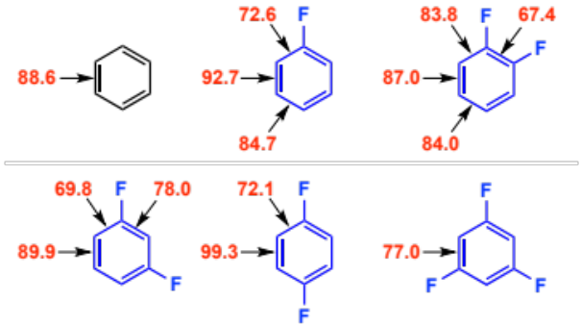

With the exception of π-acidic HFB, which typically distorts away from planarity on binding,^{58,,} well-defined examples of partially coordinated fluorobenzenes are rare.,, Bimetallic 6 and 7 that feature bridging arenes are notable examples (Chart 4). The solid-state structure of 6 indicates μ-η⁴:η⁴-coordination of the FB, which is distorted dramatically away from planarity. Interestingly this structure is retained in solution (d₈-THF) and is formed preferentially over mononuclear η⁴-FB and THF adducts. In the case of 7, the 1,4-DiFB variant was crystallographically characterised and revealed a μ-η²:η²-coordination mode, where the HC=CH moieties are coordinated to the metal centre in line with the thermodynamic preferences calculated by Perutz and Clot (Chart 3).

Chart 4. Partial coordination of fluorobenzenes through the arene ring.ª
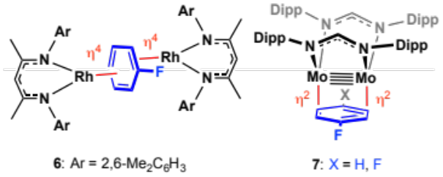
ª Dipp = 2,6-^{i}Pr₂C₆H₃

Coordination through the fluorine substituents
In addition to binding through the arene π system, coordination of fluorobenzenes through the fluorine substituents of FB (κ_{F}) and 1,2-DiFB (κ_{FF}) has been reported in a number of well-defined early transition metal complexes (8, 9, 10; Chart 5).,, Consistent with primarily electrostatic interactions, FB is found to bind with approximately linear M−F−C bond angles and in all cases significant C–F bond elongation is observed compared to the free arene (e.g. for 8; 1.417(3) vs. 1.364(2) Å). This suggestion has been supported through computational analysis,⁶⁸ which also showed the κ_{FF}–1,2-DiFB binding to [MCp*₂]⁺ decreases in the order M = Sc > Ti > V. This trend was attributed to the availability of unfilled frontier molecular orbitals and increasingly unfavorable sterics as the metal centres becomes smaller. Correspondingly no reaction was observed between the vanadium cation and 1,2-DiFB (or FB).⁶⁸

Chart 5. Coordination of fluorobenzenes through the fluorine substituents.
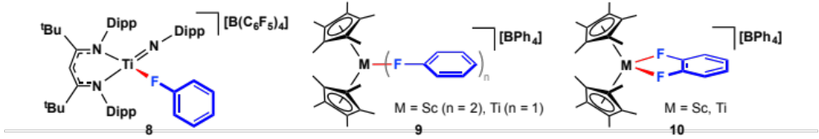

Applications of fluorobenzene complexes
The ability of complexes of partially fluorinated benzenes to be used as well-defined organometallic precursors and pre-catalysts, through facile dissociation of the fluorobenzene in solution, is exemplified by a growing body of rhodium systems developed by Weller and co-workers (Scheme 1). For instance, “operationally unsaturated” rhodium bis-phosphine and rhodium diphosphine fragments have been employed as catalysts for dehydrocoupling reactions of amine- and phosphine-boranes.^{47,} Bench stable (i.e. air stable in the solid-state) small-bite angle diphosphine variants are also notable for their application as highly active pre-catalysts for the hydroacyclation of alkenes and alkynes,^{48,} hydrogenation of alkynes,¹⁹ and C–C bond coupling reactions of aryl methyl sulfides and boronic acids.

Scheme 1. Examples of reactions catalysed by well-defined fluorobenzene complexes.
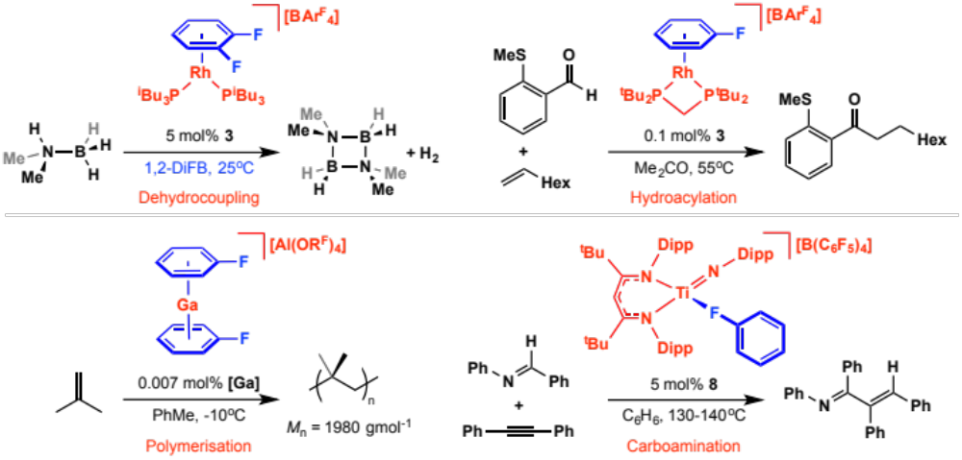

Well-defined [Ga(η⁶-FB)₂]⁺ has also been used as a high activity pre-catalyst for the polymerisation of iso-butylene.⁵⁵ Indeed, complexes of the formulation [E(η⁶-FB)₂][Al(OR^{F})] (E = Ga, In) have proven to be excellent precursors for a range of main compounds of gallium and indium.^{53,54,65,} Related “naked” cations of Cu(I), [Cu(η⁴-1,2-DiFB)₂][Al(OR^{F})], can also be prepared and are reactive starting materials for Cu(I) chemistry.⁶³ Titanium complex 8, bearing a κ_{F}-FB ligand, is a pre-catalyst for carboamination reactions that enable the preparation of α,β-unsaturated imines and triaryl-substituted quinolines.⁶⁹ In this example the reactions were conducted in benzene, which is not able to bind to the resulting reactive titanium fragment generated on loss of FB.

As part of their work with organometallic anti-cancer agents of the type [Ru(PTA)Cl₂(η⁶-arene)] (11, PTA = 1,3,5-triaza-7-phosphatricyclo[3.3.1.1]decane), for which hydrolysis products 12 are suggested to be active under physiological conditions (Scheme 2),^{45,} Dyson and co-workers have prepared a series of derivatives bearing partially fluorinated arenes (FB, PhCF₃, 1,4-F(Me)C₆H₄, 1,4-DiFB). These piano-stool complexes were obtained using procedures involving [RuCl₂(η⁶-arene)]₂ and [Ru(η⁴-COD)(η⁶-arene)] as isolated intermediates, both of which represent potentially versatile Ru(II) and Ru(0) precursors, respectively; the latter were all characterised in the solid-state by X-ray diffraction. Showing potential promise for selective targeting of tumour cells, which are characterised by more acidic environments compared to healthy cells, the PhCF₃ derivative of 11 showed enhanced rates of hydrolysis to 12 at lower pH values and was significantly more cytotoxic than the analogous complex of 1,4-^{i}Pr(Me)C₆H₄, in assays using the A2780 human ovarian cancer cell line.

Scheme 2. Ruthenium arene anti-cancer complexes.
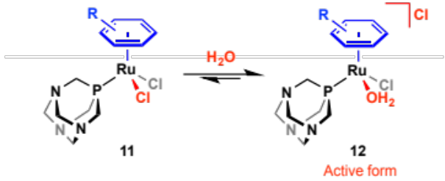

C–H bond activation of partially fluorinated benzenes
As a result of inductive effects the constituent C–H bonds of fluorobenzenes are significantly stronger, but more acidic than benzene.^{59,} These electronic effects are most pronounced in highly fluorinated aromatic systems and as such C–H bond activation reactions of arenes bearing three or more fluorine substituents have been most widely exploited in organic chemistry (vide infra). In contrast, C–H bond activation chemistry of FB and 1,2-DiFB is significantly more challenging and commensurately less well developed. In the context of being used as innocent solvents for organometallic chemistry, the relative inertness of FB and 1,2-DiFB is advantageous, but nevertheless irreversible C–H (and C–F, vide infra) bond activation does represent a key limitation for highly reactive low-coordinate metal complexes. Typically the activation of fluorobenzenes by such metal fragments is not unique and mirrors similar reactions with alkanes, unsaturated hydrocarbons or indeed heteroatom-based solvents/substrates.

Stoichiometric reactions
Indeed some of the first well-defined systems known to activate the C–H bonds of fluorobenzenes involved transient formally 16 VE, rhodium(I) cyclopentadienyl fragments {Rh(η⁵-C₅R₅)(PMe₃)} (R = H, Me), generated by thermolysis of [RhCp*(PMe₃)(Ph)H] or photolysis of [RhCp*(PMe₃)(H)₂]/[RhCp(PMe₃)(C₂H₄)] in the arene solvent; species that readily undergo reversible C–H bond oxidative addition of alkanes and benzene (Scheme 3, Chart 6).^{60,} This work described in 1994 by Jones, Perutz and co-workers, encompassed C–H bond activation reactions of a range of partially fluorinated benzenes, including FB and 1,2-DiFB, and is notable for marking out the thermodynamic preference for C–H bond activation ortho to the fluorine substituents, the so called “ortho fluorine effect”. For instance, although Rh(3,4-C₆H₄F₂)H and Rh(2,4-C₆H₄F₂)H / Rh(3,5-C₆H₄F₂)H aryl hydride intermediates were initially observed in the activation of 1,2-DiFB and 1,3-DiFB, the Rh(2,3-C₆H₄F₂)H and Rh(2,6-C₆H₄F₂)H regioisomers, respectively, were ultimately obtained (e.g. 13, Scheme 3). Similarly, [RhCp*(PMe₃)(2-C₆H₅F)H] was produced exclusively on thermolysis of [RhCp*(PMe₃)(Ph)H] in FB. The presence of η²-arene intermediates preceding C–H bond oxidative addition can be used to help rationalize the initial product distributions in these cases – coordination to double bonds lacking fluorine substituents is kinetically preferred (vide supra; Chart 3). In these systems it is the reversible nature of the C–H bond activation that enables the thermodynamic species to ultimately be obtained. Formation of η²-arene adducts of fluorobenzenes is substantiated though isolation of adducts of HFB, viz. [Rh(η⁵-C₅R₅)(PMe₃)(η²-HFB)] (14, R = H, Me).^{58,61,} Under analogous conditions it is only on prolonged photolysis of [RhCp*(PMe₃)(η²-C₆F₆)] that C–F bond activation was observed.⁷⁹

Scheme 3: Reactions of 1,3-DiFB and HFB with rhodium cyclopentadienyl complexes (R = H, Me).ª
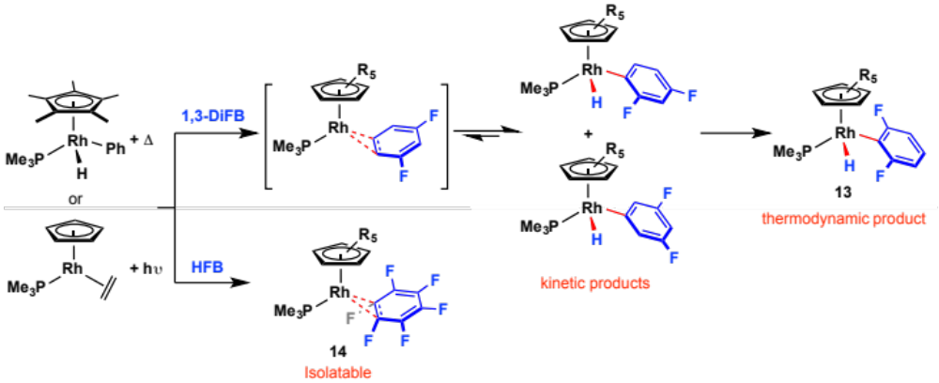
ª Where relevant only single rotamers are depicted.

In subsequent computational work involving elucidation of calculated C–H and M–C bond energy correlations, Eisenstein, Perutz and co-workers provided quantitative evidence to support the thermodynamic preference for C–H bond activation ortho to the fluorine substituents. Not only for the aforementioned rhodium cyclopentadienyl systems (using {RhCp(PH₃)} as a computationally amenable model fragment), but as a general phenomenon for a range of other reactive transition metal fragments relevant to the activation of C–H bonds: {ZrCp₂}, {TaCp₂H}, {TaCp₂Cl}, {WCp₂}, {ReCp(CO)₂}, {ReCp(CO)(PH₃)}, {ReCp(PH₃)₂}, {RhCp(CO)}, {IrCp(PH₃)}, {IrCp(CO)}, {Ni(H₂PCH₂CH₂PH₂)}, and {Pt(H₂PCH₂CH₂PH₂)}. The thermodynamic driving force for this regioselectivity was attributed to significantly greater strengthening of the M–C versus the C–H bonds ortho to fluorine substituents (Figure 2).⁵⁹ In additional to this computational work, Jones and co-workers have provided experimental verification of these thermodynamic trends though direct measurement of metal–fluoroaryl bond strengths through competition experiments involving reactions of {Rh(Tp’)L} (Tp’ = tris(3,5-dimethylpyrazolyl)borate; L = CNneopentyl, PMe₃, PMe₂Ph) fragments in mixtures of fluorobenzenes (16, Chart 6).

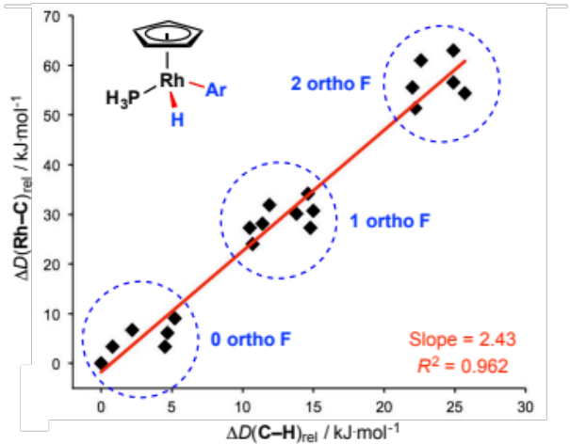
Figure 2: Correlation between calculated Rh–C bond dissociation energies of [RhCp(PH₃)(Ar)H] and C–H bond dissociation energies of Ar–H (Ar = C₆H_{5-n}F_{n}; n = 0 – 5). Redrawn using data from ref. 80.

Chart 6: Rhodium complexes resulting from C–H bond activation of FB and 1,2-DiFB.ª
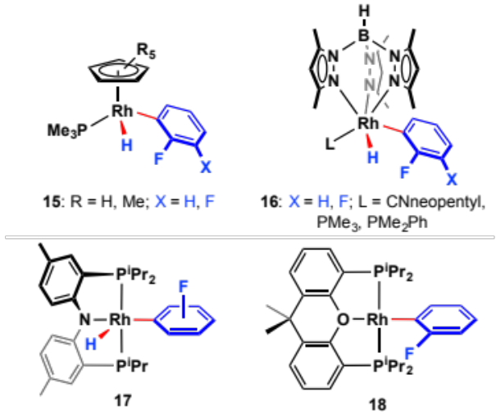
ª Where relevant only single rotamers are depicted.

In addition to the cyclopentadienyl and closely related tris(pyrazolyl)borate systems of Perutz and Jones (15, 16), rhodium(I) complexes of PNP* [(4-Me-2-(^{i}Pr₂P)C₆H₃)₂N–] and POP [9,9-Me₂-4,5-(^{i}Pr₂P)xanthene] pincer ligands are known to undergo C–H bond activation of FB (17, 18; Chart 6)., In the former case, the transient {Rh(PNP*)} fragment generated by thermolysis of [Rh(PNP*)(Ph)(Me)] in FB undergoes reversible C–H bond activation of the solvent leading to a dynamic equilibrium mixture of Rh(III) aryl hydride isomers at room temperature. The mono-hydride complex [Rh(POP)(H)] activates the C(sp²)–H bonds of a range of arenes with the concomitant elimination of dihydrogen. Reactions with toluene and m-xylene afforded mixtures of meta/para and para activated rhodium aryls, respectively, while FB and 1,3-DiFB were instead activated with exclusive ortho selectivity, viz. formation of [Rh(POP)(2-C₆H₄F)] and [Rh(POP)(2,6-C₆H₃F₂)]. Such findings are in line with the “ortho fluorine effect” and suggest the key C–H bond oxidative addition step takes place under thermodynamic rather than kinetic control in the fluoroarene reactions (i.e. elimination of H₂ is rate determining).

A range of iridium(I) and iridium(III) complexes have been shown to activate the C–H bonds of partially fluorinated benzenes. Compared to the lighter group 9 congeners these bond activation reactions of iridium are typically associated with inferior regioselectivity, i.e. reactions under kinetic control. In particular, activation of FB or 1,2-DiFB using iridium(III) cyclopentadienyl fragments have been reported to afford mixtures of regioisomers (19 – 21; Scheme 4). Moreover as an illustrative intramolecular example, Jones and co-workers have shown the sodium acetate promoted cyclometalation of N-phenyl-2-fluoro-benzaldimine with [MCp*Cl₂]₂ (M = Rh, Ir; Scheme 4), proceeds with significantly greater regioselectivity in the case of the rhodium.

Scheme 4: Group 9 cyclopentadienyl complexes resulting from C–H bond activation fluorobenzenes.ª
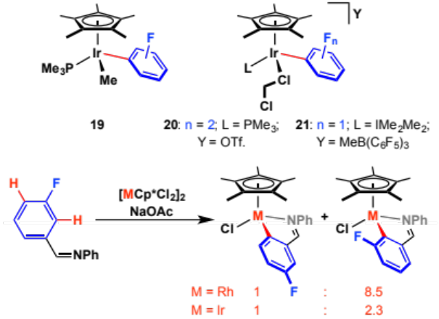
ª IMe₂Me₂ = 1,3-dimethyl-4,5-dimethylimidazol-2-ylidene

As part of their work studying oxidative addition reactions of benzene and halobenzenes with cationic iridium(I) pincer [Ir(PNP)(COE)]⁺ (22, PNP = 2,6-(^{t}Bu₂PCH₂)₂C₆H₃N; COE = cyclooctene), Milstein and co-workers reported a statistical mixture of ortho, meta and para products for the C–H bond activation of FB at 50 ºC (Scheme 5). Heating at 70 ºC for 2 days resulted in enrichment of the ortho at the expense of the meta regioisomer, however, the para regioisomer persisted (ortho:para = 2.3:1). Highlighting the unfavorable interaction of fluorine substituents with late transition metals, C–H bond activation reactions of chloro- and bromo-benzene with this pincer are directed and stabilised by halogen atom coordination, ultimately affording ortho-activated products. No products of C–Cl or C–Br bond activation were observed on extended heating. Using instead an iridium complex of the more electron rich PNP* pincer ligand, Ozerov and co-workers showed that C–Cl and C–Br bond oxidative addition becomes thermodynamically favored, with halogen directed C–H bond activation products observed as intermediates at low temperature. Contrasting the dynamic reactivity found in the analogous rhodium system (17, Chart 6), C–H bond activation of FB by {Ir(PNP*)} results in a mixture of 4 isomers, which do not exchange on the NMR timescale at RT, but evolves to a mixture of only 2 isomers on thermolysis at 100 ºC for 20 h. The authors were not able to assign these isomers, but the most probable thermodynamic products are rotamers of [Ir(PNP*)(2-C₆H₅F)H]. More recently work led by Ozerov and one of us has demonstrated selective ortho C–H bond activation of FB (and also 1,2-DiFB, in the latter case) is possible at RT using instead aryl-based POCOP’ (4-Me-2,6-(^{t}Bu₂PO)₂C₆H₃–) and PCP (2,6-(^{t}Bu₂PCH₂)₂C₆H₃–) complexes of iridium (24, 25; Scheme 5)., While reactive 14 VE Ir(I) centres supported by phosphine-based pincer ligands are well known for the oxidative addition of C–H bonds, this series of results highlights a significant influence of the pincer backbone composition on the chemo- and regio-selectivity of these reactions. In the context of the C–H bond activation of FB, it appears that pincers bearing more potent trans-influence donors in the central position aid reaction reversibility, and therefore facilitate isomerisation to the most thermodynamically favored ortho-derivatives.

Scheme 5: Oxidative addition of halobenzenes by iridium pincer complexes.ª
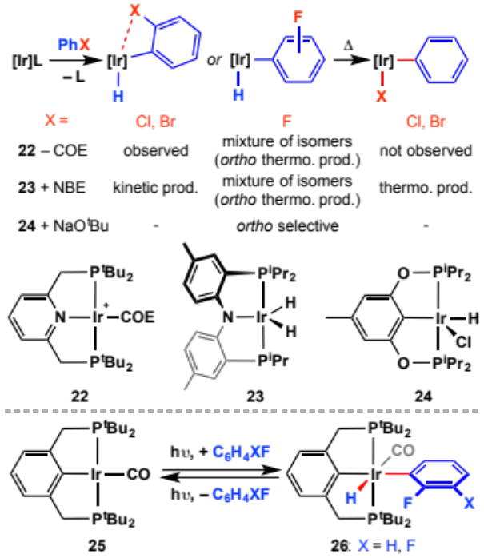
ª NBE = norbornene.

Proceeding through a similar three coordinate 14 VE Ir(I) fragment to those implicated in the pincer systems, [Ir(P^{i}Pr₃)₂Cl(COE)] undergoes C–H bond oxidative addition of benzene, FB (high ortho-selectively) and 1,2-DiFB (exclusive ortho-selectivity), on dissociation of alkene to afford five coordinate Ir(III) aryl hydride derivatives (27, Chart 7)., Five coordinate 28 instead results from C–H bond activation reactions of the 12 VE Ir(I) fragment {Ir(IBioxMe₄)₂}⁺, generated on halide abstraction from [Ir(IBioxMe₄)₂Cl(COE)], in the presence of excess N-heterocyclic carbene (NHC). In the case of 1,2-DiFB, characterisation of intermediate [Ir(IBioxMe₄)₂(C₆H₃F₂)H]⁺ at low temperature using in situ NMR spectroscopy and subsequent trapping with 2,2’-bipyridine, resulting in a stable 18 VE Ir(III) derivative 29, was used to corroborate this mechanism and demonstrated the unselective nature of the C–H bond activation. Accounting for the exclusive ortho selectivity observed, 28 are instead characterised by facile and reversible activation of fluorobenzenes in solution. Indeed, these complexes act as a latent source of the 14 VE Ir(I) {Ir(IBioxMe₄)₃}⁺ fragment in solution, by reductive elimination of the arene, enabling the relative thermodynamics of C–H bond oxidative addition to be determined by competition experiments. More favorable oxidative addition was observed in the order: FB < 1,2-DiFB << 1,3,5-TriFB. In the context of selectivity, C–H bond action of FB by an iridium porphyrin complex interestingly proceeds with a preference for meta-activation (vide infra, Scheme 16).

Chart 7: Iridium complexes resulting from C–H bond activation of fluorobenzenes.ª  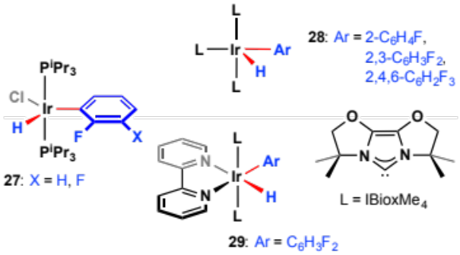  ª Where relevant only single rotamers are depicted. | Chart 8: Group 8 and 10 complexes resulting from C–H bond activation of fluorobenzenes.ª  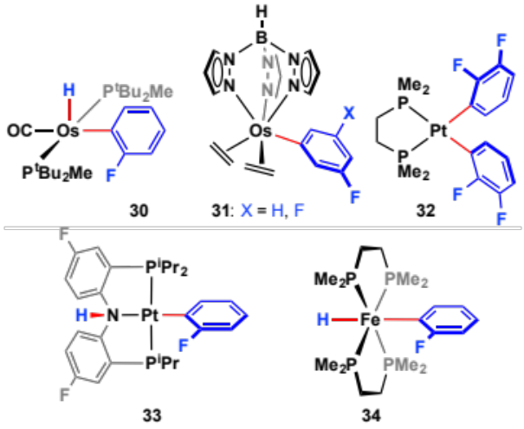  ª Where relevant only single rotamers are depicted.
Of the other platinum group metals, Caulton’s work involving the C–H bond activation of a range of fluorobenzenes mediated by 14 VE Os(II) intermediates, generated on reductive elimination of benzene from [OsH(Ph)(CO)(P^{t}Bu₂Me)₂], is perhaps the most notable. In the case of FB, exclusive ortho-selectivity was observed (e.g. 30, Chart 8). Promoted by irreversible elimination of [CH₃CH₂CH₂P^{i}Pr₃][BF₄], reaction of [OsTp(κ¹_{C}-CH₂CH₂P^{i}Pr₃)(C₂H₄)₂][BF₄] (Tp = tris(pyrazolyl)borate) with both FB and 1,3-DiFB has been shown to result instead in selective meta-activation of the arenes (31) – presumably as this product is in contrast formed under kinetic control. Platinum examples include thermolysis of [Pt(dmpe)(Me)(OTf)] in 1,2-DiFB, affording a mixture of products including the interesting bis-activated [Pt(dmpe)(2,3-C₆H₃F₂)₂] (32), and the regioselective bifunctional C–H bond activation of FB by [Pt(PNP^{F})]⁺ (PNP^{F} = (4-F-2-(^{i}Pr₂P)C₆H₃)₂N–, 33). Of the late transition metals, the formation of trans-[Fe(dmpe)₂(2-C₆H₄F)H] from thermolysis of [Fe(dmpe)₂(2-naphthyl)H] in fluorobenzene, is to the best of our knowledge the only first row example of FB or 1,2-DiFB C–H bond activation (34).
Chart 9: Group 6 and 7 complexes resulting from C–H bond activation of fluorobenzenes.ª
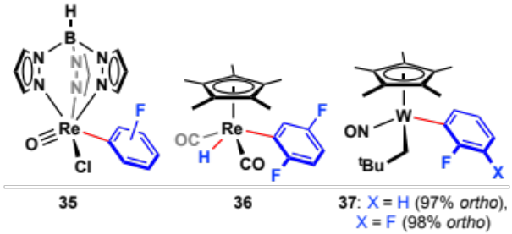
ª Where relevant only single rotamers are depicted.

Early transition metal complexes have also been shown to activate the C–H bonds of FB and 1,2-DiFB (Chart 9, Scheme 6). As part of a study by Mayer and co-workers, exploring photochemically induced aryl C–H bond activation reactions of the Re(V)-oxo complex [Re(Tp)O(I)Cl], the unselective activation of FB was reported (35). Photochemically induced reactions of [Re(η⁵-C₅R₅)(CO)₃] (R = H, Me) with partially fluorinated benzenes have been studied in detail; although experimental data has been reported for 1,4-DiFB (36), the chemistry of FB or 1,2-DiFB in this context has only been explored in silico.^{57,58,59} As part of a body of work relating to 1,2- and 1,3- bifunctional activation of C–H bonds of saturated and unsaturated hydrocarbons, Legzdins and co-workers have explored the activation of FB and 1,2-DiFB using two different W(II)Cp* systems., For instance, [WCp*(NO)(CH₂^{t}Bu)₂] reacts with high ortho-regioselectivity with both FB and 1,2-DiFB to afford 37,¹⁰² whereas the reaction of [WCp*(NO)(CH₂^{t}Bu)(η³-CH₂CHCHSiMe₃)] with 1,2-DiFB bifurcates depending on the position of initial C–H bond activation, leading to two distinct organometallic products.¹⁰³ Perhaps the most remarkable early transition metal example is that reported by Mindiola and co-workers: thermolysis of [Ti=CHR(CH₂R)(PNP*)] (38, R = ^{t}Bu, SiMe₃) in a range of fluorobenzenes (including FB and 1,2-DiFB) results in regioselective C–H bond activation via 1,2-addition to corresponding transient alkylidyne {Ti≡CR(PNP*)}, generated by elimination of RMe (Scheme 6). Interestingly the product fluoroaryl complexes 39 undergo β-fluoride elimination on heating affording titanium fluorides 40 and benzynes, corresponding to net hydrodefluorination of the fluorobenzene. This process can even be made catalytic by employing LiCH₂R (R = ^{t}Bu, SiMe₃) as a transmetallation reagent. Similarly cerium aryl species are formed as unstable intermediates in hydrodefluorination reactions of [CeCp′₂H] (Cp’ = 1,2,4-^{t}Bu₃C₅H₂–) with fluorobenzenes, which ultimately produce [CeCp′₂F] and (fluoro)benzyne.

Outside of the transition elements, FB and 1,2-DiFB are well established to be selectively metalated at the ortho positions by alkyl lithium reagents such as LDA.

Scheme 6: C–H bond activation and subsequent dehydrofluoronation of FB and 1,2-DiFB by a titanium pincer complex.ª
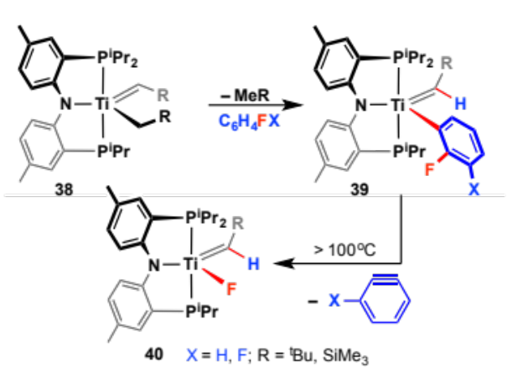
ª Where relevant only single rotamers are depicted.

Catalytic reactions
Recently there has been growing interest in exploiting the significantly more polar and electrophilic nature of C–H bonds in highly fluorinated aromatic systems in catalytic organic transformations. Arylation reactions of fluoroarenes have been reported using palladium, copper, and more recently ruthenium catalysts (Scheme 7a). Where assayed, these reactions were all found to be much more effective with increasing number of fluoride substituents, with FB and 1,2-DiFB generally shown to be poor substrates. For example, in the palladium-based process < 2 TON are found for the arylation of FB with 4-bromotoluene, whereas approaching 100 TON could be achieved in the equivalent reaction with pentafluorobenzene (PFB).¹⁰⁷ Moreover, for the ruthenium-catalysed arylation of 1-bromo-3,5-dimethylbenzene, < 1 TON was reported using FB as a substrate, but > 20 TON using instead PFB.¹⁰⁹ In an adaption of these arylation reactions, Larrosa and co-workers have employed η⁶-bound chromium carbonyl fragments for enhancing these C–H bond activation reactions. Other reactions reported include nickel mediated alkenylation reactions (Scheme 7b; both FB and 1,2-DiFB shown to be poor substrates) and gold catalysed cross-coupling reactions involving dual C–H bond activation (Scheme 7c; FB shown to be an ineffective substrate).,

More productive use of FB and DiFBs as substrates can be achieved in C–H bond borylation reactions catalysed by platinum group metals (Scheme 7d).^{83,88,,} These reactions, however, are characterised by poor regioselectivity. The recently reported borylation of FB (and other arenes) using iridium POCOP’ pincers epitomises this statement.⁸⁸ While an impressive 1500 catalytic turnovers could be achieved using ethylene as a sacrificial hydrogen acceptor, the borylation products were obtained as a mixture of ortho : meta : para isomers in a 40:46:14 ratio. Interestingly, the authors showed FB is in fact activated with exclusive ortho-C–H selectivity on reaction with the reactive metal species involved {Ir(POCOP’)} (24, Scheme 5): reaction of the resulting aryl hydride, [Ir(POCOP’)(2-C₆H₄F)H], with HBpin (pinacolborane) afforded only the ortho-borylated arene. Together these results demonstrate the importance of reaction kinetics in the activation of fluorobenzenes; while the ortho-activated aryl hydride intermediate is the thermodynamically favored regioisomer, the reaction of this Ir(III) intermediate with HBpin under catalytic conditions must occur at a significantly faster rate than aryl hydride isomerisation (via elimination of FB, Scheme 8).

Scheme 7: Catalytic reactions involving partially fluorinated arene substrates.ª
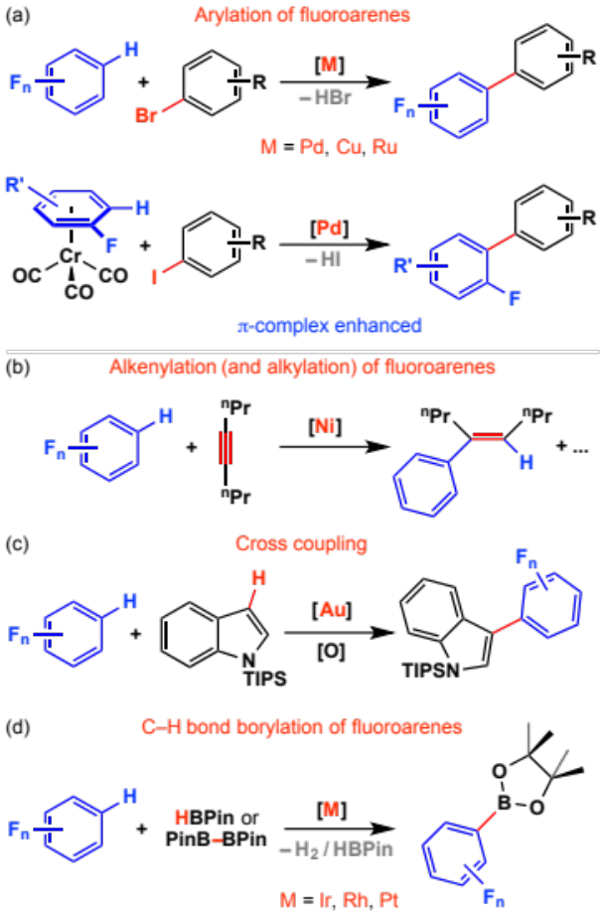
ª TIPS = OSi^{i}Pr₃

Scheme 8: Proposed mechanism for the catalytic C–H bond borylation of fluorobenzene mediated by an iridium pincer complex.

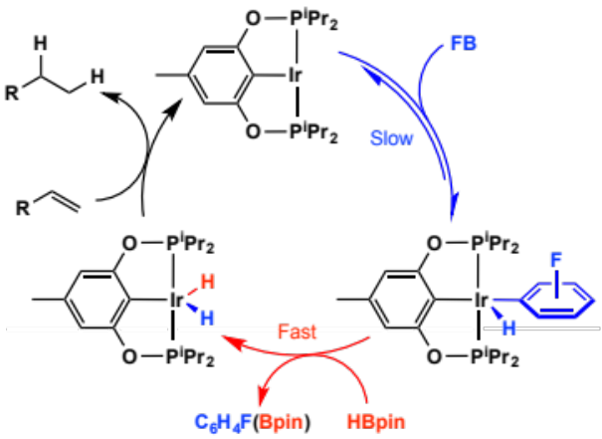
C–F bond activation of partially fluorinated benzenes
The C–F bonds in fluorobenzenes are some of the strongest carbon–element single bonds on record. FB has a C–F bond dissociation energy 526 ± 8 kJ∙mol⁻¹. The difficulty in breaking these strong bonds can result in competitive C–H bond activation being preferred. In cases that C–F bond activation with metal complexes does occur, the newly formed M–F bond provides a significant thermodynamic driving force for the reaction. If C–H bond activation of fluorobenzenes is fast and reversible, then C–F bond activation is slow and typically non-reversible.

The C–F bond strength in fluorobenzenes has been calculated to decrease by approximately 7.5, 2.2 and 0.8 kJ∙mol⁻¹ upon substitution of hydrogen atoms with a single fluorine atom in the ortho-, meta- and para-position respectively.¹¹⁵ The trend is opposed to that found for C–H bond strengths in fluorobenzenes by linear regression analysis, these increase with increasing ortho-fluorine substitution.^{5,80,81} Known mechanisms for C–F bond activation of fluorobenzenes with metal complexes are represented in Scheme 9.

Scheme 9. General mechanisms for C–F bond activation of FB.
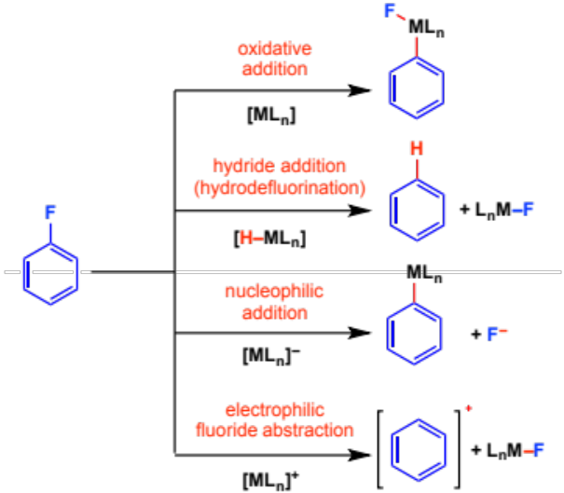

There are limited examples of well-defined reactions of transition metal complexes or main group reagents with FB or DiFBs. The vast majority of studies focus on substrates with higher fluorine content, C₆H_{6-n}F_{n} (n > 2). Here we will detail the reactions of the low fluorine content substrates (n < 3). The fundamental steps for breaking the C–F bonds will be presented in the context of further reactivity including: (i) cross-coupling with Mg- and B-based nucleophiles, (ii) homo-coupling, (iii) hydrodefluorination, and (iv) C–F borylation: the conversion of a C–F bond to a C–B bond.

Oxidative addition
Electron-rich, low-valent nickel complexes of the form {NiL₂} (L = PCy₃, NHC, cAAC = cyclic amino alkyl carbene) are currently the most broadly applied transition metal complexes for C–F bond functionalisation. While the reaction of FB with {NiL₂} has yet to be observed, not only does 1-fluoronaphthalene react with [Ni(PCy₃)₂] to form the corresponding oxidative addition product, detailed studies on the addition of perfluoronaphthalene to [Ni(PEt₃)₂] have allowed the identification of the η²-complex as a reaction intermediate in the oxidative addition pathway (Scheme 10). The focus on 1st row d¹⁰ complexes undoubtedly stems from the increased dπ-2pπ repulsion, and associated decrease in metal–fluorine bond strengths, as the triad is descended and the d-orbitals gain radial extension.⁵ Pd- and Pt- complexes, while known for C–F bond activation, are less widely employed than those of Ni.^{5,} As part of these studies a number of groups have suggested a phosphine-assisted pathway for C–F bond cleavage.^{118,}

Scheme 10. Oxidative addition of fluoronaphthalenes to [Ni(PR₃)₂] complexes.
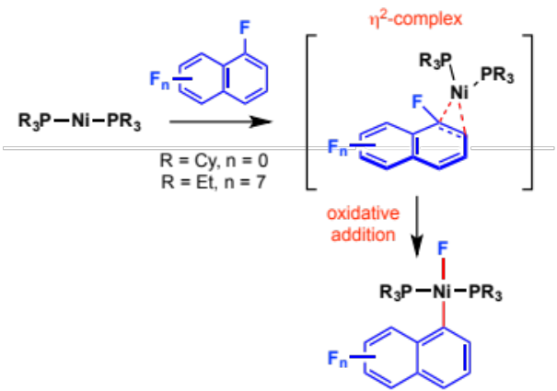

In the presence of a hydride source such as MgH₂, LiBEt₃H, LiAl(O^{t}Bu₃)H, NaO^{i}Pr, or ^{t}BuMgCl, FB and DiFBs may undergo hydrodefluorination (Scheme 11). Catalyst precursors include [Ni(acac)₂] + IMes•HCl, [NiCl₂(PCy₃)₂], [Pd₂dba₃] + P(O-2,4-^{t}Bu₂C₆H₃)₃ and bimetallic Pd–Ru complexes (IMes = 1,3-bis(2,4,6-trimethylphenyl)imidazol-2-ylidene, dba = dibenzylacetone). Reactions of DiFBs are unselective and lead to complete reduction to benzene. Deuterium labelling studies have shown that NaO^{i}Pr provides the hydride source through a β-hydride elimination step.¹²³ The involvement of a M(II)/M(0) shuttle in these catalytic cycles and C–F bond activation by oxidative addition is not unequivocal and in many cases formation (and nucleophilic reactivity) of a nickel hydride complex cannot be excluded. Whittlesey and co-workers have demonstrated that ring-expanded NHC nickel(I) complexes such as [Ni(6-Mes)(PPh₃)Br] can act as precatalysts, suggesting that Ni(I) intermediates may at least serve as an entry point into catalytic manifolds (6-Mes = 1,3-bis(2,4,6-trimethylphenyl)-3,4,5,6-tetrahydropyrimidin-2-ylidene). Additional control reactions have shown that phosphines themselves may promote the hydrodefluorination of electron-deficient arenes.
In the absence of a hydride reductant, homocoupling of FB has been observed (Scheme 11). FB may be coupled to form biphenyl in modest yield using 2 equiv. of lithium di-iso-propylamide as a base in the presence of 10 mol% [Ni(cAAC)₂]. Although homocoupling is a potential, an often observed, competitive pathway in Kumada and Suzuki-Miyaura cross-coupling chemistry, nickel-phosphine complexes are known to effectively catalyse C–C bond formation from FB and DiFBs with organomagnesium reagents or boronic esters (Scheme 11).

Scheme 11. C–H, C–C and C–B bond forming reactions catalysed by Ni-phosphine or Ni-carbene complexes, showcased using FB as a substrate.

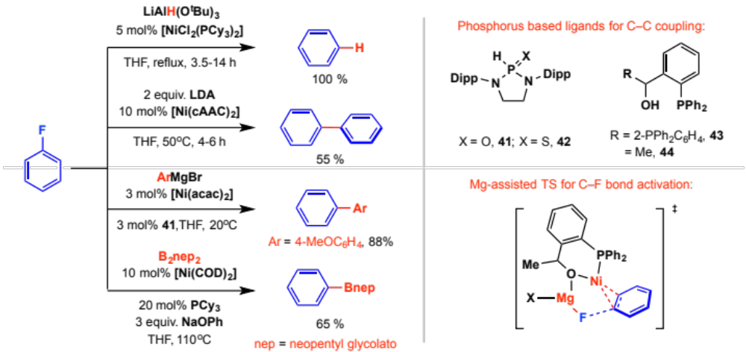

In 1973, Kumada and co-workers reported that the reaction of FB with ^{i}PrMgCl could be catalysed by [NiCl₂(dmpe)] (dmpe = 1,2-(bis)dimethylphosphinoethane). This rare-example of C(sp³)–C(sp²) cross-coupling was followed by numerous reports of C(sp²)–C(sp²) coupling using prepared or in situ generated Ni(0) (bis)phosphine or (bis)NHC complexes., Air-stable phosphine oxide and phosphine sulfide ligands (41-42) have been investigated in these reactions, as have chelating phosphines and NHCs. While ArMgX (X = Br, Cl) are regularly employed as cross-coupling partners, reports of RMgBr (R = alkyl) are limited due to the propensity of these groups to isomerise from branched-to-linear (σ–π–σ mechanism) or decompose (β-hydride elimination) on the transition metal:¹²⁹ problems that are circumvented with MeMgBr. Although most catalysts are unselective for cross-coupling reactions of DiFBs, yielding terphenyls as the main product due to two sequential C–C bond forming reactions, the selective mono-addition of organometallics to 1,2-, 1,3- and 1,4-DiFB can be catalysed by [PdCl₂(dppf)] (dppf = 1,1’-bis(diphenylphosphino)ferrocene) or a mixture of [Ni(acac)₂] and diphosphine ligand 43.

While there is no direct experimental evidence for C–F bond cleavage of FB or DiFBs by oxidative addition to {NiL₂} complexes, two aspects of the mechanistic studies of the cross-coupling reactions are noteworthy: A Hammett analysis performed on C(sp²)–C(sp²) cross-coupling of FB catalysed by [Ni(NHC)₂] gave p = 4.6±0.4,¹³⁰ while ¹²C/¹³C kinetic isotope effects measured for the addition of PhMgBr to 2-fluorotoluene catalysed by [Ni(acac)₂] / 44 are negligible for all positions but the ipso-carbon which gives a KIE = 1.014(3)., The former experiment suggests an accumulation of negative charge on the aromatic system at the rate-limiting step, while the latter suggests that a substantial amount of C–F bond breaking is present in the first non-reversible step. Both are consistent with oxidative addition of the C–F bond to an {ML₂} intermediate. Additional insight provided by DFT studies on the systems employing ligands 43 and 44 has led Nakamura and co-workers to conclude that the C–F bond is broken through Mg-assisted assisted oxidative addition:¹³⁷ coordination and polarisation by the main group metal leading to a transition state with a lower energy than that without Lewis acid assistance (Scheme 11).

Suzuki-Miyaura cross coupling of fluorobenzenes can be achieved using ArBnep (nep = neopentyl glycol) reagents in the presence of catalytic [ZrF₄], [Ni(COD)₂] and PCy₃ and stoichiometric CsF.¹³⁷ A number of heterogeneous palladium catalysts are also known to effect the coupling of boronic acids with FB or 1,4-DiFB. Replacing the nucleophile with diborane reagents including B₂pin₂ (bis(pinacolato)diborane) and B₂nep₂ (bis(neopentylglycolato)diborane) has allowed the development of a C–F to C–B bond transformation of FB, 1,2-DiFB and 1,3-DiFB.^{116,}

Scheme 12. Oxidative addition of fluorobenzene to cobalt(I) complex.
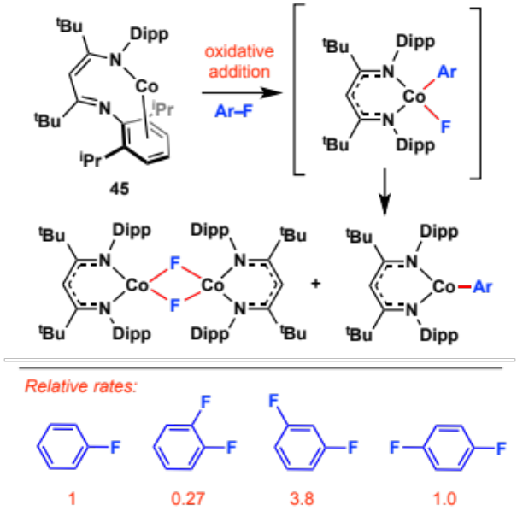

Holland and co-workers have reported the reactivity of the ‘masked two-coordinate’ cobalt complex 45 with fluorobenzenes. Oxidative addition proceeds to yield a 1:1 mixture of cobalt aryl and cobalt fluoride (Scheme 12). The empirical rate = k_{obs}[Co][FB], lack of biphenyl or benzene formation, and relative rates of reaction of the regioisomers of DiFB led the authors to conclude that the reaction proceeds by a rate-limiting oxidative addition of the C–F bond to 45 to form a Co(III) intermediate which undergoes fast disproportionation, although rate-limiting non-reversible arene binding cannot be excluded based on the current data.

Oxidative addition of fluorobenzenes to the Nb(III) imido 46 also proceeds rapidly, in this case yielding a single Nb(V) organometallic (Scheme 13). The relative rates of reaction for FB, DiFBs and 1,2,4,5-tetrafluorobenzene are in complete contrast to the expectations afforded by existing reactivity trends. In combination with DFT studies, the data support rate-limiting dissociation of the fluoroarene from a Nb(III) η⁶-fluoroarene π-complex followed by oxidative addition of the carbon–fluorine bond by a bimetallic, Nb-assisted, transition state.

Scheme 13. Oxidative addition of fluorobenzenes to a niobium(III) imido complex.

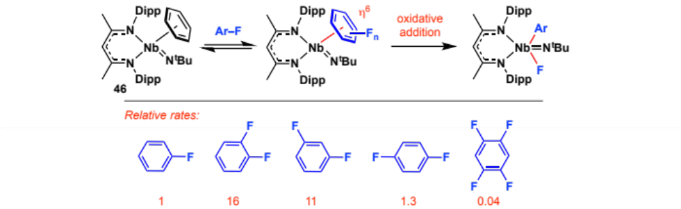

Oxidative addition of FB or 1,4-DiFB to [W(Tp)(NO)(PMe₃)(η²-C₆H₆)] (47) has also been reported (Scheme 14). Despite the potential for both competitive C–H bond activation and generation of a stable η²-fluoroarene complex, the reaction proceeds with a half-life of 3.3 h at 20 ºC. DFT studies suggest that the η²-fluoroarene complex is bypassed. The intermediate observed by ³¹P NMR is implied to be the κ_{F}-fluoroarene adduct which precedes rate-limiting oxidative addition. In the presence of a silane (e.g PhSiH₃, Ph₂SiH₂, Et₃SiH or Me₂PhSiH) 46 and 47 mediate and catalyse respectively the hydrodefluorination of FB to benzene. In the case of 46 catalytic hydrodefluorination of 1,2- and 1,3-DiFB selectively provides FB. ^{142,143}

Scheme 14. Oxidative addition of fluorobenzene to a tungsten nitrosyl complexes.

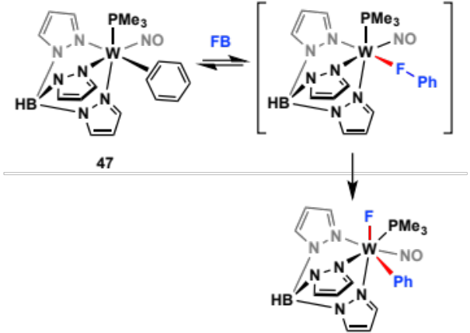

Nucleophilic addition of a metal–hydride
The reaction of [ZrCp*₂(H)₂] with FB under an atmosphere of H₂ proceeds excruciatingly slowly producing benzene, [ZrCp*₂(H)F] and [ZrCp*₂(Ph)F] in a 1:1:0.75 ratio after 40 days at 80 ºC (Scheme 15a). Jones and co-workers have rationalised the data in terms of competitive C–F and C–H bond activation. The hydrodefluorination product benzene can be produced by direct attack of the zirconium hydride on fluorobenzene by an S_{N}Ar mechanism. Competitive deprotonation of FB in the ortho-position followed by β-fluoride elimination and insertion of the resulting benzyne into a Zr–H bond leads to the formation of [ZrCp*₂(Ph)F]. Control reactions suggest that H₂ is not involved in the mechanism of C–F bond activation but is required to prevent decomposition of the organometallic due to reversible C–H activation of the Cp* ligands.

Scheme 15. Hydrodefluorination of FB, 1-fluoronaphthalene and 1,2-DiFB by metal hydrides.

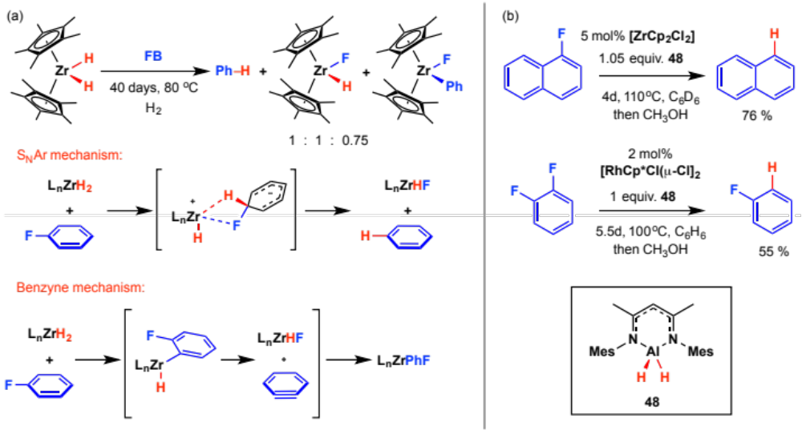
Variation of the substrate to 1-fluoronaphthalene leads to exclusive hydrodefluorination.¹⁴⁴ One of our groups has shown that in situ generation and catalytic turnover of the zirconocene hydride can be achieved using the aluminium dihydride 48 as a terminal reductant and [ZrCp₂Cl₂] as a precatalyst. Combining this aluminium reagent with 1-2 mol% [RhCp*Cl(μ-Cl)]₂ leads to the formation a highly active catalytic mixture for hydrodefluorination of fluorobenzenes, allowing the selective conversion of 1,2-DiFB to FB (Scheme 15b). As part of these studies Rh–Al and Zr–Al heterobimetallic hydrides have been isolated and shown to be catalytically competent for C–F bond cleavage. ^{145,146}

Insight into C–F bond activation of fluoroarenes with ruthenium hydride complexes,¹¹⁵ led Whittlesey and co-workers to prepare [Ru(IEt₂Me₂)₂(PPh₃)₂(H)₂] and investigate its reaction with fluorobenzenes (IEt₂Me₂ = 1,3-diethyl-4,5-dimethylimidazol-2-ylidene). The trans-arrangement of hydrides in the latter complex imparts high nucleophilicity to Ru–H and catalytic hydrodefluorination of HFB proceeds to form a mixture of products including small amounts (4-7 %) of FB derived from reaction of a mixture of regioisomers of DiFB. Grushin and co-workers have shown that H₂ may be used as a terminal reductant in the hydrodefluorination of 1-fluoronaphalene and FB using a rhodium hydride precatalyst. Reaction of 1-fluoronaphthalene with H₂ (80 psi) at 95 ºC can be catalysed by [Rh(PCy₃)₂(H)Cl₂] under rigourously anhydrous conditions. While this homogeneous catalyst is inefficient for the conversion of FB to benzene, introduction of small amounts of air/oxygen results in the formation of a highly active heterogeneous catalyst. In subsequent studies, a number of rhodium complexes and salts have been shown to be effective precursors to form heterogeneous, nano-particulate or solid-supported catalysts for the hydrogenation or hydrodefluorination of FB: benzene, cyclohexane and fluorocyclohexane are all products of these reactions.

Anionic transition metal complexes
The anion [RhCp*(PMe₃)H]– plays a key role in the catalytic hydrodefluorination of perfluoroarenes including HFB and octafluoronaphthalene. Although less wide-spread than the examples of nucleophilic addition of metal hydrides to fluorocarbons, a handful of examples of nucleophilic addition of metal anions to FB are known. Bergman and co-workers reported the preparation of [IrCp*(PMe₃)H]– from deprotonation of the parent dihydride with ^{t}BuLi. Reactions with HFB and hexafluoropropene were found to be facile, while FB reacted in only 20 % conversion after 22 h at 75 ºC (Scheme 16).

The Ir-porphyrin [Ir(ttp)(SiEt₃)] (ttp = tetratolylporphyrinato dianion) effects sequential aromatic C–F then C–H bond activation of FB, 1,4-DiFB and 1,2-DiFB under forcing conditions (150 – 200 ºC).⁹⁴ Both the regioselectivities of C–H functionalisation and the observation of kinetic C–F bond cleavage preceeding thermodynamically more favourable C–H cleavage products are exceptional. Cross-over experiments and DFT calculations support a mechanism in which KOH reacts with the iridium complex to form the anion [Ir(ttp)]– (49), which in turn effects C–F bond activation by an S_{N}Ar mechanism. At higher temperatures Ir–C bond homolysis is proposed to generate the radical [Ir(ttp)]• which then reacts with a further equivalent of substrate to form C–H activation products (Scheme 16).

Scheme 16. Nucleophilic addition of iridium anions to FB
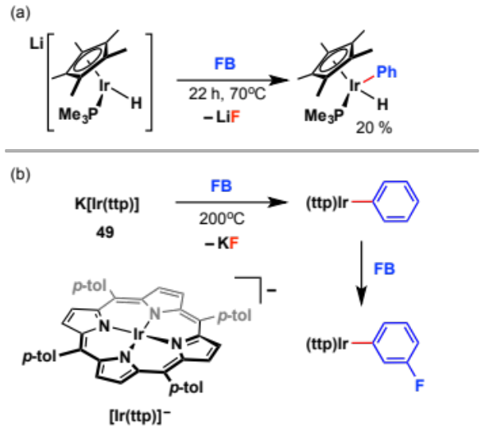

Electrophilic activation
Silylium (R₃Si⁺) and aluminium (R₂Al⁺) ions effectively activate C(sp³)–F bonds in the presence of C(sp²)–F bonds. The selectivity can be explained by considering the stability of the corresponding carbocation following fluoride abstraction. Alkyl cations are potentially stabilised through hyperconjugation, while S_{N}1 processes involving Ph–X (X = halide) are extremely rare due to the instability of C₆H₅⁺. Reed and co-workers have reported the reactions of FB with [Et₃Si][CHB₁₁Cl₁₁] and [{2,6-(2,6-MeC₆H₃}₂C₆H₃}SiMe₂][CHB₁₁Cl₁₁] (Scheme 17). Fluoride abstraction occurs to form the corresponding silyl fluoride, in the former case the intermediate [C₆H₅][CHB₁₁Cl₁₁] is trapped as an adduct, while in the later, Friedel-Crafts phenylation of the terphenyl ligand is observed. In line with these findings, [^{i}Bu₂Al][B(C₆F₅)₃] has been reported as an inefficient catalyst for the hydrodefluorination of FB to benzene (12 % conv., 5 mol% loading, toluene, 25 ºC) using ^{i}Bu₂AlH as the terminal reductant.¹⁵³

Scheme 17. Electrophilic fluoride abstraction from FB.

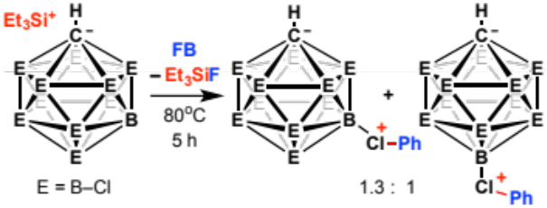

Radical (and electrochemical) reactions
Electron transfer to FB to form [C₆H₅F]• and ultimately [C₆H₅]• and F– is a potential route to C–F bond cleavage. While many authors have cited the potential for single electron chemistry during reactions of fluorocarbons, the reduction potentials of perfluorinated aromatics have been measured as -2.4 to -3.0 V (versus Fc/Fc⁺). Electron transfer to these substrates is thermodynamically challenging.¹⁵⁰ Nevertheless, the electrochemical hydrodefluorination of FB and DiFBs has been reported, as has the generation and trapping of phenyl radicals from FB with solvated electrons generated from potassium in liquid ammonia. The Mn-porphyrazine 50 is an effective catalytic agent for the reductive defluorination of 1,2-DiFB using chemical or electrochemical reduction (Scheme 18). As part of these studies isomers of both trifluorobiphenyl and difluorobiphenyl were observed, arising from C(sp²)–H / C(sp²)–F coupling presumed to occur from the reaction of intermediate [C₆H₄F]• with DiFB and itself respectively. In related work, Sorokin and co-workers have reported the catalytic defluorination of perfluoroarenes under oxidative conditions with diiron phthalocyanine complexes.

Scheme 18. Radical homocoupling of 1,2-DiFB with a Mn-porphyrazine.

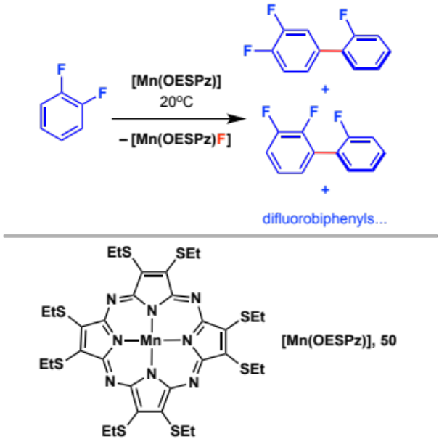

Overview and outlook
Organometallic reactions of the transition elements not only enrich, but enable many aspects of modern synthetic chemistry and catalysis. Given its presence in large excess, the solvent employed is a critical consideration: competitive binding or non-reversible reaction with the metal, especially with coordinately unsaturated intermediates, can effect the rate and in extreme cases overall viability of the desired transformation.

From a survey of their known coordination chemistry, fluorobenzene (FB) and 1,2-difluorobenzene (1,2-DiFB) can justifiably be considered weakly coordinating solvents. Both are commercially available, non-toxic, readily dried, and polar enough to solvate both neutral and charged organometallics.
The formation of π-complexes is hampered by the poor electron-donating ability of the arene and typically only electron-rich metal fragments bind fluorobenzenes strongly due to enhanced π-back bonding. Moreover, as a result of weak binding energies, well-defined complexes of FB and 1,2-DiFB can represent valuable organometallic precursors: facile substitution of the arene in solution, revealing up to three coordination sites simultaneously, enables these species to be considered “operationally unsaturated” metal fragments, or even “naked” metal atoms in the case of sandwich complexes.

Amongst the fluorobenzenes, FB and 1,2-DiFB strike a happy medium in which the C–H and C–F bonds are both chemically robust: on increasing fluorination the bond strength and polarity of the C–H bonds increase, while the C–F bond strengths decrease and the arene becomes more activated towards nucleophilic attack. As a consequence, the bond activation chemistries of FB and 1,2-DiFB are not well developed in comparison to more fluorinated arenes such as C₆F₆ (HFB) and C₆F₅H (PFB). In cases where C–H or C–F bond activation does occur, detailed mechanistic studies have highlighted interesting subtleties associated with the kinetic and thermodynamics of these processes. For instance, the formation of η²-arene intermediates in C–H bond oxidative addition reactions result in kinetic selectivity for bond activation at positions remote to the fluorine substituent(s), despite activation of the ortho C–H bonds being favoured thermodynamically by the “ortho fluorine effect”. Activation of C–F bonds is typically observed with first row and early transition metal complexes, and here the newly formed M–F bond provides a significant thermodynamic driving force for the reaction. If C–H bond activation of fluorobenzenes is fast and reversible, then C–F bond activation is slow and often non-reversible.

In this perspective, we have not only provided representative examples of the application of FB and 1,2-DiFB as solvents, but also highlighted cases where they can no longer be considered chemically innocent. Such information we hope will help mark out their “chemical window” for reactive organometallics and constitute a useful reference point for chemists that employ FB and 1,2-DiFB as solvents. Outside this window, FB and 1,2-DiFB may be viewed as inexpensive substrates for chemical synthesis by C–H or C–F bond activation. Due to increasing appreciation of the beneficial role of fluorine in pharmaceuticals, agrochemicals and materials, the use of FB and DiFBs as partially fluorinated building blocks by C–C or C–heteroatom bond formation becomes an attractive prospect. Challenges, however, remain in this area; these include the development of efficient catalysts for C–H (or C–F) bond activation of aromatic substrates with low fluorine content and directing the position of the fluorine atoms in the products by controlling the regioselectivity of which C–H (or C–F) bond is broken.

Acknowledgements
We thank the Herchel Smith Fund (S.D.P.) and Royal Society (M.R.C., A.B.C.) for research fellowships. M.R.C and A.B.C also gratefully acknowledge the European Research Council for provision of Starting Grants (677367 and 637313) to support their current work on C–F and C–H bond activation, respectively.

References

S. i. Kawahara, S. Tsuzuki, T. Uchimaru, Chem. Eur. J., 2005, 11, 4458-4468.
J. I. Wu, F. G. Pühlhofer, P. v. R. Schleyer, R. Puchta, B. Kiran, M. Mauksch, N. J. R. v. E. Hommes, I. Alkorta, J. Elguero, J. Phys. Chem. A, 2009, 113, 6789-6794.
Interestingly such differences result in electrostatic interactions in the solid-state between these arenes and formation of the C₆H₆∙HFB charge transfer complex (for example see: J. H. Williams, Acc. Chem. Res., 1993, 26, 593–598). A related charge transfer complex is also formed between [Cr(C₆H₆)₂] and HFB (C. J. Aspley, C. Boxwell, M. L. Buil, C. L. Higgitt, R. N. Perutz and C. Long, Chem. Commun., 1999, 1027–1028.).
Y. P. Ho, R. C. Dunbar, Int. J. Mass spectrom., 1999, 182–183, 175-184.
E. Clot, O. Eisenstein, N. Jasim, S. A. Macgregor, J. E. McGrady and R. N. Perutz, Acc. Chem. Res., 2011, 44, 333–348.
M. K. Whittlesey and E. Peris, ACS Catal., 2014, 4, 3152–3159.
(a) M. F. Kuehnel, D. Lentz and T. Braun, Angew. Chem. Int. Ed., 2013, 52, 3328–3348; (b) T. Ahrens, J. Kohlmann, M. Ahrens and T. Braun, Chem. Rev., 2015, 115, 931–972.
H. Amii and K. Uneyama, Chem. Rev., 2009, 109, 2119–2183.
Safety Information taken from www.sigmaaldrich.com, November 2016. Hazard statements for C₆H_{(6-n)}F_{n} exemplified by: H225, H302, H315, H318, H319, H332, H335, H412
Data taken from www.chemicalbook.com, November 2016.
W. L. F. Armarego, C. L. L. Chai, Purification of Laboratory Chemicals (Sixth Edition); Elsevier, 2009.
Private communication, Gemma M. Adams and Andrew S. Weller.
A. A. Maryott, E. R. Smith, Table of Dielectric Constants of Pure Liquids, United States Department of Commerce, National Bureau of Standards, 1951.
A. Mansingh and D. B. McLay, J. Chem. Phys., 1971, 54, 3322–3325.
The dipole moments of FB and 1,2-DiFB have also been determined. See: L. Nygaard, E. R. Hansen, R. L. Hansen, J. Rastrup-Andersen, G. O. Sørensen, Spectrochim. Acta Part A: Mol. Spectrosc., 1967, 23, 2813–2819.
C. Wohlfarth, Static Dielectric Constants of Pure Liquids and Binary Liquid Mixtures (Supplement to IV/6). In Landolt-Börnstein Group IV ‘Physical Chemistry’, ed. M. D. Lechner, Springer, Berlin, 2008, vol. 17.
For example see: L. J. Sewell, G. C. Lloyd-Jones, A. S. Weller, J. Am. Chem. Soc., 2012, 134, 3598–3610.
S. D. Pike, I. Pernik, R. Theron, J. S. McIndoe and A. S. Weller, J. Organomet. Chem., 2015, 784, 75–83.
J. Luo, R. Theron, L. J. Sewell, T. N. Hooper, A. S. Weller, A. G. Oliver and J. S. McIndoe, Organometallics, 2015, 34, 3021–3028.
T. K. Trefz, M. A. Henderson, M. Linnolahti, S. Collins, J. S. McIndoe, Chem. Eur. J., 2015, 21, 2980-2991.
T. R. O'Toole, J. N. Younathan, B. P. Sullivan, T. J. Meyer, T. J. Inorg. Chem., 1989, 28, 3923-3926.
For representative examples see: (a) M. M. Schwab, D. Himmel, S. Kacprzak, D. Kratzert, V. Radtke, P. Weis, K. Ray, E.-W. Scheidt, W. Scherer, B. de Bruin, S. Weber and I. Krossing, Angew. Chem. Int. Ed., 2015, 54, 14706–14709; (b) I. C. Cai, M. Lipschutz and T. D. Tilley, Chem. Commun., 2014, 50, 13062–13065; (c) M. D. Doherty, S. J. Konezny, V. S. Batista, G. L. Soloveichik, J. Organomet. Chem., 2014, 762, 94-97; (d) H. Sun, F. Xue, A. P. Nelson, J. Redepenning and S. G. DiMagno, Inorg. Chem., 2003, 42, 4507–4509.
T. Troadec, S.-Y. Tan, C. J. Wedge, J. P. Rourke, P. R. Unwin and A. B. Chaplin, Angew. Chem. Int. Ed., 2016, 55, 3754–3757.
E. Clot, O. Eisenstein, T. Dubé, J. W. Faller and R. H. Crabtree, Organometallics, 2002, 21, 575–580.
(a) I. Krossing and I. Raabe, Angew. Chem. Int. Ed., 2004, 43, 2066–2090; (b) A. B. Chaplin and A. S. Weller, Eur. J. Inorg. Chem., 2010, 2010, 5124–5128; (c) N. A. Yakelis and R. G. Bergman, Organometallics, 2005, 24, 3579–3581; (d) S. P. Smidt, N. Zimmermann, M. Studer and A. Pfaltz, Chem. Eur. J., 2004, 10, 4685–4693; (e) C. A. Reed, Acc. Chem. Res., 1998, 31, 133–139.
K. Freitag, C. Gemel, P. Jerabek, I. M. Oppel, R. W. Seidel, G. Frenking, H. Banh, K. Dilchert, R. A. Fischer, Angew. Chem. Int. Ed., 2015, 54, 4370-4374.
S. K. Brayshaw, M. J. Ingleson, J. C. Green, J. S. McIndoe, P. R. Raithby, G. Kociok-Köhn, A. S. Weller, J. Am. Chem. Soc., 2006, 128, 6247-6263.
M. O'Neill, D. A. Addy, I. Riddlestone, M. Kelly, N. Phillips and S. Aldridge, J. Am. Chem. Soc., 2011, 133, 11500–11503.
H. C. Johnson, E. M. Leitao, G. R. Whittell, I. Manners, G. C. Lloyd-Jones, A. S. Weller, J. Am. Chem. Soc., 2014, 136, 9078-9093.
R. M. Stolley, J. M. Darmon, M. L. Helm, Chem. Commun., 2014, 50, 3681-3684.
Related electrocatalytic oxidation reactions using instead Mn complexes has been conducted in FB: E. B. Hulley, N. Kumar, S. Raugei, R. M. Bullock, ACS Catal., 2015, 5, 6838-6847.
(a) I. W. Ashworth, D. J. Nelson and J. M. Percy, Dalton Trans., 2013, 42, 4110–4113; (b) S. Fustero, A. Simón-Fuentes, P. Barrio and G. Haufe, Chem. Rev., 2015, 115, 871–930.
K. Schroeter, R. Wesendrup, H. Schwarz, Eur. J. Org. Chem., 1998, 1998, 565-571.
V. Ryzhov, C.-N. Yang, S. J. Klippenstein and R. C. Dunbar, Int. J. Mass Spectrom., 1999, 185-187, 913–923.
(a) D. Schroeder, J. Hrusak, R. H. Hertwig, W. Koch, P. Schwerdtfeger, H. Schwarz, Organometallics, 1995, 14, 312-316; (b) D. Schröder, H. Schwarz, J. Hrušák, P. Pyykkö, Inorg. Chem., 1998, 37, 624-632.
(a) R. H. Crabtree, The Organometallic Chemistry of the transition metals; John Whiley & Sons, 5th edn 2009; (b) J. F. Hartwig, Organotransition Metal Chemistry: From Bonding to Catalysis; University Science Books, 2010.
(a) M. J. McGlinchey and T.-S. Tan, Can. J. Chem., 1974, 52, 2439–2443; (b) K. J. Klabunde and H. F. Efner, Inorg. Chem., 1975, 14, 789–791; (c) N. Hao, M. J. McGlinchey, J. Organomet. Chem., 1978, 161, 381-390.
L. J. Radonovich, E. C. Zuerner, H. F. Efner, K. J. Klabunde, Inorg. Chem., 1976, 15, 2976-2981.
(a) B. R. Jagirdar, R. Palmer, K. J. Klabunde, L. J. Radonovich, Inorg. Chem., 1995, 34, 278-283; (b) B. R. Jagirdar, K. J. Klabunde, R. Palmer, L. J. Radonovich, Inorg. Chim. Acta, 1996, 250, 317-326.
J. J. Barker, A. G. Orpen, A. J. Seeley and P. L. Timms, J. Chem. Soc., Dalton Trans., 1993, 3097–3102.
J. Rawlings and C. A. L. Mahaffy, Spectrosc. Lett., 1988, 21, 597–606.
J. L. Fletcher and M. J. McGlinchey, Can. J. Chem., 1975, 53, 1525–1529.
This trend is further corroborated by calculated arene dissociation energies: A. Kalpana and L. Akilandeswari, Comp. Theor. Chem., 2015, 1069, 125–131.
A. Khaleel, K. J. Klabunde, Inorg. Chem., 1996, 35, 3223-3227.
A. K. Renfrew, A. D. Phillips, E. Tapavicza, R. Scopelliti, U. Rothlisberger, P. J. Dyson, Organometallics, 2009, 28, 5061-5071.
P. Pertici, G. Vitulli, R. Lazzaroni, P. Salvadori and P. L. Barili, J. Chem. Soc., Dalton Trans., 1982, 1019–1022.
(a) T. M. Douglas, A. B. Chaplin, A. S. Weller, X. Yang and M. B. Hall, J. Am. Chem. Soc., 2009, 131, 15440–15456; (b) R. Dallanegra, A. P. M. Robertson, A. B. Chaplin, I. Manners and A. S. Weller, Chem. Commun., 2011, 47, 3763–3765; (c) M. A. Huertos and A. S. Weller, Chem. Commun., 2012, 48, 7185–7187.
(a) A. B. Chaplin, J. F. Hooper, A. S. Weller and M. C. Willis, J. Am. Chem. Soc., 2012, 134, 4885–4897; (b) I. Pernik, J. F. Hooper, A. B. Chaplin, A. S. Weller and M. C. Willis, ACS Catal., 2012, 2, 2779–2786; (c) A. Prades, M. Fernández, S. D. Pike, M. C. Willis and A. S. Weller, Angew. Chem., 2015, 127, 8640–8644.
(a) T. M. Douglas, A. B. Chaplin and A. S. Weller, Organometallics, 2008, 27, 2918–2921; (b) A. B. Chaplin, A. I. Poblador-Bahamonde, J. A. K. Howard, S. A. Macgregor and A. S. Weller, Chem. Commun., 2009, 244–246; (c) R. Dallanegra, B. S. Pilgrim, A. B. Chaplin, T. J. Donohoe and A. S. Weller, Dalton Trans., 2011, 40, 6626–6628.
For other similar examples see: (a) T. M. Douglas, S. K. Brayshaw, R. Dallanegra, G. Kociok-Köhn, S. A. Macgregor, G. L. Moxham, A. S. Weller, T. Wondimagegn and P. Vadivelu, Chem. Eur. J., 2008, 14, 1004–1022; (b) A. B. Chaplin and A. S. Weller, Organometallics, 2010, 29, 2332–2342; (c) A. B. Chaplin and A. S. Weller, Eur. J. Inorg. Chem., 2010, 5124–5128; (d) R. Dallanegra, A. B. Chaplin, J. Tsim and A. S. Weller, Chem. Commun., 2010, 46, 3092 (e) C. Y. Tang, J. Lednik, D. Vidovic, A. L. Thompson and S. Aldridge, Chem. Commun., 2011, 47, 2523–2525.
(a) J. Powell, A. Lough and T. Saeed, J. Chem. Soc., Dalton Trans., 1997, 4137–4138; (b) T. M. Douglas, E. Molinos, S. K. Brayshaw and A. S. Weller, Organometallics, 2007, 26, 463–465; (c) S. Moret, R. Dallanegra, A. B. Chaplin, T. M. Douglas, R. M. Hiney and A. S. Weller, Inorg. Chim. Acta, 2010, 363, 574–580. (d) S. D. Pike, A. L. Thompson, A. G. Algarra, D. C. Apperley, S. A. Macgregor and A. S. Weller, Science, 2012, 337, 1648–1651; (e) S. D. Pike, F. M. Chadwick, N. H. Rees, M. P. Scott, A. S. Weller, T. Krämer and S. A. Macgregor, J. Am. Chem. Soc., 2015, 137, 820–833.
(a) H. Lei, B. D. Ellis, C. Ni, F. Grandjean, G. J. Long and P. P. Power, Inorg. Chem., 2008, 47, 10205–10207; (b) H. Lei, J. C. Fettinger, P. P. Power, Inorg. Chem., 2012, 51, 1821-1826.
(a) J. M. Slattery, A. Higelin, T. Bayer, I. Krossing, Angew. Chem. Int. Ed., 2010, 49, 3228-3231; (b) A. Higelin and I. Krossing, CCDC 913367: Experimental Crystal Structure Determination, 2012, DOI: 10.5517/ccznfgh
A. Higelin, U. Sachs, S. Keller, I. Krossing, Chem. Eur. J., 2012, 18, 10029-1034.
M. R. Lichtenthaler, A. Higelin, A. Kraft, S. Hughes, A. Steffani, D. A. Plattner, J. M. Slattery, I. Krossing, Organometallics, 2013, 32, 6725-6735.
S. Welsch, M. Bodensteiner, M. Dušek, M. Sierka and M. Scheer, Chem. Eur. J, 2010, 16, 13041–13045.
(a) F. Godoy, C. L. Higgitt, A. H. Klahn, B. Oelckers, S. Parsons and R. N. Perutz, J. Chem. Soc., Dalton Trans., 1999, 2039–2048; (b) J. J. Carbó, O. Eisenstein, C. L. Higgitt, A. H. Klahn, F. Maseras, B. Oelckers and R. N. Perutz, J. Chem. Soc., Dalton Trans., 2001, 1452–1461.
C. L. Higgitt, A. Hugo Klahn, M. H. Moore, B. Oelckers, M. G. Partridge and R. N. Perutz, J. Chem. Soc., Dalton Trans., 1997, 1269–1280.
(a) E. Clot, B. Oelckers, A. H. Klahn, O. Eisenstein and R. N. Perutz, Dalton Trans., 2003, 4065–4074; (b) E. Clot, M. Besora, F. Maseras, C. Mégret, O. Eisenstein, B. Oelckers and R. N. Perutz, Chem. Commun., 2003, 490–491.
(a) W. D. Jones and F. J. Feher, Acc. Chem. Res., 1989, 22, 91–100; (b) W. D. Jones, Inorg. Chem., 2005, 44, 4475–4484.
S. T. Belt, S. B. Duckett, M. Helliwell and R. N. Perutz, J. Chem. Soc., Chem. Comm., 1989, 928–930.
(a) T. W. Bell, M. Helliwell, M. G. Partridge, R. N. Perutz, Organometallics, 1992, 11, 1911-1918; (b) A. Martin, A. G. Orpen, A. J. Seeley, P. L. Timms, J. Chem. Soc., Dalton Trans., 1994, 2251-2255; (c) L. Lefort, T. W. Crane, M. D. Farwell, D. M. Baruch, J. A. Kaeuper, R. J. Lachicotte, W. D. Jones, Organometallics, 1998, 17, 3889-3899; (d) I. Bach, K. R. Pörschke, R. Goddard, C. Kopiske, C. Krüger, A. Rufińska, K. Seevogel, Organometallics, 1996, 15, 4959-4966; (e) S. A. Johnson, E. T. Taylor, S. J. Cruise, Organometallics, 2009, 28, 3842-3855; (f) K. H. G. Mak, P. K. Chan, W. Y. Fan, R. Ganguly and W. K. Leong, Organometallics, 2013, 32, 1053–1059.
G. Santiso-Quiñones, A. Higelin, J. Schaefer, R. Brückner, C. Knapp, I. Krossing, Chem. Eur. J., 2009, 15, 6663-6677.
(a) J. Li, C. Schenk, F. Winter, H. Scherer, N. Trapp, A. Higelin, S. Keller, R. Pöttgen, I. Krossing and C. Jones, Angew. Chem. Int. Ed., 2012, 51, 9557–9561; (b) R. Ramírez-Contreras and O. V. Ozerov, Dalton Trans., 2012, 41, 7842–7844; (c) U. P. Preiss, G. Steinfeld, H. Scherer, A. M. T. Erle, B. Benkmil, A. Kraft, I. Krossing, Z. Anorg. Allg. Chem., 2013, 639, 714-721;
M. R. Lichtenthaler, F. Stahl, D. Kratzert, L. Heidinger, E. Schleicher, J. Hamann, D. Himmel, S. Weber, I. Krossing, Nat. Commun., 2015, 6, 8288.
(a) S. T. H. Willems, P. H. M. Budzelaar, N. N. P. Moonen, R. de Gelder, J. M. M. Smits, A. W. Gal, Chem. Eur. J., 2002, 8, 1310-1320; (b) M. Carrasco, N. Curado, E. Álvarez, C. Maya, R. Peloso, M. L. Poveda, A. Rodríguez, E. Ruiz, S. Álvarez, E. Carmona, Chem. Eur. J., 2014, 20, 6092-6102.
M. W. Bouwkamp, J. de Wolf, I. Del Hierro Morales, J. Gercama, A. Meetsma, S. I. Troyanov, B. Hessen and J. H. Teuben, J. Am. Chem. Soc., 2002, 124, 12956–12957.
M. W. Bouwkamp, P. H. M. Budzelaar, J. Gercama, I. Del Hierro Morales, J. de Wolf, A. Meetsma, S. I. Troyanov, J. H. Teuben and B. Hessen, J. Am. Chem. Soc., 2005, 127, 14310–14319.
F. Basuli, H. Aneetha, J. C. Huffman, D. J. Mindiola, J. Am. Chem. Soc., 2005, 127, 17992-17993.
(a) A. B. Chaplin and A. S. Weller, Inorg. Chem., 2010, 49, 1111–1121; (b) M. A. Huertos, A. S. Weller, Chem. Sci., 2013, 4, 1881-1888; (c) T. N. Hooper, M. A. Huertos, T. Jurca, S. D. Pike, A. S. Weller and I. Manners, Inorg. Chem., 2014, 53, 3716–3729; (d) A. Kumar, I. K. Priest, T. N. Hooper and A. S. Weller, Dalton Trans., 2016, 45, 6183–6195; (e) A. Kumar, N. A. Beattie, S. D. Pike, S. A. Macgregor and A. S. Weller, Angew. Chem. Int. Ed., 2016, 55, 6651–6656.
(a) J. F. Hooper, R. D. Young, A. S. Weller and M. C. Willis, Chem. Eur. J, 2013, 19, 3125–3130; (b) R. Theron, Y. Wu, L. P. E. Yunker, A. V. Hesketh, I. Pernik, A. S. Weller and J. S. McIndoe, ACS Catal., 2016, 6, 6911–6917.
J. F. Hooper, R. D. Young, I. Pernik, A. S. Weller and M. C. Willis, Chem. Sci., 2013, 4, 1568.
(a) A. Higelin, C. Haber, S. Meier and I. Krossing, Dalton Trans., 2012, 41, 12011–12015; (b) A. Higelin, S. Keller, C. Göhringer, C. Jones and I. Krossing, Angew. Chem. Int. Ed., 2013, 52, 4941–4944; (c) M. R. Lichtenthaler, F. Stahl, D. Kratzert, B. Benkmil, H. A. Wegner, I. Krossing, Eur. J. Inorg. Chem., 2014, 2014, 4335-4341.
P. J. Dyson and G. Sava, Dalton Trans., 2006, 1929–1933.
(a) M. Schlosser and E. Marzi, Chem. Eur. J., 2005, 11, 3449–3454; (b) K. Shen, Y. Fu, J.-N. Li, L. Liu and Q.-X. Guo, Tetrahedron, 2007, 63, 1568–1576.
As an illustrative example: [Au(OH)(N,N-bis(2,6-^{i}Pr₂-C₆H₃)imidazol-2-ylidene)] readily undergoes C–H bond activation of PFB and 1,2,4,5-tetrafluorobenzene, however, is recovered unchanged after attempted reaction with 1,3,5-TriFB. S. Gaillard, A. M. Z. Slawin and S. P. Nolan, Chem. Commun., 2010, 46, 2742–2744.
For seminal work see: (a) R. A. Periana and R. G. Bergman, Organometallics, 1984, 3, 508–510; (b) W. D. Jones and F. J. Feher, J. Am. Chem. Soc., 1984, 106, 1650–1663; (c) R. A. Periana and R. G. Bergman, J. Am. Chem. Soc., 1984, 106, 7272–7273; (d) R. A. Periana and R. G. Bergman, J. Am. Chem. Soc., 1986, 108, 7332–7346; (e) R. A. Periana and R. G. Bergman, J. Am. Chem. Soc., 1986, 108, 7346–7355; (f) A. A. Bengali, R. H. Schultz, C. B. Moore and R. G. Bergman, J. Am. Chem. Soc., 1994, 116, 9585–9589.
A. D. Selmeczy, W. D. Jones, M. G. Partridge and R. N. Perutz, Organometallics, 1994, 13, 522–532.
W. D. Jones, M. G. Partridge and R. N. Perutz, J. Chem. Soc., Chem. Comm., 1991, 264–266.
E. Clot, C. Mégret, O. Eisenstein and R. N. Perutz, J. Am. Chem. Soc., 2009, 131, 7817–7827.
(a) M. E. Evans, C. L. Burke, S. Yaibuathes, E. Clot, O. Eisenstein and W. D. Jones, J. Am. Chem. Soc., 2009, 131, 13464–13473; (b) T. Tanabe, W. W. Brennessel, E. Clot, O. Eisenstein and W. D. Jones, Dalton Trans., 2010, 39, 10495–15.
Y. Zhu, D. A. Smith, D. E. Herbert, S. Gatard and O. V. Ozerov, Chem. Commun., 2012, 48, 218–220.
M. A. Esteruelas, M. Oliván and A. Vélez, Organometallics, 2015, 34, 1911–1924.
(a) P. Diversi, S. Iacoponi, G. Ingrosso, F. Laschi, A. Lucherini, C. Pinzino, G. Uccello-Barretta and P. Zanello, Organometallics, 1995, 14, 3275–3287; (b) D. M. Tellers, C. M. Yung, B. A. Arndtsen, D. R. Adamson and R. G. Bergman, J. Am. Chem. Soc., 2002, 124, 1400–1410; (c) J. M. Meredith, R. Robinson Jr., K. I. Goldberg, W. Kaminsky and D. M. Heinekey, Organometallics, 2012, 31, 1879–1887.
L. Li, W. W. Brennessel and W. D. Jones, Organometallics, 2009, 28, 3492–3500.
(a) E. Ben-Ari, M. Gandelman, H. Rozenberg, L. J. W. Shimon and D. Milstein, J. Am. Chem. Soc., 2003, 125, 4714–4715; (b) E. Ben-Ari, R. Cohen, M. Gandelman, L. J. W. Shimon, J. M. L. Martin and D. Milstein, Organometallics, 2006, 25, 3190–3210.
L. Fan, S. Parkin and O. V. Ozerov, J. Am. Chem. Soc., 2005, 127, 16772–16773.
L. P. Press, A. J. Kosanovich, B. J. McCulloch and O. V. Ozerov, J. Am. Chem. Soc., 2016, 138, 9487–9497.
J. Emerson-King, S. A Hauser, S. Habershon and A. B. Chaplin, manuscript under revision: CC-COM-12-2016-009807.
For example see: (a) K. Krogh-Jespersen, M. Czerw, K. Zhu, B. Singh, M. Kanzelberger, N. Darji, P. D. Achord, K. B. Renkema and A. S. Goldman, J. Am. Chem. Soc., 2002, 124, 10797–10809; (b) R. Ghosh, X. Zhang, P. Achord, T. J. Emge, K. Krogh-Jespersen and A. S. Goldman, J. Am. Chem. Soc., 2007, 129, 853–866; (c) W. H. Bernskoetter, P. S. White, K. I. Goldberg and M. Brookhart, J. Am. Chem. Soc., 2009, 131, 8603–8613; (d) J. Choi, A. H. R. MacArthur, M. Brookhart and A. S. Goldman, Chem. Rev., 2011, 111, 1761–1779; (e) J. Choi, D. Y. Wang, S. Kundu, Y. Choliy, T. J. Emge, K. Krogh-Jespersen and A. S. Goldman, Science, 2011, 332, 1545–1548.
H. Werner, A. Höhn, M. Dziallas and T. Dirnberger, Dalton Trans., 2006, 2597–2606.
For related work starting from an Ir(V) precursor see: M. A. Salomon, T. Braun and I. Krossing, Dalton Trans., 2008, 5197–10.
S. A. Hauser, I. Prokes and A. B. Chaplin, Chem. Commun., 2015, 51, 4425–4428.
B. Z. Li, Y. Y. Qian, J. Liu and K. S. Chan, Organometallics, 2014, 33, 7059–7068.
(a) R. Bosque, E. Clot, S. Fantacci, F. Maseras, O. Eisenstein, R. N. Perutz, K. B. Renkema and K. G. Caulton, J. Am. Chem. Soc., 1998, 120, 12634–12640; (b) K. B. Renkema, R. Bosque, W. E. Streib, F. Maseras, O. Eisenstein and K. G. Caulton, J. Am. Chem. Soc., 1999, 121, 10895–10907.
S. Bajo, M. A. Esteruelas, A. M. López and E. Oñate, Organometallics, 2011, 30, 5710–5715.
R. G. Peters, S. White and D. M. Roddick, Organometallics, 1998, 17, 4493–4499.
J. C. DeMott, N. Bhuvanesh and O. V. Ozerov, Chem. Sci., 2013, 4, 642–649.
C. A. Tolman, S. D. Ittel, A. D. English and J. P. Jesson, J. Am. Chem. Soc., 1978, 100, 4080–4089.
S. N. Brown, A. W. Myers, J. R. Fulton and J. M. Mayer, Organometallics, 1998, 17, 3364–3374.
(a) E. Tran and P. Legzdins, J. Am. Chem. Soc., 1997, 119, 5071–5072; (b) J. Y. K. Tsang, M. S. A. Buschhaus, P. M. Graham, C. J. Semiao, S. P. Semproni, S. J. Kim and P. Legzdins, J. Am. Chem. Soc., 2008, 130, 3652–3663; (c) R. A. Baillie, R. W. Y. Man, M. V. Shree, C. Chow, M. E. Thibault, W. S. McNeil and P. Legzdins, Organometallics, 2011.
J. Y. K. Tsang, M. S. A. Buschhaus, P. Legzdins and B. O. Patrick, Organometallics, 2006, 25, 4215–4225.
C. Chow, B. O. Patrick and P. Legzdins, Organometallics, 2012, 31, 8159–8171.
(a) B. C. Bailey, J. C. Huffman and D. J. Mindiola, J. Am. Chem. Soc., 2007, 129, 5302–5303; (b) B. C. Bailey, H. Fan, J. C. Huffman, M.-H. Baik and D. J. Mindiola, J. Am. Chem. Soc., 2007, 129, 8781–8793; (c) A. R. Fout, J. Scott, D. L. Miller, B. C. Bailey, M. Pink and D. J. Mindiola, Organometallics, 2009, 28, 331–347.
E. L. Werkema and R. A. Andersen, J. Am. Chem. Soc., 2008, 130, 7153–7165.
(a) G. Wittig, Naturwiss. 1942, 30, 696–703; (b) P. L. Coe, A. J. Waring and T. D. Yarwood, J. Chem. Soc., Perkin Trans. 1, 1995, 2729–9.
M. Lafrance, C. N. Rowley, T. K. Woo and K. Fagnou, J. Am. Chem. Soc., 2006, 128, 8754–8756.
H.-Q. Do and O. Daugulis, J. Am. Chem. Soc., 2008, 130, 1128–1129.
M. Simonetti, G. J. P. Perry, X. C. Cambeiro, F. Juliá-Hernández, J. N. Arokianathar and I. Larrosa, J. Am. Chem. Soc., 2016, 138, 3596–3606.
P. Ricci, K. Krämer, X. C. Cambeiro and I. Larrosa, J. Am. Chem. Soc., 2013, 135, 13258–13261.
Y. Nakao, N. Kashihara, K. S. Kanyiva and T. Hiyama, J. Am. Chem. Soc., 2008, 130, 16170–16171.
X. C. Cambeiro, N. Ahlsten and I. Larrosa, J. Am. Chem. Soc., 2015, 137, 15636–15639.
(a) G. A. Chotana, M. A. Rak and M. R. Smith, J. Am. Chem. Soc., 2005, 127, 10539–10544; (b) C. F. Rentzsch, E. Tosh, W. A. Herrmann and F. E. Kühn, Green Chem, 2009, 11, 1610; (c) M. I. Gonzalez, E. D. Bloch, J. A. Mason, S. J. Teat and J. R. Long, Inorg. Chem., 2015, 54, 2995–3005; (d) J. Takaya, S. Ito, H. Nomoto, N. Saito, N. Kirai and N. Iwasawa, Chem. Commun., 2015, 51, 17662–17665; (e) S. I. Kalläne, M. Teltewskoi, T. Braun and B. Braun, Organometallics, 2015, 34, 1156–1169.
A cobalt catalyzed C–H borylation of FB using bis(pinacolato)diboron has also been reported: J. V. Obligacion, S. P. Semproni and P. J. Chirik, J. Am. Chem. Soc., 2014, 136, 4133–4136.
Handbook of Bond Dissociation Energies in Organic Compounds, ed. Y.-R. Luo, CRC Press, 2003.
X.-W. Liu, J. Echavarren, C. Zarate and R. Martin, J. Am. Chem. Soc., 2015, 137, 12470–12473.
T. Braun, L. Cronin, C. L. Higgitt, J. E. McGrady, R. N. Perutz and M. Reinhold, New J. Chem., 2001, 25, 19–21.
M. Reinhold, J. E. McGrady and R. N. Perutz, J. Am. Chem. Soc., 2004, 126, 5268–5276.
S. A. Macgregor, D. C. Roe, W. J. Marshall, K. M. Bloch, V. I. Bakhmutov and V. V. Grushin, J. Am. Chem. Soc., 2005, 127, 15304–15321.
C. Carfagna, A. Musco, R. Pontellini and G. Terzoni, Journal of Molecular Catalysis, 1989, 57, 23–28.
(a) J. Wu and S. Cao, ChemCatChem, 2011, 3, 1582–1586; (b) W. Zhao, J. Wu and S. Cao, Adv. Synth. Catal., 2012, 354, 574–578.
J. Xiao, J. Wu, W. Zhao and S. Cao, J. Fluorine Chem., 2013, 146, 76–79.
C. Desmarets, S. Kuhl, R. Schneider and Y. Fort, Organometallics, 2002, 21, 1554–1559.
M. Weidauer, E. Irran, C. I. Someya, M. Haberberger and S. Enthaler, J. Organomet. Chem, 2013, 729, 53–59.
(a) J. Moon and S. Lee, J. Organomet. Chem, 2009, 694, 473–477; (b) S. Sabater, J. A. Mata and E. Peris, Nat. Comm., 2013, 4, 1–7; (c) S. Sabater, J. A. Mata and E. Peris, Organometallics, 2015, 34, 1186–1190.
C. J. E. Davies, M. J. Page, C. E. Ellul, M. F. Mahon and M. K. Whittlesey, Chem. Commun., 2010, 46, 5151–5153.
A. Arévalo, A. Tlahuext-Aca, M. Flores-Alamo and J. J. García, J. Am. Chem. Soc., 2014, 136, 4634–4639.
K. C. Mondal, P. P. Samuel, Y. Li, H. W. Roesky, S. Roy, L. Ackermann, N. S. Sidhu, G. M. Sheldrick, E. Carl, S. Demeshko, S. De, P. Parameswaran, L. Ungur, L. F. Chibotaru and D. M. Andrada, Eur. J. Inorg. Chem., 2014, 2014, 818–823.
Y. Kiso, K. Tamao and M. Kumada, J. Organomet. Chem, 1973, 50, C12–C14.
V. P. W. Bohm, C. W. K. Gstottmayer, T. Weskamp and W. A. Herrmann, Angew. Chem., Int. Ed., 2001, 40, 3387–3389.
(a) J. W. Dankwardt, J. Organomet. Chem, 2005, 690, 932–938; (b) L.-G. Xie and Z.-X. Wang, Chem. Eur. J., 2010, 16, 10332–10336; (c) W.-J. Guo and Z.-X. Wang, J. Org. Chem., 2013, 78, 1054–1061.
(a) L. Ackermann, R. Born, J. H. Spatz and D. Meyer, Angew. Chem., Int. Ed., 2005, 44, 7216–7219; (b) L. Ackermann, C. Wechsler, A. Kapdi and A. Althammer, Synlett, 2010, 294–298.
B.-T. Guan, S.-K. Xiang, T. Wu, Z.-P. Sun, B.-Q. Wang, K.-Q. Zhao and Z.-J. Shi, Chem. Commun., 2008, 1437–3.
T. Saeki, Y. Takashima and K. Tamao, Synlett, 2005, 1771–1774.
Y. Nakamura, N. Yoshikai, L. Ilies and E. Nakamura, Org. Lett., 2012, 14, 3316–3319.
N. Yoshikai, H. Mashima and E. Nakamura, J. Am. Chem. Soc., 2005, 127, 17978–17979.
M. Tobisu, T. Xu, T. Shimasaki and N. Chatani, J. Am. Chem. Soc., 2011, 133, 19505–19511.
(a) J. R. Ruiz, C. Jiménez-Sanchidrián and M. Mora, J. Fluorine Chem., 2006, 127, 443–445; (b) J. R. Ruiz, C. Jiménez-Sanchidrián and M. Mora, Tetrahedron, 2006, 62, 2922–2926; (c) B. J. Gallon, R. W. Kojima, R. B. Kaner and P. L. Diaconescu, Angew. Chem., Int. Ed., 2007, 46, 7251–7254; (d) M. I. Burrueco, M. Mora, C. Jiménez-Sanchidrián and J. R. Ruiz, Appl. Cat. A: Gen., 2014, 485, 196–201; (e) J.-J. Lv, Z.-J. Wang, J.-J. Feng, R. Qiu, A.-J. Wang and X. Xu, Appl. Cat. A: Gen., 2016, 522, 188–193.
(a) T. Niwa, H. Ochiai, Y. Watanabe and T. Hosoya, J. Am. Chem. Soc., 2015, 137, 14313–14318; (b) J. Zhou, M. W. Kuntze-Fechner, R. Bertermann, U. S. D. Paul, J. H. J. Berthel, A. Friedrich, Z. Du, T. B. Marder and U. Radius, J. Am. Chem. Soc., 2016, 138, 5250–5253.
T. R. Dugan, X. Sun, E. V. Rybak-Akimova, O. Olatunji-Ojo, T. R. Cundari and P. L. Holland, J. Am. Chem. Soc., 2011, 133, 12418–12421.
T. R. Dugan, J. M. Goldberg, W. W. Brennessel and P. L. Holland, Organometallics, 2012, 31, 1349–1360.
T. L. Gianetti, R. G. Bergman and J. Arnold, Chem. Sci., 2014, 5, 2517–10.
W. Liu, K. Welch, C. O. Trindle, M. Sabat, W. H. Myers and W. D. Harman, Organometallics, 2007, 26, 2589–2597.
B. M. Kraft, R. J. Lachicotte and W. D. Jones, J. Am. Chem. Soc., 2001, 123, 10973–10979.
S. Yow, S. J. Gates, A. J. P. White and M. R. Crimmin, Angew. Chem., Int. Ed., 2012, 51, 12559–12563.
O. Ekkert, S. D. A. Strudley, A. Rozenfeld, A. J. P. White and M. R. Crimmin, Organometallics, 2014, 33, 7027–7030.
M. K. Cybulski, I. M. Riddlestone, M. F. Mahon, T. J. Woodman and M. K. Whittlesey, Dalton Trans., 2015, 44, 19597–19605.
R. J. Young and V. V. Grushin, Organometallics, 1999, 18, 294–296.
(a) H. Yang, H. Gao and R. J. Angelici, Organometallics, 1999, 18, 2285–2287; (b) J. Blum, A. Rosenfeld, F. Gelman, H. Schumann and D. Avnir, J. Mol. Cat A: Chem., 1999, 146, 117–122; (c) K. J. Stanger and R. J. Angelici, J. Mol. Cat A: Chem., 2004, 207, 59–68; (d) M. L. Buil, M. A. Esteruelas, S. Niembro, M. Oliván, L. Orzechowski, C. Pelayo and A. Vallribera, Organometallics, 2010, 29, 4375–4383.
B. L. Edelbach and W. D. Jones, J. Am. Chem. Soc., 1997, 119, 7734–7742.
T. H. Peterson, J. T. Golden and R. G. Bergman, Organometallics, 1999, 18, 2005–2020.
(a) V. J. Scott, R. Çelenligil-Çetin and O. V. Ozerov, J. Am. Chem. Soc., 2005, 127, 2852–2853; (b) W. Gu, M. R. Haneline, C. Douvris and O. V. Ozerov, J. Am. Chem. Soc., 2009, 131, 11203–11212.
S. Duttwyler, C. Douvris, N. L. P. Fackler, F. S. Tham, C. A. Reed, K. K. Baldridge and J. S. Siegel, Angew. Chem., Int. Ed., 2010, 49, 7519–7522.
W.-B. Wu, M.-L. Li and J.-M. Huang, Tet. Lett., 2015, 56, 1520–1523.
G. F. Meijs and J. F. Bunnett, J. Org. Chem., 1989, 54, 1123–1125.
G. Ricciardi, S. Belviso and F. Lelj, Inorg. Chem., 2000, 39, 1618–1620.
C. Colomban, E. V. Kudrik, P. Afanasiev and A. B. Sorokin, J. Am. Chem. Soc., 2014, 136, 11321–11330.

