Cutaneotrichosporon (Trichosporon) debeurmannianum associated with a subcutaneous mycotic cyst successfully treated with voriconazole

Authors:
*ML Noy¹, A Abdolrasouli², A M Borman³, M Fraser³, N Francis⁴, LSP Moore^{2,5,6}, EE Merika¹
Affiliations:
¹ Department of Dermatology, Chelsea and Westminster Hospital, London, SW10 9NH, UK
² Department of Medical Microbiology, North West London Pathology, Imperial College Healthcare NHS Trust, London, W6 8RF, UK
³ National Mycology Reference Laboratory, Public Health England, Bristol, UK
⁴ Department of Histopathology, Charing Cross Hospital, Imperial College London, UK
⁵ Clinical Infection Department, Chelsea and Westminster Hospital, London, SW10 9NH, UK
⁶ National Institute for Health Research Health Protection Research Unit in Healthcare associated Infections and Antimicrobial Resistance, Imperial College London, Du Cane Road, London, W12 0NN, UK.

*Corresponding author:
Mariana Noy, Department of Dermatology, Chelsea and Westminster Hospital, 369 Fulham Road, London, SW10 9NH. Mariana.noy@nhs.net

Keywords: Subcutaneous mycosis, Cutaneotrichosporon debeurmannianu, mycology, infectious diseases
Word Count: 600
Figure Count: 2

Abstract
A 38-year-old Nigerian man with no significant past medical history presented with a discharging lesion on the plantar aspect of his left foot, with a provisional diagnosis of a viral wart. Cutaneotrichosporon debeurmannianum was isolated from deep tissue and identified by sequencing the internal transcribed spacer region ITS-1 and the D1-2 fragment of the 28S rDNA gene. Histopathological examination showed psoriasiform hyperplasia with dermal scarring and scanty inflammation. The patient was successfully treated with a course of voriconazole. C. debeurmannianum exhibited high MIC values for echinocandin antifungals in vitro, however MICs to triazoles and amphotericin B remained low. To our knowledge, this is the first report of a subcutaneous mycotic cyst associated with this newly described yeast in an immunocompetent man.

Subcutaneous mycoses are usually caused by traumatic penetration of the causative agent from the environment into the subcutaneous tissue. These typically present as painless subcutaneous swellings but other manifestations include cysts, ulcers, plaques and abscesses.¹

In August 2016, a 38-year-old Nigerian man presented with a four-year history of a possible viral wart on the plantar aspect of his left foot. The lesion was non-tender, intermittently discharged yellow fluid and had gradually increased in size. He had been treated unsuccessfully with cryotherapy, topical ointments and flucloxacillin. He had no co-morbidities and took no regular medications. He had been resident in the United Kingdom since 2001 and not travelled abroad since. He had previously taken barefoot walks on the beach in Nigeria.
Examination confirmed a 4mm x 4mm subcutaneous, cystic, non-tender swelling on the plantar aspect of his foot (Fig 1a). Upon removal of two overlying hyperkeratotic areas, purulent exudate and a 4mm ulcer were revealed, raising the suspicion of a subcutaneous mycosis. There were no obvious sinus tracts or discharging grains. The remainder of the dermatological examination was normal.
Two initial punch biopsies demonstrated scar tissue only, no organisms were seen on periodic acid-Schiff (PAS), Gram or Grocott stains. Fungal cultures remained negative after 4 weeks incubation.
Screening for immunosuppression was negative (HIV negative, full blood count and glucose within normal limits).
An ultrasound scan of the lesion showed a 3.5cm x 0.5cm hypoechoic area within the subcutaneous tissue. An X-Ray and MRI of the foot showed no evidence of osteomyelitis or collection.
Despite negative microbiology, the primary differential diagnosis of a subcutaneous mycosis remained and a deeper biopsy was performed in April 2017. Histological examination showed psoriasiform hyperplasia with dermal scarring and scanty inflammation.
A yeast grew after 7 days of incubation on Sabouraud dextrose agar (SDA) at 28°C (Figure 2). In order to identify the organism, the D1-D2 fragment of the 28S rDNA gene was amplified by PCR using extracted fungal genomic DNA and previously established protocols^{2,3}. BlastN comparisons of the resulting sequence (GenBank accession number MK894881) with those present in GenBank revealed 99.47% identity (378/380 nt) with the corresponding sequence of the type strain of Cutaneotrichosporon debeurmannianum (strain CBS1896; accession number KY107315). The isolate has been stored in metabolically inert form in sterile water at the National Collection of Pathogenic Fungi (NCPF), Bristol, United Kingdom with the unique identifier NCPF 13045.
The patient was treated with a 12-week course of voriconazole. Four weeks after starting treatment the lesion had stopped discharging. There was total resolution by the end of the 12-week course and there has been no recurrence since.
The diagnosis of a subcutaneous mycotic infection was initially considered in view of the site and persistence of the lesion, lack of response to treatment with antibacterial agents and the patient’s history of barefoot walks on the beach. We contemplated the diagnosis of eumycetoma, but the lesion lacked multiple sinuses and grainy discharge to fulfil the diagnostic criteria, in addition to the lack of histological confirmation.
Cutaneotrichosporon debeurmannianum is a recently described yeast, uncommonly found in clinical samples⁴. It was first described by Sugita et al.⁵ in 2001 as Trichosporon debeurmannianum isolated from bronchial aspirates from a male patient. After a recent integrated phylogenetic analysis⁶, the organism was reclassified as C. debeurmannianum. Nath et al. identified nine clinically relevant samples of C. debeurmannianum from a total of 333 yeast isolates in North India from blood and urine in septic patients.⁴
To our knowledge, this is the first reported case of a subcutaneous mycotic infection associated with Cutaneotrichosporon debeurmannianum.

MCQS:
- Subcutaneous mycoses are most commonly acquired via
  - Airborne route (false)
  - Contact with contaminated fish tanks (false)
  - Direct contact with infected individual (false)
  - Inoculation from the environment, including soil (true)
  - Mosquitos (false)
- The most common subtypes of subcutaneous mycosis are
  - Actinomycetoma, chromoblastomycosis, cysticercosis, eumycetoma, (false)
  - Cryptosporidiosis, chromoblastomycosis, phaeohyphomycosis and eumycetoma (false)
  - Onychomycosis, candidiasis, eumycetoma, sporotrichosis (false)
  - Sporotrichosis, candidiasis, phaeohyphomycosis, toxoplasmosis, (false)
  - Sporotrichosis, chromoblastomycosis, phaeohyphomycosis and eumycetoma (true)
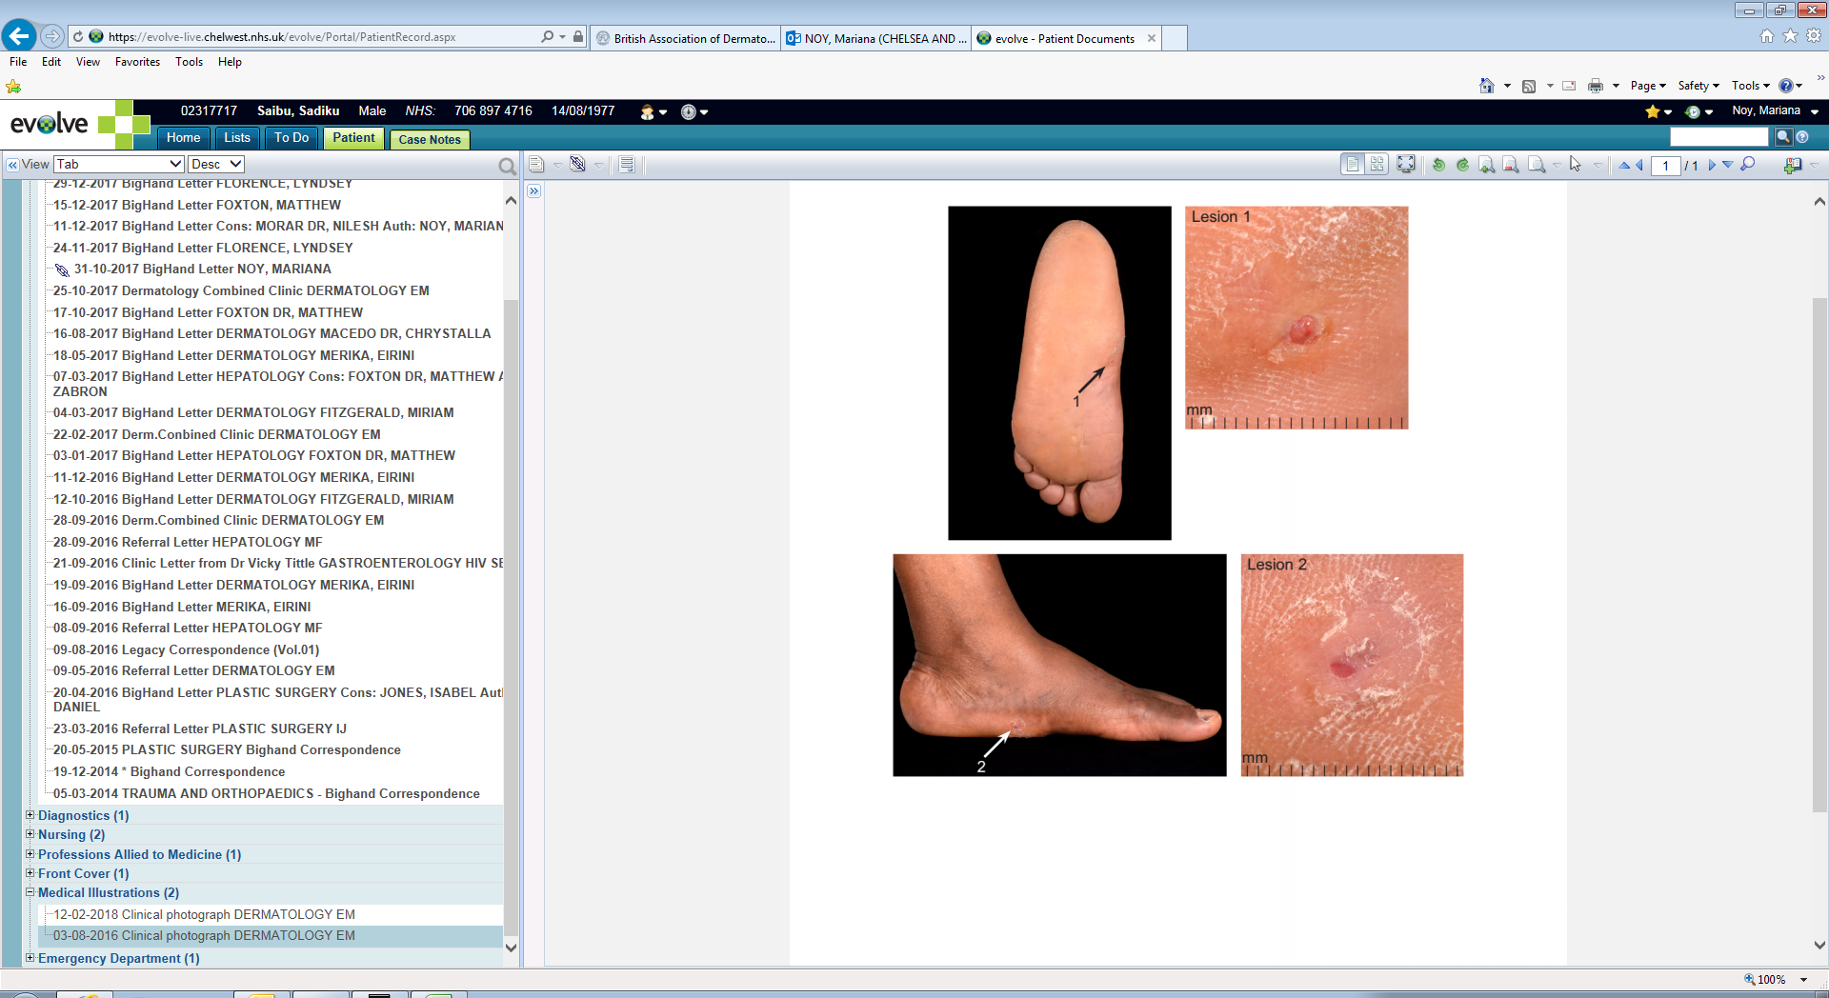
(a)

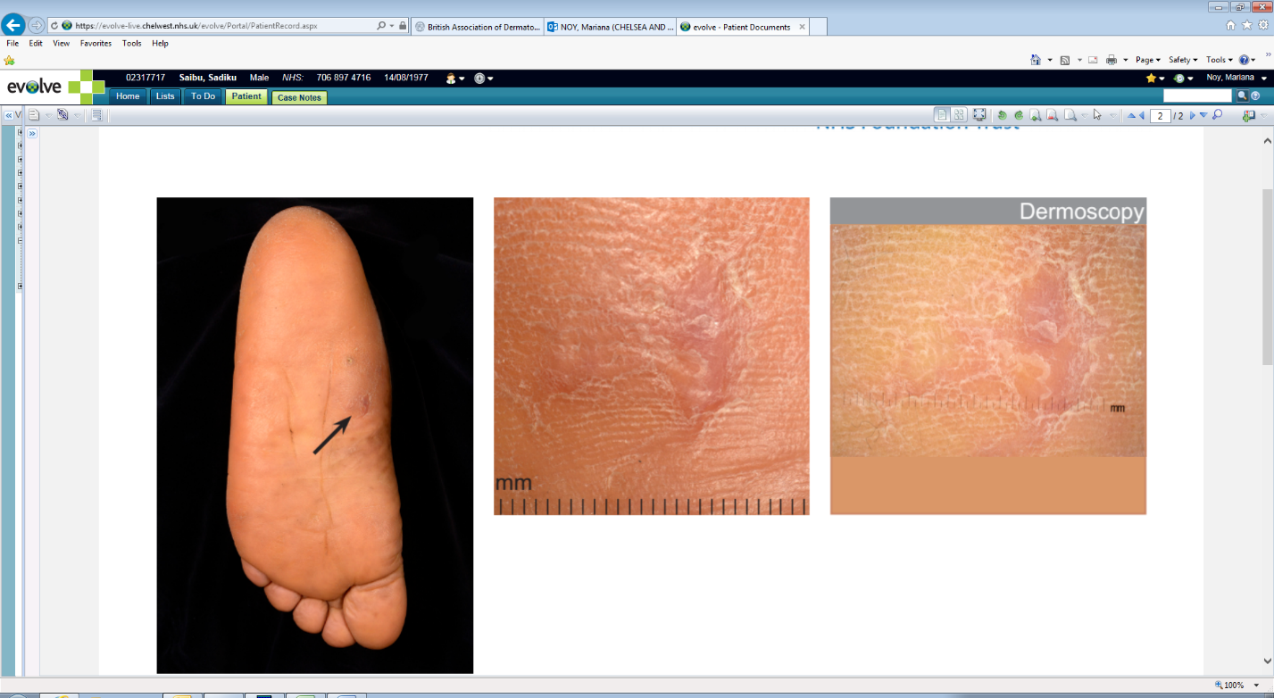
(b)

Figure 1 Ulcerated lesion on the plantar aspect of the left foot (a) pre and (b) post treatment

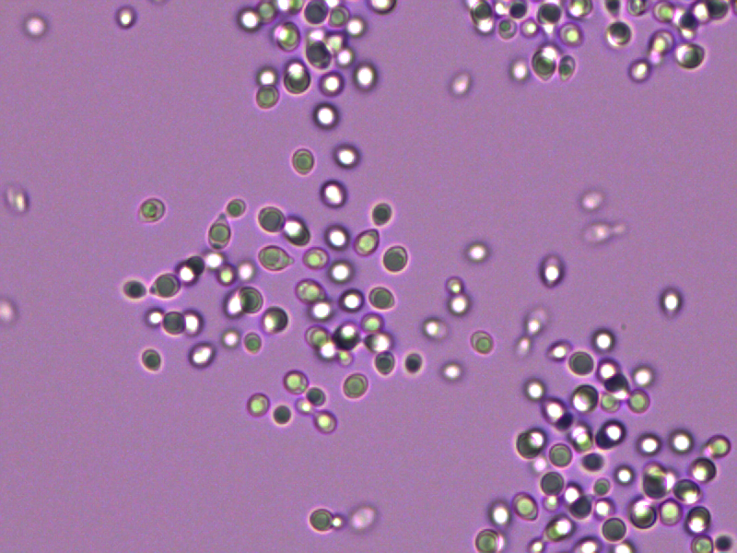
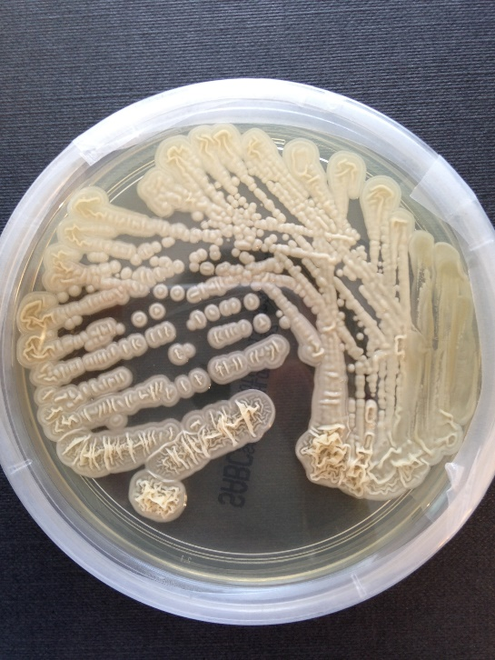
(a)
(b)

Figure 2 (a) after 3 days growth on YM broth at 28°C, the vegetative cells are ovoid, ellipsoid and elongate (2-8 x 2-13 µm), and single, paired or in clusters. Cells reproduce by budding, with no true or pseudohyphae (b) yeast colonies on SDA are pale to yellowish white, semi-shiny, smooth and wrinkled near the bottom, butyrous, and have an entire and sporadically fringed margin.

References
1 Priyadharshini G, Varghese RG, Phansalkar M, Ramdas A, K A, G T. Subcutaneous Fungal Cyst Masquerading as Benign Lesions - A Series of Eight Cases. J Clin Diagn Res. 2015;9(10):EM01-4.
2 Borman AM, Linton CJ, Miles S-J et al. Molecular identification of pathogenic fungi. J Antimicrob Chemother. 2008;61(Suppl 1):i7–12.
3 Borman AM, Campbell CK, Linton C et al. Polycytella hominis is a mutated form of Scedosporium apiospermum. Med Mycol. 2006;44(1):33–9.

4 Nath R, Sargiary P, Borkakoty B et al. Cutaneotrichosporon (Trichosporon) debeurmannianum: A Rare Yeast Isolated from Blood and Urine Samples. Mycopathologia. 2018 Jun;183(3):585-590.
5 Sugita T, Takashima M, Nakase T et al. Two new yeasts, Trichosporon debeurmannianum sp. nov. and Trichosporon dermatis sp. nov. transferred from the Cryptococcus humicola complex. Int J Syst Evol Microbiol. 2001;51:1221–8.
6 Liu X-Z, Wang Q-M, Göker M et al. Towards an integrated phylogenetic classification of the Tremellomycetes. Stud Mycol. 2015;81:85–147.

Declarations
Consent for publication
Written consent from the patient was obtained for this case study.
Funding
No specific funding was obtained.
Authors’ contributions
MLN drafted the initial manuscript with all authors contributing significantly to revising this for submission (MLN and EEM contributed to dermatological sections. AA and AMB contributed to laboratory mycology sections. NF contributed to the histopathology sections. LSPM contributed to clinical infection management sections). All authors agreed on the final version for submission to the journal.
Conflicts of interest
LSPM has consulted for bioMerieux (2013), DNAelectronics (2015–2018), Dairy Crest (2017–2018), and Pfizer (2018-19) and has received research grants from the National Institute for Health Research (2013-2019) and Leo Pharma (2016), and educational support from Eumedica (2016–2018). All other authors have nil to declare.
Acknowledgements
LSPM acknowledges support from the National Institute of Health Research (NIHR) Imperial Biomedical Research Centre (BRC) and the National Institute for Health Research Health Protection Research Unit (HPRU) in Healthcare Associated Infection and Antimicrobial Resistance at Imperial College London in partnership with Public Health England. The views expressed in this publication are those of the authors and not necessarily those of the NHS, the National Institute for Health Research, or the UK Department of Health.

