Engineering the surface of a new class of adsorbents: Metal-organic framework/graphite oxide composites

Camille Petitª and Teresa J. Bandosz ^{b}∗

ª Department of Chemical Engineering, Imperial College London, South Kensington Campus, London SW7 2AZ, UK

^{b} Department of Chemistry, The CUNY Energy Institute, The City College of New York, 160 Convent Ave, New York, NY 10031, USA
ABSTRACT
This paper reviews the results of several prior studies to highlight how the concept of the Metal-organic framework/Graphite oxide (MOF/GO) composites was developed towards their application as separation media for small molecule gases at ambient conditions. The studies are analyzed from a surface engineering standpoint. The MOF /GO composites have been developed considering both the advantages and drawbacks of the composite components: MOF provided a high porosity and reactive centers and GO a dense array of carbon atoms to increase dispersive interactions. The resulting materials showed a significant enhancement in porosity owing to the formation of pores at the interface of GO and MOF crystals. GO oxygen groups were identified as nucleation sites for the formation of the MOF crystals. Other heteroatoms like N also contributed to that effect and could positively enhance the composites structural/chemical heterogeneity. That heterogeneity governed the excellent performance of the composites as reactive adsorbents of NH₃, H₂S, NO₂ and physical adsorbents of CO₂ at ambient conditions. While the MOF structure collapsed upon exposure to toxic gases, it was preserved after CO₂ adsorption indicating the recyclability of these materials. Systematic studies of the composite properties showed that such factors as the GO level of oxidation, flake sizes of the graphite precursor and the geometry of MOF crystals are of paramount importance dictating the final morphology of the composite. The properties of the composites make them potentially suitable for gas sensing or energy harvesting.
KEYWORDS
Metal-organic framework; graphite oxide; composite; hybrid materials,; adsorption; separation; surface chemistry; materials engineering
1. Introduction
Recent research on the synthesis and use of novel functional nanomaterials has led to multiple classes of compounds, one of them, of interest to the current paper, is that of Metal-Organic Frameworks (MOFs). These materials consist of metallic ions or metal oxide polyhedra all connected via organic molecules, also called ligands [1]. Such a molecular arrangement results in crystalline compounds with a highly porous structure [1]. Owing to the large porosity of these 3D networks, MOFs have naturally become prime candidates for gas separation [2, 3]. In addition, the metallic sites provide catalytic properties that have been exploited in several reactions [4, 5]. Despite these interesting features, some MOFs still exhibit weak points that have hinder their large-scale deployment. For instance, poor water stability, although improved in the past years, remains a major concern and causes the collapse of the materials with loss of crystallinity [6-8]. This is often attributed to the fragile nature of the metal/ligand junctions. In addition, because of their organic component, MOFs are less thermostable than their structural cousins, i.e. zeolites, with typical decomposition temperatures ranging between 300 and 500 ºC. Unlike many porous materials such as activated carbons, MOFs’ pores are not atomically dense. This aspect limits the retention of small molecules due to weak dispersive forces. Finally, MOF are commonly either only microporous, for the vast majority, or only mesoporous. On the other hand, a hierarchical combination of mesopores and micropores is often preferred for the adsorption of small molecules. Indeed, for separation applications, mesopores facilitate diffusion and enhance kinetics while micropores enable higher adsorption capacity.
Two approaches are usually proposed to address the above-mentioned challenges: i) modification of the MOF itself via functionalization of the ligands, tuning of the metal/ligand interactions, or selection of different metals and/or ligands, and ii) building MOF-based composites. The latter approach is particularly attractive as it can potentially, not only limit the shortcomings of the MOF, but also bring synergistic properties. Two recent reviews broadly describes the formation and applications of a variety of MOF-based composites [9, 10]. These composites take various forms such as: i) metallic, metal oxide or polyoxometalate nanoparticles dispersed on MOF’s surface, ii) polymer-impregnated MOFs and iii) MOF/porous substrate composites. The latter category has mostly been exploited to engineer new and beneficial pore structures for targeted applications (i.e. usually the adsorption of small molecules, e.g. CO₂, NH₃, H₂). For instance, Gorka and coworkers built mesoporous silica/MOF composites and mesoporous alumina/MOF as a way to introduce mesopores to the system, thereby enhancing gas diffusion [11]. A similar approach was adopted by Furtado and coworkers who formed HKUST-1/MCM-41 composite to be used for ammonia adsorption [12]. Unlike the pure MOF, the composite exhibited a better chemical stability with minimal degradation upon ammonia adsorption. Along with these inorganic substrates, activated carbon has also been employed as a potential support for the growth of MOF crystals [13, 14]. The added advantage of carbon-based substrates resides in their hydrophobicity and their relative chemical stability. Taking advantage of these aspects, Yang and coworkers synthesized a MOF-5/carbon nanotube (CNT) composite [15]. As anticipated, the composite was found to be more resistant to humidity compared to the initial MOF-5. It also exhibited an enhanced CO₂/N₂ separation performance, which was linked to the formation of ultramicorpores at the CNT/MOF interface. Recently, we have developed and patented the synthesis of composites based on MOF and graphene-derived materials (i.e., graphite, graphite oxide and aminated graphite oxide) [16-33]. These materials have been specifically applied to the adsorption of small molecule of gases (e.g. NH₃, NO₂, H₂S and CO₂). The motivation behind the formation of these composites was to: i) take advantage of the large porosity and rich chemistry of MOFs which is beneficial for reactive gas adsorption and ii) enhance the dispersive forces compared to the pure MOF via incorporation of the graphene sheets which are atomically dense. As discussed in this paper, experiments have confirmed these hypotheses. Since our introduction of these materials, similar approaches have been adopted by other research groups [3, 14, 34-44].
This feature article reviews a series of studies by the authors in order to highlight how the substrate’s surface features as well as the type of MOF employed correlate with the chemical and physical properties (including adsorptive properties) of the resulting composites. Toward this goal, we critically present the results of our studies on MOF/graphene-based composites [16-32]. Although the findings of this work have already been published, they are for the first time gathered here to allow a direct comparison and highlight general trends with a stress on engineered surface properties. This article is divided into six sections. The following one (Section 2) describes the synthesis procedure of the composites and the reason behind the choice of an in-situ approach. The characterization techniques and the gas adsorption tests are explained as well. The targeted adsorbates included toxic gases, i.e. NH₃, NO₂ and H₂S, as well as CO₂. To put things in perspective, the readers are invited to consult two recent reviews on the use of pure MOFs for toxic gas removal [45, 46]. In Sections 3 and 4, we discuss the key surface features of the MOF and GO materials responsible for the formation of the composites and their enhanced adsorptive properties. On the other hand, the fifth section points to the chemical and structural factors limiting or even preventing the composites formation and their synergistic features. Finally, the last section summarizes the findings and provides an outlook on the future of MOF/GO composites.

2. Synthesis of the composites and determination of their adsorptive properties
2.1. Synthesis of the composites
Graphene-based compounds synthesis. Different graphene-based compounds were investigated to build the composites, namely: graphite, graphite oxide and aminated graphite oxide. When using graphite, five different types of materials were tested. All corresponded to synthetic graphite and differed in the size of the flakes and porosity.
Graphite oxide was synthesized either via the Hummers method or the Brodie method depending on the composites. These procedures are described in Ref. [47, 48] and [48, 49], respectively. Both involved the oxidation of graphite using strong oxidizing agents, which resulted in the incorporation of oxygen groups. Specifically, epoxy and hydroxyl groups formed on the surface of the graphene layers while carbonyl and carboxylic groups were found at the edges of the basal planes [50, 51].
Aminated graphite oxide was prepared by dispersing GO in an aqueous solution of urea, followed by stirring to initiate a reaction between the oxygen groups of GO and the amine groups of urea. The sample was then filtrated and dried. The amount of urea used for modifications varied based on intended completeness level of its reactions with GO surface oxygen groups. A more detailed description of the synthesis procedure is available in Ref. [28-30]. These composites are referred to as HKUST-1/GOUi with i = 1, 2 and 3 for the different amounts of urea.
The variety of the graphene-based precursors was expected to bring a detailed insight into the surface engineering process. Particularly, this was done to investigate the effects of the structural and chemical features of the graphene sheets on the formation of the composites and their adsorptive properties. Additional information on these graphene-based materials can be found in Table 1.

Table 1. Description of the precursors used to synthesize the composites (metallic, organic and graphene-based) and their composition.
Type of graphene-based component | Composite Names | MOF precursors | Graphite precursor and synthesis details | Graphene-based component content in the composites
Graphite | HKUST-1/ Graphite | Cu(NO₃)₂⋅2.5H₂O  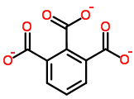 | Graphite from Sigma Aldrich; < 20 μm flakes | 11 wt%
 | HKUST-1/ Graphite |  | Graphite from Asbury; ~200 μm flakes | 10 wt%
 | HKUST-1/ Graphite |  | Graphite from Asbury; 2-3 μm flakes | 11 wt%
 | HKUST-1/ Graphite |  | Graphite from Asbury; 6 μm flakes | 15 wt%
 | HKUST-1/ Graphite |  | Natural exfoliated graphite from Asbury; 400-1000 μm flakes | 4 wt%
Graphite oxide  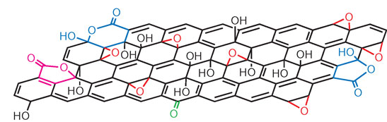 | MOF-5/GO | Zn(NO₃)₂⋅6H₂O  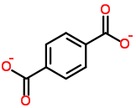 | Graphite precursor from Sigma Aldrich; < 20 μm flakes  Oxidation via Hummers method | 5 wt%  10 wt%  20 wt%  55 wt%
 | HKUST-1/ GO | Cu(NO₃)₂⋅2.5H₂O | Graphite precursor from Sigma Aldrich; < 20 μm flakes  Oxidation via Hummers method | 5 wt%; 9 wt%; 18 wt%; 36 wt%; 46 wt%
 | HKUST-1/ GO |  | Graphite precursor from Sigma Aldrich; < 20 μm flakes  Oxidation via Brodie method | 10 wt%  30 wt%
 | HKUST-1/ GO |  | Graphite precursor from Cummings-Moore; 10-20 μm flakes  Oxidation via Brodie method | 10 wt%  30 wt%
 | HKUST-1/ GO |  | Graphite precursor from Asbury; 6 μm flakes  Oxidation via Brodie method | 10 wt%  30 wt%
 | MIL-100/GO | Fe powder | Graphite precursor from Sigma Aldrich; < 20 μm flakes  Oxidation via Hummers method | 4 wt%  9 wt%
Aminated graphite oxide | HKUST-1/ Aminated GO  also referred to as HKUST-1/GOUi | Cu(NO₃)₂⋅2.5H₂O | Graphite precursor from Sigma Aldrich; < 20 μm flakes  Oxidation via Hummers method  Preparation of aminated GOs with 0.030 mol l⁻¹aqueous solution of urea | 10 wt%
 | HKUST-1/ Aminated GO  also referred to as HKUST-1/GOUi |  | Graphite precursor from Sigma Aldrich; < 20 μm flakes  Oxidation via Hummers method  Preparation of aminated GOs with 0.15 mol l⁻¹ aqueous solution of urea | 10 wt%
 | HKUST-1/ Aminated GO  also referred to as HKUST-1/GOUi |  | Graphite precursor from Sigma Aldrich; < 20 μm flakes  Oxidation via Hummers method  Preparation of aminated GOs with 0.3 mol l⁻¹ aqueous solution of urea | 10 wt%

MOFs and composite synthesis. All composites described in this article were synthesized following the same general procedure, regardless of the type of MOF or the properties of the graphene-based species used. A scheme of the synthesis procedure is provided in Figure 1. First, the MOF precursors, i.e. the metallic salt or metal and the organic ligand, were mixed with the solvents typically employed to synthesize the pure MOF. After a complete dissolution, the graphene component was added, in the form of graphite, GO or aminated GO, depending on the composite. The amount of graphene-based compound added was selected so that its content in the final composites ranged from 5 wt% to 55 wt% (see Table 1). The addition of the graphene-based component was followed by sonication to trigger the exfoliation of this carbon-based material. The formation of the MOF crystals, and thereby the formation of the composites, then proceeded via heating of the reaction mixture under the conditions used to synthesize the pure MOF (i.e. duration and temperature). The reaction took place either in a Pyrex round-bottom flask or in an acid digestion bomb, depending on the MOF. In the former case, shaking of the reaction mixture was applied. Once synthesized, the composites were filtered using a Buchner filter and solvent exchange was carried out. Finally, the samples were dried under vacuum at the same temperature as that employed for the synthesis of the pure MOF. The specific conditions for the synthesis of each composites can be found in the following references: MOF-5/GO composites [19]; HKUST-1/GO composites [21]; MIL-100/GO composites [17]; HKUST-1/aminated GO [28-30]; and HKUST-1/graphite composites [26]. The synthesis of the corresponding MOFs followed the same method as that of the composites except for the addition of the graphene-derived materials. Additional information on the composites’ synthesis and composition is provided in Table 1.
This in-situ synthetic approach was preferred compared to a physical mixing approach because: i) the defects and/or functional groups of the graphene-based components can serve as nucleation sites during the MOF crystals formation [34], ii) chemical reactions can lead to synergistic features, and iii) it allows a close contact between the graphene sheets and the MOF component, thereby leading to the formation of a new porosity. The latter two aspects will be discussed in depth in Section 3.

Figure 1. Schematic of the composites synthesis (top) and examples of the chemical species involved in the synthesis along with the resulting composite (bottom, here: MOF-5/GO composite).

2.2. Determination of the adsorption capacity
The adsorption of toxic gases, namely NH₃, H₂S and NO₂, was evaluated using dynamic breakthrough tests. In a typical experiment, a flow of the targeted gas mixed with air, either dry or humid, went through a fixed bed containing the adsorbent. The concentration of the targeted gas in the outlet stream was then measured using an electrochemical sensor. The test was conducted until the outlet gas concentration reached the upper limit of the sensor. The adsorption capacity was determined by integration of the area above the breakthrough curve. In the case of H₂S adsorption, the adsorbent was exposed to a flow of moist air prior to running the breakthrough tests. Information on the conditions of the runs (e.g., temperature, pressure, flow rate, gas concentration) is provided in Table 2. Further details can be found in the following papers: [24] (NH₃), [25] (H₂S) and [16] (NO₂).
CO₂ adsorption was determined using dynamic gravimetric tests [30], adsorption at equilibrium at atmospheric pressure [28] and at high pressure of 1.5 MPa [32]. All experiments were run at temperatures ranging from 0 to 33 ºC. Details on the experimental conditions are provided in Table 2.
The materials were characterized before and after adsorption using a variety of analytical techniques, i.e. X-ray diffraction (XRD), thermogravimetric measurement, nitrogen adsorption, FT-IR spectroscopy and scanning and transmission electron microscopy (SEM and TEM).

Table 2. Conditions and techniques used to determine the adsorption capacity of the composites for different small molecule gases.
Gas | Measurement technique | Gas concentration | Balance | Total flow rate | Temperature and pressure
NH₃ | Breakthrough test using a fixed bed | 1000 ppm | Dry air or moist air (70% humidity) | 225 mL/min | 25 ºC, 0.1 MPa
H₂S | Breakthrough test using a fixed bed | 1000 ppm | Dry air or moist air (70% humidity) | 225 mL/min | 25 ºC, 1 0.1 MPa
NO₂ | Breakthrough test using a fixed bed | 1000 ppm | Dry air or moist air (70% humidity) | 250 mL/min | 25 ºC, 1 0.1 MPa
CO₂ | Gravimetric dynamic experiments | Pure CO₂ | NA | 50 mL/min | 30 ºC , 0.1 MPa
CO₂ | Volumetric experiments at equilibrium | Pure CO₂ | NA | Not applicable | 0 ºC and 25 ºC, up to 0.1 MPa
CO₂ | Volumetric experiments at equilibrium | Pure CO₂ | NA | Not applicable | Various temperatures 0ºC-33 ºC, up to 1.5 MPa

3. MOF/Graphite oxide adsorbents as versatile adsorbents for toxic gases and CO₂
This section focuses on the composites involving graphite oxide, namely MOF-5/GO and HKUST-1/GO (see Table 1) [16, 18-25, 27]. Prior to testing these materials for gas separation, it was important to confirm their structural and chemical features. Therefore, they were initially characterized using a range of analytical techniques. First, the crystallinity of the materials was tested via XRD and the results are shown in Figure 2. Overall and regardless the GO content, the patterns of the composites, MOF-5/GO and HKUST-1/GO, resemble those of the corresponding MOFs. These features indicate that the MOF crystals were successfully formed in-situ, in the presence of the graphite oxide layers. On the other hand, the peak related to graphite oxide, typically observed at 2 Theta ~ 10 º, is missing, which is a sign of the graphene oxide layers being exfoliated. From these XRD patterns, one can already formulate some hypothesis regarding the formation of these MOF/GO composites. Taking into account the synthesis conditions, the graphene oxide layers were likely exfoliated as a result of the sonication and the presence of polar solvents. Afterwards, the formation of the MOF crystal took place. Some studies have highlighted the potential of substrates or MOF seeds to act as nucleation sites for MOF crystalline particles [34]. It is therefore reasonable to believe that the graphene oxide sheets acted as nucleation sites. Graphene oxide sheets are in essence heterogenous owing to the presence of various oxygen groups. Therefore, one can ask which factor had the predominant effect on the nucleation process: e.g. the graphene sheets themselves, the graphene sheets surface defects, the oxygen groups in general or specific oxygen groups. The next paragraph provides a partial answer to that question.

Figure 2. XRD patterns of the composites: (A) MOF-5/GO and (B) HKUST-1/GO along with those of the parent materials, i.e. MOF-5, HKUST-1 and GO. The GO content in the composites is indicated above each pattern. Adapted with permission from Ref.[19, 21]; Copyright 2014, WILEY-VCH Verlag and Elsevier.

Thermogravimetric analyses were conducted to investigate the specific chemical features of the composites. Figure 3 displays the thermogravimetric curve derivatives of GO, MOF-5 and a MOF-5/GO composite. The DTG curve for GO exhibits peaks below 100 ºC, for the removal of adsorbed water, at 200 ºC, for the decomposition of the epoxy groups, and above 250 ºC (shoulder and broad peaks), for the decomposition of the other oxygen groups. The key feature here is the absence of the epoxy-related peak on the curve of the composite. This is a sign that the epoxy groups reacted during the composite formation. The lone pairs of electrons on the oxygen of the epoxy groups of GO may have coordinated the metallic species used as MOF precursors. A reaction between the carboxylate ligand and these epoxy groups is another potential cause. In both cases, it is clear that the epoxy groups of GO played a role in the nucleation of the MOF crystal as it led to the formation of bonds between GO and the organic ligands and/or metallic species of the MOF. This does not exclude the fact that other oxygen groups may have been involved or that the graphene sheets defects influenced the composites formation. However, this hypothesis cannot be analyzed by thermogravimetry. Overall, these conclusions were also drawn for the MOF-5/GO composites with other GO contents and for the entire group of HKUST-1/GO composites.

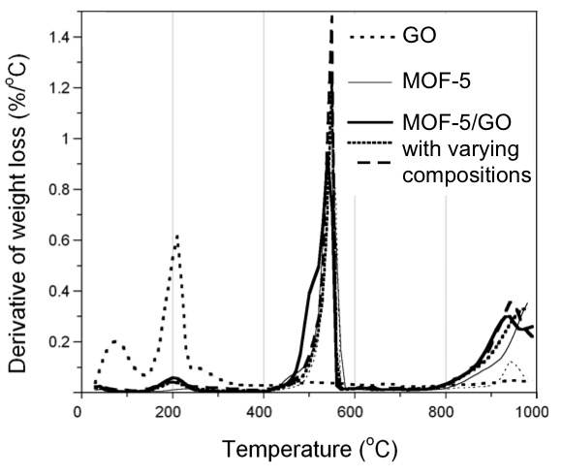
Figure 3. Derivatives of the thermogravimetric curves for GO, MOF-5 and MOF-5/GO (GO content: 5 to 55 wt%). Adapted with permission from Ref. [18]; Copyright 2010, WILEY-VCH Verlag.

These chemical interactions between the GO surface groups and the MOF influence the structure of the resulting composites, as shown by the results of the porosity measurement discussed below. While the surface area, total volume of pores and volume of micropores were all measured, only the latter two parameters are displayed here (Figure 4) for the sake of saving space and presenting only crucial information. However, the trends observed also apply to the surface area. It is important to notice here that in Figure 4, we distinguish the porosity actually measured from the porosity calculated for a physical mixture. The latter value is determined as follows (1):
$V_{composite}=xV_{MOF}+(1-x)V_{GO}$ (1)
where V_{i} is the volume of pores of material i (total volume or micropore volume, per mass of material) and x is the weight fraction of the MOF in the composite. In essence, the calculated pore volume represents the pore volume of a physical mixture of MOF and GO. This concept is used throughout this article. As seen in Figure 4, HKUST-1/GO composites have higher pore volumes (micropore and total) than those of the hypothetical physical mixtures. These new pores cannot originate from MOF particles or GO particles alone. Indeed, we found that the MOF crystalline structure was unchanged in the composites and GO could not have formed new compounds, and therefore create new pores, under the reaction conditions. On the contrary, these new pores must be located at the interface between the MOF units and the GO sheets. If the composites were simple physical mixtures, new pores might be created as well but they would likely be in the macropore range taking into account the size of GO flakes. Here, on the contrary, the volumes of micropores increased. Considering the findings from the thermogravimetric analyses, it is hypothesized that the bonds between the oxygen groups of GO and the MOF units are responsible for this new porosity. This vision is schematized in Figure 5. Interestingly, the enhancement of porosity compared to the physical mixture is not observed in the case of MOF-5/GO composites. This finding does not contradict the formation of these new pores. On the contrary, based on the thermogravimetric analyses, these new pores likely exist. The reason for this lack of apparent enhancement must be related to the lower porosity of the MOF crystals in the composites compared to those in the pure MOF. This statement is supported by the fact that the MOF crystals in MOF-5/GO appeared slightly distorted compared to those in pure MOF as is visible on the XRD patterns (Figure 2). Indeed, the peak at 2 Theta ~ 9.5 º is split in the composites especially those with high GO contents. This feature is related to a distortion of MOF crystals [53]. This distortion might have precisely been caused by the reaction between the GO layers and the MOF precursors.

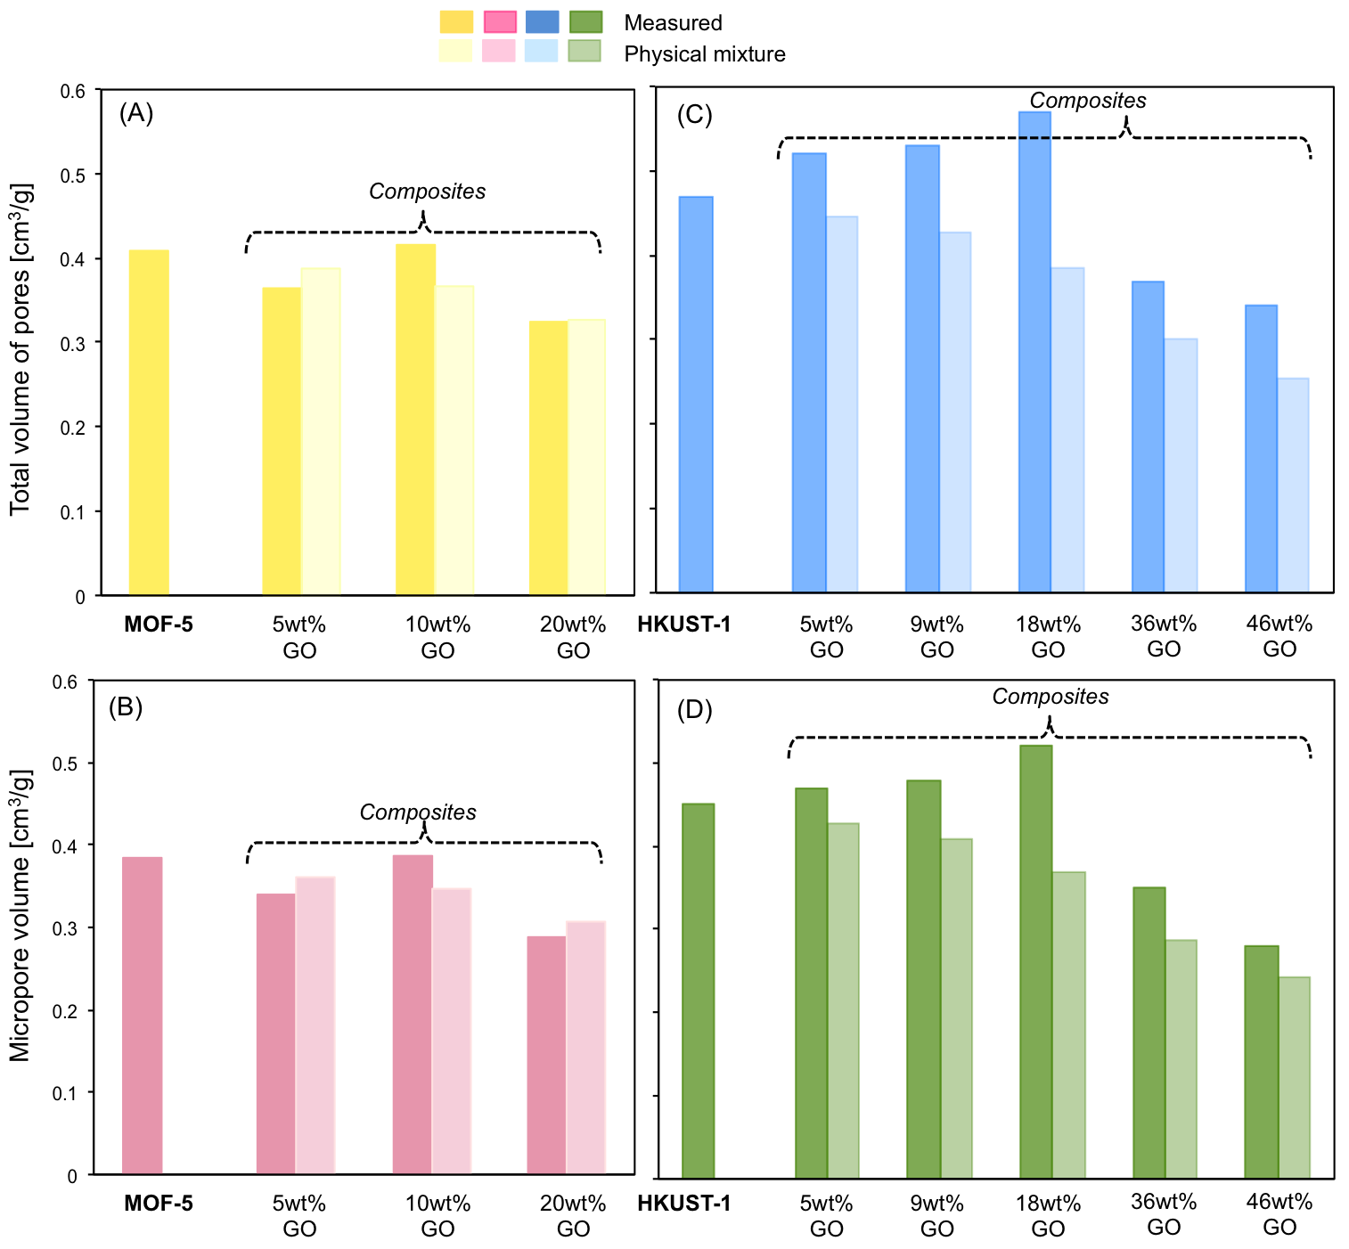
Figure 4. Results of the porosity measurements from N₂ sorption for the composites (MOF-5/GO and HKUST-1/GO) and the parent MOFs: (A, C) total volume of pores and (B, D) volume of micropores. The grey bars correspond to MOF-5-based materials, and the blue bars to HKUST-1-based materials. The GO content in the composites is indicated under each bar. Data for this figure were taken from Ref. [19, 21].

Figure 5. Schematized structure of the MOF-5/GO and HKUST-1/GO composites with visualization of the location of new pores. The pictures are SEM images of the specific composites addressed in Ref. [19] and [21].

Porosity is a crucial parameter for gas separation and therefore the creation of the new pores described above is likely to impact the adsorption of small molecule gases. To test this hypothesis, the NH₃, NO₂, H₂S and CO₂ adsorption capacities of the composites were measured and compared to those of the parent materials. The results for the toxic gases adsorption are presented in Figure 6. In the case of CO₂ adsorption, only one composite was tested in dry condition (HKUST-1/GO with 10 wt% GO). At 25 ºC and 0.1 MPa, the CO₂ equilibrium adsorption capacity for that composite jumped from 102 mg/g for the pure MOF to 136 mg/g for the composite. As it corresponds to only one result, it was not displayed on Figure 6 for the sake of saving space. This enhancement was also observed for the different composites for the adsorption of the various gases, expect for NO₂ removal under humid conditions. The improvement in the adsorption capacity can be quite significant and it is attributed to the new pores formed in the materials. In these new pores, the dispersive forces are expected to be enhanced owing to the presence of the graphene oxide layers. These forces are particularly important when considering the adsorption of small molecules at ambient conditions. The lower performance of the composites for NO₂ adsorption in moist conditions was attributed to a competitive adsorption between NO₂ and H₂O molecules. It must be noted that although pore size distribution (PSD) could have helped confirm the size of the new pores being formed in the composites, these results were not reported here owing to the lack of precise models to be used for DFT calculations. Nevertheless, the shapes of the isotherms indicate the predominant microporosity [19, 21, 31] and thus the difference in the volumes of pores could be analyzed.
Considering the above findings, one can envision the ideal composite as being composed of alternating single layers of graphene and single layers of MOF units. Such an arrangement would lead to an optimization of the occurrence of graphene layers/MOF units interface. One factor influencing the MOF/GO composite structure is the size of the graphene oxide flakes [31]. It is expected that flakes of grahene oxide similar to or smaller than to the size of MOF crystal would be preferred.

Figure 6. Adsorption capacities of GO, MOF-5, HKUST-1 and the corresponding composites for the removal of NH₃, NO₂ or H₂S. Results are for the experiments carried out in dry air (left) and moist air (right). The GO content (in wt%) in the composites is indicated under each bar. Data for this figure were taken from Ref. [16, 18, 24, 25].

The surface of the composites is decorated with many reactive sites that are likely to be involved during adsorption of non-inert gases. In fact, an indication of a reactive adsorption mechanism is provided by measurements of heat of adsorption. For instance, the isosteric heat of adsorption of NH₃ on HKUST-1/GO composites ranged from 35 to 50 kJ/mol at low coverage, depending on the composites [22, 27]. These values are higher than those typically encountered for purely physisorption processes and therefore must originate from the chemical interactions between the gas molecules and the surface functional groups of the composites. Particularly, the gases can interact with the oxygen groups of GO (those that are not involved in bonding with the MOF units) and the metallic sites of the MOF. In the case of HKUST-1/GO composites, the interactions between the toxic non inert gas and the metallic sites are particularly favored since the metal is unsaturated and therefore can directly coordinate with the gas molecules. This phenomenon is evidenced by the change in color of the material upon contact with the gas. The interactions between the gas molecules and the composites are however not limited to the latter phenomenon. Gas molecules were indeed found to react with some of the functional groups that act as structuring agents in the MOF units. This is for instance evidenced by FT-IR spectroscopy. As seen in Figure 7, the spectrum of HKUST-1/GO composite is changed upon exposure to ammonia. Specifically, the shape and intensity of the bands in the carboxylate region (around 1600 cm⁻¹) changed. In addition, new bands appeared in the 1200 cm⁻¹ region. All these trends are indicative of the presence of a “free” benzene tricarboxylate ligand, i.e. not coordinated to the metallic sites. Note that benzene tricarboyxlate is the precursor used to synthesize HKUST-1. It is therefore concluded that ammonia reacted with the benzene tricarboxylate ligands leading to a collapse of the MOF and therefore the composites, as confirmed by the loss of the crystallinity of the materials (Figure 8). Reaction of the gases with the MOF units was globally observed for the adsorption of H₂S and NO₂ on the same composites, but the mechanisms involved other reaction paths. In the case of the adsorption of ammonia on MOF-5/GO composites, the collapse was only observed for a high GO content (Figure 8). This is because, at a low GO content, only small amounts of ammonia were adsorbed (Figure 6(A)) which rendered their effect on the structure of the composites invisible. The collapse of the structure in the case of this composite is due to the fact that ammonia interacted with the zinc oxide tetrahedra via hydrogen bonding. As more ammonia was adsorbed, these interactions progressively weakened the zinc oxide/ligand interactions, thereby breaking the MOF structure.
The decomposition of the materials after adsorption directly impacts their recyclability. Nevertheless, for some applications involving toxic gases, this is not of paramount importance. Examples are gas mask filters for which the breakthrough capacity and strength of adsorption are the essential criteria. In those cases, a sufficient protection against toxic gas exposure determines the economics of real –life applications.

Figure 7. FT-IR spectroscopy of a HKUST-1/GO composites (GO content: 20 wt%) before and after exposure to ammonia in different conditions. Data for this figure were taken from Ref. [24].

Figure 8. XRD spectra before and after exposure to ammonia in dry air of: (A) MOF-5/GO and its corresponding parent materials and (B) HKUST-1/GO and its corresponding parent materials. Data for this figure were taken from [18, 24].
4. MOF/aminated graphite oxide as CO₂ capture media
Since MOF/GO composites proved themselves as very effective adsorbents for toxic reactive gases, a next important environmental application to test their suitability was as CO₂ capture media. Here the GO phase was modified with urea to introduce amines to the surface [29]. This was done knowing that amination of a surface is commonly used to increase the CO₂ adsorption on various adsorbents [54, 55]. The results obtained exceeded our expectation. The comparison of the amounts of CO₂ adsorbed in mmol/g on the composites with GO treated with different amounts of urea is presented in Figure 9 (The urea content increased from HKUST/GOU1 to HKUST-1/GOU3, Table 2). The data obtained on MOF itself and on MOF/GO composite are also included. As seen, the results collected at three different adsorption conditions (dynamic gravimetric [30], volumetric up to 0.1 MPa [28] and up to 1.5 MPa [32]) are very consistent and a systematic increase in the amount adsorbed is found with an increase in the amount of urea used for the GO modification. What is important to mention is that the amount of CO₂ adsorbed increased about 100% in comparison with that on MOF. Moreover, the adsorption at high pressure was totally reversible at various temperatures of measurements indicating the excellent cyclability of the adsorbents [32]. The selectivity study for the high-pressure adsorption showed that selectivity for CO₂/CH₄ and CO₂/N₂ separation was 9.6 and 24.8, respectively at ambient temperature.

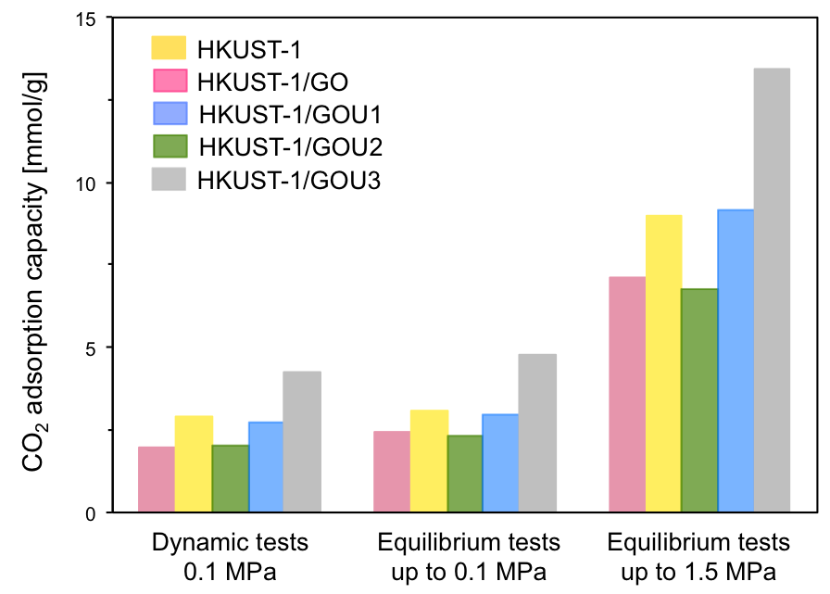
Figure 9. Comparison of the amounts of CO₂ adsorbed measured at different conditions on MOF and its composites with GO and aminated graphite oxides (left: dynamic gravimetric tests; middle and right: volumetric tests at equilibrium). The tests were conducted in pure CO₂ with temperatures ranging from 0 ºC to 33 ºC, depending on the types of test. Data were taken from [28-30, 32].

Since the cyclability results clearly showed that CO₂ is physically adsorbed and that the composites can be used in multicycle experiments [32], the development of porosity, and specifically pores with sizes about 0.6 nm upon composite formation, was linked to the marked increase in the performance. As indicated by Wu and coworkers [56], open copper sites are the CO₂ specific adsorption centers in the MOF itself (HKUST-1). In our case, the small pores at the interface as well as the defects in the crystal structure increased the amount adsorbed. The EDX analysis of the adsorbents showed that the amount of copper detected on the surface increased with an increase in the amount of urea used for GO treatment and thus so did the surface structural and chemical heterogeneity. To illustrate the physical adsorption of CO₂ on MOF and the composites, Figure 10 presents the dependence of the amount adsorbed at different conditions on the volume of micropores. The specific data points are marked in the plot to point out the differences in the porosity between the composites and the MOF itself. As seen, in the case of the best performing samples, building the composites increased the volume of micropores (and surface area) by 50 %. Since the adsorption increased by more than 90 %, there must be another factor besides the porosity enhancement to explain the increased adsorption capacity. We link this feature to an increase in the number of open copper sites where CO₂ can be specifically adsorbed. Similarity between the data obtained in dynamic experiments and in equilibrium under atmospheric pressure suggests a very fast kinetic of the CO₂ adsorption process. Moreover, the heat of CO₂ adsorption was found to be relatively low, about 23 kJ/mol) [28]. The flat trend in the adsorption heat as a function of coverage shows the abundance of the equal-energy adsorption centers.

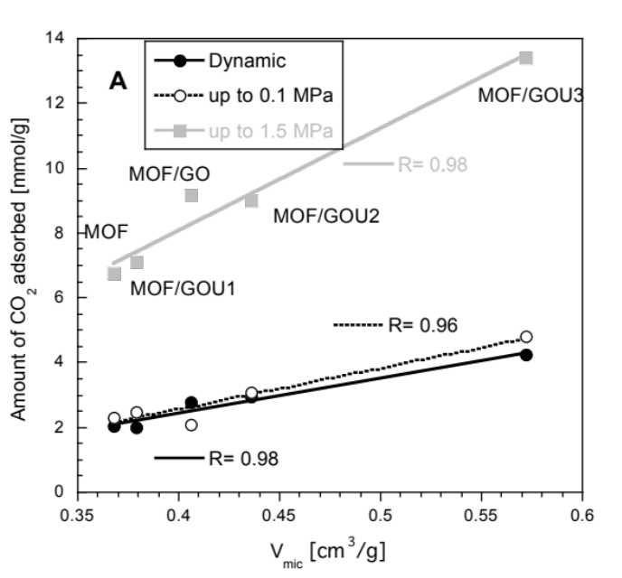
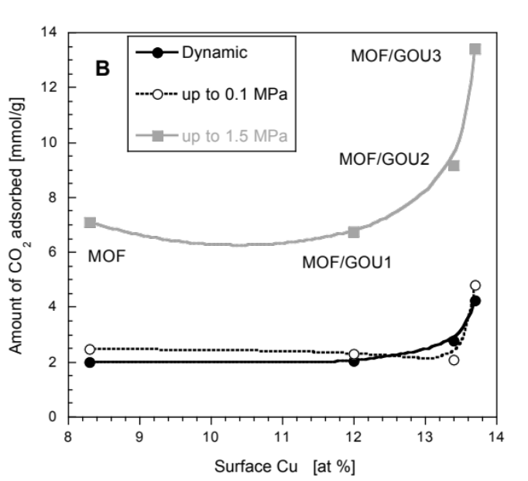

Figure 10. Dependence of the amount of CO₂ adsorbed at various conditions on the volume of micropores (A) and the surface concentration of copper (B). The tests were run using pure CO₂. Data for this figure were taken from Ref. [28-30, 32].

The number of sites for CO₂ adsorption apparently increased compared to the MOF itself and we link this increase to the increase in the level of structural and chemical heterogeneity. It is especially visible on SEM images where embedding the aminated graphite oxide sheets within the MOF crystals resulted in visible changes in their appearance with a lace–like pattern (Figure 11).

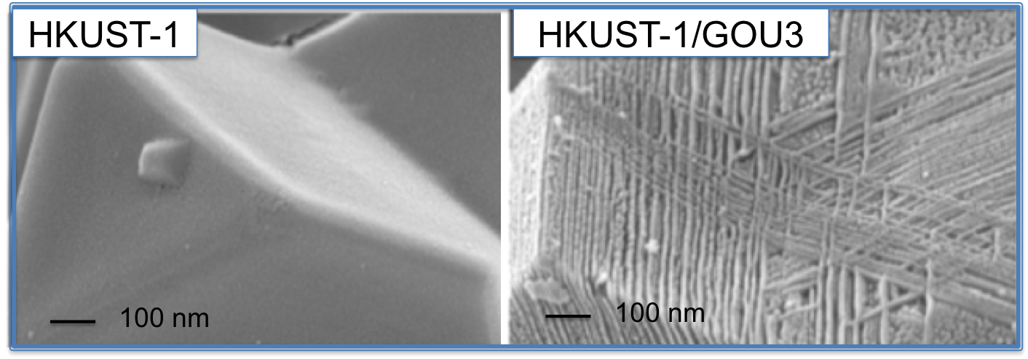
Figure 11. SEM images of the MOF and aminated composite MOF/GOU. The images have been discussed in Ref. [29].

In the case of the composites with aminated GO not only oxygen groups but also those containing nitrogen can be considered as nucleation sites for the MOF growth. Moreover the benzene tricarboxylate ligands can also interact with amines present on the surface of the GO layers. The summary of the process taking place during composite formation and CO₂ adsorption is presented in Figure 12.

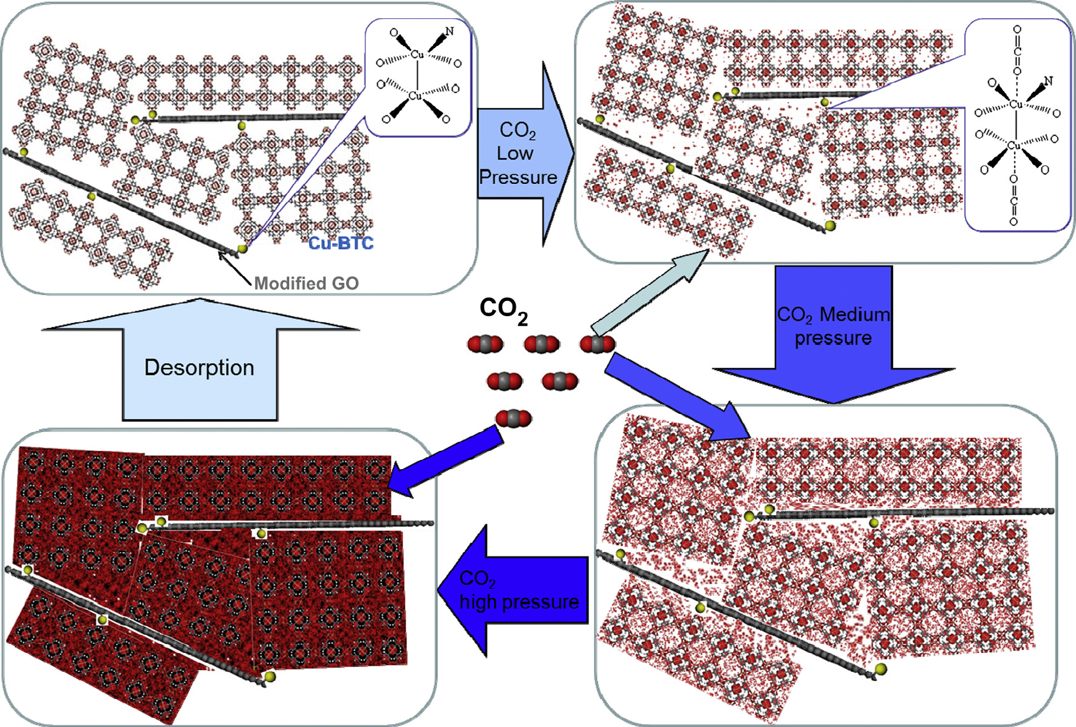
Figure 12. Schematic representation of CO₂ adsorption sites on the heterogeneous MOF/ aminated GO composites. Reprinted with permission from Ref. [28]. Copyright 2014, Elsevier.

5. The limits of MOF/graphene-based composites
Although the previous sections describe the successful synthesis of MOF/GO composites, it should not lead to the conclusion that all MOFs can be used to produce composites with similar properties. In fact, we found that the MOFs’ morphology, i.e. the shape and arrangement of the pores, was crucial to the resulting structure of the composites and therefore their properties. Such a conclusion was drawn from the study of MIL-100/GO composites (Table 1) [17]. Unlike MOF-5 and HKUST-1, MIL-100 exhibits a zeolite-like structure (Figure 13). For that reason, the arrangement of the graphene oxide layers around the MOF units differed between the two types of composites. More specifically, regardless the MOF type, the metallic sites interacted with the oxygen groups of the graphene layers as explained in section 3. In MOF-5 and HKUST-1, these metallic sites were located in parallel or perpendicular planes. Therefore the growth of the MOF crystal could proceed “normally” since the MOFs units are cubic (see Figure 13). On the contrary, in the case of MIL-100, the metallic sites were located on spheres and therefore there were multiple ways in which graphene oxide layers could interact with the metallic sites of the MOFs. Some of these ways prevented the growth of the MOF crystals as shown in Figure 13. As a result of that, MIL-100/GO composites exhibited a poor crystallinity as well as decreased porosity and adsorption capacity compared to the parent MOF or to a physical mixture as seen in Figure 14.

Figure 13. Schematic representation of the MOF/GO composite formation for different types of MOF with visualization of the crystal growth limits in the case of MIL-100/GO composite (right side). Figure adapted with permission from [17]; Copyright 2011, WILEY-VCH Verlag.

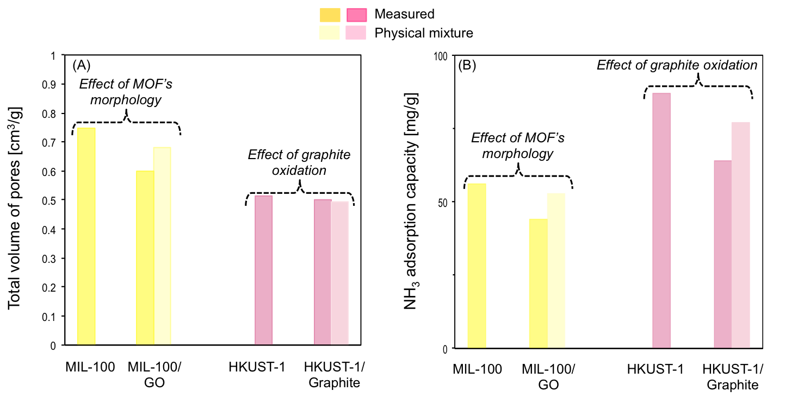
Figure 14. Limitations of MOF/graphene-based composites formation as evidenced by measurement of: (A) pore volume, and (B) ammonia adsorption. The composites displayed here are MIL-100/GO (GO content: 10 wt%) and HKUST-1/graphite (Graphite content: 11 wt%). Data for this figure were taken from Ref. [17, 26].

The morphology of the MOF component is not the only factor governing the structure and properties of the composites. The surface features of the graphene-derived materials are also important. One of these features is the oxidation level. Going to the extreme end, we studied the formation of composites based on graphite instead of graphite oxide [26]. These composites are referred to HKUST-1/graphite in Table 1. They exhibited porosity and ammonia adsorption capacities similar to or lower than those of physical mixtures as shown in Figure 14. The resemblance between these composites and the physical mixtures despite the in-situ synthesis should not be surprising. Indeed, the amount of oxygen groups on the surface of the graphite used was less than 0.2 mmol/g, which must be compared to about 2.5 mmol/g for typical GO. Therefore, chemical interactions with the MOF sites were limited. As indicated, some composites exhibited even a worse adsorption performance and porosity than that of the physical mixtures. We believe that this behavior is related to the fact that the graphite flakes contained a very small amount of oxygen groups and thus they were likely not as efficient as GO in enhancing MOF crystal nucleation. In addition, the graphite flakes could have hindered the proper formation of the MOF by acting as a physical barrier between MOF crystal seeds
Finally, the effect of the type of GO oxygen groups on the composites’ properties was studied [31]. Specifically, epoxy and carboxylic groups were compared. By using different graphite precursors, various GOs were obtained: some exhibited predominantly epoxy groups and other carboxylic groups. Composites synthesized using the latter type of GO exhibited the highest porosity. In addition, as shown by TEM (Figure 15), the MOF crystals were located at the edges of the GO layers, typically where carboxylic groups are found. It was therefore concluded that the carboxylic groups of GO also interact with the metallic sites of the MOFs and serve as nucleation sites. It is however not clear at this stage why the porosity of the composites increased in the presence of a GO material with a high carboxylic group content. The role of carboxylic groups in the formation of MOF/graphene-based materials composites has been reported by other groups who intentionally functionalized graphene layers with benzoic acid [38]. However, in the latter studies, the carboxylic groups were located on the surface of the basal planes and not on the edges. These carboxylic groups acted as structure-directing agents for the growth of the MOF crystal. It can be noted that the amount of carboxylic groups in GO tend to increase with a decrease in the graphite oxide flake size [31]. This aspect can be utilized in the future for the synthesis of MOF/GO composites with enhanced porosity.

Figure 15. TEM images of the HKUST-1/GO composite for GO with a high content of carboxylic groups. Adapted with permission from [31]; Copyright 2013, Elsevier.

6. Conclusions and future directions for the synthesis and applications of MOF/GO composites
The results collected in our efforts to design composite adsorbents for small molecule gases based on the properties of MOF and GO proved that the combination of both leads to the synergistic properties which enhance significantly the adsorptive performance. We have shown that not only a marked increase in microporosity can be achieved but also the degree of chemical and physical heterogeneity can be significantly advanced. These features have been proven as very important not only for the reactive adsorption of toxic gases but also for CO₂ capture. While the former leads to the collapse of the structure a result of the reaction of the gas molecule with either the MOF metallic centers or the functional groups of the MOF ligands, the latter can be adsorbed in large quantity in a multi-cycle regime from its mixtures with methane or N₂ with high selectivity owing to the specific, though still physical and highly reversible, interactions with the surface. The properties of the composites were shown as dependent on the type and geometry of the MOF and the physical and chemical features of GO such as the sizes of the flakes, the level of oxidation or the distribution of the type of oxygen groups on the surface. It is important to mention that not every kind of MOF can be used to build these composites. A specific geometry of the MOF crystals is required. Ideally, the MOF crystal units should not exhibit a spherical shape or too close metallic centers as this can lead to a disordered arrangement of the graphene sheets thereby disturbing the MOF phase growth.
Even though our application efforts were focused on the applications of these composites as adsorbent of small molecule gases, they might also show promising capabilities for the separation of organic molecules and solvent. Here, the presence of the graphene can be a significant advantage to increase the adsorption forces. But the real excitement is now in the application beyond adsorption. These might include their use as sensors or light sensitive materials for energy harvesting applications. Building the composite can provide the heterojunctions between GO and semiconducting MOF affecting the energy gap. In both these applications, the role of GO as promoting electron transfer to active sites is therefore crucial and its chemical and structural features should be carefully controlled/designed.

ACKNOWLEDGMENTS
The authors are grateful to Dr. Svetlana Bashkova, Dr. Jacek Jagiello, Dr. Benoit Levasseur, Dr. Deanna O’Donnell, Dr. Mykola Seredych, Dr. Sabine Wrabetz, Mr. Luang, Ms. Barbara Mendoza, Dr. Policicchio and Mr. Zhao for their involvement in this research. The majority of the results reported here was obtained as a result of the research funded by the ARO (Army Research Office) grant W911NF-10-1-0039 and W911NF-13-1-0225 and NSF collaborative CBET Grant No 0754945 and 1133112.
REFERENCES
[1] S. L. James, "Metal-organic frameworks," Chemical Society Reviews, vol. 32, pp. 276-288, 2003.
[2] A. U. Czaja, N. Trukhan, and U. Muller, "Industrial applications of metal-organic frameworks," Chemical Society Reviews, vol. 38, pp. 1284-1293, 2009.
[3] J.-R. Li, R. J. Kuppler, and H.-C. Zhou, "Selective gas adsorption and separation in metal-organic frameworks," Chemical Society Reviews, vol. 38, pp. 1477-1504, 2009.
[4] J. Lee, O. K. Farha, J. Roberts, K. A. Scheidt, S. T. Nguyen, and J. T. Hupp, "Metal-organic framework materials as catalysts," Chemical Society Reviews, vol. 38, pp. 1450-1459, 2009.
[5] J. Gascon, A. Corma, F. Kapteijn, and F. X. Llabrés i Xamena, "Metal Organic Framework Catalysis: Quo vadis?," ACS Catalysis, vol. 4, pp. 361-378, 2013.
[6] P. Küsgens, M. Rose, I. Senkovska, H. Fröde, A. Henschel, S. Siegle, et al., "Characterization of metal-organic frameworks by water adsorption," Microporous and Mesoporous Materials, vol. 120, pp. 325-330, 2009.
[7] Z. Lu, H. Xing, R. Sun, J. Bai, B. Zheng, and Y. Li, "Water Stable Metal–Organic Framework Evolutionally Formed from a Flexible Multidentate Ligand with Acylamide Groups for Selective CO2 Adsorption," Crystal Growth & Design, vol. 12, pp. 1081-1084, 2012.
[8] P. M. Schoenecker, C. G. Carson, H. Jasuja, C. J. J. Flemming, and K. S. Walton, "Effect of Water Adsorption on Retention of Structure and Surface Area of Metal–Organic Frameworks," Industrial & Engineering Chemistry Research, vol. 51, pp. 6513-6519, 2012.
[9] Q.-L. Zhu and Q. Xu, "Metal-organic framework composites," Chemical Society Reviews, 2014, doi: 10.1039/C3CS60472A.
[10] I. Ahmed and S. H. Jhung, "Composites of metal–organic frameworks: Preparation and application in adsorption," Materials Today, vol. 17, pp. 136-146, 2014.
[11] J. Gorka, P. F. Fulvio, S. Pikus, and M. Jaroniec, "Mesoporous metal organic framework-boehmite and silica composites," Chemical Communications, vol. 46, pp. 6798-6800, 2010.
[12] A. M. B. Furtado, J. Liu, Y. Wang, and M. D. LeVan, "Mesoporous silica-metal organic composite: synthesis, characterization, and ammonia adsorption," Journal of Materials Chemistry, vol. 21, pp. 6698-6706, 2011.
[13] C. A. F. de Oliveira, F. F. da Silva, G. C. Jimenez, J. F. da S. Neto, D. M. B. de Souza, I. A. de Souza, et al., "MOF@activated carbon: a new material for adsorption of aldicarb in biological systems," Chemical Communications, vol. 49, pp. 6486-6488, 2013.
[14] D. Qian, C. Lei, G.-P. Hao, W.-C. Li, and A.-H. Lu, "Synthesis of Hierarchical Porous Carbon Monoliths with Incorporated Metal–Organic Frameworks for Enhancing Volumetric Based CO2 Capture Capability," ACS Applied Materials & Interfaces, vol. 4, pp. 6125-6132, 2012.
[15] S. J. Yang, J. Y. Choi, H. K. Chae, J. H. Cho, K. S. Nahm, and C. R. Park, "Preparation and Enhanced Hydrostability and Hydrogen Storage Capacity of CNT@MOF-5 Hybrid Composite," Chemistry of Materials, vol. 21, pp. 1893-1897, 2009.
[16] B. Levasseur, C. Petit, and T. J. Bandosz, "Reactive Adsorption of NO2 on Copper-Based Metal−Organic Framework and Graphite Oxide/Metal−Organic Framework Composites," ACS Applied Materials & Interfaces, vol. 2, pp. 3606-3613, 2010.
[17] C. Petit and T. J. Bandosz, "Synthesis, Characterization, and Ammonia Adsorption Properties of Mesoporous Metal–Organic Framework (MIL(Fe))–Graphite Oxide Composites: Exploring the Limits of Materials Fabrication," Advanced Functional Materials, vol. 21, pp. 2108-2117, 2011.
[18] C. Petit and T. J. Bandosz, "Enhanced Adsorption of Ammonia on Metal-Organic Framework/Graphite Oxide Composites: Analysis of Surface Interactions," Advanced Functional Materials, vol. 20, pp. 111-118, 2010.
[19] C. Petit and T. J. Bandosz, "MOF–Graphite Oxide Composites: Combining the Uniqueness of Graphene Layers and Metal–Organic Frameworks," Advanced Materials, vol. 21, pp. 4753-4757, 2009.
[20] C. Petit and T. J. Bandosz, "MOF-graphite oxide nanocomposites: surface characterization and evaluation as adsorbents of ammonia," Journal of Materials Chemistry, vol. 19, pp. 6521-6528, 2009.
[21] C. Petit, J. Burress, and T. J. Bandosz, "The synthesis and characterization of copper-based metal–organic framework/graphite oxide composites," Carbon, vol. 49, pp. 563-572, 2011.
[22] C. Petit, L. Huang, J. Jagiello, J. Kenvin, K. E. Gubbins, and T. J. Bandosz, "Toward Understanding Reactive Adsorption of Ammonia on Cu-MOF/Graphite Oxide Nanocomposites," Langmuir, vol. 27, pp. 13043-13051, 2011.
[23] C. Petit, B. Levasseur, B. Mendoza, and T. J. Bandosz, "Reactive adsorption of acidic gases on MOF/graphite oxide composites," Microporous and Mesoporous Materials, vol. 154, pp. 107-112, 2012.
[24] C. Petit, B. Mendoza, and T. J. Bandosz, "Reactive Adsorption of Ammonia on Cu-Based MOF/Graphene Composites," Langmuir, vol. 26, pp. 15302-15309, 2010.
[25] C. Petit, B. Mendoza, and T. J. Bandosz, "Hydrogen Sulfide Adsorption on MOFs and MOF/Graphite Oxide Composites," ChemPhysChem, vol. 11, pp. 3678-3684, 2010.
[26] C. Petit, B. Mendoza, D. O’Donnell, and T. J. Bandosz, "Effect of Graphite Features on the Properties of Metal–Organic Framework/Graphite Hybrid Materials Prepared Using an in Situ Process," Langmuir, vol. 27, pp. 10234-10242, 2011.
[27] C. Petit, S. Wrabetz, and T. J. Bandosz, "Microcalorimetric insight into the analysis of the reactive adsorption of ammonia on Cu-MOF and its composite with graphite oxide," Journal of Materials Chemistry, vol. 22, pp. 21443-21447, 2012.
[28] Y. Zhao, M. Seredych, J. Jagiello, Q. Zhong, and T. J. Bandosz, "Insight into the mechanism of CO2 adsorption on Cu–BTC and its composites with graphite oxide or aminated graphite oxide," Chemical Engineering Journal, vol. 239, pp. 399-407, 2014.
[29] Y. Zhao, M. Seredych, Q. Zhong, and T. J. Bandosz, "Aminated graphite oxides and their composites with copper-based metal-organic framework: in search for efficient media for CO2 sequestration," RSC Advances, vol. 3, pp. 9932-9941, 2013.
[30] Y. Zhao, M. Seredych, Q. Zhong, and T. J. Bandosz, "Superior Performance of Copper Based MOF and Aminated Graphite Oxide Composites as CO2 Adsorbents at Room Temperature," ACS Applied Materials & Interfaces, vol. 5, pp. 4951-4959, 2013.
[31] S. Bashkova and T. J. Bandosz, "Insight into the role of the oxidized graphite precursor on the properties of copper-based MOF/graphite oxide composites," Microporous and Mesoporous Materials, vol. 179, pp. 205-211, 2013.
[32] A. Policicchio, Y. Zhao, Q. Zhong, R. G. Agostino, and T. J. Bandosz, "Cu-BTC/Aminated Graphite Oxide Composites As High-Efficiency CO2 Capture Media," ACS Applied Materials & Interfaces, vol. 6, pp. 101-108, 2013.
[33] T. J. Bandosz and C. Petit, "Nanocomposite materials comprising metal-organic-framework units and methods of using same," United States Patent US8633331, 2014.
[34] S. Liu, L. Sun, F. Xu, J. Zhang, C. Jiao, F. Li, et al., "Nanosized Cu-MOFs induced by graphene oxide and enhanced gas storage capacity," Energy & Environmental Science, vol. 6, pp. 818-823, 2013.
[35] R. Kumar, K. Jayaramulu, T. K. Maji, and C. N. R. Rao, "Hybrid nanocomposites of ZIF-8 with graphene oxide exhibiting tunable morphology, significant CO2 uptake and other novel properties," Chemical Communications, vol. 49, pp. 4947-4949, 2013.
[36] I. Ahmed, N. A. Khan, and S. H. Jhung, "Graphite Oxide/Metal–Organic Framework (MIL-101): Remarkable Performance in the Adsorptive Denitrogenation of Model Fuels," Inorganic Chemistry, vol. 52, pp. 14155-14161, 2013.
[37] M. Jahan, Q. Bao, and K. P. Loh, "Electrocatalytically Active Graphene–Porphyrin MOF Composite for Oxygen Reduction Reaction," Journal of the American Chemical Society, vol. 134, pp. 6707-6713, 2012.
[38] M. Jahan, Q. Bao, J.-X. Yang, and K. P. Loh, "Structure-Directing Role of Graphene in the Synthesis of Metal−Organic Framework Nanowire," Journal of the American Chemical Society, vol. 132, pp. 14487-14495, 2010.
[39] M. Jahan, Z. Liu, and K. P. Loh, "A Graphene Oxide and Copper-Centered Metal Organic Framework Composite as a Tri-Functional Catalyst for HER, OER, and ORR," Advanced Functional Materials, vol. 23, pp. 5363-5372, 2013.
[40] L. Li, X. L. Liu, M. Gao, W. Hong, G. Z. Liu, L. Fan, et al., "The adsorption on magnetic hybrid Fe3O4/HKUST-1/GO of methylene blue from water solution," Journal of Materials Chemistry A, vol. 2, pp. 1795-1801, 2014.
[41] L. Li, X. L. Liu, H. Y. Geng, B. Hu, G. W. Song, and Z. S. Xu, "A MOF/graphite oxide hybrid (MOF: HKUST-1) material for the adsorption of methylene blue from aqueous solution," Journal of Materials Chemistry A, vol. 1, pp. 10292-10299, 2013.
[42] Y. Zhao, H. Ding, and Q. Zhong, "Synthesis and characterization of MOF-aminated graphite oxide composites for CO2 capture," Applied Surface Science, vol. 284, pp. 138-144, 2013.
[43] X. Sun, Q. Xia, Z. Zhao, Y. Li, and Z. Li, "Synthesis and adsorption performance of MIL-101(Cr)/graphite oxide composites with high capacities of n-hexane," Chemical Engineering Journal, vol. 239, pp. 226-232, 2014.
[44] J. H. Lee, S. Kang, J. Jaworski, K.-Y. Kwon, M. L. Seo, J. Y. Lee, et al., "Fluorescent Composite Hydrogels of Metal–Organic Frameworks and Functionalized Graphene Oxide," Chemistry – A European Journal, vol. 18, pp. 765-769, 2012.
[45] E. Barea, C. Montoro, and J. A. R. Navarro, "Toxic gas removal - metal-organic frameworks for the capture and degradation of toxic gases and vapours," Chemical Society Reviews, 2014, doi: 10.1039/C3CS60475F.
[46] N. A. Khan, Z. Hasan, and S. H. Jhung, "Adsorptive removal of hazardous materials using metal-organic frameworks (MOFs): A review," Journal of Hazardous Materials, vol. 244–245, pp. 444-456, 2013.
[47] W. S. Hummers and R. E. Offeman, "Preparation of Graphitic Oxide," Journal of the American Chemical Society, vol. 80, pp. 1339-1339, 1958.
[48] C. Petit, M. Seredych, and T. J. Bandosz, "Revisiting the chemistry of graphite oxides and its effect on ammonia adsorption," Journal of Materials Chemistry, vol. 19, pp. 9176-9185, 2009.
[49] M. B. C. Brodie, "Sur le poids atomique du graphite," Annales de Chimie et de la Physique, vol. 58, pp. 466-472, 1860.
[50] A. Lerf, H. He, M. Forster, and J. Klinowski, "Structure of Graphite Oxide Revisited‖," The Journal of Physical Chemistry B, vol. 102, pp. 4477-4482, 1998.
[51] W. Gao, L. B. Alemany, L. Ci, and P. M. Ajayan, "New insights into the structure and reduction of graphite oxide," Nature Chemistry, vol. 1, pp. 403-408, 2009.
[52] M. M. Dubinin, in Chemistry and Physics of Carbon. vol. 2, P. L. Walker, Ed., ed: CRC Press, 1966, pp. 51-120.
[53] J. Hafizovic, M. Bjørgen, U. Olsbye, P. D. C. Dietzel, S. Bordiga, C. Prestipino, et al., "The Inconsistency in Adsorption Properties and Powder XRD Data of MOF-5 Is Rationalized by Framework Interpenetration and the Presence of Organic and Inorganic Species in the Nanocavities," Journal of the American Chemical Society, vol. 129, pp. 3612-3620, 2007.
[54] S. Choi, T. Watanabe, T.-H. Bae, D. S. Sholl, and C. W. Jones, "Modification of the Mg/DOBDC MOF with Amines to Enhance CO2 Adsorption from Ultradilute Gases," The Journal of Physical Chemistry Letters, vol. 3, pp. 1136-1141, 2012.
[55] Y. Belmabkhout, R. Serna-Guerrero, and A. Sayari, "Amine-bearing mesoporous silica for CO2 removal from dry and humid air," Chemical Engineering Science, vol. 65, pp. 3695-3698, 2010.
[56] H. Wu, J. M. Simmons, G. Srinivas, W. Zhou, and T. Yildirim, "Adsorption Sites and Binding Nature of CO2 in Prototypical Metal−Organic Frameworks: A Combined Neutron Diffraction and First-Principles Study," The Journal of Physical Chemistry Letters, vol. 1, pp. 1946-1951, 2010.

Captions to the Tables
Table 1. Description of the precursors used to synthesize the composites (metallic, organic and graphene-based) and their composition.

Table 2. Conditions and techniques used to determine the adsorption capacity of the composites for different small molecule gases.

Captions to the Figures
Figure 1. Schematic of the composites synthesis (top) and examples of the chemical species involved in the synthesis along with the resulting composite (bottom, here: MOF-5/GO composite).

Figure 2. XRD patterns of the composites: (A) MOF-5/GO and (B) HKUST-1/GO along with those of the parent materials, i.e. MOF-5, HKUST-1 and GO. The GO content in the composites is indicated above each pattern. Adapted with permission from Ref.[19, 21]; Copyright 2014, WILEY-VCH Verlag and Elsevier.

Figure 3. Derivatives of the thermogravimetric curves for GO, MOF-5 and MOF-5/GO (GO content: 5 to 55 wt%).

Figure 4. Results of the porosity measurements from N₂ sorption for the composites (MOF-5/GO and HKUST-1/GO) and the parent MOFs: (A, C) total volume of pores and (B, D) volume of micropores. The grey bars correspond to MOF-5-based materials, and the blue bars to HKUST-1-based materials. The GO content in the composites is indicated under each bar. Data for this figure were taken from Ref. [19, 21].

Figure 5. Schematized structure of the MOF-5/GO and HKUST-1/GO composites with visualization of the location of new pores. The pictures are SEM images of the specific composites addressed in Ref. [19] and [21].

Figure 6. Adsorption capacities of GO, MOF-5, HKUST-1 and the corresponding composites for the removal of NH₃ (grey), NO₂ (red) or H₂S (green). Results are for the experiments carried out in dry air (left) and moist air (right). The GO content (in wt%) in the composites is indicated under each bar. Data for this figure were taken from Ref. [16, 18, 24, 25].

Figure 7. FT-IR spectroscopy of a HKUST-1/GO composites (GO content: 20 wt%) before and after exposure to ammonia in different conditions. Data for this figure were taken from Ref. [24].

Figure 8. XRD spectra before and after exposure to ammonia in dry air of: (A) MOF-5/GO and its corresponding parent materials and (B) HKUST-1/GO and its corresponding parent materials. Data for this figure were taken from [18, 24].

Figure 9. Comparison of the amounts of CO₂ adsorbed measured at different conditions on MOF and its composites with GO and aminated graphite oxides. The tests were conducted in pure CO₂ with temperatures ranging from 0 to 33 ºC, depending on the types of test. Data were taken from [28-30, 32].

Figure 10. Dependence of the amount of CO₂ adsorbed at various conditions on the volume of micropores (A) and the surface concentration of copper (B). The tests were run using pure CO₂. Data for this figure were taken from Ref. [28-30, 32].

Figure 11. SEM images of the MOF and aminated composite MOF/GOU.

Figure 12. Schematic representation of CO₂ adsorption sites on the heterogeneous MOF/ aminated GO composites. Reprinted with permission from Ref. [28].Copyright 2014, Elsevier.

Figure 13. Schematic representation of the MOF/GO composite formation for different types of MOF with visualization of the crystal growth limits in the case of MIL-100/GO composite (right side). Figure adapted with permission from [17]; Copyright 2011, WILEY-VCH Verlag.

Figure 14. Limitations of MOF/graphene-based composites formation as evidenced by measurement of: (A) pore volume, and (B) ammonia adsorption. The composites displayed here are MIL-100/GO (GO content: 10 wt%) and HKUST-1/graphite (Graphite content: 11 wt%). Data for this figure were taken from Ref. [17, 26].

Figure 15. TEM images of the HKUST-1/GO composite for GO with a high content of carboxylic groups. Adapted with permission from [31]; Copyright 2013, Elsevier.

∗ Whom correspondence should be addressed to. Tel.: (212)650-6017; Fax: (212)650-6107; E-mail: tbandosz@ccny.cuny.edu

