Supporting information
Le Bail profile matching in the Ia$\overline{3}$d space group of as prepared Ga:LLZO.
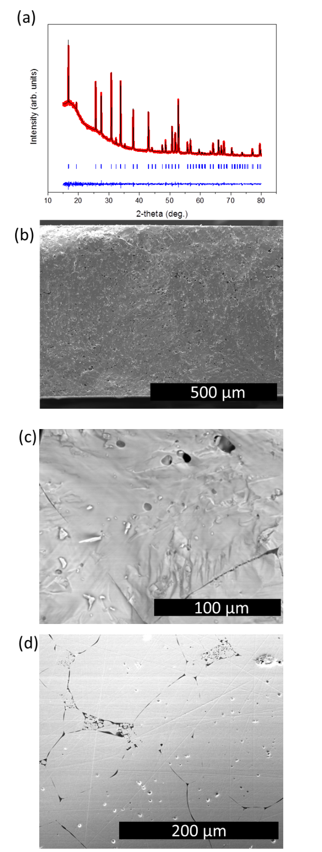
Figure S1: Structural and electrical characterization of the Ga:LLZO garnets. a) X-Ray diffraction pattern of air-protected Ga:LLZO powder after sintering. The red, black and blue lines are the experimental, simulated and difference patterns; the blue markers are the Bragg diffraction angles corresponding to the cubic Ia$\overline{3}$d phase. b), c) and d) Secondary electron images of the pellet after sintering revealing fractured and polished surfaces, respectively. Presence of pores at the surface of the grains is also evident in b) whereas c) present the characteristic bimodal distribution of the particle size with large grains up to hundreds microns and small grain below 10 μm size.
Element | 1.At% | 2.At%
CK | 9.5 | 26
OK | 50 | 57
GaL | 1.5 | 2
ZrL | 16 | 5
LaL | 22 | 8.5
AlK | 1.1 | 1.3
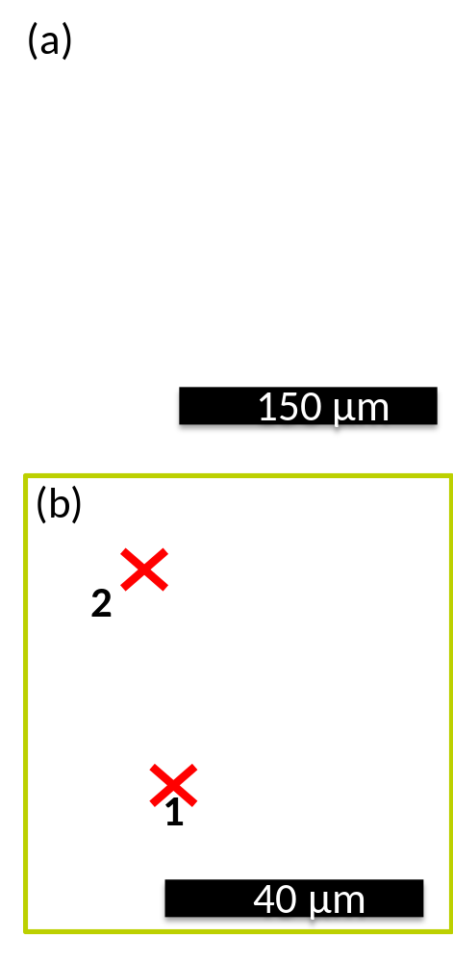

Figure S2: Backscattered SEM analysis comparing the ceramic electrolyte before a) and after b) cycling. EDX results showing the elemental distribution in Ga:LLZO ceramics after 20 cycles. The measurements were performed on various spots and averaged out.

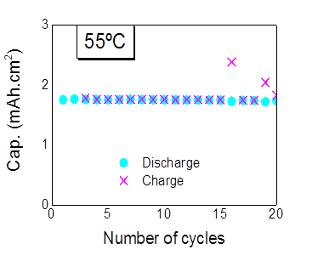
Figure S3: Capacity retention of the Li/Ga:LLZO-LP30/LFP full cell device at 55°C.

