- Department of Chemistry, School of Science, Institute of Science Tokyo, 2-12-1 W4-17 Ookayama, Meguro-ku, Tokyo 152-8551, Japan.
- Department of Materials, Imperial College London, London, SW7 2AZ, UK.
- International Institute for Carbon-Neutral Energy Research (WPI-I²CNER), Kyushu
- University, 744 Motooka, Nishi-ku, Fukuoka 819-0395, Japan.
Center for Energy Systems Design (CESD), International Institute for Carbon Neutral Energy Research (WPI-I2CNER), Kyushu University, 744 Motooka, Nishiku, Fukuoka 819-0395, Japan.

Hydration-Driven Enhancement of Interstitialcy Oxide-Ion Diffusion
Yuichi Sakuda,ª Mudasir A. Yatoo,^{b} Bhuvaneshwari Manivannan,^{c} Vediyappan Veeramani,^{c} Junko Habasaki,ª Stephen J. Skinner,^{b,c} Hiroshige Matsumoto^{c,d} & Masatomo Yashima^{a,d *}
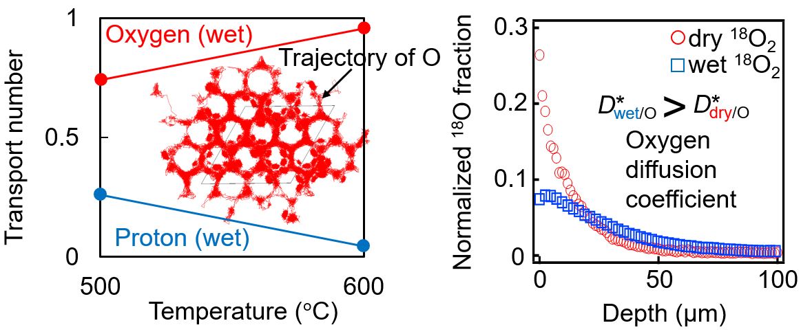
Abstract The transport properties of oxide ions (O^{2‒}) and protons (H⁺) in ceramic materials are crucial to the development of fuel cells as a clean energy source. There are two main types of oxide-ion diffusion mechanism: the oxygen vacancy mechanism and the interstitialcy diffusion mechanism. Oxide-ion conduction by the oxygen vacancy mechanism is generally suppressed by hydration due to the decreased number of oxygen vacancies. Recently, the oxide-ion conduction via the interstitialcy diffusion mechanism has attracted much attention due to its high ion conductivity in both dry and wet conditions. However, the effect of hydration on the transport properties of the interstitial oxide-ion conductors is not well understood compared to conventional oxygen vacancy conductors. In this study, we demonstrate that hydration enhances both the oxygen conductivity and diffusivity in the interstitial oxide-ion conductor Ba₇Nb₄MoO₂₀. Using both oxygen and water vapor concentration cells, we accurately determined the transport numbers of protons t_{H} and oxide ions t_{O}, showing that the predominant conducting species is the oxide ion, even in wet atmospheres (e.g., t_{O} = 0.955, t_{H} = 0.045 at 600 °C). The oxide-ion conductivity is higher in wet atmospheres than in dry conditions (e.g., twice as high at 500 ºC), due to the higher oxygen diffusion coefficient in wet atmospheres. This is evidenced by measurements of both the tracer and conductivity diffusion coefficients, and by the self-diffusion coefficients from molecular dynamics (MD) simulations using a neural network potential. The MD simulations indicated that the higher oxygen diffusion coefficient in wet atmospheres is due to an increased number of (Nb/Mo)₂O₉ dimers. This is caused by an increased number of excess interstitial oxygen ions resulting from hydration. These findings may open up new avenues in the science and engineering of proton, oxide-ion, and dual-ion conductors.
Introduction
The development and optimization of clean energy technologies, such as solid oxide fuel cells (SOFCs) and proton ceramic fuel cells (PCFCs), are fundamental to achieving carbon neutrality.^{1–12} To improve the cost efficiency and operational stability of the SOFCs, it is essential to reduce the operating temperature, since elevated temperatures accelerate degradation via undesirable chemical reactions, leading to increased costs.^{13,14} Consequently, the development of oxide-ion conductors with high ionic conductivity at lower temperatures is crucial.^{15–20} In addition to oxide-ion conductors, proton-conducting materials have been extensively investigated due to their potential for high conductivity at intermediate and low temperatures, which is attributed to their low activation energy for ion migration.^{21–23} However, proton conductors employed as electrolytes in PCFCs face significant challenges, including poor chemical stability in CO₂-rich environments, chemical expansion due to hydration, and the necessity for extremely high sintering temperatures.^{9,24–26} To overcome these challenges, dual-ion conductors have been proposed, because they enable the simultaneous diffusion of both oxide ions and protons.^{17,27–29} These electrolytes combine the advantages of both oxide-ion and proton-conducting materials. First, the concurrent transport of oxide ions and protons in the electrolyte significantly enhances the total of the oxide-ion and proton conductivities, thereby improving fuel cell performance.³⁰ Second, water is generated at both the cathode and anode, eliminating the need for external gas humidification and simplifying system design.²⁸ Recently, hexagonal perovskite-related oxides, such as Ba₇Nb₄MoO₂₀-based materials, have garnered considerable attention due to their high oxide-ion and proton conductivities, making them promising candidates for dual-ion electrolyte applications.^{29,31–41}
Dual-ion, oxide-ion, and proton conductors generally exhibit both oxide-ion and proton conduction. The key transport properties of these charge carriers in oxide materials, such as transport number, oxide-ion conductivity, proton conductivity, oxide-ion diffusion coefficient, and proton diffusion coefficient, play a crucial role in the performance and applicability of these three types of conductors. In many proton-conducting materials, protons can be incorporated by hydration of dry materials. However, the transport properties in hydrated materials are unresolved issues.
There are two important oxide-ion diffusion mechanisms.^{11,34,42} One is the conventional oxygen vacancy diffusion mechanism, and the other is the interstitialcy diffusion mechanism, also referred to as the kick-off or push-pull mechanism. Firstly, we consider an AO_{n–δ} oxide-ion conductor via the oxygen vacancy mechanism. Here the A denotes cations, n represents the number of oxygen atoms, and the δ denotes the amount of oxygen vacancies (e.g., A = BaZr_{0.8}Y_{0.2} and n = 3 for BaZr_{0.8}Y_{0.2}O_{2.9}). By hydration, water (H₂O) can be incorporated as follows:
AO_{n−δ}V_{δ} + xH₂O → AO_{n−δ+x}V_{δ−x}H_{2x} (1)
where the x denotes the amount of water uptake and V represents the oxygen vacancy. Here, the contributions of electrons and electron holes are assumed to be negligible. An example of the defect reaction for hydration can be expressed using the Kröger-Vink notation as follows:
$O_{O}^{×}$ + $V_{O}^{∙∙}$ + H₂O → 2$({OH}_{O}^{ ∙})$ (2).
The amount of water uptake x increases with hydration, thus, the amount of oxygen vacancies (δ−x) decreases with hydration (Eq. 1). Therefore, the oxide-ion conductivity is expected to decrease by hydration. Indeed, the hydration-driven reduction of oxide-ion conductivity and diffusion coefficient can be seen in the literature.^{43,44}
Next, we consider an AO_{n} oxide-ion conductor via the interstitialcy diffusion mechanism. Here the A denotes cations and n is number of oxygen atoms (e.g., A = Ba₇Nb₄Mo and n = 20 for Ba₇Nb₄MoO₂₀; A = Pr₂Ni_{0.75}Cu_{0.25} and n = 4.19 for Pr₂Ni_{0.75}Cu_{0.25}O_{4.19} (Ref. ⁴⁵)). By hydration, a water molecule H₂O can be incorporated into the conductor making an additional oxygen atom and two protons H⁺ as follows:
AO_{n} + xH₂O → AO_{n+x}H_{2x} (3)
where x is the amount of water uptake, and the contributions of electron and electron hole are assumed to be negligible. If the excess oxygen atoms are assumed to be located at the interstitial oxygen site i, an example of the defect reaction for hydration can be described as,
$O_{O}^{×}$ + $V_{i}^{×}$ + H₂O → ${OH}_{O}^{ ∙}$ + ${OH}_{i}^{ '}$ (4).
The amount of water uptake x increases with hydration, therefore, the amount of excess interstitial oxygen atoms also increases with hydration (see Eq. 3). Therefore, the oxide-ion conductivity via the interstitialcy diffusion mechanism is expected to increase with hydration. However, the oxygen transport number has often been estimated assuming that the oxide-ion conductivity of a hydrated sample is equal to that of its dry one.^{29,35,38} The effects of hydration on the oxide-ion conductivity, the oxygen transport number, and oxygen diffusivity have not been explored for interstitialcy oxide-ion conductors.
The first objective of this study is to determine the accurate oxygen and proton transport numbers by using both oxygen and water vapor concentration cells of a hexagonal perovskite-related oxide Ba₇Nb₄MoO₂₀. This material was selected because Ba₇Nb₄MoO₂₀-based materials exhibit the interstitialcy diffusion of oxide ions and negligible electron and hole electron contributions to the electrical conductivity,²⁸ and have the oxygen transport number of unity in dry conditions.^{17,29,34,36,37} The second purpose of this work is to investigate both the accurate oxide-ion and proton conductivities using the total ion conductivity and transport number data. The third purpose is to study the diffusion coefficient using not only the conductivity data but also the tracer diffusion experiments. We demonstrate that hydration enhances both oxygen conductivity and diffusivity of Ba₇Nb₄MoO₂₀. The fourth purpose of this work is to study the origins of this enhancement at the atomic scale. To this end, we performed molecular dynamics (MD) simulations using a neural network potential to enable the calculations of the large numbers of atoms over long time scales with an accuracy comparable to the ab initio MD simulations.^{46,47} Fop claimed that Ba₇Nb₄MoO₂₀ exhibits high proton conductivity and a high proton transport number at 500 °C,^{7,29} and it is believed that this material is a proton conductor rather than oxide-ion conductor in wet atmospheres.^{36,37,48,49} However, the present work will also demonstrate that Ba₇Nb₄MoO₂₀ is an oxide-ion conductor, even in wet atmospheres, rather than a proton conductor.
Methods
Ba₇Nb₄MoO₂₀ samples were synthesized by the solid-state reaction method.^{17,34,49} BaCO₃, Nb₂O₅, and MoO₃ (purity > 99.9%, Kojundo Chemical Co., Ltd.) were mixed and ground as ethanol slurries and dried powders using an agate mortar for 1 h. This was followed by calcination at 900 ºC for 12 h in static air. The calcined powders were then ground for 1 h as ethanol slurries and dried powders, and then pressed uniaxially into pellets at approximately 150 MPa. These pellets were then sintered at 1100 ºC for 24 h in static air. The product was crushed in a WC crusher, and then ground into powders in the agate mortar for 1 h. The powders were then ball-milled using yttria-stabilized zirconia (YSZ) balls (Fritsch, P7). These powders were then isostatically pressed into pellets at 150 MPa and sintered in static air at 1200 ºC for 12 h.
The X-ray powder diffraction pattern of the milled sample was measured using a laboratory-based X-ray diffractometer (Bruker AXS D8 Advance) with Cu Kα radiation. Thermogravimetric (TG) data were collected for a Ba₇Nb₄MoO₂₀ pellet using a NETZSCH STA 449 F3. The pellet was heated to 900 ºC at a rate of 10 ºC min⁻¹ in dry air (water vapor partial pressure: pH₂O < 1.5 × 10^{‒4} atm) and held at 900 ºC for 1 h. The dry air flow was then changed to a wet air flow (pH₂O = 0.021 atm) and the sample was equilibrated at 100 ºC intervals from 900 ºC to 100 ºC and 30 ºC, with 4 h stabilization period at each temperature.
To prepare the samples for measuring of the concentration cells and AC impedance spectra, platinum (Pt) paste and Pt wires were attached to the sintered pellets (sizes of pellets: 16 mm in diameter and 1.3 mm in height for the concentration cells and 4.0 mm in diameter and 12 mm in height for the impedance measurements). The pellets were then heated in static air at 1000 ºC for 1 h to remove the organics from the Pt paste. The AC total conductivity of Ba₇Nb₄MoO₂₀ was determined from the reciprocal of the total resistivity, which is the sum of the bulk and grain boundary resistivities. The AC total conductivity of Ba₇Nb₄MoO₂₀ was evaluated as a function of temperature from 613 to 396 ºC on cooling after heating up to 900 ºC using AC impedance spectroscopy in flowing dry air (pH₂O < 1.5 × 10^{‒4} atm) and wet air (pH₂O = 0.021 atm), respectively, at a flow rate of 100 mL min⁻¹. Impedance spectra were recorded using a Solartron 1260 impedance analyser in the frequency range of 1 MHz to 1 Hz at an applied alternating voltage of 100 mV.
The oxygen transport number t_{wet/O/EMF} and the proton transport number t_{H/EMF} of Ba₇Nb₄MoO₂₀ were evaluated in wet atmospheres using electromotive force (EMF) measurements, with both oxygen and water vapor concentration cells at 500 and 600 ºC. Measurements at 400 ºC were unsuccessful due to slow kinetics. The concentration cell was heated in static air at 800 ºC for 1 h to seal, then cooled to 600 ºC, and the EMF was measured at this temperature. The cell was then cooled to 500 ºC, and the EMF was measured at this temperature. The sum of the proton and oxygen transport numbers (t_{H/EMF} + t_{wet/O/EMF}) was estimated using an oxygen concentration cell and the following Nernst equation:
EMF = (t_{H/EMF} + t_{wet/O/EMF}) $RTln(P_{O_{2}}^{II}/P_{O_{2}}^{I})/(4F)$ (5)
where F is the Faraday constant, R is the gas constant, T is the absolute temperature. The $P_{O_{2}}^{I}$ and $P_{O_{2}}^{II}$ are the oxygen partial pressures of the first (I) and second (II) compartments, respectively. The cell representation of the oxygen and water vapor concentration cells can be written as follows:
$P_{H_{2}O}^{II}$, $P_{O_{2}}^{II}$, Pt |Ba₇Nb₄MoO₂₀|Pt, $P_{H_{2}O}^{I}$, $P_{O_{2}}^{I}$
Here, $P_{H_{2}O}^{I}$ and $P_{H_{2}O}^{II}$ are the water vapor partial pressures of the first (I) and second (II) compartments, respectively. In the oxygen concentration cell illustrated in Fig. S1a, we set $P_{H_{2}O}^{II}$ = $P_{H_{2}O}^{I}$ = 0.021 atm and $P_{O_{2}}^{I}$ = 0.2 atm, and then the EMF was measured at 600 and 500 ºC at each $P_{O_{2}}^{II}$ of 0.04, 0.10, 0.20, and 1 atm. In the oxygen concentration cell of Fig. S1b, we set $P_{H_{2}O}^{II}$ = $P_{H_{2}O}^{I}$ = 0.021 atm and $P_{O_{2}}^{II}$ = 0.2 atm, and the EMF was measured at 500 ºC at each $P_{O_{2}}^{I}$ of 0.04, 0.10, 0.20, and 1 atm to confirm the accuracy of EMF values.
In the water vapor concentration cell illustrated in Fig. S1c, we set $P_{O_{2}}^{I}$ = $P_{O_{2}}^{II}$ = 0.2 atm and $P_{H_{2}O}^{I}$ = 0.021 atm, and then the EMF was measured at 600 and 500 ºC at each $P_{H_{2}O}^{II}$ of 0.009, 0.012, 0.016, and 0.021 atm. In the water vapor concentration cell of Fig. S1d, we set $P_{O_{2}}^{I}$ = $P_{O_{2}}^{II}$ = 0.2 atm and $P_{H_{2}O}^{II}$ = 0.021 atm, and then the EMF was measured at 500 ºC at each $P_{H_{2}O}^{I}$ of 0.009, 0.012, 0.016, and 0.021 atm to confirm the accuracy of EMF values. The water vapor concentration cell and the following Nernst equation were used to estimate the t_{H/EMF}:
EMF = – t_{H/EMF} $RTln (P_{H_{2}O}^{II}/P_{H_{2}O}^{I})/(2F)$ (6)
The isotope effect of a Ba₇Nb₄MoO₂₀ pellet (size of the pellet: 4.3 mm in diameter and 11 mm in height) was evaluated by the direct current (DC) electrical conductivity measurements taken using the DC four-probe method in H₂O- and D₂O-saturated air with a water vapor partial pressure of 0.021 atm (pH₂O = pD₂O = 0.021 atm).
Tracer diffusion experiments were carried out on Ba₇Nb₄MoO₂₀ pellets using isotope exchange depth profiling (IEDP) coupled with secondary ion mass spectrometry (SIMS). Prior to the experiments, each Ba₇Nb₄MoO₂₀ pellet was polished with diamond spray media down to a finish of 0.25 μm. The polished samples were pre-annealed in either ¹⁶O₂ or H₂¹⁶O of natural isotopic abundance for 5 h. The samples were then annealed for 1 h in either ¹⁸O-enriched gas (200 mbar) or a mixture of ¹⁸O₂ (200 mbar) and H₂¹⁸O (30 mbar). Following the exchange annealing, the samples were cut perpendicular to the original surface and the exposed cross sections were polished to 0.25 μm finish. The diffusion profiles were measured using Time-of-Flight Secondary Ion Mass Spectrometry (ToF-SIMS) with a ToF-SIMS.5 instrument (IONTOF GmbH) with Bi⁺ ions at an energy of 25 keV. The oxygen tracer diffusion and surface exchange coefficient values were calculated by fitting the diffusion profiles to Crank’s solution of Fick’s second law of diffusion, using a Matlab application TraceX.⁵⁰
Molecular dynamics (MD) simulations of the dry material Ba₆₃Nb₃₆Mo₉O₁₈₀ ~ (Ba₇Nb₄MoO₂₀)₉ and the hydrated compound Ba₆₃Nb₃₆Mo₉O₁₈₃H₆ ~ (Ba₇Nb₄MoO₂₀·0.3 H₂O)₉ were performed with 3 × 3 × 1 supercells at a high temperature 1200 K to accelerate the oxide-ion diffusion and to investigate the effect of hydration on oxide-ion diffusivity. The MD simulations were carried out using universal interatomic potentials based on graph neural networks with three-body interactions (M3GNet).⁴⁶ We refer to these simulations as M3GNet-MD simulations. These simulations were carried out using a home-made MD program and the Atomic Simulation Environment (ASE).⁵¹ We employed structural models in which the Mo atoms exclusively occupy the M2 cation site near the oxygen-deficient cubic close-packed layer, additional oxygen atoms due to hydration exist near the Mo atoms, and protons exist in the palmierite blocks. These models were constructed based on the minimum-energy structure and ab initio molecular dynamics results reported in the literature.^{15,52} First, the atomic coordinates were optimized using static DFT calculations in the P1 space group, with a convergence condition of 0.02 eV Å^{–1}. Static DFT calculations were performed using the Vienna ab initio simulation package (VASP)⁵³ for (Ba₇Nb₄MoO₂₀)₉ and (Ba₇Nb₄MoO₂₀·0.3 H₂O)₉. A 1 × 1 × 1 set of k-point meshes was used in the Monkhorst–Pack scheme. Projector augmented wave (PAW) potentials were used for Ba, Nb, Mo, O, and H atoms, as well as plane-wave basis sets with a cutoff of 400 eV and Perdew–Burke–Ernzerhof (PBE) GGA functionals. The structures were then relaxed using M3GNet. The resulting structures were consistent with those obtained from the aforementioned DFT optimizations as well as with experimental structures reported in the literature.⁵² M3GNet-MD simulations were performed at 1200 K in the NVT ensemble with a time step of 1 fs. Mean-square displacement (MSD) was calculated by averaging the dynamic heterogeneity using a shifted time series of several thousand initial times to smooth fluctuations.⁵⁴ The OVITO program was used to visualize the snapshots from the M3GNet-MD simulations.⁵⁵
Results and Discussion
Dense pellets of Ba₇Nb₄MoO₂₀ were synthesized by the solid-state-reaction method (Relative density > 97%). The cation ratio of Ba₇Nb₄MoO₂₀, as analyzed by inductively coupled plasma-optical emission spectroscopy (ICP-OES), was found to be Ba: Nb: Mo = 7.0: 4.0: 1.0, which was the same as that of the nominal composition. The X-ray diffraction (XRD) pattern of Ba₇Nb₄MoO₂₀ powders indicated that it was a single primitive hexagonal phase with the 7H polytype (Fig. 1a), which is consistent with the literature.^{29,52,56,57} Thermogravimetric (TG) data indicated hydration of a Ba₇Nb₄MoO₂₀ pellet in wet air on cooling (water vapor partial pressure pH₂O = 0.021 atm), showing the increase of the numbers of oxide ions and protons during cooling (Fig. 1b,c). The SEM observation showed the average grain size to be 1.8 µm (Fig. S2).
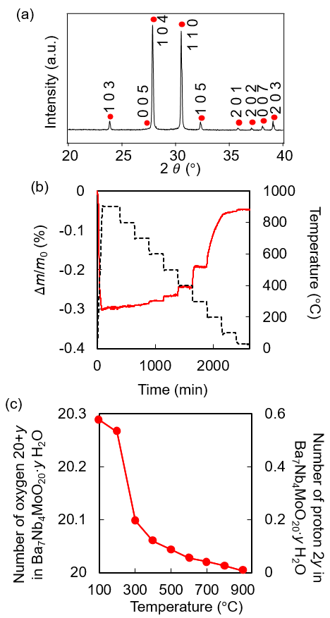
Fig. 1 (a) X-ray powder diffraction pattern of Ba₇Nb₄MoO₂₀ at room temperature. (b) Thermogravimetric (TG) data of Ba₇Nb₄MoO₂₀ obtained by an equilibrium isotherm on cooling in wet air (pH₂O = 0.021 atm). (c) Temperature dependence of the numbers of oxide ion 20+y and proton 2y in Ba₇Nb₄MoO₂₀∙y H₂O in wet air, calculated from panel (b).

To investigate the total alternating current (AC) electrical conductivity of Ba₇Nb₄MoO₂₀, its AC impedance spectra were measured at high temperatures in wet air (pH₂O = 0.021 atm) and in dry air (pH₂O < 1.5 × 10^{–4} atm) (Figs. 2 and S3). Equivalent circuit analyses were performed to extract the total AC conductivity (Fig. S4). Fig. 2c shows the Arrhenius plots of total AC conductivities for Ba₇Nb₄MoO₂₀ in wet air σ_{wet} and in dry air σ_{dry}. The obtained σ_{wet} and σ_{dry} values (solid lines in Fig. 2c) were close to those reported in the literature (dashed lines in Fig. 2c).²⁹ The σ_{wet} was higher than σ_{dry} at each temperature. The apparent oxygen transport number was calculated by the following simple equation (7):
t_{O/app} = $\frac{σ_{dry}}{σ_{wet}}$ (7).
The apparent oxygen transport number t_{O/app} (= 0.27–0.39) was low (Fig. 3a). The apparent proton transport number t_{H/app} was estimated using the following equation (8).
t_{H/app} = $\frac{σ_{wet}-σ_{dry}}{σ_{wet}}$ (8)
The t_{H/app} values (= 0.73–0.61) were large (Fig. 3b), which was consistent with the literature.²⁹ At first glance, it appears that protons are the main conducting species in Ba₇Nb₄MoO₂₀ in wet atmospheres. However, we will show below that this is not the case.
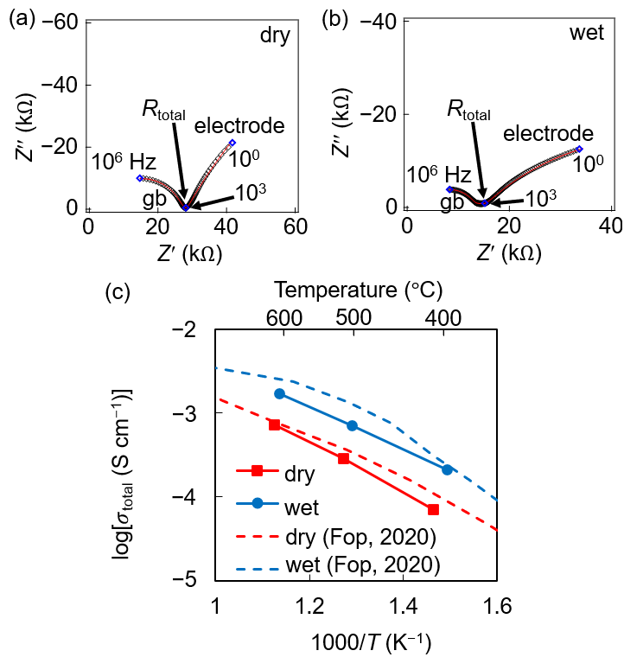
Fig. 2 Complex impedance plane plots of Ba₇Nb₄MoO₂₀ (a) at 512 °C in dry air and (b) at 501 °C in wet air (pH₂O = 0.021 atm). A black rhombus represents the measured data and a red line denotes the curve obtained by equivalent circuit analysis. (c) Arrhenius plots of the total AC electrical conductivity σ_{total} of Ba₇Nb₄MoO₂₀ in wet air (pH₂O = 0.021 atm; blue closed circles and line) and dry air (red closed squares and line). The activation energy in dry conditions, 0.60(3) eV, is comparable with that in wet atmospheres, 0.508(5) eV, suggesting that the mobile ionic species remain similar in both conditions.
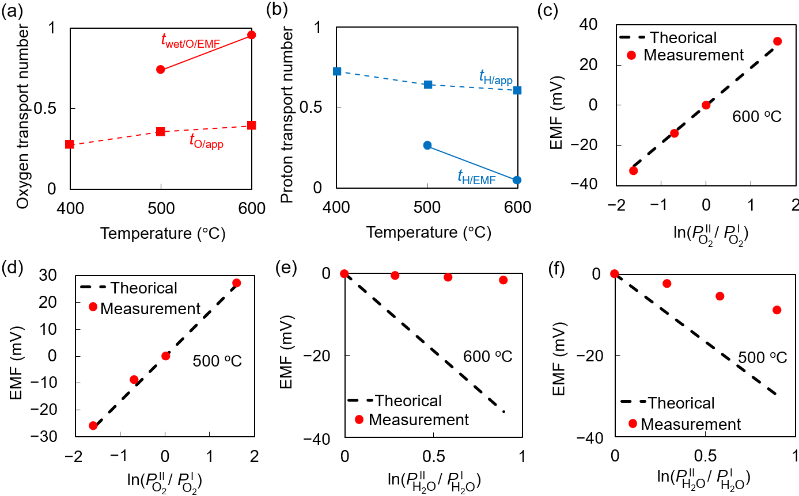
Fig. 3 (a) Oxygen and (b) proton transport numbers at different temperatures. In panel (a), the red and squares and dashed line denote the apparent oxygen transport number t_{O/app}, which is estimated using equation (7). In panel (b), the blue squares and dashed line represent the apparent proton transport number t_{H/app}, which is estimated using equation (8). In panel (a), the red circles and solid line denote the accurate oxygen transport number obtained from the EMF measurements t_{wet/O/EMF}. In panel (b), the blue circles and solid line represent the accurate proton transport number obtained by the EMF measurements t_{H/EMF}. Results of the EMF measurements of (c,d) the oxygen concentration cell ($P_{H_{2}O}^{I}$ = $P_{H_{2}O}^{II}$ = 0.021 atm) and (e,f) the water vapor concentration cell ($P_{O_{2}}^{I}$ = $P_{O_{2}}^{II}$ = 0.20 atm) of Ba₇Nb₄MoO₂₀ at 600 ºC (c,e) and 500 ºC (d,f). The black dashed line stands for the theoretical values for (c,d) t_{H/EMF} + t_{O/wet/EMF} = 1 and (e,f) t_{H/EMF} = 1. Red circles in panels (c)-(f) represent the measured EMF data.

To accurately determine the oxygen and proton transport numbers of Ba₇Nb₄MoO₂₀ in flowing wet O₂/Ar atmospheres, the electromotive force EMF was measured using both a water vapor concentration cell and an oxygen concentration cell. The EMF values measured for the oxygen concentration cell in wet O₂/Ar (pH₂O = 0.021 atm; represented by the red closed circles in Fig. 3c and d) were in good agreement with the theoretical values for the sum of the oxygen and proton transport numbers equalling unity (t_{wet/O/EMF} + t_{H/EMF} = 1). Here, the t_{wet/O/EMF} and t_{H/EMF} are the oxygen and proton transport numbers, respectively, in wet O₂/Ar, which were obtained by the EMF measurements. The (t_{wet/O/EMF} + t_{H/EMF}) was estimated to be 0.965(18) at 500 ºC and 1.052(11) at 600 ºC using the equation (5), where the number in the parenthesis denotes the estimated standard deviation in the last digit. Therefore, the sum of proton and oxygen transport numbers at pH₂O = 0.021 atm is 1.00 at 500 and 600 ºC, indicating pure ionic conduction:
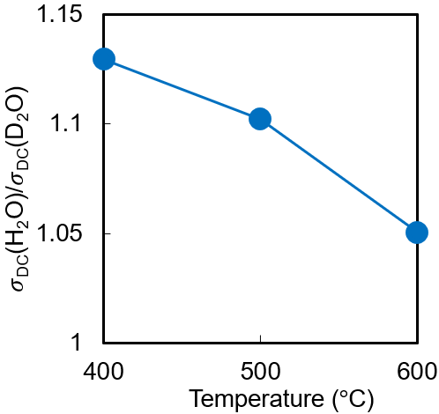
Fig. 4 H/D isotope effect on the DC electrical conductivity σ_{DC} of Ba₇Nb₄MoO₂₀ at different temperatures. The σ_{DC}(H₂O) and σ_{DC}(D₂O) represent the σ_{DC} of Ba₇Nb₄MoO₂₀ in H₂O-saturated air (pH₂O = 0.021 atm) and D₂O-saturated air (water vapor partial pressure, pD₂O = 0.021 atm), respectively.

t_{H/EMF} + t_{wet/O/EMF} = 1.00 (9).
The EMF was also measured with the water vapor concentration cell under an oxygen partial pressure pO₂ of 0.2 atm. The proton transport number t_{H/EMF} was then estimated using the EMF value and equation (6). The experimental slope of EMF against the logarithm of the water vapor partial pressure ratio corresponds to t_{H/EMF} = 0.24(3) at 500 ºC and 0.045(5) at 600 ºC (see Fig. 3e and f), which indicates that the t_{H/EMF} is lower than 0.25. It should be noted that the accurate proton transport number t_{H/EMF} is much lower than the apparent one t_{H/app} (see Fig. 3b; e.g., t_{H/EMF} = 0.045(5) << t_{H/app} = 0.61 at 600 ºC). The oxygen transport number t_{wet/O/EMF} was calculated using equation (9) to be 0.76(3) at 500 ºC and 0.955(5) at 600 ºC. This indicates that the predominant conducting species in Ba₇Nb₄MoO₂₀ is not the proton but the oxide ion at 500 and 600 ºC even in the wet atmospheres (pH₂O ≤ 0.021 atm, pO₂ = 0.2 atm). The small proton transport number was supported by the small H/D isotope effect on the electrical conductivity measured using the direct current (DC) four-probe method. Specifically, the DC conductivity of Ba₇Nb₄MoO₂₀ in H₂O-saturated air (pH₂O = 0.021 atm) was 1.05‒1.13 times higher than that in D₂O-saturated air (water vapor partial pressure, pD₂O = 0.021 atm), which is much smaller than 1.41 for the classical theory (Fig. 4).
Why is the oxygen transport number from EMF measurements is higher than the apparent one (t_{wet/O/EMF} > t_{O/app})? To answer this question, the oxide-ion conductivities in wet and dry atmospheres were calculated using the following equations (10) and (11):
σ_{wet/O/EMF} = σ_{wet} × t_{wet/O/EMF} (10)
σ_{dry/O/EMF} = σ_{dry} × t_{dry/O/EMF} (11).
Here, t_{dry/O/EMF} ($\sim$1.0) is the oxygen transport number estimated by EMF measurements with an oxygen concentration cell in dry atmospheres reported in the literature.²⁹ Interestingly, the oxide-ion conductivity in wet atmospheres σ_{wet/O/EMF} (5.2×10^{‒4} S cm^{‒1} at 500 ºC; 1.6×10^{‒3} S cm^{‒1} at 600 ºC) was higher than that in dry conditions σ_{dry/O/EMF} (2.5×10^{‒4} S cm^{‒1} at 500 ºC; 6.4×10^{‒4} S cm^{‒1} at 600 ºC) (Fig. 5). In contrast, the apparent oxygen transport number t_{O/app} is calculated by assuming that the oxide-ion conductivity in wet atmospheres equals to that in dry conditions. Therefore, the oxygen transport number from EMF measurements is higher than apparent one (t_{wet/O/EMF} > t_{O/app}, Fig. 3a). The higher oxide-ion conductivity in wet atmospheres than that in dry conditions indicates the enhancement of oxide-ion conductivity by hydration.
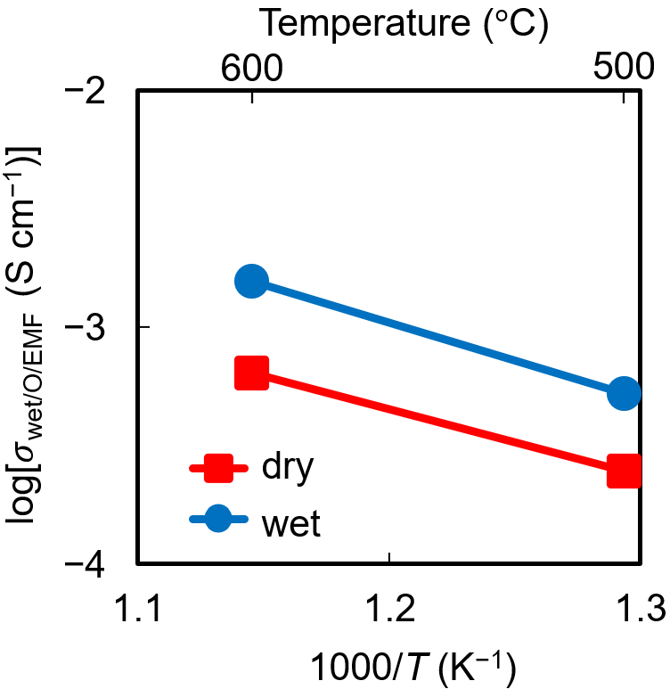
Fig. 5 Arrhenius plots of oxide-ion conductivity σ_{O/EMF} for Ba₇Nb₄MoO₂₀ in wet air (blue circles and line) and dry air (red squares and line) at 500 and 600 ºC. The activation energy was 0.55 eV in dry conditions and 0.63 eV in wet atmospheres.

To discuss the origins of the higher oxide-ion conductivity in wet atmospheres compared with dry conditions (σ_{wet/O/EMF} > σ_{dry/O/EMF}), we estimated the carrier concentration (number of oxide ions per volume) and oxygen diffusion coefficient using the oxide-ion conductivity and Nernst-Einstein equation:
D_{dry/O/σ} = kTσ_{dry/O/EMF}/(4e²n_{dry/O})
D_{wet/O/σ} = kTσ_{wet/O/EMF}/(4e²n_{wet/O}).
Here, k is the Boltzmann constant, T is the absolute temperature, e is the elementary charge, n_{dry/O} is the number of oxide ions per volume in dry conditions, n_{wet/O} is the number of oxide ions per volume in wet atmospheres. The Haven ratio is assumed to be unity. The carrier concentrations in wet and dry conditions were almost the same (n_{wet/O} $\sim$ n_{dry/O}), although the former was slightly higher than the latter (n_{wet/O} = 1.0014 n_{dry/O} at 600 ºC, n_{wet/O} = 1.0021n_{dry/O} at 500 ºC). In sharp contrast, the oxygen diffusion coefficient in wet atmospheres D_{wet/O/σ} was significantly higher than that in dry conditions D_{dry/O/σ} (D_{wet/O/σ} = 2.5D_{dry/O/σ} at 600 ºC, D_{wet/O/σ} = 2.8D_{dry/O/σ} at 500 ºC, open circles in Fig. 6b). Therefore, the higher oxygen diffusion coefficient in wet atmospheres compared with the dry conditions is the origin of the higher oxide-ion conductivity in wet atmospheres.
The direct experimental evidence for the higher oxygen diffusion coefficient in wet atmospheres compared with the dry conditions was obtained by investigating the oxygen tracer diffusion and surface exchange coefficients of Ba₇Nb₄MoO₂₀ pellets using the isotope exchange depth profiling (IEDP) technique coupled with secondary ion mass spectrometry (SIMS).^{58,59} Ba₇Nb₄MoO₂₀ pellets were annealed at 500 ºC in dry ¹⁸O₂ (p¹⁸O₂ = 0.20 atm) and wet ¹⁸O₂ (pH₂¹⁸O = 0.030 atm, p¹⁸O₂ = 0.20 atm) for 1 h. The ¹⁸O tracer diffusion profiles show that the ¹⁸O ions in a Ba₇Nb₄MoO₂₀ pellet annealed in wet ¹⁸O₂ penetrated deeper than those in dry ¹⁸O₂ (Fig. 6a). Indeed, the oxygen tracer diffusion coefficient of Ba₇Nb₄MoO₂₀ in wet ¹⁸O₂ $D_{wet/O}^{*}$ = 2.6×10^{‒9} cm²/s was significantly higher than that in dry ¹⁸O₂ $D_{dry/O}^{*}$ = 5.6×10^{‒10} cm²/s ($D_{wet/O}^{*}$ = 4.6$D_{dry/O}^{*}$). This is the direct experimental evidence that the oxygen diffusivity of Ba₇Nb₄MoO₂₀ is enhanced by hydration. This is also supported by M3GNet-MD simulations, as shown below. The tracer diffusion coefficient obtained using the IEDP technique was in good agreement with the diffusion coefficient obtained from the conductivity data (Fig. 6b), thus validating these diffusion coefficient values.
To investigate the reasons why the oxygen diffusion coefficient is higher in wet atmospheres than in dry conditions at the atomic level, we performed the M3GNet-MD simulations at 1200 K. MD simulations for both dry and hydrated Ba₇Nb₄MoO₂₀ were carried out using the 3×3×1 supercells and the graph neural network potential (NNP) implemented in the M3GNet.⁴⁶ The NNP method is capable of calculating of the large numbers of atoms over long time scales with an accuracy comparable to ab initio molecular dynamics (AIMD)
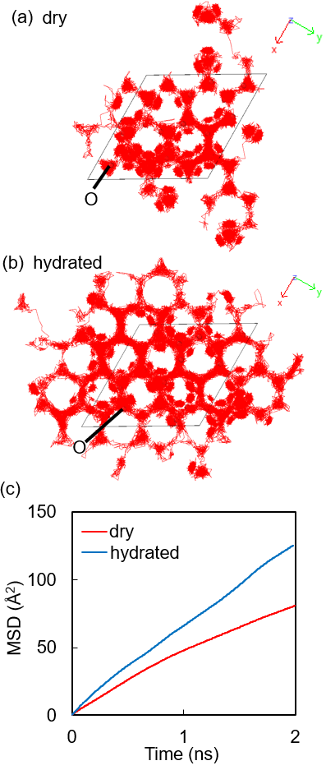
Fig. 7 Results of M3GNet-MD simulations of dry and hydrated Ba₇Nb₄MoO₂₀. Trajectories of oxygen atoms of (a) dry and (b) hydrated Ba₇Nb₄MoO₂₀ at 1200 K. (c) Mean square displacement (MSD) of oxygen atoms in dry Ba₇Nb₄MoO₂₀ (red line) and hydrated Ba₇Nb₄MoO₂₀ (blue line) at 1200 K. The oxygen self-diffusion coefficient was estimated to be 1.0×10^{‒6} cm²/s in hydrated Ba₇Nb₄MoO₂₀ and 5.6×10^{‒7} cm²/s in dry Ba₇Nb₄MoO₂₀ from the MSD data in the diffusion region (Fig. S6). Therefore, the oxygen diffusion coefficient in the hydrated Ba₇Nb₄MoO₂₀ was 1.8 times higher than that in the dry Ba₇Nb₄MoO₂₀, which is consistent with experimental data.

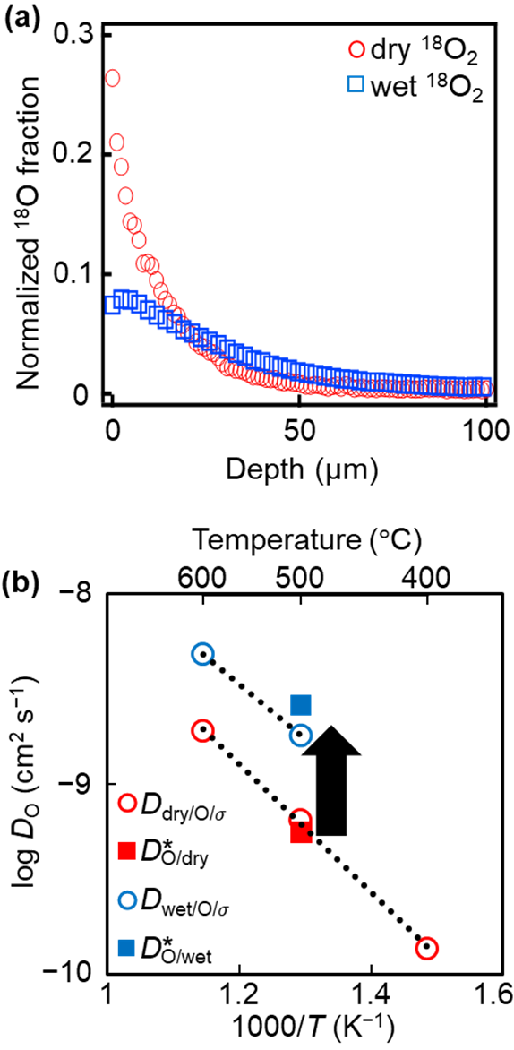
Fig. 6 (a) ¹⁸O tracer diffusion profiles of Ba₇Nb₄MoO₂₀ pellets annealed at 500 ºC in dry ¹⁸O₂ (p¹⁸O₂ = 0.20 atm, red circles) and wet ¹⁸O₂ (pH₂¹⁸O = 0.030 atm, p¹⁸O₂ = 0.20 atm, blue squares). (b) Arrhenius plots of the oxygen diffusion coefficient (Do) of Ba₇Nb₄MoO₂₀. The red and blue open circles denote the conductivity diffusion coefficients in dry atmospheres (D_{dry/O/σ}) and wet conditions (D_{wet/O/σ}), respectively, which were calculated assuming the Haven ratio (correlation factor) to be unity. The red and blue closed squares represent the tracer diffusion coefficients in dry conditions ($D_{O/dry}^{*}$) and wet atmospheres ($D_{O/wet}^{*}$), respectively. The surface exchange coefficients k* of the samples annealed at 500 ºC in dry and wet ¹⁸O₂ were 9.1×10^{‒8} and 7.2×10^{‒8} cm/s, respectively. The arrow in panel (b) indicates the enhancement of oxygen diffusivity by hydration.
simulations.⁴⁷ In contrast to the short-range migration observed in previous AIMD simulations,^{17,57,60} the trajectories of oxygen atoms via the present M3GNet-MD simulations using the NNP indicated the long-range oxide-ion diffusion in the oxygen-deficient cubic close-packed c' layer of both hydrated and dry Ba₇Nb₄MoO₂₀ materials at 1200 K (Fig. S5). No migration of hydroxide ion OH‒ was observed. Instead, the proton H⁺ migrates by the Grotthus mechanism in the MD simulations. The oxygen trajectories in the hydrated Ba₇Nb₄MoO₂₀ were more significant compared with the dry material (Fig. 7a and b). Indeed, the mean square displacement (MSD) of the oxygen atoms in the hydrated Ba₇Nb₄MoO₂₀ was greater than that in the dry Ba₇Nb₄MoO₂₀ (Fig. 7c). Therefore, the oxygen diffusion coefficient of hydrated Ba₇Nb₄MoO₂₀ was higher than that of dry Ba₇Nb₄MoO_{20.} This is consistent with the experimental results for the tracer and conductivity diffusion coefficients (Fig. 6). Figs. 8 and S7 show snapshots from the present M3GNet-MD simulations of hydrated and dry Ba₇Nb₄MoO₂₀, respectively, which enables the investigation of the local dynamics. Oxide ions migrate through the breaking and reforming of M₂O₉ dimers, MO₅ monomers and MO₄ tetrahedra (M: Nb/Mo). This process is essential for oxide-ion migration in both hydrated and dry Ba₇Nb₄MoO₂₀, which is consistent with the oxide-ion migration in Ba₇Nb_{3.8}Mo_{1.2}O_{20.1}.¹⁷ The number of M₂O₉ dimers in the hydrated Ba₇Nb₄MoO₂₀ was approximately twice that in the dry material. This is because there are more excess interstitial oxygen atoms in the hydrated form (0.3) compared with the dry form (0.0). The presence of the interstitial oxygen ions in the hydrated Ba₇Nb₄MoO₂₀ is consistent with the reported crystal structures.^{52,57} As there are more excess oxygen atoms in hydrated Ba₇Nb₄MoO₂₀ compared with dry material, there are more M₂O₉ dimers in the hydrated Ba₇Nb₄MoO₂₀ than in dry material. At the atomic level, this is the reason why the oxygen diffusion coefficient is higher in wet atmospheres compared with dry conditions.
Next, we will discuss the reasons for the low proton transport number and conductivity of hydrated Ba₇Nb₄MoO₂₀. The proton conductivity diffusion coefficient D_{H/σ} (e.g., 4.3×10^{‒7} cm²/s at 500 ºC) was higher than the oxygen conductivity diffusion coefficient D_{wet/O} (e.g., 1.8×10^{‒9} cm²/s at 500 ºC), which was also supported by the trajectories of protons (Fig. S8). However, the proton carrier concentration (e.g., 1.7×10²⁰ cm^{‒3} at 500 ºC) was much lower than the oxide-ion carrier concentration (e.g., 4.0×10²² cm^{‒3} at 500 ºC). Here the D_{H/σ} was estimated using the equation, D_{H/σ} = kTσ_{wet} × t_{H/EMF} /(4e²n_{H}), where n_{H} is the proton concentration obtained from TG measurements. In addition, the oxide-ion conductivity is enhanced by hydration (Fig. 5). The low proton concentration compared with oxide-ion concentration and enhanced oxide-ion conductivity by hydration are the reasons for the low proton transport number and conductivity.
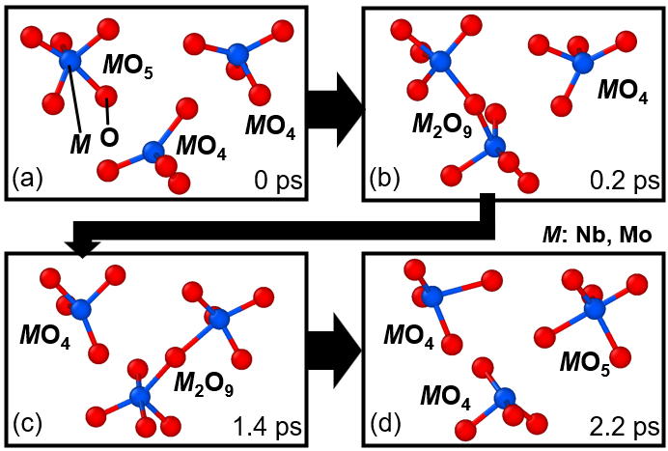
Fig. 8 Snapshots of oxygen diffusion process of hydrated Ba₇Nb₄MoO₂₀ at 1200 K. The blue spheres (M) represent Nb or Mo cation. The red spheres (O) denote oxide ions.

Conclusions and Discussion
Understanding oxide-ion and proton conduction in ceramic oxide-ion, proton, and dual-ion conductors is vital for clean energy. There are two main types of oxide-ion diffusion mechanism: the oxygen vacancy mechanism and the interstitialcy diffusion mechanism. Oxide-ion conduction by the oxygen vacancy mechanism is generally suppressed by hydration due to the decreased number of oxygen vacancies. However, the effects of hydration on the oxide-ion conductivity and diffusivity were not known for the interstitialcy diffusion mechanism. This study has demonstrated that hydration enhances both oxygen conductivity and diffusivity in the dual-ion conductor Ba₇Nb₄MoO₂₀, which exhibits interstitialcy diffusion of oxide ions. This was demonstrated using the EMF, total electrical conductivity, and IEDP measurements, as well as the M3GNet-MD simulations. The oxide-ion conductivity in wet atmospheres (σ_{wet/O/EMF} = 5.3×10^{‒4} S cm^{‒1} at 500 ºC; 1.6×10^{‒3} S cm^{‒1} at 600 ºC) is higher than that in dry conditions (σ_{dry/O/EMF} = 2.5×10^{‒4} S cm^{‒1} at 500 ºC; 6.4×10^{‒4} S cm^{‒1} at 600 ºC) (Fig. 5). The enhancement of oxide-ion conductivity was found to be attributed to that of oxygen diffusion coefficient by hydration. The oxygen diffusion coefficient is higher in wet atmospheres than in dry conditions (D_{wet/O/σ} = 2.5D_{dry/O/σ} at 600 ºC, D_{wet/O/σ} = 2.8D_{dry/O/σ} at 500 ºC, and $D_{wet/O}^{*}$ = 4.6$D_{dry/O}^{*}$ at 500 ºC, see Fig. 6b). The present M3GNet-MD simulations using the NNP have shown that enhanced oxygen diffusivity by hydration is attributable to an increased number of M₂O₉ dimer (M = Nb, Mo). This is due to an increased number of excess interstitial oxygen atoms by hydration. The present oxide-ion conductivity and conductivity-diffusion coefficient were estimated based on the total conductivity data, as the tracer diffusion coefficient and transport number were obtained using polycrystalline pellets, and therefore include the effects of grain boundaries. These values were also estimated based on the bulk conductivities under dry and wet conditions, yielding consistent conclusions. The results showed both the enhancements of bulk oxide-ion conductivity and bulk oxygen diffusivity by hydration (Fig. S9b,c). For details, see the Supplementary Note and Fig. S9 in the ESI.
This work has also demonstrated that Ba₇Nb₄MoO₂₀ is not proton, but oxide-ion conductor even in wet atmospheres. The apparent proton and oxygen transport numbers obtained from the simple estimates using equations (3) and (4) are greater than 0.6 and less than 0.4, respectively. These estimates assume that the oxide-ion conductivity of the hydrated sample is equal to that of the dry sample without water. In sharp contrast, the present accurate proton and oxygen transport numbers obtained from the EMF measurements are lower than 0.3 and higher than 0.7, respectively. Fop claimed that Ba₇Nb₄MoO₂₀ exhibited high proton conductivity of 4.0 × 10⁻³ S cm⁻¹ and high (apparent) proton transport number of 0.8 at 500 °C.⁷ However, the conductivity of 4.0 × 10⁻³ S cm⁻¹ at 500 °C is not the proton conductivity, but the total conductivity (= oxide-ion conductivity + proton conductivity). The present accurate proton conductivity σ_{wet} × t_{H/EMF} is as low as 1.6 × 10⁻⁴ S cm⁻¹ at 500 °C, which is much lower compared with leading perovskite-type proton conductors (e.g., 1.2 × 10⁻² S cm⁻¹ at 500 °C in BaZr_{0.8}Y_{0.2}O_{2.9}).⁶¹ Since the oxide-ion conductivity is higher in wet atmospheres than in dry conditions, the apparent proton transport number is higher than the accurate proton transport number. The proton diffusivity is higher than oxygen one, however, since the number of protons is smaller than that of oxide ions, the proton conductivity is relatively low compared with the oxide-ion conductivity. These new findings may advance the science and engineering of oxide-ion, proton, and dual-ion conductors.
Author Contributions
MY and YS designed the research project. YS prepared the samples and carried out the XRD measurements. YS also measured electrical conductivity and TG data, and performed the DFT calculations. MAY and YS carried out the tracer diffusion experiments under the supervision of SJS. BM, VV, SY and MY performed the EMF measurements under the supervision of HM. JH performed M3GNet-MD simulations. Funding acquisition and supervision: MY, HM, YS, and SJS. MY (leading) and YS wrote the manuscript. MY (leading), YS, SJS, and JH edited the manuscript. All the authors read the manuscript.
Conflicts of interest
There are no conflicts to declare.
Acknowledgements
We would like to thank Prof. K. Fujii and Dr. K. Saito for their assistance with the experiments and calculations, and for their valuable contributions to the discussions. We express special thanks to Kojundo Chemical Laboratory Co., Ltd. for ICP measurements and providing raw materials. This work was supported by Japan Society for the Promotion of Science (JSPS) KAKENHI (Grant Numbers JP21K18182, JP24H00041, JP24K23013, and JP25K21695), by Adopting Sustainable Partnerships for Innovative Research Ecosystem (ASPIRE) from the Japan Science and Technology Agency (JST) (Grant JPMJAP2308), and by JSPS Core-to-Core Programme (Advanced Research Networks), Solid Oxide Interfaces for Faster Ion Transport (SOIFIT). Y.S. acknowledges support from a JSPS Fellowship for Young Scientists, DC1 (JP22KJ1285). SJS and MY acknowledge that part of the work has received funding from the European Union’s Horizon 2020 research and innovation programme under grant agreement no. 952184.
References
- J. M. Serra, V. B. Vert, M. Betz, V. A. C. Haanappel, W. A. Meulenberg and F. Tietz, J. Electrochem. Soc., 2007, 155, B207.
- J. M. Serra and W. A. Meulenberg, J. Am. Ceram. Soc., 2007, 90, 2082.
- I. Staffell, D. Scamman, A. Velazquez Abad, P. Balcombe, P. E. Dodds, P. Ekins, N. Shah and K. R. Ward, Energy Environ. Sci., 2019, 12, 463.
- S. Fop, J. Mater. Chem. A, 2021, 9, 18836–18856.
- M. Coduri, M. Karlsson and L. Malavasi, J. Mater. Chem. A, 2022, 10, 5082.
- N. A. Tarasova, I. E. Animitsa, A. O. Galisheva and D. A. Medvedev, Electrochem. Mater. Technol., 2022, 1, 20221004.
- W. Zhang and M. Yashima, Chem. Commun., 2023, 59, 134.
- X. Yang, A. J. Fernández-Carrión and X. Kuang, Chem. Rev., 2023, 123, 9356.
- K. Saito, M. Baba, K. Umeda, K. Fujii, T. Honda and M. Yashima, Inorg. Chem. Front., May 30 2025, Published Online. DOI: 10.1039/D5QI00632E
- K. Hatakeyama, T. Tsugawa, H. Watanabe, K. Oka, S. Kinoshita, K. Awaya, M. Koinuma and S. Ida, J. Mater. Chem. A, 2025, 2, 734.
- A. Pathak, H. Watanabe, B. Manna, K. Hatakeyama and S. Ida, Small, 2024, 20, 2400222.
- L. Malavasi, C. A. J. Fisher and M. S. Islam, Chem. Soc. Rev., 2010, 39, 4370.
- S. Rauf, B. Zhu, M. A. K. Yousaf Shah, Z. Tayyab, S. Attique, N. Ali, N. Mushtaq, B. Wang, C. Yang, M. I. Asghar and P. D. Lund, ACS Appl. Mater. Interfaces, 2020, 12, 35071.
- H. Shi, C. Su, R. Ran, J. Cao and Z. Shao, Prog. Nat. Sci. Mater. Int., 2020, 30, 764.
- Y. Sakuda, T. Murakami, M. Avdeev, K. Fujii, Y. Yasui, J. R. Hester, M. Hagihala, Y. Ikeda, Y. Nambu and M. Yashima, Chem. Mater., 2023, 35, 9774.
- Y. Yamazaki, F. Blanc, Y. Okuyama, L. Buannic, J. C. Lucio-Vega, C. P. Grey and S. M. Haile, Nat. Mater., 2013, 12, 647.
- N. Ueno, H. Yaguchi, K. Fujii and M. Yashima, J. Am. Chem. Soc., 2024, 146, 11235.
- Y. Yasui, K. Jojima, K. Fujii, K. Mori and M. Yashima, Chem. Mater., 2025, 37, 9.
- H. Yaguchi, D. Morikawa, T. Saito, K. Tsuda, M. Yashima, H. Yaguchi, M. Yashima, D. Morikawa, T. Saito and K. Tsuda, Adv. Funct. Mater., 2023, 33, 2214082.
- J. Meng, M. S. Sheikh, R. Jacobs, J. Liu, W. O. Nachlas, X. Li and D. Morgan, Nat. Mater. 2024, 23, 1252.
- K. Amezawa, H. Maekawa, Y. Tomii and N. Yamamoto, Solid State Ionics, 2001, 145, 233.
- H. Sumi, H. Shimada, Y. Yamaguchi, Y. Mizutani, Y. Okuyama and K. Amezawa, Sci. Rep., 2021, 11, 1.
- K. Saito and M. Yashima, Nat. Commun., 2023, 14, 7466.
- A. K. E. Andersson, S. M. Selbach, C. S. Knee and T. Grande, J. Am. Ceram. Soc., 2014, 97, 2654.
- A. Løken, S. Ricote and S. Wachowski, Cryst. 2018, 8, 365.
- I. Animitsa, D. Korona, A. Bushueva, R. Andreev and S. Nokhrin, Chim. Techno Acta, 2024, 11, 202411403.
- L. Yang, S. Wang, K. Blinn, M. Liu, Z. Liu, Z. Cheng and M. Liu, Science, 2009, 326, 126.
- C. Zhou, J. Sunarso, Y. Song, J. Dai, J. Zhang, B. Gu, W. Zhou and Z. Shao, J. Mater. Chem. A, 2019, 7, 13265.
- S. Fop, K. S. McCombie, E. J. Wildman, J. M. S. Skakle, J. T. S. Irvine, P. A. Connor, C. Savaniu, C. Ritter and A. C. Mclaughlin, Nat. Mater., 2020, 19, 752.
- J. Cao, C. Su, Y. Ji, G. Yang and Z. Shao, J. Energy Chem., 2021, 57, 406.
- T. Murakami, J. R. Hester and M. Yashima, J. Am. Chem. Soc., 2020, 142, 11653.
- Y. Youn, B. Hussain, A. Ullah, I. J. Hwang, J. Shin, J. E. Hong, D. W. Joh, S. B. Lee, R. H. Song, S. J. Park, T. W. Kim, Y. Choi, T. H. Lim and H. S. Kim, Chem. Mater., 2023, 35, 9493.
- K. Matsuzaki, K. Saito, Y. Ikeda, Y. Nambu and M. Yashima, J. Am. Chem. Soc., 2024, 146, 18544.
- M. Yashima, T. Tsujiguchi, Y. Sakuda, Y. Yasui, Y. Zhou, K. Fujii, S. Torii, T. Kamiyama and S. J. Skinner, Nat. Commun., 2021, 12, 556.
- T. Murakami, T. Shibata, Y. Yasui, K. Fujii, J. R. Hester and M. Yashima, Small, 2021, 18, 2106785.
- Y. Sakuda, J. R. Hester and M. Yashima, J. Ceram. Soc. Japan, 2022, 130, 442.
- Y. Suzuki, T. Murakami, K. Fujii, J. R. Hester, Y. Yasui and M. Yashima, Inorg. Chem., 2022, 61, 7537.
- T. Murakami, M. Avdeev, R. Morikawa, J. R. Hester, M. Yashima, T. Murakami, M. Avdeev, R. Morikawa, M. Yashima and J. R. Hester, Adv. Funct. Mater., 2023, 33, 2206777.
- S. Nakayama, Results Mater., 2022, 16, 100318.
- O. Bezdorozhev, I. Solodkyi, A. Ostroverkh, I. Morozov, Y. Ostroverkh and Y. Solonin, Ukr. Chem. J., 2022, 88, 63.
- A. O. Biffo, T. Famprikis and P. B. Groszewicz, J. Mater. Chem. A, 2024, 12, 30082.
- M. Yashima, J. Ceram. Soc. Japan, 2009, 117, 1055.
- D. Pérez-Coll, G. Heras-Juaristi, D. P. Fagg and G. C. Mather, J. Power Sources, 2014, 245, 445.
- J. Kler and R. A. De Souza, J. Phys. Chem. Lett., 2022, 13, 4133.
- M. Yashima, H. Yamada, S. Nuansaeng and T. Ishihara, Chem. Mater., 2012, 24, 4100.
- C. Chen and S. P. Ong, Nat. Comput. Sci., 2022, 2, 718.
- K. Makino, N. Tanibata, H. Takeda and M. Nakayama, J. Solid State Electrochem., 2024, 28, 4471.
- Y. Choi, H. W. Kim, Y. Youn, P. J. Chun, H. S. Kim, J. H. Yu, S. D. Kim and T. W. Kim, J. Eur. Ceram. Soc., 2024, 44, 116702.
- M. Tansho, A. Goto, S. Ohki, Y. Mogami, Y. Yasui, Y. Sakuda, K. Fujii, T. Iijima and M. Yashima, J. Phys. Chem. C, 2024, 128, 19679.
- Cooper, S. J. PhD thesis, Imperial College London, 2016.
- A. Hjorth Larsen, J. JØrgen Mortensen, J. Blomqvist, I. E. Castelli, R. Christensen, M. Dułak, J. Friis, M. N. Groves, B. Hammer, C. Hargus, E. D. Hermes, P. C. Jennings, P. Bjerre Jensen, J. Kermode, J. R. Kitchin, E. Leonhard Kolsbjerg, J. Kubal, K. Kaasbjerg, S. Lysgaard, J. Bergmann Maronsson, T. Maxson, T. Olsen, L. Pastewka, A. Peterson, C. Rostgaard, J. SchiØtz, O. Schütt, M. Strange, K. S. Thygesen, T. Vegge, L. Vilhelmsen, M. Walter, Z. Zeng and K. W. Jacobsen, J. Phys. Condens. Matter, 2017, 29, 273002.
- Y. Yasui, M. Tansho, K. Fujii, Y. Sakuda, A. Goto, S. Ohki, Y. Mogami, T. Iijima, S. Kobayashi, S. Kawaguchi, K. Osaka, K. Ikeda, T. Otomo and M. Yashima, Nat. Commun., 2023, 14, 2337.
- G. Kresse and D. Joubert, Phys. Rev. B, 1999, 59, 1758.
- J. Habasaki, C. León and K. L. Ngai, Dynamics of Glassy, Crystalline and Liquid Ionic Conductors: Experiments, Theories, Simulations; Springer International, Cham, 2017.
- A. Stukowski, Model. Simul. Mater. Sci. Eng., 2009, 18, 015012.
- E. García-González, M. Parras and J. M. González-Calbet, Chem. Mater., 1999, 11, 433.
- S. Fop, J. A. Dawson, A. D. Fortes, C. Ritter and A. C. McLaughlin, Chem. Mater., 2021, 33, 4651.
- S. Skinner and J. A. Kilner, Solid State Ionics, 2000, 135, 709.
- J. A. Kilner, S. J. Skinner and H. H. Brongersma, J. Solid State Electrochem., 2011, 15, 861.
- B. Schwaighofer, M. Appel, M. A. Gonzalez and I. R. Evans, RSC Adv., 2023, 5, 1676.
- K. D. Kreuer, Annu. Rev. Mater. Res, 2003, 33, 333.

TOC figure and text
Hydration of an interstitialcy oxide-ion conductor enhances oxygen conductivity and diffusivity, as evidenced by water vapor and oxygen concentration cell, TG, conductivity, and tracer diffusion measurements and neural network MD simulations.

