Validity of LEFM to measure the Mode II and Mixed Mode I/II fracture toughness of adhesively bonded CFRP
Fengzhen Sun ^{a,*}, Qianming Wang ª, Bamber R. K. Blackman ^{b,*}
a. School of Mechanical Engineering, Tongji University, 4800 Caoan Road, Shanghai 201804, PR China
b. Department of Mechanical Engineering, Imperial College London, Exhibition Road, London SW7 2AZ, UK
To correspondence: fengzhensun@tongji.edu.cn (F Sun), b.blackman@imperial.ac.uk (BRK Blackman)

Abstract
In this work, the validity of Linear Elastic Fracture Mechanics (LEFM) for measuring the energy release rates for adhesively bonded CFRP joints under Mode II and Mixed Mode I/II loading, using end loaded split (ELS) and fixed ratio mixed mode (FRMM) specimens respectively, has been investigated. The G values determined using LEFM coupled with an effective crack length approach have been compared with the J-integral values measured simultaneously using the crack length independent slope-based J-integral methods. It is shown that higher G_{IIc} values than J_{IIc} values were measured using ELS specimens, but the G_{I/IIc} values were in good agreement with the J_{I/IIc} values measured using the fixed ratio mixed mode specimens. It is shown (by experimental and numerical investigations) that LEFM became invalid in Mode II due to the occurrence of local damage in the bondline of the specimen close to the clamp. This local damage resulted in erroneously high G_{IIc} values being measured via LEFM. In contrast, the J method was able to provide accurate and valid toughness values as the contribution of local damage could be excluded through careful selection of the integral contour. Further analysis indicates that, if the local damage was eliminated by adding additional constraint to the specimen at the clamp, then valid values of G_{IIc} via LEFM could be obtained. The J-integral method in this work provides an alternative tool to determine the fracture toughness of adhesive joints under Mode II loading in case of additional (secondary) damage outside the fracture process zone (FPZ) occurred, which is quite challenging for LEFM methods to separate the energy dissipated in and outside the FPZ.
Keywords: Energy release rate, J-integral, Linear Elastic Fracture Mechanics (LEFM), Validity of LEFM, Mode II, Mixed Mode I/II

Nomenclature
English alphabet |  | P | external load
a | crack length | T | traction along the path
a₀ | initial crack length | u | displacement vector components
a_{e} | effective crack length | w | strain energy density
b | width of joint
C | compliance of a joint | Greek alphabet
C₀ | initial compliance of a joint | ε | strain tensor
E | Young’s modulus | θ | rotation angle
G₁₂ | shear modulus | θ_{s} | slope due to bending
G_{c} | critical energy release rate determined using LEFM | σ | stress
G_{Ic} | Mode I critical energy release rate | Γ | integration path
G_{IIc} | Mode II critical energy release rate
G_{I/IIc} | mixed Mode I/II critical energy release rate | Acronyms
h | thickness of a substrate beam | CBTE | Corrected Beam Theory with Effective Crack Length
J | J-integral value | CERR | critical energy release rates
J_{c} | fracture toughness determined using J-integral | DIC | digital image correlation
J_{Ic} | Mode I fracture toughness | ELS | end loaded split
J_{IIc} | Mode II fracture toughness | ENF | end-notched flexure
J_{I/IIc} | mixed Mode I/II fracture toughness | FPZ | fracture process zones
L_{e} | effective free length | FRMM | fixed ratio mixed mode
L_{f} | free length | LEFM | Linear Elastic Fracture Mechanics
L_{FPZ} | length of fracture process zone | MMB | mixed mode bending

- Introduction
The adhesive bonding of carbon fibre reinforced plastic (CFRP) materials has been extensively adopted in various industries and applications due to their advantages of allowing significant weight reduction and design flexibility in engineering structures, for example space, aerospace, automotive, wind energy and sports equipment [1,2]. However, a major drawback of adhesively bonded CFRPs is that fracture can occur beneath the surface of structure visually undetected, and thus improved understanding and characterization of the damage and fracture behaviour of adhesively bonded CFRPs is required. Due to the differences in damage mechanisms induced, adhesive joints usually exhibit superior capacity to withstand in-plane shear loading (Mode II) to tensile opening loading (Mode I) [3,4]. To precisely predict the potential failures in solids, it is crucial to understand the relationship between crack propagation and energy dissipation in the fracture process zones for fracture analysis, and therefore the determination of fracture toughness (or energy release rate) under different loading becomes particularly important [5]. To date, several test methods have been developed to measure the Mode II and Mixed Mode I/II (i.e., in combination of Mode I and Mode II) fracture toughness such as critical energy release rates (CERR), G_{IIc} and G_{I/IIc}, for adhesive joints and laminated composites [6,7], including the three-point loaded end-notched flexure (3-ENF), the four-point loaded end-notched flexure (4-ENF), the tapered end-notched flexure (T-ENF), the end-loaded split (ELS) specimens and the mixed mode bending (MMB) specimen used at 100% Mode II ratio. Among these tests, ELS test is reported as the most reliable method to measure the Mode II fracture toughness due to its capability of providing stable and large propagation regions [8,9], during which the ELS specimens are tested in a loading jig requiring a clamping arrangement to freely slide in bearings in the horizontal direction with a fixed load point [10]. Employing the same clamping arrangement but with only one substrate arm being loaded, the fixed ratio mixed mode (FRMM) test corresponding to a constant mode-mixity, G_{II}/G_{I} = 3/4, is a convenient choice to complement the determination of fracture toughness obtained with the pure mode tests. These testing methods were initially developed for isotropic materials, but its application has been extended to orthotropic materials and adhesive joints [11]. However, when it deals with bi-material joints, the mode-mixity of G_{II}/G_{I} = 3/4 for the FRMM test has been questioned, and some researchers has proposed longitudinal strain based method [12]. It is noteworthy that in the fracture analysis of the failure in the orthotropic materials, apart from using the concept of energy release rate, additional techniques may be required, such as an reinforcement isotropic solid model [13].
To avoid delamination growth in the composite adherends at large displacements or other permanent deformation in the adherends, which would invalidate the assumptions of linear elastic fracture mechanics (LEFM), ELS and FRMM specimens should be designed with sufficient thicknesses. However, increasing adherend thickness to limit bending deformation enlarges the size of the fracture process zones (FPZ) ahead of the crack tip [8,9], further complicating the measurement of crack length. Therefore, considerable uncertainties can remain in the measurement of G_{IIc} [9]. To overcome this issue, Blackman, et al. [8] and de Moura et al. [14,15] have proposed ‘crack length independent’ schemes for the ELS and FRMM tests based on LEFM theories, in which effective crack lengths are calculated using the measured compliance. Even though these methods have shown great success in measuring fracture toughness under Mode II and Mixed Mode I/II loading, they are still based on LEFM assumptions and therefore the analysis of those situations involving large FPZs may become invalid due to the complex nonlinear effects at the crack tip. Sarrado et al. [16]reported that under Mode II loading LEFM systematically underestimated the fracture toughness by up to 25%, regardless of whether a measured or effective crack length was used. They also observed that the LEFM assumption of a small FPZ was violated, which resulted in the underestimation in G, rather than it being a consequence of an error in the measurement of crack length. In the literature [17], the value of G_{IIc} = 17.8 kJ/m² was reported for joints bonded with an AF163-2 structural film adhesive using ELS specimens and the ‘crack length independent’ method. However, the value of G_{IIc} deduced via extraction of the cohesive law for the same adhesive using shear tests ranged from 12.6 ± 0.9 kJ/m² to 13.1 ± 0.7 kJ/m² [3]. Such discrepancies raise the question of whether the fracture toughness under Mode II loading determined using LEFM methods are reliable. The validity criteria for the LEFM approach to the measurement of fracture toughness using ELS and FRMM specimens are difficult to assess, and become more difficult to achieve as adhesives become more highly toughened with complex microstructures, presenting larger FPZs. Under these conditions, the use of LEFM becomes increasingly questionable.
To analyse fracture associated with a large FPZ due to plasticity in the adhesive layer (or due to the effect of fibre bridging in a composite), non-linear fracture mechanics approaches such as the J-integral method, may be employed. This allows a wider selection of materials to be employed without the restrictions of small-scale yielding imposed by LEFM. Also, using J-integral theory, a continuous measurement of the energy release rate is achieved if the rotation angles of the specimen are measured. This has the advantage that the analysis does not require a measurement of the crack length, so this ambiguity is circumvented [18]. Sarrado et al. [19] have proposed the slope-based J equation for the MMB specimens and Pérez-Galmés et al. [20] have developed the slope-based J equation for the ELS specimen. Wu et al. [21] have explored the J equations for dissimilar ELS joints based on beam theory accounting for the tensile and shear stresses acting at the interface. Recently, the authors [22] have applied the J-integral decomposition theory to analyse the Mode I, Mode II and Mixed Mode I/II fracture behaviour, and have derived the closed form solutions for the J_{I} and J_{II} values, dependent only upon the load and rotation angles (slopes) of substrate beams. Slope based J-integral methods are therefore strong candidates for the measurement of fracture toughness and cohesive laws for structural adhesive joints [23,24].
The aim of the present work is to explore the validity of the LEFM approach to the measurement of fracture toughness of adhesive joints under Mode II or Mixed Mode I/II loading using the ELS or FRMM specimens respectively. To assess the accuracy of LEFM, the J-integral methods developed based on decomposition theory were applied such that the values of fracture toughness measured via G and J were obtained simultaneously. Digital video imaging of the tests allowed the use of digital image correlation (DIC) techniques to monitor displacement and strain in the bondline ahead of the crack tip, allowing measurement of the deformation across the bonded interfaces. Finite element analysis has also been conducted to assess the validity of LEFM in these test specimens.
2. Theory
2.1. J-integral decomposition
For an arbitrary counter-clockwise path Γ surround the crack tip as illustrated in Fig. 1, the J-integral [25] is defined as:
$$\begin{aligned}J=\int_{Γ}{\left(wdy−T_{i}\frac{∂u_{i}}{∂x_{1}}ds\right)} \#\left(1\right)\end{aligned}$$
$$w=\int_{0}^{ε_{\text{ij}}}{σ_{ij}{dε}_{ij}}\text{, }T_{i}=σ_{ij}n_{j }\left(Cauchy’s theorem\right)$$
where $w$ is the strain energy density, $T_{i}$ is the traction along the path, $σ_{ij}$ and $ε_{ij}$ are the stress and strain tensors, $n_{j}$ are the components of the unit vector normal to Γ, $u_{i}$ are the displacement vector components, $ds$ is the length increment along Γ.
The mode decomposition approach developed by Ishikawa et al. [26], Huber et al. [27] and Rigby & Aliabadi [28] was employed to decompose the J-integral into the J_{I} and J_{II} components. By considering symmetric integration paths containing points P and P’ symmetrical about the crack plane, the displacements, stress and strain fields can be decomposed into symmetric (causing Mode I) and antisymmetric (causing Mode II) components. For instance, the stress at point P can be expressed in terms of the Mode I and Mode II components [26]:
$$\begin{aligned}σ_{ij}^{P}=\underset{σ_{ij}^{PI}}{\underbrace{\frac{1}{2}\left[\begin{matrix}σ_{11}^{P}+σ_{11}^{P^{'}} & σ_{12}^{P}−σ_{12}^{P^{'}} \\ σ_{12}^{P}−σ_{12}^{P^{'}} & σ_{22}^{P}+σ_{22}^{P^{'}}\end{matrix}\right]}}+\underset{σ_{ij}^{PII}}{\underbrace{\frac{1}{2}\left[\begin{matrix}σ_{11}^{P}−σ_{11}^{P^{'}} & σ_{12}^{P}+σ_{12}^{P^{'}} \\ σ_{12}^{P}+σ_{12}^{P^{'}} & σ_{22}^{P}−σ_{22}^{P^{'}}\end{matrix}\right]}} \#(2)\end{aligned}$$
The J_{I} and J_{II} components thus can be evaluated by integrating the integrand with the symmetric and antisymmetric elastic fields as demonstrated in Eq. (2) respectively, i.e. [26],
$$\begin{aligned}J_{M}=\int_{Γ}{\left[\left(\int_{0}^{ε}{σ_{ij}^{M}}{dε}_{ij}^{M}\right)dy−T_{k}^{M}\frac{∂u_{k}^{M}}{∂x}ds\right]} \left(M=I,II\right) \#\left(3\right)\end{aligned}$$
Fig. 1 illustrates a symmetric configuration containing a crack in the middle plane subjected to a transverse load. Γ_{tip} is a contour encircling the crack tip in the counterclockwise direction, while the exterior contour Γ_{ext} comprised of Γ₁-Γ₇ is constructed mainly along the free boundary of the specimen. Integrating Eq. (3) along Γ_{tip} leads to the the fracture work dissipated in the fracture process zone, J_{Γtip}, while the integration along Γ_{ext} yields the total energy dissipated within the domain surrounded by Γ_{ext}, i.e., J_{Γext}. J_{Γtip}=J_{Γext}, only when damage, cracking and permanent deformation occurs within the domain surrounded by Γ_{tip.} The load points A and A' as well as points B and B' are symmetric with respect to the crack plane.
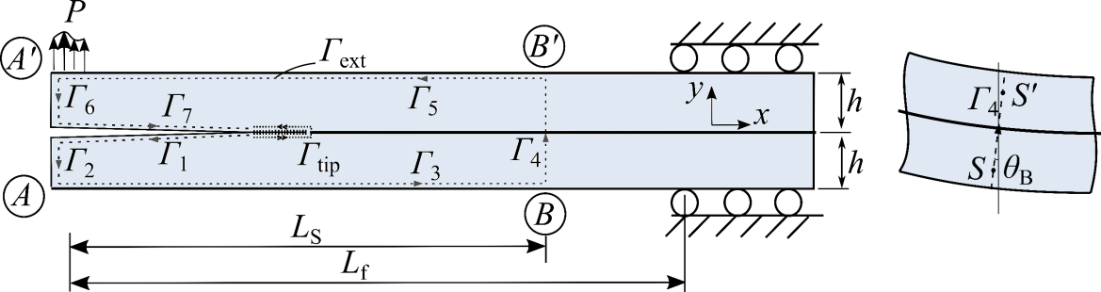
Fig. 1 The J-integral contour in an adhesively bonded joint specimen, in which the exterior contour Γ_{ext} was indicated by the dashed lines comprised of Γ₁ - Γ₇.
In the analysis that follows, all load and rotation symbols (e.g., P_{A}) contain direction signs. For point A on the loading edge of Γ₃, dy = 0. As there is no tangential traction at points A and A', thus $σ_{12}^{A}=σ_{12}^{A^{'}}=0$, $\int_{s_{0}}^{s_{1}}{{−σ}_{22}^{A}dx=\frac{P_{A}}{b}}$ and $\int_{s_{0}}^{s_{1}}{σ_{22}^{A^{'}}dx=\frac{P_{A^{'}}}{b}}$, where b is the width of joint. Under the assumption of small deformation, $\frac{∂u_{2}}{∂x}=tanθ=θ$, and thus Eq. (3) becomes
$$\begin{aligned}J_{A}^{I}=\frac{1}{4}\left(−\frac{P_{A}}{b}+\frac{P_{A^{'}}}{b}\right)\left(θ_{A}−θ_{A^{'}}\right) \#\left(4\right)\end{aligned}$$
$$\begin{aligned}J_{A}^{II}=\frac{1}{4}\left(−\frac{P_{A}}{b}−\frac{P_{A^{'}}}{b}\right)\left(θ_{A}+θ_{A^{'}}\right) \#\left(5\right)\end{aligned}$$
Similar expressions are obtained at other positions along the contour. When the contour segment Γ₄ situated at the location of x = L_{S} is far away from the crack tip (e.g., L_{S} > a + L_{FPZ}, where a is the crack length and L_{FPZ} is the length of FPZ), Γ₄ can be assumed as the cross-section of a single beam with a thickness of 2h, and thus $σ_{11}^{S}=−σ_{11}^{S^{'}}$, $σ_{12}^{S}=σ_{12}^{S^{'}}$ and $σ_{22}^{S}=σ_{22}^{S^{'}}=0$. Therefore, the J values along Γ₄ are:
$$\begin{aligned}J_{Γ4}^{I}=0 \#\left(6\right)\end{aligned}$$
$$\begin{aligned}J_{Γ4}^{II}=\int_{−h}^{h}{\left(σ_{12}ε_{12}−\frac{1}{2}σ_{11}ε_{11}−σ_{12}θ_{S}\right)dy} \#(7)\end{aligned}$$
where $θ_{S}$ is the slope of Γ₄ due to bending. When Γ₄ is far away from the crack tip, beam theory is applied and the components in Eq. (7) become $\int_{−h}^{h}{σ_{12}ε_{12}dy=}{{3P}_{L_{S}}^{2}}/{10G_{12}hb^{2}}$, $\int_{−h}^{h}{−\frac{1}{2}σ_{11}ε_{11}dy=−{{3M}_{L_{S}}^{2}}/{{4E}_{11}b^{2}h^{3}}}$ and $\int_{−h}^{h}{σ_{12}θ_{S}dy={P_{L_{S}}θ_{S}}/b}$, in which E₁₁ and G₁₂ are the Young’s modulus and shear modulus of the substrates, respectively. For the ELS specimen, $θ_{A^{'}}=θ_{A}$, $P_{A^{'}}=P_{A}=P/2$ and $P_{L_{S}}=−P$. With the summation of all individual contributions along the contour, the J components for the ELS specimen are obtained [22]:
$J_{I}=0$ (8)
$J_{II}=\frac{{3P}^{2}}{10G_{12}hb^{2}}−\frac{{3P}^{2}L_{S}^{2}}{{4E}_{11}b^{2}h^{3}}+\frac{P}{b}\left(θ_{S}−θ_{A}\right)$ (9)
A similar decomposition analysis can be made to the FRMM specimen, with $P_{A^{'}}=P$, $P_{A}=0$ and $P_{L_{S}}=−P$. Apart from the Γ₄ contour segment, at load-point A', $J_{A^{'}}^{I}=\frac{1}{4}\left(−\frac{P_{A^{'}}}{b}\right)\left(θ_{A^{'}}−θ_{A}\right)$, $J_{A^{'}}^{II}=\frac{1}{4}\left(−\frac{P_{A^{'}}}{b}\right)\left(θ_{A^{'}}+θ_{A}\right)$, and at load-point A, $J_{A}^{I}=\frac{1}{4}\left(\frac{P_{A^{'}}}{b}\right)\left(θ_{A}−θ_{A^{'}}\right)$, $J_{A}^{II}=\frac{1}{4}\left(−\frac{P_{A^{'}}}{b}\right)\left({θ_{A}+θ}_{A^{'}}\right)$. The J components for the FRMM specimen are [22],
$J_{I}=\frac{1}{2}\left(−\frac{P}{b}\right)\left(θ_{A^{'}}−θ_{A}\right)$ (10)
$J_{II}=\frac{1}{2}\left(−\frac{P}{b}\right)\left(θ_{A^{'}}+θ_{A}−2θ_{S}\right)+\frac{{3P}^{2}}{10G_{12}hb^{2}}−\frac{{3P}^{2}L_{S}^{2}}{{4E}_{11}b^{2}h^{3}}$ (11)
2.2 Determination of G using the CBTE method
The compliance of an ELS specimen is [29]
$$\begin{aligned}C=\frac{3a_{e}^{3}+L_{e}^{3}}{2E_{11}bh^{3}}+\frac{3L_{e}}{5G_{12}bh}\#\left(12\right)\end{aligned}$$
where L_{e} is the effective free length (horizontal distance between the clamp point and the load line) correcting for the effects of transverse shear and beam root rotation at the clamping point. Theoretically, the initial compliance C₀ remains constant during initial loading, both the values of a_{e} and L_{e} also remain constant. In this work, the effective free length L_{e} was deduced by solving the above equation with C₀ at initial loading with the initial crack length a₀,
$$\begin{aligned}αL_{e}^{3}+βL_{e}+γ=0 \#\left(13\right)\end{aligned}$$
in which, $α=\frac{1}{2E_{11}bh^{3}}, β=\frac{3}{5G_{12}bh}, γ=\frac{3a_{0}^{3}}{2E_{11}bh^{3}}−C_{0}$. The effective free length of the beam is obtained by solving the above cubic equation using the approach proposed in [30],
$$\begin{aligned}L_{e}=\frac{A}{6α}−\frac{2β}{A} \#\left(14\right)\end{aligned}$$
with the parameter A defined as [30],
$$\begin{aligned}A={\left[\left(−108γ+12\sqrt{3\left(\frac{{4β}^{3}}{α}+{27γ}^{2}\right)}\right)α^{2}\right]}^{1/3} \#\left(15\right)\end{aligned}$$
Once the value of L_{e} is known, the effective crack length a_{e} during crack propagation can thus be obtained as [8]
$$\begin{aligned}a_{e}={\left[\frac{2E_{11}bh^{3}}{3}\left(C−\frac{3L_{e}}{5G_{12}bh}\right)−\frac{L_{e}^{3}}{3}\right]}^{1/3} \#\left(16\right)\end{aligned}$$
Finally, the CERR for the ELS specimens, G_{IIc}, can then be determined by Eq. (17) [8].
$$\begin{aligned}G_{IIc}=\frac{9P^{2}a_{e}^{2}}{4E_{11}b^{2}h^{3}} \#(17)\end{aligned}$$
For an FRMM test, the compliance of the joint is [29],
$$\begin{aligned}C=\frac{7a_{e}^{3}+L_{e}^{3}}{2E_{11}bh^{3}}+\frac{3L_{e}}{5G_{12}bh} \#\left(18\right)\end{aligned}$$
The effective free length L_{e} can be obtained by following the procedures described above, and the effective crack length is determined as [15]:
$$\begin{aligned}a_{e}={\left[\frac{2E_{11}bh^{3}}{7}\left(C−\frac{3L_{e}}{5G_{12}bh}\right)−\frac{L_{e}^{3}}{7}\right]}^{1/3} \#\left(19\right)\end{aligned}$$
The decomposed CERR for the FRMM specimens can thus be determined by Eqs. (20, 21) [15].
$$\begin{aligned}G_{Ic}=\frac{3P^{2}a_{e}^{2}}{4E_{11}b^{2}h^{3}}+\frac{3P^{2}}{10G_{12}b^{2}h} \#\left(20\right)\end{aligned}$$
$$\begin{aligned}G_{IIc}=\frac{9P^{2}a_{e}^{2}}{16E_{11}b^{2}h^{3}} \#\left(21\right)\end{aligned}$$

3. Experiments
To verify the applicability and accuracy of the slope-based J equations, the ERR values for the ELS test specimens were measured using the slope-based J-integral method and were compared with the values determined using the Corrected Beam Theory with Effective Crack Length (CBTE) derived from LEFM [8].
3.1. Joints manufacturing and testing
The ELS and FRMM specimens were made of unidirectional MTC510-T700 composite with the carbon fibre volume fraction of 60% (E₁₁ = 119 GPa, G₁₂ = 3.6 GPa). The CFRP adherends had the length of 250 mm, width of 20 mm and thickness of 10 mm. The surface of each composite substrate was grit blasted and wiped with acetone prior to being bonded with the AF163-2 epoxy-film adhesive, with the bondline thickness of 0.4 mm. Each joint was painted with trackable speckles for displacement analysis by means of DIC. The ELS specimens were tested at a rate of 1.0 mm/min using an Instron 5584 machine installed with a 10 kN load cell, with a free length being L_{f} = 190 mm. Two cameras were employed to monitor the displacement of the arms and the bonded substrates in front of the initial crack, as illustrated in Fig. 2. The displacement resolution of the DIC analysis performed was 2 µm, and each pixel in the image represented a length of 35 µm on the joint surface. More details about the experiment and the calculation of the slope values can be found in [22].
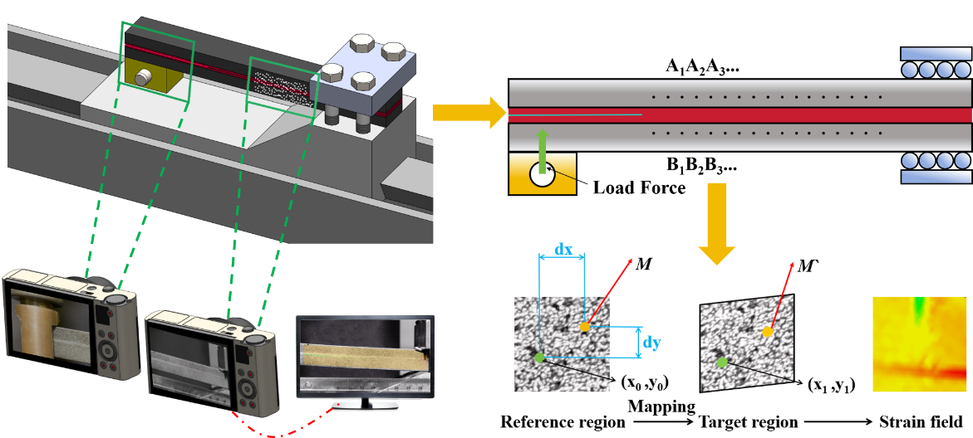
Fig. 2 Experimental testing of the ELS/FRMM specimen.
3.2 G and J results
Stable cohesive failure within the adhesive layer occurred in all ELS specimens as shown in Fig. 3a. By analysing the shear strain e₁₂ using DIC analysis, it was found that the length of the fully developed cohesive zone L_{FPZ}≈60 mm, and thus the selected value of L_{S} was set to L_{S} = 170 mm in the J_{IIc} measurement (i.e., the distance between contour Γ₄ and the crack tip is L_{S} - a₀ = 70 mm) to ensure the bonded sections could be considered a single beam when the FPZ was developed. The J and G values calculated using slope-based J approach and the CBTE method, respectively, as a function of the effective crack length a_{e} are shown in Fig. 3a. Each solid line represents the J_{II} values for one specimen, while the dashed line with the same colour represents the G_{II} values for the same specimen. Both the J and G curves exhibited plateau regions corresponding to steady crack propagation during the tests. The J_{IIc} value was 11.7 ± 1.1 kJ/m², whilst the G_{IIc} value was 15.6 ± 1.3 kJ/m². Clearly, G_{IIc} was about 33% greater than J_{IIc}. The J_{IIc} value was close to the value deduced via extraction of the cohesive law from thick single lap shear specimens bonded with the same adhesive, i.e., ranging from 12.6 ± 0.9 kJ/m² to 13.1 ± 0.7 kJ/m² reported in [31,32]. This raises the question: which method (G or J) is more reliable for the measurement of the toughness values under Mode II loading?
The macroscopic fracture surfaces of the FRMM joint shown in Fig. 3b indicated that stable cohesive failure occurred. Fig. 3(b, c, d) presents the J_{I/II} = J_{I} + J_{II}, J_{I} and J_{II} values measured respectively. The J_{I/IIc} value was 4.8 ± 0.3 kJ/m² while the G_{I/IIc} value was 5.1 ± 0.2 kJ/m². The two methods led to very similar results, in close agreement with the G_{I/IIc} results for the FRMM specimens bonded with the same adhesive in the literature [17], which ranged from 5.0-6.2 kJ/m².
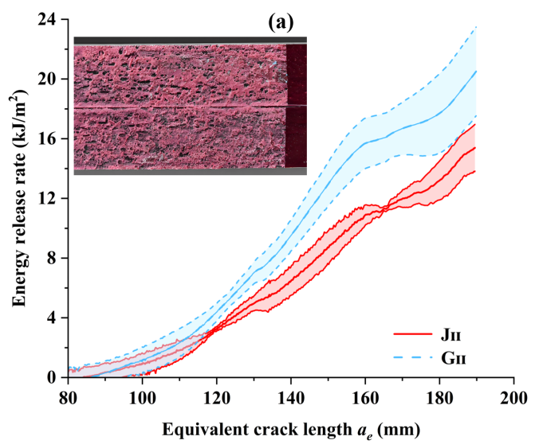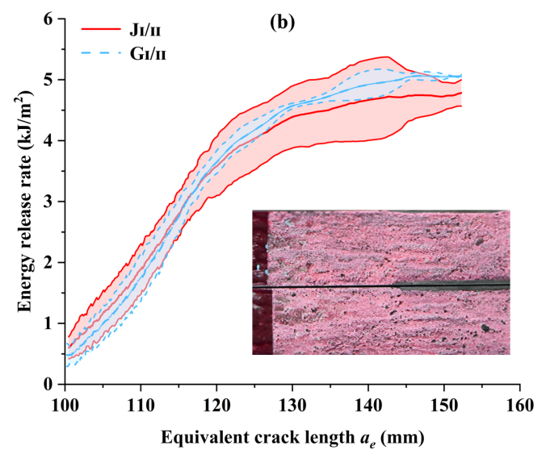
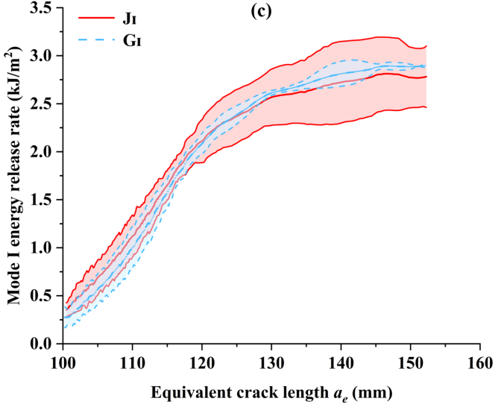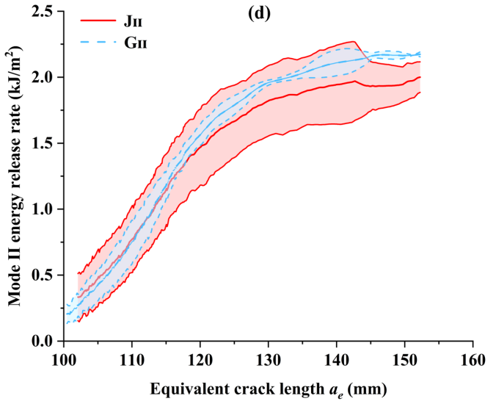
Fig. 3 (a) The J_{II} and G_{II} as a function of the effective crack length in the bonded CFRP ELS specimens, (b-d) the values of J and G as a function of the effective crack length in the bonded CFRP FRMM specimens.
The above results indicated that the J and G values determined for the FRMM specimens matched closely, whilst the J and G values determined for the ELS specimens exhibited apparent differences. This raises the important question: which method is the more accurate for the determination of fracture toughness? Generally, when the adhesive exhibits nonlinear deformation, e.g., due to large-scale damage ahead of the crack tip, the G_{c} values determined by LEFM methods deviate from the true values.
3.3 Deformation behaviour
The distribution of strain ε₁₂ on the surface of ELS specimen extracted from DIC is shown in Fig. 4. Apart from the crack tip, pronounced shear strains developed in the bondline close to the clamped end, for instance local shear strain ε₁₂ ≈ 0.07, close to the absolute value of the shear strain developed at the middle point of the FPZ. This indicates the occurrence of local damage in the bondline at the clamped end. Fig. 5 illustrates examples of the distribution of horizontal displacement along the height of the ELS specimen. The value of the horizontal displacement changed linearly along the height of either the upper or the lower substrate, with dramatic displacement transitions occurring at the bonded interface. It can be seen that even at large loading displacement, the rotation angle (the reciprocal of the slope of each plot) was relatively small, and thus small deformation analysis could be adopted. Hence, the sliding displacements across the interface, U₁, were measured directly using linear extrapolations of the displacement data just outside the transition region as suggested in [33].
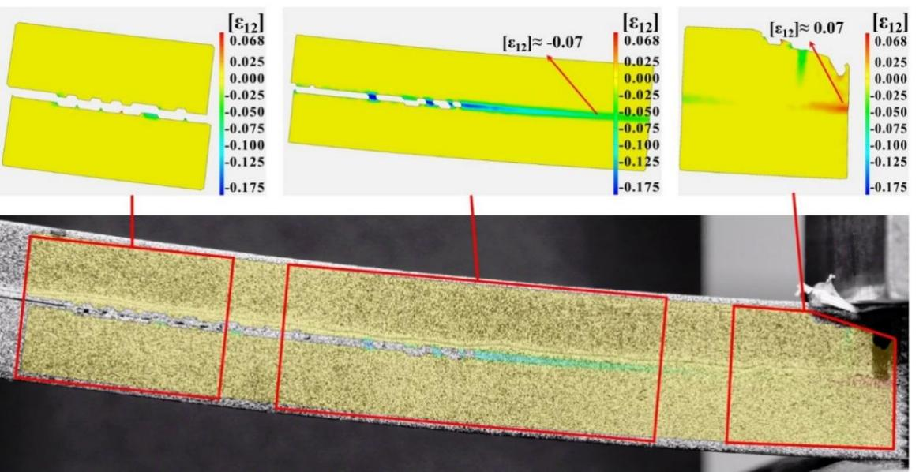
Fig. 4 ε₁₂ contour on the loaded ELS specimen measured using DIC.
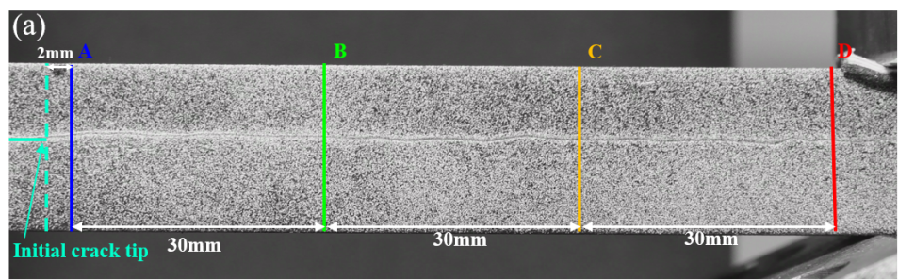
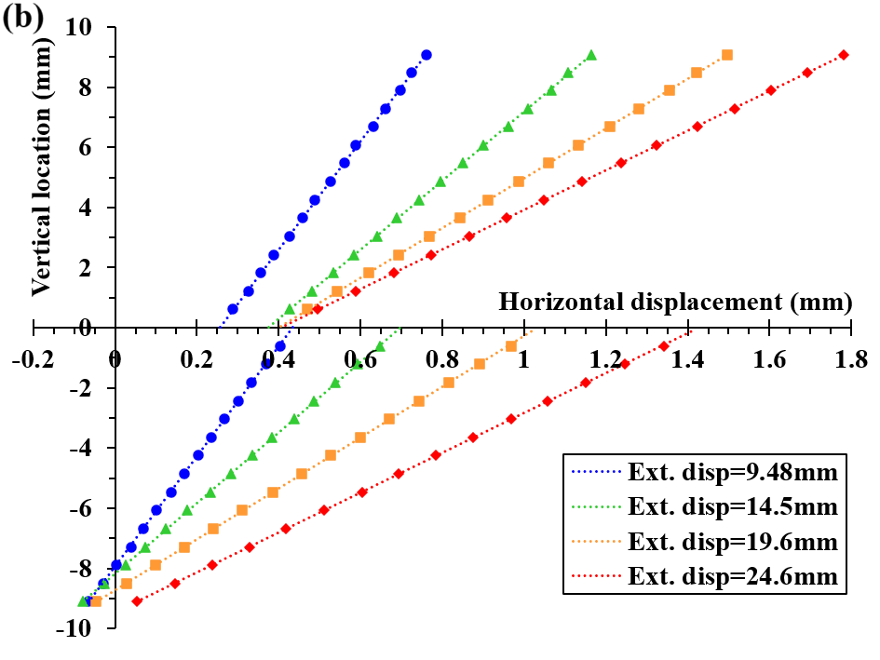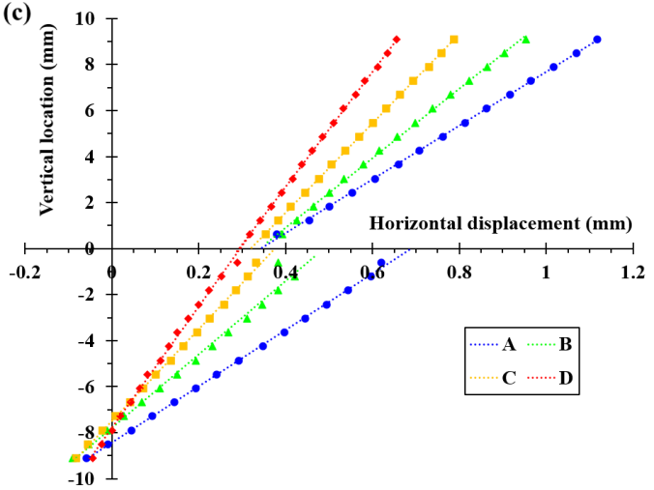
Fig. 5 (a) Illustration of inspection positions on the ELS specimen, (b) horizontal displacement measured at the location of the initial crack tip under different loading displacements, and (c) horizontal displacement measured at lines A, B, C and D, which were located at a distance of 2 mm, 32 mm, 62 mm, 92 mm respectively in front of the initial crack tip, when the external displacement of 14.5 mm was applied.

The sliding displacements U₁ across the bonded interface at different loading times measured using linear extrapolations are shown in Fig. 6. In the early stage of loading, from the left end to the right end of the bondline, the U₁ curve gradually developed from a negative region to a plateau region with a value close to zero, indicating the growth of the initial crack; beyond the plateau region, the U₁ curve was associated with positive values and increased with the bonding length until levelling off, which indicates that local damage in the bondline caused by relative sliding between the clamped upper and lower substrates had occurred. As the loading continued, the plateau region in the U₁ curve became shorter and eventually disappeared. This was because the main crack continued to propagate towards the right end, whilst the local damage close to the clamped continued to extend towards the left end, analogous to a co-planar secondary crack propagating towards the main crack from the inverse direction.
The displacement results indicate the occurrence of pronounced local deformation or damage in the bondline close to the clamp in the ELS specimen. In such cases, LEFM analysis included the additional contribution from the local damage in the bondline at the clamped end, which resisted the propagation of the main crack, and thus led to the over-estimation of the CERR values. In contrast, the J-integral approach can exclude the contribution from the local damage close to the fixture clamp when an appropriate integral path is constructed.
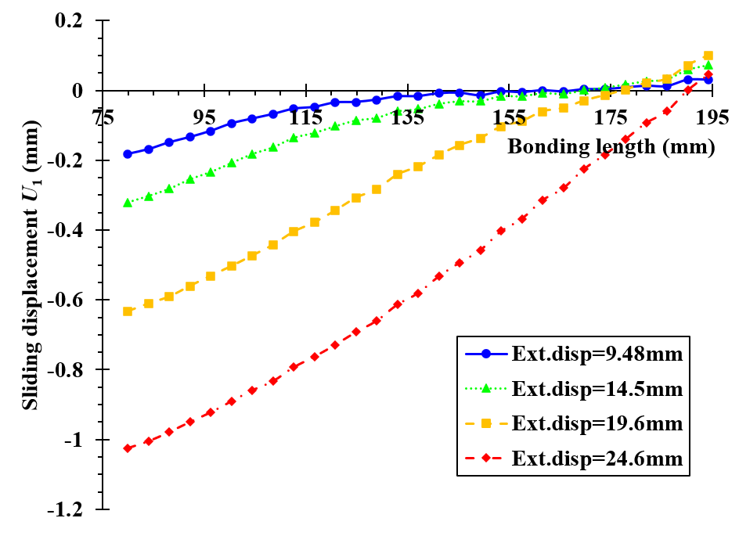
Fig. 6 Sliding displacement (U₁) along the bondline measured in the bonded ELS joint.
The distribution of strain ε₁₂ across the surface of the FRMM specimen extracted from DIC using linear extrapolations is shown in Fig. 7. Unlike the ELS specimen, no apparent shear strains were observed at the clamped end of the FRMM specimen. Fig. 8 shows the measured relative sliding displacement U₁ along the bonded interface. The U₁ curve developed from a negative region to a plateau region with a value of approximately zero and then remained at this plateau value, indicating that no pronounced local damage occurred across the bonded interface close to the clamped end, i.e., there was only the main crack propagating within the bondline. In such cases, the LEFM analysis only included the contribution from the growth of the main crack as expected such that it yielded reliable CERR values, which matched the values determined using the J-integral approach closely.
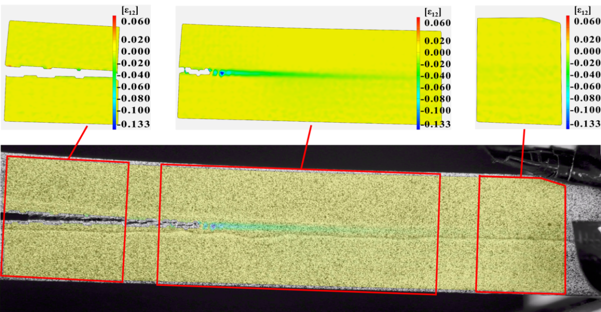
Fig. 7 ε₁₂ contour on the loaded FRMM specimen measured using DIC.
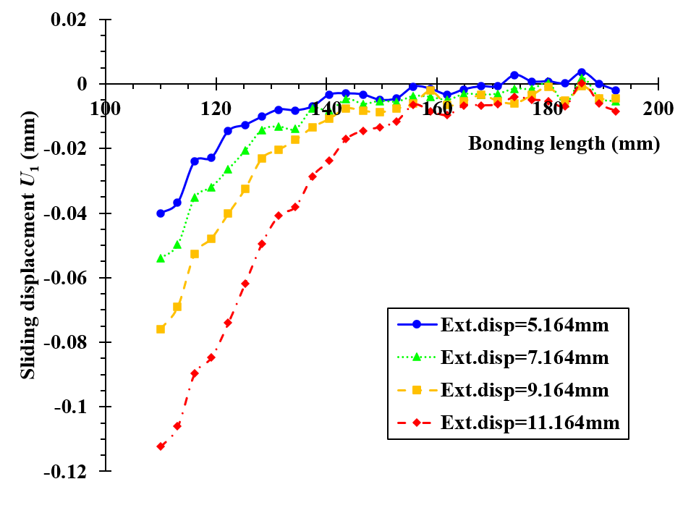
Fig. 8 Sliding displacement (U₁) along the bondline measured in the bonded FRMM joint.

4. Numerical evaluation
4.1. Numerical models
To further identify the origins of the difference in the toughness values obtained using the J-integral and LEFM methods, finite element modelling was conducted with a 2D geometrical plane strain model. The substrates and end-blocks were represented by four-node bilinear elements with reduced integration and hourglass control (CPE4R), while the adhesive was represented by a layer of cohesive elements inserted in between the substrates. The material behaviour within the cohesive elements has been described through a bilinear traction separation law, which has been shown to be the best choice for this adhesive [31,32]. These authors showed that a linear relationship between J_{Ic} and J_{IIc} under different loading was justified, and therefore a linear failure locus was assumed to account for crack propagation on the interface, i.e., ${G_{I}}/{G_{Ic}+{G_{II}}/{G_{IIc}}=1}.$Also, the Quadratic Stress criterion to model the onset of damage was adopted, i.e., ${\left({〈t_{n}〉}/{t_{n}^{0}}\right)}^{2}+{\left({t_{s}}/{t_{s}^{0}}\right)}^{2}=1$, in which the Macaulay brackets indicating that only positive traction is considered to initiate damage, and $t_{n}^{0}$ and $t_{s}^{0}$ are the interfacial normal and in-plane shear strengths under pure modes, respectively. The parameters defined in the modelling are summarized in Table 2, in which the G_{Ic} value was taken from the previously published results tested on the same adhesive used to bond CFRP substrates [32].
Table 2. Material properties employed in the modelling studies.
CFRP | E₁₁ (GPa) | E₂₂ (GPa) | ν₁₂ = ν₁₃ | G₁₂ = G₁₃ (GPa)
CFRP | 119 | 8.2 | 0.34 | 3.6
Adhesive | G_{Ic} (kJ/m²) | G_{IIc} (kJ/m²) | $t_{n}^{0}$ (MPa) | $t_{s}^{0}$ (MPa)
Adhesive | 3.0 | 11.4 | 35 | 35

4.2 Modelling results for the ELS specimens
Fig. 9a displays the modelling and experimental load-displacement results for the Mode II ELS specimens containing an initial crack length a₀ = 100 mm. With increasing displacement, the load increased to a peak value and then decreased due to crack initiation and propagation, before increasing again due to the constraint imposed by the clamp on the growing crack. The modelling results obtained using the measured J_{c} values agreed with the experiment closely, confirming the accuracy of the slope-based J-integral approach in the measurement of CERR values for the ELS specimens. In addition, the results suggest that LEFM methods such as the CBTE method, which led to a higher value of G_{IIC} = 15.6 ± 1.3 kJ/m² being measured, were not reliable.
Fig. 9b shows the modelling results obtained for the sliding displacement U₁ across the bonded interface of the ELS specimen at the different loading displacements, which were extracted by calculating the differences between the displacement values at the upper and lower nodes in the cohesive elements. The sliding displacement U₁ was consistent to the experimental results measured by DIC. The U₁ curve along the bonded interface transitioned from negative values to positive values during initial loading, with a plateau region of approximately zero being obtained between the main crack and the clamped end. This led to the development of localized shear stress in the bondline close to the fixture as shown in Fig. 9c. The length of the plateau region decreased as loading continued, indicating that the front of the main crack and the local damage met gradually. Fig. 9d displays the shear stress (tangential traction) across the bondline of the ELS joint. By comparing Figs. 9b and 9d, it is found that the shear stress was not proportional to the relative sliding occurred along the interface of the clamped end, indicating that damage has been occurred in this region during loading.
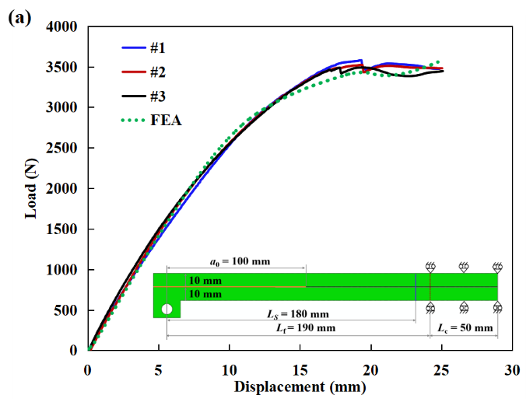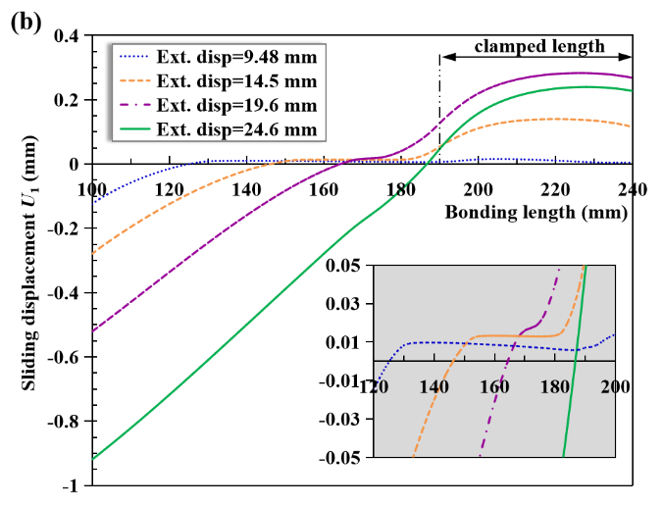
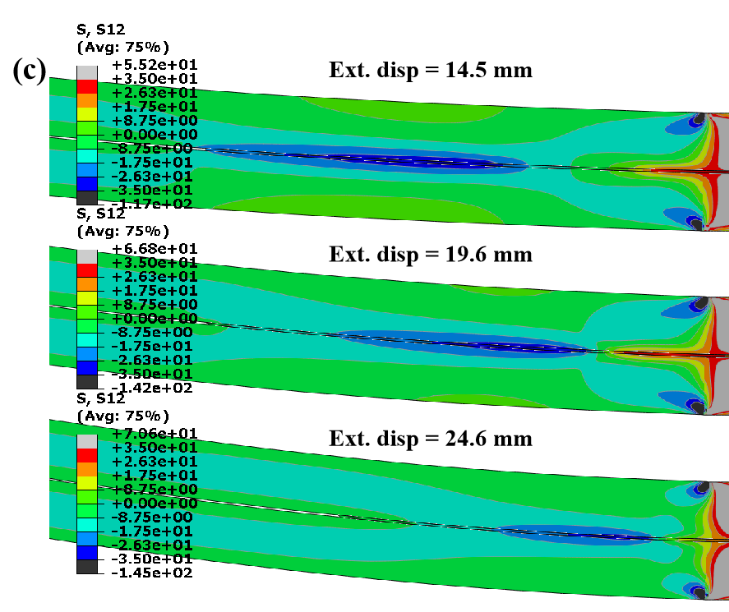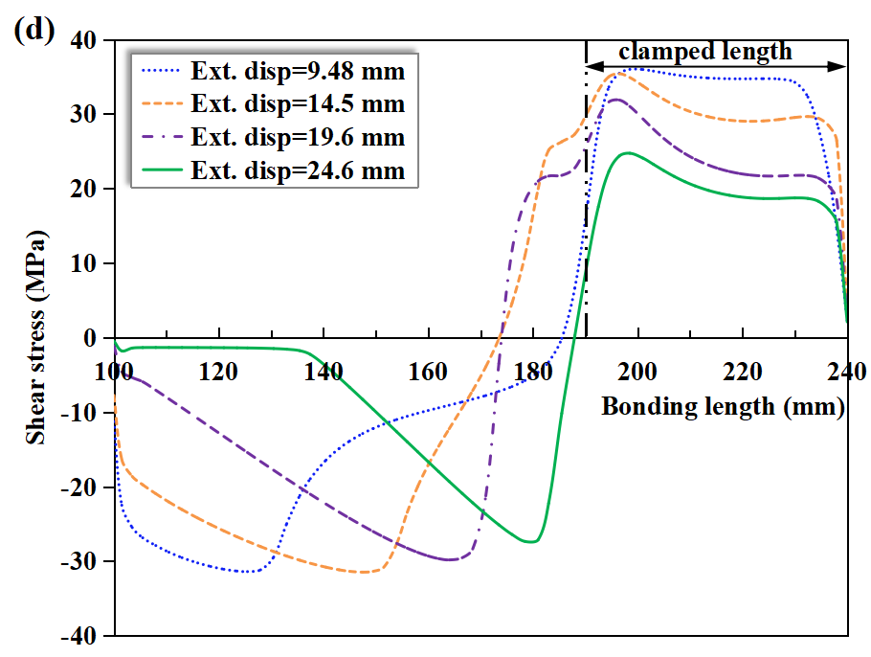
Fig. 9 (a) Loading traces in the ELS test obtained by experiment and modelling, (b) sliding displacement along the bonded interface, (c) shear stresses developed in the joint, and (d) shear stress (tangential traction) along the bonded interface.
4.3. Modelling results for the FRMM specimens
Fig. 10a shows the modelling and experimental load-displacement results for the FRMM specimens containing initial cracks with a₀ = 100 mm. For all the joints tested, although the modelling overestimated the stiffness of the joints prior to fracture, the peak loads obtained were close to the experimental values. The modelled loads during crack propagation (i.e., the decreasing part of the curve) were smaller than the experiments, corresponding to the lower bound of the load, indicating an underestimation of the fracture toughness for the mixed mode loading. Nevertheless, the results show that the J_{c} values measured were generally accurate to reproduce the load-displacement curve in the experiments, which confirmed the accuracy of the J-integral approach.
Fig. 10b shows the modelling results of the sliding displacement U₁ across the bonded interface of the FRMM specimen at different loading displacements. The evolution of the sliding displacement was in agreement with the experimental results measured using DIC, i.e., the U₁ curve along the bonded interface transitioned from negative values to a plateau region with a value close to zero. This confirmed that no local damage in the bondline occurred at the clamped end of the FRMM specimen. Figs. 10(d, e) display the shear stress (tangential traction) across the bondline of the FRMM joint. By inserting the maximum traction across the bondline at the clamped end into the Quadratic Stress criterion applied in this work, i.e., ${\left({〈t_{n}〉}/{t_{n}^{0}}\right)}^{2}+{\left({t_{s}}/{t_{s}^{0}}\right)}^{2}=1$, it is found that no damage occurred in the clamped bondline. This confirmed the experimental results, namely, damage mainly occurred in the process zone of the crack tip. In such cases, the use of LEFM method to analyze the fracture in the joints will yield reliable CERR values.
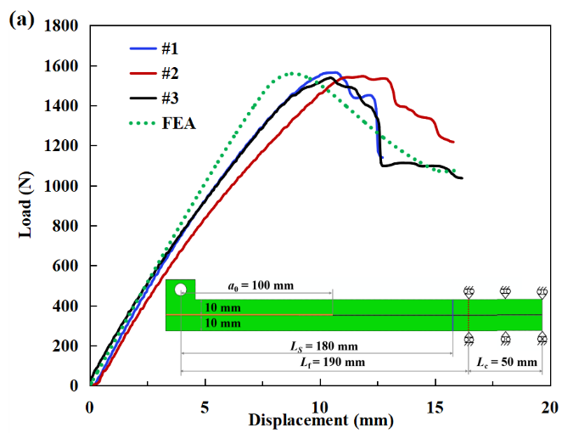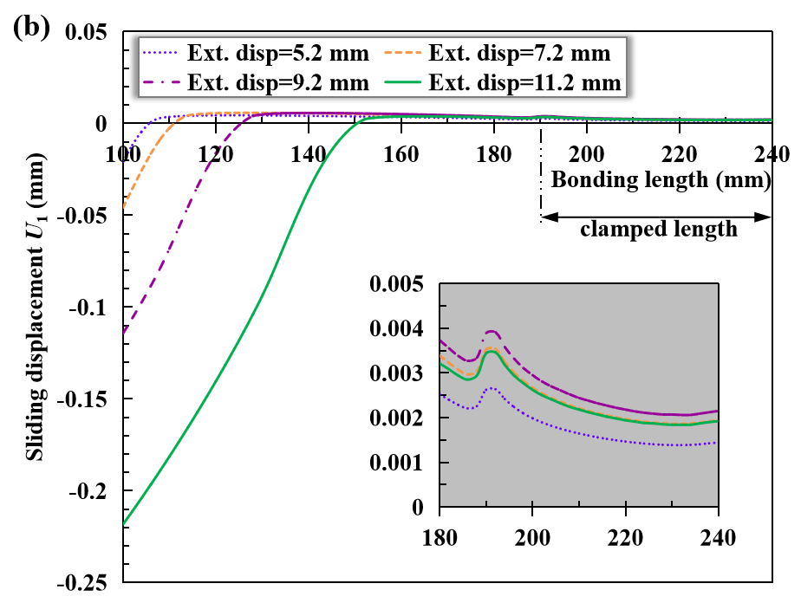
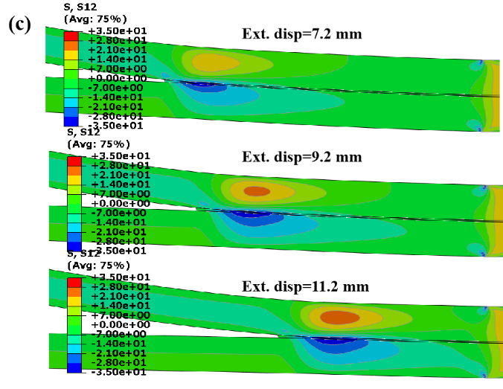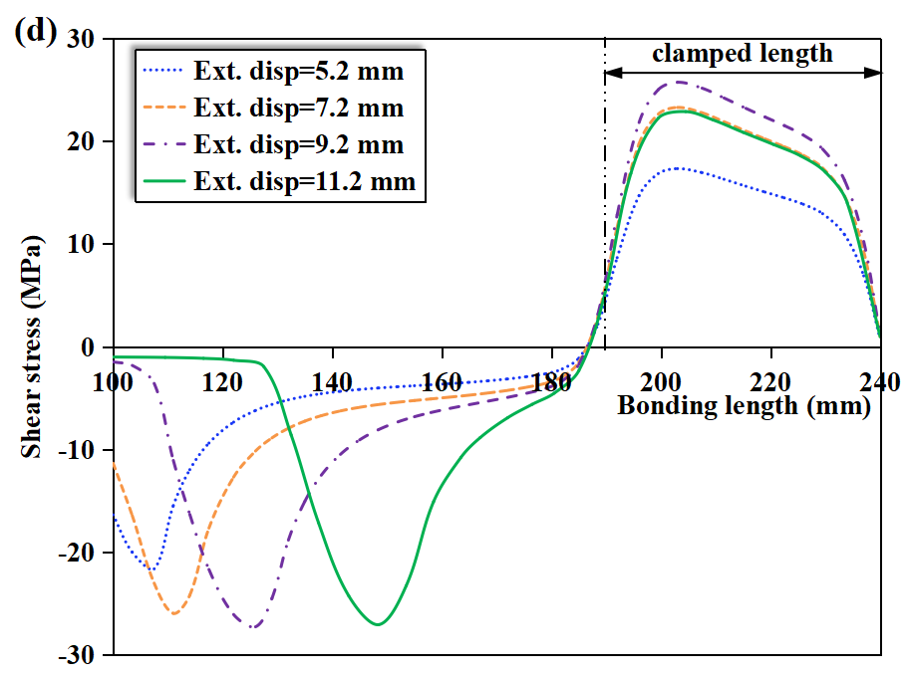
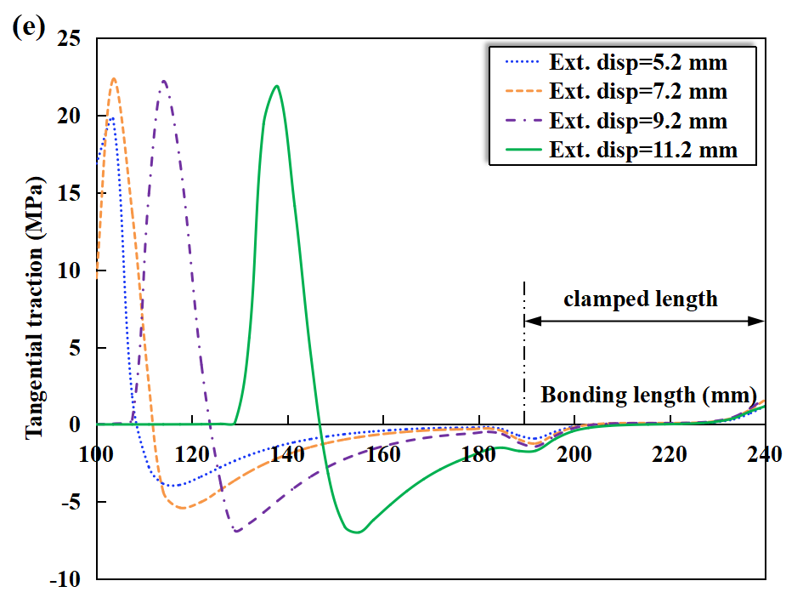
Fig. 10 (a) Loading traces in the FRMM test obtained by experiment and modelling, (b) sliding displacement along the bonded interface, (c) shear stresses in the joint, (d) shear stress (tangential traction) along the bonded interface, and (e) normal stress (normal traction) along the interface.
Overall, the FE modelling confirmed the accuracy of the CERR values measured using the slope-based J integral approach for both ELS and FRMM specimens. It reproduced the local damage in the bondline that occurred at the clamped end in the pure Mode II ELS specimen, which led to over-estimations of the CERR values when LEFM approaches were applied. As for the Mixed Mode I/II FRMM specimens, the modelling also indicates that there was no local damage at the clamped end as the proportion of Mode II was much smaller compared to ELS specimens, and thus it confirmed that LEFM approaches remained valid.

5. Discussion
5.1 Accuracy of the J and LEFM methods
Fig. 11 compares the J_{II} and G_{II} values determined from the modelling data, together with J values evaluated numerically according to its definition along a set of different contours surrounding the crack tip, with each subsequent contour being defined by adding the next ring of elements that share nodes with the elements in the previous contour [34,35]. The J_{II} values determined using the slope-based J method agreed very closely with the J values evaluated numerically, which validated the accuracy of the proposed J method for the ELS specimens. In contrast, the G_{II} values determined using the CBTE method deviated from the J values evaluated numerically as the loading increased, indicating that these LEFM values were not valid.
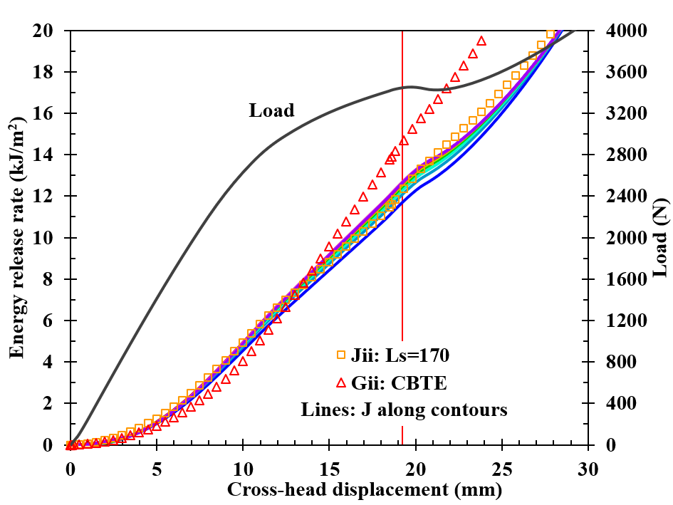
Fig. 11 Comparison of the J_{II}, G_{II} values and numerically evaluated J values.
5.2 Effect of boundary constraint
As shown above, the LEFM method to measure G_{IIc} for the ELS specimens became invalid due to the additional damage across the bonded interface at the clamped end, in contravention to the LEFM assumption of progressive failure along the interface. In the present work, numerical analysis of the ELS specimen containing an initial crack length a₀ = 100 mm with the right end subjected to a fixed boundary in the thickness direction was also conducted. In the simulation, the free length of the joint was set to be 230 mm from the loading line, which was evaluated from Eq. (14) using the compliance value taken for the initial loading. The J and G values were obtained according to Eq. (9) and Eq. (17) respectively using the modelling load-displacement results, and are shown in Fig. 12a. The G curve matched the J curve closely during the entire failure process, with both G_{IIc} and J_{IIc} values (the plateau values) being equal to the input toughness value of 11.4 kJ/m² in the cohesive elements. The results indicate that the CBTE method derived from LEFM was still valid for the analysis of the thick ELS specimen, provided the end of the specimen was subjected to fixed constraint in the thickness direction rather than sliding constraint. Under such constraint, the crack propagated along the interface progressively and no additional damage occurred in the bondline at the clamped end, as indicated by the sliding displacement in Fig. 12b. These results confirmed that the error in the G value in the ELS test when the specimen end was clamped on a sliding trolley was caused by the relative sliding occurred across the bonded interface at the clamped end, rather than the nonlinear deformation in the fracture process zone. The test setup using a sliding trolley for the ELS specimens recommended in the ISO15114 standard seems has several drawbacks: (1) it tends to induce significant increase in the free length due to the specimen rotation occurred at the clamped end under bending, which is one main error source in the determination of G using LEFM methods; (2) it tends to cause secondary interface sliding to occur at the clamped end as demonstrated in this work, especially when thick joints are tested, which may lead to the invalidity of the LEFM methods.
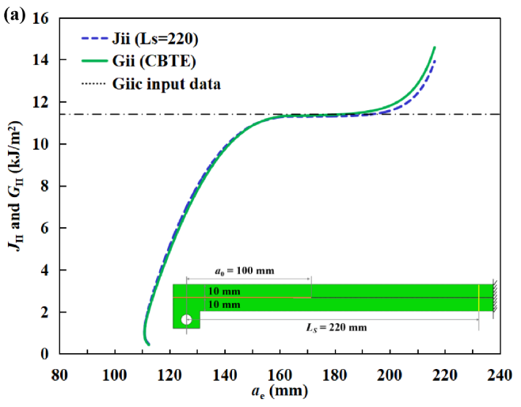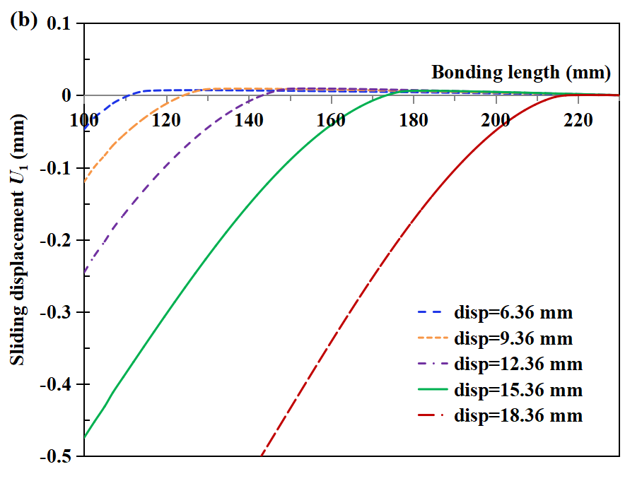
Fig. 12 (a) G and J results obtained from ELS modelling with fixed constraint applied to the end of the specimen, (b) the sliding displacement U₁ along the bonded interfaces.
The above results show that the boundary constraint to the ELS specimens has a significant effect on the accuracy of the measurement of the Mode II fracture toughness. The occurrence of relative sliding between the upper and lower substrates close to the clamp should be avoided, especially for joints bonded with tough or flexible adhesives. Therefore, modifications to the normal ELS specimen and testing jig to minimise the occurrence of local damage in the bondline close to the clamped end are worthy of investigations in the future.
6. Conclusions
In this work, the validity of LEFM for measuring energy release rate for adhesively bonded unidirectional CFRP joints under Mode II and Mixed Mode I/II loading, G_{II} and G_{I/IIc}, using ELS and FRMM specimens respectively has been investigated. The G values determined using LEFM coupled with an effective crack length approach were compared with crack length independent J-integral values measured simultaneously using slope-based J-integral methods. Numerical modelling was also conducted to analyse the validity of LEFM for these toughness measurements.
The experiments show that the use of LEFM resulted in significant errors in the measurement of the Mode II CERR for ELS joints bonded with a tough structural epoxy-film adhesive. An analysis of the shear strains in the test specimens using DIC indicated the presence of local damage in the bondline at the clamped end of the specimen, which was caused by the relative sliding between the upper and lower substrates at the clamping end simultaneously in addition to the damage and fracture ahead of the main crack. In contrast, the J method was able to provide accurate and valid toughness values as the contribution of local damage to J could be excluded when an appropriate integral contour was selected. The experimental results show that LEFM was valid for the measurement of the mixed mode fracture toughness using FRMM specimens as no local damage at the clamped end was observed to occur, with the G_{I/IIc} values being in good agreement with the J_{I/IIc} values.
The FE modelling confirmed the accuracy of the CERR values measured using the slope-based J integral approach for both ELS and FRMM specimens, and reproduced the local damage that occurred in the bondline at the clamped end in the pure Mode II ELS specimen. The results also suggest that LEFM might be still valid for the G_{II} analysis using an ELS specimen when no additional sliding/damage occurs outside the main crack, provided fixed constraint is applied to the end of the specimen in the thickness direction rather than sliding constraint.
The decomposed J method should be valid also for the fracture analysis of adhesively bonded multi-directional composites if the layer stacking in the upper and lower substrates is symmetric, which is worthy of validation by experiment in the future.

Acknowledgement
We would like to acknowledge the financial support provided by the Fundamental Research Funds for the Central Universities, China (22120240046).

References
[1] Da Silva LFM, Öchsner A, Adams RD. Handbook of Adhesion Technology. Heidelberg: Springer-Verlag Berlin Heidelberg; 2011.
[2] Yudhanto A, Alfano M, Lubineau G. Surface preparation strategies in secondary bonded thermoset-based composite materials- A review. Compos Part A Appl Sci Manuf 2021;147:106443. https://doi.org/10.1016/j.compositesa.2021.106443.
[3] Lißner M, Alabort E, Cui H, Rito R, Blackman BRK, Petrinic N. Experimental characterisation and numerical modelling of the influence of bondline thickness, loading rate, and deformation mode on the response of ductile adhesive interfaces. J Mech Phys Solids 2019;130:349–69. https://doi.org/10.1016/j.jmps.2019.06.011.
[4] Toolabi M, Blackman BRK. Guidelines for selecting the dimensions of adhesively bonded end- loaded split joints : An approach based on numerical cohesive zone length. Eng Fract Mech 2018;203:250–65. https://doi.org/10.1016/j.engfracmech.2018.05.019.
[5] Zhang Y, Shi J, Zheng J. A method of fracture toughness JIC measurement based on digital image correlation and acoustic emission technique. Mater Des 2021;197:109258. https://doi.org/10.1016/j.matdes.2020.109258.
[6] Chaves FJP, da Silva LFM, de Moura MFSF, Dillard DA, Esteves VHC. Fracture mechanics tests in adhesively bonded joints: A literature review. J Adhes 2014;90:955–92. https://doi.org/10.1080/00218464.2013.859075.
[7] Wang W, de Freitas ST, Poulis JA, Zarouchas D. A review of experimental and theoretical fracture characterization of bi-material bonded joints. Compos B Eng 2021;206. https://doi.org/10.1016/j.compositesb.2020.108537.
[8] Blackman BRK, Kinloch AJ, Paraschi M. The determination of the mode II adhesive fracture resistance, GIIC, of structural adhesive joints: An effective crack length approach. Eng Fract Mech 2005;72:877–97. https://doi.org/10.1016/j.engfracmech.2004.08.007.
[9] Pérez-Galmés M, Renart J, Sarrado C, Brunner AJ, Rodríguez-Bellido A. Towards a consensus on mode II adhesive fracture testing: Experimental study. Theor Appl Fract Mech 2018;98:210–9. https://doi.org/10.1016/j.tafmec.2018.09.014.
[10] ISO. ISO, 15114:2014. Fibre-reinforced plastic composites-determination of the mode II fracture resistance for unidirectionally reinforced materials using the cali-brated end-loaded split (C-ELS) test and an effective crack length approach. 2014.
[11] Blackman B, Sun F, Teixeira de Freitas S, de Barros S, Moreira Arouche M, Ivankovic A. Understanding fracture mode-mixity and its effects on bond performance. Advances in Structural Adhesive Bonding, Second Edition, Elsevier; 2023, p. 579–613. https://doi.org/10.1016/B978-0-323-91214-3.00015-6.
[12] Wang W, Lopes Fernandes R, Teixeira De Freitas S, Zarouchas D, Benedictus R. How pure mode I can be obtained in bi-material bonded DCB joints: A longitudinal strain-based criterion. Compos B Eng 2018;153:137–48. https://doi.org/10.1016/j.compositesb.2018.07.033.
[13] Ebrahimi MT, Khaji Z, Fakoor M. On mixed-mode fracture of brittle orthotropic solids: A novel micromechanical damage model. Eng Fract Mech 2025;313:110628. https://doi.org/10.1016/j.engfracmech.2024.110628.
[14] de Moura MFSF, Campilho RDSG, Gonçalves JPM. Pure mode II fracture characterization of composite bonded joints. Int J Solids Struct 2009;46:1589–95. https://doi.org/10.1016/j.ijsolstr.2008.12.001.
[15] de Moura MFSF, Cavaleiro PMLC, Silva FGA, Dourado N. Mixed-mode I+II fracture characterization of a hybrid carbon-epoxy/cork laminate using the Single-Leg Bending test. Compos Sci Technol 2017;141:24–31. https://doi.org/10.1016/j.compscitech.2017.01.001.
[16] Sarrado C, Turon A, Costa J, Renart J. On the validity of linear elastic fractrue mechanics methods to measure the fracture toughness of adhesive joints. Int J Solids Struct 2016;81:110–6. https://doi.org/10.1016/j.ijsolstr.2015.11.016.
[17] Álvarez D, Guild FJ, Kinloch AJ, Blackman BRK. Partitioning of mixed-mode fracture in adhesively-bonded joints: experimental studies. Eng Fract Mech 2018;203:224–39. https://doi.org/10.1016/j.engfracmech.2018.04.032.
[18] Sun F, Blackman BRK. A DIC method to determine the Mode I energy release rate G, the J-integral and the traction-separation law simultaneously for adhesive joints. Eng Fract Mech 2020;234:107097. https://doi.org/10.1016/j.engfracmech.2020.107097.
[19] Sarrado C, Turon A, Renart J, Costa J. An experimental data reduction method for the Mixed Mode Bending test based on the J-integral approach. Compos Sci Technol 2015;117:85–91.
[20] Pérez-Galmés M, Renart J, Sarrado C, Rodríguez-Bellido A, Costa J. A data reduction method based on the J-integral to obtain the interlaminar fracture toughness in a mode II end-loaded split (ELS) test. Compos Part A Appl Sci Manuf 2016;90:670–7. https://doi.org/10.1016/j.compositesa.2016.08.020.
[21] Wu C, Huang R, Liechti KM. Simultaneous extraction of tensile and shear interactions at interfaces. J Mech Phys Solids 2019;125:225–54. https://doi.org/10.1016/j.jmps.2018.12.004.
[22] Sun F, Lißner M, Petrinic N, Blackman BRK. Universal slope-based J-integral methods for characterization of the mode I, mode II and mixed mode I/II fracture behaviour of adhesively bonded interfaces. Compos Sci Technol 2024;252. https://doi.org/10.1016/j.compscitech.2024.110611.
[23] Höwer D, Jois KC, Stier B, Bednarcyk BA, Pineda EJ, Reese S, et al. Experimental and numerical investigation of the mixed mode delamination of monolithic laminates exhibiting severe fiber bridging. Compos Struct 2020;242:112035. https://doi.org/10.1016/j.compstruct.2020.112035.
[24] Sun F, Zhang R, Blackman BRK. Determination of the mode I crack tip opening rate and the rate dependent cohesive properties for structural adhesive joints using digital image correlation. Int J Solids Struct 2021;217–218:60–73. https://doi.org/10.1016/j.ijsolstr.2021.01.034.
[25] Rice JR. A Path Independent Integral and the Approximate Analysis of Strain Concentration by Notches and Cracks. J Appl Mech 1968;35:379–86. https://doi.org/10.1115/1.3601206.
[26] Ishikawa H, Kitagawa H, Okamura H. J INTEGRAL OF A MIXED MODE CRACK AND ITS APPLICATION. Mechanical Behaviour of Materials, Elsevier; 1980, p. 447–55. https://doi.org/10.1016/B978-1-4832-8414-9.50137-1.
[27] Huber O, Nickel J, Kuhn G. On the decomposition of the J-integral for 3D crack problems. Int J Fract 1993;64:339–48. https://doi.org/10.1007/BF00017849.
[28] Rigby RH, Aliabadi MH. Decomposition of the mixed-mode J-integral—revisited. Int J Solids Struct 1998;35:2073–99. https://doi.org/10.1016/S0020-7683(97)00171-6.
[29] Hashemi S, Kinloch AJ, Williams JG. The analysis of interlaminar fracture in uniaxial fibre-polymer composites. Proceedings of the Royal Society of London A Mathematical and Physical Sciences 1990;427:173–99. https://doi.org/10.1098/rspa.1990.0007.
[30] de Moura MFSF, Morais JJL, Dourado N. A new data reduction scheme for mode I wood fracture characterization using the double cantilever beam test. Eng Fract Mech 2008;75:3852–65. https://doi.org/10.1016/j.engfracmech.2008.02.006.
[31] Alvarez Feito D. Fracture mechanics of carbon fibre reinforced plastics to Ti-alloy adhesive joints. PhD Thesis, Department of Mechanical Engineering, Imperial College London 2012.
[32] Álvarez D, Blackman BRK, Guild FJ, Kinloch AJ. Mode I fracture in adhesively-bonded joints: A mesh-size independent modelling approach using cohesive elements. Eng Fract Mech 2014;115:73–95. https://doi.org/10.1016/j.engfracmech.2013.10.005.
[33] Gorman JM, Thouless MD. The use of digital-image correlation to investigate the cohesive zone in a double-cantilever beam, with comparisons to numerical and analytical models. J Mech Phys Solids 2019;123:315–31. https://doi.org/10.1016/j.jmps.2018.08.013.
[34] Abaqus version 2020. User Documentation. Dassault Systems; 2020.
[35] Zeng X. Multiple kinking of a tensile crack in the brittle multilayered media abundant with closely-parallel weak interfaces. Eng Fract Mech 2024;301:110021. https://doi.org/10.1016/j.engfracmech.2024.110021.

