Title: Reducing contamination parameters for clumped isotope analysis: The effect of lowering Porapak™ Q trap temperature to below -50˚C

Amelia J. Davies*, Cédric M. John

Department of Earth Science and Engineering, Imperial College London, SW7 2BP, UK
*Correspondance to; A. J. Davies Department of Earth Science and Engineering, Imperial College London, SW7 2BP. E-mail: ad5209@ic.ac.uk

Keywords
Clumped Isotope, Carbonate, Porapak Q trap, CO₂ purification, Contamination

Abstract
RATIONALE: Carbonate clumped isotope thermometry examines the thermodynamic preference of ¹³C-¹⁸O bonds to form within the carbonate crystal lattice. The ¹³C¹⁸O¹⁶O isotopologue in analyte CO₂ has a natural abundance of 44.4ppm necessitating stringent purification procedures to remove contaminant molecules that may produce significant isobaric effects within range of the mass 47 isotopologue. Strict purifications of analyte CO₂ are thus required as well as reliable contamination indicators.
METHODS: CO₂ purification was carried out by vacuum cryogenic purification through the static trap packed with Porapak™ Q (PPQ). The correlation between mass excesses on on m/z 47, 48 and 49 in CO₂ produced by acid digestion of 12 natural samples was measured by IRMS. CO₂ from two contaminated carbonate samples was then purified at PPQ trap temperatures between -25˚C and -65˚C and measured by IRMS to determine changes in mass excesses on m/z 47, 48 and 49. Finally carbonate standards, Carrara Marble (CM) and ETH3, were purified at PPQ trap temperatures -35˚C and -60˚C to identify isotopic fractionation associated with lowering trap temperature.
RESULTS: The correlation between mass excesses on m/z 47, 48 and 49 is determined to be sample dependent. Lowering PPQ trap temperature to -60˚C has a 78% success rate in decreasing ∆_{48offset}, a measure of sample contamination, to within an acceptable range (<1.5‰). Lowering PPQ temperature in purification of CM and ETH3 is associated with decreases in δ¹³C and δ¹⁸O as a result of isotopic fractionation. We demonstrate that we can correct for fractionation at trap temperature of -60˚C.
CONCLUSIONS: Lowering the temperature of the Porapak Q trap to -60˚ C results in improved sample cleaning. It is possible to correct for fractionation in δ¹³C and δ¹⁸O lower PPQ temperatures using identically prepared standards. This result has important connotations for laboratories using similar sample preparation methods.

INTRODUCTION
Clumped isotope geochemistry is the study of naturally occurring molecules containing two or more rare isotopes. ^{[1]} Carbonate clumped isotope analysis specifically examines the extent to which ¹³C and ¹⁸O bond together in the carbonate crystalline lattice. The formation of ¹³C-¹⁸O bonds is based on the temperature dependent homogenous isotope exchange equilibrium: M¹³C¹⁶O₃ + M¹²C¹⁸O¹⁶O₂ ⇌ M¹³C¹⁸O¹⁶O₂ + M¹²C¹⁶O₃, decreasing temperature favoring the formation of M¹³C¹⁸O¹⁶O₂ (where M is a metal such as Ca). ^{[2]} As current methods of analysis require a gas analyte, the carbonate is acid digested to produce CO₂ in which the abundance of the ¹³C¹⁸O¹⁶O isotopologue is proportional to the extent of ¹³C-¹⁸O ordering in the carbonate. The excess of ¹³C¹⁸O¹⁶O relative to a stochastic distribution, in which all isotopes are equally distributed among isotopologues, is then measured and expressed using the metric ∆₄₇ ^{[3]} defined as:

$$∆_{47}=\left(\frac{R^{47}}{R^{47*}}-1\right)-\left(\frac{R^{46}}{R^{46*}}-1\right)-\left(\frac{R^{45}}{R^{45*}}-1\right)× 1000 (2)$$

Where R^{i} =m_{i}/m₄₄ and R* gives the abundance of each isotopolgue of a gas with the same bulk isotopic composition as R but with a stochastic distribution. ^{[4]}

The ¹³C¹⁸O¹⁶O isotopologue in analyte CO₂ has a natural abundance of only 44.4ppm at 25˚C, thus small isobaric effects on mass 47 can have a significant impact on calculated carbonate formation temperature. Short chain hydrocarbons, halocarbons and sulfide gases are all potential sources of contamination. ^{[5-7]} Gas molecules such as these may undergo fragmentation and/or recombination reactions in the source of the mass spectrometer producing significant isobaric interferences within the mass range 44-49. ^{[8]} The natural abundance of isotopologues of CO₂ with a mass of 49 is undetectable by mass spectrometry, while the natural abundance on mass 48 in atmospheric CO₂ at 25˚C is 3.98 ppm. The presence of a measurable signal on masses 48 and 49 has thus been used as a sign of contamination on all masses, including on mass 47. ^{[3]}

The application of the clumped isotope method to an increasing variety of geological problems has led to an expansion in the types of samples on which clumped isotopic analysis has been performed. This includes meteorites ^{[9,10]} cataclasites ^{[11]} and concretions. ^{[12,13]} Materials such as these often contain high concentrations of organic compounds, which may be volatilized on acid digestion to produce short-chain organic molecules. Elemental sulfur and sulfur compounds may also be volatilized to produce sulfide gases.

Purification of carbon dioxide gas for clumped isotopic analysis is increasingly carried out using automated sample devices such as the modified Thermo Scientific Kiel IV ^{[14]} and small sample preparation inlets. ^{[15]} These facilitate the removal of contaminants from evolved carbon dioxide by cryogenic purification through the stable phase Porapak Q (hereafter “PPQ”), without a helium carrier gas, following a commonly used method. ^{[16]} This method, though easier to implement than gas chromatographic purification with a helium carrier remains, with the exception of two studies,^{[17,18]} relatively untested with respect to optimum operating temperature and memory effects of the PPQ trap.

The goal of this paper is to test the efficiency of the CO₂ purification procedures for clumped isotopic analysis in which CO₂ is passed through a PPQ column without carrier gas by cryogenic trapping. The effect of PPQ trap temperature on gas yield, contaminant removal, ∆₄₇ and bulk isotopic values has been previously illustrated. ^{[17]} This study however focused on standards with low ∆₄₈ offset values at PPQ trap temperatures between -10˚C and -40˚C. By further lowering the temperature at which the PPQ trap is held to below -50˚C we attempted to enhance separation between CO₂ and contaminant gases with longer retention time on the stable phase Porapak Q, such as halocarbons and hydrocarbons, resulting in more efficient CO₂ purification. In contrast to previous studies, ^{[17,18]} we address purification of samples with problematically high mass excesses on m/z 48 and 49 manifested in high ∆₄₈ offset and 49 parameter values^{[19]}. This is achieved by the measurement of 2 contaminated samples at 9 different PPQ temperatures between -65˚C and -25˚C. This also enables review of the contamination parameters ∆₄₈ offset and 49 parameter used to quantify the “cleanliness” of evolved CO₂ gas. Uncontaminated standards, used as control experiments, test whether trap temperature introduces analytical bias.

This study, the first to test purification at PPQ trap temperatures below -40˚C, illustrates effective, achievable improvements in sample purification procedures that may be applied to both manual and automated sample preparation procedures.

EXPERIMENTAL SETUP
Sample preparation and isotopic analyses were carried out in the Qatar Stable Isotope Laboratory at Imperial College London. In preparation for analysis, all samples were finely powdered using a dental drill. Typical sample sizes used for analysis were in the range of 5-10 mg.

Heated gases and carbonate standard were measured alongside samples to allow for data correction and conversion to the absolute reference frame.^{[20]} For heated gas measurements, aliquots of carbon dioxide of varying bulk isotopic compositions were prepared in quartz break seals and equilibrated by heating to 1000˚C for >2 h followed by quenching at room temperature following the procedures of Eiler and Schauble^{[3]}. Heated gases are hereafter referred to as “HG” and have an attributed ∆₄₇ value of 0.027‰. ^{[21]}

The carbonate standards used in this study were:
ETH3: Inter-laboratory calcite standard with an accepted ∆₄₇ value of 0.705‰, ^{[22]} used to project values into the absolute reference frame. ^{[23]}
Carrara Marble (CM): Pure calcite standard from Carrara, Italy which has been metamorphosed to greenschist facies (~360˚C) during the Alpine orogeny. ^{[24]} Average ∆₄₇ carrara marble replicates measured at standard PPQ temperature of -35˚C is 0.388 ± 0.005 (n = 74).

The carbonate samples used in this study were:
DDOL1-6: Dolomite samples exhibiting high ∆₄₈ offset and 49 parameter values before and after treatment of the powdered sample with hydrogen peroxide and multiple CO₂ purification attempts. ^{[25]}
DCM1: ~5 mg Carrara marble standard mixed with up to 2 mg of commercial gypsum powder (CaSO₄·2H₂O). Gypsum was obtained from the Sorbas Basin, Spain and had dark inclusions of organic matter.
DCM2: Carrara marble standard mixed with an evaporitic anhydrite (CaSO₄) rich sample from the Jurassic Weald anhydrite in the UK. ^{[26]} Anyhdrite was mixed with Carrara marble in order to generate an adequate CO₂ yield on acid digestion for analysis. Samples typically consisted of 5 mg anhydrite and 5 mg Carrara marble.

Purification of CO₂ through the PPQ trap
The Porapak-Q trap (PPQ) consists of a glass U-trap, packed with Porapak Q and held under vacuum. Samples were reacted in 105% orthophosphoric acid at 90˚C.^{[27,28]} The reaction is allowed to proceed for 10 minutes for calcite samples and 20 minutes for dolomite samples. Product CO₂ is cryogenically trapped throughout the reaction. The temperature of the Porapak-Q trap is lowered to the desired temperature 10 minutes prior to the release of trapped product CO₂. Non-condensable gases are pumped away and the CO₂ is released on heating to -90˚C using a liquid nitrogen and ethanol slush trap. The carbon dioxide is then passed through the Porapak Q trap using cryogenic trapping and the pressure differential generated by the high vacuum pump. The purified CO₂ is captured in a second glass trap immersed in liquid nitrogen until pressure on gauge 1 is in the order of 10⁻² Mpa, prior to re-release and freezing into a cold finger for transfer to the mass spectrometer. In between samples, the Porapak-Q trap is baked to 140˚C under vacuum for at least 30 minutes to promote desorption of adhered contaminant particles and thus clean the trap.

Prior to transfer across the PPQ trap, CO₂ is passed through a silver trap. The silver trap consists of 5cm length of ¼ inch glass tubing containing 7.2 g of silver wool. Treatment of analyate CO₂ with elemental silver or Ag₃PO₄ to remove and sulfur compounds has been previously documented^{[5,10]}. The silver trap was not cleaned or exchanged during the course of this study thus its effect is assumed constant in all analyses.

IRMS analysis
Two Thermo MAT 253 gas source mass spectrometers (Thermo Instruments Bremen, Germany) 'Nina' and 'Pinta' were used to measure sample isotopic composition. These instruments are equipped with a dual inlet system that allows rapid repeated inter-comparison between sample gas and a reference gas of known isotopic compositions.^{[29]} Each mass spectrometer has collection systems consisting of standard cups registered through m/z 44-49. Measurements consisted of 8 acquisitions each with 7 cycles with 26 s integration time. ^{[29]} A typical acquisition time is 20 minutes corresponding to a total analysis time of 2.5-3 h. The working reference gases were both CO₂ standards from Oztech, with δ¹³C_{VPDB} -3.62‰, δ¹⁸O_{VSMOW} 25.09‰ for Pinta and δ¹³C_{VPDB} -3.63‰, δ¹⁸O_{VSMOW} 25.02‰ for Nina.

Data Correction Procedures
∆_{47raw,} ∆_{48raw}, δ47, δ48, 49, δ¹⁸O_{raw} and δ¹³C_{raw} values were calculated using the computer software program Easotope ^{[19]}. Beam intensities in millivolts are converted to δ^{i} values. δ^{i} is a bulk value, correlated with the δ¹³C and δ¹⁸O values of the carbonate sample and the reference gas used for the analysis (Equation 2) ^{[4]}.

$$δ47=\left(\frac{R^{47}sample}{R^{47}reference}-1\right)× 1000 (2)$$

In calculation of ∆_{47raw} (Equation 1) stochastic isotope rations R^{45*} R^{46*} and R^{47*} are calculated as R^{45*} = R¹³ + R¹⁷, R^{46*} = 2R¹⁸ + 2R¹³R¹⁷ + (R¹⁷)² and R^{47*} = 2R¹³R¹⁸ + 2R¹⁷ R¹⁸ + R¹³ (R¹⁷)² where R¹³ R¹⁷ and R¹⁸ are based on the abundance ratios of ¹³C/¹²C ¹⁷O/¹⁶O and ¹⁸O/¹⁶O and R¹⁷ is calculated from R¹⁸ assuming specific mass dependent fractionation between them. ^{[1]}. The isotopic parameters of Gonfiantini et al.^{[30]} are used to define (¹³C/¹²C) ratio of VPDB, the (¹⁷O/¹⁶O) and (¹⁸O/¹⁶O) ratios of VSMOW and the slope of the triple oxygen isotope line (λ). The difference between calculated ∆₄₇ CDES, δ_{final}, δ¹³C_{final} and ∆_{48offset} values using the isotopic parameters of Gonfiantini et al. ^{[30]} and those calculated using the parameters of Brand et al. ^{[31]} for sample DDOL1 as an example are minimal with both values within range of counting statistics (<0.01‰) in ∆₄₇ CDES and <0.34 in ∆_{48offset} .

In this study, the raw data for ∆₄₇ is corrected in three steps unless otherwise discussed within the text. These corrections were also performed using Easotope. ^{[19]} First, in order to correct for non-linearity of the mass spectrometer, heated gases with different bulk isotopic compositions, are measured and normalized by projecting all ∆₄₇ measurements to a δ47 of 0. ^{[8]} ∆₄₇ measurements corrected for non-linearity are then translated into the absolute reference frame using standards ETH3, Carrara Marble and heated gasses. ^{[20]} ∆₄₇ is corrected for acid fractionation by adding the acid fractionation factor 0.092‰,^{[32]}δ¹⁸O values are corrected for phosphoric acid digestion at 90˚C using acid fractionation factors of 1.00930‰ for calcite ^{[33]} and 1.00813‰ for dolomite. ^{[34]}

Metrics of Contamination
∆₄₈ may be calculated in an analogous fashion to ∆_{47.} ^{[29]} The offset in a sample’s ∆₄₈ from δ48 vs. ∆₄₈ heated gas regression lines is used to detect the presence of contaminants that may fall within the range of the mass 47 isotopologue of carbon dioxide. ^{[8,35]} Heated gases are considered nominally pure as the heating procedure is thought to degrade most contaminant molecules present. Heated gases that that show poor correlation with δ48 vs. ∆₄₈ regression, possibly as a result of SO₂ or SO₃ contamination, are disabled and not included in the regression. Those samples with ∆₄₈ offset more than 1.5 ‰ outside the range of heated gas lines are deemed contaminated and unsuitable for used in analyses. An occasionally used measure of the degree of contamination in a sample is the 49 parameter. This is calculated based on the difference in m/z 49 measured between the sample and reference gases. ^{[19]}

RESULTS
Impacts of contamination on ∆₄₇ values
To test the effect of increasing contamination on sample ∆₄₇, up to 45 wt% powdered gypsum was added to a Carrara Marble standard (Figure 1). In these experiments PPQ trap temperature was kept constant at -35˚C. Samples were acid reacted, purified and measured in order of increasing gypsum concentration to mitigate potential memory effects of either the silver or PPQ trap. The mean ∆₄₇ of contaminated DCM1 is 0.04‰ greater than the mean of uncontaminated standards. Also important to note is the increase in external error of the measurement on the addition of gypsum CM1: standard deviation values are up to 0.117‰ (1 SD) for contaminated samples in comparison with a standard deviation of 0.04‰ for uncontaminated samples. There is however no significant correlation between gypsum weight added, ∆₄₇ and ∆₄₈ offset.

To ensure there is no decrease in the efficiency of the silver wool and PPQ trap in reducing CO₂ contamination over time we monitored the ∆_{48offset} of standards (Figure 2). No change in ∆₄₈ offset of standards over time indicates that purification of the sample gas using both the silver trap and PPQ trap remain consistent under the same analytical conditions throughout the study. Further determination of the effects altering the silver trap is however outside of the scope of this study. We regard the treatment of sample gas using silver wool as a constant and focus on the additional step of purification using the PPQ trap.

DDOL samples measured show little correlation between ∆₄₈ offset and ∆₄₇ excesses (Figure 3a). Variability in the ∆₄₇ measurement indeed remains high especially for samples DDOL6 and DDOL4, even under the ∆₄₈ threshold value of 1.5‰ below which samples are considered free of contamination. The lack of clear correlation between ∆₄₈ offset and ∆₄₇ is also reflected in modern shells measured (Figure 3c). All modern shells measured with ∆₄₈ offset <1.5‰ however have ∆₄₇ CDES values within the expected range based on growth temperature using the calibration of Kluge et al.^{[36]}. In contrast over 50% of measurements ∆₄₈ offset >1.5‰ show erroneously high ∆₄₇.

∆₄₈ offset values of DCM1, purified at PPQ trap temperature -35˚C, are well correlated with ∆₄₇ (Figure 3e). The ∆₄₇ of DCM1 a ∆₄₈ offset of 1.52‰ is 0.518 at giving a temperature of formation of 107˚C, 146˚C lower than the expected temperature of 253˚^{[36]}. Furthermore DCM1 samples with ∆₄₈ offset values <1.5‰ exhibit ∆₄₇ values within 1 SE of the expected value of uncontaminated standards 0.389 ± 0.05 (n = 74). Higher ∆₄₈ offset values in sample DCM2 however do not correspond to higher ∆₄₇ measurements.

We observe positive correlation between sample ∆₄₇ and the 49 parameter in all samples measured (Figure 3). In dolomite samples DDOL1-6 there is good correlation between the 49 parameter and ∆_{47,} 5 of 6 samples have an r² >0.7 (Figure 3b). This is evident for sample DDOL1 in which measurements with a 49 parameter >0.19 have ∆₄₇ values of between 0.49‰ and 0.67‰ while for replicates with a 49 parameter <0.19 ∆₄₇ varies between 0.39‰ and 0.42‰. The difference in ∆47 values corresponds to a difference of 49˚C based on Kluge et al.. ^{[36]}

There is also excellent correlation between the 49 parameter and ∆47 in the modern shells measured, r² = 0.960. The correlation between 49 parameter and ∆47 sample replicates for modern shells is consistently good with all samples with r² >0.93 (Figure 3d). 49 parameter values of of DCM1 are also well correlated with measured excesses on mass 47 while samples of DCM2 are weakly correlated with ∆47 (Figure 3f).

The dependence of mass 47 excesses on 49 parameter values is however variable. The linear regression between 49 parameter and ∆₄₇ of DDOL2 has a gradient of 0.21 over twice as steep as that of DCM1 (0.09) (Figure 3b,f).

Effect of PPQ trap temperature on ∆_{48offset} and 49 parameter values
DDOL1 was purified at 6 PPQ trap temperatures between -25˚C and -65˚C (Figure 4). DDOL1 exhibits an average ∆₄₈ offset of 18.30‰ when purified with the PPQ trap at -35˚C. At lower trap temperatures a decrease in average ∆₄₈ offset is observed, falling to 0.24‰ at -65˚C. This is below the ∆₄₈ offset threshold of 1.5‰ used at Imperial College London below which samples are generally considered clean and suitable for use in analysis. This is however not accompanied by a notable decrease in ∆₄₇ CDES (‰) (Figure 4). At -65˚C a decrease in the standard deviation of ∆₄₈ measurement to 0.218‰ is also observed. This is much closer to the average “background” variability in ∆₄₈ exhibited by three consecutive Carrara marble standard replicates of 0.017 ± 0.002 ‰.

DCM2 was also purified at 7 PPQ trap temperatures between -25˚C and -65˚C. As observed for sample DDOL1 there is a decrease in ∆₄₈ offset and 49 parameter with decreased PPQ trap temperature (Figure 4). Below -50˚C, ∆₄₈ offset values are >1.5˚C and 49 parameter values are >0.2. In DCM1 the decrease in ∆₄₈ offset and 49 parameter observed is also accompanied by a decrease in ∆₄₇ values. Average ∆₄₇ for samples purified at PPQ temperature of -45˚C and above is 0.445‰ (excluding the anomalous ∆₄₇ measurement at -35˚C) while at PPQ temperatures of -55˚C and below, average sample ∆₄₇ is 0.429‰. This corresponds to an 11˚C lower temperature using the calibration of Kluge et al.^{[36]}, a greater than 10% difference in carbonate formation temperature.

Over the period ranging from 18 February 2014 to 19 January 2015 samples with ∆₄₈offset values between 0.27‰ and 9.15‰ prepared at a PPQ trap temperature at -35˚C were also prepared with the PPQ trap held at -60˚C (Figure 5). Of these, 33% of samples purified at -35˚C have an average ∆₄₈ offset greater than 1.5‰. Following carbon dioxide purification with the PPQ trap at -60˚C, two thirds of samples measured showed lower ∆₄₈offsets. Moreover 5 of the 7 samples exhibiting ∆₄₈offset values above 1.5‰ when purified at -35˚C had ∆₄₈ offset values below 1.5‰ when purified at a PPQ temperature of -60˚C. When including samples DDOL1 and CM2 measured at PPQ temperatures of -60˚C and -35˚C in this data set, we conclude that cleaning samples at -60˚C results in a 78% success rate for samples that were systematically considered as contaminated when treated at -35˚C.

Effect of PPQ trap temperature on δ¹⁸O, δ¹³C and ∆₄₇ values

DDOL1 shows a collapse in δ¹⁸O and δ¹³C to lower values on lowing PPQ temperature below -45˚C. This is also associated with an increase in the standard deviation in δ¹⁸O and δ¹³C (Figure 6). Sample DDOL1 however exhibits significant variation in δ¹⁸O and δ¹³C at all PPQ trap temperatures (up to 3‰ at -35˚C and 5‰ at -65˚C). This behaviour is typical of a solid solution, i.e. a sample that contains multiple phases of carbonates and does not reproduce very well due to high heterogeneities. We thus conclude that DDOL is not ideal to determine changes in δ¹⁸O and δ¹³C with decreased PPQ trap temperature.

Instead, we focus on the pure CM and ETH3 standards purified at PPQ temperatures of -60˚C and -35˚C over the period 22 January 2014 to 24 March 2014 were measured on mass spectrometer Nina (Figure 7). As standards were run over a 46-day time window it was necessary to assess changes in non-linearity of the mass spectrometer that may prevent direct comparison of raw ∆₄₇ over the duration of the measurement period. We applied a linear correction to ∆_{47Raw} of CM and ETH3 to account for drift between the beginning and end of the correction interval (Equation 3):

$∆_{47Corr}= ∆_{47Raw}-\left(\frac{d∆_{47Raw}}{dt}× t\right)$ (3)

where ∆_{47Raw} describes non-linearity corrected ∆₄₇ values and $\frac{d∆_{47Raw}}{dt}$ is the slope of the shift in in ∆_{47Raw} to lower values over the measurement period and t is time elapsed since the initiation of the measurement period. This allows comparison of ∆₄₇ of standards from both the beginning and end of the measurement period without the added potential error of translation of ∆₄₇ into the absolute reference frame. Correction of ∆47_{raw} over the course of the measurement period is illustrated (Figure 8).

The median raw δ¹⁸O_{PDB} of CM standards purified at a PPQ temperature of -60˚C is -2.61‰ in comparison with a mean of -2.00 ‰ for standards purified at -35˚C. δ¹³C _{PDB} values for the same CM standards measured have a median of 1.91‰at -60˚C and 2.12‰ at -35˚C. This corresponds to a difference of 1.1‰ in back calculated fluid composition (δ¹⁸O_{VSMOW}) based on an accepted ∆₄₇ value of CM of 0.395‰ ^{[33,37]}. There is an offset in the mean of ∆_{47corrected} CM standards of 0.017‰ to lower values when purified at -60. The inter quartile ranges and standard deviations in δ¹⁸O, δ¹³C and ∆_{47Raw} values of CM and ETH3 standards measured during the above period at PPQ trap temperature of -60˚C is greater than the standard deviation of those measured at -35˚C. For example the interquartile range δ¹⁸O values of CM standards at -35˚C is 0.19‰ while at -60˚C over two times greater at 0.46‰ (Figure 7)

A histogram of the difference in ∆₄₇ CDES between a PPQ trap temperature of -60˚C and -35˚C (Figure 9) illustrates that lowering trap temperature results in lower ∆₄₇ values in 53% of samples. The reduction in ∆₄₇ is up to 0.11‰.

Discussion
Impacts of contamination on ∆₄₇ values
The presence of contaminant molecules within sample-derived CO₂ is believed to be a causative factor in poor reproducibility of ∆₄₇ measurements. Poor mass resolution however limits our ability to identify contaminant molecules. ^{[8]}

The addition of gypsum to Carrara Marble standards has enabled us to determine the effect of increasing contaminant richness on ∆₄₇. Results indicate that whilst the addition of gypsum increases mean ∆₄₇, contaminant concentration affects ∆₄₇ in a non-linear way. Whilst exposure of analyte CO₂ to the silver wool may be a significant contributing factor in the removal of sulfur compounds present, conditions of the silver trap were maintained constant during analyses, thus its effect does not explain the lack of proportionality between weight percent gypsum added and ∆_{47.} PPQ trap temperature in these experiments was kept constant thus reducing the potential for fractionation affecting ∆₄₇ measurements. We therefore propose results observed are as a consequence of volatilization of sulfur compounds and/or elemental sulfur and organic matter during acid digestion in a non-proportional relationship to overall contaminant concentration thus affecting sample reproducibility.
The lack of correlation between ∆₄₈ offset and ∆₄₇ in dolomite (DDOL) samples and DCM2 differs from the highly correlated relationships between small mass 47 excesses and proportionally greater mass 48 and 49 excesses observed on the addition of pentane and or CaCl₂ to whole air samples ^{[3]}. Natural carbonate samples contain a greater variability of contaminant molecules than artificially spiked gases. DCM1 and modern shell samples (Figure 3c,e) however show good correlation between ∆₄₈ offset and ∆₄₇ indicating that for some materials ∆₄₈ offset is a good indicator of the presence of contaminants causing interference on mass 47. The lack of correlation between ∆₄₈ offset and ∆₄₇ for samples DDOL and DCM2 may be attributed to contaminants such as ³²S¹⁶O⁻, that have not been removed by exposure of analyte CO₂ to silver wool, causing interference on masses 48 and potentially 49 but not 47. The reduction of “false positives” such as these is an important factor in aiding our ability to identify contaminated samples in analyses.

The 49 parameter as defined in ^{[19]} is not a widely discussed and reported metric of contamination. This is due in part to the strong correlation between mass 49 signals and pressure imbalance between the sample and reference bellows in the mass spectrometer. ^{[8,38]} Our results however illustrate that higher ∆₄₇ values often correlate well with higher 49 parameter values but not necessarily with changes in ∆₄₈ offset. This is especially the case for samples that exhibit “false positive” signals in ∆₄₈ offset. In cases such as these the 49 parameter may prove a useful additional tool in identifying sample contamination.

The relationship between mass 47 excesses and 49 parameter is however sample dependant. In modern shell samples, DCM1 and DCM2 49 parameter values up to 0.4 produce ∆₄₇ measurements within error of expected carbonate formation temperature based on Kluge et al.^{[36]}. This differs from dolomite samples measured in which 49 parameter values are associated with proportionally much greater increases in ∆₄₇ values. Consequently there is a need to strike a balance in the choice of a threshold 49 parameter value. Selection a lower value of 0.2 may result in some sample replicates with acceptable ∆₄₇ values being discarded. The choice of a higher value such as 0.4 however may result in the inclusion of sample replicates with erroneously high ∆₄₇ measurements for a few materials. We take a conservative approach in maintaining use of the lower value of 0.2 in analysis.

Effect of PPQ trap temperature on ∆_{48offset} 49 parameter and ∆₄₇ values
Decreasing temperature for gas chromatographic applications of some permanent gases results in an increase in the separation factor between contaminant gases and CO₂. ^{[39]} Our application is in principle similar to those of gas chromatography. By lowering the temperature at which the PPQ trap is held we hoped to enhance separation between CO₂ and contaminants with longer retention times on the stable phase Porapak Q, such as sulfide gases, halocarbons and hydrocarbons thus achieving efficient CO₂ purification. This principle was tested through the purification of DDOL1.

All other laboratories using static PPQ trap for CO₂ purification are reported to operate at trap temperatures above -30˚C. ^{[17]} The number of natural carbonate samples prepared at Imperial College with ∆₄₈ offset values >1.5‰ over the period 18 February 2014 to 19 January 2015 indicate that current purification procedures may not always be sufficient to remove contamination or reduce “false positives” for sample contamination in very organic and/or sulfur-rich carbonates. We have shown that by lowering the temperature of static PPQ to -60˚C during manual cryogenic carbon dioxide purification from -35˚C to -60˚C we achieve decreased ∆₄₈ offset of sample gas from nominally pure heated regression gas lines. This increases our confidence in measured of ∆₄₇ organic and/or sulfur rich samples without the need for pre treatment with H₂O₂, NaOCl or other methods shown to impact δ¹³C and δ¹⁸O values of carbonate. ^{[40]}

The result of decreasing PPQ trap temperature is to decrease 49 parameter values in both sample types measured. This is more notable in the sample DCM2 in which decreases in ∆₄₈ offset and 49 parameter are accompanied by lower sample ∆₄₇. We propose that in the the case of DCM1 by lowering PPQ trap temperature we achieve improved contaminant reduction in analyate CO_{2,} thus improving the reliability of our ∆₄₇ measurement.

Effect of PPQ trap temperature on δ¹⁸O, δ¹³C and ∆₄₇ values
In the purification of carbon dioxide for isotopic analysis we strive to avoid significant isotopic fractionation, affecting either bulk or clumped isotopic value of sample gas. Isotopic values of sample DDOL1 indicate isotopic fractionation associated with the interaction of carbon dioxide with the stationary phase PPQ occurs below -45˚C, leading to lower δ¹⁸O and δ¹³C values (Figure 6). ∆_{47CDES} of values DDOL1 purified between -25˚C and -65˚C however appear unaffected by PPQ temperature (Figure 4). The variation in δ¹⁸O and δ¹³C between at all PPQ temperatures, most likely as a result of sample contamination or inhomogeneity, make DDOL1 unsuitable to further test changes in isotopic values on lowering trap temperature.

To further test the effects of lowering PPQ trap temperature on δ¹⁸O, δ¹³C and ∆₄₇ values, CM and ETH3 standards were therefore purified at PPQ trap temperatures of -35˚C and -60˚C (Figure 7). Whilst isotopic fractionation at -65˚C results in lower δ¹⁸O and δ¹³C values, ∆_{47Corr} appears largely unaffected by lower trap temperature. The lack of change in ∆_{47Corr} is expected, as CM and ETH3 standards are considered relatively free from contaminants, exhibiting low ∆₄₈ offset and 49 parameter values when purified at -35˚C. It however indicates that improvements in ∆₄₇ observed in contaminated samples are most likely as a result of improved cleaning as opposed to significant fractionation in ∆₄₇.

Approximately half of samples with high ∆_{48offset} and/or 49 parameter values when purified at a PPQ trap temperature of -35˚C have lower∆₄₇ values when purified at -60˚C (Figure 9). Taking A 95% confidence level of 0.04‰ into consideration, we notice that for at least two samples the difference in ∆₄₇ between the two measurements falling outside the 95% confidence interval is indicative of a statistically significant change. Thus, at least for some samples setting up the PPQ trap temperature at -60˚c results in improved cleaning. Even though some samples do not exhibit lower ∆₄₇ at a ppq trap of -60˚C, those samples would appear contaminated at -35˚C as a result of false positives for contamination on masses 48, and thus lowering of PPQ trap temperature reduces the occurrence of false positives and improves confidence in sample interpretation (Figure 5).

Standard operating procedure in Imperial College London is to transfer sample gas across the PPQ trap until a pressure of < 2 x 10⁻² MPa is read on pressure gauge 1. This helps to prevent fractionation of sample gas, and is preferred to a fixed transfer time, as transfer time is dependant on both gas volume and PPQ trap temperature. Transfer times for 5 mg aliquots of sample powder with a PPQ temperature of -35˚C range from 40-50 minutes. At -60˚C time taken to transfer the sample across the PPQ trap is much greater and on average 1 hour 40 minutes increasing to up to 2 hours 30 minutes for some samples. Incomplete transfer of sample gas of a portion of replicates at -60˚C may result in the larger standard error in δ¹⁸O, δ¹³C and ∆_{47Raw} values observed. We thus propose implementation of strict procedures with regards to transfer time and sample weight at lower Porapak-Q temperatures to ensure complete transfer of gas in all replicates. In our laboratory samples of 5 mg of 100% carbonate are transferred at -60˚C for at least 1 hour 50 minutes. Whilst lowering PPQ temperature to increase the efficiency of the cleaning procedure therefore comes at the cost of longer analytical time it must be noted that the total sample preparation time from acid digestion to introduction to the mass spectrometer is still within the time taken for mass spectrometric analysis. This means that, despite the longer time taken to transfer gas across the PPQ trap, there is no change in the number of samples that can be analysed within a given time period.

Correction for fractionation in δ¹⁸O, δ¹³C and ∆_{47Raw} values at lower PPQ temperatures
Our results indicate that it may not always be possible to purify at a trap temperature where all contaminants are removed (low ∆₄₈) but where δ¹⁸O, δ¹³C values are unaffected by fractionation when passed through the PPQ trap. We propose correction of δ¹³C and δ¹⁸O for samples purified by manual cryogenic purification with the stable phase PPQ at -60˚C through normalization to a series (at least two) of standards with differing bulk isotope ratios also purified at -60˚, as implemented in the free software Easotope.^{[19]}

This may be achieved using one of two equations:

$δcorrected= δraw- \frac{\sum_{1}^{n}{\left(δSm_{n}-δSe\right)}}{n}$(4)

$δcorrected= δraw× δslope+$δintercept (5)

Where δraw and δcorrected are sample δ¹³C or δ¹⁸O values before and after correction. In equation (4) n is the number of standards used in correction Smn and Se are nth measured δ value of the standard and the expected δ value of the standard. In equation (5) δslope and δintercept are the slope and intercept of a linear regression through all the ‘n’ standards plotted in the Sm versus Se space. ^{[19]} This may be implemented in the free software program Easotope.
Samples with heavier bulk isotopic compositions have however been shown to have greater fractionation on lowering trap temperature than those with lighter δ¹³C and δ¹⁸O. ^{[17]} We therefore advocate the measurement of standards significantly different in δ¹³C and δ¹⁸O that bracket sample values, and recommend application of equation (5) in correction as this applies a linear regression in δ space to account for scale compression thus accounting for increased fractionation at heavier sample bulk isotopic composition. ^{[19]} The correction of Carrara Marble and ETH3 standards purified at -60˚C to within range of those purified at -30˚C following this approach is demonstrated in Figure 10.

In the majority of clumped isotope studies, ∆₄₇ is reported in the absolute reference frame.^{[20]} If this reference frame correction is established using standards cleaned at the same PPQ temperature as the samples, the projection in the absolute reference frame should account for fractionation in ∆_{47Raw} associated with decreased trap temperature^{[17]}.

CONCLUSIONS
Our study illustrates the relationship between the metric ∆₄₇ and the contamination parameters ∆_{48offset} and the 49 parameter. ∆₄₇ displays a non-proportional relationship to ∆₄₈ offset for some samples resulting in “false positives” for contamination. A major novel result from this study is that reducing the Porapak-Q trap temperature to -60˚C can result in improved carbon dioxide purification for contaminant-rich samples. This is manifested in a decrease in measured ∆₄₈ offset values. In order to account for isotopic fractionation at -60˚C samples purified at this trap temperature should be corrected using identically prepared standards. Transfer time across the Porapak trap should be closely monitored to prevent isotopic fractionation. This result has important procedural implications for any laboratories using this common technique to clean CO₂, including those using automated Kiel devices in which passive transfer across a PPQ is achieved via cryogenic trapping. Improvements in CO₂ purification allow for clumped isotopic characterization of a wider range of materials including subsurface samples found in association with hydrocarbon reserves.

References
[1] J. M. Eiler. “Clumped-isotope” geochemistry—The study of naturally-occurring, multiply-substituted isotopologues. Earth and Planetary Science Letters 2007, 262, 309.
[2] E. A. Schauble, P. Ghosh, J. M. Eiler. Preferential formation of 13C–18O bonds in carbonate minerals, estimated using first-principles lattice dynamics. Geochimica et Cosmochimica Acta 2006, 70, 2510.
[3] J. M. Eiler, E. Schauble. ¹⁸O¹³C¹⁶O in Earth’s atmosphere. Geochimica et Cosmochimica Acta 2004, 68, 4767.
[4] H. P. Affek, J. M. Eiler. Abundance of mass 47 CO2 in urban air, car exhaust, and human breath. Geochimica et Cosmochimica Acta 2006, 70, 1.
[5] R. A. Eagle, E. A. Schauble, A. K. Tripati, T. Tütken, R. C. Hulbert, J. M. Eiler, M. H. Thiemens. Body temperatures of modern and extinct vertebrates from ¹³C-¹⁸O bond abundances in bioapatite. Proceedings of the National Academy of Sciences of the United States of America 2010, 107, 10377.
[6] P. Ghosh, J. Adkins, H. Affek, B. Balta, W. Guo, E. A. Schauble, D. Schrag, J. M. Eiler. ¹³C–¹⁸O bonds in carbonate minerals: A new kind of paleothermometer. Geochimica et Cosmochimica Acta 2006, 70, 1439.
[7] A. K. Tripati, R. A. Eagle, N. Thiagarajan, A. C. Gagnon, H. Bauch, P. R. Halloran, J. M. Eiler. ¹³C–¹⁸O isotope signatures and “clumped isotope” thermometry in foraminifera and coccoliths. Geochimica et Cosmochimica Acta 2010, 74, 5697.
[8] K. W. Huntington, J. M. Eiler, H. P. Affek, W. Guo, M. Bonifacie, L. Y. Yeung, N. Thiagarajan, B. Passey, A. Tripati, M. Daëron, R. Came. Methods and limitations of “clumped” CO₂ isotope (Δ₄₇) analysis by gas-source isotope ratio mass spectrometry. J. Mass Spectrom. 2009, 44, 1318.
[9] I. Halevy, W. W. Fischer, J. M. Eiler. Carbonates in the Martian meteorite Allan Hills 84001 formed at 18 ± 4 °C in a near-surface aqueous environment. Proceedings of the National Academy of Sciences 2011, 108, 16895.
[10] W. Guo, J. M. Eiler. Temperatures of aqueous alteration and evidence for methane generation on the parent bodies of the CM chondrites. Geochimica et Cosmochimica Acta 2007, 71, 5565.
[11] E. M. Swanson, B. P. Wernicke, J. M. Eiler, S. Losh. Temperatures and fluids on faults based on carbonate clumped–isotope thermometry. American Journal of Science 2012, 312, 1.
[12] S. J. Loyd, F. A. Corsetti, J. M. Eiler, A. K. Tripati. Determining the Diagenetic Conditions of Concretion Formation: Assessing Temperatures and Pore Waters Using Clumped Isotopes. Journal of Sedimentary Research 2012, 82, 1006.
[13] A. Dale, C. M. John, P. S. Mozley, P. C. Smalley, A. H. Muggeridge. Time-capsule concretions: Unlocking burial diagenetic processes in the Mancos Shale using carbonate clumped isotopes. Earth and Planetary Science Letters 2014, 394, 30.
[14] T. W. Schmid, S. M. Bernasconi. An automated method for “clumped‐isotope” measurements on small carbonate samples. Rapid Commun. Mass Spectrom. 2010, 24, 1955.
[15] S. V. Petersen, D. P. Schrag. Clumped isotope measurements of small carbonate samples using a high-efficiency dual-reservoir technique. Rapid Commun. Mass Spectrom. 2014, 28, 2371.
[16] K. J. Dennis, D. P. Schrag. Clumped isotope thermometry of carbonatites as an indicator of diagenetic alteration. Geochimica et Cosmochimica Acta 2010, 74, 4110.
[17] S. V. Petersen, I. Z. Winkelstern, K. C. Lohmann, K. W. Meyer. The effects of Porapak™ trap temperature on δ¹⁸O, δ¹³C, and Δ₄₇ values in preparing samples for clumped isotope analysis. Rapid Commun. Mass Spectrom. 2015, 30, 199.
[18] X. Wang, L. Cui, Y. Li, X. Huang, J. Zhai, Z. Ding. Determination of clumped isotopes in carbonate using isotope ratio mass spectrometry: Toward a systematic evaluation of a sample extraction method using a static Porapak™ Q absorbent trap. International Journal of Mass Spectrometry 2016, 403, 8.
[19] C. M. John, D. Bowen. Community software for challenging isotope analysis: First applications of “Easotope” to clumped isotopes. Rapid Commun. Mass Spectrom. 2016, 30, 2285.
[20] K. J. Dennis, H. P. Affek, B. H. Passey, D. P. Schrag, J. M. Eiler. Defining an absolute reference frame for “clumped” isotope studies of CO2. Geochimica et Cosmochimica Acta 2011, 75, 7117.
[21] Z. Wang, E. A. Schauble, J. M. Eiler. Equilibrium thermodynamics of multiply substituted isotopologues of molecular gases. Geochimica et Cosmochimica Acta 2004, 68, 4779.
[22] A. N. Meckler, M. Ziegler, M. I. Millán, S. F. M. Breitenbach, S. M. Bernasconi. Long-term performance of the Kiel carbonate device with a new correction scheme for clumped isotope measurements. Rapid Commun. Mass Spectrom. 2014, 28, 1705.
[23] K. J. Dennis, H. P. Affek, B. H. Passey, D. P. Schrag, J. M. Eiler. Defining an absolute reference frame for “clumped” isotope studies of CO2. Geochimica et Cosmochimica Acta 2011, 75, 7117.
[24] G. Molli, P. Conti, G. Giorgetti, M. Meccheri. Microfabric study on the deformational and thermal history of the Alpi Apuane marbles (Carrara marbles), Italy. Journal of Structural Geology 2000, 22, 1809.
[25] MacDonald, J., John, C., Girard, J.-P. Testing clumped isotopes as a reservoir characterisation tool: a comparison with fluid inclusions in a dolomitised sedimentary carbonate reservoir buried to 2-4 km. In: Lawson, M. (ed.) From Source to Seep: Geochemical Applications in Hydrocarbon Systems. Geological Society of London 2016. (Accepted for Publication)
[26] S. S. Abbott, C. M. John, A. J. Fraser. Detailed 3-D depositional architecture of Late Jurassic carbonate-anhydrite cycles (Brightling Mine, Weald Basin, UK). Marine and Petroleum Geology 2016, 69, 74.
[27] J. M. McCrea. On the Isotopic Chemistry of Carbonates and a Paleotemperature Scale. J. Chem. Phys. 1950, 18, 849.
[28] P. K. Swart, S. J. Burns, J. J. Leder. Fractionation of the stable isotopes of oxygen and carbon in carbon dioxide during the reaction of calcite with phosphoric acid as a function of temperature and technique. Chemical Geology (Isotope Geoscience Section) 1991, DOI 10.1016/0168-9622(91)90055-2.
[29] K. W. Huntington, J. M. Eiler, H. P. Affek, W. Guo, M. Bonifacie, L. Y. Yeung, N. Thiagarajan, B. Passey, A. Tripati, M. Daëron, R. Came. Methods and limitations of “clumped” CO₂ isotope (Δ₄₇) analysis by gas-source isotope ratio mass spectrometry. J. Mass Spectrom. 2009, 44, 1318.
[30] R. Gonfiantini, W. Stichler, K. Rosanski. Standards and Intercomparison Materials Distributed by the IAEA for Stable Isotope Measurements. Int. Atomic Energy Agency, 1995.
[31] W. A. Brand, S. S. Assonov, T. B. Coplen. Correction for the ¹⁷O interference in δ¹³C) measurements when analyzing CO₂ with stable isotope mass spectrometry (IUPAC Technical Report). Pure and Applied Chemistry 2010.
[32] W. Guo, J. L. Mosenfelder, W. A. Goddard III, J. M. Eiler. Isotopic fractionations associated with phosphoric acid digestion of carbonate minerals: Insights from first-principles theoretical modeling and clumped isotope measurements. Geochimica et Cosmochimica Acta 2009, 73, 7203.
[33] G. A. Henkes, B. H. Passey, A. D. Wanamaker Jr, E. L. Grossman, W. G. Ambrose Jr, M. L. Carroll. Carbonate clumped isotope compositions of modern marine mollusk and brachiopod shells. Geochimica et Cosmochimica Acta 2013, 106, 307.
[34] S.-T. Kim, J. R. O'Neil. Equilibrium and nonequilibrium oxygen isotope effects in synthetic carbonates. Geochimica et Cosmochimica Acta 1997, 61, 3461.
[35] J. Rosenbaum, S. M. F. Sheppard. An isotopic study of siderites, dolomites and ankerites at high temperatures. Geochimica et Cosmochimica Acta 1986, 50, 1147.
[36] U. Wacker, J. Fiebig, B. R. Schoene. Clumped isotope analysis of carbonates: comparison of two different acid digestion techniques. Rapid Commun. Mass Spectrom. 2013, 27, 1631.
[37] T. Kluge, C. M. John, A.-L. Jourdan, S. Davis, J. Crawshaw. Laboratory calibration of the calcium carbonate clumped isotope thermometer in the 25˚C-250°C temperature range. Geochimica et Cosmochimica Acta 2015, 157, 213.
[38] S. M. Bernasconi, B. Hu, U. Wacker, J. Fiebig, S. F. M. Breitenbach, T. Rutz. Background effects on Faraday collectors in gas-source mass spectrometry and implications for clumped isotope measurements. Rapid Commun. Mass Spectrom. 2013, 27, 603.
[39] D. H. Szulczewski, T. Higuchi. Gas chromatographic separation of some permanent gases on silica gel at reduced temperatures. Anal. Chem. 1957, 29, 1541.
[40] O. Lebeau, V. Busigny, C. Chaduteau, M. Ader. Organic matter removal for the analysis of carbon and oxygen isotope compositions of siderite. Chemical Geology 2014, 372, 1.

Figure 1

Figure 2

Figure 3

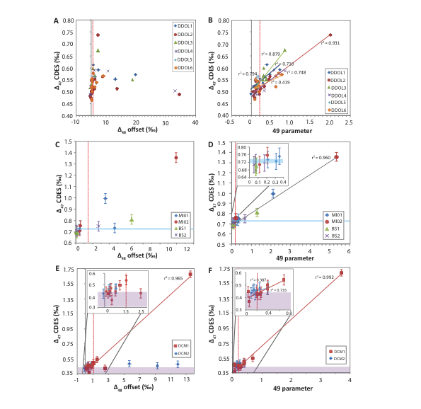

Figure 4
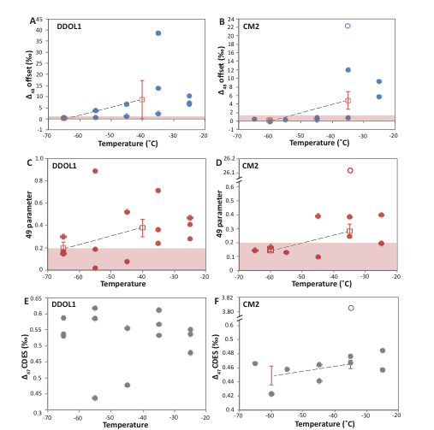

Figure 5
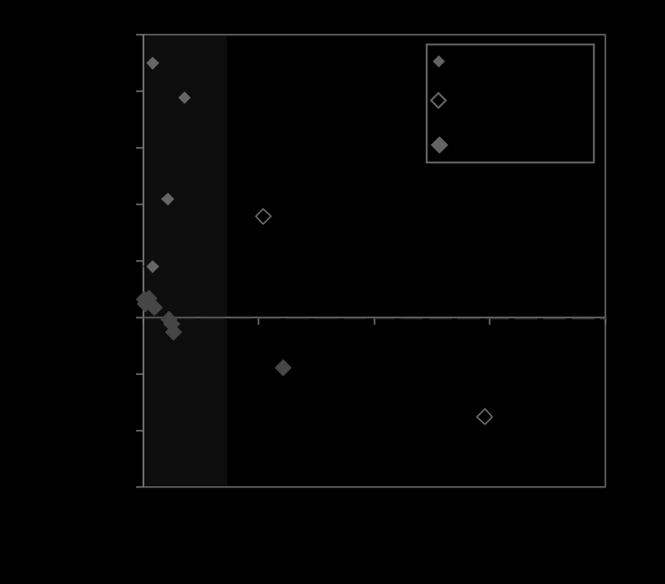
Figure 6

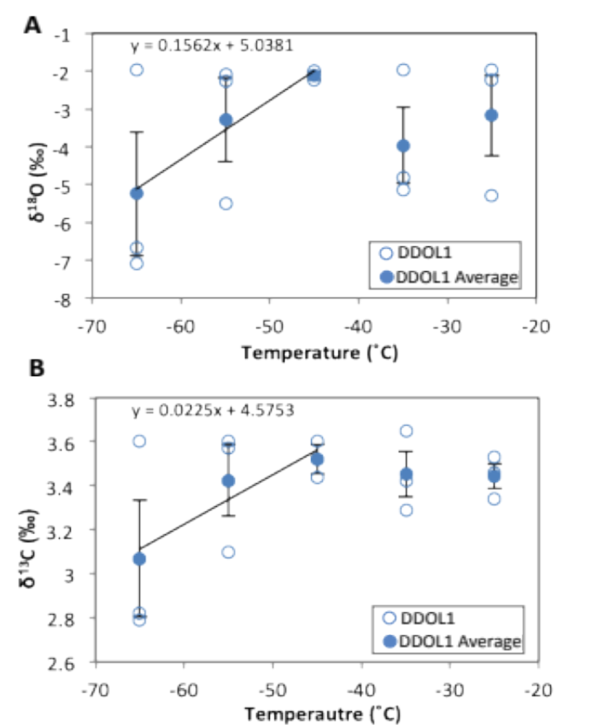

Figure 7
Figure 8

Figure 9
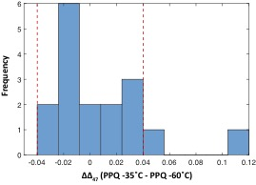
Figure 10
