Late Breaking Abstract - Matrix metalloproteinases in serum and sputum reflect distinct processes of relevance to asthma
Anna James, Cristina Gomez, John-Olof Thörngren, Magnus Ericsson, Johan Kolmert, Craig Wheelock, Richard Knowles, Ian Adcock, Sven-Erik Dahlén, . U-Biopred & Bioair Study Groups
European Respiratory Journal 2019 54: OA3802; DOI: 10.1183/13993003.congress-2019.OA3802

Abstract
Background: Local airway matrix metalloproteinase (MMP) expression associates with specific severe asthma phenotypes, but it is unknown whether circulating MMPs are useful biomarkers of asthma severity.
Aim: To examine relationships between serum and sputum MMPs with asthma severity and steroid use.
Methods: Samples were from mild-to-moderate (MA) and severe asthmatics (SA) in two European studies, U-BIOPRED (87 MA, 413 SA) and BIOAIR (55 MA, 63 SA) (ERJ 2015;46:1308 & Thorax 2013;68:611). MMPs (1, 2, 3, 7, 8, 9, 10, 12, 13, 14, 16, 17) were measured by proteomic array (SomaScan®, SomaLogic), MMP-3 by Luminex® (R&D Systems) and urinary prednisolone by mass spectrometry. BIOAIR included a 2-week intervention with oral prednisolone (0.5mg/kg/day).
Results: MMP levels in serum and sputum were not strongly related and showed varying associations with disease severity (fig 1A & B). Serum MMP-3 was markedly elevated in SA patients taking oral steroids, an effect not observed in sputum, and confirmed by the BIOAIR steroid intervention which increased serum MMP-3 4-fold (fig 1C).
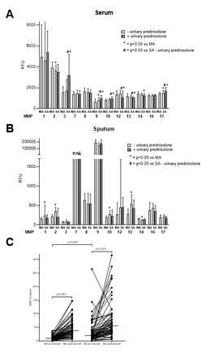
Conclusion: As local airway MMPs emerge as biomarkers of novel asthma phenotypes we find that serum and sputum MMPs differ regarding associations with disease severity and steroid use. Serum MMP-3 stands out as being strongly upregulated by steroid use, questioning its usefulness and highlighting a need to determine therapeutic effects on new biomarkers.

