Fabrication of electron tunnelling probes for measuring single protein conductance

Tao Jiang ¹, Xu Liu ¹, Long Yi ², Aleksandar P. Ivanov ², Joshua B. Edel ², and Longhua Tang ^{1*}

¹ State Key Laboratory of Modern Optical Instrumentation, Interdisciplinary Centre for Quantum Information, College of Optical Science and Engineering, International Research Center for Advanced Photonics, Zhejiang University, Hangzhou, China.
² Department of Chemistry, Molecular Science Research Hub, Imperial College London, White City Campus, 82 Wood Lane, London W12 0BZ, UK.

Abstract
The study of the electrical properties of individual proteins is one of the most prominent research directions in modern bioelectronics. Electron tunnelling or quantum mechanical tunnelling (QMT) probes can provide a powerful tool for better understanding the electrical properties of proteins; however, the current fabrication methods still have many deficiencies. In particular, reproducible fabrication, reliable contact, and effective binding of proteins onto electrodes are still critical issues that require a better solution. Here, we present a general protocol that is straightforward to implement for fabricating simple, nanopipette-based tunnelling probes and measuring conductance in single proteins. The QMT probe is based on a high aspect ratio dual-channel nanopipette that integrates a pair of gold tunnelling electrodes with a gap of less than 5 nm, fabricated through pyrolytic deposition of carbon, followed by electrochemical deposition of gold. The gold tunnelling electrodes can be functionalised using an extensive library of available surface modifications to achieve single protein-electrode contact. We demonstrate a widely used biotinylated thiol modification in the protocol, where a biotin-streptavidin-biotin bridge is used to form the single protein junction. The resulting protein-coupled QMT probes enable stable electrical measurement in solution environments of the same single protein for up to several hours. We also describe the analysis method used to interpret time-dependent single protein conductance measurements, which can provide essential information for understanding electron transport and exploring protein dynamics. The total time required to complete the protocol is approximately 22 hours.
Keywords: Quantum tunnelling; electron tunnelling probe; protein bioelectronics, protein conductance; single-molecule measurement

Introduction
In recent years, the integration of proteins into nanoscale devices has been a growing area of bioelectronics research, offering an excellent opportunity to study native biological processes through understanding the mechanism of protein-mediated electronic charge transport¹⁻⁶. The current research of protein-based bioelectronics has primarily centred on the following aspects⁷⁻¹⁰: controllable fabrication of electronic devices¹¹⁻¹⁴, efficient interfacing between protein molecules and electrical probes with stable chemical contact, reliable long-term measurement of the protein-based electrical circuits, and correlation of electrical information with protein functions^{1,2,15-19}. Among the various protein-based bioelectronic devices, tunnelling probes have become one of the most suitable because of their excellent spatiotemporal resolution and exceptionally high current sensitivity^{5,18-25}. This probe consists of a pair of nanoelectrodes or electrodes in the form of a metallic probe that is separated from a conductive surface by a gap distance smaller than 5 nm²⁶. Under applied bias, electrons are transported through the electrode gap via quantum tunnelling. Protein analytes, trapped in the electrode gap, can be studied by recording the changes in the tunnelling current through the protein junction, manifested as fluctuating telegraph noise. Statistical analysis of this telegraph noise allows studying the electron transport of the protein and, in some cases, even extracting information related to conformational changes²⁷⁻³¹.

Methods for fabricating QMT probes
In recent years, much effort has been devoted to developing methods to fabricate tunnelling probes for single-molecule measurements made using ligand-functionalised electrodes. The most common techniques are scanning tunnelling microscopy (STM) ^{1,32}, which uses an atomically sharp tip to form a tunnelling junction with the substrate surface, and mechanically controllable break junctions (MCBJ)³³, which uses mechanical force to break a metal wire to form a nanosized gap. Crack-defined fracture junction ³⁴ technology can also create nanosized gaps between electrodes through self-fracture of brittle materials. Top-down micro/nanofabrication techniques³⁵⁻³⁷, such as electron beam lithography (EBL)^{38,39}and focused ion beam (FIB)^{40,41} lithography, can also be used to fabricate QMT probes. For example, combined with lithographic techniques, the nanowire-cross-junction method and direct assembly of metal nanowires on target substrates have been proposed to form QMT probes⁵⁴. In addition, carbon nanomaterials, including single-walled carbon nanotubes (SWNTs) and graphene, are often used as the substrate for fabricating nanogap electrodes due to their unique spatial structure and electronic properties⁵³.
However, the majority of fabrication methods often require expensive equipment and infrastructure and have complicated fabrication steps. The preparation of ligand-functionalised electrodes is a significant challenge, as it is difficult to control the reproducibility and stability of the junctions, particularly at the single molecule level^{1,25,42}. Furthermore, many of the QMT probes can only be used in dry environments and are not suitable for use in aqueous environments^{1,2,4,} which is essential when studying biological molecules. A table comparing different protein measurement methods based on tunnelling devices can be found in Supplementary Table 1.

Overview of the procedure
We report on a straightforward protocol for fabricating tunnelling probes to measure individual proteins. The probe is based on a high aspect ratio dual-channel nanopipette that integrates a pair of gold tunnelling electrodes with a gap smaller than 5 nm, fabricated through pyrolytic carbon deposition, followed by electrochemical deposition of gold.⁴³ Single-protein molecular junctions can be formed by modifying the surface with biotin and using streptavidin to link the electrodes. This enables the possibility to perform single molecule protein's time-dependent electrical measurements for up to several hours.⁴⁴ A schematic of the device is shown in Figure 1.
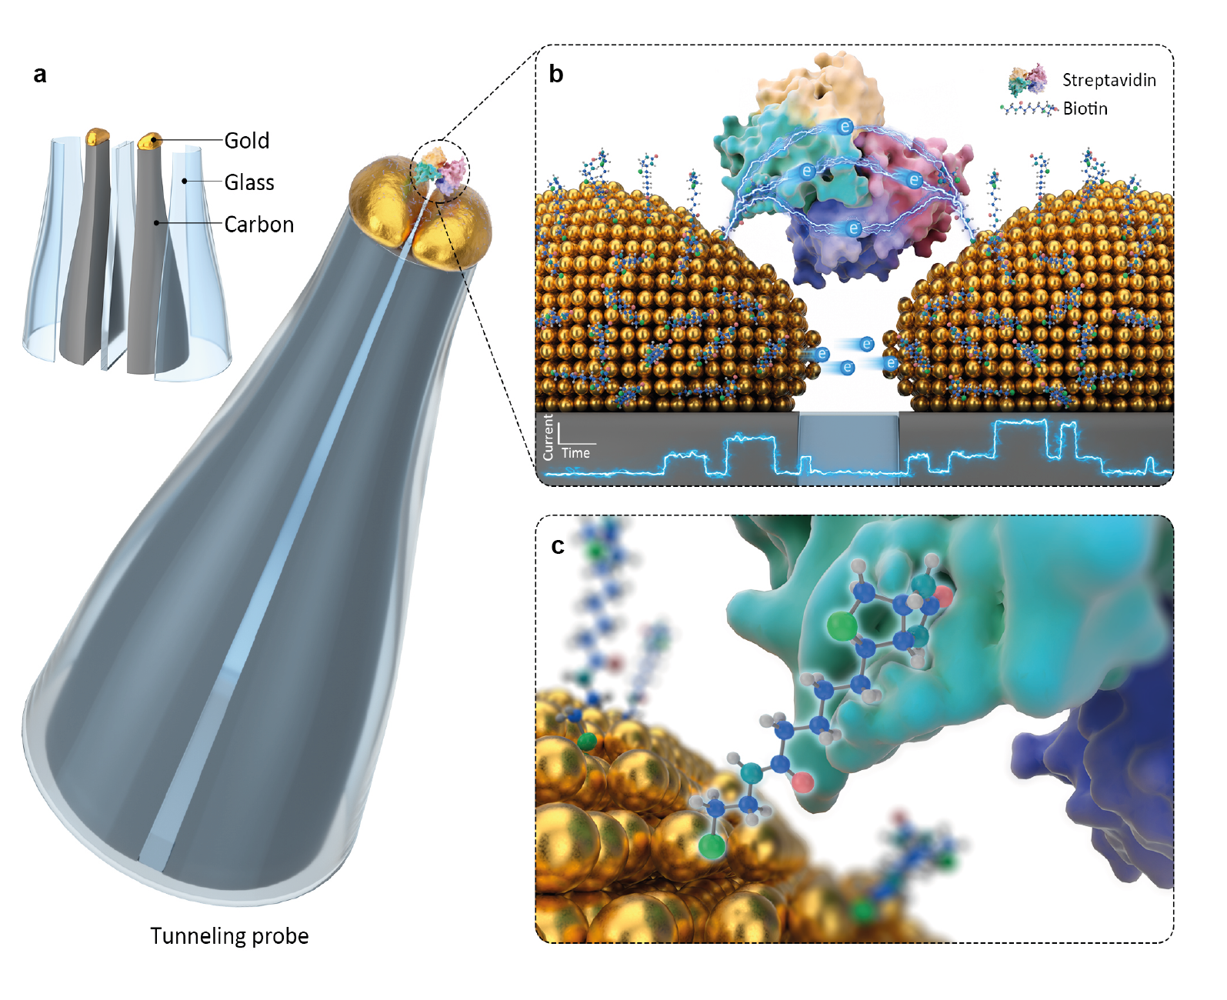
Figure 1 Schematic of a protein-QMT coupled probe. (A) The probe consists of two carbon electrodes that are sealed in a double-barrel quartz nanopipette. Only the tip of the electrode surface at the nanopipette tip is exposed to the solution. Gold is electrochemically deposited on the carbon nanoelectrodes using real-time current feedback, forming a tunnelling junction with tuneable conductance. (B, C) The stand-alone QMT probe is functionalised with thiolated biotin and used to capture individual streptavidin molecules. Image adapted with permission from ref. ⁴⁴, AAAS.

Experimental design
As shown in Figure 2, the complete experimental workflow can be divided into three stages: 1) fabrication and validation of the QMT probes, 2) ligand-functionalisation and formation of single-molecule protein junction, and 3) time-dependent single-molecule electrical measurements and data analysis.

Stage 1: The fabrication process of the QMT probe includes six steps: (1) nanopipette fabrication by laser-assisted capillary pulling, (2) pyrolytic carbon deposition, (3) electrochemical etching of the carbon, (4) initial gold deposition, and (5) tunnelling feedback-controlled electrodeposition, (6) probe stabilisation.
- A laser-based pipette puller is used to pull a dual-barrel theta quartz capillary (length 100 mm) into two symmetrical nanopipettes, approximately 50 mm in length each. After pulling, each nanopipette terminates with a sharp tip that has two adjacent nanopores (25 ± 12 nm in diameter) separated by a quartz septum (15 ± 5 nm in width).
- Both barrels of the nanopipette are filled with carbon by pyrolytic deposition, forming two carbon nanoelectrodes at the tip^{46,47}. The electrodes are enclosed in quartz barrels.
- Excess carbon on the outer pipette surface is removed by electrochemical etching in a mixed solution (0.1 M KCl, 0.1 M KOH).
- Initial electrochemical deposition of gold is carried out to rapidly deposit gold on the carbon electrodes using chronopotentiometry.
- To reduce the electrode gap distance to within the tunnelling regime, a potentiometric feedback-controlled deposition is used^{48,49}.
- Finally, the probe obtained in the previous steps are immersed in ultrapure deionised water for at least 12 hours, and a stable QMT probe is obtained by utilising the re-shaping effect⁵⁰.
The morphology and structure of the obtained tunnelling electrodes are characterised by a series of characterisation and imaging techniques, including scanning electron microscopy (SEM), scanning transmission electron microscopy-energy dispersive spectroscopy (STEM-EDS), and dark field microscopy. The electrical functionality of the QMT probes and their stability over time are characterised by current-voltage (I-V) and chronoamperometry (I-time) measurements.

Stage 2: Preparation steps for protein-QMT coupling probes include ligand modification and single-protein junction formation.
- The QMT probe is modified with thiolated biotin.
- Streptavidin is captured in the gap to form a stable single protein junction. We choose a non-redox protein, streptavidin, as a model protein to demonstrate the formation of a single-protein coupled junction. Streptavidin has four binding sites for biotin and can serve as anchors for the protein junction.

Stage 3: Time-dependent single molecule electrical measurements and data analysis
- Electrical measurement of protein-QMT coupled probes using patch clamp amplifier
- Data analysis
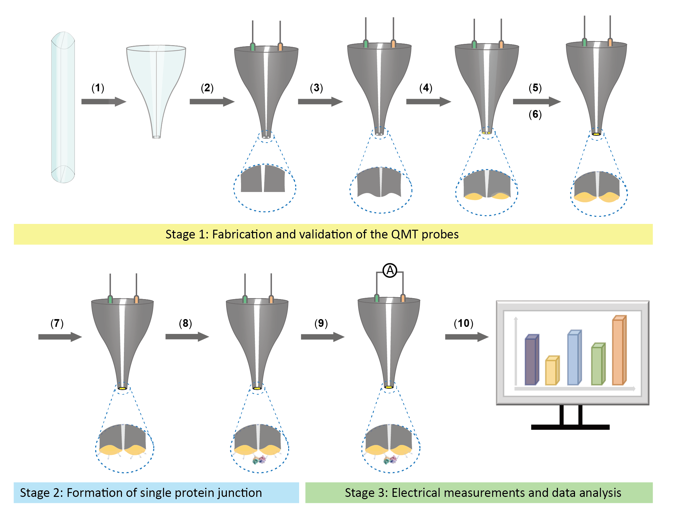
Figure 2 Fabrication procedure of a protein-QMT probe. The preparation of a single protein-couple QMT probe involves the following steps:(1) nanopipette fabrication by laser-assisted capillary pulling, (2) pyrolytic carbon deposition, (3) electrochemical etching of the carbon, (4) initial gold deposition, (5) tunnelling feedback-controlled electrodeposition, (6) probe stabilisation, (7) biotinylated modification, (8) streptavidin protein junction, (9) electrical measurements and (10) data analysis.

Limitations
The fabrication of nanopipettes via the pulling of glass capillaries is instrument dependent. The pulling parameters need to be adjusted depending on the type of glass, inner and outer diameter, ambient temperature and humidity, which can be time-consuming. Moreover, the fabrication and measurement of QMT probes can only be performed individually, which limits the method's efficiency.
It is also critical that QMT probes are preselected with appropriate gap sizes for fabricating protein-based molecular junctions. While in principle, any gap size is achieved provided that tunnelling current is detectable, to maximise the signal-to-noise ratio (SNR) and the likelihood of bridging the QMT junction, electrode gaps with appropriate size need to be selected based on the protein target. In our case, electrode gaps ranging from 1.5 nm to 3.1 nm (as calculated using the Simmons model) are selected. The gap distance in this regime is larger than the size of thiolated biotin (molecular weight: 302, size: <1nm) but smaller than that of streptavidin, tetramer, 52.8 kDa, size: ~5 nm, allowing for the protein to bridge the gap by binding to single biotin on each electrode. Importantly, the protein does not need to be fully confined in the gap, as the current tunnelling through the biotin contacts the protein. Larger gaps ( ≥5 nm) that could accommodate the full protein are challenging to fabricate in a tunnelling feedback regime and exhibit low SNR due to an exponential decrease in the magnitude of the tunnelling current with gap distance.
In terms of detection, the signal-to-noise ratio limits the time resolution of QMT probes. Typically, high-bandwidth (>100 kHz), low-noise current amplifiers (open input noise <5 pA rms at 10kHz) are required, as well as optimisation of the background electrical interference. Although sub-microsecond time resolution is achievable under highly optimised conditions, the time resolution is still too low to meet the needs for the analysis of rapid conformational and chemical changes. Finally, the relationship between protein conductance and the structure and function of the protein itself is still unclear.

Materials
Biological materials
Reagents
! CAUTION All chemicals and reactions used in this protocol are potentially harmful, and a lab coat, gloves and eye protection should be used. All chemicals used in this protocol must be handled with care and stored in appropriate cabinets. The storage temperature is room temperature (specifically, 25 °C in this protocol) unless stated otherwise.
CRITICAL All aqueous solutions should be prepared using ultrapure deionised water (18.2 MΩ·cm at 25 °C).
●Argon gas (≥99.9%, Hangzhou Minxing, cat. no. 112)
●Butane gas (≥99.9%, Clipper)
! CAUTION Butane is a flammable and explosive gas and needs to be kept in a special explosion-proof cabinet away from open flames.
●Potassium chloride (KCl; ≥99.0%; Sigma-Aldrich, cat. no. P9333)
●Potassium hydroxide (KOH; ≥99.95%; Sigma-Aldrich, cat. no. 757551)
! CAUTION KOH is highly corrosive, and it is a skin, eye, and respiratory tract irritant.
●The gold plating solution, contains 4.4 mM NH₄AuSO₃ and 52 mM (NH₄)₂SO₃, pH 9.5 (Tianyue, China, CT-288)
! CAUTION Gold plating solution is a strong eye, skin, and mucous membrane irritant.
●Hexane (C₆H₁₄; ≥99 %; Sigma-Aldrich, cat. no. 139386)
! CAUTION Hexane is highly flammable and volatile.
●Dimethyl sulfoxide (DMSO; C₂H₆OS; ≥99.9 %; Sigma-Aldrich, cat. no. 900645 )
●Ethanol (C₂H₆O; ≥99.5 %; Sigma-Aldrich, cat. no. 459836)
! CAUTION Ethanol is highly flammable and volatile.
●Biotin PEG Thiol (Biotin-PEG-SH; 95%; MW 400 Da; Aladdin, cat. no. B163355)
●Tris[2-carboxyethyl]phosphine (TCEP; Thermo Fisher Scientific, cat. no 77712), stored at 4 °C.
●Phosphate buffered saline (PBS; Sigma-Aldrich, cat. no. P4474)
●Streptavidin (Sigma-Aldrich, cat. no SA101), stored at -20 °C.
●Bovine serum albumin (Sigma-Aldrich, cat. no V900933), stored at -20 °C.
●Immunoglobin G (Sigma-Aldrich, cat. no I4506), stored at -20 °C.

Equipment
●Dual-barrel theta quartz capillaries (Friedrich & Dimmock, Inc., 1.2 mm OD, 0.90 mm ID, 100 mm long)
●PDC-002 Expanded Plasma Cleaner (Harrick Plasma)
●P-2000 laser-based pipette puller (Sutter Instrument, model no. P-2000)
●Petri dish (Nest, cat. no 755001-100EA)
●Blu Tack reusable adhesive (Bostik, cat. no. TDS00548)
●Quartz capillaries for protection (Donghuashiying, 2.5 mm OD, 1.5 mm ID, 120 mm long)
●Torch (Honest, 501JET)
●Rubber tube (MJL, 1.2 mm OD, 1.1 mm ID, 600 mm long)
●Hot glue sticks (Deli, NO.31406)
●Copper wires (Goodfellow, 0.5 mm OD)
●Silver wire (Agar Scientific, 0.25 mm OD)
●Platinum wire (Agar Scientific, 0.25 mm OD)
●CHI 760C (CH Instruments Inc. model no. 760C)
●Silver/silver chloride electrode (Ag/AgCl electrode; Chenhua, cat. no. CHI 112)
●Patch clamp Amplifier (Molecular Devices, model no. MultiClamp 700B)
●Digitizer (Molecular Devices, model no. Axon Digidata 1550B)
●Headstage (Molecular Devices, model no. CV 7B)
●Pipette holder for connecting with headstage (Haike; H-6002)
●Faraday cage (copper sheets; home designed and made)
●Pipette tips (10, 200, and 1,000 μl; Bioshrp, cat. no. BS-10-TRS, BS-200-TRS, and BS-1000-TRS)
●Microcentrifuge tubes (0.5, 2 ml; Biosharp, cat. no. BS-5-M, BS-20-M)
●Centrifuge tube (10, 50 ml; Biosharp, cat. no. BS-100-MY, BS-500-MY)
●Scanning electron microscopy (ZEISS; Ultra 55)
●Focused ion beam cutting (FIB; Quanta 3D FEG)
●Transmission Electron Microscopy and Energydispersive X-ray spectroscopy (STEM-EDS; Tecnai G2 F20, FEI)
●Dark-field microscopy (SHOIF; XSP-10)
●Refrigerator (Siemens)

Software
●Clampfit v.10.7 software (Molecular Devices: https://www.moleculardevices.com)
●OriginLab v.9.0 (OriginLab: https://www.originlab.com)
●MATLAB (Matlab 2021a: https://www.mathworks.com)
●Quantify Unknown Biophysics (QUB software: https://qub.mandelics.com)

Reagent setup
KCl solution
KCl solution is 0.2 M KCl. This solution can be stored at room temperature (25 °C) for up to 3 months.
KOH solution
KOH solution is 0.2 M KOH. This solution can be stored at room temperature (25 °C) for up to 1 month.
Plating solution
The gold plating solution is cyanide-free, with 4.4 mM NH₄AuSO₃ and 52 mM (NH₄)₂SO₃, and does not need to be further diluted throughout the process. This solution can be stored at 4 °C for up to 3 months.
PBS solution
PBS solution is 0.01 M, pH 7.4. This solution can be stored at 4 °C for up to 3 months.

Equipment setup
Setup of the dual-barrel nanopipettes fabrication system
The double-barrel theta quartz capillaries are pulled using a two-line programme on a P-2000 micropipette puller (Sutter Instrument). The P-2000 is a CO₂ laser-based puller designed to create micropipettes, electrospray/nanospray emitters and optical fibres. There are five editable parameters: HEAT, FILAMENT, VELOCITY, DELAY, and PULL, that affect the size and shape of a nanopipette. The HEAT parameter determines the laser output power and the glass heating speed. Generally, higher HEAT settings tend to result in longer and finer tips. The FILAMENT (FIL) parameter determines the scan pattern of the laser beam used for heating, each value representing a specific longitudinal length (width of the heated area) and scan rate. The VELOCITY parameter determines the point at which heating stops. The P-2000 uses an indirect method to measure glass temperature: apply a constant tension as the glass softens and then measure its velocity. With constant tension, the speed of the glass depends on its viscosity, which is related to the glass temperature. Therefore, the temperature of the glass can be measured indirectly and accurately by this method. The PULL parameter controls the force of the hard pull. In general, the higher the pull, the smaller the pipette's tip diameter and the longer the taper. The DELAY parameter determines the time interval between the end of the HEAT and the beginning of the PULL. The higher the DELAY value, the lower the glass temperature when performing the PULL, resulting in a pipette with a reduced taper length and an increased tip diameter. A detailed description of each parameter can be found at https://www.sutter.com/manuals/P-2000_OpMan.pdf.

Setup of the carbon electrode fabrication system
Pyrolytic deposition of carbon is performed with the setup shown in Figure 3. Butane is flown through a rubber tube to the larger opening of the pipette barrels (opposite the pulled side). The pipette tip is inserted in a capillary that provides a counter flow of argon to prevent oxidation of the deposited carbon and minimise carbon deposition on the outer pipette surface. A butane torch is used to heat the pipette tip to pyrolytically deposit carbon inside the barrels. In order to obtain a more uniform and stable heating effect, heating is done along the pipette length, starting from the tip. A heating time of 40 seconds is chosen to generate a large amount of amorphous carbon, forming the carbon electrodes.

Setup of the silver/silver chloride electrode
The standard potential of the silver/silver chloride electrode at 25°C is +0.2224V. Electrodes should be cleaned with ultrapure deionised water before use. When the electrode is not used for a short time, please immerse the electrode in the corresponding concentration of KCl solution for storage.

Setup of the carbon electrochemical etching system
The carbon nanoelectrodes are electrochemically etched using a CHI 760 C bipotentiostat (CH Instruments). The etching process results in the carbon electrodes forming a cavity with a concave shape. This cavity allows for improved stability and adhesion of the deposited material. Etching is performed using cyclic voltammetry⁵⁵, where both carbon nanoelectrodes are connected as working electrodes (WE), while the silver/silver chloride electrode and a platinum wire are used as the quasi-reference electrode (QRE) and counter electrode (CE), respectively. A description of the terms WE, QRE, CE, CV and potentiostat discussed in this protocol can be found in Supplementary Table 2.

Setup of the initial gold deposition system
A bipotentiostatic configuration is used to perform the electrodeposition of gold on the carbon electrodes using a CHI 760 C bipotentiostat. It is possible to use a custom solution or a 4-sense voltage source; however, it should be noted that the system requires maintaining a potential of the working electrode at a constant level with respect to the reference electrode by adjusting the current at an auxiliary electrode. We have included a circuit diagram in Supplementary Figure 1.
The initial gold deposition process is carried out by applying a constant voltage and measuring current over time (chronoamperometry, I-t). Because of the instability of AgCl in the gold plating solution, a silver wire acts as the quasi-reference counter electrode (QRCE). The two carbon nanoelectrodes are used as the working electrodes (WE1 and WE2). Gold deposition occurs simultaneously on both carbon electrodes.

Setup of the feedback deposition system
A slower, self-terminating chronopotentiometric protocol with tunnelling feedback control is used in a CHI 760 C biopotentiostat (CH Instruments). The feedback deposition process is carried out by applying a constant current and measuring voltage over time. One carbon electrode is the working electrode (WE), and the other is the QRCE. The deposition of gold occurs on the WE.

Setup of the current measurements
All tunnelling current measurements are done using MultiClamp 700B operated in voltage-clamp mode. The data acquisition bandwidth is 100 kHz, and the data are filtered using a four-pole Bessel filter at 10 kHz and digitised using Axon Digidata 1550B. The QMT probe and the amplifier headstage should be placed in a Faraday cage to shield external electrical noise. Furthermore, the setup must be placed on stable support to minimise vibrational interference. Short cables and electrode connecting wires are recommended to minimise electrical noise. It is recommended that the amplifier, Faraday cage, and support platform are all connected to the same grounding point. If no true ground is present, an isolation transformer may be used as an alternative.

Procedure
Stage I: fabrication of QMT probes ●Timing ~4h
- Clean the dual-barrel theta quartz capillaries in PDC-002 Expanded Plasma Cleaner (Harrick Plasma) for 30 minutes to remove surface contaminants.
- Install the glass pipette into the laser-based pipette puller. Heat and pull the pipette to form two virtually identical pipettes. Adjust the parameters of the P-2000 program, including HEAT, FILAMENT, VELOCITY, DELAY and PULL, to optimise the diameter of the tip and the length of the taper to produce the pipette required for the experiment. To form sharp-ended nanopipettes, we use a custom two-line program (First line, Heat: 850, Filament: 4, Velocity: 30, Delay: 160, Pull: 100. Second line, Heat: 860, Filament: 3, Velocity: 20, Delay: 140, Pull: 160). For more information on how to obtain optimal pipette shapes, see https://www.sutter.com/manuals/P-2000_OpMan.pdf
▲CRITICAL STEP The parameters for the fabrication of nanopipettes vary between pipette pullers. Note that pulling programs are device-specific and sensitive to humidity and temperature variation. To ensure high reproducibility of the nanopipette, the environmental temperature and humidity should be kept constant. Any mechanical interference should be avoided when pulling the nanopipettes. Moreover, the laser puller should be preheated before pulling nanopipettes. Since a septum separates the two barrels, it is necessary to adjust the position of the quartz capillary so that the plane of the septum is parallel to the laser beam. This ensures that the laser heats the quartz capillary uniformly and that the pulled pipettes are symmetrical. Also, the careful orientation of the septum during heating minimises variation in the shape of the two nanopores at the tip of each nanopipette after pulling.

- Use the carbon electrode fabrication system for pyrolytic carbon deposition, as shown in Figure 3. It is advised that all operations need to be carried out in a fume hood (room temperature, 25 °C). Flow the argon gas (0.2 m³/h) into a counter-flow capillary and the butane gas (0.2 m³/h) into the nanopipette. Keep the gas pressures of the two gases stable. Use a butane torch to preheat for 30 s the counter-flow capillary. Insert the tip of a double-barrel nanopipette into the counter-flow capillary under an argon flow. Use a butane torch to heat the tip of the nanopipette for 10 s, then move the flame slowly along the nanopipette to heat the middle of the tip for 10 s, and finally, heat the bottom of the tip for 20 s. After pyrolysis, turn off the flame and keep the nanopipette tip under an argon flow until it cools down (usually 10 s).
▲CRITICAL STEP The part of the pipette where carbon pyrolytic deposition occurs emits bright red light, which can indicate carbon pyrolytic deposition. Heating must start at the very tip of the pipette, as carbon deposition can block the barrel and prevent the flow of butane gas. However, the nanopipette tip is difficult to see directly by eye, and it takes a certain amount of heating time to generate the red light. Therefore, it is necessary to place the nanopipette at a distance of 2 to 3 mm from the preheating position and then slowly move the flame. Once the red light is observed, stop moving the flame immediately. To ensure the uniformity of the carbon deposition, the flame needs to be moved slowly. The deposited carbon needs to extend deep enough into the barrels to provide a sufficient carbon filament for reliable contact with copper wires used to connect measurement instrumentation.
? TROUBLESHOOTING
■PAUSE POINT All nanopipettes are fabricated immediately before experiments, unless noted otherwise, and stored in a sealed Petri dish until used to avoid contamination.
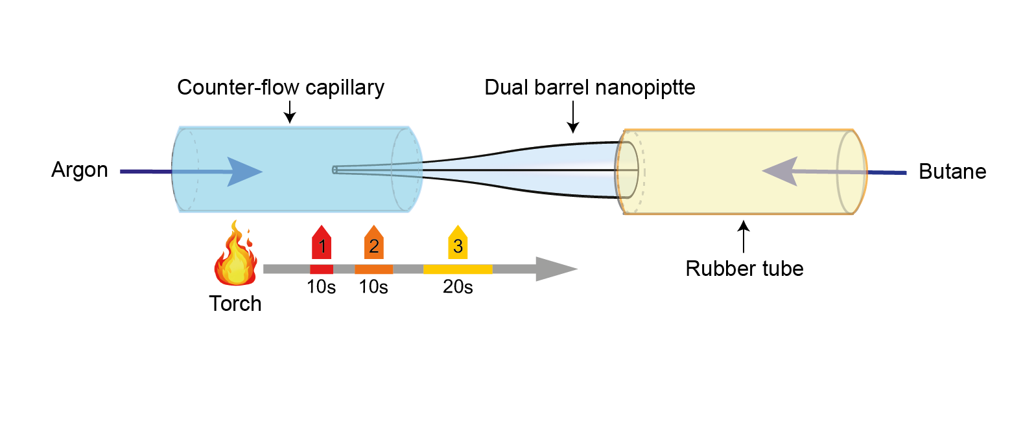
Figure 3 Schematic of setup used for pyrolytic carbon deposition. Butane is injected into the nanopipette through a rubber tube, and the dual barrel nanopipette is inserted in a counter-flow capillary that injects argon gas. Both the dual barrel nanopipette and the counter-flow capillary are mounted on micromanipulators. A butane torch is used to heat the nanopipette starting from the pipette tip, resulting in the pyrolytic deposition of carbon inside the pipette barrels and the formation of two carbon nanoelectrodes at the pipette tip. The colour bar on the chart represents the duration each location is heated. It is essential to heat location 1 for at least 10 s initially and then gradually move closer to the tip area of locations 2 and 3 for approximately 10 s and 20 s, respectively.
- Electrical contact with the carbon electrodes is established by inserting auxiliary copper wires into the carbon-filled barrels. Use hot glue to hold the copper wires in place.
▲CRITICAL STEP When inserting the copper wires into the pipette barrels, it is important to ensure good electrical contact between the auxiliary copper wire and the carbon electrode.
- Electrochemically etch the carbon nanoelectrodes in a mixed solution (0.1 M KCl, 0.1 M KOH). Carry out the etching process by cyclic voltammetry (Initial: 0 V, Final: 2 V, Segment: 4, Sample Interval: 0.1 V/s, Time: 80 s) using a biopotentiostat (CHI 760C). Use both carbon nanoelectrodes as WEs. Use the silver/silver chloride electrode and platinum wire, respectively, as the QRE and CE.
■PAUSE POINT A representative etching current curve is shown in Figure 4b, indicating the electrochemical oxidation behaviour of the surface carbon. Significant cathodic and anodic currents (between WEs and CE) can be observed when the potential (WEs vs QRE) exceeds 1.5V. Excessive carbon attached to the outside of the nanopipettes produced during deposition is removed by electrochemical etching. At the pipette tip, etched carbon adopts a concave shape and provides a better surface for the subsequent electrodeposition of gold. In addition, this step is used to confirm if the carbon electrodes and their connection to the measurement instrumentation are functional. We can use this step to screen out suitable devices for the subsequent gold deposition.
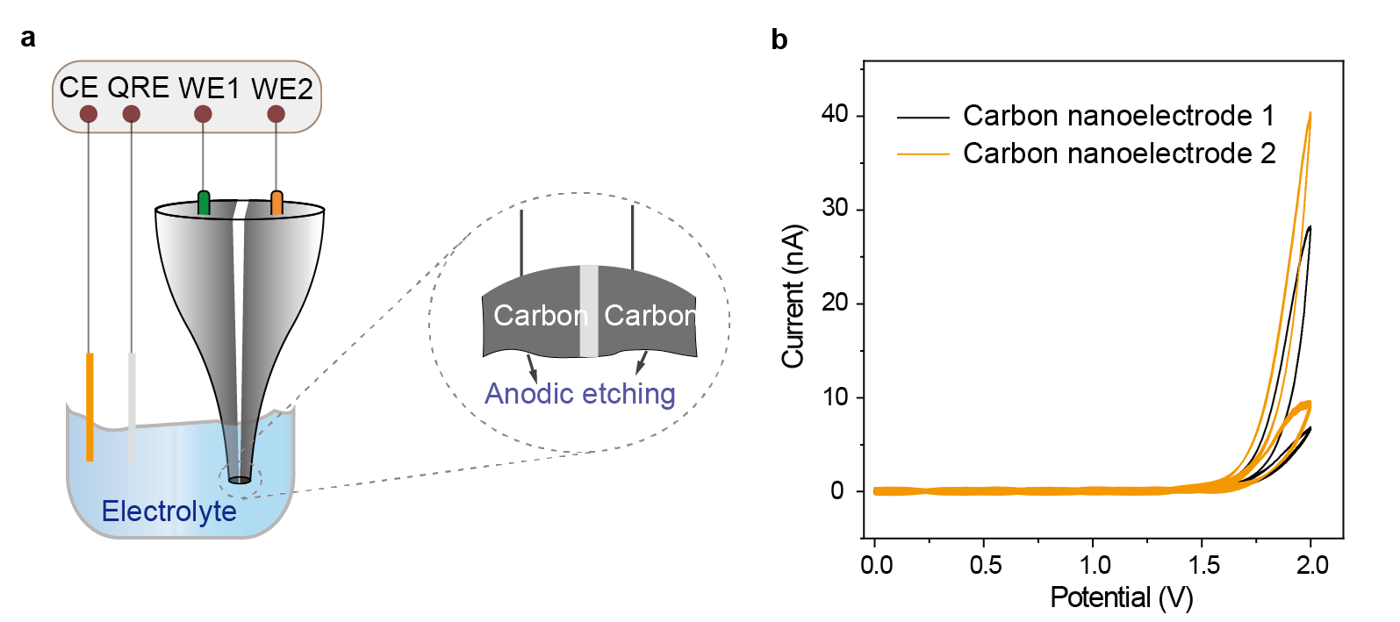
Figure 4 Electrochemical etching of carbon nanoelectrodes. (a) Schematic representation of the electrochemical etching of the carbon nanoelectrodes. (b) typical Cyclic Voltammogram recorded during the electrochemical etching of carbon. Panel b adapted with permission from ref.⁴³, CC BY 4.0 (https://creativecommons.org/licenses/by/4.0/).

- Gold is initially electrochemically deposited on the carbon nanoelectrodes in a fast bipotentiostatic configuration. Use a gold plating solution (4.4 mM NH₄AuSO₃ and 52 mM (NH₄)₂SO₃), as the electrolyte. Use Ag wire as the QRCE, and connect the two carbon nanoelectrodes via the auxiliary copper wires as the working electrodes WE1 and WE2. Measure a CV curve (Supplementary Figure 2) to locate the peak for the reduction of Au(I) to Au(0). In our case, this peak is localised at around -0.7V, and a applied voltage value of -0.73V (vs Ag wire) is selected. Maintain a potential difference of 0.02 V between the two working electrodes (WE1 V: -0.73 V, WE2 V: -0.75 V) for the electrodeposition.
■PAUSE POINT Typically, the current between these two working electrodes during initial deposition consists of a small ionic current (< 10 pA, Supplementary Figure 3a) between the two working electrodes. However, when electrical contact is formed between the two working electrodes, a conduction current (>1nA, Supplementary Figure 3b) will be generated, resulting in a sudden change in current⁵⁶, as shown in the Supplementary Figure 3c.
- Monitor the current on each carbon nanoelectrode during the deposition by current-time response.
■PAUSE POINT Short deposition times may not be sufficient to generate enough gold deposits on the carbon electrode surface, lowering the success rate in the galvanometric potentiometric feedback-controlled deposition step. However, longer deposition times will also lead to electrical contact between the two electrodes. Under the conditions described in this protocol the mean deposition time is expected to be 40 s to 50 s with the potential mentioned above (WE1 V: -0.73 V, WE2 V: -0.75 V vs QRCE). A representative initial golddeposition current (between WEs and QRCE) curve is shown in Figure 5b.

? TROUBLESHOOTING
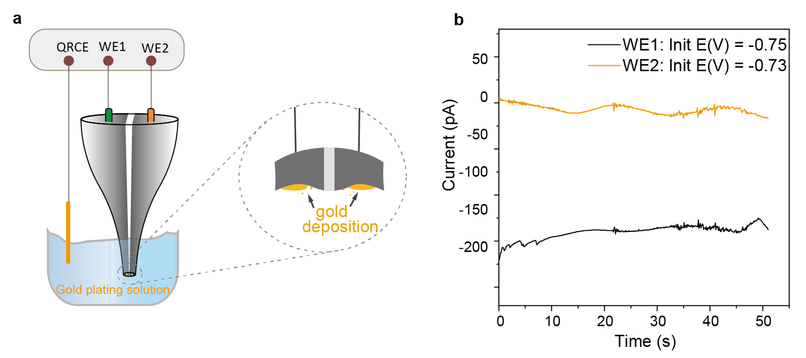
Figure 5 Electrochemical initial deposition of gold on the carbon nanoelectrodes. (a) Schematic of the bipotentiostatic configuration used for electrodeposition. The QRCE is Ag wire, and WE1 and WE2 are carbon nanoelectrodes that are exposed to solution only at the tip of the dual-barrel nanopipette (b) The current-time plot was recorded during bipotentiostatic deposition of gold onto carbon electrodes WE1 and WE2 (deposition time 50 s). Panel b was adapted with permission from ref.⁴³, CC BY 4.0 (https://creativecommons.org/licenses/by/4.0/).

- Use a slower, self-terminating chronopotentiometric step with tunnelling feedback control to decrease the electrode gap within the QMT regime. Use one nanoelectrode as the WE and the other as the QRCE. Apply a constant preset current I_{set} between the nanoelectrodes. This will result in a gradual gold deposit on WE, reducing the gap between both nanoelectrodes. Set I_{set} range between 20 pA to 10 nA, starting from the lowest available current setting.
▲CRITICAL STEP The lowest I_{set} current should be used initially. After the feedback deposition has been carried out for approximately 60 s, if the voltage does not change significantly, increase the current as appropriate or change the electrode configuration by setting the current working electrode as QRCE and the other nanoelectrode as WE.
The preset current I_{set} is composed of deposition current and tunnelling current components, I_{set}=I_{dep}+I_{tun}. When the electrode gap is large (> 5nm), the tunnelling component is negligible, so I_{set} ≈ I_{dep}. With the gradual deposition of gold, the gap between the electrodes decreases, and when the electrode gap is sufficiently small (< 5 nm), the tunnelling component increases in magnitude. As I_{tun} approaches I_{set}, I_{dep} approaches 0, and the deposition rate gradually decreases to zero. The process can be monitored in real-time by measuring the bias voltage V_{gap} using a constant current mode with I_{set} maintained. When a sharp rise in the voltage is observed, the plating process should be stopped and the pipette removed from the plating solution. This process can be automated, depending on the bipotentiostat used, by setting a threshold voltage. From the three typical curves of feedback depositions shown in Figure 6b, the abrupt change process of the voltage between two nanoelectrodes can be clearly seen. Among 650 probes fabricated by tunnelling feedback-controlled electrodeposition, approximately 85% of all probes resulted in tunnelling electrodes.

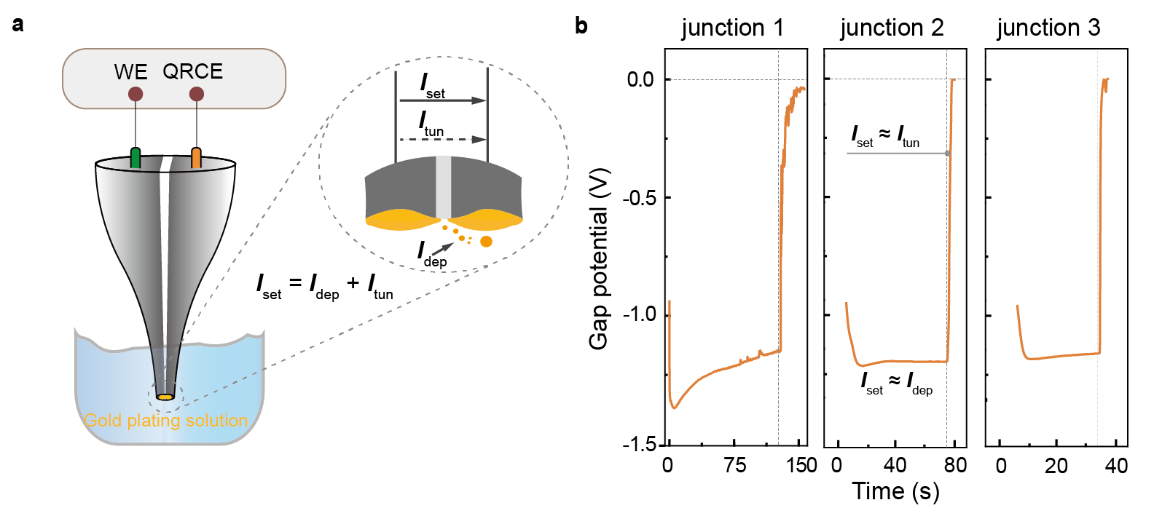
Figure 6 Electrochemical fabrication of the QMT probes. (a) Configuration for the self-terminating chronopotentiometric step. (b) Real-time voltage profile of three different probes in the feedback-controlled deposition stage. Image adapted with permission from ref.⁴³, CC BY 4.0 (https://creativecommons.org/licenses/by/4.0/).

- Immerse the freshly fabricated electrodes for 12–48 hours in ultrapure deionised water (with a resistivity of 18.2 MΩ·cm).
■PAUSE POINT After prolonged water exposure among 65 QMT probes, we observed an average 55% decrease in conductance, which was consistent with the widening of the tunnelling gaps. The probes exhibited consistent I-V characteristics over longer periods (over several days), unlike those fabricated using only electrodeposition. The effective change of gap distance can be attributed to the surface diffusion of gold atoms to minimise the total interfacial free energy at a fixed volume.

- Characterise the functionality of the QMT junctions by recording I-V curves and fitting the data to the Simmons model (Equation 1)^{44,45}, which can be used to approximate the gap distance, tunnelling barrier height, and tunnelling area.
$I=A(\frac{e}{4π^{2}ℏd^{2}})\left\{\left(Φ_{B}-\frac{eV}{2}\right)\exp\left[-\frac{2(2m)^{\frac{1}{2}}}{ℏ}{\left(Φ_{B}-\frac{eV}{2}\right)}^{\frac{1}{2}}d\right]-\left(Φ_{B}+\frac{eV}{2}\right)\exp\left[-\frac{2(2m)^{\frac{1}{2}}}{ℏ}{\left(Φ_{B}+\frac{eV}{2}\right)}^{\frac{1}{2}}d\right]\right\}+B$ (1)
where m is electron mass, d is the gap distance, Φ_{B} is the effective tunnelling barrier height, h(= 2π$ℏ$) is Planck's constant, V is applied bias, A is the active tunnelling area, and a parameter B that takes into account any current offset at zero bias, which could be due to residual Faradaic processes at the Au electrodes or minor calibration errors. In all cases, we found B to be small.
■PAUSE POINT Typically, QMT probes manifest sigmoidal-shaped I-V plot during electrical measurements. Representative I-V plots of QMT probes with different gap distances are shown in Figure 7a. Typically, the protocol allows to reliably fabricate nanoelectrode gaps in the range of 1.5 nm to 3.1 nm (calculated using the Simmons model), as shown in Figure 7b-c (for 418 probes).
? TROUBLESHOOTING

- To further confirm the tunnelling electron transport of the QMT probes, perform I–V measurements in media with different barrier heights, for example, air, Deionized (DI) water, hexane, and dimethyl sulfoxide (DMSO), Figure 7d. According to the Simmons model, measurements of the same device (same gap distance and contact area) in a media with different barrier heights should manifest in different I–V plots.
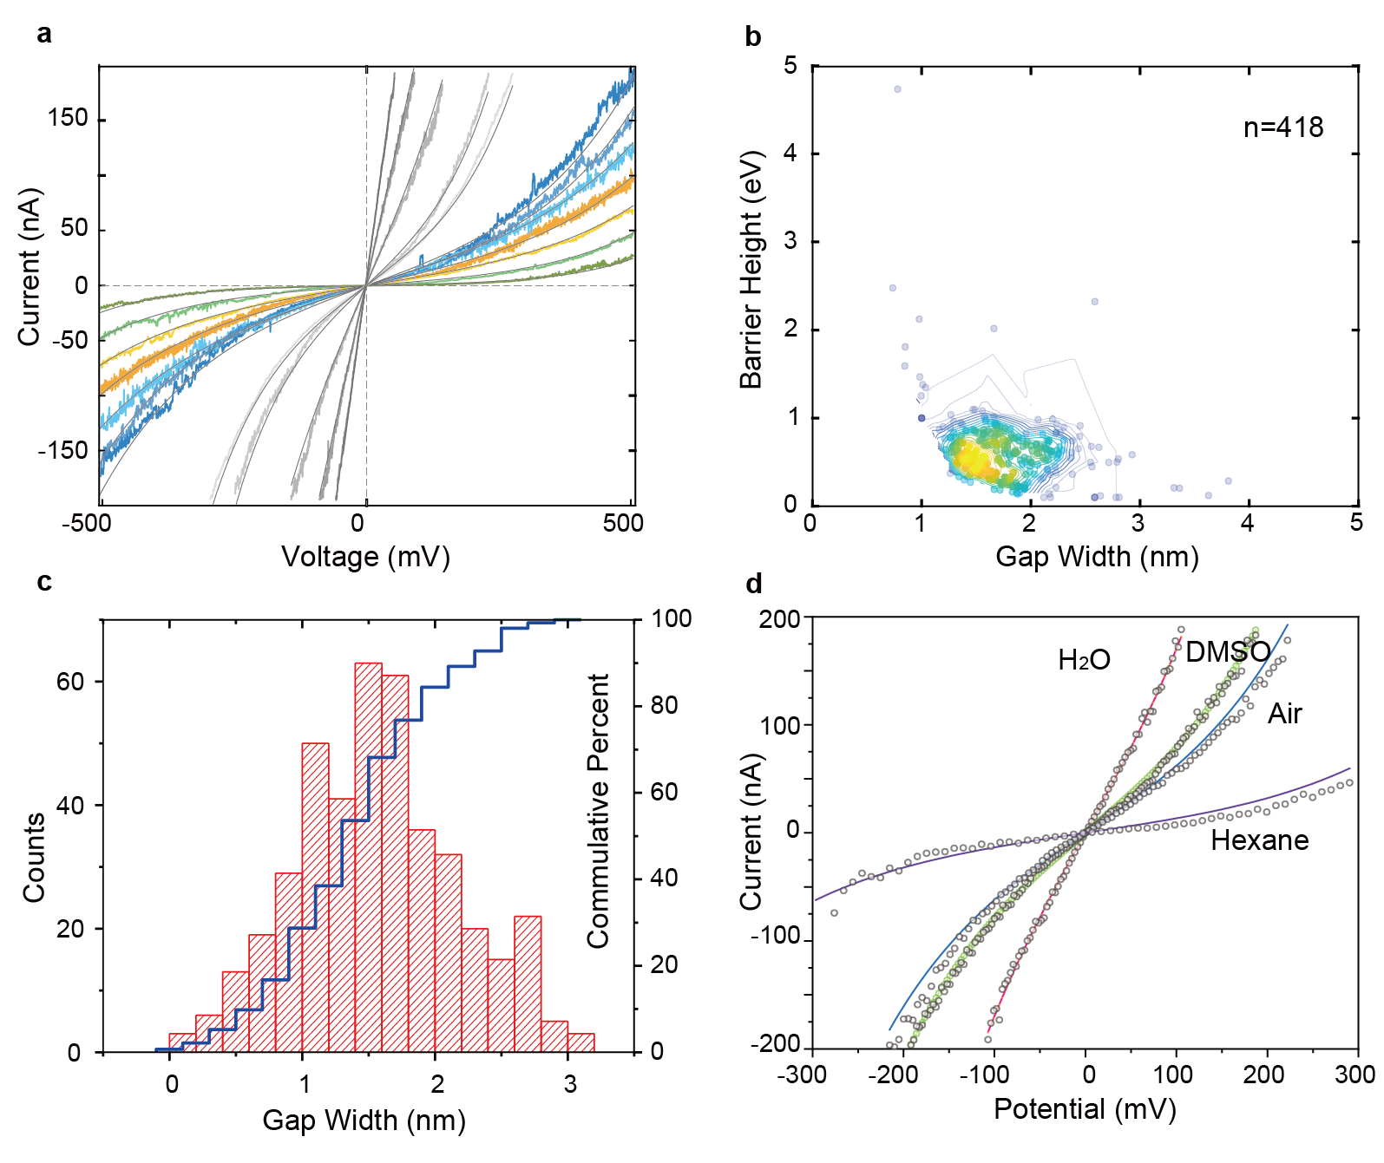
Figure 7 Electrical characterisation of QMT probes. (a) Tunnelling current−bias (I–V) measurement of QMT probes with different gaps distance in air at room temperature (25 °C). The solid curves are the data fit using the Simmons model. (b) Density scatter plot of the gap distance of 418 probes as a function of barrier height (density: high in yellow, low in navy blue). The gap distance and barrier height were obtained from the Simmons model for QMT probes measured in air. (c) Histogram of the gap distance as obtained from the Simmons model for QMT probes measured in air. (d) I-V profile recorded for a QMT probe in air, DI water, DMSO and hexane. Image adapted with permission from ref.⁴³, CC BY 4.0 (https://creativecommons.org/licenses/by/4.0/).

- Imaging of the QMT probes. Prepare the QMT probes by focused ion beam cutting with a Ga⁺ ion accelerating voltage of 30 kV. Observe the overall structure of the QMT probe with an SEM. Study the detailed structure and element distribution by a TEM at 200 kV, equipped with energy-dispersive X-ray spectroscopy (BOX 1, Figure 8).
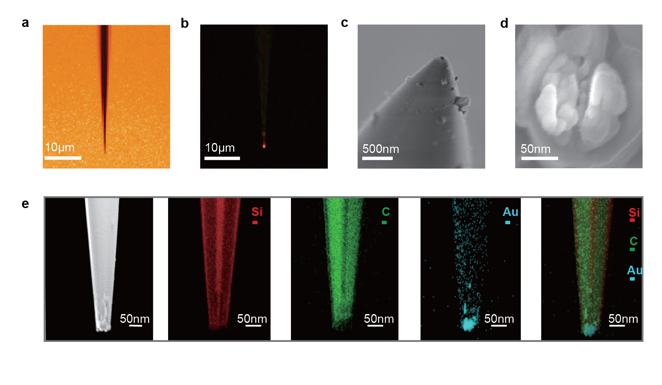
Figure 8 Characterisation of the QMT probe. (a) Bright field and (b) dark field optical images of the QMT probe show gold at the tip of the probe. (c-d) SEM images of the QMT probe show the external appearance of the nanopipette and the overall structure of the tunnelling electrodes. (e) The STEM-EDX mapping corresponding to Figure 8e shows the presence of silicon, deposited carbon and electrodeposited gold at the QMT probe tip. Images a-d adapted with permission from ref.⁴⁶, Springer Nature Limited and e from ref⁴³, CC BY 4.0 (https://creativecommons.org/licenses/by/4.0/).

Box 1 | Imaging of the QMT probes ● Timing ~4 h
Additional materials
● Diamond cutting edge knife (180 mm; Deli, cat. No. DL2702-1EA)
● Conductive silver paint (Sgltec, cat. No. 8821X-1EA)
● Carbon conductive tape (NEM, cat. No. 7322)
● Carbon supporting film (EMCN, cat. No. BZ21024b)
● Sputter coater (Emitech, SC7620)

Procedure
SEM characterisation of the QMT probe
Note that the characterisation process damages the QMT probes, and they cannot be subsequently used for the experiment in solution
- Use a diamond cutting edge knife to cut the QMT carefully and keep the pipette to 1 cm in length. Sharp glass fragments may be produced during the cutting process, and care must be taken to prevent injury.
- Gently fix the QMT to the sample stage with carbon conductive glue. Place the tip vertically upward. Since the pipette is very fragile, the installation process requires much care.
- Sputter-coat the nanopipette with a very thin layer of gold by a metal sputterer before SEM characterisation. A thin layer of titanium or chrome may be added before the gold to improve glass adhesion. These layers must be thin, as a thicker layer will obscure the QMT features. The coverage and thickness will be instrument specific. In this particular protocol, sputtering is performed for 30 s.
▲CRITICAL STEP
Sputtering of gold alone does not provide sufficient electrical conductivity, so a layer of conductive tape needs to be added after coating, and the gaps between the pipette and the tape are filled with conductive silver paint.
- Put the QMT into the vacuum chamber of the SEM to observe the morphology and measure the tip diameter. Set the voltage of the electron gun to 3 kV to characterise a QMT. Excessive voltage will damage the QMT.
▲CRITICAL Since the QMT probe is fragile and is likely to be damaged during processing, additional observation samples need to be prepared at the same time.

STEM-EDS for the QMT
▲CRITICAL Focused ion beam (FIB) is used to characterise the morphology of the QMT.
- Cut the QMT carefully to make the length of the rest tip area shorter than the specimen mount diameter.
- Use double-sided carbon tape to fix the QMT horizontally to the specimen mount.
- Put the QMT into the vacuum chamber. Use FIB to cut the tip of the QMT, then move the tip to a carbon support film. Study the structure of the QMT with a transmission electron microscope (TEM) at 200kV. Use energy-dispersive X-ray spectroscopy to characterise the elements inside the QMT probe.

Stage II: Functionalisation of the QMT probes ●Timing~14h
- Mix biotin-PEG-SH (0.001 M, 2mL) with TCEP (0.1 M, 200μL) for 2h to get thiolated biotin.
■PAUSE POINT The biotin-PEG-SH needs to be dissolved in ethanol due to low aqueous solubility. Dissolve biotin-PEG-SH immediately before use. Biotin-PEG-SH is moisture-sensitive. Store the vial of biotin reagent at -20°C with desiccant. Weigh and dissolve only a small amount of the reagent at a time, and do not prepare stock solutions for storage. Discard any unused reconstituted reagent.
- Conduct I-V measurements in air at room temperature (25 °C) to evaluate the gap distance for selecting suitable probes.
▲CRITICAL STEP To maximise the signal-to-noise ratio (SNR) and the likelihood of bridging the QMT junction, an electrode gap in the range of 1.5 to 3.1 nm (calculated using the Simmons model) is chosen, Figure 7b-c. This distance is larger than the size of thiolated biotin (molecular weight: 302 Da; size: <1 nm), but smaller than streptavidin (tetramer, 52.8 kDa; size: ~5 nm), and streptavidin can be bridged into single-protein junction by binding to biotin-modified nanoelectrode. It is not necessary to confine streptavidin in the gap of the electrodes because biotin-streptavidin-biotin builds a stable electron transport channel. Larger gaps (≥5 nm) that can accommodate intact proteins are difficult to fabricate using tunnelling current feedback mechanisms. Since the tunnelling current decays exponentially with the gap distance, larger gaps also exhibit lower SNR.
- Clean the QMT probes with deionised water and ethanol to remove possible contaminants.
- Immerse the QMT probes in ethanol-thiolated biotin (0.001 M) solution overnight (~12 h).
■PAUSE POINT The binding of thiolated biotin to the Au electrode surface is generally very stable and reliable, and most QMT probes can be used for the subsequent formation of streptavidin protein junctions. For example, in our experiments, in a batch of 50 devices, 49 were used for the subsequent formation of streptavidin protein junctions.
- Wash probes with ethanol and DI water to remove the unmodified free biotin.
- Measure I-V in DI water to confirm that the ligand-modified QMT probes are functional. Long-term repeated experiments have confirmed that the biotin-modified QMT probe can be stored at room temperature for up to 2 weeks.
■PAUSE POINT The conductance of QMT probes before and after modification with biotin are analysed. Both the bare and biotin-modified QMT probes have sigmoidal-shaped I-V curves, which are consistent with the Simmons model. An offset in the baseline current may be observed after biotin modification.
- Monitor the real-time current via chronoamperometry in PBS solution (0.001 M, pH 7.4).
- Add streptavidin (0.2 ng/mL in 0.001 M PBS solution). Monitor the real-time current via chronoamperometry
▲CRITICAL STEP Achieving a single protein junction is the key to obtaining protein-QMT coupled probes. Suitable bias is applied to the QMT probe, and the corresponding tunnelling current is measured to monitor the fabrication of a single protein junction in real-time. The selected bias voltage should not be too low; otherwise, the changes caused by the formation of protein junctions cannot be observed; the bias voltage should not be too high; otherwise, it will directly exceed the instrument range after the formation of protein junctions. Typically, for the QMT probe screened in step 13 and streptavidin junction, we choose a bias voltage of 0.1 V. When streptavidin is added to the PBS solution, individual current transients are visible in the baseline of the tunnelling current within 30-60 s. These current transients are interpreted as the interaction of single streptavidin and the biotinylated tunnelling junction and show what is expected for the successful formation of the streptavidin-bound junction in the QMT. Once the transients are observed, the QMT probe is removed from the original solution and into a new PBS solution. Real-time current recordings of single-streptavidin protein junction formation are shown in Figure 9.
? TROUBLESHOOTING

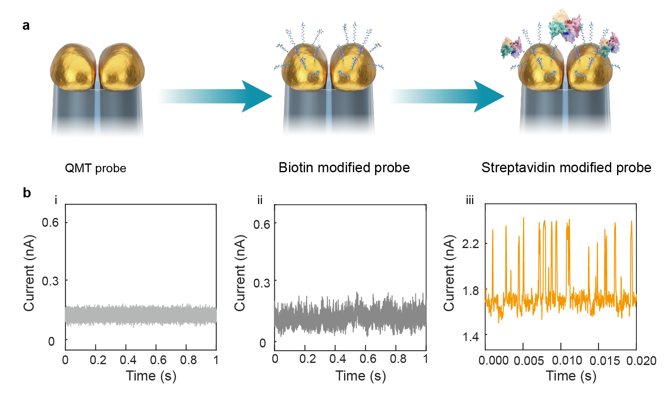
Figure 9 Formation of singe streptavidin protein junction with a QMT probe. (a) Schematic representation of the QMT probes used. (b) Real-time current recordings for QMT probe (i) before and (ii) after modification with biotin and (iii) single streptavidin-modified probe. Bias, 0.1 V. Image adapted with permission from ref.⁴⁴, AAAS
Stage III: Time-dependent single molecule electrical measurements and data analysis ●Timing~4h
- Apply a continuous scanning bias voltage (range: -0.3 V to 0.3V, scanning speed: 0.8 V/s) to study the electrical properties of streptavidin protein junctions (Figure 10a). Compare I-V curves of the bare QMT probe, the biotin-modified QMT probe and the QMT probe after streptavidin junction formation (Figure 10b).
■PAUSE POINT Approximately 31% of streptavidin-coupled QMT probes (15 of 49) exhibited stable and reproducible electrical characteristics. More I-V curves of different streptavidin-coupled QMT probes can be seen in Supplementary Figure 4.
- Investigate the voltage-dependent properties of proteins with real-time current detection at different bias voltages (Figure 10c). More data of single streptavidin-bridged QMT probes can be seen in Supplementary Figure 5.
▲CRITICAL STEP The measurement process is very sensitive to external electromagnetic and acoustic interference. Measurements should be carried out in a Faraday cage to shield external electromagnetic interference and on a stable, ideally vibrationally decoupled platform. When moving to a new test solution environment, waiting (up to 5 minutes) is necessary to ensure that any probe vibrations have subsided.
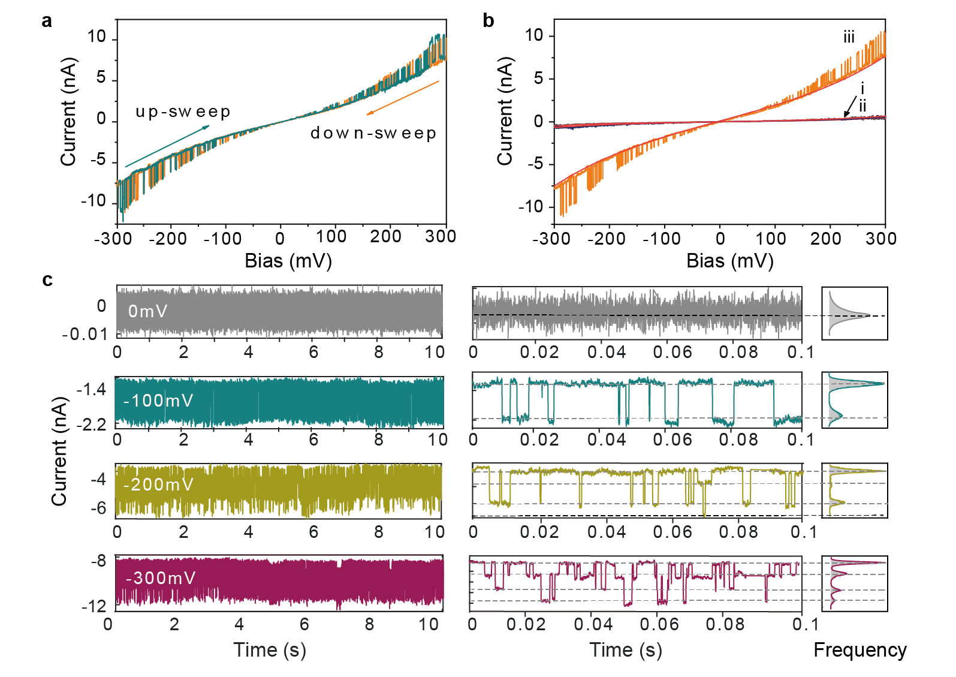
Figure 10 Electrical characterisation of the streptavidin-coupled QMT probes (a) I-V measurements of the streptavidin-coupled QMT probe between -0.3 V and 0.3 V at a sweep rate of 0.8V/s. (b) I-V curves of the (i) bare QMT probe, (ii) the biotin-modified QMT probe and (iii) the QMT probe after streptavidin junction formation. (c) Real-time current recordings of streptavidin-coupled QMT probe under different bias. The corresponding all-point current histograms are plotted on the right. Image adapted with permission from ref.⁴⁴, AAAS.

- Use hidden Markov modelling and simulations in QUB to perform idealised fitting of the I-t trajectories with multiple plain states that are derived from a segmental k-means method. Using the I-t traces, obtain the histograms of the current distribution at different bias voltages (right side of Figure 10c).
- Analyse the conductance states at a given bias. Obtain the corresponding current amplitude versus dwell time histogram, the conductance and the amplitude for each bias.
■PAUSE POINT Idealised fitting of the I-t trace reveals a multiple-state interconversion, as shown in Figure11a. Figure 11c corresponds to the dwell time distribution of each state of a typical signal at an applied bias of −0.3 V. The corresponding current amplitude and dwell time histogram of each state can be obtained, Figure 11b and Figure 11c. The dwell time and the lifetime constants for each conductance states can be calculated using monoexponential fits (Figure 11d). The same analysis can be performed at multiple biases, as shown in Figure 12.

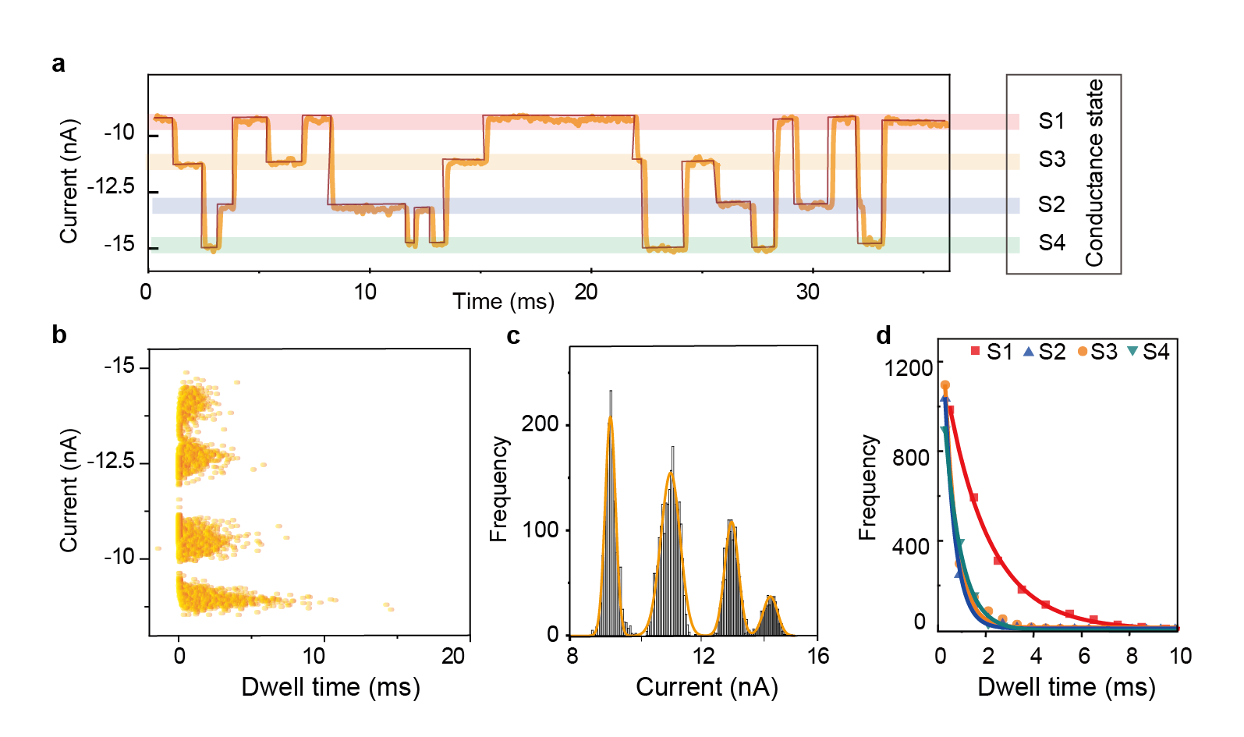
Figure 11 Statistical analysis of stochastic conductance switching for single streptavidin-coupled QMT probes at a given bias. (a) I-t current trace segment recorded at −0.3 V in PBS (pH 7.4) at 298 K (orange). Idealised fit obtained from a segmental k-means method based on hidden Markov model analysis using QUB (dark red). (b) Scatter plots of current amplitude and dwell time for each state at -0.3 V. (c) Histogram of current amplitude for each state at -0.3 V. (d) Plots of the dwell time for each state at −0.3 V using an idealised fit using QUB. The solid lines correspond to monoexponential fits from which the lifetime constants of the four states have been calculated. Image adapted with permission from ref.⁴⁴, AAAS.

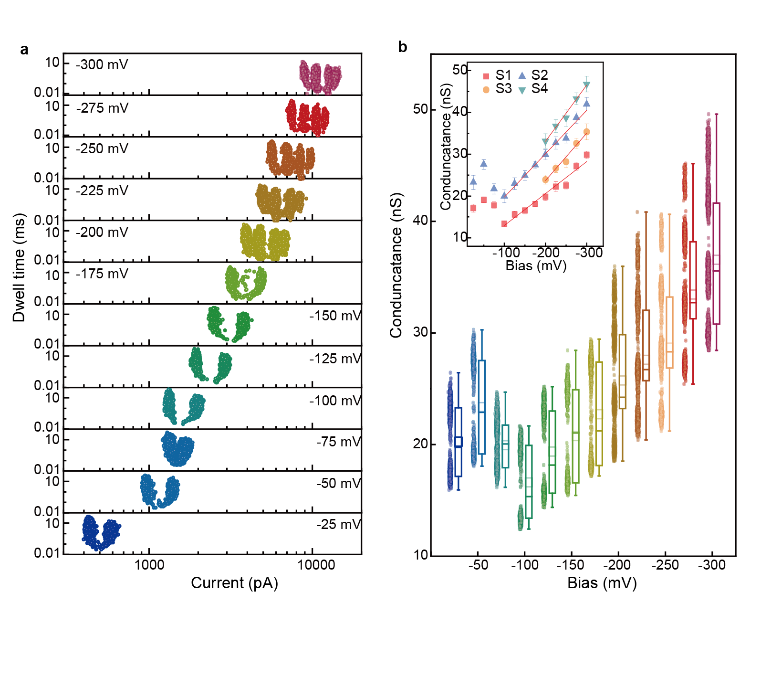
Figure 12 Statistical analysis of stochastic conductance switching for single streptavidin-coupled QMT probes. (a) Scatterplots of dwell time versus current amplitude at different constant bias. (b) Combined conductance scatter and box plots at different constant bias. (Inset) Plot of each conductance state of streptavidin-coupled QMT probe as a function of bias. Image adapted with permission from ref.⁴⁴, AAAS.

Troubleshooting
Troubleshooting advice can be found in Table 1.
Table 1 | Troubleshooting table
Step | Problem | Possible reason | Solution
3 | When heated, no red light is visible | Not enough butane gas or not high enough heating temperature | Increase the butane gas pressure, increase the butane aeration time before heating, increase the heating flame, use a thinner protective quartz tube
7 | The currents measured at WE1 and WE2 exhibit show similar magnitudes but different current directions | Too much gold is deposited, and the two electrodes are too close together | Skip step 8 and go directly to step 9
10 | Electrodes exhibit very large conductance. The I-V plots appear to be ohmic (linear) | Electrodes are too close or connected | Repeat step 9
10 | Some electrodes exhibit very small conductance. No sigmoidal-shaped IV plots cannot be observed within the measurement range of the instrument | The gap between electrodes is too large | Repeat step 8
19 | The baseline tunnelling current returns to the original state after moving into streptavidin-free PBS solution | The streptavidin junction formed is not stable, or binding has not been successful. | Repeat step 19

Timing
Steps 1–2, preparation of bare nanopipettes: ~1 h
Steps 3-9, fabrication of QMT probes: ~3 h
Steps 10-11, characterisation of QMT probes: ~4 h
Steps 12-19, preparation of streptavidin QMT probes: ~14 h
Steps 20-21, electrical measurements of single-protein junctions: ~2 h
Steps 22-23, analyse data: ~2 h
The total time to complete the protocol is 22 ~26 hours in the cases when imaging characterisation via SEM and STEM-EDS is performed.

Anticipated results
Image characterisation of QMT probes
In our experiments, we use SEM, TEM, STEM-EDS to characterise the QMT probes. SEM observes the overall structure of the QMT probe at different fabrication stages from top and side views. The effect of the pulling step can be estimated by measuring the sizes of both nanopores at the tip of the nanopipette. Using TEM to observe the structure of the formed tunnelling electrodes, it can be seen that there are tunnelling electrodes with a gap of less than 5 nm. STEM-EDS is used to observe the element distribution of the QMT probe at different production stages to verify the effect of the experiment. The carbon electrodes can be seen in the nanopipette barrels after the pyrolytic deposition of carbon. As can be seen in the resulting QMT probe, there are gold electrodes at the nanopipette tip.
Electrical Characterisation of QMT probes
The functionality of the QMT junctions can be characterised experimentally by recording I–V curves and fitting the data to the Simmons model. Figure 7a shows representative I–V curves for QMT gaps with large (in colour) and small distance (grey), which are fit using the Simmons tunnelling model. In most of the QMT probes, distinct sigmoidal tunnelling behaviour is observed as proposed by the model. Gaps with a smaller distance typically have a steeper slope and exhibit a linear shape, especially when the gap distance approaches the quantum point contact (with a conductance close to G0 = 77.5 μS). To further confirm that the fabricated QMT junctions are functional, I–V curves are measured in media with different barrier height, including air, DI water, hexane, and DMSO (Figure 7b).
Protein detection with bare QMT probes
Our QMT probes can be used to detect different protein molecules. We used a panel of proteins with different molecular weights and charges as analytical targets, including streptavidin (SA), bovine serum albumin (BSA), and immunoglobulin G (IgG). Corresponding electrical characteristic signals of tunnelling can be observed for different protein (Figure 13a). The conductance and event time distributions of the three proteins at 0.1 V bias are shown in Figure 13b–d. Each protein type produced a current transient corresponding to a specific peak conductance (ΔG) (Figure 13e). At 0.1 V bias, ΔG of SA was 1.56 ± 0.19 nS, ΔG of BSA was 1.11 ± 0.21 nS, and ΔG of IgG was 0.52 ± 0.08 nS. We believe that QMT probes may be valuable in protein detection and analysis using direct electrical readout.
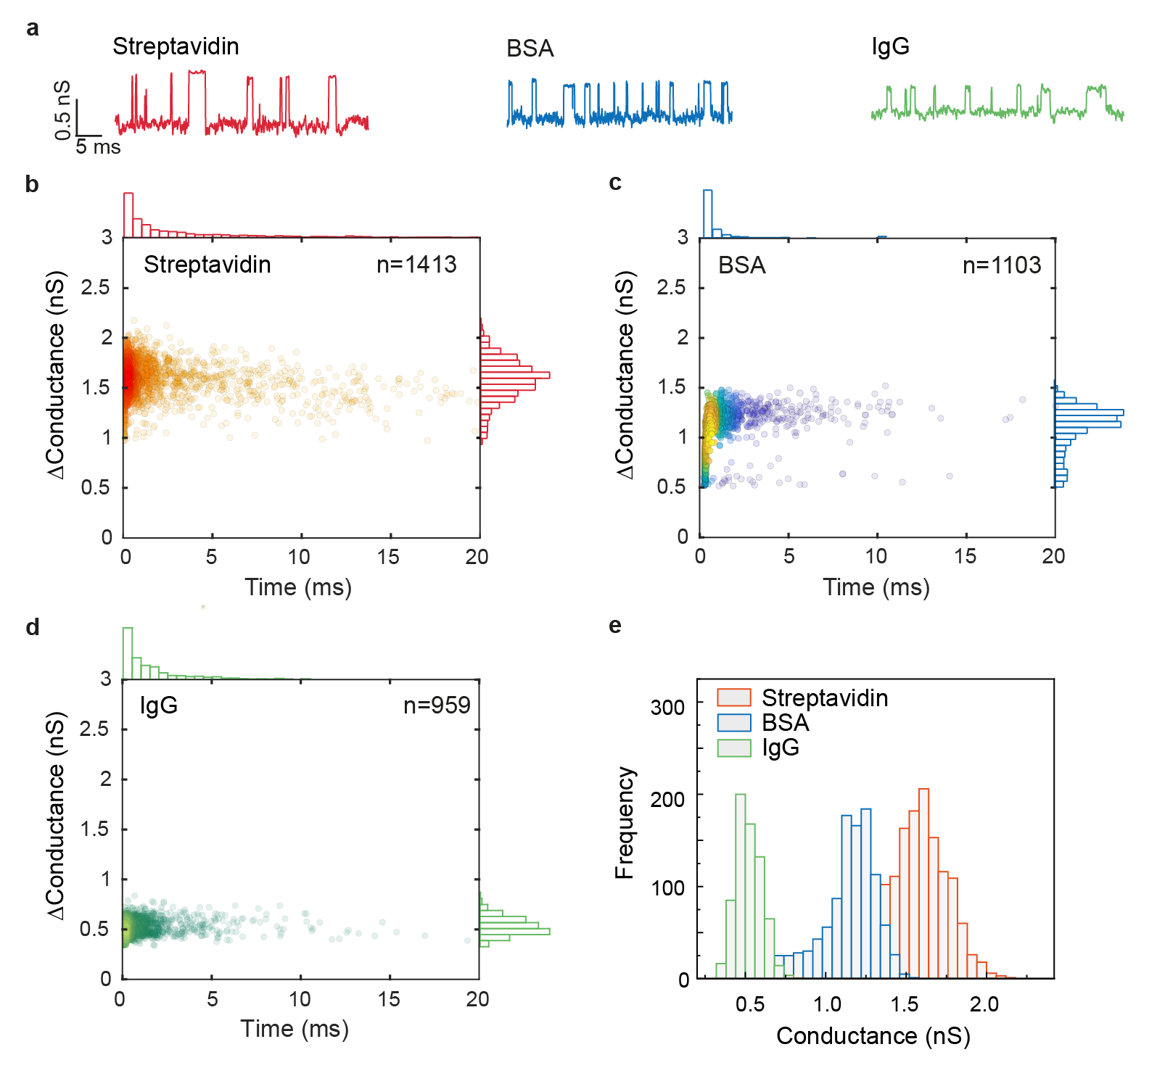
Figure 13 Protein detection with bare QMT probes. (a) Conductance vs time trace for three proteins: SA (red), BSA (blue) and IgG (green). (b-d) Scatter plot of the transients for each protein. I Normalised histogram of the change in conductance for each protein. Image adapted with permission from ref.⁴⁴, AAAS.

Analysis of protein junctions at different bias voltages
By performing real-time current measurements under different bias conditions, the effect of bias voltage on the conductance properties of single proteins can be obtained. Figure 10 shows a typical I-t trace for bias voltages ranging from 0 to -0.3 V, where the pulse-like random switching between levels can be clearly seen. These traces are used to construct the current histogram (right column in Figure 10c).
General method of protein measurement
The biotin-streptavidin linkage is relatively common in molecular biology. Both are easy to connect with other proteins through bioengineering methods such as protein engineering, modification and combination. This opens up the possibility of using the QMT probes in this work in a larger field of biological research. We can use electrodes functionalised with streptavidin to bind a target protein introduced biotinylatable peptide sequences³¹. A similar approach provides a general method to perform electrical measurements of different proteins.

Reporting Summary
Further information on research design is available in the Nature Research Reporting Summary linked to this article.

Data availability
The authors declare that the main data supporting the findings of this study are available within the article and its Supplementary Information files. Additional data is available from the corresponding authors upon reasonable request.

References
- Lindsay, S. Ubiquitous electron transport in non-electron transfer proteins. Life 10, 72 (2020).
- Bostick, C. D. et al. Protein bioelectronics: A review of what we do and do not know. Rep. Prog. Phys. 81, 026601 (2018).
- Xiang, D., Wang, X., Jia, C., Lee, T. & Guo, X. Molecular-scale electronics: From concept to function. Chem. Rev. 116, 4318-4440 (2016).
- Vilan, A., Aswal, D. & Cahen, D. Large-area, ensemble molecular electronics: Motivation and challenges. Chem. Rev. 117, 4248-4286 (2017).
- Amdursky, N. et al. Electronic transport via proteins. Adv. Mater. 26, 7142-7161 (2014).
- Di Ventra, M. & Taniguchi, M. Decoding DNA, RNA and peptides with quantum tunnelling. Nat. Nanotechnol. 11, 117-126 (2016).
- Choi, Y. et al. Single Molecule Lysozyme Dynamics Monitored by an Electronic Circuit. Science 335, 319-324 (2012).
- Schmid, S., Stömmer, P., Dietz, H. & Dekker, C. Nanopore electro-osmotic trap for the label-free study of single proteins and their conformations. Nat. Nanotechnol. 16, 1244–1250 (2021).
- Guo, C. et al. Tuning electronic transport via hepta-alanine peptides junction by tryptophan doping. Proc. Natl. Acad. Sci. U.S.A., 39, 10785-10790 (2016).
- Greenwood, J. et al. Covalent Modification of Graphene and Graphite Using Diazonium Chemistry: Tunable Grafting and Nanomanipulation. ACS Nano, 9, 5520-5535 (2015).
- Morpurgo, A. F., Marcus, C. M. & Robinson, D. B. Controlled fabrication of metallic electrodes with atomic separation. Appl. Phys. Lett., 74, 2084-2086 (1999).
- Kervennic, Y. V., Van der Zant, H. S. J., Morpurgo, A. F., Gurevich, L. & Kouwenhoven, L. P. Nanometer-spaced electrodes with calibrated separation. Appl. Phys. Lett. 80, 321-323 (2002).
- Kervennic, Y. V., Vanmaekelbergh, D., Kouwenhoven, L. P. & Van der Zant, H. S. J. Planar nanocontacts with atomically controlled separation. Appl. Phys. Lett. 83, 3782-3784 (2003).
- Bitton, O., Gutman, D.B., Berkovits, R. & Frydman, A. Multiple periodicity in a nanoparticle-based single-electron transistor. Nat. Commun. 8, 402 (2017).
- Xin, N. et al. Concepts in the design and engineering of single-molecule electronic devices. Nat. Rev. Phys. 1, 211-230 (2019).
- Fereiro, J. A. et al. Tunnelling explains efficient electron transport via protein junctions. Proc. Natl. Acad. Sci. U.S.A. 115, E4577-E4583 (2018).
- Fereiro, J. A. et al. Protein electronics: Chemical modulation of contacts control energy level alignment in gold-azurin-gold junctions. J. Am. Chem. Soc. 140, 13317-13326 (2018).
- Zhang B. & Lindsay S., Electronic decay length in a protein molecule. Nano Lett. 19, 4017-4022 (2019).
- Zhang, B., Ryan, E., Wang, X. & Lindsay, S. Probing bioelectronic connections using streptavidin molecules with modified valency. J. Am. Chem. Soc. 143, 15139-15144 (2021).
- Albrecht, T. Electrochemical tunnelling sensors and their potential applications. Nat. Commun. 3, 829 (2012).
- Xin, N. et al. Concepts in the design and engineering of single-molecule electronic devices. Nat. Rev. Phys. 1, 211-230 (2019).
- Fanget, A. et al. Nanopore integrated nanogaps for DNA detection. Nano Lett. 14, 244-249 (2014).
- Sepunaru, L., Friedman, N., Pecht, I., Sheves, M. & Cahen, D., Temperature-dependent solid-state electron transport through bacteriorhodopsin: Experimental evidence for multiple transport paths through proteins. J. Am. Chem. Soc. 134, 4169-4176 (2012).
- Fereiro, J. A., Bendikov, T., Pecht, I., Sheves, M. & Cahen, D., Protein binding and orientation matter: Bias-induced conductance switching in a mutated azurin junction. J. Am. Chem. Soc. 142, 19217-19225 (2020).
- Zhang, B. et al. Observation of giant conductance fluctuations in a protein. Nano Futures 1, 035002 (2017).
- Simmons, J. G. Generalised formula for the electric tunnel effect between similar electrodes separated by a thin insulating film. J. Appl. Phys. 34, 1793-1803 (1963).
- Fereiro, J. A. et al. A solid-state protein junction serves as a bias-induced current switch. Angew. Chem. Int. Ed. 58, 11852-11859 (2019).
- Kayser, B. et al. Solid-state electron transport via the protein azurin is temperature-independent down to 4 K. J. Phys. Chem. Lett. 11, 144-151 (2020).
- Castaneda Ocampo, O. E. et al. Mechanism of orientation-dependent asymmetric charge transport in tunnelling junctions comprising photosystem I. J. Am. Chem. Soc. 137, 8419-8427 (2015).
- Mezei, G., Balogh, Z., Magyarkuti, A. & Halbritter, A. Voltage-controlled binary conductance switching in gold-4,4`-bipyridine-gold single-molecule nanowires. J. Phys. Chem. Lett. 11, 8053-8059 (2020).
- Zhang, B. et al. Engineering an enzyme for direct electrical monitoring of activity. ACS Nano 14, 1360-1368 (2020).
- Zhang, B. et al. Role of contacts in long-range protein conductance. Proc. Natl. Acad. Sci. U.S.A. 116, 5886-5891 (2019).
- Tsutsui, M., Shoji, K., Taniguchi, M. & Kawai, T., Formation and Self-Breaking Mechanism of Stable Atom-Sized Junctions. Nano Lett. 8, 345-349(2008).
- Dubois, V. et al. Massively parallel fabrication of crack-defined gold break junctions featuring sub-3 nm gaps for molecular devices, Nat. Commun. 9, 1-10 (2018).
- Ivanov, A. P., Freedman, K. J., Kim, M. J., Albrecht, T. & Edel, J. B. High precision fabrication and positioning of nanoelectrodes in a nanopore. ACS Nano 8, 1940-1948 (2014).
- Ivanov, A. P. et al. DNA tunnelling detector embedded in a nanopore. Nano Lett. 11, 279-285 (2011).
- Jia, C. et al. Covalently bonded single-molecule junctions with stable and reversible photoswitched conductivity. Science 352, 1443-1445 (2016).
- Chang, T.H.P. Proximity effect in electron‐beam lithography, J. Vac. Sci. Technol. 12, 1271-1275 (1975).
- Manheller, M., Trellenkamp, S., Wase, R. & Karthäuser, S. Reliable fabrication of 3 nm gaps between nanoelectrodes by electron-beam lithography. Nanotechnology 23, 125302 (2012).
- Li, H., Wani, I.H., Hayat, A., Jafri, S.H.M. & Leifer, K. Fabrication of reproducible sub-5 nm nanogaps by a focused ion beam and observation of Fowler-Nordheim tunnelling. Appl. Phys. Lett. 107, 103108-103110 (2015).
- Nagase, T., Gamo, K., Kubota, T. & Mashiko, S. Direct fabrication of nano-gap electrodes by focused ion beam etching. Thin Solid Films 499, 279-284 (2006).
- Ruiz, M. P. et al. Bioengineering a single-protein junction. J. Am. Chem. Soc. 139, 15337-15346 (2017).
- Tang, L. et al. Combined quantum tunnelling and dielectrophoretic trapping for molecular analysis at ultra-low analyte concentrations. Nat. Commun. 12, 913 (2021).
- Tang, L. et al. Measuring conductance switching in single proteins using quantum tunnelling. Sci. Adv. 8, eabm8149(2022).
- Mezour, M. A., Morin, M. & Mauzeroll, J. Fabrication and characterisation of laser pulled platinum microelectrodes with controlled geometry. Anal. Chem. 83,2378-2382 (2011).
- Nadappuram, B. P. et al. Nanoscale tweezers for single-cell biopsies. Nat. Nanotechnol. 14, 80–88 (2019).
- Cadinu, P. et al. Single molecule trapping and sensing using dual nanopores separated by a zeptoliter nanobridge. Nano Lett. 17, 6376–6384 (2017).
- Xiang, J., Liu, B., Liu, B., Ren, B. & Tian, Z.-Q. A self-terminated electrochemical fabrication of electrode pairs with angstrom-sized gaps. Electrochem. Commun. 8, 577–580 (2006).
- Xiang, J. et al. A controllable electrochemical fabrication of metallic electrodes with a nanometer/angstrom-sized gap using an electric double layer as feedback. Angew. Chem. Int. Ed. Engl. 44, 1265-1268 (2005).
- Xia, Y., Xiong, Y., Lim, B. & Skrabalak, S. E. Shape-controlled synthesis of metal nanocrystals: simple chemistry meets complex physics? Angew. Chem. Int. Ed. 48, 60-103 (2009).
- Simmons, J. G. Generalised Formula for the Electric Tunnel Effect between Similar Electrodes Separated by a Thin Insulating Film. J. Appl. Phys. 34, 1793-1803 (1963).
- Wang, W., Lee, T. & Reed, M. A. Electrical Characterization of Self-Assembled Monolayers. In Nano and Molecular Electronics Handbook Edn.1 (eds. Lyshevski, S. E.) 1.3 (CRC Press, Boca Raton, FL, 2007).
- Guo, X. et al. Covalently bridging gaps in single-walled carbon nanotubes with conducting molecules. Science 311, 356-359 (2006).
- Fereiro, J. A. et al. A Solid‐State Protein Junction Serves as a Bias‐Induced Current Switch. Angew. Chem. 131, 11978-11985 (2019).
- Clausmeyer, J., Actis, P., Córdoba, A. L., Korchev, Y., & Schuhmann, W. Nanosensors for the detection of hydrogen peroxide. Electrochem. Commun. 40, 28-30 (2014).
- Li, C., He, H. & Tao, N. Quantised tunneling current in the metallic nanogaps formed by electrodeposition and etching. Appl. Phys. Lett. 77, 3995-3997 (2000).

Acknowledgements
This research was supported by the National Natural Science Foundation of China (grant nos. 21874119 and 62127818), the Natural Science Foundation of Zhejiang Province (grant no. LR22F050003) and the Fundamental Research Funds for the Central Universities. A.P.I. and J.B.E. acknowledge support from EPSRC grant EP/V049070/1, and Analytical Chemistry Trust Fund grant 600322/05. This project has also received funding from the European Research Council (ERC) under the European Union's Horizon 2020 research and innovation programme (grant agreement nos. 724300 and 875525).
Author contributions
L.H.T., X.L., L.Y., A.P.I. and J.B.E designed and supervised the research. A.P.I. and J.B.E, L.H.T. and T.J. wrote the manuscript. All authors discussed the results and commented on the manuscript.
Competing interests
The authors declare no competing interests.

