From Alternating to Selective Distributions in Chromium-catalysed Ethylene Oligomerisation with Asymmetric BIMA Ligands

James D. Nobbs, Atanas K. Tomov, Craig T. Young, Andrew J. P. White, and George J. P. Britovsek*

Department of Chemistry, Imperial College London, Exhibition Road, London, SW7 2AZ, UK

Abstract

The oligomerisation of ethylene with chromium-based catalysts containing asymmetric BIMA (bis(benzimidazole)methylamine) ligands produces linear alpha olefins (LAOs) that follow an alternating distribution. The catalytic activity and the degree of alternation is affected by the different ligands, in particular variations at the backbone of the ligand affect the nature of the distribution. For certain catalysts a deviation from regular alternating behaviour is observed, whereby increased amounts of 1-hexene and 1-octene (up to 29 mol%) are obtained compared to the amount expected from the distribution analysis based on C₁₀-C₃₄ LAOs. This behaviour towards more selective oligomerisation to 1-hexene and 1-octene can be explained by varying probabilities of single and double ethylene insertion. The deviations will depend on the size of the metallacycle and are most pronounced early on during the metallacycle growth.

Introduction
Linear alpha olefins (LAOs) are important building blocks in the chemical industry, with applications ranging from detergents to lubricants and as co-monomers for the production of commodity polymers such as LLDPE.¹⁻⁴ Ethylene oligomerisation generates a distribution of LAOs and the ability to influence this distribution using metal catalysts is of great industrial interest.⁵ Different LAO distributions can be obtained, depending on the chain growth and termination mechanisms. A linear chain growth mechanism based on single insertions of ethylene, in the absence of a termination pathway, results in a Poisson distribution.⁶ In the presence of a termination pathway, for example β-H elimination, a Schulz-Flory distribution is obtained.⁷ A metallacyclic chain growth mechanism with single ethylene insertions and a β-H transfer termination mechanism will also result in a Schulz-Flory distribution.⁸
The ability to control oligomer distributions has led to different industrial applications of ethylene oligomerisation.⁹ For example, the non-catalysed INEOS Ethyl process produces a Poisson distribution of LAOs, whereas the nickel-catalysed Shell Higher Olefin Process (SHOP) generates a Schulz-Flory distribution.¹ Other examples of more selective oligomerisations are the titanium-based IFP/Sabic Alphabutol® process for ethylene dimerisation to 1-butene,^{1, 10-14} and the Sabic/Linde Alpha-SABLIN® process based on zirconium for C₄-C₁₀ LAOs.^{1, 3} Furthermore, chromium-catalysed ethylene trimerisation to 1-hexene is operated by CPChem and an ethylene tri-/tetramerisation process to 1-hexene and 1-octene based on a PNP chromium catalyst has been commercialised by Sasol (see Figure 1).¹⁵⁻¹⁸ These selective oligomerisations can be understood as part of a spectrum of LAO distributions that extends beyond the original Schulz-Flory distribution.¹⁹
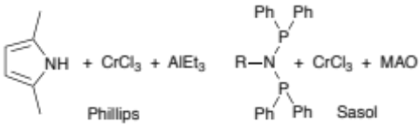

Figure 1. Industrial chromium-based oligomerisation catalysts.

We have previously reported on highly active bis(benzimidazole)amine (BIMA) chromium catalysts (1 in Figure 2) that can oligomerise ethylene with activities of 100,000 g/mmol·h·bar. A remarkable alternating distribution of LAOs is observed, whereby the selectivity towards 1-alkenes formed from an even number of ethylene units (n), such as 1-butene (n = 2), 1-octene (n = 4) and 1-dodecene (n = 6) etc., is significantly higher than those oligomers formed from an odd number of ethylene units (n = 1, 3, 5 etc.).^{20, 21} This selectivity appears odd at first sight but can be rationalised by invoking a metallacyclic mechanism with both single and double ethylene insertions.¹⁹ We show here that asymmetric variations of the BIMA ligand can lead to deviations from regular alternating behaviour resulting in distributions with increased amounts of 1-hexene and 1-octene. These new distributions link the alternating oligomerisations with the selective tri- and tetramerisations of ethylene, illustrating the range and diversity of possible distributions within the oligomerisation landscape.

Synthesis of ligands and complexes
An overview of the asymmetric BIMA-type ligands 2-12 prepared for this study is shown in Figure 2. The benzimidazole amine part is the same as in the original BIMA ligand 1. The other part of the ligand has been varied in order to study the effects of electronic and steric variations on the oligomer distributions. Three classes can be distinguished: A) electronic variations, ligands 1 - 7, B) steric variations, ligands 8 - 9, and C) ligand backbone variations, 10 - 12. Preparation of the ligands typically involves coupling a chloromethyl benzimidazole with an aminomethyl benzimidazole unit. Metal complexes [Cr(L)Cl₃] were prepared by combining the ligand with [CrCl₃(thf)₃]. In the case of ligand 2, the Cr(0) complex [Cr(2)(CO)₃] was prepared from [Cr(CO)₃(CH₃CN)₃]. Full experimental details for all ligands and complexes can be found in the Supporting Information.

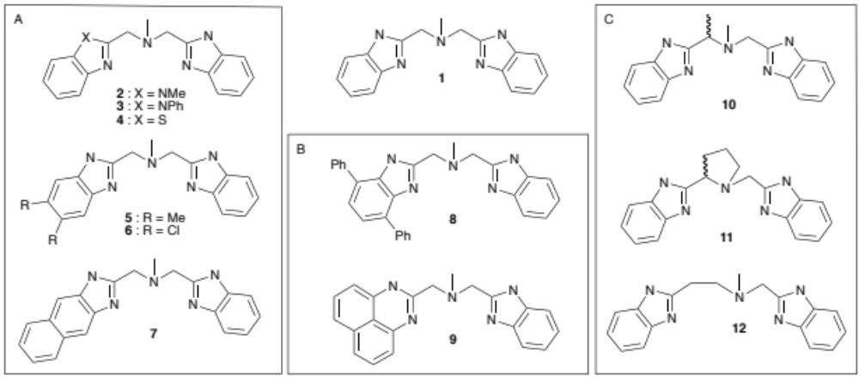
Figure 2. Overview of BIMA ligand 1 and the asymmetric ligands 2 – 12 in classes A, B and C.

Bis(benzimidazole)amine ligands typically adopt a facial coordination mode in chromium(III) trichloride complexes, as seen for [Cr(1)Cl₃] and related examples,²² with exceptions being observed for smaller ligands, which tend to prefer a meridional coordination geometry.²¹ The chromium(III) complexes generally show poor solubility in most organic solvents. Molecular structures have been determined by X-ray diffraction for single crystals obtained from DMF solutions of complexes [Cr(7)Cl₃] and [Cr(11)Cl₃]. Both complexes show the expected facial coordination mode of the ligand (see Figure 3).
Upon coordination of the asymmetric ligands to the chromium centre, the central amine nitrogen becomes a stereogenic centre and complex [Cr(7)Cl₃] crystallises as a racemate. In the case of complexes [Cr(10)Cl₃] and [Cr(11)Cl₃], the additional stereo centre results in a mixture of diastereomers. The solid state structure for complex [Cr(11)Cl₃] comprises a racemic mixture of the two enantiomers [C(R), N(S)] and [C(S), N(R)] (see Figure S8).

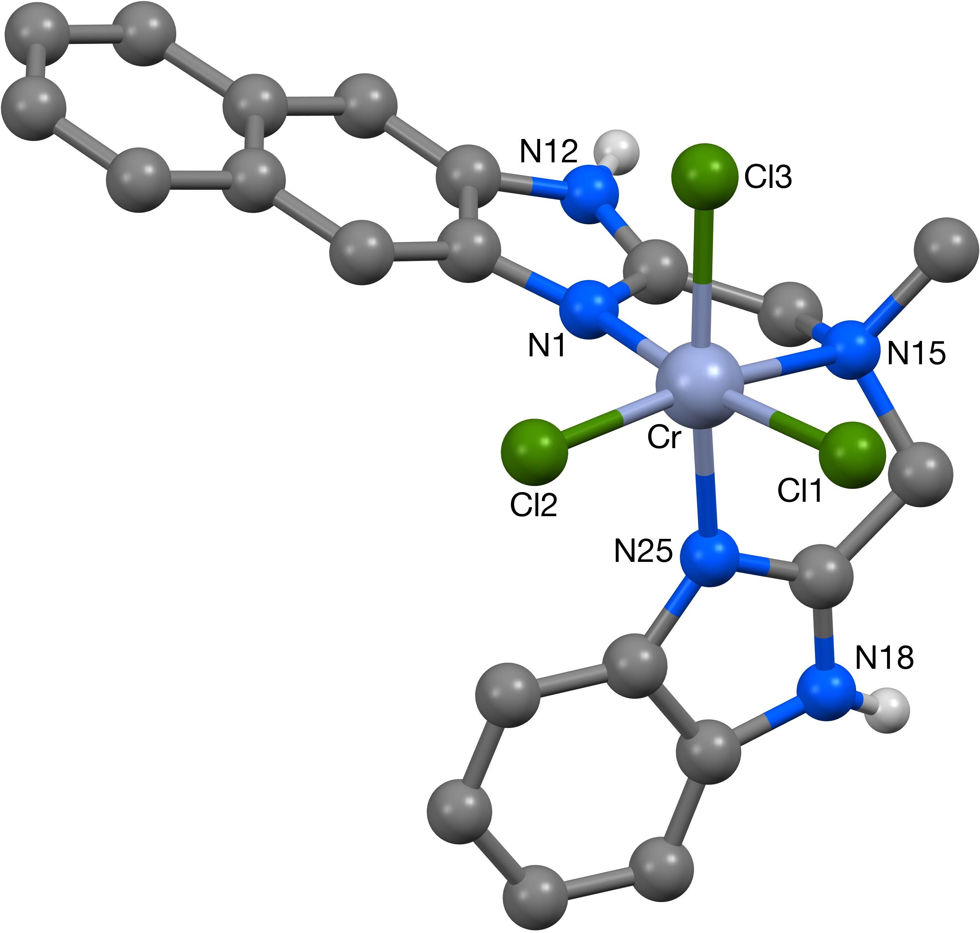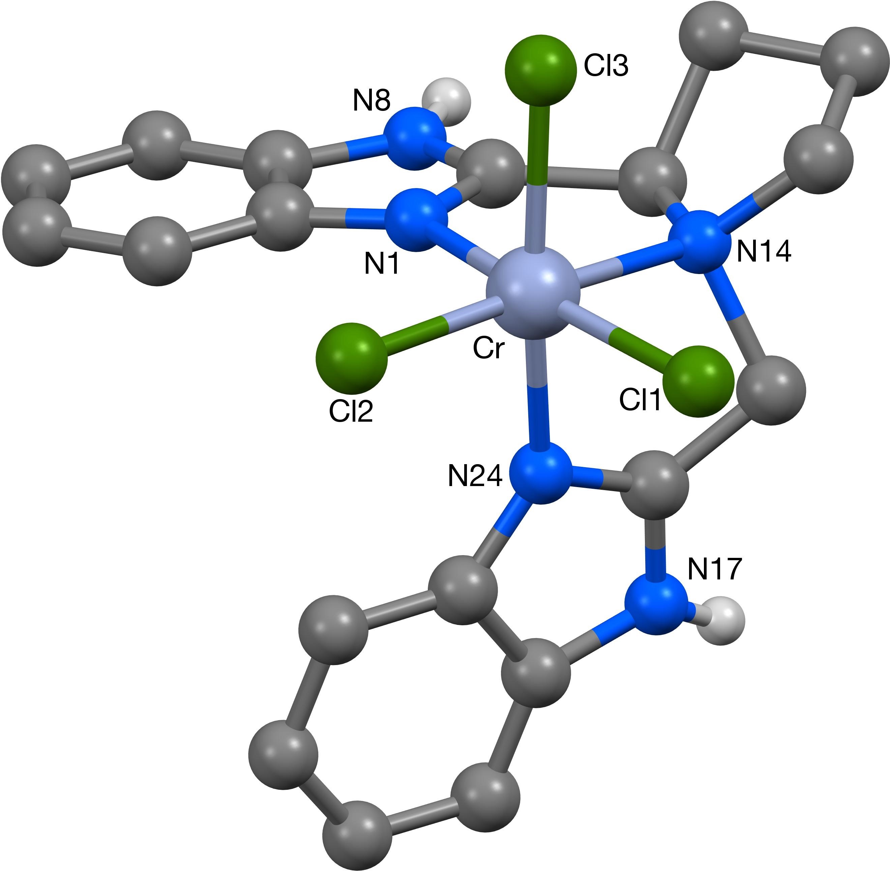

Figure 3. Molecular structures for complexes [Cr(7)Cl₃] and [Cr(11)Cl₃].

Ethylene Oligomerisation Results
The performance of the chromium complexes as catalysts for the oligomerisation of ethylene with MAO as the co-catalyst has been evaluated here for the first time and the results are compared with the parent complex [Cr(1)Cl₃] reported previously (see Table 1). Those catalysts that showed low activity under the standard conditions using 30 nmol catalyst loading were tested at a higher catalyst loading of 10 μmol in order to obtain sufficient quantities for oligomer analysis. The liquid product fraction consists of olefins from C₆-C₃₄ with >90 % selectivity for LAOs. All reactions produced approximately 40-90 wt% of low molecular weight linear polyethylene (M_{n} ≈ 2000, PDI = 1.8), which constitutes the tail end of the product distribution.²¹

Table 1. Ethylene oligomerisation results with [Cr(L)Cl₃]/MAO (L = 1 – 12).
 | catalyst (μmol) | Activity ^{a)}  gmmol⁻¹h⁻¹bar⁻¹ | liquid fraction ^{b)}  wt% (% α-olefin)
Run | catalyst (μmol) | Activity ^{a)}  gmmol⁻¹h⁻¹bar⁻¹ | liquid fraction ^{b)}  wt% (% α-olefin)
1 | [Cr(1)Cl₃] (0.03) | 122,000 | 21 (99)
2 | [Cr(2)Cl₃] (0.03) | 5,000 | 49 (97)
3 | [Cr(3)Cl₃] (0.03) | 4,000 | 54 (97)
4 | [Cr(4)Cl₃] (10) | 40 | 64 (98)
5 | [Cr(5)Cl₃] (0.03) | 37,000 | 31 (93)
6 | [Cr(6)Cl₃] (0.03) | 25,000 | 31 (91)
7 | [Cr(7)Cl₃] (0.03) | 29,000 | 29 (93)
8 | [Cr(8)Cl₃] (10) | 40 | 32 (99)
9 | [Cr(9)Cl₃] (10) | 100 | 24 (99)
10 | [Cr(10)Cl₃] (0.03) | 21,000 | 10 (94)
11 | [Cr(11)Cl₃] (0.03) | 17,000 | 30 (99)
12 | [Cr(12)Cl₃] (10) | 201 | 13 (99)
Conditions: 4 bar ethylene pressure, 50 ˚C, MAO (120 equiv.), toluene (200 mL), 1 hour. a) Activity includes solid polyethylene. b) Liquid fraction comprises C₆-C₃₄ LAOs, the remainder is insoluble polyethylene.

The activities of the different catalysts vary considerably, depending on the ligand. Substitution at one benzimidazole nitrogen (NMe and NPh) in complexes [Cr(2)Cl₃] and [Cr(3)Cl₃] reduces the activity significantly from 122,000 to 4,000-5,000 gmmol⁻¹h⁻¹bar⁻¹ compared to the benchmark catalyst [Cr(1)Cl₃]. We have shown previously that substitution of both benzimidazole NH for NMe groups results in a symmetric catalyst with a very low activity of 320 gmmol⁻¹h⁻¹bar⁻¹.²¹ The N-H unit of the benzimidazole moiety clearly plays an important but as yet unclear role and we assume that this involves a reaction with the aluminium alkyl co-catalyst.²¹ This is further illustrated by substitution of one benzimidazole unit for another heterocycle, in this case benzothiazole in [Cr(4)Cl₃], which also has a detrimental effect on catalytic activity.
Steric effects are clearly important, as illustrated by the 6-membered perimidine unit in [Cr(9)Cl₃] and the large phenyl substituents in [Cr(8)Cl₃]. Both catalysts result in very low activity, possibly due to reduced access to the metal centre for the coordination of ethylene. Substitutions at the periphery of the benzimidazole unit or at the ligand backbone, for example catalysts containing ligands 5 - 7 or 10 - 11 provide the most active catalysts of the asymmetric BIMA series, but none of these is superior to [Cr(1)Cl₃]. Extension of the backbone with an additional methylene unit in [Cr(12)Cl₃] has a detrimental effect on activity, in line with similar observations made previously with symmetric analogues.²¹

Oligomer Distribution Analysis
The toluene-soluble product fraction contains between 10-60 wt% of the total amount of oligomers and consists predominantly (>90%) of LAOs. The co-products are a distribution of 2-ethyl-1-alkenes that are generated from incorporation of 1-butene (the most abundant oligomer) into the oligomerisation process.²¹ In all runs in Table 1, an alternating oligomer distribution of LAOs is obtained, whereby the α-olefins formed from an odd number of ethylene units (n = 1, 3, 5 etc.) are significantly less abundant than the even-numbered oligomers such as 1-butene (n = 2), 1-octene (n = 4) and 1-dodecene (n = 6). Analysis of the distributions has been carried out as described previously,¹⁹ using a second-order homogeneous linear recurrence relation with constant coefficients to give the molar amounts mol(n) for each oligomer (n = number of ethylene units in the oligomer). The general solution to this recurrence relation takes the form T_{n} = c₁r₁^{n} + c₂r₂^{n}, whereby c_{1,2} and r_{1,2} are related to α and β, the probabilities for single (α) and double (β) ethylene insertions during the metallacycle growth mechanism.¹⁸ Experimental data obtained for an alternating distribution can be fitted to this equation to determine c_{1,2} and r_{1,2}, and thereby α and β (see Table 2). The term β/α indicates the extent of alternation and 1–α–β signifies the probability for chain termination. Molar fractions mol%(n) are obtained by dividing the molar amounts mol(n) by the total molar amount of oligomers produced in a given time. For example, the experimental distributions obtained with [Cr(2)Cl₃] and [Cr(5)Cl₃] are illustrated in Figure 4, together with the calculated equations mol%(n) = 18.96(0.87)^{n} + 17.47(–0.72)^{n} and mol%(n) = 20.57(0.88)^{n} + 21.80(–0.75)^{n}, respectively.

Table 2. Alternating distributions obtained with chromium catalysts [Cr(L)Cl₃]/MAO.
Catalyst | mol%(n) | α | β | 1-α-β | β/α | R^{2b)}
[Cr(1)Cl₃] | 25.16(0.90)^{n} + 23.06(–0.79)^{n} | 0.11 | 0.72 | 0.17 | 6.41 | 0.997
[Cr(2)Cl₃] | 18.96(0.87)^{n} + 17.47(–0.72)^{n} | 0.15 | 0.63 | 0.23 | 4.21 | 0.977
[Cr(3)Cl₃] | 19.82(0.88)^{n} + 16.84(–0.73)^{n} | 0.15 | 0.64 | 0.21 | 4.38 | 0.980
[Cr(4)Cl₃] | 27.48(0.85)^{n} + 17.60(–0.73)^{n} | 0.12 | 0.61 | 0.27 | 5.09 | 0.999
[Cr(5)Cl₃] | 20.57(0.88)^{n} + 21.80(–0.75)^{n} | 0.12 | 0.66 | 0.21 | 5.31 | 0.991
[Cr(6)Cl₃] | 21.98(0.87)^{n} + 23.21(–0.75)^{n} | 0.12 | 0.65 | 0.23 | 5.38 | 0.984
[Cr(7)Cl₃] | 20.74(0.88)^{n} + 22.39(–0.75)^{n} | 0.12 | 0.66 | 0.22 | 5.31 | 0.989
[Cr(8)Cl₃]^{a)} | 16.81(0.89)^{n} + 10.61(–0.75)^{n} | 0.14 | 0.67 | 0.18 | 4.72 | 0.998
[Cr(9)Cl₃]^{a)} | 21.34(0.87)^{n} + 8.60(–0.81)^{n} | 0.06 | 0.70 | 0.23 | 11.3 | 0.995
[Cr(10)Cl₃]^{a)} | 10.80(0.94)^{n} + 9.65(–0.84)^{n} | 0.10 | 0.79 | 0.11 | 8.22 | 0.995
[Cr(11)Cl₃]^{a)} | 21.48(0.88)^{n} + 14.70(–0.81)^{n} | 0.06 | 0.71 | 0.22 | 10.9 | 0.990
[Cr(12)Cl₃]^{a)} | 17.69(0.87)^{n} + 4.50(–0.83)^{n} | 0.05 | 0.72 | 0.23 | 14.6 | 0.994
Conditions: 4 bar ethylene pressure, 50 ˚C, MAO (120 equiv.), toluene (200 mL), 1 hour a) 1-hexene and 1-octene omitted from product analysis. b) R² signifies the goodness of fit of the calculated values compared to the experimental data.

Figure 4. Experimental and calculated best-fit (dashed line) LAO distributions obtained with [Cr(2)Cl₃]/MAO (left) and [Cr(5)Cl₃]/MAO (right) (n = number of ethylene units in oligomer).

The asymmetric ligands 2 – 7 of class A were designed to probe different electronic effects within the ligand. The rather similar LAO distributions obtained in this series suggest that these electronic variations have little effect. The ligand class B (8 – 9) and C (10 – 12) explore steric effects, either from the benzimidazole unit or from the backbone of the ligand and some of these catalysts, in particular those in class C, generate more significant changes to the LAO distribution.
In general, the alternating distributions obtained with different catalysts in this study reveal that the α and β values straddle a narrow range between 0.05-0.15 for α and 0.6-0.8 for β. As the probabilities α, β and 1–α–β must add up to 1, they can be graphically combined in a ternary plot as shown in Figure 5. In this diagram, Schulz-Flory distributions where β = 0 are found on the base of the triangle. Perfectly alternating distributions where α = 0 will be on the left side, whereas the right side represents distributions where the termination probability 1–α–β equals zero, so called living polymerisation.²³ All distributions obtained with the catalysts listed in Table 2 cluster together in the top left corner. Examples of distributions that would be obtained from α and β combinations in the other corners of the diagram are shown for comparison, illustrating the various types of distributions that can theoretically be obtained from oligomerisation catalysts that operate via single and double ethylene insertions.
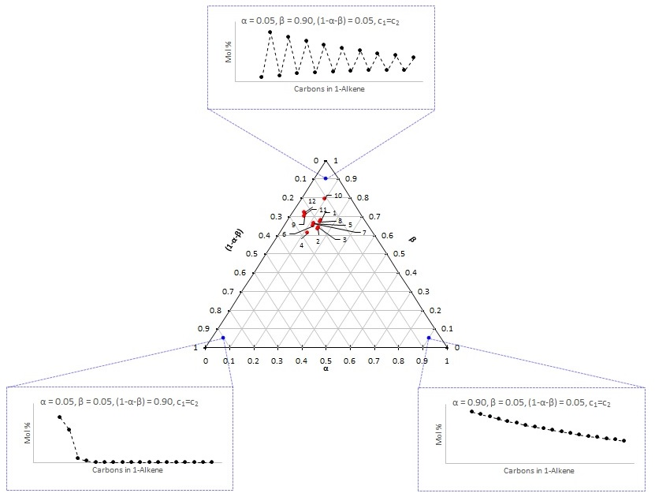
Figure 5. Ternary plot of α, β and 1–α–β values for distributions obtained with [Cr(L)Cl₃]/MAO listed in Table 2 (red points). The blue points are illustrative examples of other distributions.

Deviations from regular alternation
In the case of oligomerisation with [Cr(8)Cl₃] - [Cr(12)Cl₃], the experimentally obtained distributions show significant deviation from the calculated distributions when the entire LAO range from C₆-C₃₄ is used for analysis (see Table S1 in the Supporting Information). This deviation from regular alternation affects mainly the amount of 1-hexene and 1-octene obtained experimentally with these catalysts. The mol% values obtained are larger than the expected values based on the distribution analysis of the LAOs from 1-decene onwards (C₁₀-C₃₄) (see examples in Figure 6). Excellent results with R² values greater than 0.99 are obtained when 1-hexene and 1-octene are excluded from the data fitting, which is the analysis shown in Table 2. 1-Hexene and in particular the 1-octene values determined experimentally are significantly higher than those calculated, which suggests some degree of selective tri- or tetramerisation.

A strongly alternating distribution was observed with [Cr(10)Cl₃], which contains a methyl substituent at one of the bridging carbons (see Figure 6). This catalyst shows a high probability for double insertion (β), but the lowest termination probability in the series, resulting in oligomers with higher molecular weight and therefore only a small toluene-soluble fraction of 10 wt%. It can be seen in Figure 6 that the 1-octene fraction of 19 mol% is higher than the 13 mol% predicted from analysis of the C₁₀-C₃₄ fraction. Both ligand 10 and the complex [Cr(10)Cl₃] were prepared as racemic mixtures and attempts to obtain enantiomerically pure 10 failed. Racemisation was observed during ligand synthesis, in contrast to a report on a similar synthesis.²⁴
The asymmetric complex [Cr(12)Cl₃] with one methylene and one longer ethylene bridge also shows significant alternating behaviour with a high β/α ratio of 14.6. The selectivity of 29 mol% for 1-octene is much larger than the 12 mol% predicted from the distribution based on C₁₀-C₃₄ LAOs (see Figure 6, right), indicating a high propensity for tetramerisation. Unfortunately, the activity of this catalyst is rather low. We can conclude form these studies that steric effects on the benzimidazole unit or on the backbone of the BIMA ligand can affect the oligomer distribution significantly, resulting in a spectrum of distributions from regularly alternating to more selective trimerisation/tetramerisation behaviour.

Figure 6. Experimental and calculated best-fit (dashed line) LAO distribution obtained with [Cr(10)Cl₃]/MAO (left) and [Cr(12)Cl₃]/MAO (right) (n = number of ethylene units in oligomer, 1-hexene and 1-octene have been excluded from the analysis).

Mechanistic considerations
Analysis of an alternating distribution according to a second-order homogeneous recurrence relation with constant coefficients, T_{n} = αT_{n-1} + βT_{n-2}, requires that the coefficients α and β are constant throughout the oligomerisation reaction.¹⁹ Each metallacyclic intermediate has the same reactivity towards ethylene, and 1-butene will be the most abundant oligomer in mol%. Deviation from regular alternating behaviour can result when α and β are not constant, i.e. when the probabilities for single and double ethylene insertion change during the course of the oligomerisation process. This could be due to different relative stabilities and reactivities of the growing metallacycles, which will be most noticeable early on in the oligomerisation process. For example, a metallacyclopentane complex could be more stable than larger metallacycles and very little elimination to 1-butene will occur from this intermediate (See Scheme 1). Thus, the probability for termination 1–α–β will be close to zero and therefore α + β close to 1. Consequently, more metallacycloheptane and metallacyclononane intermediates will be formed via single and double ethylene insertion pathways, respectively. As the probability for double insertion (β) decreases due to steric reasons, termination from these larger metallacyclic intermediates will become more favourable,²⁵ which will lead to increased amounts of 1-hexene and 1-octene (see Scheme 1). A double ethylene insertion pathway implies substitution of one of the benzimidazole donors with ethylene. Based on reactivity studies of the benzimidazole ligand with AlMe₃, which results in Al-N (benzimidazole) bond formation and the elimination of methane, and the use of AlMe₃ as an effective co-catalyst,²¹ we strongly suspect an involvement of aluminium alkyls from the MAO co-catalyst in the catalyst activation process.
For complexes [Cr(10)Cl₃] and [Cr(12)Cl₃] shown in Figure 6, 1-octene in particular is significantly more abundant, commensurate with β being much larger than α (see Table 2). The amount of 1-octene is 19 and 29 mol% respectively, much higher than the 13 and 12 mol% predicted from the analysis based on the LAO distribution from C₁₀-C₃₄. Beyond the metallacyclononane intermediate, the geometric and energetic differences between individual metallacycles levels off and α and β will become constant values. It should be noted that while the deviations from regular alternation seen here can be rationalised by implying variable α and β values, distributions of this type are mathematically described as second-order homogeneous linear recurrence relations with variable coefficients, but solutions to these relations are not easily obtained.
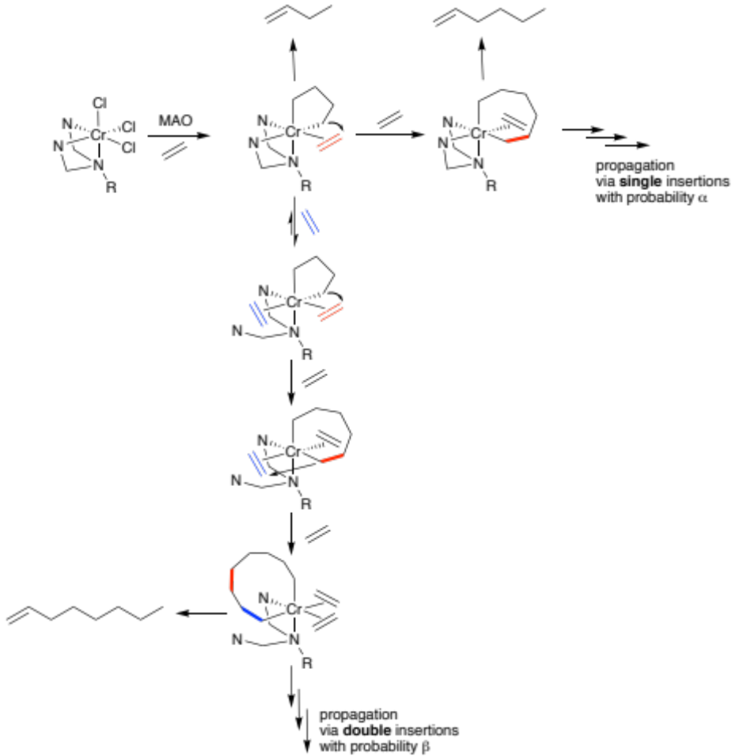
Scheme 1. Proposed oligomerisation mechanism via single and double ethylene insertions.

The distributions obtained with complexes [Cr(10)Cl₃] and [Cr(12)Cl₃] can be regarded as intermediate between a regularly alternating distribution and a more selective oligomerisation, for example tetramerisation to 1-octene with certain chromium PNP catalysts.^{17, 18, 26} These PNP catalysts can reach over 70% 1-octene selectivity,¹⁶ but the total product spectrum remains an LAO distribution with distinct amounts of each 1-alkene from C₆-C₃₄ represented.²⁷ We believe that the high 1-octene selectivity with these PNP chromium catalysts arises due to a high double insertion probability β for the metallacyclopentane intermediate, which rapidly decreases to zero as the metallacycle grows, thereby increasing the probability for termination resulting in mostly 1-octene formation. Once β = 0, a Schulz-Flory behaviour for the LAO distribution is observed from C₁₀ onwards.¹⁹

In conclusion, a series of asymmetric BIMA ligands has been investigated in the chromium-catalysed oligomerisation of ethylene to give an alternating product distribution. Variations in electronic and steric effects have shown that steric effects on the benzimidazole moiety and on the ligand backbone in particular can significantly affect the oligomer distribution. Deviation from regularly alternating behaviour is observed in some cases, in favour of more selective tri- and tetramerisation behaviour to give enhanced quantities of 1-hexene and 1-octene. Single and double ethylene insertion reactions are responsible for both alternating and selective oligomerisation behaviour. Regular alternation requires constant probabilities for single and double insertion reactions, whereas varying probabilities result in the observed deviations from regular alternation. The distributions seen here link regularly alternating oligomerisation with more selective tri- and tetramerisation of ethylene, expanding the range and diversity within the oligomer distributions landscape.

Supporting Information
Synthesis of ligand and metal complexes with characterising data, NMR spectra, GC chromatograms and crystallographic details.

Conflicts of Interest
There are no conflicts of interest to declare.

Acknowledgements

Financial support from INEOS Technologies is kindly acknowledged.

References

1. P.-A. R. Breuil, L. Magna and H. Olivier-Bourbigou, Catal. Lett., 2015, 145, 173-192.
2. A. Forestière, H. Olivier-Bourbigou and L. Saussine, Oil Gas Sci. Technol., 2009, 64, 649-667.
3. H. Olivier-Bourbigou, A. Forestière, L. Saussine, L. Magna, F. Favre and F. Hugues, Oil Gas Eur. Mag., 2010, 36, 97-102.
4. G. P. Belov and P. E. Matkovsky, Pet. Chem., 2010, 50, 283-289.
5. W. Keim, Angew. Chem. Int. Ed., 2013, 52, 12492-12496.
6. G. J. P. Britovsek, S. A. Cohen, V. C. Gibson, P. J. Maddox and M. van Meurs, Angew. Chem. Int. Ed., 2002, 41, 489-491.
7. P. Cossee, J. Catal., 1964, 3, 80-88.
8. J. R. Briggs, J. Chem. Soc. Chem. Commun., 1989, 674-675.
9. E. O. Camara Greiner and Y. Inoguchi, Chemical Economics Handbook Linear Alpha-Olefins, SRI Consulting, 2010.
10. D. Commereuc, Y. Chauvin, J. Gaillard, J. Léonard and J. Andrews, Hydrocarb. Process., 1984, 63, 118.
11. A. W. Al-Sa'doun, Appl. Catal. A: Gen., 1993, 105, 1.
12. A. M. Al-Jarallah, J. A. Anabtawi, M. A. B. Siddiqui, A. M. Aitani and A. W. Al-Sa'doun, Catal. Today, 1992, 14, 1.
13. J. A. Suttil and D. S. McGuinness, Organometallics, 2012, 31, 7004-7010.
14. R. Robinson, D. S. McGuinness and B. F. Yates, ACS Catal., 2013, 3, 3006.
15. K. Blann, A. Bollmann, J.T. Dixon, A. Neveling, D.H. Morgan, H. Maumela, E. Killian, F.M. Hess, S. Otto, L. Pepler, H. Mohamed, M.J. Overett, WO 04056479A1 (Sasol Technology), 2004.
16. A. Bollmann, K. Blann, J. T. Dixon, F. M. Hess, E. Killian, H. Maumela, D. S. McGuinness, D. H. Morgan, A. Neveling, S. Otto, M. J. Overett, A. M. Z. Slawin, P. Wasserscheid and S. Kuhlmann, J. Am. Chem. Soc., 2004, 126, 14712-14713.
17. D. S. McGuinness, Chem. Rev., 2011, 111, 2321-2341.
18. K. A. Alferov, G. P. Belov and Y. Meng, Appl. Catal. A: Gen., 2017, 542, 71-124.
19. G. J. P. Britovsek, R. Malinowski, D. S. McGuinness, J. D. Nobbs, A. Tomov, A. W. Wadsley and C. T. Young, ACS Catal., 2015, 5, 6922-6925.
20. A. Tomov, J. J. Chirinos, R. J. Long, V. C. Gibson and M. R. J. Elsegood, J. Am. Chem. Soc., 2006, 128, 7704-7705.
21. A. Tomov, J. D. Nobbs, J. J. Chirinos, P. K. Saini, R. Malinowski, S. K. Y. Ho, C. T. Young, D. S. McGuinness, A. J. P. White, M. R. J. Elsegood and G. J. P. Britovsek, Organometallics, 2017, 36, 510-522.
22. R. Cariou, J. J. Chirinos, V. C. Gibson, G. Jacobsen, A. Tomov and M. R. J. Elsegood, Macromolecules, 2009, 42, 1443-1444.
23. A. D. Jenkins, P. Kratochvil, R. F. T. Stepto and U. W. Suter, Pure & Appl. Chem., 1996, 68, 2287-2311.
24. E. Lacoste, Y. Landais, K. Schenk, J.-B. Verlhac and J.-M. Vincent, Tetrahedron Lett., 2004, 45, 8035-8038.
25. J. X. McDermott, J. F. White and G. M. Whitesides, J. Am. Chem. Soc., 1976, 98, 6521-6528.
26. M. F. Haddow, J. Jaltai, M. J. Hanton, P. G. Pringle, L. E. Rush, H. A. Sparkes and C. H. Woodall, Dalton Trans., 2016, 45, 2294-2307.
27. G. J. P. Britovsek, D. S. McGuinness, T. S. Wierenga and C. T. Young, ACS Catal., 2015, 5, 4152-4166.

TOC Entry

