Supplementary Material
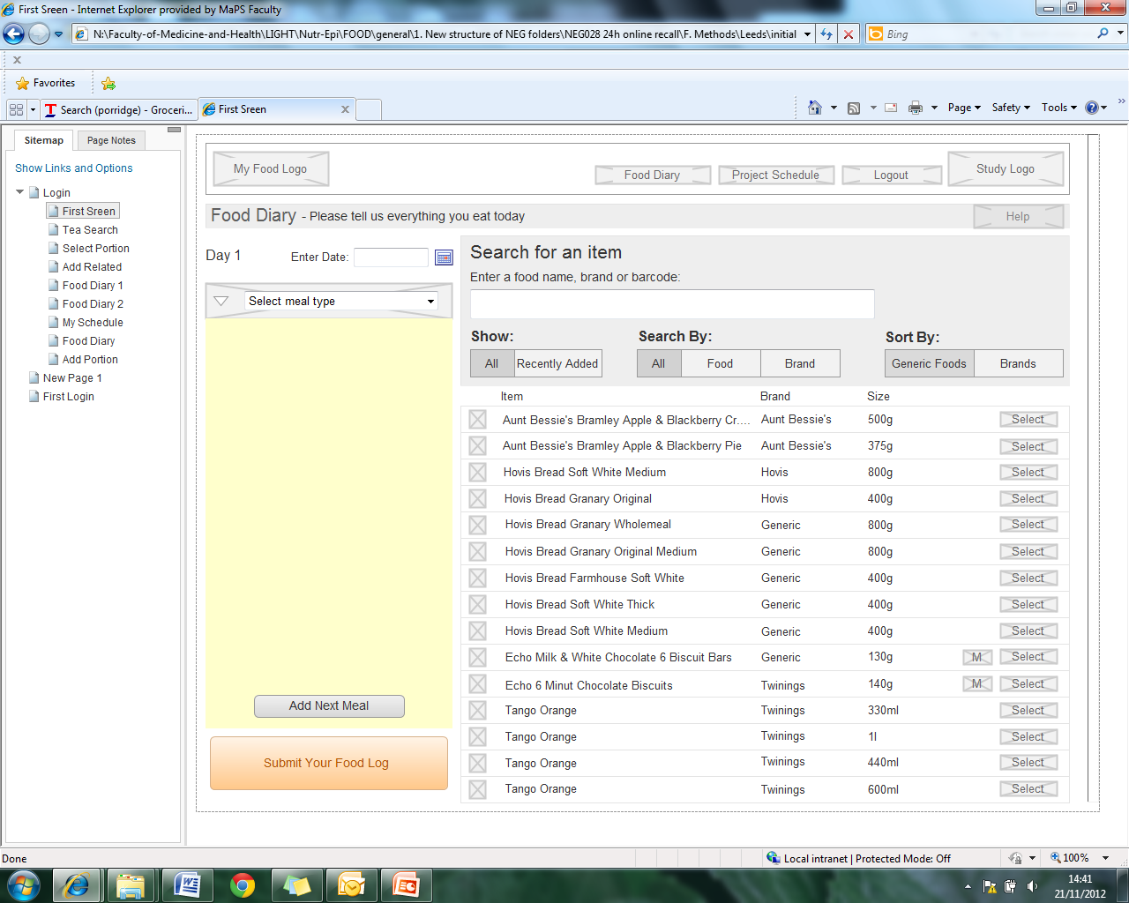
Figure S1. Cont.

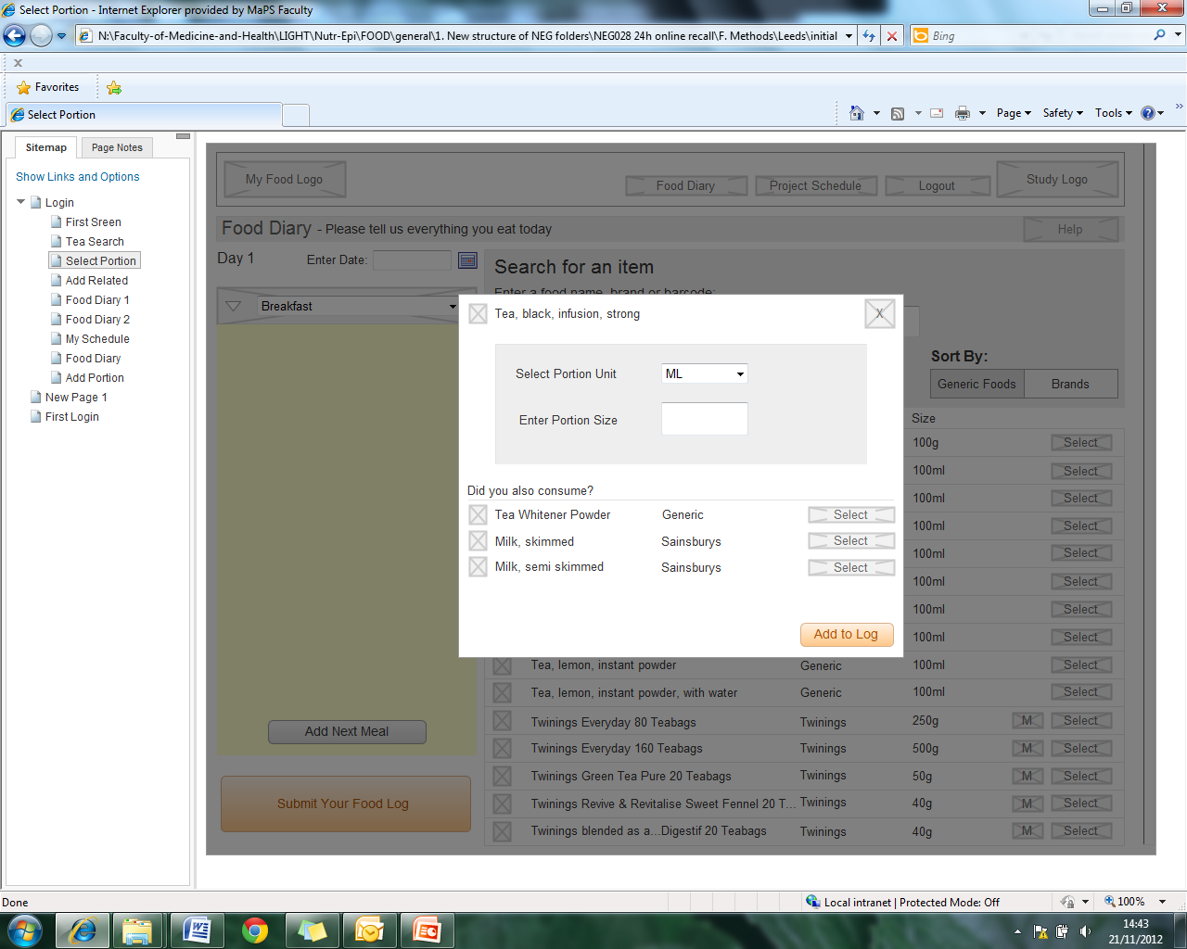
Figure S1. (a) Example of initial static click-through wireframe of myfood24 (food diary page)–clay model; (b) Example of initial static
click-through wireframe of myfood24 (food portion selection).

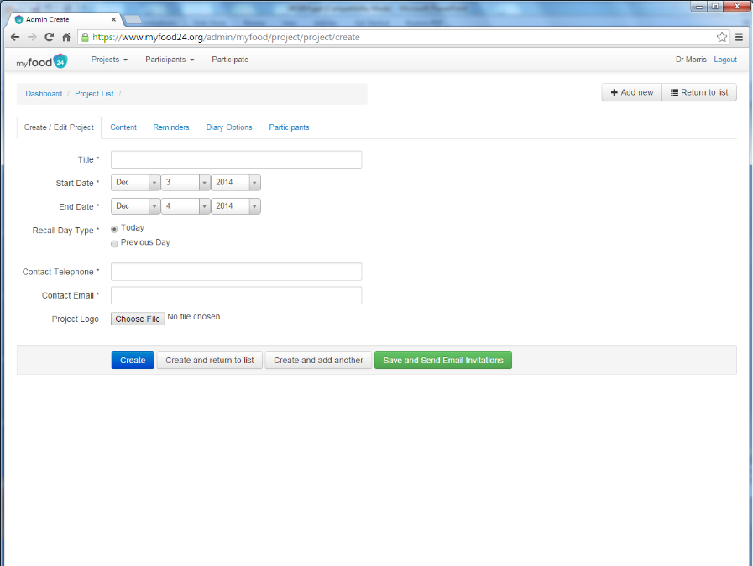 | 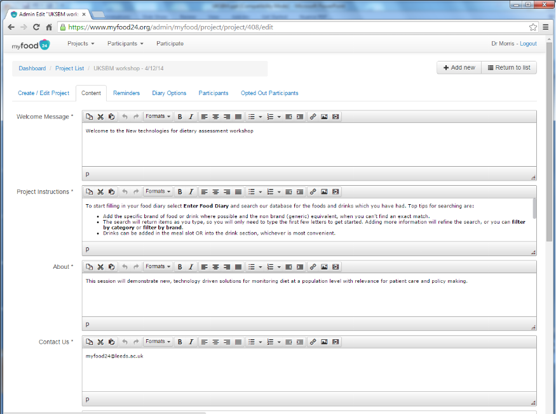
(a) | (b)
Figure S2. (a) Example of options to set up a project in the researcher area of myfood24; (b) Example of options to customise text displayed to the participant in the researcher area of myfood24.
© 2015 by the authors; licensee MDPI, Basel, Switzerland. This article is an open access article distributed under the terms and conditions of the Creative Commons Attribution license (http://creativecommons.org/licenses/by/4.0/).

