High Temperature Strength of an Ultra High Temperature Ceramic produced by Additive Manufacturing

Ezra Feilden, Daniel Glymond, Eduardo Saiz, Luc Vandeperre
Centre for Advanced Structural Ceramics, Department of Materials, Imperial College London, South Kensington Campus, SW7 2AZ, United Kingdom

Abstract
In this study hafnium diboride was fabricated using the additive manufacturing technique robocasting. Parts have been successfully produced with complex shapes and internal structures not possible via conventional manufacturing techniques. Following pressureless sintering, the monolithic parts reach densities of 94–97 % theoretical. These parts exhibit bending strength of 364±31 MPa at room temperature, and maintain strengths of 196±5 MPa up to 1950 °C, which is comparable to UHTC parts produced by traditional means. These are the highest temperature mechanical tests that a 3D printed part has ever undergone. The successful printing of the high density HfB₂ demonstrates the versatile range materials that can be produced via robocasting using Pluronic pastes.

Keywords: UHTC; hypersonic; additive manufacturing; hafnium diboride; leading edge; thermo-mechanical

Introduction

Additive manufacturing, also known as 3D printing, offers many advantages over traditional manufacturing methods for both prototyping and complex shape production. Recent research on additive manufacturing of ceramic materials has accelerated as processing techniques improve,[1] but it is still far behind additive manufacturing of metals and polymers[2], [3]. Robocasting is a direct writing additive manufacturing technique that deposits a continuous flow of paste material through a nozzle in three dimensions. [4]–[6]. The rheological behaviour of the paste is arguably the most important factor in the process as this controls both the extrusion of the paste and shape retention of the resultant piece. A number of different methods for tailoring these rheological properties have been investigated, including hydrogels, [7]colloidal suspensions whose rheology has been optimised by tuning pH or ion concentration [8] and pastes with very high solids loading , which dry rapidly after extrusion. Robocasting has concentrated on commonly used ceramics, with a focus on biological applications [9], [10] . Robocasting has been used to produce high density alumina [7], [11] , mullite [12], tricalcium phosphate [13] and SiC [7], [14], and many other ceramics.

Ultra-high temperature ceramic (UHTC) materials such as hafnium diboride (HfB₂) exhibit a combination of high thermal conductivity and high temperature strength, making them candidates for the leading edges of hypersonic and re-entry vehicles [15], [16]. Shaping of UHTC materials is typically done via electro-discharge machining of dense sintered pieces. This is a major advantage compared to non-conductive ceramic materials, and allows fast production of simple shapes. However it does not allow for complex 3D shapes or internal structures such as cooling channels which require new production processes such as additive manufacturing.

The majority of conventional processing of UHTCs is centred on ZrB₂, with tape casting [17], gelcasting [18], slipcasting [19], and injection moulding [20] being used to produce parts of near full density. So far there are only a limited number of reports of additive manufacturing of UHTC materials, with a small number of researchers using laser or electron beam based sintering, with either poor or no densities being reported in the resultant parts [21], [22]. Some robocasting of ZrB₂ has been attempted in the literature, but crucially no densities or mechanical properties have been reported [23].

This paper investigates using robocasting to produce HfB₂ parts with high density, internal structures, and high mechanical strength at ambient and elevated temperatures. To achieve this, the rheology of HfB₂ powder laden hydrogels is tuned to suit the printing process, and the drying and pressureless sintering of the resulting printed structures is tailored to give high density parts. Lastly, the microstructure of the resulting material is analysed and the mechanical properties at room and high temperature are discussed with reference to the microstructure and properties obtained elsewhere.

Experimental

A commercial hydrogel, Pluronic F-127 (Sigma-Aldrich, UK), was combined with de-ionised water to form a 25 wt% mixture. This mixture was stored at 4 °C for 12 hours until a homogenous solution was obtained. HfB₂ (Treibacher Industries, Austria), B₄C (H.C. Starck, Grade HS, Germany) and Dolapix (Zschimmer – Schwarz) at weight ratios 97.9:2.0:0.1 were then added to the solution in several steps, mixing with a planetary mixer (ARE-250, Thinky, Japan) at 2000 RPM for 1 minute and cooling between each step, until a homogeneous 40 vol% solids paste is obtained. This was then de-foamed in the same mixer at 2200 RPM for 2 minutes before manually loading the paste into syringe barrels with a spatula, ensuring no bubbles or voids are caught in the syringe.

The rheology of the pastes was measured using a 40 mm parallel plate geometry (Discovery HR-1, TA Instruments, Germany) with a solvent trap to prevent drying. Both the storage and loss moduli were measured using oscillating torque experiments, and the shear thinning effect was measured with strain rate ramp experiments.

The printing tool path was designed in Aerobasic G-code, with a raster pattern running parallel to the long axis of the test bar samples. A conical syringe nozzle of 0.41 mm internal diameter was used to print the parts. Printing was carried out on a robocasting system (3dInks, USA) onto a polished polytetrafluoroethylene (PTFE) substrate at a speed of 20 mm/s with an X and Z spacing of 0.34 mm. A custom-built enclosure was used to ensure temperature and humidity were stable at 23°C and 70-80 % respectively. The printed parts were then slowly dried in a sealed container at room temperature for 1 – 2 days. The dry monolithic parts were then isostatically pressed in a fully evacuated pouch at 300 MPa for 1 minute using a cold isostatic press (Stanstead Fluid Power, UK). This process is expected to improve the green density of these parts.

Pressureless sintering was completed in a graphite furnace with heating and cooling rates of 10 °C min⁻¹, a 1 hour hold at 600 °C to burn out the organics, followed by a 1 hour hold at either 2100 °C or 2200 °C. The final dimensions of the sintered samples used for strength measurements were approximately 4 x 3 x 25 mm.

The density of the sintered parts was determined using Archimedes’ principle and validated via image analysis using ImageJ. The microstructure was characterised by observing fracture surfaces in a scanning electron microscope, JEOL-5610LV. Grain size was estimated using ImageJ. The room temperature strength testing was performed on 17 samples using a Zwick-Roell 2.5 kN testing rig in a 3-point bend setup. High temperature results were obtained using a custom-built testing rig consisting of an MRF vacuum furnace mounted in a 100 kN universal test frame and 25 kN load cell, with molybdenum heat shields, tungsten elements and graphite push rods (3-point bend). Samples were loaded at a rate of 6 mm h⁻¹. Two samples were tested per temperature.

Results and Discussion

Rheology and Printing
For printing to be successful the ceramic powder must be mixed into a paste with suitable strength, stiffness and flow properties. To achieve this a hydrogel based on Pluronic F-127 was mixed with HfB₂ powder and the sintering additive B₄C. An example of the rheological properties of the resulting paste is shown in Figure 1. The paste shows the required shear thinning behaviour with a shear thinning coefficient of n = 0.24. This behaviour is important for extrusion as it allows flow through small nozzles at a reasonable pressure. The viscoelastic behaviour of this paste is typical of Pluronic hydrogel pastes used successfully in the literature [24]–[27]. Several solids loadings were used and the highest (40 vol%) that produced a paste that flowed well was selected.

Using this paste, a range of parts have been printed, see Figure 2c. The printed path can be selected such that the printed lines overlap and combine to form a monolithic part as detailed elsewhere[7], or alternatively internal channels can be incorporated, Figure 2a and 2b.

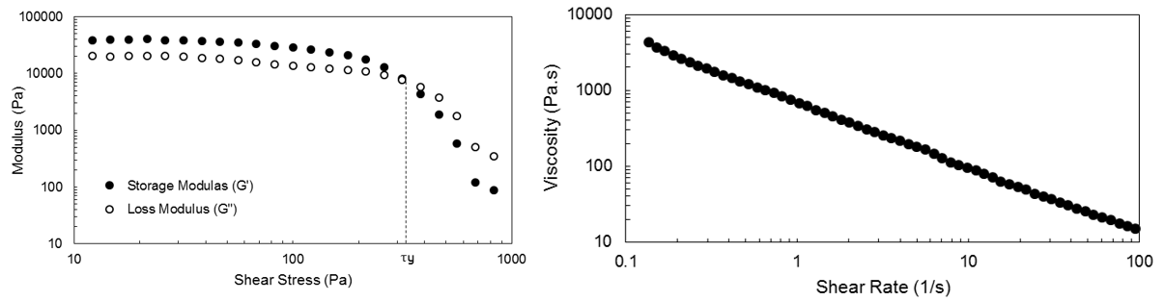
Figure 1. Rheological behaviour of the HfB₂ – hydrogel paste.

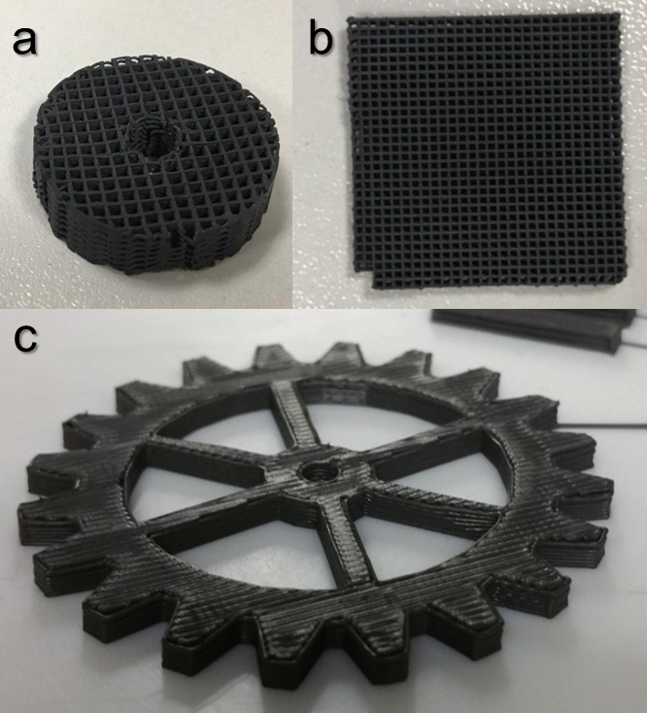

Figure 2. (a, b) Examples of a parts with internal structure and (c) example of a complex shaped, dense part.

Processing & Microstructure
After printing, the parts must be dried slowly to avoid drying defects, and the parts must detach from the substrate during the drying process to avoid warping. Following drying the printed parts can be sintered in a conventional way; typical ramp rates, burnout, sintering temperatures and times have been used. Unlike other additive manufacturing techniques, the relatively low fraction of organic binder in the green bodies (~2.5 wt%) means that burnout can be completed quickly (1 hour).

The B₄C phase was distributed evenly across the height of each of the samples, as shown in Figure 3. This indicates that HfB₂ and B₄C do not separate during printing and drying, for example via sedimentation of HfB₂. This is significant, as HfB₂ has significantly higher density than B₄C (10.5 g cm⁻³ versus 2.52 g cm⁻³). This mixture of powders is therefore very prone to sedimentation, so the hydrogel is a very successful at preventing this. This is due to the fact that the Pluronic hydrogel effectively freezes the powder in place when at rest, preventing sedimentation and segregation, even in this system with powders of very different densities. For this reason the hydrogel is well suited to producing pastes with UHTC powders, as it effectively provides a structured matrix which holds and carries the ceramic particles.

In order to investigate the most effective conditions to achieve the highest density two sintering temperatures were used: 2100 °C and 2200 °C. The microstructure of the parts sintered at 2100 °C is typical of conventionally produced HfB₂, with ~4 µm HfB₂ grains surrounding smaller B₄C rich grains, see Figure 4a. Conversely there is significant grain growth at 2200 °C. According to the known phase diagrams of this system no liquid is expected at 2200 °C, therefore any liquid formation which could promote grain growth would require some impurities such as oxides. The densities achieved by each set of samples is detailed in Table 1.

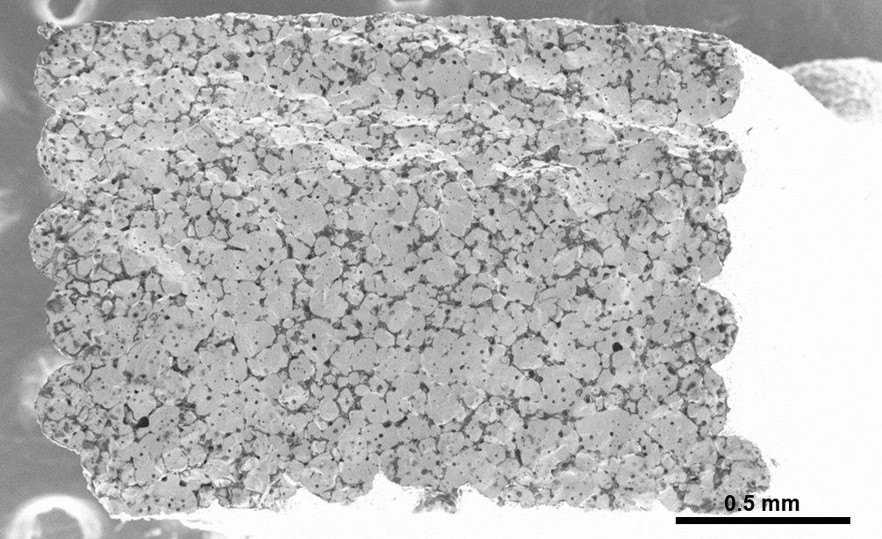
Figure 3. Section of a whole printed bar following sintering, showing an even distribution of B₄C and density.
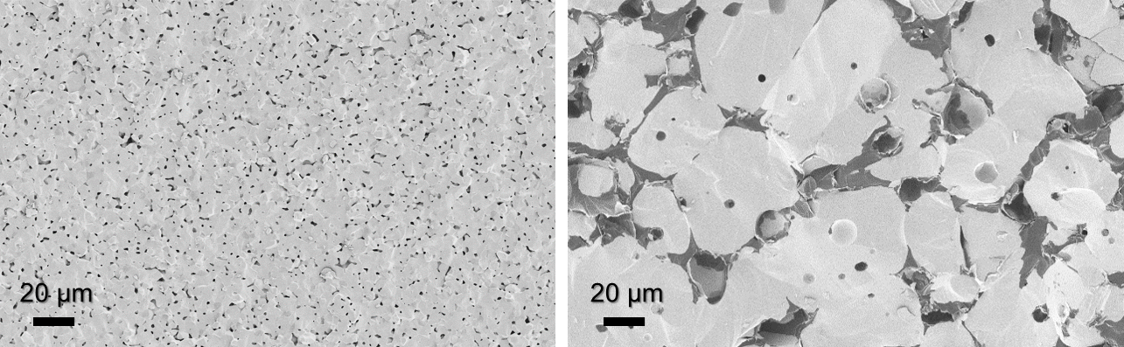
Figure 4. Fracture surfaces of printed HfB₂, sintered at 2100 °C (left) and 2200 °C (right).

Table 1. Densities and mechanical properties of the two groups of printed HfB₂ bars.
Material | Image Analysis Density (%) | Archimedes Density (%) | Max Theoretical (g/cm³) | Room Temp. Flexural Strength (MPa) | Grain Size (µm)
Fine Grained | 93.8 ± 1.2 | 97.4 ± 0.7 | 9.87 | 364 ± 31 | 3.7 ± 1.2
Coarse Grained | 95.1 ± 2.2 | 100.6 ± 0.4 | 9.87 | 287 ± 66 | 54 ± 17

Mechanical Properties
The 3-point bending strength of the two groups of samples is detailed in Figure 5. At room temperature the strength of both materials is marginally lower than equivalent materials reported in the literature. However at higher temperatures, where the mechanical properties of this material are most important, the strength is comparable to those reported in the literature. The strength of the finer grained material is ~20% higher than the coarser grained samples. As is true of many ceramics, the room temperature flexural strength of HfB₂ increases as the grain size decreases. Strength reported in the literature also varies depending on the sintering method, with pressureless sintering typically giving lower strengths than hot pressing.

As test temperature is increased the strength decreases by ~100 MPa over 1800 °C, Figure 5. This gradual drop is similar to the moderate reduction in elastic modulus over that temperature range and suggests it is related in part to a reduction in the surface energy. This effect has been reported elsewhere in the literature [28], [29]. As temperatures approaches 2000 °C the strength begins to drop more dramatically. This is also in agreement with the literature, and has been attributed to the onset of creep as a failure mechanism.[30] Figure 6 shows that for 500 ºC the failure mechanism is transgranular. As the testing temperature increases the failure mode progresses to mixed mode and finally fully intergranular at 1950 ºC.

To our knowledge this work comprises the highest temperature strength test of a 3D printed part ever conducted. The thermo-mechanical properties reported here show that additive manufacturing is a feasible method to produce HfB₂ parts with acceptable strength up to very high temperatures. This may serve a number of applications in the aerospace industry.

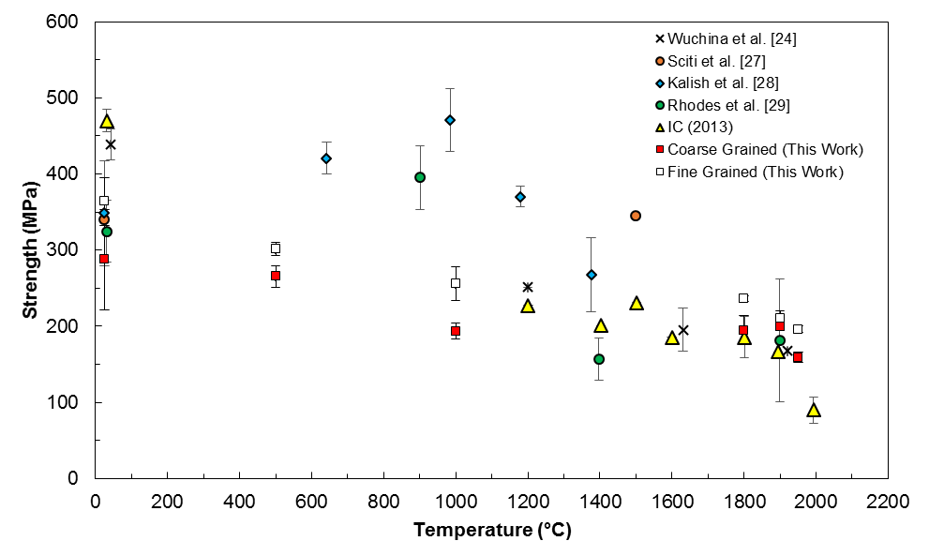
Figure 5. HfB2 bending strengths compared with the literature for a range of temperatures[28], [31]–[33].

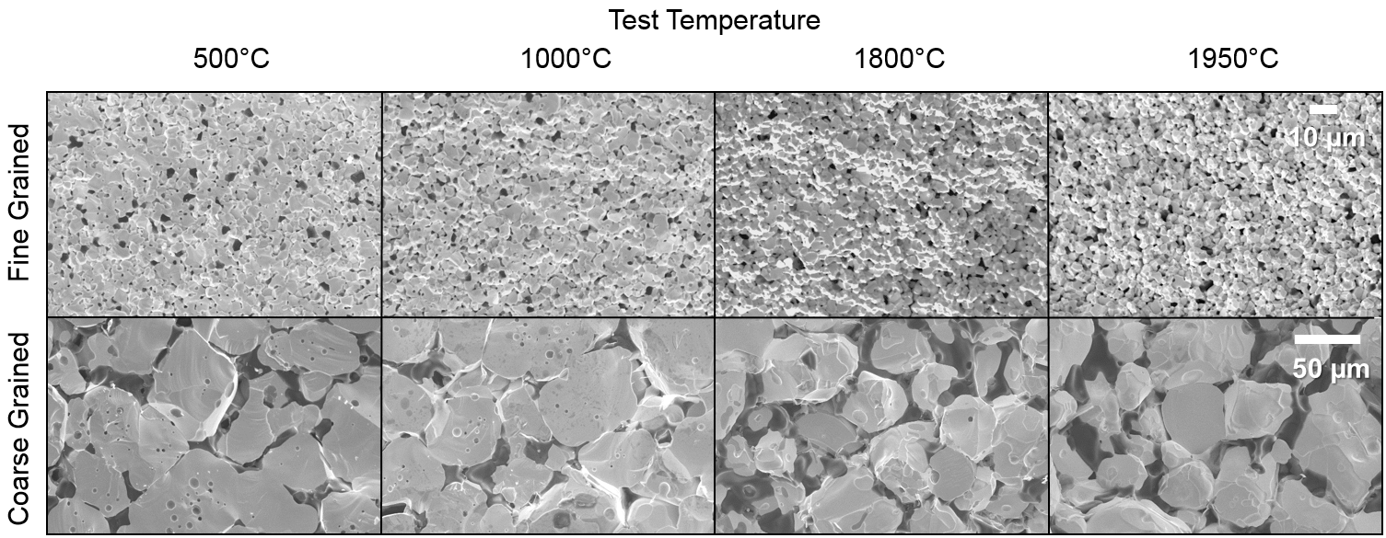
Figure 6. Fracture surfaces of the fine grained and coarse grained samples fractured during high-temperature bending from 500°C to 1950°C.

Conclusions
This research shows that HfB₂ with good mechanical strength and density can be produced via robocasting. We infer that this should be possible for many other UHTC materials too. Parts have been printed with complex geometries and internal structures with homogeneous microstructure. Due to the viscoelastic properties of the hydrogel used in the printing process, there is no evidence of segregation or sedimentation despite the wet processing conditions. The parts printed via this technique have a room temperature bending strength of ~350 MPa, and maintain a strength of ~200 MPa up to 1950°C. This is in line with the properties of HfB₂ produced by conventional means.

Acknowledgements
The support from EPSRC for this work, through the grants : Transpiration Cooling Systems for Jet Engine Turbines and Hypersonic Flight, EP/P000878/1, and the EPSRC Future Manufacturing Hub in Manufacture using Advanced Powder Processes, EP/P006566/1, is gratefully acknowledged. The authors would also like to thank the CASC industrial consortium for supporting this work.

References
[1] J. Deckers, J. Vleugels, and J. P. Kruth, “Additive manufacturing of ceramics: A review,” J. Ceram. Sci. Technol., vol. 5, no. 4, pp. 245–260, 2014.
[2] W. E. Frazier, “Metal additive manufacturing: A review,” J. Mater. Eng. Perform., vol. 23, no. 6, pp. 1917–1928, 2014.
[3] J.-P. Kruth, M. C. Leu, and T. Nakagawa, “Progress in Additive Manufacturing and Rapid Prototyping,” CIRP Ann., vol. 47, no. 2, pp. 525–540, Jan. 1998.
[4] J. Cesarano, “A Review of Robocasting Technology,” MRS Proc., vol. 542, p. 133, Jan. 1998.
[5] B. Cappi, E. Özkol, J. Ebert, and R. Telle, “Direct inkjet printing of Si3N4: Characterization of ink, green bodies and microstructure,” J. Eur. Ceram. Soc., vol. 28, no. 13, pp. 2625–2628, Sep. 2008.
[6] T. Schlordt, S. Schwanke, F. Keppner, T. Fey, N. Travitzky, and P. Greil, “Robocasting of alumina hollow filament lattice structures,” J. Eur. Ceram. Soc., vol. 33, no. 15–16, pp. 3243–3248, Dec. 2013.
[7] E. Feilden, E. G.-T. Blanca, F. Giuliani, E. Saiz, and L. Vandeperre, “Robocasting of structural ceramic parts with hydrogel inks,” J. Eur. Ceram. Soc., vol. 36, no. 10, 2016.
[8] J. A. Lewis, J. E. Smay, J. N. Stuecker, and J. Cesarano, “Direct Ink Writing of Three-Dimensional Ceramic Structures,” J. Am. Ceram. Soc., vol. 89, no. 12, pp. 3599–3609, Dec. 2006.
[9] S. Ghosh, S. T. Parker, X. Wang, D. L. Kaplan, and J. A. Lewis, “Direct-Write Assembly of Microperiodic Silk Fibroin Scaffolds for Tissue Engineering Applications,” Adv. Funct. Mater., vol. 18, no. 13, pp. 1883–1889, 2008.
[10] J. Franco, P. Hunger, M. E. Launey, A. P. Tomsia, and E. Saiz, “Direct write assembly of calcium phosphate scaffolds using a water-based hydrogel,” Acta Biomater., vol. 6, no. 1, pp. 218–28, Jan. 2010.
[11] D. Glymond and L. J. Vandeperre, “Robocasting of MgO-doped alumina using alginic acid slurries,” J. Am. Ceram. Soc., vol. 101, no. 8, pp. 3309–3316, 2018.
[12] J. N. Stuecker, J. Cesarano, and D. A. Hirschfeld, “Control of the viscous behavior of highly concentrated mullite suspensions for robocasting,” J. Mater. Process. Technol., vol. 142, no. 2, pp. 318–325, Nov. 2003.
[13] P. Miranda, A. Pajares, E. Saiz, A. P. Tomsia, and F. Guiberteau, “Mechanical properties of calcium phosphate scaffolds fabricated by robocasting,” J. Biomed. Mater. Res. - Part A, vol. 85, no. 1, pp. 218–227, 2008.
[14] K.-P. Cai et al., “Geometrically Complex Silicon Carbide Structures Fabricated by Robocasting,” J. Am. Ceram. Soc., vol. 95, no. 8, pp. 2660–2666, Aug. 2012.
[15] S. R. Levine, E. J. Opila, M. C. Halbig, J. D. Kiser, M. Singh, and J. A. Salem, “Evaluation of ultra-high temperature ceramics for aeropropulsion use,” J. Eur. Ceram. Soc., vol. 22, pp. 2757–2767, 2002.
[16] W. G. Fahrenholtz, G. E. Hilmas, I. G. Talmy, and J. A. Zaykoski, “Refractory Diborides of Zirconium and Hafnium,” J. Am. Ceram. Soc., vol. 90, no. 5, pp. 1347–1364, 2007.
[17] Z. Lü, D. Jiang, J. Zhang, and Q. Lin, “Aqueous Tape Casting of Zirconium Diboride,” J. Am. Ceram. Soc., vol. 92, no. 10, pp. 2212–2217, 2009.
[18] R. He, X. Zhang, P. Hu, C. Liu, and W. Han, “Aqueous gelcasting of ZrB2–SiC ultra high temperature ceramics,” Ceram. Int., vol. 38, no. 7, pp. 5411–5418, Sep. 2012.
[19] C. Tallon et al., “Colloidal Processing of Zirconium Diboride Ultra-High Temperature Ceramics,” J. Am. Ceram. Soc., vol. 96, no. 8, pp. 2374–2381, 2013.
[20] V. L. Wiesner, L. M. Rueschhoff, A. I. Diaz-Cano, R. W. Trice, and J. P. Youngblood, “Producing dense zirconium diboride components by room-temperature injection molding of aqueous ceramic suspensions,” Ceram. Int., vol. 42, no. 2, Part A, pp. 2750–2760, 2016.
[21] C.-N. Sun and M. C. Gupta, “Laser Sintering of ZrB2,” J. Am. Ceram. Soc., vol. 91, no. 5, pp. 1729–1731, 2008.
[22] C.-N. Sun, M. C. Gupta, and K. M. B. Taminger, “Electron Beam Sintering of Zirconium Diboride,” J. Am. Ceram. Soc., vol. 93, no. 9, pp. 2484–2486, 2010.
[23] T. Huang, G. E. Hilmas, W. G. Fahrenholtz, and M. C. Leu, “Dispersion of zirconium diboride in an aqueous, high-solids paste,” Int. J. Appl. Ceram. Technol., vol. 4, no. 5, pp. 470–479, 2007.
[24] S. Liu and L. Li, “Multiple phase transition and scaling law for poly(ethylene oxide)-poly(propylene oxide)-poly(ethylene oxide) triblock copolymer in aqueous solution,” ACS Appl. Mater. Interfaces, vol. 7, no. 4, pp. 2688–2697, 2015.
[25] M. Vadnere, G. Amidon, S. Lindenbaum, and J. Haslam, “Thermodynamic studies on the gel-sol transition of some pluronic polyols,” Int. J. Pharm., vol. 22, no. 2–3, pp. 207–218, 1984.
[26] Q. Fu, E. Saiz, and A. P. Tomsia, “Direct ink writing of highly porous and strong glass scaffolds for load-bearing bone defects repair and regeneration.,” Acta Biomater., vol. 7, no. 10, pp. 3547–54, Oct. 2011.
[27] E. Feilden et al., “3D Printing Bioinspired Ceramic Composites,” Sci. Rep., vol. 7, no. 1, 2017.
[28] D. KALISH, E. V CLOUGHERTY, and K. KREDER, “Strength, Fracture Mode, and Thermal Stress Resistance of HfB2 and ZrB2,” J. Am. Ceram. Soc., vol. 52, no. 1, pp. 30–36, 1969.
[29] T. Cheng and W. Li, “The Temperature-Dependent Ideal Tensile Strength of ZrB2, HfB2, and TiB2,” J. Am. Ceram. Soc., vol. 98, no. 1, pp. 190–196, 2015.
[30] J. Wang and L. J. Vandeperre, “Deformation and Hardness of UHTCs as a Function of Temperature,” Ultra‐High Temperature Ceramics. 10-Oct-2014.
[31] E. Wuchina et al., “Designing for ultrahigh-temperature applications: The mechanical and thermal properties of HfB2, HfCx, HfNxand αHf(N),” J. Mater. Sci., vol. 39, no. 19, pp. 5939–5949, 2004.
[32] D. Sciti, L. Silvestroni, and A. Bellosi, “Fabrication and properties of HfB2–MoSi2 composites produced by hot pressing and spark plasma sintering,” J. Mater. Res., vol. 21, no. 6, pp. 1460–1466, 2006.
[33] W. Rhodes, E. CLOUGHERTY, and D. KALISH, “Research and Development of Refractory Oxidation-Resistant Diborides. Part II, Volume IV: Mechanical Properties,” 1970.

