INVESTIGATING THE DENDRITIC GROWTH DURING FULL CELL CYCLING OF GARNET ELECTROLYTE IN DIRECT CONTACT WITH LI METAL

Frederic Aguesse^{1*}, William Manalastas¹, Lucienne Buannic¹, Juan Miguel Lopez del Amo¹, Gurpreet Singh¹, Anna Llordés^{1,2*}, John Kilner^{1,3}
- CIC Energigune, Parque Tecnológico de Álava, C/ Albert Einstein 48, 01510 Miñano, Spain
- IKERBASQUE, Basque Foundation for Science, Maria Diaz de Haro 3, 48013, Bilbao, Spain
- Department of Materials, Imperial College London, Exhibition road, SW7 2AZ, London, UK

*: faguesse@cicenergigune.com; allordes@cicenergigune.com

Keywords: Garnet electrolyte; Degradation mechanisms; Dendritic lithium formation; Full cell cycling; Li metal / garnet interface; Post mortem analysis; All-solid-state batteries

Abstract
All-solid-state batteries including a garnet ceramic as electrolyte are potential candidates to replace the currently used Li-ion technology as they offer safer operation and higher energy storage performances. However, the development of ceramic electrolyte batteries faces several challenges at the electrode / electrolyte interfaces, which need to withstand high current densities to enable competing C-rates. In this work, we investigate the limits of the anode / electrolyte interface in a full cell that includes a Li metal anode, LiFePO₄ cathode and a garnet ceramic electrolyte. The addition of a liquid interfacial layer between the cathode and the ceramic electrolyte is found to be a prerequisite to achieve low interfacial resistance and to enable full use of the active material contained in the porous electrode. Reproducible and constant discharge capacities are extracted from the cathode active material during the first 20 cycles revealing high efficiency of the garnet as electrolyte and the interfaces, but prolonged cycling leads to abrupt cell failure. By using a combination of structural and chemical characterization techniques, such as SEM and solid state NMR, as well as electrochemical and impedance spectroscopy, it is demonstrated that a sudden impedance drop occurs in the cell due to the formation of metallic Li and its propagation within the ceramic electrolyte. This degradation process is originated at the interface between Li metal anode and the ceramic electrolyte layer and leads to electromechanical failure and cell short-circuit. Improvement of the performances is observed when cycling the full cell at 55 °C as the Li metal softening favors the interfacial contact. Various degradation mechanisms are proposed to explain this behavior.

Introduction
The increasing demand for energy storage systems and the diversification of their use towards fully electrified vehicles (EV) has encouraged the scientific community to develop next generation of Li-ion batteries^{1, 2}. Conventional Li-ion technology is reaching its limits in terms of safety and durability, posing a challenge for application in large scale applications. All-solid-state batteries with Li metal anode are the most promising alternative being considered by the EV industry.
The replacement of graphite anodes by Li metal enables higher energy densities due to the high energy density of lithium (3860 mAh.g⁻¹), ten times larger than graphite (372 mAh.g⁻¹). However, the use of metallic lithium on a large scale raises many concerns in terms of safety, metal handling and waste management³ when in direct contact with conventional organic electrolytes. These electrolytes, composed of highly volatile, flammable and toxic organic solvents, favor the growth of lithium dendrites, which can have dramatic consequences in terms of short-circuit and battery ignition⁴.
A shift to all-solid-state batteries that incorporate a ceramic electrolyte acting as both, a physical barrier to dendritic growth and a fast Li-ion transport media, is a promising alternative to improve safety, energy density and durability. The requirements for such ceramics are high Li-ion conductivity at room temperature (≥ 10⁻³ S/cm), negligible electronic conductivity, (electro)chemical stability and good mechanical properties such as high stiffness and fracture toughness to keep the electrolyte integrity. Additionally thin electrolytes (<50-100 μm) are needed to achieve targeted energy densities. The so-called Li-stuffed garnets, based on Li₇La₃Zr₂O₁₂ and analogous compounds, have attracted much attention due to their excellent chemical and electrochemical stability. They also display some of the highest reported Li-ion conductivity for oxide materials⁵. In the cubic phase polymorph, the Li-ions are randomly distributed in percolative channels enabling high mobility with activation energies as low as 0.29 eV.^{6, 7, 8} A major limitation of these ceramic electrolytes is their poor interfacial contact with the electrode material leading to inhomogeneous interfaces and degradation over cycling.⁹ Low interfacial resistances (50 Ω.cm²) can be achieved by tuning the microstructure and particle size of the garnet material.¹⁰ Achieving an intimate interfacial contact at the solid-solid interfaces is a serious challenge that has only been successful in thin film batteries grown. Thin films batteries have demonstrated excellent interfacial stability, withstanding thousands of cycles more than bulk-type batteries. However, the low capacity of thin film batteries makes them only suitable for microelectronic applications. High energy density applications, such as EV, require bulk-type batteries, which are the focus of this work.
Various studies, in bulk-type Li batteries with ceramic solid electrolytes, reveal significant contradictions in terms of cycling performance. For instance, good capacity retention over 100 cycles has been reported for LiCoO₂/Li_{6.75}La₃Zr_{1.75}Nb_{0.25}O₁₂/Li metal solid state cells,¹¹ while major degradation at the ceramic electrolyte/Li metal interface were observed in symmetric cells with a high resistance behavior.¹² A good control of the battery assembly and elevated temperatures, close to the Li metal melting point, is necessary to create an intimate contact with the Li metal upon the electrolyte surface.^{13, 14} Despite this treatment, current densities above 600 μA.cm⁻² lead to systematic battery failure for measurements below 100 °C, impeding long cycle life. Recent work integrating garnet electrolytes in symmetric Li/garnet/Li cell configuration point out that the electrolyte failure originates from the formation of lithium dendrites.^{15, 16} The formation mechanisms of such dendrites remain unclear as well as the behavior of the ceramic electrolyte in a full cell.
In this study we analyze the cycling performances of polycrystalline garnet-type ceramic electrolyte in a full-cell configuration, with and without liquid catholyte layer, at various operating temperatures. Scanning electron microscopy and solid state NMR were used to investigate the microstructural and chemical changes of the garnet electrolyte after electrochemical cycling. This study suggests that a multilayer electrolyte design can facilitate Li-ion transfer between the Li metal and the cathode but confirms the formation of metallic Li inside the garnet electrolyte upon cycling.

Experimental part
Li_{6.55}Ga_{0.15}La₃Zr₂O₁₂ (noted Ga:LLZO hereafter) was prepared using a chelate-gel route with aqueous solution of citric/nitric acid. This composition provides the fastest ionic conductivity for a gallium substitution range around 0.15 and was therefore selected for this.⁷ A two-step calcination procedure was employed at 600 °C and 850 °C (12hr dwells). Ceramic green-bodies obtained from uniaxial pressing at 2.5 tons in a 10 mm diameter pellet die were embedded into the mother powder and placed on an alumina crucible for sintering.
The temperature was set to 1150ºC for 6 hours under dry 99.99% O₂ atmosphere. A furnace-coupled hygrometer (Shaw SADPS-TR) was used to control the H₂O level, which remained below 1 ppm during thermal treatment. Indeed, electrolytes presenting high Li-ion mobility are extremely sensitive to moisture/CO₂ reactions and a short exposure time of the sintered pellet to the atmosphere alters the sample surface.^{17, 18} The sintering time and temperature were optimized to obtain a dense pellet and maintain the cubic structure.
Sintered pellets were progressively abraded to remove any residual and undesirable side reactions present on its surface using 800, 1200, 2400 and 4000 grit SiC polishing papers to obtain a polished finish, in an Ar-filled glovebox (0.1 ppm O₂, <0.1ppm H₂O). Pellets were all thinned down to 1 mm for reproducibility. The density of the pellets was geometrically estimated and compared to the theoretical density of Ga:LLZO (5.15 g.cm⁻³). All the samples were freshly polished before assembling a cell.
The crystallographic structure of the samples and absence of any secondary phase were observed by powder X-ray diffraction (Bruker D8 Advance diffractometer equipped with Cu K_{α} X-ray radiation in the Bragg-Brentano geometry) using air-isolated sample holders, covered with Kapton® tape.
Symmetric cells using Au electrodes were prepared and electrochemical impedance spectroscopy measurements (EIS) carried out using a Solartron 1260 FRA module, AC frequencies ranging between 10 Hz to 10 MHz with 50 mV excitation amplitude. The ionic conductivity values were calculated after fitting of the Nyquist plot using the appropriate equivalent circuit as described in our previous work.⁷
To characterize electronic conductivity behavior, a Swagelok cell containing a polished garnet ceramic (10 mm diameter) was sputtered with Au on both sides, and subjected to voltage-float protocols with chronoamperometry. Bias was held at 0.5V, 1V, 2V, 3V, 4V and 5V for 15 minutes each, with repeat trials for 1hr constant voltage showing similar behavior using a potentiostat (Biologic VMP3 - Claix, France). An initial current spike arises as an ionic concentration gradient is established in response to the polarization bias, but decays progressively as ionic movement is impeded due to the Au electrodes, leaving a residual electronic current. A complicating factor is the probability of the formation of a Li-Au alloy at the electrode, however the Li-Au alloying fronts proceed sluggishly, even with thin films.¹⁹ The electronic component is then extracted from the decay response of the current at an applied voltage. Further explanation of the electronic measurements can be found in the Supporting Information 1: SI-1.
Microstructural characterization was obtained using a FEI Quanta-200F SEM-EDX station and 30kV acceleration voltage, using secondary electron imaging (SEI) or the backscattered electron detector (BSED). Composition analysis was performed by energy-dispersive X-ray spectroscopy (EDX) using an Oxford Instrument detector.
Full electrochemical cells were assembled in Swagelok units by stacking in the following order fresh lithium foil (Rockwood Lithium, battery grade), Ga:LLZO ceramic pellet and a commercial LiFePO₄ (LFP) laminate (loading: 1.5 mAh.cm⁻²). Improvements of the cell were then realized by added a glass-fiber with about 20 μL (2 drops) of 1M of LiPF₆ in EC:DMC (LP30) between the ceramic electrolyte and the LFP cathode.²⁰ The diameter of the cathode and metallic lithium electrodes were chosen smaller (8 mm) than the ceramic electrolyte (about 1 cm in diameter) to avoid any flooding of the liquid electrolyte around the ceramic and therefore bypassing of the ceramic electrolyte. The cells were allowed to rest for one night after fabrication and then cycling was performed using a potentiostat/galvanostat (Biologic VMP3- Claix,France). A control sample employing only a glass fiber with LP30 liquid electrolyte - without the ceramic – was also assembled and cycled as a reference. All measurements were performed at room temperature unless specified. Note that the 2 sides of the garnet pellets were carefully polished just before assembly to remove any insulating layer formed at high temperature or during sample transfer which would impede the Li transport.
For post-cycling analysis, ⁷Li solid-state nuclear magnetic resonance (ssNMR) operating in static mode was performed on selected fragments of the fractured ceramic electrolyte using a Bruker Advance III 200 MHz wide-bore magnet with a 4 mm probe. A solution of 0.1 M LiCl was used as a reference with a chemical shift of 0 ppm. The pellet surfaces were carefully clean by polishing >200 microns to eliminate any residual Li metal from the anode side. Pieces of the pellet were then placed in an NMR rotor and measured in static mode. In order not to interfere with the measurement, the NMR rotor was transferred rapidly from the inert atmosphere to the NMR spectrometer and always stored in dry atmosphere.

Results and discussion
As-prepared Li-stuffed garnet is found to crystallize in a pure cubic phase (as detailed in SI-2). The pure cubic garnet as opposed to the thermodynamically-stable tetragonal phase is obtained under specific synthesis conditions and controlled Ga-substitution (see experimental section).^{7, 21, 22, 23} Some unintentional aluminium contamination occurred during thermal treatment in an Al₂O₃ crucible up to 1.5 at.% as observed by EDS analysis shown in the SI-3; this contamination presents two effects as it acts both as a sintering aid and helps to stabilize the cubic phase along with Ga.²⁴
The conductivity of the sintered Ga:LLZO pellets was evaluated by EIS (Fig. 1a). Fitting of the recorded Nyquist plot leads to a total ionic conductivity at room temperature on the order of 1 mS/cm, which is among the highest Li-ion ionic conductivity reported for oxide materials. The electronic conductivity, which is not often reported in the ceramic electrolyte community, was separated from the ionic contribution by measurements at constant DC voltage (Fig. 1b). The electronic conductivity of the sample is determined when reaching a steady state and assuming ohmic behavior, and is calculated to have a maximum value of 10⁻⁶ mS.cm⁻¹. A wide electronic bandgap and low electronic conductivity is expected by the presence of single oxidation state elements such as Zr⁴⁺ and La³⁺. However it is possible to have p-type conductivity from the presence of O⁻. The low electronic conductivity confers to the electrolyte a high transfer number close to +1.
Regarding the microstructure, the sintered Ga:LLZO ceramics present a bimodal grain size distribution with large grains up to few hundreds microns separated by clearly defined grain boundaries and smaller grains below 10 μm size (as it can be observed in the microstructure of the sample in the SI-2). Above 1080 °C, formation of a liquid LiO₂-AlO₂ phase can facilitate the sintering and the development of large grains,²⁵ easing the open pores to become closed²⁶ and a relative density above 90%. As a consequence, micrometer-size pores are observed on the surface and in the bulk of the pellet restricting the continuous path of the Li⁺ ions (SI-2). This porosity, however, does not show any detrimental effect in the total conductivity, which remains in the range of 1 mS.cm⁻¹.

Figure 1: Electrical characterization of the Ga:LLZO garnets. a) Nyquist plot of Ga:LLZO pellet obtained at 25 °C and its equivalent circuit. The red shaded semi-circle represents both the grain and grain boundary contribution to the impedance, resulting from the total ionic conductivity of the ceramic. b) Voltage-step chronoamperometry (inset) along with the calculated electronic resistance behavior. The electronic conductivity of the ceramic is extracted using Ohm´s law.

Full cell devices were assembled using the as-prepared electrolyte pellets, Li metal as the anode and LFP as the cathode. A first cell was prepared by placing the garnet in direct contact with both Li metal and LFP (Fig 2a). The design of the cell in this later configuration results in an aerial specific resistance (ASR) value as high as 2·10⁵ Ω·cm², owing to the poor interfacial contact between the solid materials (Fig 2b, grey trace), impeding any electrochemical cycling. The origin of the high impedance is most likely related to the solid/solid interface between the garnet and the LFP electrode. As a result, a glass fiber separator soaked with a small amount of commercial liquid electrolyte LP30 (σ_{Li+} = ~10 mS.cm⁻¹ ²⁷) was added in between the electrolyte and the cathode, to facilitate ionic transfer at the interface thanks to the good wetting properties of the liquid electrolyte (Fig 2a). This modified design enables to study the cycling behavior of the ceramic electrolyte, without being limited by the poor contact at the cathode side, as all the active material will be accessible for cycling. Prior to cycling the cells were relaxed till stabilization of the OCV at ~3.4V.
The impedance of the full cell containing the catholyte (Fig 2c) is about 2 orders of magnitude lower than that of the ceramic electrolyte alone (Fig 1a) suggesting that the major impedance contribution comes from the interface between the Li metal electrode and the ceramic electrolyte. The interfacial resistance is estimated at about 1300 Ω.cm² assuming that the interface between Li metal and the ceramic is the major contribution. This value (1300 Ω·cm²) is lower, but in the same order of magnitude, than those obtained in the literature for the same composition. Janek et al. reported an ASR close to 6000 Ohm·cm² for a Ga-doped LLZO/Li interface.²⁸ However this ASR value is still high when compared to Al-doped LLZO composition, in which values as low as 37 Ω·cm² can be obtained by proper tuning of the microstructure and grain boundaries,¹⁰ or 127 Ω·cm² when using a lithiophilic surface layer.²⁹

Figure 2: Full cell device preparation and impedance measurements. (a) Schematic of the two full cell designs used in this work comprising a Li-metal anode, a LFP cathode and the Ga:LLZO ceramic electrolyte (left schematic-Li/Ga:LLZO/LFP) and including a commercial LP30 catholyte (right schematic-Li/Ga:LLZO-LP30/LFP) and ). (b)Nyquist plot extracted from the EIS measurements comparing the two full cell systems and (c) comparing the impedance signal for the cell with catholyte (Li/Ga:LLZO-LP30/LFP) as prepared and after 10 cycles.

Similar specific capacity values are obtained for both the Li/Ga:LLZO-LP30/LFP cell and the Li/LP30/LFP reference cell, with 1.4 mAh.cm⁻² (Fig. 3a). Therefore, the LP30 catholyte addition enables complete utilization of the cathode active material at a current density of 0.14 mA.cm⁻². However, a polarization increase is measured at the end of discharge suggesting a loss of contact between Li metal and the ceramic electrolyte due to Li stripping which leads to an increasing interfacial resistance. This does not affect good cyclability, as demonstrated by the excellent capacity retention for the first 20 cycles (Fig. 3b); however further cycling leads to cell failure for Ga:LLZO cell only. Further details on the cell failure will be discussed later. No irreversible capacity loss is noted on discharge indicating that the full capacity of the cathode is utilized. Degradation of the LFP cathode material leading to capacity loss is therefore excluded. However, the charging steps present some erratic variations during cycling. For instance, instability of the coulombic efficiency can be observed at the 10th, 15th, 16th and 17th cycles at 25 °C (Fig 3b). This phenomenon can be better analyzed from galvanostatic curves shown in Fig 4a. The charge profile clearly exceeds the theoretical capacity of the cathode indicating that, in addition to Li⁺ being extracted from the LFP cathode, a sporadic electrochemical side reaction is also occurring. The charge irregularities are strongly reduced when cycling the Ga:LLZO/LP30 cell at an elevated temperature of 55°C (Fig 4a). These anomalies could be explained by the presence of side reactions occurring between the ceramic material and the liquid LP30 electrolyte or due to the formation of micro short-circuit between the two electrodes, both phenomena contributing to an increase of capacity. Given that the charge irregularities were minimized at 55 °C, compared to room temperature, it is likely that the side reactions do not play a major role, being the formation of dendrites and related micro short-circuiting the dominant source of the extra capacity.
To further investigate the cycling characteristics, the derivative of the galvanostatic charge / discharge curves were evaluated (Fig 3c), revealing a change in the electrochemical redox reactions. LFP was chosen as a cathode material because it presents a flat plateau at around 3.45 V, which makes it ideal for accurate measurement of the voltages of oxidation and reduction. In the δQ/δV plot, a single and sharp peak is observed for the reference cell (in black), from which the polarization induced by the ceramic electrolyte can be easily determined. The difference between the oxidation and reduction peaks for the reference cell is equal to 0.05 V whereas, for the Ga:LLZO/LP30 cell, it doubles to 0.11 V. Therefore, the presence of the solid electrolyte increases the polarization of the cell owing to the higher resistance at the interface with Li metal as observed by the EIS measurements (Fig 2c) and in ref 13. Moreover, a peak asymmetry when using Ga:LLZO as electrolyte can be observed in the δQ/δV curves for the samples measured at 25 °C. The peak asymmetry, related to the increase of polarization at discharge observed in Fig 3a), relates to increasing interfacial resistance, most likely related to a gradual loss of contact between the Li metal electrode and garnet electrolyte. At 55 °C, the polarization and overcharging are dramatically reduced (Fig. 4a) in agreement with a better interfacial contact between the Li metal and the ceramic electrolyte. Li metal becomes more ductile when increasing the temperature which results in a larger contact area of the metal with the ceramic, leading to better cycleability at higher temperature (as presented in SI-4).

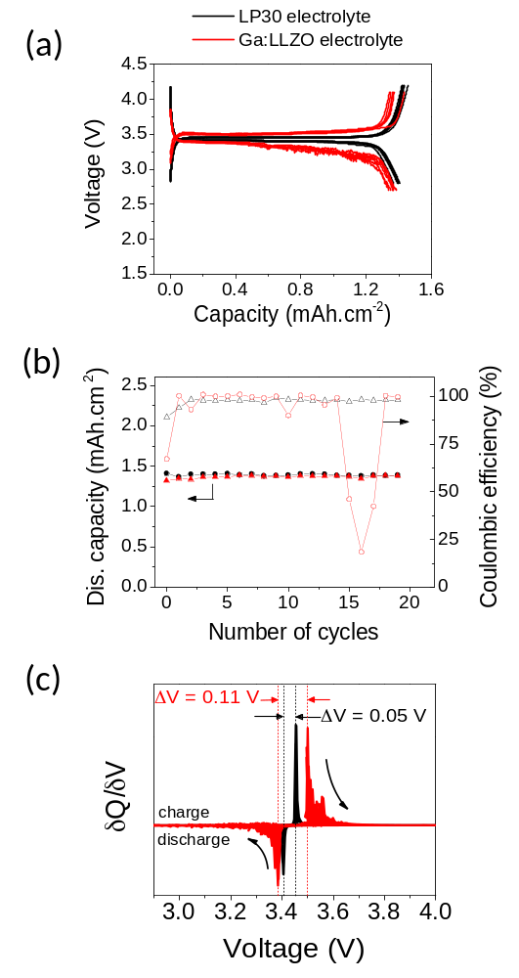
Figure 3: Electrochemical performance of the full cells. a) Galvanostatic curves of the first cycles comparing the cell performance with conventional organic and Ga:LLZO/LP30 electrolytes. b) Capacity retention and Coulombic efficiency recorded for Li/LP30/LFP and Li/Ga:LLZO-LP30/LFP cells. c) First derivative plot of a), the surface area of each peak is color-filled.

In addition to the increasing polarization, sudden voltage drops are observed during the charge plateau, both at 25 and 55°C (shown by arrows and stars in Fig 4b) which suggests an abrupt change in resistance between the anode and the cathode. It could originate from a Li⁰ redistribution at the Li metal/garnet interface, reducing the interfacial resistance, or a shorter distance between the two electrodes, reducing the Ohmic resistance between the two electrodes. Formation of Li dendrites across the ceramic electrolyte would reduce the distance between the cathode and anode and even short circuit the garnet. In that situation, the cell would still be able to cycle because of the presence of the glass fiber separator and the liquid electrolyte acting as electronic insulator. In addition, the voltage drops occur earlier in the charge step for the samples cycled at 25 °C compared to the ones cycled at 55 °C. This observation supports the formation of metallic Li, as dendrites preferentially form at low temperatures.³⁰ It is noteworthy to point out that this behavior is not observed at each cycle (as can be observed for the 11th cycle at 55 °C) but happens randomly 9 times in the first 20 cycles (4 times in the first 10 cycles and 5 times from the 11th to 20th).
Another approach to observe the ceramic stability upon cycling is to analyze the behavior of symmetric Li/Ga:LLZO/Li cells. Cyclic voltammetry measurements were performed at a voltage sweep from -0.5 to 3 V (Fig 4c). During the first cycles, a flat profile is observed confirming the low electronic conductivity of the garnet within the selected electrochemical window. However, after a few cycles, sharp and intense redox peaks appear at inconsistent voltages as can be seen for the 29th cycle in Fig 4c. These peaks can be related to sudden spikes of current crossing the ceramic material. As no redox species are present in the material and the peaks appear at unpredictable voltages, reduction of a transition metal of the garnet has been discarded. We propose that these sharp peaks originate from the formation of Liº metal inside the garnet. Similar tests, performed up to 5V, confirm this behavior. Analogously, in the slow degradation process determined for beta alumina solid electrolyte (BASE), Naº precipitates appear at high voltage (<3V) during the charging step.³¹ This deposition of Naº precipitates formation in BASE is possible due to the inhomogeneous distribution of the minority electronic carriers (electronic conductivity ≠ 0) promoting electron transfer through the material which causes the deposition of neutral species in high energy areas such as grain boundary, cracks or pores.³¹
Figure 4: Electrochemical degradation of the full cell device. a) Galvanostatic curves of cycles 10 to 20 of Li/Ga:LLZO-LP30/LFP full cells at 25 °C and 55 °C, the capacity is normalized compare to the theoretical 1.5 mAh.cm⁻². b) Zoom at the charge and discharge plateaus of Galvanostatic measurements of 9th, 10th and 11th cycles realized. Stars and arrows point to the voltage drop recorded during charge at 25 and 55 °C, respectively. c) CV measurements of the symmetric Li/Ga:LLZO/Li cell at the 1st and 29th cycle for the sample cycled at 25ºC and measured using a sweep voltage of 1 mV.s⁻¹.

After 20 cycles, the cells were dismantled and post-test analysis was performed to identify the degradation mechanisms. Fig 5a is a representative photograph of the post-cycled Ga:LLZO ceramic electrolyte. The surface of the garnet that was in contact with the catholyte exhibits black areas (inset of Fig 5a) which cannot be easily removed suggesting bulk penetration. The presence of this discoloration suggests a degradation of the liquid electrolyte. In addition to this unexpected color, small crack-like features can be noticed, propagating through the pellet and its surface (Fig 5b). Similar lines have recently been reported for another garnet material tested in a symmetrical cell.¹³ Even though the electrochemical mechanisms remain uncertain, the deposition of Li metal between the two electrodes was considered by the authors to explain such singularities in the regime of high current density.¹³ In our case, when separating the Li metal from the ceramic electrolyte, the latter fractured along the lines, resulting in the cross-section shown in Fig 5a. The cross section revealed grey areas, Li metal like, running across the pellet. It can be supposed that during cycling Li metal was formed and/or propagates inside the pellet. This result, reproduced in other duplicated cells, confirms that the mechanical failure is a consequence of electrochemical cycling rather than manipulation during cell assembly and opening. In these experiments, liquid infiltration through the ceramic is excluded as closed porosity is achieved via liquid phase sintering.²⁶
⁷Li solid state NMR was performed on the ceramic electrolyte after cycling in order to elucidate the degradation processes. To ensure no Li metal contamination from the Li anode, the sample surfaces were carefully polished before measurement, as discussed in the experimental section. The NMR spectrum obtained in static mode is shown in Figure 5c). The narrow signal observed at around 0 ppm corresponds to Li-ions of the Ga:LLZO garnet. The narrow character of this ⁷Li NMR signal and the absence of satellite transitions are both in agreement with the high Li⁺ mobility of the ions in this garnet.^{7, 32} In addition to the Li-ion signal, two minor peaks are present at high chemical shifts whereas before cycling no peaks were observed in this region of the spectrum. The main signal in this spectral region is centered at 265 ppm with a minor component at around 248 ppm (Figure 5d). These chemical shifts are in agreement with the metallic character of the lithium populations (Knight-shifts). Differences in peak positions are commonly observed in samples containing metallic lithium, and arise from the bulk magnetic susceptibility effect that depends on the morphology (1D – needle, 2D- plates, 3D- spherical) of the metallic material with respect to the magnetic field^{33, 34} and the surface to volume ratio. As dendrites and clusters are normally presenting a high surface to volume ratio, their signals are expected to be observed in the 260–273 ppm range.^{33, 34, 35, 36, 37}
We therefore assign the main signal centered at 265 ppm (that accounts to 90% of the metallic lithium signals observed in the spectrum) to dendritic or clustered aggregations of lithium. The smaller signal at 248 ppm is assigned on the other hand to larger particles of metallic lithium asymmetrically shaped respect to the applied magnetic field. The intensity ratio observed between both signals strongly suggests that the majority of the lithium metal is structured in smaller aggregates. It should be noticed nevertheless that the lithium signals arising from larger particles of metallic lithium could be underestimated due to the finite ability of the radiofrequency field, used to excite the Li nuclei, to penetrate metallic particles beyond some tens of micrometers.³³ Integration of the peak areas of Li⁺ vs Li⁰ reveals that a very low amount of lithium is in the metallic form, roughly 5 ‰ of the total amount of lithium, confirming previous observations.¹⁵ This value has to be contrasted with the high Li-ion population density within the garnet (close to 169 Li-ion per nm³).
Backscattered electron imaging of the cross-section clearly highlights the presence of compositional differences (Fig 5e and 5f). Dark precipitates, indicating the presence of light elements, are observed evenly distributed across the cross section. It is expected that these areas contain high Li concentration and most probably lithium in metallic form. EDX analyses, presented in SI-3, confirm high concentration of carbon and oxygen in the black regions. The reaction of Li metal with CO₂ present in the atmosphere (during sample transfer) would lead to the formation of carbonates (presumably Li₂CO₃), given that the lithium element cannot be detected by EDX. Bright regions present a high concentration in Zr and La with a Zr/La ratio close to the expected 2/3. It is interesting to point out that in the cross section view, the black precipitates are isolated and appear homogenously dispersed; there is no preferential Li formation towards the cathode or anode side. However SEM imaging does not allow the estimation of the interconnectivity of the lithium precipitates. Those precipitates were formed during cycling as there were not present in the uncycled material (SI-3), suggesting that they are part of the degradation processes observed in Fig 4 a) and b).

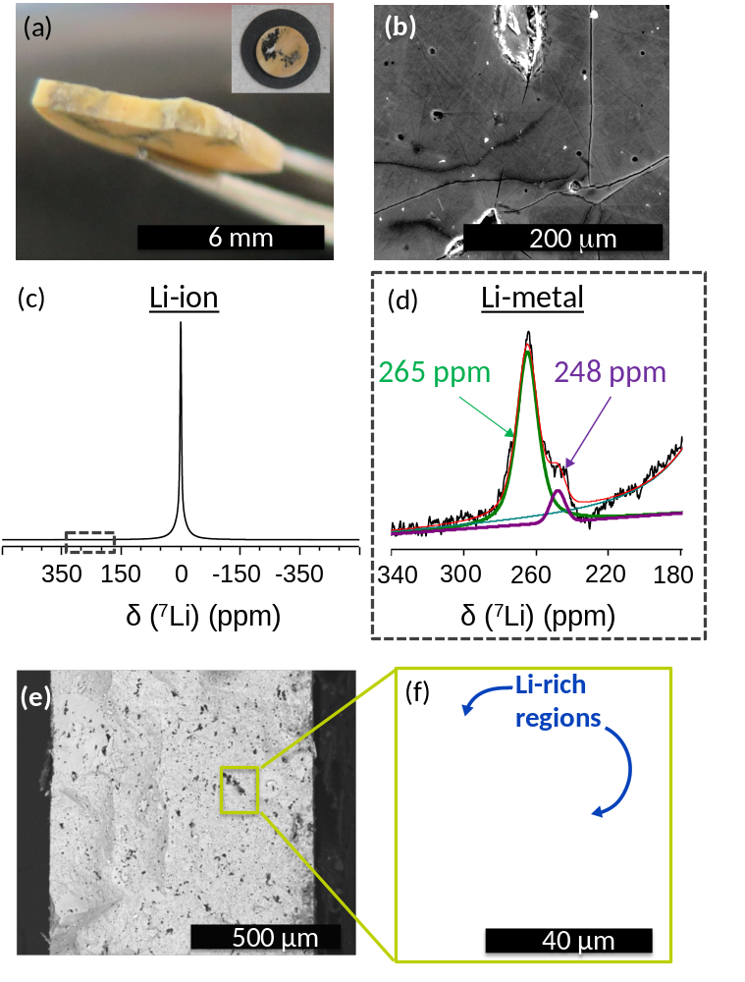
Figure 5: Post-cycling structural and chemical characterization. a) Photograph of the Ga:LLZO ceramic electrolyte cross section obtained when dismantling the cell after 20 cycles at RT. The inset shows the surface of the pellet. b) Top-view SEM image of pellet in a). c) ⁷Li Solid state NMR spectra in static mode of Ga:LLZO after cycling in the full NMR range measured and d) focused in the Li metal region between 180 - 340 ppm. e) Cross section SEM image of a fractured pellet obtained by BSED. A non-cycled sample is shown in the inset. f) SEM image of the pore highlighted in d) obtained at higher magnification.

In Fig. 6, we discuss the possibilities of Li⁰ formation mechanisms within the ceramic electrolyte when applying a current. Several mechanisms of Li metal formation and/or dendrite propagation could compete with the expected lithium plating at the anode/electrolyte interface (Fig.6 (a)) and lead to cell degradation. Surface flaws, roughness and/or wetting incompatibility between the ceramic electrolyte and the Li metal would create high localized current concentrations and dendrite propagation throughout the ceramic (Fig. 6 (b)). This mechanism will short circuit the ceramic and self-discharge the cell. Similar behavior was reported early 1980s for Na-ion electrolyte, BASE, resulting in fast propagation of cracks and rapid failure of the ceramic.^{31, 38, 39, 40} The formation of isolated Li metal agglomerates in the ceramic can also be explained by a slow degradation process occurring when a Li-ion is reduced to Li metal by gaining an electron from the oxygen backbone of the ceramic (Fig.6 (c)) or from the non-zero electronic conductivity, creating electron transfer from the electrode to the Li-ion (Fig.6 (d)). Metallic precipitates in BASE were reported at grain boundaries or at micro-fractured regions,^{31, 38} the origin of these precipitates is not well understood but, despite the low electronic conductivity, scarce electrons can transfer from one electrode and therefore reduce Na⁺.
Our study confirms the formation of lithium metal inside the garnet electrolyte during cycling. Part of the Li metal was identified by backscattered SEM imaging in the cavities of the ceramic. However dendritic lithium, also detected by solid state NMR, was not observed by SEM. Dendrites often present filament-like structures which would require higher resolution microscopy to be observed. Confirmation of dendrite formation would enable to demonstrate the interconnectivity between the lithium precipitates. One can expect that dendrites will form and propagate at the grain boundaries.
We suggest that a short circuit is formed across the garnet by the formation of dendrites penetrating from the anode side towards the catholyte. This results in lowering the cell resistance and is visualized during the sudden drops in the charging plateau (Fig 4 a and b). In larger volumes such as pores and cavities, the lithium metal accumulates to form precipitates. However the random current spikes observed in the CV of the symmetric cell (Fig. 4c) do not support the idea of continuous dendrites between the two electrodes but rather a sudden “dendrite arc”, which is present for a few seconds and then disappears. This dendrite arc would lead to crack propagation and then electromechanical failure of the ceramic.¹⁴ Further details on the mechanisms of Li dendrite formation, propagation and dispersion in the garnet electrolyte will be reported soon. Better control of the interfacial contact between the metallic lithium anode and the ceramic material will be essential to achieve homogeneous current distribution, not only during cell assembly but also during each stripping/plating step on the Li metal anode side.³⁹ Furthermore a better understanding of dendrite formation mechanisms and their evolution in the time would be necessary to develop new ceramic microstructure to control and reduce their formation. This behavior reveals the limitation of ceramic electrolytes when exposed to high current density leading to failure of the cell and is a limiting factor for all solid state batteries.
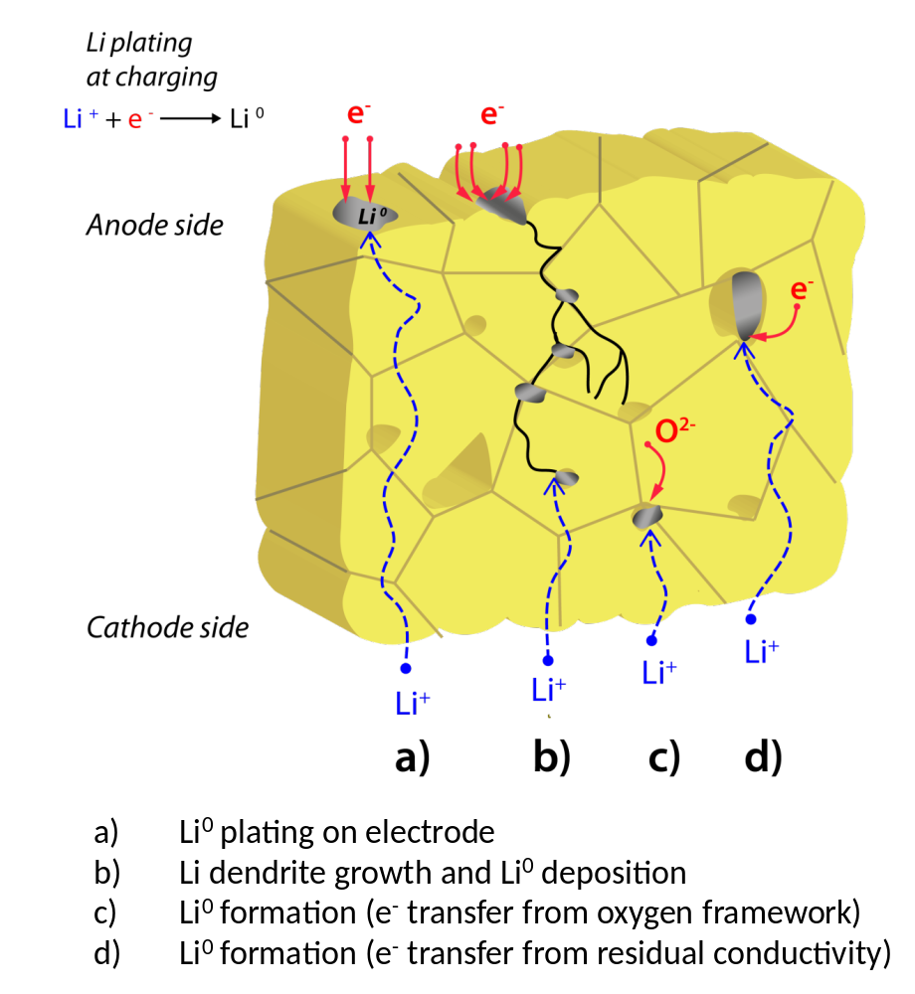
Figure 6: Schematic of a cross section in garnet ceramic electrolyte where the potential Li-ion reduction mechanisms are proposed. Li metal forms by platting a) or dendrite formation and propagation b) with an electron provided by the external circuit. Li-ions reduce by recombination with an electron from the oxygen network c) or from the residual electronic conductivity d). Li dendrites and clusters can fill the pores (shades on the drawing).

Conclusions
A Li-metal cell was assembled using a highly-conductive garnet electrolyte and a LFP cathode. A catholyte composed of a glass fiber with few drops of LP30 liquid electrolyte was added to facilitate interfacial contact between the cathode and the electrolyte. The Li-metal battery showed high capacity retention coupled with some degree of charge-transfer polarization and noticeable overcharge for the first 20 cycles. Sporadic voltage drops were also observed on cycling and more pronounced at 25°C compared to 55°C. Prolonged cycling repeatedly leads to cell failure. Cyclic voltammetry of a symmetric Li/Ga:LLZO/Li cell highlighted possible garnet degradation at the 29th cycle. Back scattered electron imaging highlighted the presence of a precipitate composed of light elements in the cavities of the cycled garnet. The deposition of Li metal in the cycled garnet was confirmed by solid state NMR. In particular, two types of Li° were observed by ⁷Li NMR and assigned to the presence of Li metal and dendritic Li, the latter not observable by SEM. Through the electrochemical analyses, three main degradation mechanisms have been observed:
- Degradation of the liquid catholyte as observed by unexpected long and noisy charging times. Further analyses reveal dark color in the glass fiber containing electrolyte.
- Increase polarization at the end of discharge presumably caused by loss of contact between the ceramic and the lithium metal anode during lithium stripping.
- Electromechanical fracture promoted by dendrite formation penetrating through the ceramic electrolyte during platting. This latter effect is due to non-uniform current distribution at the interface Li metal/ceramic followed by a dendrite propagation.
The third mechanism is believed to be the origin of the battery failure after 20 cycles. Post-mortem analyses revealed the presence of Li° across the ceramic by SEM and ⁷Li solid-state NMR analyses. Additionally presence of clusters containing Li-metal are observed in the cross section of the ceramic, however we have not been success full in determining if these clusters were interconnected via pores.

Supporting Information
The Supporting Information is available free of charge on the ACS Publications website.
It consists of: detailed explanation of the electronic conductivity measurement and calculation; structural (XRD) and microstructural (SEM) characterization of the Ga:LLZO as-prepared pellets; further post mortem analysis of the pellets after cycling (SEM and EDX measurements); additional cycling performances of the full cell at 55 °C.

Acknowledgements
This research was carried out at CIC Energigune (Spain) and was funded by Gobierno Vasco, within the project framework ETORTEK CIC ENERGIGUNE 2013. A.L. also thanks IKERBASQUE for financial support. W.M. thanks Damien Saurel, Jon Ajuria and Montse Casas for helpful discussions.

References
(1) Armand, M.; Tarascon, J-M. Building Better Batteries, Nature, 2008, 451, 652–657
(2) Goodenough, J.B.; Kim, Y. Challenges for Rechargeable Li Batteries, Chem. Mater., 2010, 22, 3, 587–603.
(3) Yoshino, A. The Birth of the Lithium-ion Battery, Angew. Chem. Int. Ed., 2012, 51, 5798–5800
(4) Lisbona, D.; Snee, T. A Review of Hazards Associated with Primary Lithium and Lithium-ion Batteries, Process Saf. Environ. Prot., 2011, 89, 6, 434 – 442
(5) Kamaya, N.; Homma, K.; Yamakawa, Y.; Hirayama, M.; Kanno, R.; Yonemura, M.; Kamiyama,T.; Kato, Y.; Hama, S.; Kawamoto, K.; Mitsui, A. A Lithium Superionic Conductor, Nat. Mater., 2011, 10, 682–686.
(6) Thangadurai, V.; Narayanan, S.; Pinzaru, D. Garnet-type Solid-state Fast Li ion Conductors for Li Batteries: Critical Review, Chem. Soc. Rev., 2014, 43, 4714–4727
(7) Bernuy-Lopez, C.; Manalastas, W.; Lopez del Amo, J.; Aguadero, A.; Aguesse, F.; Kilner, J. Atmosphere Controlled Processing of Ga-substituted Garnets for High Li-ion Conductivity Ceramics, Chem. Mater., 2014, 26, 12, 3610–3617.
(8) Miara, L. J.; Ong, S.P.; Mo, Y.; Richards, W. D.; Park, Y.; Lee, J-M.; Lee, H-S.; Ceder, G. Effect of Rb and Ta doping on the Ionic conductivity and Stability of the Garnet Superionic conductor: A first principles investigation, Chem. Mater., 2013, 25, 15, 3048–3055.
(9) Sudo, R.; Nakata, Y.; Ishiguro, K.; Matsui, M.; Hirano, A.; Takeda, Y.; Yamamoto, O.; Imanishi, N. Interface behavior between Garnet-type Lithium-conducting Solid Electrolyte and Lithium Metal, Solid State Ionics, 2014, 262, 151 – 154
(10) Cheng, L.; Chen, W.; Kunz, M.; Persson, K.; Tamura, N.; Chen, G.; Doeff, M. Effect of Surface Microstructure on Electrochemical Performance of Garnet Solid Electrolytes, ACS Appl. Mater. Interfaces, 2015, 7, 2073–2081
(11) Ohta, S.; Kobayashi, T.; Seki, J.; Asaoka, T. Electrochemical Performance of an All-solid-state Lithium ion Battery with Garnet-type Oxide Electrolyte, J. Power Sources, 2012, 202, 332 – 335
(12) Ishiguro, K.; Nakata, Y.; Matsui, M.; Uechi, I.; Takeda, Y.; Yamamoto, O.; Imanishi, N. Stability of Nb-doped Cubic Li₇La₃Zr₂O₁₂ with Lithium Metal, J. Electrochem. Soc., 2013, 160, 10, A1690–A1693
(13) Sharafi, A.; Meyer, H. M.; Nanda, J.; Wolfenstine, J.; Sakamoto, J. Characterizing the Li-Li₇La₃Zr₂O₁₂ Interface Stability and Kinetics as a Function of Temperature and Current density, J. Power Sources, 2016, 302, 135–139
(14) Schmidt, R. D.; Sakamoto, J. In-situ, Non-destructive Acoustic Characterization of Solid State Electrolyte cells, J. Power Sources, 2016, 324, 126 – 133
(15) Tsai, C-L.; Roddatis, V.; Chandran, C. V.; Ma, Q.; Uhlenbruck, S.; Bram, M.; Heitjans, P.; Guillon, O. Li₇La₃Zr₂O₁₂ Interface Modification for Li Dendrite Prevention, ACS Appl. Mater. Interfaces, 2016, 8, 16, 10617–10626
(16) Ren, Y.; Shen, Y.; Lin, Y.; Nan, C-W. Direct Observation of Lithium Dendrites inside Garnet-type Lithium-ion Solid Electrolyte, Electrochem. Commun., 2015, 57, 27–30
(17) Boulant, A.; Maury, P.; Emery, J.; Buzare, J-Y.; Bohnke, O. Efficient Ion Exchange of H⁺ for Li⁺ in (Li_{0.30}La_{0.57})TiO₃ Perovskite in Water: Protons as a Probe for Li location, Chem. Mater., 2009, 21, 2209–2217
(18) Aguesse, F.; Lopez del Amo, J-M.; Roddatis, V.; Aguadero, A.; Kilner, J. Enhancement of the Grain Boundary Conductivity in Ceramic Li_{0.34}La_{0.55}TiO₃ electrolytes in a moisture-free processing environment, Adv. Mater. Interfaces, 2014, 1, 1300143
(19) Bach, P.; Stratmann, M.; Valencia-Jaime, I.; Romero, A.; Renner, F. Lithiation and Delithiation Mechanisms of Gold Thin Film Model Anodes for Lithium Ion Batteries: Electrochemical Characterization, Electrochim. Acta, 2015, 164, 81 – 89
(20) Asl, N. M.; Keith, J.; Lim, C.; Zhu, L.; Kim, Y. Inorganic Solid/Organic Liquid Hybrid Electrolyte for use in Li-ion Battery, Electrochim. Acta, 2012, 79, 8 – 16
(21) Jalem, R.; Rushton, M. J. D.; Manalastas, W.; Nakayama, M.; Kasuga, T.; Kilner, J.; Grimes, R. W. Effects of Gallium Doping in Garnet-type Li₇La₃Zr₂O₁₂ Solid Electrolytes, Chem. Mater., 2015, 27, 2821–2831
(22) Allen, J. L.; Wolfenstine, J.; Rangasamy, E.; Sakamoto, J. Effect of Substitution (Ta, Al, Ga) on the Conductivity of Li₇La₃Zr₂O₁₂, J. Power Sources, 2012, 206, 315–319
(23) Jalem, R.; Yamamoto, Y.; Shiiba, H.; Nakayama, M.; Munakata, H.; Kasuga, T.; Kanamura, K. Concerted Migration Mechanism in the Li ion dynamics of Garnet-type Li₇La₃Zr₂O₁₂, Chem. Mater., 2013, 25, 425–430
(24) Jin, Y.; McGinn, P. J. Li₇La₃Zr₂O₁₂ Electrolyte Stability in Air and Fabrication of a Li/Li₇La₃Zr₂O₁₂/Cu_{0.1}V₂O₅ solid-state Battery, J. Power Sources, 2013, 239, 326–331
(25) Xia, W.; Xu, B.; Duan, H.; Guo, Y.; Kang, H.; Li, H.; Liu, H. Ionic conductivity and air stability of Al-doped Li₇La₃Zr₂O₁₂ Sintered in Alumina and Pt Crucibles, ACS Appl. Mater. Interfaces, 2016, 8, 8, 5335–5342
(26) L. WE and R. M, Ceramic Microstructures: Property control by processing. Chapman and Hall: Great Britain, 1994.
(27) Stallworth, P. E.; Fontanella, J. J.; Wintersgill, M. C.; Scheidler, C. D.; Immel, J. J.; Greenbaum, S. G.; Gozdz, A. NMR, DSC and High Pressure Electrical Conductivity Studies of Liquid and Hybrid electrolytes, J. Power Sources, 1999, 81, 739–747
(28) El Shinawi, H.; Janek, J. Stabilization-of cubic Lithium-stuffed Garnets of the Type Li₇La₃Zr₂O₁₂ by addition of Gallium, J. Power Sources, 2013, 225, 13–19
(29) Luo, W.; Gong, Y.; Zhu, Y.; Fu, K. K.; Dai, J.; Lacey, S. D.; Wang, C.; Liu, B.; Han, X.; Mo, Y.; Wachsman, E. D.; Hu, L. Transition from Superlithiophobicity to Superlithiophilicity of Garnet Solid-state electrolyte, JACS, 2016, 138, 37, 12258–12262
(30) Akolkar, R. Modeling Dendrite Growth during Lithium Electrodeposition at Sub-ambient Temperature, J. Power Sources, 2014, 246, 84–89
(31) DeJonghe, L. C.; Feldman, L.; Beuchele, A. Slow Degradation and Electron Conduction in Sodium-Beta-aluminas, J. Mater. Science, 1981, 16, 3, 780–786
(32) Kuhn, A.; Narayanan, S.; Spencer, L.; Goward, G.; Thangadurai, V.; Wilkening, M. Li Self-diffusion in Garnet-type Li₇La₃Zr₂O₁₂ as Probed Directly by Diffusion-induced Li-7 Spin-lattice Relaxation NMR Spectroscopy, Phys. Rev. B, 2011, 83, 094302
(33) Bhattacharyya, R.; Key, B.; Chen, H.; Best, A. S.; Hollenkamp, A. F.; Grey, C. In Situ NMR Oobservation of the Formation of Metallic Lithium Microstructures in Lithium Batteries, Nat. Mater., 2010, 9, 504–510
(34) Shimoda, K.; Murakami, M.; Takamatsu, D.; Arai, H.; Uchimoto, Y.; Ogumi, Z. In Situ NMR Observation of the Lithium Extraction/Insertion from LiCoO₂ Cathode, Electrochim. Acta, 2013, 108, 343–349
(35) Chandrashekar, S.; Trease, N. M.; Chang, H. J.; Du, L. S.; Grey, C. P.; Jerschow, A. ⁷Li MRI of Li Batteries reveals Location of Microstructural Lithium, Nat. Mater., 2012, 11, 311–315
(36) Chevalier, F.; Poli, F.; Montigny, B.; Letellier, M. In situ Li-7 Nuclear Magnetic Resonance Observation of the Electrochemical Intercalation of Lithium in Graphite: Second Cycle Analysis, Carbon, 2013, 61, 140–153
(37) Arai, J.; Okada, Y.; Sugiyama, T.; Izuka, M.; Gotoh, K.; Takeda, K. In situ solid state Li-7 NMR Observations of Lithium Metal Deposition during Overcharge in Lithium ion Batteries, J. Electrochem. Soc., 2015, 162, 6, A952–A958
(38) DeJonghe, L-C.; Feldman, L.; Buechele, A. Failure Modes of Na-beta-alumina, Solid State Ionics, 1981, 5, 267–270
(39) Vrikar, A. V.; Viswanathan, L.; Biswas, D. R. Deterioration of Beta”-alumina Ceramics under Electrolytic Conditions, J. Mater. Science, 1980, 15, 2, 302–308
(40) Collongues, R.; Gourier, D.; Kahn, A.; Boilot, J-P.; Colomban, P.; Wicker, A. Beta-alumina, a Typical Solid Electrolyte - Latest Developments in Fundamental Approach and in Battery Utilization, J. Phys. Chem. Solids, 1984, 45, 10, 981–1013

