EHL and Wear Modelling of the Knee Joint Replacements with Surface Topography

Leiming Gao^{1)*}, Zikai Hua²⁾, Robert Hewson¹⁾, Michael Skipper Andersen³⁾ and Zhongmin Jin^{4,5)}

¹⁾ Department of Aeronautics, Imperial College London, London, UK
²⁾ School of Mechatronics Engineering and Automation, Shanghai University,
Shanghai, China
³⁾ Department of Materials and Production, Aalborg University, Denmark
⁴⁾ South West Jiaotong University, Chengdu, China
⁵⁾ School of Mechanical Engineering, University of Leeds, Leeds, UK

*Corresponding author: leiming.gao@gmail.com

Introduction
The aim of this study is to predict wear of lubricated knee joints with the existing of textured surface and the possibility of surface designs to reduce wear. The knee joint replacement is a surgical treatment for damaged knee joints to retrieve their functions. Wear and wear particle generation continue to be one of the major causes of the failure of these joint implants.

A wear model of hard-on-soft (namely ceramic or metal-on-polyethylene) artificial knee joints was developed, addressing the medial and lateral knee compartments separately, with experimentally measured contact force and motion in walking cycles applied. An adapted Archard wear formula was employed where the wear factor is an exponential function of the film thickness nominalised by the RMS roughness [1-3]. The lubrication parameters was obtained from a mixed elastohydrodynamic lubrication (EHL) model with ball and socket geometry. Wear of the soft bearing surface (polyethylene tibia socket) was simulated for one million cycles without geometry update.

The surface texturing techniques have shown promising benefit to machine components in many areas of engineering practice particularly in friction reduction and lubrication enhancement [4; 5]. In this paper the effect of surface topography of the knee was also investigated. The texture parameters were designed using the Taguchi method for the geometry, size, and distribution of the micro dimples.

The results show that the lateral compartment may benefit from surface texturing only if dimples were properly designed, while it seems the medial contact area hardly got advantage over surface texturing in terms of lubrication enhancement and wear reduction.

Methodology

Materials and Geometry
A Metal-on-Polyethylene knee joint replacement was investigated. The contacts between the femoral condyles and tibia insert in the medial and lateral compartments of the knee were both represented by the same ball-and-socket geometry, The femoral condyles that were made of hard material (metal or ceramic) were assumed to rigid due to significantly large modulus thus only the soft counter bearing (tibia insert made of polyethylene) deformed. The mechanical properties of the materials and geometrical parameters are listed in Table 1 [6].

- Material and Geometrical Parameters
Radius of femoral condyles | 50 mm
Radial clearance | 0.5 mm
Tibia socket thickness | 7 mm
Elastic modulus of polyethylene | 1 GPa
Poisson’s ratio of polyethylene | 0.4
RMS roughness (R_{a}) of tibia polyethylene surface | 0.5 µm

The femoral condyles were moving against the stationary tibia insert. The loading and motion of normal walking cycles composed of one load and one motion (flexion-extension) was considered in separate medial and lateral compartment [7; 8], as shown in Figure 1.

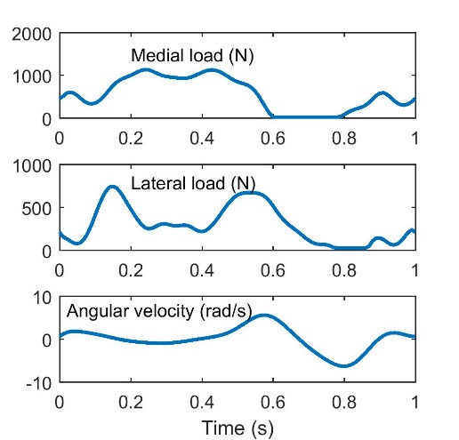
- Medial and lateral load and the angular velocity of knee joint in walking cycles

Mixed Lubrication Modelling

A ball-in-socket EHL model was used to obtain the fluid pressure and film thickness field with consideration of the non-Newtonian shear-thinning properties of the human joint synovial fluid. The flow was governed by the Reynolds equation formulated in spherical coordinates (θ, φ) [9].
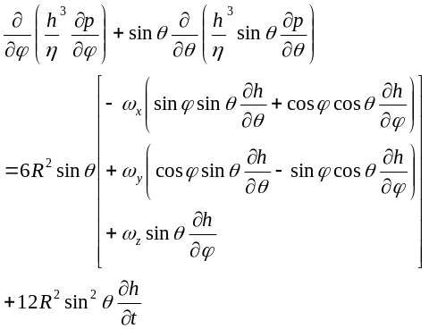 | (1)
where p is the fluid pressure, and h is the fluid film thickness. When the calculated film thickness was less than a certain small value, here chosen as 20 nm physically represent the boundary film thickness, the Poiseuille flow, i.e. the left terms in Eq.(1), was switched off and the film thickness was set to 20 nm. The elastic deformation of the soft (polyethylene) bearing surface was described by the column model which is proportional to the local pressure through a coefficient [6]. The film thickness equation is described as
(2)

The shear-thinning viscosity characteristic of synovial fluid was described by the Cross formula [10].$η=η_{∞}+\frac{η_{0}-η_{∞}}{1+α{(\dot{γ})}^{β}}$
$$η=η_{∞}+\frac{η_{0}-η_{∞}}{1+α{(\dot{γ})}^{β}}$$ | (3)
Viscosity of synovial fluid at zero and infinite shear rate was 40 Pa·s and 0.005 Pa·s respectively. The values for parameters α and β were set to 9.54 and 0.73 respectively. The pressure variation across the lubricating film thickness was neglected due to the very thin films considered. An average shear rate $(\dot{γ)}$ was adopted and calculated as the ratio of relative surface velocity to film thickness.
$$\dot{γ}=\frac{v}{h}$$ | (4)

The external loading components w_{x, y, z} are balanced by the hydrodynamic pressure integrated with respect to the corresponding axes.
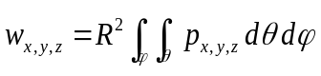 | (5)
The Multi-Grid method was used to solve the equation system and details of numerical procedures is referred to [9].

Wear Modelling
An advanced wear model recently developed by the authors was employed, which considered the lubricated contact rather than a dry contact condition in most of other studies in literature [11; 12], and was able to describe the wear evolution process due to the change of worn profiles. Based on an adapted Archard wear formula [1-3] the wear factor is proposed as a function of the ‘λ ratio’, the ratio of film thickness to the RMS surface roughness (R_{a}).

The level of wear of THRs which operate in a mixed lubricated regime was clearly dependent on the film thickness and the bearing surface roughness. The linear wear rate, i.e. wear depth per unit time, of the implant bearing surfaces was described as:
$$wear rate=\left\{\begin{aligned}k_{w}pv{\left(\frac{1}{λ}\right)}^{a}, if λ<3 \\ 0 , if λ≥3\end{aligned}\right.$$ | (6)
$$λ=h/{R_{a}}$$ | (7)
where k_{w} is fixed wear coefficient due to material and the value of 1×10⁻⁸ (mm³/Nm) was chosen according to experimental tests. The power term (a) determines how abruptly the transition to wear occurs with a decreasing film thickness and its value of 2.24 was used here. The local relative sliding speed of the two surfaces is calculated as
$$v=\sqrt{v_{θ}^{2}+v_{φ}^{2}}$$ | (8)
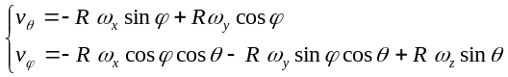 | (9)
As only one-dimensional rotation was addressed the wear due to cross-shear motion was not considered in this study.
$wear rate=\left\{\begin{aligned}k_{w}pv{\left(\frac{1}{λ}\right)}^{a}, if λ<3 \\ 0 , if λ≥3\end{aligned}\right.$

Surface Texturing
The geometry of dimples were described by the Gaussian function.
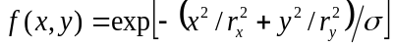 | (10)

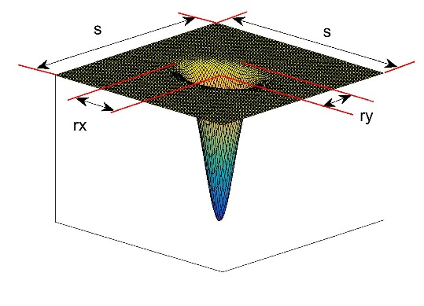
- Schematic of dimple geometry

The dimples were distributed only on the tibia component surface and the counter femoral bearing surface was assumed smooth. The experiments of the dimple parameters was designed using the Taguchi orthogonal arrays of totally 9 runs with 4 parameters in 3 levels, i.e. r_{x}, r_{y}, σ in Eq. (10) and s (the side length of each cell square), as shown in Figure 2. The parameters in each run are shown in Table 2. In Run No. 0 dimples were distributed over all bearing surface, while No. 1-9 only on the half entrainment zone.

- Design of Experiments on Dimple Parameters
Run No. | R_{x} (mm) | R_{y} /R_{x} | s/max(R_{x}, R_{y} ) | σ
0* | 0.3 | 0.5 | 2.5 | 0.1
1 | 0.3 | 0.5 | 2.5 | 0.1
2 | 0.3 | 1 | 3 | 0.2
3 | 0.3 | 2 | 4 | 0.4
4 | 0.5 | 0.5 | 3 | 0.4
5 | 0.5 | 1 | 4 | 0.1
6 | 0.5 | 2 | 2.5 | 0.2
7 | 1 | 0.5 | 4 | 0.2
8 | 1 | 1 | 2.5 | 0.4
9 | 1 | 2 | 3 | 0.1

Results and Discussion
The wear of the polyethylene tibia socket was simulated for one million cycles without geometry update, and the accumulated wear volume was 0.99 mm³ and 0.36 mm³ on the medial and lateral compartment respectively, the wear scar contours are presented in Figure 3. The abscissa (in degrees) represents the flow entrainment direction during extension, and the vertical axis for the side-leakage direction.
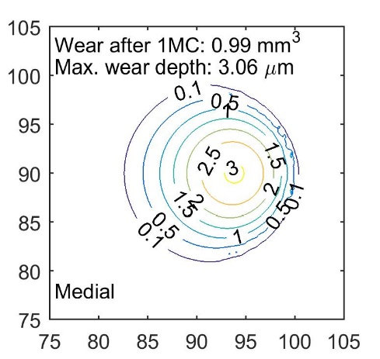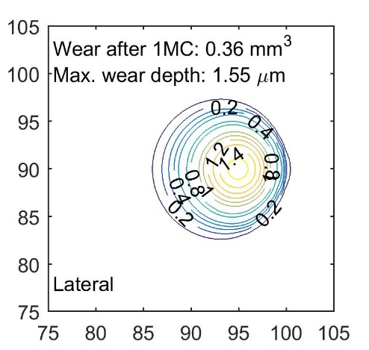

- Wear scar after one million cycles
It has been reported that the micro textures distributed over the whole surface domain may not provide the best performance compared with that on located in the entrainment half zone, instead it may cause worse lubrication in some conditions. Thus only one (No. 0*) of totally 10 runs was designed as ‘whole domain surface texturing 0 ̊ to 180 ̊, and the rest 9 runs (No.1-9) were partially textured between 0 ̊ and 90 ̊ in the entrainment direction during extension. This is because the major motion of the knee is extension when subjected to most of load in the standing phase. The effect of these dimples on the wear reduction (percentage) compared to the surfaces without texture is presented in Figure 4.

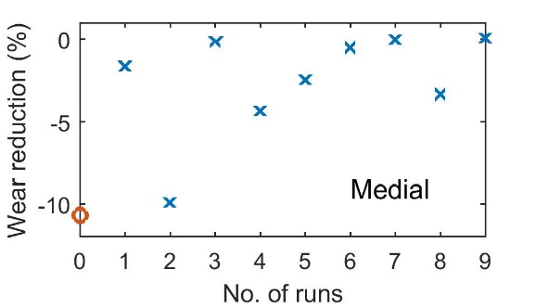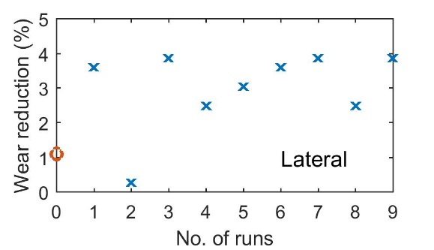

- Effect of surface texturing parameters on wear reduction (circle notes full domain distribution; cross notes half domain distribution)

It can be observed that No. 3, 7 and 9 resulted in the lowest wear among all the texture designs. For the lateral compartment, these three experiments reduced wear by approximately 4%. However, in the medial compartment, no obvious benefit was found and most of the texturing designs even caused more wear. It is difficult to find a direct relationship between the effect of texturing on wear and any single texture parameter, thus conclusion so far can be made is that the surface texture need to be designed carefully to enhance lubrication and reduce wear for specific knee joints and their loading conditions and further investigation is required.

In order to further look into the lubrication performance at each time instance in the walking cycle the minimum film thickness variation with time is presented for two cases, the smooth surface and No.9 textured surface, as shown in Figure 5. In the medial compartment the low film thickness (<0.2 μm) occurred from 0.2 s to 0.6 s. It needs to be noted that in the texturing experiment No. 9, the film thickness was even reduced compared with the smooth surface particularly at the thin film instances around 0.5 s. In the lateral compartment, low film thicknesses occurred during 0.4-0.6 s, with a much thicker film (0.2-0.5 μm) than that in the medial compartment, resulting in much lower wear. For both compartments the thinnest film occurred at around 0.5 s, when subjected to the second loading peak.

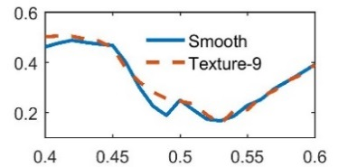
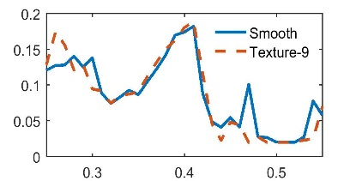
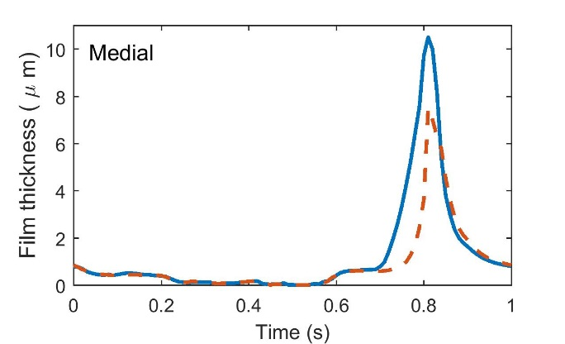
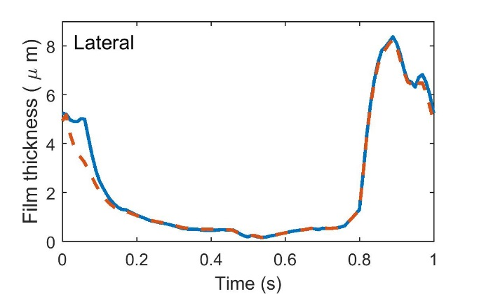
- Minimum film thickness in a walking cycle

However, the minimum film thickness at each time instance only represented the performance at one mesh point on the bearing surface, and this information is not enough to investigate the wear progress over the whole bearing surface. Thus, a statistical parameter Ʃ(P/λ), i.e. summary of the dimensionless pressure (scaled by elastic modulus) by the λ ratio over all the bearing surface, was proposed as a wear index, which qualitatively indicated the level of wear for the model developed here, as shown in Figure 6.

The importance of lubrication in wear prediction is highlighted through the variation of wear index Ʃ(P/λ). There are two loading peaks with similar peak values in the cyclic walking, but the wear at the first peak time 0.1-0.2 s was much lower than the second peak instance around 0.5s, regardless the sliding speed. This is because the film thickness was higher at the first peak loading instance than the second, due to a squeeze effect starting from the swing phase.

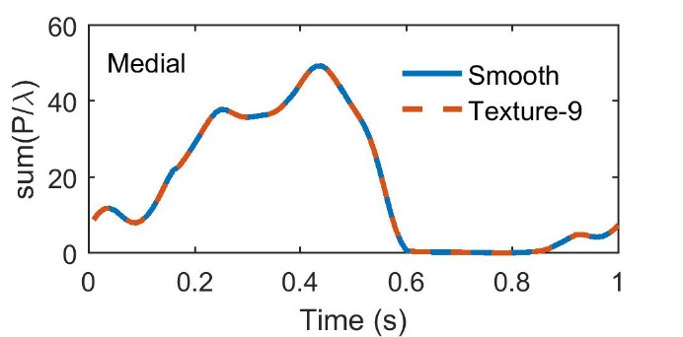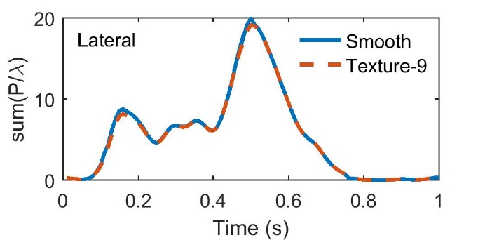
- The wear index [Ʃ(P/λ)] in a walking cycle

Conclusions
This paper qualitatively predicted the wear performance of hard-on-soft (polyethylene) knee joints, and the possibility of surface texturing designs to reduce wear. A wear index composed of statistical pressure, surface roughness and film thickness was proposed according to the adapted wear formula in this study, which indicating the level of wear at each time instances. The lateral contact area may benefit from surface texturing only if dimples were carefully designed, while it seems the medial contact area hardly got advantage over surface texturing.

Limitations and Future Work
The limitations in this study include,
- The ball and socket geometry instead of a real knee contact geometry.
- Only one load and one motion for walking conditions of the knee joints.
- The medial and lateral contact were addressed separately without interactions, and the contact between femur and patella was not considered.
- A simple column model for elastic deformation of the polyethylene bearing surface.
- The effect of protein aggregation on the fluid rheology not accounted for in the lubrication model.
- Surface roughness not considered in the surface micro scale.
- The wear simulation carried out for only 1 million cycles without geometry update.

The above limitations will be addressed in the future studies.

Acknowledgment
This work was financially supported by the Imperial Junior Research Fellowship and Shanghai Natural Science Foundation (16ZR1411800).

References
[1] Sharif, K. J. et al. "Effect of Elastohydrodynamic Film Thickness on a Wear Model for Worm Gears." Proceedings of the Institution of Mechanical Engineers Part J-Journal of Engineering Tribology, 220, J3, 2006, 295-306,
[2] Gao, L., Dowson, D. and Hewson, R.W. "Predictive Wear Modelling of the Metal-on-Metal Hip Replacements." Journal of Biomedical Materials Research: Part B, Applied Biomaterials, 105, 3, 2017, 497-506,
[3] Archard, J.F. "Contact and Rubbing of Flat Surfaces." Journal of Applied Physics, 24, 1953, 981-988,
[4] Gao, L. M. et al. "Effect of Surface Texturing on the Elastohydrodynamic Lubrication Analysis of Metal-on-Metal Hip Implants." Tribology International, 43, 10, 2010, 1851-1860,
[5] Hua, Z. K., Sang, R. Z. and Zhang, J. H. "Micro and Nano-Scale Surface Texturing: An Application in Ceramic-on-Ceramic Artificial Joint Materials." Nanoscience and Nanotechnology Letters, 4, 9, 2012, 879-882,
[6] Jalali-Vahid, D. et al. "Prediction of Lubricating Film Thickness in Uhmwpe Hip Joint Replacements." Journal of Biomechanics, 34, 2, 2001, 261-266,
[7] Fregly, B. J. et al. "Grand Challenge Competition to Predict in Vivo Knee Loads." Journal of Orthopaedic Research, 30, 4, 2012, 503-513,
[8] Marra, M. A. et al. "A Subject-Specific Musculoskeletal Modeling Framework to Predict in Vivo Mechanics of Total Knee Arthroplasty." Journal of Biomechanical Engineering-Transactions of the ASME, 137, 2, 2015,
[9] Gao, L. M. et al. "Effect of 3d Physiological Loading and Motion on Elastohydrodynamic Lubrication of Metal-on-Metal Total Hip Replacements." Medical Engineering & Physics, 31, 6, 2009, 720-729,
[10] Gao, L., Dowson, D. and Hewson, R.W. "A Numerical Study of Non-Newtonian Transient Elastohydrodynamic Lubrication of Metal-on-Metal Hip Prostheses." Tribology International, 93, 2016, 486-494,
[11] Liu, F., Fisher, J. and Jin, Z. M. "Effect of Motion Inputs on the Wear Prediction of Artificial Hip Joints." Tribology International, 63, 2013, 105-114,
[12] Mattei, L. et al. "Lubrication and Wear Modelling of Artificial Hip Joints: A Review." Tribology International, 44, 5, 2011, 532-549,

