Paracetamol, Ibuprofen, and recurrent major cardiovascular and major bleeding events in 19,120 patients with recent ischaemic stroke

Jaime Gonzalez-Valcarcel; Leila Sissani; Julien Labreuche; Marie-Germaine Bousser; Angel Chamorro; Marc Fisher; Ian Ford; Kim M Fox; Michael G Hennerici; Heinrich P Mattle; Peter M Rothwell; Philippe Gabriel Steg; Eric Vicaut; Pierre Amarenco; for the PERFORM Investigators

Université Paris Diderot, Paris, France (J Gonzalez-Valcarcel, MD; M-G Bousser, MD; Ph G Steg, MD; Eric Vicaut, MD; P Amarenco, MD);
INSERM LVTS (Laboratory for Vascular Translational Sciences) 1148 and Département Hospitalo-Universitaire FIRE (Fibrosis, Inflammation, REmodelling), Paris, France (L Sissani, BS; J Labreuche, BS; Ph G Steg, MD; P Amarenco, MD);
Department of Neurology and Stroke Centre, Hôpital Bichat, Assistance Publique-Hôpitaux de Paris, Paris France (J Gonzalez-Valcarcel, MD; L Sissani, BS; J Labreuche, BS; P Amarenco, MD);
Université de Lille, CHU Lille, EA 2694 - Santé publique : épidémiologie et qualité des soins, Lille, France (J Labreuche, BS)
Department of Neurology, hôpital Lariboisière, Assistance Publique-Hôpitaux de Paris, Paris, France (M-G Bousser, MD);
Hospital Clinic de Barcelona, University of Barcelona, Barcelona, Spain (A Chamorro, MD);
Harvard University, Brigham and Women hospital, MA, USA (M Fisher, MD);
Robertson Centre for Biostatistics, University of Glasgow, Glasgow, UK (I Ford, MD)
NHLI Imperial College, ICMS, Royal Brompton Hospital, London, UK (KM Fox, MD; Ph G Steg, MD);
University of Heidelberg, UMM, Mannheim, Germany (M G Hennerici, MD);
Neurologische Klinik und Poliklinik, Universität Bern, Inselspital, Bern (H P Mattle, MD);
Nuffield Department of Clinical Neurosciences, University of Oxford, Oxford, UK (P M Rothwell, MD);
Department of Biostatistics (E.V.), Hôpital Fernand Widal, Assistance Publique-Hôpitaux de Paris, Paris France (Eric Vicaut, MD).

Correspondence to: Pierre Amarenco, Department of Neurology and Stroke Centre, Bichat University Hospital, 46 rue Henri Huchard, 75018 Paris, France.
pierre.amarenco@aphp.fr
Tel: +33 1 4025 8726

Short title: Paracetamol, Ibuprofen and major vascular events and bleedings

Total word count (manuscript, references, table, legends): 3654

Summary
Background The presumed safety of paracetamol in high cardiovascular risk patients has been questioned. We sought to determine whether paracetamol or ibuprofen use is associated with major cardiovascular events or major bleeding in patients with recent ischaemic stroke or transient ischaemic attack (TIA) of mainly atherothrombotic origin.
Methods Using the PERFORM trial database, involving 19,120 patients with recent ischaemic stroke or TIA, we performed two nested case-control analysis (one with 2153 cases who had a major cardiovascular event during trial follow-up and 4306 controls matched on ESSEN score; a second with 809 cases with a major bleeding matched with 1616 controls). A separate time-varying analysis was performed.
Findings Of the 6459 cases and controls with or without major cardiovascular event, 11·2% were prescribed paracetamol and 2·5% ibuprofen. Median duration of treatment was 14 (IQR 5–145) days for paracetamol and 9 (5–30) days for ibuprofen. Paracetamol was associated with increased risk of a major cardiovascular event (odds ratio [OR] 1·21, 95% confidence interval [CI] 1·04–1·42) or a major bleeding (OR 1·60, 95% CI 1·26–2·03), with no impact of daily dose and duration of paracetamol treatment. There was no increased risk of major cardiovascular events (OR 1·03, 95% CI 0·73–1·34) or major bleeding with ibuprofen and no significant association with duration or dose. Time-varying analysis found an increased risk of major cardiovascular events with both paracetamol (OR 1·22, 95% CI1·05–1·43) and ibuprofen (OR 1·47, 95% CI 1·06–2·03) and of major bleeding with paracetamol (OR 1·95, 95% CI 1·45–2·62).
Interpretation There was a weak and inconsistent signal for association between paracetamol or ibuprofen and major cardiovascular events or major bleeding, which may be related to either a genuine but modest effect of these drugs, or to residual confounding. Given the uncertainty and the widespread use of paracetamol and ibuprofen, their safety among patients with stroke/TIA should be investigated in randomised studies.
Introduction
The association between non-steroidal anti-inflammatory drugs (NSAIDs) and cardiovascular risk is well established, particularly in high-risk populations.¹ Paracetamol (acetaminofen) is the most widely used analgesic and antipyretic worldwide.² It is commonly accepted that it has a better safety profile than NSAIDs, and thus it is usually the treatment of choice in many medical conditions. In patients with a high cardiovascular risk, recommendations state that paracetamol should be chosen over NSAIDs.³ Recently, this assumed safety profile has been questioned. First, Hinz et al. found that paracetamol produces a substantial selective cyclooxygenase 2 (COX-2) inhibition, to a degree comparable to non-selective NSAIDs and selective COX-2 inhibitors.⁴ Considering the vascular risk associated with COX-2 inhibitors, these results suggest that the presumed safety of paracetamol should be revisited.⁵⁻⁷ In addition, chronic paracetamol consumption maybe related to hypertension, a major vascular risk factor.⁸⁻¹⁰ Indeed some studies have shown an increased risk of cardiovascular events and stroke in patients treated with paracetamol, particularly in high-dose users.^{10, 11} Nevertheless, the hypothesis of a paracetamol-associated cardiovascular risk remains controversial. Paracetamol intake was not associated with an increase in stroke rate in a recent population-based case-control study, nor to myocardial infarction in other studies.¹²⁻¹⁴ In an acute stroke setting, paracetamol treatment to control mild-to-moderate hyperthermia (37–39°C) seemed to be associated with a better final outcome, reducing disability at 3 months according to the modified Rankin scale.¹⁵ Although there is a more commonly accepted belief that other NSAIDs, such as ibuprofen, have a higher vascular risk, there are still conflicting data in the literature. While some authors claim that ibuprofen intake is associated with an increase in vascular risk,¹⁶ others have found no such association.^{12, 13} NSAIDs associated bleeding risk is well known, particularly of a gastrointestinal origin.¹⁶ Their use represents an independent risk factor in patients with an antithrombotic treatment, even when prescribed for a short term.¹⁷ Differences between NSAIDs have been noted, probably related to a variable COX-1 inhibition and different half-lives, but while some authors claim that Ibuprofen could have a lesser risk, others have found a similar bleeding risk compared to other NSAIDs.^{16, 18} Paracetamol has an excellent gastrointestinal tolerability and safety profile concerning bleeding complications.^{19,20} It is hence again the preferred analgesic in cases of an elevated bleeding risk.
PERFORM (Prevention of cerebrovascular and cardiovascular Events of ischaemic origin with teRutroban in patients with a history oF ischaemic strOke or tRansient ischaeMic attack) was a randomised, double-blinded clinical trial comparing the efficacy of terutroban, a selective prostaglandin-thromboxane antagonist, against aspirin for the prevention of cardiovascular events after a cerebral vascular event.¹⁷ By analysing paracetamol and ibuprofen use in patients who were all on a background of antiplatelet therapy, we aimed to clarify whether there was an attributable cardiovascular risk associated with paracetamol or ibuprofen use in this high vascular risk population.

Methods
Selection of cases and controls for the nested case-control study
Two nested case-control studies were performed. One addressed cardiovascular events (death, myocardial infarction or stroke) and a second, life threatening (defined by a fatal outcome, a reduction in haemoglobin of 50 g/L or more, symptomatic intracranial haemorrhage or transfusion of 4 units or more of red blood cells) and major bleeding events (defined by a significantly disabling bleeding, an intraocular bleeding leading to significant loss of vision, a transfusion of 3 units or less of red blood cells, or needing hospital admission or surgery). The same procedure was done for both nested-case control study.
We defined cases as those with a first occurrence of a major cardiovascular (or major bleeding) event after randomisation in the PERFORM trial. Over a 4-year follow-up, 2153 cardiovascular events and 427 major bleedings were recorded. The date of the event was considered as the index date.
Based on incidence density sampling, we selected up to two control subjects for each case by random sampling from all members of the study cohort who were alive before the day the case subject had the event. With this design, all cohort members were eligible to serve as controls for more than one case subject; and case subjects before the event were eligible to serve as controls for other case subjects who died earlier. Control subjects were individually matched to each case subject by ESSEN score (+/- 1), comprising age, arterial hypertension, diabetes mellitus, previous myocardial infarction, other cardiovascular disease, peripheral artery disease, smoking, previous transient ischaemic attack (TIA) or ischaemic stroke, in addition to qualifying event and duration of follow-up. Since individual components of ESSEN score were available for all of patients, no imputation to handle missing data was done before matching. Thus, all controls were alive, not previously diagnosed as having a recurrent major cardiovascular event (or major bleeding), and had an equal duration of follow-up at the risk set date. The index date of controls was defined as the date of event of their matched case. In the analysis, estimates of paracetamol or ibuprofen exposure for each control subject were truncated at the date of the event of the matched case subject.
Exposure definition
For all cases and controls, we obtained information on paracetamol and ibuprofen use between the date of enrolment in the study and the index date. We had information about the timeline of the prescription and the dose. Also patients were asked to record the frequency of their use. They were classified into one of three groups: no use; occasional use; and daily use(several intakes for >1 days).
Statistical analysis
Data are expressed as mean ± standard deviation or median (interquartile range [IQR]) for continuous variables and count (percentage) for qualitative variables. The same analyses were performed for both the nested case-control studies.
Baseline characteristics were described and compared between the cases and ESSEN-score matched controls by using the Mc Nemar test for binary variables and the paired Student t test or the Wilcoxon signed rank test for continuous variables.
We compared the paracetamol or ibuprofen exposures between cases and controls using conditional logistic regression for matched sets with and without adjustment for history of paracetamol or ibuprofen prior randomization. Using patients with no-exposure as reference, we derived from this model, the odds ratios (ORs) with their corresponding 95% confidence intervals (CIs) as effect size measure.
A second analysis was performed using a time-varying Cox regression analysis by using all paracetamol (or ibuprofen)exposure status recorded at baseline and at each follow-up visit. This secondary sensitivity analysis, attempted to account for change in paracetamol(or ibuprofen) use status over time by including a time-dependent covariate into the Cox model with and without adjustment for the ESSEN-score and history of paracetamol or ibuprofen prior randomization.
Statistical testing was conducted at the 2-tailed α-level of 0.05. Data were analyzed using the SAS software version 9.3 (SAS Institute, Cary, NC).

Results
Nested case-control study

- Major cardiovascular event
We identified 2153 cases with a major cardiovascular (cardiac death, myocardial infarction or stroke) event and 4306 matched controls. The baseline characteristics are described in Table 1.. The mean age of cases was 69 years and 70 years for controls.13.7% of cases used paracetamol at the index date compared with 11.7% of controls. Paracetamol treatment was associated with an increased risk of major vascular events (OR 1·21, 95% CI 1·04–1·42). Patients who used paracetamol daily had a higher risk of major vascular events but the OR was not significant (adjusted-OR 1·20, 95% CI 0·89–1·63). In this group, the median duration of paracetamol treatmentwas 14 (IQR 5–145) days. No effect was found for daily dose and duration of treatment. The OR for a dose of ≥3000 mg/day was not significant (Fig. 1)
Patients who used ibuprofen had no significant increase in the risk of major vascular events (OR 1·03, 95% CI 0·73–1·34) and there was no significant association with duration or dose of ibuprofen treatment (Fig. 2). The median treatment duration for patients with a daily use was 9 (IQR 5–30) days.

- Major bleeding
- They were 809 cases with major bleeding matched with 1616 controls. Table e-1 shows sites of major bleeedings. The mean age was 69 years for cases and 68 years for controls and 60% of cases were men compared with 62% of controls. 18.4% of cases were paracetamol users at the index date, compared with 12.3% controls. Paracetamol treatment was associated with major bleeding (adjusted-OR 1.60, 95% CI 1.26-2.03, Fig 1). Daily users had a higher risk of major bleeding. We also found a significant trend between class of daily dose and the risk of major bleeding.
4.8% of cases were ibuprofen users at the index date compared with 3.7% controls. Ibuprofen was not associated with major bleeding (Fig 2). We also found no association between dose or duration of treatment.

Time-varying analysis
Using all prescriptions of paracetamol or ibuprofen during follow-up, we found an increased risk of major cardiovascular events in patients who received paracetamol (OR 1·23, 95% CI 1·05–1·43) or ibuprofen (OR 1·42, 95% CI 1·03–1·96). After multiple adjustments, the same results were obtained (table 2). For paracetamol, we also found an increased risk among patients who used the drug occasionnally (Fig. 3). There was a trend for an increased risk of major vascular events increasing doses of paracetamol (Fig. 3). For ibuprofen, similar to the previous analyses, there was no effect of daily use and no dose effect (Fig. 3).
There was also an increased risk of major bleeding with paracetamol treatment (adjusted-OR 1·95, 95% CI 1·45–2·62) but not with ibuprofen treatment (adjusted-OR 1·02, 95% CI 0·54–1·90). ORs for paracetamol and ibuprofen daily use; and paracetamol dose ≥3000 mg/d. was associated with a higher risk of major bleeding

Discussion
In this high vascular risk population of nearly 20,000 patients with recent ischaemic stroke or TIA, we found a weak and inconsistent relationship between paracetamol or ibuprofen prescription and recurrent major cardiovascular events or major bleeding. Even if there was an association between paracetamol prescription and an increased risk of major cardiovascular events or major bleeding, a dose effect was only found in the time-varying analysis and not in the nested case-control analysis, and patients who had longer paracetamol prescription showed no increase in the rate of major cardiovascular events. The results were not concordant for ibuprofen: in the nested case-control analysis there was no association between ibuprofen prescription and the risk of major cardiovascular events but this association was significant in the time-varying analysis. Overall, the strength of these associations for both paracetamol and ibuprofen was low, making possible that other undetected confounding factors explained these weak associations.
There are some limitations to our study. First, this is a high vascular risk population, and all patients were on antiplatelet treatment, so these results cannot be extrapolated to the general population. Besides, as previously pointed out, there are possible confounding factors underlying paracetamol prescription. Finally, our population was selected for a different purpose and was not homogeneous in terms of paracetamol intake, even if we tried to avoid this kind of bias with the case-control design. We also performed a propensity score-adjusted analysis and found similar inconsistent results (data not shown). The weak association between occasional paracetamol use and cardiovascular events or bleeding was possibly confounded by the underlying pathology that justified the prescription. On one hand, paracetamol could have been taken for misdiagnosed chest pain related to coronary events. On the other, paracetamol prescription is often associated with diseases implying a systemic inflammatory response. There is evidence of a relationship between systemic inflammation and stroke pathogenesis. Atherosclerosis, a major cause of stroke, is partly an inflammatory disease.²² Besides, many inflammatory conditions have been associated withstroke.23 Chronic inflammatory diseases, such as rheumatoid arthritis, systemic lupus erythematosus, giant-cell arteritis, and atopic dermatitis imply an increased risk of stroke.²⁴⁻²⁶ Finally, an increased risk of both myocardial infarction and stroke has been associated with previous infections, especially in the 7 days following a respiratory infection.^{27, 28} The unexpected association between paracetamol and major bleeding in our study raises concern about its safety in patients under antithrombotic treatment. Nevertheless there are also some confounding factors that should be considered. Most of the major bleeding were of gastrointestinal origin or related to a surgical intervention (supplementary data, table 1), Because of its alleged safety profile, paracetamol is often prescribed in patients with a pre-existing medical condition implying an important bleeding risk and in a postoperative setting as a painkiller, which constitutes an important prescription bias. Besides, paracetamol can be also used as a symptomatic treatment for gastrointestinal diseases with possible bleeding complications.²⁹ These bias have been already underlined by other authors, who found an association with major bleeding when paracetamol was prescribed for gastrointestinal discomfort, but not for other indications, like headaches.^{30, 31} Our patients were under antithrombotic treatment, either terutroban or aspirin. If an analgesic or antipyretic was needed, their physicians may have chosen paracetamol over NSAIDs in regard of its tolerability. Ibuprofen would have been used only in low risk patients, and its use seems safe when used at doses of 1200 mg/day or lower.³²
In conclusion, there was a weak and inconsistent signal for an association between paracetamol and ibuprofen use and major vascular events or major bleedings, which may be related to either a genuine but modest effect of paracetamol and ibuprofen or to residual confounding. Given the uncertainty and the widespread use of paracetamol, the safety of paracetamol andibuprofen among patients with ischaemic stroke should be elucidated in future randomised studies.

Acknowledgments
Sophie Rushton-Smith, PhD (MedLink Healthcare Communications Ltd) provided editorial assistance on the final version of the manuscript and was funded by SOS-ATTAQUE CEREBRALE Association (a not-for-profit stroke survivor association).
References
1. Kohli P, Steg PG, Cannon CP, et al. NSAID use and association with cardiovascular outcomes in outpatients with stable atherothrombotic disease. Am J Med 2014; 127: 53-60 e1.
2. Blieden M, Paramore LC, Shah D, Ben-Joseph R. A perspective on the epidemiology of acetaminophen exposure and toxicity in the United States. Expert Rev Clin Pharmacol 2014; 7: 341-8.
3. Antman EM, Bennett JS, Daugherty A, et al. Use of nonsteroidal antiinflammatory drugs: an update for clinicians: a scientific statement from the American Heart Association. Circulation 2007; 115: 1634-42.
4. Hinz B, Cheremina O, Brune K. Acetaminophen (paracetamol) is a selective cyclooxygenase-2 inhibitor in man. FASEB J 2008; 22: 383-90.
5. Bresalier RS, Sandler RS, Quan H, et al. Cardiovascular events associated with rofecoxib in a colorectal adenoma chemoprevention trial. N Engl J Med 2005; 352: 1092-102.
6. Solomon SD, McMurray JJ, Pfeffer MA, et al. Cardiovascular risk associated with celecoxib in a clinical trial for colorectal adenoma prevention. N Engl J Med 2005; 352: 1071-80.
7. Nussmeier NA, Whelton AA, Brown MT, et al. Complications of the COX-2 inhibitors parecoxib and valdecoxib after cardiac surgery. N Engl J Med 2005; 352: 1081-91.
8. Curhan GC, Willett WC, Rosner B, Stampfer MJ. Frequency of analgesic use and risk of hypertension in younger women. Arch Intern Med 2002; 162: 2204-8.
9. Dedier J, Stampfer MJ, Hankinson SE, Willett WC, Speizer FE, Curhan GC. Nonnarcotic analgesic use and the risk of hypertension in US women. Hypertension 2002; 40: 604-8; discussion 01-3.
10. Chan AT, Manson JE, Albert CM, et al. Nonsteroidal antiinflammatory drugs, acetaminophen, and the risk of cardiovascular events. Circulation 2006; 113: 1578-87.
11. Roberts E, Delgado Nunes V, Buckner S, et al. Paracetamol: not as safe as we thought? A systematic literature review of observational studies. Ann Rheum Dis 2015.
12. Garcia-Poza P, de Abajo FJ, Gil MJ, Chacon A, Bryant V, Garcia-Rodriguez LA. Risk of ischemic stroke associated with non-steroidal anti-inflammatory drugs and paracetamol: a population-based case-control study. J Thromb Haemost 2015; 13: 708-18.
13. de Abajo FJ, Gil MJ, Garcia Poza P, et al. Risk of nonfatal acute myocardial infarction associated with non-steroidal antiinflammatory drugs, non-narcotic analgesics and other drugs used in osteoarthritis: a nested case-control study. Pharmacoepidemiol Drug Saf 2014; 23: 1128-38.
14. Rosenberg L, Rao RS, Palmer JR. A case-control study of acetaminophen use in relation to the risk of first myocardial infarction in men. Pharmacoepidemiol Drug Saf 2003; 12: 459-65.
15. den Hertog HM, van der Worp HB, van Gemert HM, et al. The Paracetamol (Acetaminophen) In Stroke (PAIS) trial: a multicentre, randomised, placebo-controlled, phase III trial. Lancet Neurol 2009; 8: 434-40.
16. Bhala N, Emberson J, Merhi A, et al. Vascular and upper gastrointestinal effects of non-steroidal anti-inflammatory drugs: meta-analyses of individual participant data from randomised trials. Lancet 2013; 382: 769-79.
17. Schjerning Olsen AM, Gislason GH, McGettigan P, et al. Association of NSAID use with risk of bleeding and cardiovascular events in patients receiving antithrombotic therapy after myocardial infarction. JAMA 2015;313:805-14
18. Garcia Rodriguez LA. Variability in risk of gastrointestinal complications with different nonsteroidal anti-inflammatory drugs. Am J Med 1998; 104(3A): 30S-34S.
19. Lewis SC, Langman MJS, Laporte JR, et al. Dose-response relationships between individual nonaspirin nonsteroidal anti-inflammatory drugs (NANSAIDs) and on serious upper gastrointestinal bleeding: a meta analysis based on individual patient data. Br J Clin Pharmacol 2002; 54: 320–6
20. Lanza FL, Codispoti JR, Nelson EB. An endoscopic comparison of gastroduodenal injury with over-the-counter doses of ketoprofen and acetaminophen. Am J Gastroenterol 1998; 93: 1051–4
21. Bousser MG, Amarenco P, Chamorro A, et al. Terutroban versus aspirin in patients with cerebral ischaemic events (PERFORM): a randomised, double-blind, parallel-group trial. Lancet 2011; 377: 2013-22.
22. Ross R. Atherosclerosis--an inflammatory disease. N Engl J Med 1999; 340: 115-26.
23. Smith CJ, Lawrence CB, Rodriguez-Grande B, Kovacs KJ, Pradillo JM, Denes A. The immune system in stroke: clinical challenges and their translation to experimental research. J Neuroimmune Pharmacol 2013; 8: 867-87.
24. Bruce IN. 'Not only...but also': factors that contribute to accelerated atherosclerosis and premature coronary heart disease in systemic lupus erythematosus. Rheumatology (Oxford) 2005; 44: 1492-502.
25. Solomon DH, Karlson EW, Rimm EB, et al. Cardiovascular morbidity and mortality in women diagnosed with rheumatoid arthritis. Circulation 2003; 107: 1303-7.
26. Su VY, Chen TJ, Yeh CM, et al. Atopic dermatitis and risk of ischemic stroke: a nationwide population-based study. Ann Med 2014; 46: 84-9.
27. Clayton TC, Thompson M, Meade TW. Recent respiratory infection and risk of cardiovascular disease: case-control study through a general practice database. Eur Heart J 2008; 29: 96-103.
28. Grau AJ, Urbanek C, Palm F. Common infections and the risk of stroke. Nat Rev Neurol 2010; 6: 681-94.
29. Signorello LB, McLaughlin JK, Lipworth L, et al. Confounding by indication in epidemiological studies of commonly used analgesics. Am J Ther 2002; 9: 199–204.
30. Langman MJ, Coggon D, Spiegelhalter D. Analgesic intake and the risk of upper gastrointestinal bleeding. Am J Med 1983; 74: 79–82.
31. Garry G. Graham , Kieran F. Scott, Richard O. Day. Tolerability of paracetamol. Drug Safety
2005; 28: 227-240.
32. Doyle G, Furey S, Berlin R, et al. Gastrointestinal safety and tolerance of ibuprofen at maximum over-the-counter dose. Aliment Pharmacol Ther. 1999 Jul;13(7):897-906.

Table 1: Characteristics of cases (with major vascular events)and controls.

 | Major cardiovascular event |  |  | Major bleeding
 | Cases (n=2153) | Controls (n=4306) |  | Cases (n=809) | Controls (n=1618)
Demographics
Age (years) | 69·2±8·2 | 69·7±7·8** |  | 69·2±8·0 | 68·3±8·0 **
Men | 1449 (67·3) | 2741 (63·7)* |  | 536 (66·3) | 1012 (65·4)*
Body mass index (kg/m²) | 27·0±4·3 | 27·1±4·3 |  | 26·6±4·5 | 27·2±4·3
Systolic blood pressure (mmHg) | 138·3±15·7 | 138·1±15·8 |  | 138·8±15·6 | 137·8±15·5
Diastolic blood pressure (mmHg) | 79·4±8·5 | 79·2±8·5 |  | 79·4±8·7 | 79·6±8·4
Total cholesterol (mmol/L) | 4·7±1·2 | 4·6±1·2 |  | 4·5±1·1 | 4·6±1·2
Low-density lipoprotein cholesterol (mmol/L) | 1·2±0·3 | 1·2±0·3 |  | 1·3±0·4 | 1·2±0·3
High-density lipoprotein cholesterol (mmol/L) | 2·8±1·0 | 2·8±1·0 |  | 2·7±0·9 | 2·8±1·0 *
Risk factor
Hypertension | 1842 (85·6) | 3917 (91·0) * |  | 703 (86·9) | 1431 (88·4) **
Diabetes | 742 (34·5) | 1623 (37·7)* |  | 234 (28·9) | 559 (34·6)*
Hypercholesterolemia | 1025 (47·6) | 2145 (49·8)* |  | 395 (48·8) | 796 (49·2)
Current smoker | 571 (26·5) | 1326 (30·8)* |  | 227 (28·1) | 475 (29·4)
Previous stroke | 492 (22·9) | 945 (22·0) |  | 161 (19·9) | 294 (18·2)
Previous transient ischaemic attack | 185 (8·6) | 497 (11·5)* |  | 61 (7·4) | 140 (8·7)
Previous myocardial infarction | 312 (14·5) | 668 (15·5) |  | 73 (9·0) | 150 (9·3)
ESSEN stroke risk score | 4 (3–5) | 3 (3–4) |  | 3 (2–4) | 3 (2–4)
Duration of follow-up (years) | 11 (4-19.5) | 11 (4-19.5) |  | 12 (5-20) | 12 (5-20)
*<0.005, **<0.05
Data are number (%), mean±SD, or median (IQR) unless stated otherwise.
Figure 1: Effect of paracetamol on risk of major cardiovascular events or major bleedings
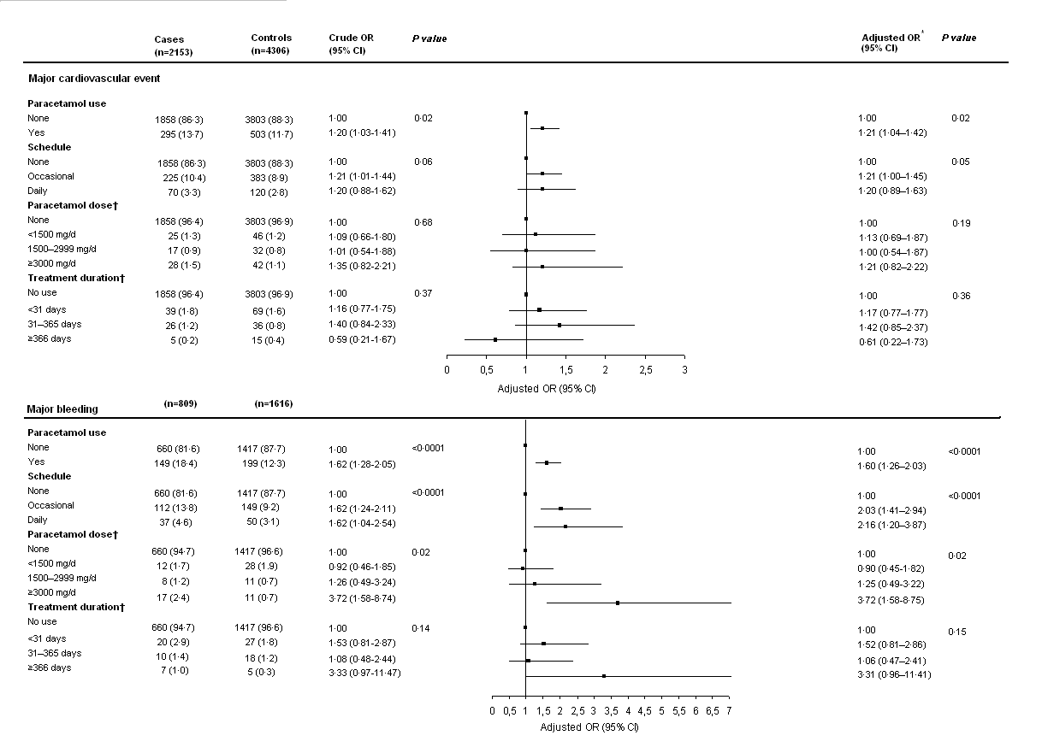
Data are number (%) unless otherwise specified. CI=confidence interval; OR=odds ratio. *Adjusted on previous use of paracetamol or ibuprofen.† Calculated for daily use. Two confidence interval were truncated

Figure 2. Effect of ibuprofen on risk of major cardiovascular events or major bleedings
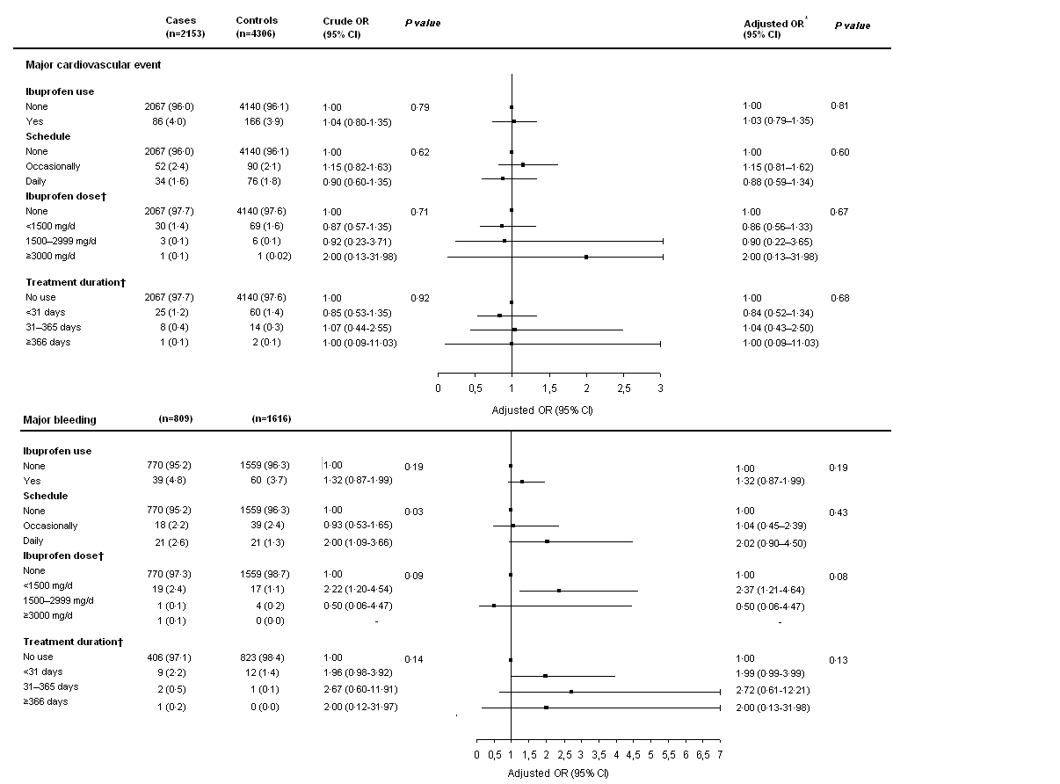
Data are number (%) unless otherwise specified. CI=confidence interval; OR=odds ratio. *Adjusted on previous use of paracetamol or ibuprofen.† Calculated for daily use. Four confidence interval were truncated

Table 2: Time-dependent HR for paracetamol and ibuprofen and major cardiovascular events or major bleeding risks
 | Unadjusted  HR (95% CI) | p value | Adjusted*  HR (95% CI) | p value
Major cardiovascular event
Paracetamol  Ibuprofen | 1·23 (1·05–1·43)  1·42 (1·03–1·96) | 0·01  0·03 | 1·22 (1·05–1·43)  1·47 (1·06–2·03) | 0·01  0·02
Major bleeding
Paracetamol  Ibuprofen | 1·84 (1·48–2·28)  1·02 (0·54–1·90) | <0·0001  0·96 | 1·89 (1·52–2·34)  1·05 (0·56–1·96) | <0·0001  0·88
CI=confidence interval; HR=hazard ratio. *Adjusted on ESSEN score and previous use of paracetamol or ibuprofen

Figure 3: Major cardiovascular events or major bleedings according to frequency ofconsumptionof paracetamol or ibuprofenand to dose of paracetamol or ibuprofen in patients who took these drugs daily
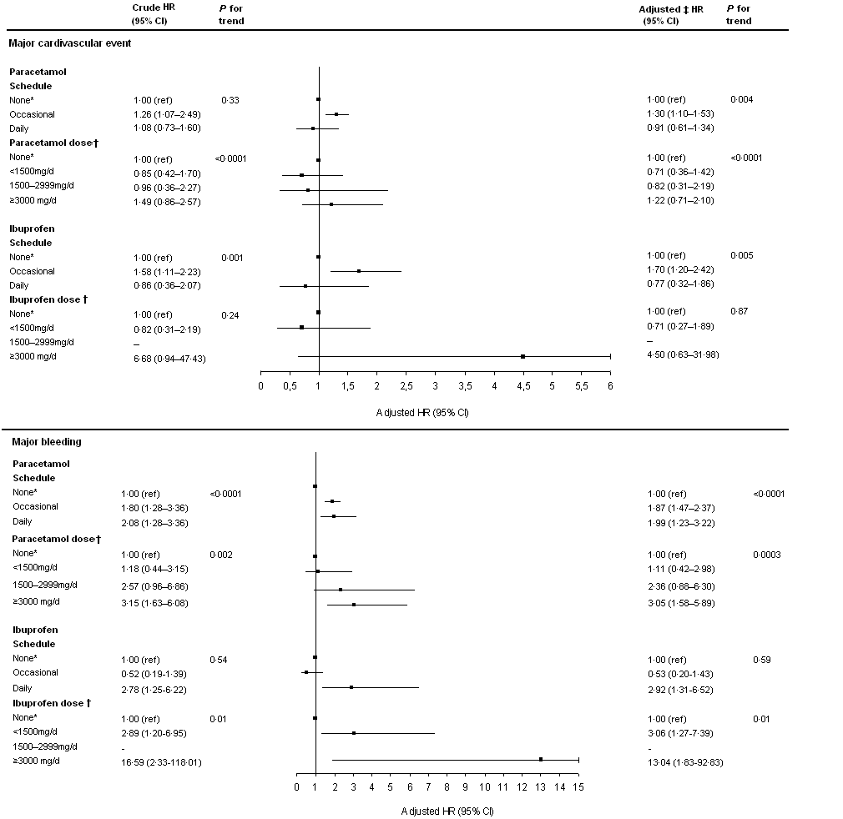
CI=confidence interval; HR=hazard ratio. *Reference.†Adjusted on ESSEN score and previous use of paracetamol or ibuprofen.Note: there was no cardiovascular event in the dose class 1500–2999 mg/d.One confidence interval was truncated

Supplementary data
Table 1 Major bleeding localisation
Localisation | Fréquence | Pourcentage
Gastrointestinal | 125 | 29,3
Surgigal site | 92 | 21,6
Intraocular | 56 | 13,1
Sub-cutaneous | 39 | 9,1
Ear-nose-throat | 33 | 7,7
Urinary | 31 | 7,3
Pulmonary haemorrhage | 17 | 4
Gynecological | 11 | 2,6
Intraarticular haemorrhage | 6 | 1,4
Thoracic haemorrhage | 4 | 0,9
Subdural haematoma | 3 | 0,7
Arterial puncture site | 2 | 0,5
Pericardial haemorrhage | 2 | 0,5
Fracture site haemorrhage | 2 | 0,5
Retroperitoneal | 1 | 0,2
Ginvigal / other mouth bleeding | 1 | 0,2
Suvarachnoid haemorrhage | 1 | 0,2
Muscle haemorrhage | 1 | 0,2

