Test-piece design for experimental and numerical evaluation of damage in relation to spatial triaxial stress inversion

M. C. Kaye, D. Balint¹, J. Lin¹, D. Farrugia²

Abstract
This work examines the effect of stress state on the nucleation and growth of damage during hot deformation of free cutting steel. A test-piece was designed to emulate stress states similar to those found in hot rolling. The novelty of the new design is its ability to maintain a constant spatial stress state during deformation, allowing a true correlation of the damage mechanism to the stress triaxiality; previous sample geometries had a large variation in stress during plastic deformation, which made it impossible to relate an observed damage mechanism to a particular stress state using a single sample. Continuum damage equations were calibrated using uniaxial tensile tests and implemented into finite element models of compressive test-pieces. The stress distributions in each test-piece geometry were compared and a single test-piece design was chosen with an optimised triaxial stress distribution. The test-piece was deformed at elevated temperatures, sectioned and the microstructure was evaluated. The combination of stress state and strain computed via finite element analysis (FEA) was compared to the damage produced across the test-piece section. The predictions of the damage equations were compared to the results of physical tests and used to identify appropriate damage models. The effect of stress state on damage was evaluated, which can be used to update and improve existing material models. The stress triaxiality was found to be the dominant factor for damage around inclusions, with a minimum stress triaxiality required for damage growth to occur.

Keywords
Ductile damage, hot rolling, inclusions, finite element simulation, stress state, high temperature testing, stress triaxiality.

Introduction
Failure to eliminate damage in industrial bulk forming processes leads to product rejection and enormous associated costs. Edge cracking is a well-known form of damage leading to product rejection in hot rolling (Saxena et al., 1997). However, macroscopic damage is not the sole consideration; a product must not experience accumulated damage at the micro-scale that may lead to fracture in service. Some manufacturing standards dictate that a product may fail to meet manufacturing specifications with a frequency no greater than 1 in 10⁶ (Harry, 1988). Therefore, the material processes contributing to damage need to be understood, which is possible by taking a mechanistic approach.
Thomson et al. suggested that ductility exhaustion is a key reason for edge cracking in hot rolling of steel (Thomson and Burman, 1980). Higher ductility is generally associated with a lower flow stress, therefore a lower rolling force is required leading to less wear on the rolls (Kalpakjian, 1984). However, rolled steel may also need to be machined, and a more ductile material would result in a poor surface finish. Thus, a compromise in chemical composition and processing treatments must be reached to balance the competing requirements. The material studied here is a ‘Free-Cutting Steel’, FCS, which is a mild steel with additives such as manganese, tellurium and lead. The additives increase machinability but decrease ductility. The manganese combines with sulphur to form inclusions, which aid chip formation but act as stress localisation sites during hot forming. The lead and tellurium are known to act as lubricants by precipitating at inclusion boundaries, but this increases the damage nucleation rates as they melt at hot forming temperatures. Several researchers have investigated damage in these steels revealing the deformation mechanisms; a review of this work will be followed by a review of applicable models.
Hot forming usually refers to processing at temperatures above two thirds of the melting temperature (Kalpakjian, 1984). These temperatures allow the activation of several deformation mechanisms within the material. In the hot metal forming process (rolling) examined here, the strain rates are typically up to 10 s⁻¹ (Liu, 2004). Damage at grain boundaries is observed at high temperatures, which is more likely to occur at relatively low strain rates, of 1 s⁻¹ or less, as it is diffusion rate limited (Hayhurst et al., 2008). Higher strain rates reduce grain boundary diffusion and sliding, therefore dislocation-based, plasticity-induced damage around inclusions will dominate (Besson, 2010, Lin et al., 2005b). However, plasticity-induced and grain boundary damage can co-exist in a proportion that depends on the temperature, strain rate and grain size (Lin et al., 2005b). The dependence of the rate of damage accumulation on the strain rate and temperature are critical information required for an appropriate damage model. However, damage propagation is dependent on the stress state (Gao et al., 2010).
Two of the foremost methods that have been used to establish constitutive equations and encapsulate the stress state are based on micromechanical response and, more phenomenologically, continuum damage mechanics (CDM). An example of the former is the work by Gurson, where voids in a porous matrix were considered (Gurson, 1977). CDM was introduced by Kachanov; the main aspect is that a damaged volume element can be equated to an effective undamaged volume (Kachanov, 1958). State variables are used to account for damage, and the methodology is versatile enough to be used for a range of problems including creep and ductile plastic damage (Cao et al., 2008, Hayhurst et al., 1977, Spindler, 2004). Attempts have been made in both methods to account for the stress state.
The stress triaxiality, which is the mean stress divided by the Von Mises, or equivalent stress, 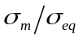, is an appropriate measure for monitoring damage in a three-dimensional stress state, such as that in hot rolling. Several damage equations that use the stress triaxiality will now be reviewed. Equations (1)-(6) are single mechanism models and only consider void growth. In the following equations ε_{f} and ε_{f} ^{uni} are the strain to failure and strain to failure in uniaxial tension, respectively.

 | 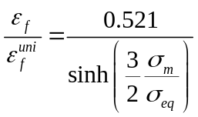 | ( 1 )

Equation (1) was derived by Rice and Tracey and is based on the concept of a spherical void undergoing dilatational growth due to tensile stress triaxiality (Rice and Tracey, 1969).

 | 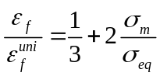 | ( 2 )

Equation 2 was based on a model by Pilling and Ridley, which was designed for superplastic forming and includes damage in compressive stress states (Pilling and Ridley, 1986). It was modified by Nicolaou and Semiatin to include stress triaxiality (Nicolaou and Semiatin, 2003).

 | 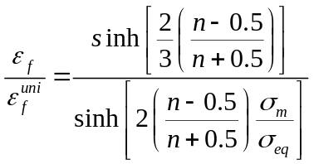 | ( 3 )

In the Cocks and Ashby model, given by Eq. (3), n is the stress exponent for steady state creep (Cocks and Ashby, 1982); n has to be calibrated for the model to be accurate. The model is based on grain boundary cavities growing by steady-state creep of the surrounding matrix. This model was later updated by Foster to take better account of inclusion distributions, and is used in this work in its updated form (Foster et al., 2007).

 | 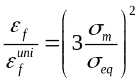 | ( 4 )

Equation (4), by Liu et al., was developed along with more complicated constitutive equations that permit including factors such as dislocation density and grain size in the damage model (Liu, 2004). That kind of complexity is not studied here. While equations (1)-(4) are functions of stress triaxiality, some models use the maximum principal stress, σ_{1,} as seen in equations (5) and (6).

 | 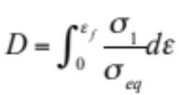 | ( 5 )

The model given by equation (5) was originally developed by Cockroft and Latham and involved the integration of the maximum principle stress with the equivalent plastic strain, ε (Cockcroft and Latham, 1968). The addition of the equivalent stress permitted the evaluation of more complex stress states (Oh et al., 1979).

 | 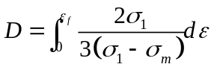 | ( 6 )

Brozzo et al. also developed the Cockroft and Latham model and explicitly included the mean stress, as in equation (6), as it had been found to decrease the growth of voids and permitted analysis of multiaxial states of stress on creep constrained cavity growth (Brozzo et al., 1972). Uniaxial tensile tests were performed to establish the strain to failure of the material; the results were used to calibrate the damage models. This work aims to analyse the effect of stress state on the damage mechanisms using high temperature tests, which will be described in the next section.

Development of existing test-piece designs
Triaxialities of -1/3 to 1/3 are often found in hot rolling (Kalpakjian, 1984). Several test-pieces were designed for the evaluation of damage under stress triaxiality levels such as those found in hot rolling (Foster et al., 2009). The studies looked at a variety of plane strain and axisymmetric geometries and observed the damage formed after hot deformation. One plane strain test-piece was a flattened cube design with chamfers on the longest edges. The test-piece was compressed and produced different triaxial stress states by varying the initial chamfer angle. An axisymmetric test-piece, a tall ring with a concave conical base, produced a range of triaxialities similar to that in hot rolling. Different stress ratios and their relation to damage were investigated in each of the test-pieces by using finite element models. Damage models were implemented and compared to the observed damage found in experiments. The physical and experimental tests showed that the models matched the trends of the damage and highlighted its temperature dependence. However, there are nevertheless significant limitations with all of the geometries available.
One limitation is that the volume in which damage can be observed relative to the size of the test-piece is often too small for meaningful conclusions. In many of the test-pieces the change in triaxiality across the test-piece was too great and the spatial distribution of stress was not constant throughout deformation, making it difficult to relate the final damage to the stress state. Hence it is necessary to develop a test-piece that can capture the effects of a range of stress states and stress components on damage.
Bao and Wierzbicki recorded the strain to failure in cold forming of aluminium for a variety of test-piece geometries (Bao and Wierzbicki, 2004). They argued that each test-piece represented a particular value of stress triaxiality, which was plotted versus the strain to failure in the respective test-piece. The main problem with this approach is that for most geometries tested, the stress state was not constant throughout the deformation, therefore the test does not show the effect of a particular stress state on damage development. Attempts to account for this have been made using the Bridgman method in uniaxial tensile tests, where the neck shape can be equated to a particular stress triaxiality (Bridgman, 1953). X-ray tomography was used to quantify damage and relate it to the triaxiality in this way (Maire et al., 2008, Babout et al., 2001, Kaye et al., 2013). However, the spatial variation in stress state changes as the neck shape evolves and it is not possible to control and maintain a constant stress state after necking. Furthermore, the strain rate in the neck is difficult to control, complicating attempts to correlate damage to the conditions of loading.
Another limitation is that there may be effects of the inhomogeneity of the batch test material, hence each test will be slightly different, making it difficult to compare the results of particular test-piece geometries. A larger test-piece would mitigate the effects of the inhomogeneities, but this is not always practical due to limitations of material availability and loading capability. A smaller test-piece would have less chance of containing porosity or other randomly distributed defects. However, if high temperatures are used then a small test-piece will have localised cooling, hence reduced ductility, which would invalidate results. It would be preferable to have a single test-piece with a spatial variation of stress state that is relevant to the damage mechanisms being evaluated. Plane stress and axisymmetric test-pieces under compressive loading offer the best results in terms of the possible range of stress states, and provide large areas under the same stress state that could be compared. The main objective of this paper is to design a test-piece that maintains a constant spatial stress state, so that a particular stress state could be related to an observed damage mechanism.
It was necessary to compare the stress distribution using finite element simulations. A quad-dominated, structured mesh with eight-node elements with linear interpolation was used. An explicit integration scheme was used and default hour glass control. The dies were modelled as rigid bodies and initially set in contact with the test-piece. The minimum mesh density was roughly 2.1 elements per mm². However, higher densities were used in areas of interest. A standard kinematic contact algorithm was used with a friction coefficient of 0.2 consistent with the findings of Munther et al. (Munther and Lenard, 1995). Though it is known that the friction coefficient decreases somewhat during the rolling process, an increase in temperature decreases the friction coefficient. Hence the friction coefficient was kept constant in the model as the variation is low over the range of temperatures considered (Munther and Lenard, 1995, Lin et al., 1991). A range of friction coefficients between 0.1 and 0.3 between the dies and the sample showed a change in the maximum stress triaxiality of 10% in the simulations, which is not considered to be significant. The deformed profiles of the experimental and simulated deformed sections matched closely, which indicated the value of friction used was sufficiently accurate.
A material model developed and calibrated for leaded free-cutting steels, LFCS, by Foster et al. was implemented using an ABAQUS Variable User MATerial, VUMAT, subroutine for explicit calculations (Foster, 2007). It is a physically-based, temperature-dependent set of constitutive equations, which include parameters for the dislocation density, equivalent stress, plastic strain rate and temperature with symbols $ρ$, $σ_{eq}$, ${\dot{ε}}_{p}$ and T respectively. All other symbols are material constants. In this way changes in temperature that cause varying rates of recovery and yielding properties are accommodated. The other damage models reviewed in Section 1 were also implemented via the VUMAT subroutine. The equation set and constants, taken from (Foster, 2007), are shown in equations (7) – (13) and Table 1. The material constants were verified by Foster for the rolling of the same leaded free cutting steel studied here (Foster, 2007). Equation (7) is based on an equation developed by Lin (Lin et al., 2005a) to account for the effect of strain rate on yield stress. The back stress, K, hardening exponent, n, and the dynamic yield point, k, decrease with temperature (Dunne 1996). The constant, B, is based on work by Estrin (Estrin, Toth et al. 1998) to include mechanical strength of obstacles to dislocation slip. Dislocation annihilation and dislocation accumulation dictate the macroscopic mechanical behaviour and microstructural evolution. Equation 8 is used to account for isotropic work hardening, controlled by constant A, as well as static dislocation recovery, controlled by constants c₁ and c₂. The associated flow rule is used in equation (9), where the elastic strain is in terms of the total strain minus the plastic strain. Equations (10) to (13) are used to control the temperature dependence of the constants. Further details on the equations can be found in Foster et al. (Foster, 2007).

 | $${\dot{ε}}_{p}={\left\langle \frac{σ_{eq}-\left(k+B\sqrt{\overline{ρ}}\right)}{K}\right\rangle }_{+}^{n}$$ | ( 7 )
 | $$\dot{\overline{ρ}}=A\left(1-\overline{ρ}\right)\dot{ε_{p}}-c_{1}{\overline{ρ}}^{c_{2}}$$ | ( 8 )
 | $$σ_{eq}=E(ε_{T}-ε_{p} )$$ | ( 9 )
 | $$k=k_{0}exp\left(\frac{Q_{p}}{R_{g}T}\right)$$ | ( 10 )
 | $$E=\frac{E_{0}}{\cosh^{2}\left(K_{1}\left(T-T_{0}\right)\right)}$$ | ( 11 )
 | $$B=\frac{B_{0}}{\cosh^{2}\left(K_{1}\left(T-T_{0}\right)\right)}$$ | ( 12 )
 | $$c_{1}=c_{1,0}exp\left(\frac{-Q_{c}}{R_{g}T}\right)$$ | ( 13 )

The commercial software ABAQUS was used to create finite element models of available geometries, several of which can be seen in Figure 1. All simulations were two dimensional using either plane strain or axisymmetric elements. Planes and axes of symmetry were exploited to reduce the computational expense.

Directly comparing by inspection the stress states between two different test-piece geometries is subjective. A program was developed, which provides a reliable and effective method for quantitatively comparing the various test-piece geometries. This facilitates the development of new test-pieces by iteratively combining the desirable aspects of known geometries by FEA. The key parameter used in the test-piece evaluation procedure was the stress triaxiality, however the program can be easily adapted to examine other parameters, e.g. the principal stress.

Evaluation of triaxiality gradient for optimum test-piece
The microstructure can be examined using micrographs of a polished section. In a single micrograph the entire microstructure will not have experienced the same stress and strain; a smaller range of stress (in this case triaxiality) in a micrograph allows a more accurate correlation between stress state and damage. In order to facilitate this, either the test-piece can be made larger for a given geometry or the geometry itself can be modified.
A scheme was developed for planar and axisymmetric FE models, which finds the spatial line on the model’s cross section between two locations having specified limiting stress values, along which triaxiality varies monotonically with the optimal combination, using equal weighting, of lowest mean and standard deviation in slope of the triaxiality. This is desirable because it gives the greatest opportunity for studying the microstructure for the effects of triaxiality. For example, the two lines shown in Figure 2 have the same mean slope, however line A has a standard deviation in slope of zero, whereas line B has a high standard deviation in slope. Line B effectively allows correlation of only a single triaxiality value to the microstructure (the plateau value).
The coordinates and triaxiality at each node were exported from Abaqus into Matlab. A Delaunay tessellation algorithm was used to connect each node to its three nearest neighbours with line segments. The gradient at each node was determined from the gradients of the triangles around it. The gradients of the projections of each line segment of a triangle were calculated in the z-x and z-y planes, illustrated in Figure 3(a). These were then used to determine the gradient of the triangle. As each node is at the vertex of several triangles, the gradients at each node were calculated from the weighted average of the gradients of the line segments around them, see Figure 3(b).
The weight for a given node and line segment is the ratio of the distance from the node to the centroid of the line segment divided by the sum of those distances for all three intersecting line segments. Therefore, the spatial change of the triaxiality per unit distance is calculated for each node. Next, the algorithm selected the line through the test-piece satisfying the objectives on the gradient that were described above. The bounds for the investigation are the nodes whose triaxiality is equal to specified upper and lower values. In this case the bounds were set to 1/3 and -1/3 stress triaxiality. However, if the stress triaxiality at the nodes is not exactly 1/3 or -1/3 then the spatial locations of the bounds cannot be identified. An iterative approach was taken to increase the range of each bound (i.e. 1/3 ± 0.005n, where n is the iteration number) to ensure that at least 30 nodal points were found on each bound. Lines connecting the nodal points at the upper and lower bounds were then created.
Figure 4(b) illustrates a single line, in this case the ‘optimum line’, drawn between the upper and lower bounds. The process for assessing a line, referred to as the original line, between the nodes on the upper and lower bounds will be considered in this paragraph. Two parallel lines, the outer lines, are created either side of, and parallel to, the original line. These lines are created to find the nodes in proximity to the original line; these nodes will be between the outer lines. There will be at least 15 nodes between the outer lines by increasing the distance between the outer lines. All nodes between the outer lines are said to be in proximity to the original line. The spatial change of the triaxiality per unit distance calculated for the nodes in proximity to the original line are recorded.
The mean and standard deviation of the spatial change of the triaxiality per unit distance of the nodes is calculated. This process is repeated for the lines between the nodes on the upper and lower bounds. The longest line length and lowest average and standard deviation are the desirable qualities that are used to compare each line. The process is demonstrated in Figure 4, with a representative example using a plate with a range of values of stress triaxiality.
For each result, the line length and its standard deviation in the slope of the triaxiality were compared to other test-piece designs. The various geometries were reviewed and where necessary further development and analysis was taken. The chosen geometry has the lowest and most constant rate of change of triaxiality between the chosen bounds across its section. This will allow the investigation of the effect of stress state, in terms of stress triaxiality, on damage.

New test-piece design
The area of interest in terms of triaxial stress in an upsetting test is the location of barrelling, where triaxiality is tensile, hence where the propensity for damage is greatest. Similar stress states are created in test-pieces where radial spread occurs. This could be achieved in a test-piece in several ways, but the common obstacle is increasing the spatial size where the distribution of 1/3 to -1/3 stress triaxiality occurs and maintaining the distribution during deformation. Cross sections of several typical geometries with contours of triaxiality are shown in Table 2 (simulations were carried out as described in section 2). It was found that some geometries (e.g. 1, 3 and 4) initially displayed good stress triaxiality distributions but they were not maintained throughout the simulation, hence areas of interest experienced varied stress states during deformation. This is unavoidable but can be minimised through suitable alterations to the geometry. Option 3, in Table 2, has the lowest average slope in triaxiality, shown as line length, and lowest standard deviation of the slope but the stress state changed continuously throughout the deformation. By introducing a stem as shown in option 4; the stress state can be maintained to a greater extent throughout the deformation. it was possible to optimise the diameter of the stem. Option 4 is the new test-piece design.
The new test-piece has three sections (see Figure 5); each section has a different stress state during deformation, allowing comparisons of the effect of different stress states on damage. However, the main area of interest is the conical section, where the useful distribution of triaxiality occurs. In addition to facilitating the creation of a desirable stress state in the conical sections, the other two sections reduce the heat loss from the conical section to the dies before deformation. The thinner the stem, the more stable the distribution in triaxiality during deformation, however the test-piece is more likely to buckle and the final strain in the conical section is reduced. The conical faces increases the radial strain in the conical section compared to a flat-faced cylinder. This test-piece can be used reliably for the quantification of the effect of stress state on damage in hot rolling.

Experimental method
The tests were conducted at the upper and lower limits of the forming parameters seen in hot rolling; as described in Section 1 the temperature ranges between 850 and 1100 °C, and the strain rate ranges between 0.1 and 10 s⁻¹. The dominant damage mechanisms occur within this range of strain rates and temperatures. The test parameters were chosen so that the effects of the various damage mechanisms would be visible in the microstructure of the deformed test-pieces. Therefore, the test-piece’s suitability for studying particular phenomena could be established.
Leaded free cutting steel was studied in all tests; the chemical composition of steel is given in Table 3. The material was machined from an as-cast billet with a 500 mm square cross section. All material was taken at least 100 mm from the surface of the as-cast billet for a more homogenous microstructure, particularly in terms of precipitate size. There is an inhomogeneous distribution of 30-40 μm MnS inclusions within the material tested (Foster et al., 2006).
The tests were conducted using a 100 tonne hydraulic press and a die set designed specifically for the test-piece, as shown in Figure 6. The dies are attached to mild steel platens; one is fixed to the columns, the other is free to glide vertically. Springs on the columns return the top platen to the starting position so that the test-piece can be placed between the dies. The lower die is circular and flat with a small conical impression matching a conical feature on the test-piece to locate the center of the test-piece in the center of the die. The upper die has a conical shape to match the test-piece.
The material was heated to a temperature characteristic of hot rolling, in the range defined previously. A schematic of the thermal history of the test-piece is shown in Figure 7. After forming, the test-piece had to be quenched by immersion in water with forced convection. It is important that the test-piece is cooled quickly to stop any recrystallisation, grain growth or other static changes. The outer surface of the test-piece cools faster than the core. Thermocouples were inserted into the test-piece at different locations and depths. They were used to record the temperature during the heating, deformation and quenching of the test-piece. The difference in temperature at different depths within the sample was negligible relative to the average temperature. The lowest heating and cooling rate is shown in Figure 7. The procedure is as follows
- The test-piece was heated in a muffle furnace to the programmed temperature (either 850 ºC or 1100 ºC, for ‘warm’ and ‘hot’ tests respectively).
- It was then held at the desired temperature for 300 seconds to homogenise the microstructure and temperature distribution, during which time an oxide layer formed. The dies were coated with a graphite lubricant to control the friction coefficient, in accordance with (Totten and Liang, 2004).
- The test-piece was then transferred to the test rig, during which time very minimal cooling occurred due to radiation and convection.
- During deformation, plastic work lead to a temperature rise within the test-piece. However, cooling increased due to increasing contact with the cold tooling and exposure to air. Heat lost from the test-piece was mainly conductive but also radiative, which caused a drop in temperature of less than 40 °C by the end of the deformation. The test-piece was compressed between the two dies by means of the actuator moving the top plate. The actuator was operated at 0.5 ± 0.01 ms⁻¹ and 0.125 ± 0.01 ms⁻¹ for the ‘fast’ and ‘slow’ deformation rates, respectively. During the deformation the stem of the test-piece deforms, which incurs barrelling, and the conical section deforms. The diameter of the conical section increases and the material deforms until damage progression leads to coalescence and the conical section forms surface cracks.
- After the forming process, the test-piece was quenched in water at 23 °C to freeze the microstructure.

Comparison of thermo-mechanical computational analysis and experiment
The theoretical results from this work encompass FEA of the damage models for the new test-piece, and the experimental results are concerned with hot forging of the new test-piece design and analysis of the damage measured from micrographs. As can be seen in Figure 8(a) and (b), the triaxiality is relatively constant with increasing strain in the range of triaxiality between -1/3 to 1/3. The distribution is relatively constant throughout the deformation at points A and C, i.e. changing by 5-10% in the tensile region after 10% strain at point C. The triaxiality changes with strain at point B, but the constancy of triaxiality with strain is most important at point C, near the surface where damage is greatest. The nearly linear (optimal) distribution along the line containing points A, B and C is shown in Figure 8(c). This result demonstrates the usefulness of the test-piece design for investigating the relationship between triaxiality and the active damage mechanisms. It was determined from finite element analysis that the strain rate at points A, B and C varies during deformation by up to a factor of four. However, this not actually a very large range with respect to the observed strain rate sensitivity of this material, which has been observed to exhibit considerable strain rate sensitivity only over greater strain rate variations, on the order of 10 or more (Lin et al., 2005b). Given the relatively constant strain rate and temperature during deformation, the spatially constant triaxiality can be correlated to the observed damage.
The test-pieces were sectioned using Electrical Discharge Machining (EDM), the sections were cut as wedges of the axisymmetric shape. A further cut was made along the line A-C in Figure 8(a), creating a planar surface perpendicular to the section shown in the figure. The surface was then polished to a 1 μm finish and micrographs were taken of the polished face.
Both plasticity and grain boundary damage could be seen in the micrographs (Figure 9). However, the relative amounts of each type of damage varied as a function of the test parameters. Examples of high rate with low temperature and low rate with high temperature are shown in Figure 9(a) and (b), respectively. There tended to be more plasticity induced damage around inclusions in the low temperature tests and more grain boundary damage in the high temperature tests.

A series of micrographs were taken from the surface of the test-piece, along the line from C to A in Figure 8, towards the centre until damage was no longer visible. These images were concatenated into a single image. Damage was highlighted by contrast adjustment. The grain boundary and plasticity-induced damage were exported into separate layers in the image. The image was exported to Matlab and the scale bar was retained in the image in an area free from damage. Matlab converted the image to a binary w by h matrix, where w and h are the number of pixels in the width and height of the original image, respectively. Each value in the matrix was either zero or one, representing a pixel of damaged or undamaged matrix material, see Figure 11. The sum of each column of the matrix gave the damage per pixel from the surface of the test-piece. The scale bar was used to convert the distance in pixels to micrometers. The damage in each column was then divided by the maximum value for damage so that the value of damage ranged between zero and one, therefore allowing a comparison between the results of different tests to be made.
In the higher rate tests highly localised damage occurred in the form of cleavage cracks, before significant damage growth could take place (see ‘not-ideal’ in Figure 12 (a)). This could be due to inhomogeneities in the microstructure. There are randomly distributed pores within the as-cast structure, which could act as local stress raisers and isolate damage to certain areas. The localised damage could also be caused by localised cooling due to the small size of the test-piece, which would leave areas with a lower ductility. However, the test was designed to avoid cooling of the conical end as contact with that section was only made when deformation was initiated. Voids created during the casting process can be as large as 2 mm in diameter. It is probable that this as-cast porosity would cause this kind of localised fracture, especially if it is close to the surface where higher triaxialities are experienced. The tests conducted at low temperatures and higher rates failed in this way more often than the higher temperature and low rate tests. Another test-piece that was reviewed for this paper, known as the ‘double collar’, has previously been tested with a similar free cutting steel (Farrugia, 2008a). The test was conducted using a much smaller test-piece having a 10 mm diameter; hence the region that experienced damage was small. However, a triaxiality of 1/3 was maintained close to the surface and the effect of inclusions was examined at that location.
Figure 11 (b) shows a comparison of the localised effect of inclusions on damage in the double collar test-piece and the same effect recorded in this study. The random distribution of inclusions near the surface of the test-piece could explain why there was highly localised cleavage cracking in several tests, but not under the same conditions.
Damage nucleation is thought to occur immediately due to the lead, precipitated at the inclusions matrix boundary, melting at temperatures above 550 °C (Foster et al., 2007). Even without lead in the inclusion-matrix interface, some authors have concluded that the debonding energy at the inclusion-matrix interface is negligible (Pietrzyk et al., 1999).
Another notable damage mechanism seen in the microstructure was that of cracked inclusions, see Figure 11 (c), which is probably due to MnO impurities in the inclusions (Farrugia, 2008b). It is generally accepted that inclusions greater than 5 μm in diameter will tend to contain microcracks as well as the possibility of impurities (Thomason, 1990). The combination of debonding and inclusion cracking has been documented before (Garrison and Wojcieszynski, 2007). As the inclusions in the material examined are between 20 and 40 μm, both inclusion debonding and cracking are expected in LFCS. However, it is more likely that inclusion cracking will occur in compressive stress states, where the void formed will be closed.
Work of Foster et al., on the test-piece depicted as option 3 in Table 2 can be compared to this work (Foster et al., 2009). Inclusions are noted to have cracked, and coalescence was observed between neighbouring particles in regions where the triaxiality was -1/3. This was not observed in the current study. The stress state was found to alter significantly during simulations of the option 3 design during test-piece deformation; this undesirable inability to associate a location with a particular stress state could explain the coalescence in negative triaxiality regions. This, however, is complicated by the local stress state, caused by the presence of the inclusion clusters. Generally, damage was found to be related to tensile triaxialities and coalescence due to cracks running normal to the local maximum tensile stress. Dunne et al. found that damage could be found around inclusions in compressive stress states in a titanium alloy using uniaxial compression test-pieces (Dunne and Katramados, 1998). This has been attributed to the local stress state around the inclusion not being entirely compressive. It is stated that a tensile normal stress at the interface causes debonding. However, it is less likely that this will occur as the macroscopic stress state becomes even more compressive. Damage under compressive stress states will not coalesce by the mechanisms related to this work, hence can be ignored.
Some researchers have argued that voids will primarily occur at the interface between inclusions and the matrix rather than at grain boundaries (Horstemeyer and Gokhale, 1999). One such proponent of this theory developed a damage model for a similar chemical composition of free cutting steel and removed all grain boundary damage from the material model [33]. It was argued in [33] that all observable grain boundary damage was related to inclusion-based damage as it initiated at inclusions on or near the grain boundaries. This argument reduced the complexity of the model (Foster, 2007). However, grain boundary damage has been observed in tests conducted in this work, unassociated with inclusions.
Higher temperatures cause the relative inclusion-to-matrix plasticity to change, making the inclusions softer than the matrix and permitting the matrix to accommodate more deformation without debonding from the inclusions. As stored elastic strain energy both in the inclusions and matrix is lower at higher temperatures, there is less driving force for debonding. Instead, there would be more opportunity for grain boundary damage. However, even at the highest temperature, the grain boundary damage was not as prevalent as plasticity-based damage. The latter appeared to be the dominant damage mechanism in regions of tensile stress. However, as grains are three dimensional and generally irregular in shape, the line fraction of visible grain boundary damage is not necessarily representative of the actual area fraction of damage boundary. As there are far more grains than inclusions in the cross sections, the grain boundary damage is more evenly distributed over the cross section than the plasticity induced damage. Further, individual voids tended to be smaller than those at the inclusion-to-matrix interfaces, making them more difficult to measure, and it is also possible that the material removed in the polishing process filled in some of those small voids (Babout et al., 2001). Hence, it is likely that the majority of the grain boundary damage was missed.
Not all inclusions showed debonding from the matrix in areas where damage growth was observed; this is in agreement with (Liu et al., 2006). There are three possible causes for this: one is that the lead was not evenly distributed at the inclusion interfaces (see Figure 12); the lead may have precipitated on a part of the interface where the normal stress was low or compressive, or the lead may not be present at the interface at all. Other possible causes are that the non-uniformity of the local stress state around individual inclusions may preclude damage growth in the plane examined. Alternatively the orientation of the inclusions relative to the surrounding grains may be such that there is higher accommodation of the plastic strain. X-ray tomography has been used to further clarify the role of lead in nucleation as well as damage growth around inclusions but not the relation to grain orientation (Kaye et al., 2013). Electron back scatter detection, EBSD, can be used to study the role of relative orientation, but these are beyond the scope of this study.
It is necessary to quantify the amount of damage occurring at both grain boundaries and at the inclusion-matrix interfaces in order to gain a satisfactory understanding of the processes. Despite the previously mentioned difficulties in measurement, the damage is plotted in Figure 13 along with the predictions of several models that have been calibrated for LFCS. The test-piece was designed to show the relation between damage and stress triaxiality. The result of Figure 13(a) suggests that void growth around inclusions requires a minimum tensile triaxiality of 0.1.
Two repeat tests for each test condition were fully analysed and there was little to no grain boundary damage in the high rate tests, so a graph was not produced. The analysis of the micrographs showed that damage in the high-rate tests occurs irregularly. The perimeter of the conical section was measured for test-pieces where cleavage cracks led to premature failure, and in all cases the high rate tests had a smaller final diameter, at the conical section, than the low rate tests. Therefore, it could be concluded that the amount of strain required for coalescence is lower in the high-rate tests. Coalescence initiated at points of localised damage growth, due to inclusion clustering, inclusion alignment or other inhomogeneities in the material. The damage localisation of the inhomogeneities is more likely to occur in high rate tests.
The lower-rate tests permit more damage growth before coalescence due to the viscoplastic nature of deformation, allowing a more even distribution in damage from the surface. The lower-rate results demonstrated grain boundary damage, which was found to occur in both tensile and compressive stress states. The actual amount of grain boundary damage is not easily comparable to the inclusion based damage, but the area fraction was far lower. Inclusions at grain boundaries may impede grain boundary sliding and resist diffusion flow. It has been reported that 60% of inclusions are found at the grain boundaries (Farrugia, 2008a). Therefore, it is possible that this decreases the possible grain boundary damage. The results reveal trends of damage mechanisms and indicate the quantity of damage related to stress state, but the interaction of the damage mechanisms is not clear. More work is required to understand and explain the complex interactions of grain boundary and plasticity based damage mechanisms, as well as establishing their joint effect on coalescence.
FEA models were used to establish the variation in stress state with the distance from the surface. The measured area fraction of damage and the calculated damage from the FEA were then plotted against the stress state in the region examined (Figure 13). The damage plots that lay on top of one another were put into groups.
None of the damage models showed damage in compressive stress states. They all decreased at various rates from their maximum where the triaxiality is highest. However, the calculated amount of damage observed in tensile hydrostatic stress states can be divided into three groups. The model by Brozzo has the correct trend and is the most accurate, but the prediction is conservative. The Cockroft-Lathem-Oh model also overestimates damage but shows a change in the relationship of damage to triaxiality above a triaxiality of 0.1. A similar change in the relationship is noticeable in the other models, which almost plateau. Due to their exponential relationship to triaxiality, the Rice and Tracey, Nicolue and Semiatin and Foster models produced very similar results to each other. The Cockroft-Lathem-Oh model produced a similar relationship but is noticeably closer to the measured result. The model by Brozzo, on the other hand, produced a more linear relationship to triaxiality than the other models. Most of the damage models did show damage at triaxialities less than 0.1, which was not observed in the measured plasticity based damage. None of the implemented models captured the trend in grain boundary damage. On the other hand, the trends in damage are captured by the models, and, on a continuum level they are appropriate. However, as the damage growth predictions from the models are inaccurate, further development is required for a better fit to the measured damage.
The active damage mechanisms found in LFCS at different triaxialities are summarised in Figure 14. The relative proportions of the damage mechanisms varied with triaxiality and temperature. Grain boundary damage was only observed at high temperatures (shown in Figure 9(b)). However, damage growth around inclusions (shown in Figure 9(a)) prevailed over other damage mechanisms under all conditions.

Conclusions
A novel test-piece was designed that successfully demonstrates the effect of stress triaxiality on damage growth, by producing a spatially constant stress triaxiality during plastic strain, thereby allowing triaxiality to be directly correlated to observed damage. The new test-piece design was studied experimentally, and computationally, in order to draw the following conclusions:

- The experimental damage observations can be analysed microscopically but comparison to finite element simulation is required to establish the stress states; the latter requires an accurate constitutive model for the strain rates and temperatures studied.
- The active damage mechanisms are altered by the test parameters: plasticity based damage dominates at lower temperatures, but high temperatures and low strain rates permit grain boundary damage.

The experimental findings and model evaluation suggests the following improvements could be made to the existing damage models:

- Plasticity based damage is generally found to occur in the form of voids growing around inclusions. However, inclusion cracking and cracks at inclusions close to the surface were also observed, which should be considered.
- Plasticity based damage growth requires a tensile triaxiality of at least 0.1.
- Grain boundary damage is low in leaded free cutting steels but can be found in both tensile and negative stress triaxialities.

Acknowledgements
The authors gratefully acknowledge financial support from the Engineering and Physical Research Council (CASE Award) and Tata Steel.

References
Babout L, Maire E, Buffiere JY, Fougeres R (2001) Characterization by X-ray computed tomography of decohesion, porosity growth and coalescence in model metal matrix composites. Acta Materialia 49: 2055-2063.
Bao Y and Wierzbicki T (2004) On fracture locus in the equivalent strain and stress triaxiality space. International Journal of Mechanical Sciences 46: 81-98.
Besson J (2009) Continuum models of ductile fracture: A review. International Journal of Damage Mechanics 19: 3-52.
Bridgman PW (1953) Studies in Large Plastic Flow and Fracture with Special Emphasis on the Effects of Hydrostatic Pressure. New York: McGraw Hill.
Brozzo P, Deluca B and Redina R (1972) A new method for the prediction of formability limits in metal sheets. Proceedings of the 7th Biennial Conference of the International Deep Drawing Research Group.
Cao J, Lin J, Dean TA (2008) An implicit unitless error and step-size control method in integrating unified viscoplastic/creep ODE-type constitutive equations. International Journal for Numerical Methods in Engineering 73: 1094-1112.
Cockcroft MG and Latham DJ (1968) Ductility and the workability of metals. Journal of the Institute of Metals 96: 33-39.
Cocks ACF and Ashby MF (1982) On creep fracture by void growth. Progress in Materials Science 27: 189-244.
Dunne FPE and Katramados I (1998) Micro-mechanical modelling of strain induced porosity under generally compressive stress states. International Journal of Plasticity 14: 577-595.
Farrugia DCJ (2008a) Internal Report of the Research Fund for Coal and Steel Steel. London: TGS4 Hot and Cold Rolling Processes.
Farrugia DCJ (2008b) Revised plane strain mechanical testing for studying ductile damage of free cutting steel. Proceedings of the 12th International Conference on Metal Forming. Dusseldorf: Verlag Stahleisen GmbH.
Foster AD (2007) Damage Modelling in Free Machining Steels. PhD Thesis, University of Birmingham.
Foster AD, Lin J, Farrugia DCJ and Dean TA (2007) Investigation into damage nucleation and growth for a free-cutting steel under hot-rolling conditions. Journal of Strain Analysis for Engineering Design 42: 227-235.
Foster AD, Lin J, Farrugia DCJ and Dean TA (2006) Experimental investigation of the spatial variation in viscoplastic response of free-machining steels in hot rolling conditions. Journal of Materials Processing Technology 177: 497-500.
Foster AD, Lin J, Farrugia DCJ and Dean TA (2011) A test for evaluating the effects of stress-states on damage evolution with specific application to the hot rolling of free-cutting steels. International Journal of Damage Mechanics 20: 113-129.
Gao X, Zhang G and Roe C (2010) A study on the effect of the stress state on ductile fracture. International Journal of Damage Mechanics 19: 75-94.
Garrison Jr. WM and Wojcieszynski AL (2007) A discussion of the effect of inclusion volume fraction on the toughness of steel. Materials Science and Engineering A 464: 321-329.
Gurson AL (1977) Continuum theory of ductile rupture by void nucleation and growth: Part 1 — Yield criteria and flow rules for porous ductile media. Journal of Engineering Materials and Technology 99: 2-15.
Harry MJ (1988) The Nature of Six Sigma Quality. Rolling Meadows: Motorola University Press.
Hayhurst DR, Leckie FA and Henderson JT (1977) Design of notched bars for creep-rupture testing under tri-axial stresses. International Journal of Mechanical Sciences 19: 147-159.
Hayhurst DR, Lin J and Hayhurst RJ (2008) Failure in notched tension bars due to high-temperature creep: Interaction between nucleation controlled cavity growth and continuum cavity growth. International Journal of Solids and Structures 45: 2233-2250.
Horstemeyer MF and Gokhale AM (1999) A void-crack nucleation model for ductile metals. International Journal of Solids and Structures 36: 5029-5055.
Kachanov LM (1958) On rupture time under creep conditions. Izvestia Akademii Nauk SSSR, Otdelenie Tekhnicheskich Nauk 8: 26-31.
Kalpakjian S (1984) Manufacturing Processes for Engineering Materials. Reading: Addison-Wesley.
Kaye M, Puncreobutr C, Lee PD, Balint DS, Connolley T, Farrugia D, Lin J (2013) A new parameter for modelling three-dimensional damage evolution validated by synchrotron tomography. Acta Materialia 61: 7616–7623.
Lin J, Liu Y, Farrugia DCJ and Zhou M (2005a) Development of dislocation-based unified material model for simulating microstructure evolution in multipass hot rolling. Philosophical Magazine 85: 1967-1987.
Lin J, Liu Y, Dean TA (2005b) A review on damage mechanisms, models and calibration methods under various deformation conditions. International Journal of Damage Mechanics 14: 299-319.
Lin JF, Huang TK and Hsu CT (1991) Evaluation of lubricants for cold strip rolling. Wear 147: 79-91.
Liu Y (2004) Characterisation of Microstructure and Damage Evolution in Hot Deformation. PhD Thesis, University of Birmingham.
Liu Y, Foster AD, Lin J, Farrugia DCJ, Dean TA (2006) On micro-damage in hot metal working. Part 1: Experimental investigation. Engineering Transactions 54: 271-287.
Maire E, Bouaziz O, Di Michiel M and Verdu C (2008) Initiation and growth of damage in a dual-phase steel observed by X-ray microtomography. Acta Materialia 56: 4954-4964.
Munther P and Lenard JG (1995) Tribology during hot, flat rolling of steels. CIRP Annals - Manufacturing Technology 44: 213-216.
Nicolaou PD and Semiatin SL (2003) An experimental and theoretical investigation of the influence of stress state on cavitation during hot working. Acta Materialia 51: 613-623.
Oh SI, Chen CC and Kobayashi S (1979) Ductile fracture in axisymmetric extrusion and drawing — Part 2: Workability in extrusion and drawing. Journal of Engineering for Industry 101: 36-44.
Pietrzyk M, Cser L and Lenard JG (1999) Mathematical and Physical Simulation of the Properties of Hot Rolled Products. Elsevier.
Pilling J and Ridley N (1986) Effect of hydrostatic pressure on caviation in superplastic aluminium alloys. Acta Metallurgica 34: 669-679.
Rice JR and Tracey DM (1969) On the ductile enlargement of voids in triaxial stress fields. Journal of the Mechanics and Physics of Solids 17: 201-217.
Saxena A, Kumar V, Sengupta PP and Chaudhuri SK (1997) Edge cracking in hot-rolled coils of semi-killed steels. Journal of Materials Engineering and Performance 6: 605-610.
Spindler MW (2004) The multiaxial creep ductility of austenitic stainless steels. Fatigue and Fracture of Engineering Materials and Structures 27: 273-281.
Thomson PF (1990) Ductile Fracture of Metals. Oxford: Pergamon Press.
Thomson PF and Burman NM (1980) Edge cracking in hot-rolled AlMg Alloys. Materials Science and Engineering 45: 95-107.
Totten GE and Liang H (eds) (2004) Mechanical Wear Fundamentals and Testing. New York: Marcel Dekker.

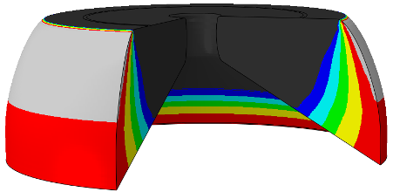
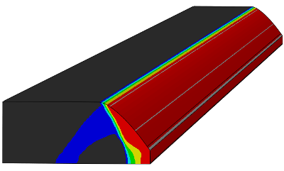
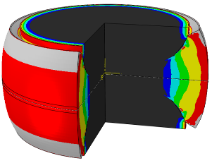
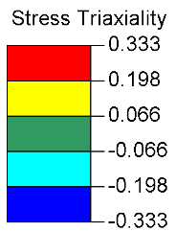
a)
c)
b)

Figure 1. Compressive test-pieces (a) double collar, (b) plane strain hexagon and (c) cylinder with conical hollow. The values higher and lower than those in the legend are grey and black respectively.

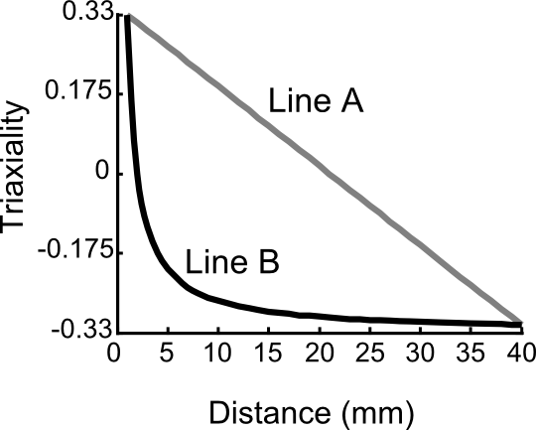
Figure 2. Graph of triaxiality with different spatial variations.

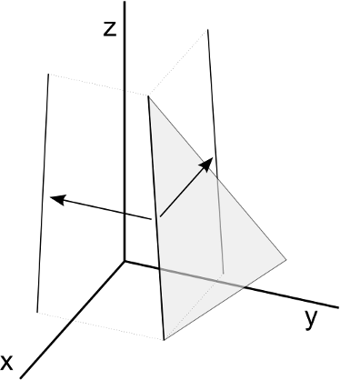
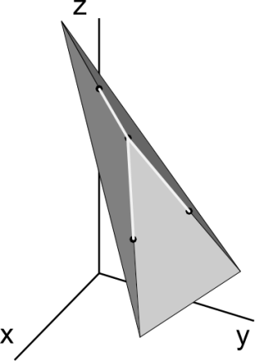
a)
b)

Figure 3. Calculating gradients at nodes (a) decomposition of line segments into z-x and z-y planes (b) applying calculated gradient to node using weighted average.

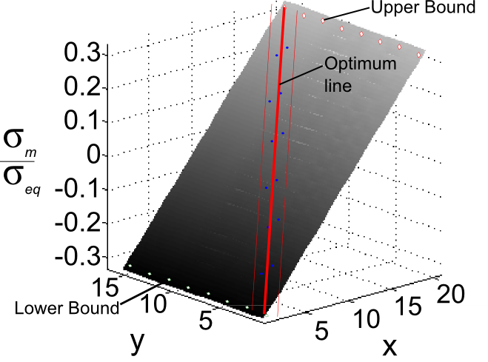
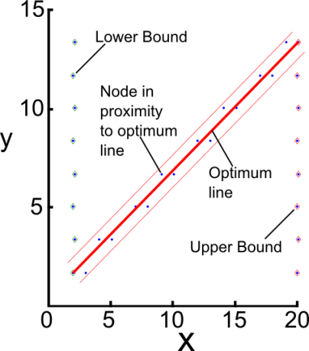
a)
b)

Figure 4. Plane with a range of triaxiality applied to its nodes (a) 3D image of plane (b) representation of the code’s output.

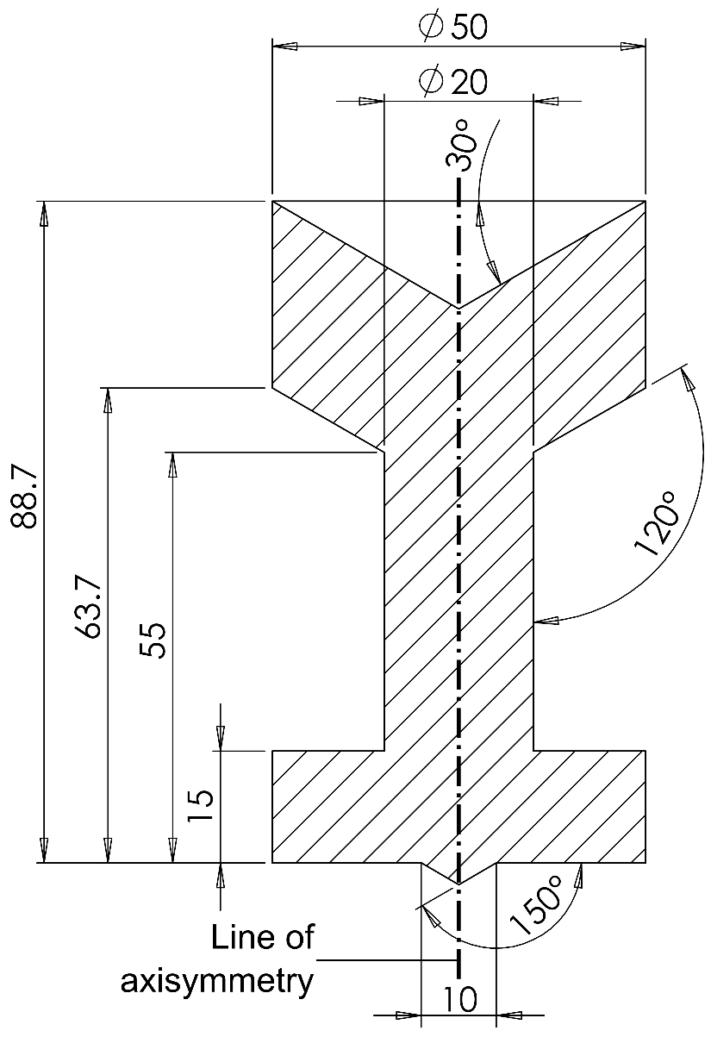
Figure 5. Chosen test-piece (units in mm).

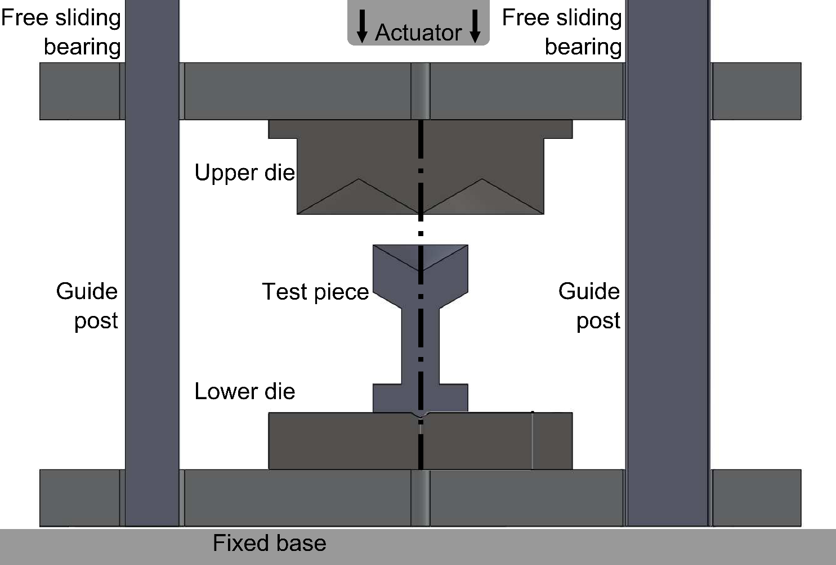

Figure 6. Section of die set and supporting rig and sample.

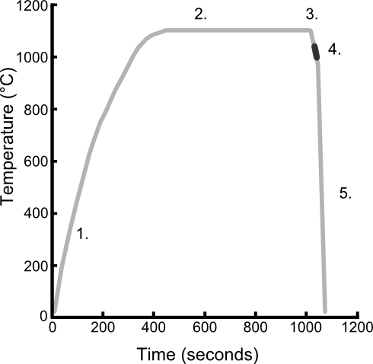
Figure 7. Temperature profile for heating and cooling the test-piece.
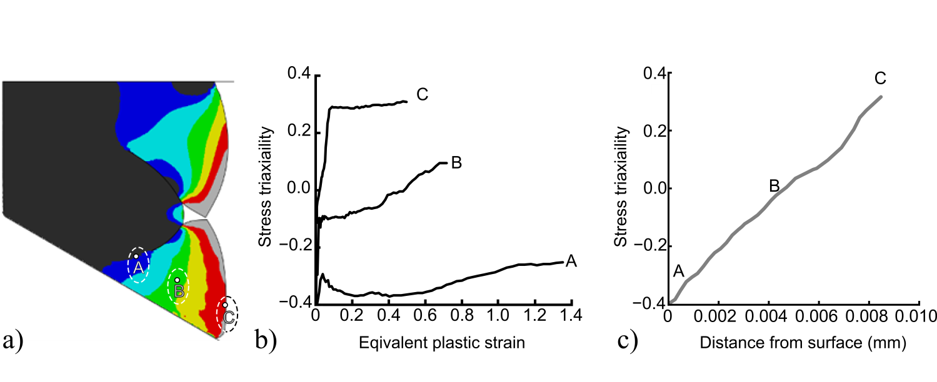
Figure 8. Distribution of triaxiality in the deformed test-piece a) finite element analysis (FEA), b) during deformation at three highlighted points and c) between two points in FEA.

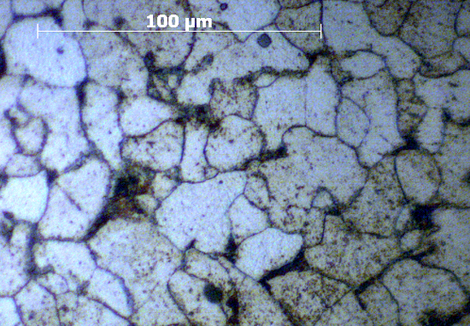
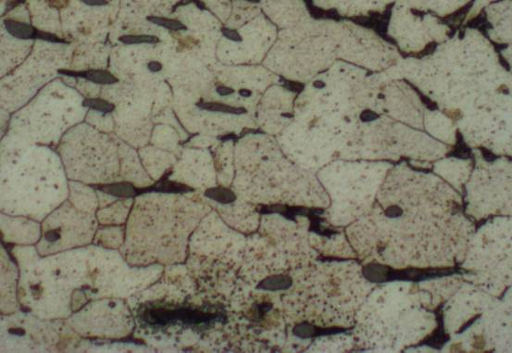
(b)
(a)

Figure 9. Two types of damage found; (a) fast low temperature test showing intragranular damage and (b) slow high temperature test showing mainly intergranular damage (scale is the same in both images).

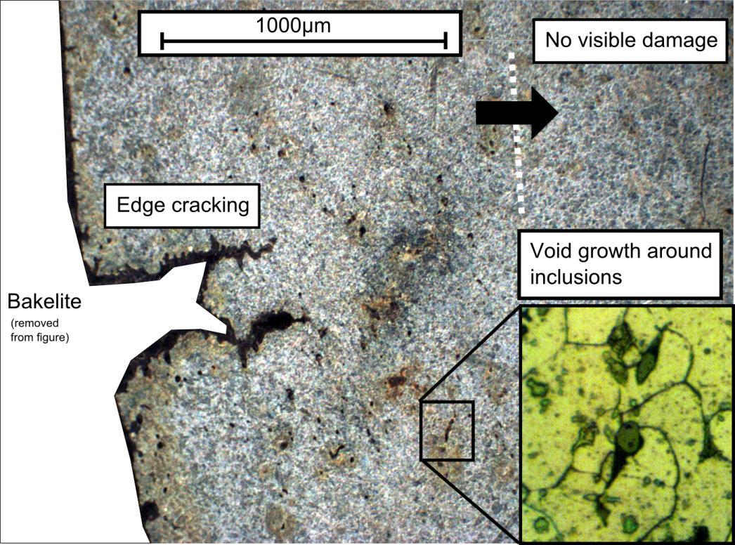
Figure 10. Damage distributed in section of deformed test-piece

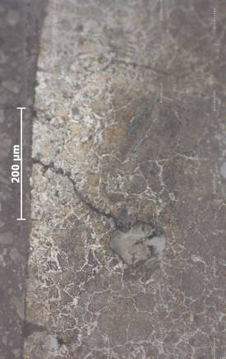
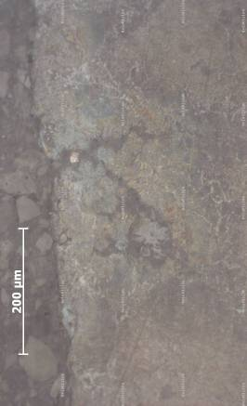
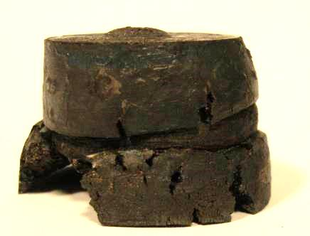
Not-ideal Ideal

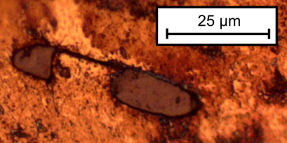

b)
c)
a)

Figure 11. a) Deformed test-piece showing localised damage due to as cast-porosity b) Inclusions close to the surface accelerating damage from current test-piece design c) Inclusion cracking observed near the center of the deformed test piece, where hydrostatic stress is compressive.

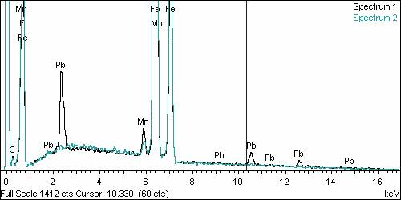
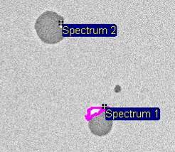
Figure 12. Variation in the LFCS distributions of lead at inclusion boundaries.

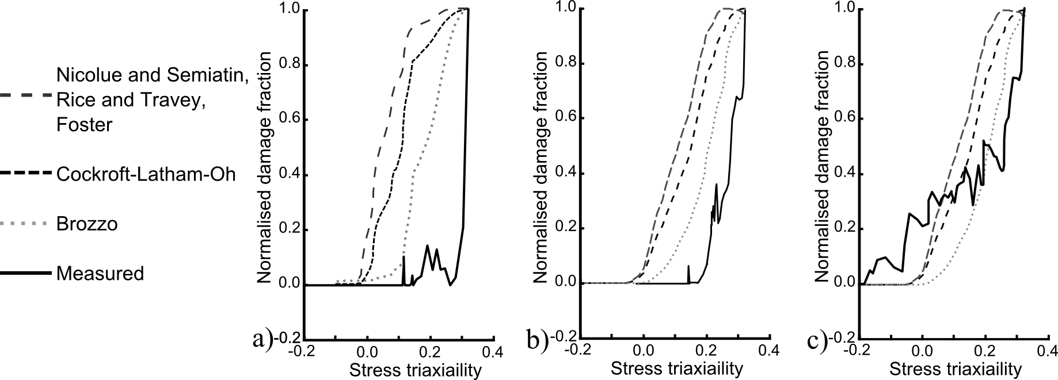
Figure 13. Inclusion related damage versus stress triaxiality in the: (a) high-rate test and (b) low-rate test; (c) grain boundary damage in the low-rate test.

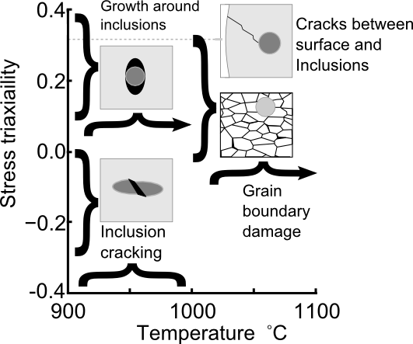
Figure 14. Damage mechanisms at various triaxialities and temperatures; arrows indicate the mechanism found up to melting.

Table 1. Values of the material constants.
Constant (units) | K (MPa s^{1/n}) | k₀ (MPa) | Q_{p} (J) | n | A(-) | R_{g} (J K⁻¹ mol⁻¹)
Value | 11.0 | 0.2 | 4.21×10⁴ | 1.7 | 2.8 | 8.314
Constant (units) | c₁ (s⁻¹) | Q_{c} (J) | c₂ (-) | B₀ (MPa) | E₀ (MPa) | K₁ (1/T)
Value | 1 | 4.23×10⁴ | 0.75 | 176 | 8.8×10³ | 3.1×10⁻³

Table 2. Comparison of several test-piece designs’ stress triaxiality distributions during deformation.
Original geometry  (dimension in mm) |  | Deformed geometry  (optimum line highlighted) | Line length (mm) | Standard deviation of gradient | Percentage (max) variation at node with highest stress triaxiality
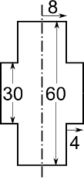 |  | - 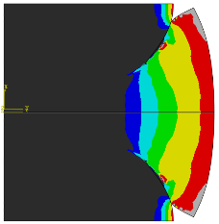 | 8.25 | 4.311 | 24%  Max: 0.368  Min: 0.279
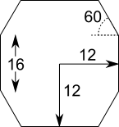 |  | - 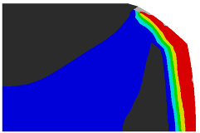 | 6.21 | 0.563 | 6%  Max: 0.330  Min: 0.317
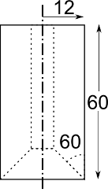 |  | - 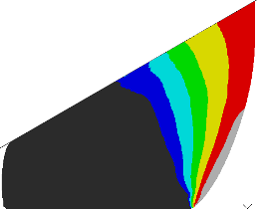 | 12.95 | 0.011 | 37%  Max: 0.307  Min: 0.149
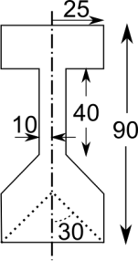 |  | - 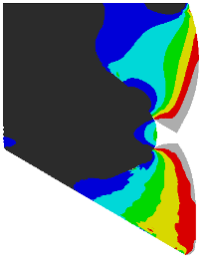 | 9.03 | 0.039 | 13.10%  Max: 0.306  Min: 0.266

Table 3. Chemical composition of leaded free cutting steel (LFCS).
Chemical | C | Si | Mn | P | S | Other
%weight | 0.07 | 0.01 | 1 | 0.05 | 0.3 | (Pb)

Department of Mechanical Engineering, Imperial College London, London SW7 2AZ, UK ²Tata RD&T UK, Swinden Technology Centre, Moorgate RD, Rotherham, South Yorkshire, S60 3AR, UK Corresponding author: D. Balint, Email: d.balint@imperial.ac.uk

