Mass Spectrometry Approaches to Metabolic Profiling of Microbial Communities within the Human Gastrointestinal Tract

Simon JS Cameron¹ and Zoltán Takáts^{1*}.

(1) Division of Computational and Systems Medicine, Institute of Integrative Systems Medicine and Digestive Diseases, Department of Surgery and Cancer, Faculty of Medicine, Imperial College London, United Kingdom

* Communicating Author: Zoltán Takáts (z.takats@imperial.ac.uk)

Acknowledgements: Work within the Takáts group is supported by a Biotechnology and Biological Sciences Research Council (BBSRC) grant (reference number BB/L020858/1), the European Research Council under contract number 617896, and the Waters Corporation.

Declaration of Interests: ZT provides remunerated consultancy to the Waters Corporation.

Abstract

The interaction between microbial communities and their environment, such as the human gastrointestinal tract, has been an area of microbiology rapidly advanced, by developments in sequencing technology. However, these techniques are largely limited to the detection of the taxonomic composition of a microbial community and/or its genetic functional capacity. Here, we discuss a range of mass spectrometry-based approaches which researchers can employ to explore the host-microbiome interactions at the metabolic level. Traditional approaches to mass spectrometry are detailed, alongside new developments in the field, namely ambient ionisation mass spectrometry and imaging mass spectrometry, which we believe will prove to be important to future work in this field. We further discuss considerations for experimental workflows, data analysis options and propose a methodology for the establishment of causal relationships between functional host-microbiome interactions with regards to health and disease in the human gastrointestinal tract.

Highlights
- Mass spectrometry provides an ideal tool for metabolic profiling of microbial communities
- Wide range of approaches suited for different metabolites of interest
- Field of ambient ionisation mass spectrometry highly promising for rapid analysis
- Experimental approach needed to separate correlation and causality

Glossary of Key Terms and Abbreviations

Amplicon Sequencing Sequencing of PCR amplification products of marker genes
CE-MS Capillary electrophoresis mass spectrometry
DESI-MS Desorption electrospray ionisation mass spectrometry
DNA Deoxyribose nucleic acid
GC-MS Gas chromatography mass spectrometry
HPLC High performance liquid chromatography
IMS Imaging mass spectrometry
LC-MS Liquid chromatography mass spectrometry
LESA-MS Liquid extraction surface analysis mass spectrometry
m/z Ratio Mass-to-charge ratio
MALDI Matrix assisted laser desorption ionisation
Metabolic Profiling Measurement of the entire complement of metabolites within a sample
Metagenomics Sequencing of the collective total of genes and genomes within a sample
Meta-Taxonomics Taxonomic characterisation of all microorganisms present within a sample
Microbiome Entire habitat including microorganisms, their genomes, and their environment
MS Mass spectrometry
NMR Nuclear magnetic resonance
REIMS Rapid evaporative ionisation mass spectrometry
RNA Ribonucleic acid
SIMS Secondary ion mass spectrometry
UPLC Ultra performance liquid chromatography

1. Moving beyond meta-taxonomics to explore host-microbiome functional relationships

1.1. Meta-taxonomics explores composition but not metabolic functionality of microbial communities: Microbial communities exist as a complex interaction between microorganisms, such as bacteria, fungi, viruses, protozoa, and parasites, and their environment. Traditional approaches to microbiology have been reliant on the isolation and culture of single colonies on solid agar plates to analyse species presence and abundance, and biochemistry. However, this approach is severely limited by current approaches to microbial culture. Estimates can vary considerably, but it is accepted that culture-based methods are only capable of isolating a minority of species [1]. Since the establishment of next generation sequencing techniques, initiated primarily by the pyrosequencing Roche 454 platform [2], researchers interested in microbial community profiling have relied on these methods as a foundation for their work. Due to the limitations of currently available culturing techniques [3], researchers have found wide utility in the use of DNA sequencing of polymerase chain reaction (PCR) amplification products targeting ribosomal RNA genes and other essential housekeeping genes to determine the taxonomic composition of the microbial communities present within a sample [4]. This has revealed a number of novel links between microbial community composition and disease state in humans, including obesity [5], inflammatory bowel disease [6], colorectal cancer [7], chronic obstructive pulmonary disease [8], and asthma [9]. However, as a result of the observational nature of these techniques, they alone are not enough to prove either a causal link, or elucidate mechanisms of interaction. This is essential in terms of validating changes in microbial community structure as biomarkers of disease [10], for establishing their potential role in disease aetiology [11], and their potential utility in disease treatment [12].

1.2. Moving beyond meta-taxonomics using sequence-based approaches: Exploring the functional relationship between microbiome and host and how this corresponds to disease was a pressing issue even before the introduction of next generation sequencing. In fact, it was originally identified by Theodore Escherich in his study of infant diarrhoea as a potential explanation of why some bacterial strains readily cause disease, whilst some exist as harmless commensal bacteria [13]. The lack of functional information obtained through traditional approaches or sequencing of PCR amplicons has, to some extent, been addressed by assigning functional capabilities to 16S rRNA based taxonomies. Examples of such tools include Tax4Fun [14] and phylogenetic investigation of communities by reconstruction of unobserved states (PICRUSt) [15]. These techniques have been widely used by researchers to expand the potential information obtained by amplicon sequencing through the assignment of predictive gene functions to marker genes, such as 16S rRNA gene amplicon sequences, from a database of reference genome sequences. However, at their core, they rely on the observational nature of amplicon sequencing and cannot therefore, provide evidence for the causative link between microbiome and functional host-microbiome interactions. Furthermore, due to the limitations of current sequencing techniques, primarily in the length of sequences which can be obtained, amplicon sequencing approaches are typically limited to the genus level of taxonomic resolution [16]. Due to the considerable variation within genera, such as between pathogenic and non-pathogenic species of the same genus, this ultimately means that a large volume of functional differences may be overlooked [17].

Due to advances in DNA sequencing technology, particularly regarding sample throughput and sequence depth and coverage, an alternative to sequencing of PCR amplicons has emerged within the field. Metagenomic sequencing, whereby all of the DNA present within a sample, regardless of biological origin, is sequenced, has become more widely used by researchers within the field. Although frequently used to describe amplicon sequencing-based meta-taxonomic studies, metagenomic sequencing is becoming a powerful tool to explore the functional component of the interactions between microbial communities and their environment. Due to the non-targeted nature of metagenomic sequencing, the technique can be used to observe changes in the genetic arsenal of the microbiome which may be indicative of evolutionary changes driven by environmental conditions; such as those caused by disease initiation and progression. The technique has been used to show that the functional capacity of the gastrointestinal microbiome alters in response to new-onset Crohn’s disease and may be a driver of inflammation [18], and that the lung microbiome in patients with chronic obstructive pulmonary disease increases its capacity for bacterial growth and potentially decreases the host’s ability to control inflammation [19]; which is an important factor in disease progression. Although metagenomic studies have the potential to expand the information obtained from sequencing-based approaches to microbial community profiling from meta-taxonomic abundance to functional capability, they are still limited by measuring the genetic capacity of the community. This does not necessarily relate directly to the expression of genes and to the production of proteins (see for Aebersold et al., [20] and VerBerkmoes et al., [21] for comprehensive reviews) and metabolites, and as these have been shown to be at the interface of host-microbiome interactions, a thorough understanding of their presence, concentration, and spatial and temporal variability is essential in establishing how microbial communities functionally relate to disease aetiology, progression, and potential treatment. There are also issues related to the establishment of sequence-function relationships – the mapping of biochemical function to DNA sequences – particularly as there has been a lack of research regarding difficult-to-culture microorganisms, resulting in many predicted coding regions possessing unknown functions [22].

1.3. The potential of metabolic profiling to explore functional capacity of microbial communities: Metabolic profiling is the technique used for the measurement in biological systems of the range of low-molecular-weight metabolites that reflects the response of the system to a range of internal and external pressures and stimuli. Metabolic profiling can be accomplished via two different spectroscopic approaches, nuclear magnetic resonance (NMR) spectroscopy and mass spectrometry. Employing NMR-based approaches carries a number of advantages including reproducibility, non-destructive sample analysis, and the relative ease of metabolite identification. As we will not cover NMR-based approaches here, for a comprehensive review of practical NMR-based approaches to metabolic profiling, we recommend Beckonert et al., [23]. Mass spectrometry is widely used in the study and analysis of microorganisms, including microbial metabolomics [24], and in clinical pathogen identification [25], and has already been shown to be a powerful analytical tool. Its use in metabolic profiling of microbial communities is gaining traction within the field and holds great promise in elucidating functional host-microbiome relationships.

In this review, we will explore a wide range of mass spectrometry based approaches which can be employed by researchers for metabolic profiling of microbial communities. We focus on the separation techniques which are frequently coupled to mass spectrometry analysis as this presents the greatest area of scope for flexibility in the approach researchers can take in determining the metabolic composition of a sample. We discuss both traditional approaches of metabolic profiling in conjunction with developing areas within the field including imaging mass spectrometry and ambient ionisation mass spectrometry alongside strategies which can be adopted for data evaluation and integration. Finally, we will suggest a methodological workflow to establish functional relationships between microbiome and host, and how these relate to disease biomarkers, aetiology of disease, and disease treatment. We hope that this review equips readers and researchers within the field with an appreciation of the diverse range of analytical tools employing mass spectrometry available to them to explore the functional aspect of microbial communities and their interaction with their environment.

2. Mass spectrometry based approaches to metabolic profiling of microbial communities

As a field, mass spectrometric metabolic profiling is typically advanced by improvements in instrumentation, such as higher levels of sensitivity, resolution, and dynamic range of analytical measurements. Here, we focus on the range of approaches which can be coupled with mass spectrometry analysis, namely direct infusion/injection (DI), liquid chromatography (LC), gas chromatography (GC), capillary electrophoresis (CE), and matrix assisted laser desorption ionisation (MALDI) as this offers the widest flexibility in terms of analytical approach. Each method carries both benefits and drawbacks which should be considered when choosing a platform and methodology for analysis. An overall comparison of different mass spectrometry approaches to metabolic profiling of microbial communities is given in Table 1, alongside examples of studies completed using each of the methods in Table 2.

2.1. Overview of mass spectrometry instrumentation: Mass spectrometry is a molecular spectroscopy technique which analyses atomic or molecular species as gas-phase ions and performs the analysis based on their different mass-to-charge (m/z) ratios. This results in a mass spectrum which plots the ion abundance as a function of the m/z ratio. Mass spectrometry is often coupled with a chromatographic technique to separate the chemical constituents of a sample based on their physical and/or chemical properties prior to MS analysis. Chromatography carries a number of benefits, the primary of which is arguably a reduction in matrix associated ion suppression events. Causes of ion suppression differ between different ionisation methods. The use of chromatographic separation prior to ion formation reduces the molecules which are present at the ion source, reducing competition between molecules and thus the potential for ion suppression; improving the precision, sensitivity, and limit of detection of mass spectrometric analysis. As shown in Figure 1, mass spectrometry analysis is performed in five steps. Firstly, the sample is introduced into the mass spectrometer, after which ions are generated using a variety of techniques including electron ionisation (EI) [26], chemical ionisation (CI) [27], electrospray ionisation (ESI) [28], matrix assisted laser desorption ionisation (MALDI) [29] or atmospheric pressure chemical ionisation (APCI) [30]. After ions are formed, they are transported into the vacuum of the mass spectrometer through the use of ion optic systems which focus and control ions through the use of electric and/or magnetic fields. The ions are then separated by the mass analyser under vacuum based on their mass-to-charge ratio; either in time or space and detected separately. Example of these techniques include time-of-flight (ToF) [31], ion traps [32], quadrupoles [33], and magnetic sector [34] mass analysers. Alternatively, the ions can also be trapped between two electrodes and the current induced by the orbiting charges used for non-destructive detection of m/z ratio following Fourier transformation of the signal. Frequently used mass analysers of this type include Fourier transform ion cyclotron resonance (FT-ICR) [35] and Orbitrap® [36] systems. The mass spectrometric signal translates to a two-dimensional representation of mass-to-charge ratios against the frequency of detection of ions with that particular mass-to-charge ratio.

2.2. Considerations in conducting metabolic profiling experiments using mass spectrometry: Regardless of the choice of mass spectrometric approach chosen for metabolic profiling analysis of microbial communities, considerations regarding experimental workflows are universal. As shown in Figure 2, there are six steps which should be considered by researchers: sample type and sampling method, sample processing, metabolite extraction, separation steps (if any), mass spectrometric ionization method and analyser and finally data processing and analysis.

The human gastrointestinal tract is an enclosed system which makes direct sampling difficult without invasive procedures such as endoscopy [37]. For this reason, the majority of studies exploring host-microbiome functional interactions have used faeces as an indirect sampling method. An important consideration here is that to ensure an accurate representation of microbial community functional activity is measured using mass spectrometry, metabolic activity of the microbiome should be quenched through ultralow temperature freezing or through the use of a chemical suppressor, such as sodium azide [38], as soon as possible. Although sample processing before this can be completed, such as centrifugation or filtering, it should be noted that there is a varied response of different microorganisms to exposure to atmospheric and temperature conditions outside of the gastrointestinal tract [39], which may alter the metabolic profile obtained through later analysis. Typically, whole faecal samples are frozen in liquid nitrogen or in an ultralow temperature freezer (≈ -70 to -80°C) and then subjected to metabolite extraction using a solvent such as chloroform, methanol, or water – either as frozen material or after thawing. Depending upon the nature of the sample, and particularly if quantitative comparisons are to be made between metabolic profiles, it may be necessary to remove the water content of the sample through freeze-drying. This may be particularly important when comparing the metabolic activity of microbial communities associated with inflammation or diarrhoea [40], but may result in the loss of certain metabolites, particularly those which are volatile [41]. Prior to solvent extraction, mechanical disruption of a sample may be used to homogenise the sample and to release intracellular metabolites. This will likely aid in sample handling, but may introduce an element of bias as mechanical disruption may, for example, cause heat damage to metabolites or preferentially lyse different microorganisms. The choice of solvent is likely to be the main determinant of the metabolites extracted with organic solvents potentially leading to a reduction in the extraction of hydrophilic products, with water showing the broadest range of metabolite extraction efficiency, particularly with regards to microbiome-related metabolites [40].

2.3. Direct infusion/injection mass spectrometry (DI-MS): DI-MS is arguably one of the simplest methods which can be used in metabolic profiling as it requires minimal sample preparation and run time; primarily as a result of no chromatographic separation being completed on the sample. This method details the injection of a sample directly into the ionisation source of the mass spectrometer, typically electrospray ionisation [42], using a syringe pump with the mass spectra either summed or averaged over the scan range of each sample. As a result, DI-MS is a high-throughput approach allowing a sample to be analysed in a few minutes which reduces sample-to-sample variability and maximises reproducibility. However, as a result of no chromatographic separation prior to introduction to the mass spectrometer, DI-MS suffers from an inability to distinguish between chemical isomers and also from ion suppression which can significantly alter the resulting mass-to-charge signal to such an extent that biological variation is suppressed [43]. A different configuration of DI-MS is that of flow-infusion electrospray ionisation mass spectrometry (FIE-MS). This differs in that the sample is infused with a solvent and injected into the electrospray source of the mass spectrometer using a liquid chromatography pump. Typically with this approach, mass spectra are summed or averaged over the scan range collected over the infusion period; prior to the background signal being restored [44]. DI-MS has been coupled with both nominal mass resolution mass spectrometers [45] and high resolution instruments [46] in the study of microbial metabolism, but to date has seen little use in the direct metabolic profiling of microbial communities within the human gastrointestinal tract.

2.4. Liquid chromatography mass spectrometry (LC-MS): LC-MS is one of the most widely used methods in metabolic profiling due to the benefit of chromatographically separating compounds prior to their introduction into the mass spectrometer; overcoming the issue of ion suppression encountered whilst using DI-MS, and also allowing the separation of isomers based on their elution through the chromatographic column. There are a variety of different chromatographic approaches which can be employed whilst using LC-MS which can target particular compound classes based on their chemical and/or physical properties. Normal-phase chromatography separates analytes based on their affinity for polar stationary surfaces, the dominant material used being silica, whilst moving in a mobile phase of a non-polar, non-aqueous solvent. The separation of analytes is driven by polar interactions, such as hydrogen bonding, but is also affected by the presence of functional groups and steric factors; allowing the method to resolve isomers [47]. In recent years, hydrophobic interaction chromatography (HILIC) has emerged as a widely used technique that combines features of normal-phase chromatography with other methods such as ion chromatography and reversed phase liquid chromatography and elutes analytes in increasing polarity. Typical mobile phase solvent for HILIC is a mixture of acetonitrile and small quantities of water; where additives can also be added to differentially change target analyte retention [48]. Reversed-phase chromatography, in comparison to normal phase, uses a non-polar stationary phase with an aqueous polar mobile phase and separates analytes based on their hydrophobic interactions, with polar molecules eluting earlier and less polar molecules being retained on the column for longer. Typically, with reversed-phase chromatography: silica is the most common stationary phase which has been modified with a straight chain alkyl group: typically, C₁₈H₃₇ or C₈H₁₇. Due to the longer chain length, C₁₈ columns show improved retention of non-polar compounds [49]. For both normal-phase and reversed-phase chromatography, analyte separation can be affected by the internal diameter of the LC column, with smaller diameters improving sensitivity, much reducing the volume of sample which can be loaded. Particle size is also important, with smaller particles providing a greater surface area and thus interaction potential, leading to improved separation [50]. Other methods of chromatographic separation used in LC-MS include size-exclusion chromatography (separation of analytes by molecular size [51]), ion-exchange chromatography (separation based on interaction between analytes and charged sites bound to stationary phase [52]), and affinity chromatography (separation based on highly specific interaction between analytes and receptor bound to stationary phase [53]). LC-MS is frequently coupled with high resolution mass spectrometers for metabolic profiling, including both time-of-flight [54] and Orbitrap® [55] instruments in the study of the microbial components of human gastrointestinal tract samples.

2.5. Gas chromatography mass spectrometry (GC-MS): GC-MS is a powerful tool for the study of volatile metabolites as it provides high-chromatographic resolution, and potential quantification of compounds using internal standards. For non-volatile metabolites, GC-MS typically employs derivatisation of metabolites through alkylation, acylation, or sialylation of hydrogen atoms in functional groups including -COOH, -OH, -NH, and -SH and for carbonyls, oximation followed by sialylation is used. In metabolic profiling, the most frequently utilised derivatizing agents including BSTFA (N, O-bis-(trimethylsilyl)trifluoroacetamide) and MSTFA (N-ethyl-trimethylsilyl trifluoroacetamide) [43]. However, these derivatizing agents are highly sensitive to water content, thus necessitating the thorough drying of samples before analysis can be completed. After sample preparation, samples for GC-MS analysis undergo chromatographic separation, which can typically take between ten and 60 minutes, and subsequent mass spectrometry analysis using either time-of-flight instruments or quadrupole instruments. Due to the presence of high numbers of volatile compounds within the gastrointestinal tract, GC-MS has been widely used in the metabolic profiling of microbial communities, typically targeting short chain fatty acids (SCFAs) of microbial origin [56].

2.6 Capillary electrophoresis mass spectrometry (CE-MS): CE-MS is a technique which has not seen as wide use as either DI-MS, LC-MS, nor GC-MS, but is particularly suited to the analysis of charged metabolites, which other methods can struggle with. It employs liquid separation by applying a high voltage electrical current to a sample, resulting in metabolites being separated according to differences in their electrophoretic mobilities and structural form. CE-MS is typically coupled with electrospray ionisation to generate ions for mass spectrometry analysis. CE-MS is a technique which can be used for highly targeted analysis and has high resolving power; potentially allowing the separation of isobaric and isomeric compounds. However, the technique can have lower sensitivity than other techniques and run times can be considerable. As a metabolic profiling technique, CE-MS has not seen wide use in terms of microbial community metabolic profiling of the human gastrointestinal tract. It has however, shown utility in other areas including urine analysis [57], cancer biomarker discovery [58-62], and quantitative analysis of cancer microenvironments [63] suggesting it may be a powerful and useful tool for researchers exploring host-microbiome interactions in the human gastrointestinal tract.

2.7 Matrix assisted laser desorption ionisation mass spectrometry (MALDI-MS): MALDI-MS is an approach that has seen widespread use in mass spectrometry analysis of microorganisms, but limited use in metabolic profiling when compared to techniques such as LC-MS and GC-MS. In MALDI-MS analysis, a sample is applied to a metallic target plate and overlaid with a matrix containing crystallised molecules. The matrix is capable of absorbing laser energy which triggers ablation and desorption of the sample and matrix material into a plume which is then analysed using a mass spectrometer. As a technique, MALDI-MS is well suited to the analysis of a wide range of molecules, such as proteins and metabolites. It is also beneficial in that it requires minimal sample and is high-throughput compared to LC-MS and GC-MS methods – although it can be coupled with these chromatographic techniques. MALDI-MS has seen wide utilisation in the analysis of microorganisms as a diagnostic tool in clinical microbiology, where mass spectral fingerprints of mainly ribosomal proteins are used in species identification [25, 64, 65]. However, as this review focuses on metabolic profiling of microbial communities, rather than proteome analysis, this will not be widely covered. Although MALDI-MS has been used in the metabolic phenotyping of biological material including urine [66] and tissue [67], it has not been widely applied to the metabolic phenotyping of microbial communities nor gastrointestinal tract samples. It has however, seen frequent utilisation as a method in mass spectrometry imaging of microorganisms (discussed in detail in Section 4), for which it has wide applicability.

3. Ambient ionisation mass spectrometry as a rapid metabolic profiling tool

3.1. Ambient ionisation mass spectrometry allows analysis of sample in its native form: The field of ambient ionisation mass spectrometry (AIMS) is a collective term for techniques which do not require any sample pre-treatment or introduction of the sample into the mass spectrometer [68]. Interest and widespread use of techniques within the field of AIMS was triggered with the publication of a number of novel ambient ionisation methods including direct analysis in real time (DART) [69] and desorption electrospray ionisation (DESI) [70]. The attractions of AIMS methods to metabolic profiling of microbial communities are numerous and revolve around the elimination of sample pre-treatment, such as metabolite extraction, which reduce the potential introduction of bias and minimise any adverse effects of removing the microbial community from their natural environment, and sample throughput. As shown in Figure 3, due to the lack of sample extraction and chromatographic separation, AIMS methods are capable of sample analysis in the scale of seconds, whilst traditional techniques such as LC-MS, GC-MS, and CE-MS are in the scale of minutes and hours. Nevertheless, although some AIMS techniques are capable of generating mass spectral data within a second, several seconds of data acquisition may be required to achieve a sufficient signal-to-noise ratio. Here, we discuss two ambient ionisation techniques which we believe are well suited to metabolic profiling of microbial communities and outline emerging techniques in the field which may also provide utility to researchers.

3.2. Desorption electrospray ionisation mass spectrometry (DESI-MS): DESI-MS is a surface analysis method where electrically charged solvent micro-droplets are directed towards a sample surface, resulting in the formation of secondary ions upon impact. These secondary ions are then directed towards a mass spectrometer allowing almost instantaneous analysis. Characteristics of DESI-MS acquired mass spectra are highly similar to those acquired using conventional electrospray ionisation, but DESI-MS has additionally been shown to be able to detect non-polar compounds such as TNT, carotene, and cholesterol; which are generally not ionised under electrospray conditions [71]. Due to the rapid nature of DESI-MS analysis, it has been suggested as an ideal tool for rapid metabolic profiling [72]. With regards to microbial community profiling, it has seen multiple uses as a tool of direct analysis microbial colonies growing on agar petri dishes [73-79], but has not yet been directly applied to the metabolic profiling of microbial communities within the human gastrointestinal tract. Nevertheless, the work completed on microbial colonies shows the powerful nature of DESI-MS analysis, particularly in regard the ability of the approach to capture microbial metabolism in an ambient setting; thus, removing any potential bias introduced by sample preparation and extraction. Furthermore, due to the non-destructive nature of DESI-MS analysis, it would be possible to capture both microbial community meta-taxonomic data and metabolic profiling data from the same sample which would be highly beneficial in linking microbiome function to the presence or absence of particular microbial taxons.

3.3. Rapid evaporative ionisation mass spectrometry (REIMS): REIMS analysis is based on the rapid thermal evaporation of a biomass which produces molecular ions in their gaseous form [80]. Thermal evaporation of a sample can be completed using a range of heating modalities including joule heating, contact heating, and radiative heating using ultraviolet and infrared lasers [81]. These gaseous ions can then be aspirated directly into a mass spectrometer allowing mass spectra to be generated in near real-time speed. REIMS has primarily been developed as a tool for the real-time intraoperative identification of cancer margins during surgery [82]; which takes advantage of electrosurgical thermal disintegration of tissue routinely used in operating theatres. In the study of microorganisms, REIMS has seen use in the direct analysis of microbial cultures directly from agar culture plates [83-88], without the requirement for sample preparation. Due to the inherent ease of sample analysis using REIMS, it is highly suited to rapid metabolic profiling of samples, such as faeces, and can detect metabolites, such as fatty acids, which have previously been shown to be important in host-microbiome functional interactions. Figure 4 shows REIMS mass spectra acquired from faecal samples collected from healthy individuals and analysed using a monopolar electrode and a Xevo G2-XS QToF instrument operated in negative ion detection mode. The spectra were annotated using tandem mass spectrometry fragmentation showing the detection of bile acids and the presence of bacterial phospholipids – identified by the presence of odd chain fatty acid tails (Unpublished data provided courtesy of Simon JS Cameron and Zoltán Takáts). The detection of bacterial metabolites and host metabolites known to be involved in host-microbiome interactions [89] using REIMS suggests that this method could provide a rapid tool for the metabolic profiling of gut microbial communities, directly from sample and without any separation or pre-treatment. A particularly promising application area for REIMS research is in vivo microbial community metabolic profiling. Due to the enclosed nature of the gastrointestinal tract, sampling is difficult and thus, faeces is commonly used as an intermediate. However, it is likely that many aspects of host-microbiome metabolic interactions take place at the mucosal surface of the gastrointestinal tract and therefore, may not be detectable in faeces. Although tissue biopsies can be taken and analysed using REIMS, this method suffers from the same issues which occur with sample collection and storage and the changes in microbial metabolism as a result of removal from their natural environment. Analysis of tissue within the gastrointestinal tract would overcome these issues and has been shown to be possible using a modified endoscopy polypectomy snare whereby the snare is used to apply joule heating to gastrointestinal tissue [90]. Although not directly used for the analysis of microbial communities, a similar approach would potentially allow for the in vivo metabolic profiling of microbial communities directly at the host-microbiome interface.

3.4. Emerging techniques for metabolic profiling of microbial communities: DESI-MS and REIMS techniques are both powerful methodologies which could be applied to the metabolic profiling of microbial communities, but they are by no means the only AIMS techniques which could show utility in this application. One promising technique, named the “MassSpec Pen” uses a small droplet of water (4 to 10 µL) to extract metabolites from tissue which is then directly analysed using a mass spectrometer [91]. Similarly to REIMS, the “MassSpec Pen” is being developed as a method for intraoperative assessment of cancer margins, but due to its non-destructive analysis, may have further utility as an in vivo tool for metabolic profiling of microbial communities. To date, however, the “MassSpec Pen” has only been used to analyse human tissue ex vivo so its utility in this area is still to be established. In a similar fashion to water extraction used by the “MassSpec Pen”, liquid extraction surface analysis mass spectrometry (LESA-MS) employs micro-liquid extraction from a solid surface to analyse metabolites and proteins [92, 93]. LESA-MS has been applied to the study of microbial proteins [94] and metabolite production, including antibiotics [95], suggesting its potential utility in the functional study of microbial communities. Paper spray mass spectrometry may prove to be a useful technique for metabolic profiling of microbial communities. This ambient ionisation methods produces molecular ions through the application of a high voltage to a paper triangle which has been impregnated with a small volume (< 10 µL) of solution [96]. This technique has been shown to be capable of bacterial analysis by smearing the paper triangle with biomass [97] and also for the direct analysis of tissue biopsies [98]. Nanospray desorption electrospray ionisation mass spectrometry (NanoDESI-MS) is a highly promising technique for the analysis of microorganisms, and has seen utilisation in a number of studies of microorganisms grown directly from culture [99-101]. It works through the production of a liquid bridge between two capillaries – one to deliver a solvent and the other to aspirate the solvent towards the mass spectrometer - on the sample surface where analytes are desorbed into the liquid droplet. Unlike DESI-MS, as NanoDESI-MS does not use a high pressure gas for solvent focussing, it is particularly suited to the analysis of microorganisms growing directly on agar surfaces.

4. Imaging mass spectrometry allows spatially resolved metabolomics

4.1. Overview of imaging mass spectrometry: Traditional approaches to mass spectrometry rely upon the homogenisation of a sample prior to metabolite extraction and thus, effectively gives an average of the sample, even though there is likely to be spatial heterogeneity; particularly with regards to tissue samples [102]. When considering the interface of host-microbiome interactions, the spatial distribution of metabolites is likely to be of high importance; particularly with regards to those microorganisms that exist at the mucosal surface of the gastrointestinal tract or in a biofilm community structure [103]. Imaging mass spectrometry is suited to the mapping of the spatial distribution of metabolites as it is able to take a sample, such as a section of tissue taken from the gastrointestinal tract, and record the mass spectra obtained for each spatial unit, or pixel, of the sample. Imaging mass spectrometry has been widely used, for example, in exploring the spatial distribution of metabolites of colonies growing on agar culture plates, but little work has been completed directly on samples at the host-microbiome interface. Nevertheless, the work completed on agar plate cultures shows the power of imaging mass spectrometry and shows it is a tool that will likely be used to unravel the complexities of metabolic interactions between host and microbiome.

4.2. Mass spectrometry techniques suited to imaging mass spectrometry: There are currently three main mass spectrometry platforms which can be used in imaging mass spectrometry: secondary ion mass spectrometry (SIMS), matrix assisted laser desorption ionisation mass spectrometry (MALDI-MS), and desorption electrospray ionisation mass spectrometry (DESI-MS). These platforms differ by their mechanism of ionisation which is the key component of determining the spatial resolution, time taken for analysis, types of samples which can be analysed, and sample preparation methods in imaging mass spectrometry experiments. SIMS is the technique capable of the greatest degree of spatial resolution and is able to achieve resolution fine enough to image individual bacterial cells [104]. SIMS works by producing analyte ions from the surface of a sample by bombardment with high-energy particles, termed primary ions, which produces secondary ions that are analysed using mass spectrometry. SIMS requires minimal sample preparation except that it must be dry and stable within a vacuum, but these later principles typically mean that samples, such as colonies on agar, have to be imprinted onto a substrate suitable for SIMS analysis [105]. In a similar way, imaging mass spectrometry of microbial cultures using DESI-MS have to be transferred to a substrate suitable for analysis by the technique. Although this process has been shown to lead to signal enrichment of certain molecules, it also leads to the loss of certain molecules which may be important components of microbial metabolism [106]. However, unlike SIMS, DESI-MS is not capable of sub-cellular spatial resolution, but capable of < 40 µm and is able to detect metabolites over a wider mass-to-charge range. MALDI-MS appears to be the more frequently used method in imaging mass spectrometry of microorganisms, primarily as a result of its versatility but it does require the application of a ionisation matrix which is ablated using a laser during imaging analysis to aid desorption and ionisation of metabolites [102].

4.3. Insights into microbial metabolism using imaging mass spectrometry: As previously discussed, imaging mass spectrometry does not appear to have been used in the direct analysis of host-microbe interactions in human gastrointestinal samples; but has been employed in systems with comparable complexity. To date, imaging mass spectrometry using predominately MALDI-MSI has been used to study the metabolic interactions between two competing microorganisms [107-109] and to give insights into the host response of invasive methicillin-resistant Staphylococcus aureus infection; showing that a human copper-chelating protein is important in the response to pathogen invasion [110]. Likely as a result of the ease of sample collection, environmental samples including soil [111, 112] and marine sponges [112] have been widely explored using imaging mass spectrometry. The complexity of these systems is comparable to that of the human gastrointestinal tract, albeit less complicated with regards to sample collection, showing the utility of imaging mass spectrometry in elucidating the underlying biochemistry of host-microbiome functional interactions.
5. Data analysis methods in metabolic profiling of microbial communities

5.1. Data analysis methods for metabolic profiling data: Mass spectrometry based metabolic profiling generates considerable volumes of data with high numbers of variables. This presents challenges regarding data analysis as many currently used statistical techniques were developed for lower dimensionality data sets. As such, data analysis is arguably the greatest bottleneck in terms of metabolic profiling experiments, particularly when AIMS methods can generate mass spectral data in a matter of seconds. Currently, data analysis approaches to metabolic profiling data are multivariate in nature, whereby all variables are considered at once in modelling approaches, such as principal component analysis, and machine learning algorithms, including neural networks and Random Forest [113]. However, due to the nature of mass spectrometry analysis, differences across variables may not all be because of biochemical changes in the observed system but rather due to instrument differences, such as deterioration of chromatography column, or sample handling, such as differences in the number of freeze/thaw cycles. Therefore, one of the key challenges is identifying which variables are of biological interest, and which are not. Univariate analysis, whereby one variable is considered in data analysis at a time, is gaining popularity within metabolic profiling; although this means that complementary changes between multiple variables which are not significant individually, but are jointly, may be overlooked [114]. These data analysis approaches do not consider the issues in combining datasets on the functionality and the taxonomic composition of microbial communities. However, they are likely to identify mass-to-charge ratios of interest which are indicative of biological differences of interest, such as disease state, the identification of which may reveal perturbed pathways which can be further analysed to explore functional host-microbiome interactions.

5.2. Metabolite identification is essential for biochemical interpretation: The majority of mass spectrometry approaches result in total ion counts as a function of mass-to-charge ratios. This is termed a metabolite fingerprint and may hold enough information to be able to discriminate between biological classes of interest. However, the data at this point is uninformative if the underlying question is to explain functional host-microbiome relationships. Therefore, assigning metabolite identification to mass-to-charge ratios is essential in identifying biochemical pathways which may differ between biological classes, and is fundamental with regards to intervention for disease prevention and/or treatment [115]. The ease of metabolite identification depends on the mass spectrometry approach adopted. For example, chromatographic separation prior to mass spectrometry analysis gives a third dimension of retention time which can be used for metabolite identification as it is indicative of chemical and/or physical properties. For mass spectrometry methods, tandem mass spectrometry (MS/MS) can be employed to provide further information towards identification of a mass spectral peak. In tandem mass spectrometry, either two (or more) mass analysers are combined, such as a quadrupole with a time-of-flight (Q-ToF) or two time-of-flights (ToF-ToF), or an ion trap with a mass analyser, such as with FT-ICR, are used. Typically, the first component is used to select an ion of interest, which can then be subjected to collision induced disassociation (CID). This fragments ions via introduction to a collision chamber, which is usually filled with collision gas, with the resulting mass fragments analysed using the second mass analyser component of the system. The distribution of these resulting fragments can then be used for structural elucidation [116]. However, it is arguable that these three approaches are only capable of tentative identifications and the only method truly capable of conclusive metabolite identification is the introduction of a metabolite standard into the sample matrix to show that its fragmentation mirrors that of the tentatively identified ion. Although not the subject of this review, nuclear magnetic resonance (NMR) spectroscopy has widely been used in metabolite identification, but as a metabolic profiling technique its analytical power is limited when compared to mass spectrometry. However, due to its strength in metabolite identification and reproducibility of data acquisition, it has been coupled to LC-MS workflows whereby a splitter is used to collect and concentrate fractions following LC separation to allow NMR structural elucidation to be completed offline, following mass spectrometry analysis [117].

5.3. Integration of multi-‘omic data sets: Metabolic profiling is, in addition to genomics, transcriptomics, and proteomics, one of the four pillars of systems biology. Discussion on data analysis strategies for metabolic profiling have examined these data sets in isolation. However, for the truly functional profiling of microbial communities, it will be necessary to integrate metabolic profiling data with data from these other areas in multi-‘omic analysis [118]. It is likely that currently available statistical analysis tools and methods used in metabolic profiling and microbiome sequence analysis, such as multivariate analysis and univariate statistics, will prove to be useful, but not wholly sufficient to meet this complex challenge. To date, interesting work has been completed on integrating multi-‘omic data sets including using pairwise comparisons [119] and correlation analysis [120]. However, these methods are incapable of establishing causal relationships over correlating abundances of microorganisms and metabolites; although this is largely due to the observational nature of the experimental design and methods for data collection. Moving beyond this limitation will necessitate changes in experimental approach in addition to the development of new statistical analysis methods.

6. Concluding remarks

Microbial community profiling has been considerably advanced through the introduction of next generation sequencing technologies; giving novel insights into the relationship between the human gastrointestinal tract microbiome and health and disease. However, these techniques are limited in their ability to only catalogue the presence of microbial taxons which are present and their genetic capability in terms of function. Metabolic profiling is a powerful technique to supplement microbial community profiling using DNA sequencing as it offers the opportunity to explore the functional interaction at the metabolic levels between host and microbiome. To date, the majority of experimentation into this area has focused on traditional mass spectrometry approaches coupled to a separation technique, such as liquid or gas chromatography. In addition to these powerful techniques, we believe the emerging technologies of ambient ionisation mass spectrometry and imaging mass spectrometry will prove to be ‘game changers’ in the field. This is due to their ability to generate mass spectral data from a sample in its native environment, avoiding the introduction of sampling bias which may obscure the biochemical interactions between host and microbiome.

Although metabolic profiling presents a useful tool for exploring the functional aspect of host-microbiome interactions, it is similar to DNA sequencing approaches in that it is observational in nature. In our opinion, to establish causal relationships between metabolic interactions regarding disease aetiology, diagnosis, and potential treatment, an alteration to experimental approach will be required. As we summarise in Figure 5, it is likely that observational studies will continue to be the starting point for hypothesis development based upon identification of differential metabolites and thus the biochemical pathways which have been perturbed. These hypotheses can then be examined using metabolic flux analysis and/or cell culture studies and validated in model organism studies. To show that a metabolite of interest is essential in driving biochemical changes, such as disease aetiology, intervention studies and/or gene knockout studies are required to show that in the absence of these metabolites, the originally observed effect is absent. Following this, the establishment of safety, efficacy, and long-term effects must be completed through clinical trials.

References

[1] J.D. Oliver, Recent findings on the viable but nonculturable state in pathogenic bacteria, FEMS microbiology reviews 34(4) (2010) 415-425.
[2] A. Ahmadian, M. Ehn, S. Hober, Pyrosequencing: history, biochemistry and future, Clinica chimica acta 363(1) (2006) 83-94.
[3] L. Ranjard, F. Poly, S. Nazaret, Monitoring complex bacterial communities using culture-independent molecular techniques: application to soil environment, Research in Microbiology 151(3) (2000) 167-177.
[4] S. Shokralla, J.L. Spall, J.F. Gibson, M. Hajibabaei, Next‐generation sequencing technologies for environmental DNA research, Molecular ecology 21(8) (2012) 1794-1805.
[5] P.J. Turnbaugh, M. Hamady, T. Yatsunenko, B.L. Cantarel, A. Duncan, R.E. Ley, M.L. Sogin, W.J. Jones, B.A. Roe, J.P. Affourtit, M. Egholm, B. Henrissat, A.C. Heath, R. Knight, J.I. Gordon, A Core Gut Microbiome in Obese and Lean Twins, Nature 457(7228) (2009) 480-U7.
[6] X.C. Morgan, T.L. Tickle, H. Sokol, D. Gevers, K.L. Devaney, D.V. Ward, J.A. Reyes, S.A. Shah, N. LeLeiko, S.B. Snapper, Dysfunction of the intestinal microbiome in inflammatory bowel disease and treatment, Genome biology 13(9) (2012) R79.
[7] J.R. Marchesi, B.E. Dutilh, N. Hall, W.H.M. Peters, R. Roelofs, A. Boleij, H. Tjalsma, Towards the Human Colorectal Cancer Microbiome, PLoS One 6(5) (2011) e20447-e20447.
[8] J.R. Erb-Downward, D.L. Thompson, M.K. Han, C.M. Freeman, L. McCloskey, L.A. Schmidt, V.B. Young, G.B. Toews, J.L. Curtis, B. Sundaram, F.J. Martinez, G.B. Huffnagle, Analysis of the Lung Microbiome in the "Healthy" Smoker and in COPD, PLoS One 6(2) (2011).
[9] M. Pérez-Losada, E. Castro-Nallar, M.L. Bendall, R.J. Freishtat, K.A. Crandall, Dual Transcriptomic Profiling of Host and Microbiota during Health and Disease in Pediatric Asthma, PLoS One 10(6) (2015) e0131819-e0131819.
[10] N. Segata, J. Izard, L. Waldron, D. Gevers, L. Miropolsky, W.S. Garrett, C. Huttenhower, Metagenomic biomarker discovery and explanation, Genome biology 12(6) (2011) R60.
[11] I. Cho, M.J. Blaser, The Human Microbiome: At the Interface of Health and Disease, Nature Reviews: Genetics 13(4) (2012) 260-70.
[12] L.G. Albenberg, G.D. Wu, Diet and the intestinal microbiome: associations, functions, and implications for health and disease, Gastroenterology 146(6) (2014) 1564-1572.
[13] R. Gross, B. Rowe, Escherichia coli diarrhoea, Epidemiology & Infection 95(3) (1985) 531-550.
[14] K.P. Aßhauer, B. Wemheuer, R. Daniel, P. Meinicke, Tax4Fun: predicting functional profiles from metagenomic 16S rRNA data, Bioinformatics 31(17) (2015) 2882-2884.
[15] M.G. Langille, J. Zaneveld, J.G. Caporaso, D. McDonald, D. Knights, J.A. Reyes, J.C. Clemente, D.E. Burkepile, R.L.V. Thurber, R. Knight, Predictive functional profiling of microbial communities using 16S rRNA marker gene sequences, Nature biotechnology 31(9) (2013) 814-821.
[16] A.M. Eren, L. Maignien, W.J. Sul, L.G. Murphy, S.L. Grim, H.G. Morrison, M.L. Sogin, Oligotyping: differentiating between closely related microbial taxa using 16S rRNA gene data, Methods in Ecology and Evolution 4(12) (2013) 1111-1119.
[17] S.R. Gill, M. Pop, R.T. Deboy, P.B. Eckburg, P.J. Turnbaugh, B.S. Samuel, J.I. Gordon, D.A. Relman, C.M. Fraser-Liggett, K.E. Nelson, Metagenomic Analysis of the Human Distal Gut Microbiome, Science 312(5778) (2006) 1355-9.
[18] D. Gevers, S. Kugathasan, L.A. Denson, Y. Vázquez-Baeza, W. Van Treuren, B. Ren, E. Schwager, D. Knights, S.J. Song, M. Yassour, The treatment-naive microbiome in new-onset Crohn’s disease, Cell host & microbe 15(3) (2014) 382-392.
[19] S.J. Cameron, K.E. Lewis, S.A. Huws, W. Lin, M.J. Hegarty, P.D. Lewis, L.A. Mur, J.A. Pachebat, Metagenomic Sequencing of the Chronic Obstructive Pulmonary Disease Upper Bronchial Tract Microbiome Reveals Functional Changes Associated with Disease Severity, PLoS One 11(2) (2016) e0149095.
[20] R. Aebersold, M. Mann, Mass-spectrometric exploration of proteome structure and function, Nature 537(7620) (2016) 347-355.
[21] N.C. VerBerkmoes, V.J. Denef, R.L. Hettich, J.F. Banfield, Systems biology: functional analysis of natural microbial consortia using community proteomics, Nature Reviews Microbiology 7(3) (2009) 196-205.
[22] D. Medini, D. Serruto, J. Parkhill, D.A. Relman, C. Donati, R. Moxon, S. Falkow, R. Rappuoli, Microbiology in the post-genomic era, Nature Reviews Microbiology 6(6) (2008) 419-430.
[23] O. Beckonert, H.C. Keun, T.M. Ebbels, J. Bundy, E. Holmes, J.C. Lindon, J.K. Nicholson, Metabolic profiling, metabolomic and metabonomic procedures for NMR spectroscopy of urine, plasma, serum and tissue extracts, Nature protocols 2(11) (2007) 2692-2703.
[24] B.B. Aldridge, K.Y. Rhee, Microbial metabolomics: innovation, application, insight, Current opinion in microbiology 19 (2014) 90-96.
[25] E. Carbonnelle, C. Mesquita, E. Bille, N. Day, B. Dauphin, J.-L. Beretti, A. Ferroni, L. Gutmann, X. Nassif, MALDI-TOF mass spectrometry tools for bacterial identification in clinical microbiology laboratory, Clinical biochemistry 44(1) (2011) 104-109.
[26] O. Orient, S. Strivastava, Electron impact ionisation of H2O, CO, CO2 and CH4, Journal of Physics B: Atomic and Molecular Physics 20(15) (1987) 3923.
[27] M.S. Munson, F.-H. Field, Chemical ionization mass spectrometry. I. General introduction, Journal of the American Chemical Society 88(12) (1966) 2621-2630.
[28] C.M. Whitehouse, R. Dreyer, M. Yamashita, J. Fenn, Electrospray ionization for mass-spectrometry of large biomolecules, Science 246(4926) (1989) 64-71.
[29] F. Hillenkamp, M. Karas, R.C. Beavis, B.T. Chait, Matrix-assisted laser desorption/ionization mass spectrometry of biopolymers, Analytical chemistry 63(24) (1991) 1193A-1203A.
[30] J. French, B. Thomson, W. Davidson, N. Reid, J. Buckley, Atmospheric pressure chemical ionization mass spectrometry, Mass Spectrometry in Environmental Sciences, Springer1985, pp. 101-121.
[31] M. Guilhaus, D. Selby, V. Mlynski, Orthogonal acceleration time‐of‐flight mass spectrometry, Mass spectrometry reviews 19(2) (2000) 65-107.
[32] R.E. March, An introduction to quadrupole ion trap mass spectrometry, Journal of mass spectrometry 32(4) (1997) 351-369.
[33] R. Yost, C. Enke, Triple quadrupole mass spectrometry for direct mixture analysis and structure elucidation, Analytical chemistry 51(12) (1979) 1251-1264.
[34] M. Barber, B.N. Green, K. Jennings, The analysis of small proteins in the molecular weight range 10–24 kDa by magnetic sector mass spectrometry, Rapid Communications in Mass Spectrometry 1(5) (1987) 80-83.
[35] R. Heeren, A. Kleinnijenhuis, L. McDonnell, T. Mize, A mini-review of mass spectrometry using high-performance FTICR-MS methods, Analytical and bioanalytical chemistry 378(4) (2004) 1048-1058.
[36] Q. Hu, R.J. Noll, H. Li, A. Makarov, M. Hardman, R. Graham Cooks, The Orbitrap: a new mass spectrometer, Journal of mass spectrometry 40(4) (2005) 430-443.
[37] C.F. Dietrich, C. Jenssen, Endoscopic ultrasound-guided sampling in gastroenterology: European society of gastrointestinal endoscopy technical guidelines, Endoscopic ultrasound 2(3) (2013) 117.
[38] M. Luginbühl, W. Weinmann, A. Al-Ahmad, Introduction of sample tubes with sodium azide as a preservative for ethyl glucuronide in urine, International journal of legal medicine 131(5) (2017) 1283-1289.
[39] R. Flores, J. Shi, G. Yu, B. Ma, J. Ravel, J.J. Goedert, R. Sinha, Collection media and delayed freezing effects on microbial composition of human stool, Microbiome 3(1) (2015) 33.
[40] S. Moosmang, M. Pitscheider, S. Sturm, C. Seger, H. Tilg, M. Halabalaki, H. Stuppner, Metabolomic analysis—Addressing NMR and LC-MS related problems in human feces sample preparation, Clinica Chimica Acta (2017).
[41] J. Saric, Y. Wang, J. Li, M. Coen, J. Utzinger, J.R. Marchesi, J. Keiser, K. Veselkov, J.C. Lindon, J.K. Nicholson, Species variation in the fecal metabolome gives insight into differential gastrointestinal function, Journal of proteome research 7(01) (2007) 352-360.
[42] J. Draper, A.J. Lloyd, R. Goodacre, M. Beckmann, Flow infusion electrospray ionisation mass spectrometry for high throughput, non-targeted metabolite fingerprinting: a review, Metabolomics 9(S1) (2012) 4-29.
[43] K. Dettmer, P.A. Aronov, B.D. Hammock, Mass Spectrometry-Based Metabolomics, Mass Spectrometry Reviews 26(1) (2007) 51-78.
[44] R. González-Domínguez, A. Sayago, Á. Fernández-Recamales, Direct infusion mass spectrometry for metabolomic phenotyping of diseases, Bioanalysis 9(1) (2017) 131-148.
[45] J.I. Castrillo, A. Hayes, S. Mohammed, S.J. Gaskell, S.G. Oliver, An optimized protocol for metabolome analysis in yeast using direct infusion electrospray mass spectrometry, Phytochemistry 62(6) (2003) 929-937.
[46] C.-C. Hsu, M.S. ElNaggar, Y. Peng, J. Fang, L.M. Sanchez, S.J. Mascuch, K.A. Møller, E.K. Alazzeh, J. Pikula, R.A. Quinn, Real-time metabolomics on living microorganisms using ambient electrospray ionization flow-probe, Analytical chemistry 85(15) (2013) 7014-7018.
[47] L. Gu, M. Kelm, J.F. Hammerstone, G. Beecher, D. Cunningham, S. Vannozzi, R.L. Prior, Fractionation of polymeric procyanidins from lowbush blueberry and quantification of procyanidins in selected foods with an optimized normal-phase HPLC− MS fluorescent detection method, Journal of Agricultural and Food Chemistry 50(17) (2002) 4852-4860.
[48] B. Buszewski, S. Noga, Hydrophilic interaction liquid chromatography (HILIC)—a powerful separation technique, Analytical and bioanalytical chemistry 402(1) (2012) 231-247.
[49] O.V. Krokhin, Sequence-specific retention calculator. Algorithm for peptide retention prediction in ion-pair RP-HPLC: application to 300-and 100-Å pore size C18 sorbents, Analytical chemistry 78(22) (2006) 7785-7795.
[50] K.J. Fountain, U.D. Neue, E.S. Grumbach, D.M. Diehl, Effects of extra-column band spreading, liquid chromatography system operating pressure, and column temperature on the performance of sub-2-μm porous particles, Journal of Chromatography A 1216(32) (2009) 5979-5988.
[51] A. Leitner, R. Reischl, T. Walzthoeni, F. Herzog, S. Bohn, F. Förster, R. Aebersold, Expanding the chemical cross-linking toolbox by the use of multiple proteases and enrichment by size exclusion chromatography, Molecular & cellular proteomics 11(3) (2012) M111. 014126.
[52] A. Jungbauer, R. Hahn, Ion-exchange chromatography, Methods in enzymology, Elsevier2009, pp. 349-371.
[53] T.S. Nühse, A. Stensballe, O.N. Jensen, S.C. Peck, Large-scale analysis of in vivo phosphorylated membrane proteins by immobilized metal ion affinity chromatography and mass spectrometry, Molecular & Cellular Proteomics 2(11) (2003) 1234-1243.
[54] C.G. Buffie, V. Bucci, R.R. Stein, P.T. McKenney, L. Ling, A. Gobourne, D. No, H. Liu, M. Kinnebrew, A. Viale, Precision microbiome reconstitution restores bile acid mediated resistance to Clostridium difficile, Nature 517(7533) (2015) 205-208.
[55] A.V. Melnik, R.R. da Silva, E.R. Hyde, A.A. Aksenov, F. Vargas, A. Bouslimani, I. Protsyuk, A.K. Jarmusch, A. Tripathi, T. Alexandrov, Coupling targeted and untargeted mass spectrometry for metabolome-microbiome-wide association studies of human fecal samples, Analytical chemistry 89(14) (2017) 7549-7559.
[56] S.L. Schnorr, M. Candela, S. Rampelli, M. Centanni, C. Consolandi, G. Basaglia, S. Turroni, E. Biagi, C. Peano, M. Severgnini, Gut microbiome of the Hadza hunter-gatherers, Nature communications 5 (2014).
[57] F. Boizard, V. Brunchault, P. Moulos, B. Breuil, J. Klein, N. Lounis, C. Caubet, S. Tellier, J.-L. Bascands, S. Decramer, A capillary electrophoresis coupled to mass spectrometry pipeline for long term comparable assessment of the urinary metabolome, Scientific reports 6 (2016).
[58] N. Khan, G. Mironov, M.V. Berezovski, Direct detection of endogenous MicroRNAs and their post-transcriptional modifications in cancer serum by capillary electrophoresis-mass spectrometry, Analytical and bioanalytical chemistry 408(11) (2016) 2891-2899.
[59] G.S. Kammeijer, B.C. Jansen, I. Kohler, A.A. Heemskerk, O.A. Mayboroda, P.J. Hensbergen, J. Schappler, M. Wuhrer, Sialic acid linkage differentiation of glycopeptides using capillary electrophoresis–electrospray ionization–mass spectrometry, Scientific reports 7(1) (2017) 3733.
[60] C.M. Snyder, X. Zhou, J.A. Karty, B.R. Fonslow, M.V. Novotny, S.C. Jacobson, Capillary electrophoresis–mass spectrometry for direct structural identification of serum N-glycans, Journal of Chromatography A 1523 (2017) 127-139.
[61] A. Zhang, H. Sun, G. Yan, P. Wang, X. Wang, Mass spectrometry‐based metabolomics: applications to biomarker and metabolic pathway research, Biomedical Chromatography 30(1) (2016) 7-12.
[62] A. García, J. Godzien, Á. López-Gonzálvez, C. Barbas, Capillary electrophoresis mass spectrometry as a tool for untargeted metabolomics, Bioanalysis 9(1) (2017) 99-130.
[63] A. Hirayama, K. Kami, M. Sugimoto, M. Sugawara, N. Toki, H. Onozuka, T. Kinoshita, N. Saito, A. Ochiai, M. Tomita, Quantitative metabolome profiling of colon and stomach cancer microenvironment by capillary electrophoresis time-of-flight mass spectrometry, Cancer research 69(11) (2009) 4918-4925.
[64] A. Croxatto, G. Prod'hom, G. Greub, Applications of MALDI‐TOF mass spectrometry in clinical diagnostic microbiology, FEMS microbiology reviews 36(2) (2012) 380-407.
[65] T.C. Dingle, S.M. Butler-Wu, MALDI-TOF mass spectrometry for microorganism identification, Clinics in laboratory medicine 33(3) (2013) 589-609.
[66] D. Mims, D. Hercules, Quantification of bile acids directly from urine by MALDI–TOF–MS, Analytical and bioanalytical chemistry 375(5) (2003) 609-616.
[67] J.L. Edwards, R.T. Kennedy, Metabolomic analysis of eukaryotic tissue and prokaryotes using negative mode MALDI time-of-flight mass spectrometry, Analytical chemistry 77(7) (2005) 2201-2209.
[68] M.E. Monge, G.A. Harris, P. Dwivedi, F.M. Fernández, Mass spectrometry: recent advances in direct open air surface sampling/ionization, Chemical reviews 113(4) (2013) 2269-2308.
[69] R.B. Cody, J.A. Laramée, H.D. Durst, Versatile new ion source for the analysis of materials in open air under ambient conditions, Analytical chemistry 77(8) (2005) 2297-2302.
[70] Z. Takats, J.M. Wiseman, B. Gologan, R.G. Cooks, Mass spectrometry sampling under ambient conditions with desorption electrospray ionization, Science 306(5695) (2004) 471-473.
[71] Z. Takats, J.M. Wiseman, R.G. Cooks, Ambient mass spectrometry using desorption electrospray ionization (DESI): instrumentation, mechanisms and applications in forensics, chemistry, and biology, Journal of Mass Spectrometry 40(10) (2005) 1261-1275.
[72] E.S. Chernetsova, G.E. Morlock, Ambient desorption ionization mass spectrometry (DART, DESI) and its bioanalytical applications, Bioanalytical Reviews 3(1) (2011) 1-9.
[73] W. AndyáTao, R. GrahamáCooks, Rapid ambient mass spectrometric profiling of intact, untreated bacteria using desorption electrospray ionization, Chemical Communications (1) (2007) 61-63.
[74] Y. Song, N. Talaty, K. Datsenko, B.L. Wanner, R.G. Cooks, In vivo recognition of Bacillus subtilis by desorption electrospray ionization mass spectrometry (DESI-MS), Analyst 134(5) (2009) 838-841.
[75] C.M. Rath, J.Y. Yang, T. Alexandrov, P.C. Dorrestein, Data-independent microbial metabolomics with ambient ionization mass spectrometry, Journal of the American Society for Mass Spectrometry 24(8) (2013) 1167-1176.
[76] Y. Song, N. Talaty, W.A. Tao, Z. Pan, R.G. Cooks, Rapid ambient mass spectrometric profiling of intact, untreated bacteria using desorption electrospray ionization, Chem. Commun. (2007) 61-63.
[77] M.A. Meetani, Y.S. Shin, S. Zhang, R. Mayer, F. Basile, Desorption electrospray ionization mass spectrometry of intact bacteria, Journal of mass spectrometry 42(9) (2007) 1186-1193.
[78] J.I. Zhang, N. Talaty, A.B. Costa, Y. Xia, W.A. Tao, R. Bell, J.H. Callahan, R.G. Cooks, Rapid direct lipid profiling of bacteria using desorption electrospray ionization mass spectrometry, International Journal of Mass Spectrometry 301(1) (2011) 37-44.
[79] A.U. Jackson, S.R. Werner, N. Talaty, Y. Song, K. Campbell, R.G. Cooks, J.A. Morgan, Targeted metabolomic analysis of Escherichia coli by desorption electrospray ionization and extractive electrospray ionization mass spectrometry, Analytical biochemistry 375(2) (2008) 272-281.
[80] K.C. Schäfer, J. Dénes, K. Albrecht, T. Szaniszló, J. Balog, R. Skoumal, M. Katona, M. Tóth, L. Balogh, Z. Takáts, In vivo, in situ tissue analysis using rapid evaporative ionization mass spectrometry, Angewandte Chemie International Edition 48(44) (2009) 8240-8242.
[81] K.-C. Schäfer, T.s. Szaniszló, S. Günther, J.l. Balog, J.l. Dénes, M.r. Keserű, B.z. Dezső, M.s. Tóth, B. Spengler, Z.n. Takáts, In situ, real-time identification of biological tissues by ultraviolet and infrared laser desorption ionization mass spectrometry, Analytical Chemistry 83(5) (2011) 1632-1640.
[82] J. Balog, L. Sasi-Szabó, J. Kinross, M.R. Lewis, L.J. Muirhead, K. Veselkov, R. Mirnezami, B. Dezső, L. Damjanovich, A. Darzi, J.K. Nicholson, Z. Takats, Intraoperative tissue identification using rapid evaporative ionization mass spectrometry, Sci. Transl. Med. 5 (2013) 194ra93-194ra93.
[83] N. Strittmatter, E.A. Jones, K.A. Veselkov, M. Rebec, J.G. Bundy, Z. Takats, Analysis of Intact Bacteria using Rapid Evaporative Ionisation Mass Spectrometry, Chem. Commun. 49 (2013) 6188-6190.
[84] N. Strittmatter, M. Rebec, E.A. Jones, O. Golf, A. Abdolrasouli, J. Balog, V. Behrends, K.A. Veselkov, Z. Takats, Characterization and identification of clinically relevant microorganisms using rapid evaporative ionization mass spectrometry, Anal. Chem. 86 (2014) 6555-6562.
[85] Z. Bodai, S. Cameron, F. Bolt, D. Simon, R. Schaffer, T. Karancsi, J. Balog, T. Rickards, A. Burke, K. Hardiman, Effect of Electrode Geometry on the Classification Performance of Rapid Evaporative Ionization Mass Spectrometric (REIMS) Bacterial Identification, Journal of The American Society for Mass Spectrometry (2017) 1-8.
[86] F. Bolt, S.J. Cameron, T. Karancsi, D. Simon, R. Schaffer, T. Rickards, K. Hardiman, A. Burke, Z. Bodai, A. Perdones-Montero, M. Rebec, J. Balog, Z. Takats, Automated High-Throughput Identification and Characterization of Clinically Important Bacteria and Fungi using Rapid Evaporative Ionization Mass Spectrometry, Analytical Chemistry 88(19) (2016) 9419-9426.
[87] S.J. Cameron, F. Bolt, A. Perdones-Montero, T. Rickards, K. Hardiman, A. Abdolrasouli, A. Burke, Z. Bodai, T. Karancsi, D. Simon, R. Schaffer, M. Rebec, J. Balog, Z. Takats, Rapid Evaporative Ionisation Mass Spectrometry (REIMS) Provides Accurate Direct from Culture Species Identification within the Genus Candida, Scientific Reports 6 (2016) 36788.
[88] O. Golf, N. Strittmatter, T. Karancsi, S.D. Pringle, A.V. Speller, A. Mroz, J.M. Kinross, N. Abbassi-Ghadi, E.A. Jones, Z. Takats, Rapid evaporative ionization mass spectrometry imaging platform for direct mapping from bulk tissue and bacterial growth media, Analytical chemistry 87(5) (2015) 2527-2534.
[89] E. Holmes, J.V. Li, T. Athanasiou, H. Ashrafian, J.K. Nicholson, Understanding the role of gut microbiome–host metabolic signal disruption in health and disease, Trends in microbiology 19(7) (2011) 349-359.
[90] J. Balog, S. Kumar, J. Alexander, O. Golf, J. Huang, T. Wiggins, N. Abbassi‐Ghadi, A. Enyedi, S. Kacska, J. Kinross, In vivo endoscopic tissue identification by rapid evaporative ionization mass spectrometry (REIMS), Angewandte Chemie International Edition 54(38) (2015) 11059-11062.
[91] J. Zhang, J. Rector, J.Q. Lin, J.H. Young, M. Sans, N. Katta, N. Giese, W. Yu, C. Nagi, J. Suliburk, Nondestructive tissue analysis for ex vivo and in vivo cancer diagnosis using a handheld mass spectrometry system, Science translational medicine 9(406) (2017) eaan3968.
[92] D. Eikel, J.D. Henion, Liquid Extraction Surface Analysis Mass Spectrometry (LESA MS): Combining Liquid Extraction, Surface Profiling and Ambient Ionization Mass Spectrometry in One Novel Analysis Technique, Ambient Ionization Mass Spectrometry2014, pp. 482-495.
[93] D. Eikel, M. Vavrek, S. Smith, C. Bason, S. Yeh, W.A. Korfmacher, J.D. Henion, Liquid extraction surface analysis mass spectrometry (LESA‐MS) as a novel profiling tool for drug distribution and metabolism analysis: the terfenadine example, Rapid Communications in Mass Spectrometry 25(23) (2011) 3587-3596.
[94] K.I. Kocurek, L. Stones, J. Bunch, R.C. May, H.J. Cooper, Top-Down LESA Mass Spectrometry Protein Analysis of Gram-Positive and Gram-Negative Bacteria, Journal of The American Society for Mass Spectrometry 28(10) (2017) 2066-2077.
[95] M. Kai, I. González, O. Genilloud, S.B. Singh, A. Svatoš, Direct mass spectrometric screening of antibiotics from bacterial surfaces using liquid extraction surface analysis, Rapid Communications in Mass Spectrometry 26(20) (2012) 2477-2482.
[96] J. Liu, H. Wang, N.E. Manicke, J.-M. Lin, R.G. Cooks, Z. Ouyang, Development, characterization, and application of paper spray ionization, Analytical chemistry 82(6) (2010) 2463-2471.
[97] A.M. Hamid, A.K. Jarmusch, V. Pirro, D.H. Pincus, B.G. Clay, G. Gervasi, R.G. Cooks, Rapid discrimination of bacteria by paper spray mass spectrometry, Analytical chemistry 86(15) (2014) 7500-7507.
[98] H. Wang, N.E. Manicke, Q. Yang, L. Zheng, R. Shi, R.G. Cooks, Z. Ouyang, Direct analysis of biological tissue by paper spray mass spectrometry, Analytical chemistry 83(4) (2011) 1197-1201.
[99] J. Watrous, P. Roach, T. Alexandrov, B.S. Heath, J.Y. Yang, R.D. Kersten, M. van der Voort, K. Pogliano, H. Gross, J.M. Raaijmakers, Mass spectral molecular networking of living microbial colonies, Proceedings of the National Academy of Sciences 109(26) (2012) E1743-E1752.
[100] J. Watrous, P. Roach, B. Heath, T. Alexandrov, J. Laskin, P.C. Dorrestein, Metabolic profiling directly from the Petri dish using nanospray desorption electrospray ionization imaging mass spectrometry, Analytical chemistry 85(21) (2013) 10385-10391.
[101] C. Song, M. Mazzola, X. Cheng, J. Oetjen, T. Alexandrov, P. Dorrestein, J. Watrous, M. Van Der Voort, J.M. Raaijmakers, Molecular and chemical dialogues in bacteria-protozoa interactions, Scientific reports 5 (2015) 12837.
[102] L.A. McDonnell, R. Heeren, Imaging mass spectrometry, Mass spectrometry reviews 26(4) (2007) 606-643.
[103] J.D. Watrous, P.C. Dorrestein, Imaging mass spectrometry in microbiology, Nature Reviews Microbiology 9(9) (2011) 683-694.
[104] J.D. Watrous, P.C. Dorrestein, Imaging mass spectrometry in microbiology, Nature reviews. Microbiology 9(9) (2011) 683.
[105] D. Debois, K. Hamze, V. Guérineau, J.P. Le Caër, I.B. Holland, P. Lopes, J. Ouazzani, S.J. Séror, A. Brunelle, O. Laprévote, In situ localisation and quantification of surfactins in a Bacillus subtilis swarming community by imaging mass spectrometry, Proteomics 8(18) (2008) 3682-3691.
[106] W.-T. Liu, Y.-L. Yang, Y. Xu, A. Lamsa, N.M. Haste, J.Y. Yang, J. Ng, D. Gonzalez, C.D. Ellermeier, P.D. Straight, Imaging mass spectrometry of intraspecies metabolic exchange revealed the cannibalistic factors of Bacillus subtilis, Proceedings of the National Academy of Sciences 107(37) (2010) 16286-16290.
[107] D.J. Gonzalez, N.M. Haste, A. Hollands, T.C. Fleming, M. Hamby, K. Pogliano, V. Nizet, P.C. Dorrestein, Microbial competition between Bacillus subtilis and Staphylococcus aureus monitored by imaging mass spectrometry, Microbiology 157(9) (2011) 2485-2492.
[108] P.D. Straight, J.M. Willey, R. Kolter, Interactions between Streptomyces coelicolor and Bacillus subtilis: role of surfactants in raising aerial structures, Journal of bacteriology 188(13) (2006) 4918-4925.
[109] J. Watrous, N. Hendricks, M. Meehan, P.C. Dorrestein, Capturing bacterial metabolic exchange using thin film desorption electrospray ionization-imaging mass spectrometry, Analytical chemistry 82(5) (2010) 1598-1600.
[110] B.D. Corbin, E.H. Seeley, A. Raab, J. Feldmann, M.R. Miller, V.J. Torres, K.L. Anderson, B.M. Dattilo, P.M. Dunman, R. Gerads, Metal chelation and inhibition of bacterial growth in tissue abscesses, Science 319(5865) (2008) 962-965.
[111] J.B. Cliff, D.J. Gaspar, P.J. Bottomley, D.D. Myrold, Exploration of inorganic C and N assimilation by soil microbes with time-of-flight secondary ion mass spectrometry, Applied and Environmental Microbiology 68(8) (2002) 4067-4073.
[112] E. Esquenazi, C. Coates, L. Simmons, D. Gonzalez, W.H. Gerwick, P.C. Dorrestein, Visualizing the spatial distribution of secondary metabolites produced by marine cyanobacteria and sponges via MALDI-TOF imaging, Molecular BioSystems 4(6) (2008) 562-570.
[113] J. Xia, I.V. Sinelnikov, B. Han, D.S. Wishart, MetaboAnalyst 3.0 - Making Metabolomics More Meaningful, Nucleic Acids Research 43(W1) (2015) W251-257.
[114] E. Saccenti, H.C. Hoefsloot, A.K. Smilde, J.A. Westerhuis, M.M. Hendriks, Reflections on univariate and multivariate analysis of metabolomics data, Metabolomics 10(3) (2014) 0.
[115] W.B. Dunn, A. Erban, R.J. Weber, D.J. Creek, M. Brown, R. Breitling, T. Hankemeier, R. Goodacre, S. Neumann, J. Kopka, Mass appeal: metabolite identification in mass spectrometry-focused untargeted metabolomics, Metabolomics 9(1) (2013) 44-66.
[116] F. Allen, R. Greiner, D. Wishart, Competitive fragmentation modeling of ESI-MS/MS spectra for putative metabolite identification, Metabolomics 11(1) (2015) 98-110.
[117] Y. Lin, S. Schiavo, J. Orjala, P. Vouros, R. Kautz, Microscale LC-MS-NMR platform applied to the identification of active cyanobacterial metabolites, Analytical chemistry 80(21) (2008) 8045-8054.
[118] N. Segata, D. Boernigen, T.L. Tickle, X.C. Morgan, W.S. Garrett, C. Huttenhower, Computational meta-omics for microbial community studies, Molecular systems biology 9(1) (2013) 666.
[119] A. Ebrahim, E. Brunk, J. Tan, E.J. O'brien, D. Kim, R. Szubin, J.A. Lerman, A. Lechner, A. Sastry, A. Bordbar, Multi-omic data integration enables discovery of hidden biological regularities, Nature communications 7 (2016).
[120] K. Hasegawa, J.M. Mansbach, N.J. Ajami, J.A. Espinola, D.M. Henke, J.F. Petrosino, P.A. Piedra, C.A. Shaw, A.F. Sullivan, C.A. Camargo, Association of nasopharyngeal microbiota profiles with bronchiolitis severity in infants hospitalised for bronchiolitis, European Respiratory Journal 48(5) (2016) 1329-1339.
[121] J.G. Markle, D.N. Frank, S. Mortin-Toth, C.E. Robertson, L.M. Feazel, U. Rolle-Kampczyk, M. von Bergen, K.D. McCoy, A.J. Macpherson, J.S. Danska, Sex differences in the gut microbiome drive hormone-dependent regulation of autoimmunity, Science 339(6123) (2013) 1084-1088.
[122] C.M. Theriot, M.J. Koenigsknecht, P.E. Carlson Jr, G.E. Hatton, A.M. Nelson, B. Li, G.B. Huffnagle, J.Z. Li, V.B. Young, Antibiotic-induced shifts in the mouse gut microbiome and metabolome increase susceptibility to Clostridium difficile infection, Nature communications 5 (2014) 3114.
[123] E. Holler, P. Butzhammer, K. Schmid, C. Hundsrucker, J. Koestler, K. Peter, W. Zhu, D. Sporrer, T. Hehlgans, M. Kreutz, Metagenomic analysis of the stool microbiome in patients receiving allogeneic stem cell transplantation: loss of diversity is associated with use of systemic antibiotics and more pronounced in gastrointestinal graft-versus-host disease, Biology of Blood and Marrow Transplantation 20(5) (2014) 640-645.
[124] W. Hou, D. Zhong, P. Zhang, Y. Li, M. Lin, G. Liu, M. Yao, Q. Liao, Z. Xie, A strategy for the targeted metabolomics analysis of 11 gut microbiota-host co-metabolites in rat serum, urine and feces by ultra high performance liquid chromatography–tandem mass spectrometry, Journal of Chromatography A 1429 (2016) 207-217.
[125] K. Lu, R.P. Abo, K.A. Schlieper, M.E. Graffam, S. Levine, J.S. Wishnok, J.A. Swenberg, S.R. Tannenbaum, J.G. Fox, Arsenic exposure perturbs the gut microbiome and its metabolic profile in mice: an integrated metagenomics and metabolomics analysis, Environmental health perspectives 122(3) (2014) 284.
[126] P. Luo, H. Yu, X. Zhao, Y. Bao, C.S. Hong, P. Zhang, Y. Tu, P. Yin, P. Gao, L. Wei, Metabolomics Study of Roux-en-Y Gastric Bypass Surgery (RYGB) to Treat Type 2 Diabetes Patients Based on Ultraperformance Liquid Chromatography–Mass Spectrometry, Journal of proteome research 15(4) (2016) 1288-1299.
[127] C. De Filippo, D. Cavalieri, M. Di Paola, M. Ramazzotti, J.B. Poullet, S. Massart, S. Collini, G. Pieraccini, P. Lionetti, Impact of diet in shaping gut microbiota revealed by a comparative study in children from Europe and rural Africa, Proceedings of the National Academy of Sciences 107(33) (2010) 14691-14696.
[128] W. Barton, N.C. Penney, O. Cronin, I. Garcia-Perez, M.G. Molloy, E. Holmes, F. Shanahan, P.D. Cotter, O. O'Sullivan, The microbiome of professional athletes differs from that of more sedentary subjects in composition and particularly at the functional metabolic level, Gut (2017) gutjnl-2016-313627.
[129] J.E. Koenig, A. Spor, N. Scalfone, A.D. Fricker, J. Stombaugh, R. Knight, L.T. Angenent, R.E. Ley, Succession of microbial consortia in the developing infant gut microbiome, Proceedings of the National Academy of Sciences 108(Supplement 1) (2011) 4578-4585.
[130] R.J. Perry, L. Peng, N.A. Barry, G.W. Cline, D. Zhang, R.L. Cardone, K.F. Petersen, R.G. Kibbey, A.L. Goodman, G.I. Shulman, Acetate mediates a microbiome–brain–β-cell axis to promote metabolic syndrome, Nature 534(7606) (2016) 213-217.
[131] T.L. Weir, D.K. Manter, A.M. Sheflin, B.A. Barnett, A.L. Heuberger, E.P. Ryan, Stool microbiome and metabolome differences between colorectal cancer patients and healthy adults, PloS one 8(8) (2013) e70803.

Table 1. Benefits and drawbacks of traditional mass spectrometry techniques for metabolic profiling
Summary of benefits and drawbacks of four frequently coupled separation techniques with mass spectrometry: direct infusion/injection mass spectrometry (DI-MS), liquid chromatography mass spectrometry (LC-MS), gas chromatography mass spectrometry (GC-MS), and capillary electrophoresis mass spectrometry (CE-MS) as discussed in section 2.
Method | Benefits | Drawbacks
DI-MS | - High-throughput  - No chromatography bias  - Reduced batch effect  - Simplified analytical set-up | - Produces metabolite ‘fingerprint’  - Metabolite identification difficult  - Potential for ion suppress  - Semi-quantitative at best
LC-MS | - Reduced ion suppression  - Potential resolution of isomers  - Separation gives higher detection limits  - Allows targeted analysis | - Long analytical run times  - Introduction of batch effects  - Range of chromatography needed  - Increased analytical equipment
GC-MS | - Chromatography improves resolution  - Ease of metabolite identification  - Reduced ion suppression  - Potential resolution of isomers | - Chemical derivatization required  - Relatively narrow chemical range  - Long analytical run times  - Introduction of batch effects
CE-MS | - Ideal for charged metabolites  - Highly targeted analysis  - Reduced ion suppression  - Potential resolution of isomers | - Range of CE separations required  - Narrow range of target compounds  - Less frequently used in field  - Typically lower sensitivity than other methods
MALDI-MS | - Wide range of analytical targets  - Can be coupled to chromatography techniques  - High-throughput  - Highly suited to mass spectrometry imaging applications | - Requires addition of matrix for ionisation  - Matrix suppression of molecules  - Sample extraction required  - Variation in user application of matrix

Table 2. Mass spectrometry based metabolic profiling studies of the human gastrointestinal tract to explore host-microbiome interactions
Summary of studies associated with the human gastrointestinal tract microbiome showing examples employing direction infusion MS (DI-MS), liquid chromatography MS (LC-MS), and gas chromatography MS (GC-MS). T1D = type 1 diabetes; SCFAs = short chain fatty acids; RYGB = Roux-en-Y gastric bypass.
Method | Disease/Condition | Sample Type | Finding | Reference
DI-MS | Culture analysis | Culture extract | Method development for screening of Saccharomyces cerevisiae strains | [45]
 | Culture analysis | Culture plate | Method development for real-time metabolic profiling of microbial cultures | [46]
 | Type 1 diabetes | Faeces/serum | Microbiome alterations lead to protective metabolomic changes for T1D | [121]
LC-MS | Method development | Faeces | Creation of method for metabolome-microbiome-wide association studies | [55]
 | Clostridium difficile | Faeces | Secondary bile acids associated with increased resistance to C. difficile infection | [54]
 | Clostridium difficile | Faeces | C. difficile adapts to altered metabolic activity of microbiome to aid infection | [122]
 | Graft Vs host disease | Urine | Microbiome changes post stem cell transplant associated with host inflammation | [123]
 | Crohn’s disease | Serum/urine/faeces | Changes in host and microbiome metabolomes associated with inflammation | [124]
 | Arsenic poisoning | Faeces | Arsenic exposure induces diverse microbiome metabolome changes | [125]
 | Type 1 diabetes | Faeces/serum | Microbiome alterations lead to protective metabolomic changes for T1D | [121]
 | RYGB surgery | Serum | Potential alteration of microbiome-associated metabolites after weight loss | [126]
GC-MS | Dietary differences | Faeces | Microbiome of children from Burkina Faso adapt to polysaccharide rich diet | [127]
 | Physical activity | Faeces | Microbial SCFAs associated with enhanced muscle turnover | [128]
 | Infant development | Faeces | Microbial SCFAs associated with introduction of solid foods and bacterial load | [129]
 | Metabolic syndrome | Faeces | Microbial acetate production activates parasympathetic nervous system | [130]
 | Dietary differences | Faeces | Microbial SCFAs associated with source of dietary fibre | [56]
 | Colorectal cancer | Faeces | Correlation of faecal metabolites and microbiome constituents in cancer patients | [131]

Figure 1. Overview of metabolite analysis upon entry to mass spectrometer.
Instrumentation workflow for mass spectrometry analysis can be divided into five steps: (a) inlet to the mass spectrometer, typically after a separation technique has been used; (b) formation of ions at the source which are then analysed by the (c) analyser which separates ions based on their mass-to-charge ratios which is determined by their differential migration towards the (d) ion detector of the instrument which calculates the total number of ions at each mass-to-charge ratio producing (e) a two-dimensional mass spectra with total number of ions detected as a function of mass-to-charge ratios.
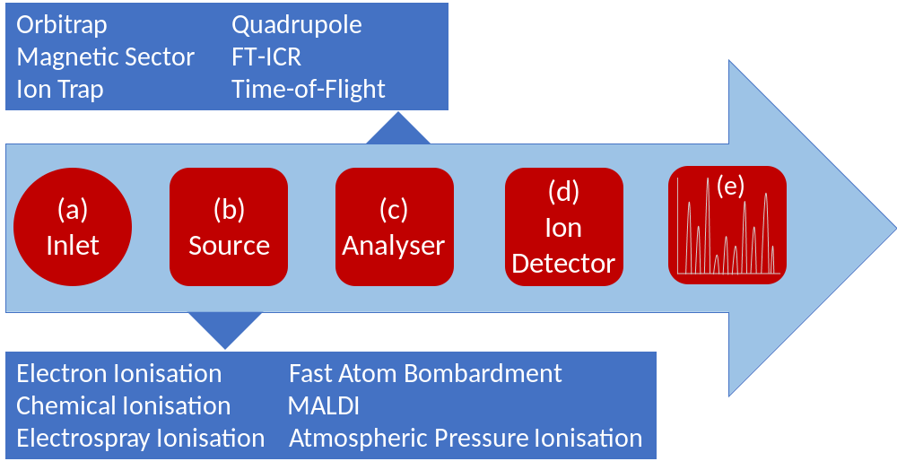

Figure 2. Experimental approach to metabolic profiling using mass spectrometry
A typical approach to metabolic profiling using mass spectrometry is shown. The process can be divided into approximately six stages from sample collection to data analysis and the identification of important metabolites. Each stage is shown alongside the main choice of steps and an approximation of the time each step can take.
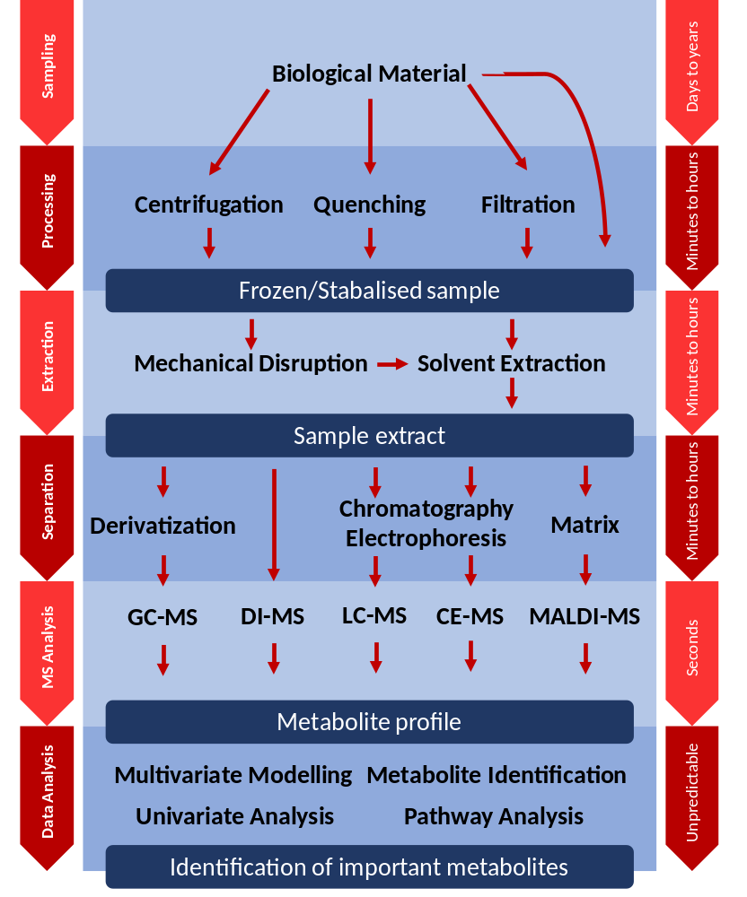

Figure 3. Workflow of ambient ionisation mass spectrometry compared to traditional approaches
Overview of ambient ionisation mass spectrometry workflows in comparison to traditional approaches coupled to chromatographic separation. As a result of minimal to no sample pre-treatment nor extraction, mass spectral data can be obtained from a sample in a matter of seconds using AIMS, compared with minutes to hours for conventional techniques.

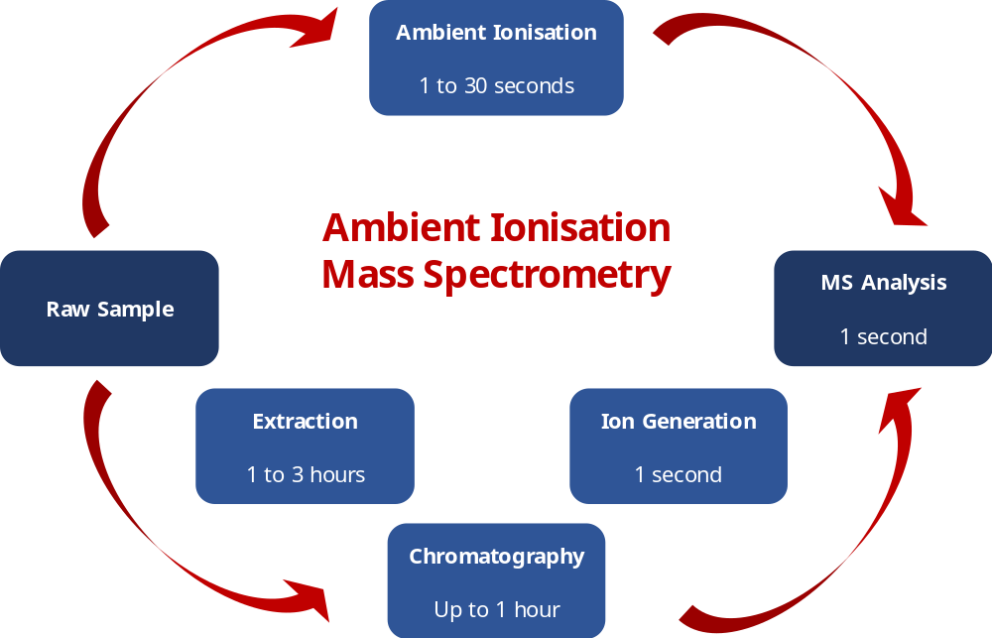

Figure 4. Annotated REIMS mass spectra of human faecal sample
REIMS was used to analyse human faecal samples from healthy individuals and analysed using a monopolar electrode and a Xevo G2-XS QToF instrument operated in negative ion detection mode. Annotated spectra using tandem mass spectrometry fragmentation shows detection of (a) bile acids and (b) the presence of bacterial phospholipids – identified by the presence of odd chain fatty acid tails. [Unpublished data provided courtesy of Simon JS Cameron and Zoltán Takáts].

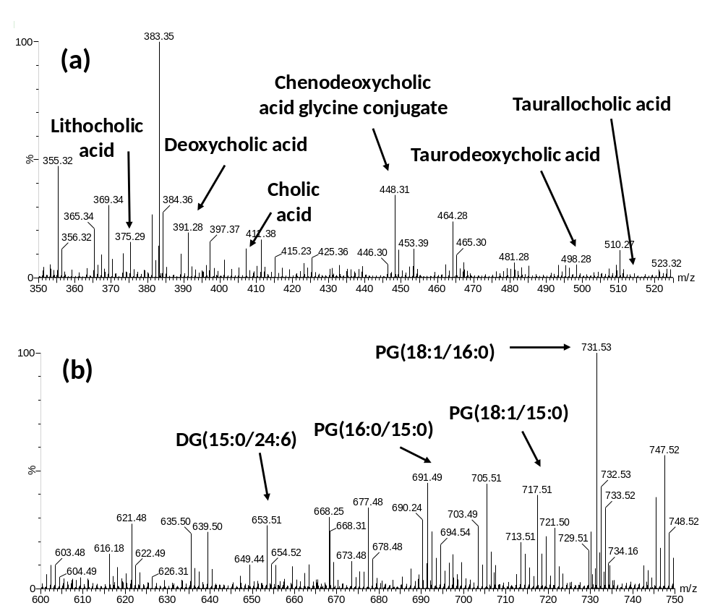
Figure 5. Suggested experimental workflow for establishment of causal relationships
Here we propose an approximate workflow that we believe is necessary for the establishment of causal relationship with regards to functional host-microbiome interactions starting from observational studies and ultimately ending in clinical trials.

